 | 
COUNCIL OF  THE EUROPEAN UNION |  |  | Brussels, 9 January 2013
 | Interinstitutional File:  2012/0217 (COD) |  | 5152/13
WTO 4
COEST 4
CODEC 30
INST 10
PARLNAT 7

COVER NOTE
from: | the President of the Assembly of the Republic of Portugal
date of receipt: | 20 December 2012
to: | Mr Enda KENNY, President of the Council of the European Union
Subject: | Proposal for a Regulation of the European Parliament and of the Council on the allocation of tariff-rate quotas applying to exports of wood from the Russian Federation to the European Union  [doc. 13143/12 WTO 286 COEST 281 CODEC 2017 - COM(2012) 449 final]  - Opinion on the application of the Principles of Subsidiarity and Proportionality

Delegations will find attached the above-mentioned opinion.

________________________

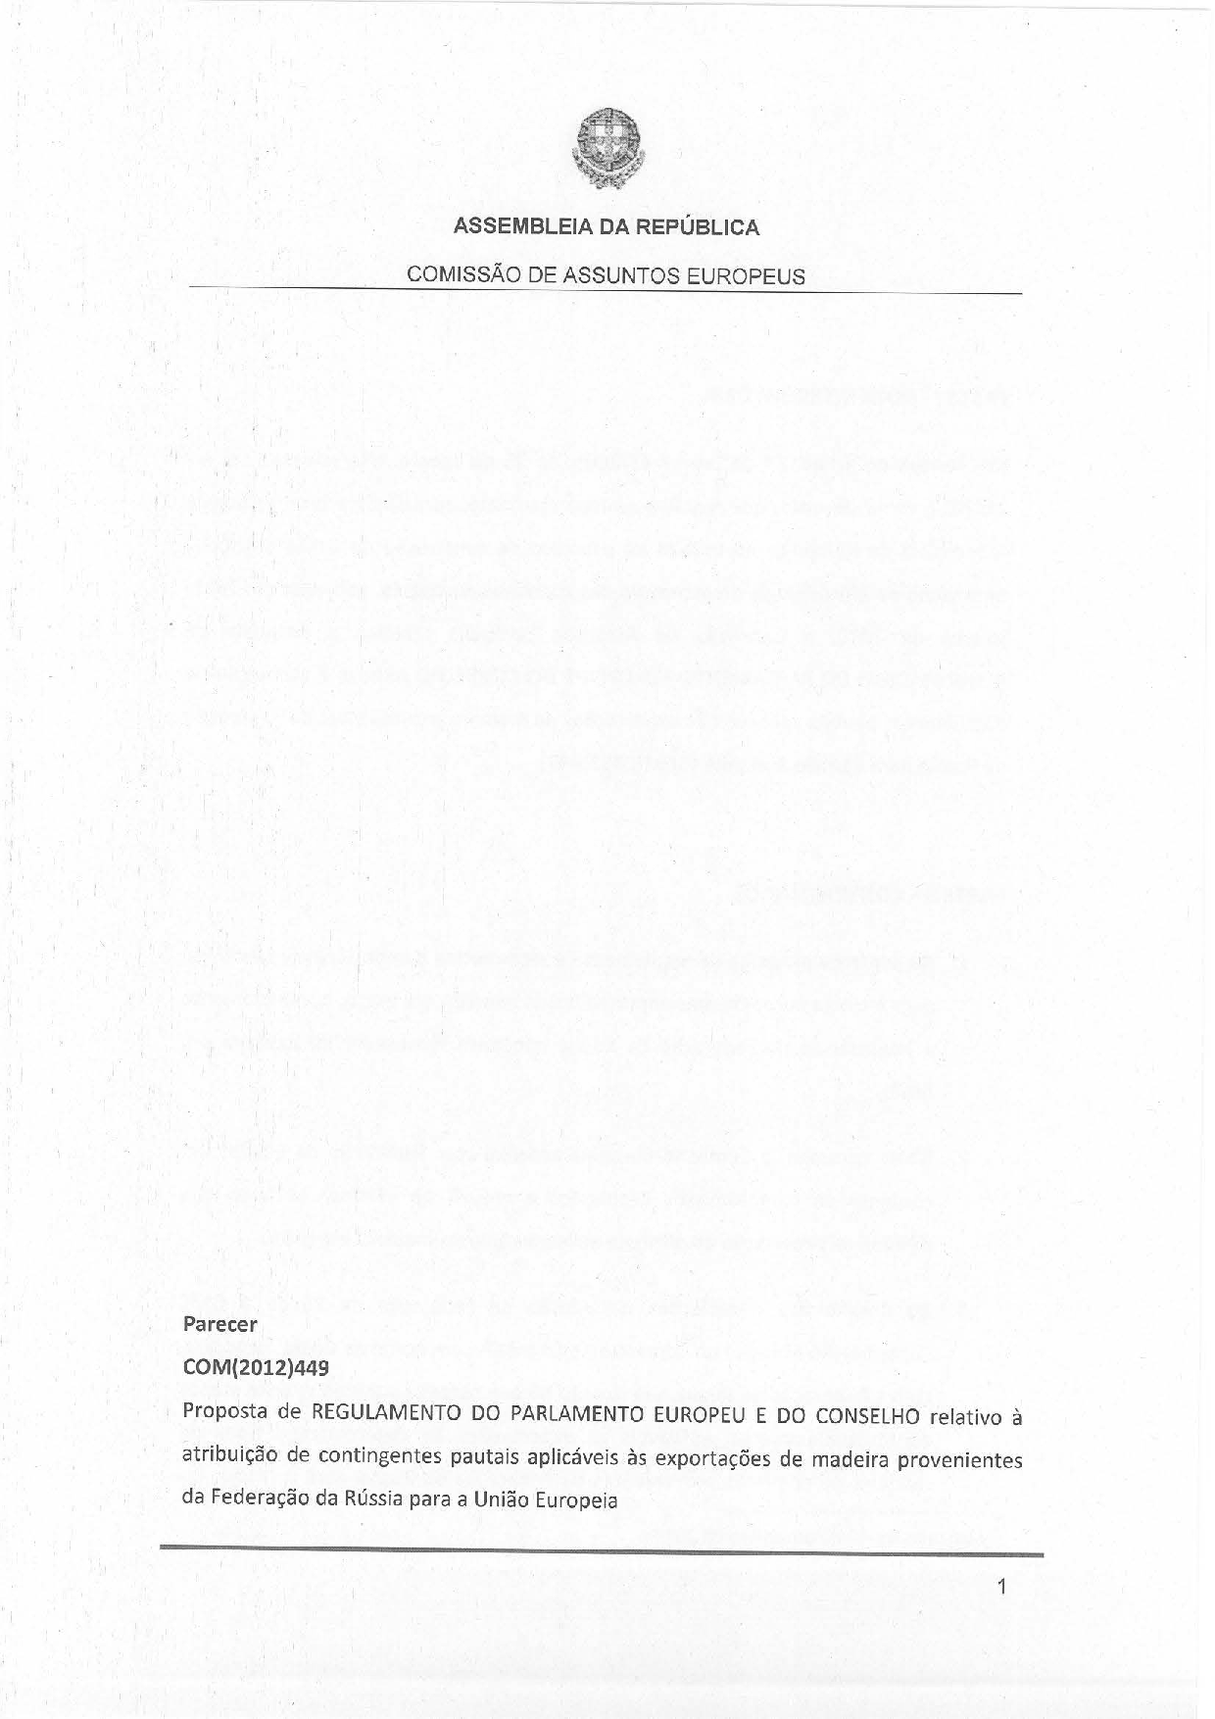
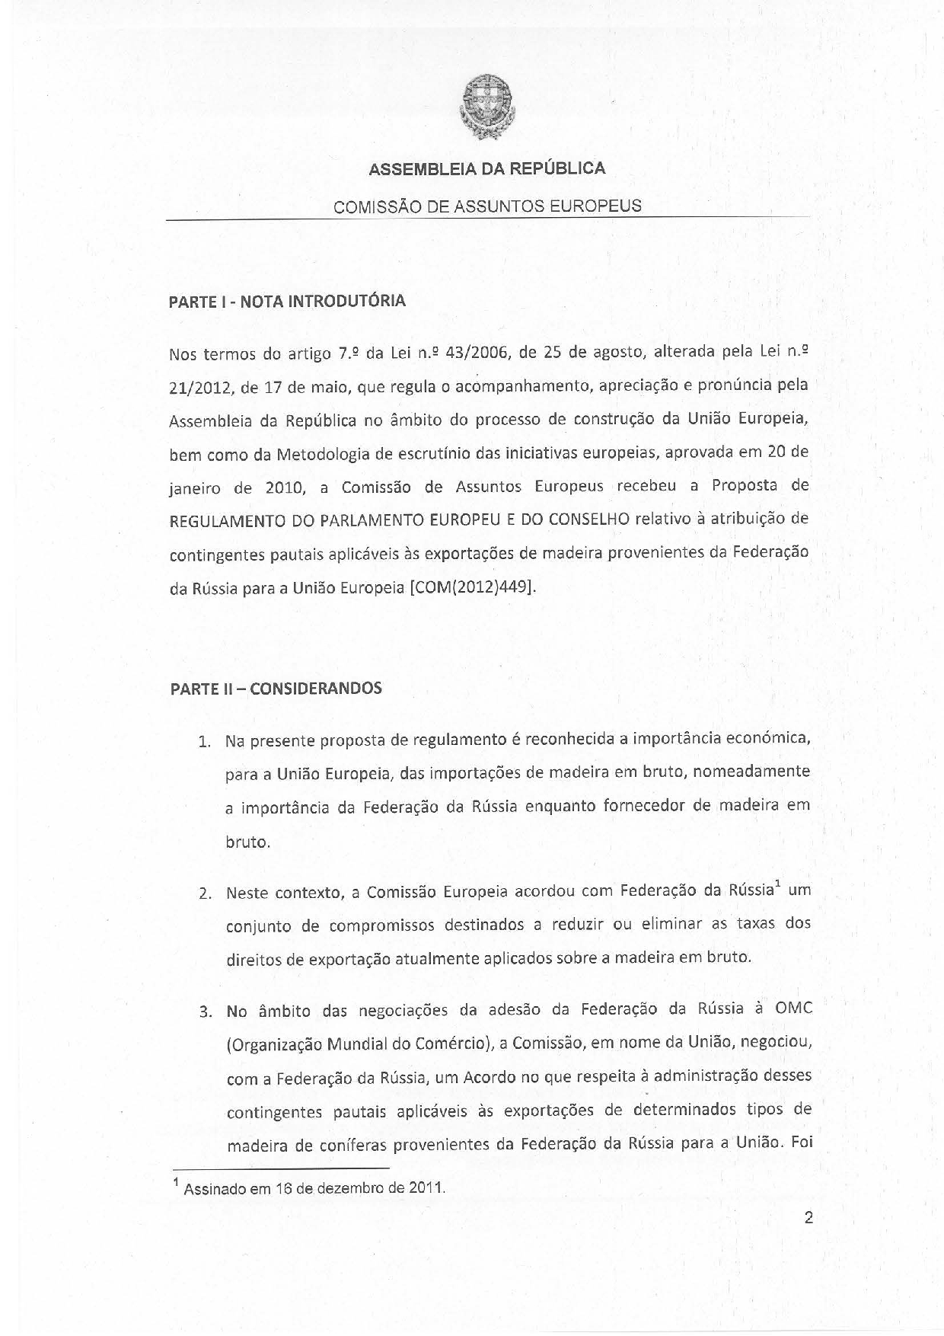
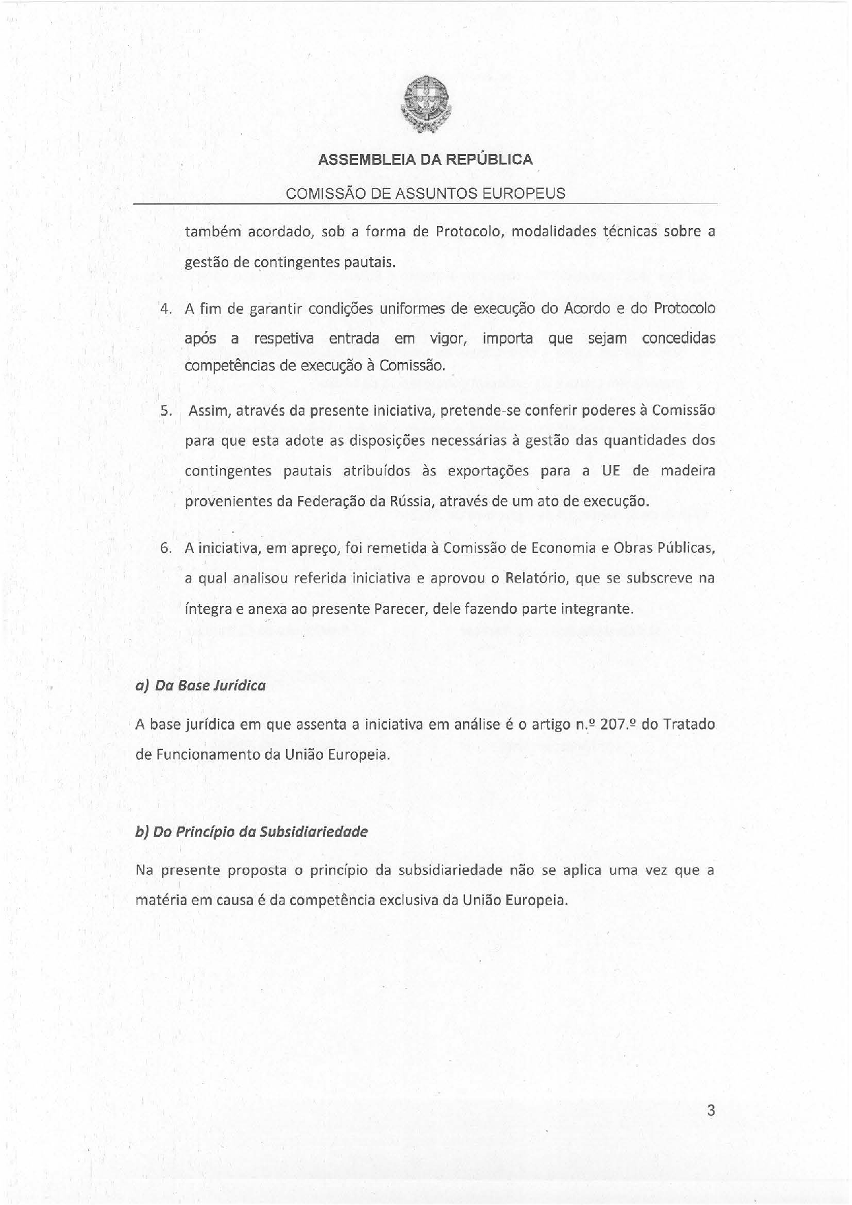
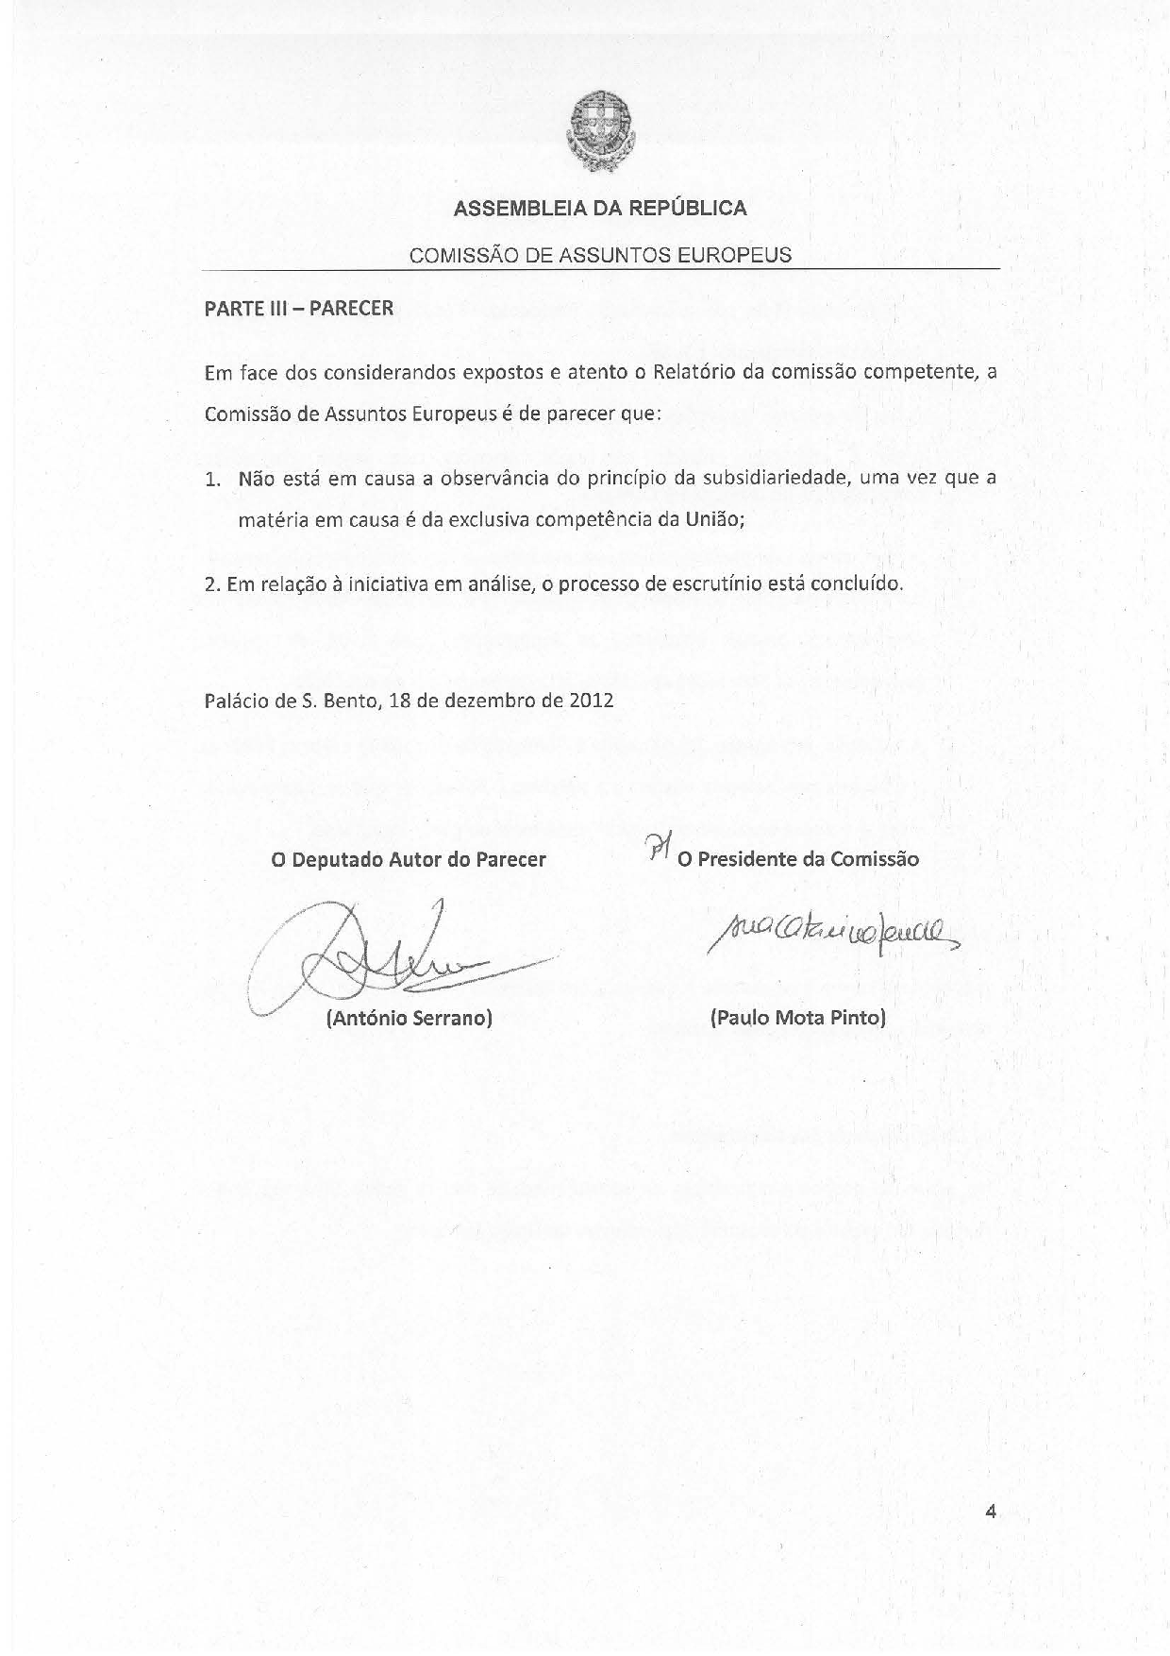
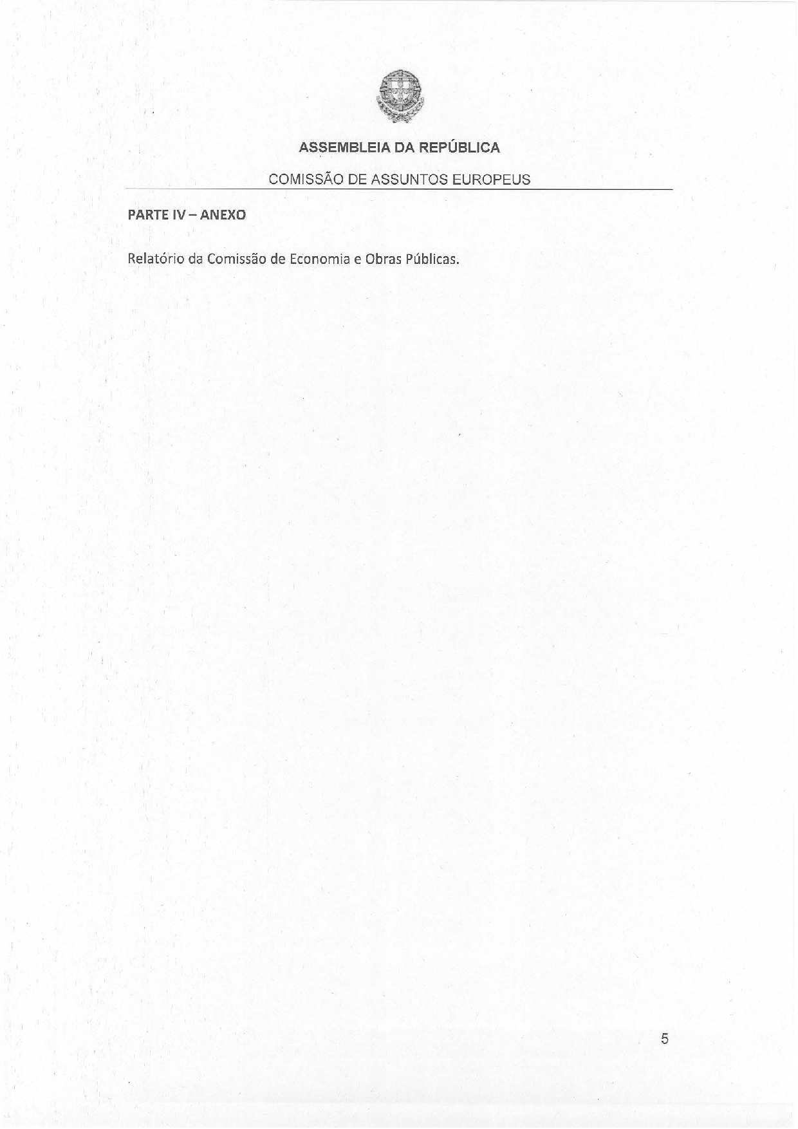
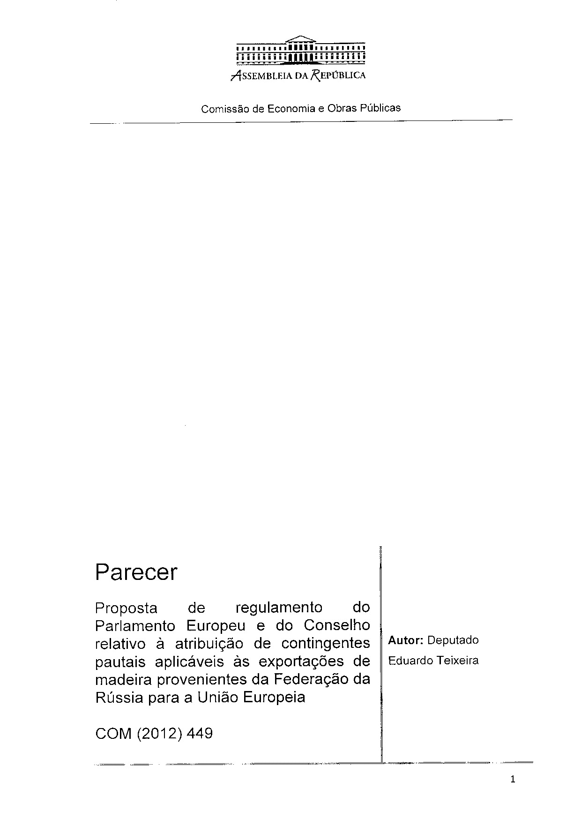
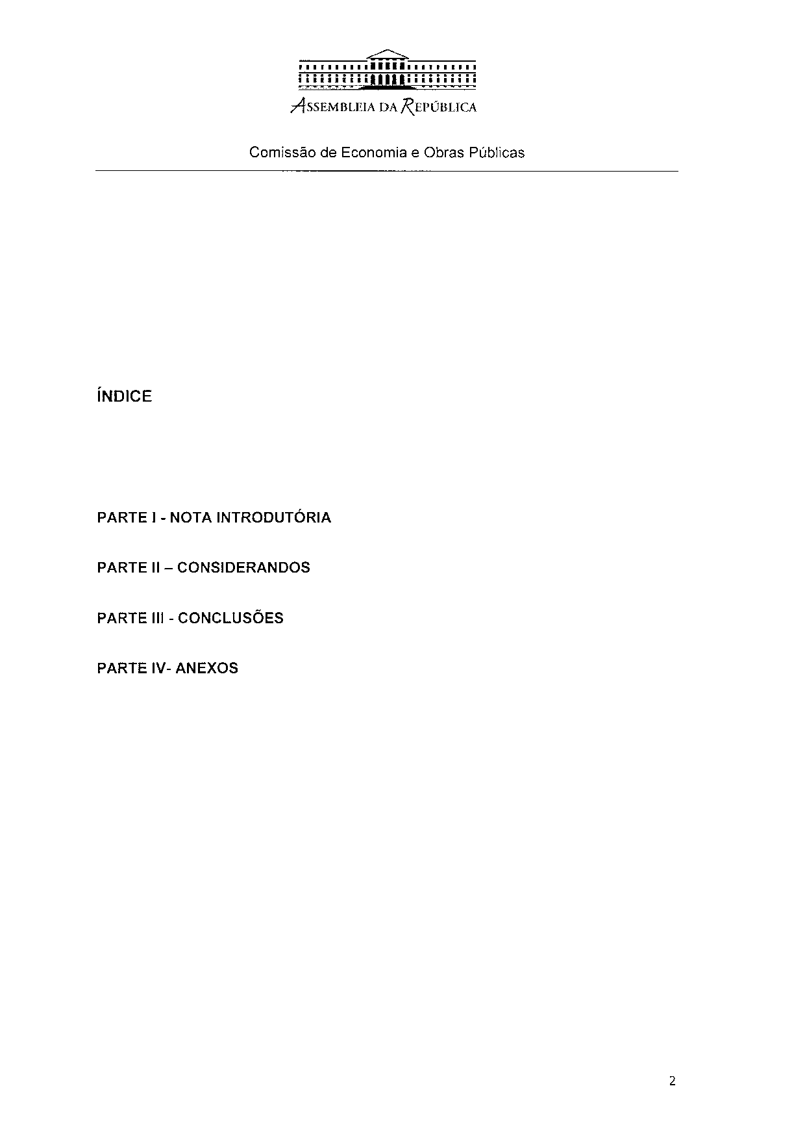
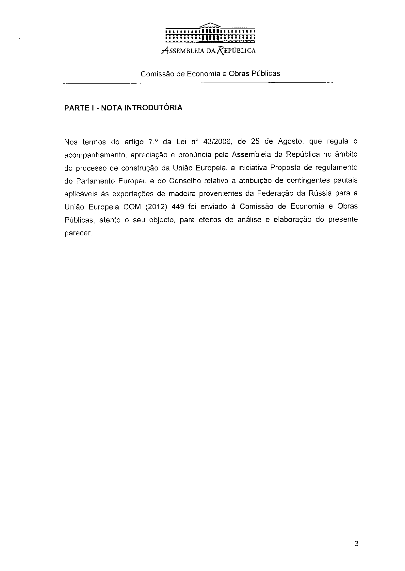
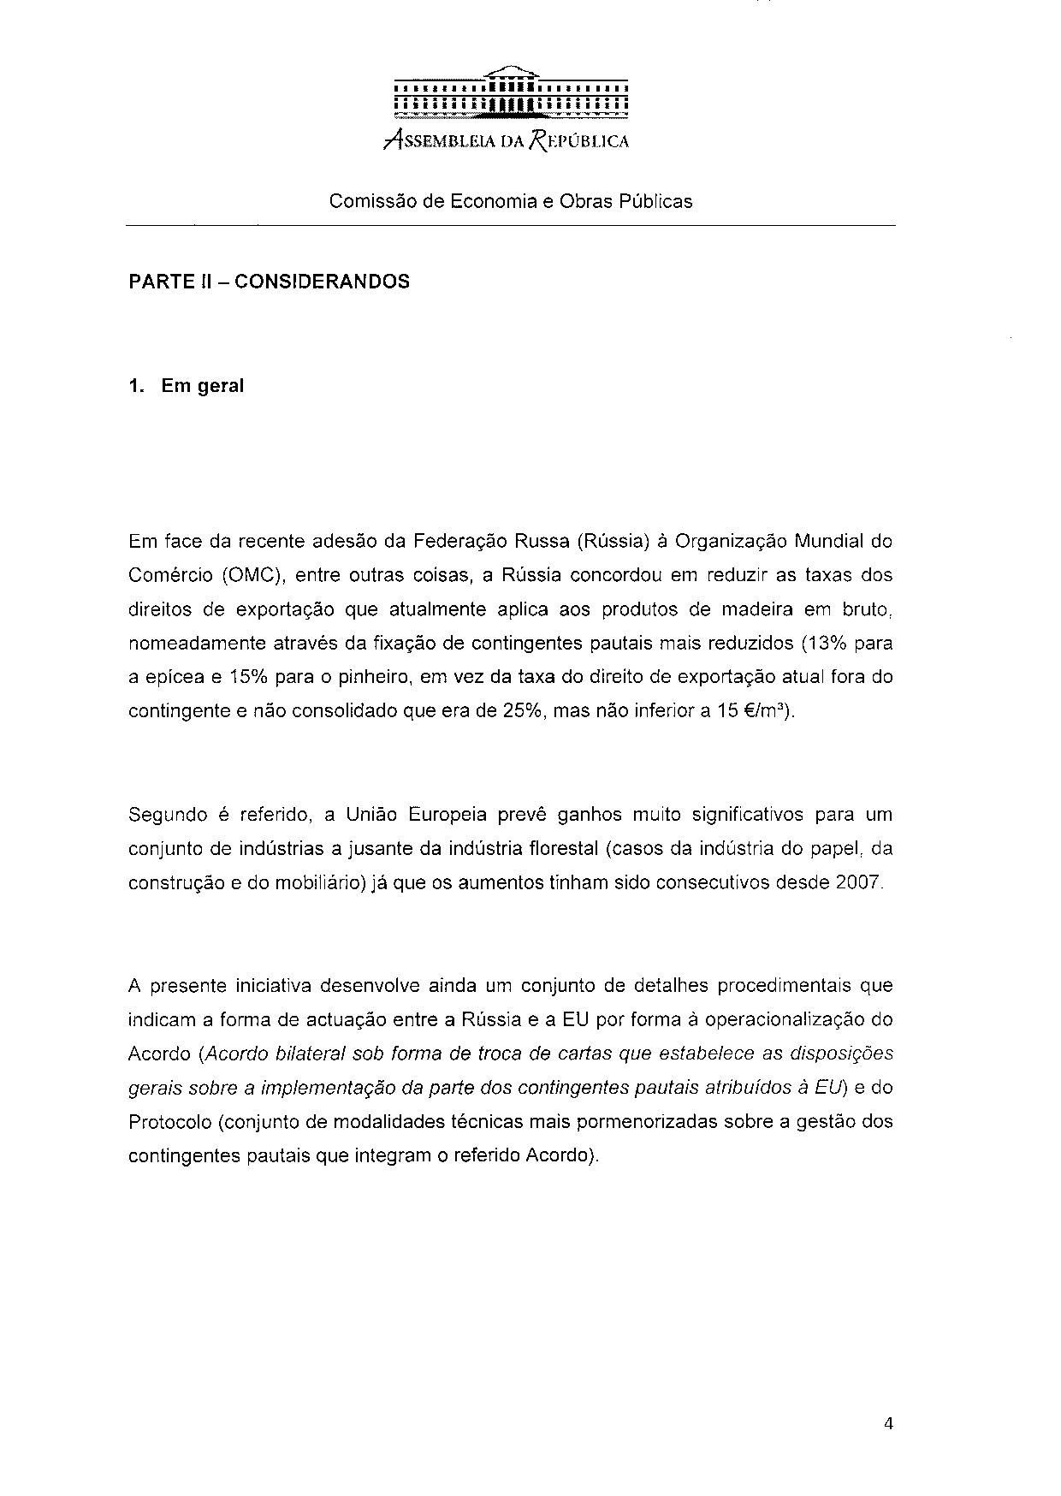
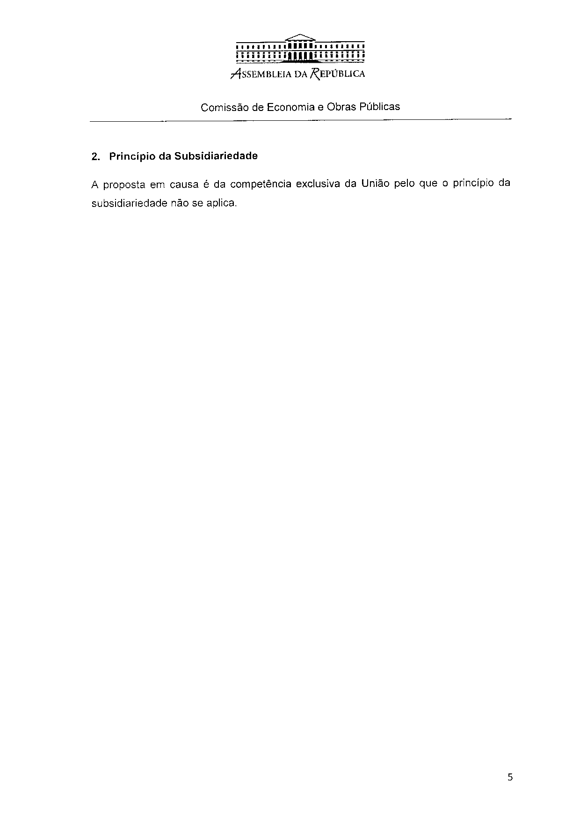
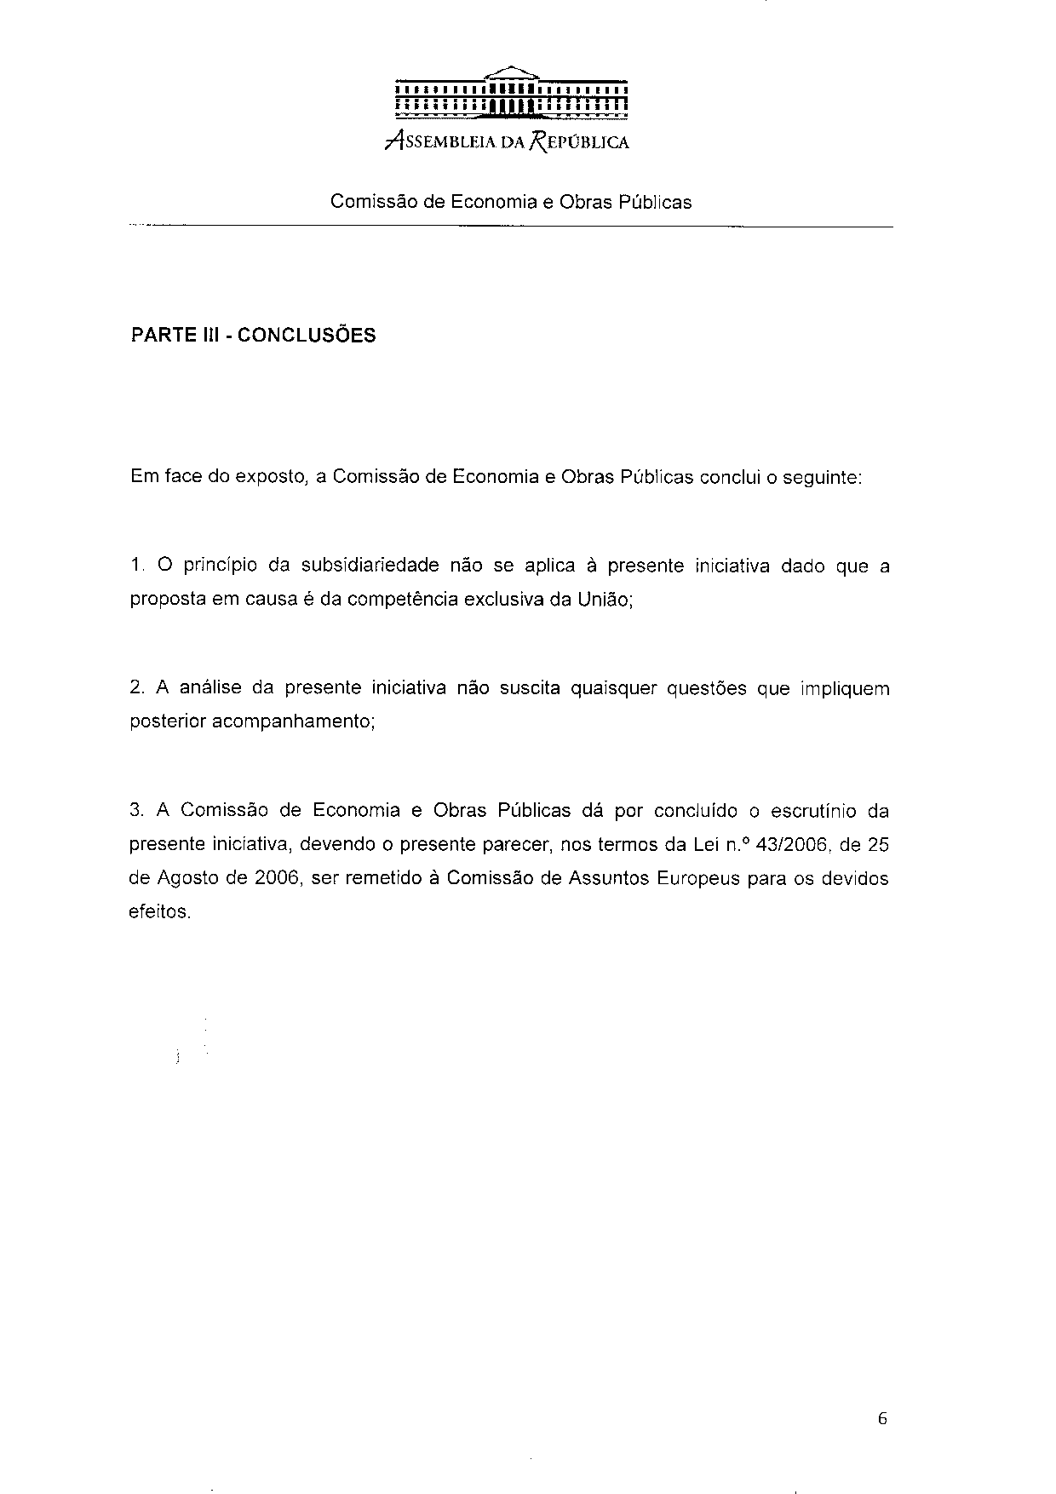
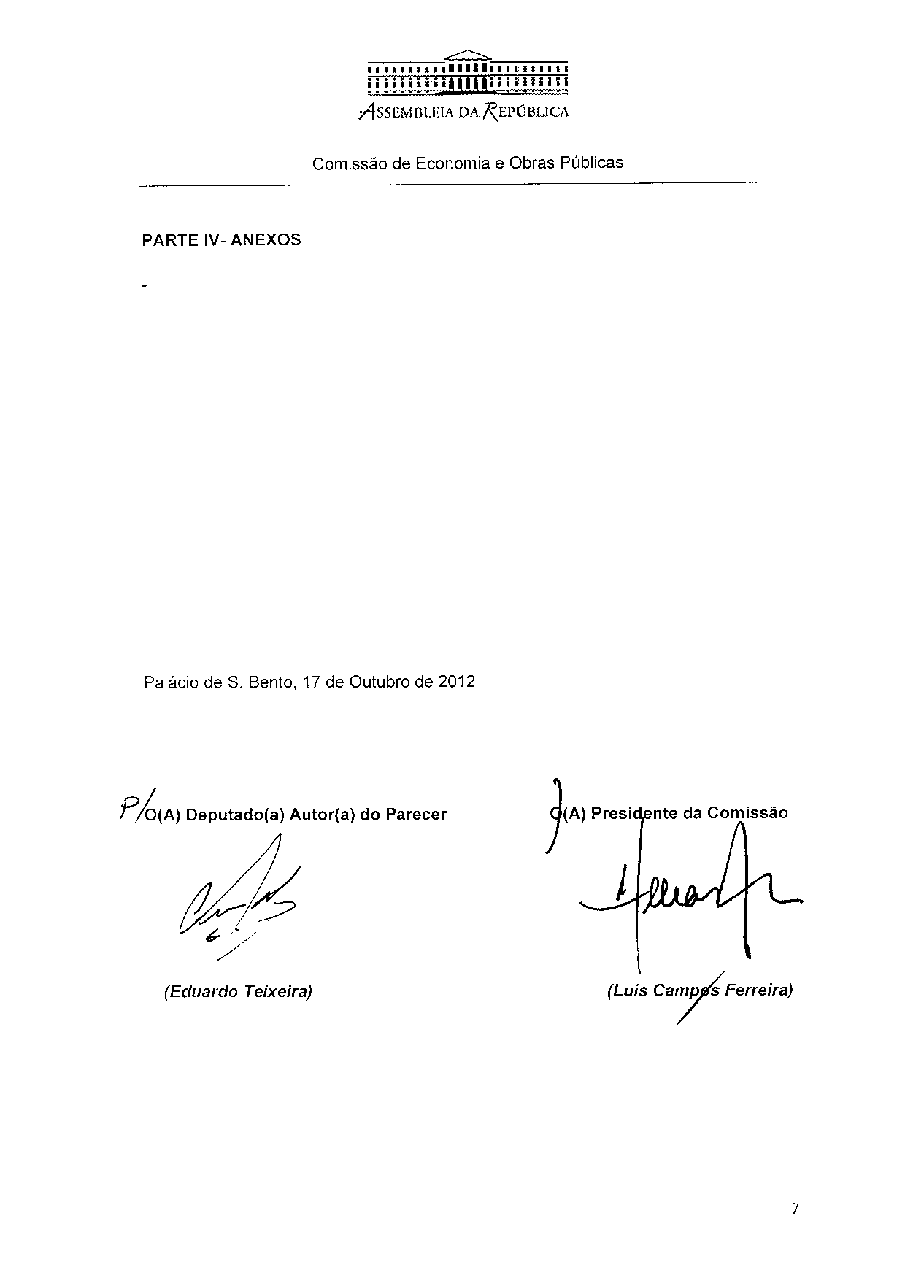

Translation(s) of the opinion may be available at the Interparliamentary EU Information Exchange site IPEX, at the following address: http://www.ipex.eu/IPEXL-WEB/search.do.

