 | 
COUNCIL OF  THE EUROPEAN UNION |  |  | Brussels, 10 January 2013
 | Interinstitutional File:  2012/0278 (COD) |  | 5087/13
ENV 11
AGRI 4
WTO 1
PI 1
DEVGEN 4
MI 3
SAN 4
CODEC 17
INST 5
PARLNAT 2

COVER NOTE
from: | Portuguese Parliament
date of receipt: | 19 December 2012
to: | General Secretariat of the Council of the European Union
Subject: | Proposal for a Regulation of the European Parliament and of the Council on Access to Genetic Resources and the Fair and Equitable Sharing of Benefits Arising from their Utilization in the Union  [14641/12 ENV 750 AGRI 650 WTO 321 PI 116 DEVGEN 272 MI 604 SAN 221 - COM(2012) 576 final]  - Opinion on the application of the Principles of Subsidiarity and Proportionality

Delegations will find annexed a copy of the above Opinion.

________________________
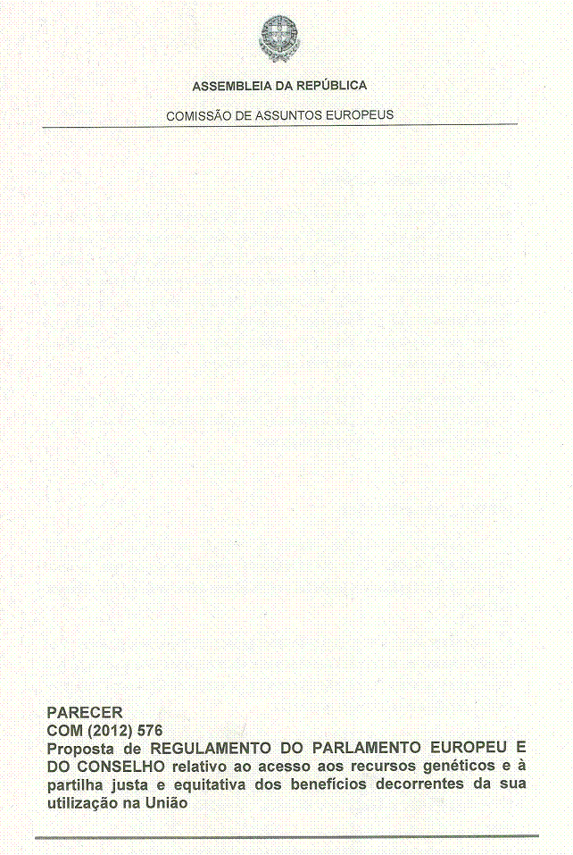
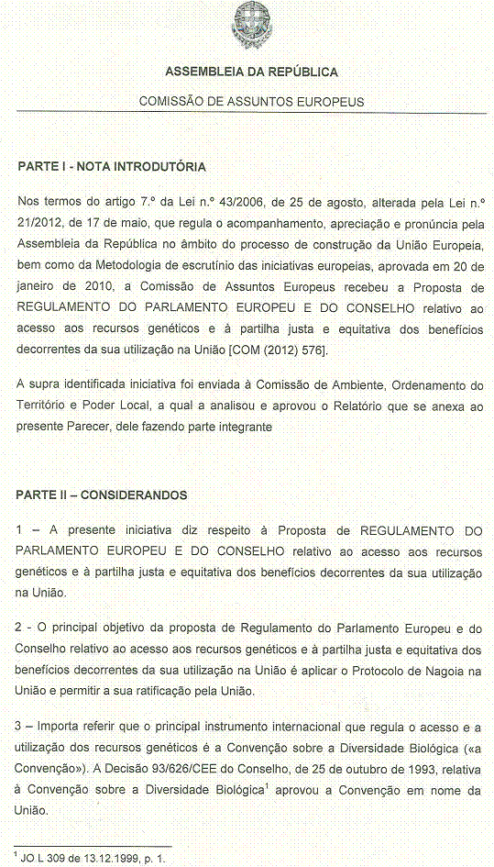
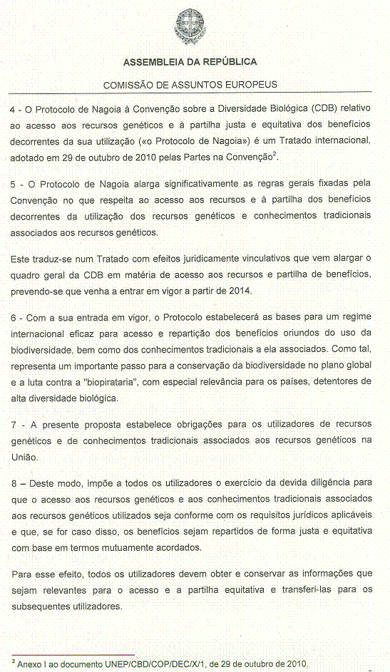
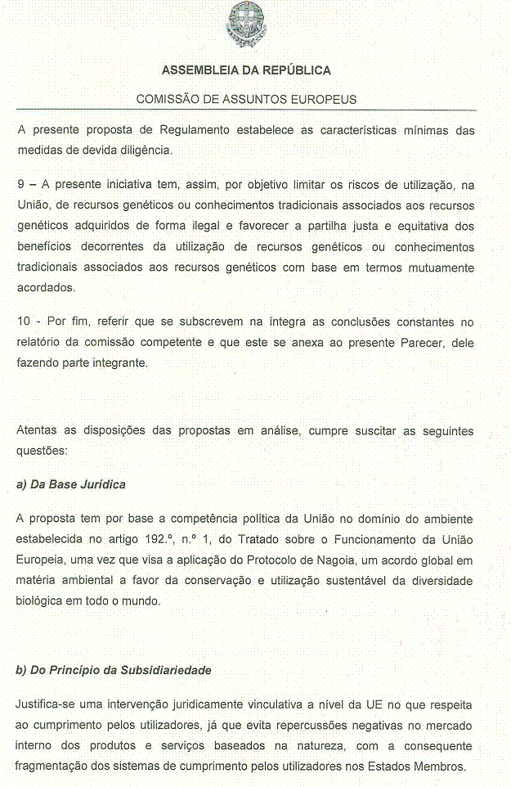
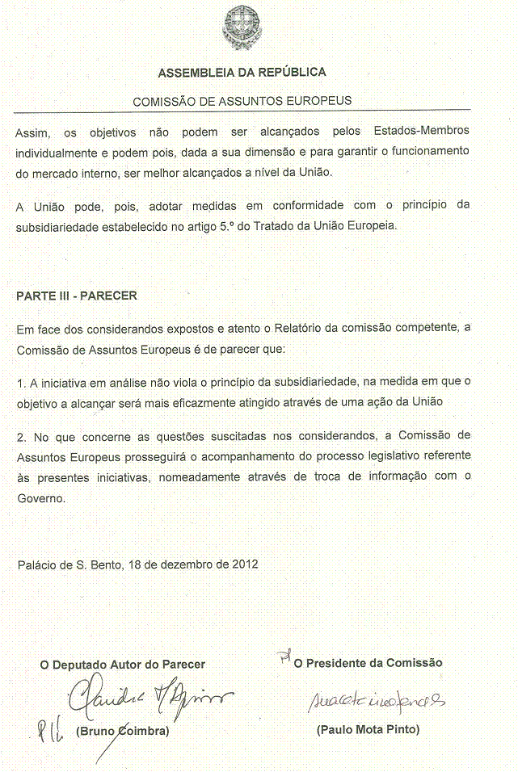
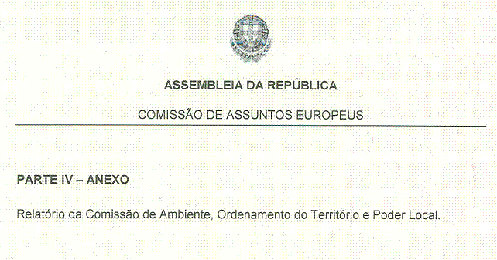
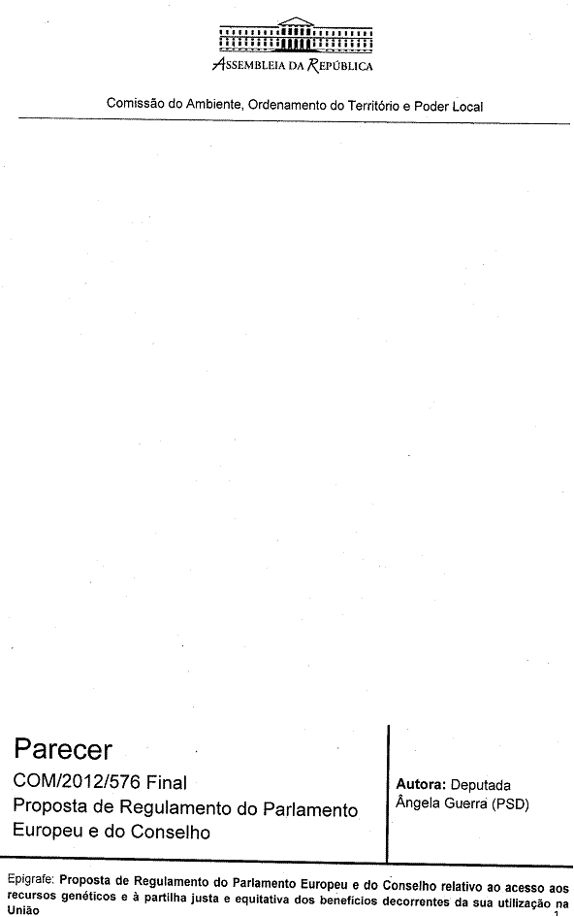
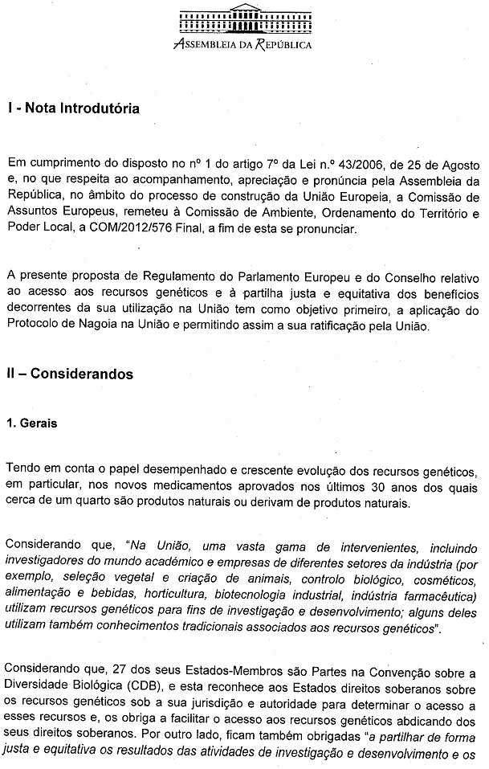
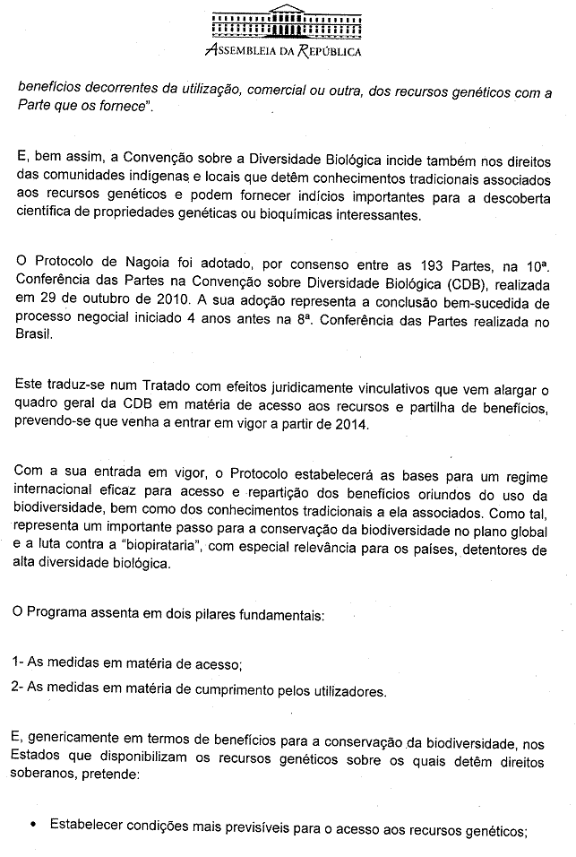
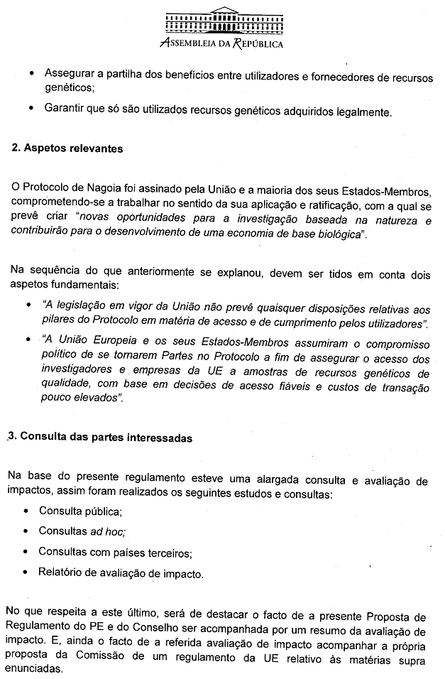
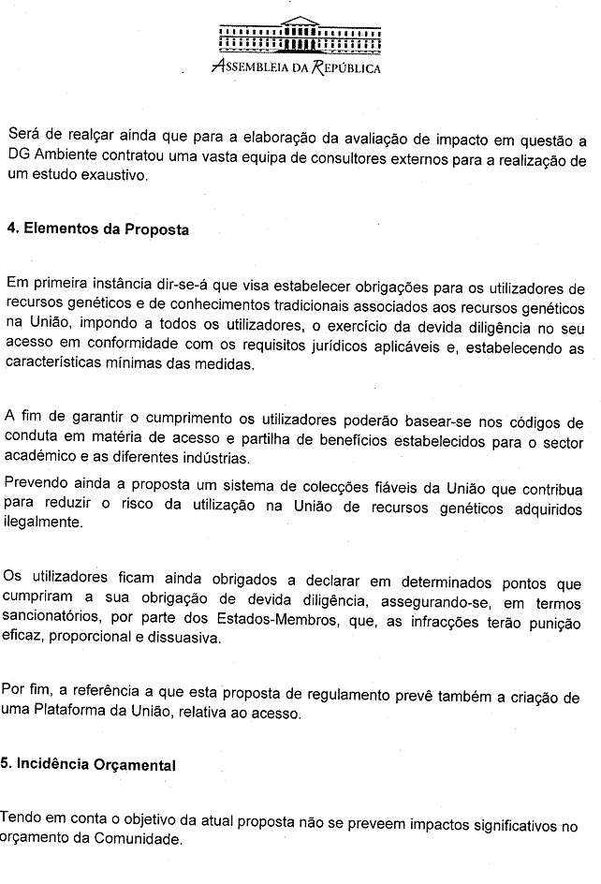
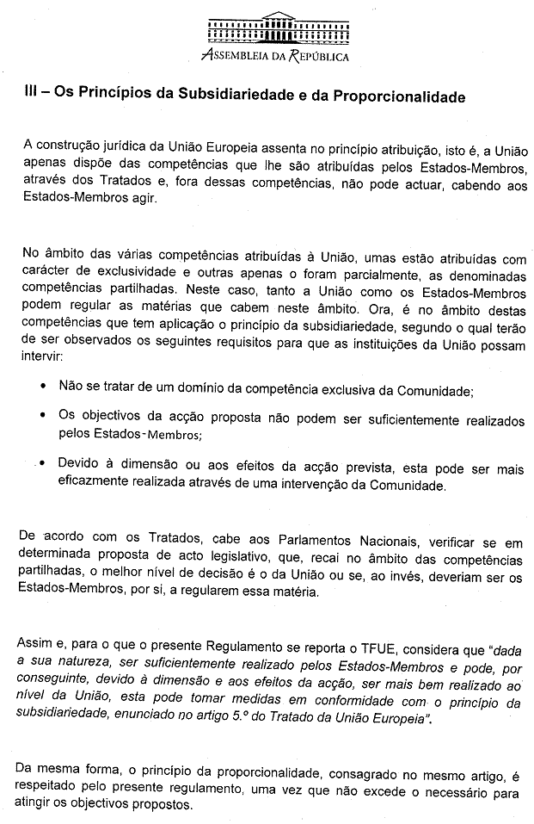
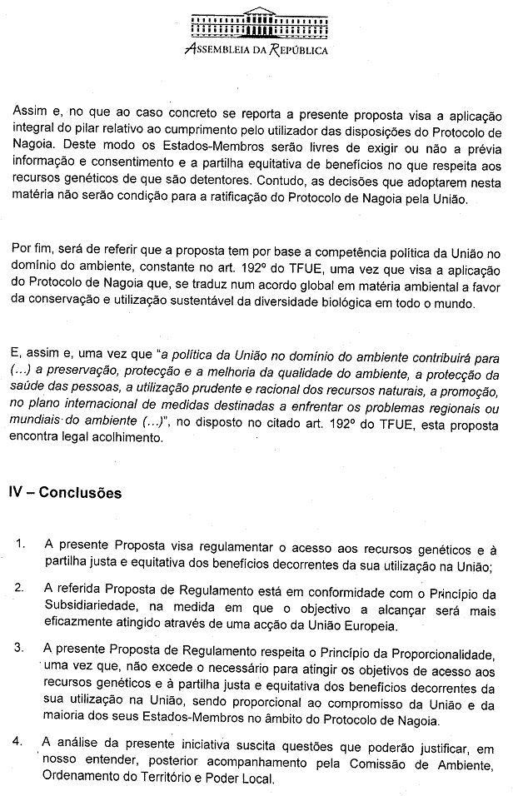
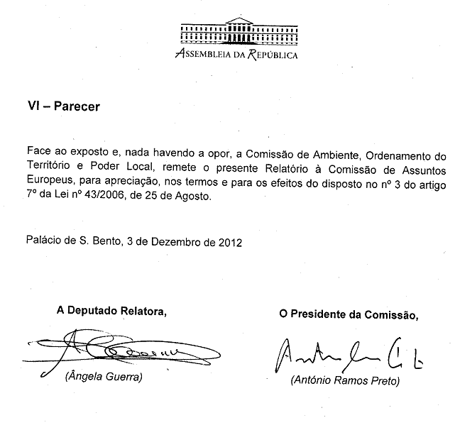

The translation of this document may be available in due course at the Interparliamentary EU information exchange site IPEX at the following address: http://www.ipex.eu/IPEXL-WEB/search.do

