ANNEX I
REPORT ON SECONDARY ADJUSTMENTS

1. Background
- The EU Joint Transfer Pricing Forum (JTPF), as part of its work programme for 2011-2015 considered so-called secondary adjustments in transfer pricing, as these adjustments may result in double taxation. A questionnaire launched in June 2011 took stock of the situation prevailing in each EU Member State at 1 July 2011 and served to prepare an overview on the legal and administrative/practical aspects in the different Member States. All 27 Member States' responses were included in document JTPF/018/REV1/2011. A draft discussion paper on secondary adjustments (doc. JTPF/010/2012/EN) was prepared and discussed at the JTPF meeting in June 2012. The present report was discussed and agreed at the JTPF meeting in October 2012.

2. Definition and Scope
- It is possible that a transfer pricing adjustment is accompanied by a so-called "secondary adjustment". The OECD defines secondary adjustments in the Glossary of the OECD Transfer Pricing Guidelines (TPG) as "an adjustment that arises from imposing tax on a secondary transaction in transfer pricing cases", and a secondary transaction as a constructive transaction that some States assert under their domestic transfer pricing legislation after having proposed a primary adjustment in order to make the actual allocation of profits consistent with the primary adjustment. Secondary transactions may take the form of constructive dividends (that is items treated as though they are dividends, even though they would not normally be regarded as such), constructive equity contributions, or constructive loans".
- Transfer pricing legislation in some States allows or requires "secondary transactions" in order to make the actual allocation of profits consistent with the primary adjustment. Double taxation may arise due to the fact that the secondary transaction itself may have tax consequences and results in an adjustment. For example, the amount of the income adjustment to a subsidiary on a transaction with a non-resident parent may be treated by the subsidiary’s jurisdiction as a deemed dividend paid to the parent and a withholding tax may be applicable.
- Secondary adjustments are reversed if the primary adjustment is reversed. Secondary adjustments taking the form of constructive dividends may create double taxation if the other State does not provide a corresponding tax credit or relief under Article 23 of the OECD Model Tax Convention (MTC) for the withholding tax arising from the secondary adjustment. Although the Commentary on Article 10 of the OECD MTC already states in paragraph 28 that constructive dividends are covered by Article 10 and by the rules for eliminating double taxation, the other State may simply not recognise such a deemed transaction, which gives rise to withholding tax (see par. 4.69 OECD TPG).
- The OECD MTC does not prevent secondary adjustments from being made where they are permitted under domestic law. Tax administrations are however "encouraged to structure such adjustments in a way so as to minimise the possibility of double taxation as a consequence thereof except where the taxpayer's behaviour suggests an intent to disguise a dividend for the purposes of avoiding withholding tax." (par. 4.71 OECD TPG).
- Out of the 27 EU Member States, 9 have legislation on secondary adjustments. The responses to the questionnaire indicate that secondary adjustments in some of those 9 Member States are discretionary.
R 1:
The application of secondary adjustments may lead to double taxation. Therefore, if secondary adjustments are not compulsory, it is recommended that MS refrain from making secondary adjustments when they lead to double taxation. Where secondary adjustments are compulsory under the legislation of a Member State, it is recommended that Member States provide for ways and means to avoid double taxation (e.g. by endeavouring to solve it through a MAP, or by allowing the repatriation of funds at an early stage, where possible). These recommendations assume that the taxpayer's behaviour does not suggest an intent to disguise a dividend for the purpose of avoiding withholding tax.
- In most Member States where secondary adjustments are possible/compulsory, these adjustments are treated as hidden profit distribution and therefore considered as constructive dividends which are potentially subject to withholding tax.
- Secondary adjustments may also take other forms e.g. a constructive loan. The OECD TPG (par. 4.70) highlight that these constructive transactions carry their own complications e.g. issues related to imputed interest on those loans. In their replies to the questionnaire most Member States did not refer to these types of constructive transactions. The reason may be that Member States want to avoid the related complications and generally make secondary adjustments in the form of constructive dividends/contributions. Constructive contributions and constructive dividends between an EU subsidiary and an EU parent company minimise the risk of double taxation, as they do not entail withholding tax consequences (see section 3).
R 2:
Given the additional complications they raise, it is recommended that within the EU Member States characterise secondary adjustments as constructive dividends or constructive capital contributions rather than as constructive loans, as long as there is no repatriation.
- A more problematic situation arises if the primary adjustment is made between parties that are indirectly related. Some MS may deal with this situation by way of hypothesising a distribution to the parent company and a contribution of the parent to the other subsidiary (par. 4.70 OECD TPG).
- This report concentrates on secondary transactions between EU resident/established entities and in the form of constructive dividends and addresses – based on the legal framework existing in the EU – ways to minimise double taxation and other administrative and financial burden (e.g. penalties) resulting from secondary adjustments.
- The following sections address the application of the EU Parent Subsidiary Directive (PSD) (see section 3)), situations where MS may consider giving relief if the taxpayer repatriates funds (in a Mutual Agreement Procedure (section 4.2) or at an earlier stage (section 4.3)) and also discuss penalties and procedural/administrative aspects (sections 5 and 6).

3. Parent Subsidiary Directive (PSD)
- When secondary adjustments are treated as hidden profit distribution/contribution and therefore considered as constructive dividends, the application of the PSD (Articles 4 and 5) results in no withholding tax being imposed on a distribution from a subsidiary to its parent within the EU.
- Nine EU Member States currently apply secondary adjustments - Austria, Bulgaria, Denmark, Germany, France, Luxembourg, the Netherlands, Slovenia and Spain. In a situation whereby a subsidiary in a MS is subject to a secondary adjustment based on a primary transfer pricing adjustment relating to a transaction with its parent company situated in another MS, seven of those nine MS would not impose any withholding tax on the basis of the provisions of the PSD. Two MS would consider that the PSD is not applicable to constructive dividends.

4. Repatriation of funds

4.1 General
- In essence, repatriation means effectively reversing the funds so that the accounts of the parties involved are in line with the economic intent of the primary adjustment. The OECD TPG (par. 4.73) describe some of the possible ways in which repatriation might be made. The OECD Manual on effective mutual agreement procedures (MEMAP) also contains guidance on repatriation. The OECD TPG (par. 4.76) recommends discussing repatriation in a MAP where it has been initiated for the related primary adjustment.
- The terms in a mutually agreed MAP settlement between the competent authorities in respect of a transfer pricing adjustment are specific to the particular settlement between the two CAs. Once the CAs have reached an agreement on the characterisation of the deemed transaction, a MAP also involves examining the following two issues:
- whether the TA which made the secondary adjustment would abstain from withholding tax or the other TA would eliminate the resulting double taxation, and,
- when repatriation is considered, how it will be made and how it is ensured that it does not result in a further taxable burden that may itself cause double taxation.
- The MEMAP indicates that a repatriation agreement may also be reached at an earlier stage, e.g. during an audit (see 4.3).

4.2 Repatriation in the course of a MAP
- If repatriation is part of a settlement, the terms may vary, but often allow for the repatriation of funds to be effected either by a direct reimbursement or through an offset of inter-company accounts. Typically, the agreed terms also allow a taxpayer to repatriate within a mutually agreed reasonable time period, free from withholding taxes by the State out of which the repatriation is made and from any additional taxable treatment in the State to which the repatriation is made. Repatriation may be subject to audit verification.
R 3:
Where competent authorities agree in a MAP on the need to effectively put the accounts in line with the economic intent of the primary adjustment, Member States consider repatriation by a direct reimbursement or through an offset of inter-company accounts as an appropriate tool for achieving this result.
R 4:
Tax administrations should be aware that taxpayers would need up to 90 days from the date of the notification of the agreement to actually implement the repatriation.
R 5:
When repatriation is agreed in a MAP settlement, it is recommended that the MAP agreement states that no withholding tax will be applied by the Member State out of which the repatriation is made and no additional taxable burden will be imposed in the Member State to which the repatriation is made.
- As a repatriation is made after the initial transaction, the Member State to which the repatriation payment will be made may consider that the payment should include an interest component to compensate its resident taxpayer for the foreign associated enterprise’s use of that taxpayer’s funds between the time of the initial transaction and the repatriation. Such an approach would, however, result in further complicating the repatriation and may also have its own tax consequences.
R 6:
Where the MAP is between Member States it is, on grounds of simplification, recommended that MS allow, as far as possible, the repatriation without an interest component and state this in the MAP agreement.

4.3 Repatriation at an early stage, e.g. an audit
- Some States have developed approaches to avoid potential double taxation by refraining from secondary transactions and secondary adjustments if a repatriation is already made at the stage of an audit. Repatriation at an earlier stage, e.g. at the stage of an audit, would from a taxpayer's perspective require an arrangement on how to conform the accounts to the primary adjustments and from a TA's perspective the agreement to this arrangement (some MS may only be able to agree on refraining from secondary transaction/adjustment in the context of a MAP). Further a corresponding treatment by the other TA involved is needed. Ensuring the latter may require informing the other MS based on the exchange of information rules or initiating a MAP as already the primary adjustment might not be acceptable for this TA. It should be noted that under Article 25 of the OECD MTC it would be possible for a taxpayer to initiate a MAP already when he considers that actions of one country are likely to result in double taxation.
R 7:
If a Member State considers repatriation at an early stage, e.g. at the stage of an audit, it is recommended to ensure that the other Member State is informed concurrently based on an exchange of information procedure, or by the taxpayer (if the taxpayer agrees).
R 8:
A repatriation agreement reached at the audit stage should not preclude a request by the taxpayer for a MAP, nor should it indicate agreement or disagreement with an audit statement.

5. Penalties
- Secondary adjustments may in some Member States be subject to specific penalties or result in penalties under the general penalty regime. The EU JTPF's summary report on penalties already elaborates on different penalty regimes within the EU and reveals in section 5 that in most Member States a possibility to abstain from imposing penalties (as long as they are not considered by a Member State as a serious penalty) exists. Further it contains the message that penalties should be in line with the final, agreed transfer pricing. This conclusion may also be read in a way that penalties should only relate to the transfer pricing adjustment itself, i.e. the primary adjustment and not to the secondary adjustment.
R 9:
When a secondary adjustment is required, Member States should refrain from imposing a penalty with respect to the secondary adjustment.
- In case penalties on secondary adjustments are nonetheless applied, it is worth to consider addressing those penalties in a MAP to ensure the removal of double taxation resulting from secondary adjustments.
R 10:
When the tax consequences of a secondary adjustment are eliminated or reduced in a MAP, it is recommended to eliminate or commensurately reduce the related penalty, respectively.

6. Procedure for removing double taxation
- In their responses to the questionnaire on secondary adjustments (JTPF/018/REV1/2011), most Member States which apply secondary adjustments stated that they do not consider double taxation issues resulting from secondary adjustments as being covered by the Arbitration Convention (AC), only a few consider them covered by the AC Convention, and some other MS indicated that the applicability of the AC to secondary adjustments remains an open question for them. However, most MS applying secondary adjustments would be willing to address them in the course of a MAP. Therefore, in cases where it is not possible to avoid double taxation at the outset, e.g. by way of applying the PSD, a taxpayer would – in a case of (potential) double taxation resulting from a secondary adjustment – have to file two requests, i.e. a request under the Arbitration Convention and a request for a MAP. The latter would require in each case a treaty being concluded between Member States that includes a MAP provision comparable to Article 25 of the OECD MTC (preferably including an arbitration clause as per Article 25 (5) OECD MTC).
R 11:
As taxpayers may not be aware of the fact that in certain situations a separate request needs to be made for avoiding double taxation resulting from secondary adjustments, Member States which do not consider that secondary adjustments can be treated under the AC are encouraged to highlight in their public guidance the fact that a separate request under Art 25 OECD MTC may be needed to remove double taxation. For reasons of efficiency, it is recommended that taxpayers submit both requests in the same letter.

ANNEX II
REPORT ON TRANSFER PRICING RISK MANAGEMENT

Background
- The Joint Transfer Pricing Forum (JTPF) considered risk assessment as an important aspect of transfer pricing and included it in the work programme of the JTPF for 2011-2015. Work on this topic started with presentations by three Member States (MS) and by Non-government Members (NGM) about their approaches to risk management. A subgroup was then created to prepare the discussion. From the start, it was felt that limiting the scope of the project to the assessment of risk would not be optimal. Therefore the scope was broadened to "risk management in transfer pricing" in general, to cover the whole process of ensuring that transfer prices are finally set in accordance with the arm's length principle. The JTPF was informed on the progress of the work of the subgroup at the meetings in October 2012 and February 2013.
- Given the comprehensive material on risk management that is already publicly available (e.g. from the OECD) and to avoid duplication of work, the report will refer to appropriate conclusions in this material and put a stronger emphasis on the specific situation in the EU.
- Given the different economic situations, the variety of transactions within a multi-national enterprise, the different legal and administrative environment as well as the differences in resources available in MS, it is not possible to develop a universal approach on how to concretely manage transfer pricing risk effectively. Therefore, this report is intended to provide best practices on effective risk management in transfer pricing with a focus on aspects specific for MS and business in the EU. Member States and taxpayers are encouraged to use this guidance within their abilities and laws to deal with transfer pricing risks effectively.

1. Preamble
- Enforcement of and compliance with transfer pricing rules as embodying the arm's length principle under Article 9 of the OECD Model Tax Convention (OECD MTC) can be resource-intensive for tax administrations and taxpayers respectively. The JTPF recognises that available resources for transfer pricing are limited and should therefore be deployed effectively. Accordingly, the term 'transfer pricing risk' as used in this report not only covers the risk that transfer prices are not set in accordance with the arm's length principle, but also the risk that resources are not allocated efficiently towards ensuring that transfer prices are set in accordance with the arm’s length principle.
- The JTPF seeks to find practical solutions for the proper functioning of the arm’s length principle in the EU. In line with this task, the role of the JTPF in the context of transfer pricing risk management is seen as assisting MS and taxpayers in coordinating actions, ensuring transparency and working on the basis of aligned approaches.
R 1:
It is recommended to respect the following general principles when managing transfer pricing risk:
- It is preferable to take a cooperative approach based on dialogue and trust. A cooperative approach is inter alia characterised by communication between tax administration and taxpayer at an early stage, i.e. already when considering an audit, preparing an audit or actually beginning an audit. Early communication can prevent misunderstandings and inefficient allocation of resources by helping to focus on the most critical aspects which contribute to effective risk management. A cooperative approach implies the disclosure and understanding of facts and circumstances of the case under consideration by the taxpayer.
- It is worthwhile to put efforts in identifying aspects which involve a higher transfer pricing risk than others and to take the specific belongings of SMEs into account.
- Effective risk management also implies allocating resources to areas with a high transfer pricing risk.
- Legal tools should be available to effectively address situations with high transfer pricing risk.
- To avoid unnecessary deployment of resources it is important to ensure that all actions envisaged are well-targeted and appropriate to the circumstances of the case, taking into account the resources available and the burden these actions create.
- It should, however, be stressed that the cooperative approach is only valid when dealing with a cooperative taxpayer. Whether a taxpayer can be regarded as cooperative may be indicated, for example by experience with past administrative procedures (e.g. audits), transparency or the fact that documentation consistent with the Code of Conduct on Transfer Pricing Documentation for Associated Enterprises (EU TPD) is maintained and can be made available to the tax administration.

2. The different phases in transfer pricing
- This part is structured according to the three phases a transfer pricing file normally follows:
- Initial phase – period prior to an audit of the transfer pricing issue;
- Audit phase – period from start to end of an audit;
- Resolution phase – period during which the tax authority and the tax-payer seek to resolve any disagreements.

2.1 The initial phase
- It is recognised that MS have different practices on how they organise their administrative procedures and especially their audits. In some MS taxpayers are selected for an audit based on general criteria like size, location, or industry sector. The concrete focus of the audit, e.g. transfer pricing, is then determined at a later stage. Other MS have a procedure where taxpayers are specifically selected for a transfer pricing audit. It is not the purpose of this report to strictly and universally distinguish between the different steps. Therefore the term 'initial phase’ in the context of this report should be understood as covering the time before a serious commitment of a tax administration's resources is made to concretely investigate whether transfer prices are set in accordance with the arm's length principle, regardless of whether this is already considered as audit or pre-audit in the administrative practice of the MS.
- The objective of the initial phase is to enable the tax administration to make a well-founded judgement on whether it is, in the light of the risk identified and the resources available, appropriate to pursue with a further investigation (the audit phase) and if so, where to put the focus. Accordingly, a tax administration should also be prepared not to start/continue addressing transfer pricing issues in an audit if the initial phase reveals no or a low transfer pricing risk.
- The following aspects should generally be taken into account for effectively structuring the initial phase:
- A certain amount of information is needed to assess whether there is a transfer pricing risk that requires further action. This information may be available to the tax administration from various sources such as public sources, findings in past audits, information requested automatically (e.g. in the context of the tax return) or specifically (e.g. by issuing specific questionnaires on transfer pricing).
R 2:
Requests for additional information should be balanced between the needs of the tax administrations, taking into account their different approaches, on one side and the burden imposed on the taxpayer on the other side. The following aspects should be taken into account in particular:
- what information is actually needed for the initial phase,
- what is the most appropriate point in time to request this information,
- what is the appropriate form for requesting the information, and
- what burden is imposed on the taxpayer by the request.
More generally, understanding the facts and circumstances is often regarded as more helpful than pure numbers.
- The information obtained needs to be evaluated with respect to the question whether it reveals transfer pricing risks to which it is worth allocating more resources. It is therefore necessary to know what factors create transfer pricing risk, which are the typical scenarios triggering risk and how to evaluate the information available with respect to these risk factors. For this purpose it would be helpful to have an organisational framework that enables a decision on whether (in light of the risk and the resources available) it is worth taking further steps. Some MS have, for example made good experience with setting up a group of TP experts (TP board) who decide how to proceed with specific TP issues and cases.
R 3a:
When considering the application of risk-based approaches it is recommended to develop specific criteria that indicate transfer pricing risk.
R 3b:
It is recommended to establish an appropriate administrative organisation that enables a tax administration to make a well-founded decision on whether further resources should be deployed to a certain case/audit field.
- Some MS have good experience with establishing a so-called cooperative compliance arrangement with taxpayers, i.e. maintaining communication on transfer pricing issues between the taxpayer and tax administrations before the tax return is made or even the transaction takes place. From their experience taxpayers also welcome such an approach.
R 4:
While it is recognised that an approach of cooperative compliance arrangement may - due to their respective administrative framework and practice - not be considered appropriate in all MS, it is recommended to at least implement measures that allow communication between taxpayers and tax administrations at an early point in time. This would be especially useful when the taxpayer identifies transfer pricing aspects where problems in substance or administration are foreseeable.
- There are also situations where it would make sense that a transfer pricing risk which was identified by one tax administration is communicated to the other tax administration(s) involved. The EU Directive on Administrative Cooperation provides a practicable framework for exchanging such information from risk assessment in an effective manner and at an early point in time. In this initial phase, the detail of information submitted should, however, be rather limited as the aim of the exchange would be to prevent problems resulting from early and late audits or to envisage a simultaneous or joint audit.
R 5:
It is recommended that MS exchange information on transfer pricing risks based on the EU Directive on Administrative Cooperation (2011/16/EU) when problems in substance or administration are foreseeable between the MS involved or joint action of Tax Administrations could be considered as an appropriate reaction.

2.2 The audit phase:
- For the purposes of this report the ‘audit phase’ starts with the decision to make a serious commitment of a tax administration's resources to concretely investigate whether transfer prices were set in accordance with the arm's length principle. During the audit phase it is important that the procedure is structured as effectively as possible and the available resources are deployed to complete the audit as quickly as possible.
- The foundation for an effective audit process is a well-founded result of the initial phase, i.e. the identification of areas involving a transfer pricing risk that is worth being investigated further. In addition, it is important to establish a work plan which includes the steps that will probably be taken and the timelines envisaged on both sides - the tax administration and the taxpayer. Setting up such a work plan can help ensure an effective process which is characterised by mutual understanding.
R 6:
It is recommended to set up a work plan for the audit. The work plan should cover both the perspective and actions on the side of the tax administration and those on the side of the taxpayer.
The appendix to this report contains one example for such a work plan.
R 7:
It is recommended to take the following aspects into account during the audit phase:
- The importance of first establishing mutual understanding of the facts and circumstances underlying the transactions that were chosen for further review in the context of the business and the industry in which the taxpayer is operating before applying transfer pricing rules. For this purpose the involvement of sector or industry experts may be useful.
- A high degree of cooperation between taxpayer and tax administration, e.g. by establishing an early and ongoing dialogue is regarded as beneficial for the whole process. Further, well-prepared face to face meetings are helpful. Generally, keeping the time difference between the transaction and audit as short as possible or even envisage discussing on a real time basis is regarded as beneficial.
- As already mentioned in the preamble, all actions and requests should be well targeted and a reasonable balance should be kept between the usefulness of the information requested for the issue under consideration and the burden the request creates for both the taxpayers and the tax administration.
- Safe harbours and other simplification measures may in certain circumstances contribute to effective management of transfer pricing risks.
- Another aspect that should be highlighted is that a taxpayer should be able to demonstrate to the tax administration with appropriate documentation that his transfer prices are set in accordance with the arm’s length principle. Although the extent to which MS implemented specific documentation requirements varies, it can be concluded that - given the bi-/or multilateral nature of transfer pricing - establishing common key features of documentation is beneficial. While on the side of the taxpayer such key features could help to reduce the compliance burden, the benefit for the tax administration lies in the fact that availability of standardised information would assist in international cooperation and the development of common rules. In the EU, the EU TPD which was developed in 2006 already provides such an agreed framework for transfer pricing documentation. Keeping documentation consistent with the EU TPD and making it available can also be regarded as an indication for a cooperative taxpayer. The EU TPD consists of a masterfile, containing general information about the enterprise and its transfer pricing system that would be relevant and available to all MS concerned and, as a supplement to the masterfile, country specific documentation which would be available to those tax administrations with a legitimate interest in the appropriate tax treatment of the transactions covered by this documentation. With respect to the country specific documentation a balance needs to be kept between the need for information and the administrative burden the requirements create. Therefore it is important that also documentation should focus on those areas with higher risks and be less intensive in areas with lower risk.
R 8:
When considering risk-based approaches in the context of documentation it is recommended to take the following aspects into account:
- Quantitative aspects, e.g. lower documentation requirements for low amount transactions,
- Qualitative aspects, e.g. lower documentation requirements for certain low risk transactions,
- Time aspects, e.g. not imposing annual documentation requirements for continuous transactions where the facts and circumstances stay the same and
- Simplification for certain transactions and in accordance with the conclusions of the OECD on safe harbours in revised paragraphs 4.93 – 4.131 of the OECD TPG. In this context it is also useful to refer to the JTPF guidance on low value adding intra-group services and CCAs on service not creating intangible property.
- A further and important aspect of transfer pricing is its bi- or even multilateral nature. A well-founded primary adjustment by one State results in the need for a corresponding adjustment in the other State to avoid economic double taxation. If one State decided to invest resources in auditing a particular taxpayer/a particular audit field and this results in a primary adjustment, the result is that also the other State or States involved need to invest resources to determine whether this adjustment is justified in principle and as regards the amount. The other State or States involved will also need to decide whether a corresponding adjustment should be made or eventual economic double taxation will have to be removed under a Mutual Agreement Procedure (MAP). Managing transfer pricing risk is therefore not only relevant for the State considering the primary adjustment, but also for the other States affected by this primary adjustment. There is a risk that more resources than necessary are invested by States, e.g. because of timing mismatches or different levels of information. The problem is multiplied in multilateral situations, where the adjustments concern more than one State. A coordinated action at an early point in time between the MS involved may help to address these issues. The EU Directive on Administrative Cooperation (2011/16/EU) provides for simultaneous audits. Simultaneous audits or even joint audits may – given the bi- and multilateral nature of transfer pricing – be especially useful in the context of transfer pricing. It may also be helpful if there is a possibility for taxpayers to propose such simultaneous audits in situations where issues are foreseeable. Such a possibility may be regarded as closing the gap between Advance Pricing Agreements (APAs), which generally only apply before the assessment and the MAPs, which are in practice in most cases applied after an assessment, even though simultaneous audits are an instrument for exchange of information and the auditors may not have the authority to negotiate agreements. A common documentation package consistent with the EU TPD is especially useful for simultaneous or joint audits.
- The benefit of simultaneous controls is not limited to the audit phase but may also influence the resolution phase. For example, if a simultaneous audit is performed, information can be requested in the context of the simultaneous audit, so that both tax administrations have an early opportunity to point to the information they may need as minimum information for a later MAP request. Consequently, delays regarding the start of the 2-year period under Article 7 of the Arbitration Convention (AC) can be avoided.
- It is acknowledged that at the beginning the actual performance of simultaneous and joint audits provides legal and practical challenges. Therefore developing or improving existing legal frameworks and practical guidance on bi- or multilateral TP controls would be useful. It is suggested that the JTPF considers taking up this work in the future.
R 9a:
Given the bi- or multilateral nature of transfer pricing, it is recommended to take in appropriate cases simultaneous audits on the basis of the Directive on Administrative Cooperation (2011/16/EU) or joint audits into consideration but to take into account that especially at the beginning of this practice the capacity and experience of one or both of the tax administrations involved may be limited.
R 9b:
In cases where the taxpayer already foresees significant transfer pricing issues between MS and/or serious timing mismatches, it is recommended to apply for an APA or to have the possibility to inform the tax administrations involved and propose simultaneous or joint audits.
- It is beneficial for the tax administration to know whether it is dealing with a taxpayer that can be regarded as cooperative. An indicator of a cooperative taxpayer may be the experience made in past audits. That experience may not only benefit the tax administrations with respect to future proceedings, but also the taxpayer who would be aware of a feedback and may have an incentive to improve the situation if necessary.
R 10:
As already highlighted in the Preamble, it is beneficial for the tax payer and tax administration to communicate effectively. It is therefore helpful if both parties during the various phases of the audit not only discuss content but also the audit process. This is especially true at the beginning and the end of the audit.

2.3 The resolution phase
- Even if all parties involved act in the best manner, there will be cases in which it will not be possible to come to an agreement. The disagreement may be between the taxpayer and the tax administration or, e.g. in case of simultaneous or joint audits, the tax administrations involved may come to different conclusions. In these situations it is important to decide whether the issue can be resolved within the audit phase or whether the so called resolution phase should be started. In this report 'resolution phase' means further proceedings (litigation or MAP) if the taxpayer claims for these proceedings.. The decision to enter the resolution phase should not be postponed unnecessarily.
- While MAP and litigation start following a taxpayer's request, dispute resolution requires an explicit decision in case unilateral relief cannot be provided. Some MS have positive experiences with having a third person review the case and the areas of conflict to evaluate whether the case is worth to go to litigation/MAP. Such a process may be established purely internally or may involve external persons.
- If it is not possible to resolve the case by a common agreement, it is important to have an efficient mechanism for the resolution of disputes in place. In the EU the Arbitration Convention (AC) and the Code of Conduct for the effective implementation of the AC provide for such a mechanism. Although this mechanism already works well, the JTPF has identified various areas where further improvements could be made.
R 11:
It is recommended to establish an administrative framework which ensures that the decision to enter the resolution phase is made in a timely and efficient manner. MS and taxpayers should ensure the proper functioning of the AC by following the guidance in the Code of Conduct. Given the high workload on MAP, MS may also consider the implementation of Alternative Dispute Resolution Mechanisms.

3. Evaluation
- The challenges with respect to risk management in transfer pricing vary and change over time. Taxpayers and tax administrations may be confronted with new issues and structures. The JTPF therefore agrees to evaluate after a certain period of time the experience from applying risk-based approaches. The experiences will then be exchanged at the level of the JTPF.

4. Conclusion
- The application of the arm’s length principle involves the risk that transfer prices are not set in accordance with it and that resources are not deployed efficiently to ensure compliance. One component for addressing this is the availability of clear guidance appropriate for today’s economy and the complexity of multinationals' global operations. Risk-based approaches are aimed at targeting the higher risk cases including uncooperative taxpayers. For this purpose it is important to assess risks, address them effectively by audits and have mechanisms in place which solve disputes in an effective and timely manner. This report highlights that in addition to the tools generally available, the situation for tax administrations and taxpayers in the EU is improved by providing special tools for effectively exchanging information, common working procedures for audits in general as well as for coordinated approaches, a common documentation standard and an effective dispute resolution mechanism. The combination and actual application of these tools contributes to effectively dealing with the risks arising from transfer pricing.

Appendix: TP audit work plan
Explanatory note to the TP audit work plan
This TP audit work plan is an example of the various steps that are typically performed during a TP audit (not a comprehensive audit) on the side of the taxpayer and on the side of the tax administration, respectively. It should be understood as an informative guide rather than as prescriptive rules. It is recognised that the structure suggested may not fit into all MSs' and taxpayers’ legal framework and administrative practice. An underlying assumption of the work plan is that properly prepared documentation - as requested by local tax authorities - is available and well-trained staff act on both sides.
The summary of steps on the first slide presents an overview of the various steps that are typically performed and their sequence. The following slides elaborate on these steps in more detail.
In particular, the first steps on notification and preparation of the audit may be different in some MS or in situations where transfer pricing is only part of the audit rather than the purpose of the audit. As far as possible the preparation should already be part of the initial phase. Furthermore, not every step which is suggested in the work plan needs to be performed in each and every case and certain steps, such as, e.g. information request, may, if necessary, be repeated. It may make sense to have further interim meetings also held regularly during the audit.
The timing of the various steps will have to be tailored to the facts and circumstances of the case and the various steps should be agreed in advance as far as possible. Also, the respective people in charge of the different steps may vary in accordance with the organisational structure of the taxpayer and the tax administration.
Generally, the TP audit of a cooperative taxpayer should be characterised by mutual understanding, transparency, timeliness and targeted action on both sides.
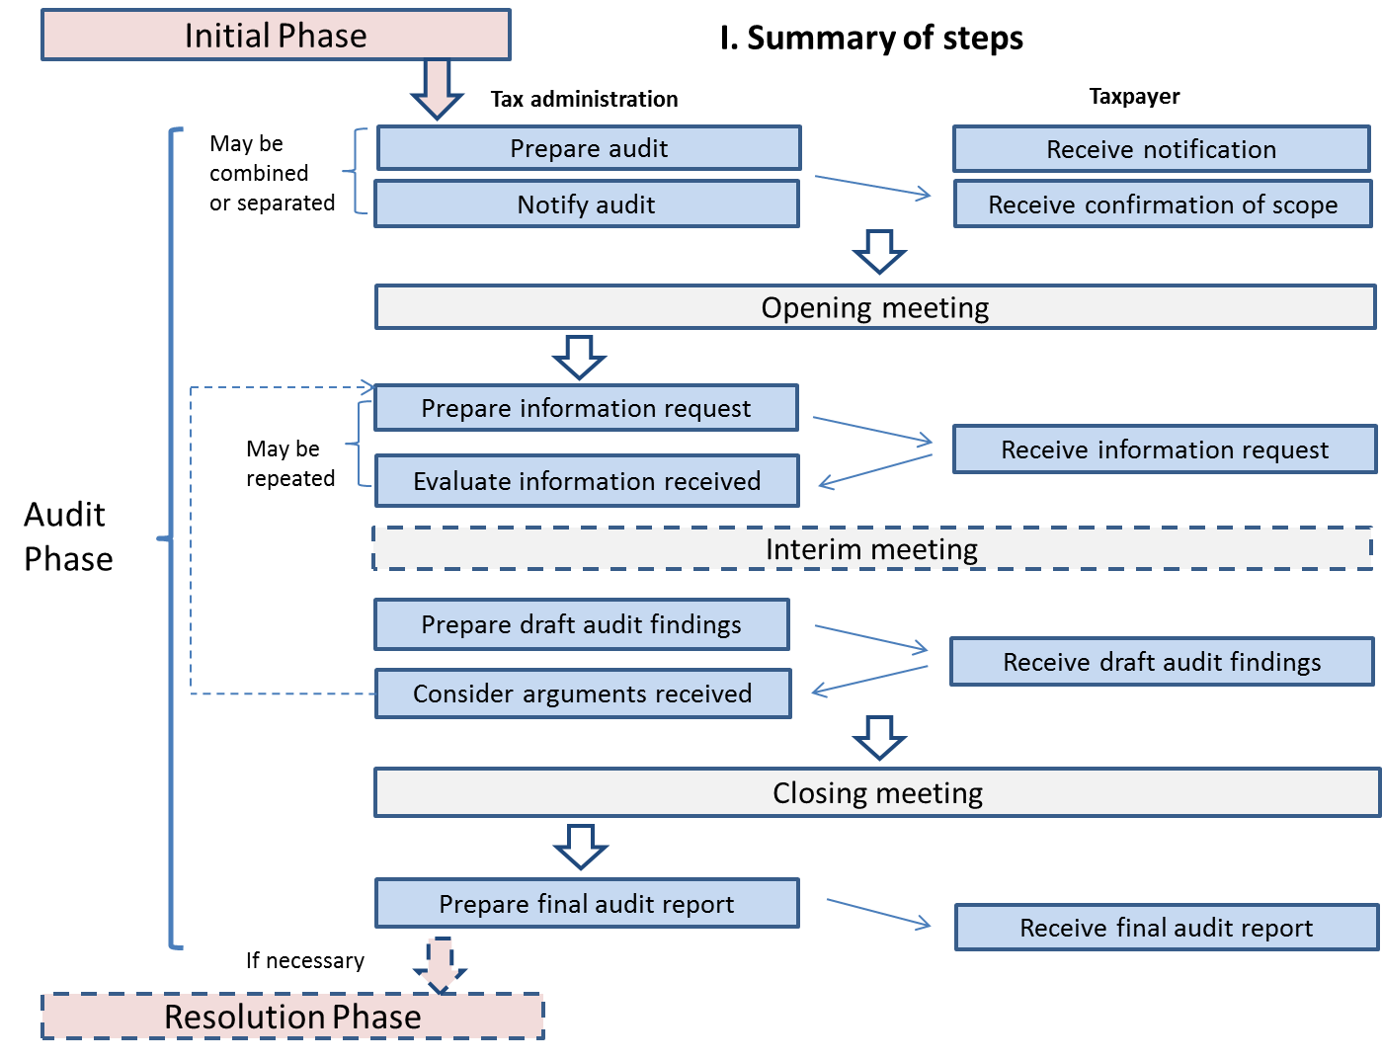
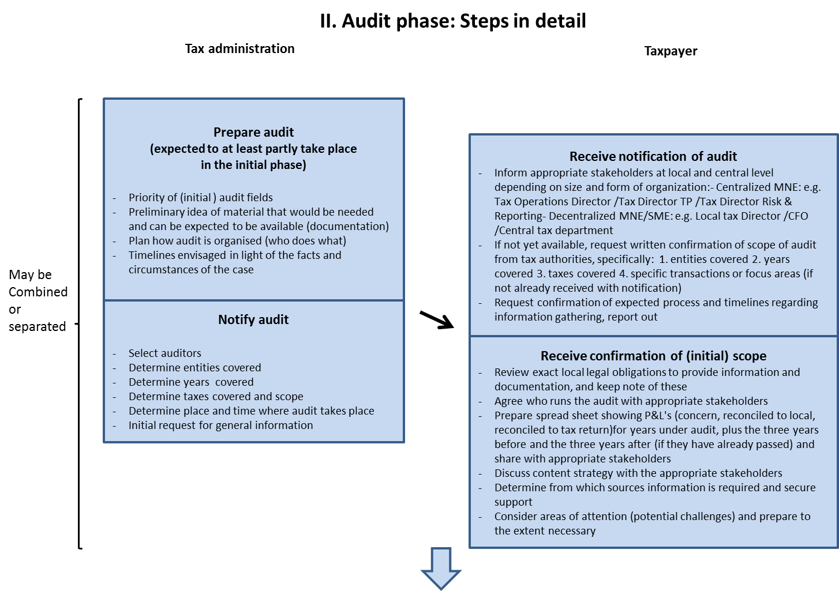
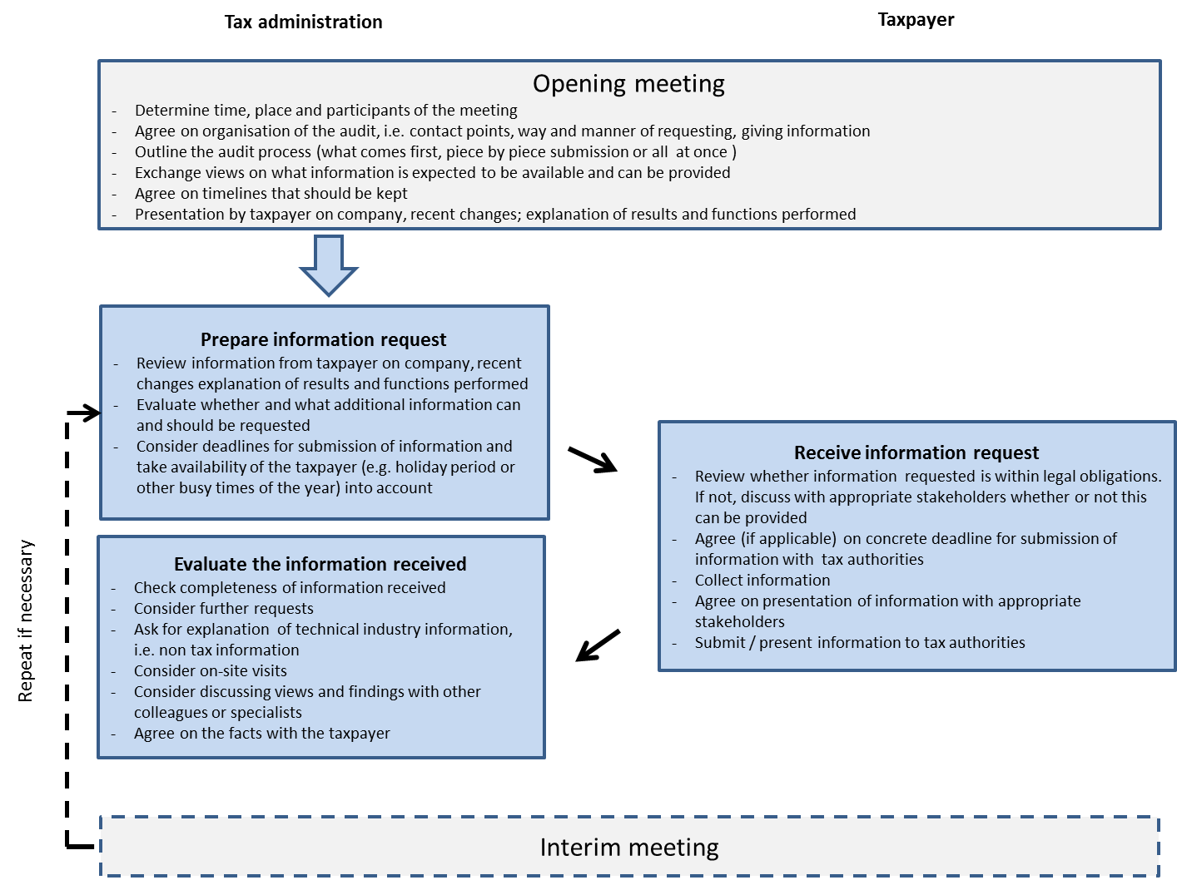
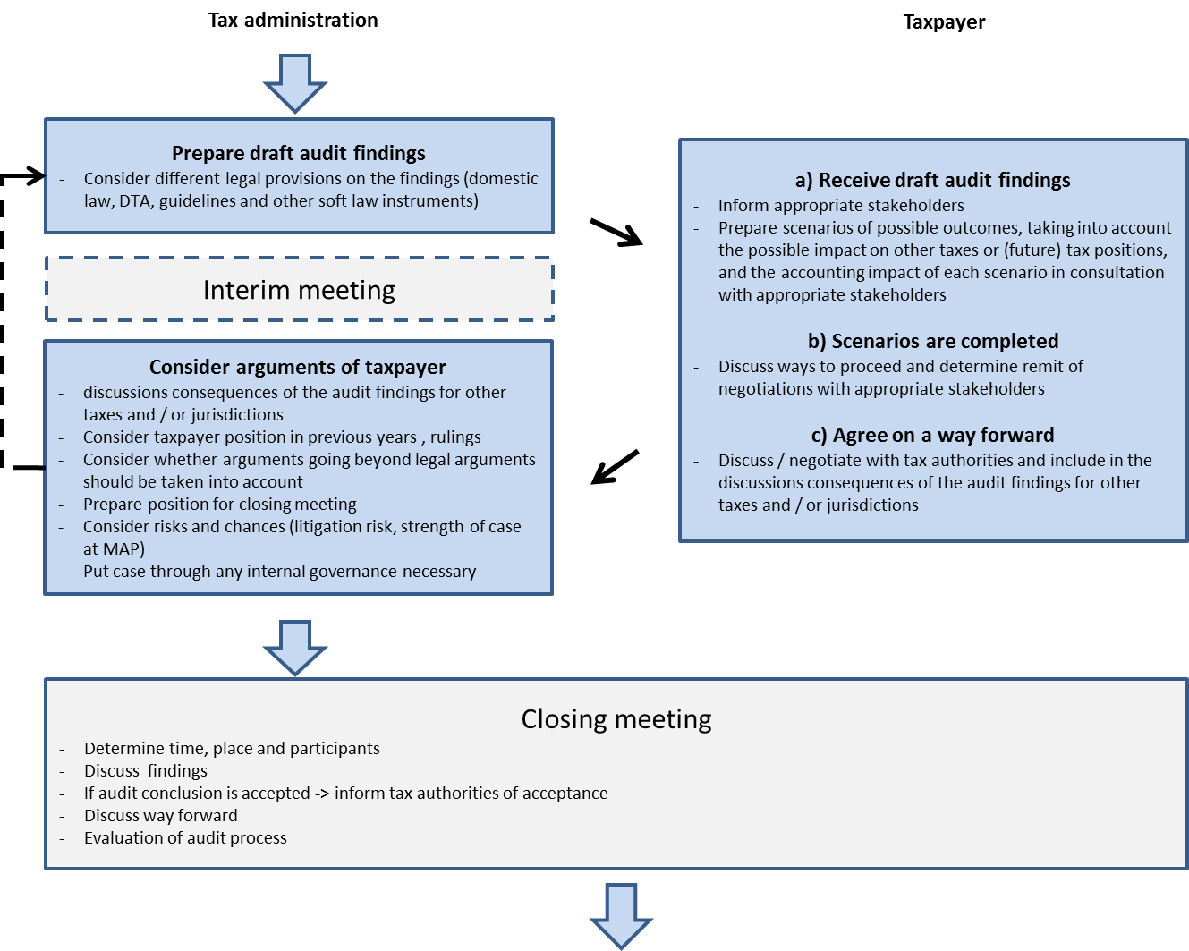
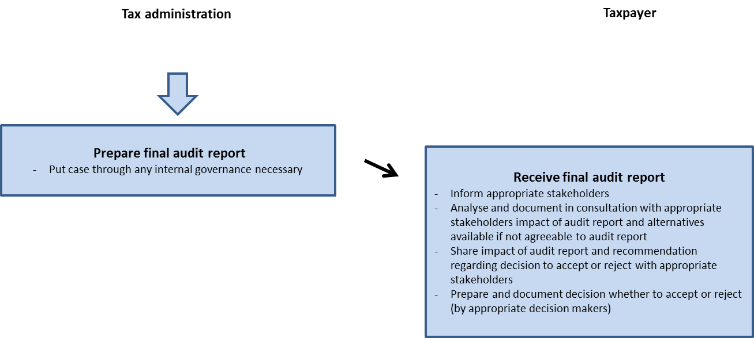
ANNEX III
REPORT ON COMPENSATING ADJUSTMENTS

1. Background
- In line with the work programme of the Joint Transfer Pricing Forum (JTPF) for 2011-2015 (doc. JTPF/016/2011/EN), Member States (MS) agreed during the JTPF meeting of 9 June 2011 that in relation to compensating adjustments it would be useful to take stock of the situation prevailing in each MS by 1 July 2011, establish an overview and evaluate whether further work might be done on this issue (doc. JTPF/015/2011/EN).
- The Secretariat prepared a questionnaire for MS' tax administrations and circulated it for input on 30 June 2011. MS' responses to the JTPF questionnaire on compensating adjustments (doc. JTPF/019/REV1/2011/EN) and further contributions by non-government members of the JTPF (doc. JTPF/006/2013/EN) and MS informed a JTPF discussion on compensating adjustments which led to the preparation of a draft report (JTPF/009/2013/EN) for the JTPF meeting in June 2013.
- The present report reflects the discussion on compensating adjustments that the JTPF had in June and November 2013. It proposes guidance for a practical solution to issues arising from the application of different approaches to compensating adjustments by MS. Price adjustments and theoretical issues remain outside the scope of this report.

2. Definition
- In the Glossary of the OECD Transfer Pricing Guidelines (TPG) the term “compensating adjustment” is defined as “an adjustment in which the taxpayer reports a transfer price for tax purposes that is, in the taxpayer's opinion, an arm's length price for a controlled transaction, even though this price differs from the amount actually charged between the associated enterprises. This adjustment would be made before the tax return is filed.”

3. Scope of this report
- MS' responses to the JTPF questionnaire on compensating adjustments (doc. JTPF/019/REV1/2011/EN) indicate that MS apply different approaches with respect to compensating adjustments. It is recognised that these differences are often grounded in a different understanding of more fundamental principles in transfer pricing, e.g. timing issues and the use of information relating to contemporaneous uncontrolled transactions, the availability of comparable data and the quality of benchmark studies created on the basis of commercial databases and what constitutes the inappropriate use of hindsight in transfer pricing.
- The guidance in this report should not be understood as indicating the JTPF's view on these more fundamental principles. Rather, the purpose of this report is to provide a practical solution for the issues described in section 4.1 below which arise from different approaches applied by MS. Moreover, the acceptance of compensating adjustments should not be understood as limiting a tax administration’s ability to make an adjustment at a later stage.
- The recommendations in this report are applicable to compensating adjustments which are made in the accounts and explained in the taxpayer’s transfer pricing documentation.

4. Compensating adjustments

4.1 General
- In general, the adjustment, at a later point of time, of transfer prices set at the time of a transaction touches upon the important theoretical issue in transfer pricing on whether
- taxpayers should be required to establish transfer pricing documentation that demonstrates that they have made reasonable efforts to comply with the arm's length principle at the time their intra-group transactions were undertaken based on information that was reasonably available to them at that moment (ex-ante or arm's length price setting approach), or whether
- taxpayers can or should test the actual outcome of their controlled transactions to demonstrate that the conditions of these transactions were consistent with the arm's length principle (ex-post or arm's length outcome testing approach).
- MS which follow the reasoning of an ex-ante approach would generally require the taxpayer to make reasonable efforts to establish the transfer prices at the time of transaction. If prices were set in a way third parties would have done and with the information reasonably available to third parties at the time of transaction, these prices and the economic result would be binding.
- MS which follow the reasoning of an ex-post approach would generally allow or even require taxpayers to test and, if necessary, to adjust their transfer prices at the end of the year, before closing the books or when filing the tax return. Following an ex-post approach may also imply that at the time of an audit the best data available (e.g. data relating to the time when the transaction was undertaken) may have to be used.
- When both MS apply an ex-post approach and require compensating adjustments, problems and even a risk of double taxation or double non-taxation may arise with respect to the following:
- The point in time when such an adjustment should/can be made (year-end, closure of books, filing of the tax return),
- The data which should be used for determining the need for an adjustment and the adjustment itself,
- Whether an adjustment can be made in both directions (upwards and downwards) and
- To which price the adjustment should be made (in case of ranges e.g. closest quartile, median etc.).
- If the transactions under review are between two related parties which are situated in two MS one of which follows an ex-ante while the other follows an ex-post approach with an obligation to reflect the adjustments in the books, a conflict arises on whether such an adjustment can be made at all.
- The guidance in the OECD TPG on those issues is currently rather limited. Both the arm's length price setting approach and the arm's length outcome-testing approach are recognised as being applied by MS and in case of dispute, the OECD refers to the Mutual Agreement Procedure (MAP).
- However, a MAP may not yet be available or may not yet provide a solution for the conflict at an early stage, e.g. at the time when the taxpayer is obliged to file his tax return.
- To address these or related practical issues, MS agree on conditions under which taxpayer-initiated compensating adjustments should be accepted for the tax return. The decision whether to oblige the taxpayer to make such an adjustment is left to the discretion of the MS.

4.2 Practical solution to compensating adjustments in the EU
- To address the practical issues arising from the situation described in section 4.1 above, MS agree that: (i) the profits of the related enterprises with respect to the commercial or financial relations between them need to be calculated symmetrically, i.e. enterprises participating in a transaction should use the same price for the respective transactions, and that (ii) a compensating adjustment initiated by the taxpayer should be accepted if the conditions listed below are fulfilled. This means that if the MS involved have less prescriptive rules on compensating adjustments, these less prescriptive rules apply; furthermore, this report does not encourage MS to introduce more conditions for compensating adjustments than currently apply. The conditions are:
- Before the relevant transaction or series of transactions, the taxpayer made reasonable efforts to achieve an arm's length outcome. This would normally be described in the transfer pricing documentation of the taxpayer.
- The taxpayer makes the adjustment symmetrically in the accounts in both MS involved.
- The taxpayer applies the same approach consistently over time.
- The taxpayer makes the adjustment before filing the tax return.
- The taxpayer is able to explain for what reasons his forecast did not match the result achieved, when it is required by internal legislation in at least one of the MS involved.
- In case the actual result is outside the range of arm's length results targeted when setting the price at the time of the transaction, the adjustment should be made to the most appropriate point in an arm's length range. In this context the guidance in paragraphs 3.55 ff. of the TPG may be helpful. Upward as well as downward adjustments should be accepted.
- Accepting an adjustment in the aforementioned manner should be regarded as a practical solution to issues arising from the application of compensating adjustments and should not be understood as indicating a MS's view on the more fundamental principles referred to in Section 3, paragraph 6 above. Further it should not be understood as limiting a tax administration's ability to make an adjustment at a later stage (e.g. in an audit) and has no bearing in a MAP procedure.

Paragraph 9 of the Commentary on Article 9 OECD MTC.
Reservation by Italy: Italy does not have internal provisions on secondary adjustments and is of the opinion that it should be primarily up to those Member States with legislation on secondary adjustments to structure these adjustments in such a way so as to minimize the possibility of double taxation as a consequence thereof. In principle, Italy will not grant relief for the withholding tax arising from the secondary adjustment made by the other Member State which led to double taxation.
Minimising the possibility of double taxation as a consequence of secondary adjustments is recommended in paragraph 4.71 of the OECD TPG.
Austria, Denmark, Germany, Luxembourg, the Netherlands, Slovenia and Spain.
Bulgaria and France.
http://www.oecd.org/document/1/0,3746,en_2649_33753_36195905_1_1_1_1,00.html
Paragraph 14, Commentary on Article 25 of the OECD MTC
EU JTPF Summary report on Penalties accompanying the communication on the work of the JTPF in the period March 2007 to March 2009 (COM(2009)472 final).
See document JTPF/016/2011/EN.
The Netherlands (JTPF meeting of 26 October 2011, Agenda Item 6), Austria and the United Kingdom (JTPF meeting of 8 March 2012, Agenda item 6 (ii)).
JTPF meeting of 26 October 2011, Agenda Item 6.
OECD FTA study "How to deal effectively with the Challenges of Transfer Pricing” (2012); OECD Handbook on Transfer Pricing Risk Assessment (2013).
The OECD has identified transfer pricing, in particular in relation to the shifting of risks and intangibles as one of the key pressure areas in the context of its project 'Base Erosion and Profit Shifting' (BEPS).
See document JTPF/001/FINAL/2011/EN.
See paragraph 19 and Recommendation 10 below.
Commission Communication (COM(2005)543) from 10 November 2005.
See e.g. Chapter 3 of the OECD FTA Study "Dealing Effectively with the Challenges of Transfer Pricing" and Chapter 4 of the OECD Draft Handbook on Transfer Pricing Risk Assessment.
See e.g Chapter 2 of the OECD FTA Study "Dealing Effectively with the Challenges of Transfer Pricing" and Chapter 4 of the OECD Draft Handbook on Transfer Pricing Risk Assessment.
See e.g. European Commission: Risk Management Guide for Tax Administrations (2006) ("2006 EC guide") http://ec.europa.eu/taxation_customs/resources/documents/taxation/tax_cooperation/gen_overview/risk_management_guide_for_tax_administrations_en.pdf and Chapter 5 of the OECD Draft Handbook on Transfer Pricing Risk Assessment.
Such approaches are for example followed in the Netherlands and the United Kingdom. Guidance is provided by the European Commission in the Compliance Risk Management Guide for Tax Administrations (2010) ("2010 EC Guide"): http://ec.europa.eu/taxation_customs/resources/documents/common/publications/info_docs/taxation/risk_managt_guide_en.pdf and Chapter 6 of the OECD Handbook on Transfer Pricing Risk Assessment.
Council Directive 2011/16/EU of 15 February 2011 on administrative cooperation in the field of taxation and repealing Directive 77/799/EEC, OJ L 64, 11.3.2011.
For further guidance see Chapter 5 of the OECD FTA study: „Dealing effectively with the Challenges of Transfer Pricing”.
See OECD Transfer Pricing Guidelines (OECD TPG), item 4.125 in the new section on safe harbours (http://www.oecd.org/ctp/transfer-pricing/Revised-Section-E-Safe-Harbours-TP-Guidelines.pdf).
Commission Communication (COM(2011) 16 final) from 25 January 2011.
Commission Communication (COM(2012) 516 final) from 19 September 2012.
Article 12 of the Directive on administrative cooperation in the field of taxation of 15 February 2011 (2011/16/EU) provides for simultaneous controls. In a simultaneous control, two or more Member States agree to conduct a control simultaneously in their own territory, of one or more persons of common or complementary interest to them, with a view to exchanging the information thus obtained. As in the context of direct taxes and transfer pricing the term "audit" is more common, this report uses the term simultaneous audit which should be understood as simultaneous control in the meaning of the directive.
Following paragraph 7 of the OECD Forum on Tax Administration's 2010 report, "a joint audit can be described as two or more countries joining together to form a single audit team to examine an issue(s) / transaction(s) of one or more related taxable persons (both legal entities and individuals) with cross-border business activities, perhaps including cross-border transactions involving related affiliated companies organized in the participating countries, and in which the countries have a common or complementary interest; where the taxpayer jointly makes presentations and shares information with the countries, and the team includes Competent Authority representatives from each country."
See Chapter 6 of the OECD FTA Study "Dealing Effectively with the Challenges of Transfer Pricing".
See Chapter 6, section on Alternative Dispute Resolution of the OECD FTA Study "Dealing Effectively with the Challenges of Transfer Pricing".
See document JTPF/020/REV1/2012/EN.
3.68 TPG
3.30 ff. TPG
3.73 TPG
3.69 TPG
3.70 TPG
4.38/4.39 TPG
3.71 TPG and 4.39 TPG

