REPORT FROM THE COMMISSION
Synthesis Report on the Quality of Drinking Water in the EU examining the Member States' reports for the period 2008-2010 under Directive 98/83/EC

Introduction
Safe drinking water is essential to our lives. It is vital for public health and an important driver of a healthy economy. The WHO concludes that by ‘improving access to safe drinking water and adequate sanitation, in addition to the health benefits through prevention of waterborne diseases, significant economic benefits may be gained’. These include healthcare savings, productive days gained per year, increased school attendance and value of life lost averted. The water industry sector also makes a significant contribution to GDP. The total estimated gross value added (GVA) of the industry covering sanitation and water supply services reached €43.84 billion in 2010 and represented that year about 500,000 full-time equivalent jobs.
The Drinking Water Directive, introduced in 1980 and revised in 1998, has led to the availability of high-quality drinking water across the EU. Joint efforts from EU institutions, Member States and service providers have resulted in high compliance rates with the drinking water standards and the Directive is therefore one of the success stories, albeit not a very well known one, of EU legislation in the field of environment and public health.
The quality of drinking water and the required level of treatment is very much related to the quality of drinking water sources. The level of protection of water resources, in particular groundwater and surface water, is thus crucial for the Drinking Water Directive as it impacts on the treatment costs.
Drinking water is also an important issue for EU citizens. This is reflected in a EUROBAROMETER survey and in the recently launched European Citizens’ Initiative Right2Water. In its reply to the initiative, the Commission announced an EU-wide public consultation on the Drinking Water Directive, notably with a view to improving access to quality water in the EU.

Drinking Water Situation
This document gives a summary of the status of implementation of the Drinking Water Directive, based on the latest data reported by Member States. Technical reports which contain detailed fact sheets per Member State will be soon available on DG Environment's website.

2.1. Water Supply
Drinking water supply in the EU is organised by supply zones, i.e. geographically defined areas within which water intended for human consumption comes from one or more sources and within which water quality may be considered as being approximately uniform. There are nearly 100,000 water supplies zones (WSZ) in the EU. The Directive makes a distinction between large and small supplies. Minimum water quality requirements are equal for both large and small supplies. However, monitoring requirements differ and Member States do not need to report on the small supplies. About 65 million people are served by small water suppliers.
'Supply' in the sense of the Directive does not mean 'access' to the public water supply network. Eurostat has collected data about the "population connected to public water supply, see table 1 at the end of the report. Due to the voluntary nature of the reporting, this collection shows data gaps and does not allow calculating EU totals/averages.

Sources of Raw Water
In the EU, water supply is mainly fed by groundwater and by surface water, including artificial reservoirs. Water sources vary considerably between Member States. Overviews have been provided in earlier reports, and are collected by Eurostat. There are significant differences in the percentage between large and small supplies with much higher rates of groundwater sources for small supplies (84%).
Groundwater contamination, in particular by substances difficult to detect like pesticides, and surface water contamination, increasingly influenced by climate change (floods, extreme rainfalls, rain overflow) can pose problems that are passed on to drinking water. A coordinated monitoring of groundwater and drinking water, along with putting in place climate change adaptation and mitigation measures would be beneficial for safe drinking water.

2.2. Drinking Water Quality
In order to ensure that drinking water is safe for human consumption, the Drinking Water Directive sets out minimum water quality requirements. It identifies microbiological and chemical parameters that could pose a risk to human health when concentrations exceed certain thresholds. For each of the parameters, the Directive sets maximum concentration values that must be complied with. In addition to the microbiological and chemical parameters, the Directive identifies indicator parameters for the purpose of indicating a possible risk for human health and which requires remedial action only if further investigation confirms the human health risk.
Reported data on these parameters show that drinking water quality in the EU is in general very good. The overall trend is also positive. For the large supplies, the vast majority of Member States show compliance rates for microbiological and chemical parameters of between 99% and 100%. For the few Member States showing compliance rates lower than 99%, reinforced action will be required to ensure that all citizens served by the large supplies concerned can safely use drinking water.
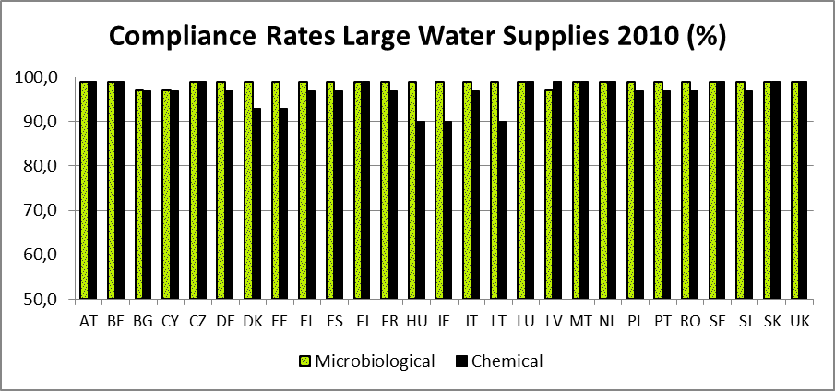Figure 1: Summary overview - compliance rates microbiological and chemical parameters in Member States
Detailed figures can be found in table 1 at the end of the report.
As regards the small water supplies, the picture is more divergent. Lower compliance levels are noted for the microbiological parameters, with only three Member States achieving compliance rates between 99% and 100%. A breakdown of compliance rates for microbiological parameters shows that the compliance for small supplies is significantly lower than for large supplies.
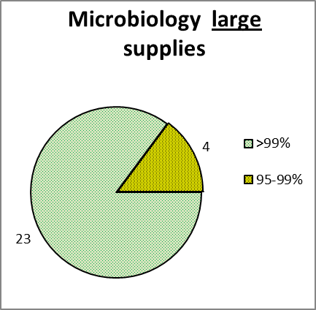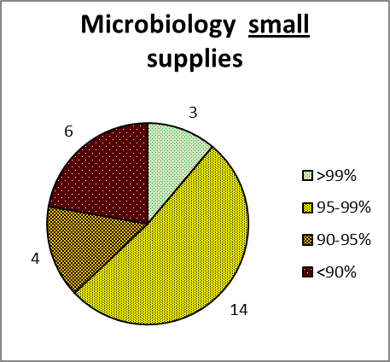
Figure 2: Compliance Rate Microbiology, Number of Member States
For the chemical parameters for small supplies, similar high compliance levels are noted as for the big supplies. In some supply zones, problems were reported in relation to nitrate, nitrite, arsenic, and to a lesser extent, boron and fluoride. For example, in 2010 more than 1000 small supplies with nitrate concentrations exceeding the prescribed levels were identified (see table 1 at the end of the report). The compliance rates for indicator parameters show that in general the performance of small supplies was lower than that of large supplies.
The assessment of reported data on the small supplies showed that some Member States are struggling to manage small supplies in a safe way. This could potentially affect between 11.5 and 15.5 million people. However, more information and a detailed assessment on the way these small supplies are managed would be required to estimate any concrete risk for human health for the citizens concerned.
Concerns in relation to small water supplies have also been recognised by the 7th Environmental Action Programme (7th EAP), which calls for increased efforts in the implementation of the Directive in particular for small drinking water supplies.
As a first step, the Commission, in close cooperation with Member States, has elaborated a "Framework for Action" document setting out best practices for conducting risk-assessments for small water supplies that will soon be available on DG Environment’s website. As millions of EU citizens are concerned, further efforts should be pursued to improve the supply with high-quality water in particular in remote and rural areas.
Data from Member States show that in cases of incidents and failures to meet the quality standards, in general remedial action is taken by Member States within an appropriate response time. In relation to the microbiological parameters, measures entailed improving the treatment and cleaning of the contaminated components of the public distribution system. For chemical parameters, failures were addressed through better agricultural practice, conditioning or treatment of the water, change of the source water, and providing information to the public.

2.3. Monitoring and Information
The Directive requires Member States to ensure that regular monitoring of the quality of water intended for human consumption is carried out. However, monitoring approaches differ between Member States and even between different water supply zones within individual Member States, resulting in different levels and availability of monitoring data. This does not necessarily amount to a failure in meeting the legal requirements as the Directive allows for adapted monitoring programmes depending on the specific characteristics of the water supply zone. The analysis suggests, however, the need to review and better streamline the current monitoring approaches, considering in particular the WHO's risk assessment and risk management water safety plan approach.
To address Member States’ monitoring and performance, the Commission is working on a so called "Structured Implementation and Information Framework" (SIIF), establishing systems at national level which actively disseminate information about how EU environment legislation is being implemented. This information is then brought together to provide an EU-wide overview. The Directive's requirement that up-to-date information on drinking water quality is made available to consumers could also be linked to such an information framework and be improved in this context. Drinking water data could also be more clearly linked to the Water Information System for Europe (WISE) which comprises a wide range of data and information collected by the EU institutions.

2.4. Derogations
The Directive allows derogations from the drinking water quality standards under very strict conditions and limited in time. Such derogations may not constitute a potential danger for human health and may only be established if the supply of drinking water in the area concerned cannot otherwise be maintained by any other reasonable means. A derogation may not exceed a period of three years. However, where a Member State considers that a longer derogation period is required, it may grant a second derogation for a maximum period of three years and it must communicate the grounds for this decision to the Commission. In exceptional cases, a Member State may request a third derogation from the Commission. The Commission will in this case carefully assess the request and may either refuse the request or grant the derogation for a maximum period of three years.
The Commission has so far granted a number of third three-year derogations to the Czech Republic, Italy, Hungary and Germany, referring mainly to the parameters of nitrate and nitrite, fluoride, boron, arsenic and nickel. It has refused one request for a derogation, from Estonia. Further information is available on DG Environment’s webpage. The Commission is looking into appropriate ways of ensuring the correct implementation of related decisions.
Derogations and other possible exemptions in exceptional circumstances could jeopardize a consistent EU-wide implementation of the Directive if not applied prudently. The Commission considers that the current derogation regime provided Member States with sufficient time to ensure that drinking water quality standards are met. The Commission considers that no new derogations to the drinking water quality standards should be granted for existing water supplies with the exception of situations of new unforeseen pollution sources or following the introduction of standards for new parameters or reinforced drinking water quality standards of existing parameters. For new supplies, derogations could be considered under strict conditions if the pollution sources can be remediated within an acceptable timeframe and in case no alternative to the new supply is possible.

2.5. Challenges
EU policy on drinking water has led to the development of high drinking water quality across the EU over the past decades. However, in order to keep these high quality standards and address specific remaining challenges, there may be a need to further adapt the EU legal framework.
The nature of small water supplies differs significantly from large water supplies. They are small in scale and often located in rural and remote areas, requiring management approaches taking into account the specific situations in these areas. The current Drinking Water Directive focuses mainly on the large supplies. Adding specific provisions for small supplies, including a reporting obligation, would help to ensure efficient, risk-based management of small supplies and allow better mapping of drinking water quality in small supply zones. This would contribute to increasing access to safe drinking water, particularly in remote areas, and increased availability of information for the public and stakeholders on drinking water quality.
The current parameter list and corresponding parametric values as well as monitoring and analysis requirements may need to be adapted in light of the risks related to emerging pollutants and scientific and technological progress. There may be a need to extend this list to new emerging pollutants such as certain products used in agriculture or industry, including pharmaceuticals. Monitoring methodologies and specifications for the analysis of parameters should consider the latest methods and techniques, including risk-based approaches, to allow quality control in the most efficient and cost effective way, both as regards treatment processes in the treatment facility and the distribution network up to and including the tap. The EU framework should be assessed against updated WHO guidelines on this matter. Specific action may be required as well to reduce leakages in the distribution networks. In about half of the Member States, more than 20% of clean drinking water is lost in the distribution network before it reaches consumers’ taps, while for some Member States the proportion is as high as 60%.
It is important for the public to have access to information on drinking water quality. While often provided on national websites, it is frequently not up to date and is difficult to understand. The majority of Member States do not use comprehensive maps or other public supports. The current set-up for reporting does not provide the Commission with adequate and timely information to perform a thorough synthesis of drinking water quality developments in the European Union. This makes it difficult to provide the Council, European Parliament and the public with updated EU-wide information on drinking water policy and quality on a regular basis. In addition, the way data are collected, processed and reported differs across the EU, which makes it difficult to compare situations in different Member States with regard to their performance and compliance with the Directive. A revised or new reporting concept could facilitate transparent data dissemination and management at both national and EU level. Also, benchmarking drinking water quality could allow easier interpretation and visualisation of water quality data across the EU and better comparison of water quality and trends between Member States.

Conclusions
The analysis confirms that the Drinking Water Directive contributed to high quality drinking water across the EU, as demonstrated by the high compliance levels with the drinking water quality standards.
Although enforcement is satisfactory and progress has been made in many areas, the following issues and challenges have been identified:
- The supply of high-quality water, in particular in remote and rural areas, should be improved. Small water supplies in these areas require specific risk-based management approaches and the role of the Drinking Water Directive in this context should be explored.
- Risk-based approaches to the management of big water supplies would allow for more cost effective monitoring and parameter analysis in relation to identified risks and provide better guarantees for the protection of human health. Methodologies for monitoring and analysis should reflect the latest scientific and technological developments.
- New scientific information about chemical and other parameters in relation to the drinking water parameter list should be considered in line with the ongoing revision of the WHO drinking-water guidelines, including emerging pollutants.
- Modern information technology and easier access to environmental information should be used to provide more up-to-date information for consumers, and to explore how to link different monitoring data with reporting and consumer information.
- Implementation timescales and derogation mechanisms are out- of-date and would benefit from a general update and overhaul.

An EU-wide public consultation will be a first step towards a further in-depth assessment of the above mentioned challenges and how they could be best addressed. It may also identify additional issues to be tackled in order to ensure and further improve high drinking water quality standards across the EU.

Fact Sheet – Implementation of the Drinking Water Directive (98/83/EC) in 2010

Number of Water Supply Zones
- 96,388 water supplies zones in the EU, covering a population of approximately 474 million people
- 11,233 large water supplies serving 317 million people
- 85,559 small water supplies serving 65 million people (based on voluntary survey)

Drinking Water Quality – Large Supplies
For this report, full compliance with the parametric values was considered if more than 99% of the analyses were in compliance.
Microbiological parameters
All Member States' large supplies have compliance rates of over 95%, and 23 Member States reached full compliance (99-100%). Only BG, CY, HU and LV did not meet these high levels.
Chemical parameters
Compliance rates were high, but slightly lower than those for the microbiological parameters. All Member States reported compliance rates above 90% except for 3 Member States – HU (parameter arsenic), IE (parameter trihalomethane) and LT (parameter fluoride).
Indicator parameters
Seven Member States achieved maximum performance rates (99-100%), while in ten Member States they were above 95%. The remaining 10 Member States achieved performance rates of between 90% and 95%. DK (Coliform bacteria), HU (ammonium), LV (sulphate) and MT (chloride and sodium) had for these parameters rates below 90%.

Drinking Water Quality – Small supplies
Microbiological parameters
Levels of compliance were lower than for large water supplies, with compliance rates over 99% reported only for 3 Member States (EE, MT, SE). Sample compliance of 95-99% was found for 14 Member States, of 90-95% for 4 Member States (BG, CY, IT, UK), and below 90% for 6 Member States (DK, EL, LT, PL, RO, SI).
Chemical parameters
The compliance of small supplies was similar to large supplies.
Indicator parameters
Possible underperformance was due to coliform bacteria, clostridium perfringens, iron, manganese, ammonia and pH. Many Member States were able to achieve performance rate of above 95%; however, there were significant problems in some Member States.

Table 1: Overview data per Member State (WSZ = Water Supply Zone)
MS | Nr. of Large WSZ | Nr. of  Small WSZ | Population connected to public water supply (year) Source Eurostat | Microbiology  Sample compliance % |  | Chemicals
 |  |  |  | Large  (figure 1) | Small | Large: Sample Compliance %  (figure 1, (x) In figure 1 set to = 90% | Small:  Example: Nitrate, Nr of non-compliant WSZ
AT | 260 | 4570 | 95,05 (2008) | 99-100% | 95-99% | 99-100% | 20
BE | 225 | 522 | 99,9 (2009) | 99-100% | 95-99% | 99-100% | 3
BG | 196 | 2226 | 99,2 (2011) | 95-99% | 90-95% | 95-99% | 349
CY | 20 | 268 | 100 (2011) | 95-99% | 90-95% | 95-99% | 1
CZ | 283 | 3870 | 93,5 (2010) | 99-100% | 95-99% | 99-100% | ?
DE | 2283 | 5873 | 99,3 (2010) | 99-100% | 95-99% | 95-99% | 12
DK | 252 | 2071 | 97 (2002) | 99-100% | < 90% | 90-95% | 4
EE | 25 | 1115 | 80 (2009) | 99-100% | 99-100% | 90-95% | -
EL | 177 | 713 | 94 (2007) | 99-100% | < 90% | 95-99% | 20
ES | 928 | 7907 | 100 (2010) | 99-100% | 95-99% | 95-99% | -
FI | 158 | 697 | 91 (2011) | 99-100% | 95-99% | 99-100%
FR | 2487 | 18363 | 99,4 (2001) | 99-100% | 95-99% | 95-99% | 381
HU | 275 | 2731 | 100 (2011) | 95-99% | 95-99% | < 90% (x) | 10
IE | 241 | 1920 | 85 (2007) | 99-100% | 95-99% | < 90% (x) | 9
IT | 1046 | 3977 | - | 99-100% | 90-95% | 95-99% | 6
LT | 65 | 1734 | 75 (2011) | 99-100% | < 90% | < 90% (x) | 1
LU | 43 | 154 | 99,9 (2011) | 99-100% | 95-99% | 99-100% | 1
LV | 29 | 1145 | - | 95-99% | 95-99% | 99-100%
MT | 12 | 7 | 100 (2011) | 99-100% | 99-100% | 99-100%
NL | 209 | 250 | 100 (2010) | 99-100% | 95-99% | 99-100% | -
PL | 970 | 8839 | 87,6 (2011) | 99-100% | < 90% | 95-99% | -
PT | 362 | 3176 | 96,9 (2009) | 99-100% | 95-99% | 95-99% | 28
RO | 310 | 5398 | 56,5 (2011) | 99-100% | < 90% | 95-99% | 133
SE | 182 | 1486 | 87 (2010) | 99-100% | 99-100% | 99-100% | -
SI | 78 | 899 | - | 99-100% | < 90% | 95-99% | 4
SK | 95 | 957 | 86,9 (2011) | 99-100% | 95-99% | 99-100% | 11
UK | 22 | 4691 | - | 99-100% | 90-95% | 99-100% | 109

http://www.who.int/water_sanitation_health/wsh0404summary/en/
EUROSTAT (2013)
Directive 98/83/EC, OJ L 330, 5.12.1998
http://ec.europa.eu/public_opinion/flash/fl_344_en.pdf
Communication in response to the European citizens' initiative (ECI) "Water and Sanitation are a human right! Water is a public good not a commodity!" COM (2014)177 of 19.03.2014: http://ec.europa.eu/citizens-initiative/public/initiatives/finalised/answered
Council Directive 98/83/EC of 3 November 1998 on the quality of water intended for human consumption, OJ L 330, 5.12.1998, p. 32
Reported data in accordance with Article 13 of the Drinking Water Directive for the reference period 2008-2010 and voluntary reported data on small water supply for which no reporting is required by the Directive.
http://ec.europa.eu/environment/water/water-drink/reporting_en.html; https://circabc.europa.eu/faces/jsp/extension/wai/navigation/container.jsp
Large WSZ are individual supplies of water exceeding 1 000 m3 a day as an average or serving more than 5000 persons; small WSZ are those below 1 000 m3 or less than 5000 persons
The Treaty, Article 345 TFEU, obliges the EU to remain neutral in relation to the ownership regime for water. Therefore the aspect of the physical right to 'access' water is not addressed here.
http://appsso.eurostat.ec.europa.eu/nui/show.do?dataset=env_wat_pop&lang=en
https://circabc.europa.eu/sd/a/b580866d-8eb7-4937-9a97-d3d3485d046e/2005-2007%20SynthesisReport.pdf
http://epp.eurostat.ec.europa.eu/statistics_explained/index.php/Water_statistics
Decision 1386/2013 of the European Parliament and Council
http://ec.europa.eu/environment/water/water-drink/small_supplies_en.html
http://www.euro.who.int/en/health-topics/environment-and-health/water-and-sanitation/country-work/ensuring-drinking-water-safety-through-water-safety-plans
http://ec.europa.eu/environment/water/water-drink/derogations_en.html, and on CIRCABC
A margin of error of 1% is acceptable due to the level of uncertainties and incidents (e.g. sampling or analytical errors) that occur; compliance rates are furthermore given in ranges because they are mostly time-limited exceedances. The results are not entirely comparable because of differences in sampling and monitoring methods and the lack of standardised approaches, but the data give a good overview of the situation across the EU.
In relation to chemical parameter trihalomethane total, the Directive provided up to December 2008 a derogation from the threshold listed in Annex I, Part B (up to 150 microgrammes/l from 100 microgrammes/l).

