REPORT FROM THE COMMISSION TO THE COUNCIL AND THE EUROPEAN PARLIAMENT
Fourth report on monitoring development of the rail market
TABLE OF CONTENTS
1. Evolution of internal market in rail services 4
1.1. The objectives of the White Paper on Transport (2011) 4
1.2. The passenger rail market today 5
1.3. Evolution of the passenger rail market 8
1.4. The rail freight market today 9
1.5. Evolution of the rail freight market 9
2. Evolution of the internal market in services to be supplied to railway undertakings 11
2.1. Stations 11
2.1.1. Stations across the European Union 11
2.1.2. Ownership and management 12
2.1.3. Access to station facilities by railway undertakings 14
2.1.4. Quality of services in stations (including accessibility by persons of reduced mobility) 14
2.2. Freight terminals, marshalling yards and storage facilities 16
2.3. Maintenance facilities 18
2.4. Other facilities: port access, relief and refuelling facilities 19
3. Framework conditions 20
3.1. Infrastructure charging 20
3.1.1. Infrastructure charges for freight services 20
3.1.2. Infrastructure charges for intercity services 21
3.1.3. Infrastructure charges for suburban services 23
3.1.4. Infrastructure charges – overall rankings 23
3.2. Capacity allocation 24
3.3. Investments made in infrastructure 27
3.4. Developments as regards prices 28
The annexes of this report are found in SWD(2014) 186
INTRODUCTION
According to Article 15 (4) of Directive 2012/34 of the European Parliament and of the Council of 21 November 2012 establishing a single European railway area (Recast), the Commission has to report every two years to the European Parliament and the Council on:
- The evolution of internal market in rail services; and
- services to be supplied to railway undertakings (Annex II to Directive 2012/34/EU)
- The framework conditions
- The state of the Union railway network
- The utilisation of access rights
- Barriers to more effective rail services
- Infrastructure limitations
- The need for legislation
According to Article 15 (3) of Directive 2012/34/EU, the Commission has to monitor the “use of the networks” and the “evolution of framework conditions in the rail sector”, in particular in respect of:
- Infrastructure charging
- Capacity allocation
- Investments made in infrastructure
- Developments as regards prices
- Quality of rail transport services
- Rail transport services covered by public service contracts
- Licensing
- Degree of market opening
- Harmonisation between Member States
- Development of employment and related social conditions
Directive 2012/34/EU has broadened the scope of the Commission's regular reporting as compared to the previous Directive which now includes the evolution of the internal market of service facilities and framework conditions such as investments in infrastructure, price developments, service quality, public service obligations and the development of employment and related social conditions and that are presented for the first time in the Rail Market Monitoring Scheme (RMMS) report. The Commission's earlier reporting and monitoring obligations were covered under Directive 91/440 as amended by Directives 2001/12 and 2004/51 and implemented under Regulation 91/2003 on rail statistics.
This report is the fourth report on the development of the rail market and is accompanied by a staff working document SWD(2014) 186] providing all the annexes containing most of the data supporting the assessments. The previous reports were published in 2007, 2009 and 2012 and were systematically accompanied by staff working documents containing the statistical annexes.
Data for this report has been collected mostly from the Member States through questionnaires ('RMMS questionnaires' sent in 2011 and 2012) and Eurostat, but has been completed by other sources such as a Eurobarometer survey (service quality), publicly available railway fare information, annual financial reports, data for the State aid scoreboard or data provided by specific stakeholders (e.g. UIC, UNIFE…). Data collection in some of the recently added areas such as the internal market for rail services is still being discussed in the context of the RMMS implementing act – as a result, reporting in such areas is still fragmentary.

1. Evolution of internal market in rail services

1.1. The objectives of the White Paper on Transport (2011)
The White Paper on Transport (2011) recommends that:
- 30% of the increase of freight transport on land over 300 km should be carried by rail or waterborne transport by 2030;
- 50% of road freight over 300 km should shift to rail or waterborne transport by 2050;
- The majority of medium-distance passenger transport should go by rail by 2050.
BOX 1 – MEASUREMENT UNITS IN RAIL TRANSPORT
Passenger transport is mostly measured in passenger(s) x km which are called passenger-km or p-km. Train-km refers to the distance actually run by the train.
A train from Paris-Brussels transporting 500 passengers over 300 km will generate 150.000 passenger-km and 300 train-km.
Freight transport uses tonnes x km which are called tonnes-km or t-km.

1.2. The passenger rail market today
Based on a Flash Eurobarometer survey conducted in 2013 with some 28.000 respondents aged more than 15 years, only 12% of Europeans are regular users of trains (14% for suburban trains): 6% of Europeans take the train at least once a week and 6% of them take the train “several times per month” but 32% of them never take the train, although 83% of Europeans live within 30 minutes of a train station (cf. graph 14bis).
Graph 1- Frequency of rail use – national, regional and international trains - 2013
Source: Flash Eurobarometer 382a on Europeans' satisfaction with rail services – Annex 2 of Staff Working Document SWD(2014) 186
It is interesting to note that suburban rail use is much more polarised between a group of heavy users (14%) and non-users (53%) than conventional trains. The group of heavy users is mostly composed of youngsters and young commuters, whereas the group of non-users is mostly composed of respondents above 55+ (39% have never used a suburban train).
Graph 2- Frequency of rail use – suburban trains - 2013
Source: Flash Eurobarometer 382a on Europeans' satisfaction with rail services – Annex 2 of Staff Working Document SWD(2014) 186

Rail services are to a very large extent domestic services, which represent 94% of all EU passenger-km. International services only represent 6% of all passenger-km, but are important in Luxembourg (30%), Austria (15%), Belgium (13%), France and Latvia (both 11%).
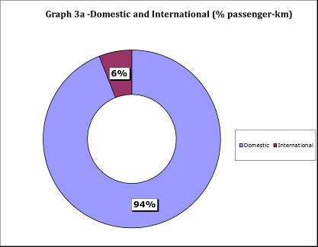
Source: Eurostat
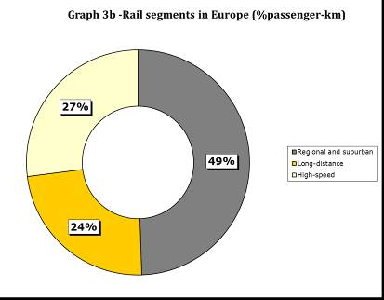
Source: Member States questionnaires, estimations based on annual reports, UIC and Steer Davies Gleave (Study on 4th railway package); data for EU and EEA (including Norway) are identical, – Annex 5a of Staff Working Document SWD(2014) 186
In terms of market segments, half of European railway journeys can be assimilated to regional and suburban services and half relate to long-distance/intercity or high-speed services (27% of all pass-km in 2011). There are important variations across Member States: the UK is, for instance, mostly a commuter market whereas France, thanks to the TGV, is mostly a long-distance market.
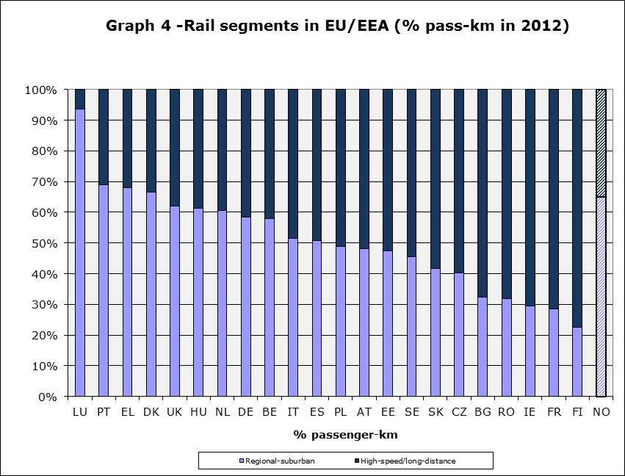
Source: RMMS questionnaires, as well as estimations (sources: UIC datasets, Amadeus, annual reports of CP, FS and RENFE, White Paper on Transport assumptions) – no data available for Lithuania, Latvia and Estonia
High-speed trains almost exclusively dominate the long-distance market in some Member States: in 2011, in France and Spain respectively, 58% and 49% of total passenger-km were travelled in high-speed trains.
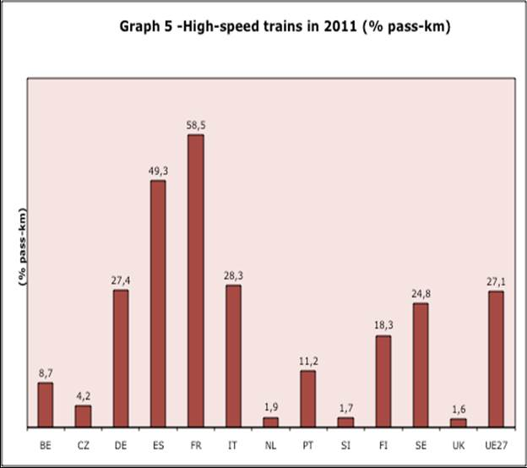
Source: EU transport in figures, Statistical pocketbook 2013, quoting UIC, – Annex 5b of Staff Working Document SWD(2014) 186 – In this graph, high-speed rail transport covers all traffic with high-speed rolling stock (incl. tilting trains able to run 200 km/h). This does not necessarily require high-speed infrastructure.
BOX 2 – RAIL MARKET SEGMENTS
High-speed train services (e.g. TGV, ICE…) and long-distance conventional train services (e.g. Intercity), which often (but not always) require seat reservation, compete mostly against air transport and, to some extent, cars and coaches. High-speed trains operate (almost always) in dedicated infrastructure – since 1990, high-speed tracks kilometres have increased 6-fold (from 1024 km to 6872 km in 2009) – and generally only stop in sizeable urban agglomerations.
Medium-distance/regional train services (e.g. Inter-Regio) and suburban/commuter train services (e.g. RER, S-Bahn, Cercanias…) compete mostly with cars and have free seating. Suburban/commuter train services are often interconnected with metro networks. These services operate almost exclusively with subsidies and public service contracts and call at a high number of stations. Suburban services require very often intensive-frequencies railway operations (e.g. a train very 5-15 minutes).

1.3. Evolution of the passenger rail market
As shown in graph 6, the modal share of rail has been increasing since 2003.
However, despite some progress, the share of rail travel journeys in the EU remains modest compared to other transport modes like car and air. The modal share of rail in 2011 has remained stable at 6,2% compared to 2010.
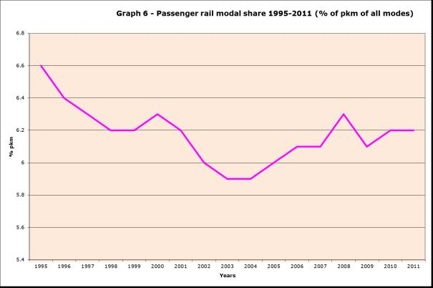
Source: Eurostat – Annex 3 of Staff Working Document SWD(2014) 186 – Data for 2012 is not yet available
Since 1995, rail travel has grown most compared to other modes in the United Kingdom (+70%), Sweden (+42%), France (+37%) and Belgium (+26%). On the other hand, it has decreased by more than 60% in Greece, Poland, Bulgaria, Romania, Estonia and Lithuania (-90%). Overall, the passenger rail modal share has grown by 16% in the EU15 since 1995 (no data is available for EU25) and by 3% in the EU25 since 2000.
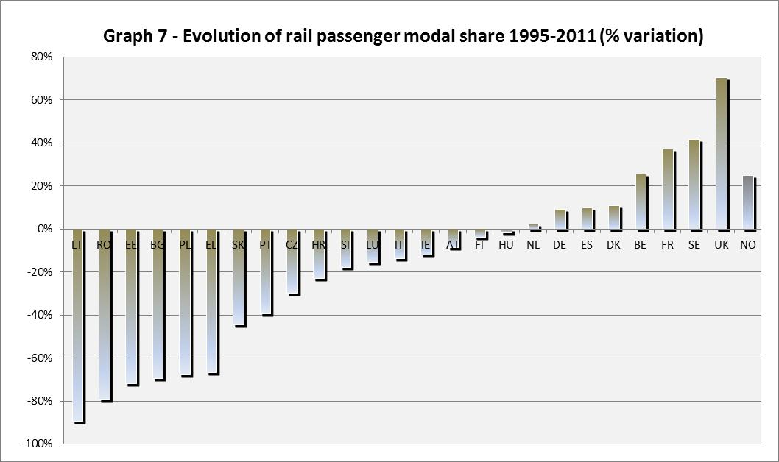
Source: Eurostat
As shown in graph 8 below, domestic rail passenger services, which represented 94% of all passenger traffic in 2011, has grown most in Denmark (+15%), Lithuania (+12%), Luxembourg and UK (+9%) since 2010. Member States like Austria, Italy and Czech Republic, where there is now competition on domestic long-distance lines, have also experienced robust growth (6-8% growth). After years of decreasing rail traffic, Lithuania and Italy have been able to revert to growth. The decline of railways in several Member States of South-East Europe resulted from budget restrictions on public service compensations (-38% in Croatia and Greece).
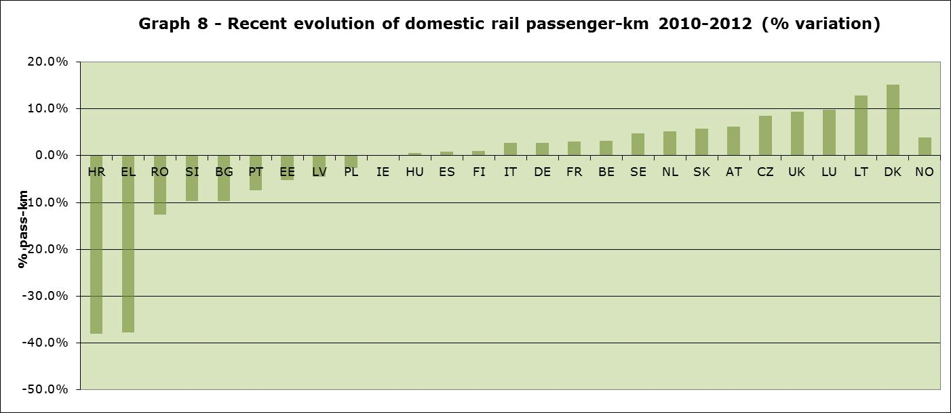Source: Eurostat, Member States’ RMMS questionnaires
The European domestic rail passenger market is evolving in several Member States. There are now one or more new entrant unaffiliated railway undertakings competing on the long distance Vienna-Salzburg, Naples-Rome-Milan/Venice/Turin and Prague-Ostrava lines. In the Rome-Milan route, the transport share of rail has grown from 36% in 2008 to 66% in 2012. In these lines, incumbent railway undertakings have experienced an increase of traffic (+10% for the Italian incumbent).
International rail services, which represented 6% of rail passenger traffic in 2012, have continued their growth (+25% in the period 2004-2011) by growing some 2% in 2011 and some 13% in 2012. Between 2010 and 2012, international rail traffic has grown most in Finland (+42%) thanks notably to the introduction of high-speed services between Helsinki and St-Petersburg. Growth has been impressive in several Central and Eastern European Member States and also in Germany (+23%), France (+20%) and Italy (+13%), where the new entrant Thello has opened night services between Paris and Venice. High-speed services across the Channel have continued to grow (+5% of international rail traffic in the UK).
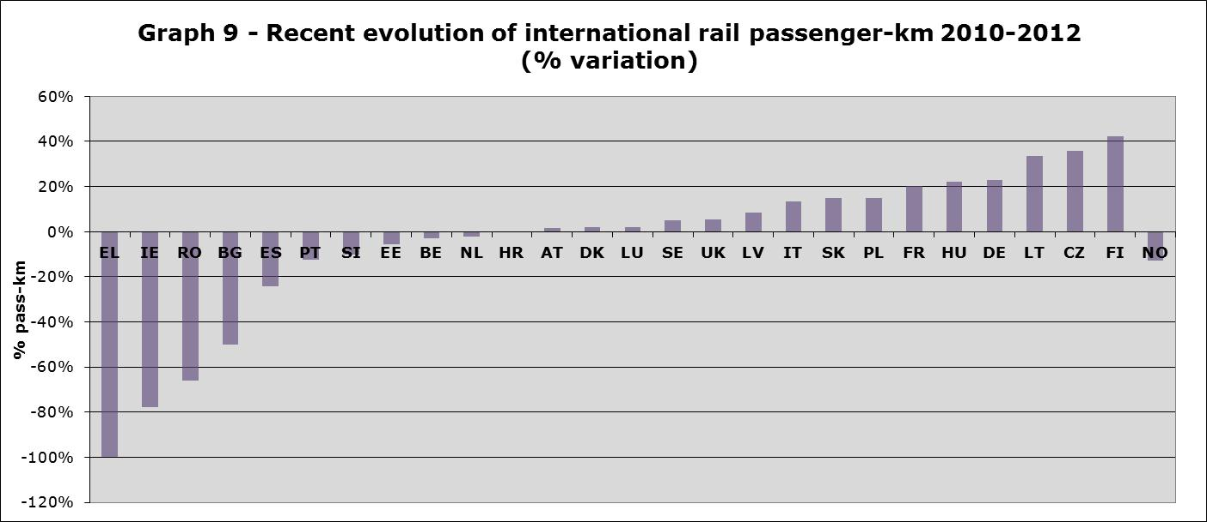
Source: Eurostat, Member States’ RMMS questionnaires
There are signs however that international passenger traffic is stagnating in important international rail markets like Belgium and the Netherlands, although several companies have started administrative proceedings or expressed their interest to operate rail services on the London/Paris-Brussels-Köln/Amsterdam axes. Finally, rail international services in crisis-hit Member States have taken a toll. TrainOSE, the Greek incumbent, has halted all international services, while cross-border passenger services have nosedived in Ireland (-78%), Croatia (-75%), Romania (-66%), Bulgaria (-50%), Spain (-24%), Portugal (-13%) and Slovenia (-10%). This could be a sign that subsidised public service conventional trains operating over very long-distances are not competitive vis-à-vis other modes, in particular low-cost airlines– the same seems to have taken place in Italy in the early 2000.

1.4. The rail freight market today
Unlike passenger rail, rail freight is far more international: some 47% of all tonne-km in the EU were international in 2011 (out of which 9% of all tonne-km relate to transit). In Belgium, the Netherlands and in the Baltic States, more than 70% of rail freight is international (originating in Germany and Russia), however, in the UK, only 2% of rail freight is international. In Germany, France and Italy, the other 3 major economies of the EU these percentages reach respectively 39%, 19% and 50%. Finally, some 85% of the Danish rail freight traffic is only in transit.
It is also important to underline that Germany and its rail infrastructure play a central role in rail freight, representing alone 27% of all EU tonne-km, leaving far behind even the second major European rail freight market, Poland (12%). Germany is also at the very heart of the EU rail network: it is by far the most transited Member State (28% of all transiting tonnes-km) together with Austria (13% of transiting tonnes-km).

1.5. Evolution of the rail freight market
The share of rail freight among all modes has remained stable since 1995 and reached 10,2% in 2010, before rebounding to 11% in 2011 and 10.9% in 2012. Rail freight has lagged behind the overall growth of freight in the EU – rail freight has only grown 5% in tonne-km since 1995 while the overall growth for all modes has been 22%.
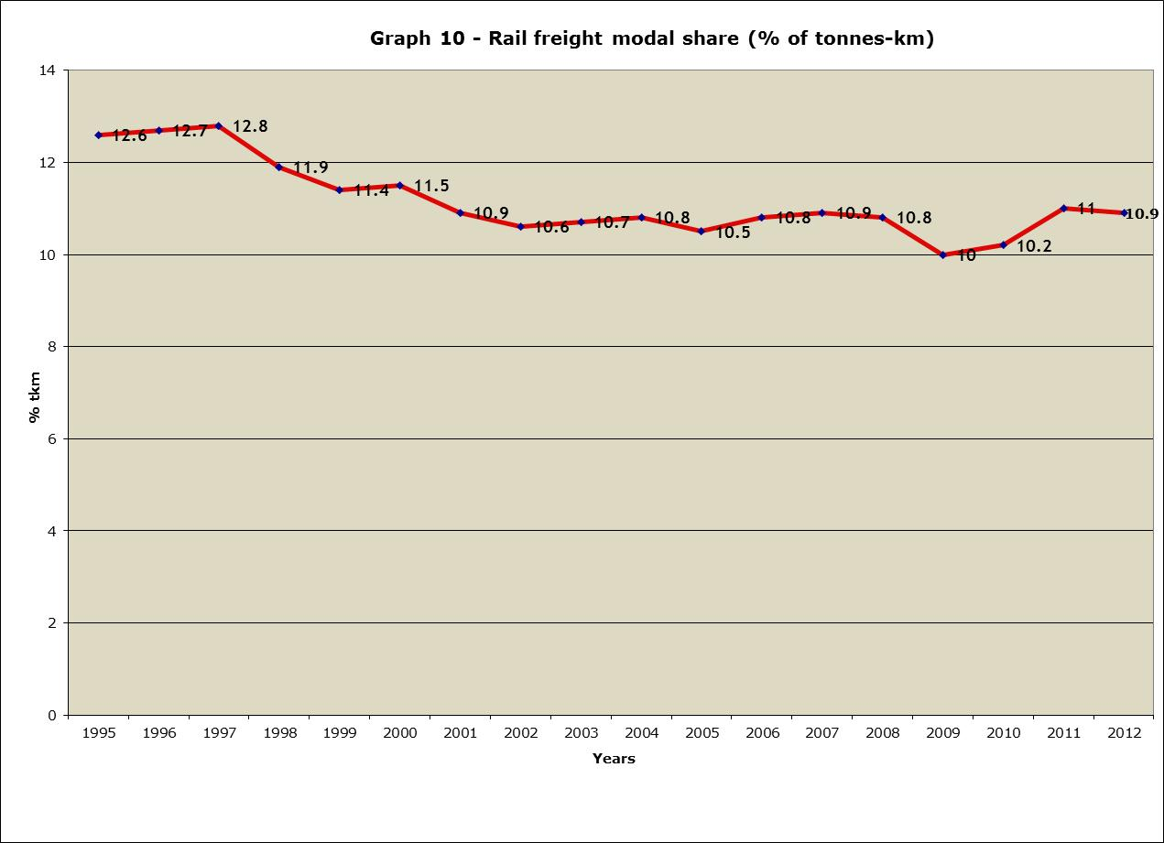
Source: Eurostat– Annex 3 of Staff Working Document SWD(2014) 186
Since 1995, the rail modal share has grown most in Northern Europe and has fallen in Southern and Eastern Europe (less so in the Baltic States). Largest growth rates were recorded in the Netherlands (+76%), Denmark (+71%) and the UK (+66%), but also in Germany, the largest rail freight market in Europe. In spite of a slight growth in Italy (+ 4%), rail freight has decreased in France (-5%) and Spain (-54%).
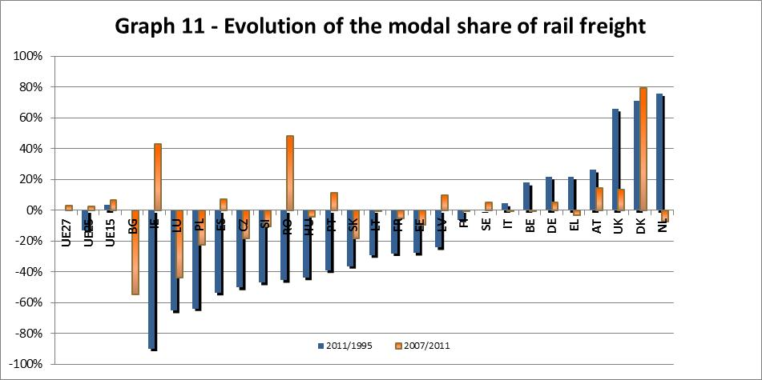
Source: Eurostat
Since 2007, the year when rail freight services have been opened to competition at EU level, traffic has continued to grow strongly in Denmark (+79%), Austria (+15%), UK (+14%), but also in Romania, Ireland, Portugal and Latvia. Although the economic crisis lasted in Romania longer than in Northern Europe, rail freight grew due to high performing non-affiliated freight operators since 2007.
Intermodal rail freight is growing, but single wagonload is decreasing. The share of intermodal rail freight has grown from 15% to 18% between 2007 and 2011 – albeit mostly in Germany, Ireland and Spain. Intermodal rail freight is stagnating in France and Italy and remains small in Poland and the Baltic States (while growing fast). On the other hand, the single wagonload appears to be decreasing everywhere (Eurostat data series are incomplete). In Germany it went down from 39% of all tonne-km in 2004 to only 26% in 2011. In Poland, it reached only 17% of all tonne-km in 2010.
The portfolio of transported goods (cf. graph) has remained stable and remains concentrated in commodities (agriculture, minerals) or products in their first stages of industrial processing (basic metals, chemicals). Coal, mineral ores, petroleum products and chemicals represented 57% of all tonne-km. Transport of chemical products is the only segment that has grown in absolute and relative terms since 2007 (+7%). Yet, interestingly this growth has been concentrated in Germany, Scandinavia and the Baltic States - as transport of chemicals has declined in Poland and France (- 38%). It is worth underlining the importance of certain transports in some Member States: the rail transport of coal in Poland is more important than the rail freight market of 20 Member States (taken alone).
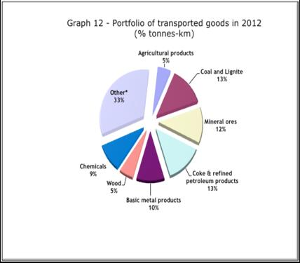
Source: Eurostat – "Other*" includes miscellaneous articles (cf. footnote 21)
More than half of the decrease in traffic in 2008-2012 can be explained by specific segment evolutions. In Germany, the increase of chemical and transport equipment transport has not compensated important decreases in the rail freight transport of agricultural products, coke, wood and basic metals. In France, most of the decrease has taken place in chemicals (unlike Germany), basic metals (like Germany) and metal ores, but there has been growth in the transport of grouped goods (included in the segment "other"). Finally, more than half of the decrease in Poland, the second largest rail freight market in the EU, derives from a decrease in the transport of coal.
One also ought to ask whether specialisation of rail freight in commodities and basic industrial products does not make its business cycle particularly vulnerable to economic cycles (evolution of commodity prices), energy policies (choices of specific energy sources) and inventory management (commodities cost less to inventory than finished industrial products). Additionally, to be successful, railway freight needs to move into higher-added value "niches" and increase average transport distances.

2. Evolution of the internal market in services to be supplied to railway undertakings
Information in this field is still fragmentary. This report focuses on the structures of ownership and management and reports on problems encountered in the access to those facilities that have been declared officially.

2.1. Stations

2.1.1. Stations across the European Union
There are some 22.000 stations in the EU, out of which some 250 are “big stations” that have more than 25.000 travellers/day. The importance of suburban services, which carry much more passengers, explains that some small-sized Member States like the Netherlands have more big stations than Spain or Italy (Luxembourg has for instance one big station). The fact that some important suburban networks are part or not of the railway network covered by the Railway directives could also play a role. Urban decentralisation may also explain why Germany has some 112 big stations, against some 45 and 38 respectively in the UK and France (with Paris-Nord as the busiest station in Europe).
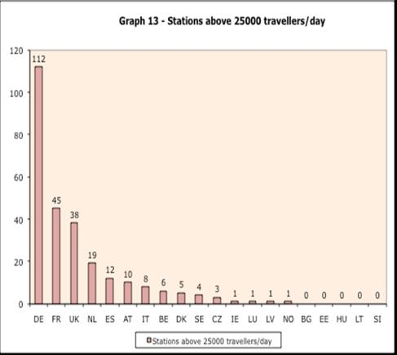
Source: RMMS questionnaires – Annex 6 of Staff Working Document SWD(2014) 186
Density of stations on the network would also vary from one Member State to the other. On average, the distance between two stations on the rail network does not exceed 5 kilometres in Czech Republic, Slovakia, Greece and Austria. In Finland however, this distance goes up to an average of nearly 28 kilometres.
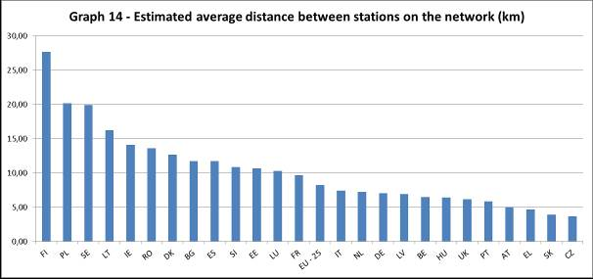
Source: Eurostat, latest data available for length of lines, EIM, CER, infrastructure managers' network statements, number of stations per MS as provided in RMMS questionnaires
This indicator does not imply that trains will necessary stop at all of these stations. Nor does it give the average distance for European citizens to the nearest station. The latest Eurobarometer actually reveals that the Member States where the highest share of population lives less than 10 minutes away from the nearest station are not those with the highest station density on the network. Luxembourg and Denmark are the two Member States where this proportion is the highest while their average distance between stations is above the EU-25 average. On the contrary, in Czech Republic and Slovakia, the share of population living within 10 minutes of the nearest station is around EU-25 average although these two Member States have the lowest distance between stations. This seems to indicate a discrepancy between the spread of stations throughout the territory and the population repartition.
Graph 14bis- Population to the nearest station
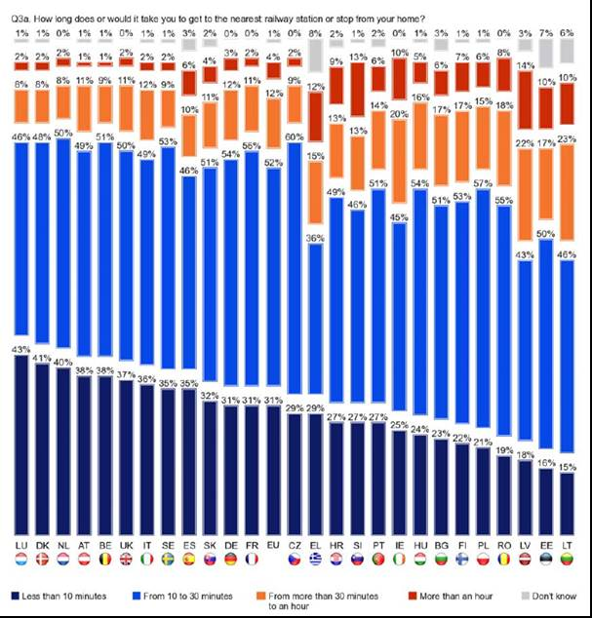
Source: Flash Eurobarometer 382a on Europeans' satisfaction with rail services – (telephone interviews of 28.036 EU citizens above 15 years) – Annex 7 of Staff Working Document SWD(2014) 186

2.1.2. Ownership and management
In spite of various structures of ownership of stations (cf. Table 1), in most cases stations are strongly linked to the incumbent – either through the incumbent holdings (e.g. Ireland and Poland), a subsidiary thereof (e.g. Germany) or the holding’s infrastructure manager (e.g. Austria, Italy). In many cases, there are complex arrangements of ownership of stations – where the infrastructure manager owns platforms but the railway incumbent owns the terminal (e.g. France, Netherlands and Belgium). In other Member States, stations are owned by independent infrastructure managers (e.g. UK, Spain) or by the national government itself (Portugal, Luxembourg, Slovakia and Bulgaria).
Table 1 – Structures of ownership of stations in Europe
Sources: RMMS questionnaires’ contribution from Member States, own research for missing information
(grey background)
Management structures of stations are in general identical to those of ownership. However, in those Member States whose national government own stations (Bulgaria, Slovakia, Portugal, Hungary and Luxemburg), management is entrusted to the infrastructure manager. In France, in spite of co-ownership with the French IM RFF, stations are completely managed by the incumbent (SNCF Gares et Connexions). In the UK, Network Rail owns and operates the top 14 largest stations while the rest is owned by Network Rail but operated under lease by the main franchise operator.
In any case, stations are still owned or managed (or at least partly) by incumbent railway operators in all Member States except Bulgaria, Portugal, Slovakia, Spain and the UK.

2.1.3. Access to station facilities by railway undertakings
Stations may constitute bottlenecks in particular where important stations are concentrated (e.g. Italian 8 mega-stations or Paris). NTV, the Italian new entrant in the Rome-Milan high-speed line has to operate from Rome-Ostiense (instead of Termini) and Milan-Porta Garibaldi (instead of Centrale). On the other hand, using peripheral stations can also be part of a business strategy: Ouigo, the low-cost rail service between Paris-Lyon provides cheaper fares departing from Marne-la-Vallée (Eurodisney), in the outskirts of Paris.
Ownership and management of stations by incumbents creates situations of suspicions of conflict of interest or actual complaints. NTV has filed a complaint to the Italian competition authority accusing Trenitalia of abuse of dominant position, amongst others as regards the management of advertising in Italian stations.

2.1.4. Quality of services in stations (including accessibility by persons of reduced mobility)
On average, Europeans are fairly satisfied with stations (satisfaction rates have slightly increased since 2011). The 2013 Flash Eurobarometer survey estimates that 51% of Europeans have “high” or “good” satisfaction levels as regards stations, and conversely 49% have “medium” or “low” levels. Highest levels of satisfaction with stations were reached in the UK (73%), Ireland (71%) and Luxembourg (70%). The below-average satisfaction rates are found in Germany (40%), Italy (34%) and Central- and South-Eastern Europe.
Graph 15 – Satisfaction index of railway stations (2013)
Source: Flash Eurobarometer 382a on Europeans' satisfaction with rail services – (telephone interviews of 28.036 EU citizens above 15 years) – Annex 7 of Staff Working Document SWD(2014) 186
According to the same survey, 68% of Europeans are satisfied with the provision of information about train timetables and 67% with the ease to buy tickets. Europeans are less positive as regards cleanliness of stations (57% of satisfaction) and access to complaint-handling mechanisms (37%). Satisfaction with cleanliness of stations is highest in Luxembourg, Austria (80%) and the UK (79%). The below-average satisfaction rates are found in Germany, Italy and Central- and South-Eastern Europe.
Only 37% of Europeans report “high” or “good” satisfaction levels with all the aspects of accessibility of persons with reduced mobility. Satisfaction is highest in the UK (61%), Ireland (56%) and France (52%). The below-average satisfaction rates are found in Germany, Italy and Central- and South-Eastern Europe.
Graph 16 – Satisfaction index of accessibility of stations (2013)
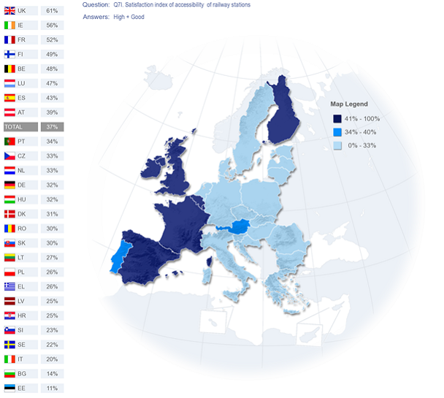
Source: Flash Eurobarometer 382a on Europeans' satisfaction with rail services – (telephone interviews of 28.036 EU citizens above 15 years) – Annex 7 of Staff Working Document SWD(2014) 186
More specifically, the majority of EU citizens are positive for accessibility of ticket offices and vending machines (51%), but less so with accessibility of platforms (46%) and carriages (42%) , and even much less with pre-journey information on accessibility (39%) or assistance for persons with reduced mobility (37%). Dissatisfaction rates are very high when citizens themselves are directly concerned (40% dissatisfaction with accessibility of platforms and 42% as regards accessibility of carriages).
Questions of accessibility are essential to improve the modal share of rail, in particular in the context of the ageing of the European population. 34% of all Europeans never using the train cited at least one accessibility issue as a reason to explain why they do not do so. Rail appears not to be reaching some 19% of the EU population because of accessibility issues.

2.2. Freight terminals, marshalling yards and storage facilities
Overall, freight terminals, marshalling yards and storage sidings seem to be mostly owned and managed by incumbents’ holdings (in particular in the important freight markets like Germany, Austria, Poland, Lithuania, Latvia), except in the UK and the Netherlands – where the independent infrastructure manager predominantly owns them. In Portugal, Bulgaria, Luxembourg and Slovakia, they are State-owned but managed by the infrastructure manager. Germany appears to account for the majority of reported freight terminals.
Table 2 – Structures of ownership of freight terminals, marshalling yards and storage facilities in Europe
Sources: RMMS questionnaires’ contribution from Member States, own research for missing information
(grey background)

2.3. Maintenance facilities
Ownership of maintenance facilities remains in most Member States under the responsibility of the incumbent railway groups, with the notable exceptions of Romania, the UK and the Netherlands.
Table 3 – Structures of ownership of maintenance facilities in Europe
Sources: RMMS questionnaires’ contribution from Member States, own research for missing information
(grey background)

2.4. Other facilities: port access, relief and refuelling facilities
The remaining facilities appear to be less controlled by incumbent railway undertakings and witness a much greater involvement of private companies. However, in Germany, Ireland, Latvia and Lithuania, these are mostly related to the railway incumbent.
Table 4 – Structures of ownership of port access, relief and refuelling facilities in Europe
Sources: RMMS questionnaires’ contribution from Member States, own research for missing information
(grey background)

3. Framework conditions

3.1. Infrastructure charging
The “main” infrastructure managers (cf. Part 3.2) have collected from railway undertakings an estimated € 15,7 billion of infrastructure charges in 2012 (up by 3% compared to 2011) based on financial accounts. Infrastructure charges appear to have represented 41% of all of the “main” infrastructure manager’s revenues (public funds appear to have represented 48% - cf. Part 3.2).
BOX 3 – INFRASTRUCTURE CHARGING AND RAIL MARKET SEGMENTS
Railway undertakings pay "infrastructure charges" to infrastructure managers for the use of rail infrastructure. Infrastructure charging impacts rail freight, intercity and suburban services differently. Rail freight is reputedly the most sensitive to variations of track access charges. Track access charges also have an impact on the cost structure of intercity services but only marginally on the final fare. Finally, as far as public service obligations are concerned (whose rail fares are generally regulated anyway), the level of track access charges is embedded in the financial architecture of the railway system.

3.1.1. Infrastructure charges for freight services
As shown in the graph hereunder, the average track access charges in 2014 for a 1000 tonne freight train range between 1.60 €/train-km and 3.40 €/train-km, except in the Baltic States and Ireland. In the Baltic States, infrastructure managers attract significant hinterland traffic from Russia, which operates over very long distances and has a higher average train mass. Networks in Europe's periphery tend to have very low or, in case of Ireland, very high charges. The same holds for the smallest networks, where border crossing problems are prevalent and therefore freight trains cannot pay high charges.
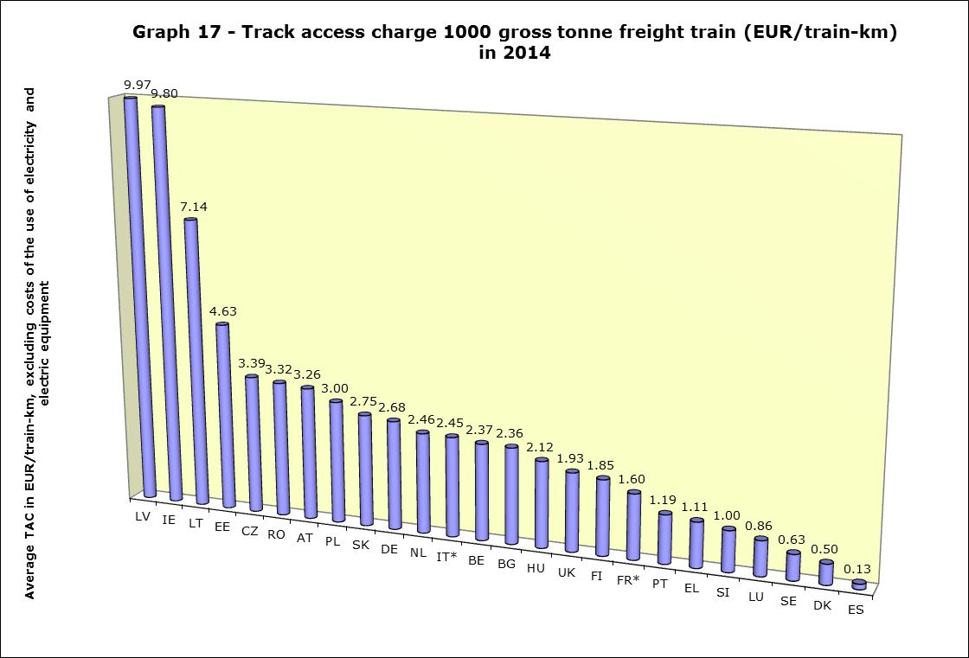
Source: RMMS questionnaires - no data for Norway; *= for France and Italy, data refers to 2013, as these Member States did not provide data for 2014. – Annex 8 of Staff Working Document SWD(2014) 186
Although rail freight reputedly has difficulty to bear “mark-ups” because of its narrow margins, freight trains seem to pay more for access to tracks than passenger trains - the median of all the Member States’ average track access charge for freight is higher than those of intercity and suburban services, even when Ireland and the Baltic States are excluded from the calculation. Finally, it is interesting to note that completely separated networks have generally lower infrastructure charges.
The reported freight track access charges for 2014 have decreased in Bulgaria (–36%), Czech Republic (-7%) and the Netherlands (-1%) and have remained stable in 8 Member States (hence decreasing de facto). On the other hand, they have substantially increased in Poland (+13%) and Sweden (+6,8%). With the exception of Poland and the Baltic States' networks, the process of a certain levelling out of charges across Member States continues.
In some cases increases have been specific to some segments: in Germany, in the context of increased congestion, track access charges of feeder lines for freight trains with speeds between 50-100 km/h increased 12%, although the average freight track charge seems only to have increased by 2% (hence in line with inflation) in 2014 compared to 2013.
Comparing the evolution of the European average track-access charge for freight suggests a steady decrease over the last years (-28% between 2008 and 2014). More interestingly, the standard deviation – that is the dispersion of the values from the average – has dropped from 2.26 to just 1. In other words, the different national track-access charges seem to be increasingly converging towards the European average, which is helpful in the context of the development of a Single European Railway Area for freight with not only lower but standardized charges too.
Graph 17bis – Convergence of freight track access charges
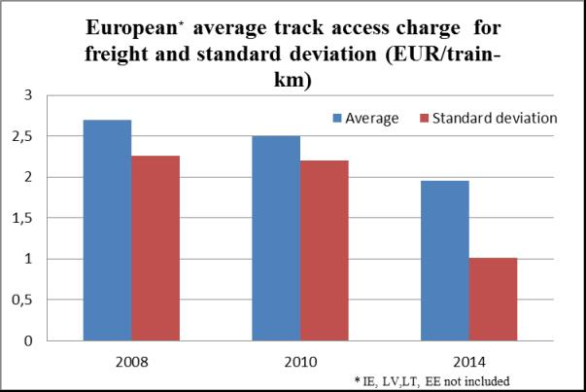

3.1.2. Infrastructure charges for intercity services
As shown in the graph hereunder, the average track access charges in 2014 for a 500 tonne intercity train also vary substantially: running an intercity train in Germany or France (and Belgium) costs on average the double of that in Italy or Spain (which also have high-speed networks) and 5 times more than in the UK, Czech Republic or Sweden. Networks with high speed lines (BE, DE, FR, AT, IT, ES) can be found at the "expensive" end of the scale, together with the Baltic States and Ireland.
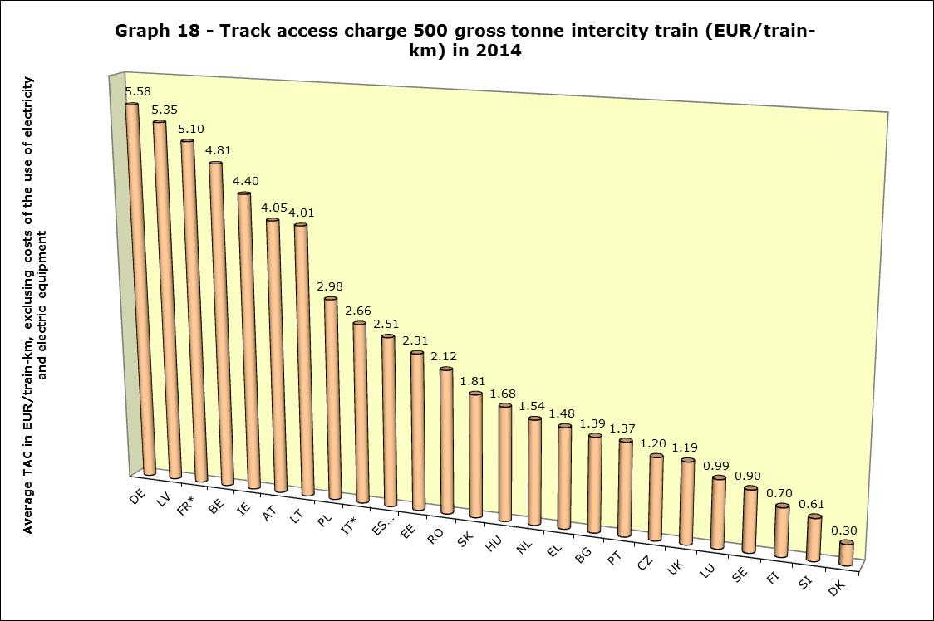
Source: RMMS questionnaires; *= for France and Italy, data refers to 2013, as these Member States did not provide data for 2014.**= for Spain, average track access charge for high-speed trains running on the network with speed limited at 260km/h – no data for Norway - – Annex 8 of Staff Working Document SWD(2014) 186
The reported intercity track access charges for 2014 have increased in several Member States – in particular in Poland (+43%), Austria (+23%), Spain (+14%) and Sweden (+8,4%, albeit from a very low base). In Austria, the increase of 23% is based on a high-speed surcharge, which has been rejected by the Austrian regulator on 27 September 2013, further to a complaint from the new entrant Westbahn, but is now being appealed by ÖBB Infrastruktur before the Austrian High Administrative Court.

Finally, as far as the evolution of track access charges for intercity trains is concerned, these have remained stable, but their dispersion has increased.
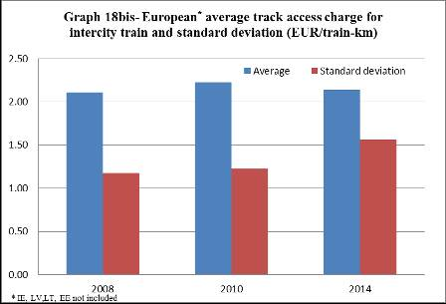

3.1.3. Infrastructure charges for suburban services
As shown in the graph hereunder, the average track access charges in 2014 for a 140 tonne suburban train are skewed. French suburban track access charges in 2013 are above € 10 train-km, while in 20 Member States they are all below € 2 train-km. German suburban track access charges are also well above those of most Member States (yet in France they are twice as high as German ones). This situation reflects the structure of financing of railways in France (where regions pay track access charges for regional trains under public service obligations (PSOs) directly to the infrastructure manager, which in turn pays the main railway undertaking SNCF to provide maintenance services on the infrastructure) and Germany (where regional authorities provide PSO subsidies that include means to pay track access charges). Similarly, track access charges for suburban rail services are lowest in the UK and Finland.
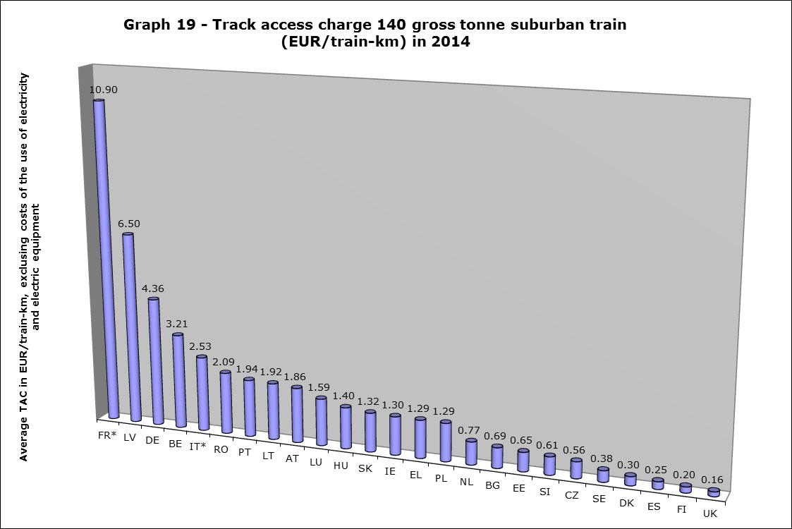
Source: RMMS questionnaires No data for Norway; *= for France and Italy, data refers to 2013, as these Member States did not provide data for 2014 - – Annex 8 of Staff Working Document SWD(2014) 186
As far as suburban track access charges are concerned, they seem to have remained stable (slight decrease), but their dispersion has increased.
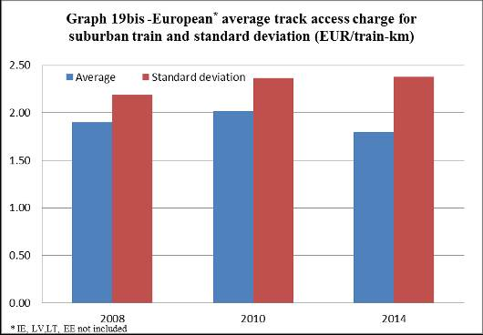

3.1.4. Infrastructure charges – overall rankings
Overall, track access charges are on the one hand the lowest in Denmark and Sweden and on the other hand the highest in Germany, the most transited network in Europe, and Lithuania, Latvia and Estonia, which have rail networks rather isolated from the core of Europe. To better reflect market structure, it might be useful and necessary in the future to further refine this analysis and distinguish between regional intercity services and high-speed services (instead of a bulk analysis for intercity trains). Last but not least, the fact that some Member States are well ranked in terms of low level of charges has to be analysed with due care – Member States are under the obligation under Directive 2012/34/EU to adequately fund their infrastructure (low track access charges explain why the UK opts for significant investment grants).
Graph 20 – Lowest TAC – rankings for the 3 segments
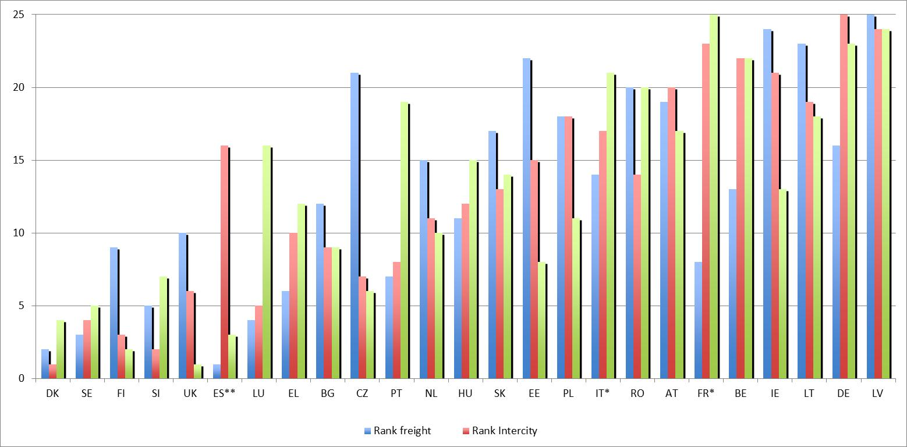
Source: RMMS questionnaires - No data for Norway; *= for France and Italy, data refers to 2013, as these Member States did not provide data for 2014. **= for Spain, average track access charge for high-speed trains running on the network with speed limited at 260km/h.
Infrastructure charging appears to be suffering from 3 main problems:
- Important transit networks placed in the centre of the European rail system or carrying hinterland traffic levy higher charges than smaller and peripheral networks. This situation prevails for both freight and passenger trains. It hampers the integration of national rail systems, whereby the high costs of interoperability exacerbates the conditions of cross border traffic.
- Track access charges in the East of the Union remain higher for freight than for (suburban) passenger transport; which from an economic point of view, suggests an insufficient level of compensation for services under public service obligations, whereby infrastructure managers could be recouping the resulting revenue losses through higher charges for freight services. As a result, rail freight traffic could be becoming less competitive than road and the railway undertakings cannot generate the funds they would need for renewing their wagon fleet.
Finally, it has not been possible to usefully take advantage of data requests as regards stations and facilities charges, traction current and diesel, as Member States' data collection has been rather piecemeal. Station and terminal charges would account for a significant part in the total infrastructure charges where trains travel short distances and stop frequently, in some Member States they account for more than half of total infrastructure charges. Market segments that require intensive use of facilities, such as open access regional passenger trains and single wagon load, display the least intensive level of competition.

3.2. Capacity allocation
BOX 4 – CAPACITY ALLOCATION
Infrastructure managers allocate path access rights to railway undertakings every year based on the requests made by the latter. Infrastructure managers also get ad hoc path requests, in particular from rail freight companies who cannot predict their services one year in advance. Path requests can be rejected if there is congestion.
Productivity of railway track varies between Member States: At one extreme there are the dense networks of the Netherlands and the UK, under strong pressure of commuter services, followed by Germany, Austria and Belgium, and at the other extreme, the relatively under-used rail networks of Baltic States and South-Eastern Europe. There are four times more trains-km per km of track in the Netherlands than in Bulgaria, Romania and Estonia.
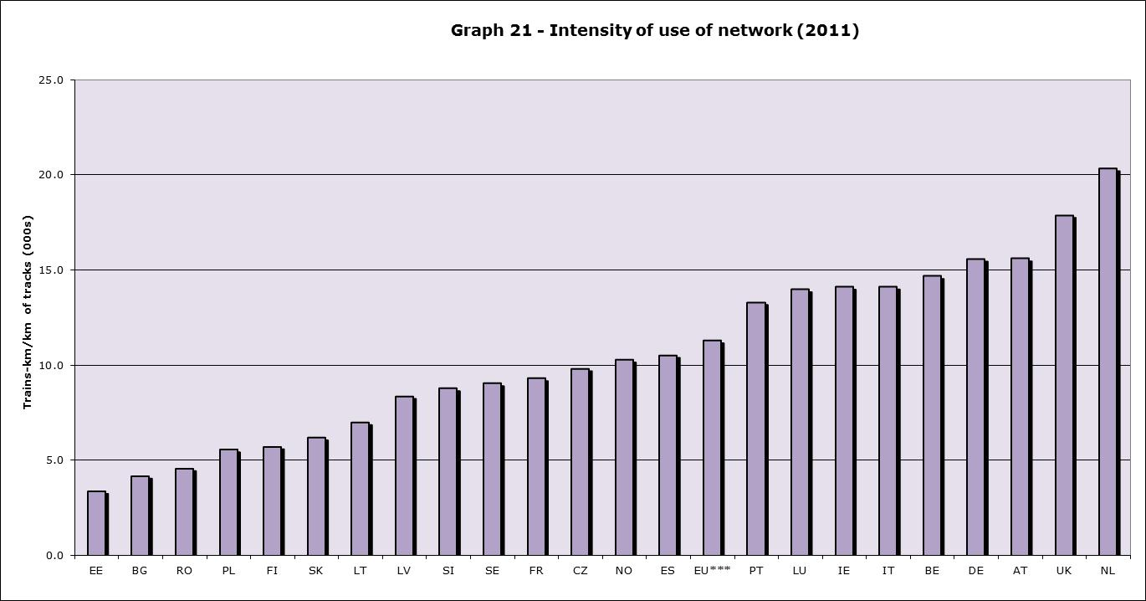Source : Eurostat, UIC, RMMS (Bulgaria) - – Annex 9 of Staff Working Document SWD(2014) 186
BOX 5 – CONGESTION OF RAIL INFRASTRUCTURE
Services under PSO generally have pre-reserved paths, as they require very intensive frequencies throughout the day (in particular suburban trains). High-speed trains operate (almost always) in dedicated infrastructure and generally only stop in sizeable urban agglomerations. Freight trains operate in many instances with paths that are allocated ad hoc.
For each railway line, there is a theoretical maximum level of trains ("maximal capacity"). However, the difference between the real capacity and the theoretical capacity results from a series of trade-offs like maintenance works, stopping patterns, conflicting junction movements (trains at switches), rolling stock mixes and off route constraints. The shape of rail networks also plays an important role: trains are more easily rerouted in mesh networks (e.g. Germany) than in star-shaped networks (e.g. France, Spain)
The European rail networks are predominantly used by passenger trains (78% of all train-km), although there are variations in terms of types of services between Member States. Trains running on the intensely used networks of the UK and the Netherlands, but also in Ireland and Luxemburg, are mostly passenger trains. Trains in the sparsely used networks of the Baltic States will mostly be freight trains.
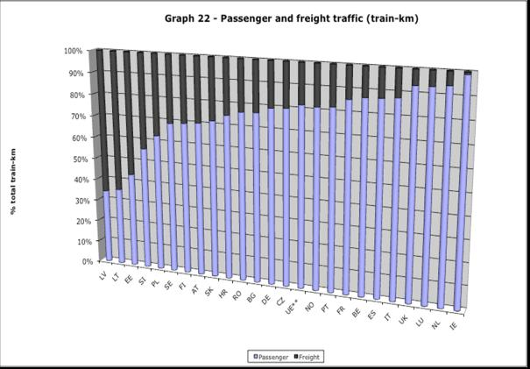
Source: Eurostat, DB, ISTAT, INSEE – situation in 2011; EU average excludes DK, HU and GR for which no data was found
Only 5 EU Member States (Germany, Denmark, the Netherlands, Romania and the UK) and Norway have declared part of their infrastructure to be “congested” according to their responses to the RMMS questionnaire. In total 1324 km of lines (0,6% of the whole EU lines) have been declared congested and the greatest bottleneck appears to be located in absolute terms in Germany (399 km), but Denmark and Romania have important bottlenecks.
Most Member States have opted for the prioritisation of PSOs (cf. table 5), services with direct value for society and high frequency services – which often in practice cover mostly commuter services. EU market access law allows for the prioritisation of path allocations in favour of services with value for society, PSOs and international rail freight services. France has not reported any prioritisation of rail services in the context of the RMMS. This prioritisation covers more than 85% of all train-kms in the Netherlands, the UK, Luxembourg and Ireland (cf. graph 23).
Table 5 – Type of priorities in path allocation
Source: RMMS questionnaires

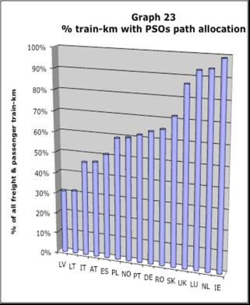
Source: RMMS questionnaires
Finally, a first attempt to take stock of the quantity of rejected paths, suggests that France (4,1 %) and Poland (1,3 %) are experiencing the largest numbers of path rejections. In France, which has not established service priorities, most rejections have actually concerned local and regional services (2,3% of all path requests of local and regional services, which represented 42% of all rejections), but the segment most hit have been domestic and international freight (18% and 13% of path rejected respectively). Path rejections have also been reported in Germany, Netherlands, Norway and Hungary (all less than 0,1%).

3.3. Investments made in infrastructure
The total amount of reported State grants for rail infrastructure managers varies according to various sources from which it can be estimated (financial accounts of infrastructure managers, State aid scoreboard and RMMS questionnaire on the compensation of multi-annual contracts) and the gaps in data series, but remains overall around € 18-21 billion in 2012.
All but 7 Member States (AT, CZ, EE, FI, GR, LV and PL) have concluded multi-annual contracts with their infrastructure managers. Such contracts cover an equivalent of 73% of the entire EU rail infrastructure and they last on average 5 years (in Spain they last for 2 years, whereas in Luxembourg, the multi-annual contract extends as long as 2024). There’s a wide variety of performance indicators. It is interesting to note that several Member States in Central and South-Eastern Europe use “train speed” as a performance incentive whereas many congested networks (the Netherlands, Germany, and Belgium) use punctuality or delays as performance indicators.
As illustrated in Annex 10b of the Staff Working Document SWD(2014) 186 accompanying this report, in terms of investments in the network, slightly less than € 29 billion appear to have been invested in the conventional network in 2012 (some 7% more than 2011) and some € 34,5 billion in the whole rail network (including high-speed). As far as the conventional network is concerned, the shares of maintenance (29%), enhancement (36%) and renewal (35%) appear to be roughly equal in 2012 (slightly less so in 2011, where renewals reached 39%).
BOX 6 – MAINTENANCE, ENHANCEMENT AND RENEWAL
There are varying definitions of 'maintenance', 'enhancement' and 'renewal'. However, broadly speaking, 'enhancement' covers in general the extension and modernisation of infrastructure through for instance new technologies (e.g. ERTMS, replacing level crossings with underpasses or overpasses), 'renewal' covers the replacement of assets putting the infrastructure back in the condition of when it was new (e.g. replacing sleepers, ballast or rails, renewing a bridge) and 'maintenance' refers to actions that ensure the functioning and extend the life time of existing assets (e.g. grinding, tamping, pruning trees and shrubs at the track side).
Finally, railway-related projects financed by EU funds, either under TEN-T or structural and cohesion funds, have amounted to some 22 billion EUR through the period 2007-2013, hence some 3 billion EUR/year, representing some 2% of the EU annual budget.
The total EU funding for railway infrastructure under the TEN-T 2007-2013 framework programme allocated by the end of 2013 reached some 4.4 billion EUR for rail (including ERTMS), corresponding to 65% of all TEN-T funds allocated by the end of 2013. 8 Member States (IT, FR, DE, AT, ES, SE, BE and DK) attracted 87% of all TEN-T funding for rail during the period 2007-2013, whilst the remaining 19 Member States absorbed 587 million EUR (hence each of them absorbed less than 110 million EUR).
Graph 24a – Allocated TEN-T funding for rail per Member State by the end of 2013
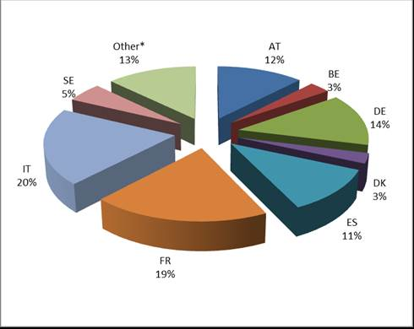
Source: Innovation and Networks Executive Agency (INEA) - *Member States with less than 100 million EUR of TEN-T funding (taken individually – these Member States have totalled 587 million EUR of funds allocated to them).
Most of the funding of rail projects between 2007 and 2012 took place through the structural and cohesion funds (17 billion EUR). The major recipients have been Italy, Poland, Spain, the Czech Republic and Hungary (all in the range of 2 billion EUR or more).
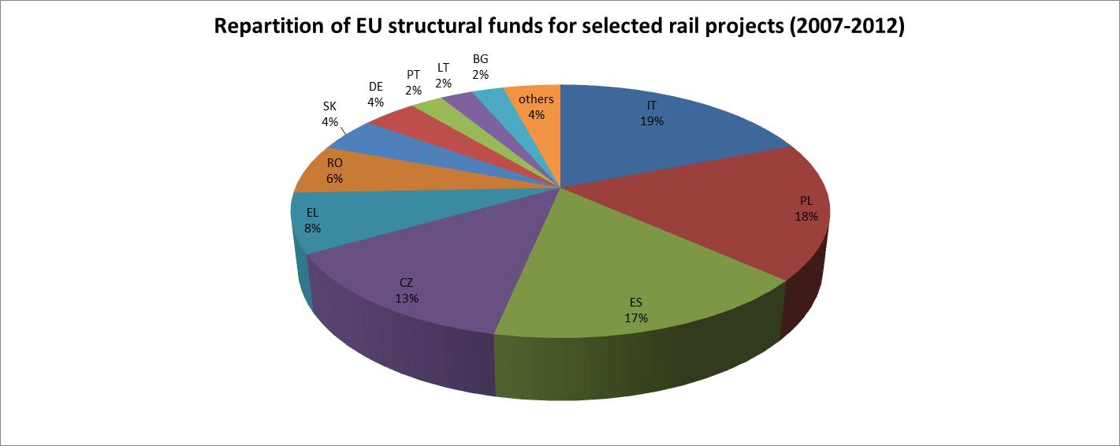
Source: European Commission, DG REGIO
As a result, for the period 2007-2012, rail projects selected for EU funding were concentrated in Italy, Spain, Poland and the Czech Republic. Member States like Denmark, Sweden and the UK remained largely aside of project funding.
Graph 24c – Earmarked EU funding for selected rail and ERTMS projects, 2007-2012 (million EUR)
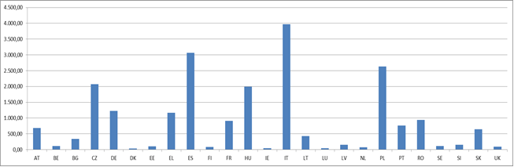
Source: Innovation and Networks Executive Agency (INEA), European Commission, DG REGIO

3.4. Developments as regards prices
Nominal prices for railway services have increased by 4% in 2012 compared to 2011, based on the harmonised consumer price index (HCPI) – which includes urban transport. Major increases took place in Central and South-Eastern Europe (in Slovakia, the increase reached 35%). In Sweden, prices have decreased by 1%.
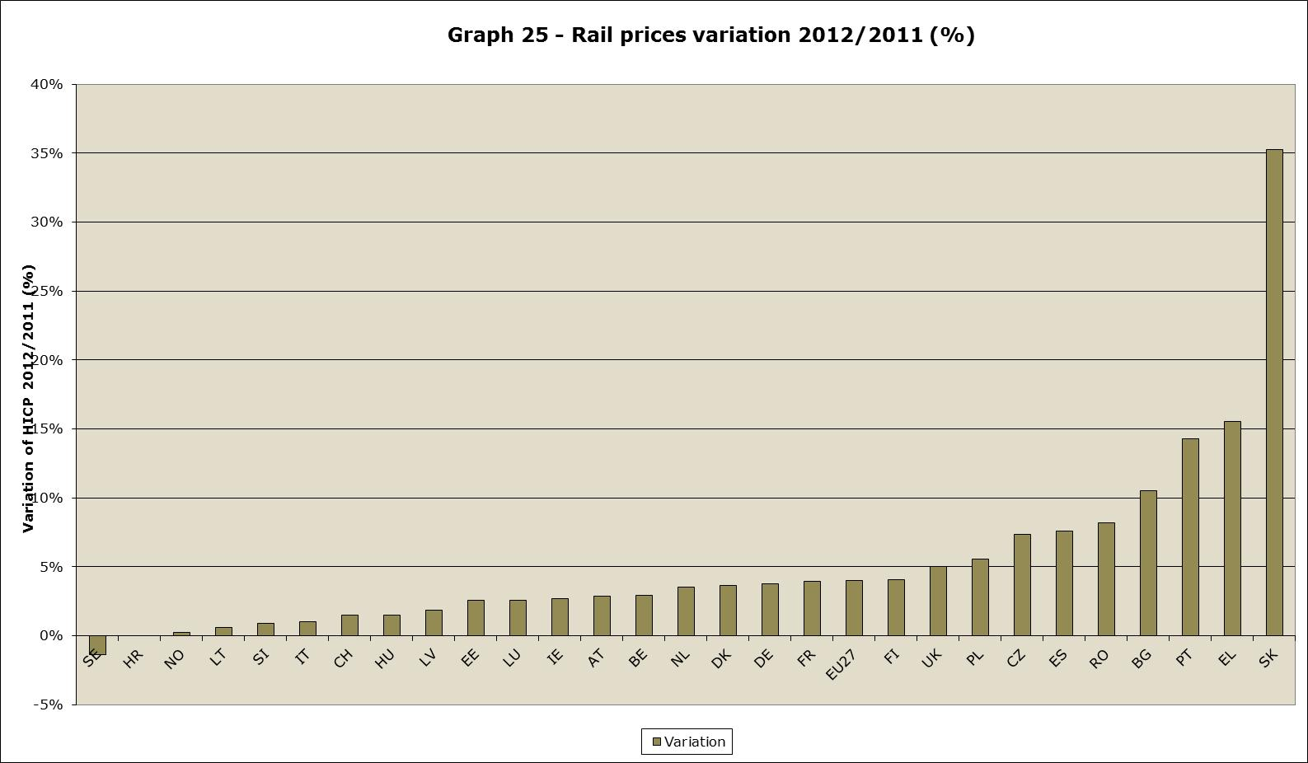Source: Eurostat
These aforementioned variations are part of a similar trend. Since 2005, the reference year for the HCPI, rail prices have been increasing by more than 50% in most Southern- and Central-Eastern Europe. In the UK and Italy, they have increased by more than 40% in nominal terms. On the other hand, in Sweden, rail fares have increased only by 3,7% in nominal terms.
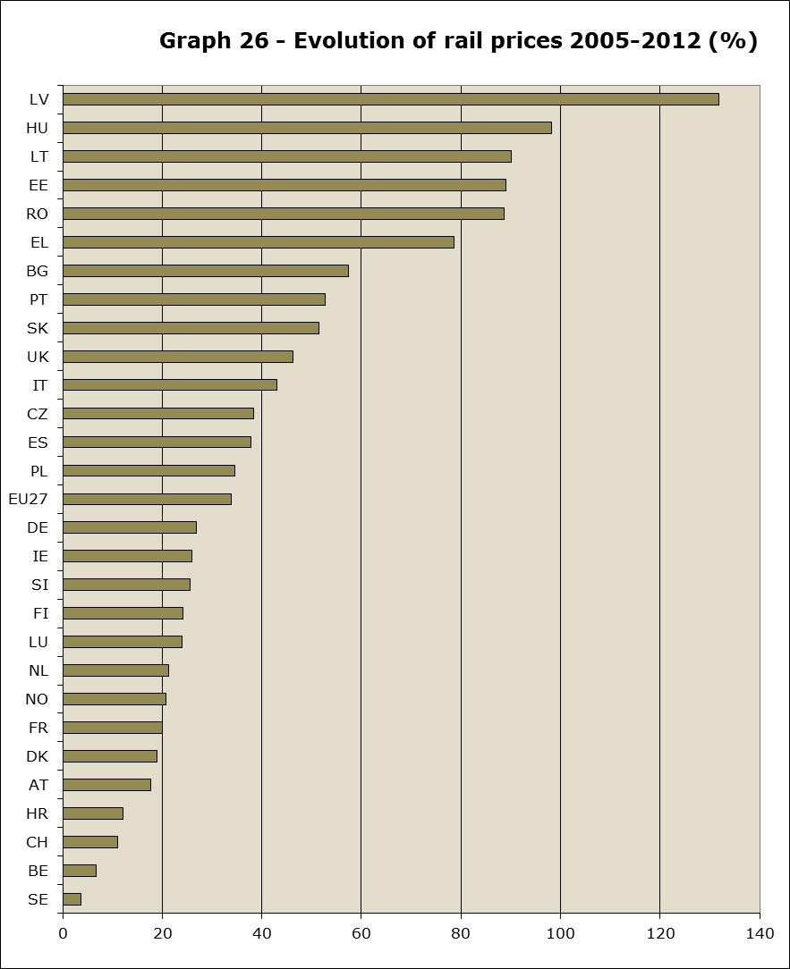
Source: Eurostat
However, rail fares since 2005 have increased less than other modes of transport. In fact, in the EU27 rail fares have increased by 0,15 percentage point less than transport prices overall. This is particularly important as regards Sweden and the UK, where transport prices have increased by 17 and 15 percentage points more than rail prices. On the other hand, in Southern- and Central-Eastern Europe, the high rail price increases have overtaken the price increases of other modes. In Germany, rail price increases have been in line with transport prices increases.
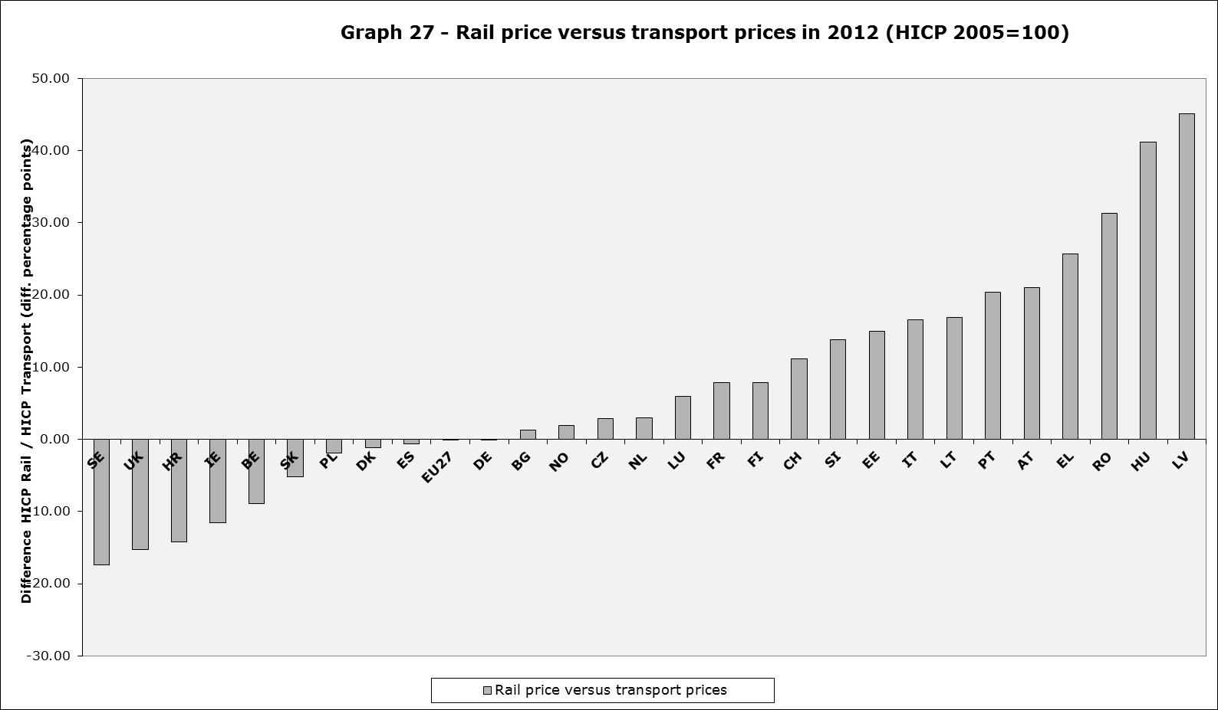
Source: Eurostat
Rail fares have grown in line with the prices of the operation of transport equipment, but it is interesting to note that since 2005 the price of fuel has increased by 12 percentage points more than rail fares. However, in Portugal and several Central- and South-Eastern Member States, rail fares have increased more than fuel prices (with extremes of 50 percentage points like in Latvia). In most "old" Member States (and Poland), rail fares increased less than fuel prices. In Belgium and Sweden, fuel has increased by more than 30 percentage points more than rail fares.
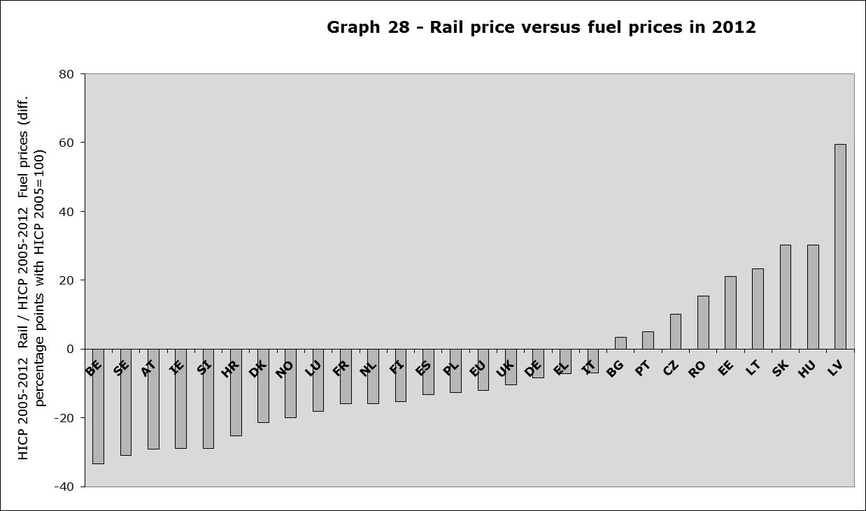
Source: Eurostat
Beyond this macro-economic outlook, it is necessary to recall that the variation of fares greatly depends on the structure of financing of the railway market. Public service obligations normally have regulated prices, whereas commercial services have unregulated prices. In some Member States, the public service obligations cover the entire territory (cf. infra). This being said, in the UK, which falls in this category, unregulated prices co-exist with the PSO regulated prices. In the Netherlands, the incumbent NS appears to be free to set fares. Finally, it is important to underline that most long-distance and international services are commercial services (cf. infra).
Rail fares in some commercial lines can vary strongly in relative terms throughout the EU and one should underline that, from a consumer perspective, day returns in some routes remain costly, even if sometimes fidelity rail cards can halve fares (cf. infra). Business class same-day returns in the Paris-London, Madrid-Barcelona, Cologne-Munich have been found to cost around 400 EUR, based on a price survey made by Commission services in February 2013. Similarly, booking a weekend trip 2 weeks in advance between Paris and London can still cost 260 EUR and an immediate departure from Madrid to Barcelona can cost 173 EUR. The fares of railway companies in commercial lines are also influenced by competition of other modes (air and road transport). It also appears that in some lines like London-Paris the vast majority of fares are reserved at lower prices with reservations taking place between 6 weeks and 4 months in advance or more, but at the same time, it is unclear if demand is influencing the booking times or if pricing structures are ultimately influencing demand. Finally, according to German authorities, the overall fares in Germany would fluctuate between 0,18 and 0,66 EUR/km, notably because of the effects of fidelity cards.
The average day return business class fare in February 2013 varied from 0,13 EUR/km on the Prague-Ostrava line (where 3 companies are competing against each other) up to 1,81 EUR/km on the Paris-London line. Similarly, leisure fares evolved in a similar fashion from 0,09 EUR/km on the Prague-Ostrava line till 0,86 EUR/km on the Paris-London line. Interestingly, Ouigo – SNCF low-cost service from Paris’ suburb of Marne-la-Vallée – and the Italian high-speed operators were the cheapest high-speed services at around 0,25 EUR/km, half the price of the TGV and ICE services in France and Germany (0,40/0,45 EUR/km), consequently well below international services in the PBKA square or France-Germany lines, where no competition has yet materialised (0,60 EUR/km).
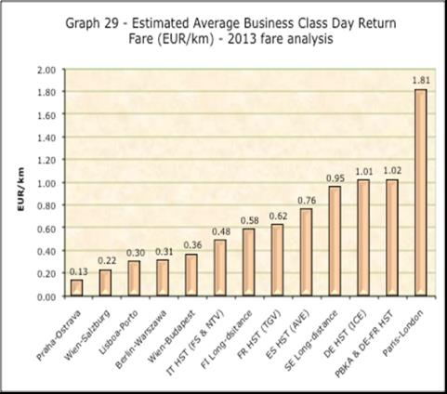
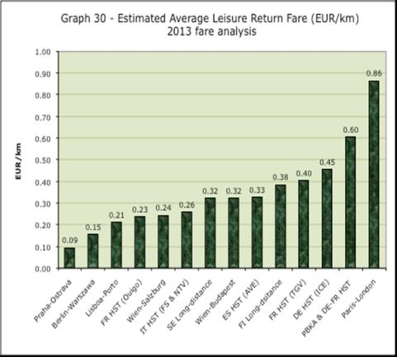
Source: Commission’s services price research and own calculations – cf. annexed data, data collection on 19 February, 8 March and 1st April 2013,– Annex 11 of Staff Working Document SWD(2014) 186
For public service obligations, it is useless to compare fares, as these are regulated. It is more useful to look at the financing ratio of passengers versus public transport authorities.

OJ L 343, 14.12.2012, p. 32.
Directive 2001/14/EC of the European Parliament and of the Council of 26 February 2001 on the allocation of railway infrastructure capacity and the levying of charges for the use of railway infrastructure, OJ L 75, 15.3.2001, p. 29.
On 18 October 2007 the European Commission adopted a Communication to the Council and the European Parliament on monitoring development of the rail market COM(2007) 609, accompanied by staff working document SEC(2007)1323;
On 18 December 2009, the European Commission adopted a Report to the Council and the European Parliament on monitoring development of the rail market COM(2009)676, accompanied by Commission Staff Working Document SEC(2009)1687
On 21 August 2012, the European Commission adopted the third Report to the Council and the European Parliament on monitoring development of the rail market COM(2012)0459, accompanied by Commission Staff Working Document SWD(2012)246 final/2
Union Internationale des Chemins de Fer (UIC)
European association of railway equipment manufacturers
White Paper – Roadmap to a Single European Transport Area – Towards a competitive and resource efficient transport system COM (2011) 0144 final.
Flash Eurobarometer 382a on Europeans' satisfaction with rail services, published on 16 December 2012. – 28.036 interviews were conducted over the telephone (some 1000 respondents per Member State) with citizens aged more than 15 years. For more details, refer to Annex 1
Ibid.
Students travelling to work, school or university
EU transport in figures, Statistical pocketbook, 2013, p.52
EU transport in figures, Statistical pocketbook 2013
Italian data, as provided in January 2014 by Italian authorities – includes international traffic.
This estimation was made by using a mix of Eurostat and RMMS statistics (completing gaps in Eurostat series)
Air traffic in the Lisbon-Madrid route has continued to (slightly) grow over the period 2009-2011
International passenger rail traffic has decreased by 50% in Italy since 2004
France (8%), Italy and UK (5%)
In Poland, volumes of intermodal have doubled since 2007 (source: Eurostat)
CER (2013), Rail Freight Status Report 2013 (p.37 fig. 24), reports that the share of single wagon load would have decreased from 41% in 2002 to 31% in 2008, based on a variety of sources (Eurostat, McKinsey, XRail)
The 33% of tonne-km representing "Other" (cf. graph 12) includes often finished products in intermodal traffic.
There is no data for Romania, Poland, Finland and Portugal.
The definition of this indicator could be further refined in the context of the RMMS implementing act
In Luxembourg, the infrastructure manager is part of the incumbent’s holding
No data for UK, Spain, Finland, Latvia and Belgium.
In some Member States, it is difficult to distinguish between public funds and infrastructure charges. In France, regions pay themselves the so-called « redevance d’accès » of the rail services under public service obligations that they purchase from SNCF. To be able to map the financial flows from railway undertakings to infrastructure managers, the payment of the redevance d’accès has been assimilated to a subsidy.
Financial accounts may differ from regulatory accounts, which fall under the supervision of national regulators
Median of the average track access charges in the Member States for 1000 tonne freight trains is 2,31 versus 1,81 and 1,30 for respectively intercity and suburban services.
Withdrawing the average freight track access charges of the 4 more “expensive” networks (Baltic States and Ireland) brings down the median for freight to 2,12 (versus 1,51 and 1,29 for respectively intercity and suburban) and reduce the variance to 0,98 (which is then lower than those of suburban and intercity trains).
The median freight track access charge of completely separated networks (BG, CZ, DK, EE, ES, FI, GR, NL, RO, SE, SK and UK) was 1,93 EUR/train-km compared to other networks ; similarly the median rank was 10th against 15th for other networks. The main exceptions are LU and SI, which have low freight track access charges.
Denmark, Spain, Finland, Hungary, Luxembourg, Latvia, Romania and Slovakia – all these Member States have had inflation based on the 12-month November 2013 inflation rate; in Greece, based on that same indicator, because of deflation (-0,7% inflation), stable track access have de facto increased.
Ireland and the Baltic States are excluded from this calculation since they are isolated from the rest of the European network. All data come from the RMMS questionnaires
Denmark ranks on average as the second cheapest rail network (Sweden the fourth cheapest), whereas Latvia overall ranks 24th as the most expensive (and Germany ranks 21st cheapest or 4th most expensive).
This calculation includes track managed by UIC members, whereas other track, notably so called 'industrial track', is not considered in this calculation.
Congestion declarations: UK 551 km, Germany 399 km, Romania 170 km, Norway 70 km and the Netherlands 47 km.
Data from the UK regulator (ORR) shows that rail fares over the same period have evolved in different ways: between 2005 and 2012, ""advance" tickets in the London suburban services have only increased by 14%, while "off peak" and "anytime" tickets have increased 44% and 42% respectively.
Heute vom Gleis gegenüber, Der Spiegel 14/2003 - 30.03.2013
The methodology of this fare analysis is provided in the Commission staff working document annexed to this report and is still subject to further refinement with the Member States in the context of the Rail Market Monitoring working group of the Single European Railway Area Committee.
The average was calculated between the fare of a citytrip reserved 2-weeks in advance and an immediate departure
PBKA stands for Paris-Brussels-Köln (Cologne)-Amsterdam

