REPORT FROM THE COMMISSION TO THE COUNCIL AND THE EUROPEAN PARLIAMENT
Fourth report on monitoring development of the rail market
TABLE OF CONTENTS
3.5. Quality of rail transport services 44
3.5.1. Rail services versus other services 44
3.5.2. Quality of services 44
3.5.3. Frequency 47
3.5.4. Punctuality 47
3.6. Rail transport services covered by public service obligations (PSOs) 48
3.6.1. Public service obligations and railway segments 48
3.6.2. Financing public service obligations 49
3.6.3. Competitive tendering of public service obligations 51
3.7. Licensing of railway undertakings 52
3.8. Degree of market opening 53
3.9. Harmonisation between Member States 54
3.10. Development of employment and social conditions 56
3.10.1. Employment in rail 56
3.10.2. Socio-demographic structure of the rail labour market 57
3.10.3. Training activities 58
3.10.4. Other aspects of working conditions 58
4. State of the EU network and infrastructure limitations 59
4.5. Variation of infrastructure 59
4.6. Management of infrastructure 59
4.7. Electrification 59
4.8. Train movements 59
5. Utilisation of access rights 60
5.5. Railway freight 60
5.6. Passenger railways – regional and suburban segments 61
5.6.1. Passenger railways – all segments 61
5.6.2. Regional and suburban segments 61
5.6.3. Rail high-speed and long-distance segments 61
5.7. Passenger railways – international services 62
6. Barriers to more effective rail services 62
7. Conclusions 62

The annexes of this report are found in SWD(2014) 186

3.5. Quality of rail transport services

3.5.1. Rail services versus other services
Rail services continued to be quite badly ranked in the Consumer Scoreboard, which compares several types of services in the internal market. Rail ranked 27th in 2012 compared to other internal market services in terms of the consumer market performance indicator - only real estate, mortgage and investment products fare worse, whereas airlines, postal services and urban transport rank far better than rail.

3.5.2. Quality of services
BOX 7 – PASSENGER RIGHTS REGULATION – THE MINIMUM SERVICE QUALITY STANDARDS
Regulation (EC) No 1371/2007 on rail passengers' rights and obligations lays down the following minimum service quality standards in its Annex III:
- Information and tickets
- Punctuality of services, and general principles to cope with disruptions to services
- Cancellation of services
- Cleanliness of rolling stock and station facilities
- Customer satisfaction survey
- Complaint handling, refunds and compensation for non-compliance with service quality standards
- Assistance provided to disabled persons and persons with reduced mobility

3.5.2.1. Overall satisfaction
According to the Consumer Scoreboard, rail also ranks 27th out of 30 internal market services in terms of overall satisfaction (15% of consumers rate rail services between 0 and 4 in scale of 0 to 10).
Based on the Eurobarometer survey 2013, where 28,036 citizens in the EU were interviewed (some 1,000 interviews per Member State), it appears that only 58% of EU citizens are highly or fairly satisfied with the level with rail services.
Graph 31 – Satisfaction index of railway stations and travels (2013)
Source: Flash Eurobarometer 382a on Europeans' satisfaction with rail services -– (telephone interviews of 28,036 EU citizens above 15 years) – Annex 12 of Staff Working Document SWD(2014) 186
In terms of overall satisfaction, Finland and the UK top the satisfaction index with more than 75% of user satisfaction, whereas Bulgaria and Estonia have less than 30% satisfied users. Italy has also a very low satisfaction rate (36%). More than 50% of respondents are satisfied in Germany and Sweden, albeit below the EU average (55%).
As far as most indicators are concerned, it is essential to underline that in general lowest satisfaction rates are found in Italy and Central-/Southern-Eastern European Member States.

3.5.2.2. Satisfaction with retail transactions
68 % of Europeans are satisfied with the provision of information about train timetables (16% dissatisfaction rate). As far as conventional trains are concerned, satisfaction has slightly increased since 2011 (3 percentage points), with big jumps in Poland and the Netherlands (satisfaction has increased by 16 and 12 percentage points respectively).
67% of Europeans are satisfied with the ease of buying tickets in stations (17% dissatisfaction rate – although up to 37% in Germany). The satisfaction rate has remained stable since 2011 (78% satisfaction) with big jumps in Austria and Greece (14 and 10 percentage points increase), but worryingly dissatisfactory in Italy, Denmark and Slovenia (all more than 10 percentage points decrease). Dissatisfaction is slightly higher in rural villages (19% dissatisfaction) than in cities (14% dissatisfaction). Europeans affected by accessibility issues (e.g. persons with reduced mobility) are also slightly more dissatisfied (20% dissatisfaction).
Only 36% of Europeans are satisfied with complaint mechanisms (18% dissatisfaction –up to 31% in Italy). Satisfaction with complaint handling has jumped by 10 percentage points since 2011 – showing the first effects of the implementation of Regulation (EC) No 1371/2007. Satisfaction has jumped by more than 20 percentage points in 4 Member States (France, Latvia, Finland and Spain) and by 10-20 percentage points in 7 others. Satisfaction has only decreased by more than 5 percentage points in the Czech Republic, Italy and Estonia. It is important to underline that 54% of consumers that experienced a problem with trains complained to the railway undertaking or a third party, which is below the 70% average for all services.
Most Europeans are satisfied with the availability of through tickets (58%), with highest levels being reached in France, Belgium and Finland (all above 70%), but also the UK and Germany. As with other satisfaction rates, Italy/Central/South-Eastern European Member States underperforms (but also Sweden and Austria).

3.5.2.3. Satisfaction with on-board service
Satisfaction with provision of information during train journeys, in particular in case of delays has remained stable but insufficient (less than 50% of satisfaction). The highest rates of satisfaction are found in the UK (70%), Finland and Ireland. Highest rates of dissatisfaction are found in France (47%) and Germany (42%). Since 2011, as far as conventional trains are concerned, great improvements have taken place in Finland, Poland and the Netherlands (all above 9 percentage points increase).
Satisfaction with availability of staff: 58% of Europeans are satisfied with the availability of staff in their Member State. Highest levels of satisfaction are found in Belgium, Finland and Luxembourg (all above 70%), whereas Germany, (32%) Ireland and France have the highest degrees of dissatisfaction (all above 28%).
Satisfaction with cleanliness and maintenance of rolling stock has remained insufficient. Less than half of Europeans (48%) are satisfied with the cleanliness of railway carriages, including toilets. Finland, Ireland and the UK top satisfaction (above 68%), while Italy, Romania and Bulgaria experience the lowest levels of satisfaction (together with Germany and Central/South-Eastern Europe). Since 2011, on conventional lines, major increases took place in Austria, Poland and the Czech Republic (all have increased by more than 10 percentage points) and major decreases in Italy, Portugal and Latvia (all have decreased by more than 10 percentage points).
Satisfaction with bicycle access to trains is highest in Denmark (47%) and the UK (44%). The highest levels of dissatisfaction are found in Romania (28%), France (24%) and Germany (20%).

3.5.3. Frequency
Satisfaction with frequency is essential to attract travellers to rail – as time is with price the most critical factor affecting travel consumer decisions. Overall, 59% of Europeans are satisfied with frequency according to the Eurobarometer survey. The UK, Sweden and the Netherlands have the lowest dissatisfaction rates for frequency. Italy, Central-/Southern-Eastern Europe have the highest dissatisfaction rates (as in previous surveys). France and Germany have polarised opinions – satisfaction with frequency is above-average yet so is dissatisfaction.
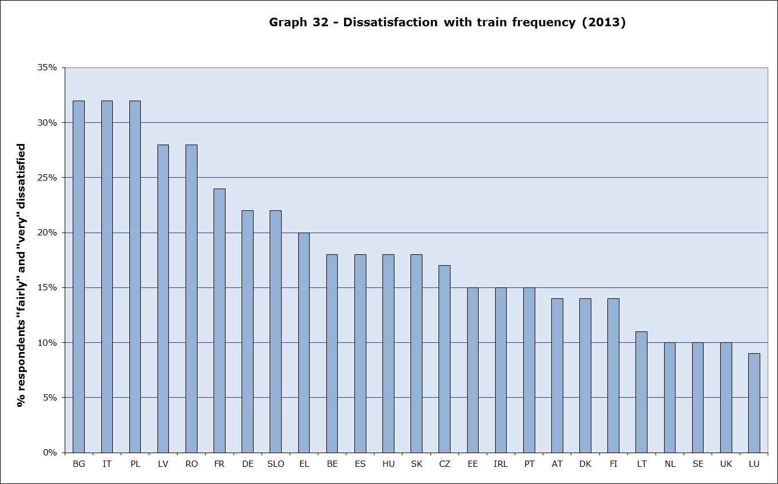
Source: Flash Eurobarometer 382a on Europeans' satisfaction with rail services - – Annex 12 of Staff Working Document SWD(2014) 186
In terms of frequencies in important high-speed lines, there are now some 4 trains/hour in the Italian high-speed network, which has the advantage of crossing most important cities in a single axis. The Paris-Nantes, Paris-Lyon and Frankfurt-Köln lines have also reached at least 3 trains/hour. On the other hand, otherwise important lines like Paris-London (which links the two major cities of the EU) are still at 1,5 trains/hour.
Overall, in terms of surveyed networks (cf. Analysis on fares), the highest frequencies are reached in the lines with more than 1 operator like the Italian high-speed network, Vienna-Salzburg and Prague-Ostrava with up to 2,5 trains/hour. The frequencies in Paris-Benelux/Germany remain under 1 train/hour (on average).
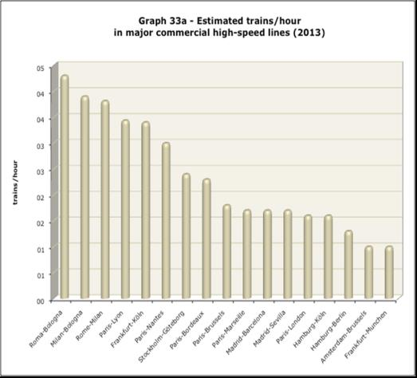
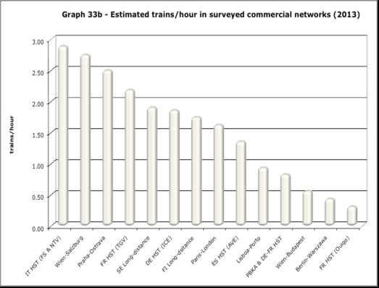
Source: European Rail Timetable, Summer 2013 edition

3.5.4. Punctuality
According to the Eurobarometer survey, dissatisfaction with punctuality and reliability is the greatest in France (47%), Germany (42%) and Italy (38%) and the lowest in the UK, Estonia and Lithuania. Conversely, satisfaction with punctuality is the greatest in Ireland, Latvia, Austria and the UK (above 73%).
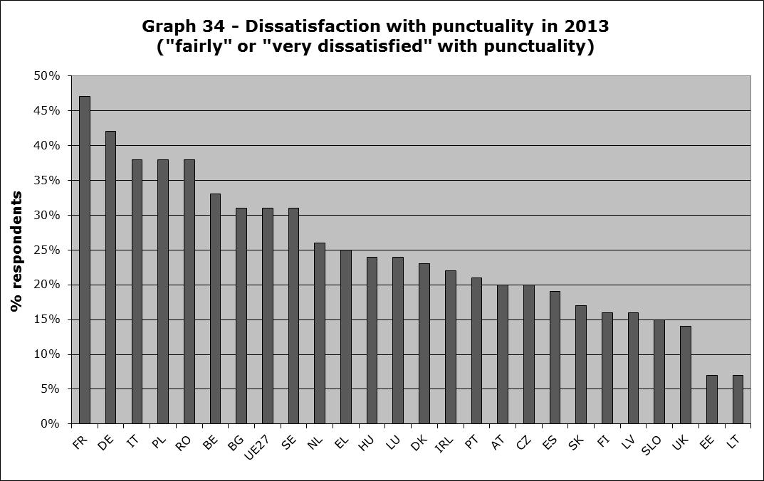
Source: Flash Eurobarometer 382a on Europeans' satisfaction with rail services - – Annex 12 of Staff Working Document SWD(2014) 186
Local and regional trains have been very punctual in Latvia, Portugal, Austria and Lithuania – while Belgium and Hungary – two important commuter markets - perform badly. Sweden and Italy also fall below 90% of punctuality.
Long-distance trains have been very punctual in Finland, Denmark and Italy while Poland and Lithuania perform badly. The punctuality rates of Germany and Portugal appear as lower because they have been accounted from a 5 minutes threshold, although there is a high degree of dissatisfaction of German travellers.
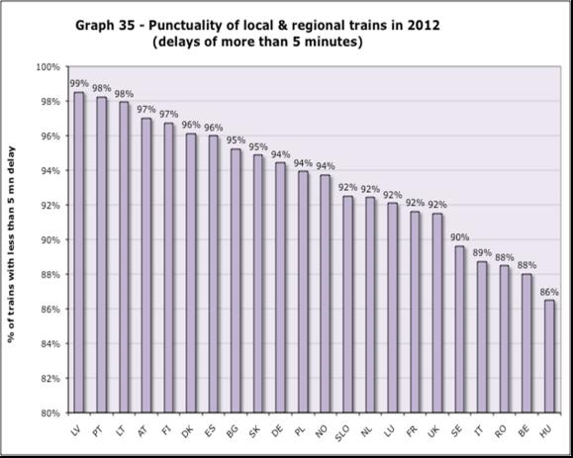
Sources: RMMS questionnaires and Trafikverket for Sweden (excludes suburban services)– data for Germany and Portugal covers delays above 6 and 3 minutes (respectively – cf. annex 14 of Staff Working Document SWD(2014) 186
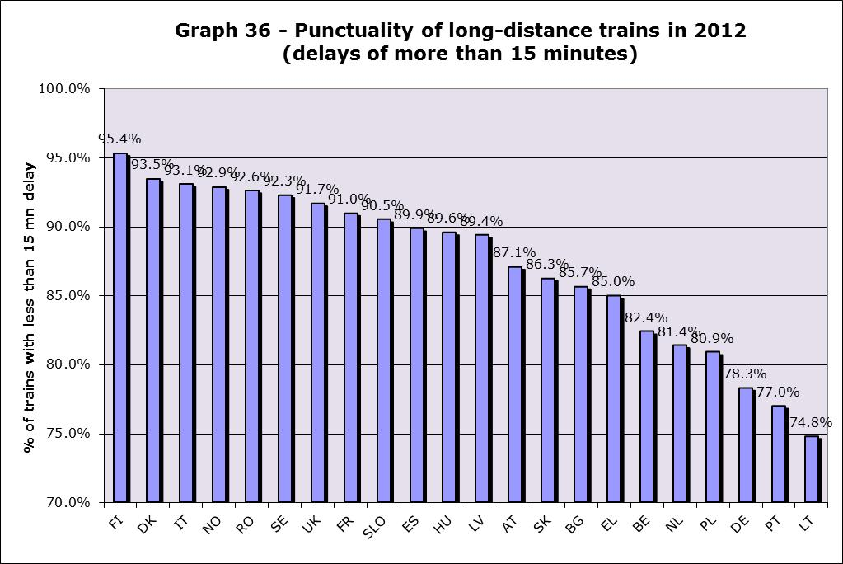
Sources: RMMS questionnaires and Trafikverket for Sweden – data for Germany and Portugal covers delays above 6 and 5 minutes (respectively) - annex 14 of Staff Working Document SWD(2014) 186]
There are interesting contrasts in punctuality rates. In Sweden and Italy, long-distance trains have been very punctual in contrast to local trains. In Portugal and Lithuania, it has been exactly the opposite. None of the rates appear to explain the high degree of dissatisfaction with punctuality and reliability in France. Finally, as far as high-speed services are concerned, AVEs in Spain have reached a punctuality rate of 99,2%, whereas in the more congested networks of France, TGVs have reached a 91% rate (and 85% for Thalys services in Belgium). Finally, as far as combined freight is concerned, it appears that punctuality has reached 67% in 2011, with still 19% of trains delayed by more than 3 hours and 4% by more than 24 hours.
In terms of reliability, although series of data are incomplete, Hungary performs worst with some 14% of trains cancelled. Denmark, France, the UK and Norway had all some 2-3% of local trains cancelled. The UK and Norway presented similar percentages for long-distance services. High-speed services appear to be highly reliable: less than 0,2% of cancellations in France and Italy.

3.6. Rail transport services covered by public service obligations (PSOs)

3.6.1. Public service obligations and railway segments
Public service obligations (PSOs) cover some 62-65% of all EU passenger-km and some 74% of train-km in 2011-2012. The number of passenger-kilometres under PSO has changed in France (with the inclusion of the Trains d'équilibre du Territoire, increasing from 31% to 43% of all domestic passenger-kilometres) and Finland (where they increased from 14% in 2010 to 45% in 2012).
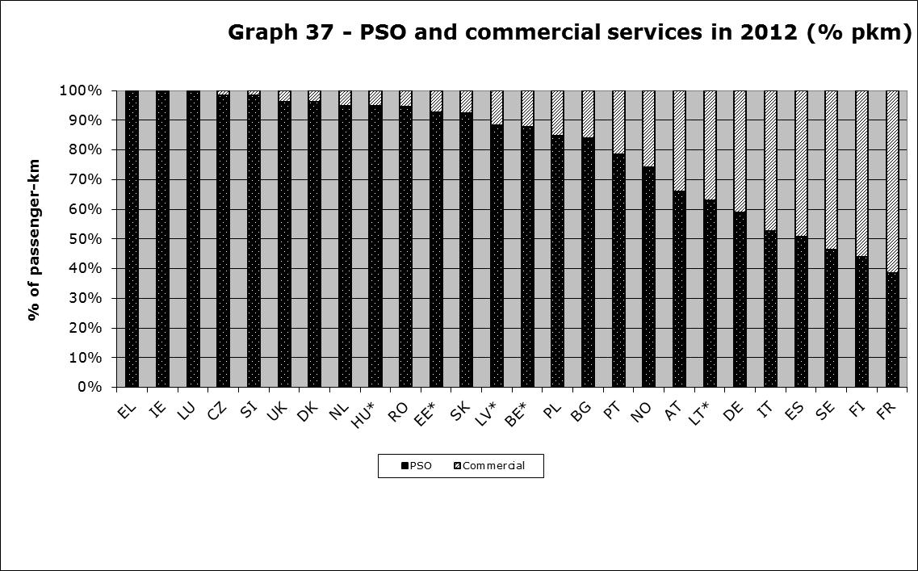
Source: RMMS questionnaires - annex 15 of Staff Working Document SWD(2014) 186
The relative share of rail services under PSOs and commercial services varies for the different market segments. In the UK, where most rail services are commuter services (cf. graph 4), PSOs cover 99% of all domestic passenger-kilometres. This situation contrasts with France, which is mostly a high-speed market and where PSOs only cover 38% of all passenger-kilometres.
All suburban and regional services (corresponding to 49% of all passenger-km) in Europe appear to be covered by PSOs. High-speed services, which represented some 27% of all EU passenger-km, do not seem to be operated under PSOs in any of the Member States, except maybe in some domestic line sections in the Netherlands and Austria (e.g. Salzburg-Innsbruck). As a result, it can be assumed that the two-thirds of the conventional long-distance services are operated as PSOs. Finally, PSOs can cover the entire domestic networks, either with one or several public service contracts, of some small-sized Member States like the Netherlands, Belgium, Hungary, Denmark and Ireland – or bigger Member States as it is the case of the United Kingdom.
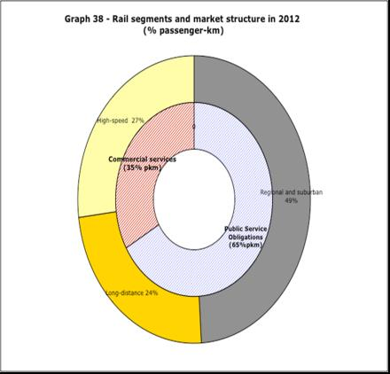
Source: RMMS questionnaires, own research, State aid scoreboard; the situation in Poland could be
slightly different with some commercial services running on regional lines

3.6.2. Financing public service obligations
In 2011-2012 some 18 billion EUR of public support have been granted to railway PSOs in the EU, with alone some 6 billion EUR in Germany, 4,5 billion in France and 2 billion in Italy. Direct public support in the UK and the Netherlands is very low as these Member States cross-finance their loss-making services through profitable services falling in the same public service contracts for rail services and revenues from passenger fares (cf. infra). This partly explains why Luxembourg or France provide some 18-17 EUR/train-km of subsidies whereas in the UK and the Netherlands public support is as low as 0,1-0,2 EUR/train-km. As in France, the level of net support also varies in Germany. Finally, there are also some differences in the number of passengers per train in European PSOs: in the Netherlands, France, Belgium, Italy and the UK there are some 120 passengers per train, whereas in the Czech Republic, Lithuania and Luxembourg, there are less than 60 passengers per train.
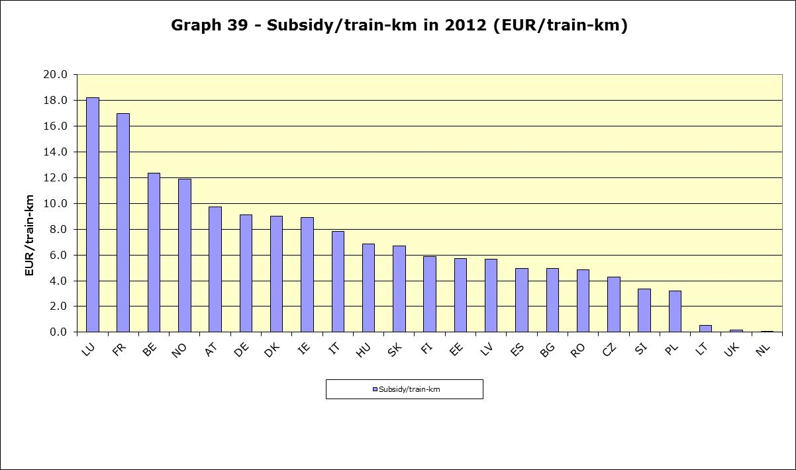
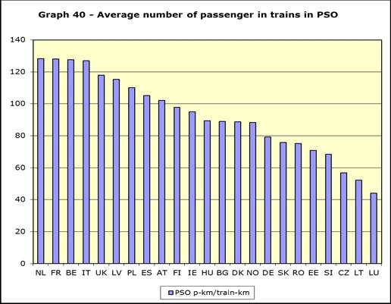

Source: RMMS questionnaires, own research, State aid scoreboard, annex 15 of Staff Working Document SWD(2014) 186
PSO costs have also been covered by passenger fares, which have amounted to at least 21 billion EUR in the EU. As explained, in the UK or the Netherlands, passenger fares cover 99% of the PSO costs, whereas in Bulgaria, Germany, Italy and the Czech Republic, the taxpayer has supported more than 70% of PSO costs.
Graph 41 – Who is paying public service obligations?
(2012)
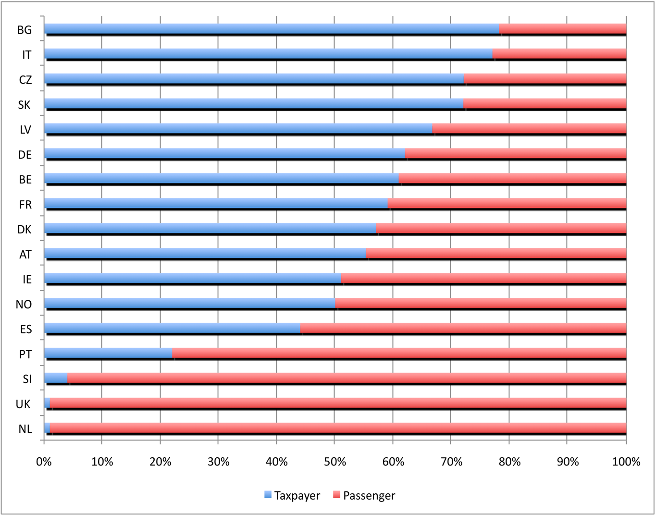
Source: RMMS questionnaires, own research, annual reports of incumbents

BOX 8 – FINANCIAL FLOWS IN THE RAIL SECTOR
Based on the information provided by Member States in the RMMS and the analysis of financial accounts of railway undertakings (RUs) and infrastructure managers (IMs), it is possible to map the main estimated financial flows (presented in the graph hereunder in € billion for the year 2012). Passengers have purchased from RUs some € 38 billion of rail passenger services and businesses have purchased some € 11-13 billion of rail freight services. RUs have paid some € 15 billion of track access charges to IMs, which have received some € 18 billion of State grants. The compensation of PSOs has amounted to some € 18-20 billion. Last but not least, IMs receive some € 4 billion of other revenue (electricity, real estate…).
Graph 42 – Financial flows in the rail sector (in billion EUR)
Source: Annual reports, RMMS questionnaires

3.6.3. Competitive tendering of public service obligations
Several Member States are tendering their public service contracts for rail services. Some are doing so on a large scale (the UK, Germany, Sweden,), whereas some others have only done so for a few contracts (Poland, Italy, Denmark, Portugal, the Netherlands, the Czech Republic and Slovakia). In 2011, the UK launched the renewal of 5 franchises, while Germany and Slovakia reported the competitive tendering of respectively 18 and 1 public service contract , of a smaller size, though.
Interestingly, there seems to be an emerging internal market for public service contracts (PSCs). A growing number of these PSCs for rail are published in the OJEU (TED website) as any other public procurement contract. The number of contract notices for PSCs published in 2012 reached 41, hence a doubling since 2006 – overall 205 PSCs have been published since then. The vast majority have been German tenders (some 113), but this might be also due to the size of contracts and there are indications that almost all German PSCs are published in the OJEU. The publication of contract award notices and ex-ante voluntary notices has doubled since 2010, improving therefore transparency.
Table 6 -Public service contracts published in OJEU in 2012 per Member State
 | BG | CZ | DE | DK | IT | NL | PL | SE | UK | Total
Contract notices | 3 | 1 | 113 | 1 | 2 | 3 | 62 | 13 | 7 | 205
Source: OJEU database TED
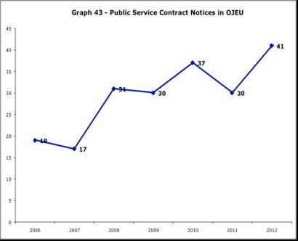
Source: OJEU database TED
The PSCs published in the OJEU present an interesting sample of PSCs overall in the EU. In this context, it is interesting to note that 76% of published PSCs used “better value for money” as the award criteria and only 23% used price as the only award criteria.
Based on a study of the European social partners in rail, it appears that transfer of personnel is required in Czech Republic, Denmark, Spain, France, Italy, Netherlands, UK and Norway and is optional in Austria, Bulgaria, Germany, Ireland, Poland and Sweden. Additionally, in Austria, Denmark, Germany Netherlands and Sweden, where there are sectoral agreements, it is not strictly necessary to prescribe social criteria in tender documents, as social standards apply to all operators.

3.7. Licensing of railway undertakings
Germany continues to top by far the number of licences with 417 licences granted, followed by Poland. It is interesting to note that while all German and Dutch licences are reported to the European Railway Agency (ERA), more UK licences are notified to national authorities than to ERA (probably because most railway operations are confined to the UK, given the low degree of cross-border freight traffic and the fact that so far only Eurostar provides cross-border passenger services). Another interesting peculiarity of the UK is the issue of licences for ‘operators of last resort’ – in case of bankruptcy of franchise operators or prolongation of tendering procedures. The number of licences is obviously very low in those Member States where the incumbent still has a monopoly on domestic passenger services.
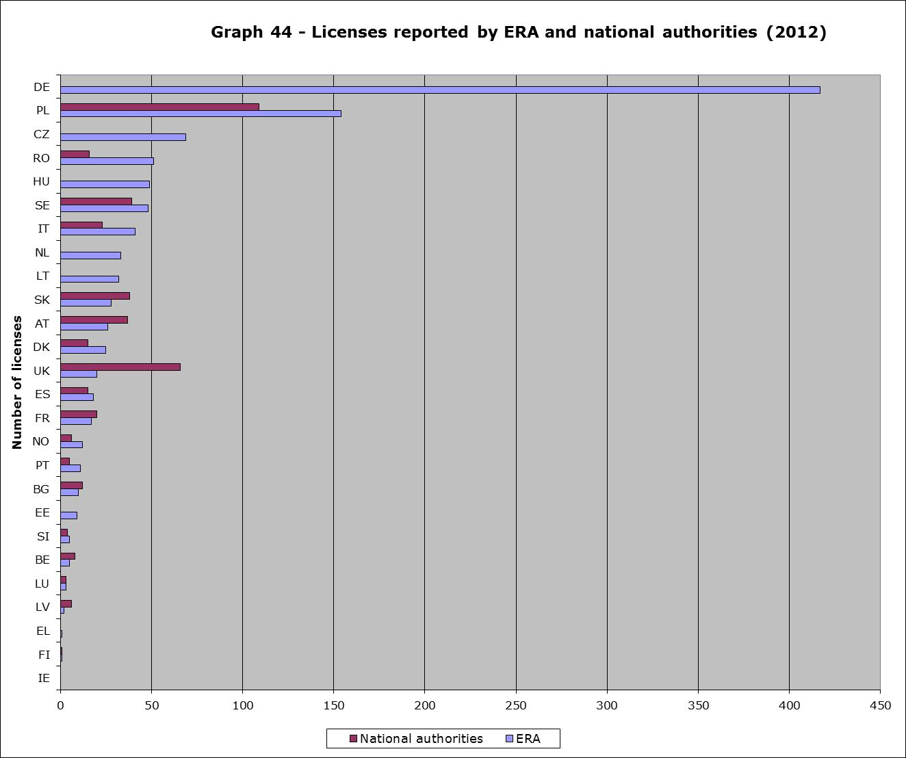
Sources: European Railway Agency (ERADIS database),
RMMS questionnaires filled by Member States - annex 16 of Staff Working Document SWD(2014) 186
Most licences reported to ERA are for freight (51%) – in particular in Germany and Poland. According to ERA, some 200 licences have been reported for passenger rail, whereas some 550 concern only freight – and 336 covered both.
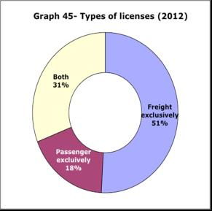
Sources: European Railway Agency (ERADIS database)- annex 16 of Staff Working Document SWD(2014) 186

3.8. Degree of market opening
Under EU law, the market of railway freight services have been open since 2007 and the one of international passenger services since 2010. For railway markets that are not open, it is important to underline that there is currently no obligation at EU level to open passenger domestic markets and that these represent 94% of all passenger-km in the EU.
In the context of the impact assessment of the 4th railway package, Commission services have estimated that in 2010, some 40% of the EU domestic passenger railway market has been so far accessible to new entrants. Only two Member States (Sweden and the UK) have fully opened their commercial services and services under public service obligations, and across the EU 40% of all passenger-kilometres are closed to competition. Repeating this exercise in 2012, based on 2010 assumptions, leads to the same results.
Graph 46 – Rail market structure (2012)
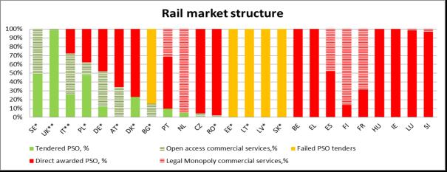
Source: RMMS questionnaires, impact assessment 4th railway package, CER (2010), own estimations
10 Member States (with asterisk in graph), representing 20% of all passenger-kilometres, have opened markets in a way that allows commercial services in open access to co-exist with directly awarded PSCs. Further to the Bundesgerichtshof decision calling for generalised competitive tendering, Germany will not be part of this group anymore. In Estonia, Latvia, Lithuania and Slovakia, full open access co-exists with directly awarded PSCs covering all rail services. PSCs in these Member States should be de jure competitively tendered, however de facto only the incumbent participated.
This percentage has not changed substantially since no further opening has been reported, except for rail tourist services in Spain. It is important to underline that press reports suggest that the Czech Republic is considering increasing the tendering of public service contracts and Spain ponders to open to competition some of its commercial services. It is also important to underline that in Germany, the number of train-kilometres in PSO that have been competitively tendered has progressed to up to 51%.
In spite of this situation, European railway undertakings have been pursuing their internationalisation. The shares of foreign sales of the main European railway groups have become significant over the years:
- DB appears to have made 42% of its turnover in 2012 outside Germany (as it controls inter alia Arriva and also the main rail freight undertakings in the UK, Denmark and the Netherlands),
- SNCF derives 24% of its turnover from outside France (even though the French market is fully closed to foreign competition), most notably through its subsidiary Keolis (for suburban trains) and its shares in NTV, Westbahn, Eurostar and Thalys.
- NS, operating in a Dutch passenger market that is almost fully closed to competition, appears to be making 38% of its turnover outside the Netherlands through its subsidiary Abellio.
- Trenitalia is also active outside Italy (Netinera, the German subsidiary of Trenitalia represents some 5% of the latter’s turnover).

3.9. Harmonisation between Member States
Rail Market Scoreboard
17 rail-related Directives have been adopted since 2000. As of November 2013, the transposition period of 15 of them has expired while it remains open for two (Directives 2012/34 and 2013/9). The transposition deficit indicator – which was developed for the purpose of the Single Market Scoreboard – indicates the percentage of Directives not transposed by a Member State through national measures duly notified to the Commission, in relation to the total number of Directives that should have been transposed by the cut-off date (10th of November or 10th of April, as the Single Market Scoreboard is published twice a year). The transposition deficit of the rail Directives appears significantly higher than the general one for the Internal Market.
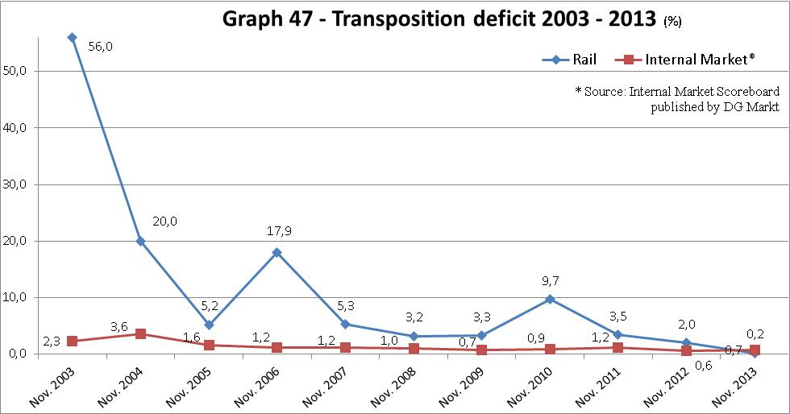
Source: European Commission
The rail related transposition deficit was initially of 56%, which reflects the low timely transposition of the first railway package into national laws (due April 2003). All of the 2004's entrants had transposed it when joining which, along with the absence of new Directives to be transposed by November 2004 and 2005, led to a decrease. The two peaks of 2006 and 2010 reveal a low on-time transposition of the second and third railway packages. Although the deficit was practically resorbed in 2013, it may rise again with the expiry of the transposition period for Directive 2013/9 amending Directive 2008/57 (due in January 2014). As of late November 2013, only eight Members States had notified national measures (BG, HR, IE, GR, IT, LV, PL, SE).
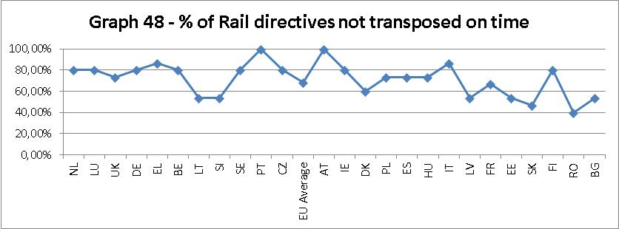
Source: European Commission
Overall, the on-time transposition is low. Since 2000, only 32% of rail Directives were transposed on time while 6% required more than two additional years to be transposed. If looking at Member States individually, Romania performs best with 60% of on-time transposition. On the other hand, Austria and Portugal have not transposed one single Directive on time since 2000.
Average delays for overdue Directives show that in four Member States it takes on average 18 "extra" months for rail Directives to be transposed (NL, LU, DE, UK). If considering market Directives only, it goes beyond two years in one Member State (NL).
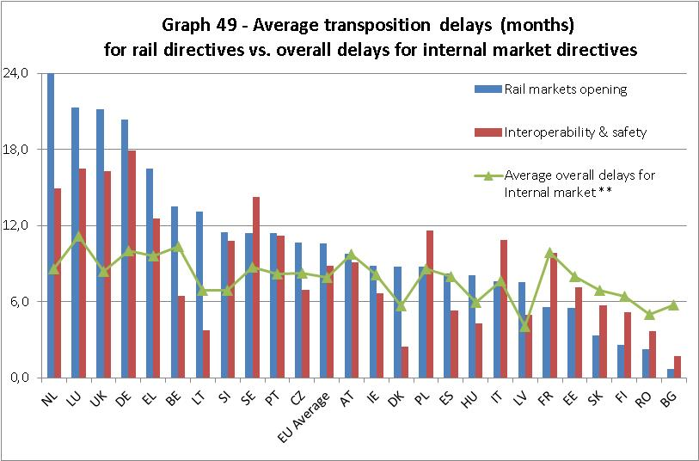
Source: European Commission; **- as explained in footnote 67, the average overall delays for internal market reflect a general trend
Although subject to some caution, the comparison of this data with the general trend for all of the internal market Directives shows that 21 Member States perform poorer for rail markets Directives than they do in other fields. This figure goes down to 13 Member States if only taking into consideration rail interoperability and safety Directives. The difference between rail and general delays is particularly important for the afore-mentioned four Member States (NL, LU, DE, UK), but also for SE, SI and GR. On the contrary, five Member States perform better on rail Directives than they do for the internal market overall (EE, SK, FI, RO, BG).
Graph 50 – Infringements in rail legislation
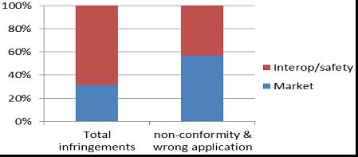
Source: European Commission
The Commission has initiated 134 infringement procedures on rail related provisions: 130 on Directives and 4 other on Regulations. By topic, 32% are on rail market provisions and 68% on interoperability and safety. Yet, an analysis by type of infringements shows that market provisions account for a disproportional 56% of all non-conformity and incorrect application infringements. Conversely, 95% of all non-notification infringements deal with interoperability and safety Directives.
For reasons of late or incorrect transposition, Poland, Germany and France are the Member Stares against which the most infringements were initiated. On the other hand Bulgaria and Luxembourg have had the least.
However, France and Italy come first in terms of infringements for non-conformity of the transposing measures or incorrect application of the rail related Directives. Netherlands, Luxembourg and the UK, three of the slowest Member States to transpose rail Directives, have had only one non-conformity/incorrect application infringement initiated against them.
Graph 51 – Infringements per Member State and per topic
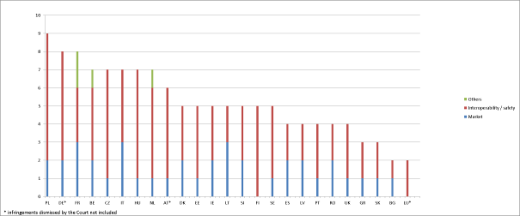
Source: European Commission - (*) infringements dismissed by European Court of Justice are not included

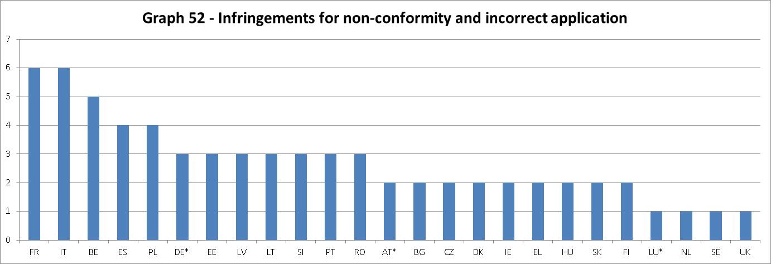
Source: European Commission - (*) infringements dismissed by European Court of Justice are not included

3.10. Development of employment and social conditions

3.10.1. Employment in rail
Based on data provided by Member States in the RMMS questionnaires, it appears that some 912,000 persons have been employed either in railway undertakings (561,000) or in infrastructure management (351,000). Employment in these two types of railway entities seems to have diminished by 4% in 2012 compared to 2011. Interestingly, as shown in the graph hereunder, the overall percentage of staff in infrastructure management is generally higher in South and Eastern Europe and lower in Northern Europe.
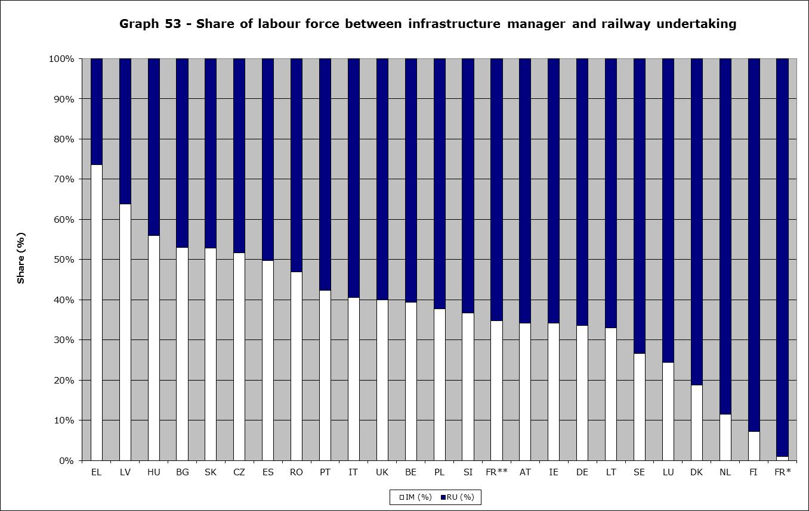
Source: RMMS questionnaires
**/*for France, the share of jobs as provided by France for the infrastructure management comprises both employees of SNCF Infrastructures and Réseau Ferré de France under (**) and exclusively Réseau Ferré de France (*).
Furthermore, new entrants appear to be employing some 118,000 (21%) of the total. There appear to be also some 118.000 train drivers (21% of all employees) across the EU, incumbents and new entrants combined.
Finally, 4 of the 5 most staff intensive infrastructure managements (LU, AT, BE, SE, SK) in terms of jobs per kilometres of infrastructure all operate small sized networks, whereby different levels of outsourcing (infrastructure construction and maintenance) and different scopes of activities remain out of consideration.
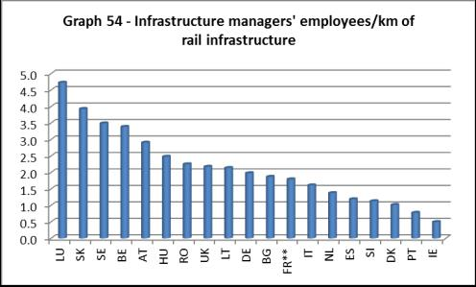
Source: RMMS questionnaires, annual reports RFIREFER/RFF

3.10.2. Socio-demographic structure of the rail labour market
In all European Member States, the proportion of men working in the rail sector is superior to the male share of the overall active population. This overrepresentation is among the highest in south European Member States such as GR, ES and IT but also in LU and BE. In GR and LU, more than 90% of all staff are men. A survey organised by the European social partners in the rail sector among EU railway undertakings estimates the share of women at 19.5%, but indicates that women are greatly underrepresented in some professions like drivers, where only 1.4% of the workforce is female (in managerial positions, 18% of the workforce is female). According to this survey, the situation tends to be better in Eastern Europe (in Latvia, 58% of engineers are female).
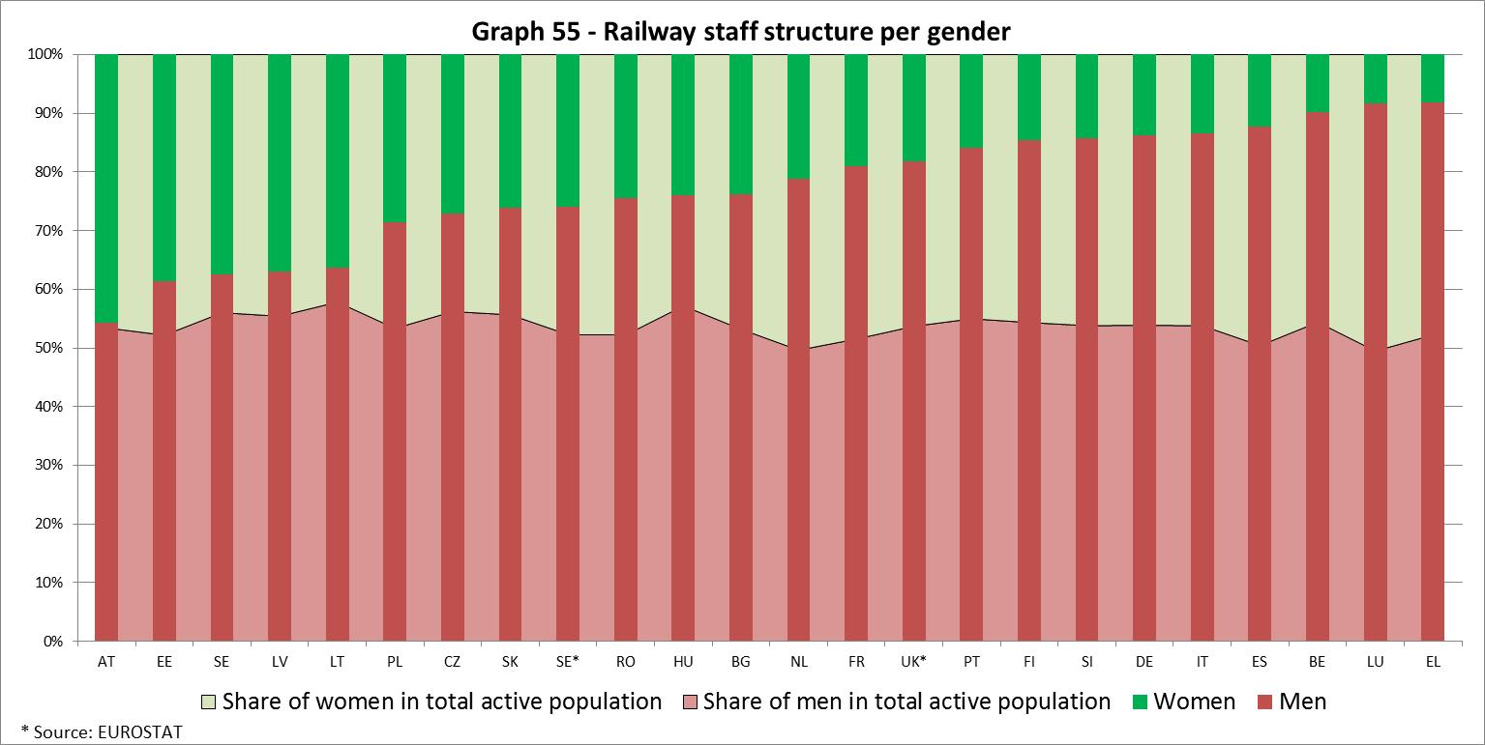
The rail sector is further characterized by an acute underrepresentation of young people (less than 30 years old). In all Member States where data is available, the share of staff under the age of 30 (blue bar on the graph) is significantly lower than the proportion of young people in the overall active population (light grey area on the graph). The percentage of people under the age of 30 is the lowest in southern Member States (GR, ES and PT) but also in PL or CZ. On the other hand, FR, LV and LU have the largest proportion of young rail staff, albeit still lower than the national average. Conversely, the share of rail staff over the age of 50 (pink and red bars on the graph) exceed the according proportion in the overall active population (dark grey area) in all the Member States studied except RO. In GR and FI, more than half of the rail staff is over 50 years old. In another 13 Member States, staff over 50 account for one third or more of the total (AT, BE, BG, CZ, DE, EE,IT, LT, LV, NL, PL, PT, SK). In France, the proportion is only slightly over the national average (27.5% in the rail sector against 26.8% nationally). Although data is missing for countries such as SE and UK where the rail sector appears to be particularly dynamic, this section seems to indicate an overall ageing of the rail labour force that may lead to a staff shortage once the current staff reach retirement age.
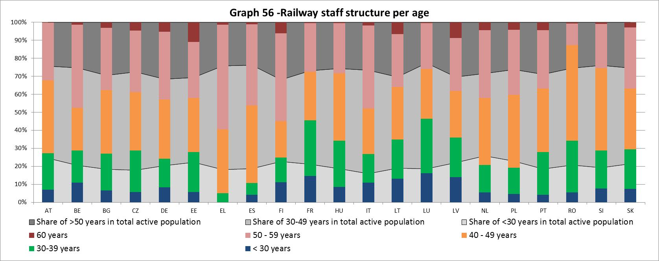
Source: UIC (2010)
In most of the studied Member States, the percentage of recently recruited staff is low generally due to downsizing of the labour force in line with other economic sectors. In only 3 Member States is the share of staff with less than 5 years of experience superior to the share of staff with more than 30 years (LT, LV and RO). On the contrary, in 4 Member States, the largest of all groups by seniority is the +30 years one (BE, FI, DE and LU). In GR, PL and ES, more than 80% of the staff has over 20 years of seniority. In another 10 Member States, this proportion is above 50% (SI, BG, PT, AT, DE, CZ, SK, HU, BE, FI). Due to the overall ageing of the labour force, this low replenishment of staff may have adverse effects for the sector, which may imply it has to downsize.
These evolutions plead for a thorough monitoring in terms of statistics, notably to determine which professions are most affected by this greying.
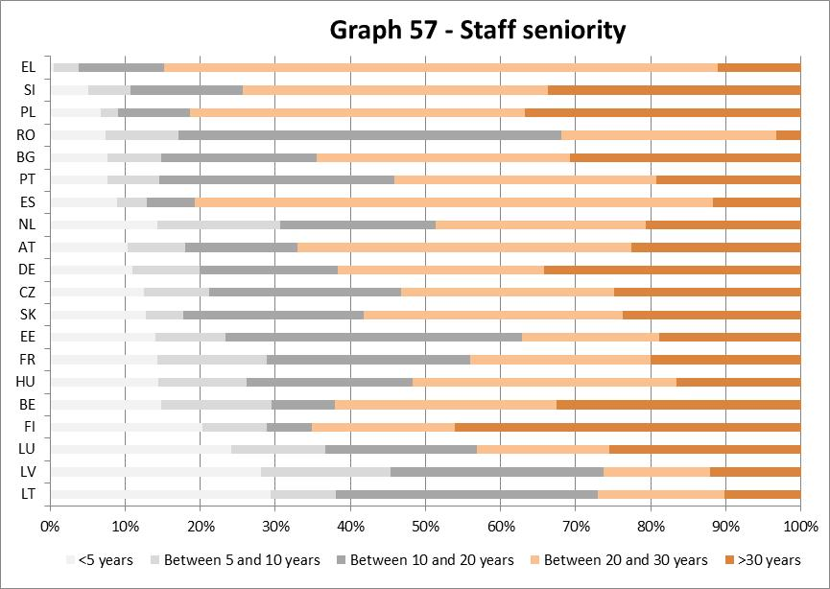
Source: UIC (2010)

3.10.3. Training activities
BG, DK, FI, GR, HU, LT, NL, PT and UK reported in their RMMS questionnaires their main training activities. In most Member States, training activities have been focused on drivers training and safety. The following schemes deserve attention:
- In DK, railway undertakings and infrastructure managers have developed a common training programme to support competence acceptance between employers.
- In NL, a new train drivers school, fully independent from railway undertakings, has been accredited by the Ministry of Education in 2011. 37 students graduated in spring 2013.
- In UK, the main infrastructure manager, Network Rail, created the cross-rail industry paid graduate programme "Track and Train", where recent graduates are placed 3 times for 6 months in different areas of Network Rail and also in railway undertakings.

3.10.4. Other aspects of working conditions
A study of the European Foundation for the Improvement of Living and Working Conditions provides some anecdotal evidence of the evolution of wages, temporary contracts and flexible working. Although there appear to have been increases in wage inequalities in Germany between old and new employees, there were actual wage increases in Belgium, France, Italy, Lithuania and Sweden. The same study indicates that temporary work remains very marginal in the rail sector, except in Slovenia, where most contracts are temporary and are addressed by a collective agreement. Initiatives appear to have taken in Slovakia, Spain and, Czech Republic as regards flexible working time.

4. State of the EU network and infrastructure limitations

4.5. Variation of infrastructure
Between 2009-2011, EU railway infrastructure has grown by 882km (+0,4%) reaching 216.297 km. This increase masks variations among Member States: 981km and 602km of railway infrastructure were added in respectively France and Spain, whereas 335km, 203km and 138km were withdrawn in Austria, Bulgaria and Germany. In relative terms, the greatest growth was recorded in the Netherlands (+130km, hence +5%) and the largest decrease in Estonia (-127km, hence – 14%).
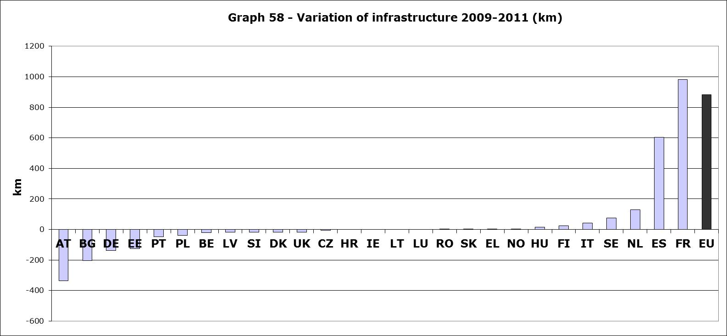
Source: EU Transport in figures, 2013, Statistical Pocketbook 2013
Since 1995, some 12.958km of rail infrastructure have been abandoned, with the largest decreases taking place either in the Eastern Member States (Poland, Latvia, Estonia) or in Germany (-8412km or a loss of 20%), and the largest increases taking place in Slovenia/Croatia (+18%) and Spain (+1624km or +11%).
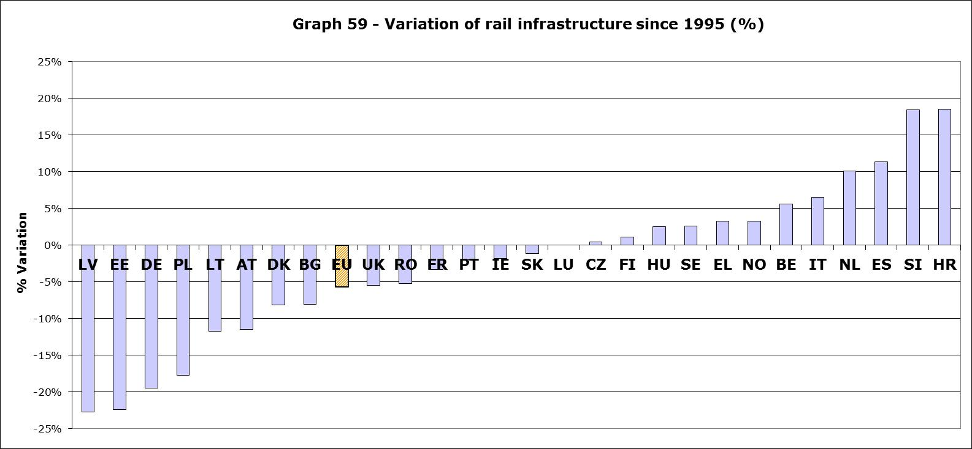
Source: EU Transport in figures, 2013, Statistical Pocketbook 2013

4.6. Management of infrastructure
The structures of management of infrastructure have not evolved during the period 2011-2012, except in Belgium, where the NMBS-SNCB Holding has been dismantled. Infrabel and SNCB-NMBS are now two separate entities that have a common subsidiary in charge of human resources.

4.7. Electrification
Overall, in terms of electrification, in 2011, only 53,2% of the EU rail infrastructure is electrified. There again, there are important variations between Member States: electrification is low in the UK, the Czech Republic (33% of the network) and extremely low in Greece (17%) and the Baltic Member States (6%).

4.8. Train movements
The analysis of train movements in TEN segments underlines the expected importance of rail freight traffic around cities, their marshalling yards and ports. In 2010, 44 out of the 56 EU rail segments with freight traffic above 60,000 trains/year (i.e.164 trains/day) were located in Germany and 7 were located in Austria (all in the Vienna-Salzburg axis). In Germany, the most important segments are around the marshalling yards of Maschen (Hamburg), Seelze (Hanover) and Oberhausen (Duisburg). Important movements of freight trains are recorded around cities like Cologne, Warsaw, Krakow and Innsbruck.
The analysis of train movements also suggests that the important freight traffic in Germany is feeding the port of Hamburg, and that Antwerp and Rotterdam are lagging behind in terms of rail freight connections. Rail traffic around the port of Rotterdam only reached 32,600 trains/year (i.e. 89 trains/day)- i.e. Rotterdam rail freight only represented 25% of Hamburg’s rail freight, where some 140.000 trains/year (i.e. 383 trains/day) circulated. Traffic in the rail freight dedicated Betuwe line reaches "only" some 18.000 trains/year (50 trains/day). These conclusions seem to be confirmed by a study of UIC which shows that the rail share of hinterland transport in Hamburg reached 36.8% against 11% and 12% for respectively Rotterdam and Antwerp.
Similar trends can be seen for passenger rail: the most important passenger rail movements are found in the vicinity of important central stations with important commuter railway networks, like London and Paris, but also in many German cities (Berlin, Frankfurt, Cologne, Stuttgart) and important European cities (Amsterdam, Barcelona, Helsinki, Stockholm and Vienna), which all have traffic above 200.000 trains/year (some 550 trains/day). Interestingly, segments around Rome and Madrid remain at 140.000 trains/year, while Luxembourg-City manages 75.000 trains/year, i.e. as much as a 2-million inhabitant city like Budapest.
This suggests that cities with important suburban train networks overlapping with the remaining train infrastructure are or could become bottlenecks, either for high-speed services or freight operations. Similarly, in rail freight, data suggests that traffic flows from the Ruhrgebiet to the Netherlands (and probably Belgium) are well below those reaching out Hamburg, who happens to have the largest marshalling yard in Europe. It might well be interesting to analyse the impact of these North-South rail freight traffic flows on the overall congestion of the German network, in particular with the need to complete on the German side interconnections with Belgium and the Netherlands.

5. Utilisation of access rights

5.5. Railway freight
The rail freight market was opened to competition in 2007. Since then new entrants have emerged in all but 3 Member States (Finland, Ireland and Lithuania) and the total share of freight new entrants in 2012 is estimated at 28%. DB, the German incumbent, is now the main railway operator in Denmark and the Netherlands. Finally, in the UK and Romania, the principal railway undertaking has less than 50% of the market.
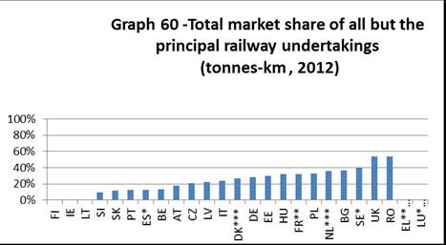
Source: RMMS contributions from Member States; *for Spain, data is based on the RENFE annual report and the RMMS questionnaire, whereas for Sweden, data is for 2010; ** includes VFLI, a subsidiary of incumbent; *** DB is the main railway freight operator; **** not available - annex 19 of Staff Working Document SWD(2014) 186

5.6. Passenger railways – regional and suburban segments

5.6.1. Passenger railways – all segments
Overall, the total market share of all but the principal railway undertaking reaches 23%. However, it is important to distinguish the situation of real new entrants, which have been awarded contracts through competitive tendering and/or through open access rights, from the one of other "non-incumbent" railway undertakings to which exclusive rights for commercial services or public service obligations have been directly awarded. This is important, for instance, to distinguish the situation of rail in Poland, where non-incumbents are regional operators, to which public service contracts have been directly awarded, and the situation in the UK, where franchises have been tendered. In these conditions, the market share of new entrants is estimated at 21% for the whole EU.
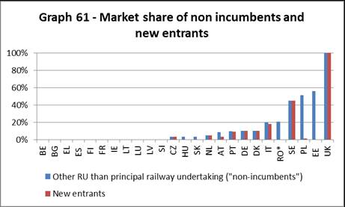
Source: RMMS contributions from Member States; RO= all non-incumbents appear to be regional operators; annex 19 of Staff Working Document SWD(2014) 186

5.6.2. Regional and suburban segments
The share of new entrants in regional and suburban rail is the greatest in those Member States that have opted for competitive tendering for public service contracts completely (the UK, Sweden) or extensively (Germany, Romania). The same also applies to Italy, Denmark, the Netherlands, the Czech Republic, Austria and Poland, where some public service contracts have been tendered. Hungary is a special case as there are two incumbents. In the UK, the incumbent has been respectively completely dismantled and franchises were awarded through competitive tendering. In Poland, the regional incumbent was dismantled and replaced by in-house operators owned by Polish regions (through direct award). There are no new entrants in the regional services inter alia in France, Spain and Belgium. Finally, in the context of a broadening of PSO tendering in the Czech Republic, Arriva has been doing some pilot tests services in open access in Prague suburban services.
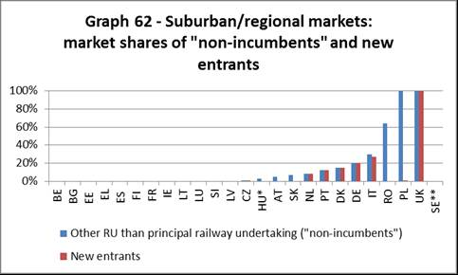
Source: RMMS contributions from Member States, completed with own calculations
based on UIC, CER, annual reports, annex 19 of Staff Working Document SWD(2014) 186
*there are 2 incumbents - this is the market of the small one; **no data for Sweden

5.6.3. Rail high-speed and long-distance segments
The share of new entrants in long-distance services is the greatest in the UK, where the incumbent has been dismantled, and Estonia, where the public service contract for long-distance services has been awarded to a new entrant. There are new entrants in Sweden (Veolia, BluTag), Italy (Italo-NTV in the Italian high-speed network), the Czech Republic (LeoExpress and Regiojet, both in the Prague-Ostrava route) and Austria (Westbahn in the Vienna-Salzburg route).
A number of companies have made known their intentions to open domestic commercial services in several Member States. MTR, part of the broad MTR Group from Hong Kong, has indicated its intention to start new services on the Stockholm-Goteborg line. Leo Express/DLA applied to enter the Warsaw-Krakow/Katowice and Warsaw-Szczecin routes, but the application was refused on administrative grounds.
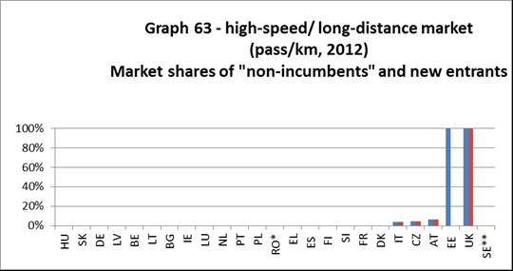
Source: RMMS contributions from Member States, completed with own calculations
based on UIC, CER, annual reports, annex 19 of Staff Working Document SWD(2014) 186
*all new entrants appear to be regional new entrants
** no data for Sweden

5.7. Passenger railways – international services
Thello a joint venture between Veolia and Trenitalia operating night services between Paris and Venice is the only new entrant in international services. DB has indicated that it intends to operate as a competitor to Eurostar on the Brussels-London line (originating in Frankfurt). Thello has also applied for a Belgian licence and the city of The Hague appears to have signed an agreement with DB Arriva to link it with Brussels. Finally, thanks to the opening of the France-Spain high-speed connection, SNCF and RENFE are now offering Paris-Barcelona and Madrid-Marseille services.

6. Barriers to more effective rail services
The Commission has identified the lack of opening of domestic passenger rail markets (which cover 94% of all passenger-km) and the inadequate portfolio of functions for infrastructure managers as the two main obstacles in the area of market access for a fully functioning Single European Railway Area. On the 30th January 2013, the Commission adopted the 4th railway package proposals to modify Directive 2012/34/EU and Regulation (EC) No 1370/2007 on public passenger transport services by rail and by road to fulfil these objectives.

7. Conclusions
The assessment of this report confirms the analysis made by the Commission when submitting the 4th railway package proposals: the level of satisfaction with railway services leaves great room for improvement, many high-speed infrastructures are under-used (and their usage could be increased thanks to open access) and it is necessary to ensure the efficiency of the important amounts of public funds devoted to rail (some € 36 billion for infrastructure grants and public service obligations) to ensure the sector's long-term viability in a context of constrained public budgets. The assessment of this report also confirms the need to proceed with the adoption of several implementing acts under Directive 2012/34/EU (direct costs, economic equilibrium of public service obligations, RMMS statistics, template for licences…). Furthermore, it also shows that measures to improve accessibility of persons with reduced mobility are likely to have a positive impact for ridership overall. The completion of railway freight corridors can help rail to increase its average transport distances (which make rail more cost-effective and thus more competitive). Finally, this report also supports a research and innovation programme under 'Shift2Rail' devoted to the improvement of the quality of rail services, the reduction in the life-cycle cost of railway transport, and an overall increase in reliability in the different rail market segments, including rail freight (which needs to move more fluidly throughout Europe carrying more high-added value products).

The Consumer Scoreboard’s Market Performance Indicator is a composite index that takes into account 4 key aspects of consumer experience (easiness to compare services, consumer’s trust that seller complies with consumer protection law, problems experienced and overall consumer satisfaction).
OJ L 315, 3.12.2007, p. 14.
Consumer Scoreboard 2012, page 27 – the internal market averages are: 9% of 0-4 rating and 37% of 5-7 rating (for rail, the latter is 40%)
For more information, see also Annex 12 of Staff Working Document SWD(2014) 186
The Flash Eurobarometer conducted in 2013 on the quality of rail services follows up a similar exercise performed in 2011 – however, the Flash Eurobarometer of 2011 does not cover suburban services. As a consequence, comparison between the two surveys is only done for national, international and regional services ("conventional").
Ibid.
Consumer Scoreboard 2012, page 24
Cf. Annex 12 of Staff Working Document SWD(2014) 186
Although the focus is on frequency, other time-related variables play an important role in traveller's decision such as waiting time, distance to station, in-vehicle journey time, transfers, ...
i.e. respondents that are fairly or very dissatisfied with punctuality and reliability – excludes respondents without opinion
Ireland, Czech Republic and Estonia did not provide any data.
UIRR, Road-Rail Transport: new developments and best practices, 55. Session of the UNECE Working Party on Intermodal Transport and Logistics, 6-7 November 2011, available at www.unece.org – this data seems to be confirmed by CER (2013) Rail Freight Status Report 2013, where less than 70% of freight trains arrived within 15 minutes of their scheduled time during the period 2008-2012.
17,8 billion in 2011 (no data for Slovenia and Finland) and 18,4 billion in 2012 (no data for The Netherlands)
The "net public support" to a 140 tonne suburban train in France is estimated to amount only to 7.1 EUR/train-km, as 10.9 EUR/train-km serve to pay track access charges.
The "net public support" to a 140 tonne suburban train in Germany is estimated to amount only to 4.8 EUR/train-km (deducting track access charges).
The number of tendered contracts in a Member State also depends on the contract size. There are only 19 franchises in the UK, whereas based on the Mofair report, there are at least 31 railway undertakings operating one or several public service contracts in Germany.
Contract notices have been interpreted as calls for competition and not notices used only for transparency (for which ex ante voluntary notices or contract award notices are best suited)
The German RMMS questionnaire reports the tendering of 49 PSCs in 2009-2011, whereas there are 45 PSCs in OJEU/TED during the same period.
As far as rail is concerned, the number of contract award notices for negotiated and accelerated procedures without prior publication and voluntary ex-ante notices has doubled since 2009: there were on average 12 publications in 2006-2009 and 22 for the period 2010-2012.
Social criteria, if used, are regrouped statistically under this award criteria
CER-ETF (2012), Social Aspects and the protection of staff in case of change of railway operator: the current situation, pp.66-67 – in some Member States there are provisions of transfer of staff for urban transport (which explains why some Member States that did not open their PSOs to tendering are listed.
Franchises are UK public service contracts
These assumptions have been based mostly on CER (2010) Public service in rail transport in the European Union: an overview
Bundesgerichtshof Beschluss X ZB4/10 vom 8. Februar 2011 S-Bahn Verkehr Rhein/Ruhr
Railway Gazette (2013), Czech passenger market opening in sight, 17.10.2013
Single Market Scoreboard: http://ec.europa.eu/internal_market/scoreboard/
Due to the limited number of rail Directives (15) compared to internal market's (over 1500), the calculation method for average delays of transposition differ. While the internal market scoreboard calculates the average delays at a cut-off date each year, the rail statistics show the average 'net' delays for the 15 rail Directives (i.e. between the end the transposition period and actual notification by a Member State). The graph therefore indicates a general trend rather than a statistical-based accuracy. Sources: internal market scoreboard n°12,14bis, 15,16,20,21,22,23,24. The indicator only catches Directives not transposed on-time (there was a single case of full non-transposition, but where the non-transposed Directive was repealed in the meantime).
At least some 63,100 additional persons are working with railway service facilities – however, numbers remain insufficiently reliable to provide an EU-wide estimate.
Unless otherwise mentioned, all data in this section comes from the 2010's International Railway Statistics published by UIC (International Union of Railways). It provides no comprehensive datasets for IE, DK, UK and SE, which could therefore not be included in the age structure and seniority studies. As for the structure per gender, data were provided by Eurostat for SE and UK but not for IE and DK. These two Member States are thus completely excluded from the scope of this section. Moreover UIC datasets for a certain number of Member States deviates significantly from the figures indicated in the RMMS questionnaires completed directly by the Member States and transmitted to the European Commission's services. For these Member States, the indicators developed in this section then ought to be interpreted with caution. These Member States are: DE (inclusion of DB Schenker in the UIC statistics), NL (Infrastructure manager ProRail not included in UIC), AT, BE, PL, RO (fragmental UIC datasets).
CER (2014), Results of the 2013 questionnaire on the development of women employment in the railway sector in Europe, published on 20.01.2014. This survey was a joint exercise between the European social partners in rail: employers (railway undertakings represented by CER, the Community of European railways) and workers, (represented by ETF, European Transport Workers Federation)
Employment and industrial relations in the railway sector, study of the European Foundation for the Improvement of Living and Working Conditions, 2012
The first TEN decision dates back from 1996.
Data on traffic in TEN infrastructures and, in most cases in non-TEN, is collected by Eurostat as part of Annex G of Regulation 91/2003 every 5 years (2005 and 2010, which was just recently released). Data for Belgium and Greece is missing for 2010, data for Bulgaria and Romania was not recorded in 2005, as these were not yet EU Member States.
30,000 in each segment direction – hence 60.000 trains in both directions.
Data for Antwerp is not available in 2010.
UIC (2012): 2012 Report on Combined transport in Europe, December 2012, p.80
As indicated under quality of services, frequencies of high-speed services still have room for growth (except in France).
Swedish rail freight undertakings have identified Copenhagen, which manages 180.000 trains/year, as a major difficult cross point. In Germany, the highest increases of track access charges took place on regional lines.
Given that the freight sector does not have any more public service obligations and is legally completely open, "Railway undertakings other than the principal undertaking" give a good estimation of the market penetration of new entrants (since the market leader is almost always the incumbent). In the UK, further to the dismantling of British Rail, it could be argued that all rail freight undertakings are new entrants.
PKP PLK rejects Leo Express access bid, International Rail Journal, 22.07.2013 – It appears that the application was rejected as the regulator had not been consulted on the impact of those services on the economic equilibrium of public service obligations.
OJ L 315, 3.12.2007, p. 1.

