Executive summary 2
1. Introduction 15
1.1 Risks and resilience 15
2 Current European energy security 16
2.1 Energy sources in the EU 16
2.1.1 All energy products 16
2.1.2 Oil 25
2.1.3 Natural gas 36
2.1.4 Coal 61
2.1.5 Uranium and nuclear fuel 72
2.1.6 Renewable energy 79
2.2 Energy transformation 81
2.2.1 Refining 81
2.2.2 Electricity 85
3 Expected European energy security in 2030 92
3.1 Oil 93
3.2 Natural gas 95
3.3 Solid Fuels 96
3.4 Uranium 97
3.5 Electricity 98
3.6 Comparison to IEA projections 100
4 Assessment of energy capacity, transport and storage 102
4.1 Hydrocarbon reserves 102
4.2 Oil 104
4.2.1 Infrastructure and supply routes 104
4.2.2 Internal energy reserve capacity 107
4.2.3 External energy reserve capacity 107
4.2.4 Emergency response tools 108
4.3 Natural gas 110
4.3.1 Internal energy reserve capacity 110
4.3.2 External energy reserve capacity 113
4.3.3 Improving the internal market and infrastructure 115
4.4 Coal 127
4.4.1 Internal energy reserve capacity 127
4.4.2 External energy reserve capacity 127
4.5 Uranium and nuclear fuel 128
4.5.1 External energy reserve capacity 129
4.5.2 Improving the internal market 130
4.6 Renewable energy 131
4.6.1 Internal energy reserve capacity 131
4.7 Electricity 134
4.7.1 Internal energy reserve capacity 134
4.7.2 Improving the internal market 141
4.8 Research and innovation 144
4.9 Country-specific supplier concentration indexes 146
5 Conclusions 153
Annex I: Country annexes 154
Annex II: Emergency response tools to address an oil supply disruption 228

Executive summary
Introduction
As energy has come to be a vital part of Europe's economy and of modern lifestyles, we have come to expect secure energy supplies: uninterrupted access to energy sources at an affordable price. We expect to find petrol at the pumps, gas for heating and non-stop electricity, with blackouts too disruptive to countenance. To meet such expectations, for several years, Europe's energy policies have had a security of supply "pillar". Policies have been introduced to create electricity and gas markets, increase competition, diversify sources and supplies, to cut consumption and emissions. These policies not only aim to increase competitiveness and keep affordable prices as well as move towards a more sustainable energy system, but –the EU being a major energy importer- they are equally important for energy security. Thus, with the EU's 2020 energy and climate policies, energy efficiency and renewables polices and the planned 2030 policies, a range of measures exist to also address security of supply concerns.
Despite the national and European measures and laws in place, current events on the EU's Eastern border have raised concerns regarding both the continuity of energy supplies and regarding the price of energy. This has provoked apprehension regarding short term access to energy, in particular access to affordable gas supplies in the coming months. It has also raised questions about the adequacy of the measures taken for the medium term.
To help address and better understand all the issues surrounding the security of energy supply, the March European Council called on the Commission to conduct an in-depth study of EU energy security and to present by June a comprehensive plan for the reduction of EU energy dependence. The study - this report - provides an extensive range of information and analysis regarding the sources, diversity, dependency and cost of energy in each Member State and for the EU as a whole. In this way, it aims to provide Member States, the European Parliament and stakeholders a deeper understanding of the energy system from a security perspective. It also provides a basis, underlying data and evidence for the comprehensive plan for the reduction of EU energy dependence, presented by the Commission together with this document.
Risks and resilience
The energy system is a complex structure, where aspects of "security" differ according to the actors involved at each point in the chain. Schematically, the system consists of fuels, transformation and consumption:
Figure S 1. Energy system
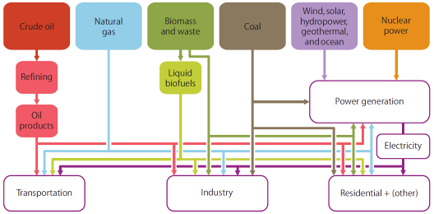
(Source: IEA MOSES working paper 2011)
For each tier, the risks to security differ, as does the element's resilience.
The risk of disruptions or significant price spikes to fuel supply depends on the number and diversity of suppliers, transport modes, regulatory framework and supply points, and the commercial and political stability in the countries of origin. The resilience of energy providers or consumers to respond to any disruptions by substituting other supplies, suppliers, fuel routes or fuels depends on stock levels, diversity of suppliers and supply points (infrastructure, ports, pipelines). These are the elements which are the common focus of energy security discussions, focussing both on events which require short term responses (to short term "crises") and medium responses to reduce risks and improve resilience.
The energy transformation tier, including refining and power generation, also faces risks. Refining risks are associated with having access to sufficient capacity for refining of different fuel sources. In the electricity sector, in addition to the above fuel risks, there are risks of volatility of supply, of system stability and generation adequacy, and risks related to operation and development of networks, including interconnection capacities. Resilience in this sector also depends on the number and diversity of fuels, refineries and power plants, as well as imports from third countries in the case of petroleum products.
The third element of the energy system is the composition of the consumers: amongst the variety of different households and industries, the costs of supply disruptions differ, as does the resilience of different groups and their flexibility to shift or reduce energy consumption.
For each of these three components of the energy system, of Europe's energy mix, the degree of risk or of insecurity can be assessed. And for each component there are a variety of measures that can be adopted, both at national and at European level.
It needs to be stressed that the EU's energy system is increasingly integrated, while at the same time Member States are importing from the same supplier countries. It is therefore important to consider energy security from an EU perspective, an issue that is reflected in the new Energy Article of the Lisbon Treaty. Choices taken on the level of fuel supply, infrastructure development, energy transformation or consumption lead to spill-over effects on other Member States. Next to providing key information on the energy security situation of each Member State, this assessment aims to consider energy security aspects also from a regional and EU perspective.
Current European energy security
Total demand for energy slowly declining
Total demand for energy has been increasing slowly in the period 1995-2006, but since then has been gradually falling, it is now more than 8% below its 2006 peak due to a combination of factors, including the economic crisis and structural changes in the economy of the EU, and efficiency improvements. Such changes and improvements have been linked to concrete polices implemented in the last 10 years, as well as to the significant increase of fossil fuel prices, most notably oil.

Figure S 2. Total energy demand, EU28, ktoe
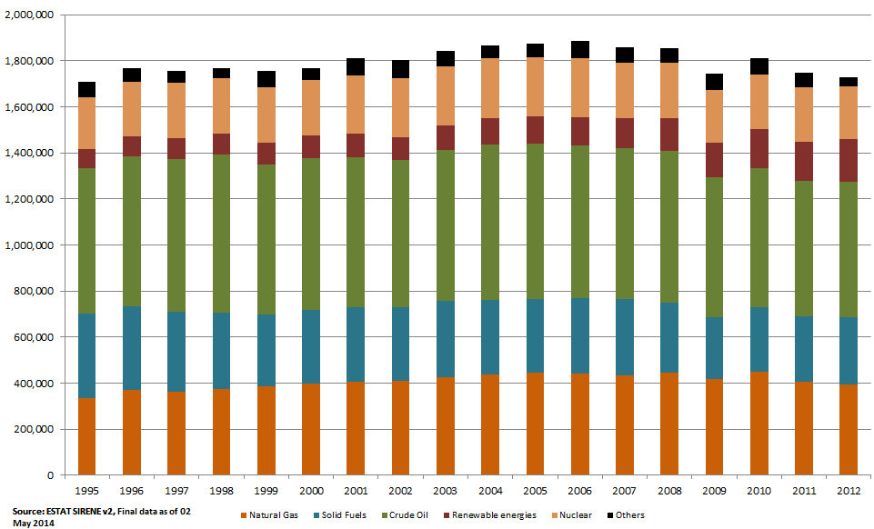
The composition of consumption has shown a slow but persistent change over time with the share of gas going up from around 20% to 23% of gross inland consumption between the mid-1990s and 2012 and the share of renewables more than doubling to almost 11% in 2012. In contrast, the shares of solid fuels declined from around 21% to 17%, oil from 37% to 34%, whilst nuclear remained stable in relative terms at 13%.
Figure S 3 Total energy demand, shares by fuel (%) in each Member State, 2012
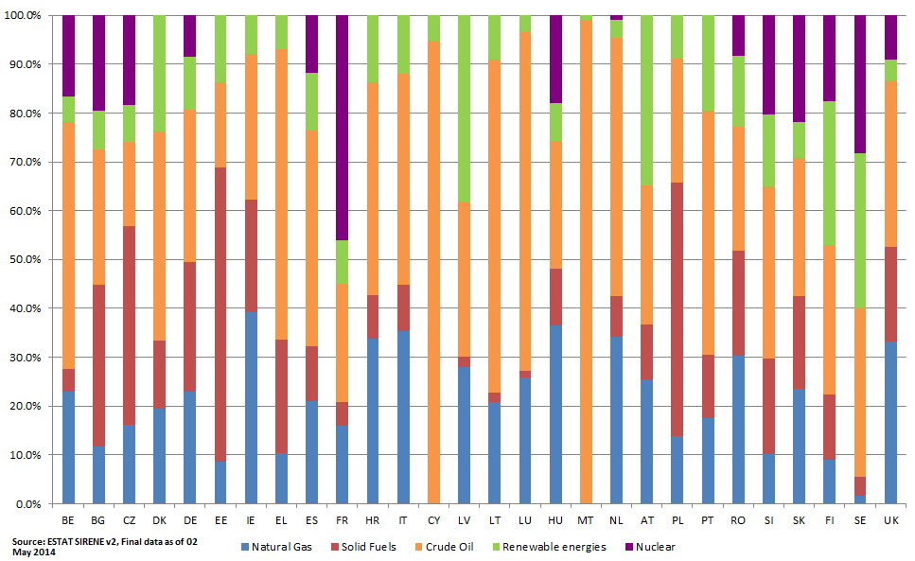
Note: In the case of Cyprus, Estonia, Latvia, Luxembourg Malta and Slovenia values refer to petroleum products, not crude oil.
A trend of increasing import dependency, reaching more than 50% in recent years
In the last 20 years, import dependency has increased by almost a quarter (10 percentage points), especially in the first decade. Two factors are at the origin: (1) a significant decline of EU production of oil, gas and coal, linked to a gradual depletion of EU reserves and the closure of uncompetitive sources, and (2) growing amounts of imported oil, gas, and coal to compensate for declining domestic production.
However, since 2006, the increasing share of renewables as well as the reduction of overall demand seems to have contributed to a stabilisation of import dependency.
The result is that for 2012, oil still constitutes the largest quantity of imports and at almost 90% still one of the highest shares of import dependency. The 66% import dependency of gas is the next greatest quantity, and the 62% of hard coal the third. Whilst import dependency for uranium is 95%, it constitutes a relatively small quantity. And the lowest import dependency of 4% occurs for renewable energy (chiefly biomass).
Figure S 4. Share of EU energy imports, %
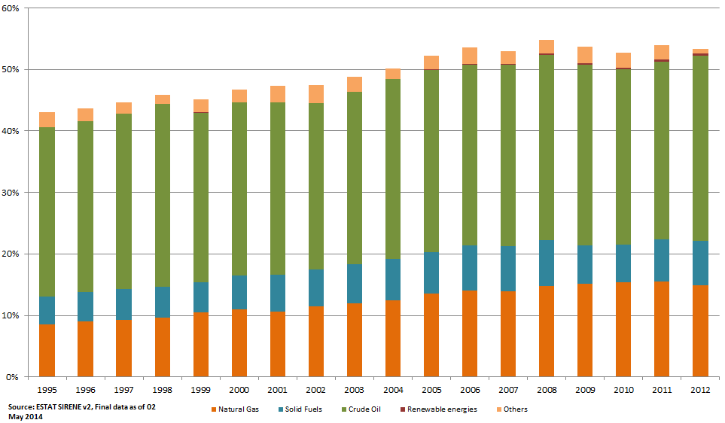
Major differences among Member States, but nearly all are heavily import dependent
The aggregated EU-level numbers hide a great deal of differences between Member States. In Member States with indigenous energy production, import dependency has changed considerably: two Member States have gone from having an energy surplus to a significant deficit, another has changed from deficit to slight surplus; 18 member States import more than 50% of their energy. Whilst the deficit of some countries has decreased, this is mostly due to falling energy demand rather than increased domestic supply.

Figure S 5. Energy import dependency, all products
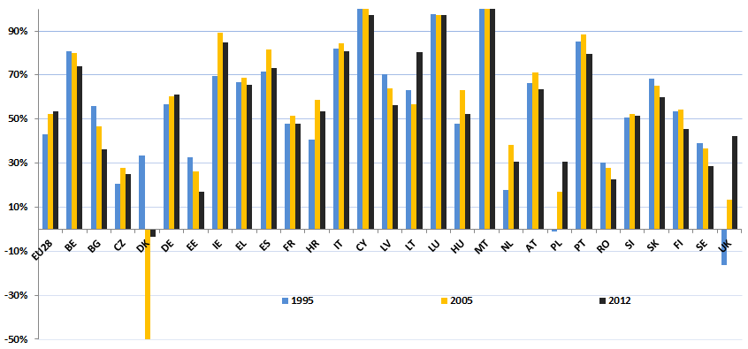
France, Spain and Italy have all seen energy deficits peak in 2005, the subsequent decrease driven by a combination of weak demand and increased renewable energy. The deficit of the largest energy consumers in the EU – Germany – has unsurprisingly been the largest in energy terms and since its peak in 2001 has shown fluctuations in both directions, without a stable trend.
Crude oil: risks of supply disruption mitigated by liquid global oil markets and regulated stocks, but a tight supply/demand balance, the concentration of suppliers and high import dependency can lead to price shocks with significant economic consequences in case of supply disruption events
Oil continues to be the largest single primary energy source used in the EU. It is mainly fuelling transport where it has limited viable alternatives (providing 95% of transport fuel). Of all energy sources, it has one of the highest shares of imports (almost 90%), leaving the EU exposed to the global oil market where the EU is a price taker. Because of the structural unbalances in European refining, the EU is also reliant on international product trade. Oil is traded in a liquid global market, but suppliers are quite concentrated, hindering diversification efforts. However, since it is mostly imported by sea, from a logistical point of view, it is relatively easy to switch from one supplier. Refineries reliant on Russia's Druzhba pipeline constitute an exception. The concerned Member States would require improved alternative supply routes in order to ensure effective diversification.
Given oil's history of supply and price shocks, significant steps have been taken to diversify supplies and to prepare for short term shocks. EU Member States are legally required to hold emergency oil stocks equivalent to 90 days of net imports. In addition, other measures including demand restraint can contribute to addressing longer lasting disruptions. Transport's dependence on oil still has to be addressed. Whilst efficiency levels have improved significantly in the last decade, progress towards substitutes and alternative supplies (e.g. biofuels, electricity) continues to be limited.
Gas: development of markets and gas infrastructure (interconnectors, reverse flows and storage) are improving resilience, but a short term winter supply disruption through Ukraine transit routes poses significant challenges, in particular for Bulgaria, Romania, Hungary and Greece.
The EU's increasing dependency on gas imports has posed a challenge and increased the risks to security of supply. A reliable, transparent and interconnected market has the potential to mitigate these risks. The EU imports over 60% of its gas, with two thirds of these imports coming from countries outside of the EEA. The Baltic States, Finland, Slovakia and Bulgaria are dependent on a single supplier for their entire gas imports. The Czech Republic and Austria also have very concentrated imported gas supplies.
Figure S 6. Supplier concentration, natural gas, 2012
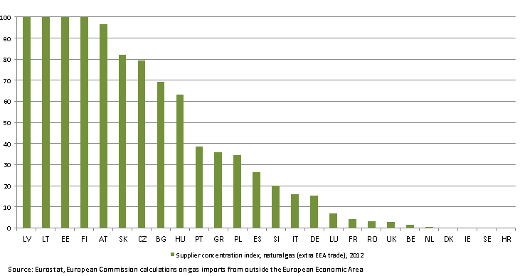 Note: The supplier concentration index takes into account both the diversity of suppliers and the exposure of a country to external suppliers: Large values indicate limited diversification with imports forming a large part of consumption
The flexibility of transport infrastructure in terms of location, number and available capacity of pipelines and LNG terminals, underground storage and the way infrastructure is operated all play an important role in shaping the resilience of the gas sector. The potential to operate pipelines in two directions increases the resilience in case of a supply disruption. Further investment in physical reverse flows is therefore important.
Figure S 7. Underground gas storage facilities in Europe
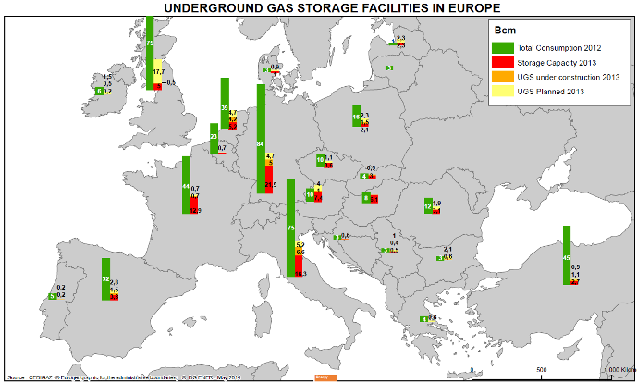
Source: CEDIGAZ.
The flexibility of supply in the short term and availability of alternative external sources depend on competition on the world markets, most notably for LNG, and on the degree to which such sources are already reserved by long-term contracts or other commitments (e.g. intergovernmental agreements). In the EU the long term contracts of pipeline gas are estimated to cover 17-30% of market demand, nearly entirely from Russia.
EU import pipeline capacity is 8776 GWh/day, roughly comparable to the capacity of LNG terminals (6170 GWh/day). The scope for using more of the LNG capacity differs among terminals, largely depending on their location and infrastructure. There is more scope on the Iberian Peninsula and less for supplies in Eastern Europe. The role of LNG as a ready tool to increase resilience in the short term is undermined by high global LNG prices on Asian markets and long term contracts for pipeline gas deliveries. The EU's gas storage, together with increased scope for reverse flows, can play a mitigating role in the event of supply disruption. A well-functioning market sending correct price signals will also help steer gas flows and boost storage levels in the event of restrictions to supplies. So EU internal market, reverse flow and gas storage rules all help to boost EU gas supply resilience and ensure that missing gas is being delivered.
The estimates of ENTSO-G show, depending on the duration and on the level of the demand (e.g. high demand in winter), potential disruptions will affect a majority of EU Member States directly (except for France, Spain and Portugal). Indirect effects will include increases in LNG gas prices for the entire EU. The state of infrastructure, levels of interconnections and market development expose some Member States in the east to greater disruption than those in the west. According to various analysis of ENTSO-G, in the case of disruption of transit through Ukraine, those countries exposed to likely disruption of deliveries are Bulgaria, Romania, Hungary and Greece, as well as Energy Community Members FYROM, Serbia and Bosnia and Herzegovina. In the case of disruption of all supplies from Russia over winter (October to March), in addition to the above countries, Finland, Poland, the Czech Republic, Slovakia, Croatia, Slovenia, and the three Baltic States - Lithuania, Latvia and Estonia - are also exposed to disruption. Interruption of supply to Lithuania may also impact on the level of supply in Kaliningrad.

Solid fuels: increasing import dependence, liquid markets, but low level of modernisation, ageing power plants, low efficiency and lack of diversification lead to high carbon intensity in some countries

Solid fuel (including hard coal, sub-bituminous coal, lignite/brown coal and peat) provides 17% of the EU's energy, with Germany, Poland, the UK and Greece being the top four consumers. The largest part of solid fuels serves as transformation input to electricity, CHP and district heating plants, with smaller amounts going to coke ovens, blast furnaces and final energy demand.

Between 1995-2012 demand declined by almost 20%, falling in nearly all Member States. The import dependency for solid fuels has been increasing also due to the closure of uncompetitive mines in a number of EU countries, and currently stands at 42%. However, for hard coal on its own, this figure increases to more than 60%, with Russia being the main source (26% of all imports to the EU). Most recently, demand for coal has rebounded as a result of favourable prices compared to gas, leading to gas to coal switch in electricity generation.
The global market for hard coal is liquid, with multiple suppliers and broadly well-functioning transport infrastructure. Given coal's high carbon intensity, (higher carbon content and relatively low generation efficiency), its viability and potential contribution to energy security in the medium to long term is subject to modernisation in terms of increasing conversion efficiencies and further technological improvements, notably the development and application of carbon capture and storage.
Nuclear: diversified supply of uranium, but final fuel assemblies are not, notably for Russian reactors in Bulgaria, Czech Republic, Finland, Hungary and Slovakia
Nuclear powered electricity constitutes 13% of the EU's energy consumption, and 27% of its electricity generation. 95% of the fuel, uranium, is imported, from a variety of supplying countries (including Kazakhstan, Canada, Russia, Niger and Australia), for the EU's 131 nuclear power plants (in 16 Member States, led by France, the UK, Sweden, Germany, Belgium and Spain). The Euratom Treaty set up a common supply system for nuclear materials, in particular nuclear fuel, established the Euratom Supply Agency to guarantee reliability of supplies and equal access of all EU users to sources of supply.
Uranium must undergo several processing steps (milling, conversion, enrichment) before being fabricated into tailor-made, reactor type-specific "fuel assemblies". And whilst the uranium itself can be purchased from multiple suppliers and easily stored, the final fuel assembly process is managed by a limited number of companies. For western designed reactors, this process can be split, and diversification of providers achieved. For Russian designed reactors, the process is "bundled" and managed by one Russian company, TVEL, currently with insufficient competition, diversification of supplier or back up. Thus, EU fuel assemblies are approximately 40% dependant on non EU suppliers.
Renewable energy: the most indigenous resource with greatest fuel diversity, but with concerns regarding the variable nature of wind and solar power, creating challenges in terms of reliability, requiring adaptation of the grid
Renewable energy, promoted by the EU in particular for energy security and sustainability/decarbonisation reasons for almost two decades, constitutes the most indigenous form of energy, with imports (of biomass) constituting only 4% of total renewable energy production. In 2012 the production of renewable electricity reached 799 TWh. Hydro power is the most important renewable electricity source and accounts for 46% of renewable electricity generation in the EU, biomass 18%, and wind and solar power 35% (or 7% of gross electricity production). As the share of wind and solar power grows, however, further modernisation of the grid and system operations will be necessary to ensure the electricity supply continues to be reliable.
Refining
Regarding energy transformation, the refining industry has a crucial role in transforming crude oil into oil products which can be used for final consumption. While the EU has ample refining capacity to cover the overall demand for petroleum products, it is a net exporter of certain products (in particular gasoline and, to a smaller extent, fuel oil) but a net importer of others (gasoil/diesel, jet fuel, naphtha and LPG). As with Uranium, the reliance on non EU processing can add commercial or supply constraints if the global market is not competitive.
Electricity: an increasingly diverse fuel mix with high system reliability, but more integrated and smart infrastructure is needed to enhance market functioning, improve efficiency and the integration of renewable and distributed generation
The transformation of fuel into electricity is a critical element of the EU's energy sector. Unlike other final energy sources, electricity constitutes the most fuel-diverse form of energy available. In addition, diversity in terms of fuels and generation technologies is expected to increase further in the future. To a degree, fuel switching is feasible, in response to price signals or supply constraints, with the range of commercially available electricity generating technologies continuing to grow, increasing the potential to combine energy security, sustainability and GHG emission reduction objectives. Nevertheless, this overall EU picture conceals large differences between Member States.
The storage capabilities for electricity are very limited, which means that production and consumption need to match almost instantly, posing particular challenges to the transmission and distribution network infrastructure. Nevertheless, system reliability of the electricity system is very high compared to other regions of the world. The resilience of the EU's energy system is being improved through the growing use of electricity, notably with improvements to the integration of the European electricity grid and completion of key inter-connectors. Import dependency is being reduced through the growth of the use of renewable energy sources. As well as improving the EU's overall energy resilience, such measures are also tackling the vulnerability of isolated electricity systems, (notably the energy islands of the Baltic Member States); improving their scope for developing competitive markets and reducing the negative security and economic impacts of market concentration.
The difficulties of building and maintaining such a network create bottlenecks which constrain competition and market development. Electricity infrastructure constraints can also undermine the reliability or security of electricity supply, since infrastructure, power plant or fuel supply failures in relatively isolated systems (e.g. "energy islands") will have less scope for market responses and more negative impacts than in well interconnected areas.
In conclusion, in the case of electricity, security of supply issues are different from those of fossil fuels, and in most of the EU countries the resilience of the power system is good enough to cope with problems of usual magnitude. However, simultaneous occurrence of unusual or extreme events (e.g.: an ongoing cold and dry winter coupled with a major external gas supply disruption) might cause perceivable disturbances in the functioning of the European electricity system and internal market. In order to avoid such disturbances, member states need to coordinate their electricity generation adequacy assessments at least with their direct neighbours or with other countries in the EU as well. In the case of the electricity security of supply issues are rather related to the stability of the grid, however, supply issues of fuel feedstock have repercussions on the electricity market. Therefore, exchanges of information on negotiations with external fossil suppliers among the EU member states could also contribute to assuring the security of generation feedstock supply.
Expected European energy security in 2030
In a medium-term perspective, the 2030 Framework for energy and climate policies will generate substantial energy security benefits. In particular, the increase of indigenous energy sources via the proposed renewable energy target, as well as the reduction of energy consumption via a new energy efficiency framework will contribute to lowering the Union's energy dependence. As part of the 2030 Framework, the Commission proposed a governance scheme based on national plans for competitive, secure and sustainable energy which aims to increase enhance regional coordination and coherence between EU and national energy policies. It also proposed 3 energy security indicators: diversification of energy imports and the share of indigenous energy sources used in energy consumption; deployment of smart grids and interconnections between Member States; and technological innovation. As with this in-depth study, monitoring of these indicators over time can help track the benefits of EU energy security policy.
Under a regime of more coordinated European energy policies, common climate policy objectives and a growing single market, the resilience of Europe's energy sector should improve. The figure below combines the historic trends on energy deficit until 2012, with the projected energy deficit under 2 scenarios: the Reference scenario reflecting the full implementation of the 2020 policies and a '2030' scenario reflecting, the implementation of the proposed 2030 Climate and Energy policy framework. It illustrates that despite continued reduction in the production of indigenous fossil fuels, the net imports are decreasing significantly, as a result of efficiency as well as fuel diversification.

The importance of energy efficiency for attaining the energy policy objectives of sustainability, competitiveness and energy security in the medium term has been underlined by the 2030 Framework. In the proposed governance scheme, national plans for competitive, secure and sustainable energy would include Member States' contributions to EU energy efficiency improvements.

Figure S 8. EU net imports, ktoe, 1995-2012 and Commission projections
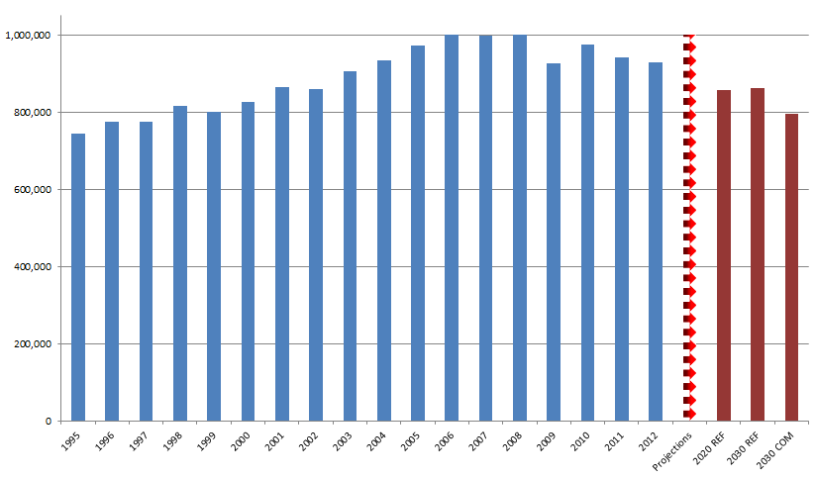
Source: Eurostat and European Commission projections based on the PRIMES model

The table below gives a more detailed overview per fuel for both these scenarios, and compares it with the IEA 'new policies' scenario, which broadly serves as the IEA's baseline scenario. Import dependency will keep increasing over time in order to compensate for the declining domestic production. At the same time though, a considerable reduction in total demand for the various fossil fuels in 2020, and also in 2030 with the implementation of the proposed 2030 policy framework, is projected. The projected reduction in total demand is important from an energy security perspective, but also from an economic perspective to reduce the total import bill, which already increases due to the projected increase in fossil fuel prices.

Table S 1. Total Demand and Import Dependency per fossil fuel for different scenarios
 |  |  | 2010 | 2020 | 2030
projection for EU28 (Reference Scenario) | Oil | Total Demand (Mtoe) | 669 | 606 | 578
projection for EU28 (Reference Scenario) | Oil | Import Dependency (%) | 84% | 87% | 90%
projection for EU28 (Reference Scenario) | Natural gas | Total Demand (Mtoe) | 444 | 407 | 400
projection for EU28 (Reference Scenario) | Natural gas | Import Dependency (%) | 62% | 65% | 73%
projection for EU28 (Reference Scenario) | Coal | Total Demand (Mtoe) | 281 | 236 | 174
projection for EU28 (Reference Scenario) | Coal | Import Dependency (%) | 40% | 41% | 49%
projection for EU28 (2030 policy framework) | Oil | Total Demand (Mtoe) | 669 | 604 | 559
projection for EU28 (2030 policy framework) | Oil | Import Dependency (%) | 84% | 87% | 90%
projection for EU28 (2030 policy framework) | Natural gas | Total Demand (Mtoe) | 444 | 404 | 347
projection for EU28 (2030 policy framework) | Natural gas | Import Dependency (%) | 62% | 65% | 72%
projection for EU28 (2030 policy framework) | Coal | Total Demand (Mtoe) | 281 | 231 | 155
projection for EU28 (2030 policy framework) | Coal | Import Dependency (%) | 40% | 40% | 48%
 |  |  | 2010 | 2020 | 2030
IEA projection for EU28 (WEO2013 new policies scenario) | Oil | Total Demand (Mtoe) | 683 | 569 | 481
IEA projection for EU28 (WEO2013 new policies scenario) | Oil | Import Dependency (%) | 83% | 85% | 89%
IEA projection for EU28 (WEO2013 new policies scenario) | Natural gas | Total Demand (Mtoe) | 446 | 407 | 442
IEA projection for EU28 (WEO2013 new policies scenario) | Natural gas | Import Dependency (%) | 62% | 73% | 79%
IEA projection for EU28 (WEO2013 new policies scenario) | Coal | Total Demand (Mtoe) | 280 | 248 | 174
IEA projection for EU28 (WEO2013 new policies scenario) | Coal | Import Dependency (%) | 40% | 43% | 48%
Source: European Commission projections based on the PRIMES model, IEA World Energy Outlook 2013
Finally, while electricity consumption itself is expected to grow, continuous fuels and technology diversification is expected, notably with higher shares of renewable energy, which from a supply perspective will improve security. The changing diversity of fuels, notably the growth of wind and solar power, together with the building of the internal electricity market, will however also require significant infrastructure investment, to ensure that power generation adequacy is maintained.
A sufficiently ambitious renewable energy target for 2030 at the EU level will contribute to increase the share of indigenous renewable energy sources in the Union's energy mix, thereby reducing EU energy dependency. The proposed governance scheme proposed in the 2030 Framework based on national plans for competitive, secure and sustainable energy will ensure an effective implementation of the target.
Figure S 9. Power generation from different sources in the 2013 PRIMES Reference Scenario
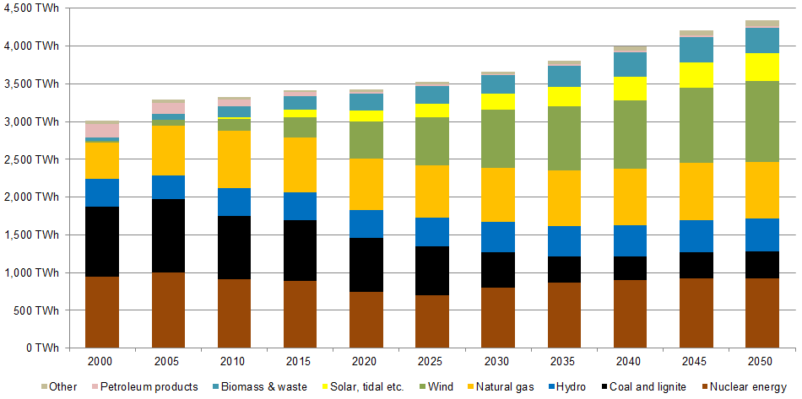
Assessment of energy capacity, transport and storage
Having reviewed the risks and resilience of the different fuel sectors in Europe, and the changes expected over the coming decades, it is important to take stock of existing measures regarding the management of energy capacity, transport and storage both in the short and medium term.
Short term
For oil, following IEA practice, the EU has oil stock storage rules and demand restraint (short term energy efficiency) action plans that can help improve short term market resilience and partly sustain the European economy in the event of a price or supply shock. Moreover new entrants to the global oil market also reduce risks of any such shocks. In the gas sector, EU rules for responding to shocks are weaker, with some rules covering back up, adequacy requirements and demand side, efficiency measures. Recent EU infrastructure policy measures improving reverse gas flow options have also reduced the weakness of the EU's resilience in this area. Adequate inventories make a shortage of nuclear fuel highly unlikely.
The IEA has analysed a scenario of interruption of transit of Russian gas to Europe via Ukraine. This explores how alternative supply routes (LNG, Norway, Nordstream etc…) and supplies, EU production and storage and demand response/curtailment measures could attempt to replace Russian gas flows through Ukraine.

ENTSO-G recently estimated the impact of a possible disruption crisis by analysing the response of gas infrastructure in the EU (pipelines, LNG, storages) in the case of disruption of gas supplies from Russia or transit from Ukraine. Assuming maximum solidarity between Member States, the summer outlook and the estimate for winter confirm the vulnerability of Member States in the South-East of the EU and the Balkans. If disruptions of Russian deliveries occur during daily peak demand in January, almost the entire EU, except the Iberian Peninsula and the south of France would be likely to be directly affected. The effects are likely to be less severe in the case of disruption from Ukraine, however South-East Europe could face a situation where more 60-80% of supply is not covered.
Disruption of Russian supplies across season (June 2014 to March 2015) could result in shortages (based on average demand) in states in the East of Europe. Bulgaria and FYROM might face a disruption of 60-80% of demand from September to March, Poland 20-40% and Lithuania 40-60%. Latvia and Estonia might face difficulties from October to March with more than 80% of demand not covered; Finland would face similar disruption from January to March. A 20-40% disruption might also occur in Romania, Croatia, Serbia and Greece for the late 2014/early 2015. Cross seasonal disruption to supplies transiting Ukraine would also create shortages in South East Europe, with Bulgaria and FYROM affected from September onwards.
Figure S 10. Disruption crisis: estimate of affected countries
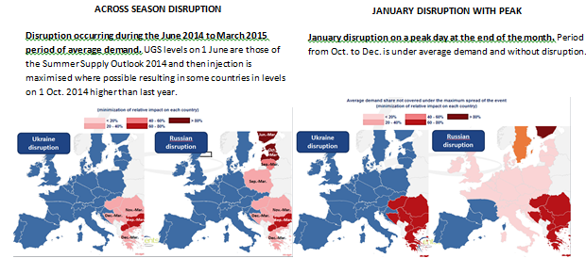

The extent of disruption also depends on the reliability of infrastructure bringing alternative fuels, the scope for demand response measures and on gas market price signals attracting supplies. Regarding this last point, in March 2013 (a cold spell), high demand in Member States with diverse sources, good infrastructure connections and established markets saw significant price rises which attracted increased supplies. In contrast, prices did not react greatly in Member States in the East and South-East of the EU. So whilst eastern Member States are the most vulnerable to supply disruptions, the limited markets and/or price regulation in the east resulted in the market instead delivering increased supplies to Western Europe. Thus more liquid markets (with more supply options) are more able to respond to disruptions.

Figure S 11. Market resilience: the cold spell of March 2013
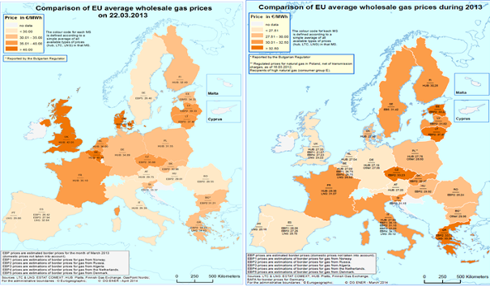
For electricity, Europe's growing interconnectedness and the growing trade in electricity between Member States has already proved the security benefits that come from growing diversity: at different times in recent years, short term surpluses of one form of electricity in one Member State (e.g. nuclear power in France or wind and solar in Demark and Germany) have flowed to counter deficits in another Member State.
Medium term
Core EU policies already in place steer the EU's energy sector towards a more secure and resilient form in the medium term. Regarding internal energy reserve capacities, the promotion of the development of a wide range of indigenous low carbon fuels can clearly increase the diversity of fuel supplies and thus reduce the risk of both supply and price shocks. Some Member States are also exploring the scope for expanding non-conventional fossil fuel production, such as shale gas, which may also diversify supply. More broadly, building up the flexibility of Europe's infrastructure, both for gas and electricity, facilitates the more efficient use of existing reserves. And the greater competition resulting from more integrated markets reduces individual suppliers' scope for supply disruptions or anti-competitive pricing.
Improving the integration of Europe's energy sector can also improve the diversity of external energy reserve capacities. This is because the bottlenecks, monopoly suppliers and supply risks of currently isolated Member States dissolve when the alternative infrastructure, ports, pipelines, etc. of other Member States become available. Member State access to global energy reserves are also improved when European purchasing power is coordinated; where measures are taken against product bundling (either directly in the form of nuclear fuel processing, or indirectly through compliance with EU single market rules), the scope for supplier control of uncompetitive oil, gas, coal, uranium and electricity markets is reduced, and the diversity of fuel reserves and suppliers increased.

Introduction
As energy has come to be a vital part of Europe's economy and of modern lifestyles, we have come to expect secure energy supplies: uninterrupted availability of energy sources at an affordable price. We expect to find petrol at the pumps, gas for heating and, in this computerised era, non-stop electricity, with blackouts too disruptive to countenance. We also expect supplies to be "affordable". Whilst energy as a part of household consumption is only around 6% in the EU, almost 11% of EU households feel unable to keep their homes warm. In addition, several European energy intensive industries warn of the negative impact of energy costs on their competitiveness.
To meet such expectations, for several years, Europe's energy (and climate) policies have had a security of supply "pillar". Policies have been introduced to create electricity and gas markets, increase competition, diversify sources and supplies, to cut consumption and emissions. And these same policies also reduce the risk of loss of supply and, through increasing competition, can help keep prices in check and affordable.
Despite the national and European measures and laws in place, current events on the EU's eastern border have raised concerns regarding both the continuity of energy supplies and regarding the price of energy. This has provoked apprehension regarding both short term access to energy; in particular access to affordable gas supplies in the coming months. It has also raised questions about the adequacy of the measures taken for the medium term.
To help address and better understand all the issues surrounding the security of energy supply, the March European Council called on the Commission to conduct an in-depth study of EU energy security and to present by June a comprehensive plan for the reduction of EU energy dependence. The study - this report - provides an extensive range of information and data regarding the sources, diversity, dependency and cost of energy in each Member State and for the EU as a whole.

Risks and resilience
The energy system is a complex structure, where aspects of "security" differ according to the actors involved at each point in the chain. Schematically, the system consists of fuels, transformation and consumption:
Figure 1. Energy system
Source: IEA MOSES working paper 2011
For each tier, the risks to security differ, as does the element's resilience.
The risk of disruptions or significant price spikes to fuel supply depends on the number and diversity of suppliers, transport modes, market structure and regulatory framework and supply points, and the commercial stability in the countries of origin. The resilience of energy providers or consumers to respond to any disruptions by substituting other supplies, suppliers, fuel routes or fuels depends on stock levels, diversity of suppliers and supply points (infrastructure, ports, pipelines). These are the elements which are the common focus of energy security discussions, focussing both on events which require short term responses (to short term "crises") and medium responses to reduce risks and improve resilience.
The energy transformation tier, including refining and power generation, also faces risks. Refining risks are associated with having access to sufficient capacity for refining of different fuel sources to meet consumer needs to refined products. In the electricity sector, in addition to the above fuel risks, there are risks of volatility of supply (including weather patterns (rain, wind, sun), unplanned power plant outages, age profile of power plants), risks to ensure system stability and generation adequacy and risks related to operation and development of networks, including interconnection capacities. Resilience in this sector also depends on the number and diversity of fuels, refineries and power plants, as well as imports from third countries in the case of petroleum products.
The third element of the energy system is the composition of the consumers: amongst the variety of different households and industries, the costs of supply disruptions differ, as does the resilience of different groups and their flexibility to shift or reduce energy consumption.
For each of these three components of the energy system, of Europe's energy mix, the degree of risk or of insecurity can be assessed. And for each component there are a variety of measures that can be adopted, both at national and at European level.
It needs to be stressed that the national energy mix choices of each of the Member States affect others. Choices taken on the level of fuel supply, infrastructure development, energy transformation or consumption may lead to higher negative spill-overs on other Member States and therefore also on the level of the EU. It seems inevitable that assessment of necessary measures to mitigate risks has to include an assessment of risks and negative effects linked to particular fuel choices. The below analysis shows that when formulating policy options for closer cooperation and solidarity among the Member States in improving various aspects of security, mechanisms need to be developed to avoid that risky choices are taken in the first place.

Current European energy security

Energy sources in the EU

All energy products

Gross inland consumption of energy in the EU
The way energy flows through the system before reaching the final consumer in the form of electricity, heat or transport fuels has profound implications on energy security. Crude oil and petroleum products, along with natural gas, dominate the energy mix on the supply side, while industry and households have largest shares on the demand side (see Figure 2 and Figure 4).
Changes in the energy system in general, and changes related to the energy mix in particular, are slow and underpinned by significant investment capital needs. Total demand for energy in 2012 was roughly at the same level as it was in the mid-90s, but is more than 8% below its peak in 2006 due to a combination of factors, including structural changes in the economy of the EU, the economic crisis and efficiency improvements.
Most Member States have seen their gross consumption peak towards the middle of the first decade of this century – mostly in the period 2005-2008 – and subsequently contract.

Figure 2. Total energy demand 1995-2012, EU28, ktoe
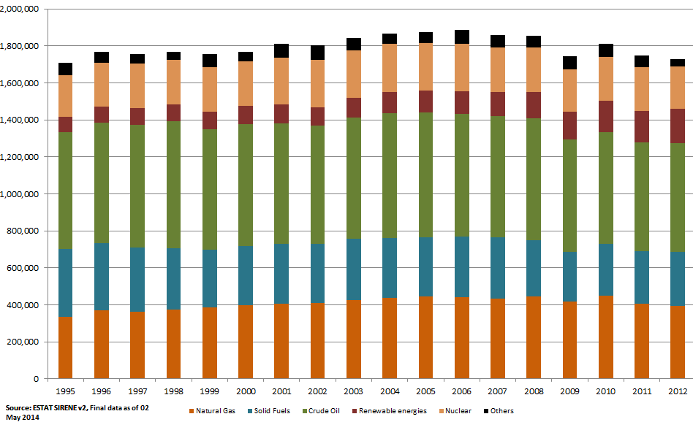

The composition of consumption has shown a slow but persistent change over time with the share of gas going up from around 20% to 23% of gross inland consumption between the mid-1990s and 2012 and the share of renewables more than doubling to almost 11% in 2012. In contrast, the shares of solid fuels declined from around 21% to 17%, oil from 37% to 34%. Nuclear remained relatively stable in relative terms at 13%.

Figure 3 Total energy demand, shares by fuel (%) in each Member State, 2012
Note: In the case of Cyprus, Estonia, Latvia, Luxembourg Malta and Slovenia values refer to petroleum products, not crude oil.
Figure 4. Energy flow in the EU, all products, 2012 (Eurostat, European Commission calculations)
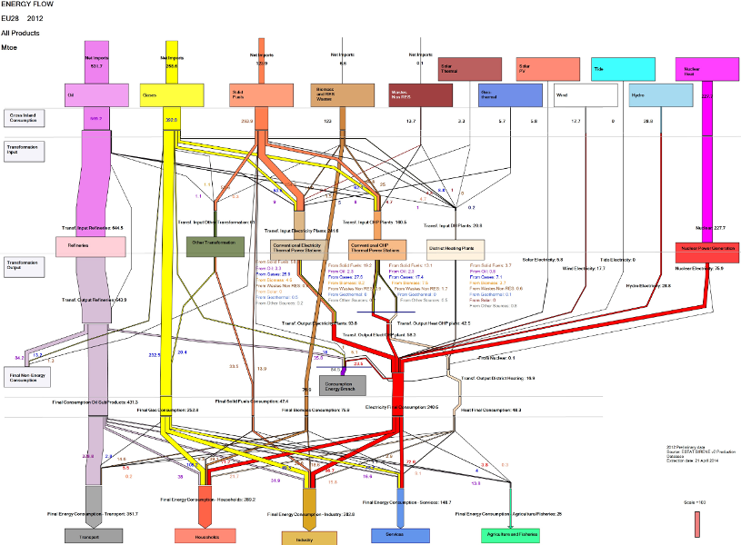

EU primary energy production
EU primary energy production decreased by almost a fifth between 1995 and 2012. In this period natural gas production dropped by 30%, production of crude oil and petroleum went down by 56% and of solid fuels (including coal) by 40%. On the other hand renewable energy production registered a remarkable growth – 9% only over the period 2010-2012 – and has reached a 22% share of primary energy production.
Netherlands and the UK are the largest producers of natural gas in the EU and in 2012 respectively accounted for 43% and 26% of gas production in the EU; the third and fourth producers - Germany and Romania – have a 7% and 6.5% share of natural gas production in the EU. The UK is the largest producer of crude oil in the EU with a 61% share of EU production in 2012; Denmark is the second largest producer with a 14% share.

Imports and energy deficit of the EU
The EU has been importing growing amounts of energy to compensate for declining domestic production and meet demand that until 2006 was steadily growing. Overall EU import dependency has increased, mostly driven by growth in import dependency of natural gas (+6 p.p in the period 1995-2012) and crude oil (+3 p.p. in the same period). Import dependency is a function of net imports and total demand. Therefore a drop in production would result in an increase in imports if demand is stable, growing or decreasing by more than the drop in production. If the drop in production is faster and/or larger than the decrease in demand, this would result in increasing import dependency against falling demand.
Figure 5. EU import dependency by fuel, 1995-2012, %
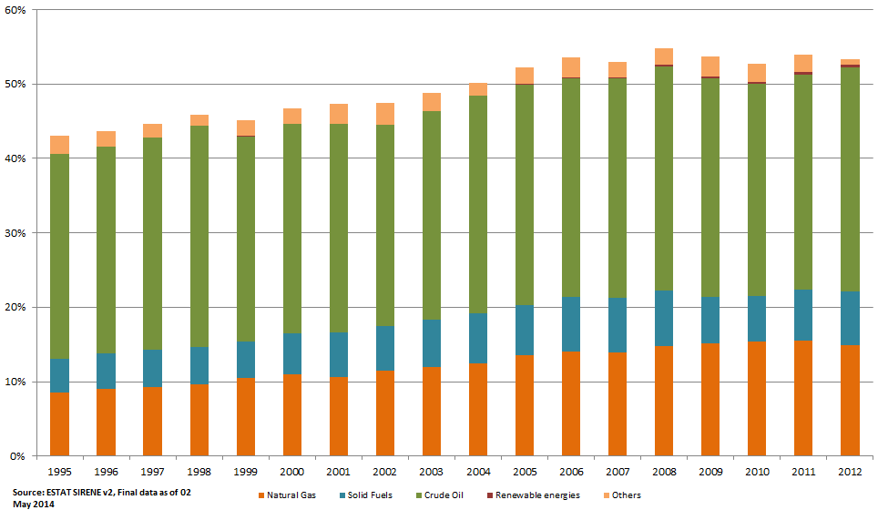
While import dependency points to the relative share of imports in demand (in %), the net imports – showing the total energy deficit - denotes the absolute volumes of energy that the European economy needs to import (in energy terms, e.g. ktoe), that is the difference between total demand and total production. Since the peak in 2006-2008, the net imports have decreased – largely driven by fall and shift of consumption; still net imports in 2012 were at 25% above its 1995 levels.

Figure 6. EU net imports by fuel, ktoe, 1995-2012
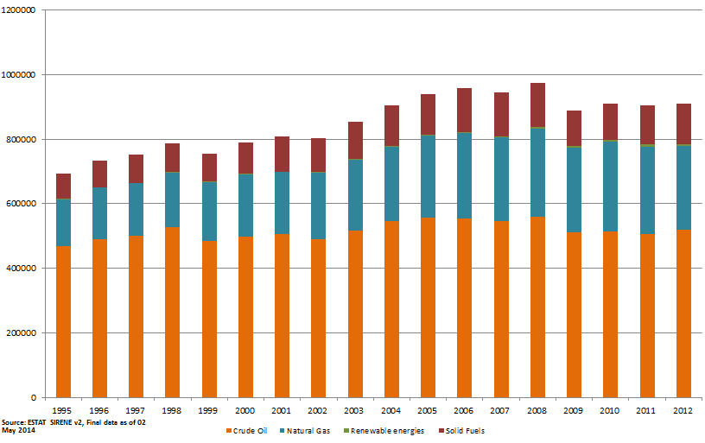

Great differences among Member States
The aggregated EU-level numbers hide a great deal of differences between Member States. In Member States with indigenous energy production, the share of production to total demand has decreased – in the case of the UK by half from its peak, in the case of Denmark and Poland by 30-40% and in the case of the NL by more than 15%. EE is the only Member State that has seen a stable and significant increase in the share of domestic production in total energy demand against a stable growth in demand.
As a result, the net imports of most Member States have increased. Nowhere is this more visible than in the UK, which had an energy surplus until 2003 and a steeply growing deficit ever since. France, Spain and Italy have all seen energy deficits peak in 2005 and go down ever since, likely driven by a combination of weak demand and increased renewables share. The deficit of the largest energy consumers in the EU – Germany – has unsurprisingly been the largest in energy terms and since its peak in 2001 has shown fluctuations in both directions, without a stable trend.

Figure 7. Net imports of all energy products, by Member State, 1995-2012, ktoe
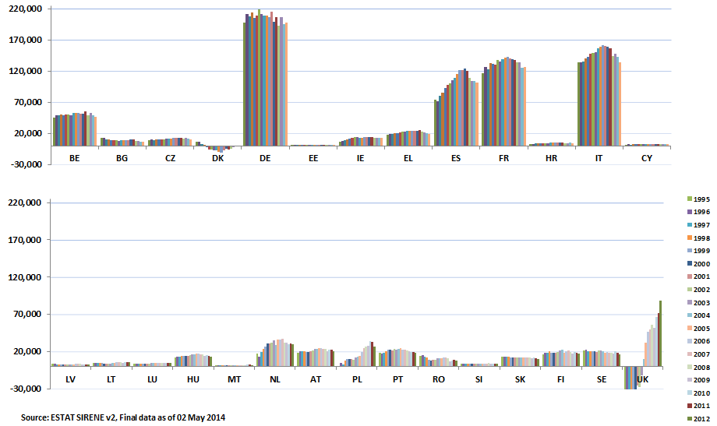

Energy consumption and the role of energy efficiency
At the level of the EU, transport is the largest energy consumers and accounts for almost a third of final energy consumption. Industry and the residential sector account for about a quarter each. In 7 Member States industry accounts for a third or more of final energy consumption; the share of the residential sector varies between 17% of total final energy consumption in Portugal and Malta and 36% in Romania.
Figure 8. Final energy consumption by end-use sector, all energy products, 2012
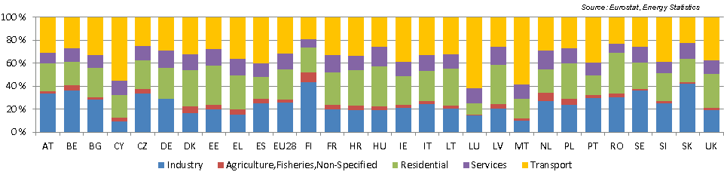
Looking at sectoral level, electricity and gas each account for around 30% of final energy consumption of the industrial sector in the large majority of Member States, followed by oil (mostly below 20% of final energy consumption of industry, apart from Cyprus, Denmark, Greece, Croatia, Ireland and the Netherlands) and solid fuels (mostly below 15% except for the Czech republic, Estonia, Poland and Slovakia).Gas accounts for 40% or more of final energy consumption of industry in Belgium, Spain, Hungary, Luxembourg and Romania.
Figure 9. Final energy consumption in the industrial sector, relative shares of energy products, 2012
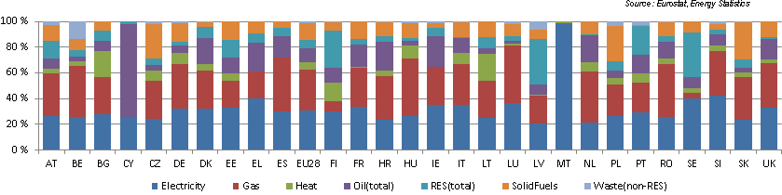
In the residential sector electricity accounts for about a quarter of final energy consumption and gas for almost 40%. In Germany, Hungary, Italy, Luxembourg, the Netherlands, Slovakia and the UK more than 40% of residential energy consumption depends on gas. Heat has an important share (above 15%) in the final energy consumption of the residential sector of most Member States that joined the EU in 2004 and 2007, and in Scandinavian countries (Bulgaria, the Czech republic, Denmark, Estonia, Finland, Lithuania, Latvia, Poland, Sweden, Slovakia).
Figure 10. Final energy consumption in the residential sector, relative share of energy products, 2012
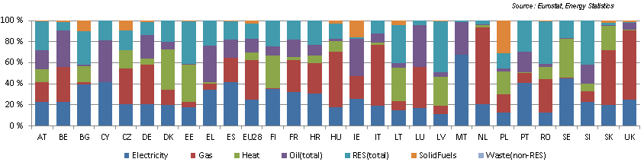
In the services sector electricity accounts for 40% or more in almost all Member States. Gas has a relatively high share in the service sector of the Czech republic, Hungary, Italy, Luxembourg, the Netherlands, Romania, Slovakia and the UK.
Figure 11. Final energy consumption in the service sector, relative share of energy products, 2012
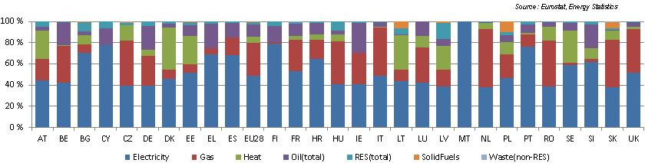
Finally, transport is almost entirely reliant on oil. Gas accounts for about 9% of final energy consumption of transport in Bulgaria and Slovakia. The share of renewable energy sources in the transport sector is to rise to a minimum 10% in every Member State by 2020 (Directive 2009/28/EC).
Figure 12. Final energy consumption in transport, relative share of energy products, 2012
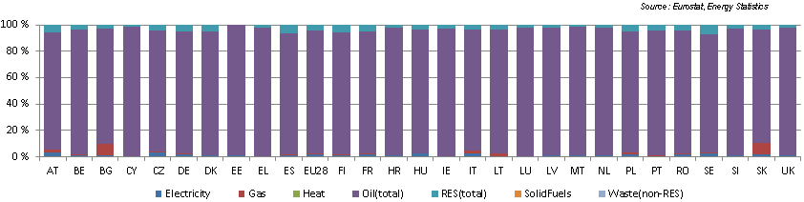
Energy efficiency measures have the potential to reduce energy consumption and imports. Energy efficiency gains can be evaluated after removing the impact of factors such as climate conditions, activity levels, social changes, etc. from the evolution of energy consumption. In the period 2000-2012 energy efficiency has contributed to a reduction of energy consumption in almost all Member States. In this period energy efficiency has contributed to a 1% annual reduction in energy consumption in the EU. For countries like Slovakia and Bulgaria the efficiency driven decrease in consumption was around 5% and 3% per year, respectively. Other Member States highly exposed to a disruption of Russian gas supply have also achieved important savings through energy efficiency, in particular Hungary (-2%/y), Poland (-1.7%/y) or the Czech Republic (-1.6%/y).

Figure 13. The role of energy efficiency in reducing final energy consumption (2000-2012)
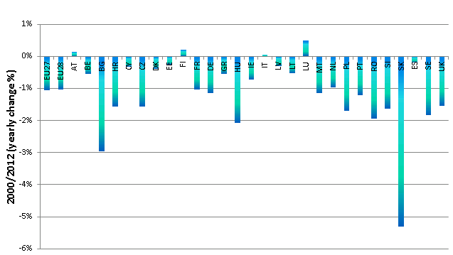
Source: Fraunhofer Institute. Study evaluating the current energy efficiency policy framework in the EU and providing orientation on policy options for realising the cost-effective energy-efficiency/saving potential until 2020 and beyond. Work in progress.

Summary all energy products
Changes in the energy system are slow and underpinned by significant investment capital needs. Total demand for energy in 2012 was roughly at the same level as it was in the mid-90s, but is more than 8% below its peak in 2006. Structural changes in the economy of the EU, the economic crisis and efficiency improvements all played a role in this decline.
Against falling domestic production, overall energy dependency in the EU has been increasing since the mid-90s, mostly driven by growing import dependency in natural gas and crude oil (together +9 p.p. in the period 1995-2012). The aggregated EU-level numbers hide a great deal of differences among Member States and across fuels. This is why it is important to examine recent trends fuel by fuel.

Oil

Consumption, production and imports
Oil continues to be the main fuel in the EU energy mix, representing about 34% of gross inland consumption. Transport is by far the biggest user of oil in the EU, followed by the petrochemical industry; it has been largely phased out from power generation and its role is decreasing in heating. Oil has a dominant role in Cyprus and Malta where, in addition to fuelling transport, it remains the main fuel for power generation. In 2012, the EU was the second largest consumer in the world after the US, representing about 15% of global consumption.
Figure 14. Gross inland consumption of crude oil in the EU, 1995-2012, ktoe
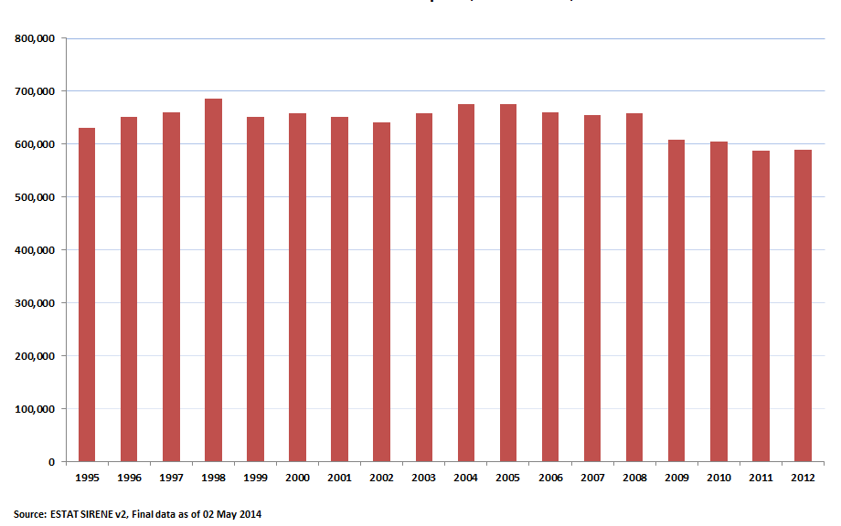
EU crude oil consumption has been fluctuating in the study period but since 2005 it has shown a marked decreasing tendency which accelerated after the economic crisis of 2008. Consumption decreased by 12.9% since 2005 (average -2.0%/year) and by 10.5% since 2008 (average -2.7%/year). In addition to the impact of the crisis, the decline is at least partly driven by structural factors (e.g. by the improving fuel economy of vehicles) which is helped by relevant EU policies (see chapter 4.2.1.2). Compared to 1995, the decrease of gross inland consumption is only 6.6%.
As practically all crude oil is processed in refineries, the gross inland consumption of crude oil basically shows the quantity of crude oil refined in EU refineries and is not necessarily reflecting the final consumption of oil products (part of the refinery output is exported while part of the consumed products are imported). Therefore, crude oil consumption of Member States without refineries is zero.

Figure 15. Energy flow of petroleum and products in the EU, 2012

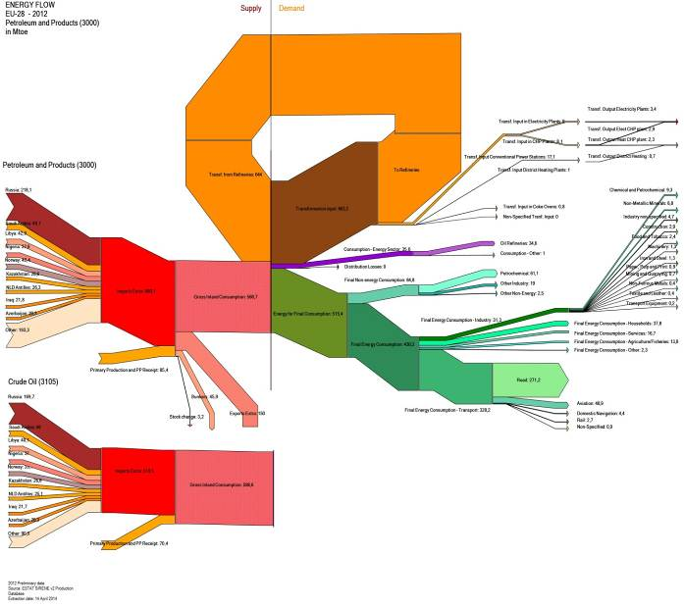
A decline in crude oil consumption has been observed across most of Europe after 2005. Only four Member States (Finland, Greece, Poland and Sweden) have seen an increase of crude oil consumption in the period 2005-2012 but Poland is the only country with a consistent and significant rise. The decline was particularly steep in Croatia, France and Romania where crude oil consumption decreased by more than 30% between 2005 and 2012. In France, several refineries have been closed in the last few years. Germany, Italy, Portugal and the UK have also seen above-average declines in oil consumption, at least partly driven by refinery closures.

Figure 16. Gross inland consumption of crude oil by Member State, 1995-2012, ktoe
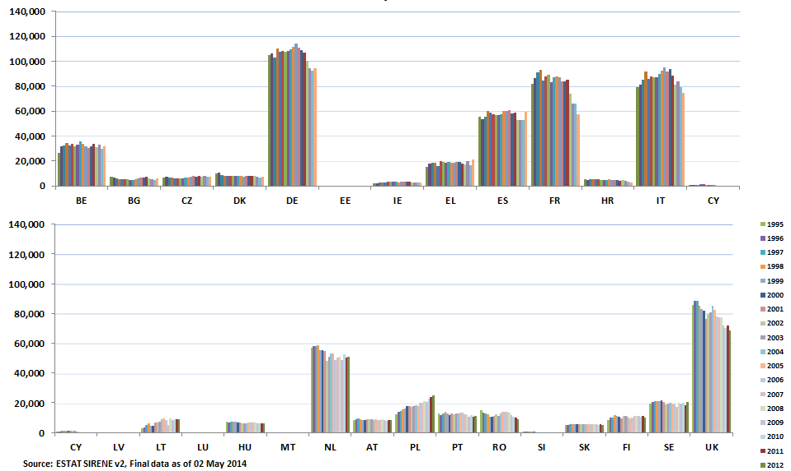
Between 1995 and 2012, indigenous crude oil production decreased from 160 million tons to 71 Mtoe, reflecting the fact that the North Sea, the main producing region, is a mature area. Since its peak in 1999, production decreased by around 56% (average -6.4%/y). The UK remains by far the largest producer, although its share from the EU-28 has decreased from 78% in the second part of the 1990s to 61% in 2012.
Figure 17. Indigenous production of crude oil in the EU, 1995-2012, ktoe
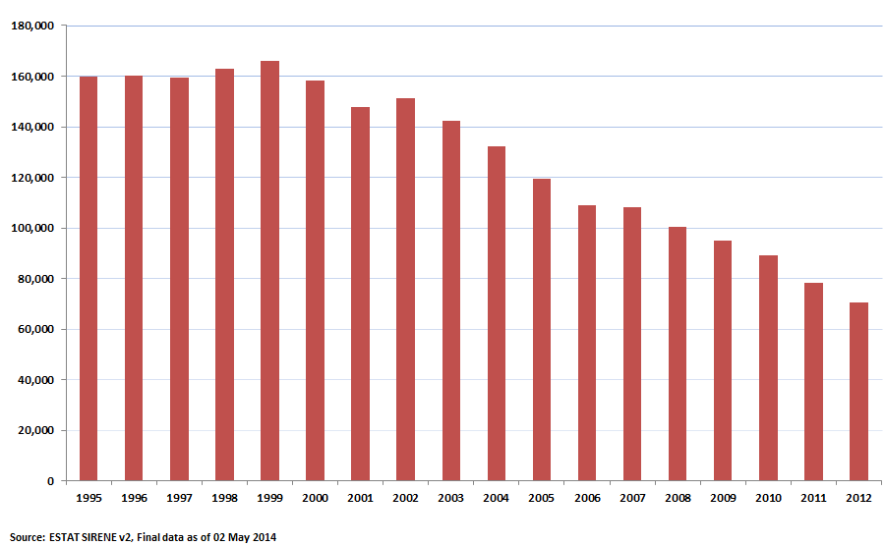
While net imports of crude oil (including both external and internal) have fallen after 2008, in 2012 they were still 11% higher than in 1995. Over the last few years the decrease of consumption and the decrease of production have more or less offset each other and net imports have stabilized at around 510 million tons.
Figure 18. Net imports of crude oil in the EU, 1995-2012, ktoe
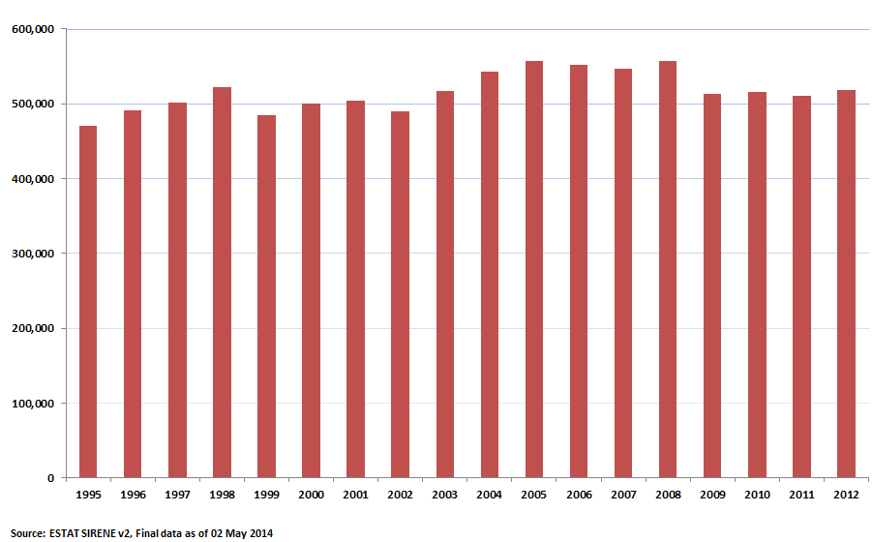
Source: Eurostat
If only extra-EEA trade is considered, net imports increased even faster: in 2012 they were 25% higher than in 1995 because of the decline in imports from Norway. While Norwegian supplies exceeded 100 million tons in the period 1995-2004, they fell below 70 million tons in 2011. Over the last few years net extra-EEA imports have averaged at around 440 million tons.
Figure 19. Net imports of crude oil in the EU (extra-EEA), kt
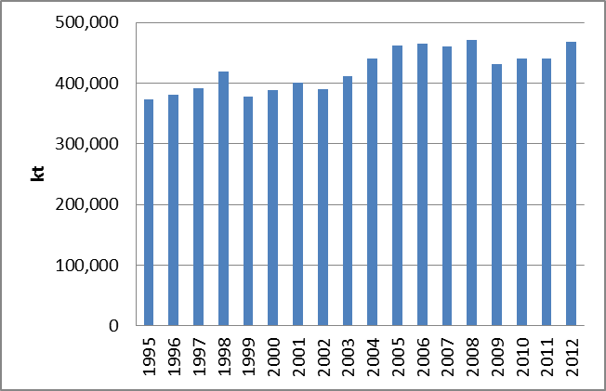
Source: Eurostat
Import dependence of crude oil, expressed as a percentage of consumption, continued to increase and in 2012 reached 88% which is the highest level among fossil fuels. Extra-EEA import dependence (i.e. when Norwegian supplies are not counted as imports) is slightly lower, in 2012 it was 80%. Chapter Error: Reference source not found offers another metric of diversification – referred to as supplier concentration index – which takes into account both the diversity of suppliers and the exposure of a country to external suppliers looking at net imports by fuel partner in the context of gross inland consumption of each fuel.
Figure 20. Import dependency of crude oil, 1995-2012
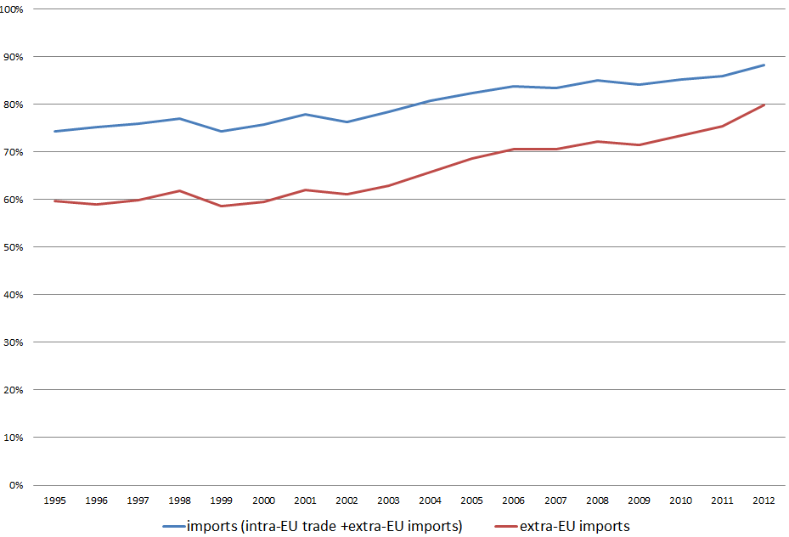
Source: Eurostat, European Commission calculations
The UK, the largest oil producer in the EU, became a net importer in 2005, leaving Denmark as the only net exporter. However, Danish oil production is also falling (by almost 50% since its peak in 2004) and in some years Denmark is likely to become a net importer. Germany, Italy, Spain, France and the Netherlands remain the largest net importers of crude oil although – with the exception of Spain – the absolute value of net imports decreased in these countries between 1995 and 2012.
In 2012, a third of extra-EU imports of crude oil and NGL came from Russia, followed by Norway (11%) and Saudi Arabia (9%). In terms of monetary value, the total value of extra-EU imports of crude oil and NGLs was 302.3 billion Euro. Russian accounted for the largest share of imports in monetary terms (33%), followed by Norway (11%), Nigeria (9%) and Saudi Arabia (8%).

Figure 21. Extra-EU imports of crude oil and NGL, share of main trading partners in energy terms, 2012
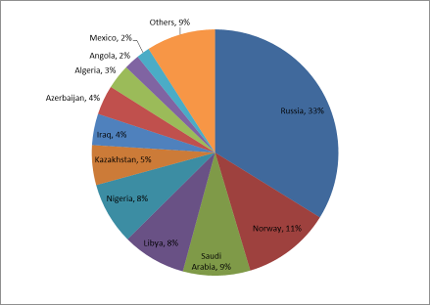
Source: Sirene database, Eurostat
Table 1. Extra-EU imports of petroleum oil, crude and NGL, share of main trading partners in monetary value and energy terms, 2013
Partner | VALUE (Share %) | NET MASS (Share %)
Russia | 33% | 34%
Norway | 11% | 11%
Nigeria | 9% | 8%
Saudi Arabia | 8% | 8%
Kazakhstan | 7% | 6%
Libya | 6% | 6%
Algeria | 5% | 5%
Azerbaijan | 5% | 4%
Iraq | 3% | 4%
Angola | 3% | 3%
Mexico | 2% | 2%
Equatorial Guinea | 1% | 1%
Egypt | 1% | 1%
Kuwait | 1% | 1%
Source: Comext database, Eurostat

Infrastructure and supply routes
Nearly 90% of crude oil imported to the EU arrives by sea, giving considerable flexibility with respect to supply sources and routes. While transport costs can be volatile, they represent a low share of the value of crude oil, facilitating imports from distant regions like the Middle East or Latin America.
Most refineries are located on the coast and therefore have direct access to oil coming from producing countries of the world. Inland refineries on the other hand are typically supplied by the pipelines coming from the major ports, the most important of which are the Rotterdam-Rhein Pipeline (RRP) from Rotterdam, the South European Pipeline (SPSE) from Marseille and the Transalpine Pipeline (TAL) from Trieste.
Refineries in Central Eastern Europe (Poland, the Eastern part of Germany, Slovakia, the Czech Republic and Hungary) constitute a notable exception as they are typically supplied by the Druzhba pipeline with oil coming directly from Russia (with the Czech refiners partly supplied through the TAL and IKL pipelines). This pipeline delivers about 50 million tons of oil a year, approximately 30% of total Russian imports to the EU. Main oil ports in the EU according to inwards tonnages of crude oil in 2012 are indicated in the map below.
Considering the decreasing oil consumption in Europe, the majority of existing infrastructure (ports and pipelines) are unlikely to constitute a serious bottleneck. However, in 2012 the TAL pipeline became saturated as the Karlsruhe refinery redirected all imports to this route (previously, about half of its crude oil arrived through the SPSE pipeline) while Czech refineries tried to compensate the falling Druzhba volumes by increased imports on the TAL pipeline.

Figure 22. Main oil ports in the EU
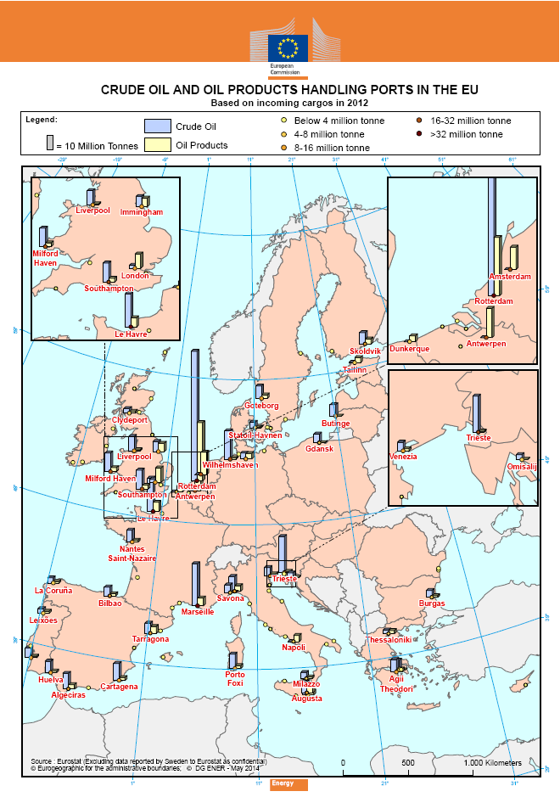
Figure 23. Refineries and oil pipelines in Europe
Source: Europia
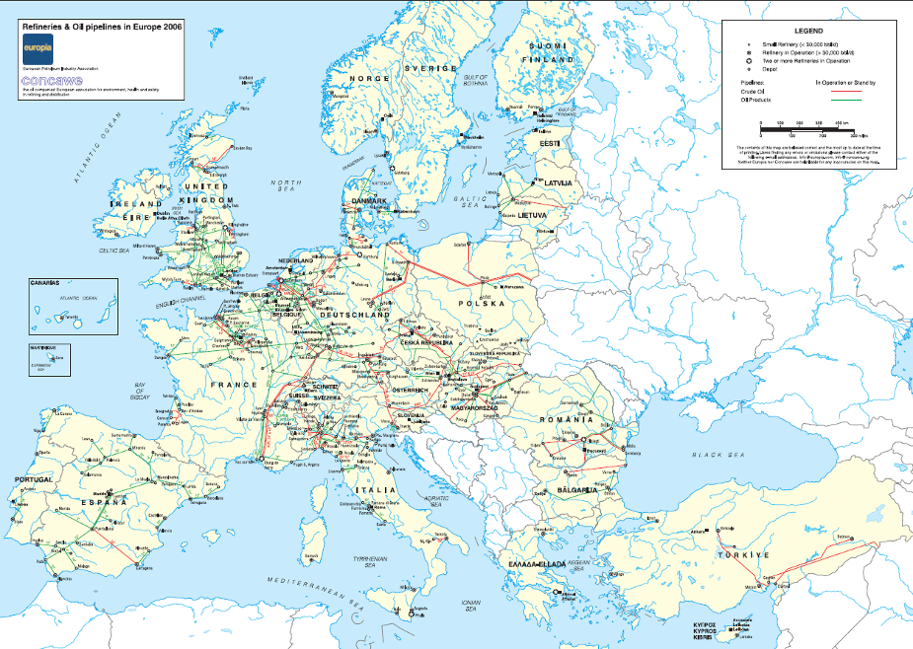
Summary oil
While the consumption of oil has been decreasing since 2005 (by 13% in the period 2005-2012), it continues to be the main primary energy source used in the EU, representing 34% of the energy mix. Oil is mainly fuelling transport (64% of final consumption of oil and oil products) where it has limited viable alternatives.
Of all energy sources, oil has the highest import dependency, 88% (80% if only imports from outside the European Economic Area are taken into consideration), contributing to a significant import bill (EUR 302 billion in 2012) and making the EU exposed to the global oil market where the EU is a price taker.
Oil is traded in a liquid global market, which is however characterized by a concentration of suppliers, hindering diversification efforts. As many suppliers are exposed to geopolitical risks, the market is prone to supply disruptions and volatility of prices but market forces generally ensure the continuity of supplies to consumers.
Oil is imported to the EU mostly by sea (nearly 90% of total imports), at relatively low transportation cost. Therefore, from a logistic point of view, it is relatively easy to switch from one supplier to another. On the other hand, refiners are often configured to process a particular type of oil so the quality of crude oil can be a constraint.
Refineries supplied by the Druzhba pipeline are in turn highly vulnerable to a risk of disruption of this route. The concerned Member States require improved alternative supply routes in order to ensure effective diversification of supplies; there are a couple of "projects of common interest" which would bring an improvement in this respect.
Overall, there is ample EU refining capacity (about 15 million barrels/day) to cover the demand for oil products. However – when individual products are considered – there is a mismatch of supply and demand, making the EU reliant on international product trade: it is a net exporter of gasoline (49 million tons in 2012) and a net importer of middle distillates (31 million tons).
The decline of consumption in recent years has led to an overcapacity of refining which is exacerbated by the increasing competition from other regions. The ensuing rationalisation of the sector (1.7 million barrels/day capacity closed since 2008) means that in the future the EU is likely to become more dependent on product imports.
Having equipped with emergency oil stocks equivalent to about 100 days of net imports, the EU is well prepared to cope with temporary disruptions. In addition to the release of stocks, other measures including demand restraint can contribute to addressing a lasting disruption.
In the longer run, transport's dependence on oil has to be addressed in order to decrease the EU's exposure to imports. Whilst efficiency levels have improved significantly in the last decade, generating a significant reduction in energy intensity, substitutes and alternative supplies (e.g. biofuels, electricity) continue to be elusive.

IEA MOSES working paper 2011
Calculated as Gross Inland Consumption + Bunkers.
The graph show the contribution of different energy sources to total energy import dependency, which for all energy sources adds up to 53%. i.e. crude oil (the import dependency of which is 88%) constitutes 30 percentage points of the 53% total import dependency; natural gas (the import dependency of which is 66%) 15 percentage points of the 53%; solid fuels (with an import dependency of 42%) constitute 7 percentage points of the 53%. n.b. Eurostat ignores uranium as imports in this context and treats nuclear electricity as a domestic resource
Poland, Germany, Slovakia, Czech Republic, Hungary
90 days of net imports or 61 days of consumption, whichever is higher
Some even beyond 2030
(European Network Transmission System Operator – Gas)
Different international organisations apply different definitions and classifications of solid fuels. See Eurostat classification of solid fuels at http://epp.eurostat.ec.europa.eu/cache/ITY_SDDS/Annexes/nrg_quant_esms_an1.pdf .
Strongest growth 2011-2012 seen in Portugal, UK, Spain, France, Ireland and the Netherlands, driven by falling coal and rising gas prices.
Russian reactors in Finland, Bulgaria, Czech Republic, Hungary and Slovakia depend on Russian fabrication services, while the reactor in Slovenia depends on US-fabricated fuel.
See ENTSOG presentation of 7/5/2014. ENTSOG underlines that the estimation should not be understood as an actual forecast neither in term of demand disruption nor supply mix.
For example the prices in the UK and in Belgium increased to the level close to € 40/MWh in comparison to average prices of between € 25 and € 30/MWh. The price increases at the hubs in the EU were also following this trend. See analysis of the European Commission at http://ec.europa.eu/energy/observatory/gas/doc/20130611_q1_quarterly_report_on_european_gas_markets.pdf
Eurostat Income and Living Conditions (ILIC) questionnaire 2012.
IEA MOSES working paper 2011
Some MS that joined the EU in 2004 and 2007 – including BG, RO, PL and LT - witnessed a steep drop in consumption at the end of the 90s with the collapse of inefficient heavy industry
Bulgaria has also seen a significant increase, but mostly due to drop in demand rather than increase in production.
The share of the residential sector in Luxembourg is only 10%, but this number is likely influenced by the very high share of the transport sector due to transit and 'fuel tourism' from neighbouring countries.
BP Statistical Review of World Energy 2013
Product codes 27090090 (petroleum oils and oils obtained from bituminous minerals, crude) and 27090010 (petroleum oils from natural gas and condensates)

