Natural gas
Given its limited and decreasing reserves of natural gas, the EU is a net importer of gas. The increasing dependency on gas imports has posed challenges and increased the risks to security of supply. A reliable, transparent and interconnected market has the potential to mitigate some of these risks. Gas is transported by pipelines to the final consumer, making the operation of pipelines and the availability of capacity crucial factors. Finally, in case of the crisis supply of gas requires mechanisms in order to mobilise reserves on time and replace them with supply or demand measures to cover missing amounts of gas.

Consumption, production and imports
The pre-crisis gas demand in the EU was close to 450 Mtoe. The gas consumption in 2012 dropped below 400 Mtoe – its lowest levels since the turn of the century. The economic crisis, subdued demand for electricity and changes in electricity production sector with growing role of solid fuels (mainly coal) and renewables are all factors behind this drop.
Figure 1. Total energy demand for gas in the EU, 1995-2012, ktoe
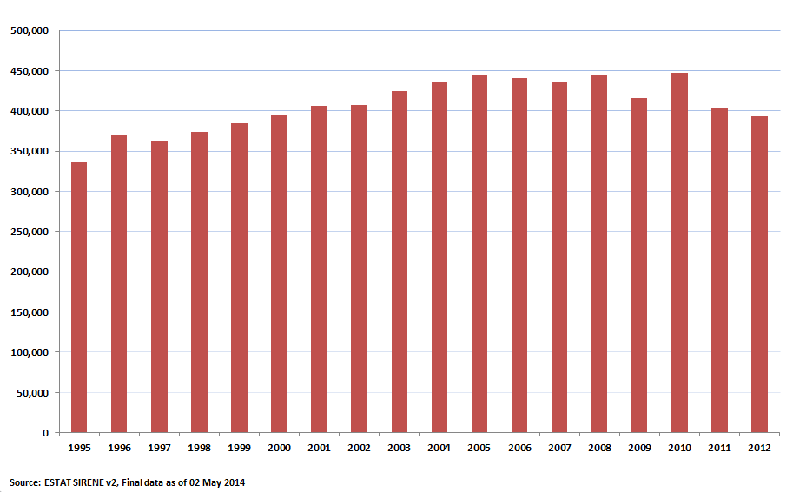
As shown in the energy flow chart majority of gas is being consumed in households (108 Mtoe) and in electricity production (107 Mtoe) of which more than half (59 Mtoe) is used as input in CHP plants. Almost 19% of the electricity generated in the EU comes from gas and for some Member States the share of gas in electricity generation is significant (in 2012 above 40% in Italy, Ireland, Lithuania, Luxembourg and the Netherlands). As regards non-household consumers, services consume 45.3 Mtoe whereas the biggest industrial consumers are sectors of chemical and petrochemical industries, production of non-metallic minerals and food and tobacco production.
Figure 2. Energy flow of natural gas in the EU, 2012
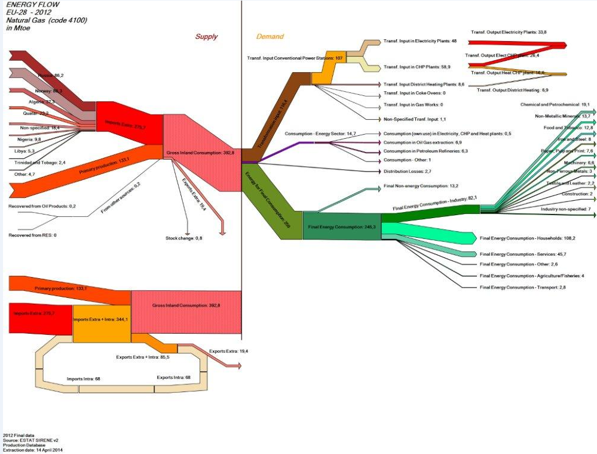
Electricity production, heating for households and services (including district heating) and industry consume more than 90% of the natural gas in the EU.
Industry accounts for approximately 25% of gross inland consumption of gas. This includes both natural gas uses for heat generation for industrial consumption as well as gas used as raw material. The residential and tertiary sectors account for approximately 40% of gross inland consumption of gas. This consists mainly of direct use for heating and domestic hot water preparation for households and commercial buildings (using individual or central boilers) also with very important variations among Member States, in France the share of these sectors goes up to 50% while in Bulgaria it is only 5%.
In 2012 the transformation sector accounted for about 30% of gross inland gas consumption, mostly as input in electricity and CHP plants. The share of natural gas in power generation varies between Member States (see details in Table 7 in the electricity section of chapter 2). The use of electricity for heating and domestic hot water preparation also has an impact on gas use, depending on the electricity mix of the Member State. For instance, Bulgaria has a highly electrified heating sector and more than a third of gas consumption is used for electricity production. Thus, measures reducing heating demand or increasing the efficiency of electric appliances will also have an important impact on gas consumption.
Figure 3. Natural gas consumption by sector, 2012
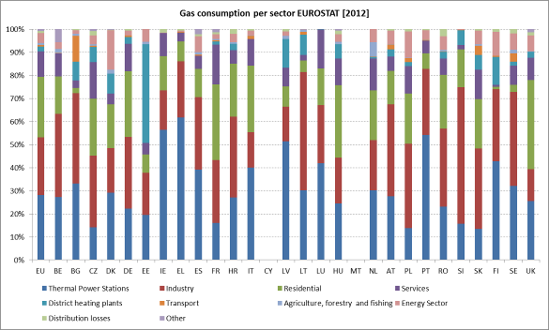
Source: Eurostat
The relative importance of the gas used in industry per Member State varies from percentage values above 35% in Austria, Belgium, Bulgaria, Croatia, Poland, Lithuania and Slovenia to much lower values in Member States such as Ireland or the United Kingdom. Nevertheless the distribution of gas use per different industry sector presents important variations per Member State so it is to be understood that “one fits all” solution is not possible for the industrial sector and Member States should focus their efforts on the sectors were they have a highest relative consumption and a highest improvement potential.
Figure 4. Natural gas consumption per industrial sector, 2012
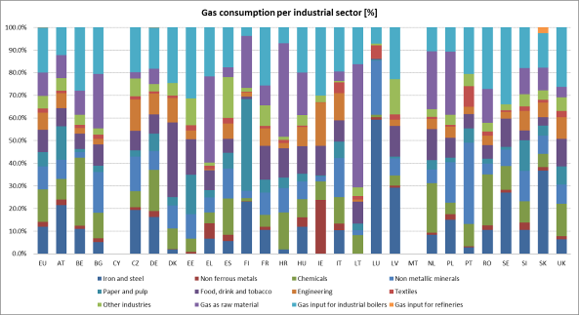
Source: Eurostat
The overall gas use in district heating installations is 2% for the whole EU. District heating accounts for a relatively small part of final gas consumption at European level, but it has a significant share in the Eastern European countries. Gas consumption in district heating in Estonia, Latvia, Lithuania and Finland represents more than 10% of the total gas consumption and around 7% in Slovakia and the Czech Republic.
Figure 5. Heating and domestic hot water: production by fuel
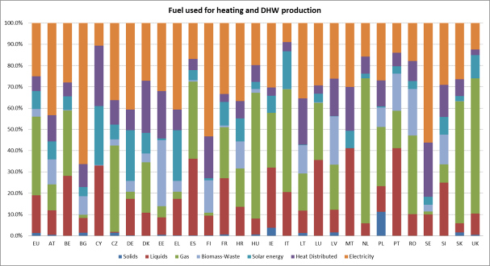
Source: PRIMES 2013

Figure 6. Fuel input for district heating (%)
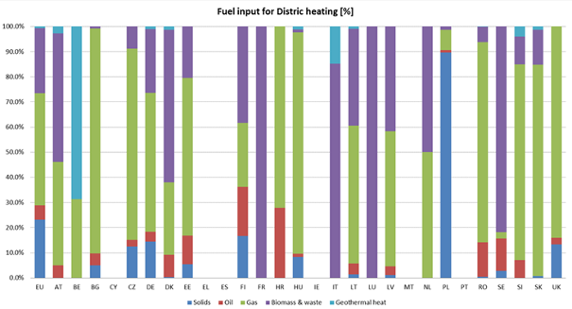
Source: PRIMES 2013
Germany and the UK are the largest consumers of gas, with drop in the UK in the year 2012 below 70 Mtoe. Other significant consumers of gas include Italy, France, the Netherlands and Spain. In the eastern part of the EU consumption of gas in Poland increased in 2012 above 10 Mtoe whereas in Romania dropped to similar level from 20 Mtoe in the late 90ties.
The EU production decreased over last 10 years from the level of 200 Mtoe in the late 90ties to the level of below 150 Mtoe in 2012 marking the lowest level since 1995. The biggest producer of gas in 2012 the EU are the Netherlands with production close to 60 Mtoe. Production of the UK dropped to the level of 35 Mtoe in 2012 from a level of above 90 Mtoe in the beginning of the decade. The EU exports 19.4 Mtoe to non-EU states, mostly transits to Switzerland, the southern Balkans and Turkey.

Figure 7. Total energy demand for gas in the Member States, 1995-2012, ktoe
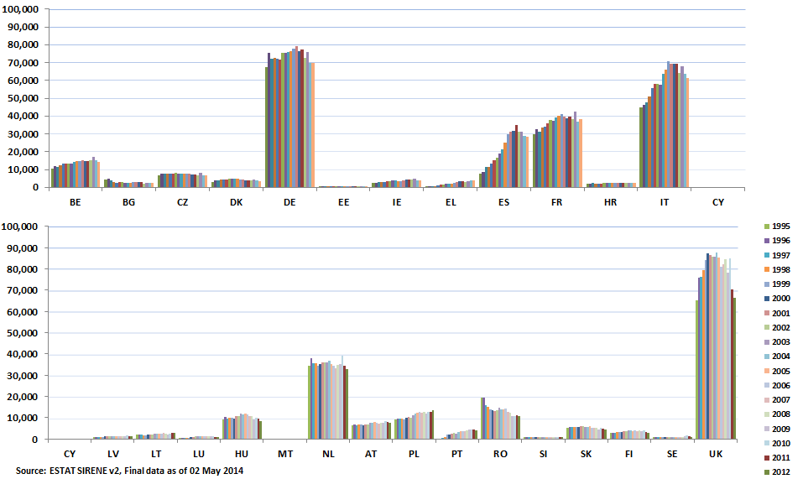
Figure 8. Total production of natural gas in the EU, 1995-2012, ktoe
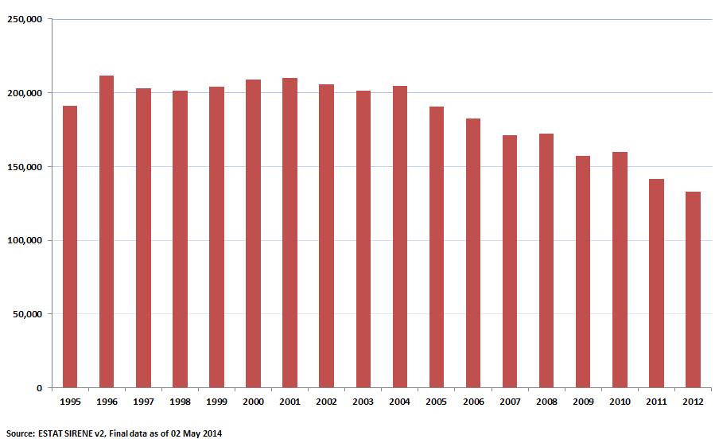

The conventional gas proved reserves of the EU for the end of 2012 have been estimated on the level of 1412 Mtoe (1700 bcm) i.e. less than four years of total EU consumption (see Error: Reference source not found in chapter 4.1. for reserves-to-production ratios). Germany, Italy, Poland and Romania hold ca 83 Mtoe each, UK 166 Mtoe and Netherlands 830 Mtoe. As regards remaining EEA Member States Norway holds 1744 Mtoe.
Natural gas production from shale formations seems to have higher potential in Europe compared to other unconventional hydrocarbons: shale gas technically recoverable resources are estimated to amount to 13289 Mtoe. However, only a part of these resources is likely to be economically recoverable and there is high uncertainty as to the extent of those until more exploration projects have been undertaken.
Since domestic production of gas covers only 30% of consumption, the gap between demand and supply reaches currently 250 Mtoe and Member States rely on imports of gas from non-EU states. The import dependency for gas peaked in 2011 before falling by 1.3 p.p. in 2012 to 65.8%. This dynamics was underpinned by a fast decrease in gross inland consumption of gas (-12% between 2010 and 2012) and a more moderate drop in import volumes (-5% between 2010 and 2012).
Figure 9. Natural gas import dependence in the EU, 1995-2012, %
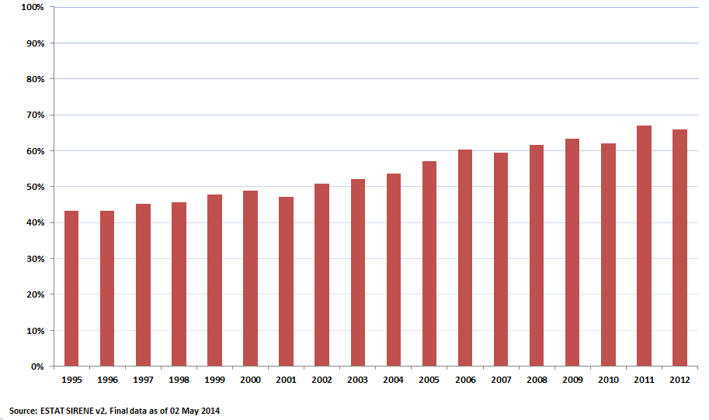
The biggest net importers of gas are the biggest EU economies with Germany and Italy importing most in 2012. UK and Italy increased their imports of gas in absolute values most. The Netherlands and Denmark are net exporters of natural gas.
Net imports to Germany and Italy have been relatively stable in the last decade (in 2012 down by 8% and 12% respectively from the peak in 2006). In 2004 the UK became a net importer with import volumes growing thirty-fold in less than a decade to reach 31 mtoe in 2012.
Among EU Member States, the level of dependency and diversifications of suppliers and supply routes varies greatly. Some northern and eastern Member States depend on a single supplier, and often on one supply route, for their entire natural gas consumption, while others have a more diversified portfolio of suppliers.
Due to the size of their economies, Member States with similar import dependencies (measuring the relative share of imports in consumption) have rather different energy deficits (measuring in absolute terms the difference between demand and production, i.e. the net import volumes). The dynamics of import dependency over time is also important and driven by the relative changes in consumption and production. For example countries like Germany and France decreased their gas import dependency between 1995 and 2012 (in percentage terms), but their energy deficits increased (in absolute terms).
Figure 10. Natural gas import dependency by Member State (intra+extra-EU imports), 2012, %
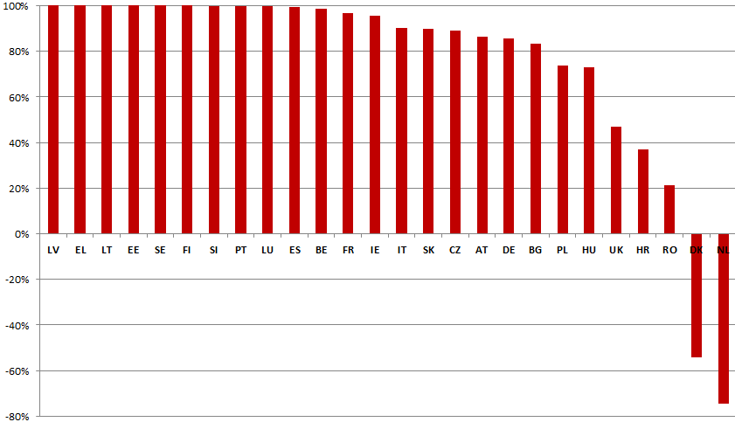

The supplier concentration indices in chapter Error: Reference source not found offer another metric of diversification which takes into account both the diversity of suppliers and the exposure of a country to external suppliers, looking at net imports by fuel partner in the context of gross inland consumption of each fuel.
In 2012 imports from Russia accounted for 32% of total extra-EU imports to the EU in energy terms, followed by imports from Norway (31%) and Algeria (14%). According to data from the COMEXT database of Eurostat, in 2013 the extra-EU import bill for natural gas was at 87 billion Euro. Looking at natural gas imports from outside of the EU, Russia holds the biggest share of total imports in value terms (41%), followed by Norway (32%), Algeria (14%) and Libya (7%).
Table 1. Extra-EU imports of natural gas, by main trading partners (share in monetary value and in mass in 2013)

Partner | VALUE (Share %) | NET MASS (Share %)
Russia | 41% | 39%
Norway | 32% | 34%
Algeria | 14% | 13%
Qatar | 7% | 7%
Libya | 2% | 2%
Nigeria | 2% | 2%
Source: Comext, Eurostat
Figure 11. Extra-EU imports of natural gas, by main trading partners (share in energy terms in 2012)
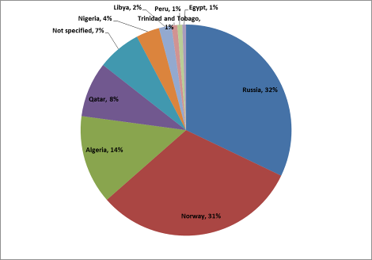
Source: Sirene, Eurostat
When looking at the total trade movements of gas – both gas entering the EU from outside (extra-EU) and the internal trade movements of gas across the EU (intra-EU), one can see that about 20% of all trade movements are within the EU. Russian gas is estimated to account for one quarter of these internal trade movements, chiefly due to transit through Germany, Austria, the Czech Republic, Slovakia, Italy and Hungary.
Figure 12. Gas trade movements: intra-EU and extra-EU, 2012

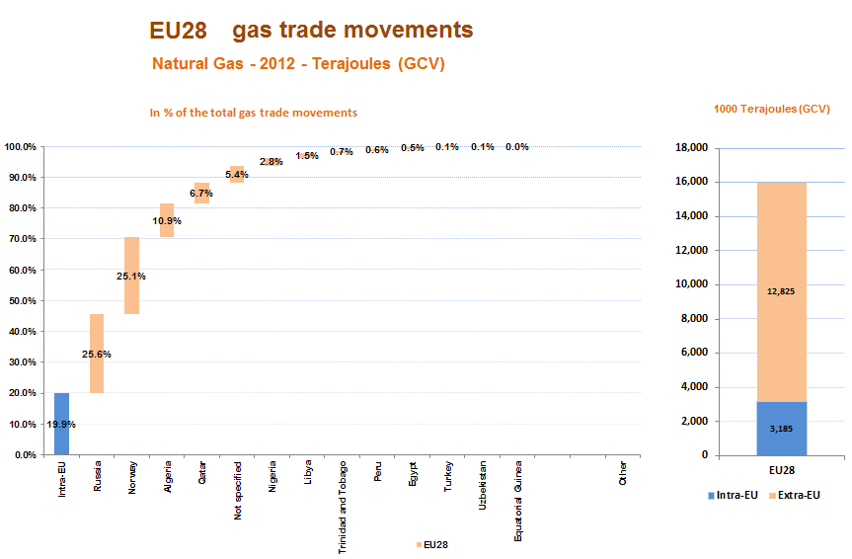
Source: Eurostat Sirene

Transport infrastructure
An important factor influencing the use of gas is the flexibility of transport infrastructure and the way it is being operated. Geographical location, the number and available capacity of pipelines, LNG terminals and underground storage are key factors in considering the flexibility with which the infrastructure allows to react to supply disruptions and periods of high demand.
The majority of the gas imported to the EU comes through pipelines. While in 2011 LNG imports exceeded 20% of total imports, in 2012 the share of LNG in total imports went down by more than 5 p.p. – a significant drop, even if LNG share has doubled in a decade. In 2012, against falling demand for natural gas, the strong decrease of LNG deliveries (more than 22 bcm/ year) was only partially compensated by an increase of imports of natural gas delivered by pipelines (12 bcm/ year).

Figure 13. Share of LNG in EU natural gas imports
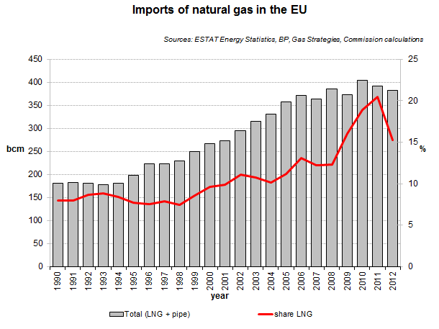
The 2013/14 Winter supply Outlook of ENTSOG pointed out that there is no big variation in the Norwegian, Algerian and Libyan supplies, but there are important decrease in the LNG imports (-32%). The drop in imports of LNG was due to the divergence of gas prices between Europe and Asia, which lead to cargo redirection and re-exports to Asia and caused a decrease in the arrival of spot cargos. This drop was replaced with a relevant increase withdraws from storages (+40%) and of Russian imports (+7.5%, mostly Nord Stream flows).

Pipeline deliveries
The total capacity of pipelines directed to the EU from supplier countries is 397 bcm/year. The major entry points of the pipelines are on the Eastern borders of the EU and in the north. New projects under construction include the pipelines of the Southern Gas Corridor which will allow by 2020 supplies to the EU markets of 10 bcm per year gas from Azerbaijan. The currently envisaged infrastructure in Turkey could transport up to 25 bcm per year for the European market and is thus able to absorb further gas volumes from Azerbaijan as well as volumes from Northern Iraq.
Reverse flows that provide a possibility to operate the pipelines in two directions are a crucial element in mitigating security of supply risks and allowing gas flowing freely. The security of gas supply Regulation 994/2010 made implementation of such investments obligatory where the costs and benefits analysis showed positive spillovers of such projects. On this basis three projects have been implemented. Since 1st of April 2014 Poland has implemented physical reverse flows on the Yamal pipeline . This allows Poland to cover almost half (7.15 bcm) of its consumption through imports from Germany and the Czech Republic. This is indeed an important step in diversification of supply routes by which Poland (which relies on imports for some 74% of its gross inland consumption) will be able to replace the 72% of Russian imports (9.8 bcm) by internal flows from the EU. The allocation of capacity procedure for firm capacity from Germany started on the 29 of April 2014. Since 2009 a number of projects have been completed with the aid from the European Energy Programme for Recovery (EEPR).
In Austria, reverse flow modifications on the connections between Baumgarten and the pipelines HAG and TAG were completed in 2011. This allows countries adjacent to Austria to use the Italian LNG terminals as a point of entry, in particular in case of a disruption of the supply of gas entering EU at the Ukraine and Slovak border. In addition, it also eliminates bottlenecks in transport of gas to Croatia, Italy and Slovenia and vice versa. The Austrian transmission grid is making progress to become an easily accessible and integrated system, and further steps should be taken to ensure integration of the TSOs. The Austrian market plays a key role in connecting the liquid northwest European markets to the Southeast European markets. The Baumgarten hub can play an important role but it needs to ensure that gas from different sources is traded there, that it is reliable, and that gas can be transported to and from the hub easily and flexibly.
Projects of the interconnector in Cieszyn between Poland and Czech Republic as well as establishing reverse flow connections in Hungary and Czech Republic enable bidirectional transmission between West and East and were completed in 2011 and 2012. Further projects with support of EEPR are on-going between Lithuania and Latvia, Portugal and Spain.
The maps below show major investment made in infrastructure developments in Central and South-East Europe since 2009. Physical reverse flows in pipelines require investments which have not been made yet on all interconnector points within the EU. When implementing the Regulation 994/2010 the Regulatory authorities agreed in most of the cases to grant exemptions to the system operators from the obligation of conducting such investments.
Thus, reverse flows are an important factor of flexibility as they provide alternative supply routes and connect gas systems to additional entry points, including indirect access to LNG terminals. In addition, the alternative supply routes provide more opportunity to trade and increase hub liquidity. As indicated in Figure 12, despite a high dependency of the EU on external suppliers, the equivalent of a fifth of the EU gas imports is already being traded within the EU.

Figure 14. Infrastructure developments in Central and South-East Europe since 2009
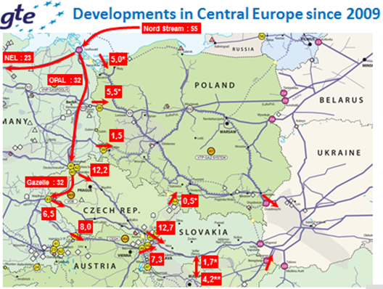
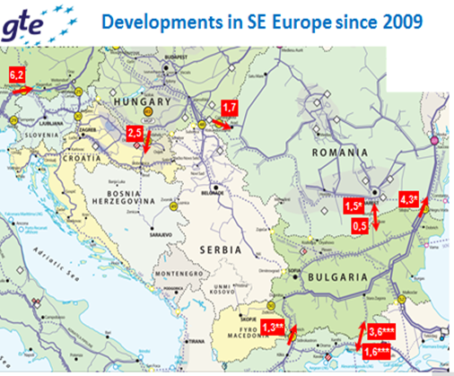
Source: GIE, Presentation at the 25th Madrid Forum 6/5/2014
Congestion of interconnector points in the EU (physical and contractual) poses an important challenge to free flow of gas and a factor that needs to be addressed as part of efforts to mitigate security of supply risks. In their report ACER concluded that out of over 350 interconnection points at least 118 are congested. Most of the congestion points were found in the Central Western Europe.Congestion at the Austrian border and the German-Polish border is critical as these are connecting the liquid northwest European markets to the Central and Southeast European markets. Congestion appears also on the borders of Bulgaria, Poland and Hungary. Based on their preliminary findings, ACER recommends greater transparency and coherence in reporting of data.
It needs to be emphasised that the existing main transport pipeline that transports gas from Russia through Ukraine, Moldova, Romania, to Bulgaria, Greece and Turkey, is not operated in line with EU legislation (no TpA, no unbundling, no reverse flows) and therefore separates markets and undermines security of supply instead of being an interconnection that can be flexibly used to transport gas between vulnerable markets.
Figure 15. Indicative map of contractually congested interconnection points in Europe
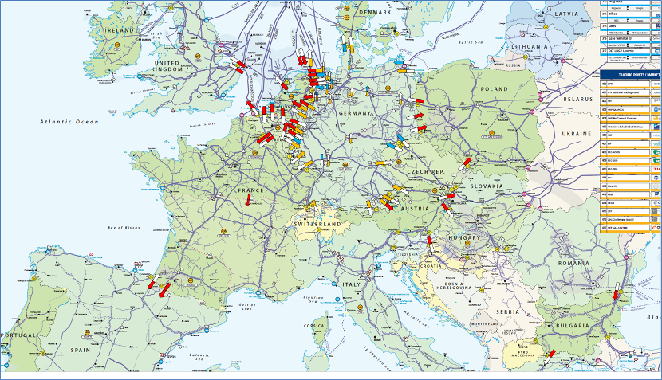
Source: 2014 ACER annual report on congestion at interconnection points in Q4/2013, TSO responses to the ACER survey on CMP implementation and analysis of TSOs’ data and ENTSOG Transparency Platform

Contractual obligations
Diversification of supply via pipelines requires construction of new infrastructure outside of the EU, which is normally underpinned by longer term commitments. The long term contracts of pipeline gas are estimated to cover 17-30% of EU market demand i.e. nearly entire import from Russia, with different duration periods. From the reports by Member States to the Commission made on the basis of security of supply Regulation 994/2010 is appears that there are close to 300 contracts with duration above one year, for supply of gas from third countries. They are evenly distributed regarding their duration 31% of these contracts has duration between 1-10 years, 33% duration between 10-20 years, 36% duration of more than 20 years. Six Member States have less than 5 gas supply contracts (BG, FI, EL, LV, PT, SI) while five Member States have more than 30 contracts each (BE, FR, IT, ES, DE). As regards expiry dates 47% will expire within 10 years, 45% within 10-20 years and 8% above 20 years. For 4 Member States all their contracts will expire within 10 years. These contracts are sometimes covered by the intergovernmental agreements and cover nearly entire deliveries of the Member States concerned.
Figure 16. Gas supply contracts in the EU
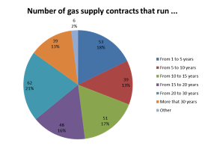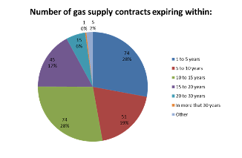
Long term commitments and geography of pipelines in the EU (lack of North-South connections) lead to congestions in the network and are reasons why some of the Member States are more dependent than others from single upstream suppliers.

LNG terminals
The total regasification capacity of LNG terminals in the Europe (excluding small scale LNG) is around 200 bcm/year. Further terminals are planned and their total capacity is planned to reach 275 bcm/year in 2022. The map below shows capacities of terminals that are operating as of 2013. The map shows that main LNG capacities are in the west of the EU.
Whereas the pipeline capacities are almost fully utilised, the utilisation of LNG terminals is much lower. Data from Thompson/Reuters shows that utilisation rate of LNG terminals is about 25%. The Council of European Energy Regulators (CEER) estimates that 137 bcm of regasification capacity (73% technical capacity) in the EU was not used in 2013. In terms of volume 58 bcm of capacity was not used in Spain and 44 bcm in the UK, 15 bcm in France, 11 bcm in Netherlands, 8 bcm in Belgium, 6 bcm in Italy and 5 bcm in Greece.
This latest development characterizes well the variables with the major impact on the supply in the gas market and its potential in the future. The supplies of the LNG can in principle provide a certain degree of flexibility due to free capacities. Additional factors at play in evaluating the role of LNG include tightness of global LNG markets and competition for spot cargos between Europe, Asia and Latin America, very high prices with Asian LNG deliveries at significant price premium over European ones and a time lag before a cargo arrives. CEER points also out that the number of countries importing LNG is growing (29 in 2013), whereas the number of exporting is rather stable and the LNG market is supply constrained at present. The relative inflexibility of some European market participants who are bound by long-term contracts for pipeline gas with take-or-pay obligations may be another reason of the decreasing relative share of LNG in total imports in the EU and the low level of utilisation of LNG terminals.

Figure 17. LNG import capacities and delivered quantities in the EU, 2013

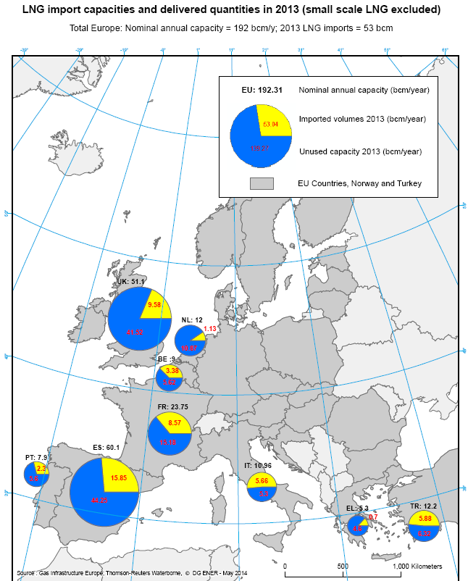
The diversion of LNG cargoes to the Pacific basin in the aftermath of Fukushima is well documented and the figure below provides further evidence for the more attractive pricing conditions in Japan (similar price levels were also observed in South Korea and China). The EU – Asia price differential is greater than the shipping cost difference so in the case of LNG destination clauses have served to lock supplies, which in a genuine spot market would probably have been delivered to Asia.
Against a background of falling demand a new LNG trade feature has expanded – re-exports, whereby LNG importers can take advantage of arbitrage opportunities by selling LNG to a higher-priced market, but have to meet the contractual obligation of unloading the LNG tanker at the initial destination as described in the contract with their LNG supplier. The IEA estimates that in 2012 Spain re-exported 1.7 bcm, Belgium 1.6 bcm, France 0.2 bcm and Portugal 0.1 bcm.
Figure 18. LNG price developments, selected countries
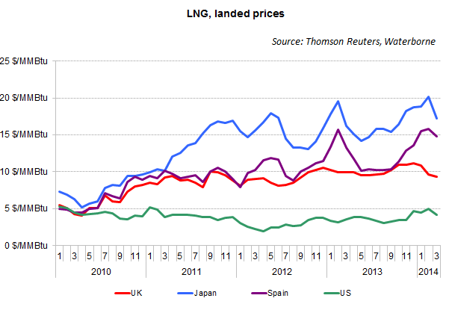

Gas storage
Gas storage can act as a buffer in case of a disruption of gas deliveries, but its availability depends on storage levels and the speed with which gas can be delivered to the consumers. According to CEDIGAZ there are 130 UGS facilities in Europe, including non EU countries such as Turkey, comprising a combined capacity exceeding 90 bcm. As the map shows there are more storage capacities in the West of the EU. However the ratio gas consumption/storage capacity is similarly spread across the EU with some exceptions such as Austria and Latvia whose storage capacity exceeds consumption.

Figure 19 Underground storage facilities in Europe
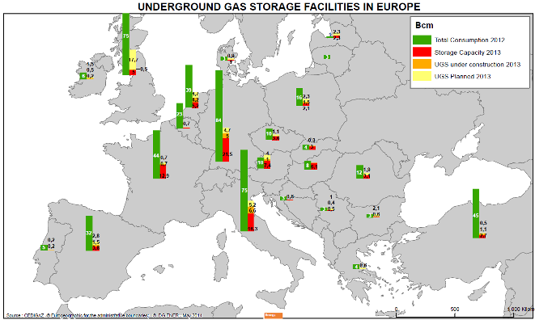
Source: CEDIGAZ.
As pointed out by Gas Storage Europe (GSE) and CEER the current storage levels are above the level normally observed around this time of the year. This is because of the mild winter 2013/2014. The storages are also filling quickly and ENTSO-G forecasts that 90% level can be reached by the end of this summer.
As of mid-May 2014, the underground gas storages of the 8 EU hub regions (Baumgarten, France, Germany, Iberian, NBP, PSV, TTF and Zeebrugge) contained 44 bcm of natural gas and were full at 55%. The maximum storage withdrawal rate is estimated at 1.4 bcm/day (data from Thomson-Reuters and Gas Storage Europe). However, the business model for filling gas storages is not necessarily setting incentives to store gas to prevent crisis situations. Gas storages are being filled in on the basis of spreads between summer and winter time. Analysis of such spreads, based on historic events does not predict unexpected events. Moreover the price spread between winter time and summer time decreases over years. The decreasing spreads and volatility - due to a combination of factors such as excess of supply in Europe and competition from other sources of flexibility (LNG, interconnectors and spot gas) and increasing storage-to-storage competition – have undermined the value of storage.

Figure 20. Storage Levels 29 April – 2013 vs. 2014 (million m³)
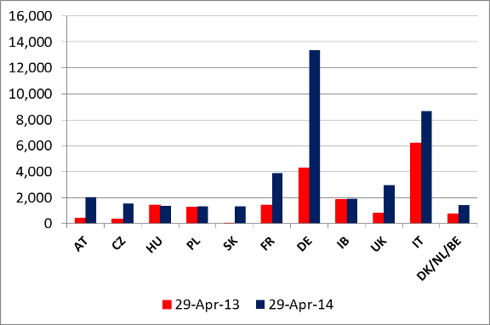
Source: GSE: Data from the Aggregated Gas Stock Inventory which delivers online daily data representing approximately 78 BCM, i.e. 87 % of EU technical storage capacity. Data per country and for 8 defined hub areas on the volume in stock as well as the daily injection and withdrawals.
Figure 21. Gas storage in Europe (% of full storage)
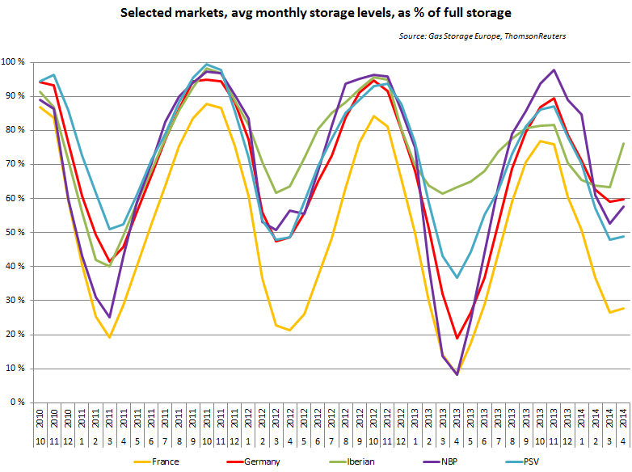

http://www.bp.com/content/dam/bp/pdf/statistical-review/statistical_review_of_world_energy_2013.pdf
COM/2014/023 final/2 : http://eur-lex.europa.eu/legal-content/EN/TXT/?uri=CELEX:52014DC0023R(01)
Arguably robust growth of domestic demand in Turkey might constrain the volumes transited.
Three reverse flow investments are under implementation: from Germany to Poland, from Greece to Bulgaria and from Romania to Hungary
http://en.gaz-system.pl/en/press-centre/news/information-for-the-media/artykul/201826/
http://en.gaz-system.pl/en/press-centre/news/information-for-the-media/artykul/201838/
SWD(2013) 458 final
Romania-Hungary is currently one-directional and delivers Russian gas to Romania. Croatia-Hungary is bidirectional, but in the absence of an LNG terminal quantities would be relatively limited.
http://www.acer.europa.eu/Official_documents/Acts_of_the_Agency/Publication/ACER%20Gas%20Contractual%20Congestion%20Report%202014.pdf
However this was the region were most of the data were reported.
See paragraphs 54-56 of the Report regarding the limitations of the data collected and therefore preliminary character of the findings
http://ec.europa.eu/energy/gas_electricity/studies/doc/gas/lt-st_final_report_06092013final.pdf
Check for example the regular publications of the Market observatory for energy here: http://ec.europa.eu/energy/observatory/gas/gas_en.htm
A precondition for re-exports is that the receiving regasification terminal is technically capable of loading the initially unloaded LNG back into the tanker, a feature many regasification terminals lack. Source: IEA. 2013. Mid-term gas market report. OECD/IEA.

