COMMISSION STAFF WORKING DOCUMENT
Evolution of the market situation for milk and milk products
Accompanying the document
REPORT FROM THE COMMISSION TO THE EUROPEAN PARLIAMENT AND THE COUNCIL

Development of the dairy market situation and the operation of the "Milk Package" provisions.

1. market developments to date
Together with price volatility, the weather has played a significant role in the milk market developments during the years 2012 and 2013. Indeed, a severe drought in the US and in certain EU Member States in the summer 2012 led to a sharp increase in feed prices, and put EU dairy farms highly dependent on purchased feed under pressure.
The first half of 2013 was characterised, on the contrary, by a cold and wet weather in the EU, which conditioned the quality and volume of pastures and forages, leading to a lower milk output. At the same time Oceania was hit by the worst drought in 30 years. As a result, the global milk supply was unexpectedly tight.

1.1. milk production
Cow milk collection in the EU observed a correction in the second half of 2012, following the boost experienced in 2011 and the beginning of 2012. In June 2012, the cumulated milk collection in the EU-27 was 2% over the same period in 2011. As a reaction to narrowing margins, the sector slowed down milk output, managing to reduce the cumulated production increase down to 0.6% by the end of the year.
The cold spring compromised EU milk production in the first half of 2013. The cumulated milk collection up to June 2013 was 1.9% below 2012 levels. Favourable weather conditions, high price levels thanks to strong global demand, and the improved margins pushed milk production in the second half of the year, leading to month on month increases by 4% in October, November and December (the strongest quarter in the last ten years). Year 2013 eventually closed with a 0.7% increase compared to 2012. Provisional figures for January 2014 suggest a continuation of this upward trend, with a 4.7% increase compared to January 2013.

Graph.1 Milk collection developments
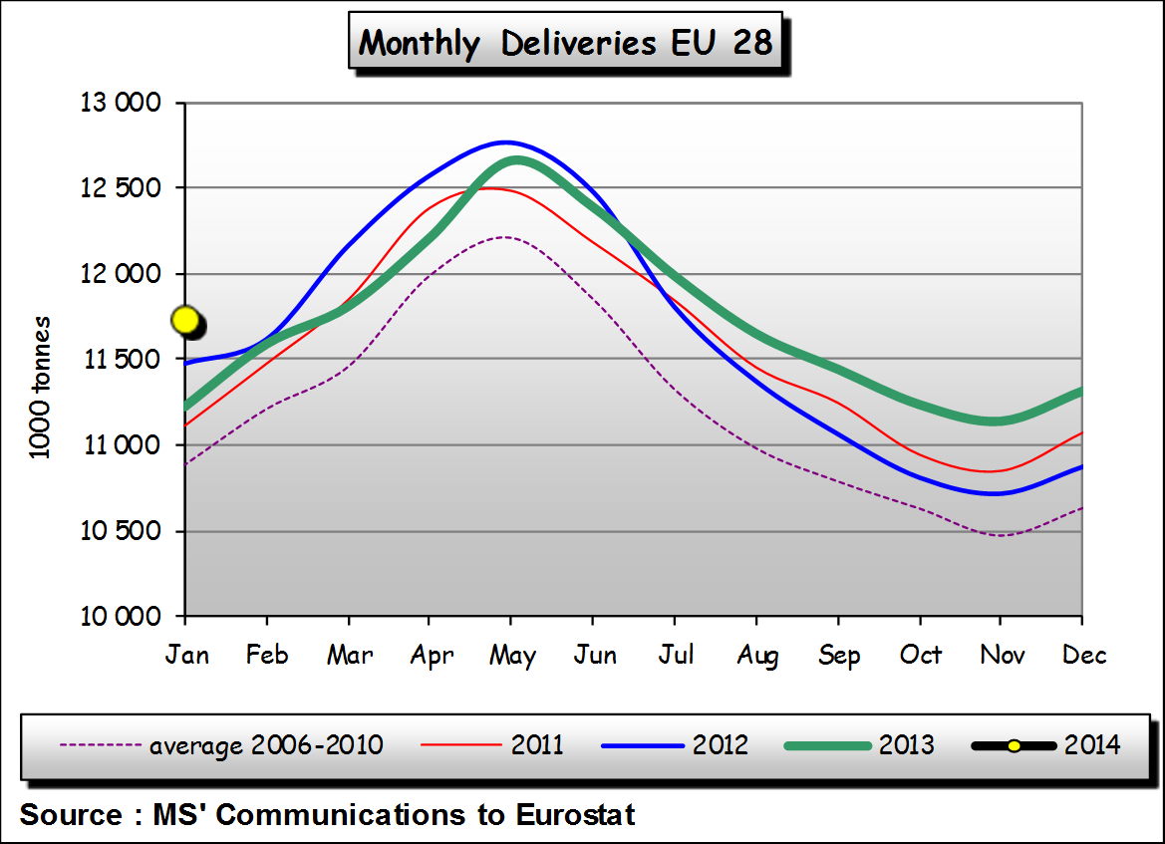
Different milk output patterns were observed in the main milk supplying regions of the world during this period: in Oceania, milk production in New Zealand kept on growing through the second half of 2012, and closed the year with an 8.5% increase compared to 2011. Then the region was hit by the heat wave and milk production dramatically fell from February to July 2013 (cumulate milk output during these months was 19% lower than in previous year). The 2013-2014 season started with good weather perspectives, which were confirmed by a rebound in milk production towards the end of the year. Cumulated production in the first six months (June-December 2013) was 5.4% higher than in the previous season (although 2013 production was 1.8% lower than in 2012).
Fluctuations were less accentuated in Australia, where milk production closed the year 2012 with a relatively modest 2.5% increase compared to 2011. Milk output has been persistently lower - month on month - between December 2012 and November 2013, due to the prolonged droughts, thus leading to a yearly decrease of 4.9% in 2013. In the first seven months of current the season (July 2013 to January 2014) milk production was still 2.1% below the previous one.
In the US, despite contraction in farms' margins in 2012, milk output only slowed down moderately in three months (August-September 2012), and the cumulated figure for the whole year was 2.1% higher than in 2011. Contrary to what happened in the EU and Oceania, the US was the only region keeping the pace in the first months of 2013 and showing month on month increases already as from April. Milk production unexpectedly weakened in Q4, reaching in November and December similar volumes as in the previous year. The overall milk production in 2013 was 0.4% higher than in 2012. In the first month of 2014, milk production in the US increased by 0.9% compared to 2013.

1.2. eu farm gate milk prices
Following two years of high farm gate milk prices and milk production expansion, a price correction took place in the first half of 2012. The seasonal downward pattern, which usually occurs by the end of each year, was prolonged in 2012 until the summer responding to pressure from increased milk supply in and outside the EU. Milk prices fell to 30.9 c/kg in June 2012, a 10% decrease in the first six months of the year. Prices then started to move upwards with the only exception of two small corrections in February and March 2013, leading to record high figures from April 2013 onwards.
Graph.2 Milk price developments
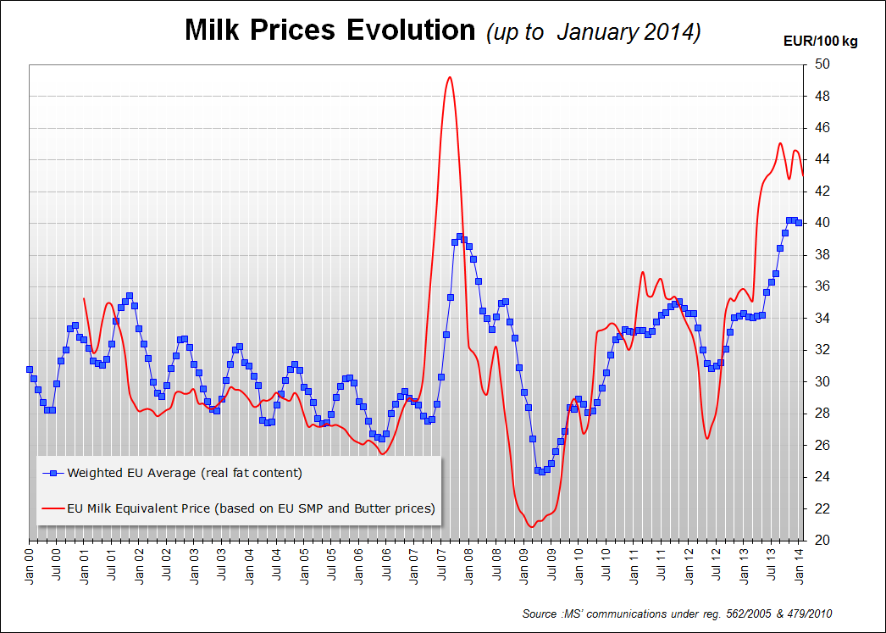
The EU average farm gate milk price reached an historical peak (statistics available since 1977) of 40.35 c/kg in December 2013. A slight correction by -0.5% has been observed in January 2014 (17% higher than in January 2013) following the seasonal patterns, and possibly also induced by higher milk output since the beginning of the season.
A correction in milk prices throughout 2014 (notably in the second half of the year) can not been discarded, given the current production behaviour in the main regions of the world. However, the strong global demand is expected to support prices at reasonably firm levels.

1.3. dairy product prices, stock levels and exports
A strong increased demand, notably from emerging economies, and limited supplies from all main producing regions in the first half of 2013, pushed upwards dairy commodities prices which have steadily increased since mid-2012 up to historical levels. In October 2013 EU average butter price hit an all-time record of 423 €/100 kg. Similarly, EU average cheddar cheese prices reached an unprecedented level of 407 €/100 kg in February 2014. All the main dairy products' prices increased throughout 2013 by more than 20% (23% for butter, 22% for SMP, 27% for WMP and 20% for cheddar cheese).
Some pressure has been observed in the butter price during the first weeks of 2014, although prices for all dairy products have generally remained firm.
Graph.3 Dairy products price developments
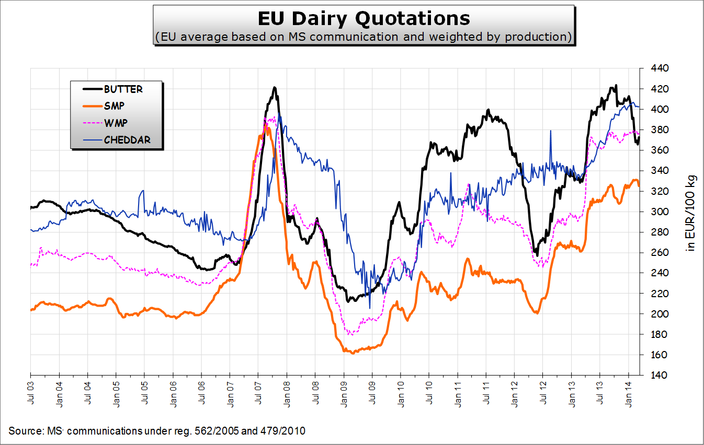
Thanks to the positive price developments previously described, there has been no buying-in into intervention in the period 2012-13 and public stocks are empty for both butter and skimmed milk powder.
Good export performance was observed throughout 2012 for most of EU dairy products, although a downward adjustment took place by the end of the year, as a consequence of reduced milk production. Cheese was once again the most dynamic product, registering a 13.6% increase compared to year 2011 (which was already a remarkably good year in terms of cheese exports). Needless to say, all exports were carried out without export refunds.
The unavailability of products to trade conditioned European exports during 2013. By September 2013, SMP production was 7.7% below last year's level, while exports were down by 31%. Similarly, butter production decreased by 1.4%, and exports by 5% in the same period. A hindmost upsurge by the end of the year lead to a cumulated decrease of SMP exports by 21%, and a modest increase of butter exports by 0.3%. Cheese exports registered positive figures throughout the whole year, and closed with a +2.6% compared to 2012.

1.4. estimated dairy farms' margins in the eu
Milk margins in the EU shrank in the first three quarters of 2012, as a consequence of falling milk prices and rising of operating costs, notably feed costs. According to the model developed in DG AGRI, the margin index would have decreased by 27% between Q1 and Q3 2012, as a result of a diminution in the milk price index by 7% and an increase of the operating cost index by 5%.
The trend clearly reversed since then, triggered by an uninterrupted improvement in milk price and an easing of feed prices. The milk price index would have increased by 27% between Q3 2012 and Q4 2013, and the operative cost index only by 1.7%. Gross margin index would have improved, as a consequence, by 84% in the same period.
The situation varies from Member State to Member State and even within Member States, depending on the milk farming system chosen and on the product mix used by the dairy sector.
Graph.4 Gross margin evolution
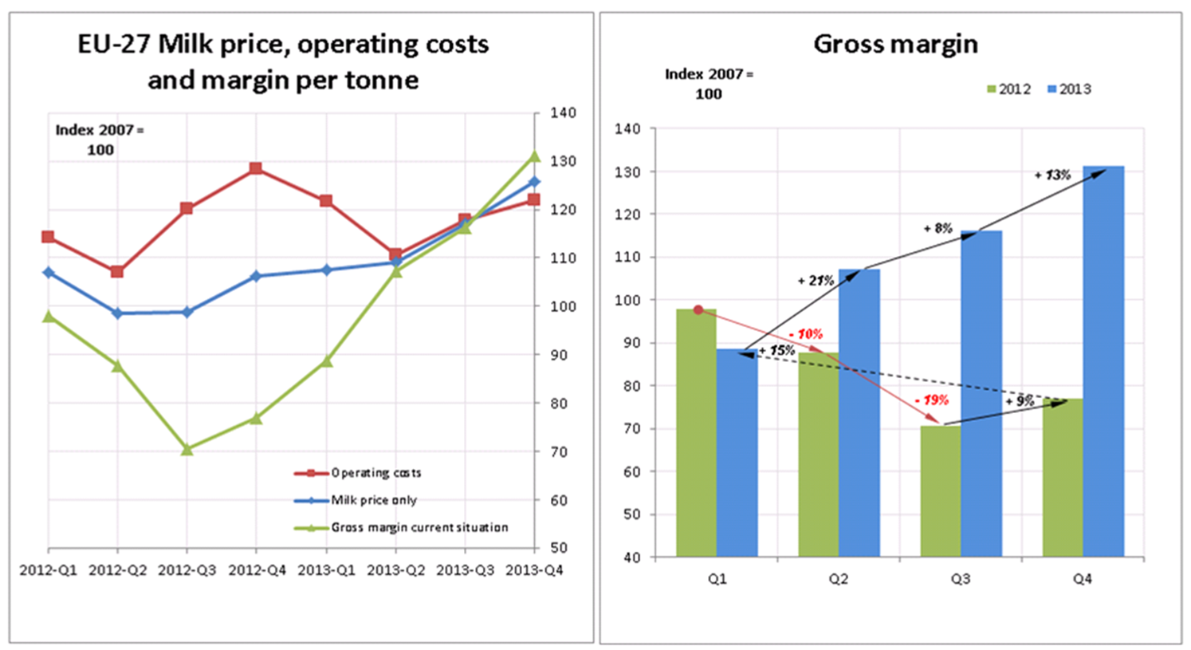

2. medium term market prospects 2013-2023
The medium-term prospects for milk and dairy commodities are favourable on both the world and domestic markets. World demand remains dynamic (especially in the emerging economies), despite the slowdown in economic growth, with a higher proportion of middleclass households, dairy products are featuring more prominently in people’s diets. On the supply side, feed prices are projected at lower levels than those observed since 2010. These positive drivers will maintain prices at relatively high levels and boost EU milk production.
Some dairy farmers may switch to crop production and in Germany silage maize production for biogas is especially competing with dairy farming. Furthermore; production development will also have to adapt to the pace of consumption increase in both the EU and on the world market. In addition, the EU will face competition on the world market from Oceania but also from the US and Argentina whose exports are expected to increase.

2.1. market prospects in the eu
These projections assume normal weather conditions, but it has to be borne in mind that weather is a strong determinant of milk production growth – not only in Europe. Dairy production in the EU (especially from grass-fed systems) is affected not only by droughts implying higher compound feed costs, but also by wet and cold weather.
Graph.5 EU-28 milk deliveries and dairy herd developments, 2005-2023
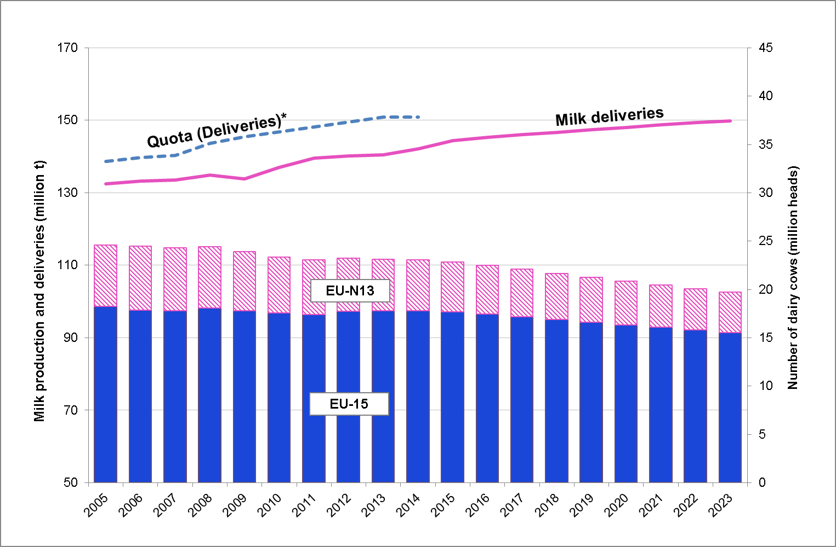
* In Romania, Bulgaria and Croatia for the years prior to accession the quota is set at the level of the first year of accession
Milk deliveries are projected at 150 million tonnes in 2023 i.e. 9.6 million tonnes more than in 2012. Most of the growth will take place in the EU-15; the EU-N13 could produce an additional 1.2 million tonnes. This increase will come from further yield improvements to 8 500 kg/cow in the EU-15 in 2023 and 6 050 kg/cow in the EU-N13.
Production increases can be expected in those Member States currently restricted by the quota (e.g. the Netherlands, Denmark, Germany, Austria and Cyprus).
By the end of the projection period, the annual growth in milk deliveries is expected to slow down because of narrower operating margins. Given the strong world demand for dairy commodities and feed price projections 15 % below 2010-12 levels, the nominal EU milk price should be quite stable, but steady increases in other operating costs (especially for energy) are likely to squeeze margins. In addition, as already mentioned environmental constraints and competition for land with other sectors will limit production expansion in some Member States.
It is expected that the cheese sector will be boosted by a dynamic world market and steady growth in domestic demand. Cheese production is therefore expected to absorb most of the additional milk delivered to dairies.

The additional milk produced will allow the EU increasing its exports to the world market and maintain a share in world exports close to 60% for whey powder and around 30% for cheese and SMP.
Graph.6 EU share in world exports (%)

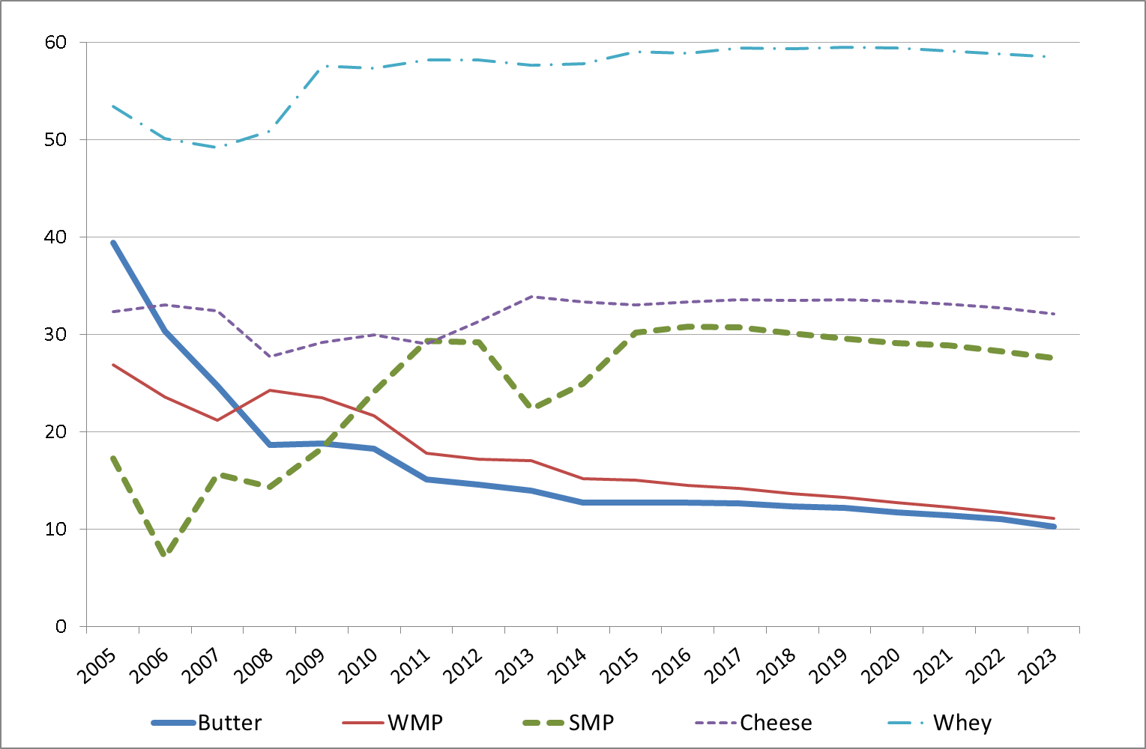

2.2. projected milk deliveries by member state
When the EU milk quota system is abolished, the milk and dairy sector is likely to expand in the most competitive countries, while contracting elsewhere. Nevertheless, the development of the production at Member State level is uncertain because milk markets have been constrained by quotas for many years in the EU.
In order to project the change in milk marketable production in 2023 compared to 2012, JRC-IPTS has used the ESIM model. This modelling exercise accounts for farmers reaction to price developments, milk margins, observed trends in milk deliveries during the phasing out of the quota system, environmental constraints and information available on the recent investments in the dairy sector.
By 2023, milk marketable production is projected to increase by more than 20% in Ireland, more than 15% in Germany and the Netherlands, more than 10% in Denmark, France, Austria, Estonia, Cyprus and Poland. The projected increase in Belgium and the United Kingdom is below 5%. By contrast, production could decrease in Greece, Finland, Sweden, Czech Republic, Slovakia, Hungary, Bulgaria, Romania and Croatia. A relatively stable production is projected in Italy, Spain, Portugal, Latvia, Lithuania and Slovenia.
Graph.7 % change in milk deliveries in 2023 compared to 2012 projected by JRC- IPTS with ESIM model
However, a modelling exercise can not include all the market expertise available, which takes into account other types of information and expectations about the future than the assumption described above. In some cases, these projections may seem optimistic. For example, contrary to the stability in the Spanish and Portuguese milk deliveries simulated by the model (explained by strengthening dairy prices on world markets), many market experts rather expect a decrease of milk deliveries due the structure of the milk production and processing in these two countries. In France, the increase in deliveries could be smaller because some major private companies have announced their willingness to restrain milk collection expansion and to concentrate their activity in value added products without producing powders.
In other cases, they might be seen to be too pessimistic. Irish authorities announce 50% higher milk deliveries by 2020, other experts bet more on a less important increase, between 30% and 40%. This modelling exercise concludes on a lower increase because of possible environmental constraints and also because cold and wet weather conditions similar to those observed in 2012/13 could repeat once or twice over the projection period and affect the milk production increase achieved by 2023. Certain market experts argue that milk deliveries in the United Kingdom could increase more, given recent investments in the dairy industry. Another example is the projected decrease in Bulgaria and Romania, which is based on past observation. However, the decrease in milk deliveries in these two countries could slow down if part of the decline in subsistence farming is compensated by farmers working with dairies. Given the recent developments observed in Estonia and market opportunities in neighbouring countries, deliveries could increase more in that country but anyhow are not likely to not translate into major additional quantities on the EU market. The performance of Estonia will affect particularly the neighbouring countries - Lithuania and Latvia - where stable deliveries are projected. The decrease in milk deliveries in Hungary could be lower, if Poland performs less than projected.
Last but not least, the effect of environmental constraints and their implementation by national authorities implies a significant uncertainty on the development of milk deliveries in particular in the Netherlands, France (Brittany) and Italy. In the latter, milk valorisation is good because of the importance of cheese production for which prospects are positive. Nevertheless, some domestic milk could be displaced by imported milk.
For more information on the medium term market prospects, the projected milk deliveries by Member State and details on the methodology and the macroeconomic assumptions please see: http://ec.europa.eu/agriculture/markets-and-prices/medium-term-outlook/index_en.htm

based on data available till mid-March 2014

