Resilience of infrastructure today and ahead
The availability and location of pipelines and management of their congestion, available LNG terminals and storages give a view how gas can be supplied in case of disruptions from main sources of supply.
The 2013 Ten Years Network Development Plan (TYNDP) of the European Network Transmission System Operators for Gas (ENTSO-G) identifies zones whose balance relies strongly on dependency on Russian gas and LNG gas, with different ranges depending on the minimum supply share of the predominant supply.
The study concludes that supply dependence on Russian gas will increase when considering only TYNDP projects where final investment decision has been taken (FID-Projects). ENTSO-G is of the view that this is due to the lack of appropriate infrastructure being available to bring other sources to compensate for the increase of gas demand and the decrease of national production in the eastern part of Europe. ENSTO-G argues that dependence can be strongly reduced with the commissioning of projects where final investment decisions have not been yet made (Non-FID Projects foreseen for 2017 and 2022) and especially if new sources of gas can be supplied to the South-East of Europe. ENTSO-G notes that the dependence on LNG is more local and of a lower degree. It concentrates on the Iberian Peninsula and South of France. It has been also underlined that LNG is by nature diversified in its potential origins. Further investments in FID projects will diminish by 2017 and 2022the dependence on LNG deliveries. Implementation of Non-FID projects could be reduced further with the commissioning of Non-FID projects.
In addition, ENTSO-G analyses as well the resilience level of the EU Member States infrastructure and its flexibility i.e. the ability of infrastructure to respond to situations of high particularly demand or supply disruptions. In the 2013 TYNDP the simulation shows the flexibility of infrastructure by comparing the normal situation of demand and supply (the Reference Case) and of two scenarios: in a single day of highest transported gas quantity and in a day at the end of a 14 day period of high demand. Further the gas system infrastructure has been assessed in respect of situations of supply disruptions: disruptions of transit via Belarus and Ukraine. The below map shows the outcome for the scenario in day 14 of high demand and disruptions in Belarus and Ukraine transits. The case shows lack of infrastructure resilience of South-East Europe, Sweden, Denmark and Finland in case of an interruption of Russian gas transit through Ukraine.

Figure 1. Supply Source Dependence on annual basis (red colours indicate high dependence)
Note: FID projects - projects with final investment decision. Non-FID projects – projects where final investment decisions have not been yet made
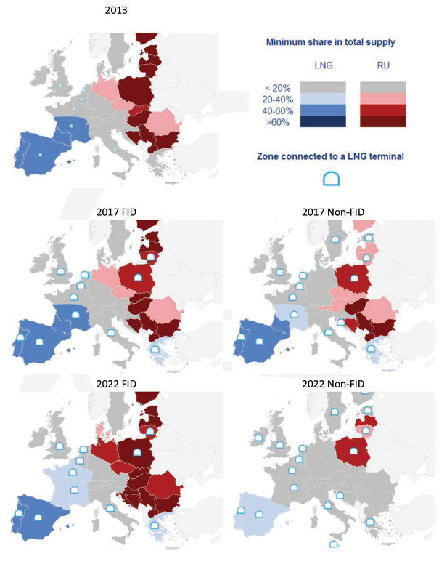

Figure 2. Infrastructure Resilience under 14-day Uniform Risk Situation
Note: FID projects - projects with final investment decision. Non-FID projects – projects where final investment decisions have not been yet made

Summary
- Gas import dependency of the EU exceeds 60% of total demand, with two thirds of imports coming from countries outside of the EEA. The Baltics and Finland are dependent on a single supplier for their entire gas consumption.
- The flexibility of transport infrastructure in terms of geographical location, the number and available capacity of pipelines and LNG terminals, underground storage and the way infrastructure is operated all play an important role in shaping the resilience of the gas sector.
- The potential to operate pipelines in two directions increases the resilience in case of a supply disruption. It is thus important to ensure investment in physical reverse flows and prevent physical and contractual congestion at interconnectors.
- The flexibility of supply in short term and availability of alternative external sources depends on competition on the world markets and on the degree to which such sources are already reserved by long-term contracts or other commitments (e.g. intergovernmental agreements). In the EU the long term contracts of pipeline gas are estimated to cover 17-30% of EU market demand i.e. nearly entire import from Russia, with different duration periods. These volumes are sometimes covered by the intergovernmental agreements and some reach beyond the year 2030.
- The capacity of the pipes to the EU is 8776 GWh/day, roughly comparable to the capacity of LNG terminals (6170 GWh/day). The possibility of the existing under-utilised LNG capacity to contribute to improved resilience differs among terminals, largely depending on their geographical location and the infrastructure allowing the transport of gas (mostly on the Iberian Peninsula with less importance for supplies in the eastern part of Europe). The role of LNG as a tool to increase resilience is undermined by ongoing tightness in global LNG markets and high prices on Asian markets, as well as the relative inflexibility of some market participants bound to long-term contracts with take-or-pay obligations.
- In case of disruption of gas the deliverability of gas from underground storages is a mitigating factor but its availability depends on storage level and the speed with which gas can be delivered to the consumers. It needs to be pointed that the large majority of storage is designed for a rigid winter-summer cycle, so the contribution to a sustained disruption may be more limited than what capacity numbers suggest.

Coal

Consumption, production and imports
Coal is a generic term used for a range of solid fuels with varying composition and energy content, including hard coal, sub-bituminous coal, lignite/brown coal and peat.
The EU is the third largest coal-consuming region globally, after China and North America; the gross inland consumption of solid fuels in 2012 stood at 294 mtoe. In the period 1995-2012 the total demand for solid fuels in the EU went down by almost 20%, falling down in virtually all Member States. Following the slump in consumption in 2009, demand started recovering and 2012 was the fourth consecutive year of growth in solid fuel consumption. Yet, consumption is still below pre-crisis levels and indeed about 15% below the levels in the mid-90s. By far the largest part of solid fuels serves as transformation input to electricity, CHP and district heating plants, with smaller amounts going to coke ovens, blast furnaces and final energy demand.
Hard coal accounts for about 70% of gross inland consumption, but the EU produces about one third of the hard coal consumed and is dependent on imports for about 63%. About 70% of hard coal is used in power plants, the rest almost equally distributed between steel mills/coking plants and the heating market. In the period 2011-2012 the weakened steel business and the reduction in pig iron and crude steel production at the mills witnessed a drop in demand for hard coal. This was more than overcompensated with the growing use of steam coal for power generation. Lignite production and consumption also increased at a faster rate (VKI 2013).
At the level of all solid fuels, EU production meets more than half of EU demand. Germany, Poland and the UK remain the largest consumers of solid fuels with consumption in 2012 up by 4% on annual basis in Germany, up by 27% in the UK and down by 4% in Poland. A number of Member States have seen a double-digit growth in consumption between 2011 and 2012, in particular Portugal (+33%), Spain (+23%), France (+12%), Ireland (+16%) and the Netherlands (+10%), though consumption remains below pre-crisis levels. The decline in coal and CO₂ prices and the high gas prices provided coal with a strong competitive advantage to gas in power generation.
Directive 2001/80 on the limitation of emissions of certain pollutants into the air from large combustion plants limited an even higher increase. It allowed a fixed number of operating hours for opted out plants, which have been utilised at a high speed; thus the upswing in the last two years in effect may lead to accelerated decommissioning.
Figure 3. Energy flow of solid fuels in the EU, 2012
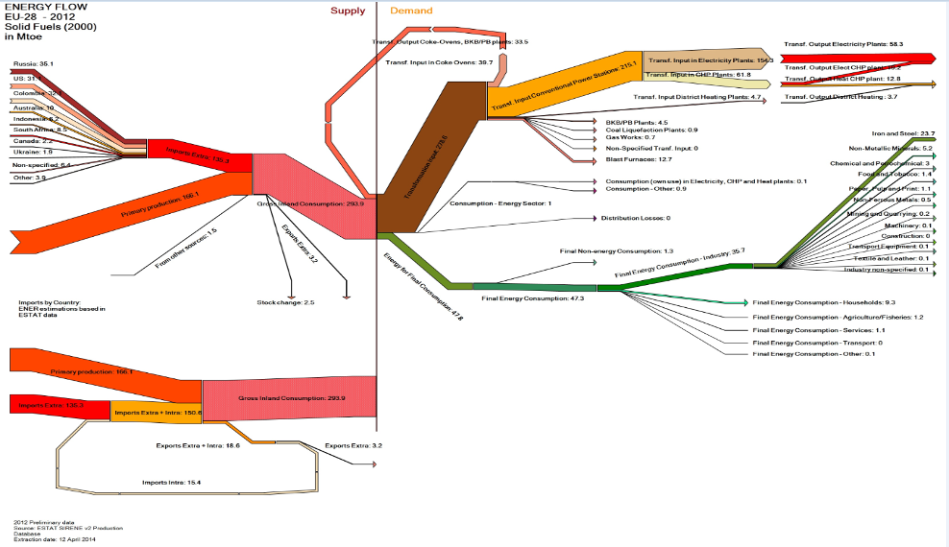

Figure 4. Gross inland consumption of solid fuels in the EU, 1995-2012, kt
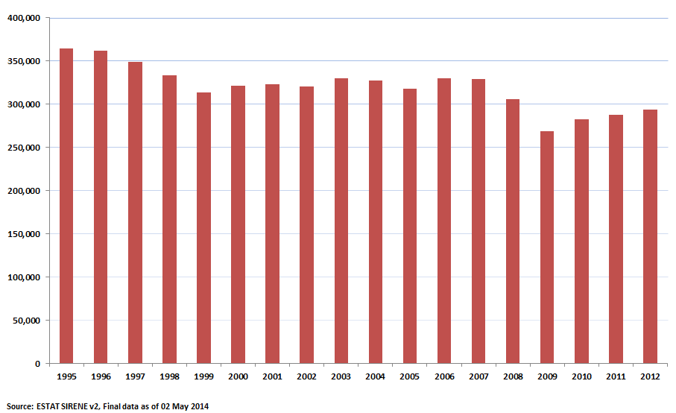
Note: Solid fuels includes the following categories:hard coal and derivatives; lignite, peat and derivatives; oil shale and oil sands.
Figure 5. Gross inland consumption of solid fuels by MS, 1995-2012, kt
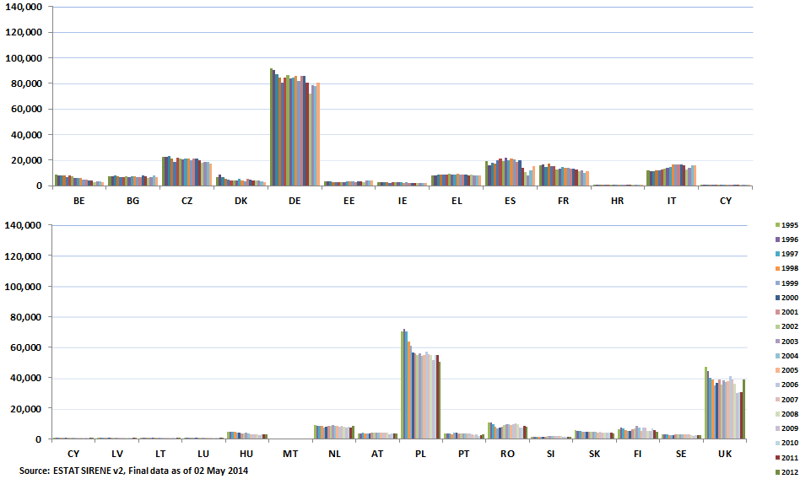
The EU remains a large coal producer. In 2012 it produced 590,000 kt of solid fuels, a relatively stable output on annual basis, but down by 40% in comparison to the mid-1990s and well below pre-crisis levels. Since the mid-1990s the production of solid fuels in the largest producers in the EU – Poland, Germany and the Czech Republic – went down by 37%, 40% and 25%, respectively, but has been stable over the last 2 years.
Figure 6. Total energy production of solid fuels in the EU (1995-2012), kt
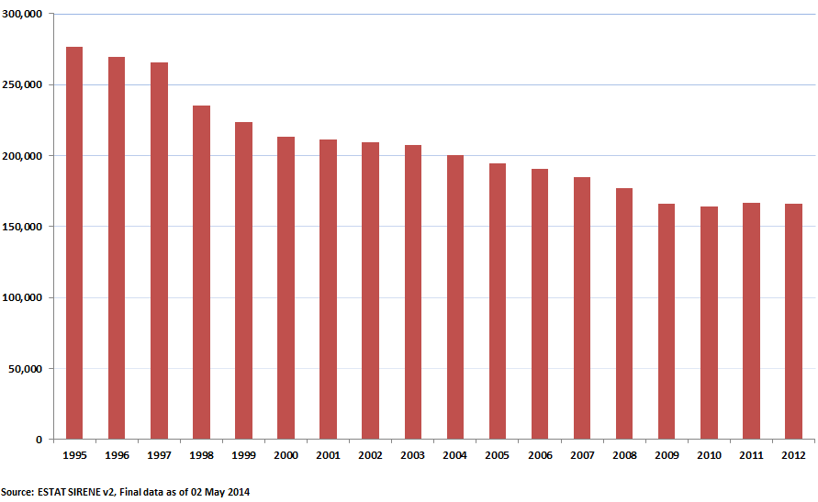
Hard coal imports to the EU are rising to compensate for the decline in domestic coal production and meet the recent increase in demand by power utilities driven by the fall in coal import prices and the competitive position of coal in the power sector. Total imports on 2012 increased faster than consumption (+3.3% on annual basis), pointing to high stockpiles of coal at major ports and power plants.
Russia remains the largest importer of solid fuels to the EU (26% of imports to the EU), followed by Columbia (24%) and the US (23%). The United States has gained a higher share of the European market. Declining steam coal exports from Indonesia and South Africa have been replaced by greater supplies from Colombia and the United States. Australian imports have declined against competition from North American exporters.

Figure 7. Extra-EU imports of solid fuels, by main trading partners (share in energy terms in 2012)
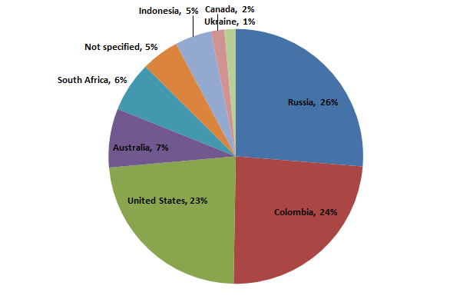
Source: Sirene, Eurostat
The largest importers of coal in the EU are Germany, the UK, Italy and Spain. Between 2011 and 2012 there has been a decrease in hard coal net imports to Germany as higher consumption was absorbed by growing domestic production and less stock building. Demand for steam coal surged in the UK due to increased coal-fired generation, driving up net imports of hard coal (including steam coal) (IEA 2013).
The fall in production, along with the increase in consumption of solid fuels, have been driving up the energy deficit of solid fuels – calculated as the difference between total demand and total production. While the deficit is below the 2007 peak levels, it has grown up by 5% in 2012 compared to 2011 (and by 25% since 2009, the lowest value since the turn of the century).

Figure 8. Energy deficit of solid fuels to the EU28, 1995-2012, kt
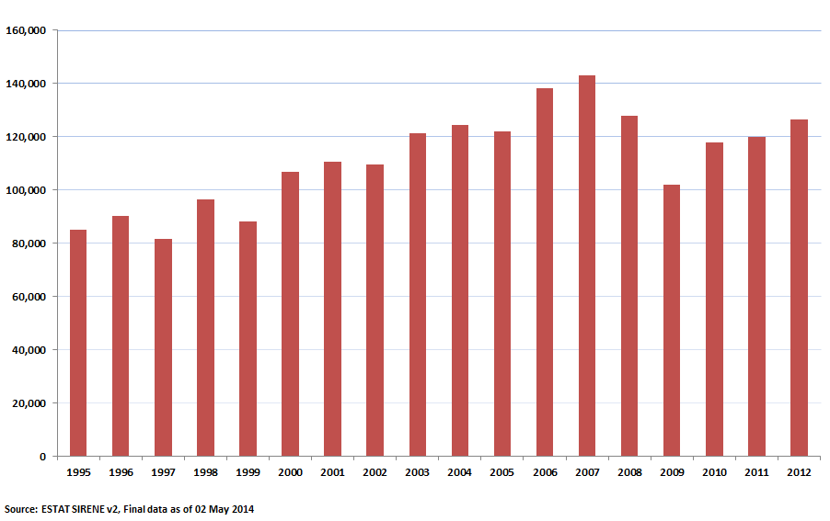
The net import dependence of the EU on solid fuels from countries outside the EEA remains low in comparison to other fossil fuels, but has almost doubled since the mid-90s and has been above 40%in recent years, after peaking at 45% in 2008. Should these be excluded, the extra-EU import dependency on solid fuels is below 30%. Hard coal accounts for virtually the entire solid fuel imports to the EU. Chapter Error: Reference source not found offers another metric of diversification (supplier concentration index) that takes into account both the diversity of suppliers and the exposure of a country to external suppliers and looks at net imports by fuel partner in the context of gross inland consumption of each fuel.
Figure 9. Import dependence of solid fuels, EU28 from countries outside the European Economic Area
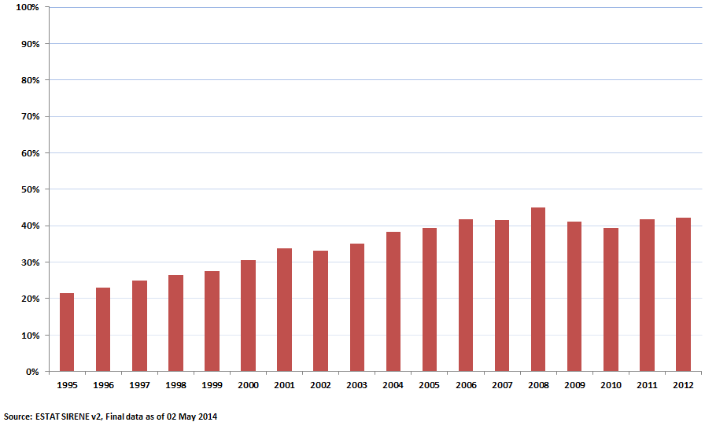

Coal infrastructure
Coal mining, transport, processing, storage and blending infrastructure come at play before coal reaches the final user.
The way that coal is transported to where it will be used depends on the distance to be covered – in general coal can be moved directly by railroad, truck, pipeline, barge or ship. Over relatively short distances coal transportation can be carried out by conveyor or truck. Trains and barges are used for longer distances within domestic markets, or alternatively coal can be mixed with water to form a coal slurry and transported through a pipeline. International transportation commonly relies on ships in different sizes (BGR 2013). The use of barges on inland waterways and as an interconnecting link between land- and sea-freight is also locally important. The share of transport costs in the delivered price of coal varies widely depending on the type of coal purchased and location of the consumer.
Coal enters the EU predominantly by sea and to a smaller extent by land (rail) and is transported overland or on major rivers. The main trans-loading ports for coal imports into Europe are in the Netherlands (Rotterdam and Amsterdam), which along with Antwerp in Belgium, constitute the ARA trading area – the most important for imported coking coal and steam coal in north-west Europe, with Rotterdam alone handling 60% of seaborne coal to Europe.
Besides seaborne imports, Europe is also supplied by significant overland transport volumes. The main entry points by rail are coal imports to Poland from Ukraine and Russia. Coal is also transported by land within the EU by railway or truck, e.g. from Poland to Germany or from Scotland to England.
Efficient transport infrastructure therefore is of utmost importance with cross-border rail links and links to ports. For example, in 2012 about 50% of German hard coal imports enter on domestic ships from ARA ports, 30% are transported through German seaports and the remaining 20% overland by rail (VKI 2013). About half of the hard coal exports from Poland are transported by land to neighbouring countries, with the remaining volumes trans - shipped via the Baltic ports.
Volume is one of the crucial aspects of measuring performance of ports, indicating the throughput or a port’s output (see Figure 10).
Coal stockyards act as storage capacity – either as a buffer or for the longer term – and also have an important role in helping to achieve the most appropriate blend of coals for particular end uses. Various stacking and reclaiming methods exist. In principle stocks are held by producers (mines), importers (e.g. at ports), energy transformation industries (power plants) and large consumers. The coal stored in European ports is the property of coal traders and consumers (e.g. power companies). Unlike in the case of oil, there is no minimum stock requirement in terms of coal inventories and stock changes almost daily. The total storage capacity of Europe's largest transhipment hub – the EMO in Rotterdam – has a stock of 7 million tons of hard coal. Apart from EMO, there are other larger cargo-handling companies with daily transhipment of 60.00 to 120,000 tonnes in the Netherlands ( Rotterdam EBS and RBT; Amsterdam OBA), in Germany (Hamburg Hansa port; Wilhelmshaven and Nordenham Rhenus Midgard), in Belgium (Antwerp Seainvest), in UK (Immingham). All these ports have an estimated 2 to 4 million tonnes of storage capacity related to the handling capacities .
Figure 10. Major coal handling ports in the EU, 2012 throughput
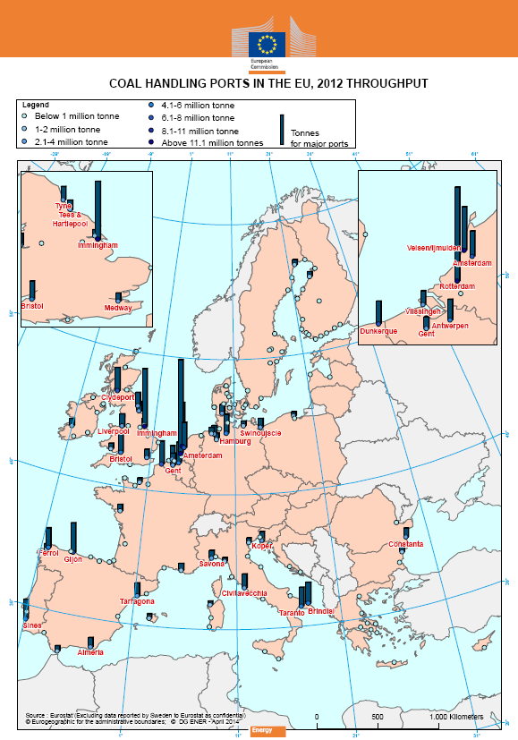
International coal trade has grown over the past three decades, accounting for less than a fifth of hard coal production. The collapse in maritime freight rates since the economic and financial crisis has reduced costs associated with international transportation of coal. Different geographic markets are generally well integrated, as seaborne transport costs are much lower than, for example, for LNG.
Historically steam coal was produced domestically in Member States close to the place of consumption of steam coal – mine-mouth thermal power plants. The production costs of domestic steam coal exceeded increasingly the import costs of steam coal plus the associated transport costs and gradually Member States downsized domestic production of steam coal.
Internationally traded steam coal is split into two major markets: the Atlantic basin (focussed on the Amsterdam-Rotterdam-Antwerp, ARA hub) and the Pacific basin (focussed on the Newcastle hub in Australia). The Atlantic market for steam coal – that has gradually come to replace domestic steam coal production – is made up of the major utilities in Western Europe and the utilities located near the US coast, with major suppliers being South Africa, Colombia, Russia and Poland; the share of US coal in total coal imports to the EU has increased from 12% in 2008 to 17% in 2012. The Richards Bay port in South Africa plays an important role in constraining price divergence across the two basins.. The intercontinental maritime coal market is well integrated with extensive spot and derivative trading.
Europe is increasingly an import led coal market and international prices act as leverage to negotiate price contracts with domestic coal producers. At the same time, global coal markets are very competitive, well diversified and operate with minimal geopolitical risk.
Coal prices can differ due to differences in coal quality and transportation costs. In recent years the spreads between the major coal benchmarks for internationally traded coal to the Atlantic market have been edging ever lower. China became a significant net importer of coal in 2009. Since then prices of Chinese coal imports have risen above those in Europe and have remained at a price premium of up to 50%.
The demand-driven doubling of global hard coal production capacities since the turn of the century and the continuing expansion of existing mines and the opening up of new mines, have given rise to today‘s excess capacities and oversupply in the global hard coal market (VKI 2013). The current increase in US exports due to the shale gas boom that depressed the domestic coal market also plays a role in the oversupply.
This excess global supply of hard coal has already led to the closure of mines in the USA, Australia and China, as well as the announcement of planned closures in Europe as well. Against this oversupply situation, prices of coal have gone down.
Figure 11 Evolution of coal benchmarks (2007-2013)
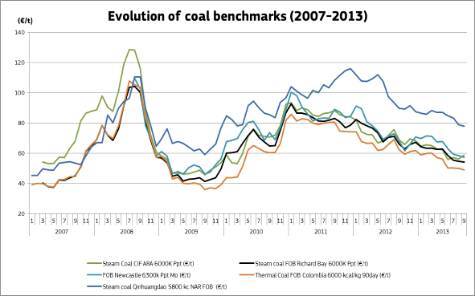
Sources: Platts and Bloomberg
Summary coal
The EU is the third largest coal-consuming region globally. Demand for solid fuels in the EU went down by almost 20% since the mid-90. Following the slump in consumption in 2009, demand started recovering and 2012 was the fourth consecutive year of growth in solid fuel consumption. A number of Member States have seen a double-digit growth in consumption between 2011 and 2012, in particular Portugal (+32%), Spain (+20%), France (+13%), Ireland (+12%) and the Netherlands (+10%). The decline in coal and CO₂ prices and the high gas prices provided coal with a strong competitive advantage to gas in power generation.
The EU is dependent on imports of hard coal (used in power plants, steel mills/coking plants and the heating market). Hard coal accounts for about 70% of gross inland consumption of solid fuels, but the EU meets only about one third of its needs for hard coal with idnigenous production.
The EU has a diversified portfolio of coal suppliers, with Russian, Colombian and US imports accounting for each for apprximately a quarter of hard coal import quantities.
Raising production costs of domestic hard coal and depressed prices on global coal markets have made imports an economically attractive option; international prices increasingly act as leverage to negotiate price contracts with domestic coal producers.
Efficient transport infrastructure is of utmost importance for coal trade with cross-border rail links and links to ports.
Global hard coal markets are very competitive and well diversified. Different geographic markets are generally well integrated, as seaborne transport costs are much lower than, for example, for LNG. Global markets have not experienced spikes or disruptions as the ones observed in the crude oil market or in some regional markets for natural gas. Thus, there is no minimum stock requirement in terms of coal inventories and stock changes almost daily.
Just like with other energy commodities, coal deliveries run physical, including weather-related, risks to security of supply. Weather conditions, such as floods, may impact mine production. In addition, weather can cause delays in seaborne imports and domestic river transport (low river levels or freezing conditions). Congestion of transport infrastructure can lead to disruption of supplies. Yet, one could reasonably expect such disruptions to be short-lived, with inventories offering a short-term buffer and the continuing oversupply in global coal markets giving scope for reaction.

Uranium and nuclear fuel
Nuclear fuel differs from fossil fuels in the sense that the raw material (uranium) must undergo several processing steps (milling, conversion, enrichment) before being fabricated into fuel assemblies which in turn must be tailor-made for each reactor type.
Nuclear materials and fuel cycle services are bought and sold by industrial companies (reactor operators and fuel producers), not directly under government-to-government agreements, although in many cases bilateral state-level agreements set the framework for commercial contracts. Many but not all reactor operators and fuel producers are partly or even fully state-owned (Table 5).
In the EU, there are two distinct nuclear fuel procurement approaches: utilities operating western design reactors usually enter into separate contracts with uranium mining companies, conversion service providers (which convert solid U₃O₈ into a gaseous form, UF₆), enrichment service providers and finally fuel assembly manufacturers. This approach allows for diversification of all steps of the front end of the fuel cycle, and for bigger utilities it offers the possibility to maintain several suppliers at all stages.
In contrast, utilities operating Russian design reactors in most cases purchase their fuel as integrated packages of fuel assemblies, including the uranium and related services, from the same supplier, the Russian company TVEL. In this approach, there is no diversification, nor backup in case of supply problems (whether for technical or political reasons). Ideally, diversification of fuel assembly manufacturing should also take place, but this would require some technological efforts because of the different reactor designs (VVER 440 and 1000).
On the supply side, EU industry is active in all parts of the nuclear fuel supply chain. While uranium production in the EU is limited, EU companies have mining operations in several major producer countries. EU industry also has significant capacities in conversion, enrichment, fuel fabrication and spent fuel reprocessing, making it a global technology leader.
Since the 1990's, EU dependency on imported uranium has remained constant, while domestic mining production and reprocessing cover roughly 5 % of the EU needs for uranium. In conversion and enrichment, external dependence in the 1990's was around 20 %, the rest being covered by domestic supplies. However, with the EU enlargements of 2004 and 2007 and the enrichment technology transition in France, this share has increased to around 40 % in 2012, although the latest date from 2013 point to a slight decrease in this dependency rate. Likewise, for fuel fabrication, in the 1990's, only 2 Russian design reactors in Finland were dependent on Russian fabricated fuel, but today reactors also in Bulgaria, Czech Republic, Hungary and Slovakia depend on Russian fabrication services, while the reactor in Slovenia depends on US-fabricated fuel.
Demand for natural uranium in the EU represents approximately one third of global uranium requirements.
Table 1. Commercial nuclear power reactors in the EU, 2013
Belgium | 7
Bulgaria | 2
Czech Republic | 6
Finland | 4 (1)
France | 58 (1)
Germany | 9
Hungary | 4
Netherlands | 1
Romania | 2
Slovakia | 4 (2)
Slovenia/Croatia* | 1
Spain | 7
Sweden | 10
United Kingdom | 16
Total | 131 (4)
* Croatia’s power company HEP owns a 50% stake in the Krsko nuclear power plant in Slovenia
Source: ESA
At the end of 2013, there were 131 commercial nuclear power reactors operating in the EU, located in 14 EU Member States and managed by 18 nuclear utilities. There were four reactors under construction in France, Slovakia and Finland. According to the latest available data published by the Commission in 2013, EU gross electricity generation amounted to 3295 TWh in 2012 and nuclear gross electricity generation accounted for 26.8 % of total EU production. A significant share of nuclear power plants in the EU is 20 or more years old.
Figure 12 Average age of nuclear power plants in the EU
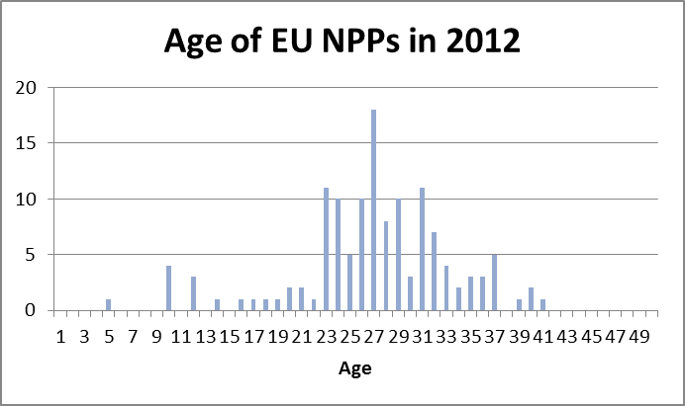
Source: European Commission
In 2013, fresh fuel containing the equivalent of 2 343 tonnes uranium (tU) was loaded into commercial reactors in the EU-28. It was produced using 17 175 tU of natural uranium and 1 024 tU of reprocessed uranium as feed, enriched with 12 617 thousand Separative Work Units (tSWU).
Deliveries of natural uranium to EU utilities occur mostly under long-term contracts, the spot market representing less than 10 % of total deliveries.
Figure 13 Origins of uranium delivered to EU utilities in 2013 (% share)
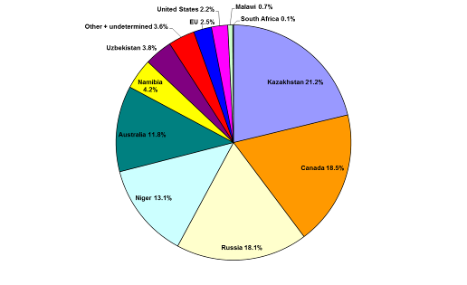
Source: ESA
Figure 14 Purchases of natural uranium by EU utilities by origin, 2004–13 (tU) (%)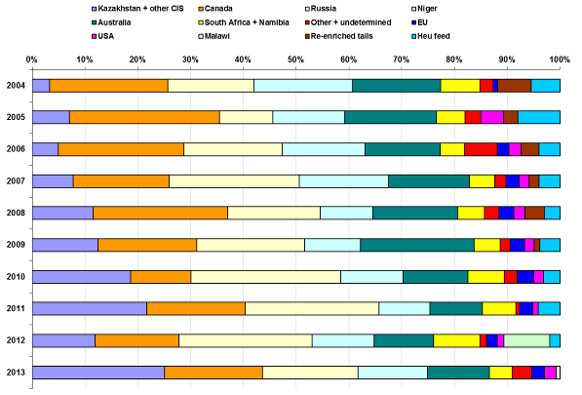
Source: ESA
Natural uranium supplies to the EU come from well-diversified sources, with the main uranium-producing regions being the CIS, North America, Africa and Australia.
Kazakhstan and Canada are currently the top two countries delivering natural uranium to the EU in 2013, providing 40 % of the total. In 2013 uranium originating in Kazakhstan represented the largest proportion, with 3 612 tU or 21 % of total deliveries. In third place, uranium mined in Russia (including purchases of natural uranium contained in enriched uranium product, EUP) amounted to 18 %. Niger and Australia account for 13 % and 12 %, respectively.
Table 2. Providers of enrichment services delivered to EU utilities
Enricher | Quantities in 2013 (tSWU) | Share in 2013 (%) | Quantities in 2012 (tSWU) | Share in 2012 (%) | Change over 2012 (%)
AREVA/Eurodif and Urenco (EU) | 6 956 | 60% | 7 211 | 57% | -4%
Tenex/TVEL (Russia) | 4 249 | 36% | 5 218 | 41% | -19%
USEC (USA) | 354 | 3% | 174 | 1% | 104%
Others (1) | 119 | 1% | 122 | 1% | -2%
TOTAL | 11 678 | 100% | 12 724 | 100% | -8%
(1) including enriched reprocessed uranium. Source: ESA
In 2013, the enrichment services (separative work) supplied to EU utilities totalled 11 678 tSW. Some 60 % of the EU requirements were supplied by the two European enrichers (AREVA and Urenco). Deliveries of separative work from Russia (Tenex and TVEL) to EU utilities accounted for 36% of EU requirements, while 3 % were provided by the US company USEC.
Figure 15 Supply of enrichment to EU utilities by provider, 2004–13 (tSW)
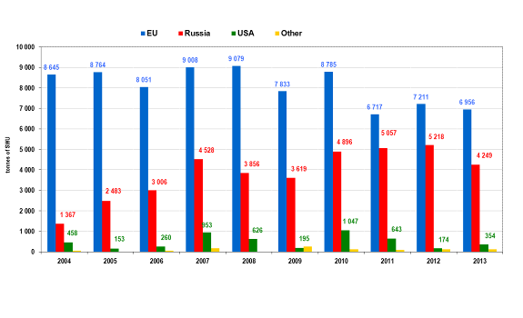
Source: ESA
In terms of mining volume, European uranium produced in the Czech Republic and Romania covers approximately 2 % of the EU utilities' total requirements.
When it comes to conversion: The current EU capacity operated by the French AREVA, 14 000 tU/y would be more than sufficient to cover most of EU needs, if run at full capacity and if no exports were taking place. This plant is being replaced by a more modern COMURHEX II facility of similar capacity with progressive starting of the units planned by 2015.
Likewise for enrichment, the EU-based capacities operated by AREVA and Urenco would be sufficient to cover all EU needs if no exports were taking place. It has to be underlined that these EU companies are major suppliers for worldwide customers (in the USA, Asia, South Africa, Latin America).
In fuel fabrication, EU industry – with facilities in Germany, Spain, France, Sweden and the UK – would be able to cover all EU needs for western design reactors, and in principle could also establish the production capacity needed for VVER fuel (for Russian design reactors). However, developing and licensing fuel assemblies for Russian design reactors would take a few years in normal circumstances, provided that a sufficient market is available to make the investment attractive for the industry.
Currently roughly 20% of EU nuclear power plant requirements for natural uranium and 36% of the requirements for uranium enrichment services are covered by supplies from Russia. A small portion of EU requirements are fulfilled by imports from the USA.
In addition Russia supplies fuel assembly manufacturing services for the Russian design reactors in Bulgaria (2 reactors) Czech Republic (6), Finland (2), Hungary (4), Slovakia (4).
While Finland also operates non-Russian design reactors with western fuel supplies, BG, CZ, HU and SK are 100 % dependent on Russian nuclear fuels (uranium, conversion, enrichment and fuel fabrication) with the exception of CZ which has domestic uranium mining and partly diversified enrichment supplies). In order to estimate the risk of this dependency for overall energy supplies, the share of nuclear in the energy mix needs to be taken into account (Figure 4).
In addition, also many western EU utilities have substantial supplies of enriched uranium from Russia (20-40 % of their needs). However, nuclear materials and other fuel cycle services than fabrication may be substituted by other sources, in particular in current market conditions which are rather favourable for buyers (as long as reactors in Japan remain shut down the market for uranium and fuel cycle services is in oversupply and prices have been declining since the Fukushima accident in 2011).
The situation of Romania deserves a special mention. Although the two reactors operating in Romania are based on the Canadian CANDU technology, Romania is self-sufficient for its fuel needs as it produces uranium and masters the fuel fabrication process, because the uranium used in this type of reactors does not need to be enriched.
One important development is the success of non-EU reactor vendors (Russian and to some extent US-Japanese and possibly Korean in the future) to win orders for new build in the EU, often based on attractive financing arrangements. In the case of the Russian vendor, reactor construction is linked to long term fuel supplies due to the lack of alternative fuel fabricator.
At the same time, the Russian industry is developing fuel assemblies for western type pressurised water reactors and could enter this commercial market in the 2020 horizon. These two developments together could increase the EU dependency on Russian nuclear fuel supplies, if mitigating measures are not taken.

Risk and resilience
While the EU is highly dependent on uranium imports, uranium can be and is sourced from a large number of countries, and some of the major producers such as Australia and Canada are long standing close EU partners. Even in countries such as Kazakhstan and Niger, EU industry has large ownership interests in uranium mining operations.
On the risk side, there is certainly some political uncertainty with uranium coming from CIS countries (Russia, Kazakhstan and Uzbekistan) and Africa. In recent years, Kazakhstan has become by far the world's largest producer, with still further potential to increase its production. It is thus the equivalent of Saudi-Arabia in oil production. Serious political unrest in Kazakhstan or Niger could certainly impact uranium prices, but considering the significant inventories held by EU utilities, a real shortage appears highly unlikely in the medium term. Other countries, e.g. Canada, Australia or Namibia could increase their production in response. During the commodity boom around 2004–2008, a lot of exploration was carried out and identified uranium reserves have increased but are not being developed due to currently depressed prices. The market is thus working according to price signals.
When global demand recovers or in case of a supply problem somewhere, other producers could fill the gap. More widespread reprocessing of spent fuel and re-enrichment of depleted uranium could also provide additional supplies if needed and could be performed by EU industry.
For other parts of the fuel cycle, EU industry can cover most or all of the EU utilities' needs. The main element there is to ensure the continued viability of the EU industry so that this capacity remains at least at the current level and does not disappear as a result of short term economic considerations.
While the EU uranium conversion capacity is concentrated in France, enrichment plants operate in France, Germany, the Netherlands and the UK. Likewise, fabrication plants are located in many Member States, albeit not all can produce fuel for different types of reactors, without major investments.
In general, transport and storage capacity do not constitute major issues for the nuclear fuel cycle.
- Market resilience: European price levels versus major benchmarks
The market for uranium and fuel cycle services is a global market and prices are very similar in different regions. Compared to oil and gas markets, the nuclear fuel market is much smaller and less liquid, meaning that prices could spike up rapidly in case of supply problems. However, the cost of uranium and even of the whole nuclear fuel is only a small part of the operating costs of nuclear power plant (5–10%), so that even a sharp increase in fuel prices would not lead to a big change in the final electricity price.
- Risks to the viability of the EU industry
The Russian potential in enrichment services is very strong. The installed capacity of Russian uranium enrichment facilities accounts for about 28 500 tSWU, which covers roughly half of the world's total capacity and over twice the EU annual requirements. Therefore, as happened in the 1990's, the risk remains that over abundant imports from Russia could jeopardize the viability of the EU enrichment industry, leading to less secure supplies in the future if European capacities were to be reduced.
At the moment, the traditional US enricher (USEC) is able to supply only very limited quantities of enrichment services. It is possible that in the early 2020's one or two American companies and possibly the Chinese may be exporting some enrichment services but will most likely not be significant players outside their domestic markets. Longer term, more competition to EU suppliers can be expected.
- The problem of fuel fabrication
While all parts of the fuel cycle are indispensable, before fuel fabrication takes place, nuclear materials can be substituted with equivalent materials from other sources. However, fuel assemblies are reactor-specific and fuel fabrication is a critical part for security of supply.
For western design reactors, alternative fabricators are available and licenced but replacing the Russian-made fuel assemblies for Russian design reactors by a non-Russian supplier could take 2–3 years in a best-case scenario, likely even more, due to extensive licensing and testing requirements before commercial use. Many of the Russian reactor operators in the EU have stocks of fuel for only a few months and would be wise to consider increasing their inventories of fabricated fuel.
While there is previous experience of fuel fabricated by the US-Japanese company Westinghouse (with production facilities in Spain and Sweden) used for the Russian design reactors of VVER-440 and VVER-1000 type, the new proposed Russian reactors, to be built in Finland, Hungary, Turkey and possibly in the UK, would be of a new type VVER-1200 and it is uncertain whether Westinghouse or another producer would develop this type of fuel assemblies without a reasonable assurance of having a market.
The Westinghouse production capacity for the VVER-440 fuel, which used to be produced in Spain, has been dismantled due to lack of orders in the face of aggressive pricing by the Russian competitor. For the VVER-1000 fuel, production capacity exists in Sweden and is currently used to supply some reactors in Ukraine. This capacity might be expanded in case of sufficient demand from EU utilities. The mere existence of a competing alternative would be a strong incentive for Russia to not use nuclear fuel as political leverage and to not raise prices unilaterally.
With a view to mitigating dependence from Russian supply, in some cases utilities operating Russian design reactors have diversified part of the supply chain and have sent uranium enriched in the EU to Russia for fuel fabrication (no alternative fabricator due to reactor type). Such an option is technically possible, but allegedly increases costs and entails delays and risks due to increased transport requirements, and Russian custom practices and taxes. In fact, this option is discouraged by the Russian side, as the fuel fabrication company TVEL (which is also a part of ROSATOM) usually delivers its customers a ready, all-inclusive package and is not keen to decrease its sales.
Summary nuclear
While the EU is highly dependent on uranium imports, uranium can be and is sourced from a large number of countries, and some of the major producers such as Australia and Canada are long standing close EU partners.
EU industry has large ownership interests in uranium mining operations in countries such as Kazakhstan and Niger.
EU utilities hold significant inventories, making a real shortage highly unlikely.

Renewable energy
The total demand for renewables in the EU has almost doubled in a decade with steep growth in a number of Member States, including Germany, Spain and Italy. Import dependency in renewables is negligible (below 4% overall, though much higher for all biomass uses) and often conferred to intra-EU trade movements.
Figure 16. Gross inland consumption of renewable energy sources in the EU, 1995-2012, ktoe

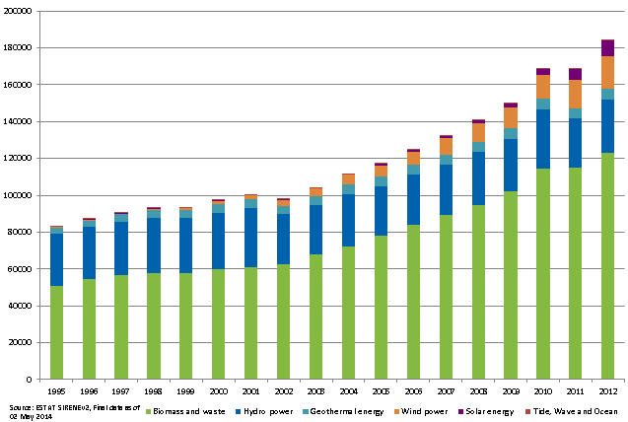
Figure 17. Total production of renewable energy sources by MS, 1995-2012, ktoe
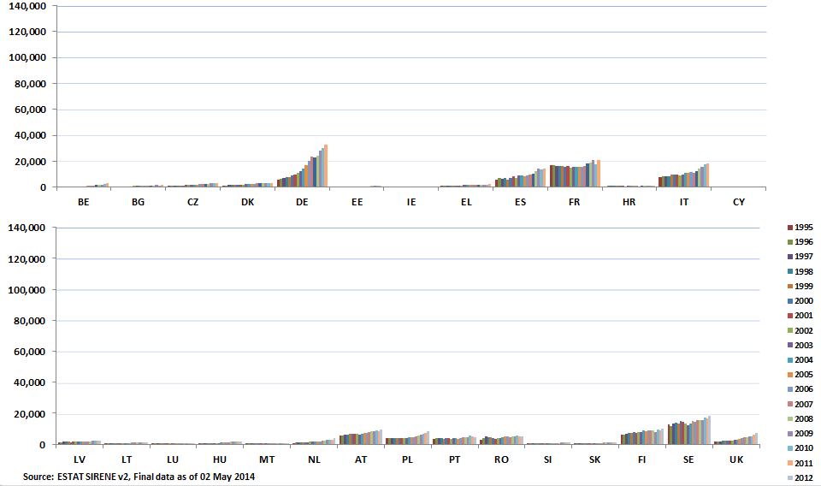

Figure 18. Import dependence of renewable energy sources, 1995-2012, %
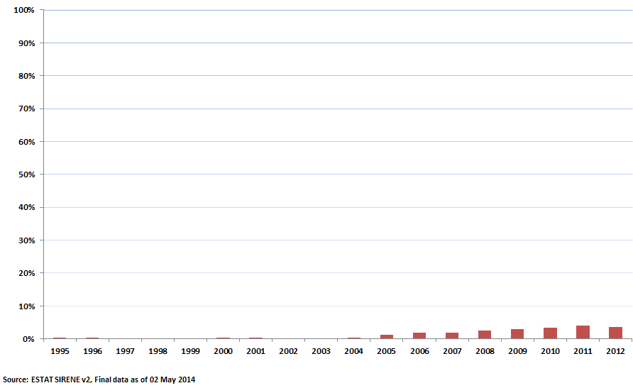
In 2012 the production of renewable electricity reached 799 TWh, an increase of more than 13% compared to 2011. It now accounts for 24% of gross electricity generated. Hydro power is the most important renewable electricity source and accounts for 46% of renewable electricity generation in the EU, followed by wind (26%), biomass and RES wastes (19%) and solar (8%). Between 2011 and 2012 electricity from solar energy saw an impressive growth of more than 50%, with its share in renewable electricity generation reaching 9%. Electricity from wind registered a growth of about 14% and electricity from biomass and waste of about 12%.
Figure 19. EU gross electricity generation of renewables by source, 2012
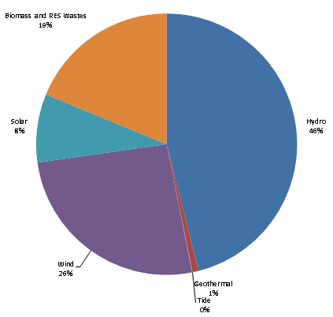
In 2012 the EU had installed about 44% of the world's renewable electricity (excluding hydro). The average RES share is highest in the electricity sector – 24%, and this sectors has also witnessed major increase in renewable energy based capacity. The RES share in heating sector stands at about 16% and in transport – 5%.

Energy transformation

Refining
The refining industry has a crucial role in transforming crude oil and other feedstock into oil products which can be used for final consumption. From the final consumption of oil and oil products, transport has a dominant role, representing 64% in 2012. Within the transport sector, road transport makes up 83% and aviation 15%. Industry, including both non-energy and energy consumption, uses 22% (from which the chemical and petrochemical industry 14%) while the share of other sectors (mainly residential, services and agriculture) is 14%.
The EU is the second largest producer of oil products after the United States, with a production capacity of some 15 million barrels per day in 2012, about 16% of global refining capacity. According to Europia, the association of European petroleum industry, 83 mainstream refineries (those with an annual capacity of at least 2.5 million tons/year) operated in the EU in 2012.
Overall, EU refining capacity is well above EU demand for oil products. In fact, the decline in the demand for refined products since 2005, which accelerated after the financial crisis, has led to a significant excess refining capacity. Falling demand (by 14% between 2005 and 2012), coupled with excess capacity, decreasing utilization and increased competition from non-EU refineries have depressed margins. Projections for future oil product demand point towards continuing decline, with the exception of middle distillates which may continue to grow for a few more years.
Figure 20. Final consumption of oil products in the EU
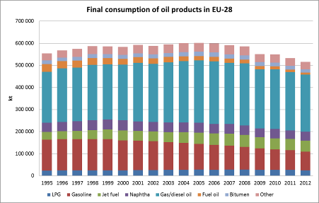
Source: Eurostat
While the EU has ample refining capacity to cover the overall demand for petroleum products, there is a mismatch of supply and demand when individual products are concerned. As a result, the EU is a net exporter of certain products (in particular gasoline and, to a smaller extent, fuel oil) but a net importer of others (mainly gasoil/diesel, jet fuel, naphtha and LPG).
Figure 21. Net imports of main petroleum products in the EU, 1995-2012, kt
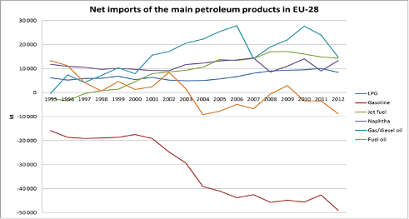
Source: Eurostat
Overall, exports and imports are more or less in balance (with a net product export of 7.5 million tons in 2012). In 2012, net exports of gasoline amounted to 49 million tons, close to 40% of EU refinery total gasoline output of 127 million tons. Net imports of middle distillates (gasoil/diesel, jet fuel and other kerosene) totalled 31 million tons, equivalent to about 10% of the consumption of these products.
This is a result of the "dieselisation" whereby gasoline-fuelled vehicles are replaced by those equipped with diesel engines. At least partly, this development has in the past been driven by taxation policy across the EU which has generally imposed a lower duty on diesel fuel than on gasoline.
Figure 22. Gasoline and diesel in motor fuel consumption
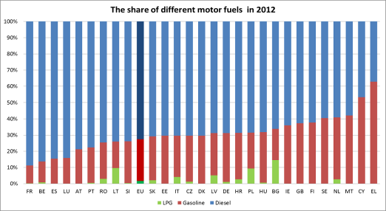
Source: DG Energy
In 2012, the consumption of gasoline represented only 26% of total consumption of motor fuels in the EU. Greece – where diesel cars have been banned from the main cities – was the only country where the consumption of gasoline exceeded that of diesel. The share of LPG among motor fuels is less than 2% in the EU although in some Member States (especially Bulgaria, Lithuania and Poland) its share can reach up to 9-15%.
The response of a number of EU refining companies to the current market situation and future prospects has been to put refineries up for sale or to halt operations, sometimes for indefinite periods of time, and/or converting sites to terminals. However, complete closures of refineries is often hindered by high clean-up costs which owners would have to incur.
According to the IEA, there has been a reduction in capacity of 1.7 million barrels/day in Europe since 2008, in terms either of refinery closures, transformation of refineries into import terminals or capacity reductions. Despite these reductions, it is considered that the region is still suffering from overcapacity and that more refineries, especially the less sophisticated ones, remain at risk of closure in the coming years.
Capacity reductions have an impact on security of supply because every refinery produces a certain amount of products which are indispensable from a security of supply standpoint (such as middle distillates and naphtha, of which the EU is a net importer). Therefore, refinery closures are making the EU more dependent on product imports and increasing the reliance on related infrastructure (import terminals and product storage facilities).
In addition to shut-downs, many refineries have changed hands since the beginning of the crisis. Many of the sellers have been vertically integrated oil companies, while not all recent buyers have significant experience in refining. Indeed, it is far from evident that all recent buyers of refineries in the EU either have long-term interests or the financial strength to keep refineries open. Furthermore, most of the EU refining capacity that has been sold since the crisis has been to non-EU companies.
In sharp contrast to EU demand, non-EU petroleum product demand especially for products such as diesel, gasoil and naphtha is projected to grow significantly. Expectations are therefore of growing global competition - and, therefore, growing prices - for supplies of such products, which happen to be also the petroleum products which the EU consumes more than it produces. The EU has in fact been experiencing a growing trend in net imports of middle distillates and naphtha in the last few years. Major refining investments in the Middle East and Asia are expected to stabilise refining capacity globally.
On the other hand, the EU produces much more gasoline than it consumes and exports the rest. The US has been the main outlet for this excess gasoline over the last few years, but it has been significantly reducing its imports of gasoline. Finding new outlets for gasoline exports has become an increasingly difficult challenge.
Going forward, and even taking into account falling EU demand, it therefore appears very likely that the EU's import dependence on certain products such as gasoil/diesel will increase, unless the industry is able to invest in further conversion capacity to produce more middle distillates. Such investments are also necessary (but technically more difficult) to decrease the high gasoline yield of the EU refining industry, which would reduce the EU refining industry's 'export dependence' in that fuel.

Electricity
Electricity is the most widely used energy source in the EU and its existence is indispensable for almost all domains of everyday life and economic operations. Electricity can be generated from various sources (fossil fuels, nuclear, renewable energy sources, etc.). There is a great deal of variety in the composition of power generation mixes and the source of feedstock used for electricity generation.

Electricity consumption, generation and imports
As Table 3 shows the share of solid fuels in the EU-28 power mix was 27.4% in 2012, and the import dependency of solid fuels was 26%, being lower than for other fossil fuels, mainly due to abundant domestic brown coal and lignite endowments. 53% of all solid fuels in the EU-28 were used in conventional electricity generation power plants and 21% were used in conventional thermal power stations.

Table 3. Import dependency and solid fuel consumption in the electricity generation in 2012
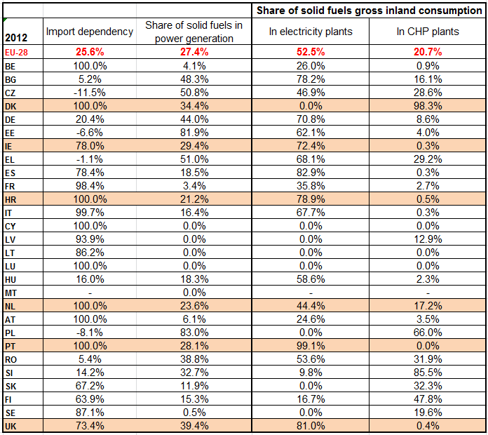
Source: Eurostat
Across different Member States there were significant differences regarding import dependency, the share of coal in power generation, and the importance of electricity and heat generation in the annual coal consumption. Countries like Denmark, Ireland, Croatia, the Netherlands, Portugal and the UK could all have been characterised by a significant share of coal in their power mix (at least 20%), a high level of import dependency (at least 70%), and the majority of their solid fuel consumption being taken up by the electricity and heat sector. The power sector in these member states is therefore sensitive to changes in import volumes of solid fuels, mainly steam coal, otherwise saying an import supply disruption would primarily impact electricity and heat generation.
shows similar data for gas. Import dependency of gas (66%) was much higher than that of solid fuels in the EU-28 in 2012. The share of gas in the EU-28 power mix was 18.7%. The share of electricity generation was 14% in the annual EU gas consumption, while another 16% was used in combined heat and power plants. In the case of natural gas sectors besides power generation (e.g.: residential heating, industry, transport) are also important consumers.
Table 4. Import dependency and gas consumption in the electricity generation in 2012
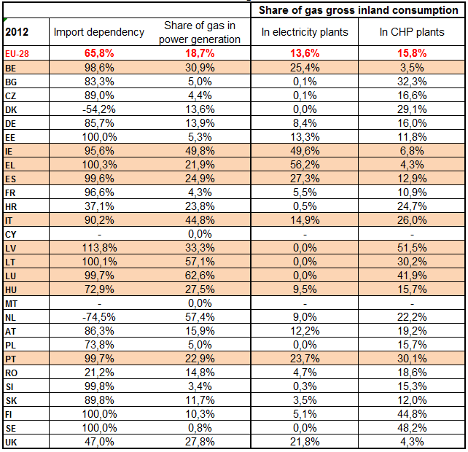
Source: Eurostat
Again, Member States showed significant differences regarding gas import dependency and its use in the electricity and heat sector. Countries like Belgium, Ireland, Greece, Spain, Italy, Latvia, Lithuania, Luxembourg, Hungary and Portugal were all common in having significant share of natural gas in their power mixes (at least 20%) and in high gas import dependency rates (at least 70%) in 2012. The electricity and heat generation sector in these countries are sensitive to import supply disruptions. Nevertheless, the share of the power sector is lower in the overall gas consumption than that in the solid fuel consumption in the countries highlighted in the table above. In case of supply shortages gas volumes might be put to the disposal of the power sector, though other important consumers (e.g. residential heating) may limit the flexibility of redirection of gas among different consumer segments.

It is important to note that from a security of supply point of view electricity generation is more sensitive to natural gas than to solid fuels. Import dependency is lower for solid fuels in the EU than for natural gas and coal import sources are more diversified globally, meaning that power generation in the EU is more resilient to external coal supply disruptions than to natural gas shortages. Additional measures to promote short-term flexibility of sources of electricity production are needed..
Crude and petroleum products only had significant shares in the power generation mix of Malta (with a share of 99%), Cyprus (94%), and, to a lesser extent, Greece (10%). These countries had full external dependency on oil and petroleum products. Malta used 78% of its gross inland petroleum product consumption in the electricity and heat sector, while in the case of Cyprus this ratio was 54%, and in Greece it was only 9% in 2012. Bearing this in mind we can say that the power sector is sensitive to import oil supply disruptions only in Malta and Cyprus in the EU.
Biomass and wastes accounted for 4.5% of power generation in the EU-28 in 2012. Around 12% of the annual biomass consumption in the EU was used in electricity plants and another 20% in combined heat and power generation. In the case of biomass and wastes import dependency is not significant in the EU, but biomass imports represent a significant share of the increase in biomass use in the EU. In the case of nuclear, hydro, wind and solar almost all energy was used in power generation and with the exception of nuclear feedstock talking about import dependency cannot make any sense (domestically produced electricity from renewable energies).
The three main economic sectors consuming electricity were industry (with a share of 36% of the EU-28 electricity final consumption – 2,796 TWh in 2012), services (31%) and households (30%).
Electricity consumption in the EU-28 was steadily growing between 1995 and 2008, increasing by more than 26% during this time period. This growth was mainly due to the general increase in economic activities across the EU; resulting in growing demand for power.
With the outbreak of the economic crisis in 2008 electricity consumption fell back in 2009 in most of the EU member states and was 2.4% lower in 2012 compared to 2008 on EU average, mainly due to the sluggish economic recovery, especially in those member states, which were the mostly affected by the economic downturn. During the whole 1995-2012 period the EU-28 electricity consumption went up by 23.5%, from 2,264 TWh measured in 1995 to 2,796 TWh in 2012.
The average EU growth hides significant differences among different member states. Bulgaria was the only member state where electricity consumption decreased during this period (-2.8%), while in Denmark it remained practically unchanged (+0.5%). There were four member states where the increase in electricity consumption remained below 10% (Sweden: 2.2%; Romania: 6.6%; United Kingdom: 7.8% and Slovakia: 8.8%) while on the other hand there were four countries where it exceeded 60% (Portugal: 60.5%; Ireland: 63.7%; Spain: 69.9%; Cyprus: 97.8%).
Electricity demand has been influenced besides the economic growth by the changes in the structure of the economy, energy efficiency measures and the role of electricity in overall energy consumption. For example, in many countries in Central and Eastern Europe restructuring of the economy, resulting in decreasing electricity intensity, helped to mitigate electricity consumption, though many countries in the region showed impressive economic performance during the 1995-2012 period.

Figure 23 Electricity available for final consumption in the EU-28 (1995-2012)
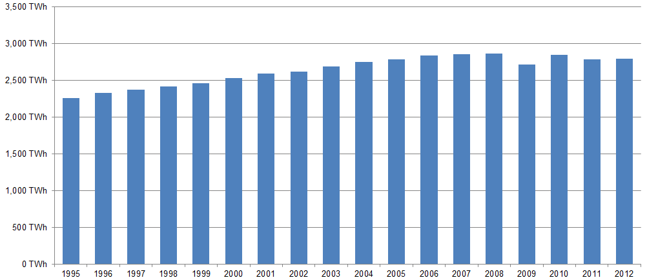
Source: Eurostat
Figure 24 Electricity available for final consumption in the EU member states (1995-2012)
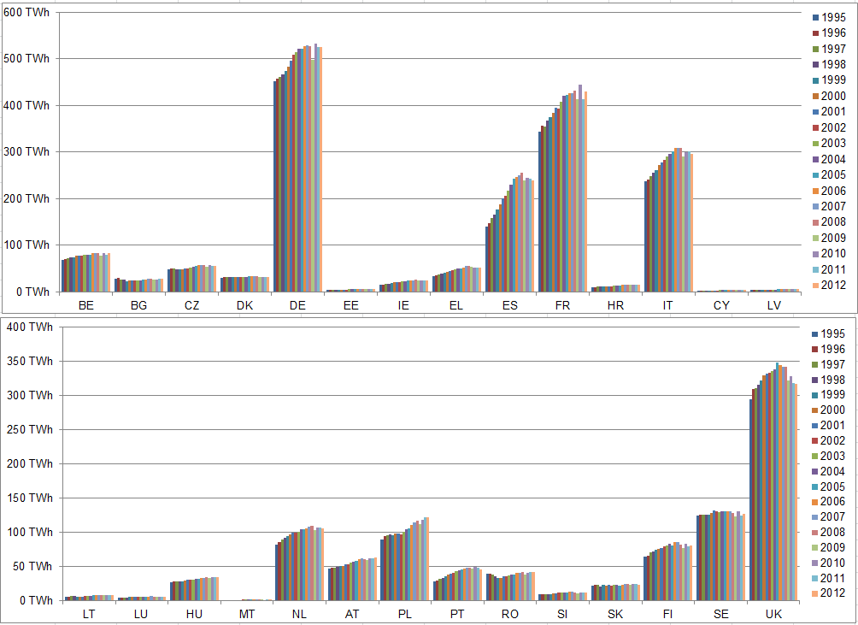
Source: Eurostat
Not surprisingly, electricity consumption in a given country shows strong correlation with the size of the economy. In the EU the biggest electricity consumers are Germany, France, the UK, Italy and Spain, which countries accounted for 65% of the EU electricity consumption in 2012 (18.8%, 15.4%, 11.4%, 10.6% and 8.6%, respectively). On the other hand, the combined electricity consumption of Malta, Cyprus, Latvia, Lithuania and Luxembourg was 1% of the total EU consumption in 2012.
Figure 25 shows the evolution of power generation in the EU between 1995 and 2012. 27.1% of the EU-28 power generation was based on solid fuels (mainly coal and lignite) in 2012, followed by nuclear (26.8%), renewable energy sources (24.1%) and natural gas (18.7%). Since the mid-90s the share of solid fuels and nuclear went down by 8 and 5 percentage points, respectively, while the share of gas went up by almost 9 percentage points and of renewables by 10 percentage points. The increase in the share of renewables was mainly due to the rapidly growing wind and solar based power generation in the last decade, while the share of hydro remained practically stable.
Figure 25 Total gross domestic power generation in the EU-28, TWh
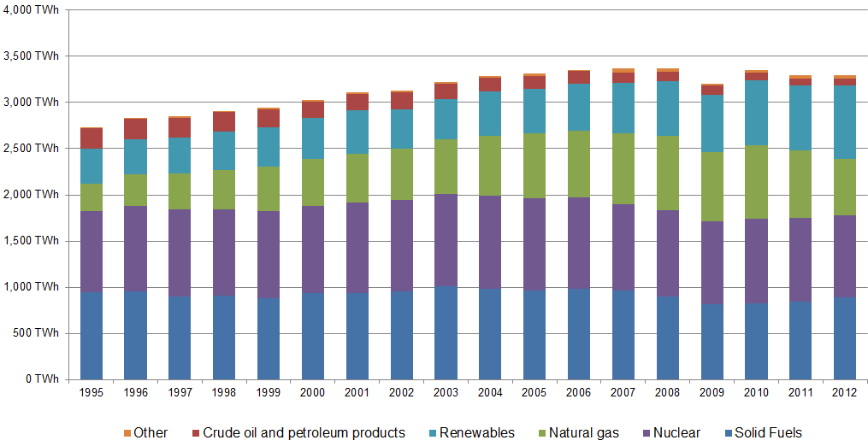
Source: Eurostat
The share of nuclear power generation followed a downward trend in the EU power mix in this period, as in many member states the broader public opinion was not favourable of using nuclear as power source, especially after the two most serious nuclear power plant incidents ever (Chernobyl, 1986 and Fukushima, 2011). Countries like Germany or Belgium have decided to gradually phase out existing nuclear generation capacities, while Italy halted the nuclear plants after the Chernobyl accident and Austria has always been unfavourable towards nuclear power. In France however, though energy policies reckon with decreasing share of nuclear, this generation source will continue playing an important role even on the longer run. New nuclear power plant projects are in the phase of implementation in Finland, the UK and some Central and Eastern European countries.
Within renewable energies the share of wind energy has been rapidly growing; from the almost negligible share of 0.1% in 1995 to 6.7% in 2012 in the EU. Solar power generation has also started to gain importance, though its share was only 2.2% in the same year. These two generation sources have emerged as alternatives to conventional fossil fuels and nuclear, however, it is important to note that due to their intermittent nature back-up generation capacities need to be assured to maintain an adequate power supply to the grid. In the case of hydro generation the impact of intermittency can be mitigated by increasing the storage capacities.
The competition between coal and gas fired generation has always been influenced by the relative price ratio of these two fuels, and recently the price of carbon emission allowances has begun to play an important role. As greenhouse gas emissions (GHG) for each unit of generated power have always been higher in the case of coal than gas, for fulfilling climate change objectives it is reasonable to move towards gas-fired generation from coal in the power mix. However, during the last two-three years the decreasing trend of the share of coal-fired power generation in the mix and the increasing trend of gas is being reversed. Between 2010 and 2012 the share of gas went down from 23%.6 to 18.7%, while that of coal went up from 24.5% to 27.1%. This was mainly due to the rapidly decreasing import steam coal prices in Europe since the beginning of 2011, coupled with steadily high gas prices, and to the permanently low level of carbon prices, being favourable to coal and unable to give incentives to switch to gas-fired generation.
Figure 26 shows the profitability of coal-fired (clean dark spreads) and the gas-fired (clean spark spreads) power generation in the UK and Germany. It is obvious that coal-fired generation assured better profitability than gas-fired generation both in the UK and Germany in 2012 and 2013. In the last two years gas-fired generation became highly uncompetitive in Germany and in other parts of the continental Europe as well, squeezing out gas from the European power mix. Coal-fired generation became highly competitive in the UK, though the emission limits imposed by the Large Combustion Plants Directive have put a limit on the use of coal and as consequence significant coal-fired capacities had to be taken offline in the last two years. In the EU power mix coal could only partially replace the missing gas and nuclear generation; the remaining gap was filled by renewable energy sources during the last couple of years.
Consequently, the deterioration of the competitiveness of gas-fired generation resulted in the decrease of the load factor of gas power plants in most of the EU member states. The already low load factor of gas-fired generation reduces the scope for the power sector to react in a gas curtailment situation.

Figure 26 Evolution of monthly average clean dark spreads and clean spark spreads in the UK and Germany
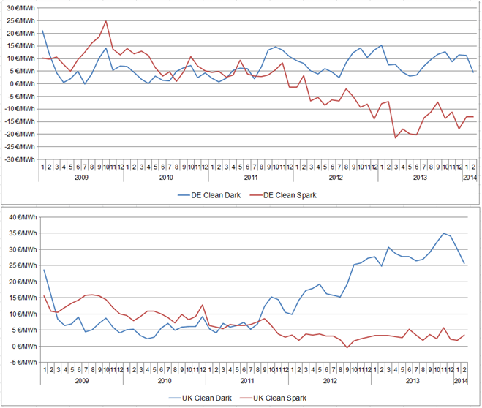
Source: Platts

Expected European energy security in 2030
The EU Reference Scenario 2013 (Reference Scenario) projections indicate that even if adopted policies (both in EU and national level) are fully implemented, EU’s import dependence increasing trend will not change. Reliance on fossil fuel imports will keep increasing in the coming years in order to compensate for the declining domestic production, despite the parallel reduction in energy demand for these resources (Figure 27).
Most interestingly, this import dependency trend remains persistent until 2030 even in the case of the 2030 policy framework, despite the strong energy and climate policies assumed leading to decarbonisation in 2050. What changes though in these projections are the diminishing net imports volumes, which combined with the projected increases in fossil fuel prices, lead to significant fuel savings. This holds especially true for the scenarios with concrete energy efficiency policies and RES targets, highlighting their importance in an energy security context. For example, while the average yearly fuel savings of the preferred scenario in the 2030 framework Communication (i.e. GHG40) amounts to 25 bn, the savings double when concrete energy efficiency policies are present, even in the scenario without a RES target.
Figure 27. Import Dependency for Fossil Fuels (Reference Scenario)
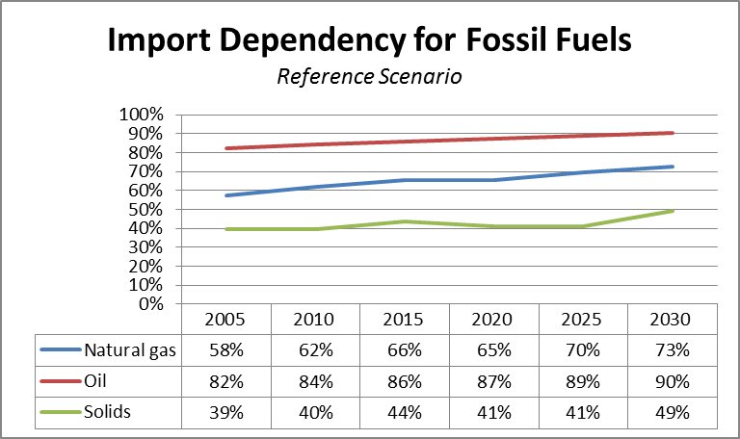
Source: PRIMES 2013

Figure 28. Average Annual Value of Net Fossil Fuel Imports (2030 Policy Framework Impact Assessment)
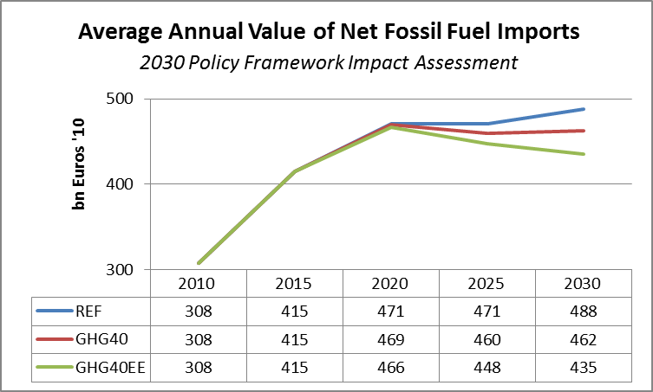
Source: PRIMES 2014,

Oil
Oil imports decline steadily over the Reference Scenario projection period, but at a smaller rate compared to the reductions in production. As a result the import dependency for oil increases. The main reductions in the final consumption of oil and its liquid products between 2010 and 2030 lie within the Transport sector, where oil consumption drops by around 35 Mtoe (from 345 Mtoe to 310 Mtoe), and the Residential sector, with a similar drop of around 30 Mtoe (from 78 Mtoe to 48 Mtoe).

Figure 29. Oil Projections until 2030 (Reference Scenario)
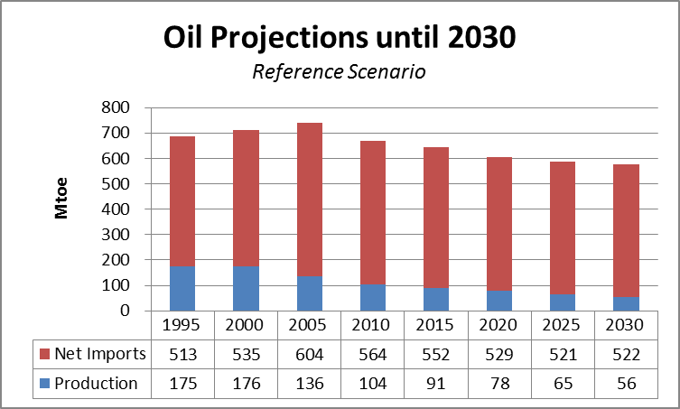
Source: PRIMES 2013
The declining trend of oil imports appears stronger in the 2030 Policy Framework, slowly starting to diverge from the Reference Scenario as of 2020. The effects of the modelled climate and energy policies start showing in 2030, when net imports are lower by 17 Mtoe compared to the Reference Scenario, although the trend becomes much more pronounced in the later projection years and closer to 2050 (Figure 30).

Figure 30. Oil Projections until 2030 (2030 Policy Framework)
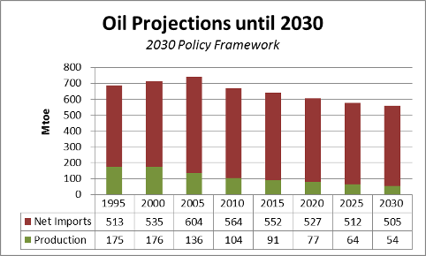
Source: PRIMES 2014

Natural gas
Contrary to the other fossil fuels, the consumption of natural gas is projected to only slightly decrease until 2030, remaining proportional to the respective use of natural gas in power generation and households. Therefore, in combination with the decline in production, net imports of natural gas are projected to increase until 2030.
Figure 31. Natural Gas Projections until 2030 (Reference Scenario)
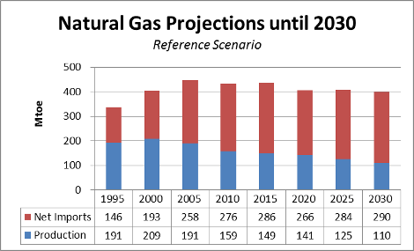
Source: PRIMES 2013
In the presence of the 2030 framework energy and climate policies, final consumption in gas decreases further, most notably in households and power generation, thus leading to a slight decrease of natural gas imports this time. Despite this tendency though, the decreasing production of natural gas retains the increasing trend in its import dependency.
Figure 32. Natural Gas Projections until 2030 (2030 Policy Framework)
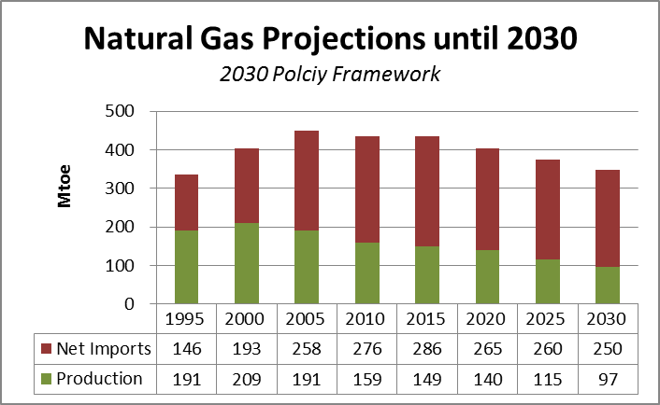
Source: PRIMES 2014

Solid Fuels
Similar to oil, solids imports decline steadily over the Reference Scenario projection period, but again at a smaller rate compared to production. As a result import dependency for solids also increases, despite the significant reduction in the consumption of solids (mainly in power generation, where their use as an input fuel is halved).
Figure 33. Solids Projections until 2030 (Reference Scenario)
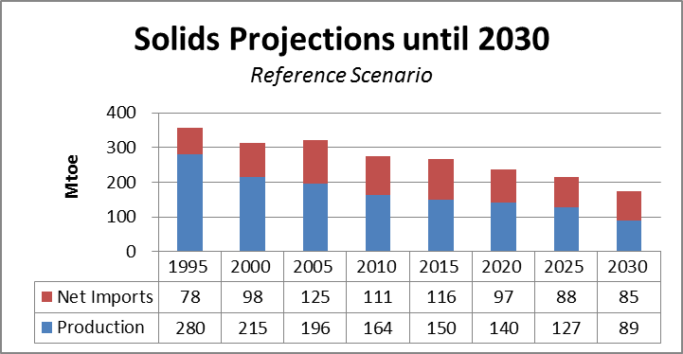
Source: PRIMES 2013
The 2030 Policy Framework is projected to have similar effects to solids as in oil, further strengthening the declining rate of solid imports. The trend is much more pronounced in the later projection years.
Figure 34. Solids Projections until 2030 (2030 Policy Framework)
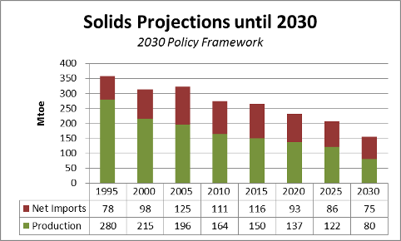
Source: PRIMES 2014

Uranium
The supply and demand situation for nuclear fuels is not expected to change radically by 2030. Under current assumptions, nuclear generating capacity in the EU may somewhat decrease in that time frame due to ageing reactors and political decisions in some Member States (Figure 35). However, most existing reactors are expected to undergo a licence renewal leading to a lifetime extension or be replaced by new reactors of similar capacity.
Figure 35. Net generating capacity forecast in the EU by type of reactor – 2013-2032
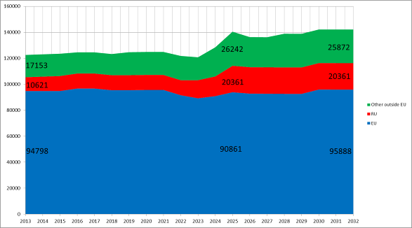.
Source: ESA
Taking into account EU utilities' contractual coverage for the coming years and their inventories, EU reactor requirements for both natural uranium and enrichment services are sufficiently covered in the short and medium term (Figure 36).

Figure 36 Coverage rate for natural uranium and enrichment services, 2014–22 (%)

- 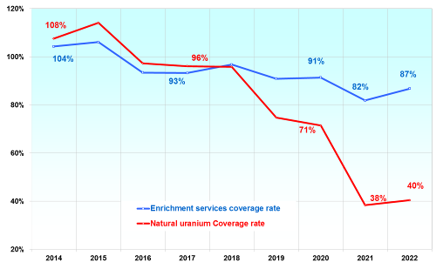
Source: ESA

Electricity
The 2013 PRIMES energy reference scenario, taking into account all energy and climate policy measures being already in force, shows a gradual increase in electricity generation and consumption until 2050 in the EU-28 (see Figure 37). According to this scenario the share of solid fuels will drop to 8% until 2050 from their current share of more than one quarter in the power mix. The share of nuclear generation will also go down to 21%, while that of natural gas will also decrease (to 17% in 2050). Wind power will gain a large share compared to the current 6%, as it will assure almost 25% of the power generation in 2050. The share of solar power will also grow significantly and it will assure 8% of the power mix in 2050, similarly to biomass whose share will double from the current 4%.
The evaluation of the 27 National Renewable Energy Action Plans shows that the share of renewables in the EU final energy consumption would reach 20.6% in 2020. Renewable energy production is projected to increase from 99 million tonnes of oil equivalent (Mtoe) in 2005 to 245 Mtoe in 2020 (an average annual growth rate of 6% per year).
Based on Member State projections for renewable energy use and their sectoral targets, the combined EU renewable energy share in electricity will grow form 19.4% in 2010 to 34% in 2020, in heating and cooling respectively - from 12.5% to 21.5% and in transport from 5% to 11%. Renewable energy industry expectations for the renewable energy shares in the three sectors are higher – EU Industry roadmap estimates that 2020 renewable energy share in the electricity sector could reach even 42%, in the heating and cooling – 23.5% and in the transport 12%. According to NREAP analysis, in the next decade the strongest growth will occur in wind power (from 2% to 14,1% of the total electricity consumption) and solar electricity (from 0% to 3% of the total electricity consumption).
In the electricity sector, according to NREAP technology projections by 2020 wind would become the most important renewable energy source providing 40% of all renewable electricity compared to 25% in 2010, the contribution of photovoltaic and solar thermal electricity would also grow from current 3% to 9%, the contribution of biomass is expected remain almost unchanged (18% in 2010 compared to 19% in 2020), while the role of hydro would decrease from 50% in 2010 to 30% in 2020. The role of geothermal and wave and tidal are still expected to remain marginal in 2020 with respectively 1% and 0.5%.
Figure 37 Power generation from different sources in the 2013 PRIMES Reference Scenario
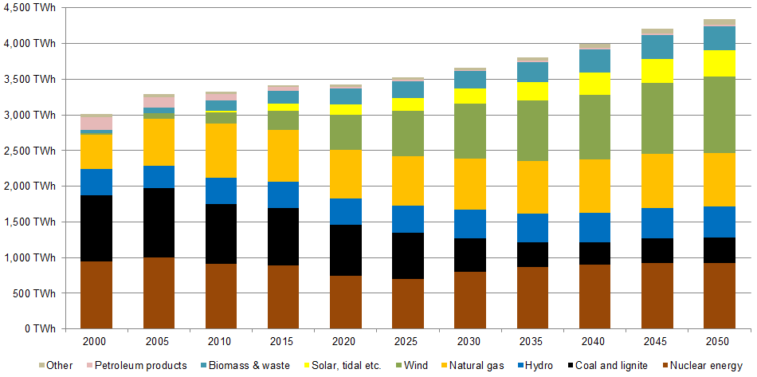
Source: PRIMES
In the heating sector the analysis of Member State projections in NREAPs indicate that biomass would maintain its dominance (80% of all renewable heating in 2020, down from 90% in 2010), solar energy based heating would increase to 6% compared to 2% in 2010 and geothermal is expected to contribute 2% in 2020 compared to the current 1%. The use of heat pumps would also increase from 6% in 2010 to 11% in 2020.
Concerning the transport sector, in 2020 the first generation biofuels (biodiesel and bioethanol) are still expected to maintain their predominance with 66% and 22% share of the total RES use in transport compared to the current 71% and 19%. The contribution of lignocellulosic biofuels and biofuels made from wastes and residues and the renewable electricity is expected to make up the rest of contribution - 12% - towards the renewable energy share in transport in 2020.

Comparison to IEA projections
In order to provide a more complete picture on the projections for the fossil fuel import dependency until 2030, PRIMES projections are compared to the ones of the IEA World Energy Outlook 2013.
Despite their different assumptions, modelling techniques, statistical definitions, etc. and the diverging projections for various energy system figures, both projections seem to indicate a similarly increasing trend in EU import dependency, independently of the chosen scenario. At the same time though, if adopted or announced policies are fully implemented, then a considerable reduction in the volume of fossil fuel imports should be expected.
For a more complete set of projections per fuel and per scenario, see Table 6 below. By comparing the IEA projections with the PRIMES ones, the most notable difference is that although the general direction of the various trends is similar (increase of gas imports, decrease of oil and gas) they differ in their intensity, with the IEA ones showing much stronger tendencies than the PRIMES ones, which tend to be more conservative (except for solids, where projections are similar).
Table 5. Net Imports and Import Dependency for all Fossil Fuels for different scenarios

 |  |  | 2010 | 2020 | 2030
PRIMES projection for EU28 (Reference Scenario) |  | Total Imports (Mtoe) | 950.9 | 891.8 | 897.4
 |  | Import Dependency (%) | 68.19% | 71.36% | 77.96%
PRIMES projection for EU28 (2030 policy framework) |  | Total Imports (Mtoe) | 950.9 | 884.9 | 828.7
 |  | Import Dependency (%) | 68.19% | 71.39% | 78.08%
IEA projection for EU28 (WEO2013 new policies scenario) |  | Total Imports (Mtoe) | 951.0 | 884.6 | 860.1
 |  | Import Dependency (%) | 67.51% | 72.30% | 78.39%

Table 6. Total Demand and Import Dependency per fossil fuel for different scenarios
 |  |  | 2010 | 2020 | 2030
PRIMES projection for EU28 (Reference Scenario) | Oil | Total Demand (Mtoe) | 669 | 606 | 578
PRIMES projection for EU28 (Reference Scenario) | Oil | Import Dependency (%) | 84.25% | 87.21% | 90.38%
PRIMES projection for EU28 (Reference Scenario) | Natural gas | Total Demand (Mtoe) | 444 | 407 | 400
PRIMES projection for EU28 (Reference Scenario) | Natural gas | Import Dependency (%) | 62.10% | 65.43% | 72.58%
PRIMES projection for EU28 (Reference Scenario) | Coal | Total Demand (Mtoe) | 281 | 236 | 174
PRIMES projection for EU28 (Reference Scenario) | Coal | Import Dependency (%) | 39.52% | 40.93% | 49.08%
PRIMES projection for EU28 (2030 policy framework) | Oil | Total Demand (Mtoe) | 669 | 604 | 559
PRIMES projection for EU28 (2030 policy framework) | Oil | Import Dependency (%) | 84.25% | 87.22% | 90.29%
PRIMES projection for EU28 (2030 policy framework) | Natural gas | Total Demand (Mtoe) | 444 | 404 | 347
PRIMES projection for EU28 (2030 policy framework) | Natural gas | Import Dependency (%) | 62.10% | 65.40% | 71.68%
PRIMES projection for EU28 (2030 policy framework) | Coal | Total Demand (Mtoe) | 281 | 231 | 155
PRIMES projection for EU28 (2030 policy framework) | Coal | Import Dependency (%) | 39.52% | 40.45% | 48.41%
 |  |  | 2010 | 2020 | 2030
IEA projection for EU28 (WEO2013 new policies scenario) | Oil | Total Demand (Mtoe) | 683 | 569 | 481
IEA projection for EU28 (WEO2013 new policies scenario) | Oil | Import Dependency (%) | 82.5% | 84.6% | 89.0%
IEA projection for EU28 (WEO2013 new policies scenario) | Natural gas | Total Demand (Mtoe) | 446 | 407 | 442
IEA projection for EU28 (WEO2013 new policies scenario) | Natural gas | Import Dependency (%) | 62.1% | 72.7% | 78.8%
IEA projection for EU28 (WEO2013 new policies scenario) | Coal | Total Demand (Mtoe) | 280 | 248 | 174
IEA projection for EU28 (WEO2013 new policies scenario) | Coal | Import Dependency (%) | 39.6% | 43.4% | 48.1%

Assessment of energy capacity, transport and storage
The ever growing complexity and interdependencies of energy systems calls for understanding of a wider range of factors that define the energy security profile of a country or a region, including resource availability and diversification of suppliers, infrastructure or end‐use sectors.
The risk of disruptions or significant price spikes to fuel supply depends on the number and diversity of suppliers, transport modes, regulatory framework and supply points, and the commercial stability in the countries of origin. The resilience of energy providers or consumers to respond to any disruptions by substituting other supplies, suppliers, fuel routes or fuels depends on stock levels, diversity of suppliers and supply points (infrastructure, ports, pipelines).
The energy transformation tier, including refining and power generation, also faces risks. Refining risks are associated with having access to sufficient capacity for refining of different fuel sources. In the electricity sector, in addition to the above fuel risks, there are risks of volatility of supply (including weather patterns (rain, wind, sun), unplanned power plant outages, age profile of power plants), risks to ensure system stability and generation adequacy and risks related to operation and development of networks, including interconnection capacities. Resilience in this sector also depends on the number and diversity of fuels, refineries and power plants, as well as imports from third countries in the case of petroleum products.
Finally, the resilience and cost of supply disruptions differ amongst the variety of households and industries, as does their flexibility to shift or reduce energy consumption.
The energy mix of a country has by tradition been a national responsibility. Before functioning energy markets were established, governments managed the energy sector and were held directly responsible for energy supplies. As energy markets have been established, both nationally and at European level, the market is being harnessed to ply and manage the energy sector: multiple entrants at each point of energy supply increase the reliability of supplies as well as increasing competition which induces lower costs. However the market does not always capture the costs of disruptions to energy supplies. Where there are direct commercial arrangements which may suffer, broader and indirect sectoral and macroeconomic costs of disruption are not necessarily captured by contracts or insurance arrangements made by the market. In light of such market failures, governments have also regulated the market, to insist on a secure energy supply under most circumstances. And as the European energy market is established, it functions more smoothly and with fewer distortions when regulated at the European level or when national or regional regulatory measures are well coordinated.
The previous chapter looked at energy security as projected for the year 2030, given that the EU reduces its consumption of fossil fuels. The below text introduces first an overview over the energy dependence of the EU as it is the case currently. Finally it analyses the available external and internal reserves as well as infrastructural and contractual constraints to tap them.

Hydrocarbon reserves
The EU is poorly endowed with indigenous hydrocarbon energy resources in comparison to other world regions. At the end of 2012, proved oil reserves amounted to 6.8 billion barrels, only 0.4% of global reserves and equivalent to about 12 years of 2012 production levels. In the case of natural gas, at the end of 2012, proved reserves amounted to 1.7 trillion cubic meters, 0.9% of global reserves and equivalent to about 12 years of 2012 production levels (BP Statistical Review of World Energy). In the case of coal, proved reserves at the end of 2012 were at 56 billion tonnes, or 6.5% of global reserves, equivalent to 97 years of 2012 production levels.

Figure 38. Proved hydrocarbon reserves in the EU at the end of 2012
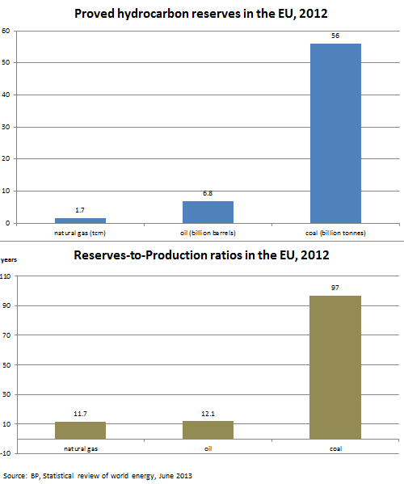
Producing oil from unconventional sources might slow down this trend but there is limited information on the potential of such resources. Current exploration efforts are focusing on shale gas but hampered by geological and public acceptance issues.
Information on EU shale gas reservoirs is limited and uncertain, due to early stages of exploration. It appears nonetheless that potential shale gas producers in the EU may not achieve similar production volumes and costs as their US counterparts. The main reason is that shale gas resources in the EU appear to be significantly smaller than the US. In addition, the EU potential reserves are dispersed across several countries, which may entail lower economies of scale in their exploitation.
Figure 39. Unproved technically recoverable shale gas resources
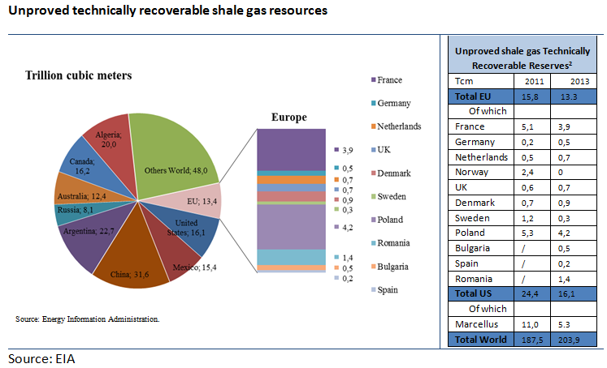
Source: "Energy Economic Developments in Europe, DG ECFIN, European Commission, 2014
The recently adopted Commission Recommendation 2014/70/EU sets minimum principles for the exploration and production of hydrocarbons using high-volume hydraulic fracturing, aiming to ensure that proper environmental and climate safeguards are in place.

Oil

Infrastructure and supply routes
While the refineries supplied by the Druzhba pipeline have alternative supply routes, some of these are not immediately available and/or have insufficient capacity to wholly replace the Druzhba pipeline. The dependence of these refineries on the Druzhba pipeline underlines the need for infrastructure projects facilitating the diversification of supply sources and routes.
The list of "projects of common interest" (PCI) unveiled by the Commission in October 2013 contains a number of projects which, if realised, would help the countries of Central Eastern Europe in this respect (see Figure 40):
- Bratislava-Schwechat-Pipeline: pipeline linking Schwechat (Austria) and Bratislava (Slovak Republic)
- TAL Plus: capacity expansion of the TAL Pipeline between Trieste (Italy) and Ingolstadt (Germany)
- JANAF-Adria pipelines: reconstruction, upgrading, maintenance and capacity increase of the existing JANAF and Adria pipelines linking the Croatian Omisalj seaport to the Southern Druzhba (Croatia, Hungary, Slovak Republic)
- Litvinov (Czech Republic)-Spergau (Germany) pipeline: the extension project of the Druzhba crude oil pipeline to the refinery TRM Spergau
- Adamowo-Brody pipeline: pipeline connecting the JSC Uktransnafta’s Handling Site in Brody (Ukraine) and Adamowo Tank Farm (Poland)
- Construction of Oil Terminal in Gdańsk
- Expansion of the Pomeranian Pipeline: loopings and second line on the Pomeranian pipeline linking Plebanka Tank Farm (near Płock) and Gdańsk Handling Terminal
Figure 40. Projects of common interest - Oil Supply Connections in Central Eastern Europe
Dependence on Russian oil and impacts of a possible (full) disruption of Russian oil supplies
Russia is by far the main supplier of crude oil to the EU with about 35% of extra-EU imports (the share of the second supplier, Norway, is only 10%), and also supplies considerable amount of petroleum products. To compare, EU imports from Iran before imposing the sanctions in mid-2012 amounted less than 6% of total oil imports. Almost all Member States having refineries import crude oil from Russia. The high dependence on Russian oil is not restricted to the countries supplied by the Druzhba pipeline: in 2012, 12 Member States imported more than a third of their crude oil from Russia.
Only about 30% of Russian oil (about 50 Mt) is arriving to Europe by pipeline, through the Druzhba pipeline system; most of the rest is transported by sea from the Russian ports in the Baltic Sea (Primorsk and Ust-Luga) and the Black Sea (mainly Novorossiysk).
About 2/3 of Russian exports of crude oil and oil products is directed to Europe, with the rest going to Asia (mainly China and Japan), the FSU (mainly Belarus) and to a lesser extent to the Americas. While Russian oil production has been rather stable in the past few years, there is a tendency of decreasing crude oil exports as more oil is directed to domestic refineries. This is helped by the system of export duties which favours product exports (lower export duty).
Considering the huge volumes, a disruption of Russian oil supplies to the EU is likely to have a marked impact on oil prices. Even without an actual disruption of oil flows, the escalating/easing of tensions over the Ukraine-Russia crisis have been a major force behind oil price movements since early March 2014. While these movements have so far been limited, leaving the Brent price in the $105-110 range, an actual disruption would undoubtedly trigger a bigger price rise, potentially having a detrimental impact on the European and global economy.
While a disruption of this size may be temporarily covered by releasing stocks (emergency stocks held by EU Member States are equivalent to about 7 months of crude oil and product imports from Russia) and production increases from other countries (in April 2014, OPEC's effective spare capacity was 3.4 million barrels per day), oil prices would probably see a lasting rise unless Russia can redirect exports to other regions. In that case, the price hike could be moderated in the longer run.
EU refineries would have to find new suppliers which is made difficult by the Iranian sanctions (EU import ban still in force), ongoing supply disruptions across the world (Libya, Yemen, Syria, Sudan etc.) and the US oil export ban. Furthermore, several EU refineries are configured to process Russian oil and may find it difficult to procure crude oil of comparable quality, leading to suboptimal operation. (Russia's main export grade, the Urals blend is a sour and medium heavy oil and it accounts for more than 80% of the country's oil exports.) This would squeeze the already fragile EU refining sector, suffering from low margins and decreasing demand. Some of the products imported from Russia are used as feedstock and processed further in EU refineries. These would also have to be replaced from other sources.
Some of the Russian oil imports may be replaced by increased product imports, in particular from the US which, helped by the increasing indigenous oil production, has become a major net exporter of products. Again, this would hurt the EU refining sector by further reducing capacity utilization.
The refineries supplied by the Druzhba pipeline would be in a particularly difficult situation: in addition to finding new suppliers, they would need to resort to alternative supply routes. However, in some cases these are not immediately available and/or have insufficient capacity to wholly replace the Druzhba pipeline. Therefore, some or all of the concerned countries (Germany, Poland, Czech Republic, Slovakia, Hungary) would have to release emergency stocks in order to ensure the continuous supply of the refineries before alternative supply routes become operational.
As Russia has a massive crude oil export capacity surplus (oil export capacity of over 6 mb/d compared to about 4.5 mb/d available for exports), most of the oil flows going to Europe (including those carried by Druzhba) could be redirected to other export routes, including the Baltic Sea, the Black Sea and, to a lesser extent, the Far East and, in principle, sold on the global market. Accordingly, in the longer run Russian oil output would not necessarily have to decrease but would have to find new buyers. The feasibility of finding new customers will largely depend on the attitude of other consuming countries. (NB In case of Iran, the US was putting pressure on the Asian buyers of Iranian oil to reduce their purchases.)
In case of redirecting Russian exports to new buyers, oil trade patterns would have to change significantly, with supply routes (from new suppliers to Europe and from Russia to new customers) becoming longer, putting pressure on the tanker market and increasing freight rates. Such a readjustment of supply routes would take time.
Provided that Russia cannot swiftly and fully redirect exports, there may be a significant impact on the Russian federal budget, but this may be partly offset by the increase of crude prices.

Internal energy reserve capacity
The EU has put a range of policies and legislation in place aiming to reduce CO2 emissions and improve energy efficiency, many of which will also moderate oil demand, either directly or indirectly. These include:
- A strategy is in place to reduce emissions from light-duty vehicles (cars and vans), including binding emissions targets for new fleets by 2020. As the automotive industry works towards meeting these targets, average consumption of vehicles is falling each year.
- A target is in place to reduce the greenhouse gas intensity of vehicle fuels (calculated on a life-cycle basis) by up to 10% from 2010 to 2020.
- To help drivers choose new cars with low fuel consumption, EU legislation requires Member States to ensure that relevant information is provided to consumers, including a label showing a car's fuel efficiency and CO2 emissions.
- Rolling resistance limits and tyre labelling requirements have been introduced and tyre pressure monitoring systems made mandatory on new vehicles.
- Since the beginning of 2012, aviation has been included in the EU Emissions Trading System (ETS). Currently this applies to flights within the European Economic Area.
- Public authorities are required to take account of life time energy use and CO2 emissions when procuring vehicles.
- The EU is aiming for a 20% cut in Europe's annual primary energy consumption by 2020. The Commission has proposed several measures to increase efficiency at all stages of the energy chain: generation, transformation, distribution and final consumption. In particular, the measures focusing on the building sector has a potential for reducing oil use in Member States where heating oil or kerosene is widely used in the residential sector (e.g. Austria, Belgium, Germany, Greece, Ireland). The Energy Performance of Buildings Directive 2010/31/EU (EPBD) is the main legislative instrument to reduce the energy consumption of buildings. Under this Directive, Member States must establish and apply minimum energy performance requirements for new and existing buildings. The Directive also requires Member States to ensure that by 2021 all new buildings are so-called 'nearly zero-energy buildings'.
- Under Directive 2003/30/EC on the promotion of the use of biofuels or other renewable fuels for transport, the EU established the goal of reaching a 5.75% share of renewable energy in the transport sector by 2010. Under Directive 2009/28/EC on the promotion of the use of energy from renewable sources, this share rises to a minimum 10% in every Member State by 2020, thereby reducing the demand for oil-based fuels.
There is still significant potential for reducing the consumption of heavy-duty vehicles. In this area, the Commission is currently working on a comprehensive strategy to reduce CO2 emissions in both freight and passenger transport.

External energy reserve capacity
Oil is traded in a global market and most of the oil traded internationally is shipped by sea. Accordingly, most European refiners have an access to oil across the world. Refiners are free to select their suppliers; the choice is primarily governed by economics, i.e. price, transportation costs and crude oil quality. As it is relatively easy to switch from one supplier to another, security of supply is not the main consideration but many consumers prefer to establish a diversified supplier portfolio.
While increasing the diversification of oil supplies is certainly desirable, there are constraints which limit the potential for such diversification.
First, oil supply is rather concentrated: 6 countries cover 50% of global production and 14 countries cover 75%.
Second, crude oil comes in different grades, represented by variable properties, e.g. in terms of gravity and sulphur content. Refineries are typically configured to process a particular type of oil and switching to alternative supply grades may lead to suboptimal operation. For example, during the 2011 civil war in Libya, some refiners had difficulties to replace the sweet (low sulphur) and light Libyan crude while the Iran sanctions introduced in 2012 caused supply problems for some refineries specialised in bitumen production. Heavier and sourer (high sulphur content) crudes typically require additional processing to produce lighter products; therefore, complex, more sophisticated refineries are better equipped to process such feedstock.
Third, the choice of suppliers is often restricted by disruptions and other unplanned outages in producing countries. For example, in 2011, practically the total Libyan oil production came to a standstill due to the civil war. As a result, buyers of Libyan oil (which represented 10% of EU imports) had to find new suppliers. In a liquid global market this was possible but often at higher cost and/or different quality. In recent years the size of such unplanned outages has significantly increased: according to the US Energy Information Administration, they increased from 0.4 million barrels/day in January 2011 to 3.2 million barrels/day in March 2014. In some cases, decisions by the EU limit the scope of suppliers. For example, the Iran sanctions introduced in 2012 banned EU oil imports from the country (which previously supplied 6% of EU imports), forcing refiners to find alternative suppliers.
Forth, some countries are restricting oil exports. For example, while the US oil output is quickly increasing thanks to the expanding tight oil production, existing legislation does not allow the export of oil.
For the Member States supplied by the Druzhba pipeline it is essential that, in case of need, they can quickly switch to alternative supply routes which have adequate spare capacities.

Emergency response tools
Member States have various emergency response tools at their disposal, many of which are underpinned by EU legislation.
Emergency stocks constitute the easiest and fastest way of making large volumes of additional oil and/or petroleum products available to an undersupplied market, thereby alleviating market shortage. The release of stocks can replace disrupted volumes and thereby it might be possible to avoid physical shortage and to dampen or eliminate potential price hikes. As a result, negative impacts of a disruption on the economy can be mitigated. The release of emergency stocks is now generally considered as the main emergency response tool to address an oil supply disruption (with other measures considered as supplementary to stock releases).
EU Member States have to hold oil stocks for emergency purposes since 1968. The currently applicable Council Directive 2009/119/EC requires Member States to hold emergency stocks of crude oil and/or petroleum products equivalent to 90 days of net imports or 61 days of consumption, whichever is higher. At the end of 2013, emergency stocks held by Member states pursuant to this legislation amounted to 131 million tons (60 million tons of crude oil and 71 million tons of products), equivalent to 102 days of net imports. The Directive also specifies the emergency procedures under which emergency stocks can be released.
In a recent study the IEA examined the cost and benefits of holding public stocks for emergency purposes. Annual costs were found to be in the range of USD 7-10 per barrel; the actual figure will depend on the size and type of storage facilities, the composition of stocks and the interest rate. Considering recent oil price levels, the acquisition of stocks represents the biggest share of costs (up to 85%). The benefits of stockholding were assessed focusing on global crude oil disruptions and consist of reduced GDP losses and reduced import costs. Economic benefits were found to be quite significant, amounting to about USD 50 per barrel on a yearly basis, resulting in annual net benefits of some USD 40 per barrel.
Another important emergency response tool is demand restraint. By reducing oil use in a sector in the short term, oil can be "freed up", thereby alleviating market shortage. Considering that most oil is used in transport, demand restraint measures typically target this sector. Such measures can range from light-handed measures like information campaigns encouraging people to use public transport to heavy-handed measures such as driving bans based on odd/even number plates. Most of these measures can be introduced at relatively low cost and at short notice but do require public acceptance (which may sometimes be difficult to obtain) and administrative control. In addition, extensive demand restraint may hamper economic activity and mobility. Demand restraint measures often have a limited impact (e.g. speed limit reductions) and/or take some time to have an impact on consumption (e.g. encouraging ecodriving).
In a serious and prolonged disruption it will be necessary to ensure that certain groups of users (e.g. emergency services) are adequately supplied with petroleum products which might require the introduction of rationing/allocation schemes.
According to EU legislation, Member States have to be able to reduce demand and allocate oil products in case of a disruption: Council Directive 2009/119/EC requires them to have procedures in place "to impose general or specific restrictions on consumption in line with the estimated shortages, inter alia, by allocating petroleum products to certain groups of users on a priority basis" (Article 19(1)).
Fuel switching means the temporary replacement of oil by other fuels in certain sectors/uses. For example, oil used for electricity generation or for heating purposes may be replaced by other fuels, provided that technical systems are in place to allow the switch to the alternative fuel (e.g. natural gas). However, the actual potential to use fuel switching in a crisis is limited in most Member States. The majority of oil is now used in transport and in the petrochemical sector, where it is difficult or almost impossible to replace significant amounts of oil in the short term.
In principle, a temporary increase of indigenous oil production can make additional oil available to the market. However, for technical and economic reasons, it is difficult to increase oil production at short notice. Only a handful of Member States produce oil in the EU and most of them have little or no spare capacity.
By relaxing fuel specifications, the supply of certain petroleum products can be increased which, in principle, could contribute to alleviating a shortage. Under Directive 98/70/EC (fuel quality directive), the Commission may authorize higher limit values on the request of a Member State in case of “exceptional events, a sudden change in the supply of crude oils or petroleum products” (Article 7).
The IEA's founding treaty, the International Energy Program (IEP) also foresees the (re)allocation of oil in case of a severe supply disruption, drawing oil from countries that are less negatively affected to those which are more severely affected. This tool has never been applied in practice.
In case of the disruption of supplies on a particular route, it may be possible to switch to alternative supply routes. This is particularly relevant for Member States and refineries supplied by pipelines. For example, the countries supplied by the Druzhba pipeline have the following alternative supply routes at their disposal: the Rostock-Schwedt pipeline (Germany), the Pomeranian Pipeline (Poland), the Ingolstadt-Kralupy (IKL) pipeline (Czech Republic) and the Adria pipeline (Hungary and Slovakia). However, some of these are not immediately available and/or have insufficient capacity to wholly replace the Druzhba pipeline. The oil-related "projects of common interest" (PCI) announced by the Commission in October 2013 would increase the capacity of these routes and/or would establish additional routes.
Producing hydrogen using electricity generated from renewables, and using fuel cells that convert it back into electricity more efficiently than conventional technologies, can provide a solution. In this context, the Fuel Cells and Hydrogen 2 Joint Undertaking under Horizon 2020 (the EU Framework Programme for Research and Innovation) will aim at increasing energy efficiency of the production of hydrogen from water electrolysis and renewable sources whilst reducing operational and capital costs so that the combination of the hydrogen and the fuel cell system is competitive with the alternatives available in the marketplace and demonstrating on a large scale the feasibility of using hydrogen to support the integration of renewable energy sources into energy systems including through its use as a competitive energy storage medium for electricity produced from renewable energy sources.
Annex II provides a comprehensive overview by Member State of emergency response tools to address an oil supply disruption.
In addition to IEA-based plans, many signatories of the EU's Covenant of Mayors foresee actions to limit urban traffic and generate energy savings in the transport sector.

Natural gas

Internal energy reserve capacity
Today, Regulation 994/2010 concerning measures to safeguard security of gas supply establishes market-based security of supply measures, non-market based measures in exceptional circumstances and defines "responsibilities among natural gas undertakings, the Member States and the Union regarding both preventive action and the reaction to concrete disruptions of supply". The Regulation names main factors on which security of supply will depend in the future:
- evolution of the fuel mix,
- the development of production in the Union and in third countries supplying the Union,
- investment in storage facilities and in the diversification of gas routes and of sources of supply within and outside the Union including Liquefied Natural Gas (LNG) facilities.
The obligations imposed by the Regulation require gas undertakings to ensure supplies to protected customers in three climatic conditions, however does not set a uniform supply standard i.e. there is no storage obligation in natural gas, it is rather up to national Competent Authorities to decide what proof they accept from undertakings to demonstrate their ability to satisfy demand. Further, the Regulation requires Member States to ensure until end of 2014 that in case of a disruption of the single largest gas infrastructure, the capacity of the remaining infrastructure is able to satisfy the total exceptionally high gas demand in a MSs (N-1 standard). It also requires developing physical reverse flow capacity, following a procedure examining the potential benefits and costs. In May 2013 only 16 Member States meet the N-1 standard.
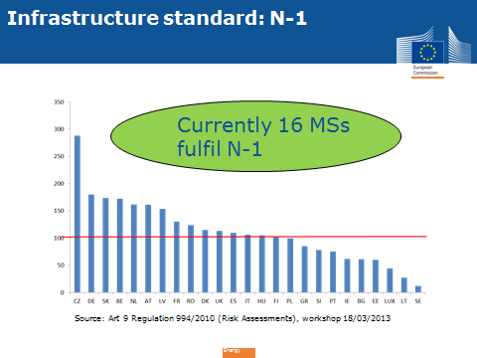
Annex II of the Regulation lists measures the authorities of the Member States shall take into account when developing the Preventive Action Plan and the Emergency Plan established by the Regulation. The authorities are called upon to give preference, as far as possible, to those measures which have the least impact on the environment while taking into account security of supply aspects.
The Regulation points to the following supply-side market based measures:
- increased production flexibility,
- increased import flexibility,
- facilitating the integration of gas from renewable energy sources into the gas network infrastructure,
- commercial gas storage — withdrawal capacity and volume of gas in storage,
- LNG terminal capacity and maximal send-out capacity,
- diversification of gas supplies and gas routes,
- reverse flows,
- coordinated dispatching by transmission system operators,
- use of long-term and short-term contracts,
- investments in infrastructure, including bi-directional capacity,
- contractual arrangements to ensure security of gas supply.
Further, it points to a set of demand-side market based measures, in particular:
- use of interruptible contracts,
- fuel switch possibilities including use of alternative back-up fuels in industrial and power generation plants,
- voluntary firm load shedding,
- increased efficiency,
- increased use of renewable energy sources.
Only in the event of emergency the authorities can consider the contribution of the following indicative and non-exhaustive list of measures to re-establish security of supply:
- use of strategic gas storage,
- enforced use of stocks of alternative fuels (e.g. in accordance with Council Directive 2009/119/EC of 14 September 2009 imposing an obligation on Member States to maintain minimum stocks of crude oil and/or petroleum products (1)),
- enforced use of electricity generated from sources other than gas,
- enforced increase of gas production levels,
- enforced storage withdrawal.

Finally, demand-side non-market emergency measures include:
- various steps of compulsory demand reduction including:
- enforced fuel switching,
- enforced utilisation of interruptible contracts, where not fully utilised as part of market measures,
- enforced firm load shedding.
In addition, Commission Decision of 10 November 2010 amending Chapter 3 of Annex I to Regulation 715/2009 on conditions for access to the natural gas transmission networks imposes obligation on TSOs to publish data on gas flows, nominations, storage levels etc.
In terms of demand moderation Member States have the possibility to introduce package of measures as defined in the Regulation 94/2010. The measures need to take into account longer periods of supply disruptions impacting also on winter supplies. In particular Member States relying on district heating can plan more strongly on fuel switch possibilities. Market measures such as increased use of interruptible contracts and fuel switch possibilities can be incentivised in Member States with high share of gas in industrial production. Awareness programmes and incentive for more efficient use of energy (including in CHPs) are a possible way forward to increase energy efficiency and lower consumption of gas in households, power production. Increase of production of power from renewables has a high potential to reduce EU demand for gas, however it is a medium term measure.
On the demand-side, the potential of the power sector to switch to coal is relatively limited due to the current drop in gas use for power generation driven by relatively low coal and CO₂ prices. Wind and solar generation could potentially contribute to a reduction of demand for fossil fuels in the power sector though their impact on gas use would depend on the merit order in each power market.
A large part of European gas demand comes from heating in the residential sector, making weather conditions critical to gas demand.
In terms of increase of production from the area of EEA, such increase is possible in Norway and the Netherlands and will be incentivised by the increase in gas prices if shortage of supply takes place. However it is necessary to warn/coordinate with the supplying states that demand increase is expected. Production of shale gas is also possible in medium term; in some countries of the EEA exploration is already on-going.

External energy reserve capacity
Another medium term measure is to aim at higher diversification of suppliers, such as increase of imports form the US and from Arab states. An obstacle to broader commitments is the ability of the EU Member States to enter into commitments while being bound with long term contracts with Russia. In such situation an opportunity is to use the supplies form non-Russian sources to increase gas storage. On the other hand measures can be taken that allow in the future to rely on the short term markets and do not bind Member States in the long term commitments i.e. such as introduction of obligatory sales of imported gas via power exchanges.
Triggered by the recent events, IEA has analysed a scenario of interruption of transit of Russian gas to Europe via Ukraine, exploring the following options to replace Russian gas flows through Ukraine that were at 82 bcm in 2013, or about half of Russian imports to Europe:
• Alternative supply routes, i.e. re-routing of Russian imports (Nord Stream, Yamal and Blue Stream)
The analysis points that when it comes to alternative supply routes in a short-term disruption, there is very limited capacity on Yamal and Blue Stream, leaving Nord Stream as the only route providing re-routing opportunities for Russian gas.
• Additional and/or alternative supplies, including additional volumes from Norway, additional LNG, North Africa, Azerbaijan, Iran
The IEA does not expect alternative supplies from North Africa to provide incremental supply due to growing demand in Algeria, uncertainties with Libyan supplies that could come through the Green Stream pipeline and Iran's exports to Turkey dependent on Iranian domestic demand; Azerbaijan could provide some limited volumes through the South Caucasus pipeline.
Global LNG markets remain tight and there is competition for cargos between Europe, Asia and Latin America. The IEA estimates that an increase of 1 USD/mbtu in Asia leads to a loss of 0.4 bcm of LNG to Europe.
• production and seasonal storage
The IEA expects that Norway could provide some additional volumes, but its impact is limited due to pipeline capacity to north-west Europe.
A short-lived disruption could imply limiting the injection into seasonal storage facilities. After a relatively warm winter season 2013-2014, storages across Europe are well filled. The IEA points to the fact that flexibility in storage injection is lower than in storage withdrawal, so lower injection into storages may push forward the consequences to the next winter season.

Figure 41. Replacing gas imports through Ukraine
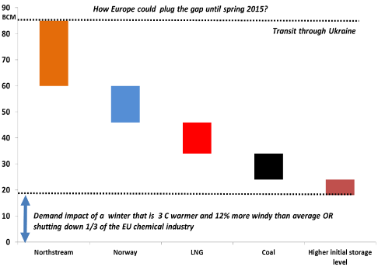
Source: IEA, presentation at the Governing Board
Recent research on the costs of reducing Russian gas dependence in Europe estimates that approximately 57 bcm of demand could be saved through six short-term measures at a cost of around 1.2 USD/bcm saved or a total of 33 billion/year. The top three short-term measures include drawing down gas inventories, outbidding Asia on LNG and switching gas power to oil power.
When it comes to drawing down gas inventories, to bridge between supply today and future supply sources, Bernstein Energy estimates a potential reduction of 9 bcm/year. Since inventories need to be subsequently rebuilt, this is not a sustainable solution. There is a correlation between storage levels and gas prices decline in inventories putting pressure on spot prices; on the basis of this, Bernstein Energy estimates that the 9 bcm/year drawing down on inventories would equate 41 billion annual cost increase for gas consumers and 41 billion annual before-tax windfall to gas producers.
When it comes to outbidding Asia on LNG cargoes, the estimate points to potential to replace 18 bcm/year of Russian imports at annual monetary cost of 5 billion USD, assuming half of the LNG previously diverted to Japan can be attracted back into Europe for a price in the range of 17 USD/mmbtu (see Error: Reference source not found for recent evolution of LNG landed prices). Error: Reference source not foundThis could gain 18 bcm of incremental supply at 5 billion USD/year incremental cost, which would need to be absorbed by the consumers, assuming no price-response from Asian consumers (Bernstein Energy 2014).
The diversion of LNG cargoes to the Pacific basin in the aftermath of Fukushima is well documented. The EU – Asia price differential is more than the shipping cost difference so destination clauses in LNG contracts have served to lock supplies, which in a genuine spot market would probably have been delivered to Asia. Against a background of falling demand a new LNG trade feature has expanded – re-exports, whereby LNG importers can take advantage of arbitrage opportunities by selling the LNG to a higher-priced market, but have to meet the contractual obligation of unloading the LNG tanker at the initial destination as described in the contract with their LNG supplier. The IEA estimates that in 2012 Spain re-exported 1.7 bcm, Belgium 1.6 bcm, France 0.2 bcm and Portugal 0.1 bcm.
The third short-term measure outlined is the switch of gas power to diesel power, doubling the share of electricity generated from diesel in total electricity and doubling the utilisation rate. Taking into consideration that diesel is priced higher than gas, this could save 15 bcm of gas per year but would entitle additional costs of around 11 billion USD/year, which would need to be absorbed by electricity users (Bernstein Energy 2014).

Page 95 of the 2013 TYNDP: This dependency is measured as the minimum share of a given supply source required to balance the annual demand and exit flow of a Zone. This assessment is based on full supply minimisation modelling seeking for cases where a Zone will require a supply share of more than 20% from the minimized source”.
Different international organisations apply different definitions and classifications of solid fuels. See Eurostat classification of solid fuels at http://epp.eurostat.ec.europa.eu/cache/ITY_SDDS/Annexes/nrg_quant_esms_an1.pdf .
Mid-term coal market report 2013
Energy obtained from coal can be transported as a liquid or gaseous fuel.
Handysize - 40-45,000 DWT, Panamax - about 60-80,000 DWT, Capesize vessels - about 80,000 DWT
Numbers provided by Euracoal. No information on transhipment of coal ports in Spain (Gijon) or France (Dunkirk).
The intercontinental maritime coal market is proportionally small because of the vast domestic coal market in China.
KEMA 2013
Unlike for hard coal, there is no free - market price formation for lignite used in power generation and very little international trade. This is because its low energy density makes transport uneconomic over longer distances. For this reason, it is common to build lignite - fired power plants adjacent to lignite mines such that producer and consumer co–exist in a captive market and form a single economic entity. Lignite is then most economically transported by dedicated infrastructure – typically a conveyor belt – delivered directly to nearby power plants under, for example, 50 - year contracts (Euracoal 2013).
Most refinery upgrade projects increase middle distillate yield by decreasing fuel oil yield; eliminating the gasoline surplus is not straightforward.
DIRECTIVE 2001/80/EC OF THE EUROPEAN PARLIAMENT AND OF THE COUNCIL of 23 October 2001 on the limitation of emissions of certain pollutants into the air from large combustion plants
The EU Reference Scenario 2013, elaborated using the PRIMES model for energy and CO2 emission projections, assumes that the legally binding GHG and RES targets for 2020 will be achieved and that the policies agreed at EU level by spring 2012 as well as relevant adopted national policies (but no additional ones) will be fully implemented in the Member States.
The trend changes after 2030, when the positive effects of these policies materialize.
Note that Oil figures for PRIMES are not restricted to crude oil, but also include oil products and feedstock.
Scenario GHG40 corresponds to the 2030 Policy Framework Communication (used subsequently in this section).
Figures have been calculated approximately based on modelling simplifications. Each value corresponds to the previous 5yr period (i.e. 2005 corresponds to average yearly value for 2001-2005).
Mapping Renewable Energy Pathways towards 2020, EU Industry Roadmap, European Renewable Energy Council (EREC) (2011)
Differences in the import dependency shares for oil in 2010 are due to different statistical definitions and calculations of the energy balances.
In general the two most comparable scenarios are the Reference Scenario with the New Policies Scenario, which both assume full implementation of adopted policies (although New Policies assumes additionally implementation even of announced policies).
Developed over the spring and summer of 2013
Calculated as Gross Inland Consumption + Bunkers.
Between one third and half of the potential US reserves are located in one basin (Haynesville, 10% of total, around 2 tcm); other US basins are also sizeable.
IEA Oil Market Report, 15 May 2014
Sulphur content of about 1.3%, API gravity of approximately 32
BP Statistical Review of World Energy 2013, data for 2012
Source: EIA, http://www.eia.gov/forecasts/steo/xls/Fig35.xlsx and http://www.eia.gov/forecasts/steo/xls/Fig36.xlsx
Focus on Energy Security - Costs, Benefits and Financing of Holding Emergency Oil Stocks, http://www.iea.org/publications/insights/FocusOnEnergySecurity_FINAL.pdf
In extreme temperatures during a 7-day peak period occurring with a statistical probability of once in 20 years; any period of at least 30 days of exceptionally high gas demand occurring with a statistical probability of once in 20 years; for a period of at least 30 days in case of the disruption of the single largest gas infrastructure under average winter conditions.
Currently 18 MSs fulfil, 5 MSs have exemptions
See section 2
Bernstein Research/Bernstein Energy. 2014. Twelve steps to Russian gas independence in Europe: is the cure worse than the disease?
Bernstein Energy also looks at three other short-term measures, namely closing loss-making refineries, rationing gas-intensive manufacturing industries and rationing residential gas usage.

