TABLE OF CONTENTS
1. INTRODUCTION 3
1.1. Scope 3
1.2. Links with other Commission initiatives on smart grids 4
2. State-of-play of smart metering roll-out in Member States 7
2.1. Legal framework on the provisions of Annex I.2 of Electricity Directive 2009/72/EC 7
2.2. State of play in smart metering roll-out- electricity 9
2.3. Common minimum functionalities- electricity 14
2.4. Set-up of smart metering deployment — electricity 21
2.5. Legal framework on the provisions of Annex I.2 of Gas Directive 2009/73/EC 26
2.6 State of play in smart metering roll-out– gas 27
2.7. Set-up of smart metering deployment — gas 31
3. MEMBER STATES’ COST-BENEFIT ANALYSES FOR ELECTRICITY SMART METERING 33
3.1. CBA boundary conditions and scenarios 33
3.1.1. Overview of the benchmarking results 34
3.1.2. Communication architecture 46
3.2. Costs and benefits considered in the CBA 48
3.3. Overall alignment of the Member States’ CBAs with EC Recommendation 2012/148/EU 54
3.4. Data handling — security and privacy 55
3.5. Benefits for the consumer — experience to date 58
4. MEMBER STATES’ COST-BENEFIT ANALYSES FOR GAS SMART METERING 63
4.1. Roll-out strategy 63
4.2. CBA insights and lessons learned 63
5. summary 68
REFERENCES 71
ABBREVIATIONS AND ACRONYMS 72
COUNTRY CODES 72
LIST OF TABLES 74
TABLE OF FIGURES 74

1. INTRODUCTION

1.1. Scope
This Staff Working Document accompanies the Commission Report ‘Benchmarking smart metering deployment in the EU-27’ and gives an overview of progress on the roll-out of intelligent metering in EU Member States (EU-27) to date. Detailed country-specific information is available in the respective fiches’ Staff Working Document also linked to the main Report.
The data presented and discussed here are coming from Member States’ cost-benefit analyses (CBAs) and roll-out plans for electricity and gas smart metering in accordance with Annex I.2 to the Third Energy Package. The latter promotes the use of intelligent metering systems in electricity and gas to the benefit of the consumer while taking into account the high level of consumer protection. These provisions are complemented by the Energy Efficiency Directive mainly to support the development of energy services based on data from intelligent meters. It is also noted that, as measuring devices, smart meters must comply with the Measuring Instruments Directive (Directive 2004/22/EC) in order to be used in the European Union.
The Third Energy Package provides (Annex I.2) that implementation of smart metering may be subject to an economic assessment of long-term costs and benefits to the market and individual consumers. In that case, the CBAs should be performed by 3 September 2012. For electricity, Member States must:
- proceed with the smart metering roll-out to at least 80% of positively assessed cases on their territory by 2020; and
- prepare an implementation timetable over a period of up to ten years.
The present analysis was carried out in line with the key issues set out in Recommendation 2012/148/EU to support Member States in their preparations for the roll-out of smart metering. The Recommendation was drafted based on lessons learned and good practices accumulated from experience in about half of the Member States over the past ten years. It provides Member States with guidelines for conducting a cost-benefit analysis to ensure that the respective assessments are comparable, relevant and based on comprehensive and realistic deployment plans. The Recommendation also specifies ten key common minimum functionalities that smart metering systems should have to yield benefits also for consumers. Special attention is given throughout this document when discussing related data to the implementation of those recommended functionalities intended to promote active consumer participation in the electricity supply market. The Recommendation also includes provisions to guarantee the protection of personal data and the proper management of vulnerabilities and threats. This is in line with the fundamental right to protection of personal data according to Article 8 of the Charter of Fundamental Rights of the European Union (the Charter).
Besides highlighting specific roll-out programmes and expected benefits in individual Member States, this document presents key issues and factual information as regards programme governance and management, and reflects on principal indicators (e.g. starting conditions, volumes, phases, timelines, system functionalities, costs, cost recovery and incentives), best practices and lessons learned about consumer experience and evolving costs and benefits.
The Commission collected this information in close contact with Member States, national regulatory authorities and the Council of European Energy Regulators. It held two dedicated workshops (in March and June 2013) with Member States’ representatives to discuss the main indicators and preliminary observations from the CBAs and roll-out plans, along with key points for the way forward.

1.2. Links with other Commission initiatives on smart grids
The analysis takes stock of the work of the expert groups (EG) of the Smart Grids Task Force set up by the Commission, standardisation work, and lessons learned from smart metering roll-outs and pilot projects in the EU.
The Smart Grids Reference Group (EG1) is in charge of ensuring the timely adoption of smart grid-related standardisation work under Commission mandates M/490 (smart grids), M/468 (electric vehicles) and M/441 (smart metering — on the development of an open communication architecture for utility meters). The first set of European smart meter and smart grid standards was released at the end of 2012. Under the agreed iteration of mandate M/490 (for 2013-14), work will focus on developing a second set of standards, system interoperability testing methods and conformance testing map.
Expert Group 2 (EG2) is working to develop a data protection impact assessment template for use with smart metering and grids. The Article 29 Data Protection Working Party has provided two opinions on this template. Pending the taking on board, as appropriate, of comments from the Article 29 Data Protection Working Party, the Commission could envisage issuing a Recommendation to ensure take-up the template.
The Commission is also monitoring the work to develop a cyber-security assessment framework, including best available techniques (BATs) with reference to the smart metering common minimum functionalities in its 2012 Recommendation. This work will involve identifying optimal controls and ‘privacy enhancing technologies’ to mitigate potential inherent risks. The proposed BATs will be updated and amended as appropriate as new information and technologies become available.
Consultations are ongoing with national cyber-security authorities and the energy and ICT industries with a view to creating a minimum framework for resilience throughout the EU. This work is based on an ENISA report which identifies minimal measures for smart grid security and resilience, thus complementing the BATs (which focus only on ‘end-of-the-line’ issues).
EG3 has drawn up and analysed three different smart metering data-handling models for guaranteeing the active management and reliable operation of the grid and its connection points while keeping the customer at the centre of attention. This feeds into the ongoing debate on a possible future retail market design in a smart grid environment and work to identify potential regulatory and legislative implications. The adoption of one model or another in a Member State will clearly affect how smart metering is rolled out.
As part of EG4's work on smart grid-related infrastructure issues, the Joint Research Centre and the Directorate-General for Energy have released an update of the comprehensive inventory of smart grid investments in Europe., The resulting analysis is available online. This work serves as the basis for an exchange among Member States of lessons learned and best practice in smart grid–related implementation.
Finally, the remit of the recently launched EG5 is to develop an industrial policy for smart grids, and draw up an action plan to speed up the uptake of smart grid-related technology and innovation.
The European Electricity Grid Initiative (EEGI) which was set up under the Strategic Energy Technology Plan in 2009, compiled in 2010 an innovation roadmap describing smart grids innovation needs, including smart metering aspects, to achieve the 2020 objectives. This roadmap along with the correlated implementation plan prioritising the support to smart grids research and development at European and national level was updated in 2013. EEGI also fosters the exchange of technical knowledge and cross-replications as well as in the area of smart metering.

2. State-of-play of smart metering roll-out in Member States
As stated earlier, intelligent metering is covered in the provisions under the Annex I.2 of the Electricity Directive 2009/72/EC and the Gas Directive 2009/73/EC. The European Commission has been officially notified by the responsible Member States authorities on the legal measures taken to transpose the Third Energy Package and the specific provisions of Directive 2009/72/EC and Directive 2009/73/EC, including Annex I.2. The Commission services are currently studying the officially notified implementing measures in order to assess compliance of the national transposition measures with EU law.

2.1. Legal framework on the provisions of Annex I.2 of Electricity Directive 2009/72/EC
The Table below summarises the main legal provisions taken per Member State with respect to intelligent metering deployment as stated in Annex I.2 of the Electricity Directive 2009/72/EC, and other related issues such as technical specifications of metering systems to be rolled-out, or timeline for the deployment.
Table 1 Status of relevant national legislation with respect to smart metering as stated in the Electricity Directive 2009/72/EC (Annex I.2) (status — July 2013)
Relevant Legislation for electricity smart metering
Country | Electricity
AUSTRIA | Ministerial Decree — Intelligente Messgeräte-Einführungsverordnung 2012
BELGIUM | No legal framework in place for rolling out smart metering;  Regional CBAs approved by relevant authorities
BULGARIA | Not yet available; National Regulatory Authority decision is pending
CYPRUS | Not yet available – expected in 2014
CZECH REPUBLIC | Energy Act § 16  Act No 458/2000, Coll. on Business Conditions and Public Administration in the Energy Sectors and on Amendment Other Laws (Energy Act)
DENMARK | Law no. 642 of 12 June 2013 mandating a full smart metering roll out;  Ministerial Order on respective framework for roll-out — in the process of notification according to Directive 98/34/EC)
ESTONIA | Development Plan of the Estonian Electricity Sector until 2018; Grid Code § 39 and chapter 7; Electricity Market Act § 42; Grid Code § 39 § 42
FINLAND | Finish Electricity Market Act No. 66/2009
FRANCE | Governmental decision
GERMANY | Energy Industry Act (‘EnWG’), Draft of the Metering System Ordination (‘MSysV’ notified according to Directive 98/34/EC)
GREECE | Provisions in Law 4001/2011 transposing Directive 2009/72/EC;  Ministerial Decree of 04/02/2013
HUNGARY | Not yet available
IRELAND | Issued by the National Regulatory Authority i. Smart metering Decision paper CER/12/008, 04/07/2012; ii. Smart metering Information Paper & appended reports, 17/12/2012
ITALY | Decision of the Regulatory Authority 292/06
LATVIA | Not yet available
LITHUANIA | Not yet available  Strategy draft document: ‘Implementation plan of National Energy Independency Strategy for 2012-2016’
LUXEMBOURG | Law of 07.08.2012 modifying the Law of 01.08.2007 related to the electricity market organisation; Technical specifications to be set in 2014
MALTA | Electricity Supply Regulations (SL 423.01)
NETHERLANDS | Decision pending Parliamentary approval
POLAND | Respective new Energy law pending Parliamentary approval
PORTUGAL | Dispatch defining rules for CBA periodic update; minimum technical specifications for smart meters and guidelines for the information to be provided to consumers (Portaria 213/2013)
ROMANIA | Act of electricity and natural gas No 123/2012; MECMA Order 2081/11.11.2010
SLOVAKIA | Ministerial Decree not yet available (pending approval);  Act No. 251/2012 Coll. on Energy; Related technical requirements in the process of notification according to Directive 98/34/EC)
SLOVENIA | Art. 70 of Energy Act — pending adoption
SPAIN | Royal Decree 809/2006; Royal Decree 1634/2006; Royal Decree 1110/2007; Order ITC/3022/2007; Order ITC/3860/2007; Order IET/290/2012
SWEDEN | Roll-out not mandated by Law; Hourly readings mandated
UNITED KINGDOM  — GB | Amendment of the Standard Electricity Supply Licence and the Standard Gas Supply Licence 30/11/2012; Smart Metering Equipment Technical Specifications — SMETS (2012); Electricity and Gas (Smart Meters Licensable Activity) Order 2012; Electricity and Gas (Competitive Tenders for Smart Meter Communication Licences) ; and Designation of the Smart Energy Code, September 2013, and the Electricity and Gas (Designation and Exclusion)

2.2. State of play in smart metering roll-out- electricity
Table 2 and Figure 1 present an overview of the situation in July 2013 concerning the outcome of CBAs (whether positive or negative) and of the smart metering general roll-out plans in the Member States, targeting at least 80% of all consumers by 2020. For some Member States (e.g. Germany, Latvia and Slovakia) the CBA conducted yielded positive results only for a specific group of consumers translating in smaller overall penetration rate by 2020 with reference to the total number of available metering points, thus favouring a selective roll-out.
- 16 Member States (Austria, Denmark, Estonia, Finland, France, Greece, Ireland, Italy, Luxemburg, Malta, the Netherlands, Poland, Romania, Spain, Sweden and the UK) have decided in favour of large-scale roll-out of smart electricity metering by 2020 or earlier. Some countries like Italy or Spain have decided to go ahead with the smart metering roll-out without conducting an elaborated or official CBA; in the case of Italy a CBA was undertaken by the DSO ENEL before the start of its own large-scale roll-out plan.
- According to our estimates (Table 5) this represents the installation of about 195 million of smart meters by 2020 for electricity (ca. 72% of European consumers considering the EU-27) and an accumulated investment of €35 billion.
- 2 Member States — Poland and Romania have presented a positive CBA but an official decision for large-scale roll-out of smart meters is still pending.
- 7 Member States (Belgium, the Czech Republic, Germany, Latvia, Lithuania, Portugal, and Slovakia) conducted CBAs with negative or inconclusive outcomes for large-scale roll-out (at least 80% by 2020). Belgium, Lithuania and the Czech Republic have decided for the time being not to proceed with a wide roll-out of smart meters. Portugal has reported their CBA as inconclusive and to be annually re-evaluated; for Germany, Latvia and Slovakia, the CBA outcome is reported negative for a full scale roll-out but economically justified for a specific group of customers.
- The outcome of the CBAs for the remaining 4 Member States (Bulgaria, Cyprus, Hungary and Slovenia) is not yet available neither are their intentions with respect to the implementation of large-scale smart metering roll-out.

Table 2 Status of electricity smart metering large-scale roll-out in Member States
(as of July 2013)

Table 3 Number of electricity smart metering systems to be deployed per country in Member States that are proceeding with large-scale roll-out (covering at least 80% of consumers by 2020)
Large-scale roll-out  (at least 80% of consumers by 2020) | Metering points in the Country by 2020 | Expected Diffusion rate by 2020  (%) | Total Number of Smart Metering Points to be installed up to 2020
Austria | 5700000 | 95% | 5415000
Denmark | 3280000 | 100% | 3280000
Estonia | 709000 | 100% | 709000
Finland | 3300000 | 100% | 3300000
France | 35000000 | 95% | 33250000
Greece | 7000000 | 80% | 5600000
Ireland | 2200000 | 100% | 2200000
Italy | 36700000 | 99% | 36333000
Luxembourg | 260000 | 95% | 247000
Malta | 260000 | 100% | 260000
Netherlands | 7600000 | 100% | 7600000
Poland | 16500000 | 80% | 13200000
Romania | 9000000 | 80% | 7200000
Spain | 27768258 | 100% | 27768258
Sweden | 5200000 | 100% | 5200000
United Kingdom — GB | 31992000 | 99.5% | 31832040
Total | 192469258 | 95.3% | 183394298

Table 4 Number of electricity smart metering systems considered per country in Member States that have not decided in favour of large-scale roll-out by 2020
No large-scale roll-out  (at least 80% of consumers by 2020) | Electricity Metering points in the Country by 2020 | Expected Diffusion rate by 2020  (%) | Total Number of Smart Metering Points to be installed up to 2020
Belgium | 5975000 | NA | NA
Czech Republic | 5700000 | 1.0% | 57000
Germany | 47900000 | 23.0% | 11017000
Latvia | 1089109 | 23.0% | 250495
Lithuania | 1600000 | NA | NA
Portugal | 6500000 | NA | NA
Slovak Republic | 2625000 | 23.0% | 603750
Total | 71389109 | 16.7% | 11928245
Table 5 Estimate of total number of electricity smart metering systems to be deployed in the EU by 2020
Member States | Metering points in the Country by 2020 | Expected Diffusion rate by 2020  (%) | Total Number of Smart Metering Points to be installed up to 2020
EU-23  (for which data are available) | 263858367 | 74.0%  (~72% for EU-27) | 195322543

Table 6 Status of electricity CBAs and roll-out plans in the EU-27
STATUS OF ELECTRICITY CBAs and ROLL-OUT PLANS
Countries that have conducted a CBA | 20
Positive result of CBA | 13
Countries for which no CBA is available | 5  (2 not applicable + 3 in progress)
Countries with large-scale (>80% of consumers) roll-out plans | 16  (for 2 official decision pending)
Countries with positive result in national CBA for a selective roll-out by 2020 | 3
Countries having decided not to proceed with a large-scale roll-out under present conditions | 4
Countries where there is neither an official CBA nor a decision yet for a roll-out | 4

Figure 1 Overview of CBA outcomes and intentions for electricity smart metering large-scale roll-out (for more than 80% of consumers) in Member States, by 2020 (status — July 2013)
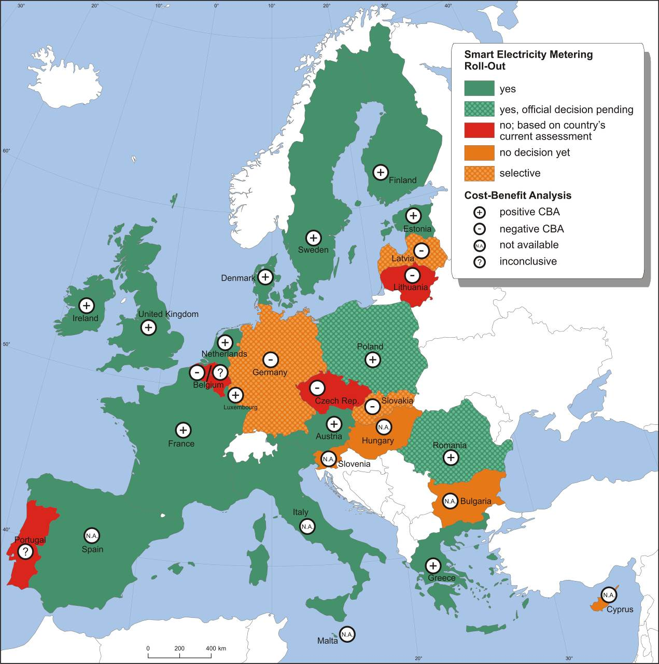

Figure 2 Roll-out plans: Implementation speed and penetration rate of at least 80% of all consumers by 2020 (status — July 2013)
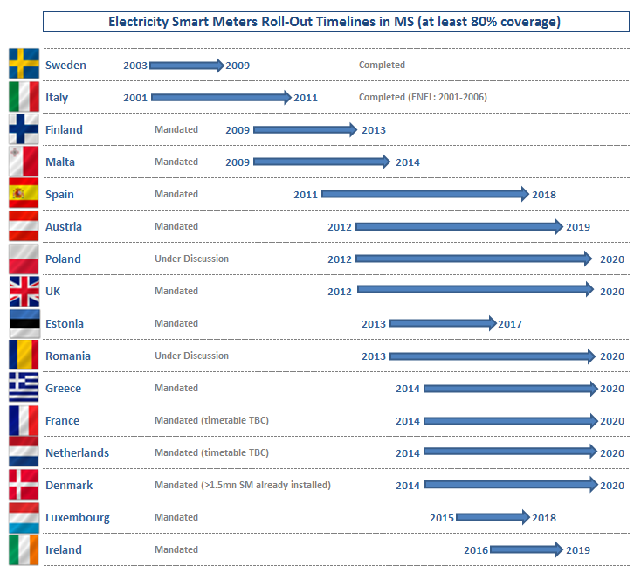

2.3. Common minimum functionalities- electricity
The Commission has included in Recommendation 2012/148/EU ten common minimum functional requirements for electricity smart metering systems. These functionalities capture the essential elements that a smart metering set-up should have to benefit all stakeholders — the consumer, the metering and system operator — while enabling, in a secured and safe environment, commercial aspects of supply/demand and the integration of distributed generation. The Recommendation proposes that all electricity smart metering systems are at least equipped with the functionalities summarised in Figure 3.

Figure 3: List of the recommended ten common minimum functional requirements that every smart metering system for electricity should fulfil (2012/148/EU Recommendation)
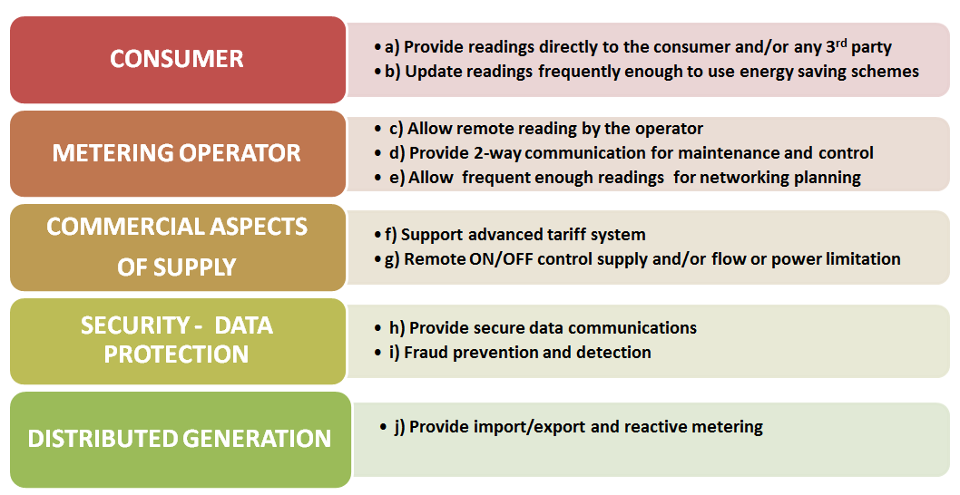

These functionalities are the outcome of the Commission consultation with Member States who had already advanced, before the publication of the Recommendation, with the deployment of smart metering. The ten common minimum functionalities recommended are consistent with the European Energy Regulators respective guidelines regarding smart metering functionalities, in particular those which benefit consumers. They are based on, and remain consistent with, those tabled under the standardisation mandate M/441. Table 7 illustrates the correspondence of the ten common minimum functionalities with those proposed by the M/441 working group. The only difference noted is the case of pre-payment which is not covered by the EC recommended functionalities as it is specific to certain energy markets and could not therefore be considered as 'common'.

Table 7 Correspondence of the smart metering systems functionalities identified by M/441 with the recommended common minimum functional requirements in 2012/148/EU, for electricity
SMART METERING FUNCTIONALITIES for ELECTRICITY
M/441 additional functionalities  identified in  CEN-CLC-ETSI TR 50572:2011  ‘Functional reference architecture for communications in smart metering systems" |  | 2012/148/EU common minimum functionalities  identified in  EC Recommendation of 9 March 2012 ‘on preparation for the roll-out of smart metering systems", OJ L 73 p.9
F1 | Remote reading of metrological register(s) and provision to designated market organisations | For the customer:  a) Provide readings directly to the customer and to any third party designated by the consumer  b)Update the readings referred to in point (a) frequently enough to allow the information to be used to achieve energy savings  …The rate has to be adapted to the response time of the energy-consuming or energy-producing products. The general consensus is that an update rate of every 15 minutes is needed at least.
F2 | Two-way communication between the metering system and designated market organisation(s) | For the metering operator:  c ) Allow remote reading of meters by the operator  d) Provide two-way communication between the smart metering system and external networks for maintenance and control of the metering system  e)Allow readings to be taken frequently enough for the information to be used for network planning
F3 | To support advanced tariffing and payment systems | For commercial aspects of energy supply:  f) Support advanced tariff systems
F4 | To allow remote disablement and enablement of supply and flow power limitation | g) Allow remote on/off control of the supply and/or flow or power limitation
F5 | To provide secure communication enabling the smart meter to export metrological data for display and potential analysis to the end consumer or a third party designated by the end consumer | For security and data protection:  h) Provide secure data communication  i) Fraud prevention and detection
F6 | To provide information via web portal/gateway to an in-home/building display or auxiliary equipment | a) (…) readings provided directly from the interface of customer’s choice to the customer and any third party designated by the consumer … equipped with a standardised interface which provides visualised individual consumption data to the consumer.
Note: The smart metering system may be used for a further important functionality:  To enable communication of AMI components with devices or gateways within the home / building used in the provision of energy efficiency and demand-side management services. |  | For distributed generation:  j) Provide import/export and reactive metering
Each one of these functional specifications contributes to one or more benefits which arise from smart metering systems. It is of particular importance to have in place functionalities which are related to the customers (see functionality (a) and (b)) in order to make their consumption data available to them (at a rate of at least 15 minutes) and to energy service providers, if they choose so. This kind of information update is absolutely necessary for the consumer to efficiently manage his consumption, and also for the network as a whole.
Functionalities (a) and (b) in conjunction with functionality (f) support advanced pricing structures and are key for both consumer and network operators to achieve energy efficiencies and save costs by reducing the peaks in energy demand. It is therefore strongly recommended that the smart metering systems to be rolled-out are equipped with such functionalities that allow the automatic transfer of information about consumption data and advanced tariffs’ options to the final customers, e.g. via standardised interface. They foster the development and running of service platforms that enable demand response services, ultimately yielding benefits for both the network operators and consumers.
Therefore, it is important to carefully consider the functionalities that smart metering systems should have, and map those into benefits when conducting the Cost Benefit Analysis, since different functionalities result in significant variation of the final outcome of the assessment, and in the decision for, or against, large-scale deployment.
In designing their smart metering systems, the relevant authorities in Member States must also anticipate future energy services, operational needs of the energy system and the deployment of smart grids. Accordingly, it is important to focus on screening of any relevant technological developments which would allow Member States to deploy the most advanced smart metering systems in order to boost the competitiveness of the devices’ producers in line with the cost-benefit analysis. In this context, setting a complete set of functionalities is key for facilitating the roll-out process itself, but also securing benefits for different stakeholders (DSOs, Consumers, Suppliers, etc.), creating the necessary cost-efficiencies and ensuring lasting value.
The functionalities currently being considered by the Member States — or they are at the moment activated and in operation as is the case of FI, IT, SE — are summarised in the Tables below.

Table 8 Smart metering functionalities: Member States rolling out by 2020 Compliance check against common minimum functionalities (Reference: EC Recommendation 2012/148/EU, art. 42)

Table 9 Smart metering functionalities: Member States NOT rolling out smart metering by 2020
Compliance check against common minimum functionalities (Reference: EC Recommendation 2012/148/EU, art. 42)

According to information available to date, the majority of Member States have carefully considered the majority of the common minimum functional requirements described in the Recommendation 2012/148/EU. However, there are cases where some of the functionalities are not included or are only partially covered. Given the benefits that these functionalities can bring also to the consumer and the value they represent, it is strongly recommended to reconsider fulfilling them.
For instance, and as discussed earlier, functionality (b) representing the frequency at which consumption data are updated and made available to the consumers — and not only to the system operator — is essential. However, only in few cases the data refresh rate / update to be offered with the smart metering systems comply with the recommended 15 minutes, as demonstrated in Table 10. It is appreciated that in some cases 30 min or 60 min data refresh intervals are to be used and these may be still frequent enough to support advanced tariffs for demand response programmes and consequent account settling. However, systems that do not support direct, (near) real time information of consumption data and of available tariffs to the consumer, and are limited in purpose (supplying data only every 24 hours or even less frequently) cannot be considered fit-for-purpose. On the contrary smart meters which are equipped with the appropriate functionalities can become an economically attractive proposition for consumers, and contribute to lower energy bills and increased comfort. Through new technologies, consumers will be able to not only efficiently manage their consumption but get actively engaged in the energy market. But they can only do this meaningfully by having frequent access to their consumption patterns and when offered incentives to respond and make a change via their participation – themselves directly or through an aggregator or service provider — to innovative, ICT-enabled, added-value energy management products, like home energy management and demand response, smart appliances, micro-generation and (re-) charging of electric vehicles.

Table 10 Frequency of consumption data readings available to consumer; compliance check to functionalities (a) and (b) from the list of recommended common minimum functionalities (2012/148/EU).

Member States rolling out smart metering | Functionality  – (a) | Functionality  – (b) | Minutes
AT | YES | YES | 15’ (decision)
DK | YES | Partly | 15’ readings (decision — some meters installed before 2011 provide hourly readings)
EE | Yes | Partly | hourly (measurement)
FI | Yes | Partly | Obligation to report data in one hour intervals; real time readings to customer (optional)
FR | YES | YES | 10’ - 30’ (charging)
GR | YES | YES | Not specified
IE | Yes | Yes | real time to consumer (via HAN), 30’ measurements
IT | Yes | Partly | 10’ updates to consumers — Interfaces currently provided to customers in pilots only; expected to be shortly available in the market
LU | NA | NA | Not specified
MT | Partly | Yes | Not specified
NL | YES | YES | Not specified
PL | Yes | Yes | Not specified
RO | YES | YES | Not specified
ES | Yes | No | N/A
SE | Yes | Partly | 1 hour for measurements
UK — GB | YES | YES | 10 seconds updates to consumers via HAN, 30’ measurements via WAN

Member States not rolling out smart metering | Functionality — (a) | Functionality  — (b) | Minutes
BE | YES | see Country FicheError: Reference source not found | see Country FicheError: Reference source not found
BG | Yes | No | N/A
CY | YES | YES | Not specified
CZ | YES | YES | Not specified
DE | YES | YES | 15’ (draft of metering ordinance)
HU | Partly | Yes | Not specified
LT | YES | YES | Not specified
LV | YES | YES | Not specified
PT | YES | YES | Consumption registration at least every 60 seconds. Communication of data to Centre is expected to be in 15’ intervals.
SK | YES | YES | 15’ readings to consumer or third party
SI | Yes | Partly | Not specified

Based on available information, very few Member States have set (Figure 4) prior to the smart metering roll-out, in a clear and descriptive manner the functional requirements (e.g. in Austria by law) for the systems to be installed. Most of them lag behind, leaving the analysis, options and protocols with the responsible parties for rolling-out — in most cases the DSOs — neither formalise nor set legal guidelines on functionalities. Furthermore, in most cases the functionalities, not only they are not set as obligatory specifications of the systems to be rolled-out but are considered only at the level of the CBA or are tried in pilots or not even addressed.

Figure 4 Status of smart metering functionalities setting in EU Member States — considered or not in CBA; tried in pilots; being implemented even though not yet regulated; set in a ministerial decision; regulated; or in full operation for completed roll-outs
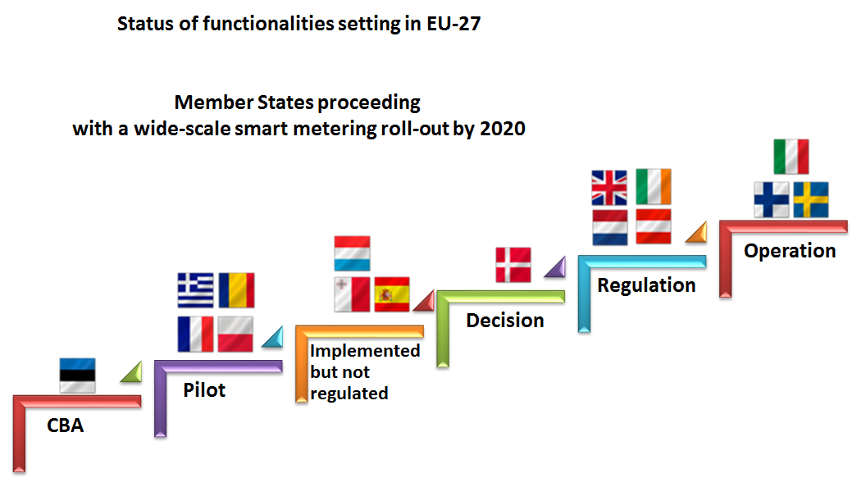
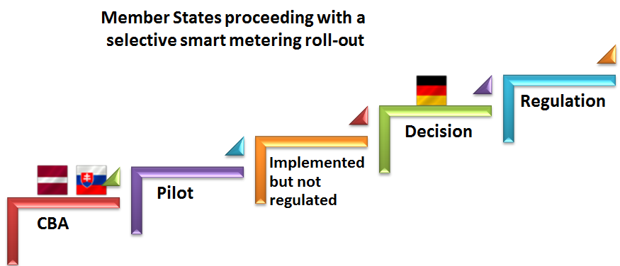 | 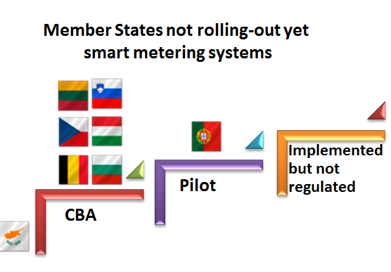

2.4. Set-up of smart metering deployment — electricity
Decisions taken concerning policy options for smart metering deployment are crucial in order to allow consumers to reap the full benefits, encouraging their active participation in the electricity supply market.
Based on information provided by Member States after consultation, Table 11 and Table 12, sum up the choices made by each EU Member States with reference to each of the key issues considered: metering deployment strategy and respective arrangements, responsibility for the installation and ownership of smart meters, responsibility to make the data measured through the smart meter accessible to consumers and energy suppliers, and financing options.
The smart metering deployment arrangements play an important role in establishing responsibilities and ownership rights of the market participants. Furthermore, it is also relevant in determining the possibility of combining the metering systems of other utility service providers (gas, water and heating).
Competitive versus regulated metering market
All Member States with large-scale roll-out plans have opted for regulated metering market. Member States not rolling-out smart meters yet intend to also consider adopting a regulated metering market. Two exceptions are noted: the United Kingdom — Great Britain and Germany, where the metering market is competitive.
The idea behind this is that competition between metering service providers could drive down metering costs. This choice is also coupled with the provision that suppliers, or companies like ‘metering operators’, will be responsible for the roll-out installing the meters at their customers' premises. In the UK-GB DSOs do not own and do not install smart meters, while in Germany they only do so if the consumer does not choose a third party as meter operator.
No data about the deployment arrangements have been communicated by Bulgaria, Hungary and Slovenia.
Which party is responsible for granting access to metering data?
Voluntary versus mandatory smart metering deployment strategy
Sixteen Member States (including Romania and Poland, where the official approval for a large-scale roll-out of smart metering systems is still pending) will proceed with a national smart metering roll-out for electricity. Twelve of them opted for mandatory smart metering deployment (Austria, Denmark, Estonia, Finland, Greece, Ireland, Luxembourg, Poland, Romania, Spain and United Kingdom — Great Britain), while the Netherlands decided in favour of a mandatory approach with opt-out possibility (see further below).
Examples of Voluntary approaches
Two Member States (Malta and Sweden) adopted a voluntary deployment strategy, whereas Italy, Finland and Denmark have started with a voluntary approach (driven by the DSO initiative) then turned into mandatory roll-out through a decision of the National Regulatory Authority (Italy) and by law (in Denmark).
In Italy, Automated Meter Reading (AMR) infrastructure was completed following the initiative of the Italian DSO (ENEL), with an implementation plan that resulted in about 36.7 million meters installed from 2001 to 2011, well before the regulatory framework for mandatory roll-out of electricity smart metering was put in place.
Similarly, in Malta no formal legislation for smart metering roll-out has been adopted, but the ongoing implementation is led by the DSO.
In Sweden, the main driver towards the implementation of smart metering was the adoption of a national legislation imposing mandatory monthly meter reading for small customers with a fuse description less than 63 A. To this end, in 2003, Sweden became the first EU country to indirectly mandate automatic meter reading, due to the adoption of a law requiring, from July 1st 2009, a monthly billing based on actual electricity consumption.
The smart metering roll-out in Finland was originally initiated by the industry already in the early 2000’s as many of the DSOs saw the benefits of remote reading and better control of the network being greater than the costs incurred. In 2007 the industry gave out recommendations for the DSOs to install smart meters for 80% of the customers by 2014. This development was later fortified with a government degree in 2009 under the same objectives. By the end of the year 2013 almost all customers will have a smart meter installed as the DSOs are finalising their roll-out. Already from the beginning of the roll-out back in the early 2000’s hourly meter readings were chosen as a basis for data storage.
A unique situation can be found in the Netherlands, where, following a public debate on data privacy and security, it was decided to grant consumers the possibility of refusing the smart meter: the DSO is committed to offer smart meters to all consumers; however the consumer can refuse the smart meter or turn it ‘administratively off’. Therefore, in the Netherlands, the DSO has the obligation to install the smart meter, but any consumer can refuse to be provided with it.
Who owns the smart metering assets? Who is responsible for the installation of the smart metering services?
The most prevalent model adopted for smart metering in those EU Member States that will proceed with (or already completed) a roll-out is the definition of a regulated market for smart metering. In fact, most countries have chosen to bestow to DSOs the responsibility of installing, and consequently retaining ownership, of smart meters (15 out of 16 Member States proceeding with the roll-out). In the case of FI, the DSO has the responsibility to install smart metering, but can outsource the actual service. In most countries the metering sector is in fact considered part of the distribution business, with the DSO, the regulated entity responsible for the low voltage network, being both the owner and the responsible party for smart meters roll-out and granting access to metering data.
The choice of DSOs as responsible party has also been the favourite route for many of the Member States who have not decided yet for a large-scale roll-out plan: Belgium, Cyprus, the Czech Republic, Lithuania, Latvia, Portugal, Slovakia, and the United Kingdom — Northern Ireland already considered this as the most viable option. In Germany the DSOs are the responsible party for the roll-out, as long as the respective consumer does not choose a third party as meter operator.
Slight deviations concerning meter ownership can be found when analysing the French roll-out plan: DSOs will be responsible for the roll-out, but the meter ownership will pertain to the each City Council. In addition, in the UK and Germany the meter ownership is (potentially) attributed to third parties (see above ‘competitive versus regulated metering market’). In the UK, the energy suppliers are responsible in regulation for the provision of metering. There are a number of different firms offering metering services to suppliers. Some suppliers will choose to provide their metering requirements, in line with regulatory obligations, in house, while others will choose to subcontract to others to provide metering services.
Granting access to smart metering data
Notwithstanding the leading role of DSOs in ownership and implementation, few Member States (Denmark, Estonia, Poland, the UK-GB and, among those not rolling out yet Slovakia) exercise the possibility of having a separate entity (central communication hub) responsible for providing access of metering data to third parties, decoupling de facto the treatment of data from the physical meter. In the Czech Republic there is an existing Market Operator (central hub) authority as the entity described above.
In such a deployment set-up, consumers' data are stored on the smart meter installed at their premises (either the electricity meter or the communication hub for gas). The ‘Central Hub’ entity is then responsible for routing (but does not store) data, gathering them from the equipment in consumer's premises and delivering them to energy suppliers, DSOs and other third parties with appropriate access permissions according with privacy legislation. One of the key reasons behind this choice is that centralised communications, particularly in competitive electricity retail market, could lead to improved supplier competition as a result of enabling easier switching between suppliers.
Concerning the Member States not opting for a nation-wide roll-out, there is a balanced tendency between using the DSO and the central hub as responsible party for granting access to metering data.
No data have been communicated on this regard by Bulgaria and Hungary.
Financing of the smart metering roll-out
The financing of smart metering is mostly secured through an adequate remuneration of the Regulatory Asset Base via network tariffs. Some countries like Austria or Spain have provided for an explicit metering tariff or for a rental price for the smart meter. Only in Italy, Denmark and Sweden, has a significant part of the implementation been initiated by the DSO on their own funds, with remuneration through network tariffs introduced only at a later stage. In Italy, a full recovery of the investment was allowed through the metering tariff (introduced in 2004). In the case of Denmark and Sweden a partial recovery of the investment has also been allowed through the network tariff, whereas in Malta the roll-out has been financed by network tariffs with no direct charge to the consumer. In the United Kingdom — Great Britain the roll-out is to be financed through private investment.
From the Member States currently not opting for a national smart metering roll-out, Lithuania and Latvia would finance the deployment through network tariffs. In the case of Portugal and Slovakia, the roll-out would be financed through both DSO funds and network tariffs. In Germany, the financing mechanism is still to be discussed. No data have been communicated of the remaining countries (Belgium, Bulgaria, Cyprus, the Czech Republic, Hungary and Slovenia).
Table 11 Summary of deployment arrangements for electricity smart metering in EU Member States that decided to roll out 80% or more of the metering points
Table 12 Summary of deployment arrangements for electricity smart metering in EU Member States decided NOT to proceed with a (large-scale) roll-out under present conditions

2.5. Legal framework on the provisions of Annex I.2 of Gas Directive 2009/73/EC
Table 13 summarises the main legal provisions taken per Member State with respect to intelligent metering deployment as stated in Annex I.2 of the Gas Directive 2009/73/EC, and to address other related issues such as technical specifications of metering systems, or timeline for the deployment.
Table 13 Status of relevant national legislation with respect to smart metering as stated in the Gas Directive 2009/73/EC (Annex I.2) (status — July 2013)
Relevant Legislation for gas smart metering
Country | Gas
AUSTRIA | Intelligente Gas-Messgeräte-Verordnung 2012 – for minimum standards
BELGIUM | No legal framework in place for rolling out smart metering; Regional CBAs approved by relevant authorities
BULGARIA | No information available
CYPRUS | No natural gas network
CZECH REPUBLIC | Energy Act § 16; Act No. 458/2000, Coll. on Business Conditions and Public Administration in the Energy Sectors and on Amendment Other Laws (Energy Act)
DENMARK | No decision yet
ESTONIA | Not available
FINLAND | No decision yet
FRANCE | No decision yet
GERMANY | Energy Industry Act (‘EnWG’), Draft of the Metering System Ordination (‘MSysV’, notified according to Directive 98/34/EC)
GREECE | No decision yet
HUNGARY | Not available
IRELAND | Issued by the National Regulatory Authority: i. Smart metering Decision paper CER/12/008, 04/07/2012; ii. Smart Metering Information Paper & appended reports, 17/12/2012
ITALY | Decision by the National Regulatory Authority n. 155/2008
LATVIA | Not available
LITHUANIA | National Law transposing gas Directive 2009/73/EC; Terms of Reference for a gas CBA are being drafted by the National Regulatory Authority
LUXEMBOURG | Law of 07.08.2012 modifying Law of 01.08.2007 related to electricity market organisation
MALTA | No natural gas network
NETHERLANDS | Respective law pending Parliamentary approval
POLAND | Respective law pending Parliamentary approval
PORTUGAL | Decree 77/2011 mandated the CBA whose result was negative; Government decision not to proceed with roll-out
ROMANIA | Electricity and Natural Gas Law no. 123/2012; MECMA Order 2081/11.11.2010
SLOVAKIA | Act No. 251/2012 Coll. on Energy
SLOVENIA | No information available
SPAIN | No legal framework in place for rolling out smart metering;  CBA approved by the National Regulatory Authority
SWEDEN | No decision yet
UNITED KINGDOM — GB | Amendment of the Standard Electricity Supply Licence and the Standard Gas Supply Licence, 30/11/2012; Smart Metering Equipment Technical Specifications — SMETS (2012); Electricity and Gas (Smart Meters Licensable Activity) Order 2012; Electricity and Gas (Competitive Tenders for Smart Meter Communication Licences) ; and Designation of the Smart Energy Code, September 2013, and the Electricity and Gas (Designation and Exclusion)

2.6 State of play in smart metering roll-out– gas
Table 14 and Figure 5 present an overview of the CBAs outcome (whether positive or negative) and of the smart metering large-scale roll-out plans in Member States targeting at least 80% of all consumers in their territories by 2020. It is remarked that Cyprus and Malta have no natural gas network.
- 5 Member States (Ireland, Italy, Luxemburg, the Netherlands and the UK-GB) have decided to roll-out smart gas metering by 2020 or earlier. According to preliminary estimations, this represents the installation of about 45 million of smart meters by 2020 and an accumulated investment of €10 billion.
- 2 Member States — Austria and France — have not yet taken an official decision to proceed with large-scale gas smart metering. Austria has published the minimum standards for the meters but not yet the roll-out plan. France notified a positive CBA which is currently being revised, and an official decision for large-scale roll-out is expected later in 2013.
- 12 Member States (Belgium, the Czech Republic, Denmark, Finland, Germany, Greece, Latvia, Portugal, Romania, Slovakia, Spain and Sweden) concluded CBAs with negative results and with the exception of Denmark, Finland, Greece, Latvia, and Sweden, have decided not to proceed with large-scale roll-out at least under the current conditions. Latvia reports that the installation of smart metering systems can be economically justified only for a specific group of customers. Greece notified that an additional CBA by the gas distribution system operators is foreseen by summer 2013 and will feed in the final decision with respect to a smart gas metering roll-out. The legal framework in Germany foresees no separate smart metering infrastructure for gas, Gas meters shall use the communication infrastructure of the electricity meters, where they exist.
- The outcome of the CBAs and respective information for the remaining 6 Member States (Bulgaria, Estonia, Hungary, Lithuania, Poland and Slovenia) was not yet available at the moment of data analysis for the current document nor were their intentions with respect to large-scale implementation of smart gas metering.

Table 14 Status of gas smart metering roll-out in Member States (July 2013)

Table 15 Summary of CBAs status and roll-out plans for gas metering in EU-27 (status — July 2013)
STATUS OF GAS CBA & ROLL-OUT PLANS
Countries that have conducted a CBA | 19
Positive result of CBA for large-scale roll-out of at least 80% by 2020 | 7
Countries for which no CBA is available | 8  (6 + 2 cases where not applicable)
Countries with large-scale (>80% of consumers) roll-out plans | 7  (for 2 official decision still pending)
Countries with positive result in national CBA for a selective roll-out by 2020 | 1
Countries having decided not to proceed large-scale roll-out under present conditions | 7
Countries where there is no decision yet for a roll-out | 10

Figure 5 Overview of CBA outcomes and intentions for gas smart metering large-scale roll-out (for more than 80% of consumers) in Member States (status July 2013)
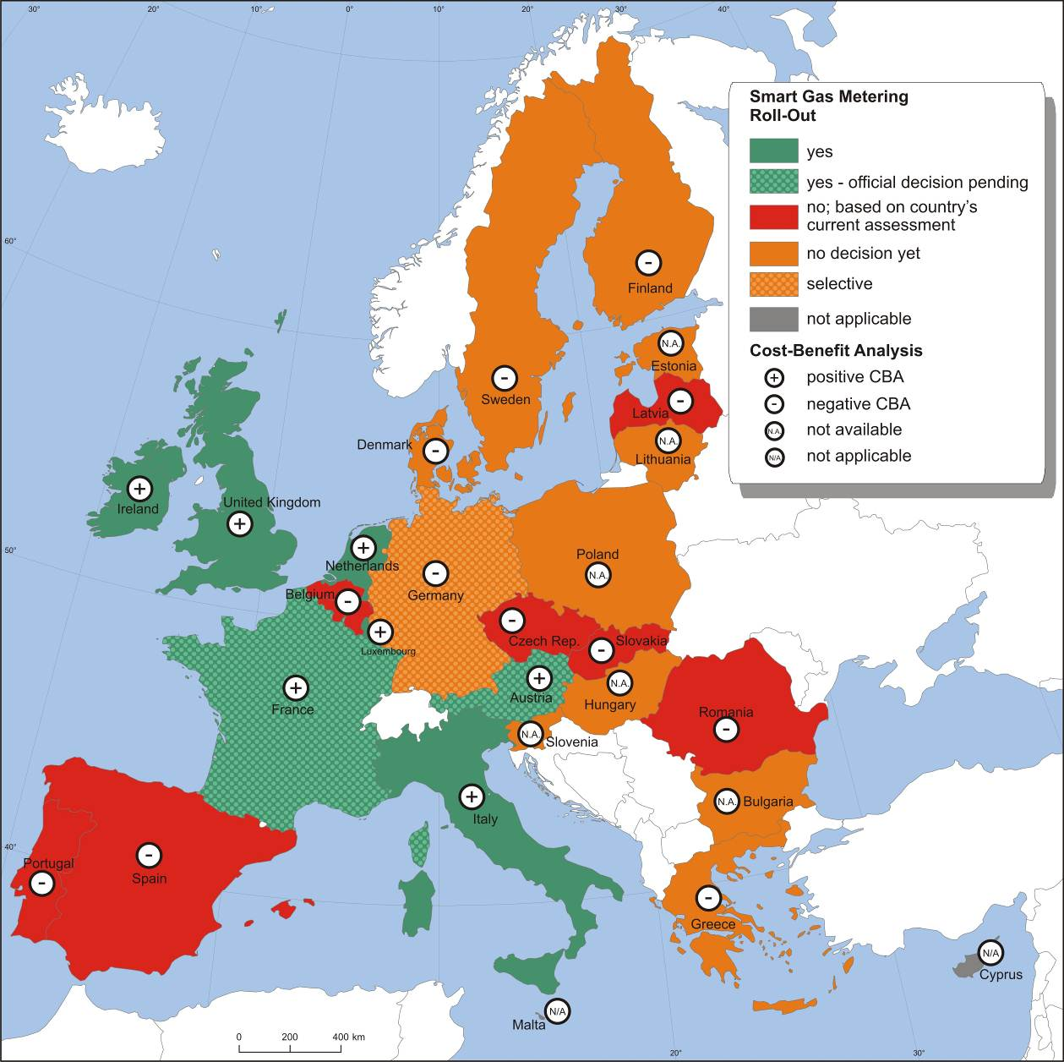

2.7. Set-up of smart metering deployment — gas
The following tables summarise the deployment strategy and respective arrangements in the EU Member States. Table 16 includes Member States that have decided to proceed with a large-scale roll-out of gas smart metering systems or have a positive CBA and the decision to proceed is pending. In most of these Member States the responsible party for the implementation of smart metering in the gas sector will be the DSOs. Consequently the majority of the decided roll-outs will be financed through the network tariffs. The DSOs are also responsible for metering and for handling of the smart meters data. The only exception is this of the UK-GB where the roll-out is led by the suppliers and a Central Data Hub will be the responsible party for handling the data.

Table 16 Summary of deployment arrangements for gas smart metering in EU Member States that have decided to proceed with a (large-scale) roll-out or have a positive CBA (status July 2013).
Member States rolling out smart meters | CBA Outcome | Deployment Strategy | Metering Market | Responsible party  —  implementation and ownership | Responsible party  —  access to metering data | Financing of  roll-out
Austria | positive | Mandatory (official decision pending) | Regulated | DSO | DSO | Network tariffs
France | positive | Mandatory (official decision pending) | Competitive | DSO | DSO | Network tariffs
Ireland | positive | Mandatory | Regulated | DSO | DSO | Network tariffs
Italy | positive | Mandatory | Regulated | DSO | DSO | Metering tariffs
Luxembourg | positive | Mandatory | Regulated | DSO | DSO | Network tariffs
Netherlands | Positive | Mandatory (opt-out option) | Regulated | DSO |  | Network tariffs
United Kingdom - GB | positive | Mandatory | Competitive | Supply companies | Central Data Hub | Funded by suppliers

Table 17 includes Member States that have not yet decided a large-scale roll-out under the current circumstances. All these Member States had a negative CBA or have not performed a CBA. Austria and France were not included in this table as they had a positive CBA and are therefore included in Table 16. In the majority of Member States CBAs assumed that the DSOs will be the responsible party for the implementation of the roll-out and handling of smart meters data.

Table 17 Summary of deployment arrangements for gas smart metering in EU Member States that have decided NOT to proceed with a (large-scale) roll-out under present conditions (status July 2013)
Member States NOT rolling out smart meters yet | CBA Outcome | Deployment Strategy | Metering Market | Responsible party  —  implementation and ownership | Responsible party  —  access to metering data | Financing of  roll-out
Belgium | negative
Bulgaria |  | No decision yet
Cyprus | N/A | N/A | N/A | N/A | N/A | N/A
Czech Republic | negative | No large-scale roll-out / Voluntary | Regulated | DSO | Central Hub — Market operator | No decision
Denmark | negative | No roll-out | Not Regulated | DSO | DSO-TSO | Network tariffs
Estonia |  | No decision yet
Finland | negative | No roll-out | Competitive | DSO | DSO | Network tariffs
Germany | negative | Competitive | Competitive | Metering point operator or DSO | Metering point operator or DSO | No decision yet
Greece | negative | No roll-out | Regulated | DSO
Hungary |  | No decision yet
Latvia | negative | No roll-out | Competitive | Customer | System Operator | Network tariffs
Lithuania |  | No decision yet
Malta | N/A | N/A | N/A | N/A | N/A | N/A
Poland | No CBA | Voluntary (No official decision yet) |  | DSO |  | Network tariffs
Portugal | negative | No roll-out | Regulated | DSO | DSO | DSO resources + network tariffs
Romania | negative | No large-scale roll-out / Voluntary | Regulated | DSO | TSO-DSO | Network tariffs
Slovakia | negative | No large-scale roll-out / Voluntary | Regulated | DSO | DSO | No Decision
Slovenia |  | No action |  |  | DSO | No Decision
Spain | negative | No roll-out | Regulated | DSO, but customer can own the meter | DSO | Meter rental or purchasing fees
Sweden | negative | No large-scale roll-out / Voluntary | DSO | DSO | DSO

3. MEMBER STATES’ COST-BENEFIT ANALYSES FOR ELECTRICITY SMART METERING

The present study concentrated on the roll-out of smart metering in electricity for which a specific target is identified in the Third Energy Package. In carrying out the analysis of the respective long-term economic assessment of costs and benefits performed by Member States, focus was placed on three different dimensions and associated issues, namely:.
- CBA conditions and scenarios
  - Definition of input data and model parameters
  - Deployment speed and penetration ratios
  - Smart metering communication architecture
- CBA outcome
  - Main benefits
  - Main costs
  - Beneficiaries
  - Critical variables (sensitivity analysis)
  - Overall compliance with EC recommendations
- Lessons learned and recommendations

3.1. CBA boundary conditions and scenarios
In order to carefully assess the implementation of smart metering systems according to Directive 2009/72/EC, Annex I.2, Member States may choose to undertake, by September 3rd 2012, ‘an economic assessment of all the long-term costs and benefits to the market and the individual consumer or which form of intelligent metering is economically reasonable and cost-effective and which timeframe is feasible for their distribution’.
Although the Third Package does not provide the methodology to be used for the aforementioned economic assessment, this has been detailed by the European Commission. It is appreciated that a number of Member States had already conducted their cost-benefit analysis for the smart metering roll-out prior to the issuing of the Commission Recommendation. Nevertheless, the proposed methodology is based on generally accepted principles which are widely employed in economic assessments of long-term costs and benefits for similar investments and to large extend has been applied by the Member States.. A number of key issues to be considered, and herein benchmarked against, are identified such as: discount rate, number of metering points involved, roll-out period, implementation speed, penetration rate, smart meter lifetime, CBA horizon, total investment and benefits, consumer benefit, energy savings and peak load shifting.

3.1.1. Overview of the benchmarking results
Table 18, Table 19, Table 20 summarise both actual data for those who have completed the roll-out and main assumptions used in elaborating the CBAs in the sixteen EU Member States that decided to proceed with (or have already completed –see Table 18) a large-scale smart metering roll-out and communicated these data to the Commission.
Table 18 CBA Scenarios — Member States having already completed the smart metering roll-out

Table 19 shows data from the three Member States, IE, the UK-GB and the NL that are proceeding with a large-scale joint roll-out for both gas and electricity. In the case of the NL and UK-GB, the number of metering points represents the sum of electricity and gas metering points, whereas the figure reported by Ireland represents the number of electricity metering points only.
Table 19 CBA Scenarios — Member States rolling-out smart metering in electricity and gas jointly (targeting at least 80% of consumers)

Table 20 CBA Scenarios: Member States rolling out electricity-only smart metering by 2020

Table 21 presents the data of the Member States not rolling out smart metering systems at a nation-wide level. It is important here to make the distinction for those countries which have decided to proceed with a selective roll-out of smart metering, such as Germany, the Slovak Republic and Latvia.
Table 21 CBA Scenarios: Member States NOT rolling out smart metering in large-scale by 2020

Regarding the data, the first dimension considered in the tables above is the number of metering points in each Member State. This number has been reported by the Member States, with the only exception of Ireland, which only estimated the number of consumers to be equipped with smart meters. In our analysis, the number of metering points is assumed to remain constant throughout the roll-out. Some countries, e.g. the UK-GB, explicitly took into account an increase in the number of metering points during the appraisal period; this is driven by reasons beyond the scope of this benchmarking exercise, e.g. expected increase in population, decrease of the average number of persons per household, etc.
Most of countries, namely 13 out of 16 (Austria, Denmark, Estonia, France, Ireland, Luxemburg, Malta, the Netherlands, Spain, the UK-Great Britain, in addition to those who have completed their roll-outs: Finland, Italy, Sweden), decided to proceed with a roll-out well above the target of 80% of metering points by 2020, recognising the importance of granting access to advanced metering infrastructure to the widest consumer base. On the other hand, Greece, Poland and Romania are foreseeing an 80% roll-out by 2020.
Concerning the smart metering lifetimeconsidered in the CBAs, reported in Table 19, Table 20,Table 21, the landscape appears less homogeneous: the range of smart metering lifetime varies from 8 years to 20 years, with 15 years being the median value of the distribution. The direct implication for this is that, when elaborating CBAs, Member States preferred a long amortisation period, which might be closer to the real lifetime of a smart metering device. The second part of the aforementioned tables report figures calculated by each Member State when assessing their respective smart metering roll-out plans. These data are therefore estimated ex-ante, and might turn out to be significantly different in an ex-post assessment; for this reason a sensitivity analysis is recommended. In the case of Member States who have already completed the roll-out (Table 18), namely Italy, Finland and Sweden, some of these actual data are provided but a complete account has not yet become available. These Member States are frontrunners in smart metering and their roll-outs were subject to different drivers. The focus of the smart metering system in Italy was originally driven by significant operational savings (€500 million per year over about 30 million meters) while it is now moving towards customer engagement and energy savings. In Sweden, the requirement for monthly meter reading for smaller customers with a fuse description less than 63 A (since 1 July 2009) has led to a nation-wide roll-out of smart metering systems, yielding a significant increase in accuracy of billing and settlement. In Finland the initiator for the roll-out was the energy industry. The main focus of the wide spread roll-out was to enable demand side management, better network control and enhance the working of retail markets. Looking at the specific parameters for each roll-out, for those completed and scheduled, a number of observations can be made. Starting with the absolute total investments and benefits, it can be seen from the data provided that they clearly increase with the size of the Member State. On the basis of these figures provided by Member States, the Commission services have estimated normalised values per metering point (Table 23), in order to favour the comparability of data (Figure 6).
When the investment data are consulted it becomes apparent that the estimated total costs of installing and running smart metering systems are included in a range of less than €100 (PT, MT, IT, RO) to €590 (Austria) whereas the next value, and highest, is €766 from the not rolling out countries (the Czech Republic).
Figure 6 Normalised cost and benefit values per metering point estimated from the Member State CBA data
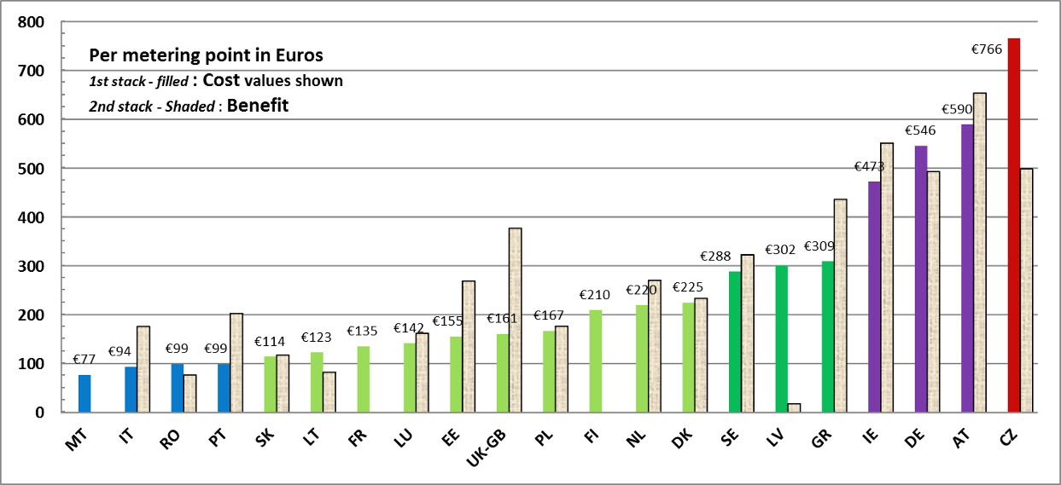
The investment per metering point associated to the procurement of smart metering devices might have been expected to be quite similar across Member States, given the high level of competition in the smart metering vendors market. Three main reasons are then seen as the drivers for such differences among Member States when looking at the investment normalised by number of metering points:
- Different local realities and boundary conditions in each Member States, namely labour costs, geographical configuration, etc.
- Inclusion of additional features in the smart metering system, e.g.:
  - Other functionalities (beyond or not all of) the 10 common minimum functionalities recommended;
  - Add-ons for the smart metering device, e.g. in-home displays, which might bring significant additional benefits but also increase the initial investment;
  - Investment in additional security measures for the ICT/TLC system supporting Automatic Metering Reading; and
  - Share of tri-phase versus mono-phase meters over the total number of meters to be procured; design and manufacturing of tri-phase meters might increase the costs for smart meters procurement.
- Methodological differences in conducting the CBA:
  - Differences in the appraisal period
The CBA horizon — the period over which all costs and quantitative benefits are discounted is an important metric for calculating the Net Present Value of the costs and benefits. Some Member States use the smart metering life time (for instance Latvia) or the roll-out period as a CBA horizon; however most Member States consider a longer CBA appraisal period to ensure that the entire lifecycle of the first generation of smart equipment is captured. The appraisal period is an important parameter and a big driver for costs and benefits differences between Member States and it should be borne in mind when comparisons of the data are attempted;
  - Differences in the rate of social discounting that is applied;
  - From the data collected, it can be seen that there is a range of discount rates used across Member States. Obviously the discount rate has a significant impact on the assessment of the smart metering scenarios, as costs are incurred predominantly at the beginning of the scenario, while the smart metering roll-out often provides benefits only in the long-term. The range of discount rate used across Member States deciding to roll-out electricity smart metering systems varies between 3.5% used in the UK-GB (social discount rate) to 8.5% used for Luxembourg. Among countries not rolling-out, Portugal opted for a higher discount rate of 10%. in their CBA;
  - Differences in the counterfactual assumptions; and
  - Inclusion of financing costs or optimism bias or exclusion of operational costs or broader costs to society (as opposed to just private costs to the party responsible for the installation of the equipment).
The analysis of the Member States CBAs elements indicates that a strict comparison as such of the respective data is not possible. Differences in scope and methodology mean that caution should be applied in the interpretation of the cost-benefit comparisons herein presented. Nevertheless, useful indications and trends on parameters of particular interest to all stakeholders can still be drawn with the reservations expressed earlier.
When the respective data for the ‘cost per metering point’ are therefore grouped into price bands (Figure 7) a projected average cost range is revealed within which most of the data are falling in, while the corresponding average price is €252 with a wide standard deviation of €189. If we account only for those countries that have completed or will be proceeding with the roll-out, then this is further reduced to €223 and the respective spread is narrowed (€143).
The case for the associated benefits is also complicated. The estimation of benefits per metering point seems to also return a scattered picture of smart metering roll-out in Member States: the range of benefits varies significantly from as low as €18 (Latvia) to €654 (for Austria), as shown in Figure 8. On average for those Member States rolling-out the expected benefit per metering point is €309 (with a standard deviation of ±€170).
Some caution is needed in interpreting these figures given the different methodologies used to estimate benefits and the different items included in the evaluation: in fact, several Member States only accounted for the benefit associated with the DSO rolling out and not for the consumers’ benefit or other benefits accruing to the society as a whole. The benefit attributed to the DSO is in general easier to estimate, as smart metering primarily implies savings in meter reading operations, switching, non-technical losses etc. In addition, advanced metering infrastructure allows for more accurate billing of electricity consumption, reducing complaints and litigations, to which a monetary value for the DSO can be calculated.
Figure 7 Price bands for cost per smart metering point in the Member States
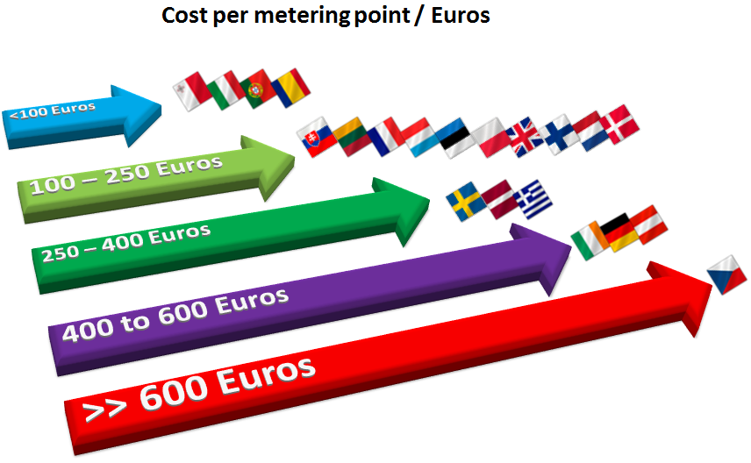

Figure 8 Normalised benefit values per metering point in the Member States
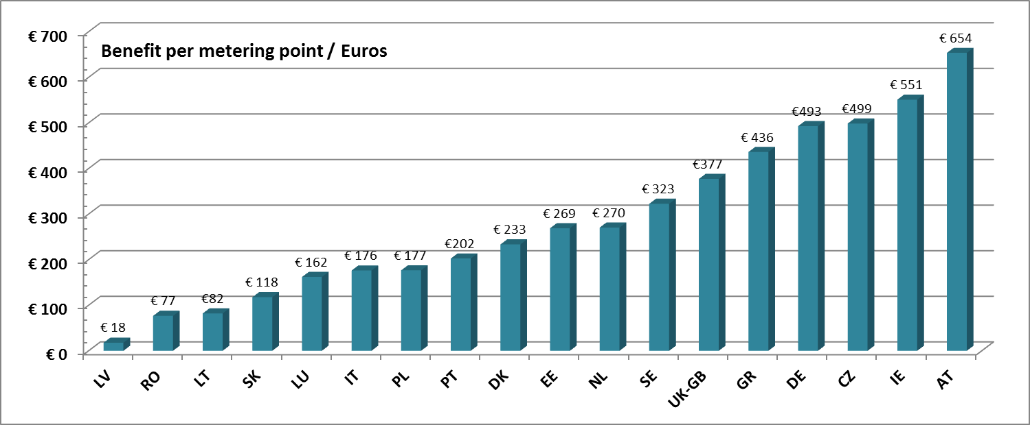
The benefit associated with consumers, besides the part arising from more accurate billing information, is instead more difficult to estimate, as it also depends on the actual involvement of consumers themselves in for example demand response mechanisms, time-of-use pricing, etc. This can be also confirmed by the low number of countries from those proceeding with the electricity smart metering roll-out that provide an estimate — as a percentage — for such a benefit.
Other types of benefits are associated with energy savings and peak load shifting over total electricity consumption. Also, when analysing these two indicators, a scattered picture of the expected positive effects of smart metering roll-out emerges. Expected energy savings vary from 0% (considered in the CBA of the Czech Republic) and 1% (Poland, Slovakia) to 5% (Greece, Malta), with an average — for all data available — around 2.6% (±1.4%) or 3% (±1.3%) considering only the data from those countries who have rolled out or are proceeding with large-scale roll-out. The peak load shifting varies greatly from 0.75% (UK-GB) and 1% (Poland) to 9.9% in Ireland, and 1.2% (in CZ) to 4.5% quoted for Lithuania from those Member States that are not presently proceeding with large-scale roll-out.
Figure 9 Potential for energy saving and peak load shifting over total electricity consumption expected from smart metering roll-outs in the Member States
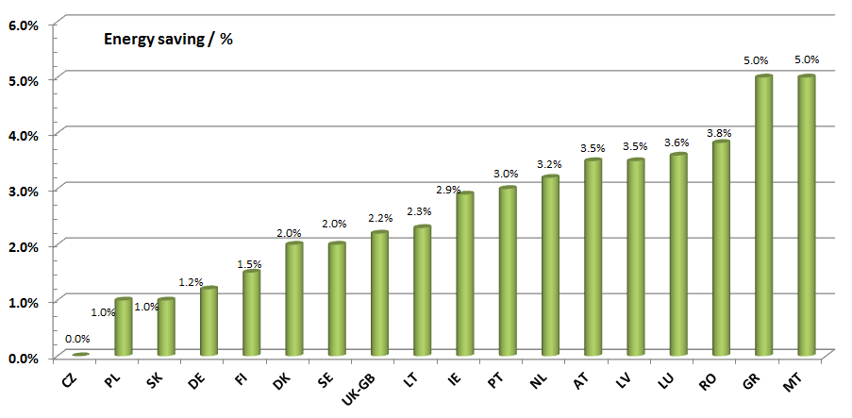
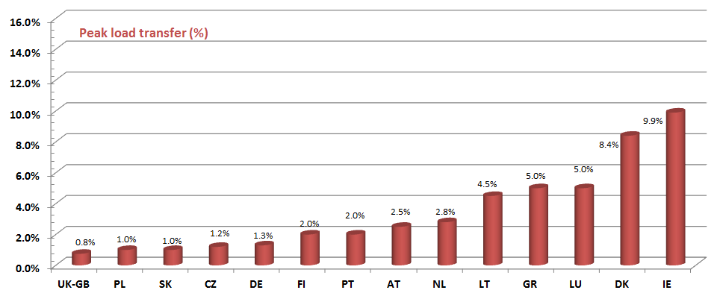

It should be noted that these significant differences may appear due to:
- Different experiences in pilot projects and/or hypotheses adopted in building the scenarios, e.g. consumers' participation rate in demand response programmes (time-of-use pricing, etc.), different consumer engagement strategies (e.g. indirect vs. direct feedback); and
- Different patterns in electricity consumption, e.g. presence of district heating, wide-spread use of gas, etc.

To conclude the overview of the current situation in EU, Table 22 lists Member States that had not communicated yet their CBA data at the time of analysis and writing of this document.

Table 22 CBA Scenarios: missing CBAs from Member States

Table 23 Costs and Benefits normalised by number of metering points
* Highlighted cells present values directly supplied by the Member States and not calculated by Commission services as the ratio of total costs or benefits over the number of metering points.

The following chart represents the cost and benefit values per metering point reported in Table 23 for all four groups of Member States considered: Member States having already completed their roll-out; Member States that decided to go ahead with a roll-out whether jointly for electricity and gas, or separately; and Member States that will not yet proceed, at least under the current conditions, with large-scale roll-out.
As seen, all Member States proceeding with a roll-out, either for electricity only or for both electricity and gas, identified that smart metering benefits are higher than costs. Exceptions are fictitious, as Malta, France and Finland did not have a quantitative evaluation of the benefits, and therefore their values on the y axis are zero. Romania also provided an investment figure including the total for the full roll-out up to 2022, while the benefits accumulate up to 2020.
On the other hand, the majority of Member States that will not yet proceed with a large-scale roll-out assessed that the costs of smart metering are higher than its benefits, with the exception of Portugal. Portugal has not taken yet a final decision and it is currently re-assessing the results of its CBA.
Figure 10 Normalised cost and benefit values per metering point
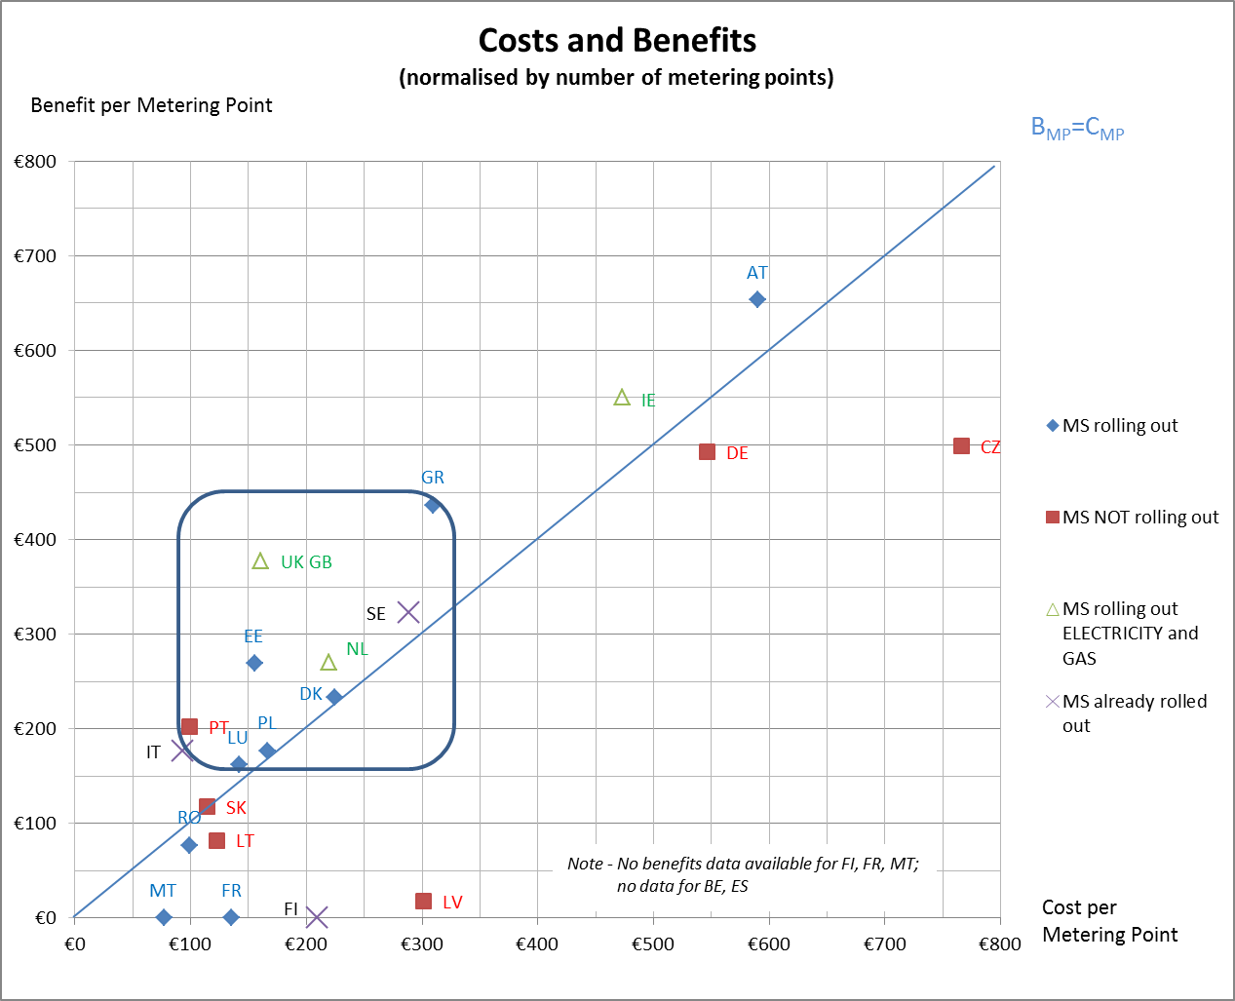

In general, the deviation of each of the rolling-out Member States from the blue reference (1:1) line (Benefit = Cost per metering point) (Figure 10) is contained in a relatively small range. On the other hand, the deviation for Member States not rolling out yet varies significantly from country to country. This implies that, while there is a fairly unanimous evaluation of the percentage of benefits of smart metering roll-out among the Member States rolling out, a comparable consensus on how much the costs surpass the benefits cannot be found among Member States not rolling out. Therefore, at this stage it is not possible to identify a threshold value for expected costs or benefits which will make the business case for large-scale deployment. Nevertheless, an observation can still be made: the respective benefit over cost values in the majority of the positively assessed cases, where the Member States are proceeding with large-scale roll-out, lie within certain boundaries of cost (about €100-€300 plus) and benefit (€150 - €450) per metering point as illustrated in Figure 10. This is a first indication for a threshold area within which costs and benefits could range to result in a positive business case for smart metering deployment.
Figure 11 and Figure 12 show how each Member State evaluated the main benefits arising from smart metering roll-out in terms of energy savings and peak load shifting. The respective values for the case of the UK-GB and the NL that are proceeding with a combined roll-out of electricity and gas are not illustrated in this figure as the energy saving potential in the figure refers only to electricity whereas cost and benefits for these two Member States refer to both electricity and gas. Estonia, France and Spain have not communicated nor evaluated the energy savings, whereas Malta and Finland have not quantitatively estimated the total benefit associated with the smart metering deployment.
As in previous charts, the blue line represents the series of points where the benefits equal the costs. Most Member States, regardless of their decision for rolling out or not, have given a quite consistent evaluation of the potential for energy savings, included in the range 1% to 5%. The only outlier value is that for the Czech Republic, which have estimated that no energy savings can be achieved through smart metering. The others are providing a quite univocal estimation of the potential benefit in terms of energy savings arising from smart metering. This positive result underpins the fact that the ex-ante estimation of energy savings achieved through smart metering in EU Member States rolling out is not controversial, although further refinement might be achieved through the observation of real energy savings once the massive roll-out start. It is therefore important to accompany the roll-out plans with appropriate monitoring schemes in order to quantify the effects of a large-scale smart metering deployment.
Figure 11 Benefit cost ratio over energy savings reported by Member States
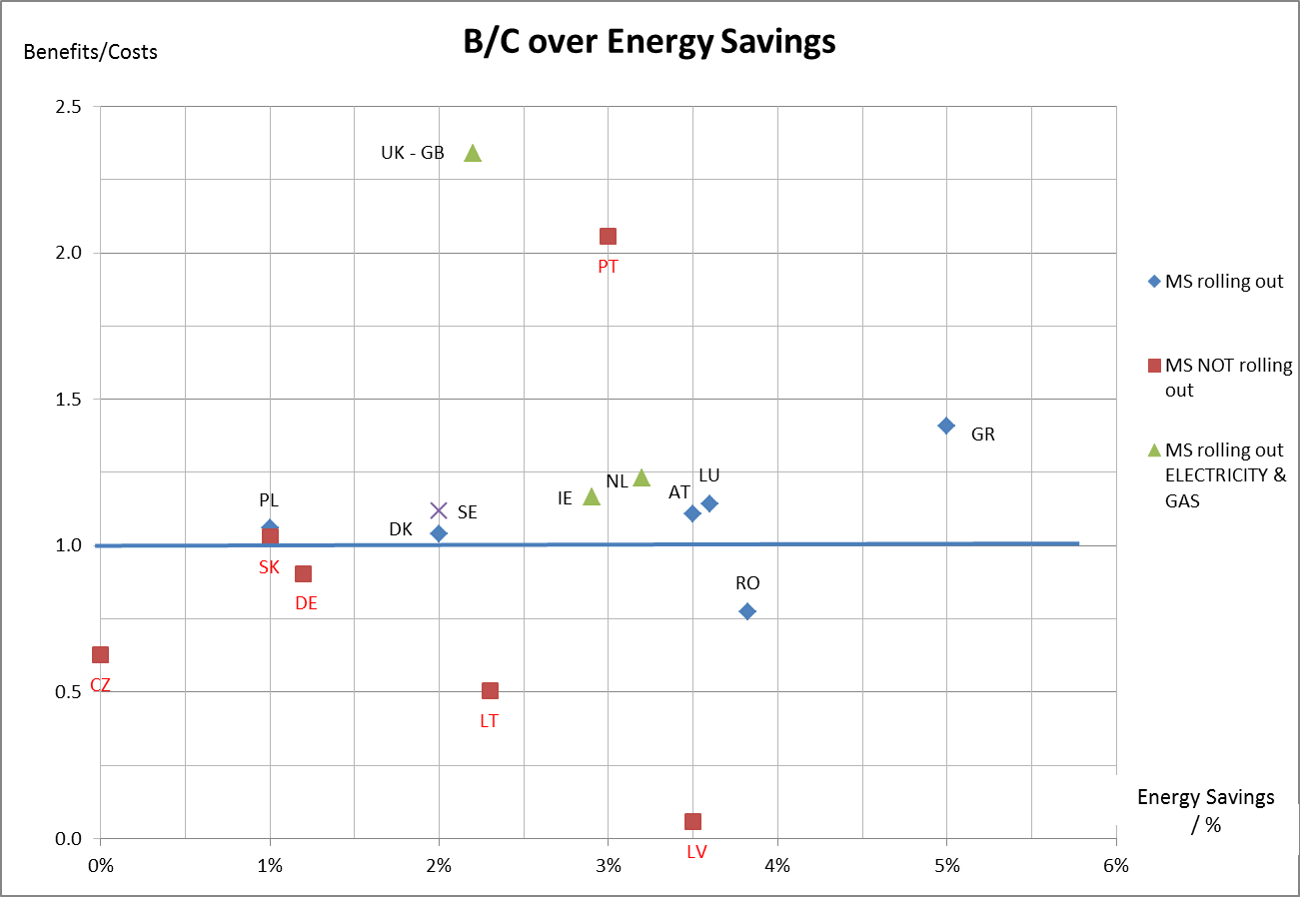

Concerning benefits coming from peak load transfer, the picture is on the other hand not clear-cut, with estimations ranging from 0.8% to 9.9%. This spread is rather anticipated, as the benefit from peak shaving/load shifting depends on several local variables, such as:
- consumption patterns typical to each country (i.e. the percentage of shiftable energy consumption over the total energy consumption might differ significantly across countries);
- the availability of demand response programmes; and
- expected consumer participation in such programmes.
Member States may further carefully assess the peak load shifting potential in their territory through appropriate monitoring mechanisms, while also taking into consideration results from smart metering pilot projects.

Figure 12 Benefit cost ratio over peak load shifting reported by Member States
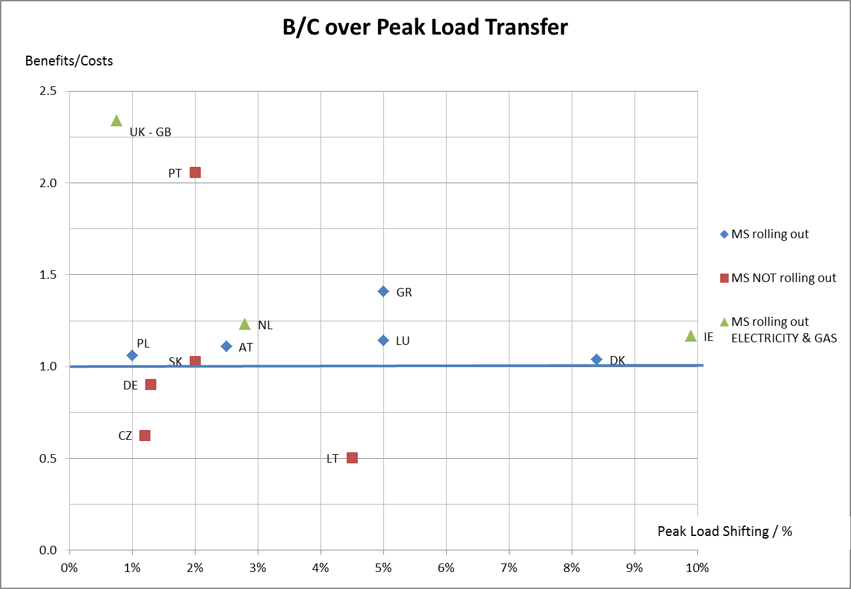

3.1.2. Communication architecture
The successful integration of advanced applications of intelligent electricity grid involves the real-time generation, control, and analysis of extensive amount of data. The communication system is therefore a key component of smart metering. Electricity utilities are challenged to define communication requirements and architecture to handle the output data and deliver reliable, secure and cost-effective service throughout the whole power system.
Most Member States have adopted or intend to adopt a communication architecture (Table 24) between the smart meter and the Data Management System (DMS) based on a middleware (i.e. Data Concentrator). In this way, the Data Concentrator (DC), located at Medium Voltage/Low Voltage substations works as a communication gateway between the Data Management System (DMS) and the electricity smart meters.
Power Line Carrier (PLC) along with GPRS appears to be the most spread technology for communication between the smart meter and the Data Concentrator, while in most cases the DC communicates with the DMS through GPRS.

Table 24 Summary of preferred communication infrastructure for smart metering roll-out in Member States
Country | Option 1 | Option 2 | Option 3
AUSTRIA | - Smart meter (SM) — Data Concentrator (DC): 70% PLC and 30% GPRS  - DC — DMS: 100% Fibre Optics
BELGIUM | see Country Fiches
BULGARIA | PLC, GPRS
CYPRUS | First phase implementation: PLC with GPRS
CZECH REPUBLIC | - SM — DC: PLC+GPRS (where not possible to use PLC)  - DC — DMS: GPRS +Fibre Optics
DENMARK | PLC+GSM/GPRS and wireless radio frequency
ESTONIA | 90% PLC and 10% GPRS
FINLAND | PLC (~30%) + GPRS (~60%) + RF (~10%)
FRANCE | PLC
GERMANY | Market-driven
GREECE | - SM — DC: PLC  - DC — DMS: PLC | - SM — DC: GPRS  - DC — DMS: GPRS | - SM — DC: Fibre Optics (90%) and RF/GPRS (10%)  - DC — DMS: Fibre Optics (90%) and RF/GPRS (10%)
HUNGARY | N/A
IRELAND | All options to be considered; decision during design phase
ITALY | SM—DC: PLC  DC—DMS: GSM/GPRS
LATVIA | PLC – tbc at official procurement stage
LITHUANIA | - SM — DC: PLC/GPRS  - DC — DMS: GPRS | Fibre optics network (FTTx) available
LUXEMBOURG | To be decided  Considered & tested:  Consumption data: PLC, GPRS and fibre optics;  M-Bus between electricity and gas meters
MALTA | PLC/GPRS
NETHERLANDS | Not prescribed; DSOs to decide; GPRS chosen for small scale rollout;  Reference scenario– 20% GPRS and 80% PLC
POLAND | Most probably PLC – choice will be influenced by standardisation
PORTUGAL | 85% PLC, 15% GPRS
ROMANIA | - SM — DC: PLC  - DC — DMS: GSM/GPRS, WiFi/WiMAX, Fibre Optics
SLOVAKIA | More used: GPRS/ETHN  PLC (testing PLC S-FSK, OFDM, BPL, eventually radio)
SLOVENIA | PLC+GSM
SPAIN | PLC
SWEDEN | - SM — DC: GPRS (1%); RF (17%); PLC (37%) and GPRS+PLC+RF (46%)  - DC—DMS: GPRS (86%); IP (33%); RF (9%); PLC (8%) and other (17%)
UNITED KINGDOM — GB | (subject to final technical design) Smart meter to Data and Communications Company (DCC):  - 65% cellular (GPRS and 3G)  - 33% long range radio  - remainder mesh radio

3.2. Costs and benefits considered in the CBA
Table 25 presents the top 3 benefits and costs associated with the smart metering roll-out across Member States. The benefits reported relate to the electricity smart metering roll-out with the exception of the UK—GB and NL where the benefits are due to both electricity and gas smart metering deployment.
Table 25 Most significant cost/benefits share from electricity smart metering roll-out considered in Member States’ analyses
Country | Main benefits | Main costs
AT | - Energy savings — 55% | - Operational costs (30%)
AT | - Operational savings due to more efficient supplier switch procedure — 19% (indirect benefits to the consumers) | - Capital costs — smart meter, installation, communication infrastructure, IT system (26%)
AT | - Reduction of DSO associated meter reading cost – 9% | - Supplier associated network balancing costs due to consumer behaviour change (24%)
BE | see Country Fiches | see Country FichesError: Reference source not found
BG | NA | NA
CY | NA | NA
CZ | - Reduced electricity theft (53%) | - Meter procurement (24%)
CZ | - Peak load transfer (42%) | - Investments in ICT (10%)
CZ | - Deferred generation capacity investments (5%) | - Operation costs of ICT — meter reading (9%)
DE | - Energy savings (33%)  - Load shifting (15%)  - Avoided distribution grid investments (13%) | - Investments in smart metering systems (meter, gateway, communication infrastructure) 30%  - Communication costs (20%)  - IT costs (8%)
DK | - Saved metering investment (29%) | - Capital costs (smart meter, installation, communication infrastructure, IT system) — 67%
DK | - Increased competition (21%) | - Tax distortions (8%)
DK | - Energy savings (16%) | - Operational costs (data collection, validation and delivery to central data hub) — 4%
EE | - Network losses reduction | - Operating costs
EE | - Avoided investments | - Maintenance cost of the central metering system
EE | - Avoided meter operating cost (repair and maintenance costs of metering systems) | - Cost of tele-service
FI | - Demand side management | - Meters (40-55%)
FI | - DSO cost reduction (due to remote reading) | - Accessories for the meters (relays, switching gears, etc.) 5-25%
FI | - Electricity trade and new services | - Installation and maintenance (10-25%)
FI |  | - Communications (5-40%)
FR | - Avoided Investment in installing existing meters: 30% of total benefits for the DSO | - Meter procurement and installation cost – 80 %
FR | - Avoided network losses: 25% for the DSO | - Procurement and installation cost of data concentrators – 10 %
FR | - Avoided meter reading costs: 15% | - IT systems – 10%
GR | - Reduction in consumption — direct feedback (44%) | - Procurement and installation of meters (55%)
GR | - Meter reading savings (14%) | - Display costs (20%)
GR | - Carbon benefits (11%) | - Communication Infrastructure — PLC (9%)
HU | NA | NA
IE | - Energy savings — 2.9% of overall electricity consumption and 9.9% peak load reduction from total peak | - DSO costs — cost of meters, installation, communication and project management
IE | - Deferred capacity investments and reduction of System Marginal Price | - Supplier costs— Improved billing systems and customer education, running more complex set of bills and tariffs
IE | - Retailer savings — fewer complaints and queries, less costly management of bad debts and supplier switch savings
IT | - Revenue protection (including reduction of non-technical losses) | - 95% of CAPEX is associated with the production and installation of smart meters and concentrators.
IT | - Reduction of readings and operations costs | - The remaining 5% of CAPEX corresponds to costs associated with IT system development, R&D costs and other expenses.
IT | - Purchasing and logistics
IT | - Customer service (e.g. invoicing, bad debts management)
LT | - Consumption reduction (26%) | - Cost of smart meters (38%)
LT | - Commercial loss reduction (22%) | - Installation of the smart metering system (18%)
LT | - Consumption shifting (14%) | - Procurement of data concentrators (8%)
LU | - Reduced meter reading and operating cost | - Meters cost
LU | - Reduced energy consumption | - Meters installation cost
LU | - Non-replacement of old meters | - Investment and operating cost of common IT infrastructure
LV | - Decrease of energy consumption (57%) | - Cost of smart meters (32%)
LV | - Decrease of personnel costs for the DSO (24%) | - cost of communication infrastructure (16%)
LV | - CO₂ reduction (11%) | - Meter installation cost (8%)
MT | - NA | - NA
NL | - Energy savings (15%) | - Smart electricity meters and installation cost (25%)
NL | - savings on call centre costs (15%) | - Smart meter data management system (16%)
NL | - savings due to increased number of supplier switches (8%) | - Communication infrastructure – PLC (14%)
PL | - Energy savings (27%) | - Meter reading costs (24%)
PL | - Reduction of balance sheet differences in respect of both technical and commercial losses (25%) | - Customer service costs (3%)
PL | - Reduced meter reading costs (24%) | - Cost for extra infrastructure to increase the grid capacity (7%)
PL | - Postponement of generation plant and of extra grid capacity due to peak shaving (15%)
PT | - Demand reduction (55.3%) | - Supplier profit reduction —by consumer demand reduction — (47.4%)
PT | - Peak reduction (13.3%) | - Acquisition and installation of smart meters (31%)
PT | - Commercial losses reduction (11.1%) | - Communication infrastructure (14.6%)
RO | - Reduced meter reading costs (36%) | - Implementation and investments costs (mostly, but not exclusively, CAPEX) —57.53%
RO | - Reduced commercial losses (33.6%) | - Costs for system operations and maintenance (37.78%)
RO | - Avoided distribution investments (12.9%) | - Financing costs (4.69%)
RO | - Reduced distribution operation costs 7.7%
SK | - Reduction of cost related to load shifting (26%) | - Meters cost (69%)
SK | - Reduction of balancing cost (23%) | - Meters installation cost (17%)
SK | - Reduction in electricity consumption (16%) | - Procurement of IT (7%)
SI | - NA | - NA
ES | - NA | - NA
SE | - NA | - NA
UK — GB | - Supplier cost savings: 54% (domestic); 15% (non-domestic) | - Smart meter costs (CAPEX and OPEX): 43% (domestic); 49% (non-domestic)
UK — GB | - Energy savings : 28% (domestic); 60% (non-domestic) | - Communication costs (CAPEX and OPEX): 23% (domestic); 31% (non-domestic)
UK — GB | - CO₂ savings: 7% (domestic); 19% (non-domestic | - Installation: 15% (domestic); 16% (non-domestic)

When consulting the data presented in Table 25, a number of observations can be made regarding the long-term assessment of costs and benefits considered by the Member States, as described below.
Main benefits
Two of the most wide spread benefits across the total benefits attributed to the smart metering roll-out (see Table 25) are supplier-related savings and energy savings, reported as major benefits in a number of Member States.
One of the main factors in achieving energy savings (listed in the Table above as major benefit in 10 Member States: AT, DE, GR, IE, LT, LU, LV, NL, PL, SK) is feedback provision on the electricity consumption data to the consumers enabled by smart metering infrastructure. A general distinction is made on indirect (via web sites, usage statements on the electricity bill, etc.) and direct feedback (via in-house displays of current consumption). In most of the CBA analyses across Member States, the same benefit appeared as determining factor for turning out a positive business case for smart metering deployment. There is a substantial variation in the value of the energy savings for the consumers from the total benefits mix across Member States, mainly due to different hypotheses adopted in building the scenarios in respect to:
- Provision of different feedback on consumption data, i.e. indirect vs. direct feedback;
- Different consumer engagement strategies (time-of-use pricing, real time pricing, peak load pricing, etc.);
- Expected consumer participation rate;
- Different energy efficiency programmes (e.g. through more efficient use of the domestic appliances); and
- Different patterns in electricity consumption, e.g. presence of district heating, wide-spread use of gas, etc.
A most spread benefit due to electricity smart metering deployment across Member States is the savings of meter reading costs and network losses reduction (technical and commercial). Both have served as main drivers in many smart metering pilot projects, e.g. InovGrid in Portugal and ENEL in Italy before proceeding with a nation-wide smart metering roll-out.
Savings on meter reading costs appear as a second major benefit in smart metering deployment in eight Member States (AT, FI, FR, GR, IT, LU, PL and RO). The focus of smart metering adoption in Italy was on the commercial electricity losses reduction, and this appears to be also the case for Romania. Furthermore, it was identified in the national CBAs conducted as the largest external benefit for the Czech Republic, and the second largest benefit for LT. Both technical and commercial electricity losses reduction emerge as a second largest benefit in Estonia, Poland and the Slovak Republic.
Main costs
On the cost side, all Member States, with the exception of PT and PL reported the meter costs (CAPEX and OPEX) as major cost (Table 25) of the smart metering roll-out followed by the capital and operational cost due to data communication.
In most of the countries (and relative to the electricity deployment arrangement of the country), the smart metering investment and installation cost appears as an upfront cost for the DSO in the initial stage of the deployment; however, later fully or partly passed to the final consumer through network tariffs, with the exception of the UK-GB where the cost is faced by the energy supplier.
Main beneficiaries
In Member States, such as CZ, DK, EE, FR, IT, LU and RO, the DSO is the first/large direct beneficiary of the electricity smart metering and the reasons behind this reflect different countries realities and market mechanisms. Accordingly, in countries such as EE and IT the main focus of smart metering systems is on electricity losses reduction (technical and commercial), whereas in LU and RO (along with the need for commercial losses reduction) is on avoided meter reading costs.
Furthermore, consumers' energy saving potential is a strong driver in the decision for smart metering deployment. A number of Member States (AT, DE, GR, IE, LT, LV, NL, PL, PT, UK-NI) shed particular light on this potential in their economic analysis of long-term benefits and costs associated with smart metering, indicating the energy saving as the major benefit coming out from smart metering roll-out. The smart metering infrastructure in itself does not save energy, but using it correctly does. Therefore, the consumer has a central position in achieving energy savings and whether he/she will accept and the way he/she will use it would have a major influence in exploiting the energy saving potential. To this end, some Member States, such as the Netherlands, dedicated particular focus in their analysis on the consumer behaviour in smart metering acceptance and efficient use.
The energy supplier appears as another beneficiary of smart metering roll-out. In Member States, such as the UK-GB and the NL; the major benefit is attributed to the suppliers in terms of increased suppliers’ switching (due to enhanced and easier procedure), reduced call centre costs, etc.
Finally, CO₂ emissions reduction due to first energy savings and then more efficient electricity network operation (reduced technical and commercial losses) results in benefits accrued to the whole society.
Critical variables — sensitivity analysis
The economic assessment of long-term costs and benefits of smart metering deployment across Member States is sensitive to a number of parameters. Energy savings (CZ, DE, GR, IR, LT, PT, NL, UK-GB), smart meter capital costs and data communication systems (CZ, FR, LT, LV) and discount rate (CZ, GR, PT, RO) are the three top variables most discussed in the respective CBAs performed by the Member States.
Qualitative analysis — additional non-monetary impacts
The following qualitative benefits have been addressed by most of the Member States in evaluating costs and long-term benefit related to electricity smart metering roll-outs.
- Enabling smart grids — Some Member States, such as GR and IE addressed the importance of smart metering infrastructure in enabling smart electricity grids (through facilitation of decentralised electricity generation, integration of electric vehicles, etc.). Building smarter electricity a network is an incremental process of communication technology adoption to enable real time flows of network information and allow for closer interaction between suppliers/DSO and the consumers and facilitate integration of growing potential of renewable energy and electric vehicles. To this end, smart metering infrastructure is an essential component in building more complex electricity network than today, which would deliver more efficient, reliable and sustainable electric energy. Although, the benefits resulting from smarter electricity grids are likely to be significant in the long-term, their estimation at this stage is difficult. Nevertheless, certain benefits are expected to arise from the deployment of smart metering infrastructure (due to demand response and system optimisation, reduced need for network reinforcements, lower predictive maintenance, distributed generation, reduced technical losses and customer minutes lost). In addition, in the period of 2020-2050 greater use of demand side management (due to higher assumed level of heat pumps and electric vehicles) and more cost effective management of distributed energy sources would result in greater benefits due to smart grid deployment.
- Increased market competition — smart metering infrastructure provides accurate and reliable data flows that will support easier and quicker switching between suppliers. In addition the information on energy consumption provided to consumers via displays will enable them to seek out better tariff deals, switch suppliers and therefore drive prices down.
- Future products and provision of new services — smart metering infrastructure is expected to enable strong growth in the home energy management sector. The availability of detailed consumption data will create significant new opportunities to these companies in offering services and products on appliance diagnostics, more refined automation of heating and hot water controls and the analysis of heating patterns. Furthermore, it will facilitate multi utility smart meters deployment (e.g. gas, water, etc.).

3.3. Overall alignment of the Member States’ CBAs with EC Recommendation 2012/148/EU
The EC Recommendation 2012/148/EU focuses on three main aspects to be considered in preparation of the smart metering systems roll-outs:
- Data protection and security considerations;
- Methodology for the economic assessment of the long-term costs and benefits for the roll-out of smart metering systems; and
- Common minimum functional requirements for smart metering systems for electricity.
The data protection and security considerations imply protection of personal data by considering ‘data protection by design’ and ‘data protection by default’ measures. Few Member States, such as the Netherlands and the UK refer to the Personal Data Protection Act put in place to ensure data privacy and security. In the Netherlands, data security and privacy was one of the main drivers for revision of the CBA from 2005, leading to an option for the consumer to refuse the smart meter or turning it ‘administratively off’ ensuring no data exchange with the DSO or any third party. The UK-GB acknowledged the importance of freedom given to the consumers to decide whether they would like to share their data with third parties, (for instance, to seek tailored advice on energy efficiency or decision on supplier or tariff that best suit them). In the case they decide to share their energy consumption data, these data will be treated as personal data for the purposes of the Data Protection Act. In this aspect, the national smart metering roll-out plans are committed to ‘privacy by design’; this is to ensure that privacy issues are considered and embedded into the design of the system from the start.
Other countries, such as Austria, Germany, Ireland, Lithuania and Greece have explicitly mentioned the importance of this issue in their economic assessment of long-term costs and benefits associated with the smart metering roll-out. However no Protection Law/Act is yet present on this matter except for Germany, where the draft of the ‘Metering System Ordinance’ has passed the notification process according to Directive 98/34/EC. The draft refers to Protection Profiles and Technical Guidelines for Smart Metering Systems which have been developed by the German Federal Office for Information Security.
Most of the Member States have addressed the main methodological features of the long-term costs and benefits for the roll-out of smart metering systems, in particular on the costs benefit analysis tailored to local conditions and realities. However, countries such as CZ, FR, PL and SK lack insight into the qualitative assessment of long-term benefits, including externalities and social impact of smart metering systems.
Regarding the common minimum functionalities proposed by the Commission in its Recommendation, there has been a particular divergence of compliance with functionality one and two, i.e. on the provision of standardised interface for electricity data readings to the consumer and the time frame of the update for the same readings. Some Member States do not comply (ES) or partially consider (DK, EE, IT, SE) functionality b). In the case of Denmark this is due to meters installed before the first national Regulation in June 2011, while it is now being assured that all new meters are capable to update the readings every 15 minutes. On the same note, Finland has carried out the roll-out with smart meters capable of hourly measurements, and countries, such as Estonia and Sweden also consider hourly updates to the consumers. On the other hand, in Italy, while technological solutions for data provisions to the consumers at every 10 minutes are available and are already deployed in large scale projects, they are not yet offered to all consumers.
To conclude, most Member States have clearly considered the common minimum functionalities in their smart metering systems. However, very few Member States have formalised a set of legal guidelines regarding functionalities to be deployed in the field (for instance by law as in Austria).
Reaching a consensus towards adoption of common minimum functionalities has a multifold relevance: i) ensure technical and commercial interoperability in smart metering; ii) guarantee data privacy and security; and iii) enable demand response and home automation services that would ultimately support future retail markets and deliver full benefits to the consumers and the energy system.

3.4. Data handling — security and privacy
Smart grids and smart metering lead to an increase in IT communications and introduce the processing of personal data on a massive scale. Smart metering systems can bring numerous innovative ways of handling and processing (personal) data and delivering services to consumers, thus making collection and use of data as significant as business processes in the investments by energy utilities. This potential to process increasing amounts of personal data is unprecedented in this industry, but also implies challenges for data security.
In the internal energy market, data should flow freely, but the fundamental right of protection of personal data as provided for in Article 8 of the Charter of Fundamental Rights of the European Union, Article 16 of the TFEU and Directive 95/46/EC on protection of personal data and the national laws implementing it, must always be guaranteed. To increase consumer confidence, consumption and also own production data should be protected and only shared, with consumer consent, at the appropriate level of detail between network operators and retail market actors for running novel businesses, energy services and new choices for consumers.
Accordingly, measures for ‘data protection by design’ and ‘data protection by default’ need to be carefully considered when rolling-out smart metering. As stated earlier, only few Member States, such as the Netherlands and the UK refer in their smart metering assessment and respective roll-out programme to the Personal Data Protection Act put in place to ensure data privacy and security. In the Netherlands, data security and privacy was one of the main drivers for the CBA revision that led to introducing a consumer option to refuse the smart meter or turn it ‘administratively off’ ensuring that there is no data exchange with the DSO or any third party. The UK-GB acknowledged the importance of freedom given to consumers to decide whether they would like to share their energy consumption data with third parties; if this option is taken, the data will be treated as personal data for the purposes of the Data Protection Act. Here, the national smart metering roll-out plans are committed to ‘privacy by design’ as privacy issues are considered and embedded into the system design from the start. Other countries (such as Austria, Germany, Ireland, Lithuania and Greece) have explicitly mentioned the importance of data privacy and security in their smart metering assessments. However no Protection Law/Act is yet present on this matter except for Germany, where the respective draft ‘Metering System Ordinance’ refers to Protection Profiles and Technical Guidelines for Smart Metering Systems which have been developed by the German Federal Office for Information Security.
The Commission bearing in mind its obligation to respect and promote the fundamental right of everyone to protection of his or her personal data has taken a number of actions with respect to protection of personal data. It has proposed a comprehensive reform of Directive 95/46/EC on the protection of personal data in order to strengthen trust and innovation in the digital market. The proposal for a Regulation setting out a general EU framework for data protection is particularly interesting for both the smart metering and smart grid environment.
Moreover, the Commission is monitoring the work of the Smart Grids Task Force with respect to the following tasks. A Data Protection Impact Assessment template for smart metering and smart grid environments is currently under development. The preparation of the Data Protection Impact Assessment template is foreseen in COM Recommendation 2012/148 of March 2012 and is fully in line with the General Data Protection Regulation currently undergoing co-decision. The Commission initiated its preparation in 2012 through a dedicated Expert Group (EG2) under the Smart Grids Task Force. Stakeholders from the energy and ICT sectors, consumer associations and regulators worked closely on the development of the template, with guidance provided by the Article 29 Data Protection Working Party (WP29). Energy regulators took a positive stance via CEER in March 2013, while the Article 29 Data Protection Working Party has provided two opinions on this template. WP29 asked in its opinion of April 2013 to provide more specific and practical guidance to data controllers allowing them to better assess the privacy risks, more sector-specific content as well as more focus on the risks to the data subject. A revised template was subsequently submitted to WP29 in August 2013. WP29's final opinion issued in December 2013 recognizes the considerable improvements and paves the way, with some additional changes, for a successful deployment and use of the template. After having taken into account these final comments of the Article 29 Working Party, the Commission may issue a Recommendation to promote it.
Work is also being undertaken on cyber-security in response to concerns expressed by industry and potential investors and to guarantee the appropriate management of vulnerabilities and threats, based on the review of possible technological solutions and on the collection of best practices.
Accordingly, a process is currently ongoing under the Smart Grids Task Force on the definition of best available techniques looking at enabling a framework where high level of security and privacy protection is preserved while fully exploiting the benefits offered by smart metering equipped with the right set of functionalities — the earlier described common minimum functionalities promoted in Commission Recommendation 2012/148/EU. This is of interest to both consumers and system operators, and the respective deliverable is scheduled by 2014.
The work performed to date identified that data protection concerns are mainly related for example to the risk of user profiling i.e. the possibility to gather sensitive information on the end-user’s energy-based footprint in his private environment, his behavioural habits and preferences by analysing the information collected through the meters. Such a situation may infringe the fundamental right of an individual’s privacy and could make people more susceptible to criminal attacks. The potentially sensitive issue is the so-called ‘frequency of readings’ and the way in which these readings are remotely stored and processed. However, in most of the smart metering use cases, high frequency reading appears to be relevant not in the case of single meters but to clusters of meters and aggregated data. Under these circumstances, it is the distributed and hierarchical architecture of the smart grid itself which allows guaranteeing a minimum level of user privacy from a data reading perspective.
Other concerns regarding consumer’s data protection might be related to the ‘access to stored data’. However, the technology available is mature, and therefore the concerns are not founded, as once stored in databases at the operator’s premises, these data are treated as all the customer’s sensitive information, i.e. technically protected with the most advanced cyber-solutions (e.g. access regulated through RBAC on encrypted channels, etc.) and legally protected by related privacy and confidentiality policies.
Cyber-security of the smart-meters and of the communication channel used to perform remotely monitoring and operational management may raise concerns.
The critical issue is that the smart-meter could potentially be seen as an additional door to get a privileged access to the digital domain of a house (especially considering the coming smart-home paradigm). Under this light, the cyber-security of the smart-metering infrastructure assumes a relevant role.
However, both the market and the relevant authorities in the Member States seem to begin to pay the due attention to this particular aspect. Some Member States already require the security assessment certification of the smart-meters (e.g. Commercial Product Assurance for Smart metering components in the UK, Common Criteria Protection Profile for smart-meter gateways in Germany etc.). On the operator’s side, the use of firewalls and cyber-security mechanisms to protect the smart-metering infrastructure are a well consolidated practice. The communication channel between the consumer and the remote web-site (for those cases where remote reading service is offered to the end-user) is protected as the usual login&password + https approach is adopted. On the other hand, regarding the security of the communication channel between meters, aggregators, home interfaces and remote operators/third parties, the landscape appears more heterogeneous; some actors addressed the concern adopting proprietary full-encryption approaches, while others applied existing traditional cyber-security solutions and standards on critical portions of the communication channels. It is good that, both industry and governmental bodies have understood the relevance of the potential concerns related to the cyber-security of smart metering and are working to provide this system with appropriate solutions. However, the heterogeneity of both the solutions adopted and the requirements to be fulfilled could be an obstacle to the wide deployment and integration of these systems at EU level. A comprehensive security approach is strongly encouraged to ensure that the individual technical measures are used in a way that achieves the required level of security.
Some apprehension is also being expressed related to the common minimum functionality (g) — the ‘remote on/off control and power limitation’. The concern is on cyber-threats which might impact this functionality. Appropriate cyber-security protection mechanisms and coordination mechanisms should be put in place to seek to mitigate the risk that someone could leverage this functionality to perform societal damages. The benefits in emergency management would be substantial. Furthermore, there are also ethical/policy concerns as this functionality might be used to reduce or completely shut down the energy flow in selected smart-meters. These aspects are currently being debated at national level in a number of Member States.

3.5. Benefits for the consumer — experience to date
Based on experience to date with smart metering pilot projects and consumer engagement programmes, it has become apparent that there are a number of ways that smart meters can benefit consumers. Figure 13 depicts six possible ways to benefit the electricity consumer by means of the smart metering deployment and his potential successful engagement.
While some of the outcomes address potentially conflicting interests (e.g. increased distributed generation would result in decreased suppliers’ revenue), others exhibit cooperative interest, (e.g. both consumers and suppliers would benefit from more efficient retail market mechanism that would allow the consumers to easily switch among suppliers and lower their electricity cost). Another example of cooperative interest (win-win situation) for the DSO and consumers is the possibility to both profit from increased distribution network efficiency that may lead to lower ‘use of network’ tariffs for the consumers and less technical and commercial losses for the DSO, etc.
Figure 13 Six possible ways that smart metering could benefit the consumer

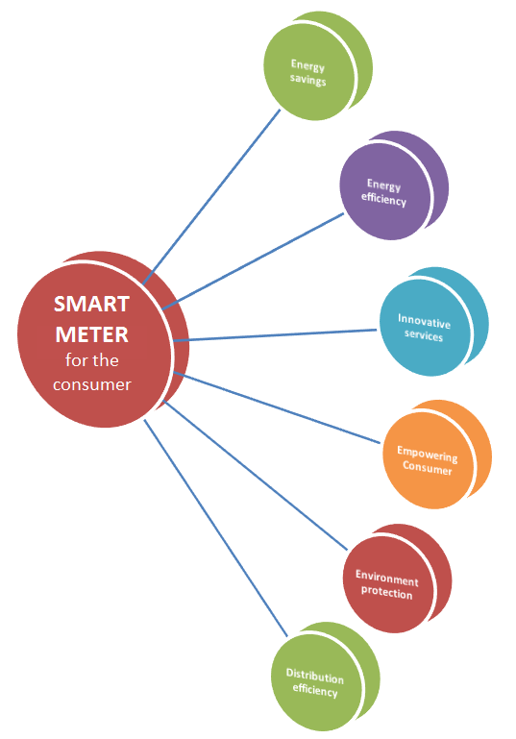

- Energy Savings: smart meters demonstrably help consumers reduce their consumption and save energy
Smart metering system in itself does not necessarily lead to energy savings, however correct use of the infrastructure, does. The relevant focus is therefore whether the consumer will: i) accept the smart metering infrastructure and ii) the way in which this infrastructure will be used, and iii) how both these aspects can be affected, and where the role of the government/policies is key role for the efficient roll-out of smart metering infrastructure.
Generally speaking, energy savings can be achieved in two ways: i) using domestic appliances differently (more efficiently), e.g. shorter showers, thermostat one degree lower, etc. (influenced by information stimuli by the DSO) and ii) purchasing more energy-efficient appliances.
The level of energy savings achieved and consumers’ behavioural change in general depend on:
- The type of feedback provided to the consumers, i.e. direct vs. indirect feedback.
  - Illustration of current electricity consumption (via direct feedback) allows the consumer to associate the use of specific appliances to the level and profile of electricity consumption, leading to a range of 5%-15% of energy savings in comparison to 0%-10% energy savings due to indirect feedback. Another study examines the results on experiments conducted on 219 households into energy savings of 5.1% by ‘tailored recommendation’, where customers receive information and feedback on a personal webpage.
- The type of motivation.
  - A clear understanding of motivation is important when addressing consumer’s behavioural change. While environmental concerns appear to be a driving factor in Denmark, the cost reduction came across as the strongest motivator for energy savings in all the rest of countries from total of 10 Member States covered in the survey performed by Logica.
- Barriers preventing energy savings.
  - Three main barriers for exploiting the full potential of energy savings in EU are reported in the Logica survey: i) insufficient government incentives, ii) high investment costs and iii) lack of information on exact energy usage.
Member States such as the Netherlands, Ireland and the UK, have clearly addressed the consumer aspect in deployment plans for smart metering systems through different customer behaviour trials and underlined the importance of consumer engagement in their economic assessment of long-term costs and benefits of smart metering roll-outs. Some examples below reflect the potential of smart metering and consumer engagement in achieving energy savings:
- The ‘Smart Metering Customer Behaviour Trials’ in Ireland demonstrated that smart meters (combined with time-of-use tariffs and some demand side management stimuli) reduce overall electricity usage by 2.5% and peak usage by 8.8%;
- The UK Energy Demand Research Project (EDRP) reported consumer electricity savings of 2% to 4%. Furthermore, and more relevant to the UK-GB roll-out, it was shown that in the case for gas, the provision of a smart meter rather than the in-home display is most significant in delivering savings (of around 3%). This is in keeping with theoretical considerations that real time feedback is more relevant to electricity.
- Another example is the Dutch Home Energy Management Systems (HEMS) which led to an overall energy consumption reduction of 7.8%.
- Energy Efficiency: smart meters help consumers master their consumption and therefore increase their energy efficiency
Energy efficiency is another relevant aspect of consumer engagement mainly related to:
- the way electricity is used (i.e. more efficient use of electric energy); and
- the use of more energy efficient appliances.
Both aspects imply consumers’ behavioural change. The former refers to different usage behaviour, whereas the latter to different purchase behaviour. In both cases, smart metering deployment allows the consumer to be more energy-aware, and enables him to make decisions regarding purchase of more energy efficient appliances and turning towards energy efficient buildings. In this respect, the ‘Smart Metering Customer Behaviour Trials’ in Ireland demonstrated that smart meters helped 82% of participants to make some change in the way they use electricity.
- Innovative services for consumers: smart meters open the door to smart home solutions and innovative home automation services
Information retrieved from smart meters can help suppliers, ESCOs or other market players create innovative services, like home energy management and demand response, which can be tailored to consumers’ needs and offer them more profound energy savings and higher efficiency. In this respect, consumers could choose among a wider range of providers (energy retailers, aggregators etc.) and power options (e.g. green electricity and power quality premiums).
Additionally, thanks to innovative services enabled by smart meters like home energy management and demand response, smart appliances, micro-generation and electric vehicles can become an economically attractive proposition for consumers, and contribute to lower energy bills and increased comfort.
Member States, such as the UK, Ireland, Greece and the Netherlands, perceived this benefit as part of the smart grid and in this sense, recognised the importance of smart metering (and detailed consumption data) in enabling future products and services, such as appliance diagnostics and more refined home automation services.
- Consumers’ empowerment: smart meters will improve competition in retail markets
The introduction of smart meters will have an impact on the competitive pressure within energy supply markets. Provision of accurate and reliable data flows due to smart metering infrastructure would enable easier and quicker switch between suppliers for both consumers and suppliers. To this end, the consumers will be able to choose from different offers that better adapt to their consumption patterns.
While greater level of competition may result in lower electricity prices, this benefit at the current stage of smart metering roll-out across Member States is difficult to quantify, and it has therefore been identified only qualitatively in Member States, such as the UK and the Netherlands.
Some examples below give an indication of the value of this benefit for the consumers:
- In the AMR project (SE), lead time for exporting meter readings to suppliers was shortened from 30 days to 5 days;
- In the ‘Storstad smart metering project’, the period for settlement of balance of power was reduced from 13 to 2 months. Over a two year period, the number of calls for both meter reading and invoice-related issues dropped by 56%' and
- In the ‘First Utility smart meters’ programme, consumers were informed of their consumption via emailed reports, sms and a web portal. High bill alerts were designed to help consumers avoid excessive bills.
- Environment protection: less energy consumption and higher energy efficiency help protecting the environment
The reduction of CO₂ emissions, as a benefit affecting the consumers and the society in general, results from:
- Energy savings and higher energy efficiency in the way electricity is used; and
- Higher electricity network operational efficiency.
Moreover, smart meters help foster the diffusion of micro-generation at consumers’ premises (e.g. photovoltaics on roofs) and make the consumers aware of the CO₂ associated to the electricity they consume, giving them the option to choose producing it by renewable sources.
- Distribution system efficiency: management of distribution systems becomes cheaper and more effective, leading to lower distribution costs
Advanced monitoring and control due to smart metering infrastructure deployment allow for more efficient network operation (reduced technical and commercial losses) and more effective management of the system, particularly in the presence of growing renewable energy potential. Furthermore, increased distribution network efficiency and enhanced network management could ultimately lead to lower distribution network costs and better service for the consumers and increased revenue for the DSOs due to: (i) reduced technical and commercial losses, and (ii) improved reliability and power quality, particularly in the presence of growing renewable energy potential,. In both cases, adequate regulatory mechanisms should be put in place.

4. MEMBER STATES’ COST-BENEFIT ANALYSES FOR GAS SMART METERING

4.1. Roll-out strategy
The Third Energy Package gives no specific target for the implementation of gas smart metering systems, nevertheless a reasonable period of time should be considered for such a deployment, as also argued in the respective Commission interpretative note. However for gas, it appears to be more difficult to demonstrate a positive business case. This is shown by the CBAs conducted to date in the EU yielding results that do not justify the roll-out of gas smart metering in a significant number of Member States also reflecting local conditions.
As discussed earlier, in 6 Member States (AT, FR, IE, LU, NL, UK-GB) the results of the CBA were positive, and in 4 of these Member States a decision has been made to proceed with large-scale roll-out of gas smart metering systems (in AT and FR the decision is pending). Also, In IT a CBA was conducted in 2008 and the regulator (AEEG) has decided a roll-out of smart meters with different implementation level for each customer category.
In 6 Member States (AT, BE, DE, GR, NL, RO, UK) the CBA was performed jointly for electricity and gas. From these 6 Member States, 2 have already decided to proceed with a joint roll-out of gas and electricity smart meters (NL, UK-GB), while in Austria the CBA was positive and minimum standards for gas smart meters have been published. There is no Member State where a roll-out only for gas has been decided or where only the gas CBA was positive.

4.2. CBA insights and lessons learned
The number of Member States that have assessed positively the gas smart metering roll-out is significantly lower than the respective number in electricity. One of the main reasons for this is that the expected benefits from the implementation of gas smart metering systems are lower than those expected in the electricity sector. Some of the benefits which are justifiable in the case of electricity cannot be taken into account or they yield lower values in the case of gas. These benefits are either not included in gas CBAs or their inclusion leads to less favourable results than in electricity CBAs. The fact that gas networks can store large amounts of energy results in less need for flexibility on the demand side — in comparison to electricity where real time response to changes in demand is required — may limit the benefits that can be realised for example from demand side participation programmes.
Local market conditions can also affect the level of potential benefits. In some Member States (SE, FI) the limited use of gas at household level (e.g. only for cooking) reduces the benefits and leads to negative CBA results. Different market conditions may also lead to different assumptions for the CBA parameters. For instance, the potential energy savings considered in the different CBAs vary from 0% (CZ) to 7% (AT). Furthermore, technical attributes of gas smart meters such as the use of batteries as an energy source, can limit the transmission intervals of consumption data and thus the benefits for the consumer. In addition, technical requirements in some Member States, such as the presence of technical staff in the case of reactivation of gas supply, can significantly reduce the potential benefits from smart metering functionalities (e.g. remote on/off of gas supply).
On the other hand, in the case of joint gas and electricity roll-out there are cost elements where economies of scale can be exploited (communication, data management, customer information campaigns, installation etc.) For instance the UK-GB assessment estimates higher installation costs for gas meters than for electricity meters, but in the case of a joint roll-out the assessment also accounts for cost savings from installing two meters with a single visit to a customer’s premise, for example because travelling costs are reduced or connectivity testing only has to be carried out once for the whole equipment.. Moreover, in a joint roll-out synergies between electricity and gas smart metering systems may arise in the telecommunication infrastructure or in data handling where for instance a central data hub can serve both systems.
The following tables summarise some of the key data considered by Member States in the assessment of gas smart meters roll-out. The tables do not include CY and MT as gas is not available there, as well as BG, EE, GR, HU, LT, PL, PT and SI for which detailed data were not available during the elaboration of the current analysis.
Table 26 presents data from the gas roll-out in Member States with positive CBA whereas Table 27 presents the respective data considered in CBAs with a negative outcome. In 2012 Italy has updated its targets to 60% penetration in households by end 2018, instead of 80% by 2017. In all Member States that intend to roll-out smart meters or have positive CBAs, the roll-out period does not exceed 2020, even if there is no clear obligation set by the Gas Directive.
Table 26 Key data of gas smart metering CBAs in EU Member States that have a positive CBA for large-scale roll-out.
Member State | Metering points in the Country | Roll-out period | Penetration rate (%) | Smart Meter lifetime (years)
Austria | 1470000 | 2011-2017 | 95% | 12
France | 11000000 | 2014-2020 | 100% | 20
Ireland | 600000 | 2014-2019 | 100% | 17
Italy | 22200000 | 2010-2018 | 60% | 15
Luxembourg | 80000 | 2015-2020 | 95% | NA
Netherlands | 7600000 | 2014-2020 | 80% | NA
United Kingdom — GB | 25663000 | 2012-2020 | 99.5% | 15

Table 27 Key data of gas smart metering CBAs in EU Member States which have a negative CBA for large-scale roll-out.,
Member State | Metering points in the Country | Roll-out period | Penetration rate (%) | Smart Meter lifetime (years)
Belgium | NA | NA | NA | NA
Czech Republic | 2870000 | 2020-2029 | 100% | 10
Denmark | 410000 | NA | NA | 15
Finland | 37000 | NA | 14% | 15
Germany | 14000000 | No roll-out | NA | 15
Latvia | 2200 | 2013-2020 | NA | 15
Romania | 2800000 | 2014-2025 | 100% | 20
Slovakia | 805000 | 2013-2023 | NA | 10
Spain | 7500000 | 2013-2026 | 100% | 20
Sweden | 37000 | NA | NA | NA

Table 28 presents some key parameters of the positive CBAs, while Table 29 includes the respective parameters considered in country CBAs with a negative result. The energy savings percentage range between 0% and 7%, in positive CBAs; only in the case of France the assumed percentage is lower than 2% (0.2%). In the case of negative CBAs the energy savings percentage is below 2%, except in the case of Romania (2.2%). The investment cost (TOTEX) per meter, for Member States where data are available, range between 100 to 268 €/metering point.

Table 28 Key parameters of gas smart metering CBAs in EU Member States that have a positive CBA for large-scale roll-out .
Member State | Investment (TOTEX)  (€ mn) | Total Benefit  (€ mn) | Energy savings  (% of total consumption)
Austria | 352 | 1400 | 7.0%
France | 1100 | NA | 0.2%
Ireland | 140 (incremental cost to electricity roll-out) | NA | 2.90%
Italy | Net present value 6 – 7 euro/customer  (for large – medium size gas distribution companies) |  | NA
Luxembourg | 12 | 14.5 | 2.0%
Netherlands | Joint electricity and gas roll-out; no separate calculation available | Joint electricity and gas roll-out; no separate calculation available | NA
United Kingdom — GB | Joint electricity and gas roll-out; no separate calculation available | Joint electricity and gas roll-out; no separate calculation available | 2% (0.5% for pre-payment)

Table 29 Key parameters of gas smart metering CBAs in EU Member States that have a negative CBA for a large-scale roll-out
Member State | Investment (TOTEX)  (€ mn) | Total Benefit  (€ mn) | Energy savings  (% of total consumption)
Belgium | NA | NA | NA
Czech Republic | 2370.1 | 944.3 | 0.0%
Denmark | 110 | NA | NA
Finland | NA | NA | 0.0%
Germany | No separate calculation available | No separate calculation available | NA
Latvia | 4.65 | NA | NA
Romania | 407 | 422 | 2.20%
Slovakia | 129 | 148 | 0.50%
Spain | 1173 | 1050 | 0.50%
Sweden | NA | NA | 1% (0.5% for businesses)

Finally, Table 30 summarises the top three costs and benefits which were considered in the CBAs. As in the case of electricity, avoided meter reading costs and energy savings are two of the most wide spread benefits. The fact that the gas bill may account for up to 70%, of the total household energy costs, makes energy savings an important benefit to be considered in the economic assessment of gas smart metering systems. Regarding cost, infrastructure costs and operation costs are among the most wide spread costs considered in the CBAs for which data were available.
Table 30 Top 3 benefits and top 3 costs for a selected EU Member States in considered in CBAs.
Member State | Top 3 benefits | Top 3 costs
Austria | Reduced energy consumption (88%), efficient administration (12%) | Installation costs
Belgium | NA | NA
Czech Republic | Reduced commercial losses (100%) | Procurement of AMM (31%), ICT investments (11%), ICT operational costs (7%)
Denmark | NA | NA
Finland | Meter reading costs avoided (30%), lower customer service costs (17%), Billing (15%) | Installation & Infrastructure costs (65%), reading services (21%), Maintenance (14%)
France | Actual billing index (50%), possible energy saving (30%), possible development of smart pipes (10%) | Meters (31.5%), Installation (48.2%), ICT system (6.7%), pilot project (8.3%)
Germany | No separate calculation available | No separate calculation available
Ireland | NA | NA
Italy | reduced meter reading costs; remote accessibility to meters for services (e.g.: reading/activation/deactivation/bad payers management); less unaccounted gas | smart meter costs  installation costs  ICT infrastructure
Latvia | Decrease energy consumption, decrease DSO personnel costs, decrease CO₂ | Costs of SM, installation costs, ICT infrastructure
Luxembourg | Reduced energy consumption, reduced meter reading operating costs, non-replacement of old meters | Meters investment costs, additional operating costs, additional costs for energy supplier
Netherlands | Energy savings (21%), Savings on call centre costs (8%), Savings from increase number of supplier switches (9%) | Smart gas meters and installation (30%), smart meter data management system (16%), communication infrastructure based on PLC (14%)
Romania | Reduced meter reading costs (57.3%), avoided distribution investments (30.1%), reduced gas theft (6.1%), reduced distribution operation costs (6.1%) | Implementation and investment costs (67.17%), Costs for system operation & maintenance (29.35%), Financing costs (3.48%)
Slovakia | Reduction in gas consumption (44%), Reduction in gas losses (41%), Savings from reduced complaints (8%) | Operational costs (62%), Investment costs (38%)
Spain | Investments avoided (59%), meter reading costs avoided (30%), energy savings (9%) | Smart meter investment (42%), Installation costs (27%), maintenance & operation (19%)
Sweden | More efficient use of energy, lower costs for manual reading, bill based on actual consumption (not standardised bill) | Costs of the meter and the remote reading system, Installation — Managing costs
United Kingdom — GB | Joint electricity and gas roll-out, no separate data available | Joint electricity and gas roll-out, no separate data available

5. summary
The Third Legislative Energy Package has paved the way for the roll-out of smart metering systems also for the benefit of consumers. It provides that implementation may be subject to a positive economic assessment (to be conducted by 3 September 2012) of long-term costs and benefits, and for the deployment of smart metering systems in 80% of positively assessed cases by 2020. For electricity, Member States are required to prepare an implementation timetable for a period of up to ten years.
This Staff Working Document accompanies the Commission Report ‘Benchmarking smart metering deployment in the EU-27’ and records progress in the EU-27 to date as regards Member States’ cost-benefit analyses and subsequent implementation of smart metering. Given the explicit target in Directive 2009/72/EC, our analysis has naturally focused on electricity.
The findings show that the majority of Member States decided to carry out a cost-benefit analysis before reflecting on the way forward and deciding next steps.
Making the business case for gas smart metering is more of a challenge, given that the expected benefits are either less significant than for electricity or do not apply. Among the particularities of gas networks are that they can store large amounts of energy and are not as dynamically responsive as electricity systems. This means that there is less of a need for flexibility and demand response and rather limits the opportunities for extra savings and benefits supporting a business case. As a result, only a few countries are currently proceeding with a roll-out in the gas sector – such an approach is taken particularly on the basis that a joint electricity and gas deployment will bring benefits from synergies and economies of scale.
As regards electricity, about two thirds of Member States have decided in favour of a large-scale roll-out of smart metering by 2020 or earlier. Some, such as Italy and Spain, have decided to go ahead without conducting a detailed CBA. According to our estimates, the planned roll-outs will involve the installation of 240 million smart meters (for both electricity and gas) by 2020 and total investment of €45 billion. On the basis of their CBAs, some countries (e.g. Germany, Latvia and Slovakia) are opting for a selective roll-out with an overall lower penetration rate (in relation to the total number of available metering points) by 2020. Nevertheless, these roll-outs add to the numbers of electricity smart meters scheduled for installation, and associated investment levels, and bring the EU-27 average penetration rate, as forecast for 2020, close to 72% of consumers.
On the preparation for the roll-out, Member States have carefully reflected on a number of issues also raised in the Commission Recommendation 2012/248/EU. The Recommendation draws particular attention to key functionalities for fit-for-purpose and pro-consumer arrangements, data protection and security issues, and a CBA methodology that takes account of all costs and benefits of the roll-out of smart metering systems.
Among Member States’ CBAs, there is a striking divergence of data on costs and benefits. Smart metering systems for electricity are costed at anything from €77 to €766 per customer, also reflecting differences in communication infrastructure costs; the average estimate is €223. The cost per metering point for gas is put at around € 200 on average (ranging from €100 to €268). Based on available data, these metering systems could deliver energy savings, in terms of consumption, of the order of 3 %, offer potential for load shifting and overall benefits in the order of €160 per metering point for gas (ranging from €140 to €1000) or €309 (ranging from €18 to €654) for electricity.
The range of values placed on costs and benefits may stem from different starting conditions in Member States, local realities and CBA scope and methodology. However, the divergence poses significant comparability challenges and complicates the exercise of calculating key parameters such as ‘cost per metering point’ and ‘savings’ consistently. It should also be noted that the currently available figures are in most cases only a forecast and do not represent actual costs or benefits. Only as the roll-outs unfold will the consolidated figures become clear – what is shown is in most cases a projection.
Furthermore, economic assessment of the long-term costs and benefits of smart metering across the EU is sensitive to a number of parameters. Energy savings, smart meter capital costs, data communication systems and the discount rate are the critical variables raised most frequently in Member States’ CBAs. In addition, total smart metering investment itself appears to be influenced by local conditions (including local labour costs, geographical configurations, etc.).
Regarding smart metering functionalities, available data show that currently at least, the systems being contemplated by Member States do not fully deliver the common minimum functionalities proposed in the Recommendation and also endorsed by standardisation (under M/441). The most critical of these – and the one that is found least – relates to the frequency at which consumption data can be updated and made available to consumers (and third parties on their behalf), which in turn will facilitate the spread of tariff differentiation and advanced pricing systems. Even though (as seen in discussions with Member States) there is consensus on the importance of these factors for future-proofing the systems and their functioning in a consumer-centric retail market, not all have addressed the challenge of equipping the systems accordingly.
Available data do not indicate a direct link between the range of common minimum functionalities considered for the smart metering systems and their overall cost. As we have noted, total investment appears to be influenced far more by other parameters such as local conditions, additional features beyond the minimum set of functionalities, and the discount rates and appraisal periods considered in the CBAs.
To date, very few Member States, like Austria, UK, Ireland and the Netherlands, have issued guidelines on functionalities. Most countries leave the analysis, options and protocols to those responsible for the roll-out (in most cases the DSOs) rather than laying down formal or legal guidelines. Also, specifications are in most cases not only not obligatory, but are mentioned only in the CBA, are still being piloted or not even referred to. Discussions with Member States indicated that, when setting up technical specifications for the systems to be rolled out, it is important to consider common standards, ensure interoperability and create a market environment conducive to newcomers offering innovative services.
Under the smart metering mandate (M/441) as noted earlier, 50 standards have been available for use since end of 2012. Work is currently ongoing to standardise the core interfaces between the meter and the communication network, and between networks, so as to allow true ‘any-to-any’ connectivity. At the same time, under the smart grid mandate (M/490), further standards will be developed in the course of 2013-14 on key issues such as demand response, conformance testing and interoperability; this is also of crucial importance for the metering/grid interface.
A large number of European pilot projects have shown that home interfaces play a key role in helping consumers to realise the benefits offered by the installation of smart meters and their participation in demand response programmes. They also showed that, it is important to gain the consumers trust and confidence in smart metering. This can happen when consumers understand the functionalities and know what data will be collected, how they will be protected and what these data will be used for.
Ensuring a high level of personal data protection during this process, as guaranteed in Article 8 of the Charter, remains a central concern in the development of standards. Furthermore, the Smart Grids Task Force is currently working to develop a data protection impact assessment template for smart metering and smart grid environments, and a cyber-security assessment framework responding to concerns expressed by industry and potential investors, and to guarantee the appropriate management of vulnerabilities and threats in the light of possible technical solutions and best practice. The respective deliverables due in 2014 will be of interest both to consumers and system operators.
Finally, according to available data, in 15 out of the 16 Member States that have decided to proceed with a large-scale roll-out of electricity smart meters, the distribution system operators (DSOs) are responsible for the implementation of smart metering and ownership of the meters. On top of that, the DSOs may also be responsible for data handling in 12 Member States. Therefore, the roll-out in a large number of Member States will have implications in the market, data handling requirements and options for specific transactions.

REFERENCES
- JRC — Joint Research Centre (March 2012). Guidelines for Cost Benefit Analysis of Smart Metering Deployment, Luxembourg, European Commission Publication Office; http://ses.jrc.ec.europa.eu/sites/ses/files/documents/guidelines_for_conducting_a_cost-benefit_analysis_of_smart_grid_projects.pdf
- AEA — Austrian Energy Agency (October 2012), European Smart Metering Landscape Report, SmartRegions Deliverable 2.1, February 2011, AEA, Vienna; http://www.smartregions.net/default.asp?sivuID=26927.
- CEER — Council of European Energy Regulators (September 2013). Status Review of Regulatory Aspects of Smart Metering, including an assessment of roll-out as of 1 January 2013, Ref. C13-RMF-54-05, Council of European Energy Regulators, Bruxelles; http://www.ceer.eu/portal/page/portal/EER_HOME/EER_PUBLICATIONS/CEER_PAPERS/Customers/2013/7-1_C13-RMF-54-05-Status_Review_of_Regulatory_Aspects_of_Smart_Metering_FOR_PUBLICATION.pdf.

ABBREVIATIONS AND ACRONYMS
AEEG Autorità per l’Energia Elettrica e il Gas (IT)
AMI Advanced Metering Infrastructure
AMR Automated Meter Reading
BPL Broadband over Power Lines
CAPEX Capital Expenditures
CBA Cost-Benefit Analysis
CHP Combined Heat and Power
CO₂ Carbon Dioxide
DC Data Concentrator
DMS Distribution Management System
DSO Distribution System Operator
EC European Commission
EU European Union
GPRS General Packet Radio Service
GSM Global System for Mobile Communications
ICT Information and Communication Technologies
IP Internet Protocol
IEM Internal Energy Market
kWh kilowatt-hour
NA Not Available
NPV Net Present Value
PLC Power-Line Carrier; Power Line Communications
R&D Research and Development
SM Smart Meter
TSO Transmission System Operator

COUNTRY CODES
AT Austria
BE Belgium
BG Bulgaria
CY Cyprus
CZ The Czech Republic
DE Germany
DK Denmark
EE Estonia
EL Greece
ES Spain
FI Finland, Suomi
FR France
HR Croatia
HU Hungary
IE Ireland
IT Italy
LT Lithuania
LU Luxemburg
LV Latvia
MT Malta
NL Netherlands, The
PL Poland
PT Portugal
RO Romania
SE Sweden
SI Slovenia
SK Slovakia
UK United Kingdom

LIST OF TABLES
Table 1 Status of relevant national legislation with respect to smart metering as stated in the Electricity Directive 2009/72/EC (Annex I.2) (status — July 2013) 7
Table 2 Status of electricity smart metering large-scale roll-out in Member States 10
Table 3 Number of electricity smart metering systems to be deployed per country in Member States that are proceeding with large-scale roll-out (covering at least 80% of consumers by 2020) 11
Table 4 Number of electricity smart metering systems considered per country in Member States that have not decided in favour of large-scale roll-out by 2020 11
Table 5 Estimate of total number of electricity smart metering systems to be deployed in the EU by 2020 12
Table 6 Status of electricity CBAs and roll-out plans in the EU-27 12
Table 7 Correspondence of the smart metering systems functionalities identified by M/441 with the recommended common minimum functional requirements in 2012/148/EU, for electricity 16
Table 8 Smart metering functionalities: Member States rolling out by 2020 Compliance check against common minimum functionalities (Reference: EC Recommendation 2012/148/EU, art. 42) 17
Table 9 Smart metering functionalities: Member States NOT rolling out smart metering by 2020 18
Table 10 Frequency of consumption data readings available to consumer; compliance check to functionalities (a) and (b) from the list of recommended common minimum functionalities (2012/148/EU). 19
Table 11 Summary of deployment arrangements for electricity smart metering in EU Member States that decided to roll out 80% or more of the metering points 24
Table 12 Summary of deployment arrangements for electricity smart metering in EU Member States decided NOT to proceed with a (large-scale) roll-out under present conditions 25
Table 13 Status of relevant national legislation with respect to smart metering as stated in the Gas Directive 2009/73/EC (Annex I.2) (status — July 2013) 26
Table 14 Status of gas smart metering roll-out in Member States (July 2013) 28
Table 15 Summary of CBAs status and roll-out plans for gas metering in EU-27 (status — July 2013) 29
Table 16 Summary of deployment arrangements for gas smart metering in EU Member States that have decided to proceed with a (large-scale) roll-out or have a positive CBA (status July 2013). 31
Table 17 Summary of deployment arrangements for gas smart metering in EU Member States that have decided NOT to proceed with a (large-scale) roll-out under present conditions (status July 2013) 32
Table 18 CBA Scenarios — Member States having already completed the smart metering roll-out 34
Table 19 CBA Scenarios — Member States rolling-out smart metering in electricity and gas jointly (targeting at least 80% of consumers) 35
Table 20 CBA Scenarios: Member States rolling out electricity-only smart metering by 2020 36
Table 21 CBA Scenarios: Member States NOT rolling out smart metering in large-scale by 2020 37
Table 22 CBA Scenarios: missing CBAs from Member States 43
Table 23 Costs and Benefits normalised by number of metering points 44
Table 24 Summary of preferred communication infrastructure for smart metering roll-out in Member States 46
Table 25 Most significant cost/benefits share from electricity smart metering roll-out considered in Member States’ analyses 48
Table 26 Key data of gas smart metering CBAs in EU Member States that have a positive CBA for large-scale roll-out. 64
Table 27 Key data of gas smart metering CBAs in EU Member States which have a negative CBA for large-scale roll-out., 65
Table 28 Key parameters of gas smart metering CBAs in EU Member States that have a positive CBA for large-scale roll-out . 65
Table 29 Key parameters of gas smart metering CBAs in EU Member States that have a negative CBA for a large-scale roll-out 66
Table 30 Top 3 benefits and top 3 costs for a selected EU Member States in considered in CBAs. 67

TABLE OF FIGURES
Figure 1 Overview of CBA outcomes and intentions for electricity smart metering large-scale roll-out (for more than 80% of consumers) in Member States, by 2020 (status — July 2013) 13
Figure 2 Roll-out plans: Implementation speed and penetration rate of at least 80% of all consumers by 2020 (status — July 2013) 14
Figure 3: List of the recommended ten common minimum functional requirements that every smart metering system for electricity should fulfil (2012/148/EU Recommendation) 15
Figure 4 Status of smart metering functionalities setting in EU Member States — considered or not in CBA; tried in pilots; being implemented even though not yet regulated; set in a ministerial decision; regulated; or in full operation for completed roll-outs 20
Figure 5 Overview of CBA outcomes and intentions for gas smart metering large-scale roll-out (for more than 80% of consumers) in Member States (status July 2013) 30
Figure 6 Normalised cost and benefit values per metering point estimated from the Member State CBA data 39
Figure 7 Price bands for cost per smart metering point in the Member States 40
Figure 8 Normalised benefit values per metering point in the Member States 41
Figure 9 Potential for energy saving and peak load shifting over total electricity consumption expected from smart metering roll-outs in the Member States 41
Figure 10 Normalised cost and benefit values per metering point 45
Figure 11 Benefit cost ratio over energy savings reported by Member States 45
Figure 12 Benefit cost ratio over peak load shifting reported by Member States 46
Figure 13 Six possible ways that smart metering could benefit the consumer 59

Information on Croatia is not included as data were collected before its accession to the EU.
Annex I.2 to both the Electricity Directive 2009/72/EC and Gas Directive 2009/73/EC.
Energy Efficiency Directive 2012/27/EU on energy efficiency, amending Directives 2009/125/EC and 2010/30/EU and repealing Directives 2004/8/EC and 2006/32/EC, OJ L315, 14.11.2012, p.1.
Commission Recommendation 2012/148/EU, OJ L 73, 13.3.2012, p.9; http://eur-lex.europa.eu/LexUriServ/LexUriServ.do?uri=CELEX:32012H0148:EN:NOT.
Based on a review of 219 projects, accounting for a total investment of about €5.5 billion; Smart Grid projects in Europe: lessons learned and current developments (a joint ENER/JRC reference report) was issued in 2011 and a 2013 update is available online: http://ec.europa.eu/energy/gas_electricity/smartgrids/doc/ld-na-25815-en-n_final_online_version_april_15_smart_grid_projects_in_europe_-_lessons_learned_and_current_developments_-2012_update.pdf.
Particularly those Member States that had not yet performed their CBAs when the Recommendation was issued or were/are considering a revision of previous national assessments.
Particularly important for residential consumers are: a reading update rate of 15 minutes and a standardised interface to transfer and visualise individual consumption data in combination with information on market conditions and service or price options.
Recommendation 2012/148/EU provides guidance on data protection by design and by default, data minimisation, the development of a data protection impact assessment template, best available techniques for smart metering, the use of privacy certification seals, the use of data security standards, personal data breach notifications and information policies.
The mission of the European Task Force for the Implementation of Smart Grids into the European Internal Market (Smart Grids Task Force – SGTF) is to advise the Commission on policy and regulatory frameworks at European level to coordinate policies towards the implementation of smart grids under the Third Energy Package and to assist the Commission in identifying projects of common interest in the field of smart grids, in the context of the Regulations of the European Parliament and of the Council on guidelines for trans-European energy (COM(2011) 658) and telecommunications networks (COM(2011) 657) infrastructure. The SGTF was set up by the Directorate-General for Energy (DG ENER) in 2009; for more information: http://ec.europa.eu/energy/gas_electricity/smartgrids/taskforce_en.htm.
CEN/CENELEC/ETSI related smart grid work: http://www.cencenelec.eu/standards/Sectors/SmartGrids/Pages/default.aspx.
http://ec.europa.eu/energy/gas_electricity/smartgrids/doc/2011_03_01_mandate_m490_en.pdf.
http://ec.europa.eu/energy/gas_electricity/smartgrids/doc/2010_06_04_mandate_m468_en.pdf.
http://ec.europa.eu/energy/gas_electricity/smartgrids/doc/2009_03_12_mandate_m441_en.pdf.
Opinions 04/2013 and 07/2013 on the Data Protection Impact Assessment Template for Smart Grid and Smart Metering Systems (‘DPIA Template’) prepared by Expert Group 2 of the Commission’s Smart Grid Task Force; http://ec.europa.eu/justice/data-protection/article-29/documentation/opinion-recommendation/index_en.htm#h2-1.
ENISA – European Union Agency for Network and Information Security.
Smart Grid projects in Europe: Lessons learned and current developments — 2012 update, European Commission, 2013; http://ses.jrc.ec.europa.eu/sites/ses.jrc.ec.europa.eu/files/documents/ld-na-25815-en-n_final_online_version_april_15_smart_grid_projects_in_europe_-_lessons_learned_and_current_developments_-2012_update.pdf.
Inventory of smart grids projects and related analysis; available on the JRC’s website: http://ses.jrc.ec.europa.eu/jrc-scientific-and-policy-report.
Inventory of EU Smart Grid projects — 2012 update; also available on JRC’s website.
www.smartgrids.eu/projects.
Data from the regional CBAs are available in the respective Country Fiches document.
DK – a ministerial order on the smart metering roll out framework was signed the 03/12/2013, and issued with effect by the 10/12/2013.
http://www.mkm.ee/legislation-acts/.
http://www.legaltext.ee/et/andmebaas/tekst.asp?loc=text&dok=XXXX010K1&keel=en&pg=1&ptyyp=RT&tyyp=X&query=grid.
Δ5/ΗΛ/Α/Φ33/2067/04-02-2013 MD.
HU – status December 2013: A resolution was passed stipulating that HU won’t be proceeding with the roll-out of smart metering and until a further assessment of related costs and benefits is undertaken (scheduled by end 2016) based on results from ongoing pilots.
(http://www.lrs.lt/pls/proj/dokpaieska.showdoc_l?p_id=158290&p_org=&p_fix=n&p_gov=n ).
No additional legislation introduced as existing legislation permits the change of meters as and when required.
Published in the Official Gazette No. 485 of 16.07.2012.
Note – throughout the document the data on the United Kingdom-Great Britain (UK-GB) are discussed as representative of the UK. The region of Northern Ireland (NI), in terms of overall metering points, represent a very small proportion of the overall UK figure – around 1.5% of the UK total — and therefore it is not reflective of the Member State position as a whole. Furthermore, it is rather difficult to generate data which are representative of the whole UK due to the varying methodologies as well as differences in the energy markets between NI and GB. The specific NI position is also captured as it is incorporated in the respective Country Fiches document.
http://epr.ofgem.gov.uk/index.php?pk=folder100997.
http://epr.ofgem.gov.uk/index.php?pk=folder101001.
http://www.legislation.gov.uk/uksi/2012/2400/contents/made.
http://www.legislation.gov.uk/uksi/2012/2414/contents/made.
http://www.legislation.gov.uk/uksi/2013/2429/contents/made.
The Danish Law no. 642 of 12 June 2013 mandates a full smart metering roll-out. The framework for implementation is laid down in a ministerial order (issued in December 2013). However, more than 50% of consumers in its territory have already an intelligent meter installed by the distribution system operators.
The Maltese DSO anticipates that the capital cost of the smart meters will be partially offset from savings in lowering non-technical losses (billing errors, theft/fraud, etc.) which currently lie at around 7%. In fact around 70% of non-technical losses (5% of total consumption) may be recoverable through improved metering & billing.
Portugal has an inconclusive CBA for electricity. The intention is to conduct a re-evaluation of the CBA based on updated assumptions and taking into consideration the current economic context and constraints.
The Hungarian CBA for electricity and gas was notified to the Commission services in December 2013.
Slovenia is currently working on an official CBA — a DSO CBA is already available; the outcome is not yet known.
HU- The cost-benefit analysis for the smart metering roll-out in Hungary was notified to the Commission services in December 2013. The current document refers to CBA data available by end of July 2013.
The diffusion rates quoted here are those expected by 2020. In the case of the Netherlands the final diffusion rate depends on the level of acceptance / opt-outs.
The diffusion rate figure for the case of the Czech Republic refers to voluntary deployment of smart metering.
Slovak Republic: (i) the number of metering points reported are those at Low Voltage level, as estimated for 2020; (ii) the penetration rate of 23% refers to metering points (with annual consumption of over 4MWh) to be equipped with smart meters from a total of 2,625,000 metering points at low voltage level.
Germany —number of metering points in the country quoted here correspond to number projected for 2020.
The graph considers the start of mandated large-scale roll-outs and not pilot phase deployment. For instance, in the Netherlands activity has started since 2012 but the indicated starting date is 2014; in Ireland Phase 2 of the roll-out programme (requirements, definition and procurement) will start in 2014 followed by the build and test phase (Phase 3) in 2015-2016, and the large-scale roll-out is scheduled to start in 2016.
See also Commission's report ‘A joint contribution of DG ENER and DG INFSO towards the Digital Agenda, Action 73: Set of common functional requirements of the Smart Meter’, October 2011; available online: http://ec.europa.eu/energy/gas_electricity/smartgrids/doc/2011_10_smart_meter_funtionalities_report_full.pdf.
idem.
ERGEG- European Regulators’ Group for Electricity and Gas Publication, “Final Guidelines of Good Practice on Regulatory Aspects of Smart Metering for Electricity and Gas”, ERGEG, February 2011, Ref: E10-RMF-29-05: http://www.energy-regulators.eu/portal/page/portal/EER_HOME/EER_PUBLICATIONS/CEER_PAPERS/Customers/Tab2/E10-RMF-29-05_GGP_SM_8-Feb-2011.pdf.
Mandate M441 for smart meters (March 2009). http://ec.europa.eu/energy/gas_electricity/smartgrids/doc/2009_03_12_mandate_m441_en.pdf. http://www.cencenelec.eu/standards/Sectors/SustainableEnergy/Management/SmartMeters/Pages/default.aspx.
See ‘Guidelines for Cost Benefit Analysis of Smart Metering Deployment’, 2012 European Commission, JRC.
BE — specifics on functionality (b) can be found in the also accompanying Country Fiches' Staff Working Document. Note — in the case of the Belgium data, given the individual, region-specific, and not strictly comparable cost benefit analyses performed for the roll-out of smart metering in the three regions of Belgium, it is rather difficult to determine a single, country-representative value for the parameters herein considered. Data from the regional CBAs are available in the respective Country Fiches document.
See for instance the case of Denmark. Partial compliance is due to meters having been installed prior to the first national regulation of June 2011. All new meters will comply with the minimum functionalities, when the first generation of meters has been replaced, after the expiry of their technical lifetime.
Directive 2009/72/EC concerning common rules for the internal market in electricity and repealing Directive 2003/54/EC, ANNEX I "Measures on consumer protection", point 2.
In Finland the DSOs are free to outsource the roll-out project and metering function as they please, but the overall responsibility of the measurement is still with the DSO. Currently many of the DSOs are buying the measurement and related data connections as a service from a third party.
In UK-Great Britain there is an obligation on all gas and electricity suppliers to take all reasonable steps to complete the roll-out of smart metering by 31 December 2020. There is no legal obligation on individual consumers to have a smart meter.
The ‘administrative off’ option grants the consumers with guarantee that no information has been exchanged with the DSO or any third party; however the consumer himself can still have access to his metering data (via the consumer port).
In France, meters ownership is retained by local municipalities, while DSO will operate them under a multi-annual concession. Furthermore, the ‘mandatory’ of the deployment applies to the DSO and not to the consumers.
Energy Act (§ 16 letter k); the Ministry of Industry and Trade (MIT), as the central government authority for the energy industry, shall provide analyses for implementing of smart metering systems in the power and gas industry.
HU – status December 2013: A resolution was passed stipulating that HU won’t be proceeding with the roll-out of smart metering and until a further assessment of related costs and benefits is undertaken (scheduled by end 2016) based on results from ongoing pilots.
Published in the Official Gazette No. 485 of 16.07.2012.
http://epr.ofgem.gov.uk/index.php?pk=folder100997.
http://epr.ofgem.gov.uk/index.php?pk=folder101001.
http://www.legislation.gov.uk/uksi/2012/2400/contents/made.
http://www.legislation.gov.uk/uksi/2012/2414/contents/made.
http://www.legislation.gov.uk/uksi/2013/2429/contents/made.
In cases of joint electricity and gas smart metering rollouts, it is difficult to sensibly separate the related costs and expected investments between electricity and gas.
Estonia — an elaborated cost-benefit analysis for gas is expected to be conducted by 2015.
Hungary — the respective CBA for electricity and gas was notified to the Commission services in December 2013.
HU— The cost-benefit analysis for the smart metering roll-out in Hungary was notified to the Commission services in December 2013. The current document refers to CBA data available by end of July 2013.
In Denmark, the metering market is regulated in the sense that the DSO follows technical and security regulations when installing meters and can recover (under regulation) installation costs from the consumers. But the DSO is free to purchase from any supplier of meters on competitive terms.
Commission Recommendation 2012/148/EU, OJ L 73, 13.3.2012, p.9.
"Guidelines for Cost Benefit Analysis of Smart Metering Deployment", JRC Scientific and Technical Report, EUR25103 EN, :http://ses.jrc.ec.europa.eu/sites/ses/files/documents/guidelines_for_cost_benefit_analysis_of_smart_metering_deployment.pdf.
It is noted that in the case of Member States that are not part of the Eurozone the exchange rate used is that of month June 2013 given in the official European Commission webpage: http://ec.europa.eu/budget/contracts_grants/info_contracts/inforeuro/inforeuro_en.cfm.
With the exception of cost and benefit per metering point, which were calculated by Commission services.
- Acronyms: ‘CAPEX’ is capital expenditures and ‘OPEX’ stands for operational expenditures. - ‘Consumer benefit’ is calculated as percentage of ‘Total benefit’- data found in CBAs and also provided by Member States. - Italy: investment and benefit figures are for DSO only. No estimation of other investment/benefit has been calculated. The figures reported are present values, discounted to the reference year of 2005. - Sweden- total investment includes CAPEX only. - Finland: The quoted peak load shifting represents the share of peak load that smart meters for low consumption customers can actually shift from the peak load hour. Industrial customers which make for 50% of the Finnish consumption have hourly readings since 1998 and are actively participating in peak load shifting.
Furthermore, in the case of UK-GB the number of metering points reported assumes population growth in line with Government projections.
- Ireland: The number of metering points quoted for Ireland is for electricity consumers only (gas metering points not included in the figure). - The Netherlands: Metering points are counted as follows: one for electricity and one for gas, where dual fuel is present. - United Kingdom — GB (all GB figures refer to domestic and non-domestic deployment): - Metering points –the total quoted splits into 32.94million electricity meters and 26.63million gas meters; since cost and benefit figures are reflective of an appraisal period up to 2030, the number of metering points provided is also by 2030. Smart meters which would have been installed under the non-domestic counterfactual have been deducted from the actual meter number to ensure consistency with the reported cost and benefit information. Adding the counterfactual installations would result in a total metering point number of 63.8m (34.27 million electricity meters and 27.56 million gas meters). - Roll-out period end date: 2020 is the end date for the roll-out as per the updated timetable announced in May 2013 by DECC- UK Department of Energy and Climate Change. - Penetration rate: for modelling purposes the CBA considers 97% is achieved by 2020, although by 2030 full roll-out is assumed. - Smart meter lifetime is 15 years. The appraisal covers though the period 2013-30. - The total investment figure has been derived from the April 2012 GB Impact Assessment. In order to aid comparability with investment figures from other member states, financing costs have not been included in the reported figures. - The energy saving rate presented here is the weighted average energy saving across domestic and non-domestic sectors and different payment types. For the non-domestic sector, the energy savings assumed to be realised from deployments in the counterfactual scenario are also deducted. - Peak load shifting — as a percentage of total domestic and small and non-domestic consumption, peak load shifting is estimated at between 0.5% (in 2012) and 1% (in 2030). As a percentage of peak load, the shifting potential is estimated at between 1.3% and 2.9%.
- Roll-outs stretching to 2022 consider 100% by that date. - Estonia: Figure on total investment accrues to year 2017, whereas benefits are considered up to 2031. - France: Investment includes only DSO-related investment. - Malta: The figure for investment includes CAPEX only. OPEX has not been calculated but is expected to be lower than the amount incurred for non-smart meters (due to reduced need for meter readers and inspections). - Poland: The figures provided for investment and benefits consider a period up to 2022. - Romania: The figure for investment is calculated over a period up to 2022, whereas the benefits are calculated up to 2020.
- Belgium: In the case of the Belgium data, given the individual, region-specific, and not strictly comparable cost benefit analyses performed for the roll-out of smart metering in the three regions of Belgium, it is rather difficult to determine a single, country-representative value for the parameters herein considered. Data from the regional CBAs are available in the respective Country Fiches document. - Czech Republic: - The investment (CAPEX+OPEX) represents total costs of Blanket scenario (€4 367 million). Total Benefit (€2735) represents CAPEX+OPEX of Basic scenario (represents investments saved due to discontinuation of Basic scenario) plus external benefits of Blanket scenario (€ 81 million). The cost per metering point (€766) represents a proportion of total costs of Blanket scenario. The benefit per metering point (€480) represents proportion of the total benefit (external benefits included).Consumer’s benefit (21 %) represents share on external benefits (€16.7 million). Share of consumer’s benefit on total benefit is reported as 0.6%. All values are not discounted. - The value reported for peak load shifting is only related to household consumption. - Germany: - Energy savings and peak load shifting values are for both smart metering systems and intelligent meters. - Peak load shifting is estimated at 1.3% in average between 2014 and 2022, and at 2.9% in 2032. - Lithuania: - The value reported for peak load shifting is only related to households and commercial users under 30kW per year. - Slovak Republic: - The number of metering points reported are those at Low Voltage level. - The penetration rate of 23% refers to metering points (with annual consumption of over 4MWh) to be equipped with smart meters from a total of 2,625,000 metering points at low voltage level. - All cost and benefit values quoted are discounted.
This number reflects the number of measuring points for electricity consumption in the country; a portion of this number represents the metering points equipped with smart meters. In the case of multi-utility smart metering roll-out, there are different metering points per each type of utility: electricity, gas, heat, etc. .
The smart metering lifetime in this analysis should reflect the amortisation period of both smart meters and the ICT system installed to make the automated meter reading work. It is not intended to represent the physical lifetime of the equipment, but to estimate the period for the implementing party to recover the investment for installation and setup of the system. However, the data available point to the fact that a number of Member States have intended this as expected physical lifetime of each single meter, e.g. including in the CBA analysis the cost for two installations and appliances when the CBA horizon is higher than the meter’s lifetime.
Commission Recommendation on preparation of the roll-out for smart metering systems (2012/148/EU).
Total investment considers both capital expenditure (CAPEX) and operational costs (OPEX).
Smart Grid: 10 Trends to Watch in 2013 and Beyond, Navigant Research, 2013 Navigant Consulting, Inc. http://www.navigantresearch.com.
This can have a considerable effect on the overall analysis. For example, the UK GB roll-out assumes for the non-domestic sector that 50% of premises would even in the absence of Government intervention eventually have received advanced metering. Costs and benefits of those installations are consequently excluded from the roll-out consideration.
There are no benefit values available for Finland, France, Malta and Spain. France considers that the assumptions for the benefits calculation are too uncertain to give a reliable value.
This is calculated as a percentage with reference to the total electricity consumption (MWh) in a given Member State.
The term ‘peak load transfer’ is defined in the Annex of Recommendation 2012/148/EU as: the Value in EUR = wholesale margin difference between peak non-peak generation margin (EUR/MWh) * % Peak Load transfer (%) * total energy consumption at LV (MWh)."
UK-GB: the peak shaving/load shifting benefit ranges from 1.3% to 2.9% (an average is herein used). These numbers represent the percentage of peak consumption that is assumed to be shifted. Peak consumption in turn is assumed to be 30% of overall consumption. The lower number represents the shifting potential during the early years of the roll-out, while the higher figure reflects load shifting by 2030.
The Hungarian CBA for electricity and gas was notified to the Commission services in December 2013. The current document and analysis discusses data available by July 2013.
For countries rolling out both electricity and gas, costs per metering point will appear general higher given that the higher cost of a gas meter versus an electricity meter is not taken into account in the normalisation applied in the figure.
GPRS – General Packet Radio Service.
BE — Data from the regional CBAs are available in the respective Country Fiches document.
Current situation estimations.
Data from the regional CBAs are available in the respective Country Fiches' Staff Working Document.
Share of main benefits refers to external benefits (benefits in the Blanket scenario). It is not share on total benefit.
For joint electricity and gas roll-out.
For joint electricity and gas roll-out.
Energy savings (12.5% savings of the small-scale, low voltage electricity consumption) was identified in the case of the CZ as the sole parameter that could potentially, and under different conditions, turn the national smart metering business case positive.
Directive 95/46/EC of the European Parliament and of the Council of 24 October 1995 on the protection of individuals with regard to the processing of personal data and on the free movement of such data, OJ L 281, 23.11.1995, p. 31.
This is currently under discussion in the European Parliament and Council and it is scheduled for adoption in 2014.
Opinions 04/2013 and 07/2013 on the Data Protection Impact Assessment Template for Smart Grid and Smart Metering Systems (‘DPIA Template’) prepared by Expert Group 2 of the Commission’s Smart Grid Task Force; http://ec.europa.eu/justice/data-protection/article-29/documentation/opinion-recommendation/index_en.htm#h2-1.
‘Best available techniques’ refer to ‘ the most effective and advanced stage in the development of activities and their methods of operation, which indicate the practical suitability of particular techniques for providing in principle the basis for complying with the EU data protection framework. They are designed to prevent or mitigate risks on privacy, personal data and security’ [Commission Implementing Decision of 10 February 2012 laying down rules concerning guidance on the collection of data and on the drawing up of BAT reference documents and on their quality assurance referred to in Directive 2010/75/EU of the European Parliament and of the Council on industrial emissions]. ‘Available techniques’ means those techniques developed on a scale which allows implementation in the relevant industrial sector, under economically and technically viable conditions, taking into account the costs and advantages, whether or not the techniques are used or produced inside Member States, as long as they are reasonably accessible to the operator. ‘Best’ means effective in achieving a high general level of protecting the customer and his privacy. BAT‘s need to be periodically reviewed and if necessary updated regularly as a result of the nature of science, technology and privacy level considered as being protectable. The precise process as well as detail steps to be done, amendments to be made, are continuously monitored within a so-called BREF (best available techniques reference document). Such a document needs to be drawn up for defined activities describing, in particular, the installation, operation, and maintenance of smart metering systems.
RBAC stands for Role-Base Access Control. It is a method of restricting or authorising system access for users based on user roles and locales.
Reference Sarah Darby, Environmental Change Institute, Oxford University Centre for the Environment.
Idem.
Reference Wokje Abrahamse.
Logica survey.
Electricity Smart Metering Customer Behaviour Trials Findings Report CER/11/080a, 2011.
Energy Demand Research Project — A suite of large-scale trials across the UK-GB, co-funded by the Government, to provide information on consumers’ responses to a range of forms of feedback, including smart meter-based interventions. The final report provided new evidence on the behavioural impact of improved energy information in the GB context. https://www.ofgem.gov.uk/gas/retail-market/metering/transition-smart-meters/energy-demand-research-project.
Empower Demand, VaasaETT, Global Energy Think Tank, 2011.
Smart meters will increase reliability and power quality ultimately resulting to better customer service: better reaction to customer contacts, e.g. by checking the status of customer’s power quality. Also outage verification and compensations can be automated and thus avoiding time-consuming reclamation processes and manual labour. Especially these issues have reportedly led to increased customer satisfaction to the meters & roll-out process in Finland.
In this case for instance low consumption limits the benefits from energy savings both in terms of monetary savings for the consumers and environmental (CO2 reduction). Furthermore, longer billing periods lead to marginal benefits from lower reading costs.
UK-GB, NL: total investment & benefit figures are covered in the CBA data aforementioned in this document (see earlier tables).
UK-GB: the numbers quoted in this table refer to 2020 and include metering points that are assumed to also receive smart meters in the counterfactual.
Data for Latvia refer to roll-out of smart meters to industrial consumers only.
Belgium: In the case of the Belgium data, given the individual, region-specific, and not strictly comparable cost benefit analyses performed for the roll-out of smart metering in the three regions of Belgium, it is rather difficult to determine a single, country-representative value for the parameters herein considered. Related data from the regional CBAs are available in the respective Country Fiches document.
UK-GB, NL: total investment and benefit figures are covered in the CBA data illustrated earlier on in the document .
Data for Latvia refer to roll-out of smart meters to industrial consumers only.
BE — Related data from the regional CBAs are available in the respective Country Fiches document.
Values are not discounted.
This depends on the mix of energy sources in domestic and commercial sectors. In the UK for instance the average gas bill for a standard account is £811 and for electricity it is £531 based on average annual consumption of 3300 kWh for electricity and 16500 kWh for gas (Ofgem factsheet 98, February 2013).
BE — Related data from the regional CBAs are available in the respective Country Fiches document.
For joint gas and electricity roll-out.
Related information is available in the country fiches also accompanying the Report from the Commission Benchmarking Smart Metering Deployment in the EU-27.

