TABLE OF CONTENTS
1. AUSTRIA 4
1.1. Organisation of the deployment and regulation 4
1.2. CBA local boundary conditions and scenarios 4
1.3. Smart metering deployment rate 5
1.4. CBA outcome 6
1.5. Remarks 8
2. BELGIUM 9
2.1. Flanders - Organisation of the deployment and regulation 9
2.2. Flanders - CBA local boundary conditions and scenarios 9
2.3. Flanders - CBA outcome 10
2.4. Brussels Capital - CBA local boundary conditions and scenarios 12
2.5. Brussels Capital - CBA outcome 14
2.6. Wallonia - CBA local boundary conditions and scenarios 16
2.7. Wallonia - CBA outcome 17
3. CZECH REPUBLIC 20
3.1. Organisation of the deployment and regulation 20
3.2. CBA local boundary conditions and scenarios 20
3.3. CBA outcome 22
3.4. Critical variables – sensitivity analysis 24
3.5. Remarks 24
4. DENMARK 26
4.1. Organisation of the deployment and regulation 26
4.2. CBA local boundary conditions and scenarios 26
4.3. CBA outcome 27
4.4. Critical variables – sensitivity analysis 29
4.5. Qualitative assessments of non-monetary impacts and new enabled services 29
4.6. Remarks 29
5. ESTONIA 30
5.1. Organisation of the deployment and regulation 30
5.2. CBA local boundary conditions and scenarios 30
5.3. Smart metering deployment rate 31
5.4. CBA outcome 31
6. FINLAND 33
6.1. Organisation of the deployment and regulation 33
6.2. CBA local boundary conditions and scenarios 33
6.3. Smart metering deployment rate 34
6.4. CBA outcome 34
6.5. Remarks 35
7. FRANCE 37
7.1. Organisation of the deployment and regulation 37
7.2. CBA local boundary conditions and scenarios 37
7.3. Smart metering deployment rate 38
7.4. CBA outcome 39
7.5. Critical variables – sensitivity analysis 39
7.6. Remarks 40
8. GERMANY 41
8.1. Organisation of the deployment and regulation 41
8.2. CBA local boundary conditions and scenarios 41
8.3. Smart metering deployment rate 43
8.4. CBA outcome 44
8.5. Critical variables – sensitivity analysis 45
8.6. Remarks 46
9. GREECE 47
9.1. Organisation of the deployment and regulation 47
9.2. CBA local boundary conditions and scenarios 47
9.3. Smart metering deployment rate 48
9.4. CBA outcome 49
9.5. Critical variables – sensitivity analysis 50
9.6. Qualitative assessments of non-monetary impacts and new enabled services 50
9.7. Remarks 51
10. IRELAND 52
10.1. Organisation of the deployment and regulation 52
10.2. CBA local boundary conditions and scenarios 52
10.3. Smart metering deployment rate 54
10.4. CBA outcome 54
10.5. Critical variables – sensitivity analysis 55
10.6. Qualitative assessments of non-monetary impacts and new enabled services 56
10.7. Remarks 56
11. ITALY 57
11.1. Organisation of the deployment and regulation 57
11.2. CBA local boundary conditions and scenarios 57
11.3. CBA outcome 58
11.4. Remarks 59
12. LATVIA 61
12.1. Organisation of the deployment and regulation 61
12.2. CBA local boundary conditions and scenarios 61
12.3. CBA outcome 62
12.4. Remarks 64
13. LITHUANIA 65
13.1. Organisation of the deployment and regulation 65
13.2. CBA local boundary conditions and scenarios 65
13.3. CBA outcome 66
14. LUXEMBOURG 69
14.1. Organisation of the deployment and regulation 69
14.2. CBA local boundary conditions and scenarios 69
14.3. Electricity smart metering deployment rate 70
14.4. CBA outcome 70
15. MALTA 72
15.1. Organisation of the deployment and regulation 72
15.2. CBA local boundary conditions and scenarios 72
15.3. Electricity smart metering deployment rate 73
15.4. CBA outcome 73
16. THE NETHERLANDS 75
16.1. Organisation of the deployment and regulation 75
16.2. CBA local boundary conditions and scenarios 76
16.3. CBA outcome 77
16.4. Critical variables – sensitivity analysis 79
16.5. Qualitative assessments of non-monetary impacts and new enabled services 79
16.6. Remarks 79
17. POLAND 81
17.1. Organisation of the deployment and regulation 81
17.2. CBA local boundary conditions and scenarios 81
17.3. Electricity smart metering deployment rate 82
17.4. CBA outcome 82
17.5. Critical variables – sensitivity analysis 84
17.6. Remarks 84
18. PORTUGAL 85
18.1. Organisation of the deployment and regulation 86
18.2. CBA local boundary conditions and scenarios 86
18.3. Smart metering deployment rate 87
18.4. CBA outcome 87
18.5. Critical variables – sensitivity analysis 88
19. ROMANIA 89
19.1. Organisation of the deployment and regulation 89
19.2. CBA local boundary conditions and scenarios 89
19.3. Electricity smart metering deployment rate 91
19.4. CBA outcome 91
19.5. Critical variables – sensitivity analysis 92
19.6. Qualitative assessments of non-monetary impacts and new enabled services 92
19.7. Remarks 93
20. SLOVAKIA 94
20.1. Organisation of the deployment and regulation 94
20.2. CBA local boundary conditions and scenarios 94
20.3. Electricity smart metering deployment rate 95
20.4. CBA outcome 96
20.5. Sensitivity analysis 97
20.6. Remarks 97
21. SLOVENIA 98
21.1. Organisation of the deployment and regulation 98
21.2. CBA local boundary conditions and scenarios 98
21.3. CBA outcome 99
21.4. Remarks 100
22. SPAIN 101
22.1. Organisation of the deployment and regulation 101
22.2. CBA local boundary conditions and scenarios 101
22.3. Smart metering deployment rate 102
22.4. CBA outcome 102
22.5. Remarks 103
23. SWEDEN 104
23.1. Organisation of the deployment and regulation 104
23.2. CBA local boundary conditions and scenarios 104
23.3. Smart electricity deployment rate 105
23.4. CBA outcome 105
23.5. Remarks 106
24. UK 107
24.1. UK – GB 107
24.2. Organisation of the deployment and regulation 107
24.3. CBA local boundary conditions and scenarios 108
24.4. Smart metering deployment rate 109
24.5. CBA outcome 109
24.6. Critical variables – sensitivity analysis 111
24.7. Qualitative assessments of non-monetary impacts and new enabled services 111
24.8. Data privacy and security 111
24.9. Remarks 112
24.10. UK-NI 112
24.11. Organisation of the deployment and regulation 113
24.12. CBA local boundary conditions and scenarios 113
24.13. Smart metering deployment rate 114
24.14. CBA outcome 114
24.15. Critical variables – Sensitivity analysis 117
24.16. Qualitative assessments of non-monetary impacts and new enabled services 117
24.17. Remarks 117
ABBREVIATIONS AND ACRONYMS 118
COUNTRY CODES 119
LIST OF TABLES 120
TABLE OF FIGURES 120

COUNTRY FICHES FOR ELECTRICITY SMART METERING
This Staff Working Document accompanies the Commission Report ‘Benchmarking smart metering deployment in the EU’ and presents, specifically for those Member States whose data were available by July 2013, a summary of key parameters of their economic assessment of long-term costs and benefits for the roll-out of electricity smart metering in their territory. An overview of the progress to date on the roll-out in Member States, and an analysis of the related costs and benefits across the EU, are included in the respective Staff Working Document also accompanying the Benchmarking Report.

AUSTRIA
The Austrian regulator (E-Control) commissioned a cost-benefit analysis for the roll-out of smart metering in 2010 which led to a positive result. To this end, the Ministry of Economy issued a ministerial Decree in 2012 for the electricity smart metering roll-out.
The CBA report analyses the long-term costs and benefits of introducing a joint roll-out of electricity and gas smart meters in Austria and presents its impact on the main stakeholders, such as consumers, suppliers, system operators and national economy in general. Despite the joint economic assessment of both electricity and gas, the CBA report includes separate values on costs and benefits related to electricity and gas smart metering. In addition, notwithstanding the existence of minimum functional requirements for gas smart meters, there is currently no final decision for the roll-out of gas smart metering.

Organisation of the deployment and regulation
Table 1-A depicts the smart metering deployment set-up adopted in Austria.
Table 1-A Smart metering deployment set-up and regulation in Austria
AUSTRIA
Metering activity | Regulated
Deployment strategy | Mandatory roll-out (by decree of the Ministry of Economics)
Responsible party -implementation and ownership | DSO
Responsible for third-party access to metering data | DSO
Financing | Metering fees and network tariffs
The smart metering deployment is defined as regulated, with minimum requirements for electricity smart metering set by the National Regulatory Authority E-Control. Distribution system operators (DSOs) will be the responsible party for implementation and ownership and the main link for third-party access to metering data. Most of the investment costs are covered by the so-called ‘metering tariff’ paid by the electricity customers and regulated by E-Control. Additional costs (e.g. ICT systems) will be covered by general network tariffs.

CBA local boundary conditions and scenarios
The economic evaluation includes the definition of four different scenarios for electricity and smart metering roll-out which vary according to implementation scale and time frame. These scenarios are:
- Scenario I – 95% of replacement of all electricity and gas meters to smart electricity and gas meters. Implementation time frame: 2011-2017.
- Scenario II – 95% of replacement of all electricity and gas meters to smart electricity and gas meters. Implementation time frame: smart electricity meters to be introduced in the period of 2011-2015 and smart gas meters within 2011-2017.
- Scenario III - 95% of replacement of all electricity and gas meters to smart electricity and gas meters. Implementation time frame: smart electricity meters to be introduced within a period of 2011-2017and smart gas meters to be introduced within 2011-2019.
- Scenario IV – 80% of replacement of all electricity and gas meters to smart electricity and gas meters. Implementation time frame: 2011-2020.
Scenario II presents the highest net present value (NPV) and envisages the fastest smart metering implementation along with the highest market penetration (95%).
Table 1-B summarises the local conditions and implementation parameters (e.g. discount rate, roll-out time, smart metering functionalities, etc.) and the scenarios considered for the electricity smart metering roll-out.
Table 1-B CBA boundary conditions and scenarios in Austria
CBA BOUNDARY CONDITIONS
Scenarios | Scenario I, II, III and IV
Metering points in the country | 5.7 mn.
Common Minimum functionalities (as proposed in EC Recommendation 2012/148/EU) | Full compliance with the common minimum functionalities of EC Recommendation 2012/148/EU. Minimum required functionalities set by the Regulator (2011 Ordinance)
Implementation speed | 2012-2019
Penetration rate by 2020 | 95%
Discount rate | 4.2%
Smart metering lifetime | 15
CBA Horizon | 15
Communication technology | - From the smart meter to the data concentrator – 70% PLC and 30% GPRS  - From the data concentrator to the Data Management System – 100% Fibre Optics

Smart metering deployment rate
Figure 1-A illustrates the electricity smart metering deployment rate throughout the roll-out period. The starting year refers to the Ministerial decision; however, most of the effective roll-outs will start later.

Figure 1-A Smart metering roll-out plan in Austria

CBA outcome
All four scenarios have a positive outcome. However, scenario II (smart meters' implementation speed up to 95%, with roll-out of electricity smart meters between 2011 and 2015) represents the highest net present value, indicating the preference to such an implementation plan over the rest of the scenarios considered.
Table 1-C illustrates the CBA result referring to Scenario II and includes the range of main benefits and costs associated with electricity smart metering.
Table 1-C Main results of CBA due to electricity smart metering roll-out in Austria
CBA OUTCOME | POSITIVE
Total Investment | € mn 3195
Total Benefit | € mn 3539
Cost/metering point  (EC calculation) | €590
Benefit/metering point (EC calculation) | €654
Consumers' benefit (% of total benefits) | 78.5%
Main benefits  (% of total benefits) | - Energy savings - 55%  - Operational savings due to more efficient supplier switch procedure - 19% (indirect benefits to the consumers)  - Reduction of DSO associated meter reading cost – 9%
Main costs  (% of total costs) | - OPEX - 30%  - CAPEX - 26%  - Indirect costs - supplier associated network balancing costs due to consumer behavioural change - 24%
Energy savings  (% of total electricity consumption) | 3.5%
Peak load shifting  (% of total consumption) | 2.5%

The main benefits are expected to be realised on the consumer side; in terms of energy savings they account to 55% of the total gross benefits due to electricity smart metering roll out (see Figure 1-B) or to 70% from the total gross benefits attributed to the consumer only. The rest of the total benefits are shared among the DSO, suppliers and the society (through increased efficiency of the deployment set-up). The second highest benefit (19%) due to more efficient supplier switching procedures is also attributed to consumers. The higher share of benefits attributed to the DSO is coming from reduced meter reading cost (9%), whereas suppliers mainly benefit as a result of reduced balancing costs (due to peak shaving/ load shifting).
Most of the direct costs of electricity smart metering roll-out (CAPEX+OPEX) are attributed to the DSO, as depicted in Figure 1-C, mainly smart metering investment, operational, maintenance, IT costs and indirect costs. The energy suppliers also need to adopt their corresponding IT systems, while at the same time it is expected that they will incur revenue reductions due to lower electricity sales (mainly due to changes in the consumer behaviour). However, energy suppliers may have the greatest potential to offset their costs by introducing new tariff models.

Figure 1-B Share of main benefits associated with electricity smart metering roll-out in Austria
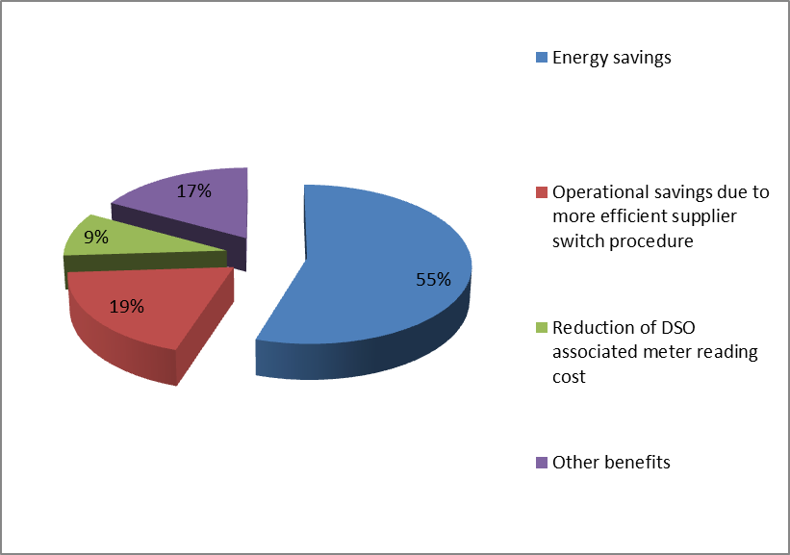

Figure 1-C Share of main costs associated with electricity smart metering roll-out in Austria
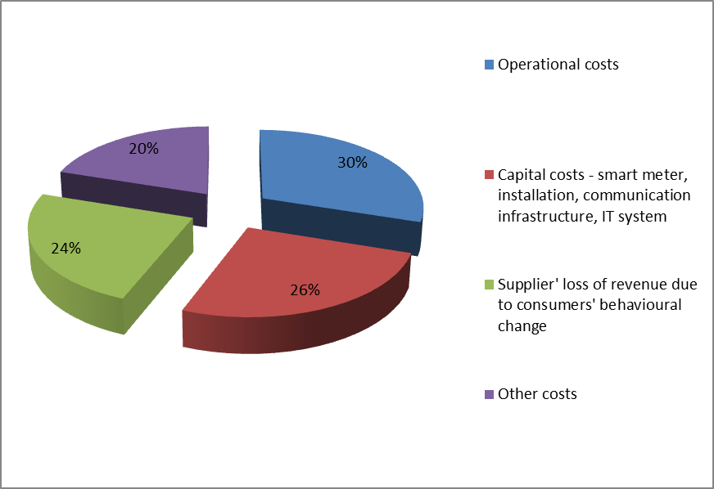

Remarks
All four scenarios considered in the long-term assessment of smart metering implementation in Austria return an overall positive net effect. When the electricity and gas sectors are considered separately, the net effect is still positive for each of the scenarios, while consumers are expected to benefit the most.
In particular, consumers are likely to enjoy the highest amount of net benefits from smart metering implementation, through: i) reduced electricity bill as a result of energy savings (on average 3.5 %) and ii) lower network tariffs due to improved system operation efficiency. Both benefits will also lead to lower CO₂ emissions.

BELGIUM
In Belgium the competence on energy policy is shared between the federal and the regional administrations. The central government deals with issues pertaining to electricity transmission and distribution networks from 70kV up, while the section of the network below this threshold is under the supervision of regional administrations. Accordingly, each of the three Belgian regions (Flanders, Wallonia and Brussels-Capital) has been in charge of their region-specific cost-benefit analysis (CBA) for the smart metering roll-out.

Flanders - Organisation of the deployment and regulation
The competent authority for the smart metering roll-out in Flanders is the regional energy regulator, VREG, while there are two operators: Eandis and Infrax carrying out the operational tasks for the distribution network operators in the region. Table 2-D depicts the smart metering deployment set-up adopted in Belgium, Flanders region.
Table 2-D Smart metering deployment set-up and regulation in Belgium - Flanders
BELGIUM - Flanders
Metering activity | Regulated
Deployment strategy | N/A (no roll-out yet)
Responsible party -implementation and ownership | DSOs
Responsible for third-party access to metering data | DSOs
Financing | Not decided yet

Flanders - CBA local boundary conditions and scenarios
Two different CBAs were realised on behalf of VREG from a private contractor: the first in 2008 and a second one in 2011. The main features of the CBA performed in 2011 for VREG are reported below. The CBA analysis is based on the following hypotheses:
- Simultaneous roll-out of electricity and gas smart metering;
- Penetration rate at the end of the hypothetical roll-out: 98% for electricity;
- Communication infrastructure as communicated by the DSOs (PLC, Multi Utility Controller (–MUC through GPRS and cable));
- Energy savings of 1% for electricity and 2 % for gas, without home display, and taking into account only the indirect feedback from consumers; and
- Roll-out plan completion within 5 years. Note that the CBA takes into consideration a period of 30 years, therefore it includes the costs for a second round of meters installation (each meter has an estimated lifetime of 15 years).
The aforementioned assumptions are all included in the first scenario adopted in the CBA, the so-called ‘Reference’ scenario. Alternative scenarios have been developed as well: ‘Spontaneous deployment’, considering a voluntary approach for rolling out and a final penetration rate of 80%; and ‘Segmented deployment’, with a deployment spanning over 15 years and rolling out by different customer segments, one at a time.
Table 2-E summarises the local conditions and implementation parameters (e.g. discount rate, roll-out time, smart metering functionalities, etc.) and the scenarios considered for the smart metering roll-out.
Table 2-E CBA boundary conditions and scenarios in Belgium - Flanders
CBA BOUNDARY CONDITIONS
Scenarios | Reference, Spontaneous deployment, Segmented deployment
Metering points in the country | 5.5 mn for both electricity and gas  (3.45 mn for electricity only)
Common minimum functionalities (as proposed in EC Recommendation 2012/148/EU) | All recommended functionalities were considered
Implementation speed | 5 years, from 2015 to 2019 in the Reference scenario
Penetration rate by 2020 | Considered in CBA: 98%
Discount rate | 5.50%
Smart Metering lifetime | 15
CBA Horizon | 30 years, from 2015 to 2045
Communication technology | - From the smart meter to the data concentrator: 80% PLC – with internet gateway (Eandis customers). The remaining 20% (Infrax customers) are equipped by MUC cable (60%) and MUC GPRS (40%)  - From the data concentrator to the DMS: Cable or GPRS

Flanders - CBA outcome
Among the three scenarios considered in the CBA, only the reference scenario results in a positive net present value (NPV) of €144 mn over 30 years, while the two alternative scenarios result respectively in a NPV of -€200 mn (spontaneous deployment 80%) and of -€265 mn (segmented deployment 15 years). The scenario with the highest NPV is based on a roll-out of smart meters up to 98% penetration rate, with a hypothetical roll-out between 2015 and 2020. However the result under the reference scenario is considered to be inconclusive as it does not yield a strong positive result.
Table 2-F illustrates the CBA result, including the range of main benefits and costs associated with electricity smart metering.
Table 2-F CBA outcome in Belgium - Flanders
CBA OUTCOME | Inconclusive
Total Investment | € mn 1932
Total Benefit | € mn 2076
Consumers' benefit  (% of total benefits) | 59%
Main benefits  (% of total benefits) | - Energy savings by indirect feedback (19%)  - Reduced costs of physical meter reading (17%)  - Fraud detection (13%)
Main costs  (% of total costs) | - Provision and installation of smart meters (50%)  - Investment in data communication infrastructure (23%)  - Investment in data management services (14%)
Energy savings  (% of total electricity consumption) | 1% with indirect feedback for electricity (2% for gas), 4% for electricity (3% for gas) with direct feedback (only for customers equipped with home displays, a hypothesis not included in the Reference scenario)
Peak load shifting  (% of total electricity consumption) | 5%
Remarks | Simultaneous deployment of gas and electricity smart metering drives costs down (single technical intervention for installation)

One of the main benefits included in the CBA is energy savings originating from indirect feedback (no direct feedback is considered possible without the provision of home-displays to consumers). This accounts for about 19% of the total benefits (Figure 2-D). Similar amounts of benefits arise from the avoided costs of manual meter reading (17% and from fraud detection 13%). The highest share of the total benefits, about 60%, accrues to consumers, with a significant share for DSOs as well.
The analysis performed identifies the following stakeholder groups: Consumers, DSOs, Energy supplier, Energy producers, TSOs, environment and society. Consumers will benefit most from the introduction of electricity and gas smart meters, thanks to a gain in energy efficiency of 1% in electricity consumption and 2% in gas consumption. Positive net effects also accrue to energy suppliers and to the environment and society.
Figure 2-D Share of main benefits from electricity smart metering roll-out in Belgium – Flanders
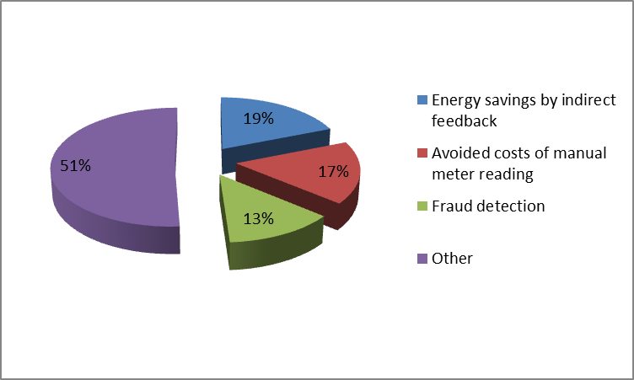

The main cost items considered in the analysis are:
- Investment in setting up a data management system (14%);
- Investment in the necessary telecommunication system (23%); and
- Investment (including procurement and installation) in smart meters (50%).

Figure 2-E Share of main costs from electricity smart metering roll-out in Belgium – Flanders

Almost 90% of the costs expected by a potential smart metering roll-out are attributed to DSOs, responsible for procurement and installation of the smart meters, telecommunication infrastructure (in PLC case, to be provided to about 80% of customers) and appropriate data management system. Half of these costs refer to the smart meters procurement and installation cost (Figure 2-E).

Brussels Capital - CBA local boundary conditions and scenarios
The CBA for the region of Brussels capital considers four scenarios, in addition to a ‘Business as Usual’ situation: ‘Basic model (PLC)’, ‘moderate model (UMTS)’, ‘advanced model (smart grid)’ and ‘full model (WiMax)’.
Given the four different scenarios above, the following assumptions have been adopted in the CBA:
- Simultaneous roll-out of electricity and gas smart metering systems;
- Implementation over 4 years, starting from 2015;
- Expected meter lifetime of 15 years;
- Time horizon considered in the CBA of 20 years;
- Discount rate of 6.5%;
- Number of metering points is increasing over the period considered;
- The expected energy efficiency gains are estimated at about 1.2% in electricity and the same in gas (basic scenario);
- Pre-paid meters are not considered in any scenario;
- Penetration rate at the end of the hypothetical roll-out is not specified (for calculation purposes, the Commission assumed a final penetration rate of 100%);
- Communication infrastructure is constituted by two systems: a data gathering system and a data management system; the latter communicates through PLC or mobile/radio networks (GRPS, UMTS, WiMAX, Wi-Fi, Mesh); and
- A specific set of functionalities has been identified.
The CBA conducted results in negative net present value (NPV) for all four considered scenarios: the ‘Basic’ has a NPV of -€142 mn, the ‘Moderate’ of -€158 mn, the ‘Advanced’ of -€79 mn and the ‘Full’ of -€142 mn, with an average investment per installation (which includes both electricity and gas smart metering) ranging from €267 to €472. Table 2-G summarises the CBA boundary conditions and scenarios considered for the electricity smart metering roll-out.
Table 2-G CBA boundary conditions and scenarios in Belgium – Region de Bruxelles Capitale
CBA BOUNDARY CONDITIONS
Scenarios | Basic, Moderate, Advanced, Full
Metering points in the country | 1 mn. for both electricity and gas  (620.000 for electricity only)
Common minimum functionalities (as proposed in EC Recommendation 2012/148/EU) | The functionalities considered in the least negative scenario (Advanced scenario), comply with the recommended except for functionality (b) (real time readings to customers are not considered in the Advanced scenario)
Implementation speed | 4 years, from 2015 to 2018 in all scenarios
Penetration rate by 2020 | N/A
Discount rate | 6.50%
Smart Metering lifetime | 15
CBA Horizon | 20 years, from 2015 to 2030
Communication technology | Depending on scenario:  - PLC (Basic)  - UMTS (Moderate, Advanced)  - WiMAX (Full)

Brussels Capital - CBA outcome
As mentioned earlier, all four scenarios considered turn out negative. The scenario with the highest NPV is the ‘Advanced’ scenario, the outcome of which is summarised in Table 2-H.
Table 2-H CBA outcome (advanced scenario) in Belgium – Region de Bruxelles Capitale
CBA OUTCOME | Negative
Total Investment | € mn 460
Total Benefit | € mn 381
Consumers' benefit  (% of total benefits) | 47%
Main benefits  (% of total benefits) | - Energy savings (46%)  - Reduced non-technical losses (22%)  - Field service management (16%)
Main costs  (% of total costs) | - Installation materials and field service (43%)  - Data transfer and communication (24%)  - Planned and unplanned maintenance (17%)
Energy savings  (% of total electricity consumption) | 3.45% quoted for the advanced scenario. (Ranging from 1.2% of total electricity consumption (basic scenario) to 4.6% of total electricity consumption (full scenario)
Peak load shifting  (% of total electricity consumption) | 0.47% of total benefits (not in electricity consumption)
Remarks | The inclusion of advanced features in the smart metering roll-out may imply a higher investment, but also higher benefits

The most significant benefit is energy savings accounting for 46% of total benefits in the advanced scenario, as depicted in Figure 2-F. The second important benefit is the reduction of non-technical losses (fraud detection) which accounts for 22% of total benefits, and the third is the decrease in manual reading costs (16%). Consumers are expected to enjoy the highest benefit from the smart metering roll-out, according to the CBA performed.
Figure 2-F Share of main benefits from electricity smart metering roll-out – Region de Bruxelles Capitale
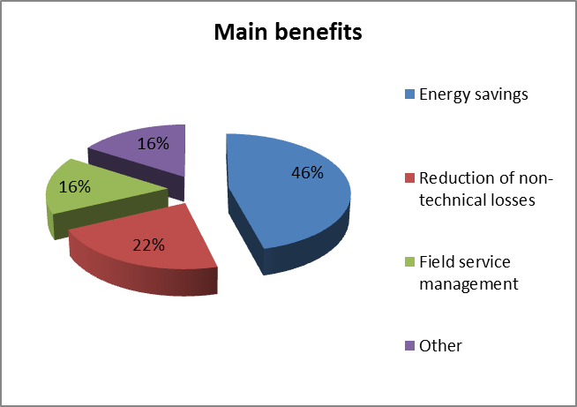
The main cost items considered in the analysis, as also indicated in Figure 2-G, are:
- Installation materials and service (43%);
- Data transfer and communication (24%); and
- Planned and unplanned maintenance (17%)
The relative high costs of installation material and service in the Region of Brussels Capital are mainly driven by the necessity to procure tri-phase meters at 230V without neutral accounting for about 7% of the total number of meters estimated for year 2015. Other costs are also considered in the respective CBA including costs for communication and public acceptance campaigns.
Figure 2-G Share of main costs from electricity smart metering roll-out in Belgium – Region de Bruxelles Capitale
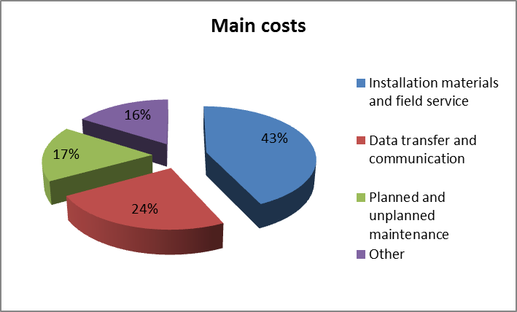

Wallonia - CBA local boundary conditions and scenarios
In the Wallonia Region the competent authority for assessing the deployment of smart metering system is the Commission Wallonne pour l'Energie – CWAPE. A dedicated CBA for the smart metering roll-out in Wallonia has been realised in 2012. This CBA also investigates what priority should be given to smart metering roll-out versus other investments useful for the deployment of smart grids (e.g. incentives to distributed generation, etc.). For the Wallonia Region, the CBA undertaken includes three relevant scenarios, of which only the last two are used in the analysis as the first is the reference scenario:
- ‘Reference Scenario’, which is not a ‘Business as Usual’ ('do nothing and nothing happens', 'frozen') scenario, but takes into consideration the additional interventions needed to ensure the achievement of Renewables targets according to the 20-20-20 strategy, including reinforcements of DSO networks.
- Scenario 1 ‘Full roll-out’, with 80% of consumers equipped with smart electricity and gas meters by 2020.
- Scenario 2 ‘Smart meter friendly’, which features a selective roll-out to specific segments: customers requesting explicitly smart metering and paying for the installation, new connections, replacements, and consumers with a bad payment record (installation of prepayment meters).
In order to carry out the analysis, the following assumptions have been adopted in the CBA:
- Simultaneous roll-out of electricity and gas smart metering;
- Implementation: over 5 years for the ‘Full roll-out scenario’, starting from 2015 and ending in 2019. For the ‘Smart Meter Friendly’ scenario, a total estimated penetration rate of 15% of total metering points is reached in 2020;
- Expected meter lifetime of 15 years, for communication modules of 7.5 years;
- Time horizon considered in the CBA is 30 years;
- Discount rate is 5.5% (WACC);
- The communication technology is a mix of PLC and GPRS;
- A general increase of 2.5% per annum in electricity demand is expected over the evaluation period, due to the spread of heat pumps, electric cars and air conditioning. Inflation effects are taken into account for each category of costs: material, manpower, energy, etc.; and
- 9 ‘applications’ are identified as sources of benefits, in order to carry out a coherent evaluation across all the three scenarios.
The results reported are the following: in the ‘Full roll-out’ the net present value (NPV) is negative (€185.9 mn), while in the ‘Smart Meter friendly’ scenario the NPV is positive (€504.9 mn), and in particular the analysis underlines that the ‘Smart Meter Friendly’ scenario brings less benefits of about 20% with reference to the ‘Full roll-out’ scenario, but implies also 75% less total costs. The table below summarises the CBA boundary conditions and scenarios considered for the electricity smart metering roll-out.
Table 2-I CBA boundary conditions and scenarios in Belgium – Wallonia
CBA BOUNDARY CONDITIONS
Scenarios | Full roll-out Smart Meter Friendly
Metering points in the country | 2.6 mn for both electricity and gas  (1.9 mn for electricity only)  - Full roll-out scenario: 80% of metering points equipped with smart meters by 2020  - Smart Meter Friendly: 15% smart metering penetration rate by 2020
Common minimum functionalities (as proposed in EC Recommendation 2012/148/EU) | Taken into account as ‘applications’: management of active demand, energy savings, on/off functionality, fraud detection, payment management through pre-paid meters, remote switching, AMR, operational efficiency of the DSO network, AMR of decentralised generation. These applications considered in the CBA, are reported to include all the common minimum functionalities recommended in 2012/148/EU
Implementation speed | 5 years, from 2015 to 2019 in all scenarios
Penetration rate by 2020 | 80% in the Full roll-out scenario  15% in the Smart meter Friendly
Discount rate | 5.50% (WACC)
Smart Metering lifetime | 15 years (7.5 for communication module)
CBA Horizon | 30 years, from 2012 to 2041
Communication technology | - From the smart meter to the data concentrator: 80% PLC and 20% MUC+GPRS  - From the data concentrator to the DMS: GPRS

Wallonia - CBA outcome
The table below reports results from the ‘Full roll-out’ scenario. This scenario is the one coherent with the target of 80% smart metering roll-out by 2020. On the basis of net present value results, the least negative scenario is the ‘Smart meter Friendly’. However, as the latter does not comply with the 80% target, the ‘Full roll-out’ can be used for benchmarking purposes with other Member States’ CBAs data. The results of the ‘Smart Meter Friendly’ scenario are therefore also indicated in the table below for comparison purposes. It is noted that the respective CBA assumes that there are no energy savings due to smart metering roll-out as this can be attained also by other means alone (like more efficient appliances or advanced home energy systems). However, bill savings due to more active demand side management and load shifting, were taken into account.
Table 2-J CBA outcome in Belgium – Wallonia
 | Full Roll-out  scenario | Smart Meter Friendly scenario
CBA OUTCOME | Negative | Positive
Total Investment | € mn 2232 | € mn 947
Total Benefit | € mn 2046 | € mn 1531
Consumers' benefit  (% of total benefits) | 2.8% | Not available
Main benefits  (% of total benefits) | - Default management (49%)  - Remote ON/OFF control (15%)  - Demand side management (13%)  - Fraud detection (11%) | - Default management (64%)  - Remote ON/OFF control (14%)  - Demand side management (11%  - Fraud detection (6%))
Main costs  (% of total costs) | - Installation (37%)  - Maintenance (23%)  - Equipment (16%) | - Installation (35%)  - Maintenance (18%  - Equipment (15%)
Energy savings  (% of total electricity consumption) | 0% | 0%
Peak load shifting  (% of total electricity consumption) | 12% | Not available
Remarks | A selective roll-out might imply a lower total investment but also spreading of total costs over a fewer number of meters.

The main benefits, as indicated in Figure 2-H, are related to:
- Default management, intended as better management of bad payers through the introduction of pre-paid smart meters (49% of total benefits in the ‘Full roll-out’ scenario). This benefit accrues for 96% to the DSO and for 4% to the suppliers.
- Remote on/off control (15% of total benefits in the ‘Full roll-out’ scenario). This benefit accrues in total to the DSO.
- Demand-side management (13% of total benefits in the ‘Full roll-out scenario’). This benefit accrues for 22% to consumers, for 49% to the DSO and for 29% to the energy supplier.
Figure 2-H Share of main benefits from electricity smart metering roll-out
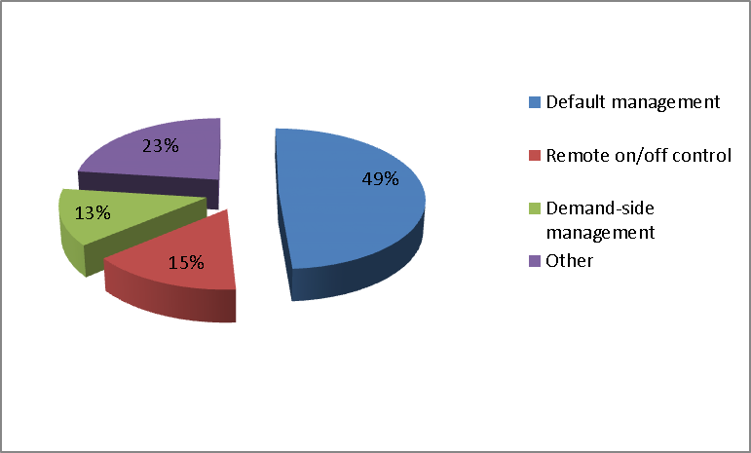

In the analysis performed, under the ‘Full roll-out’ scenario consumers are the only stakeholders gaining from the roll-out thanks to demand management (€56 mn). On the other hand, within the ‘Smart meter friendly’ scenario, consumers have a negative net present value (-€295 mn), as they are expected to bear the costs of the smart metering installation. In the ‘Full roll-out’ scenario, the smart metering deployment also implies an increase of the RAB for the DSO, meaning that a higher remuneration through the network tariff might be put in place. The total cost for the ‘Full roll-out’ is estimated at €2.2 bn. The main cost items considered in the analysis are shown in Figure 2-I: Installation (37,3%), Maintenance (23%), and Equipment (15,7%). Notably, all major costs reported are related to the smart meters roll-out itself (76% in total).

Figure 2-I Share of main costs from electricity smart metering roll-out
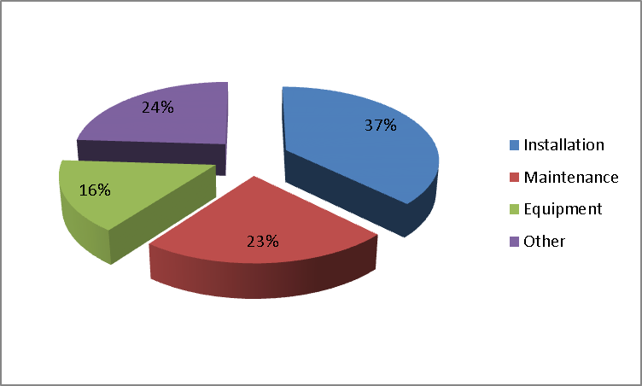

CZECH REPUBLIC
The Czech Republic performed in 2012 an economic assessment of long-term costs and benefits associated with electricity smart metering, with the aim to evaluate the framework for a cost-effective deployment of intelligent metering and the respective feasible timeframe.
Currently, customers who use electricity for space heating and water heating can make use of a double-tariff system interlinked with remote control of appliances by ‘district ripple load control’ (in Czech ‘HDO’). This system is used for direct remote control of groups of appliances according to the time schedules set, and reflecting the electricity network load conditions. The HDO system allows consumers to differentiate between the high and low electricity price level for the part of electricity load associated with space and water heating. In this way, the distribution system operators are able to optimise daily load profiles within a tariff framework approved by the Energy Regulatory Office.
The cost-benefit analysis (CBA) of electricity smart metering yields a negative net present value (NPV) considering the current conditions and price of available technology. The CBA assumes that nearly 70 % of the potential benefits are already achieved by the existing system that proved to be robust and secure, whereas distribution system operators and finally consumers might be burdened with the costs of rapid implementation of a new system.

Organisation of the deployment and regulation
Table 3-K illustrates the metering deployment set-up to be adopted in the Czech Republic.
Table 3-K Smart metering deployment set-up and regulation in Czech Republic

Czech Republic
Metering activity | Regulated
Deployment strategy | No roll-out yet
Responsible party -implementation and ownership | DSO
Responsible for third-party access to metering data | Central hub
Financing of the roll-out | NA

The Distribution system operator remains the owner and responsible party for smart meters implementation, whereas a central body (central hub) will be the eligible link for granting access to metering data.

CBA local boundary conditions and scenarios
The direct consumption control through the HDO system (district ripple load control) is based on contractual agreements between the electricity consumers and the DSO for part of their consumption related with space and water heating appliances subject to load shedding in periods of peak electricity load (high tariffs) and shifting to periods of lower electricity consumption (lower tariff), and in the case of an emergency situation.
According to the national CBA, the HDO system allows for easier control and thus more effective integration of decentralised energy sources (and to greater extent renewables) and gives an added value to the DSO due to an optimised distribution network operation (i.e. less technical losses).
The CBA considers the current conditions and addresses the HDO system through: i) further development and adaptation to smart metering system, or ii) complete replacement by smart metering technology. To this end, two scenarios have been used for the economic assessment:
- ‘Basic’ (BaU - business as usual) scenario
- ‘Blanket’ scenario
The basic scenario preserves the existing status, (i.e. the HDO system), for consumption and generation management, metering, data processing and billing. The blanket scenario features installation of smart metering at 100 % consumer points of delivery. The HDO system and its functionalities is still considered in the blanket scenario. As long as the smart metering does not completely substitute the current HDO functions, it is assumed that the HDO system will be operated concurrently with the smart metering system.
All results provided in the sections below relate to the blanket scenario which is compared to the basic scenario (BaU). Table 3-L summarises the local conditions and implementation parameters (e.g. discount rate, roll-out time, smart metering functionalities, etc.) and the scenarios considered for the electricity smart metering roll-out.
Table 3-L CBA boundary conditions and scenarios in Czech Republic
CBA BOUNDARY CONDITIONS
Scenarios | Basic scenario; Blanket scenario with penetration rate 100 % at completion of smart metering roll-out
Number of metering points in the Country | 5.7 mn.
Common minimum functionalities (as proposed in EC Recommendation 2012/148/EU) | All recommended functionalities considered
Implementation speed | 2020 – 2026
Penetration rate by 2020 | 1% final penetration rate as there is no plan to roll-out yet.  100 % penetration rate considered for the purposes of the CBA
Discount rate | 6.1 %
Smart Metering lifetime | 12 years
CBA horizon | 26 years
Communication technology | - PLC communication infrastructure from the smart meter to the data concentrator:, GPRS (or any other applicable wireless technology) only where it is not possible to use PLC  - GPRS+fibre optics from the Data Concentrator to the Data Management System

CBA outcome
Table 3-M illustrates the result of the economic assessment performed, including the range of main benefits and costs associated with electricity smart metering and referring to the blanket scenario. The figures on costs and benefits reported below present non-discounted values.
Table 3-M CBA outcome in Czech Republic
CBA OUTCOME | NEGATIVE
Total Investment | € mn. 4367
Total Benefit | € mn. 2735
Cost/metering point  (as communicated by the Member State) | €766
Benefit/metering point (as communicated by the Member State) | €499
Consumers' benefit  (% of total benefits) | - 21 % of external benefits (€ mn. 16.7)  - 0.6 % of total benefit
Main benefits  (% of total benefits) | - Reduced commercial losses (53%)  - Peak load transfer (42%)  - Deferred generation capacity investments (5%)
Main costs  (% of total costs) | - Procurement of smart meters (24%)  - ICT investments (10%)  - ICT operation cost – meter reading (9%)
Energy savings  (% of total electricity consumption) | 0 %
Peak load shifting  (% of total electricity consumption) | 1.2 % of household segment consumption

One of the main benefits expected to be realised as a result of smart metering deployment (and not currently fully exploited under the HDO system) is the reduction of commercial losses and peak load transfer, as shown in Figure 3-J. Procurement and installation of smart meters along with ICT investments present the highest share of the cost burden associated with smart metering roll-out (Figure 3-K).
Figure 3-J Share of main benefits associated with electricity smart metering roll-out
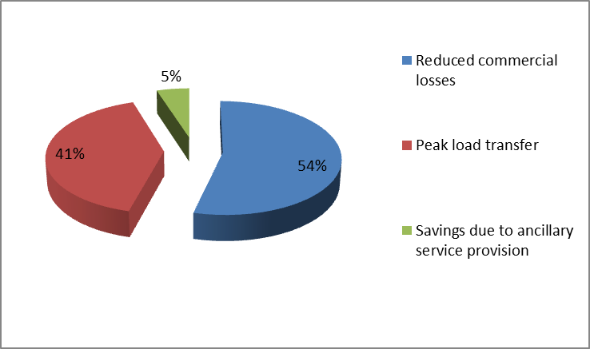

Figure 3-K Share of main costs from electricity smart metering roll-out
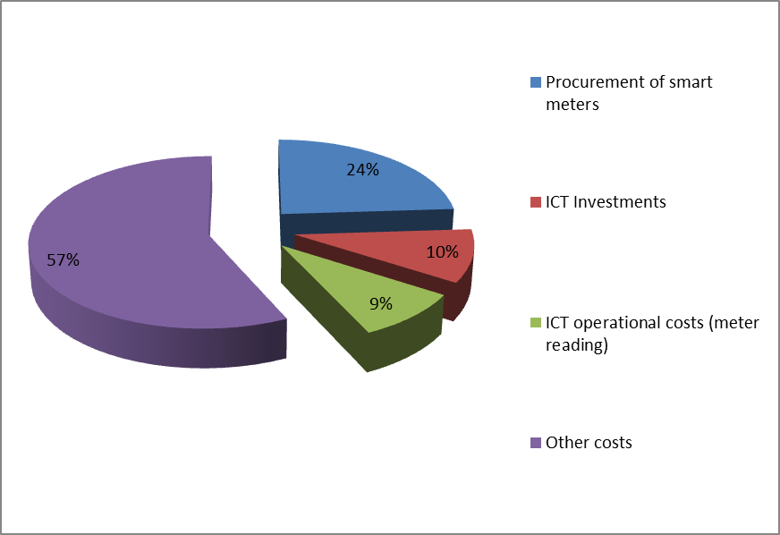

Critical variables – sensitivity analysis
The sensitivity analysis performed as part of the CBA showed that only the variation of absolute electricity savings could shift the net present value (NPV) value into positive. However, as indicated in the CBA, the achievement of such savings under current conditions in the Czech Republic is not feasible. Additionally, combination of several parameters, such as the CAPEX of smart meters and their installation, CAPEX of the ICT infrastructure (including the DTS accessories), CAPEX of the DSO data centre and energy savings could lead to a net present value equal to zero.

Remarks
The national economic evaluation concludes that there is no business case for implementation of smart metering in the Czech Republic in the presence of the currently operating HDO system, under which most of the benefits expected from smart metering are argued as already achieved. Furthermore, the CBA states that, additional benefits can be attained by complementing the existing system with new, and wider offer of, tariff schemes without additional costs in technology, and in particular, through the introduction of price response mechanisms based on a voluntary change of consumer consumption patterns. Moreover, the local analysis concludes that if the social dimension of the smart metering becomes central to the roll-out, it would lead to higher consumer engagement and more favourable environment for a nation-wide smart metering deployment.
Therefore, the national CBA study proposes the following:
- Smart metering implementation (Blanket scenario) should not commence before 2018; it is necessary to continue operation and technological development in the framework of pilot projects.
- Extend the ability of the current HDO system by adding tariffs without direct control of appliances, i.e. based on sending tariff signals to customers together with encouraging more customers to participate in HDO system using wider offer of tariff schemes.
- Continuously follow the technological development in the field of smart networks and metering; in particular from the viewpoint of parameters’ development and prices of key components, which are important for decision-making and thus commencing the smart metering preparation and realisation.
- Set national communication standards, standards of metering devices and major smart metering system elements, along with technical and legal norms to ensure the cyber-security of the system by 2017.
- Assess applicability and effectiveness of the smart metering by 2017.
- Based on the evaluation of the smart metering pilot projects and impact of possible extension of the current HDO system, elaborate the implementation plan of smart metering roll-out by 2018 as a part of a wider project of smart grids implementation in the Czech Republic.

DENMARK
An updated economic evaluation of long-term costs and benefits was finalised in 2013, covering 1.38 million metering points and resulting in a positive outcome. There are already 1.63 million metering points where a smart meter is installed following a voluntary roll-out led by the distribution system operators (DSOs).
A recently introduced law (June 2013) mandates the full smart metering roll-out. The detailed framework of the roll-out will be set by the Minister for Climate, Energy and Building. The roll-out will be carried out by the DSOs from 2014 through to 2020.

Organisation of the deployment and regulation
The metering deployment set-up in Denmark is regulated with the DSO being the owner and responsible party for the smart metering implementation, as shown in Table 4-N. The main link for granting access to metering data will be through central hub and the roll-out will be financed via network tariffs.
Table 4-N Smart electricity metering deployment set-up and regulation in Denmark
DENMARK
Metering activity | Regulated
Deployment strategy | Mandatory roll-out
Responsible party -implementation and ownership | DSO
Responsible for third-party access to metering data | Central hub
Financing of the roll-out | Network tariffs

CBA local boundary conditions and scenarios
The economic analysis, carried out for the roll-out of electricity meters which are read remotely every hour (the associated billing is also provided on an hourly base), considered the following scenarios:
- Complete roll out (3 scenarios):
  - ‘Baseline’ scenario with complete roll out
  - ‘Conservative’ scenario, characterised by:
    - No energy or grid-loss savings;
    - No shifts in consumption;
    - No savings in reserves/regulating power; and
    - Increased meter price
  - ‘Progressive’ scenario, characterised by:
    - More electric vehicles; and
    - Increased service life of electricity meters
- ‘Selective’ roll out:
  - To metering points with electric vehicles; and
  - To metering points with heat pumps
Table 4-O summarises the local conditions and implementation parameters (e.g. discount rate, roll-out time, smart metering functionalities, etc.) and the scenarios considered for the electricity smart metering roll-out.
Table 4-O CBA boundary conditions in Denmark
CBA BOUNDARY CONDITIONS
Scenarios | - Complete roll out: Baseline scenario with complete roll-out; Conservative scenario, Progressive scenario  - Selective roll-out
Number of metering points in the Country | 3.28 mn. (The CBA covers 1.38 mn; the rest are already fitted with a smart meter)
Common minimum functionalities (as proposed in EC Recommendation 2012/148/EU) | All meters installed after new regulation entered into force in 2011 comply with the minimum functionalities of the Commission Recommendation. Regarding functionality (b), previously installed meters still reflect electricity consumption readings, available to the consumers, on an hourly base. (The basis for the CBA was hourly billing, but the requirement for new meters will be 15 min readings).
Implementation speed | 2014-2020
Penetration rate by 2020 | 100%
Discount rate | 5%
Smart metering lifetime | 10 years
CBA horizon | 10 years
Communication technology | PLC, GPRS/GSM, WiFi and RF

CBA outcome
Table 4-P illustrates the CBA result, including the range of main benefits and costs associated with electricity smart metering and considering the Baseline scenario with complete roll-out. Figures for ‘Cost per metering point’ and ‘Benefit per metering point’ have been calculated and communicated by the Member State, as the conducted CBA analyses only investments and benefits for a given year, and not for the whole roll-out period.

Table 4-P CBA outcome in Denmark
CBA OUTCOME | POSITIVE
Total Investment | € mn. 310
Total Benefit | € mn. 322
Cost/metering point (as communicated by the Member State) | €225
Benefit/metering point (as communicated by the Member State) | €233
Consumers' benefit  (% of total benefits) | Not available
Main benefits  (% of total benefits) | - Saved metering investment (29%)  - Increased competition (21%)  - Energy savings (16%)
Main costs  (% of total costs) | - CAPEX (67%)  - Tax distortion loss (8%)  - OPEX (4%)
Energy savings  (% of total electricity consumption) | 2%
Peak load shifting  (% of total electricity consumption) | 8.4%

Figure 4-L and Figure 4-M show the main benefits and costs, respectively, associated with electricity smart metering deployment.

Figure 4-L Share of main benefits associated with electricity smart metering roll-out
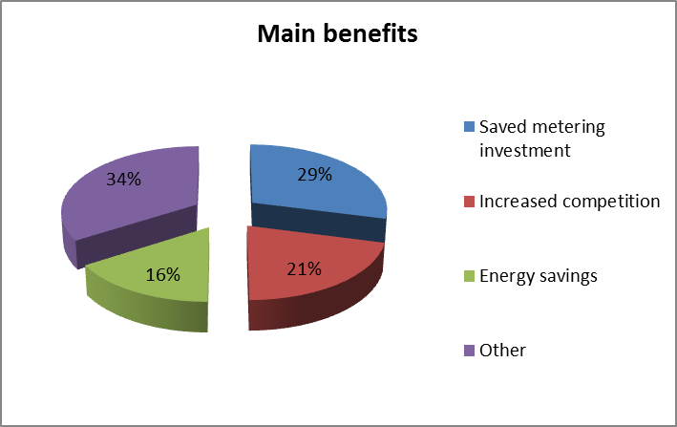

Figure 4-M Share of main costs associated with electricity smart metering roll-out
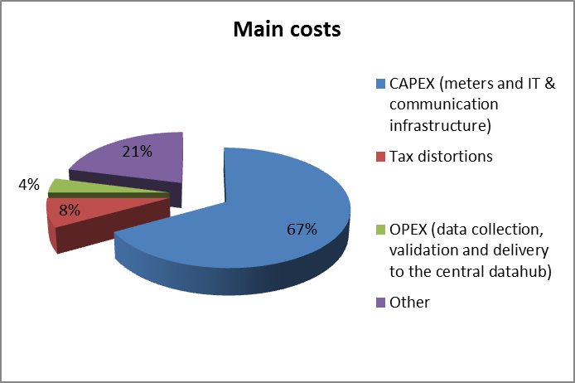

Critical variables – sensitivity analysis
The socio-economic value of the electricity smart metering roll-out appeared to be particularly sensitive to two parameters: the capital cost of the electricity meters and the penetration of consumers who will switch to hourly measured electricity consumption.

Qualitative assessments of non-monetary impacts and new enabled services
Despite the quantifiable benefits of smart metering systems deployment, the Danish CBA considers also the following non-monetary impacts:
- Time-of-use network tariffs – in addition to the spot electricity prices differences, price differences for time-of-use grid tariffs could be included in the analysis;
- Security of the energy supply – due to price responsive electricity load;
- Network capacity deferral;
- Increased competition - hourly billing, based on a partial roll-out, will create a fragmented market that will be less transparent than a market with the matching frameworks since some geographical areas will have remotely-read meters and others will not. That would mean that the areas with remotely-read meters would have weaker competition than other areas.

Remarks
The results of the economic evaluation have shown a socio-economic benefit for getting the rest of the 1.38 million metering points hourly metered and for successfully implementing a billing system which makes it possible to invoice all customers on hourly consumption readings.
A separate analysis has been conducted for electric vehicles and heat pumps. The results indicate that hourly metering and billing for electric vehicles and heat pumps are socio-economically viable. The flexible demand will reduce price spikes, postpone grid investments and provide additional ancillary services, and therefore, offset the costs for electricity meters, enhanced billing and investments in automated control of electricity consumption.

ESTONIA
Estonia is proceeding with a nation-wide roll-out of electricity smart metering systems following the positive results of the economic evaluation of respective long-term costs and benefits.

Organisation of the deployment and regulation
The metering activity in Estonia, as in most Member States, is regulated (Table 5-Q). Under this set-up the DSO is the owner and responsible party for smart meters implementation. The responsibility of third-party access to metering data is granted to a central hub.
Table 5-Q Smart electricity metering deployment set-up and regulation in Estonia
ESTONIA
Metering activity | Regulated
Deployment strategy | Mandatory roll-out
Responsible party -implementation and ownership | DSO
Responsible for third-party access to metering data | Central hub
Financing of the roll-out | Network tariffs

CBA local boundary conditions and scenarios
Table 5-R summarises the local conditions and implementation parameters (e.g. discount rate, roll-out time, smart metering functionalities, etc.) and the scenarios considered for the electricity smart metering roll-out.
Table 5-R CBA boundary conditions in Estonia
CBA BOUNDARY CONDITIONS
Scenarios | Not available
Number of metering points in the Country | 709000
Common minimum functionalities (as proposed by the EC Recommendation 2012/148/EU) | - Partly complying with the second functionality (functionality (b)): Meter readings are on an hourly base (instead of 15min)  - Compliance with the rest of the functionalities
Implementation speed | 2013-2017
Penetration rate by 2020 | 100%
Discount rate | 6.67%
Smart metering lifetime | 15 years
CBA horizon | NA
Communication technology | - PLC – 90%  - GPRS – 10%

Smart metering deployment rate
Figure 5-N illustrates the electricity smart metering deployment rate throughout the roll-out period.
Figure 5-N Electricity smart metering roll-out plan in Estonia

CBA outcome
Table 5-S illustrates the result of the economic evaluation, including the range of main benefits and costs associated with electricity smart metering.
Table 5-S CBA outcome in Estonia
CBA OUTCOME | POSITIVE
Total Investment | € mn. 110
Total Benefit | € mn. 191
Cost/metering point  (EC calculation) | €155
Benefit/metering point (EC calculation) | €269
Consumers' benefit (% of total benefit) | Not available
Main benefits  (% of total benefit) | - Network losses reduction  - Avoided investments  - Avoided meter operating costs (repair and maintenance costs of metering systems)
Main costs  (% of total costs) | - Operating costs  - Maintenance cost of central operating system  - Cost of tele-service
Energy savings  (% of total electricity consumption) | Not available
Peak load shifting  (% of total electricity consumption) | Not available

FINLAND
An economic analysis was carried out in 2008 focusing mainly on the potential of electricity demand elasticity rather than assessing the economic benefits and costs of smart metering roll-out. The industry had voluntarily started a widespread roll-out already in the early 2000’s. The Finnish government mandated a smart metering roll-out for 80% of meters until 2014, but nearly 97% penetration of smart-meters was expected by the end of 2013. However, after completion of the DSOs roll-out projects, the penetration will be close to 100 %.

Organisation of the deployment and regulation
The metering activity in Finland is regulated (Table 6-T). Under this set-up, the distribution system operator (DSO) is the responsible party for smart metering implementation and for granting third-party access to metering data.
Table 6-T Smart electricity metering deployment set-up and regulation in Finland
FINLAND
Metering activity | Regulated
Deployment strategy | Mandatory roll-out
Responsible party -implementation and ownership | DSO
Responsible for third-party access to metering data | DSO
Financing of the roll-out | Network tariffs

CBA local boundary conditions and scenarios
Table 6-U illustrates the result of the economic evaluation, including the range of main benefits and costs associated with the electricity smart metering roll-out.
Table 6-U CBA boundary conditions and scenarios in Finland
CBA BOUNDARY CONDITIONS
Scenarios | No scenario analysis.
Number of metering points in the Country | 3.3 mn.
Common minimum functionalities (as proposed in EC Recommendation 2012/148/EU) | - Compliance with functionality (a); customers have the possibility to order (at an extra cost) metering equipment with separate output installation for real time readings.  - Partly complying with functionality (b), as electricity consumption data are communicated on an hourly base.
Implementation speed | 2009-2013
Penetration rate by 2020 | designed for 97% but actually reaching closer to 100 %
Discount rate | Not available
Smart metering lifetime | 15 – 25 years
CBA horizon | 15 years
Communication technology | - PLC – 30 %  - GPRS – 60 %  - RF – 10 %

Smart metering deployment rate
Figure 6-O illustrates the electricity smart metering deployment rate throughout the roll-out period. Penetration of 97% is expected by the end of 2013 as some of the DSOs had not yet finalised at the time of writing their roll-out project. By 2015, the smart metering penetration rate will be almost 100%.
Figure 6-O Electricity smart metering roll-out plan in Finland

CBA outcome
The economic evaluation of long-term costs and benefits was carried out in 2008 and therefore the costs and benefits reported in Table 6-V are based on that smart metering roll-out appraisal (performed in 2008). The evaluation was mainly focused on finding the prerequisites for demand side response and therefore a comprehensive analysis of benefits of smart meters was not carried out.
Table 6-V CBA outcome in Finland
CBA OUTCOME | POSITIVE
Total Investment | € mn. 692
Total Benefit | Not available
Cost/metering point  (EC calculation) | €210
Benefit/metering point (EC calculation) | Not available
Consumers' benefit (% of total benefits) | Not available
Main benefits  (% of total benefits) | - Demand side management  - DSO cost reduction (due to remote reading)  - Electricity trade and new services
Main costs  (% of total costs) | - Meters costs (40-55%)  - Accessories for the meters (relays, switching gears, etc.) 5-25%  - Installation and maintenance (10-25%)  - Communications (5-40%)
Energy savings  (% of total electricity consumption) | 1-2%
Peak load shifting  (% of total electricity consumption) | 2%

Remarks
In addition to the DSOs, the retail market has also greatly benefitted from the new meters. Remote reading possibility eases the supplier switching procedures and gives consumers tools to better control their consumption. After the installation of smart meters the billing has been based on the actual hourly consumption. The customers can choose their tariff programme, while there are several suppliers offering tariffs based on hourly pricing. The same hourly measurement data is also used for the balance settlement. Finland is therefore one of the first to utilise this kind of accuracy in the electricity retail market, reducing the imbalance risks for the electricity retailers and enabling different pricing schemes to emerge. Also services based on the new meters are developing, and it is reported that there are already companies providing active demand side management of selected loads.
It is stipulated in the law that the consumption data is measured and stored on an hourly basis and that the meter should be read once a day. Most of the newest meters installed are capable of storing data also in 15 minutes intervals but the internal memory does not usually allow for such frequent readings. Changing this in retrospect would be costly as in effect the whole meter would have to be changed. All the meters should have an output terminal where the customer can connect a monitoring screen with instantaneous consumption readings. However, in the case of apartment blocks, technical difficulties and associated costs should be considered for the installation of monitoring screens inside each apartment, due to the fact that usually the meters are situated in the common switchgear room of the building.
In contrast to other countries, data security has not been a great concern of the general public. Even though the smart meters have been widely used for almost a decade in Finland, there have been no major incidences regarding data security.
Based on the Finish experience, various issues should be considered in order to run a smooth installation schedule and achieve customer acceptance. In this context, it is important to train electricians who carry out the actual installation of the meters so as to be ready to address any customer requests. Also, good communication during installation is essential for the acceptance of the roll-out by the consumers.

FRANCE
A financial Cost-Benefit Analysis (CBA) has been carried out based on the outcome of the pilot project Linky. Two scenarios have been considered by the Regulator in its evaluation, in respect to electricity tariffs:
- Scenario 1: Annual average tariffs increase of 2.3% from 2010 to 2020 and 1.8% after 2020; and
- Scenario 2: Annual average tariffs increase of 5.75% from 2010 to 2020 and 1.8% after 2020
The CBA outcome was almost financially neutral for the first scenario and positive for the second. The economic evaluation of the project focused on costs and benefits of the distribution system operator (DSO). Following this assessment and based on the fact that smart metering will empower consumers and support grid stability, the regulator gave his recommendation to proceed with a national roll-out.

Organisation of the deployment and regulation
The metering activity in France is regulated and the DSO is the owner and responsible party for the meters installation (Table 7-W). Also, the DSO is the eligible body for granting third-party access to metering data, however, strictly upon customers' agreement.
Table 7-W Smart electricity metering deployment set-up and regulation in France
FRANCE
Metering activity | Regulated
Deployment strategy | Mandatory roll-out
Responsible party -implementation and ownership | DSO
Responsible for third-party access to metering data | DSO (according to French law, access to metering data for third parties must be agreed on by network users)
Financing of the roll-out | N/A

CBA local boundary conditions and scenarios
Table 7-X summarises the local conditions and implementation parameters (e.g. discount rate, roll-out time, smart metering functionalities, etc.) and the scenarios considered for the electricity smart metering roll-out.

Table 7-X CBA boundary conditions and scenarios in France
CBA BOUNDARY CONDITIONS
Scenarios | Scenario 1 and scenario 2
Number of metering points in the Country | 35 million
Common minimum functionalities (as proposed in EC Recommendation 2012/148/EU) | Compliance for all recommended functionalities reported by the Member State
Implementation speed | 2014-2020
Penetration rate by 2020 | 95%
Discount rate | Not available
Smart metering lifetime | 20 years
CBA horizon | Not available
Communication technology | PLC

Smart metering deployment rate
Figure 7-P illustrates the electricity smart metering deployment rate throughout the roll-out period.
Figure 7-P Electricity smart metering roll-out plan in France

CBA outcome
Table 7-Y illustrates the result of the economic evaluation, including the range of main benefits and costs associated with electricity smart metering.

Table 7-Y CBA outcome in France
CBA OUTCOME | POSITIVE
Total Investment | € mn. 4500
Total Benefit  (€ mn) | Not available – The value depends on the assumptions used, especially regarding the future development of services for data management, the sensitivity of consumers to demand management tools, etc.)
Cost/metering point  (EC calculation) | €135
Benefit/metering point (EC calculation) | Not available
Consumers' benefit  (% of total benefit) | Benefit not quantitatively evaluated. However, the analysis shows net benefit to the consumers.
Main benefits  (% of total benefits) | - Avoided investment in installing existing meters: 30% of total benefits (attributed to the DSO)  - Avoided network losses: 25% (attributed to the DSO)  - Avoided meter reading costs: 15% (attributed to the DSO)
Main costs  (% of total costs) | - Meters (procurement and installation) : 80%,  - Data concentrators (procurement and installation) : 10%  - IT system : 10%
Energy savings  (% of total electricity consumption) | Not available
Peak load shifting  (% of total electricity consumption) | Not available

Critical variables – sensitivity analysis
The result of the CBA outcome associated with the electricity smart metering roll-out appeared to be particularly sensitive to the following parameters:
- Average meter installation time and installation rate;
- Number of data concentrators; and
- Functional operation of the G3-PLC technology.

Remarks
The net present value (NPV) of the Linky project is based on the difference between the costs and benefits of carrying out the project and those of not carrying out the project (i.e. ‘business as usual’). The estimated benefits are the investment or operating expenses avoided, whereas the additional costs are the extra costs generated by the project. The result of the performed CBA indicates nearly balanced outcome in scenario 1 (+ EUR 0.1 billion) and positive outcome in scenario 2 (+ EUR 0.7 billion).
The universal deployment of the Linky smart meter system will entail the installation of 35 million meters, or of about 2 to 7 million meters per year, which will take place in two stages:
- First deployment stage of 7 million meters between 2013 and 2015
- Second deployment stage of 28 million meters over four years (7 million meters per year).

GERMANY
The cost-benefit analysis (CBA) conducted (finalised July 31st 2013) advocates a roll-out in Germany which is tailored to the technology and compliant with the national energy reforms. The CBA does not recommend a large-scale roll-out for smart metering (at least 80% of all consumers by 2020) as costs of smart metering systems for final users with low levels of annual consumption would far outweigh the average potential of annual energy savings.
The current legislative approach encourages smart metering roll-out for the following cases: i) consumers with annual electricity consumption over 6000 kWh; ii) major generation facilities pursuant to the national Renewable Energy Sources Act and the Combined Heat and Power Act, and iii) final consumers in new and renovated buildings.
For the rest of the cases, it is recommended to use intelligent meters – an upgradeable measuring system in accordance with Section 21c(5) of the national Energy Act (EnWG) with no external communication link. Combined with a certified smart meter gateway, they can be extended to a BSI Protection Profile-compliant smart metering system and thus securely integrated into any communication system.

Organisation of the deployment and regulation
A competitive metering deployment set-up is supported in Germany, where the DSO is the owner and responsible party for the smart metering implementation (Table 8-Z). However, the consumer is entitled to the possibility of choosing a third party as meter operator. The Smart Meter Gateway Administrator (SMGA) is the responsible party for granting third-party access to metering data. The role of the SMGA is generally assigned to the meter operator.
Table 8-Z Smart electricity metering deployment set-up and regulation in Germany
GERMANY
Metering activity | Competitive
Deployment strategy | No decision yet
Responsible party -implementation and ownership | Metering point operator (can be the DSO)
Responsible for third-party access to metering data | Metering point operator (can be the DSO)
Financing of the roll-out | No decision yet

CBA local boundary conditions and scenarios
The economic assessment of long-term costs and benefits associated with the smart metering roll-out in Germany considers the following scenarios:
- The ‘EU Scenario’ – it reflects the EU requirement to provide smart metering systems for at least 80% of all consumers by 2020 (which may be subject to a positive CBA as stated in the Electricity Directive 2009/72/EC).
- The ‘Continuity Scenario’ (‘Business-as-usual’) – reflects 25% of metering points equipped with smart metering systems by 2022 under the current regulatory framework. It indicates a mandatory installation in the following cases:
  - For electricity consumers with annual consumption of over 6000 kWh and operators of RES plants with a connected capacity of over 7 kW; and
  - In new and renovated buildings.
- ‘Continuity Scenario Plus’ – it considers installation of intelligent meters instead of, or in addition to, the installation of smart metering systems. The intelligent meters must offer the possibility of integration into a BSI Protection Profile-compliant communication system. The same scenario allows for a comprehensive roll-out of smart metering systems by 2029, whereas by 2022 the proportion will be 1/3 smart metering systems and 2/3 intelligent meters.
- ‘Roll-out Scenario’ – it focuses on the integration of renewable energies. Under the current legal framework, the obligation to install smart metering systems applies only to new RES and CHP with a contracted power of at least 7 kW. This scenario extends the mandatory installation of smart metering systems to old RES/CHP plants as well as to the ones with less than 7 kW, down to a threshold of 250 Watt.
- ‘Roll-out Scenario Plus’ – it is an extended ‘Roll-out Scenario’ that includes the installation of intelligent meters along with the mandatory installation of smart metering systems, as described in the previous scenario.

Table 8-AA illustrates the local conditions and main parameters used for the economic assessment of smart metering roll-out in Germany associated with the ‘roll-out scenario plus’.
Table 8-AA CBA boundary conditions in Germany
CBA BOUNDARY CONDITIONS
Scenarios | Continuity scenario; Continuity scenario Plus; EU scenario, Roll-out scenario, Roll-out scenario plus
Number of metering points in the Country | 47.9 mn., of which:  - 11.9 million (2022) to be equipped with Smart Metering  - 15.8 million (2032) to be equipped with Smart Metering
Common minimum functionalities (as proposed in EC Recommendation 2012/148/EU) | Compliance for all the functionalities, except on functionality g), there is no decision yet
Implementation speed | 2014-Not available
Penetration rate by 2020 | 23 % (by 2022)  31 % (by 2032)
Discount rate | - 5 % (for cash flows of commercial stakeholders)  - 3.1 % (for cash flows of the end consumers and of the distribution system operator (DSO))
Smart metering lifetime | 13 years
CBA horizon | 20 years (2012-2032)
Communication technology | Market based  - GPRS/UMTS/LTE – 80 %  - PLC/BPL – 20 %  - DSL – 5 %  - Fibre-optics – 5 %

Smart metering deployment rate
Figure 8-Q illustrates the electricity smart metering deployment rate throughout the roll-out period and refers to the Continuity Scenario.

Figure 8-Q Electricity smart metering roll-out plan in Germany

CBA outcome
Table 8-BB illustrates the main outcome of the economic assessment of long-term costs and benefits carried out and referring to the Roll-out Scenario Plus.

Table 8-BB CBA outcome in Germany
CBA OUTCOME | POSITIVE (for the Roll-out Scenario Plus)  NEGATIVE for the EU scenario
Total Investment | - € mn. 6493 (by 2022)  - € mn. 14466 (by 2032)
Total Benefit | - € mn. 5865 (by 2022)  € mn. 16968 (by 2032)
Cost/metering point (as communicated by the Member State) | € 546
Benefit/metering point as communicated by the Member State) | € 493
Consumers' benefit  (% of total benefits) | 47%
Main benefits  (% of total benefits) | - Energy savings - 33%  - Load shifting - 15%  - Avoided investments in the distribution grid - 13%
Main costs  (% of total costs) | - Investments smart metering systems (meter, gateway, communication infrastructure) - 30%  - Communication costs - 20%  - IT-costs - 8%
Energy savings  (% of total electricity consumption) | 1.2%
Peak load shifting  (% of total electricity consumption) | - 1.3% in average between 2014 and 2022  - 2.9% in 2032

Figure 8-R and Figure 8-S show the share of main benefits and costs, respectively, associated with the smart metering systems roll-out.

Figure 8-R Share of main benefits associated with electricity smart metering roll-out
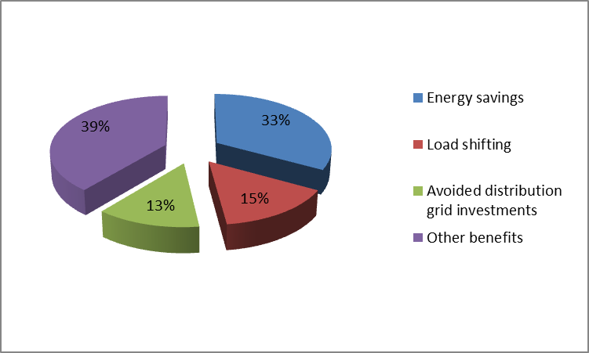

Figure 8-S Share of main costs associated with electricity smart metering roll-out
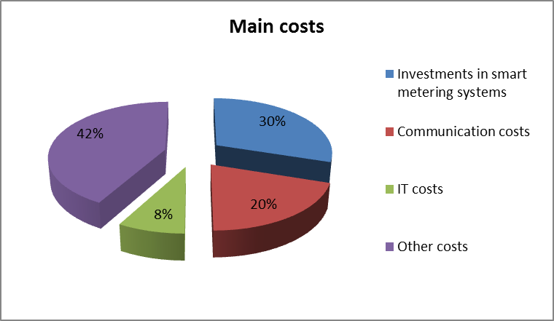

Critical variables – sensitivity analysis
The economic assessment of long-term costs and benefits associated with smart metering deployment considers the following parameters for performing the sensitivity analysis, based on the Roll-out Scenario Plus:
- Energy savings;
- Electricity price;
- Grid efficiency;
- Halving the EEG (Renewable Energy Source Act) compensation payments for limitation of RES feed-in capacity;
- Delayed mandatory installation from the past;
- Optimisation of the organisational structure;
- Expansion of mandatory installations to further consumer groups;
- Changes in mandatory installations for new and renovated buildings;
- Consideration of heat pumps, electric vehicles and other controllable energy applications;
- Telecommunication infrastructure;
- Extension of the deadline for mandatory installations and replacement interval; and
- Provision of value added services.

Remarks
The CBA conducted by a private consulting firm (finalised the July 31st 2013) advocates a roll-out in Germany which is tailored to the technology and compliant with Germany’s energy reforms. It does not recommend a large-scale roll-out of smart metering systems targeting all (or at least 80% of) households by 2020. Based on the analysis performed, in the case of final users with low levels of annual consumption, the costs of a smart metering system would far outweigh the average potential annual energy savings. The authors of the CBA report believe that compulsory installation would be disproportionate and would represent an unacceptable economic burden. Instead, in the view expressed in the CBA, the current legislative approach, which provides for a roll-out to high-consumption end-users, operators of major generation facilities pursuant to the Renewable Energy Sources Act and the Combined Heat and Power Act, and final consumers in modern buildings, should be resolutely further developed. All renewable energy and cogeneration facilities, as well as controllable consumption units pursuant to Section 14a of the Energy Industry Act (e-mobility, night storage heaters and heat pumps), should be included. Such a roll-out would make sense, as argued in the national CBA, in overall economic terms if it could simultaneously achieve various beneficial effects (e.g. improvement in energy efficiency, improvements in processes, avoidance of need to expand the grid due to active feed-in management, and optimisation of grid planning and operation). For all other installation cases, the report recommends the use of upgradable meters (digital electricity meter protected by protection profile which can be upgraded into a metering system compliant with the protection profile).
The German Federal Ministry of Economics and Technology announced, at the moment of writing this Staff Working Document, that it will give associations and consumer representatives the opportunity to discuss the findings of the study with its authors. Afterwards, Germany will define its roll-out strategy after checking which recommendations of the conducted CBA can be implemented. Business associations and consumer representatives will have the opportunity to discuss the findings of the study with the authors via the Grid Platform's Smart Meter Working Group.

GREECE
The economic assessment of long-term costs and benefits associated with the smart metering roll-out was initially conducted in June 2010 and then revised in August 2012. The results presented hereinafter refer to the revised economic assessment under the scenario of ‘Electricity Meters Only with DLC LV’.

Organisation of the deployment and regulation
The metering activity in Greece is regulated and the DSO is the owner and responsible party for the meter installation and for granting third-party access to metering data (Table 9-CC).
Table 9-CC Smart electricity metering deployment set-up and regulation in Greece
GREECE
Metering activity | Regulated
Deployment strategy | Mandatory
Responsible party -implementation and ownership | DSO
Responsible for third-party access to metering data | DSO
Financing of the roll-out | Information not available

CBA local boundary conditions and scenarios
The reference scenario for the cost-benefit analysis (CBA) conducted was the electricity smart metering roll-out only with main communications technology PLC (Power Line Communication) to data concentrators and GPRS (General Packet Radio Service) from concentrators to back-office (Data Management System). For areas of low density (assumed to be 10% of the meter population), the technology opted for the appraisal was low power radio (mesh) with GPRS to the back-office.
In summary, six scenarios were used in the assessment, as follows:
- Implementation of Automated Metering Infrastructure (AMI) using a combination of Power Line Carrier (PLC) and General Packet Radio Service (GPRS) or fibre optics communications media over the Low Voltage and Medium Voltage network;
  - electricity only option
  - electricity and gas option.
- Implementation of Automated Metering Infrastructure (AMI) using a combination of Distribution Line Carrier (DLC) and General Packet Radio Service (GPRS) communications media over the Low Voltage network;
  - electricity only option
  - electricity and gas option.
- Implementation of AMI using optical fibre networks to be provided by OTE in Athens, Thessaloniki and urban centres up to 8000 inhabitants; and a combination of Mesh technology and GPRS in areas and islands where optical fibre is not planned for
  - electricity only option
  - electricity and gas option.

Table 9-DD illustrates the local conditions and main parameters used for the economic assessment of smart metering roll-out in Greece associated with the reference scenario (i.e. electricity meters only with PLC over Low Voltage (LV)/Medium Voltage (MV) networks)
Table 9-DD CBA boundary conditions in Greece
CBA BOUNDARY CONDITIONS
Scenarios | Six scenarios considered (see above)  Preferred scenario: Electricity meters only with PLC over LV/MV networks
Number of metering points in the Country | 7 mn.
Common minimum functionalities (as proposed in EC Recommendation 2012/148/EU) | Compliance reported with all recommended functionalities
Implementation speed | 2014-2020
Penetration rate by 2020 | 80%
Discount rate | 8%
Smart metering lifetime | 15 years
CBA horizon | 25 years
Communication technology | - From the smart meter to the data concentrator: PLC (for the reference scenario)  - From the data concentrator to the DMS: PLC (for the reference scenario)

Smart metering deployment rate
Figure 9-T illustrates the electricity smart metering deployment rate throughout the roll-out period.

Figure 9-T Electricity smart metering roll-out plan in Greece

CBA outcome
Table 9-EE illustrates the main outcome of the economic assessment of long-term costs and benefits carried out and referring to the scenario of ‘electricity meters only with PLC over LV/MV networks’.
Table 9-EE CBA outcome in Greece
CBA OUTCOME | POSITIVE
Total Investment | € mn. 1733
Total Benefit | € mn. 2443
Cost/metering point  (EC calculation) | €309
Benefit/metering point  (EC calculation) | €436
Consumers' benefit  (% of total benefits) | 80.7%
Main benefits  (% of total benefits) | - Consumption reduction - direct feedback (44%)  - Meter reading savings (14%)  - Carbon benefits (11%)
Main costs  (% of total costs) | - Procurement and installation of meters (55%)  - Display costs (20%)  - Communication infrastructure – PLC (9%)
Energy savings  (% of total electricity consumption) | 5%
Peak load shifting (% of total electricity consumption) | 5%

Figure 9-U and Figure 9-V illustrate the main benefits and costs, respectively, associated with the electricity smart metering roll-out in Greece.

Figure 9-U Share of main benefits associated with electricity smart metering roll-out
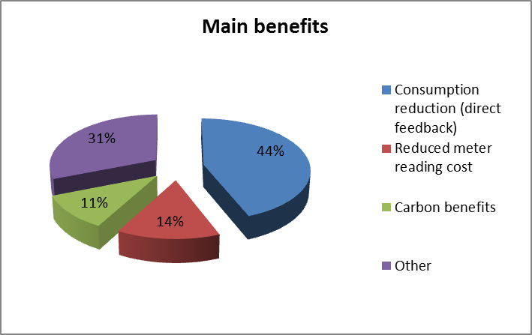

Figure 9-V Share of main costs associated with electricity smart metering roll-out
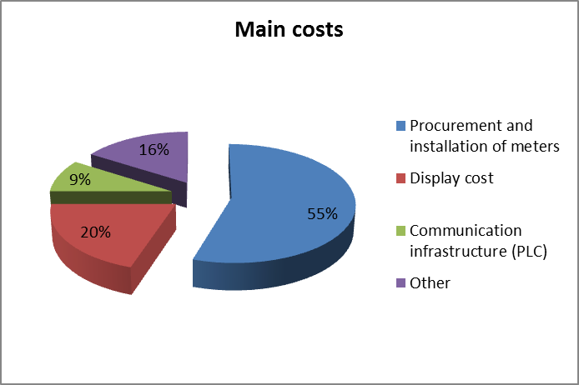

Critical variables – sensitivity analysis
The outcome of the national electricity smart metering deployment appears to be particularly sensitive to the following parameters:
- Amount of energy savings – variation from 3% to 7% could lead to negative net present value in the second scenario (electricity and gas smart metering deployment with PLC);
- Discount rate;
- Capital costs for meters and displays;
- Appraisal (discounting) period;
- Duration of the smart metering roll-out programme;
- Electricity, gas and CO₂ price changes were included in the sensitivity analysis;
- The labour force costs; and
- Cost of IHD (in-home display)
The amount of energy savings and the value of the discount rate are the two parameters that trigger the larger variations in the overall net present value (NPV) in all cases.

Qualitative assessments of non-monetary impacts and new enabled services
A number of other benefits are likely to be accrued with the smart electricity roll-out since it paves the way to the transition to smart grids, therefore enabling a set of opportunities as provided below:
- Management of distributed (and micro) generation;
- Demand response benefits;
- Easier integration of energy storage and electric vehicles in the electricity system; and
- Provision of new energy services to the consumers.

Remarks
Results from the national cost-benefit study on the roll-out of smart metering indicate that there is a positive business case for Greece when it comes to rolling out smart metering in their territory. Out of the selected technologies, the fibre option outperforms the rest since it utilises communications infrastructure that would be installed in the country regardless of the outcome of the smart metering roll-out. This solution is argued in the national study to be a proven technology, the most 'future-proof’, and able to achieve the highest speeds and bandwidth than the other two solutions considered. From the PLC options, the option that utilises the Medium Voltage network is more cost-efficient than the DLC option, mainly due to less communication costs. However, this might be the slowest solution with relatively limited bandwidth. Consumers are expected to gain the largest share of benefits due to the possibility for an enhanced management of their energy consumption and potential for electricity bill reduction.
From the sensitivity analysis undertaken, it is clear that the most sensitive parameter is the assumption on the amount of electricity savings due to feedback from in-home displays. This clearly indicates that household consumers will need to be well-informed, accept the new technology, and actively engage in it so as to achieve maximum benefits from the programme. This requires a co-ordinated approach from different institutions, like electricity retailers, the respective Ministry of Environment, Energy and Climate Change, the General Secretariat of the Consumer, the Regulatory Authority for Energy and others.

IRELAND
The economic assessment of long-term costs and benefits associated with smart metering roll-out was performed in May 2011 and had a positive outcome. To this end, Ireland has laid out plans for a large-scale smart metering roll-out.

Organisation of the deployment and regulation
The metering activity in Ireland is regulated and the distribution system operator (DSO) is the owner and responsible party for the meter installation and for granting third-party access to metering data (Table 10-FF).
Table 10-FF Smart electricity metering deployment set-up and regulation in Ireland
IRELAND
Metering activity | Regulated
Deployment strategy | Mandatory
Responsible party -implementation and ownership | DSO
Responsible for third-party access to metering data | DSO
Financing of the roll-out | Network tariffs

CBA local boundary conditions and scenarios
The ‘business as usual’ (counterfactual) scenario covers the costs that will be incurred if the roll-out of smart metering would not proceed, namely:
- Unsaved benefits in meter reading, meter replacement and meter operations;
- Unsaved benefits in postponing future network reinforcement; and
- Normal digital meters installed for new connections and special keypad type meters installed for prepay.
Furthermore, the counterfactual scenario assumes increased frequency of meter readings (in absence of smart meters) from 4 readings per annum to 6 or 12 annual readings per customer. In addition to the counterfactual scenario, the Irish Commission for Energy Regulation (CER) identified 12 high level smart metering national roll-out options, as illustrated in the table below.

Table 10-GG Smart electricity metering roll-out options in Ireland
Option | Billing Baseline | Billing Scenario | Comm's | In-Home Display
Option 1 | Bi-monthly | Bi-monthly | PLC-RF | No
Option 2 | Bi-monthly | Bi-monthly | PLC-RF | Yes
Option 3 | Bi-monthly | Monthly | PLC-RF | No
Option 4 | Bi-monthly | Bi-monthly | PLC-GPRS | No
Option 5 | Bi-monthly | Bi-monthly | PLC-GPRS | Yes
Option 6 | Bi-monthly | Monthly | PLC-GPRS | No
Option 7 | Bi-monthly | Bi-monthly | GPRS | No
Option 8 | Bi-monthly | Bi-monthly | GPRS | Yes
Option 9 | Bi-monthly | Monthly | GPRS | No
Option 10 | Monthly | Monthly | PLC-RF | No
Option 11 | Monthly | Monthly | PLC-GPRS | No
Option 12 | Monthly | Monthly | GPRS | No

The table below illustrates the local conditions and main parameters used for the economic assessment of smart metering roll-out in Ireland associated with the reference scenario (i.e. electricity meters only with PLC over Low Voltage (LV)/Medium Voltage (MV) networks).
Table 10-HH CBA boundary conditions and scenarios for smart electricity metering roll-out in Ireland
CBA BOUNDARY CONDITIONS
Scenarios | Twelve scenarios (options) considered in the CBA  Preferred scenario: Option 2
Number of metering points in the Country | 2.2 million
Common minimum functionalities (as proposed in EC Recommendation 2012/148/EU) | Compliance for all the functionalities reported by the Member State
Implementation speed | 2014-2019
Penetration rate by 2020 | 100%
Discount rate | 4%
Smart metering lifetime | 17 years
CBA horizon | 21 year (2011-2032)
Communication technology | PLC/RF

Smart metering deployment rate
Figure 10-W illustrates the electricity smart metering deployment rate throughout the roll-out period.
Figure 10-W Electricity smart metering roll-out plan in Ireland

CBA outcome
Table 10-II illustrates the main outcome of the economic assessment of long-term costs and benefits carried out and referring to the aforementioned option 2.
Table 10-II CBA outcome for electricity smart metering roll-out in Ireland
CBA OUTCOME | POSITIVE
Total Investment | € mn. 1040 (DSO related cost)
Total Benefit | € mn. 1212
Cost/metering point  (EC calculation) | €473
Benefit/metering point (EC calculation) | € 551
Consumers' benefit (% of total benefits) | Not available
Main benefits  (% of total benefits) | - Energy savings  - Deferred capacity investment and reduction in SMP  - Suppliers savings (fewer complaints and queries, less costly management of bad payers and supplier switch savings)
Main costs  (% of total costs) | - DSO costs (CAPEX+OPEX)  - Supplier costs (Improved billing system and customer education, running more complex set of bills and tariffs)
Energy savings  (% of total electricity consumption) | 2.9%
Peak load shifting  (% of total electricity consumption) | 9.9%

Critical variables – sensitivity analysis
The estimated total net present values for the 12 options considered in the cost-benefit analysis performed are generally positive. If these results were borne out in an actual deployment of smart metering, the project would bring about substantial net benefits for Ireland in comparison with the base case scenario. PLC-RF communications show higher net benefits than the other technologies examined, although the difference to PLC-GPRS may depend upon the value of key parameter assumptions. The attractiveness of GPRS communications depends strongly on the assumed cost of network services and, to a lesser extent, on the perceived need to build in compatibility with more advanced communication standards.
Turning to the informational stimuli, bi-monthly billing with no IHD exhibits consistently the highest total net present value, but the margin is only € 4 mn. compared to the next best option (bi-monthly billing with an IHD).
Important sources of variation in estimated net present values arose from assumptions about the expected pattern of residential demand response, the level of additional billing system OPEX by suppliers and network costs such as the costs of meters, meter installation and IHDs. Most other sensitivity tests on network cost items showed modest effects.
The project’s viability does not appear to be particularly sensitive to the assumed discount rate.

Qualitative assessments of non-monetary impacts and new enabled services
There are a number of potential costs and benefits from a national roll-out of electricity smart metering that are very difficult to put a robust quantifiable estimate on, and can only be qualitatively assessed. Such elements include the following potential costs and benefits:
- Facilitation of a smarter electricity network, or ‘smart grid’, in Ireland that will assist in efficiently managing the greater levels of renewable generation on the system;
- Facilitation of a greater uptake of micro generation;
- Facilitation of electric vehicles (EVs);
- Facilitation of gas smart metering;
- Facilitation of water smart metering; and
- Facilitation and/or synergies with a smart grid implementation, and integration of micro generation, electric vehicles, gas smart metering and water smart metering systems.

Remarks
The estimated total net present values for the 12 main national smart metering roll-out options analysed are generally positive and remain positive under the sensitivity analyses run. Each option combined different parameters for billing, communication and IHD, which allows drawing interesting conclusions and providing a sufficient combination of options for the actual implementation of the system.
PLC-RF communications solution shows higher net benefits than the other technologies examined, although the difference to PLC-GPRS may depend upon the value of key parameter assumptions.
Regarding the information stimuli provided to the final consumers, bi-monthly billing with no IHD consistently exhibits the highest total net present value; however the margin is only €4m compared to the next best option (bimonthly billing with an IHD) under Tariff A.

ITALY
The largest Italian distribution system operator (DSO) ENEL Distribuzione carried out an internal CBA to assess long-term costs and benefits before proceeding to the large-scale roll-out of smart metering systems in 2001. The figures for a nation-wide roll-out in Italy are obtained by extrapolating the figures from this first exercise, covering about 85% of metering points in Italy.

Organisation of the deployment and regulation
The metering activity in Italy is regulated and the DSO is the owner and responsible party for smart metering implementation and granting third-party access to metering data, as indicated in Table 11-JJ.
Smart metering deployment on ENEL's meters started already in 2001 and was completed in 2006. During the same year and in the following, the national regulatory authority (Autorita per l'Energia Elettrica ed il Gas) defined the legal framework for mandatory roll-out to all metering points in the Country (and therefore also to other DSOs).
Table 11-JJ Smart electricity metering deployment set-up and regulation in Italy
ITALY
Metering activity | Regulated
Deployment strategy | Voluntary + Mandatory
Responsible party -implementation and ownership | DSO
Responsible for third-party access to metering data | DSO
Financing of the roll-out | DSO resources for the very first years + Metering tariffs since 2004

CBA local boundary conditions and scenarios
Table 11-KK presents the local conditions and the main parameters considered for the economic assessment of long-term costs and benefits associated to smart metering roll-out.
Table 11-KK CBA boundary conditions and scenarios for smart electricity metering roll-out in Italy
CBA BOUNDARY CONDITIONS
Scenarios | Not available
Number of metering points in the Country | 36.7 million
Common minimum functionalities (as proposed in EC Recommendation 2012/148/EU) | Compliance with all the functionalities (at the moment partly for functionality (b)) of the smart metering systems, as drafted in the Recommendation of 2012/148/EU.  Regarding compliance with functionality (b):  The metering data can be accessed through local interface (Enel smart info®) that can be connected by the customer in every domestic socket. This interface is already available and it is currently being provided in large pilot projects. With the Enel smart info® final customers can monitor their consumption data collected every 10 min and achieved in real time upon customer request.
Implementation speed | 2001-2011
Penetration rate by 2020 | 99%
Discount rate | 4.5%
Smart metering lifetime | 15-20 years
CBA horizon | Not available
Communication technology | Smart meter-DC: PLC  DC-DMS: GSM/GPRS

CBA outcome
Table 11-LL illustrates the main outcome of the economic assessment of long-term costs and benefits carried out in Italy.
Table 11-LL CBA outcome for electricity smart metering roll-out in Italy
CBA OUTCOME | POSITIVE
Total Investment | € mn. 3400
Total Benefit | € mn. 6400 (only DSO benefit)
Cost/metering point  (EC calculation) | €94
Benefit/metering point (EC calculation) | €176
Consumers' benefit  (% of total benefits) | Not available
Main benefits  (% of total benefits) | - Revenue protection (including reduction of non-technical losses)  - Reduction of meter reading and operations costs  - Purchasing and logistics  - Customer service (e.g. invoicing, bad debts management)
Main costs  (% of total costs) | - 95% of CAPEX is associated with the production and installation of smart meters and concentrators.  - The remaining 5% corresponds to costs associated with IT system development, R&D costs and other expenses.
Energy savings  (% of total electricity consumption) | Not available
Peak load shifting  (% of total electricity consumption) | Not available

Remarks
The Enel’s Telegestore® project was a voluntary project, bringing forward the large-scale smart meters installation programme in Italy and paving the way towards smart grids. Recognizing the benefits of implementing smart metering, in 2006 the Italian Regulatory Authority (AEEG) set the mandatory installation of smart meters in Italy, with minimum functional requirements for all the DSOs and Low Voltage customers starting from 2008 and reaching 95% penetration rate in 2011. This allowed Italy to meet the EU target for 80% of households, on the positively assessed cases, to have smart meters, well ahead of 2020.
Over the course of years that Telegestore was implemented, the Italian electricity sector was moving towards a liberalised market, with the distribution and transmission parts of the business still subject to regulation and the rest of the business open to competition. Since the beginning of the liberalisation process, energy retailers offered competitive and differentiated schemes in order to attract customers, and were reportedly facilitated in that by the responsible DSOs. Fully deployed smart metering systems are considered to have played a pivotal role in accelerating the market liberalisation process. Switching from one retailer to another, as well as changing the tariff structure or other contractual parameters became a remotely managed operation, consisting of new configurations to be stored in the central system and to be remotely programmed on the meters.
Smart metering also played an important role in the activation of new tariffs defined by the energy regulator for customers who preferred to remain in the regulated market instead of the liberalised one, supporting time-of-use with the aim of harmonising consumption and limiting peaks in demand. To this regard, in 2010 AEEG set the introduction of mandatory Time-of-Use tariffs for residential customers under the universal supply regime, which was possible because of the large-scale installation of smart meters. In addition, the Regulator introduced a new service for the protection of vulnerable consumers enabled by smart metering. While in the past bad payers were fully disconnected, they are now allowed for a ‘minimum vital service’ (0.5 kW) for 2 weeks before full disconnection. Further, when the debt is settled after disconnection, they can be reactivated almost instantaneously after the payment.
The experience gained in the deployment of electricity smart metering can be exploited also by other utilities (such as gas, water, etc.) to support the evolution of smart metering in other sectors. In this respect it is noted that:
- In 2008 the National Regulatory Authority introduced obligations for deployment of gas smart metering (currently target is at 60% by 2018 for smaller gas customers, whilst remote reading is already implemented for medium and large size gas customers (regulatory decision no. 155/2008);
- Furthermore, the National Regulatory Authority has recently launched a call for demonstration projects for multi-service smart metering pilots, encompassing gas, water, electricity and other ‘smart city’ applications (mobility services, urban waste collection, etc. (regulatory decision n. 393/2013).

LATVIA
The Latvian competent authority for smart metering is the Ministry of Economics, Energy Department, Division of energy markets, infrastructure and coordination of cooperation.
A cost-benefit analysis for the intelligent metering deployment has not been made available to the Commission services. The data shown below are those reported by the national authorities responsible for following smart metering issues.

Organisation of the deployment and regulation
The metering activity in Latvia is set up as a regulated market, and the DSO is to remain the owner and responsible party for the meter, including smart meter, installation and for granting third-party access to the respective metering data. The financing will be ensured through network tariffs.
Table 12-MM Smart metering deployment set-up and regulation in Latvia
LATVIA
Metering activity | Regulated
Deployment strategy | Not available (no roll-out yet)
Responsible party -implementation and ownership | DSOs
Responsible for third-party access to metering data | DSOs
Financing | Network Tariffs

CBA local boundary conditions and scenarios
The outcome of the analysis is negative for a large-scale roll-out, but it is reported that in the near future installation of definite amount of smart meters could be mandatory; in fact a roll-out of up to 23% of total metering points in the country by 2017 is currently foreseen.

Table 12-NN CBA boundary conditions and scenarios in Latvia
CBA BOUNDARY CONDITIONS
Scenarios | Not available
Metering points in the country | 1089109
Common minimum functionalities (as proposed in EC Recommendation 2012/148/EU) | Full compliance to recommended functionalities is reported
Implementation speed | 3 years, from 2015 to 2017 (for a roll-out of up to 23% of total metering points)
Penetration rate by 2020 | 23%
Discount rate | 6.6% for years 2015 – 2017  6.8% for years 2018-2019  6.9% fir tears 2020-2024
Smart metering lifetime | 12
CBA Horizon | 10 years, from 2015 till 2024
Communication technology | - 100% of communication technology adopted from the smart meter to the concentrator is PLC  - 100% of technology adopted from the data concentrator to the data centre is GSM

CBA outcome
The CBA performed considers a period from 2015 to 2024. The result for a large-scale roll-out is negative, although Latvia will proceed with the roll-out to specific customer segments.
Table 12-OO CBA outcome in Latvia
CBA OUTCOME | Negative
Total Investment | € mn. 75.6
Total Benefit | € mn. 4.44
Cost/metering point  (EC calculation) | €302
Benefit/metering point  (EC calculation) | €18
Consumers' benefit  (% of total benefits) | 2% - 5%
Main benefits  (% of total benefits) | - Energy savings (57%)  - Savings on personnel costs for DSO (24%)  - CO2 reduction (11%)
Main costs  (% of total costs) | - Cost of Smart Metering (32%  - Cost of communication infrastructure (16%)  - Installation cost (8%)
Energy savings  (% of total electricity consumption) | 2% - 5%
Peak load shifting  (% of total electricity consumption) | Not available

Figure 12-X and Figure 12-Y show the main benefits and costs, respectively, associated with the electricity smart metering roll-out in Latvia. The main benefits considered in the CBA are energy savings and savings due to avoided manual meter readings. It is not possible to proceed with a detailed analysis of beneficiaries from the roll-out plan, as the detailed CBA has not been made yet available for analysis (at least at the moment of writing this Staff Working Document). The only benefit identified is that for consumers, which is estimated within a range of 2% to 5%, i.e. the consumers’ benefit equals the expected energy savings. For comparison purposes it is preferable that energy savings are accounted in terms of total electricity consumption (GWh), and consumers’ benefit is expressed as part of the total benefit (estimated in euros). In the absence of further information to this respect, it is unclear what the consumers’ benefit represents.
Regarding costs, the Latvian assessment identifies as main costs those directly related to the smart meters’ roll-out: about 1/3 of the whole investment is for the procurement of smart meters. However, a significant amount of costs (44%) are reported to come from other sources, which cannot be identified as the CBA is not yet available for consultation.

Figure 12-X Share of main benefits from electricity smart metering roll-out
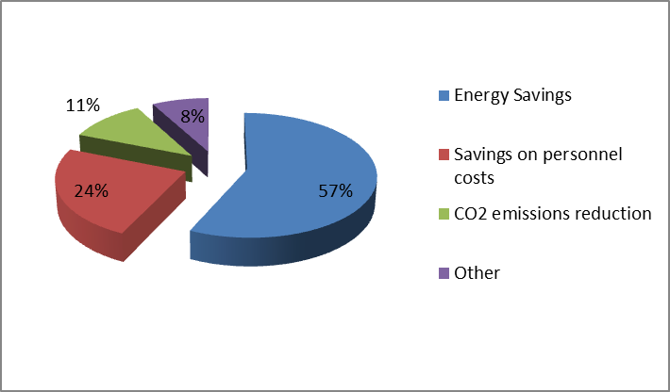

Figure 12-Y Share of main costs from electricity smart metering roll-out
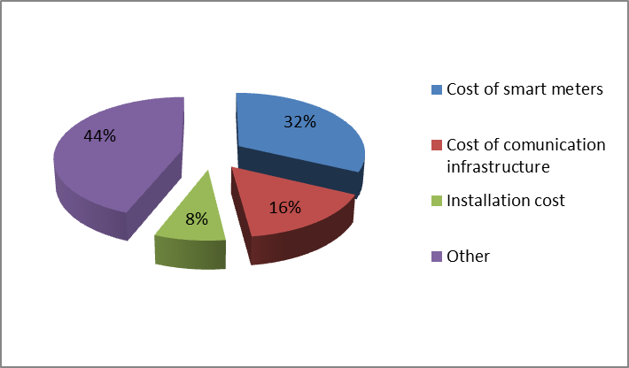

Remarks
The evaluation for smart metering roll-out in Latvia argues that peak load shaving/load shifting benefit is not relevant and therefore has not been assessed, as most consumers have rather small energy consumption. In addition, it is reported that no tariff differentiating peak and off-peak hours is available.

LITHUANIA

Organisation of the deployment and regulation
The competent authority in Lithuania for the smart metering roll-out is the Ministry for Energy. The Ministry has established a dedicated working group on ‘Defining the Smart Grid Development Direction’ in 2009 and selected an external consultant to perform a cost-benefit analysis (CBA).
Table 13-PP Smart metering deployment set-up and regulation in Lithuania
LITHUANIA
Metering activity | Regulated
Deployment strategy | Not available (no roll-out yet)
Responsible party -implementation and ownership | DSOs
Responsible for third-party access to metering data | DSOs
Financing | Network Tariffs

CBA local boundary conditions and scenarios
The CBA identified three relevant scenarios to evaluate the impacts of smart metering roll-out in Lithuania: 1) ‘Base case’; 2)‘Advanced functionality’; and 3) ‘Multi metering scenario’.
The least negative is the ‘Base case’ scenario, characterised by:
- meters featuring basic functionalities;
- a communication technology based exclusively on PLC (from the meter to the concentrator) and GPRS (from concentrator to data aggregator); and
- the mandatory set-up of a Time of Use pricing.
This scenario (as the ‘Multi-metering scenario’) entails a roll-out to 80% of all consumers by 2020, while the scenario ‘Advanced Functionality’ entails a roll-out to 100% of consumers. In the ‘Advanced Functionality’ and the ‘Multi-metering’ scenario, the provision of a in-home display is included among the hypotheses for the analysis.
It should be noted that the Lithuanian case has some specificities that affect the results: the average consumption per household (and consequently the average electricity bill) in Lithuania are among the lowest in EU, and transmission and distribution networks have significant spare capacity.

Table 13-QQ CBA boundary conditions and scenarios in Lithuania
CBA BOUNDARY CONDITIONS
Scenarios | Base case, Advanced Functionality, Multi-metering scenario
Metering points in the country | 1.6 mn.
Common Minimum functionalities (as proposed in EC Recommendation 2012/148/EU) | The functionalities considered in the CBA are reported to be compliant with the recommended.
Implementation speed | 5 years, from 2014 until 2020
Penetration rate by 2020 | 80% considered in the CBA  Not available – the expected roll-out rate by 2020
Discount rate | 5.5% for the CBA  (5% in the financial analysis)
Smart metering lifetime | 15
CBA Horizon | 2011 – 2029
Communication technology | - PLC and GPRS from the meter to the concentrator  - GPRS from the concentrator to the data centre

CBA outcome
The CBA performed considers a period from 2011 till 2029. The sensitivity analysis showed that significant changes in the key variables, such as the electricity price, are likely to also impact the CBA results.
Table 13-RR CBA outcome in Lithuania
CBA OUTCOME | Negative
Total Investment | € mn. 254
Total Benefit | € mn. 128
Cost/metering point (as communicated by the Member State) | €123
Benefit/metering point (as communicated by the Member State) | €82
Consumers' benefit  (% of total benefits) | 26%
Main benefits  (% of total benefits) | - Energy savings (26%)  - Reduction of non-technical losses (22%)  - Load shifting (14%)
Main costs  (% of total costs) | - Smart Meters procurement (38%  - Smart Meters installation (18%)  - Data concentrators procurement (8%)
Energy savings (% of total electricity consumption) | 2.3%
Peak load shifting (% of total electricity consumption) | 4.5%

Figure 13-Z and Figure 13-AA show the main benefits and costs, respectively, associated with the electricity smart metering roll-out in Lithuania. The main benefits considered in the CBA are energy savings and reduction of commercial losses, as indicated in Figure 13-Z. The analysis features a detailed estimation of benefits for each customer segment: household urban, household rural, commercial under 30kW, commercial over 30 kW. About one third of the total metering points need three-phase meters. According to the analysis performed, the consumers are the most important beneficiaries from the smart metering roll-out. No detailed analysis is provided on the impact of smart metering on DSOs, the environment and an account of the positive effects on the process towards a higher participation in the electricity markets and towards integration of renewable energy sources.
Figure 13-Z Share of main benefits associated with smart metering roll-out
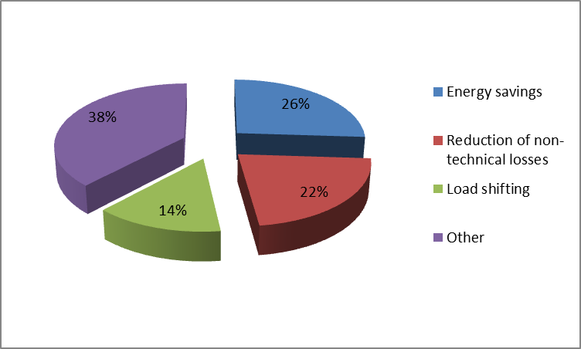
Concerning costs, the Lithuanian CBA identifies the smart meters costs as main costs of the roll-out, as depicted in Figure 13-AA.
Figure 13-AA Share of main costs from electricity smart metering roll-out
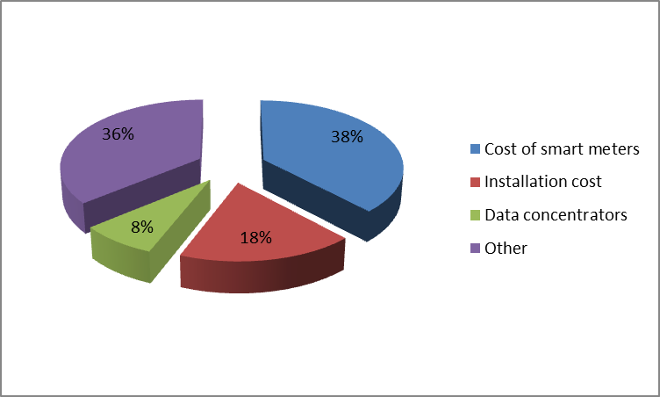

LUXEMBOURG
According to national law, each network operator must ensure that at least 95 % of electricity customers connected to the network are equipped with a smart metering system by 31/12/2018. The technical standards or functionalities of smart meters have not yet been set at the moment of writing the present Staff Working Document, however a public consultation is still on-going and the regulator will set these specifications early 2014 at the latest. The modified laws of August 1st, 2007 set that the general roll-out of smart metering systems will start by July 1st, 2015. A detailed cost-benefit analysis (CBA) has not been made available. The data shown below have been provided by the national authorities following smart metering activities.

Organisation of the deployment and regulation
The metering activity in Luxembourg is regulated, and the distribution system operator (DSO) is the owner and responsible party for smart meter installation and for granting third-party access to metering data (Table 14-SS).
Table 14-SS Smart electricity metering deployment set-up and regulation in Luxembourg
LUXEMBOURG
Metering activity | Regulated
Deployment strategy | Mandatory
Responsible party -implementation and ownership | DSO
Responsible for third-party access to metering data | DSO
Financing of the roll-out | Network tariffs

CBA local boundary conditions and scenarios
Table 14-TT presents the local conditions and the main parameters considered for the economic assessment of long-term costs and benefits associated to smart metering roll-out.
Table 14-TT CBA boundary conditions and scenarios for smart electricity metering roll-out in Luxembourg
CBA BOUNDARY CONDITIONS
Scenarios | Not available
Number of metering points in the Country | 260 000
Common Minimum functionalities (as proposed in EC Recommendation 2012/148/EU) | No information available regarding compliance of smart metering functionalities with the recommended common minimum functionalities (namely (a), (b), (f), (g), (i) and (j)). Compliance reported for the rest of the functionalities.
Implementation speed | 2015-2018
Penetration rate by 2020 | 95%
Discount rate | 8.5%
Smart metering lifetime | 20 years
CBA horizon | 20 years
Communication technology | PLC, GPRS

Electricity smart metering deployment rate
There is no specific smart metering roll-out timeline, except the requirement of 95% smart metering deployment by 2018.
CBA outcome illustrates the main outcome of the economic assessment of long-term costs and benefits carried out in Luxembourg.
Table 14-UU CBA outcome for electricity smart metering roll-out in Luxembourg
CBA OUTCOME | POSITIVE
Total Investment | € mn. 35
Total Benefit | € mn. 40
Cost/metering point  (EC calculation) | €142
Benefit/metering point (EC calculation) | €162
Consumers' benefit  (% of total benefits) | 17%
Main benefits  (% of total benefits) | - Reduced meter reading and operating cost  - Reduced energy consumption  - Non-replacement of old meter
Main costs  (% of total costs) | - Meter cost  - Meter installation cost  - Investment and operating cost of common IT infrastructure
Energy savings  (% of total electricity consumption) | 3.6%
Peak load shifting  (% of total electricity consumption) | 5%

MALTA
An economic assessment of long-term costs and benefits for the implementation of smart metering was not carried out in Malta and is therefore not available. The main driver for the smart metering deployment has been the need to reduce non-technical requirement for bi-monthly billing and billing errors.
Firstly a voluntary roll-out for smart metering systems was launched by Enemalta (the distribution system operator - DSO) and started in 2009 with a pilot phase, followed by a mandatory roll-out to all consumers which commenced in 2010 with the main aim to reduce the costs of bi-monthly billing and non-technical losses. Over 180000 smart meters out of a total of 260000 meters have been replaced and it is expected that the deployment will be completed by 2014.

Organisation of the deployment and regulation
The metering activity is Malta is regulated with the DSO having the responsibility to implement and grant third-party access to metering data (Table 15-VV).
Table 15-VV Smart electricity metering deployment set-up and regulation in Malta
MALTA
Metering activity | Regulated
Deployment strategy | Voluntary + Mandatory
Responsible party -implementation and ownership | DSO
Responsible for third-party access to metering data | DSO
Financing of the roll-out | Network tariffs

CBA local boundary conditions and scenarios
Table 15-WW presents the local conditions and the main parameters considered for the economic assessment of long-term costs and benefits associated with smart metering roll-out.
Table 15-WW CBA boundary conditions and scenarios for smart electricity metering roll-out in Malta
CBA BOUNDARY CONDITIONS
Scenarios | Not available (No detailed CBA available)
Number of metering points in the Country | 260 000
Common Minimum functionalities (as proposed in EC Recommendation 2012/148/EU) | - Partly compliance with the recommended smart metering functionalities (a), (g) and (i);  - Compliance reported with the rest of the functionalities
Implementation speed | 2009-2014
Penetration rate by 2020 | 100%
Discount rate | Not available, no CBA
Smart metering lifetime | 11 years
CBA horizon | Not available
Communication technology | PLC and GPRS

Electricity smart metering deployment rate
Figure 15-BB illustrates the electricity smart metering deployment rate throughout the roll-out period.
Figure 15-BB Electricity smart metering roll-out plan in Malta

CBA outcome
Table 15-XX illustrates the main outcome of the economic assessment of long-term costs and benefits carried out and communicated directly by the Maltese authorities, as no national CBA has been conducted.
Table 15-XX Key data for electricity smart metering roll-out in Malta
OUTCOME | POSITIVE
Total Investment | € mn. 20 (CAPEX only)
Total Benefit | Not available
Cost/metering point (EC calculation) | €77 (considering CAPEX only)
Benefit/metering point (EC calculation) | Not available
Consumers' benefit  (% of total benefits) | Not available
Main benefits | Customers benefits:  - Accurate bills  - No need to wait for the meter reader  - Energy plan to fit the consumption pattern  - Consumer engagement through better consumption information  - Energy savings and peak load shifting  Utility's benefit  - Precise bills  - Consumption history  - Better network planning  - Meter reading cost reduction  - Reduction of losses, thefts and fraud  - Management of bad payers  - Evidence of service rendered to consumer
Main costs | Not available
Energy savings  (% of total electricity consumption) | 5%
Peak load shifting  (% of total electricity consumption) | Not available

THE NETHERLANDS
The first economic assessment of long-term costs and benefits associated with a nation-wide joint deployment of electricity and gas smart metering was based on the 2005 study mandated by the Ministry of Economic Affairs. The economic assessment resulted in a positive net present value (NPV) of approximately 1.3 billion euro.
After this assessment, issues of political, economic and technical context were further considered, as well as different aspects such as: energy efficiency; data protection/security measures; additional functional requirements; introduction of smart grids; and other benefits for the consumer.
These aspects pointed to the need for a revised cost-benefit analysis in 2010 in order to gain an insight into the consequences of the changed circumstances with respect to the business case for the introduction of smart metering in the Netherlands. In addition to this, and in line with the proposal of billing amendment, the consumers have been granted with the possibility to refuse the smart meter or to opt using one, under one of the three settings:
- ‘Administrative off’;
- Standard reading (bi-monthly reading);
- Detailed reading.

Organisation of the deployment and regulation
The metering activity in the Netherlands is regulated, and the DSO has the responsibility to implement the smart metering systems and grant third-party access to metering data. However, the supplier has also access to metering data since it is the responsible party for collecting and validating the metering data (Table 16-YY).
Table 16-YY Smart electricity metering deployment set-up and regulation in Netherlands
NETHERLANDS
Metering activity | Regulated
Deployment strategy | Mandatory with opt-out
Responsible party -implementation and ownership | DSO
Responsible for third-party access to metering data | DSO
Financing of the roll-out | Network tariffs

CBA local boundary conditions and scenarios
The reference scenario (almost 100% smart meter acceptance as well as almost 100% standard readings) refers to a positive business case with a net present value of 770 million euro. It includes the following assumptions and it is characterised by these conditions:
- All smart meters are read as standard (once every two months);
- A small percentage of consumers (2%) will refuse the smart meter and will be given a traditional meter and 80% of the smart meters will be read via PLC and 20% via GPRS;
- In the case of new construction and renovations it is compulsory to install a smart meter. Nevertheless, the consumer can have the smart meter treated as a traditional meter by registering it as ‘administrative off’. In this case, the consumer himself does still have access to accurate metering data however, the consumer cannot be remotely disconnected;
- The In-Home Display is not considered as part of the smart meter;
- Only indirect feedback is considered on the energy usage – energy usage and indicative cost overview is sent once every two months (80% of the consumers opt for a digital statement);
- Timeline of 8 years is considered for the smart metering roll-out – 2 years trial period (2012-2013) followed by a further roll-out of the smart metering infrastructure over the next 6 years until the end of 2020;
- Positive net present value of 770 million euros; and
- Payback period 15 years.

Table 16-ZZ illustrates the local conditions and the main parameters considered for the economic assessment of long-term costs and benefits associated to electricity and gas smart metering roll-out in the Netherlands.

Table 16-ZZ CBA boundary conditions and scenarios for smart metering roll-out in Netherlands
CBA BOUNDARY CONDITIONS
Scenarios | Reference scenario
Number of metering points in the Country | 7.6 mn. (electricity) + 7.6 mn. gas
Common Minimum functionalities (as proposed in EC Recommendation 2012/148/EU) | Full compliance with the recommended functionalities.
Implementation speed | 2012-2020
Penetration rate by 2020 | 100%
Discount rate | 5.5%
Smart metering lifetime | 15 years
CBA Horizon | 50 years
Communication technology | PLC and GPRS

CBA outcome
Table 16-AAA illustrates the main outcome of the economic assessment of long-term costs and benefits carried out in the Netherlands and associated with electricity and gas smart metering .
Table 16-AAA CBA outcome for electricity smart metering roll-out in Netherlands
CBA OUTCOME | POSITIVE
Total Investment | € mn. 3340 (electricity+gas)
Total Benefit | € mn. 4108 (electricity+gas)
Cost/metering point  (EC calculation) | €220
Benefit/metering point (EC calculation) | €270
Consumers' benefit (% of total benefits) | 80%
Main benefits  (% of total benefits) | For electricity only:  - Energy savings (15%)  - Savings on call centre costs (15%)  - Savings due to increased number of supplier switches (8%)
Main costs  (% of total costs) | For electricity and gas:  - Smart electricity meters and installation costs (25%)  - Smart meter data management system (16%)  - Communication infrastructure - PLC (14%)
Energy savings  (% of total electricity consumption) | - 3.2% (indirect feedback)  - 6.4% (direct feedback)
Peak load shifting  (% of total electricity consumption) | 2.8%

The highest benefits appear to go to the consumer, as the advantages of energy savings and efficiency improvements in the market largely benefit the consumer. The metering company (on behalf of the DSO) will also benefit due to increased efficiency in the meter data collection.
Other parties though may lose revenue, for instance through lost tax revenue (government) and lost margin on unsold electricity as a result of savings made by the consumers (suppliers).
Figure 16-CC depicts the share of the three top benefits associated with electricity smart metering roll-out. The upfront cost of the electricity smart metering roll-out will be at the expense of the DSO, and it is mostly related with CAPEX costs of meters and installation costs. Figure 16-DD illustrates the top three costs associated with electricity and gas smart metering roll-out.

Figure 16-CC Share of main benefits associated with electricity smart metering roll-out
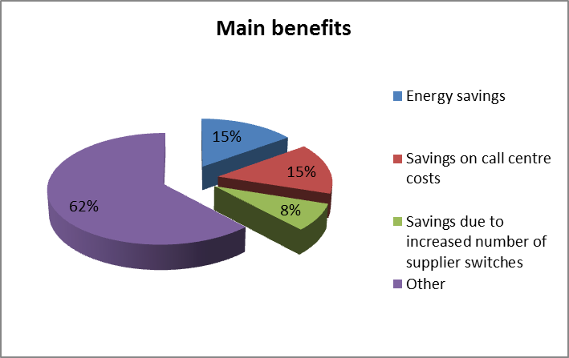

Figure 16-DD Share of main costs associated with electricity and gas smart metering roll-out
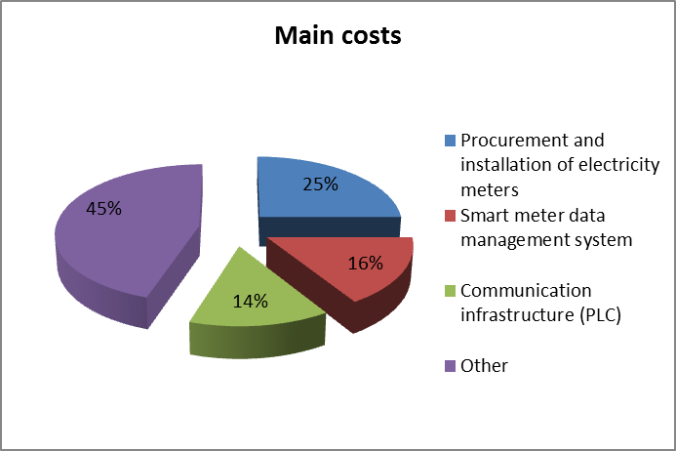

Critical variables – sensitivity analysis
The proposal of the electricity bill amendment grants the consumer with a possibility of choosing among a number of options:
- refuse the smart meter;
- opt to have the meter turned to ‘administrative off’;
- opt for detailed reading.
On that basis, additional assumptions were introduced in the updated CBA with respect to the reference scenario, namely:
- 20% of the consumers opt for the ‘administrative off’ situation;
- 20% of consumers opt for detailed meter readings; and
- 20% of consumers refuse to have a smart meter installed.
It is worth noting that even with a meter that is turned to ‘administrative off’, some commercial services and installation of display are still available to the consumer. Standard (bi-monthly) reading also provides indirect feedback. However, with detailed meter readings additional services are possible, such as time-of-use (ToU) tariffs, variable price contracts and demand management.
If 20% of consumers were to opt for detailed meter readings, this would result in an increased net present value. However, big additional benefits are not expected due to the fact that even in the standard reading option, the consumer port already offers detailed meter readings.
If 20 % of consumers were to opt for ‘administrative off’ situation, this would result in a negative net present value due to reduced energy savings as a result of lacking indirect feedback, costs for more frequent manual meter readings, etc. Nevertheless, a consumer who has an In-home Display (connected to the consumer port of the smart meter) would still be able to save energy as a result of direct feedback.
If 20% of the consumers opt for a traditional meter, then the net present value will substantially drop, however it will still be positive due to the need of fewer investments in smart metering compared to the ‘administrative off’ option. However, the smart metering roll-out will proceed less efficiently in the case where 20% of consumers refuse.

Qualitative assessments of non-monetary impacts and new enabled services
Most of the qualitative benefits are related to smart grids applications, such as: facilitation of decentralised electricity generation, optimal load behaviour of electric vehicles (smart charging strategies), etc.

Remarks
The smart metering campaign is placing special attention on issues of consumer acceptance and awareness as well as on realising the potential of energy savings’ potential of smart meters. Customer acceptance is related to data privacy and security concerns that have drawn particular attention in the country. To this end, the amended billing proposal included the option that each consumer could opt for ‘administrative off’ position, i.e. having his meter treated as traditional with a functional consumer port (allowing access to electricity consumption data), assuring no metering data are exchanged with any third parties and no possibility of being remotely disconnected.
Therefore one of the key points of the Dutch roll-out strategy is reportedly focusing on encouraging the consumer to opt for a meter with standard or detailed meter readings and being able to use it as efficiently as possible. Furthermore, policy makers note that they see the large-scale deployment of such an infrastructure as a significant contributor to a future smart grid system.

POLAND
More than one economic assessment has been performed in Poland and their positive outcome gave an indication that the smart metering implementation could be profitable to the Polish customers and the national energy system. At the moment of writing this Staff Working Document, there was still an on-going amendment in the Polish Energy Law which is expected to favour a large-scale roll-out and the installation of smart meters to 80% of electricity consumers.

Organisation of the deployment and regulation
The metering activity in Poland is regulated, and the distribution system operator (DSO) is the entity responsible for the smart metering implementation (Table 17-BBB). The Metering Information Operator plays the role of a Central Hub, and he is responsible not only to store the metering information, but also to ensure compliance with the technical and quality standards of the supplied information. The introduction of this entity will reportedly guarantee permanent and equal access to metering data for all eligible market players, making the infrastructure available to other utilities while reducing the implementation costs thanks to standardisation of information exchange on the metering data market.
Table 17-BBB Smart electricity metering deployment set-up and regulation in Poland
POLAND
Metering activity | Regulated
Deployment strategy | Mandatory
Responsible party -implementation and ownership | DSO
Responsible for third-party access to metering data | Central Hub
Financing of the roll-out | Network tariffs

CBA local boundary conditions and scenarios
Table 17-CCC presents the local conditions and the main parameters considered for the economic assessment of long-term costs and benefits associated to smart metering roll-out.
Table 17-CCC CBA boundary conditions and scenarios for smart electricity metering roll-out in Poland
CBA BOUNDARY CONDITIONS
Scenarios | Not available
Number of metering points in the Country | 16.5 million
Common Minimum functionalities (as proposed in EC Recommendation 2012/148/EU) | Full compliance reported with the recommended functionalities
Implementation speed | 2012-2022
Penetration rate by 2020 | 80%
Discount rate | Not available
Smart metering lifetime | 8 years
CBA Horizon | Not available
Communication technology | Currently PLC is considered to be the best option for the national case. Furthermore, PL highlights the importance of standardisation in this respect.

Electricity smart metering deployment rate
Figure 17-EE illustrates the electricity smart metering deployment rate throughout the roll-out period.
Figure 17-EE Electricity smart metering roll-out plan in Poland

CBA outcome
Table 17-DDD illustrates the main outcome of the economic assessment of long-term costs and benefits carried out in Poland.

Table 17-DDD CBA outcome for electricity smart metering roll-out in Poland
CBA OUTCOME | POSITIVE
Total Investment | € mn. 2200
Total Benefit | € mn. 2330
Cost/metering point (EC calculation) | €167
Benefit/metering point (EC calculation) | €177
Consumers' benefit  (% of total benefits) | Not available
Main benefits  (% of total benefits) | - Energy savings (27%)  - Reduction of balance sheet differences in respect of both technical and commercial losses (25%)  - Reduced meter reading costs (24%)  - Postponement of generation plant and of extra grid capacity due to peak shaving (15%)
Main costs  (% of total costs) | - Meter reading costs (24%)  - Customer service costs (3%)  - Cost for extra infrastructure to increase grid capacity (7%)
Energy savings  (% of total electricity consumption) | 1%
Peak load shifting  (% of total electricity consumption) | 1%

Figure 17-FF and Figure 17-GG show the share of main benefits and costs, respectively, associated with the smart metering systems roll-out.

Figure 17-FF Share of main benefits associated with electricity smart metering roll-out
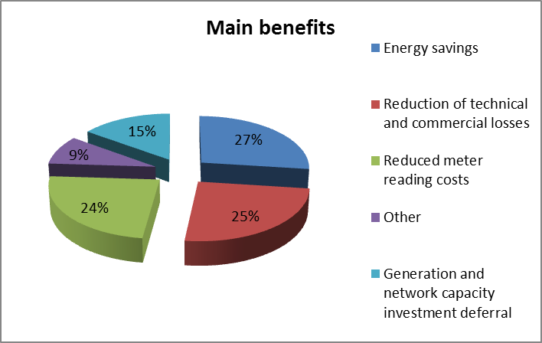
Figure 17-GG Share of main costs associated with electricity smart metering roll-out
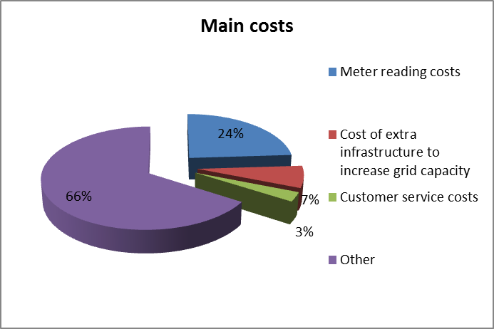

Critical variables – sensitivity analysis
The CBA communicated to the Commission services does not include a sensitivity analysis.

Remarks
The national cost-benefit assessment states that the implementation of intelligent metering systems in Poland is necessary and a cost-effective process for implementing climate policy and improving energy efficiency. In this light, and in line with the policy for reasonable and efficient use of national energy resources, measures to enable consumers to closely monitor their electricity consumption and be billed for actual consumption are promoted. Another factor of particular importance in Poland that supports the use of smart metering systems is the reduced risk of imbalance of the national electricity system.
Main benefits from the electricity smart metering roll-out include avoided costs for meter reading, customer service, balance sheet differences, and also technical and commercial losses, as well as avoided costs for construction of an additional source of electricity, and deferred investments to increase the capacity of the electricity network. Having estimated quantifiable benefits associated with the reduction/avoidance of the above-mentioned costs, the implementation of intelligent metering systems in Poland is considered to be cost-effective.
Another important variable for the successful smart metering roll-out is the financing scheme to be adopted, which should provide the right incentives to the DSOs to timely proceed with the smart metering roll-out.

PORTUGAL
The first economic evaluation of long-term costs and benefits associated with the smart metering roll-out has been completed in 2012, but a review is expected by the end of May 2014. Nevertheless, the detailed cost-benefit analysis (CBA) has not been made available to the Commission services and data reported are filled directly by the national authorities following smart metering activities.
Portugal continues with the deployment of large-scale smart metering pilot projects. Amongst these, the InovGrid project is covering to date 31000 Low Voltage customers equipped with smart meters. The integrated and intelligent electricity system that started in the municipality of Évora, will be developed in another seven regions in Portugal with the additional installation of 100000 smart meters. Évora is located in the south of Portugal with approximately 31000 Low Voltage customers with an annual consumption of around 270 GWh. About 85% of Évora’s population has a contracted power less or equal to 6.9 KVA, being 3.45 kVA (with 39%) and 6.9 kVA the most representative contracted power categories, as can be seen in Table 18-EEE.
Table 18-EEE Contracted power diffusion in Portugal
Contracted Power(kVA) | Clients (%)
1.15 | 3%
2.3 | 0%
3.45 | 39%
4.6 | 5%
5.75 | 3%
6.9 | 35%
10.35 | 6%
13.8 | 3%
17.25 | 1%
20.7 | 4%
27.6 | 1%
34.5 | 0%
41.4 | 1%

Organisation of the deployment and regulation
The metering activity in Portugal is regulated, and the distribution system operator (DSO) is the entity responsible for smart metering implementation and granting third-party access to metering data (Table 18-FFF).
Table 18-FFF Smart electricity metering deployment set-up and regulation in Portugal
PORTUGAL
Metering activity | Regulated
Deployment strategy | Not available (no roll-out)
Responsible party -implementation and ownership | DSO
Responsible for third-party access to metering data | DSO
Financing of the roll-out | DSO resources and network tariffs

CBA local boundary conditions and scenarios
Table 18-GGG illustrates the local conditions and the main parameters considered for the economic assessment of long-term costs and benefits associated with the electricity smart metering roll-out.
Table 18-GGG CBA boundary conditions and scenarios for smart electricity metering roll-out in Portugal
CBA BOUNDARY CONDITIONS
Scenarios | Not available
Number of metering points in the Country | 6.5 million
Common Minimum functionalities (as proposed in EC Recommendation 2012/148/EU) | Full compliance reported with recommended functionalities.  Functionalities published in Portaria 231/2013.
Implementation speed | 2014-2022
Penetration rate by 2020 | An expected rate of 80% (100% by 2022) has been used in the CBA. However, Portugal has not yet decided in favour of a large-scale smart metering roll-out, thus it is not clear what will be the real penetration rate by 2020.
Discount rate | 10%
Smart metering lifetime | 15 years
CBA Horizon | 40 years
Communication technology | 85% PLC and 15% GPRS

Smart metering deployment rate
An annual deployment rate from 370000 to 900000 meters is expected to take place during the period of 2014-2020.

CBA outcome
Table 18-HHH illustrates the main outcome of the economic assessment of long-term costs and benefits carried out in Portugal associated with electricity smart metering roll-out.

Table 18-HHH CBA outcome for electricity smart metering roll-out in Portugal
CBA OUTCOME | INCONCLUSIVE
Total Investment | € mn. 640
Total Benefit | € mn. 1316
Cost/metering point  (as communicated by the Member State) | €99
Benefit/metering point (as communicated by the Member State) | €202
Consumers' benefit  (% of total benefits) | 69%
Main benefits  (% of total benefits) | - Demand reduction (55.3%)  - Peak reduction (13.3%)  - Commercial losses reduction (11.1%)
Main costs  (% of total costs) | - Supplier profit reduction by consumer demand reduction (47.4%)  - Acquisition and installation of smart meters (31%)  - Communication infrastructure (14.6%)
Energy savings  (% of total electricity consumption) | 3%
Peak load shifting  (% of total electricity consumption) | 2%

Figure 18-HH and Figure 18-II show the share of main benefits and costs, respectively, associated with the electricity smart metering systems roll-out.

Figure 18-HH Share of main benefits associated with electricity smart metering roll-out
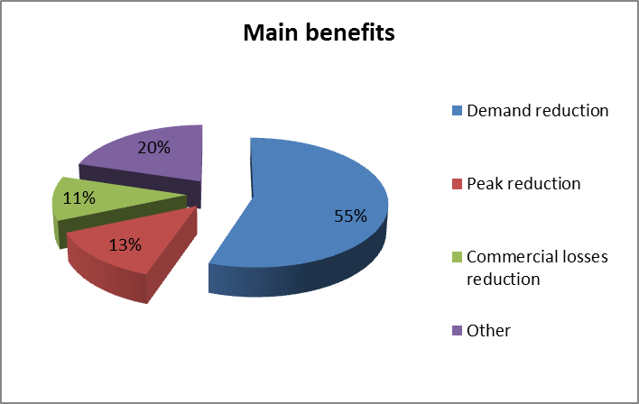

Figure 18-II Share of main costs associated with electricity smart metering roll-out
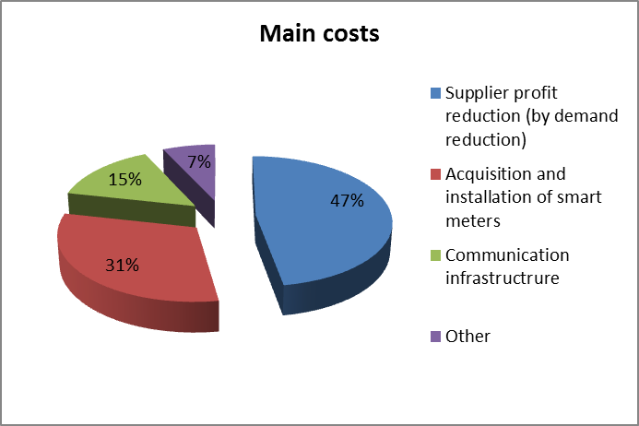

Critical variables – sensitivity analysis
The sensitivity analysis identified the following critical parameters:
- Discount rate;
- Consumption reduction due to enhanced information provided to the consumers by the smart meters;
- Current economic context and capital constraints;
- Market regulation and impact on the stakeholders;
- Increase of tariffs as a result of the roll-out (even with expected invoice reduction); and
- Current cost of smart metering technology.

ROMANIA
Romania carried out in 2012 an economic assessment of long-term costs and benefits associated with the electricity smart metering roll-out which led to a positive outcome. However, an official smart metering roll-out plan has yet to be endorsed.

Organisation of the deployment and regulation
The metering activity in Romania is regulated, and the distribution system operator (DSO) is the entity responsible for smart metering implementation and granting third-party access to metering data. Table 19-III illustrates the main characteristics of the metering deployment in Romania.
Table 19-III Smart electricity metering deployment set-up and regulation in Romania
ROMANIA
Metering activity | Regulated
Deployment strategy | Mandatory
Responsible party -implementation and ownership | DSO
Responsible for third-party access to metering data | DSO
Financing of the roll-out | Network tariffs

CBA local boundary conditions and scenarios
The economic assessment in Romania was made from a societal perspective, addressing all low voltage (LV) customers for both electricity and gas and assuming that installation of smart meters at medium voltage (MV) customers has already been implemented.
For the electricity sector there are three different scenarios that were tested:
- ‘Balanced implementation’ – with a relatively linear yearly evolution targeting 80 % smart metering implementation by 2020 and full roll-out by 2022;
- ‘Accelerated implementation’ pace – aiming at full roll-out in 5 years' time, by 2017;
- ‘Exponential implementation’ – with a lower number of meters replaced during the first years to allow for companies to adjust, plan and learn from the implementation, and then a gradual increase to finalise the full roll-out by 2022 as in the ‘balance implementation’ scenario.
In addition to these scenarios, four models regarding the communication infrastructure have been considered in the economic evaluation:
- Model 1: Independent infrastructure for electricity, gas and heat smart metering without middleware (i.e. data concentrator): Communication technology – GPRS, WiMAX;
- Model 2: Independent infrastructure for electricity, gas and heat smart metering with middleware. Communication technology – PLC from the smart meters to the concentrators and GPRS, WiMAX or Fibre Optics from the concentrator to the data centre;
- Model 3: Common infrastructure for electricity, gas and heat smart metering without middleware. Communication technology – GPRS, WiMAX; and
- Model 4: Common infrastructure for electricity, gas and heat smart metering with middleware. Communication technology – PLC from the smart meters to the concentrators and GPRS, WiMAX or Fibre Optics from the concentrator to the data centre.

Table 19-JJJ illustrates the local conditions and main parameters used for the economic assessment of smart metering roll-out in Romania associated with the scenario of ‘balanced implementation’ and common infrastructure for electricity and gas smart metering system with middleware.
Table 19-JJJ CBA boundary conditions and scenarios for smart electricity metering roll-out in Romania
CBA BOUNDARY CONDITIONS
Scenarios | Three different scenarios have been considered in the CBA (see above).  Preferred scenario: ‘Balanced implementation’, common infrastructure for electricity and gas smart metering systems with middleware.
Number of metering points in the Country | 9 million
Common Minimum functionalities (as proposed in EC Recommendation 2012/148/EU) | Full compliance reported with recommended functionalities.
Implementation speed | 2013-2022
Penetration rate by 2020 | 80%
Discount rate | 7.5%
Smart metering lifetime | 20 years
CBA Horizon | 20 years (2012-2032)
Communication technology | - From the smart meter to the data concentrator PLC;  - From the data concentrator to the DMS: GSM/GPRS, WiFi/WiMAX and Fibre Optics

Electricity smart metering deployment rate
Figure 19-JJ illustrates the electricity smart metering deployment rate throughout the roll-out period.
Figure 19-JJ Electricity smart metering roll-out plan in Romania

CBA outcome
Table 19-KKK illustrates the main outcome of the economic assessment of long-term costs and benefits carried out in Romania.
Table 19-KKK CBA outcome for electricity smart metering roll-out in Romania
CBA OUTCOME | POSITIVE
Total Investment | € mn. 712
Total Benefit | € mn. 552
Cost/metering point  (EC calculation) | €99
Benefit/metering point  (EC calculation) | €77
Consumers' benefit  (% of total benefits) | Not available (only qualitative benefit reported)
Main benefits  (% of total benefits) | - Reduced meter reading cost (36%)  - Reduced commercial losses (33.6%)  - Avoided distribution investments (12.9%)  - Reduced distribution operation costs (7.7%)
Main costs  (% of total costs) | - Investments and implementation costs (57.53%)  - Costs for system operations and maintenance (37.78%)  - Financing costs (4.69%)
Energy savings  (% of total electricity consumption) | 3.8%
Peak load shifting (% of total electricity consumption) | Not available
Figure 19-KK and Figure 19-LL show the share of main benefits and costs, respectively, associated with the smart metering roll-out. Reduced commercial losses and meter reading costs are the main benefits expected, whereas, typically, a significant share of the costs is related to installation, operation, and maintenance of the meters.
Figure 19-KK Share of main benefits associated with electricity smart metering roll-out
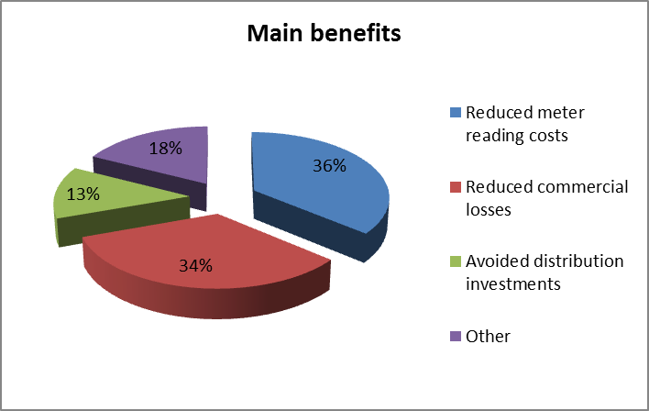

Figure 19-LL Share of main costs associated with electricity smart metering roll-out
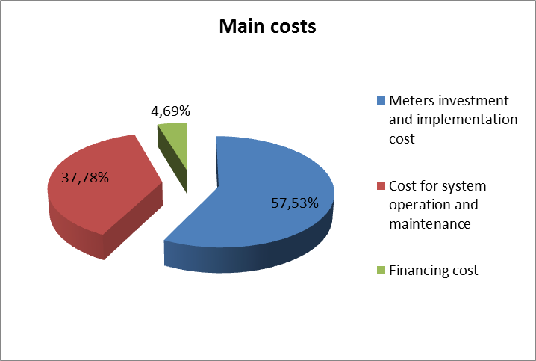

Critical variables – sensitivity analysis
The sensitivity analysis identified the following critical variables:
- Level of reduction in commercial losses – this is the main benefit to be achieved;
- Communication channels used for the metering system – the number of meters working through different communication channels (GPRS/PLC/WiFi/WiMax);
- Communication channels used for the middleware system – the number of concentrators communicating through different communication channels (GPRS/PLC/WiMax);
- Discount rates used for utilities companies;
- Weighted Average Cost of Capital;
- Option to choose or not the installation of balancing meters;
- The implementation pace (slow versus fast installations); and
- Average number of manual readings per year.

Qualitative assessments of non-monetary impacts and new enabled services
The following non-monetised benefits have been identified:
- More accurate meter reading and billing and fewer complaints;
- Innovative tariff systems and improved customer service quality;
- Easiness to change suppliers (leading towards a more competitive market place and a more fierce price-battle and high quality services);
- Increased competition among suppliers as they are able to offer customised contracts and value-added services; and
- Easier and more effective integration of distributed generation and provision of home automation services.

Remarks
The cost-benefit analysis indicates that implementation of smart metering in the electricity sector has the potential to be a profitable investment. In the gas sector, however, there is a risk that benefits will not cover all related implementation costs.
The business case for electricity is positive, if the communication infrastructure with middleware layer (data concentrators and balancing meters) is selected. This is confirmed by the hypothesis that states that models without middleware bring less benefits and are actually more expensive. The business case for gas, on the other hand, does not show positive results on average, from the country perspective, regardless of the selected model.
In building the analysis, several assumptions have been made and were validated by both the National Regulatory Authority and key stakeholders in the market. There are two significant variables that are impacting the results of the analysis: (i) reduction in commercial losses that was estimated to have a realistic potential of 60% in the Romanian market; and (ii) the discount rate that was assumed at the level of weighted average cost of capital (WACC) regulated by the National Regulator for each of the utilities (electricity and gas distribution).
Under these assumptions, and an implementation plan designed to meet the target of an 80 % smart metering implementation by 2020 and full (100%) roll-out by 2022, the results of the business case for electricity indicate a positive net present value over the analysed period of 20 years.

SLOVAKIA
The Ministry of Economy together with the Regulatory Office for Network Industries performed an economic assessment of the long-term costs and benefits of smart metering roll-out to examine the possibility of smart metering deployment in Slovakia, identify the benefits and costs associated with this implementation and evaluate the economic efficiency of the roll-out. The economic evaluation resulted in a negative net present value for a large-scale (nation-wide) roll-out. Nevertheless, the country decided to proceed with a selective deployment of electricity smart metering for supply points with annual consumption of over 4 MWh, which accounts for approximately 23% of all forecasted Low Voltage supply points in 2020.

Organisation of the deployment and regulation
The metering activity in the Slovak Republic is regulated and the distribution system operator (DSO) is the entity responsible for smart metering implementation and granting third-party access to metering data. The latter function will be in the future exercised by a central hub. Table 20-LLL illustrates the main characteristics of the set-up for the smart metering deployment in Slovakia.
Table 20-LLL Smart electricity metering deployment set-up and regulation in Slovakia
SLOVAKIA
Metering activity | Regulated
Deployment strategy | Mandatory for selective roll-out (for CBA positively assessed)
Responsible party -implementation and ownership | DSO
Responsible for third-party access to metering data | DSO (Central hub in the future)
Financing of the roll-out | DSO private resources and network tariffs

CBA local boundary conditions and scenarios
Based on the number of supply points as on 31 December 2011 and their average annual increase, the forecast for the total number of Low Voltage supply points for 31 December 2020 is 2625000.
The economic assessment of the smart metering implementation in Slovakia anticipates a roll-out period between 2013 and 2020. The project includes supply points with annual consumption of over 4 MWh, which accounts for approximately 23% of all forecast Low Voltage supply points in 2020. The target number of supply points installed with smart meters in 2020 is 603750, accounting for the supply of approximately 53% of the total annual Low Voltage electricity consumption.
The economic evaluation envisages two scenarios for smart metering deployment in parallel to preserving the current situation i.e. a ‘progressive’ and a ‘linear’ scenario. The ‘progressive’ scenario assumes 70% of smart meters to be installed during the first four years and the target of 100% to be achieved by 2020.

Electricity smart metering deployment rate
The linear scenario assumes even implementation of smart meters over the roll-out period (2013-2020), as depicted in Figure 20-MM.
Figure 20-MM Electricity smart metering roll-out plan in Slovakia

Table 20-MMM illustrates the local conditions and the main parameters considered for the economic assessment of long-term costs and benefits (cost-benefit analysis – CBA) associated to smart metering roll-out in Slovakia.
Table 20-MMM CBA boundary conditions and scenarios for smart electricity metering roll-out in Slovakia
CBA BOUNDARY CONDITIONS
Scenarios | ‘Progressive’ and ‘Linear’ scenario  Preferred scenario: ‘Linear’ scenario
Number of metering points in the Country | 2.625 mn.
Common minimum functionalities (as proposed in EC Recommendation 2012/148/EU) | Reported by the Member State:  - Partly compliance with the recommended smart metering functionalities (e) and (j) - functionality (j) not mandatory; to be made obligatory under national law (Act on RES support)  - Compliance with the rest of the functionalities
Implementation speed | 2013-2020
Penetration rate by 2020 | 23% considered in the CBA
Discount rate | 6.04%
Smart metering lifetime | 15
CBA Horizon | 20
Communication technology | - For direct communication between the meter and the DMS (with no middleware): GSM/GPRS/ETHN  - For indirect communication (with middleware): PLC, RF, and/or WAN

CBA outcome
Table 20-NNN illustrates the main outcome of the economic assessment of long-term costs and benefits carried out in Slovakia associated with the electricity smart metering roll-out.
Table 20-NNN CBA Outcome in Slovakia
CBA outcome | NEGATIVE (for a large-scale roll-out)
Total Investment | € mn. 69
Total Benefit | € mn. 71
Cost/metering point  (EC calculation) | € 114
Benefit/metering point (EC calculation) | € 118
Consumers' benefit  (% of total benefits) | 69%
Main benefits  (% of total benefits) | - Cost reduction due to load shifting (26%)  - Reduction of balancing cost (23%)  - Reduction of electricity consumption (16%)
Main costs  (% of total costs) | - Procurement of smart meters (69%)  - Installation of smart meters (17%)  - Procurement of IT (7%)
Energy savings  (% of total electricity consumption) | 1 %
Peak load shifting  (% of total electricity consumption) | 2%

Figure 20-NN and Figure 20-OO show the share of main benefits and costs, respectively, associated with the smart metering systems roll-out.
Figure 20-NN Share of main benefits associated with electricity smart metering roll-out
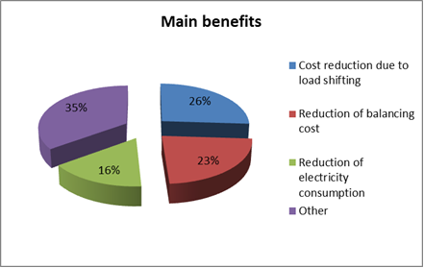
Figure 20-OO Share of main costs associated with electricity smart metering roll-out
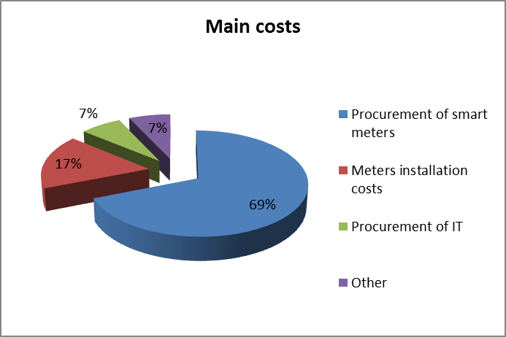

Sensitivity analysis
The CBA communicated to the Commission services does not include performance of a sensitivity analysis.

Remarks
The current focus at national level is on smart metering implementation for supply points with an annual electricity consumption of more than 4 MWh which accounts for approximately 53% of electricity consumption in the Low Voltage network.
The national authorities plan to continuously monitored the smart metering implementation with an emphasis on the economic efficiency achieved by the smart meters already deployed. The effectiveness of the proposed scenario will be reviewed on the basis of data obtained on the actual costs and benefits of smart metering deployment after the first two years.

SLOVENIA
Currently there is no binding legislation in Slovenia regarding the introduction of smart metering systems. However, the existing legal framework does not exclude the possibility of voluntary roll-out of smart meters by distribution network operators (DSOs).
The Energy Agency of the Republic of Slovenia issued a document in July 2011 on ‘Guidelines for the introduction of advanced metering in Slovenia’ intended to identify policy attention points to be clarified before proceeding with a nation-wide smart metering roll-out. The Slovenian authorities are considering smart metering systems as an enabling technology for realising energy savings though successful consumer engagement strategies and adequate incentive mechanisms put in place. The economic evaluation of long-term costs and benefits associated with smart metering systems is expected to cover electricity and gas markets and should also consider the integration of other measurement systems such as water and district heating systems. Furthermore, the cost-benefit analysis (CBA) shall address economic aspects of smart metering roll-out in more detail than the analysis performed in 2008, by EIMV (Milan Vidmar Electric Power Research Institute), which covered 890000 measuring points in Slovenia.

Organisation of the deployment and regulation
Under the current legal framework, the electricity distribution system operator is responsible for the installation, calibration and maintenance of the meters as well as for the invoicing and granting third-party access to metering data, as shown in Table 21-OOO. There is at least one meter reading per year for domestic and small business customers (customers with less than 41 kW of contracted power). Since January 1st 2008 all industrial customers and other customers with a contracted power of more than 41 kW are equipped with AMR-systems, measuring the daily load profiles of the customers in 15-minute intervals.
Table 21-OOO Smart electricity metering deployment set-up and regulation in Slovenia
SLOVENIA
Metering activity | Not available
Deployment strategy | Not available
Responsible party -implementation and ownership | Not available
Responsible for third-party access to metering data | DSO
Financing of the roll-out | Not available

CBA local boundary conditions and scenarios
The table below presents some information, as given by the national authorities, on parameters being considered for the economic assessment of long-term costs and benefits associated with the smart metering roll-out in Slovenia.
Table 21-PPP CBA boundary conditions and scenarios for smart electricity metering roll-out in Slovenia
CBA BOUNDARY CONDITIONS
Scenarios | Official CBA is not available yet.
Number of metering points in the Country | Not available
Common minimum functionalities (as proposed in EC Recommendation 2012/148/EU) | Reported by the Member State:  - No compliance with functionality (b) and (j) of the recommended functionalities  - Compliance with the rest of the functionalities
Implementation speed | Not available
Penetration rate by 2020 | Not available
Discount rate | Not available
Smart metering lifetime | Not available
CBA Horizon | Not available
Communication technology | PLC and GSM

CBA outcome
There were no data available at the moment of writing this Staff Working Document, to fill in the fields related to the main outcome of the national economic assessment of long-term costs and benefits associated with the electricity smart metering roll-out in Slovenia.
Table 21-QQQ CBA outcome for electricity smart metering roll-out in Slovenia
CBA OUTCOME | No CBA performed
Total Investment | Not available
Total Benefit | Not available
Cost per metering point | Not available
Benefit per metering point | Not available
Consumers' benefit  (% of total benefits) | Not available
Main benefits  (% of total benefits) | Not available
Main costs  (% of total costs) | Not available
Energy savings  (% of total electricity consumption) | Not available
Peak load transfer  (% of total electricity consumption) | Not available

Remarks
There is neither a mandate issued for smart metering roll-out in electricity, nor an official cost-benefit analysis available yet.

SPAIN
Spain has not conducted an economic assessment of long-term costs and benefits for an electricity smart metering roll-out. However, the country has decided to proceed with a full roll-out in the case of electricity in compliance with a Royal Decree 1634/2006 stating that by July 1st 2007 the Spanish regulator had to elaborate a replacement plan for all Spanish domestic meters with contracted power lower than 15 kW. The roll-out covers 100% of 27.8 million meters and is intended to run from 2011 till 2018.
A number of factors, such as late approval of the replacement plan, technological uncertainties in terms of system communication, alleged supply problems of certified meters and negotiations with the regulators about the level of cost acceptance, hampered the achievement of the initial target of 30 % by 2010. The latest developments are related to the introduction of the first set of smart meters in large scale pilot projects deployed by Endesa, Iberdrola, Gas Natural Fenosa, E.ON and Hidrocantábrico (EDP group).

Organisation of the deployment and regulation
The metering activity in Spain is regulated and the distribution system operator (DSO) is the responsible party for implementation and also for granting third-party access to metering data. The choice for the customer to either accept a rented meter by the DSO at a regulated monthly fee or install his own meter is a legal right in Spain.
Table 22-RRR Smart electricity metering deployment set-up and regulation in Spain
SPAIN
Metering activity | Regulated
Deployment strategy | Mandatory
Responsible party -implementation and ownership | DSO
Responsible for third-party access to metering data | DSO
Financing of the roll-out | Network tariffs + smart metering rental fees

CBA local boundary conditions and scenarios
Table 22-SSS illustrates the local conditions and main parameters used or considered for the assessment of smart metering roll-out in Spain.
Table 22-SSS CBA boundary conditions and scenarios for smart electricity metering roll-out in Spain
CBA BOUNDARY CONDITIONS
Scenarios | Not available (there is no cost-benefit analysis (CBA))
Number of metering points in the Country | 27.77 mn.
Common minimum functionalities (as proposed in EC Recommendation 2012/148/EU) | - No compliance with functionality (b) of the recommended functionalities  - Compliance with the rest of the functionalities
Implementation speed | 2011-2018
Penetration rate by 2020 | 100%
Discount rate | Not available
Smart metering lifetime | 15 years
CBA Horizon | Not available
Communication technology | PLC

Smart metering deployment rate
Figure 22-PP illustrates the electricity smart metering deployment rate throughout the roll-out period.
Figure 22-PP Smart electricity metering roll-out in Spain

CBA outcome
Table 22-TTT CBA outcome for electricity smart metering roll-out in Spain
CBA OUTCOME | No CBA performed
Total Investment | Not available
Total Benefit | Not available
Cost/metering point  (EC calculation) | Not available
Benefit/metering point  (EC calculation) | Not available
Consumers' benefit  (% of total benefits) | Not available
Main benefits  (% of total benefits) | Not available
Main costs  (% of total costs) | Not available
Energy savings  (% of total electricity consumption) | Not available
Peak load shifting  (% of total electricity consumption) | Not available

Remarks
No cost-benefit analysis available.

SWEDEN
Sweden has performed a full-scale deployment of electricity smart meters during the last years due to mandated monthly invoicing (entered in force on 1st July 2009), which encouraged widespread deployment of automatic meter reading technology. Currently, the requirements are hourly metering of the consumption for larger customers with a fuse description larger than 63 A (commercial and industrial customers), and monthly metering of the consumption for smaller customers (households) with a fuse description smaller than 63 A. The Government proposal to the Parliament (Prop. 2011/12:98) suggested that all customers should have the possibility of hourly metering of electricity consumption without extra costs. This will incentivise customers to change their behavioural patterns and reduce their consumption, but will also open a market for new services and products tailored to the consumers’ needs.

Organisation of the deployment and regulation
The metering activity in Sweden is regulated and the distribution system operator (DSO) has the responsibility of smart meter installation and granting third-party access to metering data, as indicated in Table 23-UUU. The deployment strategy is voluntary; however the requirement for monthly invoicing led to widespread deployment of remotely read meters.
Table 23-UUU Smart electricity metering deployment set-up and regulation in Sweden
SWEDEN
Metering activity | Regulated
Deployment strategy | Voluntary
Responsible party -implementation and ownership | DSO
Responsible for third-party access to metering data | DSO
Financing of the roll-out | DSO resources + Network tariffs

CBA local boundary conditions and scenarios
Table 23-VVV illustrates the local conditions and main parameters used for the economic assessment of smart metering roll-out in Sweden.
Table 23-VVV CBA boundary conditions and scenarios for smart electricity metering roll-out in Sweden
CBA BOUNDARY CONDITIONS
Scenarios | Not available
Number of metering points in the Country | 5.2 mn.
Common minimum functionalities (as proposed in EC Recommendation 2012/148/EU) | - Partly compliance with the recommended functionalities (b), (g) and (h) – Hourly meter readings for household customers  - Compliance with the rest of the functionalities
Implementation speed | 2003-2009
Penetration rate by 2020 | 100%
Discount rate | Not available
Smart metering lifetime | 10 years
CBA Horizon | Not available
Communication technology | From smart meter to data concentrator:  - Mix of GPRS, PLC and/or Radio (46%)  - PLC only (37%)  - Radio only (17%)  - GPRS (1%)  From data concentrator to the Distribution Management System:  - GPRS (86%)  - IP (fiber, etc.) – 33%  - Other (17%)  - Radio (9%)  - PLC (8%)

Smart electricity deployment rate
The electricity smart metering roll-out has already been completed in July 2009.

CBA outcome
Table 23-WWW illustrates the main outcome of the economic assessment of long-term costs and benefits carried out in Sweden, as communicated by the Member State to the Commission services.
Table 23-WWW CBA outcome for electricity smart metering roll-out in Sweden
CBA OUTCOME | POSITIVE
Total Investment | € 1500 mn
Total Benefit | € 1677 mn
Cost/metering point  (EC calculation) | €288
Benefit/metering point (EC calculation) | €323
Consumers' benefit  (% of total benefits) | 19.7%
Main benefits  (% of total benefits) | Not available
Main costs  (% of total costs) | Not available
Energy savings  (% of total electricity consumption) | 1-3%
Peak load shifting  (% of total electricity consumption) | Not available

Remarks
There is no detailed cost-benefit analysis available.

UK
The United Kingdom has carried out separate cost benefit analyses (CBAs) for the roll-out of smart metering systems in Great Britain and Northern Ireland. In Great Britain energy suppliers will be responsible for the provision and installation of smart meters and are required under conditions in their licences to take all reasonable steps to complete the roll-out by the end of 2020, both for electricity and gas.
The sections below illustrate a summary of the economic assessment carried out in the UK Great Britain and UK Northern Ireland.

UK – GB
The figures in the current report are based on the economic assessment of the long-term costs and benefits performed by the national authorities in line with the provisions of the Third Energy Package, and submitted to the Commission services.
The respective CBA has considered a joint electricity and gas roll-out. The analysis yielded a positive result and indicated a strong focus on energy savings, and empowerment of the consumers to better understand their energy consumption and deliver carbon savings. The economic evaluation (latest update in January 2013) includes: changes in fossil fuel and carbon prices, carbon emission factors, energy consumption growth, and air quality improvement benefit. It uses 2013 as a base year for all present value calculations and also considers the consultation response to the second version of Smart Meter Equipment Technical Specifications (SMETS). The updated impact assessment of 2013 includes a separate analysis for the domestic and non-domestic sectors for both electricity and gas smart metering deployment.

Organisation of the deployment and regulation
The metering activity in the UK-GB is competitive and the supplier is the owner and responsible party for the smart metering installation. Gas and electricity suppliers are required to take all reasonable steps to complete the roll-out of smart metering systems to their domestic and smaller non-domestic customers by 31 December 2020. The role of the responsible party granting access to metering data is given to a central hub – the Data and Communications Company (DCC). DCC will be reportedly providing a suitable communications platform over which data can be securely transmitted.
Table 24-XXX summarises the characteristics of the metering deployment set-up in the UK-GB.
Table 24-XXX Smart electricity metering deployment set-up and regulation in UK-GB
UK-GB
Metering activity | Competitive
Deployment strategy | Mandatory
Responsible party -implementation and ownership | Supplier
Responsible for third-party access to metering data | Central Hub
Financing of the roll-out | Funded by suppliers

CBA local boundary conditions and scenarios
The baseline case scenario assumes no Government intervention on domestic smart metering; however, it includes the following:
- Cost of continued installation of basic meters;
- Benefits from better billing;
- 5% of the predicted consumer electricity savings from smart metering are assumed to occur in the counterfactual world as a result of Carbon Emission Reduction Target (CERT) and other delivery of clip-on displays; and.
- Costs and benefits for limited roll-out of smart/advanced meters where positive business case exists (for the non-domestic sector).
In liberalised and competitive supply markets such as in Great Britain’s, suppliers or other meter owners are reluctant to install their own smart meters without a commercial and technical interoperability agreement. Without such an agreement meter owners would face a large risk of losing a major part of the value of any smart meter installed. This is because there is a significant chance that consumers will switch to a different energy supplier who will not want or be able to use the technology installed earlier and will, therefore, not be willing to pay to cover the full costs – making the smart meter redundant. This supports the idea that no smart meters have been rolled out to domestic customers in the baseline scenario, despite the available technology. Nevertheless, recognising that some level of smart meters may be rolled out in the domestic sector, the counterfactual scenario assumes 20% of the population receiving a smart meter, with 30% of the overall benefits from the full roll-out being realised.
Table 24-YYY illustrates the local conditions and relevant parameters used for the economic assessment. All the data presented below refer to smart metering roll-out for both electricity and gas in the domestic and non-domestic sector.
Table 24-YYY CBA boundary conditions and scenarios for smart electricity metering roll-out in UK-GB
CBA BOUNDARY CONDITIONS
Scenarios | Counterfactual scenario; Central scenario
Number of metering points in the Country | 59.6 million electricity and gas to be replaced – 32.94 million for electricity and 26.63 million for gas, by 2030 (total number of metering points by 2030 = 63.8 million)
Common minimum functionalities (as proposed in EC Recommendation 2012/148/EU) | - Full compliance reported with all recommended functionalities  - Functional requirements set in SMETS
Implementation speed | 2012-2020
Penetration rate by 2020 | 97% assumed in CBA for modelling purposes;  100% by 2030
Discount rate | 3.5%
Smart metering lifetime | 15 years
CBA Horizon | 18 years (2012-2030)
Communication technology | The Data and Communications Company (DCC) signed the first generation of communications contracts in September 2013. A range of technologies will be used including cellular and long range radio.

Smart metering deployment rate
Figure 24-QQ illustrates the smart metering deployment rate throughout the roll-out period.
Figure 24-QQ Smart metering roll-out in UK-GB (reference: CBA)
Note: The figure reflects the roll-out timeline as of September 2012 considered in the respective CBA.

CBA outcome
Table 24-ZZZ presents the main outcome of the economic assessment of long-term costs and benefits carried out in the UK-GB and associated with electricity and gas smart metering roll-out.
Table 24-ZZZ CBA outcome for smart metering roll-out in UK-GB
CBA OUTCOME | POSITIVE
Total Investment | € mn 9295
Total Benefit | € mn 21749
Cost per metering point | €161
Benefit per metering point | €377
Consumers' benefit  (% of total benefits) | 28% (domestic sector) and 60% (non-domestic sector)
Main benefits  (% of total benefits) | Domestic sector (electricity + gas):  - Supplier cost savings (54%)  - Energy savings (28%)  - Carbon savings (7%)  Non-domestic sector (electricity + gas):  - Energy savings (60%)  - Carbon savings (19%)  - Supplier cost savings (15%)
Main costs  (% of total costs) | Domestic sector (electricity + gas):  - Smart meters CAPEX+OPEX (43%)  - Communication costs CAPEX+OPEX (23%)  - Installation costs (15%)  Non-domestic sector (electricity + gas):  - Smart meters CAPEX+OPEX (49%)  - Communication costs CAPEX+OPEX (31%)  - Installation costs (16%)
Energy savings  (% of total electricity consumption) | 2.2%; gas 1.8%
Peak load shifting  (% of total electricity consumption) | 0.5% - 1% (as a percentage of total consumption)  1.3% - 2.9% (as a percentage of peak consumption)

The figures below illustrate the main three benefits of joint electricity and gas smart metering roll-out, referring to the domestic sector only.

Figure 24-RR Share of main benefits associated with electricity and gas smart metering roll-out (household only)
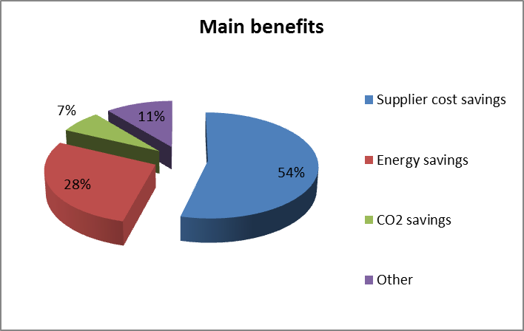
The cost figures are risk-adjusted, i.e. they have been adjusted for optimism bias. The main costs associated with electricity and gas smart metering roll-out, are the capital and expenditure costs of the smart meters and the communication technology, as shown in Figure 24-SS.
Figure 24-SS Share of main benefits associated with electricity and gas smart metering roll-out (households only)
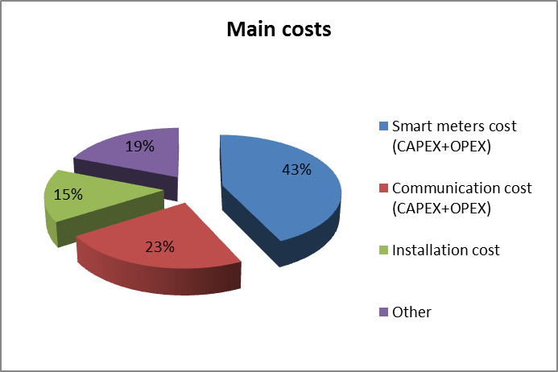

Critical variables – sensitivity analysis
A sensitivity analysis has been applied to the following benefits:
- Energy savings (relative to consumers’ behavioural response to information);
- Call centre savings;
- Reduced theft;
- Avoided site visits;
- Avoided investments due to ToU tariffs (distribution/transmission level/generation);
- Reduction in customer minutes lost;
- Operational savings from fault fixing;
- Avoided investigations on voltage complaints;
- Reduced outage notification calls; and
- Short run marginal costs savings due to time-of-use (ToU) tariffs, etc.

To this end, three scenarios have been considered: ‘low’, ‘high’ and ‘central’ scenario and the benefits reported are for the ‘central’ scenario. However, the net present value remains positive in all three scenarios.

Qualitative assessments of non-monetary impacts and new enabled services
In addition to the quantifiable benefits of smart metering systems deployment, the UK-GB CBA considers also the following non-monetary impacts:
- Enabling a smarter grid;
- Increase of energy market competition; and
- Future products (more opportunities to the home energy management sector, healthcare system savings, etc.);

Data privacy and security
The frequency of meter readings and the level of data detail to be extracted is likely to vary with the mode of operation (pre-payment or credit) and the type of tariff the customer has chosen. When offering innovative tariff schemes, the suppliers might seek access to more detailed consumption information. In this case, energy consumption data will be personal data for the purposes of Data Protection Act 1998, regardless whether the data come from conventional, pre-payment or smart meter. In this sense, the rule ‘privacy by design’ ensures that privacy issues are considered and embedded into the design of the system from the start. Furthermore, in the UK-GB the consumers will have the possibility to choose how their data are used and by whom, except where they are required to fulfil regulated duties.

Remarks
UK-GB is progressing towards the implementation of smart metering in both the electricity and gas sectors. The economic assessment indicates particular focus on the consumer side – empowering the consumer to better understand and manage its energy consumption. The privacy and security of metering data available to third-parties is addressed with the provision of the Data Protection Act of 1998.
The process of smart metering deployment will continue with monitoring and information collection in order to:
- Inform the on-going development of the approach to consumer engagement;
- Monitor the capability and readiness of industry participants for the start of mass roll-out;
- Track progress towards completion; and
- Manage the full range of costs and benefits attributable to smart metering.
The monitoring and evaluation results will be published by the Government as follows:
- An annual progress report will draw together data and information gathered from suppliers and other sources, and include an update on progress, plans, costs and benefits;
- Quarterly updates on key metrics; and
- Evaluation reports, including the results of an early assessment of emerging impacts, which is currently being developed and which will report in 2013.

UK-NI
Northern Ireland energy market conditions differ in a number of ways from those in Great Britain. The overall number of meters in Northern Ireland is a relatively small proportion (1.5%) of the total UK metering points, to which the Member State obligations for a roll out apply. It is for this reason that Northern Ireland data are not reflected in the body of the Commission Report and in the respective Staff Working Document analysing the CBA data from Member States.
However, Northern Ireland has completed a region specific economic assessment of long-term costs and benefits associated with smart metering implementation, to take account of specific regional energy market conditions which differ from those in the GB.
The economic evaluation of July 2011 resulted in a marginally positive net present value for the ‘electricity metering only’ option. The CBA analysis determined that gas metering is not currently cost effective in Northern Ireland. This situation will be reviewed in 2015 as the number of gas consumers increases. For completeness and to evidence the different approaches with respect to smart metering roll out between UK-GB and UK-NI, the key outputs from the Northern Ireland CBA is presented within this Staff Working Document.
On the basis of the marginally positive net present value for electricity, Northern Ireland proposes to undertake a public consultation during 2014 to determine a region-specific smart metering strategy for the domestic electricity sector in Northern Ireland.
Nevertheless, the aim of a roll-out in Northern Ireland is to provide all electricity consumers with smart meters by 2020 in a cost effective way which optimises benefits to consumers.

Organisation of the deployment and regulation
The Northern Ireland metering activity is regulated, and it has been determined that the smart metering deployment strategy will be mandatory, as indicated in Table 24-AAAA. The responsible parties for implementation, ownership and access to metering data have yet to be decided, although the distribution system operator (DSO) is considered a viable option. It is likely that the roll-out of smart meters will be financed through network tariffs, a final decision on this issue will be determined through further consultation.

Table 24-AAAA Smart electricity metering deployment set-up and regulation in UK-NI
UK-NI
Metering activity | Regulated
Deployment strategy | Mandatory
Responsible party -implementation and ownership | To be determined
Responsible for third-party access to metering data | To be determined
Financing of the roll-out | To be determined

CBA local boundary conditions and scenarios
The following deployment scenarios are explored in the economic evaluation of long-term costs and benefits associated with smart metering roll-out in Northern Ireland:
- Only electricity smart metering with PLC as a communication technology (reference scenario);
- Joint economic effect of deploying electricity and gas smart meters together in a single programme with PLC as a communication technology;
- Joint deployment of smart meters in electricity, gas and water sectors with PLC as a communication technology;
- Only electricity smart metering with broadband as a communication technology;
- Joint economic effect of deploying electricity and gas smart meters together in a single programme with broadband as a communication technology; and
- Develop a composite utility effect of jointly deploying smart meters in electricity, gas and water sectors with broadband as a communication technology.
All scenarios produce positive net present value (with the fourth scenario exploiting the highest benefit) over the appraisal period considered, except for the third scenario where a negative net present value is communicated. The table below illustrates the local conditions and relevant parameters used for the economic assessment. All the data presented below refer to the reference scenario, characterised with: deployment of smart electricity metering only using PLC from meters to data concentrators and 3G wireless communications for data transmission from concentrators to back-office systems.
Table 24-BBBB CBA boundary conditions and scenarios for smart electricity metering roll-out in UK-NI
CBA BOUNDARY CONDITIONS
Scenarios | Six scenarios (see above) considered in the CBA in addition to the ‘Business as Usual’ scenario (Counterfactual scenario)  Preferred scenario: ‘Reference scenario’
Number of metering points in the Country | 860000
Common minimum functionalities (as proposed in EC Recommendation 2012/148/EU) | Full compliance reported with all recommended functionalities
Implementation speed | 2014-2020 (to be confirmed)
Penetration rate by 2020 | > 80% (to be confirmed)
Discount rate | 3.5%
Smart metering lifetime | 15 years
CBA Horizon | 25 years
Communication technology | To be determined (most probably PLC/Broadband)

Smart metering deployment rate
No decision has been taken on the roll-out implementation plan, however, it is assumed to be completed in a five years period. The aforementioned consultation is scheduled to commence late 2013.

CBA outcome
All scenarios produce positive net present value except the one with water meters where the net present value is negative. In the reference scenario, the benefits outweigh the costs by 11%. Results also demonstrate that the version of the reference scenario with a broadband, instead PLC, produces the highest net present value of all scenarios. The broadband option for communication is of lower cost than PLC while yielding the same benefits and avoiding additional costs for concentrators, GPRS modems and on-going GPRS data transfer costs. This is due to the possibility of exploiting already developed internet infrastructure in NI, with almost all households having an internet connection, directly or indirectly.
Scenarios of joint roll-out of electricity and gas smart meters are still positive, albeit with lower cost benefit ratios, reflecting the fact that the expected benefits for gas smart meters probably do not outweigh the costs. This also indicates that the business case of gas smart metering roll-out only is not positive.
The only scenario with negative net present value is the one of rolling-out water smart meters jointly with electricity and gas meters.
The table below illustrates the main outcome of the economic assessment of long-term costs and benefits carried out in the UK-NI.

Table 24-CCCC CBA outcome for electricity smart metering roll-out in UK-NI
CBA OUTCOME | POSITIVE
Total Investment | € mn. 336
Total Benefit | € mn. 346
Cost per metering point  (EC calculation) | €489
Benefit per metering point  (EC calculation) | €502
Consumers' benefit  (% of total benefits) | 50% (domestic sector)
Main benefits  (% of total benefits) | - Consumption reduction (39%)  - Reduced meter reading cost (19%)  - Energy savings due to adoption of Time of Use tariffs (17%)
Main costs  (% of total costs) | - Procurement and installation cost (52%)  - Cost of IHD (10%)  - Introduction of new systems – e.g. IT systems for data management, settlement and storage (8%)
Energy savings  (% of total electricity consumption) | 3% (domestic sector)
Peak load shifting  (% of total electricity consumption) | 5%

As shown in the figure below (Figure 24-TT), about 40% of the anticipated gains originate from the consumption reduction due to customer behavioural change (assuming installation of IHD), almost 20% is attributed to meter reading savings, and additional 17% comes from savings related to ToU tariffs.
Figure 24-UU demonstrates, especially for the reference scenario that the overwhelming majority of costs relate to meters displays, communication components, with 52 % attributed to procurement and installation of electricity smart meters. New systems and processes (e.g. new IT system for data management, settlement and storage) attributed to the smart metering roll-out account for 8% of the total benefits.

Figure 24-TT Share of main benefits associated with electricity smart metering roll-out
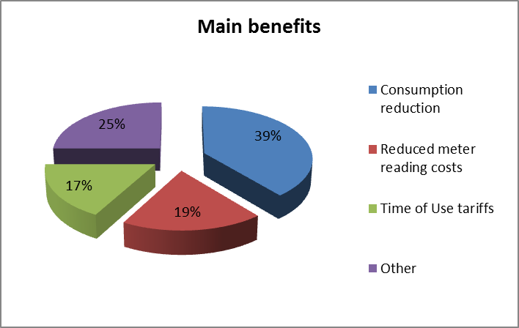

Figure 24-UU Share of main costs associated with electricity smart metering roll-out
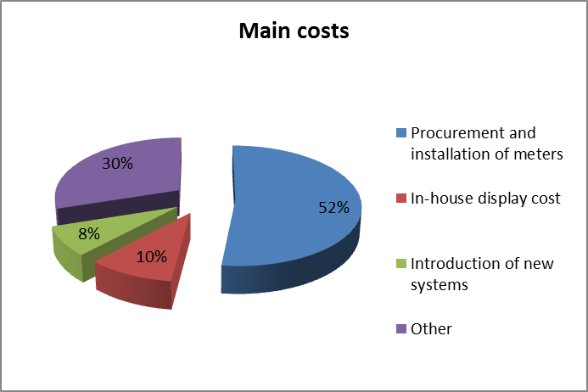

Critical variables – Sensitivity analysis
The outcome of the national electricity smart metering deployment appears to be particularly sensitive to the following parameters:
- Energy savings due to introduction of IHD: 1-5%;
- Capital costs for meters and IHD;
- Customer response to ToU tariffs; and
- Weighted Average Cost of Capital (WACC ): ±1.5%

Qualitative assessments of non-monetary impacts and new enabled services
The cost benefit analysis notes that there are several intangible benefits coming from the introduction of smart metering in the country relevant to the more generic concept of smart grids, such as: enhanced management of distributed and micro-generation, demand response benefits, easier accommodation of energy storage applications and electric vehicles, etc.

Remarks
The economic assessment of long-term costs and benefits due to electricity smart metering roll-out in Northern Ireland returned a marginally positive net present value, but turns negative when gas smart metering option is included in the mix. This reflects the respective additional costs of including gas and/or water smart metering that deliver little or (in the case of water) no added benefit.
The overall impact on customers in the reference scenario ranges from a positive benefit with added carbon benefits to a negative one. With gas included, the best case is positive with embedded carbon benefit and negative with financing costs factored in. Finally, if water is incorporated (multi utility), the effect is negative in both cases.
Therefore, the reference scenario (inclusion of electricity smart meters only) could be justified particularly when considering broader innovation benefits likely to be realised by the network operator. The latter are linked to the smart grid capability and potential home management benefits that are difficult to evaluate at this stage due to evolution of new technologies (transport, home services, renewable take up and demand response) and consequent network development.

ABBREVIATIONS AND ACRONYMS
AEEG Autorità per l’Energia Elettrica e il Gas (IT)
AMI Automated (or Advanced) Metering Infrastructure
AMR Automated Meter Reading
BPL Broadband over Power Lines
CAPEX Capital Expenditures
CBA Cost-Benefit Analysis
CHP Combined Heat and Power
CO₂ Carbon Dioxide
DC Data Concentrator
DLC Distribution Line Carrier
DMS Data Management System
DSL Digital Subscriber Line
DSO Distribution System Operator
EC European Commission
EU European Union
GPRS General Packet Radio Service
GSM Global System for Mobile Communications
ICT Information and Communication Technologies
IP Internet Protocol
IHD In Home Display
kWh kilowatt-hour
LTE Long Term Evolution (communication standard)
NPV Net Present Value
OFGEM Office of the Gas and Electricity Markets (UK)
OPEX Operational Expenditures
PLC Power-Line Carrier; Power Line Communications
R&D Research and Development
RES Renewable Energy Sources
SM Smart Meter
ToU Time-of-Use
TSO Transmission System Operator
UMTS Universal Mobile Telecommunications System
WiMax Worldwide Interoperability for Microwave Access (wireless communication standard)

COUNTRY CODES
AT Austria
BE Belgium
BG Bulgaria
CY Cyprus
CZ The Czech Republic
DE Germany
DK Denmark
EE Estonia
EL Greece
ES Spain
FI Finland, Suomi
FR France
HR Croatia
HU Hungary
IE Ireland
IT Italy
LT Lithuania
LU Luxemburg
LV Latvia
MT Malta
NL Netherlands, The
PL Poland
PT Portugal
RO Romania
SE Sweden
SI Slovenia
SK Slovakia
UK United Kingdom

LIST OF TABLES
Table 1-A Smart metering deployment set-up and regulation in Austria 4
Table 1-B CBA boundary conditions and scenarios in Austria 5
Table 1-C Main results of CBA due to electricity smart metering roll-out in Austria 6
Table 2-A Smart metering deployment set-up and regulation in Belgium - Flanders 9
Table 2-B CBA boundary conditions and scenarios in Belgium - Flanders 10
Table 2-C CBA outcome in Belgium - Flanders 11
Table 2-D CBA boundary conditions and scenarios in Belgium – Region de Bruxelles Capitale 13
Table 2-E CBA outcome (advanced scenario) in Belgium – Region de Bruxelles Capitale 14
Table 2-F CBA boundary conditions and scenarios in Belgium – Wallonia 17
Table 2-G CBA outcome in Belgium – Wallonia 18
Table 3-A Smart metering deployment set-up and regulation in Czech Republic 20
Table 3-B CBA boundary conditions and scenarios in Czech Republic 21
Table 3-C CBA outcome in Czech Republic 22
Table 4-A Smart electricity metering deployment set-up and regulation in Denmark 26
Table 4-B CBA boundary conditions in Denmark 27
Table 4-C CBA outcome in Denmark 28
Table 5-A Smart electricity metering deployment set-up and regulation in Estonia 30
Table 5-B CBA boundary conditions in Estonia 30
Table 5-C CBA outcome in Estonia 31
Table 6-A Smart electricity metering deployment set-up and regulation in Finland 33
Table 6-B CBA boundary conditions and scenarios in Finland 33
Table 6-C CBA outcome in Finland 34
Table 7-A Smart electricity metering deployment set-up and regulation in France 37
Table 7-B CBA boundary conditions and scenarios in France 38
Table 7-C CBA outcome in France 39
Table 8-A Smart electricity metering deployment set-up and regulation in Germany 41
Table 8-B CBA boundary conditions in Germany 42
Table 8-C CBA outcome in Germany 44
Table 9-A Smart electricity metering deployment set-up and regulation in Greece 47
Table 9-B CBA boundary conditions in Greece 48
Table 9-C CBA outcome in Greece 49
Table 10-A Smart electricity metering deployment set-up and regulation in Ireland 52
Table 10-B Smart electricity metering roll-out options in Ireland 53
Table 10-C CBA boundary conditions and scenarios for smart electricity metering roll-out in Ireland 53
Table 10-D CBA outcome for electricity smart metering roll-out in Ireland 54
Table 11-A Smart electricity metering deployment set-up and regulation in Italy 57
Table 11-B CBA boundary conditions and scenarios for smart electricity metering roll-out in Italy 57
Table 11-C CBA outcome for electricity smart metering roll-out in Italy 58
Table 12-A Smart metering deployment set-up and regulation in Latvia 61
Table 12-B CBA boundary conditions and scenarios in Latvia 61
Table 12-C CBA outcome in Latvia 62
Table 13-A Smart metering deployment set-up and regulation in Lithuania 65
Table 13-B CBA boundary conditions and scenarios in Lithuania 66
Table 13-C CBA outcome in Lithuania 66
Table 14-A Smart electricity metering deployment set-up and regulation in Luxembourg 69
Table 14-B CBA boundary conditions and scenarios for smart electricity metering roll-out in Luxembourg 69
Table 14-C CBA outcome for electricity smart metering roll-out in Luxembourg 70
Table 15-A Smart electricity metering deployment set-up and regulation in Malta 72
Table 15-B CBA boundary conditions and scenarios for smart electricity metering roll-out in Malta 72
Table 15-C Key data for electricity smart metering roll-out in Malta 73
Table 16-A Smart electricity metering deployment set-up and regulation in Netherlands 75
Table 16-B CBA boundary conditions and scenarios for smart metering roll-out in Netherlands 76
Table 16-C CBA outcome for electricity smart metering roll-out in Netherlands 77
Table 17-A Smart electricity metering deployment set-up and regulation in Poland 81
Table 17-B CBA boundary conditions and scenarios for smart electricity metering roll-out in Poland 81
Table 17-C CBA outcome for electricity smart metering roll-out in Poland 82
Table 18-A Contracted power diffusion in Portugal 85
Table 18-B Smart electricity metering deployment set-up and regulation in Portugal 86
Table 18-C CBA boundary conditions and scenarios for smart electricity metering roll-out in Portugal 86
Table 18-D CBA outcome for electricity smart metering roll-out in Portugal 87
Table 19-A Smart electricity metering deployment set-up and regulation in Romania 89
Table 19-B CBA boundary conditions and scenarios for smart electricity metering roll-out in Romania 90
Table 19-C CBA outcome for electricity smart metering roll-out in Romania 91
Table 20-A Smart electricity metering deployment set-up and regulation in Slovakia 94
Table 20-B CBA boundary conditions and scenarios for smart electricity metering roll-out in Slovakia 95
Table 20-C CBA Outcome in Slovakia 96
Table 21-A Smart electricity metering deployment set-up and regulation in Slovenia 98
Table 21-B CBA boundary conditions and scenarios for smart electricity metering roll-out in Slovenia 99
Table 21-C CBA outcome for electricity smart metering roll-out in Slovenia 99
Table 22-A Smart electricity metering deployment set-up and regulation in Spain 101
Table 22-B CBA boundary conditions and scenarios for smart electricity metering roll-out in Spain 101
Table 22-C CBA outcome for electricity smart metering roll-out in Spain 102
Table 23-A Smart electricity metering deployment set-up and regulation in Sweden 104
Table 23-B CBA boundary conditions and scenarios for smart electricity metering roll-out in Sweden 104
Table 23-C CBA outcome for electricity smart metering roll-out in Sweden 105
Table 24-A Smart electricity metering deployment set-up and regulation in UK-GB 107
Table 24-B CBA boundary conditions and scenarios for smart electricity metering roll-out in UK-GB 108
Table 24-C CBA outcome for smart metering roll-out in UK-GB 109
Table 24-D Smart electricity metering deployment set-up and regulation in UK-NI 113
Table 24-E CBA boundary conditions and scenarios for smart electricity metering roll-out in UK-NI 114
Table 24-F CBA outcome for electricity smart metering roll-out in UK-NI 115

TABLE OF FIGURES
Figure 1-A Smart metering roll-out plan in Austria 6
Figure 1-B Share of main benefits associated with electricity smart metering roll-out in Austria 7
Figure 1-C Share of main costs associated with electricity smart metering roll-out in Austria 8
Figure 2-A Share of main benefits from electricity smart metering roll-out in Belgium – Flanders 12
Figure 2-B Share of main costs from electricity smart metering roll-out in Belgium – Flanders 12
Figure 2-C Share of main benefits from electricity smart metering roll-out – Region de Bruxelles Capitale 15
Figure 2-D Share of main costs from electricity smart metering roll-out in Belgium – Region de Bruxelles Capitale 16
Figure 2-E Share of main benefits from electricity smart metering roll-out 19
Figure 2-F Share of main costs from electricity smart metering roll-out 19
Figure 3-A Share of main benefits associated with electricity smart metering roll-out 23
Figure 3-B Share of main costs from electricity smart metering roll-out 23
Figure 4-A Share of main benefits associated with electricity smart metering roll-out 29
Figure 4-B Share of main costs associated with electricity smart metering roll-out 29
Figure 5-A Electricity smart metering roll-out plan in Estonia 31
Figure 6-A Electricity smart metering roll-out plan in Finland 34
Figure 7-A Electricity smart metering roll-out plan in France 38
Figure 8-A Electricity smart metering roll-out plan in Germany 43
Figure 8-B Share of main benefits associated with electricity smart metering roll-out 45
Figure 8-C Share of main costs associated with electricity smart metering roll-out 45
Figure 9-A Electricity smart metering roll-out plan in Greece 49
Figure 9-B Share of main benefits associated with electricity smart metering roll-out 50
Figure 9-C Share of main costs associated with electricity smart metering roll-out 50
Figure 10-A Electricity smart metering roll-out plan in Ireland 54
Figure 12-A Share of main benefits from electricity smart metering roll-out 63
Figure 12-B Share of main costs from electricity smart metering roll-out 64
Figure 13-A Share of main benefits associated with smart metering roll-out 67
Figure 13-B Share of main costs from electricity smart metering roll-out 68
Figure 15-A Electricity smart metering roll-out plan in Malta 73
Figure 16-A Share of main benefits associated with electricity smart metering roll-out 78
Figure 16-B Share of main costs associated with electricity and gas smart metering roll-out 79
Figure 17-A Electricity smart metering roll-out plan in Poland 82
Figure 17-B Share of main benefits associated with electricity smart metering roll-out 84
Figure 17-C Share of main costs associated with electricity smart metering roll-out 84
Figure 18-A Share of main benefits associated with electricity smart metering roll-out 88
Figure 18-B Share of main costs associated with electricity smart metering roll-out 88
Figure 19-A Electricity smart metering roll-out plan in Romania 91
Figure 19-B Share of main benefits associated with electricity smart metering roll-out 92
Figure 19-C Share of main costs associated with electricity smart metering roll-out 92
Figure 20-A Electricity smart metering roll-out plan in Slovakia 95
Figure 20-B Share of main benefits associated with electricity smart metering roll-out 97
Figure 20-C Share of main costs associated with electricity smart metering roll-out 97
Figure 22-A Smart electricity metering roll-out in Spain 102
Figure 24-A Smart metering roll-out in UK-GB (reference: CBA) 109
Figure 24-B Share of main benefits associated with electricity and gas smart metering roll-out (household only) 110
Figure 24-C Share of main benefits associated with electricity and gas smart metering roll-out (households only) 111
Figure 24-D Share of main benefits associated with electricity smart metering roll-out 117
Figure 24-E Share of main costs associated with electricity smart metering roll-out 117

Note – the cost-benefit-analysis for the smart metering roll-out in Hungary was notified to the Commission services in December 2013; the respective data are not included in this Staff Working Document.
Fonctionnalités potentielles des compteurs intelligents pour le marché de la distribution de l'énergie bruxellois, 2011, Capgemini Consulting and Brugel; http://www.brugel.be/fr/secteur-de-l-energie/smart-metering---le-compteur-intelligent-en-region-bruxelloise/fonctionnalites-potentielles-des-compteurs-intelligents-pour-le-marche-de-distribution-de-l-energie-bruxellois---etude-realisee-pour-le-compte-de-brugel.
Page 22, "Fonctionnalités potentielles des compteurs intelligents pour le marché de distribution de l'énergie bruxellois", version résumée, Mai 2011, Capgemini, 2011
First table, page 154, and table page 137, "Potentiele functionaliteiten van Intelligente Tellers in de Brusselse (energie) distributie markt", Capgemini Consulting, 2011.
Regulatory Asset Base, as assessed by the competent regulatory authority and on the basis of which a fair remuneration is allowed to the DSO through an increase in the network tariff.
For the purposes of the CBA analysis only.
CAPEX+OPEX of the Blanket scenario (not discounted values).
Benefits of Basic scenario (represent investments saved due to discontinuation of Basic scenario) and external benefits of the Blanket scenario € 81 mn (not discounted values).
Benefits referring to the smart metering systems only.
External benefits of the blanket scenario.
The critical value for this is 12.5% of electricity consumption savings in the household and commercial sector ('MO' as referred in the CBA).
DK – a ministerial order on the smart metering roll out framework was signed the 03/12/2013, and issued with effect by 10/12/2013.
LINKY web site information - http://www.erdfdistribution.fr/EN_Linky.
30 minutes reading interval in line with the rate for system adjustments reported in the CBA of the Linky project.
BSI – the Federal Office for Information Security.
Meters with display but without external communication.
No formal end date. Smart metering systems have to be installed continuously in additional mandatory cases such as new buildings & renovations, connecting new decentralised generation plants, electric charging stations, heat pumps etc.
The CBA document reports though registration and collection of 30 min. profiles (linked to functionality (b) of the 2012/148/EU Recommendation).
Peak/off-peak price ratios equal to 1.7.
Instantaneous power.
Cost-benefit analysis of the roll-out of smart electricity metering grid in Lithuania, Ernst & Young, 2012.
Related to households and commercial users under 30 kW.
There is no direct charge to the consumer and savings resulting from the reduction in non-technical losses and reduced need for manual meter reading are expected to cover the cost of meters and installation over a period significantly lower than the lifetime of the meters.
‘Administrative off’ means: no information on the electricity consumption data has been exchanged with the DSO or any third party; the consumer himself can still though have access to his metering data (via the consumer port).
DSO is responsible party for making the data available. However, the supplier has also access to metering data since it is the responsible party for collecting and validating the metering data.
Legislation is based on 100% meters offered by DSO’s by 2020, the actual penetration rate depends on the acceptation rate.
For gas and electricity.
idem.
http://www.inovcity.pt/en/Pages/inovgrid.aspx.
Number of metering points at low voltage level.
Smart Metering Equipment Technical Specifications (SMETS) document describes, amongst other, the minimum functional requirements for electricity and gas smart meters.
As weighted average electricity savings across different groups of the metering population.

