Table of Contents

1. Introduction 3
2. Challenges and opportunities 4
2.1 Challenges 4
2.2 Opportunities 5
3. Response: an Action Plan 6
3.1. Blue Growth 7
3.2. Connecting the Region 8
3.3. Environmental quality 8
3.4. Sustainable tourism 9
4. Governance and implementation 10
5. Links with EU policies 12
6. Wider links 12
7. Conclusion 12
Annex Map of the EU Strategy for the Adriatic and Ionian Region 13

- Introduction
This Communication sets outs the needs and potential for smart, sustainable and inclusive growth in the Adriatic and Ionian Region. It provides a framework for a coherent macro-regional strategy and Action Plan, to address those challenges and opportunities, through cooperation between the participating countries.

The Region is a functional area primarily defined by the Adriatic and Ionian Seas basin. Covering also an important terrestrial surface area, it treats the marine, coastal and terrestrial areas as interconnected systems. With intensified movements of goods, services and peoples owing to Croatia’s accession to the EU and with the prospect of EU accession for other countries in the Region, port hinterlands play a prominent role. Attention to land-sea linkages also highlights impacts of unsustainable land-based activities on coastal areas and marine ecosystems.

Home to more than 70 million people, the Region plays a key role in strengthening geographical continuity in Europe. The Strategy builds on the Adriatic-Ionian Initiative, which concern eight countries. A map is enclosed. The Strategy remains open to other partners in the Region.

Prosperity, through trade and enterprise, will allow the Region to turn a page on economic crisis. Its people deserve improved employment prospects, better mobility, more secure and integrated supplies of energy, and enhanced environmental quality.

The European Council of December 2012 requested the Commission to present an EU Strategy for the Adriatic and Ionian Region (EUSAIR) by end 2014. The general objective of the Strategy is to promote sustainable economic and social prosperity in the Region through growth and jobs creation, and by improving its attractiveness, competitiveness and connectivity, while preserving the environment and ensuring healthy and balanced marine and coastal ecosystems. This will be achieved through cooperation between countries with much shared history and geography. By reinforcing implementation of existing EU policies in the Region, the Strategy brings a clear EU added value, while offering a golden opportunity for all participating countries to align their policies with the EU-2020 overall vision. It will thereby also contribute to bringing Western Balkan countries closer to the EU by offering them opportunities for working closely with Member States, to address common challenges and opportunities specific to the Region.

The Strategy benefits from:

- the experience over more than a decade of the inter-governmental Adriatic-Ionian Initiative. Successful cooperation has already created strong links between participating countries, and spin-off regional co-operation between cities, chambers of commerce and universities;

- the Maritime Strategy for the Adriatic-Ionian Seas, adopted by the Commission on 30 November 2012, which addresses blue growth opportunities for the sea basin;

- coincidental timing of its launch and the start of the 2014-2020 programming period. This allows it to be systematically embedded in EU, national and regional programmes, and to mobilise all policies and programmes in support of the approach;

- the lessons from the existing macro-regional strategies, i.e. the EU Strategy for the Baltic Sea Region, and the EU Strategy for the Danube Region, also with regard to cooperation with non-EU countries. Lessons point, for example, to a need to focus on a limited number of common challenges and/or opportunities, and to secure ownership, commitment and leadership from participating countries. They also point to the need to strengthen institutional and administrative capacity.

- Challenges and opportunities
- Challenges
The Adriatic-Ionian Region is facing a set of common challenges. Historically, a substantial part has been affected by difficult political and economic circumstances as well as conflict. However, Slovenia's and Croatia's accession, and the EU perspective of other countries, provide an opportunity to reinforce links and to overcome the legacy of the past. Major challenges are:

- Socio-economic disparities: Both in terms of GDP per head and unemployment rates, there are stark contrasts between countries. While some regions enjoy a GDP per head of 20% above the EU average and 4% unemployment rate, others have a GDP per head which is 70% below this average, and unemployment rate of 30%. For want of capacity, businesses do not sufficiently exploit the transnational dimension of marketing, innovation or research, particularly in the Blue economy. Clusters involving business, research and the public sector are scarce;

- Transport: The Region has significant infrastructure deficits, notably between long-established EU Member States and the other countries, resulting in poor accessibility. The Western Balkan road and rail network, in particular, needs urgent rehabilitation, removal of bottlenecks and missing links, intermodal connections, traffic management systems and upgrading of capacity. Maritime traffic congestion is increasing, while surveillance and coordination capacity needs upgrading. Excessive waiting times and procedures at borders further impede movement. Multi-modal transport is little developed;

- Energy: Interconnection of electricity grids remains inadequate, preventing the development of an integrated energy market, limiting capacity and hindering profitable exploitation of renewable energy sources. Moreover, investments in gas networks, including LNG facilities, are essential for securing efficient and diversified supply;

- Environment: Increased human use of the marine and coastal space threatens ecosystems. Unsustainable tourism activities put pressure on water, land and biodiversity. Shallowness and its semi-enclosed nature make the Adriatic Sea vulnerable to pollution. Over-fishing, discarded fishing gear and ecologically-unsound aquaculture threaten marine biodiversity, as well as human health. Untreated waste water and solid waste from mainly land-based sources, fertiliser run-off from agricultural activities causing eutrophication, invasive species from ballast waters, and pollution from oil and gas exploration further worsen the situation. Often aggravated by local climatic and geographic conditions, air quality is harmed by emissions from shipping and on-shore activities (ports, industry). Illegal hunting of migratory birds has impacts for the EU as a whole. Networks of protected areas, like NATURA 2000 and Emerald, are not yet completed;

- Natural and man-made hazards and risks entailed by climate change: In addition to major seismic activity, the Region is exposed and vulnerable to the adverse impacts of climate change. Lack of common risk assessment, disaster risk management and integrated mitigation and adaptation strategies is a major challenge. With uneven levels of experience, resources and know-how, countries cannot cope on their own with rising sea levels, flooding, drought, soil erosion and forest fires;

- Administrative and institutional issues: Capacities at national, regional or local level must be reinforced to ensure that structures are fit for working with cross-border counterparts, as well as for cross-policy coordination. When aligning with EU legislation and accessing financial instruments, the countries risk working at different speeds, thereby hampering implementation of a macro-regional approach. Problems also exist in relation to corruption, undermining public confidence and development. Migration pressure and cross-border organised crime call for coordinated border security policies.
- Opportunities
The Region also offers many opportunities, with much potential for smart, sustainable and inclusive growth:

- The Blue Economy can make a major contribution to growth. This ranges from developing blue technologies to sustainable seafood production and consumption. It includes niche markets in e.g. recreational, leisure and small cruise activities. Innovation can enable the vulnerable shipbuilding sector to switch to low emission and energy efficient vessels, and to cooperate with related sectors, including marine equipment and robotics;

- Connectivity: The Region is located at a major European cross-roads. The Adriatic-Ionian sea basin is a natural waterway penetrating deep into the EU. This provides the cheapest sea route from the Far East via Suez, making travel distance to markets of Central Europe 3,000 km shorter than via northern ports. There is potential for improved land-sea connectivity and intermodal transportation, increasing the competitiveness of hinterland economies;

- Cultural and natural heritage and biodiversity: Combined with its outstanding natural beauty, the Region's cultural, historic and archaeological heritage is one of its strongest assets. It boasts world-renowned cities (Venice, Dubrovnik, Mostar, Athens) and natural sites (the Plitvice and Skadar lakes). It is also very bio-diverse: it has exceptionally rich flora, notably in the Dinaric Arc eco-region;

- Tourism: Already a fast-growing and main GDP contributor, tourism could benefit further from increased and sustainable cooperation to expand its market and its season. The Region can become a showcase for sustainable, responsible and diversified tourism products and services. Existing commercial opportunities can be exploited more dynamically, e.g. via cruises benefiting local economies, and via recreational fishery. Sustainable tourism management can remove red tape, create a better business/SME climate, establish common standards, rules and statistics, and promote public-private partnerships.

- Response: an Action Plan
In its report on the added value of macro-regional strategies, the Commission recommended that new macro-regional strategies concentrate on a limited number of well-defined objectives, matching particular needs for improved and high-level cooperation. Using a bottom-up approach, extensive consultations of stakeholders were therefore conducted to identify clear objectives specific to the Region.

A rolling Action Plan, accompanying the Strategy and expanding the maritime dimension to include the hinterland, will be implemented to that effect. Structured around four interdependent pillars of strategic relevance, it presents a list of possible, indicative actions. The pillars are:

- Blue Growth
- Connecting the Region (transport and energy networks)
- Environmental quality
- Sustainable tourism

Two cross-cutting aspects were also identified:
- capacity-building, including communication, for efficient implementation and for raising public awareness and support;
- research and innovation to boost high-skilled employment, growth and competitiveness. Cooperation within transnational networks can bring ideas to markets, and help develop new products and services.

Furthermore, climate change mitigation and adaptation as well as disaster risk management are horizontal principles for all four pillars.

The consultation process also identified, within each pillar, a limited number of topics for the Action Plan as those needing urgent attention while gaining most from joint action. These topics are also relevant for EU policies and, in particular, those with a territorial dimension. The selected topics under each pillar are presented below.
  - Blue Growth
The objective of this pillar, coordinated by Greece and Montenegro, is to drive innovative maritime and marine growth in the Region by promoting sustainable economic development and jobs and business opportunities in the Blue economy, including fisheries and aquaculture. To this end, clusters involving research centres, public agencies and private companies must be promoted. Coordinated fishery management will improve data collection, monitoring and control. Joint planning efforts and increased administrative and cooperation capacity will improve use of existing resources and maritime governance at sea basin level.

Blue technologies

To create high-skilled job and economic opportunities, by focusing on research and innovation, cluster development and knowledge transfer related to blue technologies specific to the Region, and linked to regional and national smart specialisation strategies (e.g. green ship building, yachting, bio-technologies, underwater robotics).

Fisheries and aquaculture

To improve fisheries and aquaculture profitability and sustainability by improving data collection, monitoring and control, implementing multiannual fisheries management plans at sea basin level, harmonising standards, improving skills and capacity to comply with EU rules and standards and increasing the added value of local seafood value chains, notably through special research and innovation platforms, joint development of market intelligence and more transparent marketing and processing.

Maritime and marine governance and services

To improve administrative and institutional capacities, maritime services and better governance, including data sharing, joint planning and coordinated management of existing resources (e.g. maritime spatial planning and integrated coastal management).

Examples of targets by 2020 could include:
- 20 % increase - as compared to the base line situation - in research investment in blue technologies;
- Multiannual fisheries management plans to be adopted and implemented at sea basin level;
- 100% of the water under national jurisdiction by Maritime Spatial Planning and 100% of coast lines covered by Integrated Coastal Management, and their implementing mechanisms, fully in place.
  - Connecting the Region
The objective of this pillar, coordinated by Italy and Serbia, is to improve transport and energy connectivity in the Region and with the rest of Europe. Inter-linked and sustainable transport and energy networks are needed to develop the Region. Cooperation is needed to reduce bottlenecks, and develop infrastructure networks and regulatory frameworks. Coordinated monitoring of maritime traffic and multi-modal transport will increase competitiveness.

Maritime transport

Safe maritime traffic depends on harmonised surveillance systems and creation of modern intermodal ports, working in clusters. Cooperation among countries and ports is required to upgrade traffic management in the face of congestion and to compete globally, especially with ports in Northern Europe.

Intermodal connections to the hinterland

To support increase in the maritime transport of goods, intermodal connections to hinterlands must be upgraded. Development of nodes and hubs combining maritime, rail, road, air and inland waterways must build on sustainable transport schemes linked inter alia to local and regional air quality plans. Joint measures, both physical and non-physical, should reduce bottlenecks at borders.

Energy networks

The three EU energy policy objectives – competitiveness, security of supplies and sustainability – will be achieved through a well-interconnected energy market. Investments are needed to connect electricity grids and complete gas networks. Regulatory measures will be enforced to remove barriers to cross-border investment.

Examples of targets by 2020 could include:
- Double the current Adriatic-Ionian market share of container traffic, while limiting environmental impacts;
- Reduce the time at regional border crossings by 50 %.
  - Environmental quality
The objective of this pillar, coordinated by Slovenia and Bosnia-Herzegovina, is to address environmental quality through cooperation at the level of the Region. It will contribute to good environmental status for marine and coastal ecosystems, reducing pollution of the sea, limiting, mitigating and compensating soil sealing, reducing air pollution and halting loss of biodiversity and degradation of ecosystems. Joint action to preserve eco-regions spanning several countries is beneficial to Europe's natural heritage: it also ensures that infrastructure investments neither deteriorate the environment and landscapes nor increase pollution.

The marine environment

  - Threats to coastal and marine biodiversity: Pressure on marine and coastal ecosystems is reduced through better knowledge of biodiversity, and coordinated implementation of Maritime Spatial Planning/Integrated Coastal Management, relevant environmental legislation and the Common Fisheries Policy. Improving trans-border, open-water networks of Marine Protected Areas, and exchanging best practices among their managing authorities further preserves biodiversity.

  - Pollution of the sea: Coordinated investments in water and solid waste treatment plants, joint efforts to deal with the entire life cycle of marine litter, shared capacity to prevent and react to oil spills and other large-scale pollution, limitation of underwater noise, as well as raising farmer awareness to negative impacts of excessive use of nitrates, will significantly lessen threats to marine wildlife and human health.

Transnational terrestrial habitats and biodiversity

Joint management of eco-regions across borders will be encouraged, as well as of healthy populations of large carnivores, and measures to increase compliance with hunting rules for migratory birds.

Examples of targets could include:
- Establishment of a common platform of all countries for data collection, research and analysis by end 2015;
- Enhancement of the NATURA 2000 and Emerald networks and establishment of a coherent network of Marine Protected Areas under the Marine Strategy Framework Directive by 2020;
- 10% surface coverage by 2020 of the Adriatic and Ionian Seas by Marine Protected areas, in line with international commitments.
  - Sustainable tourism
The objective of this pillar, coordinated by Croatia and Albania, is to develop the full potential of the Region in terms of innovative, sustainable, responsible quality tourism. Diversification of tourism products and services, along with tackling seasonality, will boost business and create jobs. World-wide marketing of an Adriatic-Ionian "brand" of tourism products and services will increase demand.

Diversified tourism offer (products and services)

The potential of the Region’s rich heritage is not yet fully exploited. Advantage can be taken of climate and market for creating a strong business-oriented dynamic based on best practices. Alternative, and all-year tourism, can be promoted in territorial development action plans. Diversifying and improving the quality of the tourism offer are key to sustainable tourism products and services.

Sustainable and responsible tourism management (innovation and quality)

More measures are needed for sustainable and responsible development among tourism stakeholders. They include common standards and rules, reducing the environmental impact of mass tourism, improving skills and involving all stakeholders (public, private, visitors) in promoting the sustainable and responsible tourism concept.

Examples of targets by 2020 could include:
- 50% increase in off-season tourist arrivals;
- 5 new macro-regional tourist routes created.

- Governance and implementation
Experience with existing macro-regional strategies shows that good and stable governance mechanisms are crucial for effective implementation. The Commission’s Report on governance of May 2014 identifies three main needs: stronger political leadership, effective decision-making, and good organisation.
Better governance is not about new funds nor bureaucracy, but how and by whom the Strategy is implemented and joint actions initiated and financed. Governance must have both a political and operational dimension, with line ministries and implementing bodies setting strategic objectives, and then making sure the work is strictly followed up. This will give clearer results and greater impact.
Coordination
Co-ordination is needed between participating countries, and between the different ministries and decision-making levels within each country. For each pillar, two coordinators from relevant ministries representing two different countries will work closely with cross-border counterparts to develop and implement the Action Plan.
The Commission will act as independent facilitator, and provide an EU perspective, supported by a High-Level Group on macro-regional strategies with representatives of the EU-28, as well as non-EU countries participating in the strategies.
Implementation
Key conditions for good implementation include:
- countries recognising the Strategy as cutting across sector policies, and of concern to every level of government;
- full and effective involvement of the non-EU countries at all levels;
- high level political support, with Ministers determining the overall direction of the Strategy, taking ownership and responsibility, aligning policies and funds, and providing the resources and status for the decision-making and technical levels;
- as guarantor of the EU dimension, the Commission ensuring a strategic approach at EU level;
- countries monitoring and evaluating progress, and providing guidance to implementation;
- good use being made of the work of existing regional organisations;
- reliable support provided to pillar Coordinators, especially using the institutional and capacity-building assistance from the 2014-2020 Adriatic-Ionian transnational cooperation programme;
- involving key target stakeholders: national, regional and local authorities, members of parliaments (regional, national and European), economic and social actors, civil society, academia, and NGOs.
For the Strategy to start on solid ground, early decisions on these matters need to be taken.
Funding
The Strategy is implemented, inter alia, by mobilising and aligning existing EU and national funding of relevance to the four pillars and topics. By endorsing the Strategy, the Governments of the participating countries commit themselves to drawing on this funding to implement the Action Plan. In particular, the European Structural and Investment Fund and the Instrument for Pre-accession Assistance for 2014-2020 provide significant resources and a wide range of tools and technical options.

Other funds and instruments relevant to the pillars are available, notably Horizon 2020 for all pillars, the Connecting Europe Facility for Pillar 2, the LIFE programme for Pillar 3, as well as for mitigation and adaptation to climate change, and, for Pillar 4, the COSME programme for SMEs. Other means are available, notably from the Western Balkan Investment Framework, the European Investment Bank and other International Financial Institutions.

These funds and instruments should create significant leverage and attract funding from private investors. The Strategy will also capitalise on the work done through the two other macro-regional strategies in innovative financing.
Reporting and evaluation
Evaluation will be based on the work of the pillar Coordinators, who will report progress towards targets.
To fill gaps in available data needed to establish baseline situations, notably in non-EU countries, data collection will be promoted as a cross-cutting capacity issue via the Adriatic-Ionian transnational cooperation programme. While the prime indicator of success is implementation of the Action Plan, more refined indicators must be developed as a first step.
The participating countries will organise an Annual Forum to evaluate results, to consult on revised actions, and to develop new approaches.

- Links with EU policies
Requiring no changes to EU legislation, this Strategy aims to strengthen EU policies relevant to the Region. It also supports greater observance of EU legal obligations, addressing gaps and practical difficulties leading to delays, especially in relation to the Single Market and the environment. Emphasis is placed on an integrated approach, tying together different policy areas for a territorially-coherent implementation of EU policies. This emphasises linkages between EU policies and programmes, including the EU strategies on Biodiversity, Adaptation to Climate Change and EU R&D framework programmes.

- Wider links
Coordination with the adjoining EU Strategy for the Danube Region, as well as with the future EU Strategy for the Alpine Region, needs to be ensured. The programme INTERACT can play a central role in this respect.

Synergies must be sought with other inter-governmental bodies, matching the geography of the Strategy such as the Adriatic-Ionian Initiative (AII), or with a different/broader scope, such as the Regional Cooperation Council (RCC) or the Central European Initiative (CEI).
Coordination with Mediterranean-wide programmes and initiatives and consistency with existing legal frameworks, are important.

- Conclusion
After years of difficult political and economic circumstances, the Adriatic-Ionian Region has brighter prospects. By providing an overall framework for policy coordination and territorial cooperation, the Strategy will make the Region a better place to live, work and enjoy. It can act as a showcase for growth, jobs and ideas and as a gateway to other parts of the world. Joint efforts can prepare the Region well for the challenges and opportunities of the 21st century.
The Commission therefore invites the Council to endorse this Communication. The European Parliament, the Committee of the Regions and the European Economic and Social Committee are also invited to examine this document.

Annex Map of the EU Strategy for the Adriatic and Ionian Region

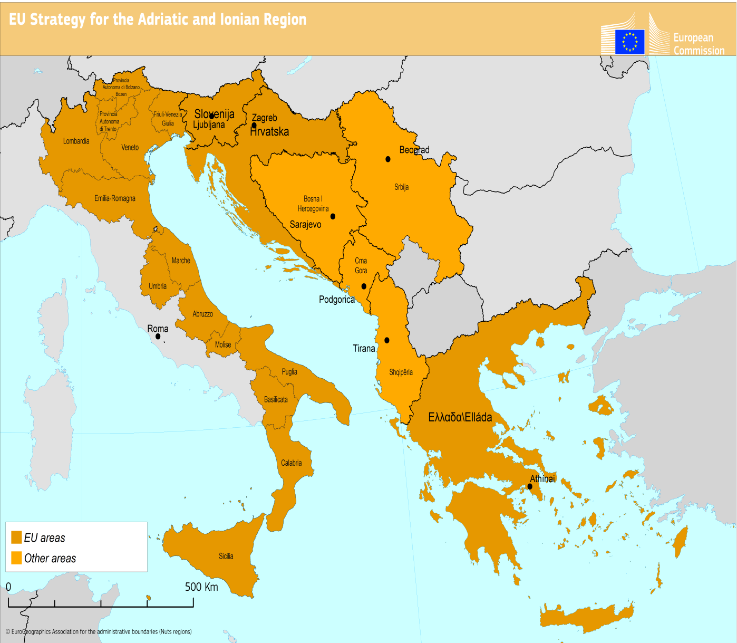

The intergovernmental Adriatic-Ionian Initiative was initiated in 2000 with the aim to strengthening regional cooperation, to promote political and economic stability thus creating a solid base for the European integration process.
COM(2012)713
COM(2011)381; SEC(2011)1071; COM(2012)128, COM(2013)181; COM(2013)468; SWD(2013)233
The North Adriatic has an average depth of around 50 metres. The waters of the Adriatic Sea are exchanged only once every 3 or 4 years with those of the Mediterranean.
In terms of SO2, NO2 and particulate matter.
COM (2013) 468 of 27.6.2013
The Action Plan will be periodically revised and updated as new needs emerge.
A pair of countries - one EU and one non-EU – coordinated the development of the Action Plan as far as the pillar of their choice was concerned.
See footnote 8
See footnote 8
SWD(2012) 101 – Guidelines on best practice to limit, mitigate or compensate soil sealing.
In terms of SO2, NO2, particulate matter and ozone.
Notably the Marine Framework Strategy Directive and the EU Habitats and Birds Directives.
See footnote 8
Report from the Commission on the governance of macro-regional strategies, COM(2014)284 of 20 May 2014.
Such as the Maritime Spatial Planning Directive, the Common Fisheries policy, the EU disaster risk management policy, Trans-European Networks (transport and energy), the future Transport Communities, etc.
Notably the Birds and Habitats, Water Framework, Marine Strategy Framework, Nitrates, Ambient Air quality, National Emission ceilings and Waste Framework Directives.
COM(2011) 244
COM(2013) 216
In particular the Union for the Mediterranean and the General Mediterranean Fisheries Commission.
Notably the "Barcelona Convention for the Protection of the Marine Environment and the Coastal Region for the Mediterranean.

