 | 
COUNCIL OF  THE EUROPEAN UNION |  |  | Brussels, 9 January 2013
 | Interinstitutional File:  2012/0299 (COD) |  | 5163/13
SOC 11
COMPET 10
DRS 4
CODEC 35
INST 14
PARLNAT 11

COVER NOTE
from: | The Sejm of the Republic of Poland
date of receipt: | 9 January 2013
to: | The President of the Council of the European Union
Subject: | Proposal for a Directive of the European Parliament and of the Council on improving the gender balance among non-executive directors of companies listed on stock exchanges and related measures  [doc. 16433/12 SOC 943 COMPET 708 DRS 130 CODEC 2724 - COM(2012) 614 final]  - Opinion on the application of the Principles of Subsidiarity and Proportionality

Delegations will find attached the above mentioned opinion.

____________________

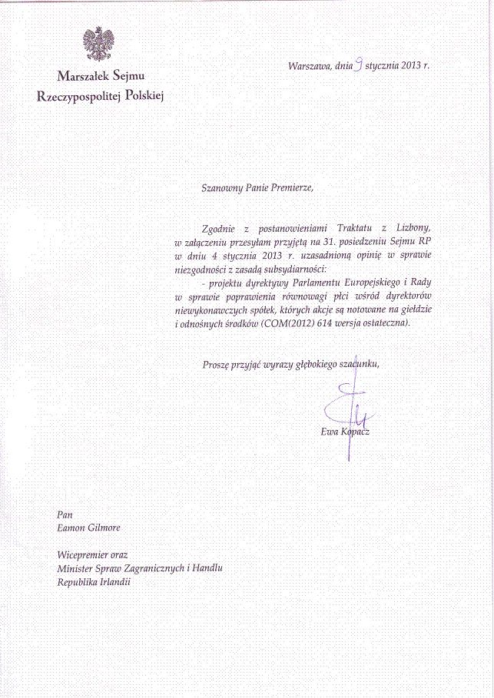
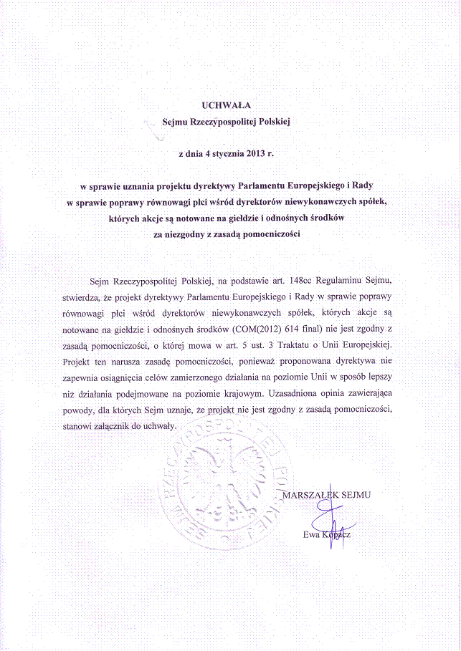
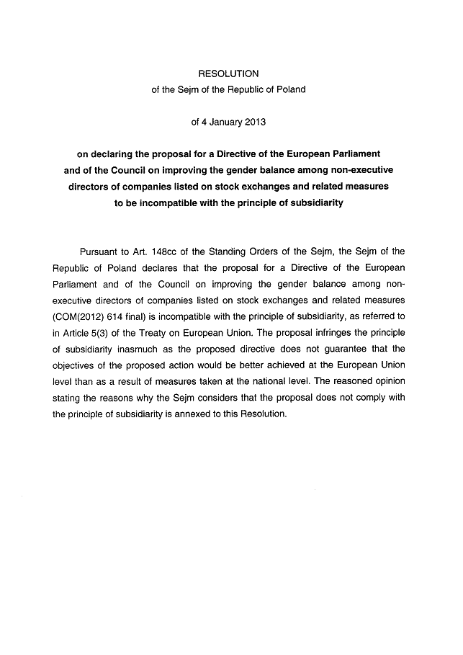_____________________

For available translations of this opinion see the interparliamentary EU information exchange site (IPEX) at the following address: http://www.ipex.eu/IPEXL-WEB/search.do

