 | 
COUNCIL OF  THE EUROPEAN UNION |  |  | Brussels, 7 December 2012
 | Interinstitutional File:  2012/0175 (COD) |  | 17490/12
EF 298
ECOFIN 1043
SURE 14
CODEC 2978
INST 720
PARLNAT 382

COVER NOTE
from: | Italian Senate
date of receipt: | 3 December 2012
to: | President of the European Union
Subject: | Proposal for a DIRECTIVE OF THE EUROPEAN PARLIAMENT AND OF THE COUNCIL on insurance mediation  (recast)  [doc. ST 12407/12 EF 168 ECOFIN 691 SURE 10 CODEC 1880 - COM(2012) 360 final]  - Opinion on the application of the Principles of Subsidiarity and Proportionality

Delegations will find attached the abovementioned opinion.
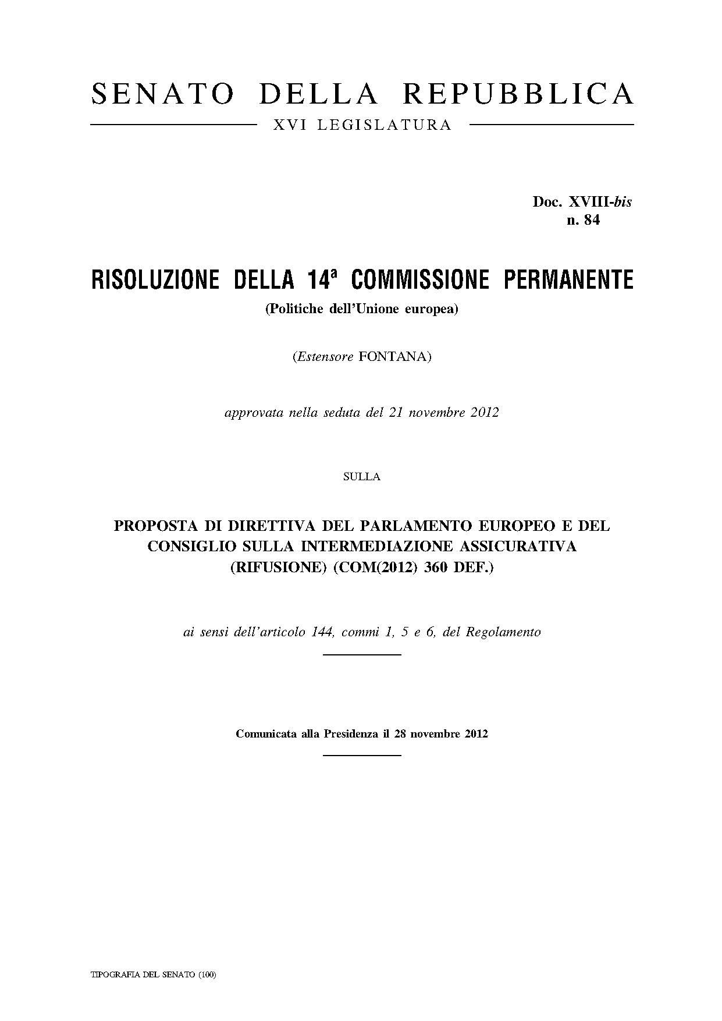
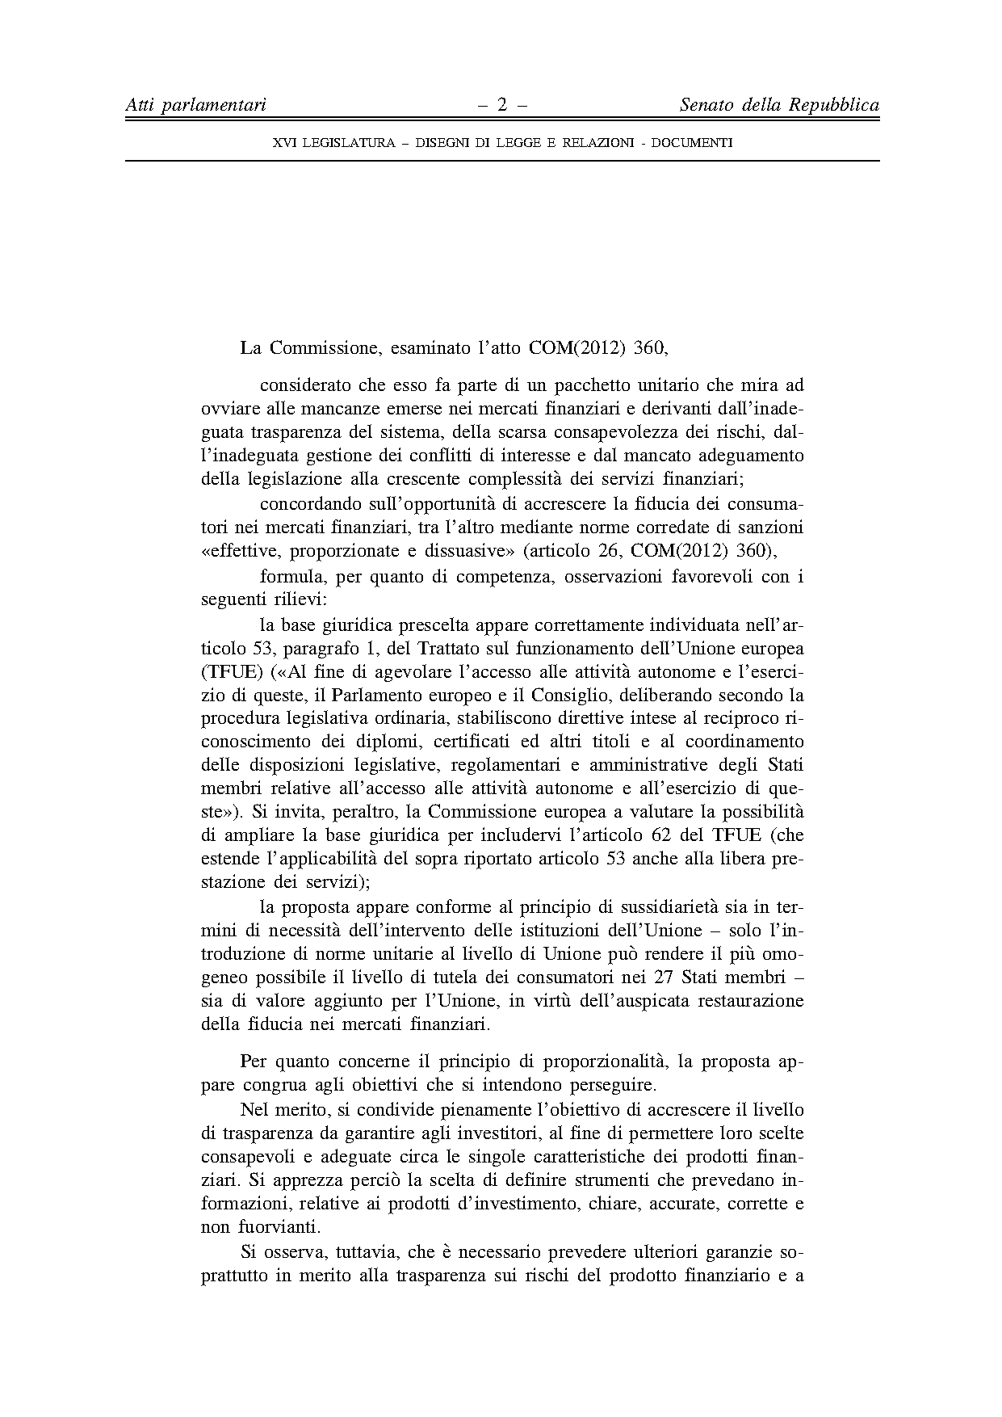
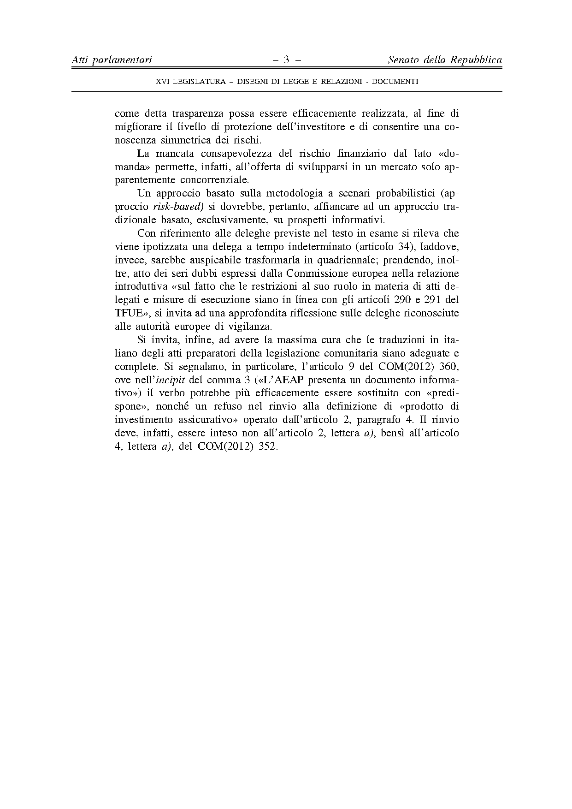


Translations of the opinion may be available in the Interparliamentary EU information exchange site IPEX at the following address: http://www.ipex.eu/IPEXL- WEB/search.do

