 | 
COUNCIL OF  THE EUROPEAN UNION |  |  | Brussels, 3 December 2012
 | Interinstitutional File:  2012/0260(COD) |  | 17138/12
DENLEG 119
AGRI 829
ENV 910
SAN 317
CODEC 2892
INST 710
PARLNAT 377

COVER NOTE
from: | Portuguese Parliament
date of receipt: | 16 November 2012
to: | The President of the Council of the European Union
No Cion doc.: | 13957/12 DENLEG 89 AGRI 600 ENV 897 SAN 201 CODEC 2175 - COM(2012) 530 final
Subject: | Proposal for a Directive of the European Parliament and of the Council amending Council Directive 2001/110/EC relating to honey  - Opinion on the application of the Principles of Subsidiarity and Proportionality

Delegations will find attached for information a copy of the above opinion.

________________________

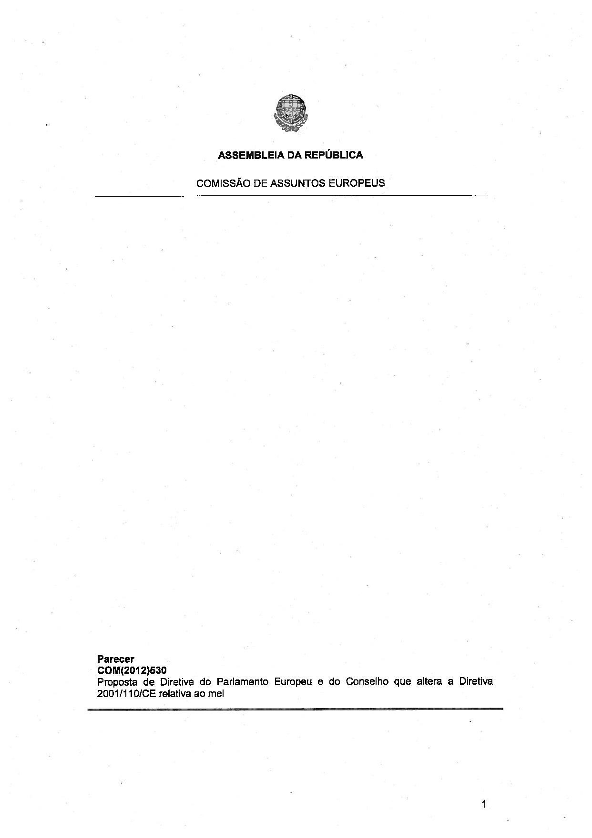

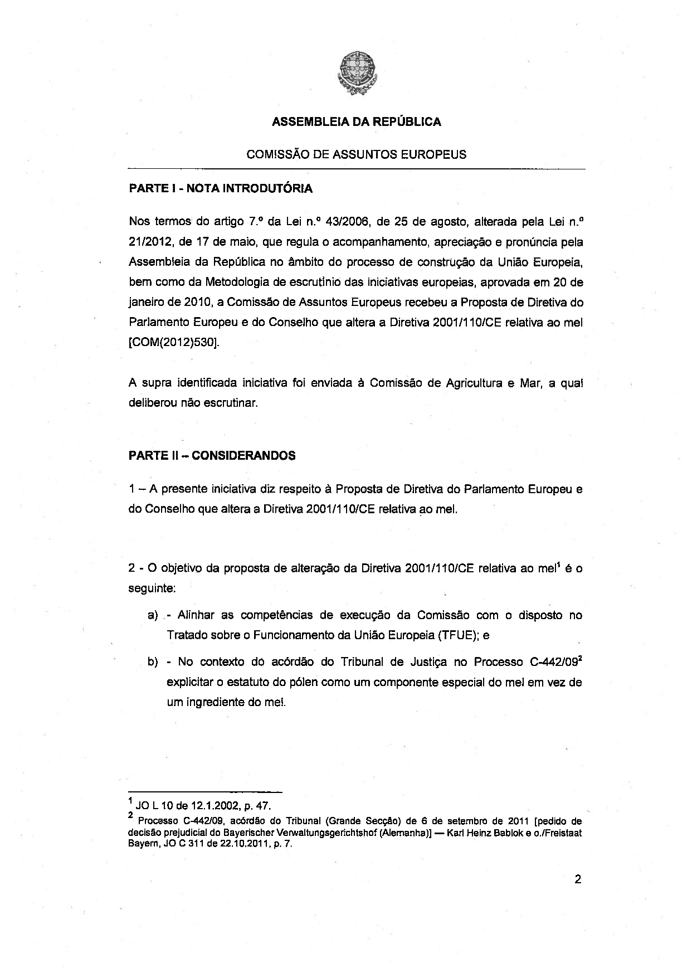

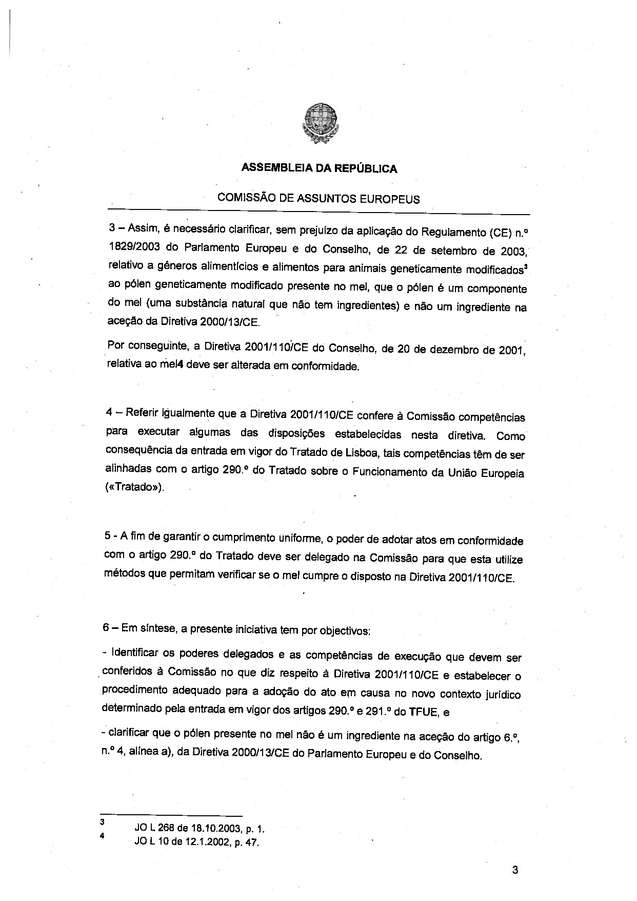

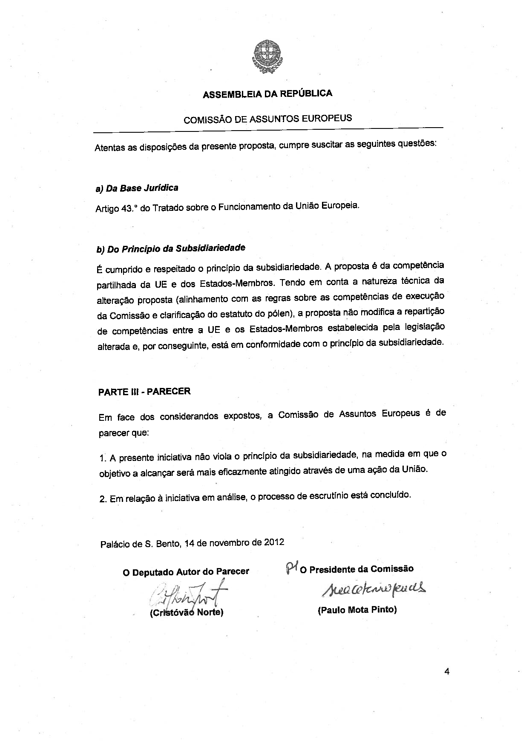

The translation can be found at the Interparliamentary EU information exchange site IPEX at the following address: http://www.ipex.eu/IPEXL-WEB/dossier/document/COM20120530.do#dossier-COD20120260

