Improving the internal market and infrastructure

The key measure in the medium term is the development of infrastructure granting priority to projects that allow higher diversification of suppliers of each of the Member States. Rapid introduction of internal market rules in particular allocation and congestion management and gas balancing network codes will allow the gas to flow more freely and solve congestion problems where such still occurs. Full abolishment of regulated prices for gas on wholesale and retail level is the only possibility to allow market signals transpire and allow energy efficiency measures to fully develop their potential.

Infrastructure development
The ENTSOG presented an estimation of the impact of a possible disruption crisis by analysing the response of the gas infrastructure in the EU for summer 2014 and preliminary estimations for winter 2014/2015 taking into account available options (pipelines, LNG, storage). Assuming maximum solidarity between Member States, the Summer Supply Outlook and the estimation for winter confirm the vulnerability of Member States in the South East EU to disruptions in transit thorough Ukraine and disruption of deliveries of Russian gas. If disruptions occur at times of daily peak demand in January and under maximum solidarity between Member States, almost the entire EU, except for the Iberian Peninsula and south of France would be affected, in particular in case of disruption of gas supplies from Russia. The effects will be severe but only regional in case of disruption from Ukraine.
With regard to the Summer Supply Outlook 2014, disruption of transit through Ukraine over the summer months will result in a disruption in Bulgaria and FYROM (average 21 GWh/day), and failure to fill storages at 90% on 30th of September in preparation for winter demand. The storage levels in Bulgaria would be empty (0%), in Hungary and Serbia the share in comparison to the 90% level would be very low (20%).

In Poland (82%) and Romania (75%) the 90% levels would not be reached either. In case of Russian supply disruption the impact on Bulgaria and FYROM would be the same as in case of disruption of Ukrainian transit but also other Member States would face demand disruptions: Poland (average 94 GWh/day) Finland (average 77 GWh/day) and Baltic States (average 64 GWh/day). The 90% level of storages would not be reached in number of states: Bulgaria, Latvia and Poland (0%), Hungary and Serbia (17%), Austria (59%), Germany, Czech Republic and Slovakia (84%) and Croatia (88%). Low storage levels at the end of September will have consequences for the resilience of the system in winter 2014/2015.
If disruptions occur at times of daily peak demand in January and under maximum solidarity between Member States, almost the entire EU, except for the Iberian Peninsula and south of France could be affected in case of disruption of gas supplies from Russia. The effects are likely to be less severe in case of disruption from Ukraine, however South-East Europe could face a situation where more 60-80% of supply is not covered. In case disruptions of supply from Russia take place during a cold spell time in March the impacts might spread across Europe, but in the case of South-East Europe of smaller magnitude in comparison to a January disruption.
In case of average demand, with disruptions of supply from Russia occurring during the June 2014 to March 2015 period, demand of states in the east of EU and neigbouring countries might not be covered over longer periods of time. Bulgaria and FYROM might face a disruption of 60-80% of demand from September to March, while Poland for the same period might not cover 20-40% of demand and Lithuania 40-60%. Latvia and Estonia might face difficulties from October to March with more than 80% of demand not covered and also Finland would face similar demand disruption from January to March. 20-40% disruption might also occur in Romania, Croatia, Serbia and Greece for the late 2014/early 2015.
In this context it is worth mentioning that combination of factors other than infrastructure might affect the level of resilience and response in case of a crisis. Analysis by the IEA points out that Italy is not able to transfer import disruption into an export reduction as it does not export natural gas. The only possibility is therefore to import form other sources, be it pipelines or LNG deliveries. However, the later might not always materialise: in February 2012 the cold weather affected the LNG deliveries in Italy and to a lesser extent in France. The sea conditions prevented scheduled LNG cargoes from docking and unloading in the Italian terminals of Rovigo and Panigaglia limiting the flexibility provided by LNG. LNG had a major role in Greece to compensate the temporarily reduced Russian volumes and the missing deliveries from Turkey, however, the financial position of the Greek companies made difficult to afford prompt spot cargoes.

Figure 1. Impact of gas disruption
ACROSS SEASON DISRUPTION

Disruption occurring during the June 2014 to March 2015 period of average demand. UGS levels on 1 June are those of the Summer Supply Outlook 2014 and then injection is maximised where possible resulting in some countries in levels on 1 Oct. 2014 higher than last year.

WINTER 2014/15 DISRUPTION

Events lasting from October 2014 to March 2015 under average demand with UGS level on 1 October as observed in 2013

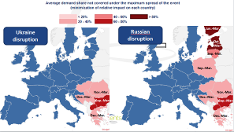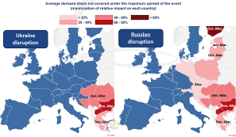
JANUARY DISRUPTION WITH PEAK

January disruption on a peak day at the end of the month. Period from Oct. to Dec. is under average demand and without disruption.

MARCH DISRUPTION WITH COLD SPELL

March disruption with a cold spell in the second half of the month. Period from Oct. to Feb. is under average demand and without disruption.

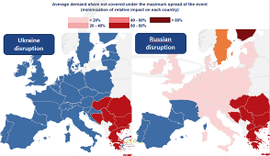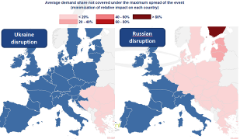

Source: ENTSO-G
A key measure in the medium term is the development of infrastructure granting priority to projects that allow higher diversification of suppliers of each of the Member States. According to ENTSOG it is not sufficient to develop projects where financial investment decision have been taken but decide projects among those already identified in the latest TYNDP edition.

Internal market and price signals
An important aspect to consider when analysing short term resilience to disruption of gas supplies is the reaction of prices of gas on the markets. In case of disruption and high demand prices will increase attracting new supplies. With adequate infrastructure in place, supplies could come from different sources and directions and the overall impact of price increase could be mitigated. As a rule, the prices at hubs give a fair representation of the supply and demand conditions in different trading areas. The operation of the gas markets improved significantly in the last couple of years, as shown by the decrease of flow against price differential (FAPD ) events that measure irrational adverse flows.
Table 1. Flows against price differential: events in selected adjacent areas
 | 2011 | 2012 | 2013
# observations / year | 251 | 248 | 251
BE-NL | 25 | 6 | 13
BE-UK | 4 | 17 | 7
NL-UK | 83 | 28 | 28
FR PEG Nord – FR PEG Sud | 2 | 1 | 0
AT-IT | 0 | 0 | 0
AT-DE | 133 | 112 | 6
Average FAPD events selected | 41 | 27 | 9
Sources. (1) Price data: Platts; (2) Flow nomination data: Fluxys, BBL, ENTSO-G TP
The 2013 cold spell events that hit the Northern part of Europe at the end of the heating season in March were another period of significant price swings as reaction in increasing demand and adjusting supply. The majority of countries in North and North-Western Europe experienced harsher than usual meteorological conditions throughout the 2012 – 2013 winter season. The March 2013 temperatures were well below the long term average, with some Member States recording more than 100 heating degree days (HDDs) above the long term average. In two separate events during the second and third week of the month, the temperatures across the UK were 6 ⁰C – 8⁰ C lower than the long term average for several days. This event can be a model how markets react when demand increases and supply reacts.
Prior to March 2013, market operators were withdrawing gas from storages at a faster-than normal rate. The March cold spell events accelerated further the withdrawal and as the winter season was coming to an end, a new minimum level of 2.71% was reached on 13.04.2013 in the NBP area. French storage levels were also extremely low and the minimum was reached on 10.04.201 (6.23%). With a decline in LNG and beach supply as well as low storage levels, the Interconnector between UK and Belgium was flexible in covering much reduced supply from other sources, setting an import record in March 2013 of 18,000 GWh (approx. 1670 mcm), breaking the previous flow record (Aug 2003). On 22 March, when the daily flow record might have otherwise have been broken again, there was a mechanical failure causing a full shutdown of the Bacton terminal in the UK. Within a few hours of the failure, IUK was back to maximum capacity, but for the first time failed to meet nominations in full. The below chart shows the increase of withdrawal from storages, imports from Norway, Netherlands and Belgium and stronger relying on LNG supplies also after the cold spell when the withdrawal form gas storages decreased.
Figure 2. The cold spell of March 2013: gas supply to the UK
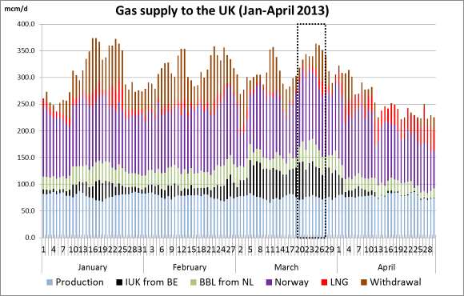
Source: Platts, Bentek
During periods of high demand markets with high degree of diversification, good infrastructure connections and established and liquid markets the prices increase significantly above the usual levels. For example the prices in the UK and in Belgium increased to the level close to € 40/MWh in comparison to average prices of between € 25 and € 30/MWh. The price increase at the hubs in the EU were also following this trend.
Similar developments took place during the February cold spell in 2012. Market signals worked well and wholesale prices reacted with a sharp increase enhancing gas and electricity flows to where it was most valued and bringing all available generation capacities online. In electricity, the increased demand pushed up prices reaching maximum level on 8 February. In France prices went up from 50€/MWh to 350€/MWh and in Germany from 50€/MWh to 100€/MWh. Wholesale day-ahead gas prices raised by more than 50% on the European hubs compared to levels registered before the cold weather. Notably in Italy prices reached 65€/MWh from 38€/MWh, while in UK, Germany and Austria prices kept aligned and reached 38€/MWh from levels of 23€/MWh.

Figure 3. The cold spell of March 2013: prices on European hubs
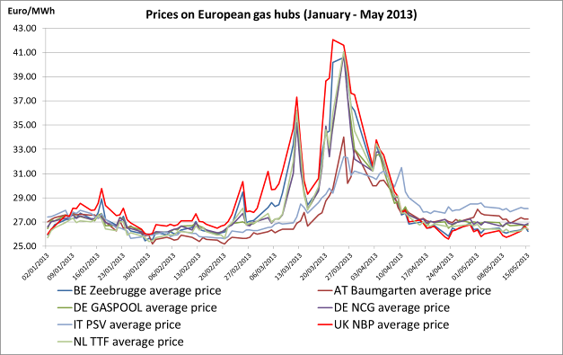
Source: Platts
Member States in the East and South-East EU are most vulnerable to supply disruptions. In addition, they tend to regulate gas wholesale prices (e.g. Poland and Romania) and/or no liquid gas markets are established in these Member States. In times of unforeseen short-term disruption those Member States are likely to be least attractive to the potential alternative gas suppliers. Therefore any additional deliveries in times of supply disruptions would likely go first to the most liquid markets where shortage would be indicated by increasing prices.

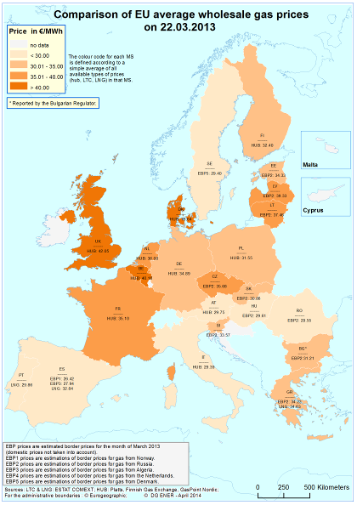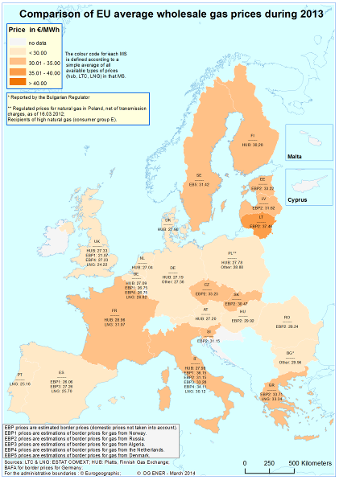

Energy efficiency
Short term reduction of energy demand
Energy efficiency can play a significant role by reducing gas demand and imports in industry and in the residential and service sectors, in particular for heating and domestic hot water production and district heating.
Studies analysing the effect of information campaigns on energy consumption indicate that the savings that can be achieved through information campaigns can go up to 10% reduction of energy consumption in the short term. Nevertheless, in most cases the energy savings achieved are lower, with the savings in the short term in the range of 3%-4%. The impact of any campaign will depend on a series of factors including its design, the target public, the level of public acceptance of the importance of energy savings (that will increase in a situation of energy supply disruptions).
The 3% savings that could be achieved in the short term in the households and services sector through information campaigns would represent a reduction on gas consumption of 4.6 Mtoe.
Long term data is scarcer and its results not conclusive, but evidence shows that these savings tend to be reduced if the campaign is not supported by further measures that have an impact in the long run.
Taking into account that a reduction on gas supply can put pressure in the very short term, information campaigns are well placed in order to have an immediate impact on the European gas demand especially taking into account that their impact might be increased during a crisis situation.
Information to consumers about the importance of reducing gas demand can also help to smooth the introduction of measures causing discomfort such as the reduction in the availability of heat from central or district heating installations or the reduction of available gas for industrial processes.
The Covenant of Mayors
After the adoption, in 2008, of the EU Climate and Energy Package, the European Commission launched the Covenant of Mayors programme which became the mainstream European movement involving local and regional authorities in the fight against climate change. It is based on a voluntary commitment by signatories to meet and exceed the 20% CO₂ reduction objective through increased energy efficiency and development of renewable energy sources. Indeed, local governments play a crucial role in mitigating the effects of climate change, all the more so when considering that 80% of energy consumption and CO₂ emissions is associated with urban activity.
In order to translate their political commitment into concrete measures and projects, Covenant signatories prepare Sustainable Energy Action Plans outlining the key actions they plan to undertake. These plans concentrate on decentralised measures to improve energy efficiency in buildings reduce emissions in urban traffic, communicate energy saving behaviour, increase efficiency in energy related infrastructure such as district heating and electricity networks, plan low energy developments, etc. The average expected reduction of emissions, mostly to be achieved through energy efficiency, is 28%. The implementation of most plans could be accelerated, resulting in significant short-term energy savings benefits with high visibility and a relevant emulation effect.

Short term disruption of supply in most exposed Member States
The state of the preparedness of the Member States in case of a disruption of supply is reflected in the measures developed in the scope of implementation of the Regulation 994/2010 i.e. the Preventive Action Plans (PAPs) and the Emergency Plans based of Risks Assessments. The Commission will present its detailed assessment of the Plans in its report required under the Regulation 994/2010 in December 2014.
Most of the measures in the Plans are related to infrastructure in general, storage facilities, import flexibility, LNG and production flexibility. Thus, 78% of the preventive measures proposed by the Member States are related to enhancement of infrastructure. The preliminary results reveal, firstly, that most of the preventive actions taken by Member States are market-based supply-side measures. Non-market-based initiatives make up just over 10% of the total, while demand-side measures constitute 14% of those discussed in PAPs.
Increased storage capacity is the most commonly adopted risk-reducing measure, followed by the increase of import flexibility either through pipeline interconnectors or LNG terminals. Domestic upgrades to the transmission system and revised contractual arrangements are also frequently employed tools. The latter includes regulatory measures such as ensuring proper monitoring and accurate forecasting of demand or implementing bilateral agreements to ensure stand-by capacity/flows in contingency situations. Production flexibility and fuel switching options are less common and in some countries the latter has been phased out by new market rules. The Plans submitted to the Commission show a high level of methodological and substantive heterogeneity. Often the link between risk scenarios and preventive measures seem to be lacking or risk scenarios are not even considered.
Figure 89: Classification of Supply Measures proposed in the Preventive Action Plans (PAPs)
Source: Preventive and Emergency Plans Review in accordance with Regulation 994/2010, JRC 2013
As shown in the estimations of ENTSO-G depending on the duration of the disruptions and on the level of the demand (e.g. high demand in winter), the disruptions could affect the majority of the EU countries directly (except for France, Spain and Portugal) and indirectly e.g. by increase in LNG gas prices. However the state of infrastructure, existing level of interconnections and the stage of development of the markets expose some the European states in the East to higher extend than those in the West. Various analysis of ENTSO-G shows that in case of disruption of transit through Ukraine exposed to disruption of deliveries are likely to be Bulgaria, Romania, Hungary and Greece, as well as the Energy Community Members FYROM, Serbia and Bosnia and Herzegovina. In case of disruption of all supplies from Russia over entire winter period (October to March), in addition to the stated above, the exposed to disruption are also Finland, Poland, Czech Republic, Slovakia, Croatia, Slovenia, and the three Baltic States; Lithuania, Latvia and Estonia. Interruption of supply to Lithuania may also impact on the level of supply in Kaliningrad since gas to Kaliningrad is transported via Lithuania.
Assessed from today's perspective on the basis of data regarding gas consumption, supply and state of development of infrastructure the Baltic States and Finland may not have much alternative instruments at their hands to counteract gas supplies disruptions from Russia. All four states are in 100% dependent on deliveries from Russia. Finland is able to use their line-pack and fuel switching options to provide gas to protected customers to satisfy the 30 day obligation of the supply standard. Latvia can rely on storage capacities which are higher than its annual demand. Estonia would be able to use fuel switching to and rely partially on gas storage from Latvia. Lithuania is advancing construction of the LNG terminal. In the perspective of the next 5 years together with the interconnector to Poland and the regional terminal i.e. the implementation of the commitments under the Baltic Energy Market Interconnection Plan (BEMIP), the new infrastructure will be able to ensure full diversification of gas sources. Therefore each of the Member States has some options at hand, however only when put together, they allow for a strong regional strategy. Elements which can be used to benefit security of supply of the region are full utilisation of storage capacities in Latvia, rapid development of LNG terminals and interconnectors. Moreover the region could benefit from the development of contingency plans. An example of such plans is the one developed in Finland.
In terms of consumption, out of 3 Mtoe of gas, Finland uses 1.3 in CHP plants and 0.4 in district heating plants. The reminder is consumed by industry (0.8 Mtoe). Consumption in Latvia follows similar pattern as in Finland. Out of the 1.4 Mtoe of imported gas in 2012, 0.6 was consumed in CHP plant, 0.2 in district heating and 0.2 Mtoe in industry. Households and services consumed 0.1 Mtoe each. In Lithuania, out of the 2.7 Mtoe of gas consumed in 2012, 1.1 Mtoe was attributed to final non-energy consumption and 0.8 Mtoe to CHP plants. The reminder was attributed in similar shares to households (0.1Mtoe), industry (0.3 Mtoe) and services (0.1 Mtoe). In Estonia almost the entire gas import of 0.5 Mtoe in 2012 was consumed in district heating plant (0.4 Mtoe) and 0.1 was consumed by industry, households and services.
Poland depends in 2/3 of demand on Russian imports. In 2012, out of the 13.6 Mtoe of gas (of which 10 Mtoe was imported) households consumed 3.4 Mtoe, industry 3.7 Mtoe and services 1.6 Mtoe. Gas plays marginal role in electricity and heat production. Due to the physical reverse flow on Yamal pipeline introduced in April 2014, in case of disruption of deliveries and availability of gas in the West of the EU Poland will be able to cover up to 30% of domestic consumption and together with LNG terminal in Swinoujscie and use of Lasow and Cieszyn interconnectors Poland has the infrastructure to be able to replace deliveries from Russia by deliveries from other directions.
In 2012 Slovakia consumed 4.4 Mtoe of gas of which 3.9 was imported from Russia. Similarly to Poland, Slovakia is able to cover missing supplies from Russia by the use of reverse flow capacities from the Czech Republic and Austria. The response to a disruption from Russia will depend on the availability of the gas in the west of the EU and the ability to transport it to those two states. Furthermore, connections with Slovakia are important to ensure additional supplies to Hungary. In terms of consumption households consumed almost ¼ of the gas in Slovakia in 2012. Industry consumes 1.4 Mtoe and Services 0.6 Mtoe. Gas is also used in CHP plants (0.5 Mtoe and District heating 0.3 Mtoe).
Gas is the most important fuel in energy mix in Hungary. The imports are up to 98% of Russian origin. Hungary fulfils the N-1 supply standard in 2012. However despite high storage capacities (almost 2/3 of consumption) Hungary might not be able to fully replace Russian imports relying on the connection to Austria. In general there are five interconnections in Hungary, with Romania, Serbia, Austria, Croatia and Ukraine. Only the connection with Croatia is bidirectional. In order to facilitate the bidirectional operation between Hungary and Romania, a compressor station on the Romanian side is necessary to be constructed. New investments are needed on Austrian and Hungarian side in order to establish reverse flow. The interconnection with Slovakia is scheduled to be on stream in 2015 and will be capable of reverse flow transmission. The use of gas in Hungary is very spread. In 2012 out of 8.3 Mtoe, 2.7 Mtoe were consumed in households, 1 Mtoe by the industry, 1.4 Mtoe by services, 1.3 in CHP power plants, 0.8 in producing electricity in conventional power plants as well as 0.6 Mtoe in district heating. Development of connection with Slovakia and completion of the North-South gas connection and application of demand side measures is important for diversification of supply in Hungary.
Investments undertaken in Hungary and Austria are important to ensure that also Romania is able to respond to supply disruption from Russia. In Romania which relies in high extend on its domestic production the Russian imports cover only 10% of consumption. Imports from Hungary or Bulgaria are therefore key to fully replace disruption of deliveries from Russia. In terms of consumption the pattern is similar as in Hungary: Households and industry consume with almost equal shares above half of the 10.8 Mtoe of total demand. 2 Mtoe is consumed in CHP plants, 0.5 mtoe in conventional plants and o.5 Mtoe in district heating plants. Since the imports amount to 2.3 Mtoe demand response measures can play an important role in replacing imports in case of disruption.
Bulgaria is fully dependent on Russian gas and did not fulfil the N-1 standard in 2012. Bulgaria identifies the disruption of gas from Russia (its only gas supplier) as the one and most severe risk. The measures proposed in the Preventive Action Plans to address this situation are the development of new interconnectors with Greece, Serbia and Turkey. Promising short term source of diversification for Bulgaria is the LNG terminal in Greece which capacity exceeds the needs of Greece by the amount necessary to cover missing volumes in Bulgaria. With the construction of the interconnector BG-RO it would be possible to have flow in both directions. However works on interconnectors (planned and existing) need to be extended in order to cover for the disruption of Russian gas deliveries. In the energy mix of Bulgaria gas is less important than oil and nuclear. Majority of gas - 1.2 Mtoe out of 2.5 Mtoe in 2012 - is being consumed by the industry e.g. aluminium production. Production of electricity and heat in CHP consumed in 2012 another 0.8 Mtoe, whereas district heating 0.2 Mtoe. These consumption patterns allow Bulgaria to identify ways to target most protected consumers and reduce consumption of gas.
Gas accounts for 10% of the gross inland consumption of Greece. Half of it is being imported from Russia. Greece did not fulfil the N-1 standard in 2012. In terms of risks Greece noted among others the unavailability of power stations with dual fuel capability, 800 MWe unavailable out of 2000 MWe. In terms of infrastructure capacities, the LNG terminal in Revithousa is able to cover shortages of deliveries from Russia. Although fulfilment of N-1 standard will only be possible in Greece by the construction of a new LNG terminal, UGS or new interconnection and is not achievable before 2016, Greece emphasized in the Preventive Action Plans that the demand side measures would contribute significantly to raise the N-1 index. Indeed in terms of demand out of 0.5 Mtoe of gas consumed in Greece 0.3 is consumed by district heating plants which has a potential of consumption reduction by fuel switching and deployment of more efficient appliances.
Annex I provides energy flow charts and assessment of alternatives in case of gas disruption for the Baltic States, Finland, Bulgaria, Romania, the Czech Republic, Slovakia, Romania and Greece, along with country charts for each Member State of the EU on total energy demand by product, import dependency by product and imports of natural gas and crude oil by country of origin (including intra-EU flows)

Emergency response measures in Finland
As identified by the IEA in their report of 2012 Finland developed precise plan of reaction to fuel switching and demand side measures in case of disruption of gas from Russia.
First market measures are implemented aiming to increase price of gas. The TSO increases the price for excess gas and implement a buy back system through the Gas Exchange. This system proved successful in 2010 to shave the peaks of gas demand.
If these measures are not sufficient, the TSO in second step reduces the volumes of all its customers on a pro rata basis, except for protected customers (detached houses and other residential properties that directly use natural gas). A secondary market system applies in which the consumers can reduce their own consumption more than required by the TSO, and sell their quota to other customers.
In case of total disruption of deliveries National Emergency Supply Agency (NESA) can give permission to release compulsory stocks of alternative fuels. Over 40% of natural gas consumption can be switched by light fuel oil within 8 hours after fuel switching starts.
To satisfy the demand of protected customers an air propane mixing plant has been built in Porvoo to provide protected customers with air mixed propane gas which is activated only in case of disruptions (the pressure in the transfer pipelines has fallen below 7 bars). The gas mixture capacity of the plant is equivalent to 350 MW (or some 0.84 mcm/d at net caloric value), by which gas demand of protected customers (200 MW or 0.48 mcm/d) can be covered.
Dedicated measures have also been prepared to address the deliveries for the biggest gas consumers. In addition to protected customers, LPG stocks are planned to be used in the Porvoo refinery of Neste Oil Oy which is one of the largest consumers of natural gas.
Domestically liquefied LNG in Porvoo can also be available during a gas disruption. However, LNG can only be delivered by trucks and fed into the network through mobile LNG vaporisers.

Summary natural gas

- The 2014 Summer Outlook and the estimation for Winter 2014/2015 of ENTSO-G concludes that the resilience of the European gas system is satisfactory when facing a one moth event (in May) in terms of ensuring proper storage levels to prepare for winter 2014/15. However in case of an event lasting the whole summer the storages of the Member States would be seriously affected.
- As demonstrated in the past (cold snap of March 2013), in a well-functioning integrated internal market for gas, markets can be instrumental in times of crisis, sending signals to where gas is needed. Lack of infrastructure or regulatory failures such as lack of liquid gas markets and wholesale price regulation can seriously undermine market resilience.
- Member States in the East and South-East EU are most vulnerable to supply disruptions. Due to lack of liquid gas markets these Member States might be least attractive for alternative suppliers to deliver the missing gas supplies.

Coal
Coal is an indigenous resource with buoyant intra-EU trade: most coal is produced and used in the vicinity of deposits. Globally coal is predominantly supplied by domestic production with internationally traded coal accounting for a relatively small part of the market (less than 20% in 2012), the large part of which was transported by sea.
Just like with other energy commodities, coal deliveries run physical, including weather-related, risks to security of supply. Weather conditions, such as floods, may impact mine production. In addition, weather can cause delays in seaborne imports and domestic river transport (low river levels or freezing conditions). Congestion of transport infrastructure can lead to disruption of supplies. Yet, one could reasonably expect such disruptions to be short-lived, with inventories offering a short-term buffer and the continuing oversupply in global coal markets giving scope for reaction.
Diversifying import sources and exploiting indigenous reserves are two ways of reducing security of supply risks related to coal.

Internal energy reserve capacity
In the EU, hard coal and lignite together account for more than 80% of non-renewable reserves. While overall the production of solid fuels currently meets more than 60% of demand (more than 70% if intra-EU trade movements are considered), hard coal is more heavily dependent on imports with production meeting less than 40% of demand. The abundance of coal reserves and the fact that many Member States meet their coal demands domestically or through movements on the internal market (intra-EU trade), makes coal more resilient from security of supply point of view.
At the same time, international coal prices have sustained low levels due to oversupply and European hard coal producers are indeed struggling to survive against competition from internationally traded coal.
Some Member States have resorted to measures such as priority dispatch for electricity generated from domestic coal or peat, including Spain, Slovakia, Ireland and Estonia. This may lead to distortions of the markets, go against climate objectives and pose challenges with state aid rules.

External energy reserve capacity
Diversifying suppliers would spread the price-related and supply-related risks associated with importing. The EU does have its own coal reserves, so global supply and demand can only affect the country's energy security up to a point. If international prices were to rise or supplies were to fall to the point where importing coal became uneconomic or impractical, it is likely that mining these indigenous reserves would become more cost-effective.

Uranium and nuclear fuel
The Euratom Treaty has set up a common supply system for nuclear materials, in particular nuclear fuel. It also established the Euratom Supply Agency (ESA) and conferred it the task to guarantee reliability of supplies of the materials in question, as well as equal access of all EU users to sources of supply.
For that purpose, pursuant to Chapter 6 of the Treaty, ESA has the exclusive right to conclude contracts for the supply of nuclear materials (ores, source material and special fissile materials) from inside or outside the Community. The Agency appears as a “single buyer”, whose task is to balance demand and supply and to guarantee the best possible conditions for the EU utilities.
In practice, in normal circumstances of supply, the “simplified procedure” (introduced by Art. 5 bis of the Agency’s Rules) is used, by which commercial partners – inside or outside the EU – may negotiate their transactions between themselves with the obligation to subsequently submit their draft contracts to ESA for consideration and conclusion. In any case, even within the framework of the simplified procedure, the Agency maintains the right to object to (and refuse to sign) a contract likely to jeopardise the achievement of the objectives of the Treaty. For that reason, all supply contracts, submitted to ESA for conclusion, undergo a thorough analysis, in the light also of the EU common policy.
The role of ESA is many-fold:
- ESA is actively promoting diversification of sources of nuclear fuel supply, with a view to preventing excessive dependence of EU users from any single, third-country source of supply.
- ESA warns individual users of potential excessive dependence from a single, external source of supply. ESA endeavours to propose alternatives and / or remedial measures to the user concerned.
- In its market-monitoring role, ESA has responsibility for early identification of market trends likely to affect medium- and long-term security of supply of nuclear materials and services in the EU market. In the event such trends were detected, the Agency will communicate, as appropriate, and consider relevant remedial action.
- In the event of a sudden deterioration of the situation in the market requiring a quick reaction (in particular, if external dependence increases significantly in a short period of time or if imports risk to distort competition within the EU internal market), as well as in case a user fails to diversify its sources of supply or to implement remedial measures, ESA shall make use of its powers under Chapter 6 of the Treaty.
Uranium resources exist in many EU MS; although the ore grades do not always compare to those in some other locations, there is some potential to increase uranium production in the EU over a 5–10 year horizon, perhaps to 1000–2000 tU, equivalent to 5–10 % of EU requirements, admittedly still a small part of the total consumption. In the longer term, the EU could even cover its needs to a large extent.
In addition, there is considerable potential to increase the use of reprocessed uranium and plutonium, should natural uranium prices rise. The recovery of uranium and plutonium through reprocessing of spent fuel is nowadays done in France and Russia. As an additional reserve, significant quantities of depleted uranium are stockpiled in the EU and could be either re-enriched or mixed with plutonium (MOX) in case of a shortage.
Conversion and Enrichment
The current EU capacities in uranium conversion would be sufficient to cover most of EU needs, if no exports were taking place. As the technology is mastered by EU industry, it is also possible to expand capacity according to demand, albeit not very suddenly.
For enrichment, the EU-based capacities operated by AREVA and Urenco would be more than sufficient to cover all EU needs if no exports were taking place. Since these EU companies are major suppliers for worldwide customers, a significant part of their production capacity is not immediately available for EU utilities' requirements.
In particular for enrichment, maintaining idle reserve capacity is not practical, since the used centrifuges must be kept continuously in operation, which also requires energy. Therefore, centrifuge enrichment plants are operating at full capacity, although part of the capacity may be used for below optimum activities, such as re-enrichment of depleted uranium, depending on market conditions. This provides some margin of flexibility for increasing output.
Inventories
Uranium inventories owned by EU utilities at the end of 2013 totalled 53 982 tU, an increase of 3 % from the end of 2012 and 24 % from the end of 2008. The inventories represent uranium at different stages of the nuclear fuel cycle (natural uranium, in-process for conversion, enrichment or fuel fabrication), stored at EU or foreign nuclear facilities.
Based on average annual EU gross uranium reactor requirements (approximately 17 000 tU/year), uranium inventories can fuel EU utilities' nuclear power reactors, on average, for 3 years. Most EU utilities have inventories for 1–2 years' operation in different forms (natural or enriched uranium, fabricated fuel assemblies). Some utilities are covered for 4–6 years but others only for some months. In the current situation, most vulnerable in terms of security of supply are those utilities that depend on Russian fabricated fuel assemblies (VVER reactors), which cannot be quickly replaced by fuel assemblies from another manufacturer.
Figure 4. Total uranium inventories owned by EU utilities at the end of the year, 2008–13 (tonnes)
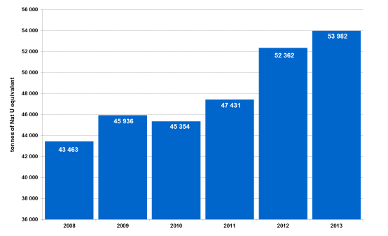

External energy reserve capacity
Transport is not a major issue in nuclear fuel supply, although the limited number of ships and harbours that can handle nuclear materials is sometimes seen as a factor of vulnerability, in particular due to a geographic unbalance between conversion and enrichment services. Two thirds of the western conversion capacity is located in North America, whereas two thirds of the western enrichment capacity is in the EU. Likewise, transport arrangements may have to be changed in case of transit problems but usually an alternative can be found.
Storage as such is not problematic; dedicated storage facilities are subject to very strict safety and security requirements.
Whereas the uranium itself can be purchased from multiple suppliers and easily stored, the final fuel assembly process is managed by a limited number of companies. For western designed reactors, this process can be split, and diversification of providers achieved. For Russian designed reactors, the process is "bundled" and managed by one Russian company, TVEL, currently with insufficient competition, diversification of supplier or back up. Thus, particular attention should be paid to new nuclear power plants to be built in the EU using non-EU technology. While the aim is not to discriminate against non-EU suppliers, the operators of such plants should ensure that fuel supply diversification is possible and should present a credible diversification plan, comprising all stages of the fuel cycle.

Improving the internal market
For bundled sales of fuel assemblies (i.e. sales including nuclear material, enrichment and fuel fabrication), in particular for new reactors, the supplier of fuel assemblies must allow the plant operator to acquire enriched uranium from other sources as well. Likewise, the reactor constructor must enable the use of fuel assemblies produced by various fabricators (e.g. by disclosing fuel design specifications and allowing testing fuel assemblies of various origins). In the current circumstances regarding Russian designed reactors, this option seems unlikely.

Renewable energy

Internal energy reserve capacity
The share of renewable energy has increased to 14.1% in 2012 as a proportion of final energy consumed (compared to 8.7% in 2005), thus increasing the EU's local energy production and gradually reducing the dependency on energy imports. This is particularly the case in the electricity sector, where the share of EU produced renewable electricity increase from 15% in 2005 to 24% in 2012. Reliance on imported fossil fuels is still high in the heating and transport in most Member States, where the use of renewables since 2005 has only increased little. The RES share in heating sector in 2012 was about 16%. In transport, the current 5% of renewable energy share is mainly based (above 95%) on first generation biofuel use, on average 70% of which are produced in the EU, while remaining share of their imports are mainly sourced from Brazil, US and South East Asian countries.
The key instrument for increasing renewable energy production has been the Renewable Energy Directive and the national measures implementing it. The share of renewable energy has increased in every Member State since 2005. The Directive established national legally binding targets which have provided the incentives to national governments to undertake a range of measures to improve the uptake of renewable energy. These include improvements to national planning and equipment/installation authorisation processes and electricity grid operations (connection regimes etc.), some of which are explicitly required by the Directive. Financial support has also been used by Member States to increase uptake, compensating for the various market failures that result in suboptimal levels of renewable energy.
On aggregate, the EU has met its interim target for 2011/2012, driven by Member States efforts to make progress towards the national targets in the Renewable Energy Directive. 3 Member States (Sweden, Estonia and Bulgaria), had already reached their national 2020 RES targets in 2012, and a few others were close to meeting them in 2013 and 2014. Other Member States were well on track. However, as the trajectory grows steeper, more efforts will still be needed from Member States in order to reach it Many Member States need however to make additional efforts to meet their respective 2020 national targets, and recent evolutions such as for instance retroactive changes to support schemes is causing concern as to whether the overall EU target will be met. In order to allow an overall cost-efficient achievement of targets the Directive envisages cooperation mechanisms allowing Member States to fulfil a part of their target by using potentially less costly RES potential abroad. In order to assist Member States in addressing these challenges, the Commission issued Guidance on support schemes and cooperation mechanisms in November 2013, which if fully adhered to is expected to have a significantly positive impact on cost-efficiency, flexibility, market integration, and further sustainable development of renewable energy in the EU.
Much increased renewable energy consumption in the EU has been achieved through developments in EU renewable energy production, which has the potential to contribute to lower energy import dependence and, therefore, a lower energy import bill. EU production in renewable energy has increased significantly in recent years (by 231% between 1990 and 2011). At the same time, the production of non-renewable energy sources has fallen (by -27%). Over the same period (1990 to 2011), the EU's net energy imports increased by 24%. Without the contribution of (increasing) domestically produced renewable energy, the EU's net energy imports would have possibly increased by more.
While the exact contribution of renewables to reduced import dependency cannot precisely be estimated, it should be noted that 90 Mtoe is the difference between renewable energy produced domestically in the EU in 2011 and 1990. Increased renewable energy production may also have reduced energy demand, and will to some extent also have displaced production of domestic non-renewable sources. Altogether, the avoided costs of imported fuel saved thanks to the use of renewable energy are conservatively estimated to amount to around €30 billion in the EU in 2010 compared to an external trade deficit in energy products that year of €304 billion.
Increased deployment can be made further cost effective by flanking and supporting policies that help Member States increase their energy security and independence by increasing the share of renewable energy in a cost competitive manner. Such policies would focus on removing market failures, which persistently reduces the rate of deployment of renewable energy. The Commission will analyse the whole possible range of such options, and propose action, including legislation wherever appropriate.
In addition to the Commission's evaluation of the NREAPs, various stakeholders have analysed the Member State renewable energy plans and have expressed their views on the Member State technology choices and the adequacy of measures planned to achieve the renewable energy targets. The REPAP 2020 project provided an independent assessment of the NREAPs evaluating the quality of measures included in the action plans for tackling the administrative barriers to renewable energy development, improvement of energy infrastructure development and electricity network operation and support measures in each of the 3 energy consuming sectors. It found that the biggest weaknesses still existed in the field of administrative procedures and spatial planning followed by still rather weak support measures for renewable energy heating and cooling. It also found that further improvements were still required in many Member States in the area of support measures in the electricity sector. This assessment is also largely echoed in European Renewable Energy Council's (EREC) EU industry roadmap.
Since the adoption of the Renewable Energy Directive, the scientific evidence base regarding the GHG emission impacts associated with indirect land use change (ILUC) has grown. In response to the ILUC issue, the Commission proposed to limit the amount of food-based (1st generation) biofuels that can contribute to the relevant targets (including the 10 % renewables target for transport) and has indicated that first generation biofuels with high estimated indirect land-use change emissions should not continue to receive public support after 2020. However, as projections indicate that Europe will need considerable amounts of biofuels towards 2050, the Commission's proposal includes increased incentives for advanced biofuels that do not need land for their production, such as biofuels made from residues, algae and wastes. In order for the transport sector to decarbonise in a cost-effective and sustainable manner, technology developments of relatively small quantities of advanced renewable fuels going beyond R&D are necessary, in line with the Commission's proposal for limiting emissions from indirect land-use change.
The Commission is currently analysing the sustainability issues associated with increased use of solid and gaseous biomass for electricity, heating and cooling in the EU, to consider whether additional EU action is needed and appropriate. While imports of wood pellets will increase up to 2030, most of the biomass for heating and power production is planned to be sourced domestically and therefore it is subject to national and EU environmental and forest policies and regulations. According to existing scientific understanding, most of the biomass supply chains currently used in the EU provide significant carbon emission reductions compared to fossil fuels. Only a limited number of biomass feedstock may have uncertain or potentially negative climate benefits. However, the comparisons depend partly on the methodological assumptions made in the relevant studies. The Commission is currently reviewing the scientific basis and possible safeguards and will take this into account in the above mentioned analysis.

Electricity
The electricity sector is in the midst of a deep transformation, which can pose new electricity security challenges. Some of these challenges can only be solved by having electricity markets that are more flexible and better integrated across borders. Traditional forms of power generation – such as coal, natural gas and nuclear – allow for central dispatch. The rapid deployment of renewables – mostly wind and solar power – contributes to sustainability, but the integration of variable renewable production creates a new set of challenges in system operation, mostly at distribution level (except for large offshore wind parks or large-scale solar parks connected at high-voltage). In addition, renewables have marginal production costs that are close to zero and, through the merit order, have an impact of the economics of other generation capacities.
In a decarbonised system, the single market will be even more important leading to a shift from intra-EU flows of fossil fuels to increasing reliance on electricity. Electricity imports from neighbouring countries often serve to replace fossil fuel imports and increase security of supply. Thus, electricity security assessments may need to be done at the level of the interconnected system in the future rather than at the level of individual systems. In addition, different geographical patterns of renewable energy power production offer efficiency gains in balancing, also implying large and expanding electricity trade. The completion of the internal energy market, including the integration of balancing markets, as well as the mobilisation of demand-side response, are pre-requisites for the smoother integration of renewables into the electricity system.

Internal energy reserve capacity
Directive 2005/89/EC establishes measures aimed at safeguarding security of electricity supply so as to ensure the proper functioning of the internal market for electricity and to ensure an adequate level of generation capacity, balance between supply and demand and level of interconnection between Member States for the development of the internal market.
The Electricity Coordination Group established in 2013 that security standards differ between Member States and no single definition what security of supply mean can be identified. In the scope of the discussion regarding the necessity of generation adequacy measures, DG ENER undertook steps to ensure that the assessment of security of supply becomes more quantifiable and transparent. This overview shows that although there is no clear definition at the EU level of what security of supply means, there is a clear focus on measures to establish security of supply. Depending on the fuel the complexity of the measures increases. On oil mandatory stocks are an obligation, on gas National Plans and measures need to be undertaken in the framework of the internal market with an important role of infrastructure. On electricity measures involve in addition secure system operation.
All the measures above focus rather on short term situations to react in times of crisis or supply disruption. However there is also a time dimension to security of supply. In longer term, pursuing policies of changing fuel mix away from fossil fuels, by investments in infrastructure and stronger integration of the energy markets the EU is able to achieve higher energy independency from external suppliers. Therefore ensuring security of supply and lowering energy dependence is a matter of interplay between trade flows of the fuels, infrastructure that is need and contractual obligations set in market terms as well as long term policies lowering consumption of fuels and their more efficient use.

Generation capacity
Security of electricity supply in a given country depends on a number of factors. First of all, it depends on the supply and demand relation: how big share of the country's annual electricity consumption is produced domestically and how much does it need to import, or in other case how big electricity surplus does to country possess, which can be exported? Security of supply also depends on the power infrastructure in the country and the interconnection capacities to its neighbours. The resilience of its power generation system (how it can react to sudden increases in power demand), the capability of rapidly substituting power generation feedstock is also important. In its import structure the number of supplier countries also impacts the concentration of imports and thus security of supply. Finally, on the long term security of electricity supply may depend on the effectiveness of the energy policies (e.g.: energy efficiency measures, decisions on energy mixes, climate policy goals, etc.)
Figure 5 shows the evolution of installed electricity generation capacities between 1995 and 2012 in the EU-28. From security of supply point of view it is important to compare the evolution of power generation/consumption with that of the installed capacities. Between 1995 and 2012 power generation in the EU-28 went up by 20.5% and final electricity consumption increased by 23.5%, while during the same period the amount of installed capacities were up by 55%. Decrease was only registered in the case of nuclear capacities in the EU (-4.1%). Combustible fuel capacities grew by more than 40%. Wind and solar installations showed the most dynamic picture within this period, as the former ones registered a forty-three fold increase while the latter ones recorded a hundred-and-forty-five fold increase between 1995 and 2012.
Figure 5 Installed power generation capacities in the EU-28 (1995 - 2012)
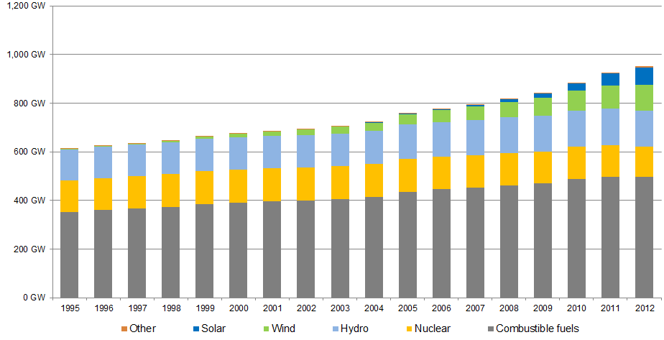
Source: Eurostat, energy
The growth in installed generation capacities exceeded both the increase in power generation and consumption, suggesting an improvement in security of electricity supply from domestic generation point of view. The growth in renewable capacities brought diversity of generation sources.
Besides generation technologies the availability of the existing capacities can exert influence on the security of electricity supply. Table 2 shows the composition of the capacities, according to generation technologies (fuel) and provides information on their availability in the December reference points in 2010, 2011 and 2012 for the transmission system operators of the ENTSO-E. By comparing data of the same month in different years (reference point) the seasonality of non-available capacities (e.g.: planned maintenance works) can be eliminated.
As we can see, the share of the unavailable capacities compared to the total net generation capacities varied between 26-33% during the observed period, of which the highest part could be attributed to non-usable capacities (17-23% of the total net generation capacities). Maintenance and plant overhaul was responsible for the non-availability of 3-3.5% of all capacities, as December is not a typical maintenance period of the year. Outages, primarily meaning unscheduled non-availability of generation capacities, had a share of 2.1-2.8% between December 2010 and 2012. Outages pose a threat to the security of electricity supply, especially combined with other non-planned events (e.g.: weather conditions, supply disruptions of fuel feedstock, etc.), however, during the observed period system service reserves were higher than capacities being unavailable due to outages.
Table 2. The availability of generation capacities in ENTSO-E member TSOs, December 2010-2012
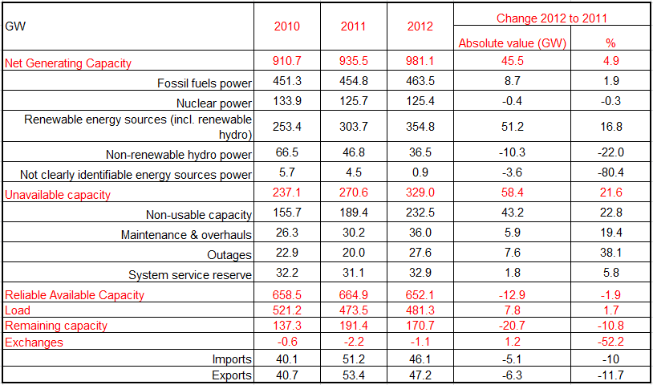
Source: ENTSO-E
It is also important to examine the ratio of domestic production and consumption in each country in order to assess the local exposure to external electricity supply shocks. Countries like Lithuania, Luxembourg, Hungary or Croatia produced in 2012 significantly less electricity than their annual national consumption, meaning that they needed to import power to satisfy all domestic demand. In contrast, Estonia, Czech Republic, Bulgaria and France produced more than their domestic needs, and export a part of their production. Here it is worth mentioning that net power flow positions in a given country can change significantly from one year to the other, for example, if the availability of domestic generating capacities are affected by planned or unplanned maintenance works or due to weather conditions the availability of hydro generation changes significantly.
In the context of security of supply for electricity it needs to be emphasised that intra-community electricity trade can have a positive impact on reducing the external dependency on fossil fuels and thus the vulnerability of a given country and thus should be clearly distinguished from extra-EU imports. Increasing intra-EU electricity imports does not necessarily result in higher external energy dependency and could even reduce the overall energy exposure to third countries in some member states. For example, as gas-fired electricity generation became uncompetitive in Hungary, the country imports more electricity from the Czech Republic generated from domestic coal. In other words, instead of burning Russian gas, the country relies on foreign (though intra-EU) coal-fired generation, which is a better situation from the aspect of external fossil fuel dependency. Recently the Netherlands tends to import more electricity from Germany (based on coal-fired and renewables generation), replacing domestic gas-fired generation, though in this case the competitiveness of imports weighs more than the security of supply aspect.
These two cases give a perfect example on why the issue of electricity security of supply should be tackled at EU level and why not only national aspects should be taken into consideration. The accomplishment of the EU internal electricity market in itself could contribute to decreasing external fossil fuel dependency in the EU.
Figure 6 Difference between power generation and annual power consumption in 2013 in the EU countries (compared with annual consumption)
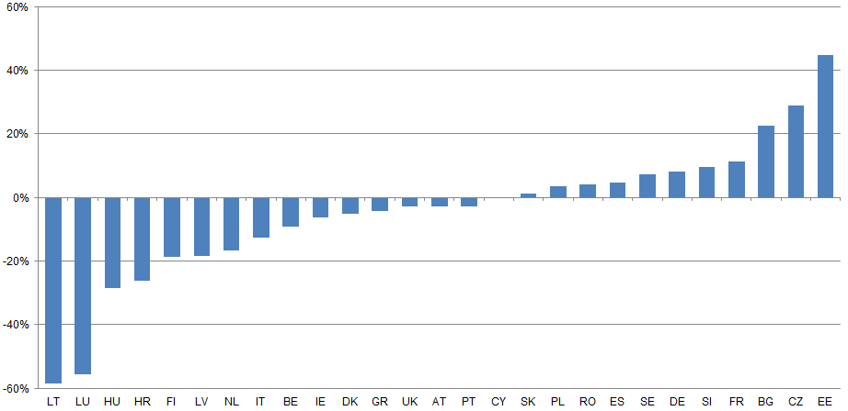
Source: ENTSO-E, calculations of the European Commission. Malta is missing

Short term disruption of supply in most exposed Member States
Another important aspect is the quality of electricity infrastructure, as security of supply risks may stem from disruptions (non-availability of an interconnector or cables). In the case of extra-EU imports it is important to see the number of interconnections and the changes in the availability of capacities.
Figure 7 Difference between power generation and annual power consumption in 2013
Source: ENTSO-E, calculations of the European Commission. Malta is missing
According to the data of Eurostat, in 2012 the Netherlands imported 5.3% of its annual electricity consumption from Norway using the NorNed high voltage direct current (DC) link. Denmark also imported power from Norway (17.5% of its annual consumption), similarly to Sweden (5.5% of its annual consumption). In the case of the Netherlands and Denmark, being net power importers, imports from Norway had higher importance than in the case of Sweden (which is a net power exporter). Both the Netherlands and Denmark are well connected with other neighbours. Norway is an EEA country, applying the community acquis.
Finland imported 5.5% of its annual electricity consumption from Russia in 2012, and given that the country is a net power importer and less connected with EU countries having cheap power sources (e.g.: Norway), a supply disruption of the Russian imports would possibly result in wholesale price hikes or higher use of domestic resources or increased imports from other sources.
Among the Baltic States Estonia has sufficient level of domestic generation capacities and the country does not need imports. During the most recent years cable links were also established with Finland (Estlink 1 and Estlink 2 – DC links). Latvia and Lithuania are in a quite different situation. Latvia imported 18% of its domestic electricity need from Russia in 2012, and the country is also connected with Estonia, Lithuania thorough 300-330 kV AC transmission power links. After the Ignalina nuclear power plant was shut down at the end of 2009, Lithuania heavily relies on power imports. In 2012 the country imported 29% of its annual power need from Russia via a 750 kV transmission line and 25% from Belarus (through several transmission lines of 300-330 kV voltage).
Poland, the Czech Republic and Slovakia are all net power exporter countries and are exposed less than 2% of their annual electricity consumption to extra-EU import sources, meaning that in their cases external supply disruptions are highly unlikely to have significant impacts. Furthermore, these countries are well connected to their neighbours, increasing the probability of finding alternative supply routes in case of a disruption.
Hungary imported 11% of its annual power need from the neighbouring Ukraine in 2012 (via a 750 kV high voltage transmission line), which share is high enough for supply problems in the case of a potential Ukrainian import disruption. The country is also sensitive for imports from the Balkan countries, being affected by hydro availability. As Hungary imports more than a quarter of its annual power need, these features make the country sensitive to extra-EU electricity supply shocks.
Croatia is also a net importer of electricity and imported 12.6% of its annual power need from Bosnia and 3.4% from Serbia in 2012. The country is well connected with its neighbours but the electricity market is sensitive to changes in power supply in the Balkans.
Romania is a net power exporter; it imported only 8% of its electricity needs in 2012. The country has a high voltage (750 kV) transmission line link towards Ukraine and is well connected with its neighbours. Bulgaria is in a net electricity exporter position and is not really sensitive to external import supply disruptions.
Greece is a net power importer and imported 3.3% of its electricity need from Turkey and 3.1% from the Former Yugoslav Republic of Macedonia (FYROM). The country is connected to all of its neighbours, including Italy (with a high voltage sub-sea DC link).
In the previous section electricity import sources and the import dependency of the EU member states having electricity supplies from countries outside the EU have been presented. Each member state should have enough interconnector capacities in order to be able to import electricity from (or alternatively, export to) neighbouring countries. The next chart (Figure 8) shows ratio of the available electricity interconnectors and domestic power generation capacities in each member state of the EU, with the exception of Cyprus and Malta, which are not connected to any other country, and Luxembourg, which has more than twice as high import capacities than domestic generation.
Figure 8 Ratio of available cross-border electricity interconnector capacities compared to domestic installed power generation capacities
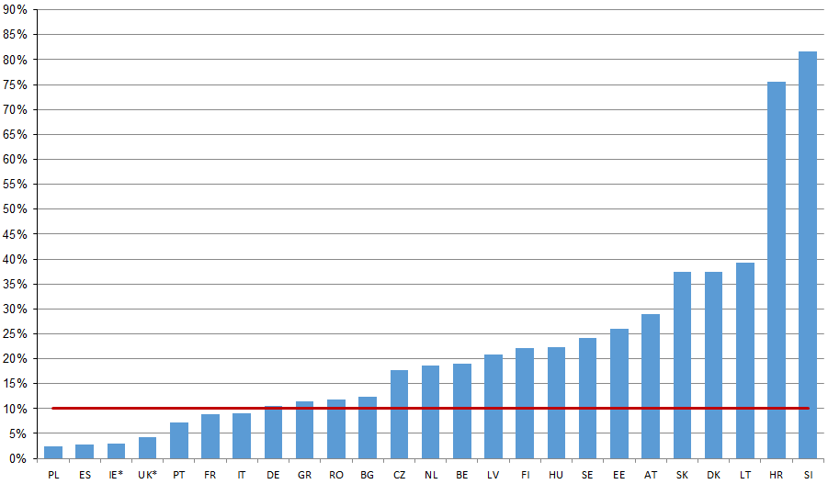
Source: Ten Year Electricity Network Development (TYNDP) Plan, 2012 Malta and Cyprus are missing. The Irish power system includes Northern Ireland as well (and it is consequently not included in the UK)
In contrast to significant import dependencies in electricity, some member states might heavily be affected by domestic supply disruptions in the lack of the option of importing power. In July 2011 an explosion in Cyprus heavily impacted the power plant, which generated almost the half of the island's electricity need, resulting in several blackouts. As Cyprus is not connected to any other countries ('a true energy island'), it could not mitigate the impact of the disruption by substituting domestic production by imports. Furthermore, as the country's power mix is extremely dominated by oil-fired generation, alternative fuels could not assure a sufficient power supply either.
In general, most EU Member States perform well in terms of quality of electricity supply. A ranking of 144 countries undertaken by the World Economic Forum on quality of electricity supply, 5 of the top 10 positions are occupied by EU Member States. There remain differences between Member States, with 15 EU Member States in the top 30, while the remaining 13 rank lower down the list with Romania and Bulgaria in positions 88 and 95 respectively.
Extreme weather conditions, natural disasters, force major events and planned or unplanned plant, interconnector or power link maintenance works can affect the electricity security of supply in each country, especially in those cases, when several events occur simultaneously. For example, in March 2011, in the aftermath of the Fukushima nuclear power plant incident in Japan, the public acceptance of nuclear power generation rapidly diminished in many EU member states; and some of them decided to take nuclear capacities off the grid immediately. This had only a short-lived impact on spot electricity prices, as increasing renewable and coal-fired generation could substitute the missing capacities and thus eliminating the security of supply risks.
In contrast, the cold spell that affected most of Europe in February 2012 put a higher risk of security of electricity supply. Natural gas prices suddenly hiked in the consequence of low temperatures, affecting electricity prices. Electricity prices in North Western Europe were further influenced by increasing heating related demand in France, where most of the heating needs are satisfied by electricity. The cold weather also had an impact on hydro and other conventional generation in some countries as river waters could not be used either for power generation or for cooling purposes in power plants because of the freezing temperatures. And nuclear capacities were reduced in the previous year. Although no severe supply disruptions occurred, the whole European power system was under heavily strain.
In the case of electricity security of supply issues are different from those of fossil fuels, and in most of the EU countries the resilience of the power system is good enough to cope with problems of usual magnitude. However, simultaneous occurrence of unusual or extreme events (e.g.: an ongoing cold and dry winter coupled with a major external gas supply disruption) might cause perceivable disturbances in the functioning of the European electricity system and internal market.
In order to avoid such disturbances, Member States need to coordinate their policies regarding the electricity generation adequacy and in negotiating with external suppliers. In the case of the electricity security of supply issues are rather related to the stability of the grid, however, supply issues of fuel feedstock have repercussions on the electricity market.
Contrarily to fossil fuels, the storability of electricity is limited. Besides fuel cells the most commonly known form for storing electricity is hydro reserves. At EU level electricity security of supply can also be reinforced by hydro reservoirs in some European countries, having significant hydro generation capacities (Austria, Norway, Switzerland, etc.). A good example for this is the cheap electricity generation during off-peak hours in Germany, which is exported to Norway in order to pump the water back to reservoirs, being used for power generation during the peak hours and this generated electricity is re-imported to Germany.
At EU level imports can be deemed to be marginal compared to the electricity consumption, and thus external import electricity dependency is of secondary nature; mainly manifesting in feedstock import dependency used for power generation. As fossil fuel feedstock is also used in economic sectors other than electricity generation (e.g.: transport), electrification of the whole economy could substantially contribute to reducing energy import dependency if electricity can substitute other energy sources.

Improving the internal market
In 2002 EU member states agreed in the presidency conclusions of the Barcelona European Council on a target for the level of electricity interconnections equivalent to at least 10% of their installed production capacities by 2005.
Although this deadline has long passed, there are still nine member states that do not meet this target according to the data of the 2012 TYNDP. Bottlenecks in interconnections may pose risks to the security of electricity supply in the case of unplanned domestic generation capacity outages, or in the case of interconnector maintenance works (or unplanned disruptions). In order to avoid these events these member states should develop sufficient level of interconnector capacities.
In order to tackle infrastructure bottlenecks, the European Commission and the member states aim at implementing a number of development projects. Figure 9 shows the electricity projects of common interests (PCI) in the EU. The first list of the PCIs was established in 2013, containing 248 projects, of which 132 in the electricity domain. The projects are contributing to the realisation of a pan-European integrated grid; to the ending of the isolation and removing bottlenecks in national grids and to the achievement of the 10% electricity interconnection target.
These projects aim at constructing new high voltage lines, substations, electricity storage capacities and phase shift transformers in order to enhance electricity security of supply in the EU internal energy market and to improve the functioning of the market by tackling the problems deriving from unplanned cross-border power flows.
However, progress with interconnectors in the onshore looped system has not been fast enough during the last couple of years; on some critical borders such as Germany – France available transmission capacity actually declined. This points to the need for the development of the transmission systems to be accelerated.

Figure 9 Electricity projects of common interest (PCIs) in the EU
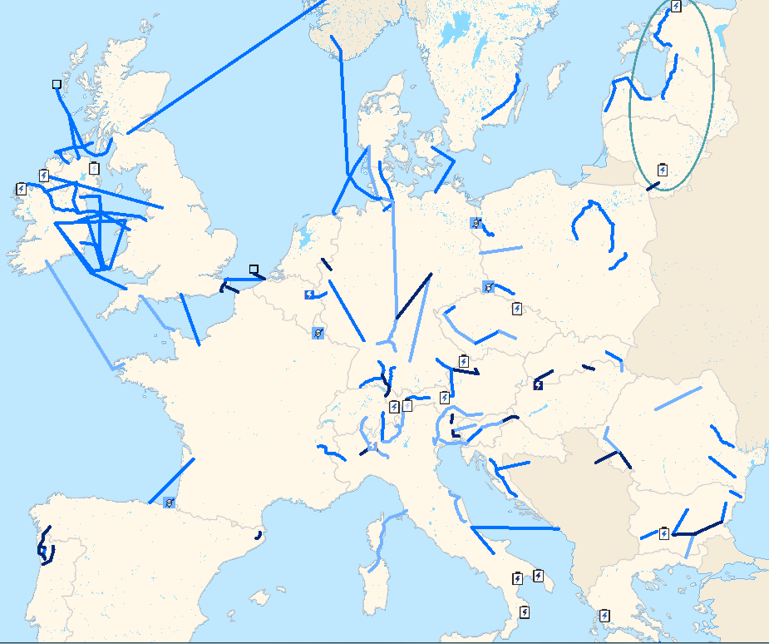
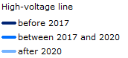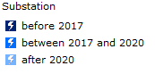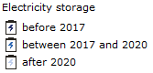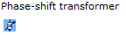
Source: European Commission
Besides infrastructure developments a solid legal framework assuring the functioning of electricity cross-border trade can also contribute to enhancing the electricity security of supply. The Third energy package foresees the development of a harmonized legal framework at European level. Binding European rules (Network Codes), are being developed, adopted and increasingly applied in the day-to-day practical functioning of the electricity wholesale markets. Their impacts may not be as immediately tangible as those of a new interconnector, but they are true progress that is fundamental to foster cross-border trade. Regional initiatives are also proving concrete value in the (early) implementation of network codes.
Day-ahead price coupling has been tested and successfully implemented first amongst the countries of the Pentalateral Forum (Germany, France, Belgium, the Netherlands and Luxembourg) and Austria. In a second step, in February 2014, that region was coupled with the UK and Ireland and the Nordic region (Norway, Sweden, Denmark, Finland and the Baltic States). In May 2014, Spain and Portugal joined, resulting in one of the largest power market areas in the world. Hungary, Slovakia and the Czech Republic have implemented as a first step the mutual coupling of their markets, with the ambition to couple that market too with the larger market in the west. Hence, market integration is developing from the North to the South and from the West to the East, based on concrete projects initiated at regional level.
Day-ahead market price couplings contribute to increasing cross-border electricity trade through implicit transaction allocations. They substantially contribute to reducing the number of hours, when electricity flows from more expensive markets to the cheaper ones (referred as adverse power flows as this is the opposite way of economically justifiable market functioning, resulting in welfare losses in cross-border power trade). Couplings usually reduce price differentials between neighbouring markets, contributing to more homogenous price levels across the coupled region, however, this does not hold true for each trading hour after the coupling takes place, as price divergences may exist, even on longer run.
Government interventions in the energy market may still be needed for investing in generation, as well as for infrastructure investment, establishment of system operation rules and market coupling. The Commission's Communication and guidance of November 2013 "Delivering the internal electricity market and making the most of public intervention" explained in detail the conditions under which such intervention may be justified. It also explained the criteria under which the interventions are legitimate, whether related to the transformation of the energy sector into a low carbon regime or to ensuring the security of energy supply.

Research and innovation
Research and innovation actions already make an important contribution to EU energy security. This is notably the aim of the SET-Plan Integrated Roadmap currently in preparation, which will identify the changes required for the transformation of the energy system in the medium to long run, the key drivers for innovation, and the necessary research and innovation actions. On the supply side, the Roadmap will support the development of new and innovative energy technologies that are at the same time more efficient, cleaner, more reliable and more cost-competitive. In terms of network infrastructure, the aim will be to ensure energy system integration by developing the tools to manage variability in the energy supply, storage and distribution, to accommodate increasing renewable production and to allow more decentralized power generation from variable sources. Last but not least, the Roadmap will support significant improvement in energy efficiency, notably in the building sector, for industrial applications and for cities. However, the political direction of the emerging version of the SET-Plan and its associated Roadmap and Action Plan should be clearly set against the opportunities that emerge from the realities of energy security.
There are a few key areas where energy research and innovation has the potential to make an important contribution to energy security.
Coal-powered generation with carbon capture and storage: the coal sector already contributes to Europe's security of energy supply and this is expected to remain the case in the long run. Research and innovation efforts are however needed to reduce the environmental impact of increasing coal use and ensure compatibility with the EU climate change goals.

Renewables: EU research on renewables will continue to seek maximization of the vast untapped EU potential for domestic energy resources, with a particular emphasis on actions supporting the decreasing of costs and pushing for the market deployment of new innovative technologies. This will be done having in mind the need to avoid creating new economic, material or feedstock dependencies.
Nuclear fission research: a number of EU Member States are currently operating pressurized water reactors of Russian design (VVERs) on fuel imported from Russia. Recent attempts were made to diversify the fuel supply for this type of reactor but experiments were not all conclusive, which have raised safety concerns. There is a need to promote research cooperation at EU level in order to tackle these issues, which were so far addressed at national level only. An amendment to the Euratom Work Programme will be proposed to allow such research and innovation action to be launched in 2014, alongside a broader assessment through recourse to external expertise.
Power to Gas (P2G): P2G has the decisive advantage to convert excess electricity from renewables (e.g. solar, wind) into storable gas and, when electricity shortage arises, to convert it back into electricity (e.g. using fuel cells) in order to balance the grid. Research and innovation actions are required to optimise the process as well as reduce the price of fuel cell technologies.
Unconventional gas: unconventional gas, in particular shale gas, is gaining interest as a new possible source in the energy mix, which could also contribute to Europe’s security of energy supply. However an important research and innovation effort would be needed to reconcile its exploitation with the imperatives of environmental stewardship, compatibility with EU climate change goals (e.g. preventing emissions of methane) as well as optimal management and sustainable use of the subsurface.
Nuclear fusion: while current research and innovation efforts aiming at the production of electricity from fusion have a much longer time perspective, and are therefore not covered in this short analysis, their success would represent a very significant contribution to the overall EU energy security.
Integrated energy system infrastructures: EU energy research is supporting a closer integration of different energy production, delivery and storage infrastructures, which will bring an important contribution to the security of supply and to the efficiency of the pan-European energy system by offering promising opportunities for the balancing of electricity generation and demand.
Electricity networks: research supporting smarter, stronger and more coordinated electricity networks will contribute to security of supply by reinforcing the market-based exchanges among Member States with a different energy mix, while also enabling the integration and transfer of vast indigenous renewable resources to the load centres.
For the 2014-2020 period, the EU is ramping up investment in energy research and innovation. Under Horizon 2020, the new Union research and innovation programme, close to €6 billion (around a doubling compared to FP7) will be dedicated to energy efficiency, to smart cities and communities and to secure, clean and low carbon technologies. This is done in close coordination with industrial stakeholders, through Public-Private Partnerships (the Energy-efficient Buildings PPP, the Sustainable Process Industry through Resource and Energy Efficiency (SPIRE) PPP, as well as the European Green Vehicles Initiative contractual PPP). At least 85% of this budget has been ring-fenced for renewable energy, end-user energy efficiency, smart grids and energy storage. In addition, close to €1.3 billion will be dedicated to nuclear fission and €4.1 billion to nuclear fusion (including close to €3 billion for ITER). Increased funds will also be available for financial instruments, public private partnerships and SME projects in the field of energy technology and innovation. Furthermore, EU funding during the period 2014–2020 is also available under the European Structural and Investment Funds, where a minimum of EUR 23 billion has been ring-fenced for the "Shift to low-carbon economy" Thematic Objective. This represents a significant increase in EU support for mass-deployment of renewables, energy efficiency, low-carbon urban transport and smart grids solutions in the EU.
In addition, the Fuel Cells and Hydrogen 2 Joint Undertaking will continue to develop a portfolio of clean, efficient and affordable fuel cell and hydrogen technologies to the point of market introduction, while at the same time helping to secure the future international competitiveness of this strategically important sector in Europe. Transport -specific objectives include reduction of the production costs of fuel cells used in transport applications whilst increasing their lifetime to levels competitive with conventional technologies.

Country-specific supplier concentration indexes
To measure diversification, in this report we use an index that builds on a Herfindahl-Hirschmann index (HHI) and takes into account both the diversity of suppliers and the exposure of a country to external suppliers (see Le Coq and Paltseva 2008, 2009, Cohen et al 2011). Other on-going work of the Commission services includes indicator-based assessment of energy dependency of Member States.
The country-specific supplier concentration index (SCI) by fuel is computed as the sum of squares of the quotient of net positive imports from a partner to an importing country (numerator) and the gross inland consumption of that fuel in the importing country (denominator). Smaller values of SCI indicate larger diversification and hence lower risk. All else equal, SCIs will be lower in countries where net imports form a smaller part of consumption; hence SCIs are likely to be correlated with the commonly used measure of import dependency.
For each fuel and country, three indices have been computed:
- SCI looking at total imports to a Member State, including intra-EU movements and imports coming from outside of the EU.
- SCI looking at the imports to a Member State that originate from outside of the EU, thus disregarding internal flows within the EU in the volume of imports of a Member State
- SCI looking at the imports to a Member State that originate from outside of the EEA, thus disregarding flows within the EEA area in the volume of imports of a Member State. Norway is the only EEA country exporting significant volumes of gas and oil to the EU.
In the case of natural gas calculations excluding imports from the European Economic Area , the SCI of the Baltics and Finland is at or above 100 indicating they have their entire consumption covered by a single supplier (above 100 indicates the role of storage in e.g. Latvia). Austria, the Czech Republic and Slovakia have SCIs above or close to 80. The high value of the SCI confirms the fact that a number of Member States have a large share or their entire natural gas consumption coming from a single supplier.
For some Member States the value of the SCI calculated on the basis of total imports and on the basis of extra-EEA imports changes significantly. For countries such as Belgium, Germany, France, Luxembourg, France and the UK that import significant quantities of gas from the Netherlands and Norway, as well as through intra-EU trade movements, the extra-EEA values are significantly lower than the values calculated with total imports. This confirms the fact that these countries have a much more balanced portfolio of suppliers, making extensive use of trade movements in the internal market and the EEA. Sweden and Ireland import volumes covering their entire consumption through transit flows from neighbouring countries. This is the reason that their supplier diversification index is 100 when looking at total imports, but zero when looking on the basis of extra-EU or extra-EEA.

Figure 10. Country-specific supplier concentration index, natural gas, 2012 (extra-European Economic Area)
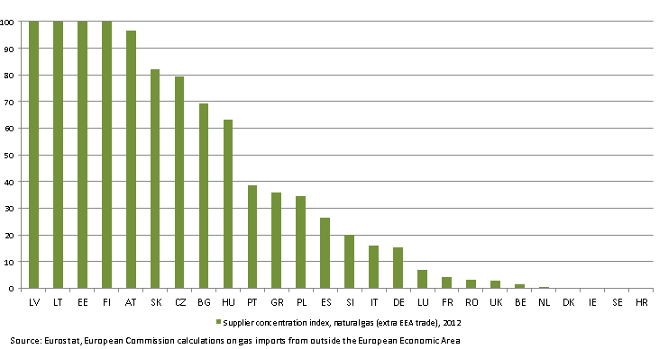
Source of data: Eurostat, energy. European Commission calculations. The vertical axis has been cut at 100; values above 100 may indicate storage or transit whereby some volumes have not been reported as exports.
Figure 11. Country-specific supplier concentration index, natural gas, 2012 (total versus extra-European Economic Area)
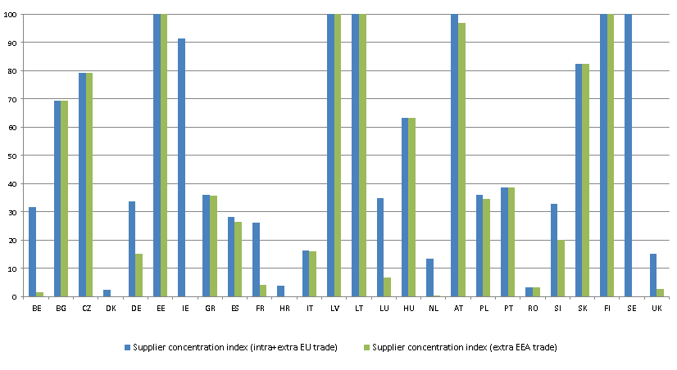
Source of data: Eurostat, energy. European Commission calculations. The vertical axis has been cut at 100; values above 100 may indicate storage or transit whereby some volumes have not been reported as exports.
In the case of crude oil, Bulgaria, Lithuania, Slovakia, Poland, Hungary, Poland and Finland have relatively high SCI at or above 80. Excluding internal EU or EEA trade movements leads to significant change in the indexes for only two Member States (Denmark and the UK), pointing to the share of Norwegian imports in these countries.
Figure 12. Country-specific supplier concentration index, crude oil, 2012 (extra-European Economic Area)
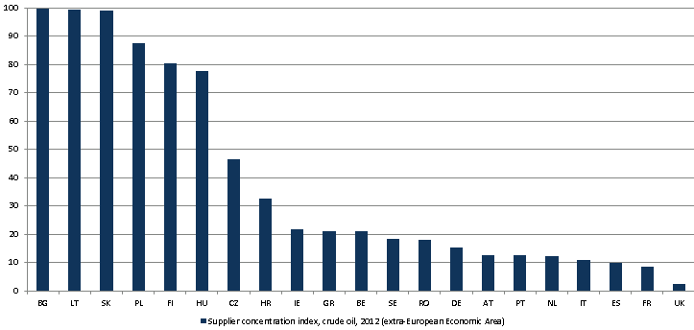
Source of data: Eurostat, European Commission calculations
The SCI of coal confirms the fact that coal imports are much more diversified and account for a smaller share of consumption for most Member States. The SCI for other bituminous coal was around and above 80 for countries like Estonia, Lithuania and Luxembourg. In the case of the Netherlands, the value of SCI is extremely high and the likely explanation is that coal imports that enter through the seaports of the Netherlands, but are then reloaded and transported to consumers in other countries are probably reported in statistics as import volumes only, but not as export volumes. This data deficiency may result in lower than real SCI for coal in countries that import coal coming through Dutch ports.

Figure 13. Country-specific supplier concentration index, solid fuels, 2012
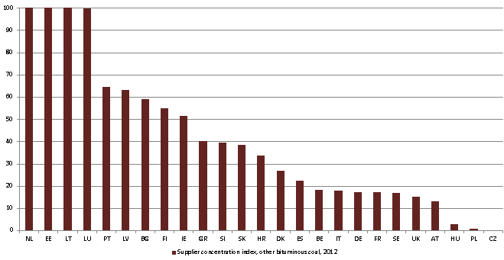
Source: Eurostat, energy. European Commission calculations. Includes other bituminous coal only. Romania does not report other bituminous coal consumption and imports in Eurostat. The vertical axis has been cut at 100; values above 100 may indicate storage or transit whereby some volumes have not been reported as exports.
The applicability of the country-specific diversification index cannot be fully justified in the case of electricity as electricity is prone to change flow direction between different markets more frequently than fossil fuels. Besides the EU member states mentioned in the electricity section of chapter 4, Luxembourg and Slovakia see significant electricity imports compared to their domestic consumption. In the case of Luxembourg imports from Germany and Belgium were significant in 2012, while in the case of Slovakia imports from the Czech Republic and Poland were dominant. Slovenia also imported a significant amount of its electricity need from neighbouring Austria in 2012. Denmark imported power from Sweden besides Norway, while the Netherlands imported significant amounts of cheap power from Germany (impact of renewables). All of the other EU member states import their electricity needs from another member states, besides the above-mentioned countries the other EU members are not affected by extra-EU imports. Italy imports some of its power needs from Switzerland, but Switzerland is strongly integrated in the West European market and well supplied with German and French power.
Table 3. Country-specific supplier concentration index, 2000-2012, by Member State and by fuel
 | Country-diversification index (extra EEA trade)
Crude Oil | 2000 | 2005 | 2009 | 2010 | 2011 | 2012
AT | 10.8 | 13.8 | 16.0 | 13.1 | 13.2 | 12.7
BE | 7.3 | 22.3 | 16.1 | 21.8 | 24.8 | 21.0
BG | 93.4 | 77.1 | 55.8 | 94.2 | 87.9 | 99.7
CY | 41.4 | 0.0 | 0.0 | 0.0 | 0.0 | 0.0
CZ | 66.1 | 54.4 | 52.6 | 46.2 | 42.4 | 46.5
DE | 10.1 | 13.2 | 13.4 | 14.4 | 15.6 | 15.2
DK | 0.0 | 0.0 | 0.0 | 0.1 | 0.2 | 0.0
EE
EL | 25.2 | 28.8 | 22.3 | 22.0 | 24.0 | 21.1
ES | 10.0 | 9.4 | 9.0 | 9.7 | 10.6 | 10.0
FI | 19.4 | 64.4 | 75.9 | 90.8 | 76.1 | 80.5
FR | 5.3 | 5.5 | 7.1 | 8.3 | 7.2 | 8.4
HR | 16.0 | 50.7 | 58.3 | 39.2 | 43.7 | 32.6
HU | 71.6 | 84.2 | 73.6 | 80.5 | 79.7 | 77.5
IE | 0.0 | 0.0 | 3.5 | 6.2 | 2.8 | 21.6
IT | 12.4 | 13.6 | 13.6 | 11.6 | 9.2 | 10.7
LT | 86.8 | 93.1 | 98.9 | 98.3 | 95.1 | 99.4
LU
LV
MT
NL | 7.6 | 16.1 | 13.3 | 12.6 | 12.4 | 12.3
PL | 86.9 | 92.2 | 87.2 | 85.5 | 81.8 | 87.4
PT | 14.3 | 10.9 | 9.4 | 9.8 | 12.8 | 12.5
RO | 11.1 | 17.3 | 18.9 | 16.0 | 18.6 | 18.1
SE | 1.4 | 13.1 | 14.4 | 19.5 | 27.0 | 18.3
SI | 40.4
SK | 93.8 | 96.8 | 100.1 | 100.4 | 101.0 | 99.1
UK | 0.6 | 0.5 | 0.6 | 0.6 | 1.0 | 2.5
Natural Gas | 2000 | 2005 | 2009 | 2010 | 2011 | 2012
AT | 42.7 | 49.0 | 63.7 | 61.8 | 79.8 | 96.8
BE | 7.8 | 5.1 | 11.8 | 7.8 | 14.6 | 1.6
BG | 87.5 | 76.8 | 97.3 | 85.8 | 74.1 | 69.5
CY
CZ | 61.1 | 56.4 | 46.6 | 57.3 | 118.5 | 79.3
DE | 15.1 | 17.0 | 11.6 | 14.1 | 15.7 | 15.3
DK | 0.0 | 0.0 | 0.0 | 0.0 | 0.0 | 0.0
EE | 100.0 | 100.0 | 100.0 | 100.0 | 100.0 | 100.0
EL | 60.5 | 71.3 | 38.1 | 39.8 | 40.1 | 35.7
ES | 39.4 | 25.2 | 18.9 | 19.8 | 24.0 | 26.5
FI | 100.0 | 100.0 | 100.0 | 100.0 | 100.0 | 100.0
FR | 14.5 | 8.8 | 6.3 | 4.7 | 5.1 | 4.2
HR | 16.8 | 15.3 | 11.7 | 10.4 | 0.0 | 0.0
HU | 44.3 | 36.8 | 51.2 | 57.5 | 48.9 | 63.4
IE | 0.0 | 0.0 | 0.0 | 0.0 | 0.0 | 0.0
IT | 24.7 | 17.9 | 16.6 | 16.4 | 16.1 | 16.0
LT | 100.1 | 101.3 | 100.7 | 99.4 | 100.5 | 100.1
LU | 100.0 | 100.0 | 6.9 | 6.9 | 6.9 | 6.8
LV | 103.9 | 111.5 | 130.1 | 38.2 | 119.7 | 129.5
MT
NL | 0.0 | 0.8 | 0.5 | 0.5 | 0.2 | 0.4
PL | 30.0 | 22.7 | 31.0 | 38.8 | 41.4 | 34.7
PT | 76.9 | 56.9 | 37.0 | 42.0 | 46.2 | 38.6
RO | 3.9 | 9.1 | 2.2 | 2.7 | 3.6 | 3.3
SE | 0.0 | 0.0 | 0.0 | 0.0 | 0.0 | 0.0
SI | 51.2 | 51.3 | 31.9 | 32.5 | 28.2 | 20.1
SK | 97.6 | 105.6 | 116.8 | 99.8 | 109.9 | 82.3
UK | 0.0 | 0.0 | 0.4 | 2.2 | 6.5
Other bituminous coal
AT | 0.0 | 0.0 | 0.1 | 8.1 | 0.1 | 13.1
BE | 35.4 | 29.1 | 36.4 | 20.3 | 35.6 | 18.5
BG | 51.8 | 41.9 | 44.4 | 50.8 | 57.5 | 59.2
CY
CZ | 0.0 | 0.0 | 0.3 | 0.7 | 0.5 | 0.2
DE | 2.6 | 8.8 | 13.2 | 11.2 | 15.9 | 17.4
DK | 11.7 | 18.6 | 28.0 | 10.3 | 39.7 | 27.1
EE | 126.9 | 93.0 | 11.9 | 140.0 | 91.6 | 152.4
EL | 29.7 | 52.3 | 47.9 | 44.7 | 46.1 | 40.1
ES | 11.5 | 17.1 | 24.6 | 16.5 | 15.5 | 22.6
FI | 39.2 | 73.2 | 105.1 | 41.2 | 153.7 | 54.9
FR | 15.5 | 12.5 | 12.0 | 15.7 | 18.3 | 17.4
HR | 40.9 | 22.3 | 17.5 | 47.0 | 43.9 | 33.6
HU |  | 24.9 | 58.5 | 13.2 | 4.8 | 3.0
IE | 16.6 | 21.7 | 50.7 | 36.6 | 87.8 | 51.6
IT | 17.9 | 22.4 | 23.8 | 25.6 | 20.5 | 18.0
LT | 100.0 | 100.0 | 102.4 | 144.3 | 141.9 | 115.4
LU | 71.5 | 73.7 | 86.6 | 100.0 | 100.0 | 100.0
LV | 64.7 | 91.8 | 92.5 | 75.2 | 35.1 | 63.3
MT
NL | 84.9 | 105.8 | 121.2 | 146.6 | 310.7 | 202.9
PL | 0.0 | 0.1 | 1.1 | 1.3 | 1.7 | 1.0
PT | 44.2 | 31.7 | 34.5 | 35.8 | 64.9 | 64.7
RO | 7.2
SE | 8.0 | 18.9 | 19.4 | 10.2 | 21.4 | 16.8
SI | 139.7 | 54.0 | 85.3 | 42.5 | 36.7 | 39.5
SK | 12.9 | 93.5 | 55.4 | 21.6 | 27.2 | 38.7
UK | 2.2 | 15.4 | 21.0 | 6.4 | 11.3 | 15.3
Source: Eurostat data, European Commission estimations

Conclusions

Chapter 2 of this report provides a review by fuel of the factors underpinning energy security, in particular consumption, production and import trends, infrastructure, suppliers and supply routes. Chapter 3 summarises the EU Reference scenario and 2030 policy framework projections on import dependency of fossil fuels
Chapter 4 of the report provides a detailed explanation of the different EU policies already in place that address the risks above and improve the resilience of the EU in the energy sector. It explores the resilience of the EU and of Member States to adjust to any such disruption, in terms of the scope for accessing alternative supplies, suppliers, fuel transport routes and fuel substitutes. The examination reveals the vulnerabilities broadly for the EU but more precisely, for the Member States who are most exposed to such risks.
Measures to mitigate security of supply include short term ones such as holding fuel stocks, preparing emergency response plans to reduce consumption in the event of a fuel crisis, and improvements to infrastructure which enable reverse flows or other fuel diversion, again in the event of a short term crisis.
Current EU policies also include the longer term actions the EU has initiated to reduce energy consumption and import dependency, and to broaden the diversity and resilience of the energy sector. Climate and energy policies that have spurred energy efficiency and renewable energy measures also contribute directly to diversifying energy supplies and reducing fuel consumption. Similarly, the EU framework of the internal energy market and the accompanying infrastructure policies and plans help integrate the European market, stimulate competition and reduce the risk of exposure to limited supplies and energy suppliers.
On the basis of this review, the accompanying European Energy Security Strategy explores the range of measures available to Europe to improve Europe's energy security. Further European cooperation regarding the development and diversity of national energy mixes will be an important means of reducing energy security risks. Other measures to further reduce consumption of energy and develop infrastructure that improves the flexibility of the energy system will also be explored. On this basis, Europe can work together to minimise energy risks in the short term and to maximise the resilience of the energy sector in the medium term.

See ENTSOG presentation of 7/5/2014 at the Madrid Regulatory Forum. ENTSOG underlines that the estimation should not be understood as an actual forecast neither in term of demand disruption nor supply mix. ENTSOG has prepared this preliminary Winter Risk Assessment on European Commission invitation in good faith and has endeavoured to prepare this document in a manner which is, as far as reasonably possible, objective, using information collected and compiled by ENTSOG from its members and from stakeholders together with its own assumptions on the usage of the gas transmission system. The scenarios included in this assessment do not represent any forecast but a view of what could happen in case of critical events. While ENTSOG has not sought to mislead any person as to the contents of this document, readers should rely on their own information (and not on the information contained in this document) when determining their respective commercial positions. The information is non-exhaustive and non-contractual in nature. ENTSOG shall not be liable for any costs, damages and/or any other losses incurred or suffered by any third party as a result of relying upon or using the information contained in this document. The estimations do not take into account the introduction of physical reverse flow on Yamal from Germany to Poland
IEA-EMS Report 24/04/2014
Flow against price differentials (FAPDs): By combining daily price and flow data, Flow Against Price Differentials (FAPDs) are designed to give a measure of the consistency of economic decisions of market participants in the context of close to real time operation of natural gas systems. With the closure of the day-ahead markets (D-1), the price for delivering gas in a given hub on day D is known by market participants. Based on price information for adjacent areas, market participants can establish price differentials. Later in D-1, market participants also nominate commercial schedules for day D. An event labelled as an FAPD occurs when commercial nominations for cross border capacities are such that gas is set to flow from a higher price area to a lower price area. The FAPD event is defined by the minimum threshold of price difference under which no FAPD is recorded. The minimum threshold for gas is set at 0.5 €/MWh. After the day ahead market closes, market participants still have the opportunity to level off their positions on the balancing market. That is why a high level of FAPD does not necessarily equate to irrational behaviour. In addition, it should be noted that close-to real time transactions represent only a fractional amount of the total trade on gas contracts.
Heating degree days (HDDs) express the severity of a meteorological condition for a given area and in a specific time period. HDDs are defined relative to the outdoor temperature and to what is considered as comfortable room temperature. The colder is the weather, the higher is the number of HDDs. These quantitative indices are designed to reflect the demand for energy needed for heating purposes. Data from the Joint Research Centre of the European Commission.
A review of intervention studies aimed at household energy conservation. Wokje Abrahamse, Linda Steg, Charles Vlek, Talib Rothengatter. Department of Pyschology, University of Groningen. Energy efficiency in buildings through information – Swedish perspective. Jessica Henryson, Teresa Håkansson, Jurek Pyrko. Lund Institute of Technology, Department of Heat and Power Eng. Innovative Communication Campaign Packages on Energy Efficiency. WEC-ADEME Case Study on Energy Efficiency Measures and Policies. Irmeli Mikkonen, Lea Gynther, Kari Hämekoski, Sirpa Mustonen, Susanna Silvonen.
http://ec.europa.eu/energy/gas_electricity/secure_supply/doc/national_plan_emergency_list.pdf
Preventive and Emergency Plans Review in accordance with Regulation 994/2010, JRC 2013
Earnst&Young points to the top risks in the mining and metals industry with infrastructure access only scoring 9 out of 10, mostly in the context of companies turning to new deposits in frontier countries, where the lack of infrastructure can be a substantial hurdle. Source: Earnst&Young, Business risks in mining and metals 2013-2014
Bundesanstalt für Geowissenschaften und Rohstoffe. 2013. Reserves, Resources and Availability of Energy Resources, Berlin.
IEA. 2013. Medium-term market report on coal.
Calculations based on the Directive 28/2009/EC
Renewable Energy Progress report, COM (2013) 175.
Directive 28/2009/EC.
See the Commission Renewables Progress Report.
Other reasons for concern include the failure to address barriers to the uptake of renewable energy: administrative burdens and delays still cause problems and raise project risk for renewable energy projects; slow infrastructure development, delays in connection, and grid operational rules that disadvantage renewable energy producers all continue and all need to be addressed by Member States in the implementation of the Renewable Energy Directive. Many Member States therefore need to make additional efforts to meet their respective national targets under the Renewable Energy Directive. More information in the Commission's "Renewable energy progress report", COM(2013) 175 final
Communication 'Delivering the internal electricity market and making the most of public intervention', C(2013) 7243 final
Report on economic aspects of energy and climate policies, 2013, European Commission, DG ECFIN
Report on economic aspects of energy and climate policies, 2013, European Commission, DG ECFIN
REPAP 2020 project report (2011), Mapping Renewable Energy Pathways towards 2020, EU Industry Roadmap, EREC (2011), EREC ECN/EEA report on Renewable Energy Action Plans (2011)
Proposal for a directive amending Directive 98/70/EC relating to the quality of petrol and diesel fuels and amending Directive 2009/28/EC on the promotion of the use of energy from renewable source, COM(2012)595
Commission own calculations on the basis of data from National Renewable Energy Action Plans (NREAPs), Eurostat and IEA 2010 (Global Wood Pellet Industry Market and Trade Study)
Given the elimination of conversion losses of thermal power generation, a growing share of renewable electricity itself reduces primary energy consumption, so its contribution is indeed sizeable. Due to conversion efficiency, conventional energy statistics tends to underestimate the contribution of renewables.
ENTSO-E provides data for 34 countries, out of the 28 EU member states Malta is not included, but Norway, Switzerland, Iceland and the Balkan countries with the exception of Albania and Kosovo are included
Due to various reasons, for example: temporary limitation due to constraints, like power stations in mothball or test operation, heat extraction for CHP’s; limitation due to fuel constraints management; power stations with output power limitation due to environmental and ambient constraints, etc.
Besides relative shares of imports to consumption it is important to examine the absolute volumes of power flows. France (net electricity exporter) and Italy (net electricity importer) do not show outstanding values in terms of relative numbers of electricity generation gaps or surpluses, though cross border flows in these two countries have major impact on the power flows in the EU as a whole.
The Netherlands, Denmark, Austria, the UK, France, Finland, Sweden, Belgium, Luxembourg, the Czech republic, Ireland, Germany, Slovakia, Portugal, Slovenia and Spain
http://ec.europa.eu/invest-in-research/pdf/download_en/barcelona_european_council.pdf
Cohen, G., Joutz, F. and Loungani, P. 2011. Measuring energy security: trends in the diversification of oil and natural gas supplies. In: Energy Policy 39 (2011), 4860-4869 and sources herein, including: Le Coq, C. and Paltseva, E. 2008. Common Energy Policy in the EU: the moral hazard of the security of external supply, SIEPS report 2008:1, Stockholm, Sweden and Le Coq, C. and Paltseva, E. 2009. Measuring the security of external supply in the European Union, in Energy Policy 37 (11), 4474-4481.
http://ec.europa.eu/economy_finance/publications/occasional_paper/2013/pdf/ocp145_en.pdf
Assuming perfect statistical data, the index takes values between 0 (no imports) and 100 (whereby the entire consumption of a product in a MS comes from a single supplier). Values above 100 can indicate storage/stocks and possible problems with statistical data e.g. unreported exports in the case of intra-EU trade movements mostly in transit countries (possibly CZ and AT for gas, NL for coal).
Other bituminous coal
No data on Spain-Morocco

