Annex I: Country annexes
Country Fiche: Austria
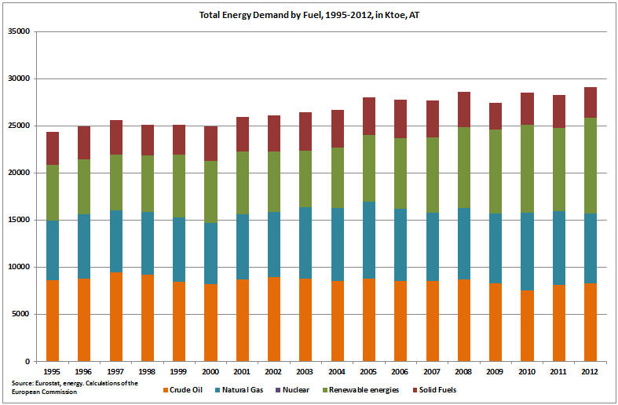
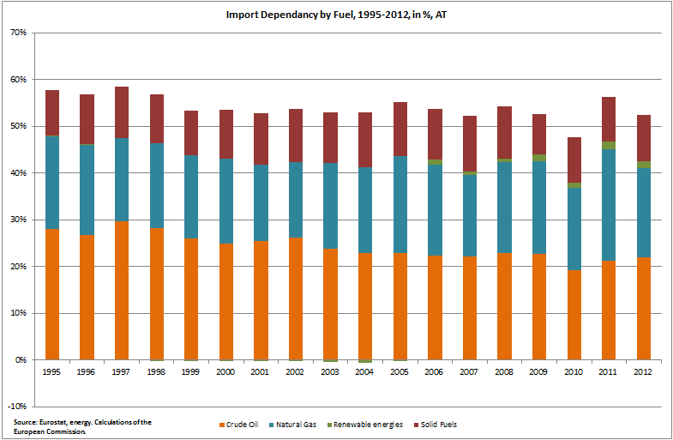

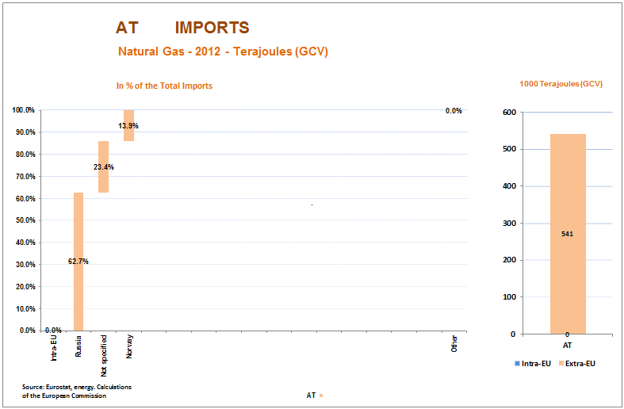

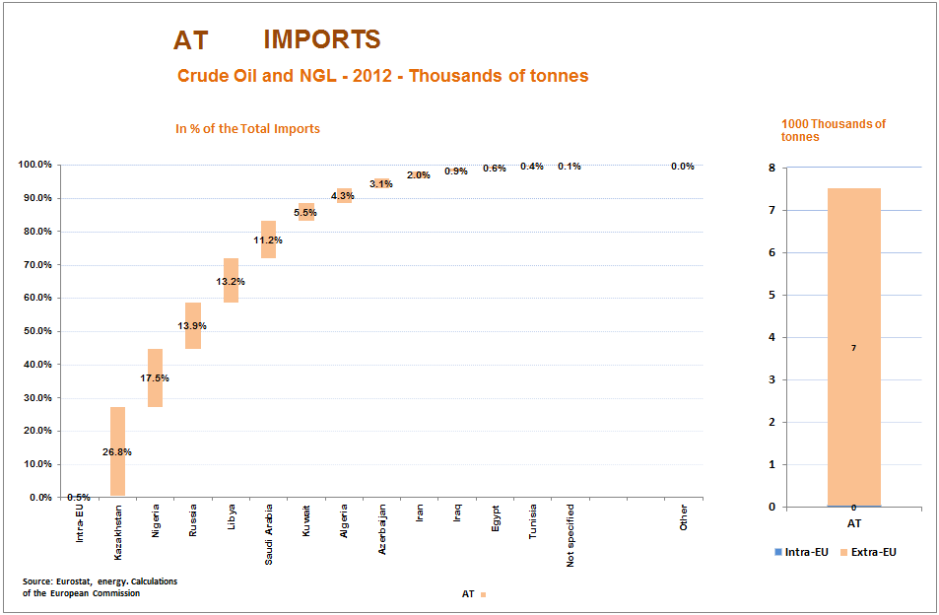
Country Fiche: Belgium
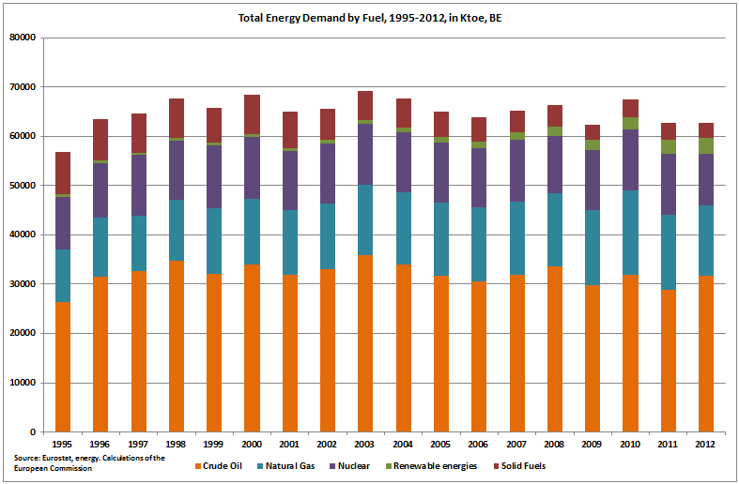
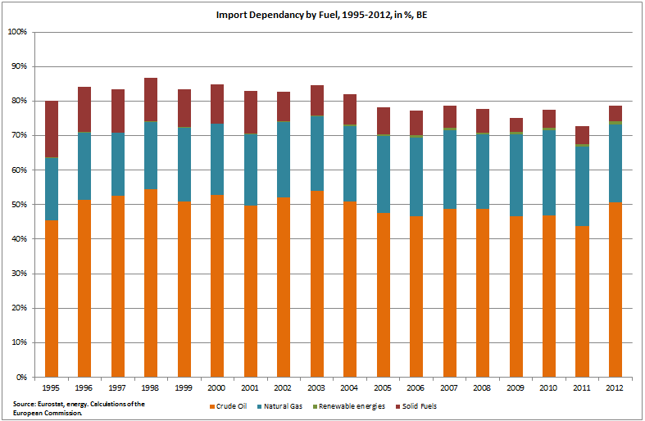

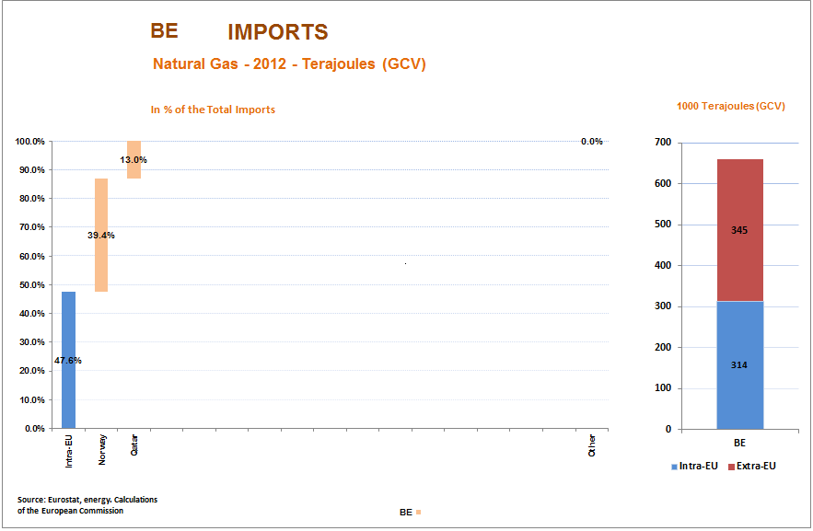

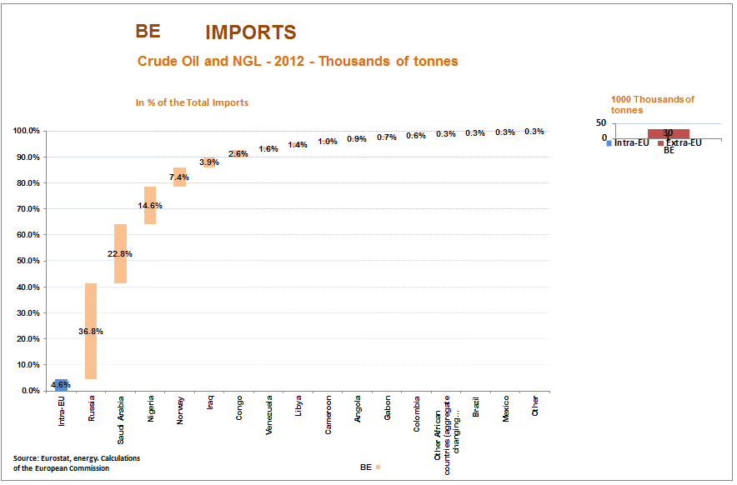
Country Fiche: Bulgaria
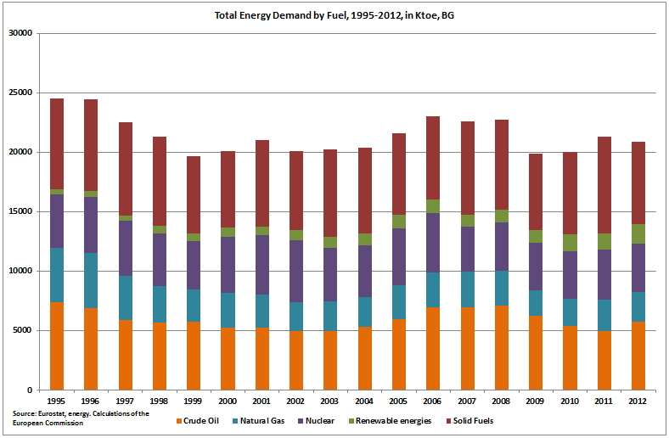
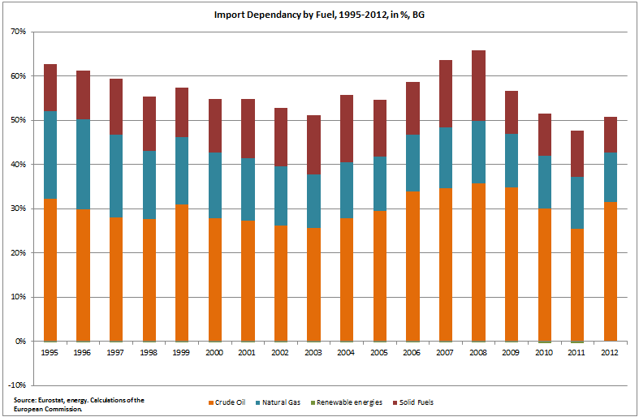

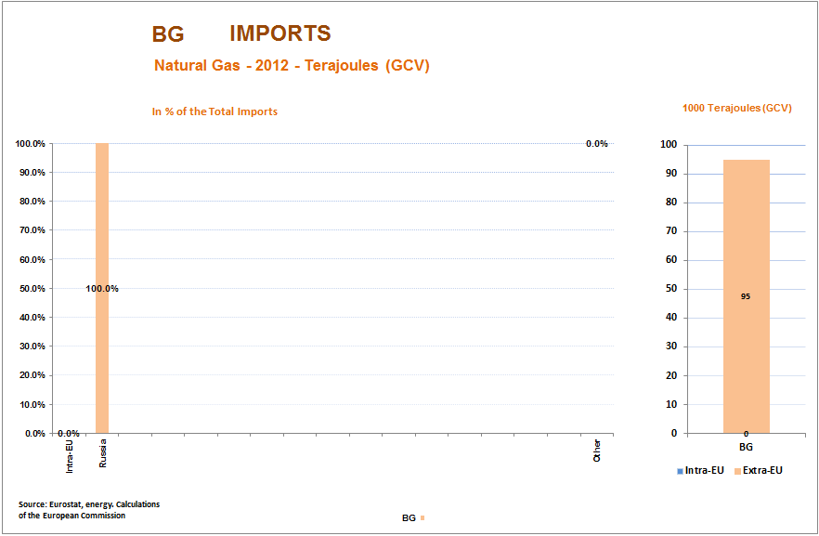

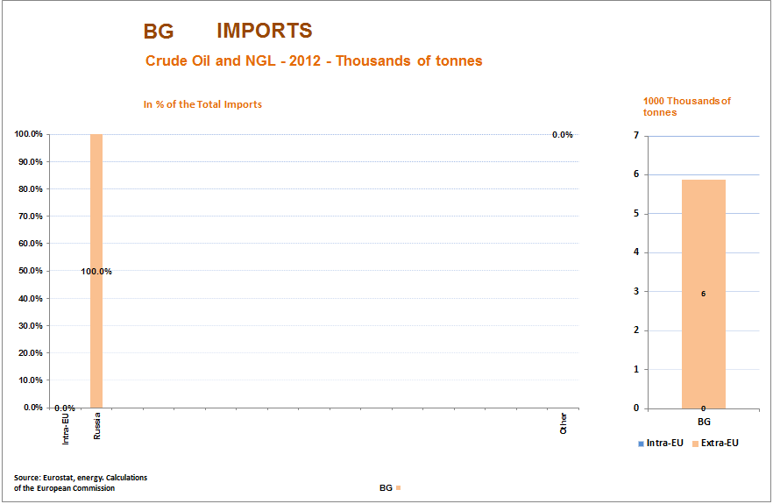
Bulgaria
Total gas consumption / Russian imports | Total: 2.6 Bcm/y // RU: 2.6 Bcm/y
Gas storage capacity and current level: | Total: 0.5 Bcm // Current: 0.2 Bcm
Connections to other MSs and capacity: | BG→GR: 3.5 Bcm/y  RO→BG (NV1): 4.9 Bcm/y  RO→BG (NV2): 19.6 Bcm/y (incl. cap. to TR)
Alternative supply options: | The interconnection with Romania is expected to come online in June 2014 with a capacity of 0.5 Bcm/y (max capacity of 1.5 Bcm will be reached by 2016).  Implementation of the interconnector BG-GR ongoing.  Installing reverse flows between GR-BG is ongoing with a planned firm capacity of 036 Bcm/y.
Assessment: The new interconnection with Romania and the reverse flows from Greece would still not be enough to cover missing Russian gas.

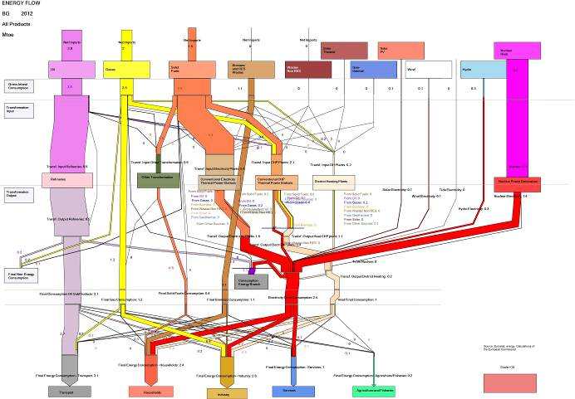

Country Fiche: Cyprus
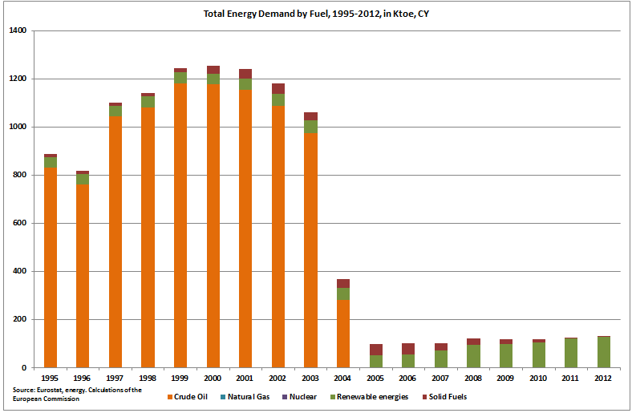
Note: Since 2005 Cyprus does not report crude oil data under energy transformation in the SIRENE database.
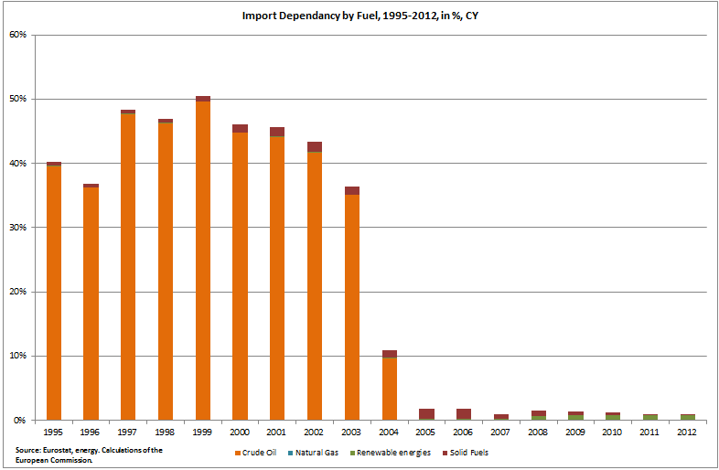
Country Fiche: Czech Republic
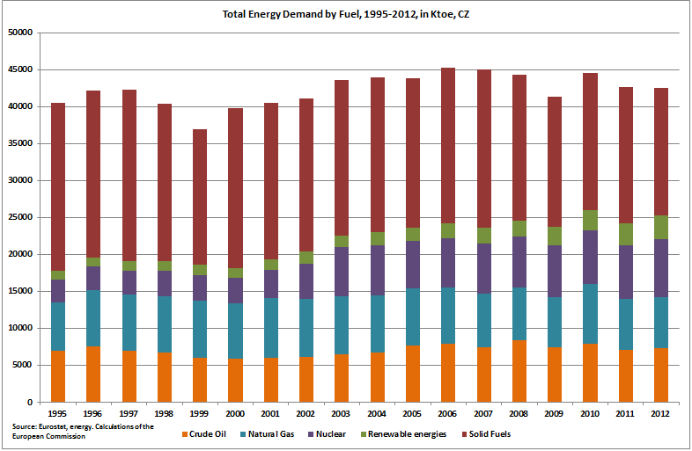

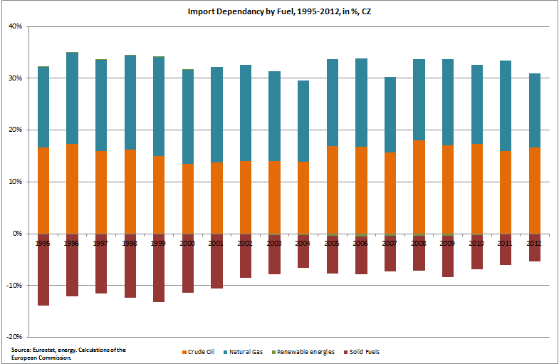

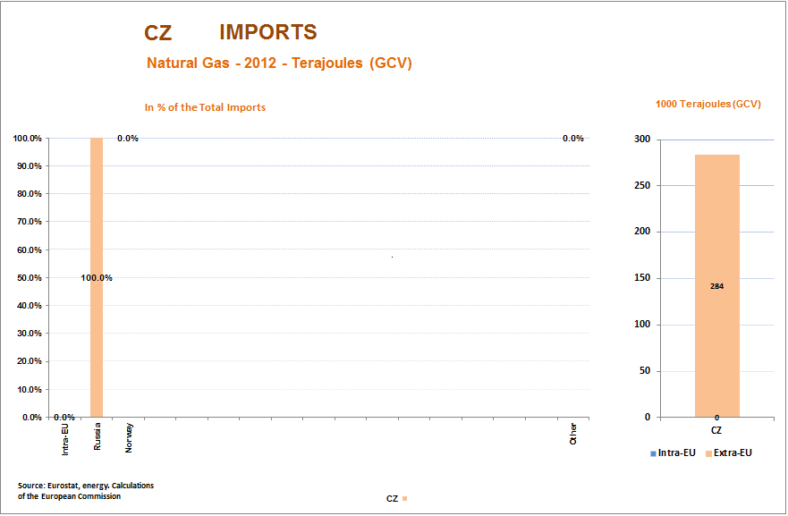

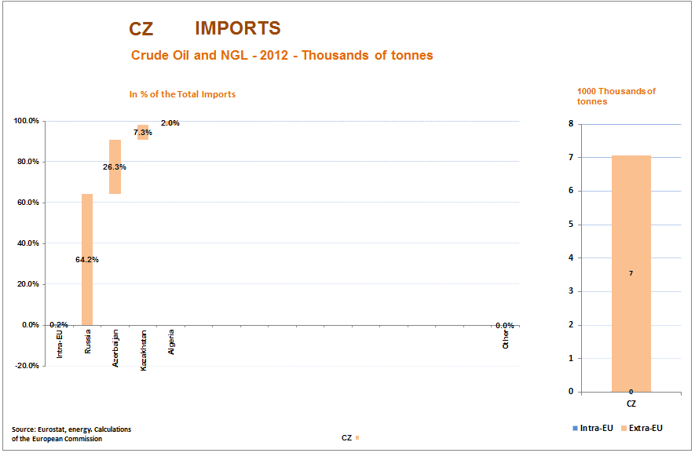
Country Fiche: Germany
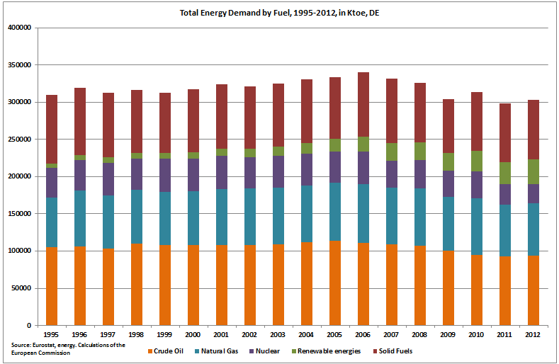

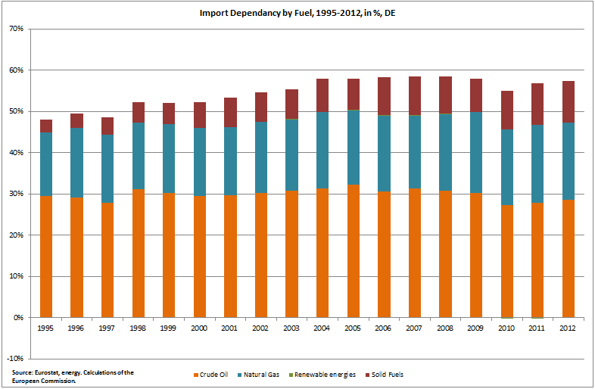

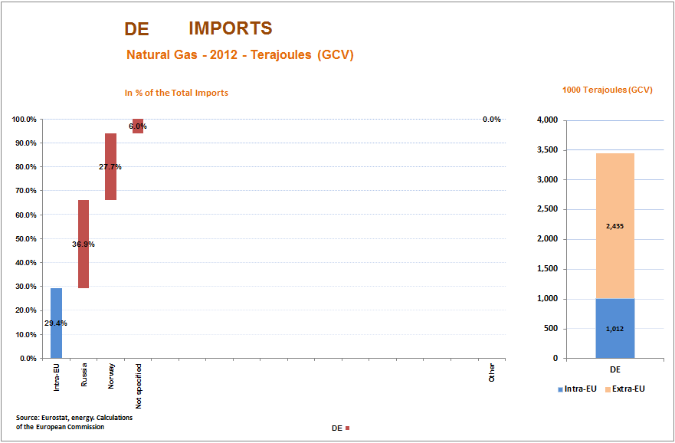

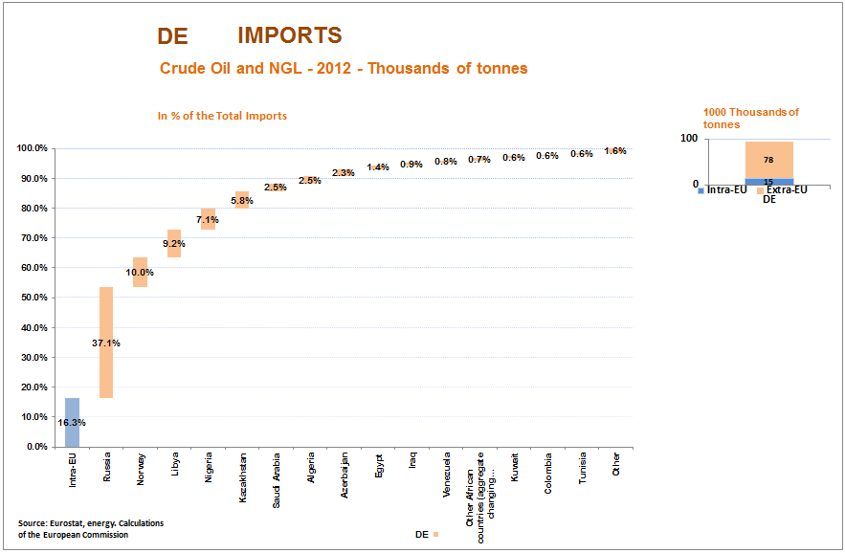
Country Fiche: Denmark
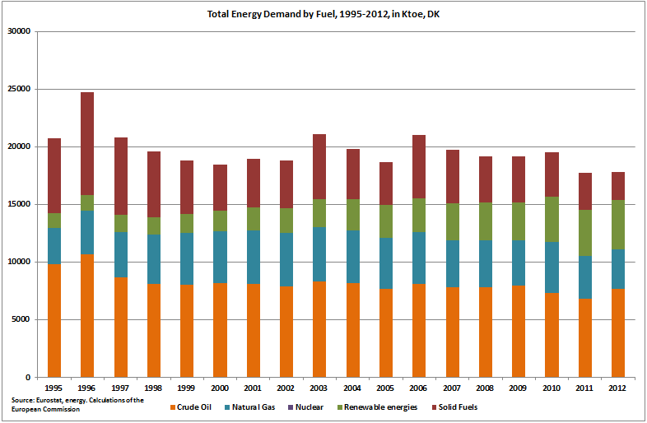

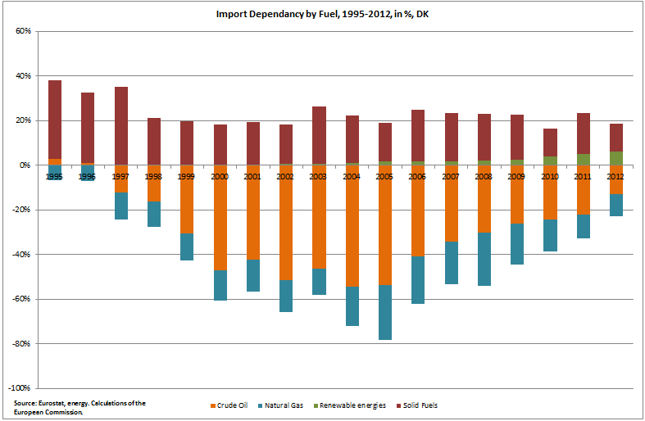

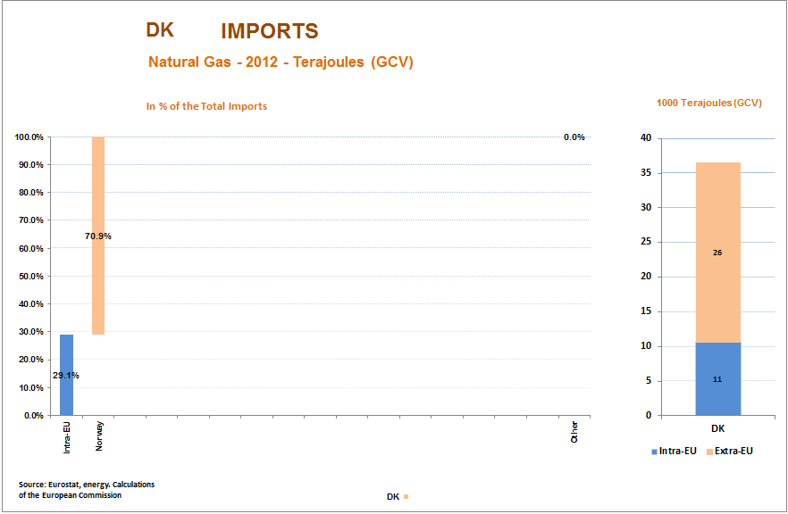

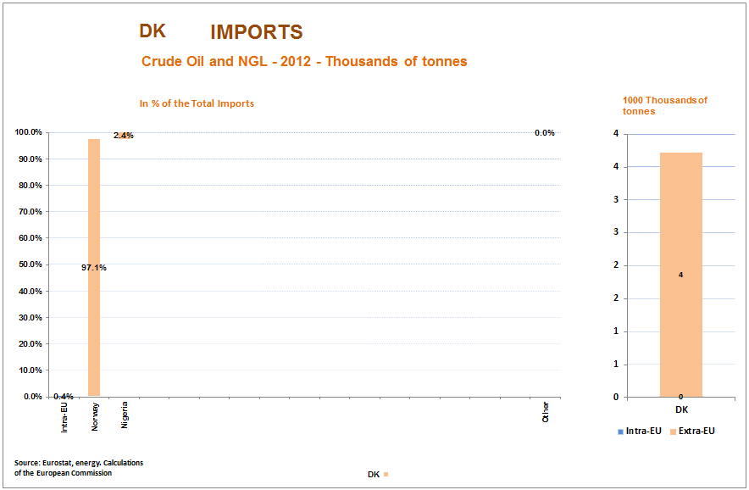
Country Fiche: Estonia
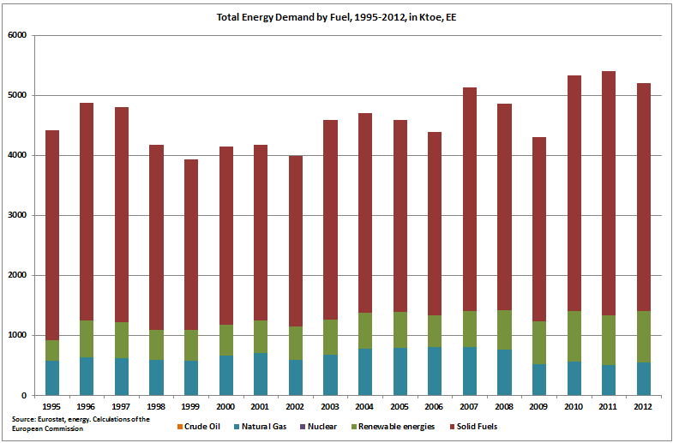

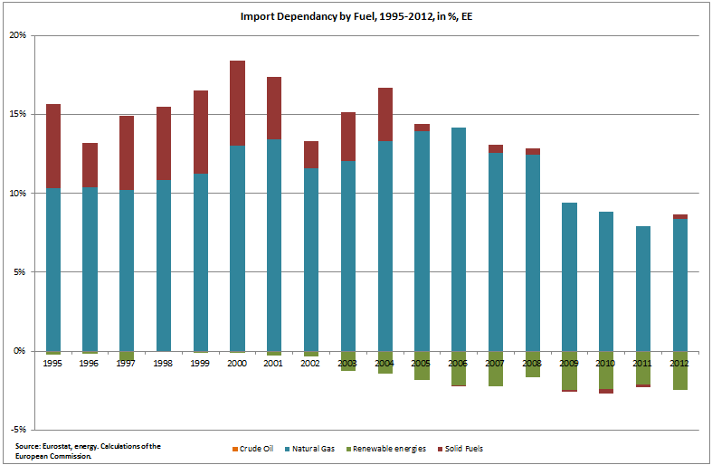
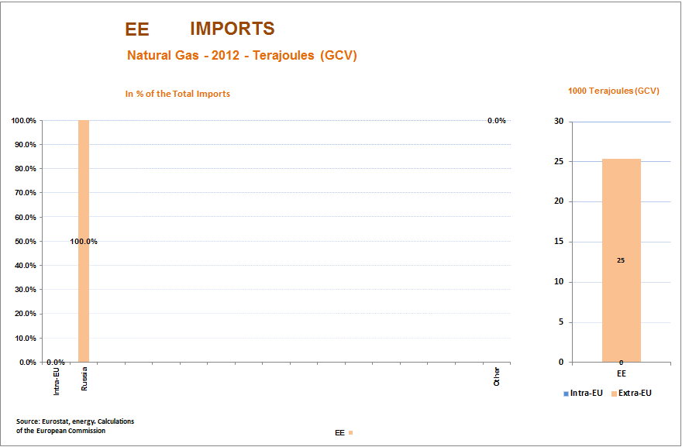

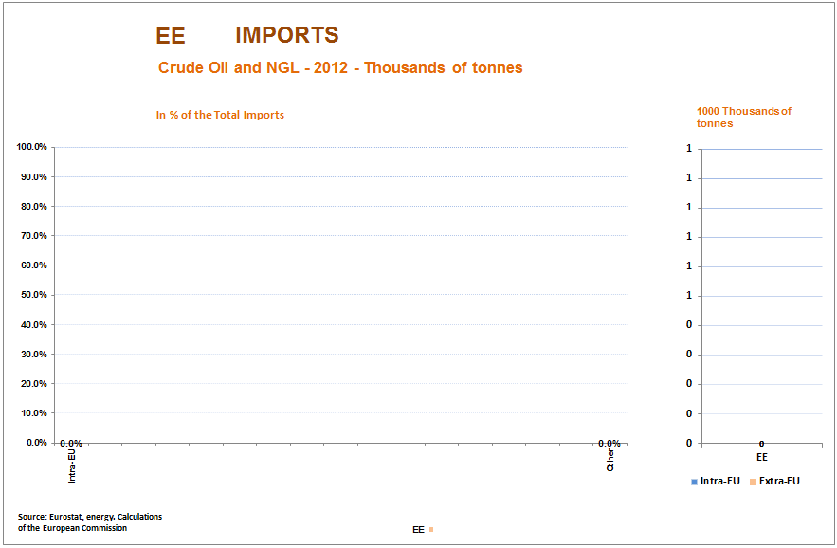

Estonia
Total gas consumption / Russian imports | Total: 0.67 Bcm/y // RU: 0.67 Bcm/y
Gas storage capacity and current level: | n.a.
Connections to other MSs and capacity: | LV→EE: 2.5 Bcm/y
Alternative supply options: | Additional supplies to Lithuania via the regasification terminal could in theory allow for swaps and thus additional sources from the end of 2014. Physical impact on the Estonian market would though be limited. Baltic connector or the LNG terminal could provide diversification in the mid-term.
Assessment: Estonia is fully and exclusively dependent on Russian gas imports. Because of the specific operating regime in Russia, Estonia receives gas in the summer directly from Russia, while in winter it receives gas from the Latvian storage facility Incukalns. As long as gas is stored in Incukalns, Estonia is safe. In the event of a disruption, Estonia must apply fuel switching.

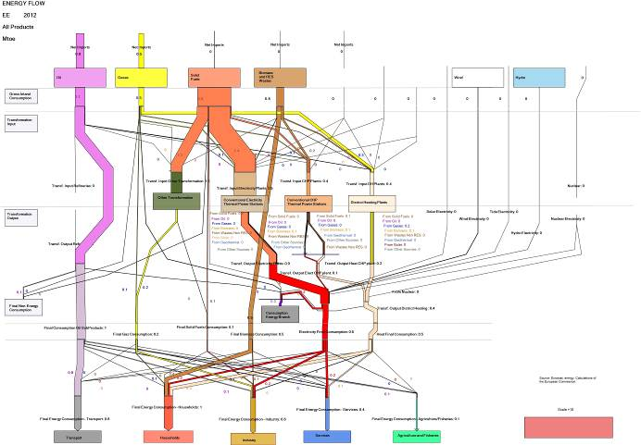
Country Fiche: Greece
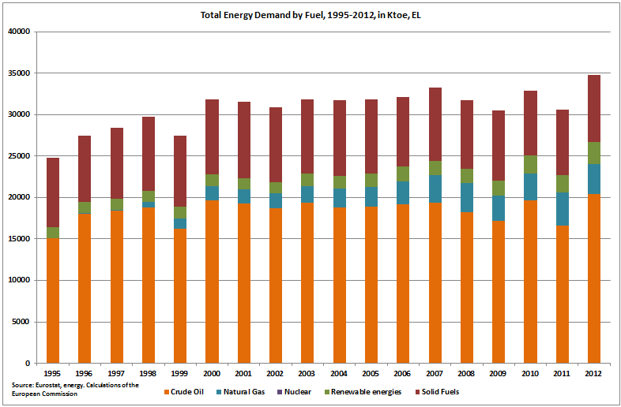

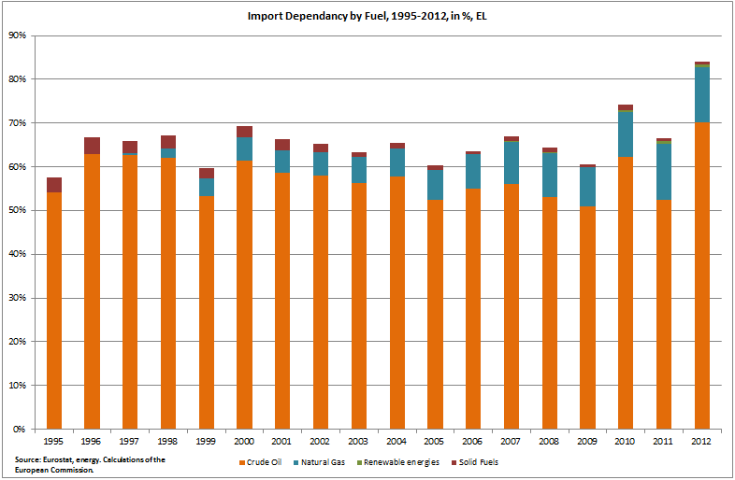

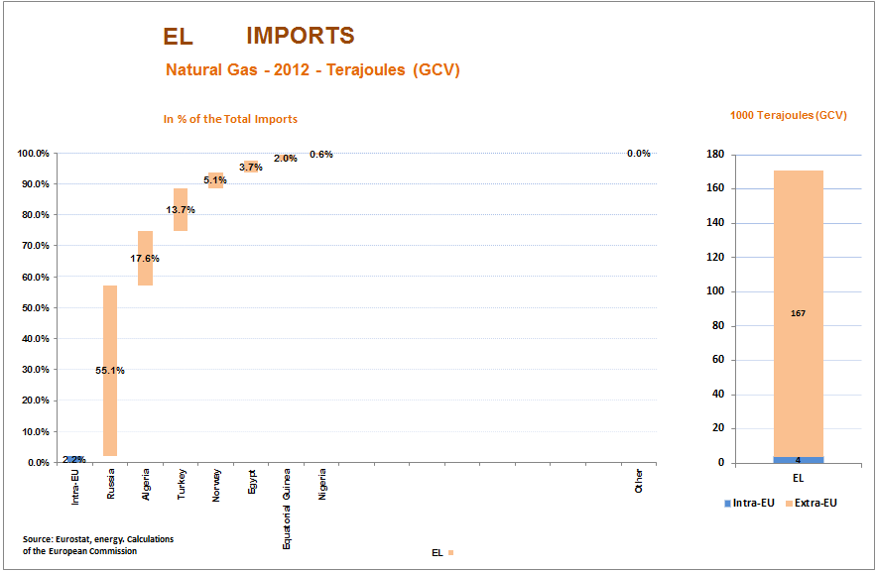

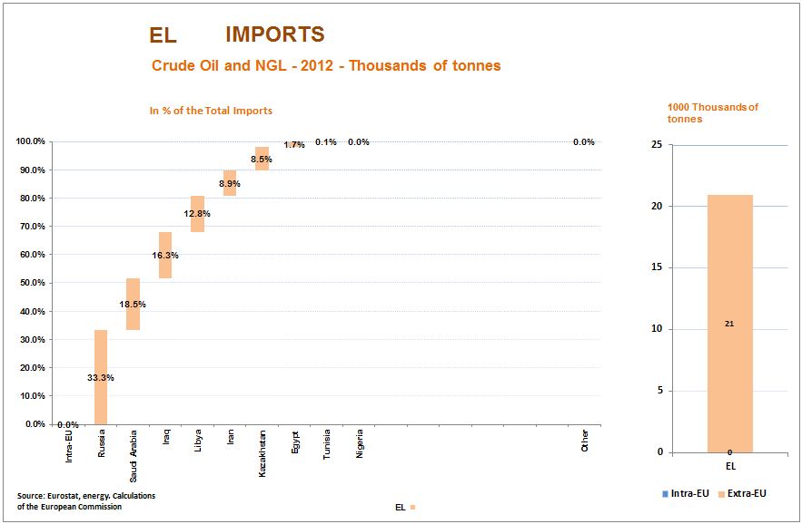

Greece
Total gas consumption / Russian imports | Total: 3.8 Bcm/y // RU: 2.6 Bcm/y
Gas storage capacity and current level: | n.a. – LNG tanks can store 130.000 cubic meters of LNG
Connections to other MSs and capacity: | BG→GR: 3.5 Bcm/y
Alternative supply options: | Implementation of the interconnector BG-GR ongoing.  Installing reverse flows between GR-BG is ongoing with a planned firm capacity of 036 Bcm/y.
Assessment: Although the nominal capacity of the Revythousa LNG terminal is 5.3 Bcm/y, it is unlikely that Greece would financially be able cover its full gas demand from LNG.

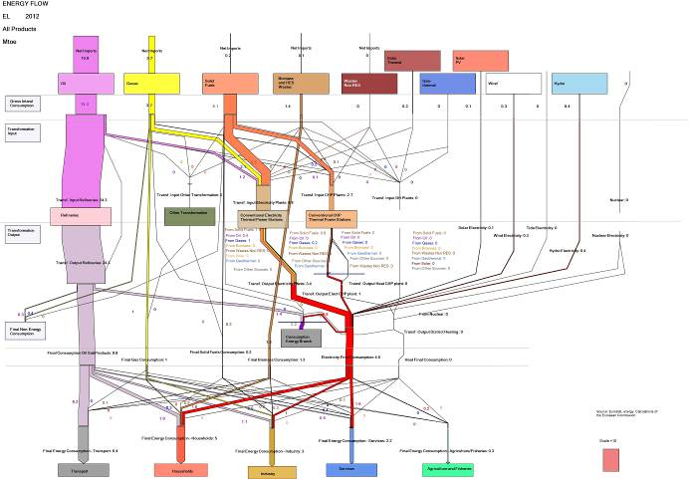
Country Fiche: Spain
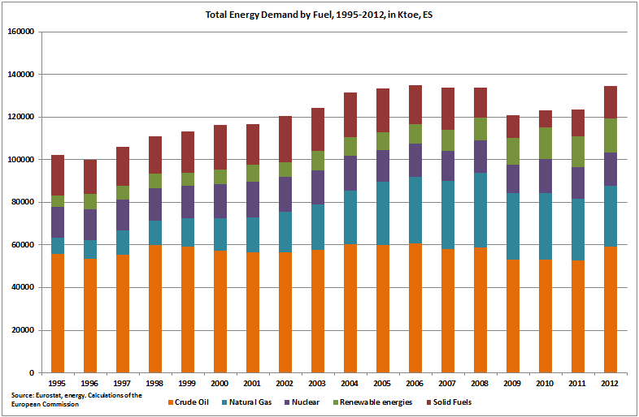

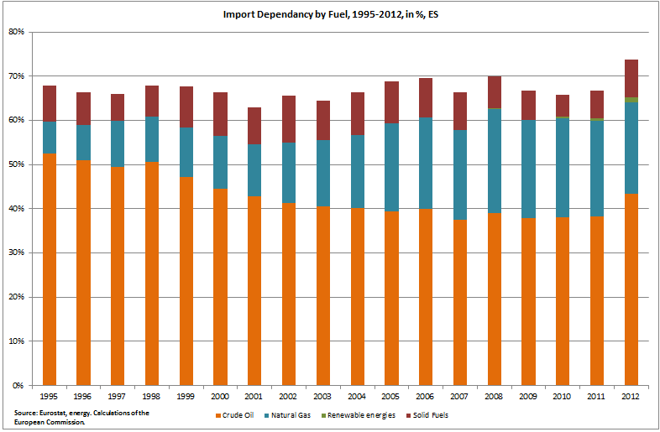
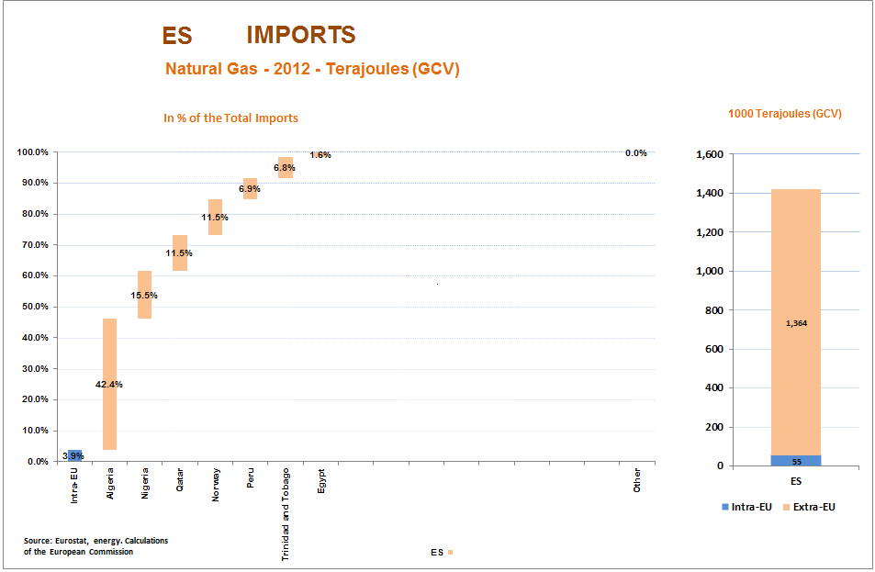

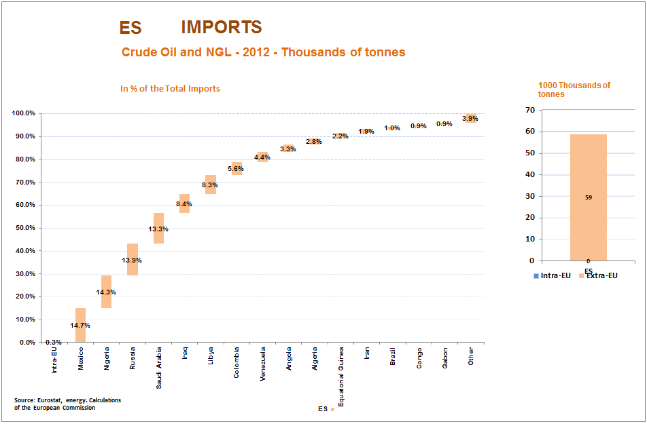

Country Fiche: Finland
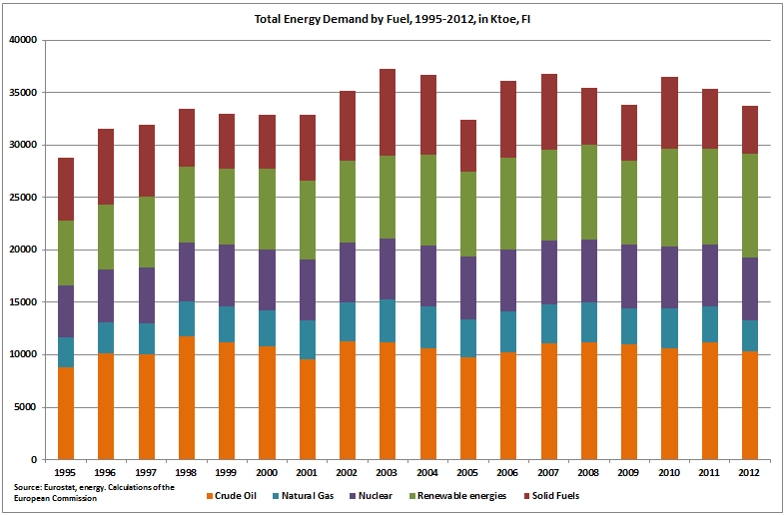
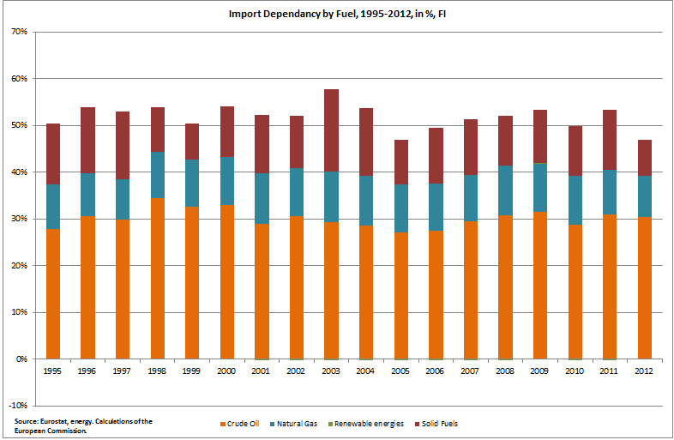

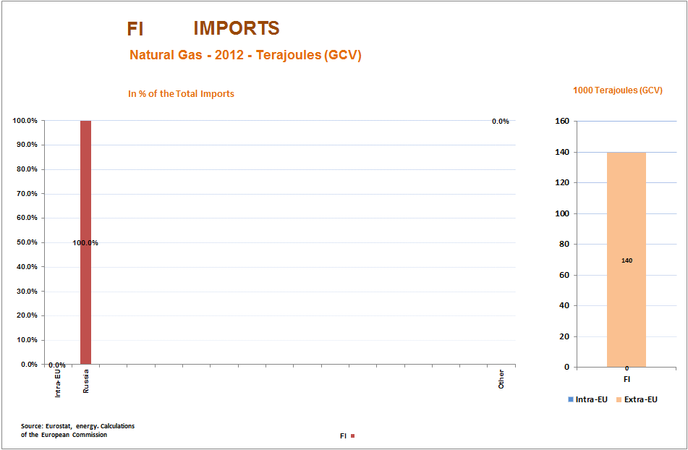

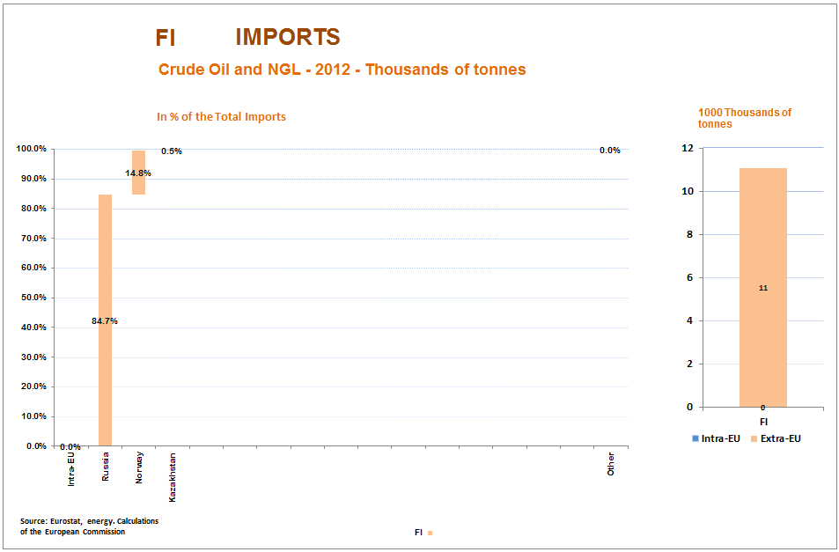

Finland
Total gas consumption / Russian imports | Total: 3.6 Bcm/y // RU: 3.6 Bcm/y
Gas storage capacity and current level: | n.a.
Connections to other MSs and capacity: | n.a
Alternative supply options: | No short-term alternative supply options.  Baltic connector or the LNG terminal could provide diversification in the mid-term.
Assessment: Finland is fully and exclusively dependent on Russian gas imports. In the event of a disruption, Finland can use the line pack in the pipes for 4 days and 9 hours. After that, all major gas users must switch fuel and the air-propane stocks are activated, which can provide gas to protected customers to satisfy the 30 day obligation of the supply standard.

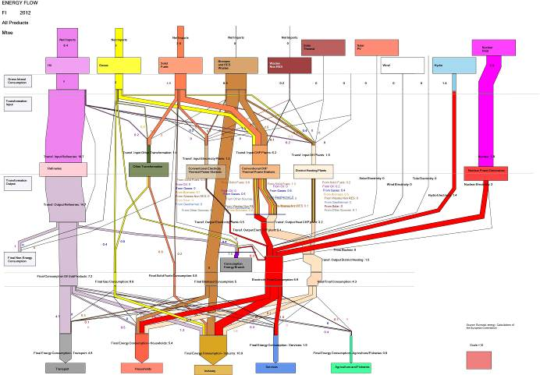
Country Fiche: France
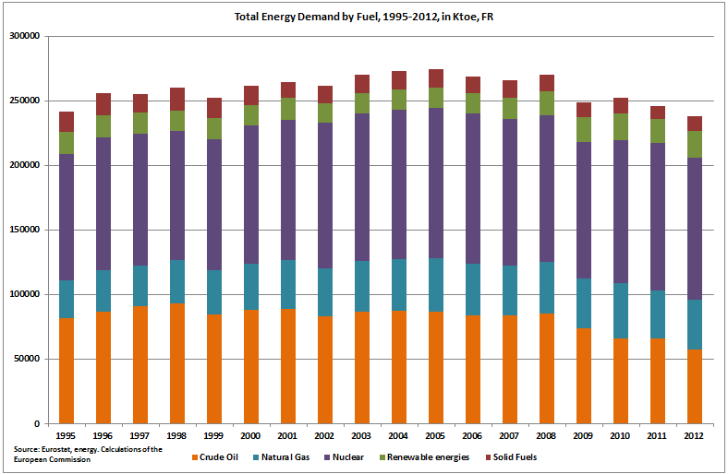

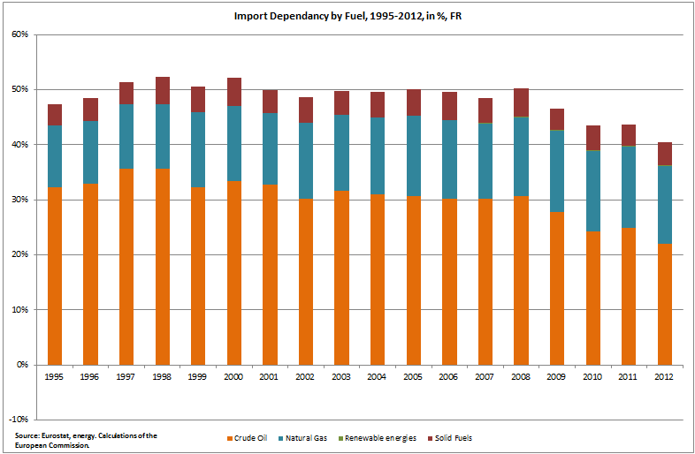

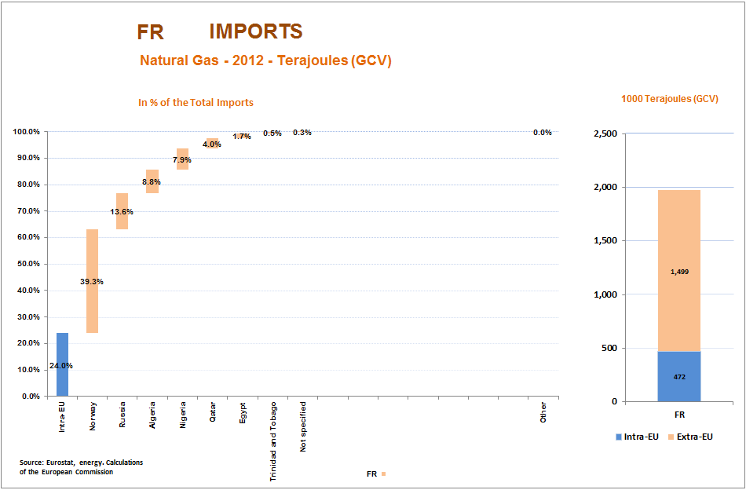

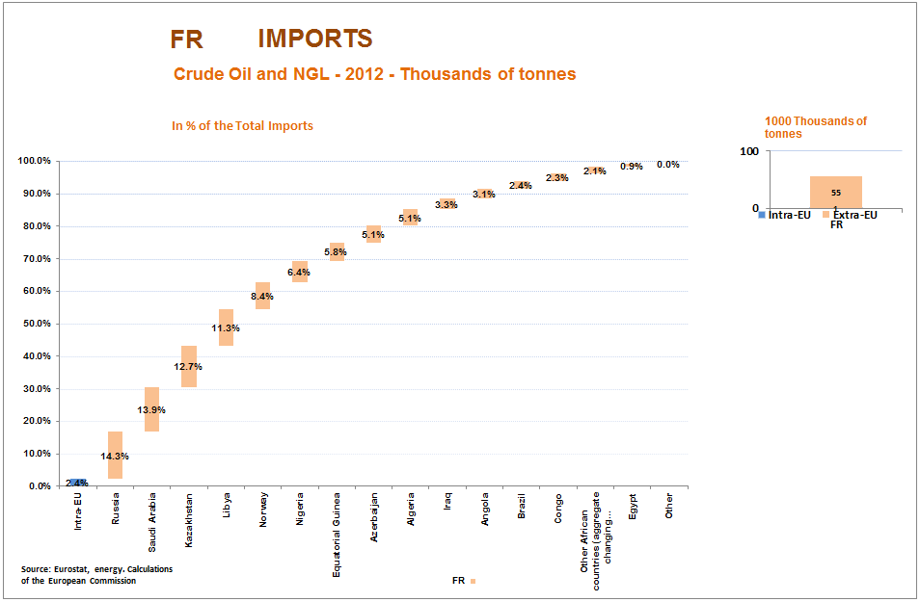
Country Fiche: Croatia
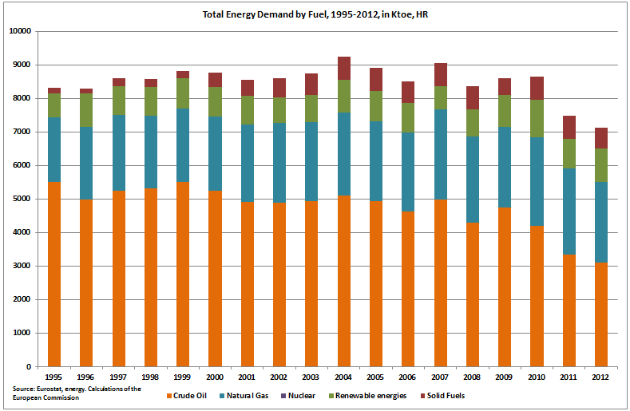

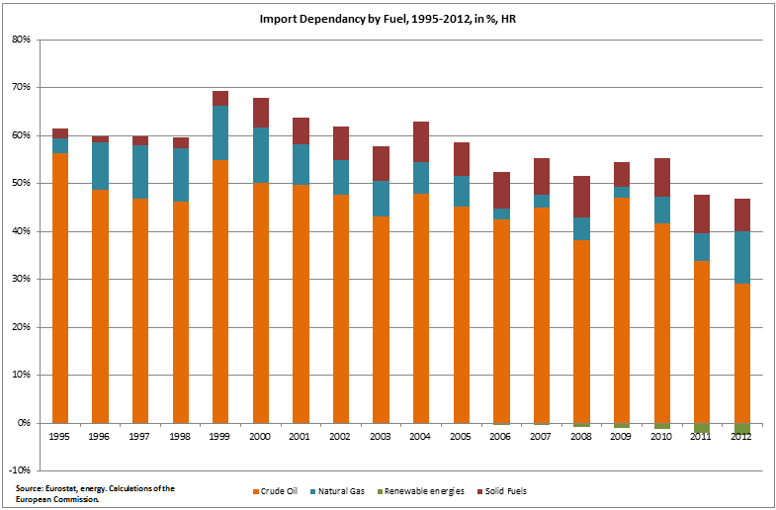

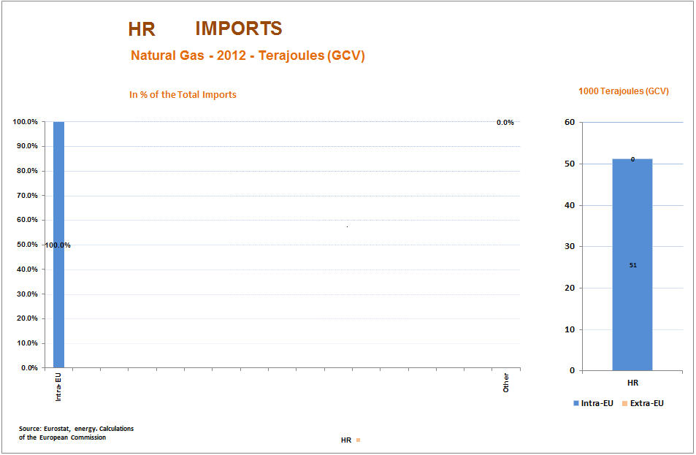
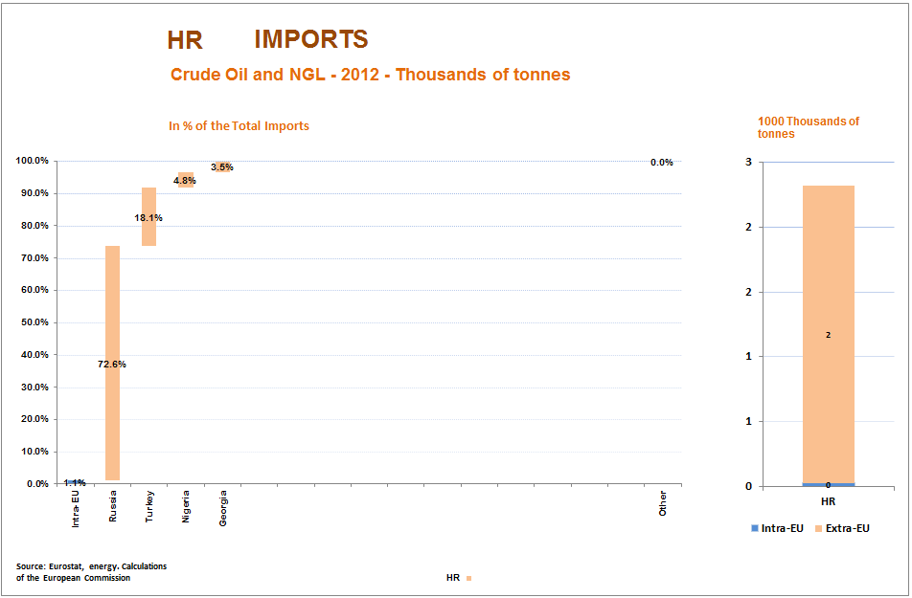
Country Fiche: Hungary
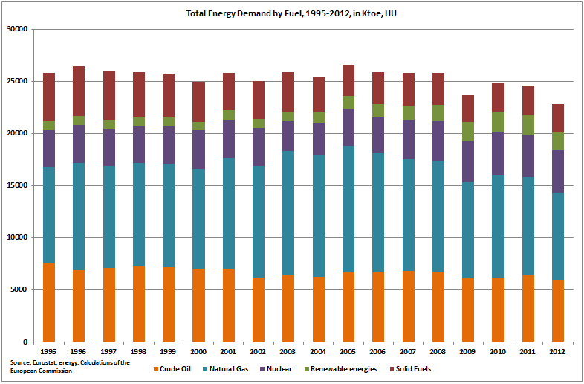

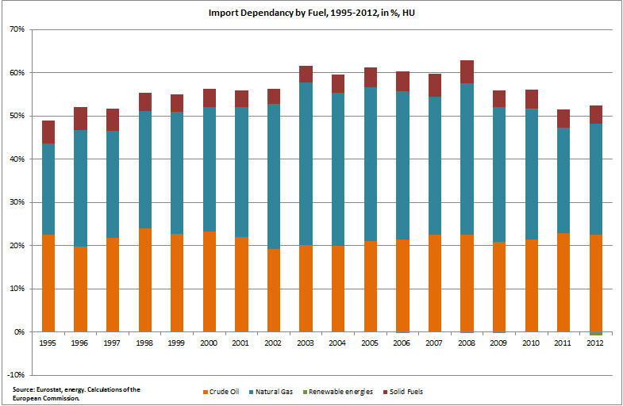

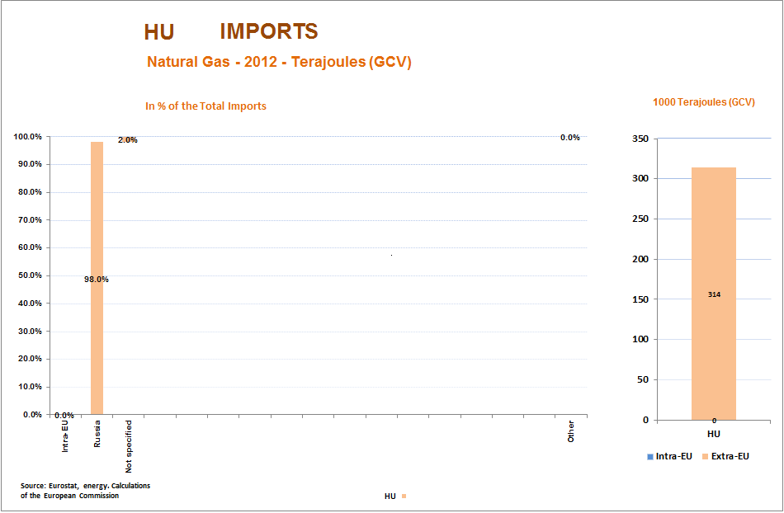
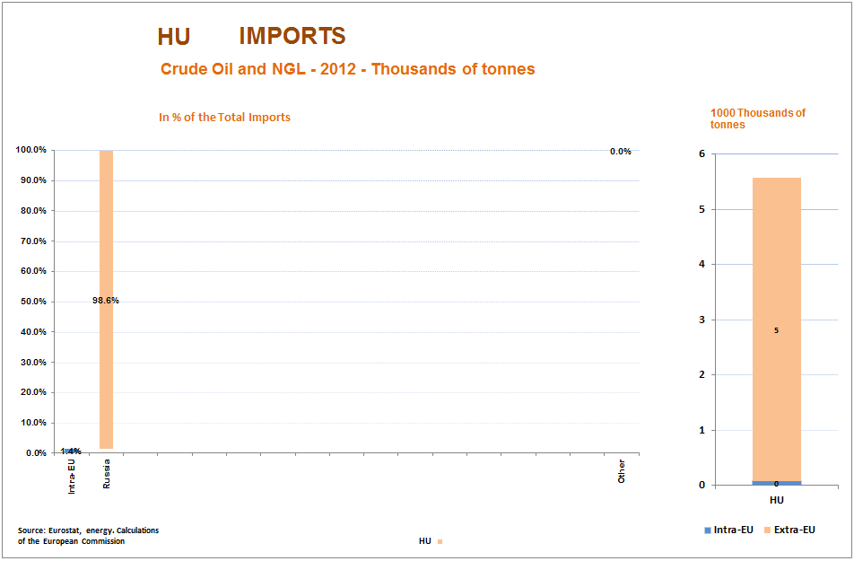
Hungary
Total gas consumption / Russian imports | Total: 9.3 Bcm/y // RU: 6 Bcm/y
Gas storage capacity and current level: | Total: 6.2 Bcm // Current: 1.2 Bcm
Connections to other MSs and capacity: | HU→CRO: 2.5 Bcm/y  HU→RO: 1.7 Bcm/y  AT→HU: 4.2 Bcm/y
Alternative supply options: | Reverse flows CRO and RO are being developed but these would not have a substantial impact on HU security of supply in the short-term.
Assessment: Hungary has considerable storage capacity compared to its annual gas consumption. However, storages could not be fully filled only from the Austrian route, Hungary needs to receive gas – at least throughout the whole injection period – to be able to secure 6.2 Bcm underground. With full storage use and maximizing imports from Austria, Hungary would still fall short if Russian gas was cut on a long-term period.

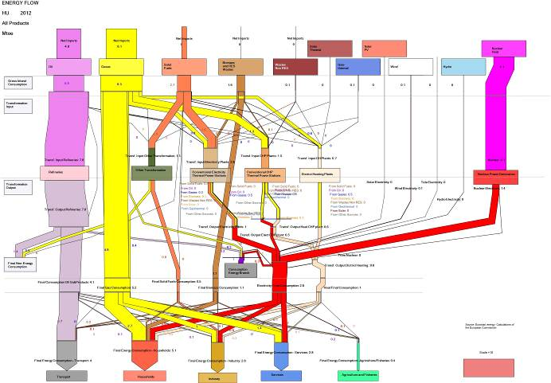
Country Fiche: Ireland
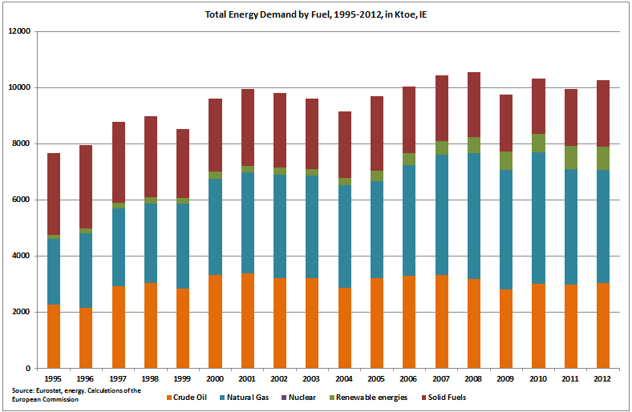

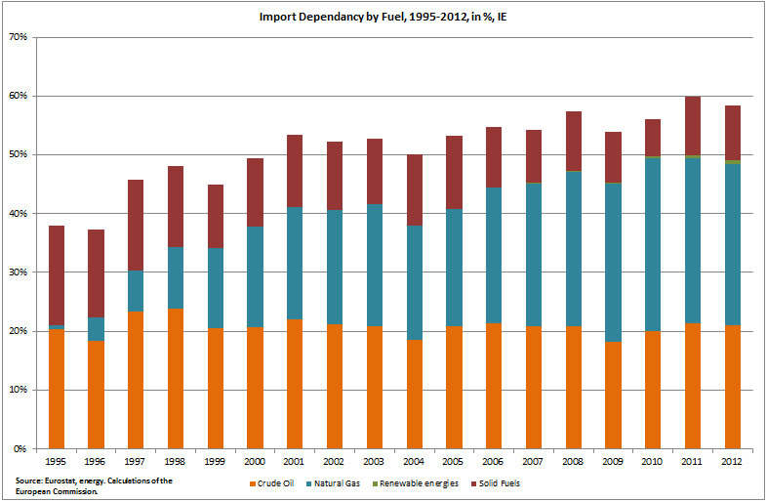

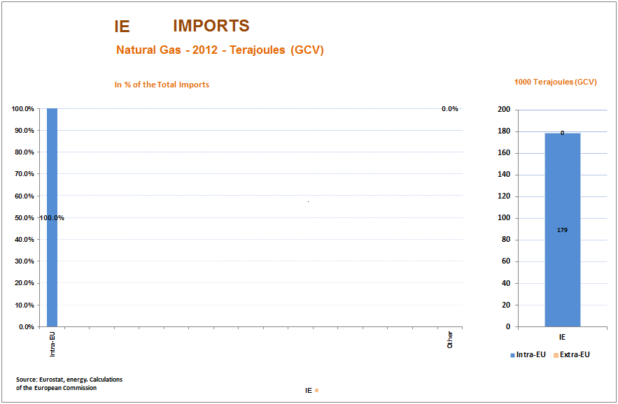
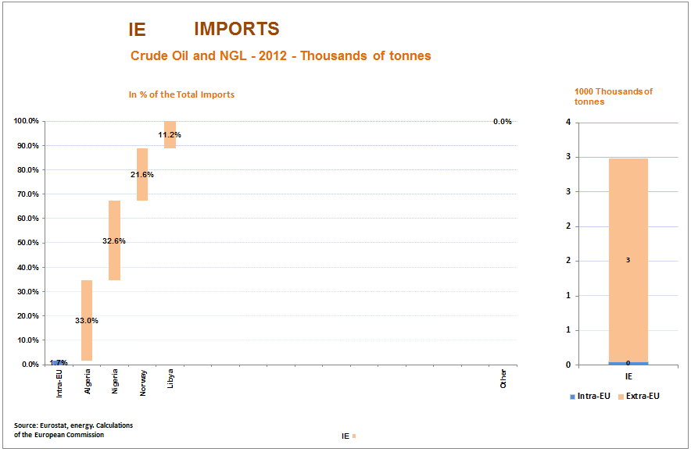

Country Fiche: Italy
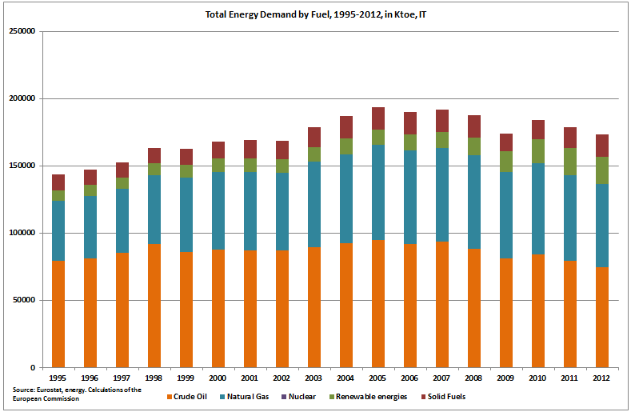
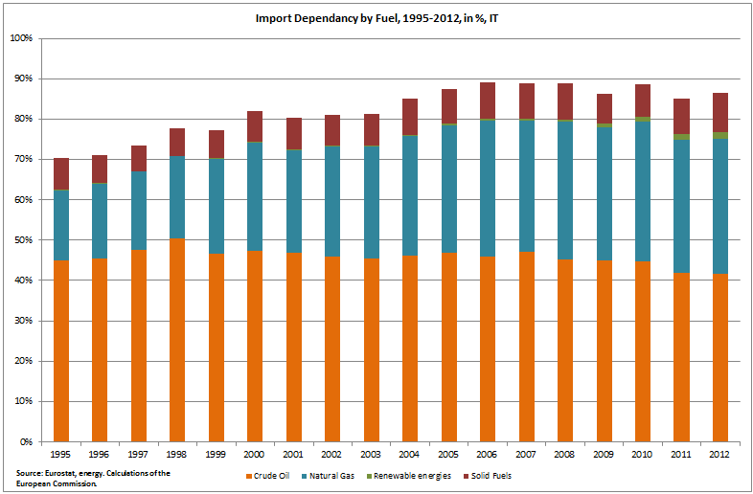

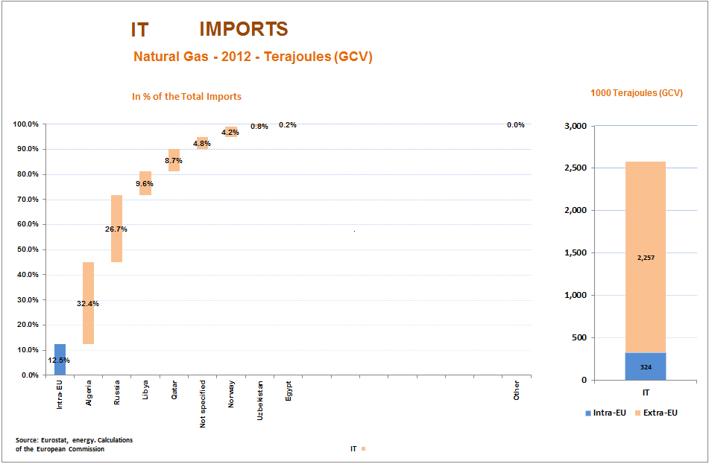
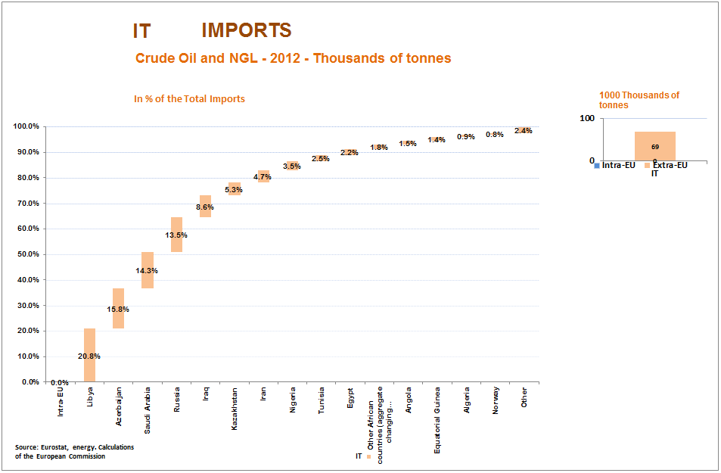

Country Fiche: Lithuania
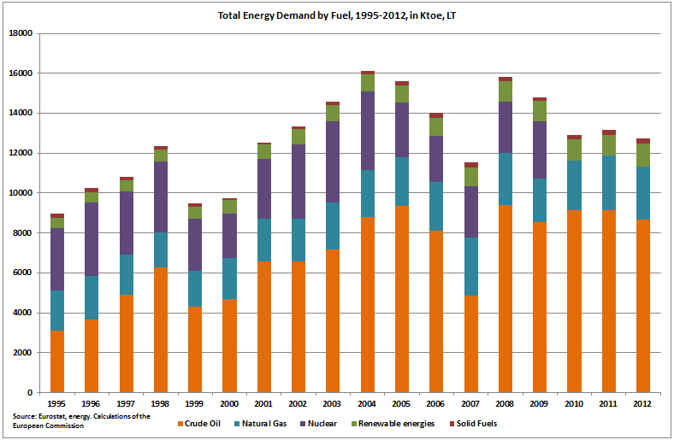
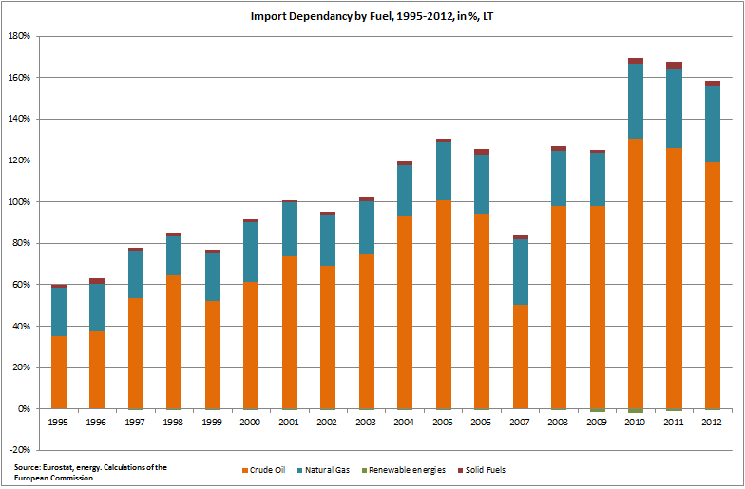

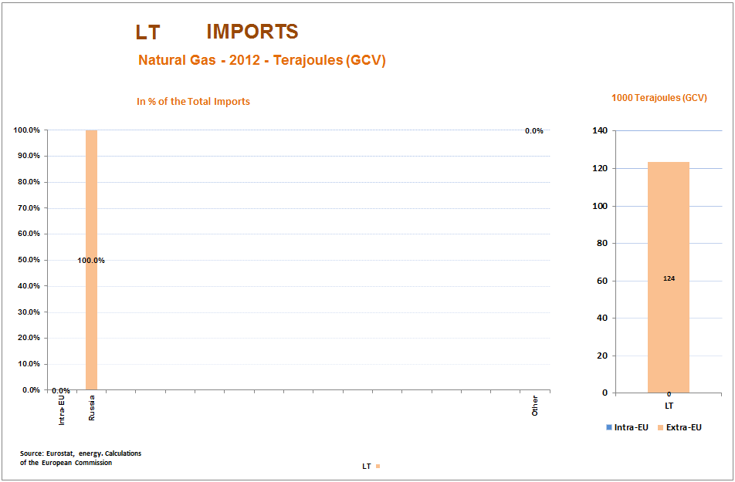
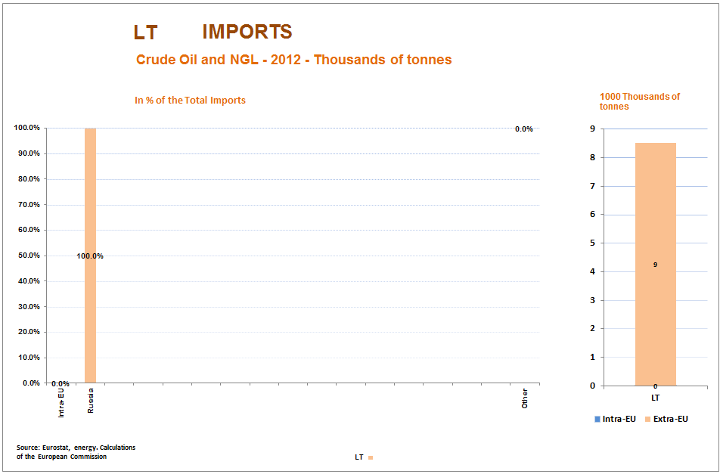

Lithuania
Total gas consumption / Russian imports | Total: 3.4 Bcm/y // RU: 3.4 Bcm/y
Gas storage capacity and current level: | n.a
Connections to other MSs and capacity: | LV→LT: 2.2 Bcm/y* (this figure is lower in winter because of limitations in the LV network)
Alternative supply options: | The planned LNG regasification unit is planned to come online by the end of 2014 with an initial capacity of 2 Bcm/y.  The interconnection with Poland would improve the situation in the mid-term.
Assessment: Lithuania is the transit country for Russian gas to Kaliningrad. So far this has been its insurance policy, however, with the development of underground gas storages in Kaliningrad, short-term disruptions would no longer have an impact on the Russian enclave.

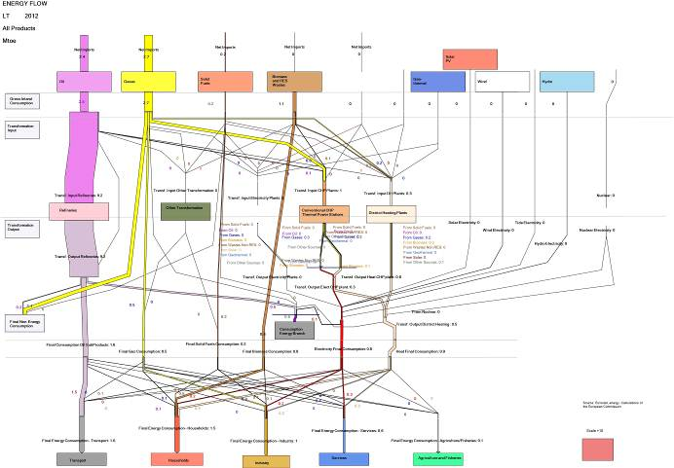

Country Fiche: Luxembourg
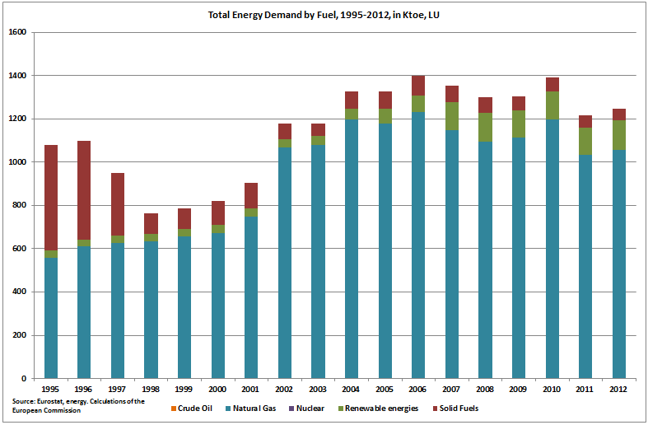
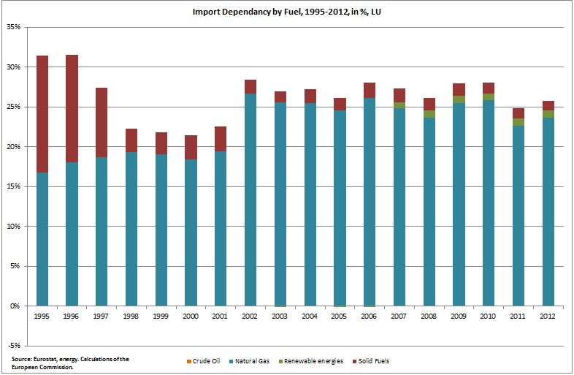

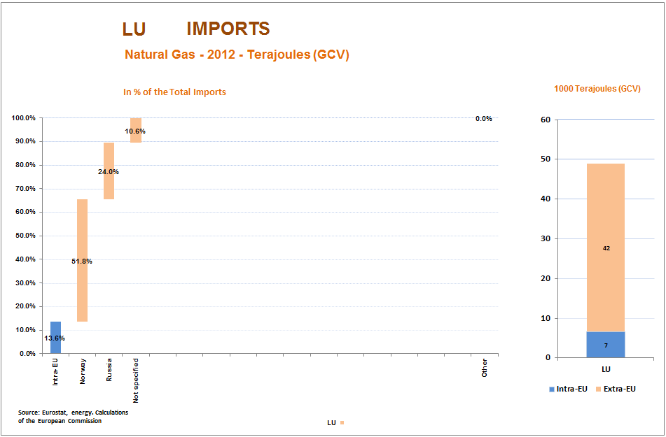
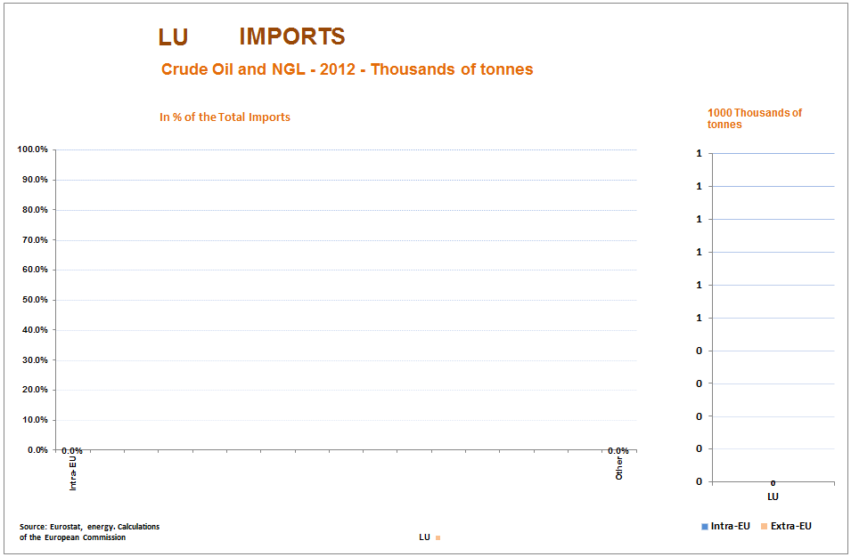

Country Fiche: Latvia
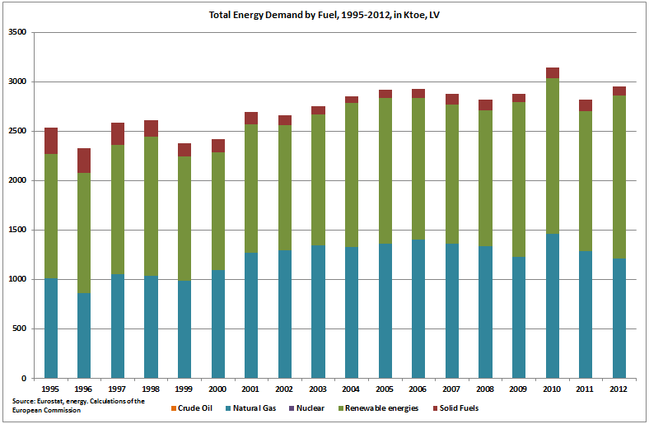
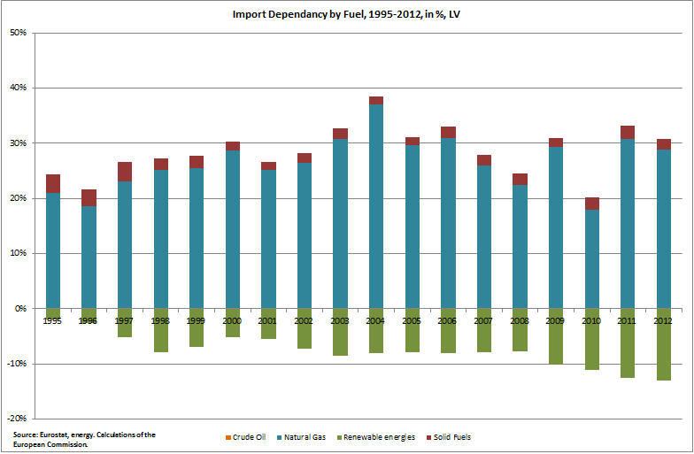

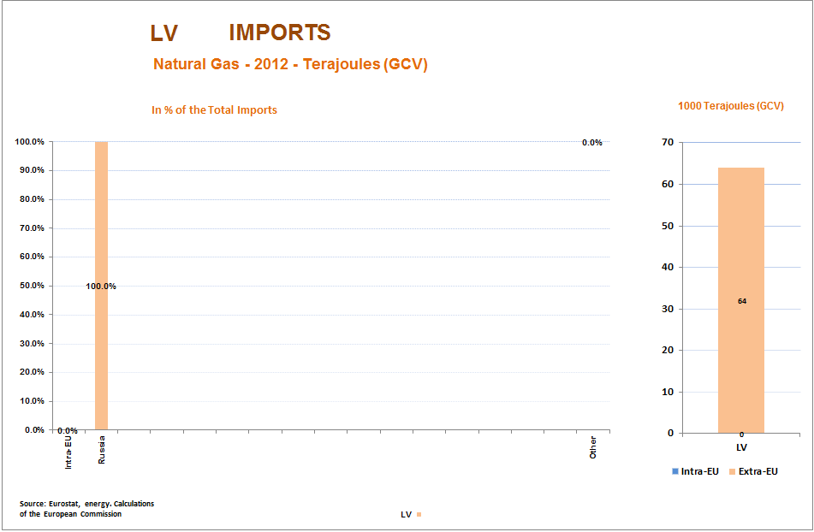
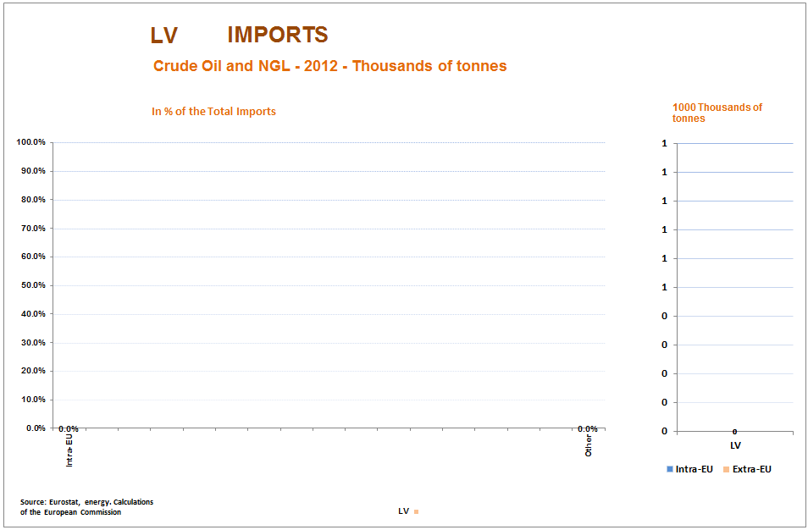

Latvia
Total gas consumption / Russian imports | Total: 1.7 Bcm/y // RU: 1.7 Bcm/y
Gas storage capacity and current level: | Total: 2.35 Bcm // Current: NO DATA PUBLIC but based on usual curve ~1 Bcm
Connections to other MSs and capacity: | LV→EE: 2.5 Bcm/y  LV→LT: 2.2 Bcm/y* (this figure is lower in winter because of limitations in the LV network)
Alternative supply options: | Additional supplies to Lithuania via the regasification terminal could allow for additional sources from the end of 2014. Physical impact on the Latvian market would though probably be limited.  Baltic connector or the LNG terminal coupled with reverse flows from EE could bring new gas in mid-term. Connection between PL-LT could bring gas in the long-term.
Assessment: Latvia is fully and exclusively dependent on Russian gas imports. Because of the specific operating regime in Russia, Gazprom in winter time is not able to supply the St. Petersburg area from its own network. Hence, it uses the storage facility in Incukalns to send the gas towards Russia, Estonia and – to a smaller extent – Lithuania in the winter, and the facility is filled up during the summer, when the gas is physically flowing in from Russia. The disruption of the storage facility (or lack of injections) would have main impact not only in Latvia and Estonia but in Russia as well. This situation may change if Russia upgrades its domestic network and will no longer need to keep gas in Latvia for winter supplies.

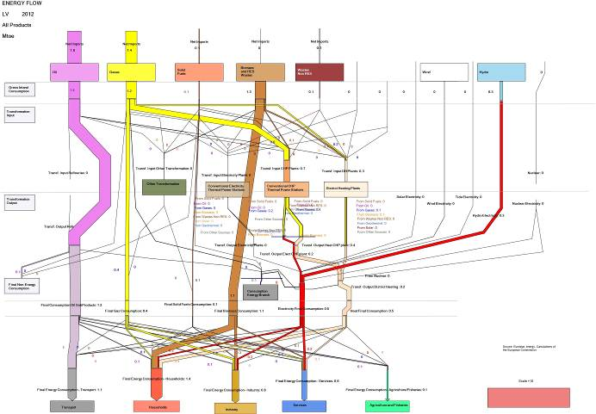
Country Fiche: Malta
Note: Malta reports all energy sources, except for renewables, under the category "Others" in the SIRENE database. For this reason, no breakdown of total demand by fuel or of import dependency by fuel is presented.
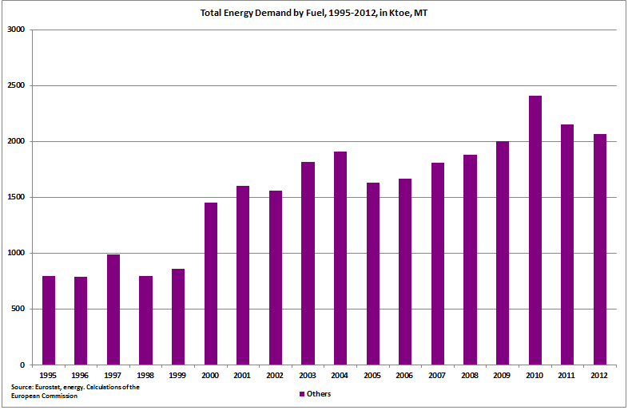
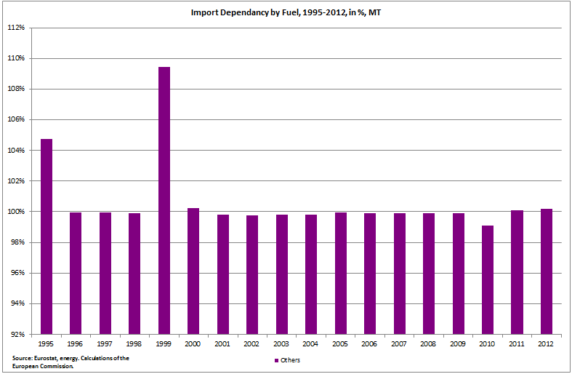
Country Fiche: The Netherlands
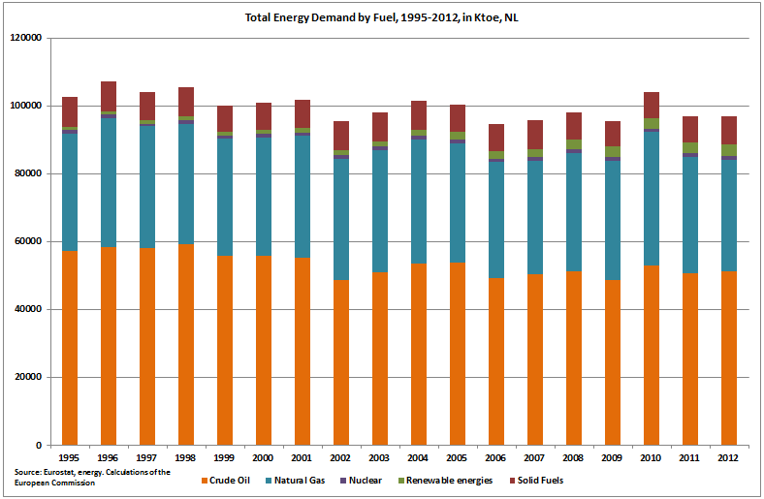

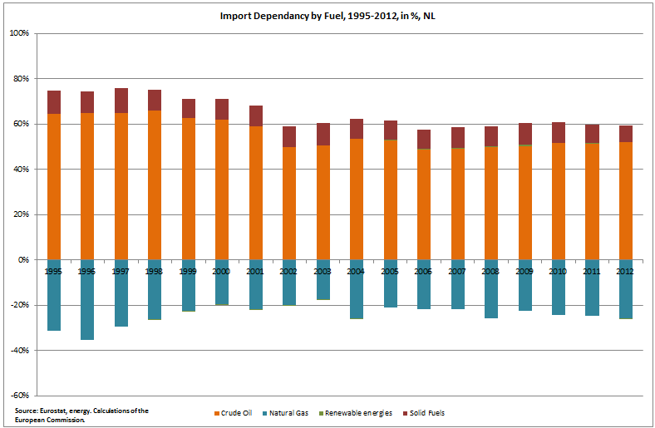

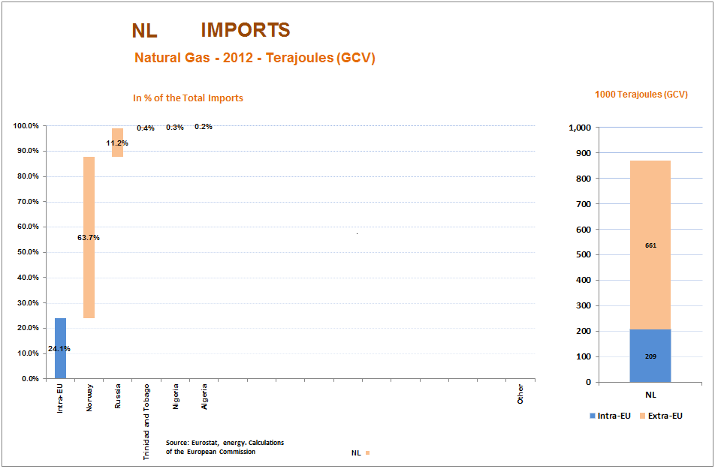
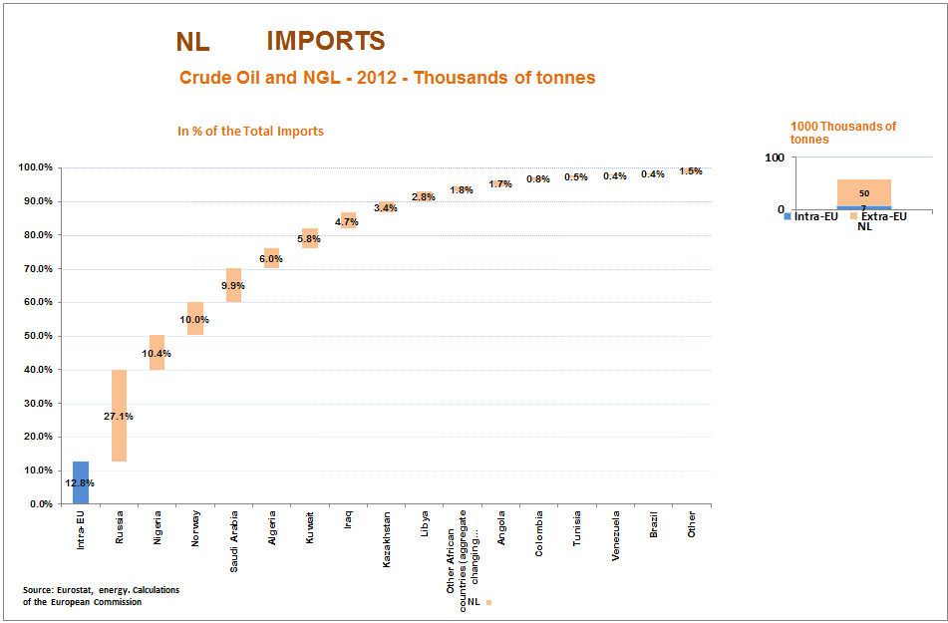

Country Fiche: Poland
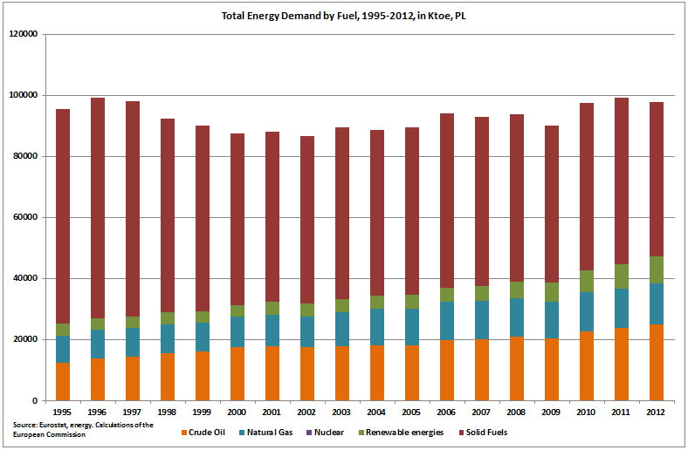
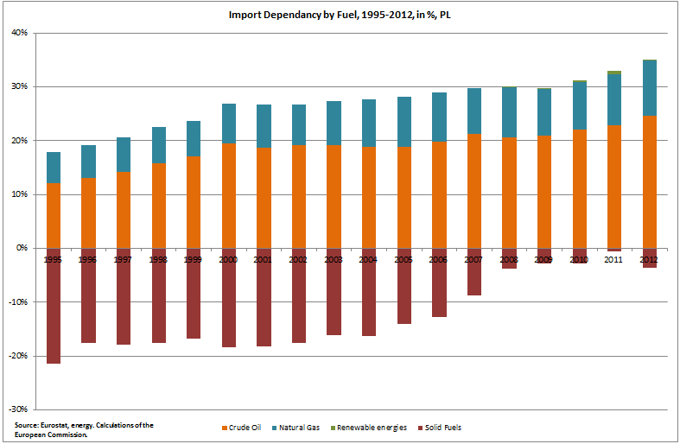

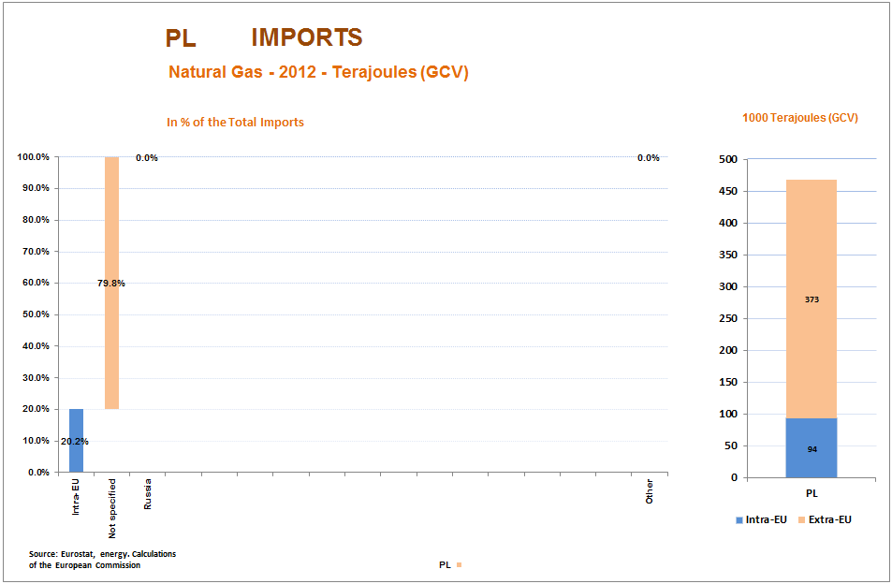
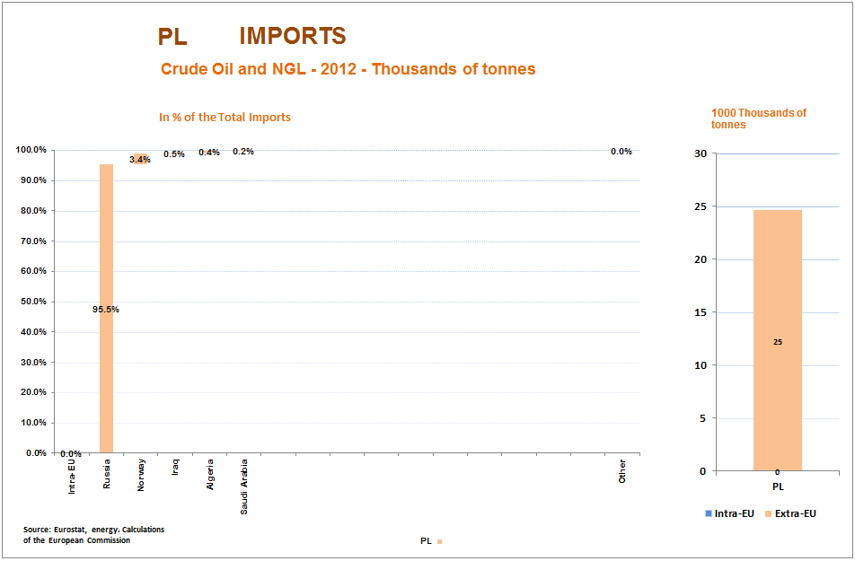

Poland
Total gas consumption / Russian imports | Total: 16.3 Bcm/y // RU: 9.8 Bcm/y
Gas storage capacity and current level: | Total: 1.75 Bcm // Current: 1.23 Bcm
Connections to other MSs and capacity: | PL→DE: 30.6 Bcm/y (Yamal)  DE→PL: 1.6 Bcm/y (from April extra 5.4 Bcm/y capacity expected to be added by implementing reverse flow on Yamal)  CZ→PL: 0.15 Bcm/y
Alternative supply options: | Physical reverse flows on the Yamal pipeline from DE – as a result of Regulation 994/2010 – will become operational from April 2014.  The LNG terminal at Swinoujscie is planned to become operational by the end of 2014, with capacity of 5 Bcm/y. Expansion to 7.5 Bcm/y is part of the PCIs, with a target date of 2020.
Assessment: Poland receives part of its gas via direct interconnections with Belarus and Ukraine. In terms of quantities the LNG terminal and increased reverse flows from Germany could substitute missing Russian gas. However, these amounts may be difficult to be shipped to the South-Eastern part of Poland.

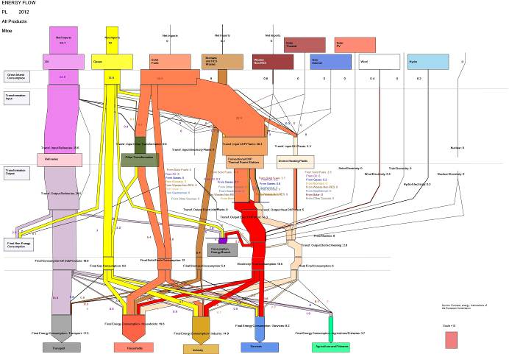
Country Fiche: Portugal
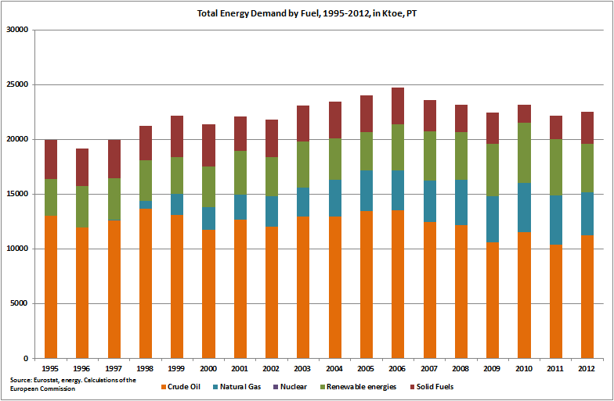

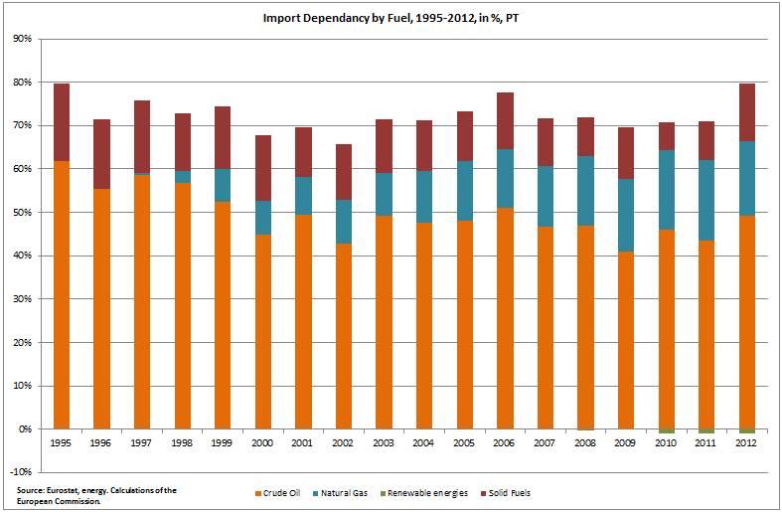
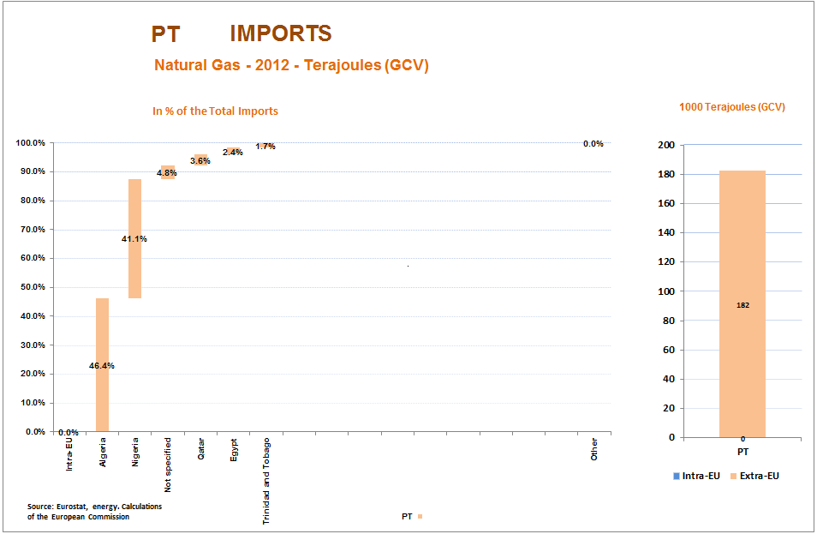
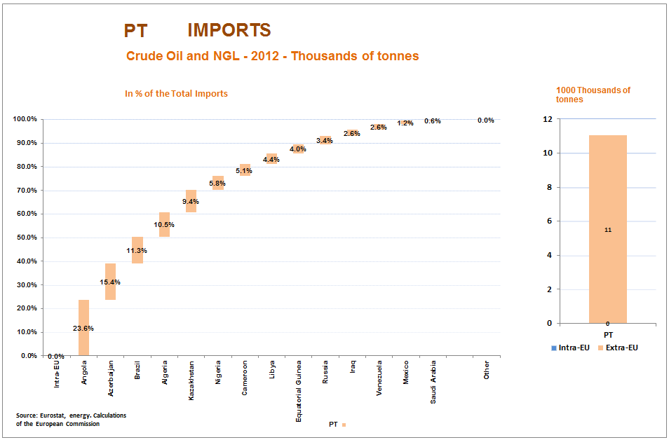

Country Fiche: Romania
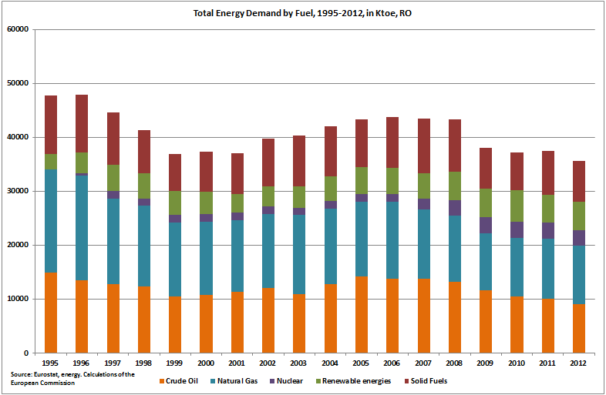

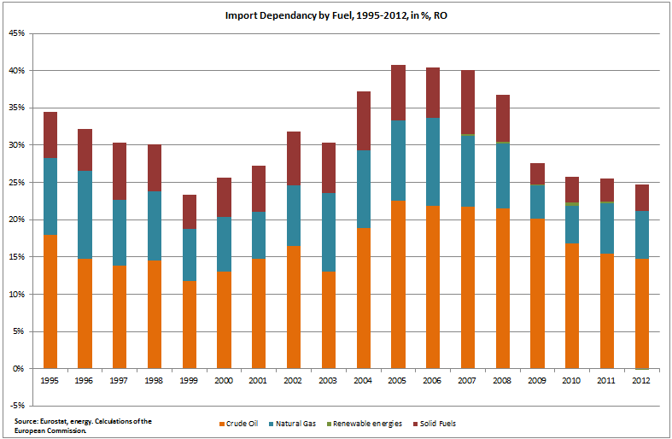
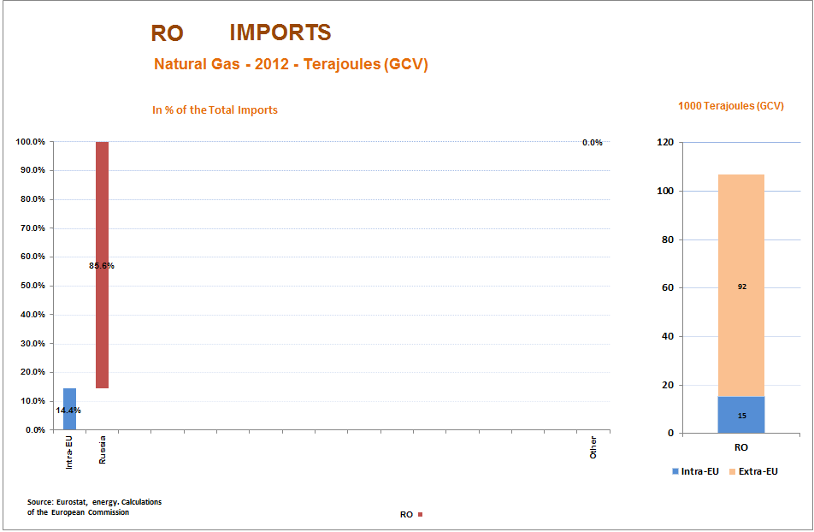

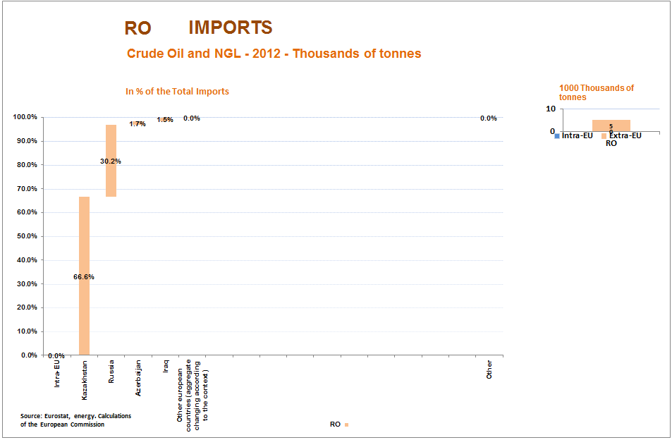

Romania
Total gas consumption / Russian imports | Total: 11.6 Bcm/y // RU: 1.2 Bcm/y
Gas storage capacity and current level: | Total: 2.7 Bcm // Current: NO DATA available in GSE's AGSI database
Connections to other MSs and capacity: | HU→RO: 1.7 Bcm/y
Alternative supply options: | The interconnection with Bulgaria is expected to come online in June 2014 with a capacity of 0.5 Bcm/y (max capacity of 1.5 Bcm will be reached by 2016).
Assessment: Romania has significant domestic production, therefore Russian imports constitute ~10% of its total demand. In quantities, the maximization of imports from Hungary could cover the missing volumes, but in reality Hungary is also dependent on the same Russian gas, therefore it is questionable whether this is a realistic option.

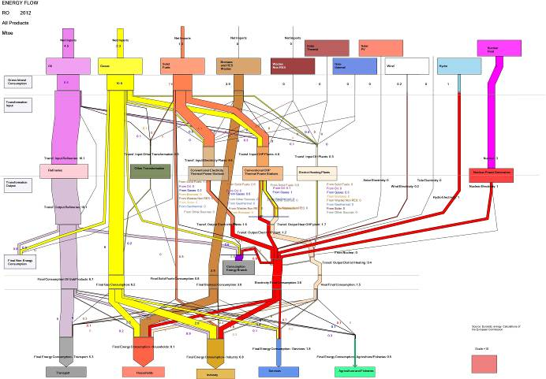

Country Fiche: Sweden
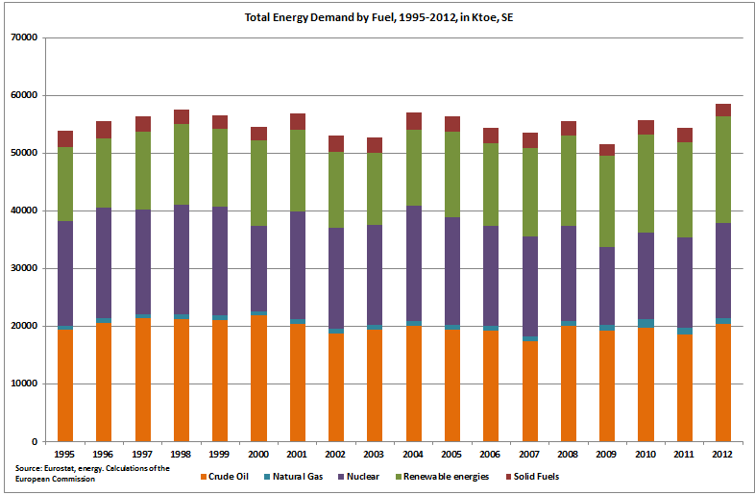
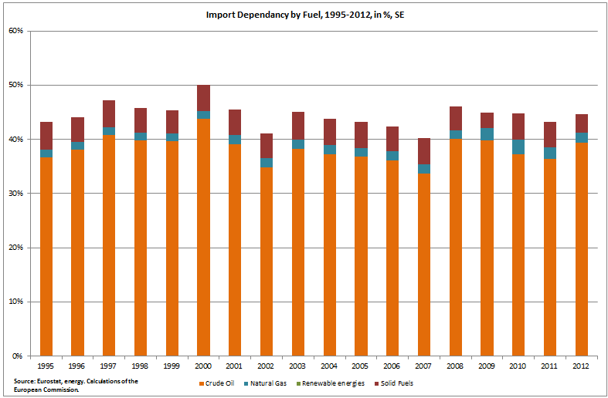

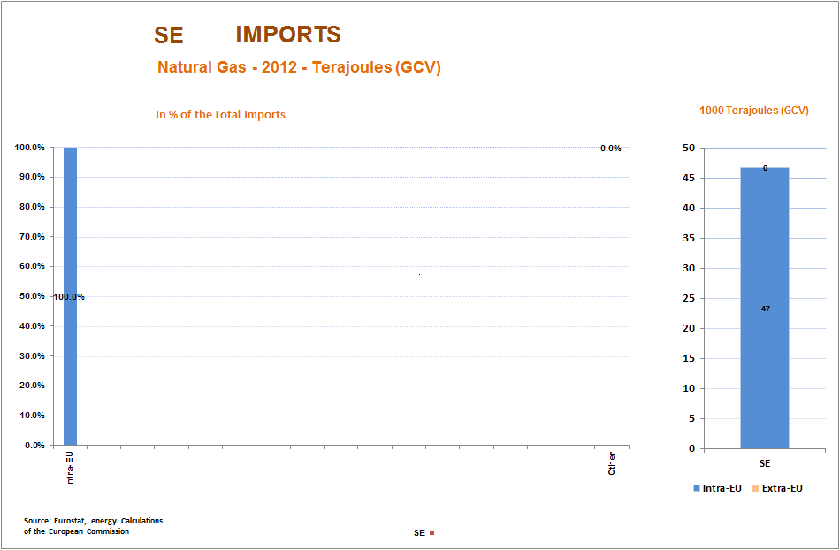
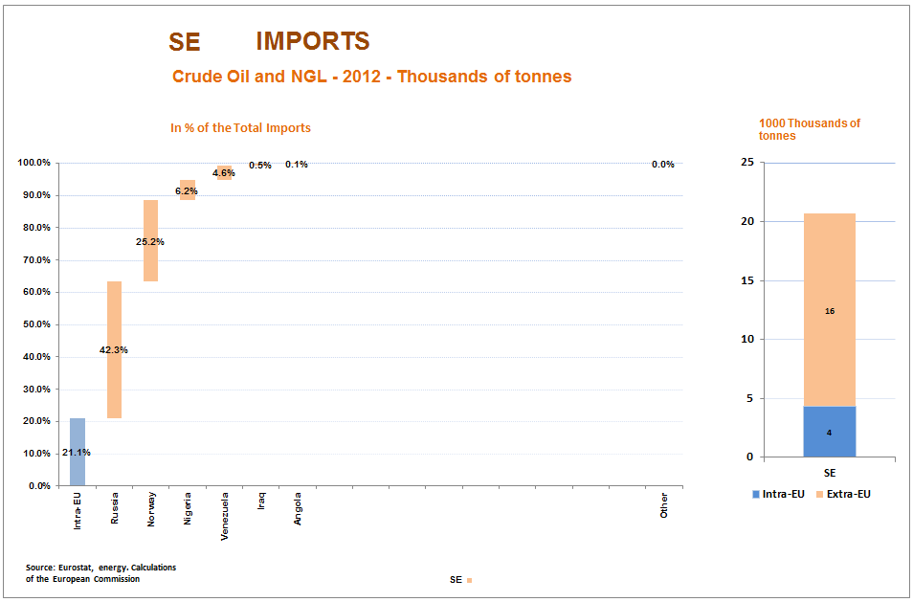

Country Fiche: Slovenia
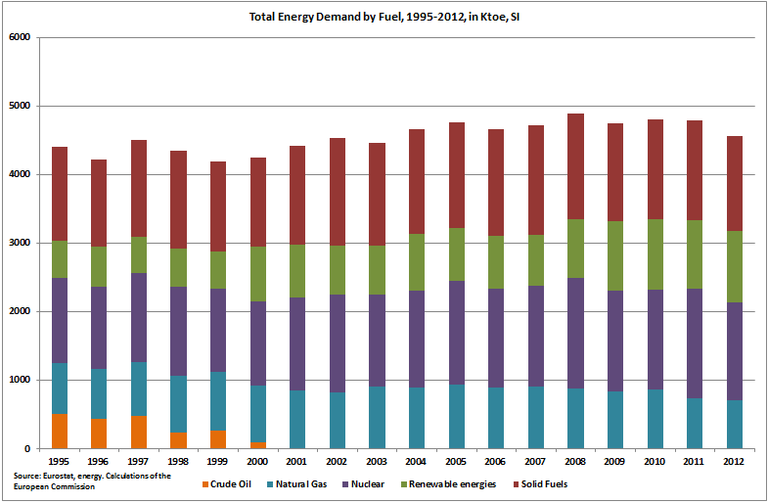
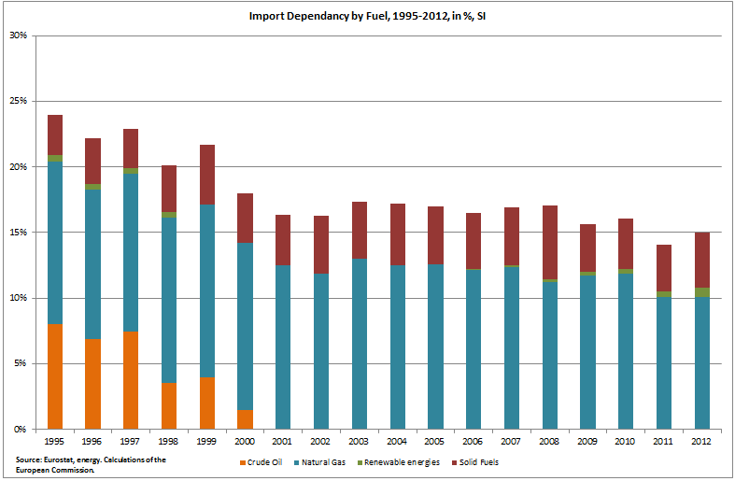

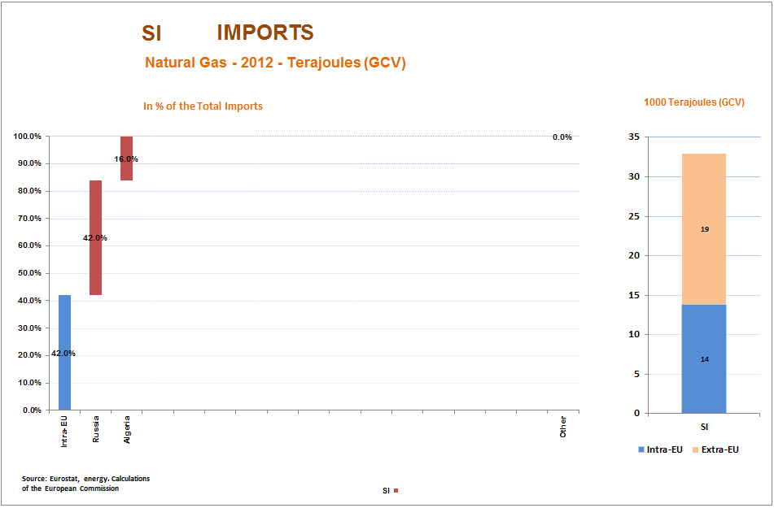

Country Fiche: Slovakia
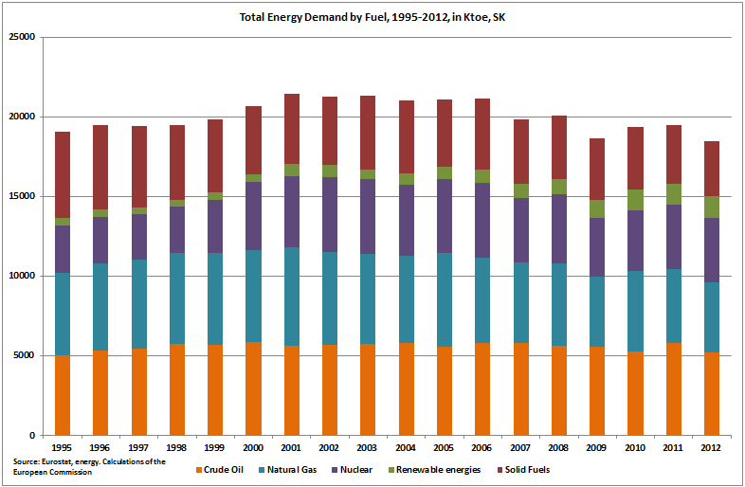
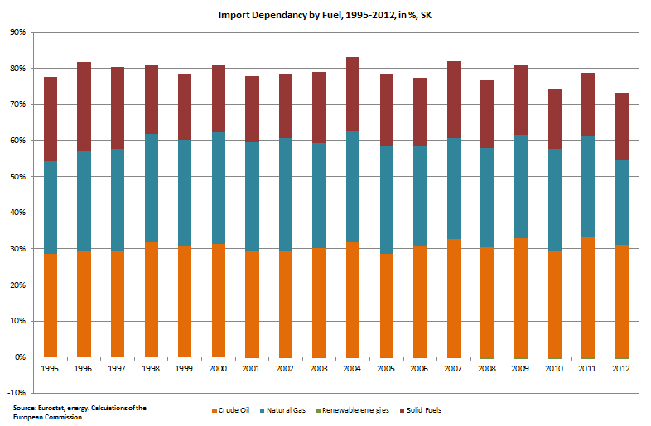

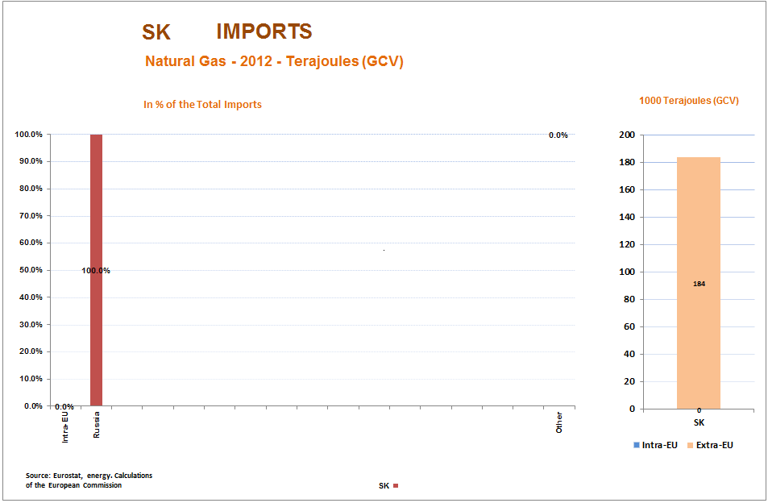
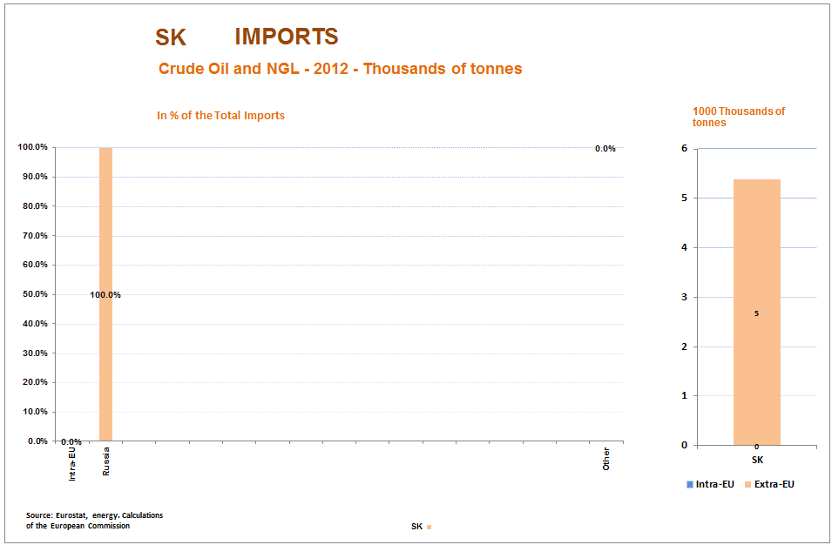

Slovakia
Total gas consumption / Russian imports | Total: 5.1 Bcm/y // RU: ~4.8 Bcm/y
Gas storage capacity and current level: | Total: 2.9 Bcm // Current: 1.15 Bcm
Connections to other MSs and capacity: | SK→CZ: 25.4 Bcm/y  SK→AT: 56.7 Bcm/y  CZ→SK: 13.2 Bcm/y  AT→SK: 13.8 Bcm/y
Alternative supply options: | Interconnection with HU is expected to be fully operational from mid-2015. SK could receive ~1.6 Bcm/y and could transport to HU ~4.5 Bcm/y via that new link.
Assessment: Slovakia has considerably improved its security of supply after the 2009 gas crisis by putting in place massive reverse flow capacities that could cover its annual demand – in case there are enough sources and capacities from Western Europe.

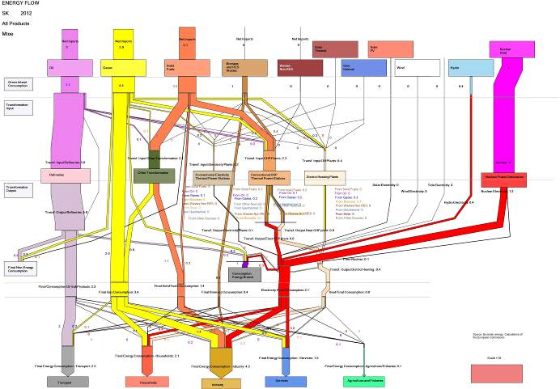

Country Fiche: United Kingdom
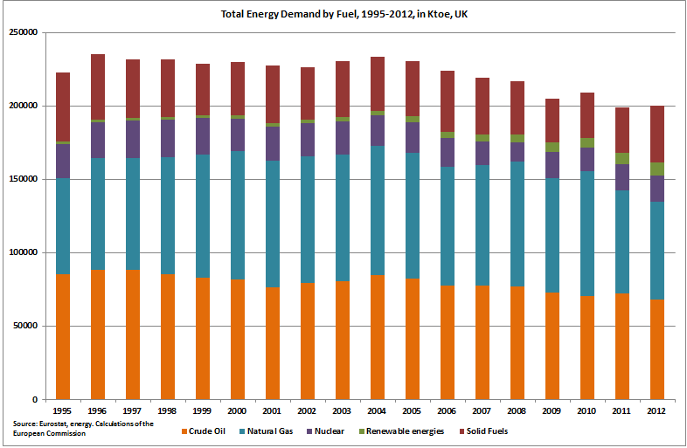
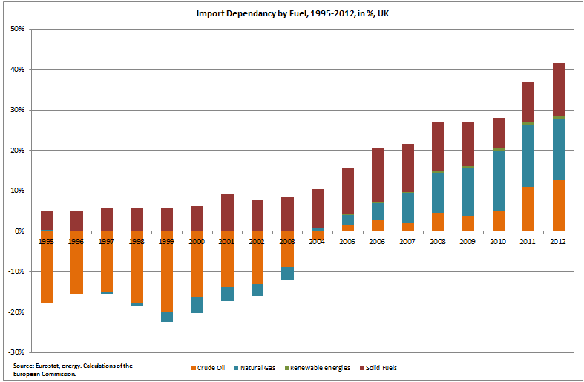

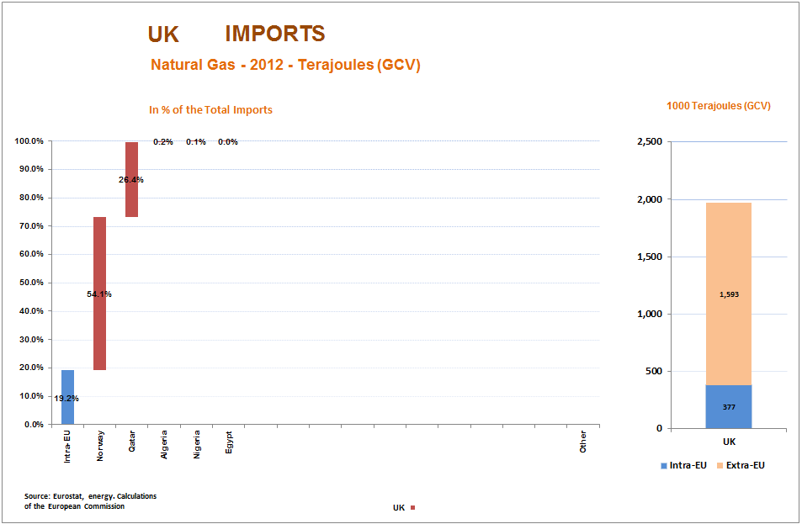

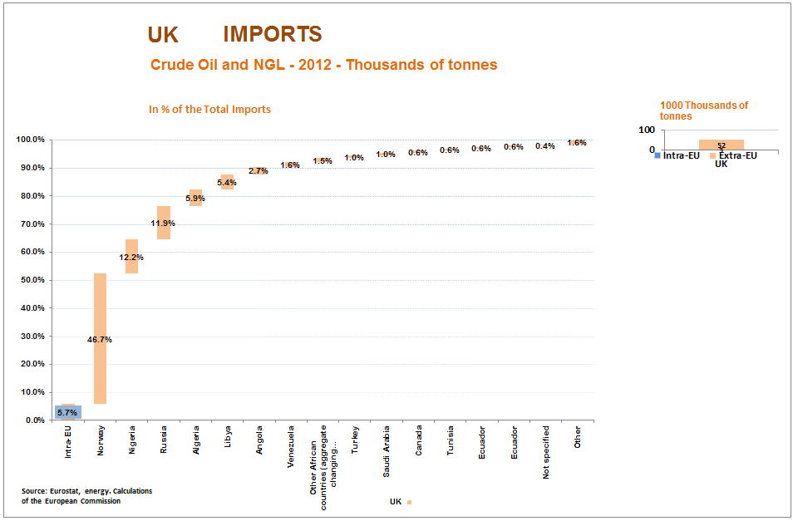
Annex II: Emergency response tools to address an oil supply disruption

The information in this table is primarily based on the findings of the IEA Emergency Response Reviews carried out in 2008-2013 and the national laws transposing Council Directive 2009/119/EC; in some cases the information could be incomplete and/or not entirely up-to-date

