Table of Contents
1. Analysis of Impacts 3
1.1. Identification of the main impacts 3
1.1.1. Economic impacts 3
1.1.2. Social impacts 7
1.1.3. Environmental impacts 8
1.2. Impacts of the key options 9
Option 1: Full implementation 9
Option 2: Measures to simplify the legislation, ensure proper monitoring and disseminate best practices 11
Option 3: Upgrade EU targets 14
1.3. Impacts on groups of stakeholder 22
2. Comparing the Options 23
2.1. Costs, benefits, employment and marine litter 23
2.2. Contribution to the main objectives, efficiency and coherence 24
2.3. Preferred Option 26
2.4. Key implementation challenges 27
2.5. Access to raw materials 28
2.6. Conclusions 29
3. Monitoring and Evaluation 30

Analysis of Impacts
In this section, the main impacts will be first identified and some methodological elements to assess these impacts will be provided. Then the main impacts of the selected options under section 4 will be presented.

1.1. Identification of the main impacts

1.1.1. Economic impacts
Financial cost and savings of waste collection and treatment technologies
Achieving higher recycling rates will require changes to the collection systems operating in a number of MS as they move towards capturing greater quantities of material. In order to achieve the higher recycling rates, it is assumed that MS collection systems will have to evolve over time. For example, a MS may start with 'bring systems' focusing mainly on 'dry recyclables', but it is assumed that households will have to move progressively to door to door collection systems, insofar as this is possible, in order to target biowaste and to increase the capture rates of the dry recyclable waste.
At the same time, less and less mixed waste will be collected and treated, therefore the systems used for collection of mixed waste will have to switch to a lower frequency of collection, or move to a pay-as-you-throw system. This allows for savings to be made in the collection of mixed waste as either the collection frequency or the set out rate falls. At the same time, the cost of collecting recyclables becomes more costly as the system for collecting recyclables as well as biowaste becomes more comprehensive. Hence, on the collection side, there are opposing tendencies in the costs of collection: the costs of recycling increase, but the costs of residual waste collection fall.
This is illustrated in the following figure related to investigations in Lombardia in Italy. The combined bars indicate the costs of collection and treatment, with the green component related to waste collection, and the blue bar relating to the treatment of waste. This indicates how the average costs of collection per inhabitant barely change as one moves from systems delivering less than 20% recycling to those delivering more than 70% recycling.
On the other hand, as this happens, the expenditure outlay on treatment, particularly on residual waste, declines, so that those municipalities delivering higher recycling rates can achieved progressive savings on waste management costs.
Figure 1: Collection and treatment costs in Lombardy and recycled rates

The changing collection and treatment costs associated with this transition were assessed for each MS since many factors influencing the financial cost are specific to MS conditions - energy costs, labour costs, etc.
A summary of the main unit costs used for treatment in this IA is given in Annex 7 - Table 3-10: the 4 main categories of treatment (composting/digestion, incineration, MBT and landfilling) were divided between different sub treatment (4 categories for incineration, 5 for MBT and 3 for composting/digestion) depending on the technical characteristic of the treatment (for instance for composting/digestion: open air composting, in vessel composting or anaerobic digestion). For the 13 possible treatment technologies, specific unit treatment costs were calculated for each MS on the basis of several parameters including labour and energy costs.
The costs used in the model do not include taxes (e.g. landfill and incineration taxes) or subsidies (such as those on energy generation) as the objective is to assess the cost for society of the proposed options. In this IA, it has been assumed that the efforts needed to meet the proposed targets on Packaging waste will mainly be concentrated on municipal waste.
This reflects the assumption that systems will have prioritised the collection of commercial waste at an early stages since it has been demonstrated that separately collecting and recycling secondary and tertiary packaging waste originating from commercial and industrial sources is easier to achieve – more homogenous waste streams from less waste producers, and even profitable in most instances. On the contrary, municipal waste is produced by a multitude of small mixed packaging waste producers which requires more collection and sorting efforts. This approach – which is confirmed in the fitness check - is considered as prudent, and could lead to an over estimation of the direct costs linked with the increased targets for packaging waste.
Additional possible costs of imposing new sorting requirements for the dry fraction as proposed in section 4.4 (separation of the 3 flows – paper/cardboard, glass and plastics/metals) should be compensated by savings linked with simplified sorting conditions and improved quality/prices for recyclable materials due to the absence of cross contamination. Meeting the proposed targets will require an increased involvement of households in prevention and separate collection at source. No reliable method to monetise or even quantify this impact is available due to the large number of factors to be taken into consideration and the lack of generally accepted methodologies.
Access to raw materials
Similarly, it has not been possible to ‘monetize’ the impacts in terms of access to raw materials notably in terms of reduced dependency from imported raw materials. Nevertheless, the actual tonnages which could be recovered with the proposed option were assessed and are detailed in Section 6.
Administrative burden
In comparison to the full implementation scenario, no additional significant administrative costs have been identified linked with the increase of the targets. On the contrary, proposing a single measurement method for the target on municipal waste, removing the obsolete requirements of the PPWD like the maximum recycling target, aligning the main definitions, replacing the current landfill diversion target on biodegradable waste with an overall target which is easier to monitor, removing the overall recovery target from the PPWD will simplify the tasks of the MS.
Apart from the introduction of progressive bans on landfilling and the split between ferrous and nonferrous metals in the PPWD targets, no new types of target are proposed, and the possible additional efforts linked with the monitoring/enforcement of these new targets will be largely compensated by the proposed simplifications. More details are provided in Section 5.2 on the impacts on administrative burden of the proposed measures included in Option 2.
Functioning of the internal market
Some positive effects on the functioning of the internal market can be expected: for instance, measures to increase recycling and limit landfilling will 'naturally' push some MS having developed excess capacities for incineration to open their facilities to MS still landfilling significant amounts of waste. This movement has already been observed with an increasing amount of imported waste being treated for instance in Sweden, Denmark and the Netherlands. Recent information coming from the UK for instance clearly shows an acceleration of the trend in exporting waste to energy recovery facilities (waste exports from UK to EU passed from few tons in 2010 to more than 1 Million tons in 2013).
Some countries, such as the Netherlands, are actively seeking to promote the utilisation of capacity at domestic incinerators so as to free up the potential for additional recycling. The new waste management plan in Denmark also, implicitly, seeks to reduce the amount of waste sent for incineration in the country through setting higher targets for municipal waste.
Increasing recycling rates could also contribute to the expansion of the EU waste recycling market though the development of specific recycling industries for which a critical mass of recyclable waste is needed before investments are profitable.
Defining common principles for EPR will also have beneficial impacts on the internal market: today producers and importers placing goods targeted by National EPR systems on the EU market are facing significant different regimes.
The proposed harmonization will help reducing the differences between these regimes and therefore contribute to the fluidity of the market.
Competitiveness and Innovation- manufacturing sector
As explained in section 2.2, materials are one of the largest shares of input costs of European manufacturing companies - around 30 to 40 per cent of the cost structures.
In absence of solid forecasts on raw material prices, it has been assumed in this IA and in the model that raw material prices will remain constant (outside inflation) on time. This assumption is considered as prudent notably as regards the expected pressure on raw material demand and the recent raw material price changes - see Error: Reference source not found.
At the same time, the implementation of the proposed Options will allow re-injecting secondary raw materials on the EU market which might influence the prices of raw materials for the EU industry. In the context of the IA, it has not been possible to assess the possible effect on the raw material prices of the production of additional secondary raw materials. These prices will remain dependent on several factors including the worldwide demand for raw material and their availability both from virgin and recycled materials.
Broadly speaking it can be assumed that fixing ambitious mid-term waste management targets now will help mitigate against the risks which might be associated with increasing prices for primary materials in future, potentially contributing to maintaining and improving EU industry competitiveness in the medium term. The production of additional secondary raw material in the EU will also attenuate EU dependency on imports of raw materials - some of them being considered as ‘critical’ in terms of availability.
In addition, improving the functioning of EPR schemes can bring additional savings for those placing goods on the EU market – including the manufacturing sector - see Error: Reference source not found.
Competitiveness and Innovation- waste management sector
Several countries are implementing forward thinking strategies for managing waste in the future. EU companies either already are, or may become, exporters of technology or of services to markets outside the EU. A far-sighted approach to managing waste and resources is, therefore, expected to foster innovation and skills which make EU companies more competitive in non-EU markets.
This has been confirmed during the stakeholder consultation: the main EU worldwide companies involved in waste management and/or recycling activities are largely in favor of EU ambitious targets considered as one of the key driver for their business but also for innovation.
Competitiveness and Innovation- SME’s
SME's active in the waste/recycling sector will benefit from the above mentioned impacts – notably in terms of business development potentials, safe access to raw materials, etc. SME's should be first in line to capture the potential opportunities linked with innovation and the development of new business models. Their flexibility has already allowed them to develop for instance new sorting techniques or business models based on application of the concept of circular economy. At the same time, meeting higher targets might imply for other SME's a short term increase of at-source sorting costs, at least in the lower performing MS in which landfilling and incineration remain more economically attractive. In the mid-term, the potential cost increase should be compensated by the saving achieved through better material management as a whole in the SME’s. This would be all the more likely if material values continue to increase in real terms in future, as trends over the last decade indicate they may.
The proposed measures to simplify permitting procedures for SME generating or handling small amounts of non-hazardous waste should also allow for a reduction in SME’s administrative costs.

1.1.2. Social impacts
Effects on employment
As detailed in Annex 6, Section 4.1.6, the upper tiers of the waste hierarchy (preparation for reuse and recycling) are much more labour intensive than disposal and incineration; thus, the movement of waste up the hierarchy is generally associated with an increase in employment opportunities. Based on changes in material flows the model allows for a high level assessment of the likely impacts that each option will have on employment.
In the EU as a whole, the potential employment opportunities will be greatest where the materials being collected and sorted for recycling are recycled within the EU. In this regard, it should be noted that where materials are collected for recycling in a manner which ensures the quality of the materials (source separation), it seems more likely that they will be reprocessed in the EU since EU disposal costs are already much higher than in those countries to which materials are exported: the lower costs of disposal can give countries an advantage where the quality of the collected materials is low (and hence, the proportion of contrary materials requiring disposal is high).
Social acceptance
Actions to promote prevention, infrastructures required to reuse and recycle waste are generally more readily accepted than proposals for new incineration or landfilling facilities. In many countries, citizens are willing to engage more actively in recycling, but the services available to them are not adequate. In the consultation, when citizens were asked whether they would sort out more wastes for recycling, 88% said they would, with food waste, textiles, non-bottle plastics and hazardous wastes among the most often cited materials that citizens would like to be able to recycle.
Notwithstanding the potentially self-selecting nature of the respondents to the consultation, this indicates a desire across EU citizens to recycle more (and more materials) than they currently do. This is also reflected in several so-called ‘willingness to pay’ studies seeking to elicit the strength of households’ preference for recycling.
Public health, safety, crime
It is assumed in the full implementation scenario that the existing Directives are applied and that, as a result, the impacts of waste management facilities are regulated. Clearly, where they are not, waste management can give rise to problems in terms of emissions to air, land or water, with related health consequences. The analysis of external costs in the assessment has included an assessment of the change in the damages associated with emissions to air, which constitute some of the main impacts on public health. The assessment has not been able to monetise damages associated with several other impacts of waste management, not least those associated with long-term impacts on water courses, for example. However, in the main, these indicate a positive effect on public health.
There are also potential public health concerns related to marine litter. Microplastics may contain persistent organic pollutants (POPs) or similar toxins. Ingested by marine life, these toxins have the potential to end up in the food chain. Waste management measures which reduce new marine litter inflows will mitigate these risks to some extent.
In a limited number of MS or zones of MS, waste management remains in the hands of uncontrolled groups managing waste in an illegal way which has led to a clear deterioration of the local or even international environment - illegal export of toxic waste outside the EU, for instance, or fires deliberately started at waste facilities. Measures aiming at improving the implementation of waste legislation can contribute to reducing those illegal activities: for instance improving statistics through centralised registries or applying economic instruments could contribute to identifying and combating these ‘underground’ activities. The lost revenue for the formal waste management sector is believed to be very large.
Similarly, improved registries and improved EPR schemes can contribute to reduce illegal shipment of waste outside the EU.

1.1.3. Environmental impacts
In this IA, both direct (linked with each treatment method and waste collection system) and indirect environmental impacts (avoided emissions/impacts due to the 'non-use' of virgin raw materials, energy produced in energy recovery facilities) were assessed and as far as possible quantified. It includes an assessment of GHG and air pollutant emissions, impacts on marine litter, and benefits of improved soil structure and nutrient supply. The environmental impacts were assessed assuming that all installations are in compliance with the existing relevant Directives and notably the Landfill and the Industrial Emissions Directives.
Direct GHG and air pollutant emissions from waste treatment
Environmental damage associated with emissions to air were assessed. The model defines the damage costs for GHGs and a number of air pollutants and also identifies what emissions are likely from a comprehensive range of waste treatment and disposal technologies. In this way, the costs of damage can be calculated depending on the quantity of waste being treated via each form of technology. Further details of what is included and excluded from the environmental damage cost calculations is provided in Annex 8, section 3.1.5.
Marine litter
Improved waste management will have an impact on the presence of both terrestrial and marine litter. For most sea regions, up to 80% of litter is transported there from land by rivers, drainage or wind. Plastic waste is particularly problematic, consistently making up over half of marine litter in all four marine regions, and in some cases accounting for over 80% of marine litter. Increasing recovery rates will mean higher volumes of waste are captured within appropriate management systems, which is likely to bring about a decrease in new debris entering the marine environment.
Many of the most common items of marine litter are fully recyclable, e.g. plastics bags, plastic bottles, bottlecaps, beverage cans, plastic cutlery. However, these items are frequently not being recycled, and instead end up as marine litter. Waste which is recycled into new products never ends up as marine litter. If the right incentives/policies are put in place to drive recycling rates (everything from an EPR scheme which gives consumers an incentive to return a plastic bottle to ensuring the availability of recycling facilities/separate waste collection to make the recycling choice an "easy" one), then by definition, much of the waste currently "at risk" of becoming marine litter is taken out of this category and reused as secondary raw materials for new products.
As detailed in Annex 7, a specific module was added to the modelling tool to assess the possible impacts of improved waste management and revised waste-related targets on marine litter.
Impacts not quantified
Due to the lack of available methodologies, it has not been possible to quantify the following impacts:
- Those associated with the production of leachate and waste water from all the processes
- Effects of odour and bio-aerosols from landfilling, composting and anaerobic digestion processes, as well as other nuisances such as insects and vermin;
- Estimation of the financial disamenities linked with living in the vicinity of waste treatment facilities as well as impacts on landscape
While the data on both the magnitude of disamenities and their possible valuation are inadequate, it is assumed that these impacts are likely to be relatively small as it has been assumed that all plants are supposed to respect the EU relevant legislation.

1.2. Impacts of the key options
The key impacts – financial and environmental costs, the net social costs as well the impact on employment have been assessed for each options identified in Section 4.
The added value of each option is presented against the full implementation option which is considered as the starting point or the baseline in the context of the IA.
Nevertheless, in order to get a complete analysis, the business as usual scenario was used as the basis to assess the added value of ensuring the full implementation of existing legislation.

Option 1: Full implementation
As detailed in Figure 2 below, moving from the business as usual scenario to the full implementation scenario implies an increase of recycling by over 5 % across the EU whilst landfilling falls by a corresponding amount.
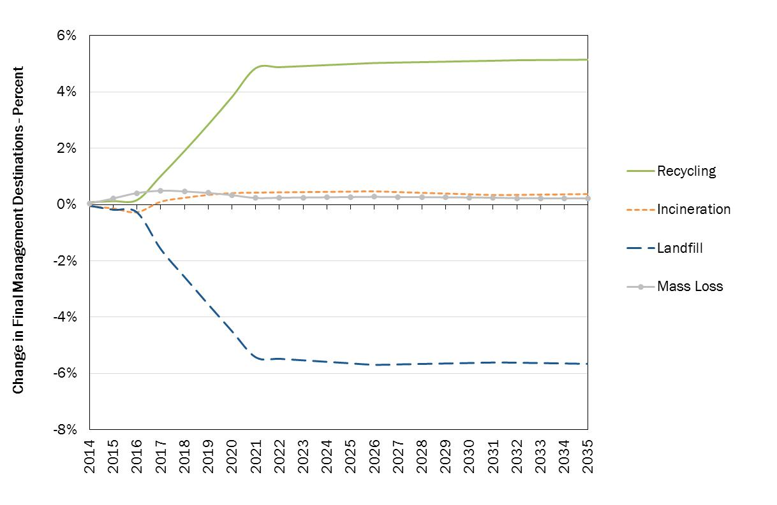
Figure 2: Changes in mass flow - Full implementation vs BAU scenario (% - EU 28)
Financial Costs
A comparison of the full implementation scenario against the BAU scenario indicates that significant investments will have to be made between now and 2020 if MS are to be fully compliant with the targets. These costs are largely associated with investments required to improve collection services mainly in the larger countries (notably ES, PL, CZ, GR, RO, SK) where there appears to be a large gap between then BAU scenario and the demands of full implementation.
Generally speaking, it is assumed that existing predominantly bring-based collection infrastructure in the lower performing MS will have to be partly and progressively supplanted by a door-to-door collection system where this is feasible to ensure higher capture of recyclable waste. At the same time, the existing bring-based collection systems may have to be intensified (increasing the collection points) and adapted (buried collection points in urban zones), with intensive communication campaigns used to support use of the services. Investments in new collection trucks will be needed as well as, depending on system choice, new sorting centres and composting or digestion facilities. In this first phase, significant efforts of communication will be needed to change citizen behaviour. As explained before, there is a large variety of tools available for MS to cover the costs associated with this first investment phase – EPR schemes notably have demonstrated their importance to launch the necessary dynamic and to provide additional source of funding for this necessary first phase of intense investments.
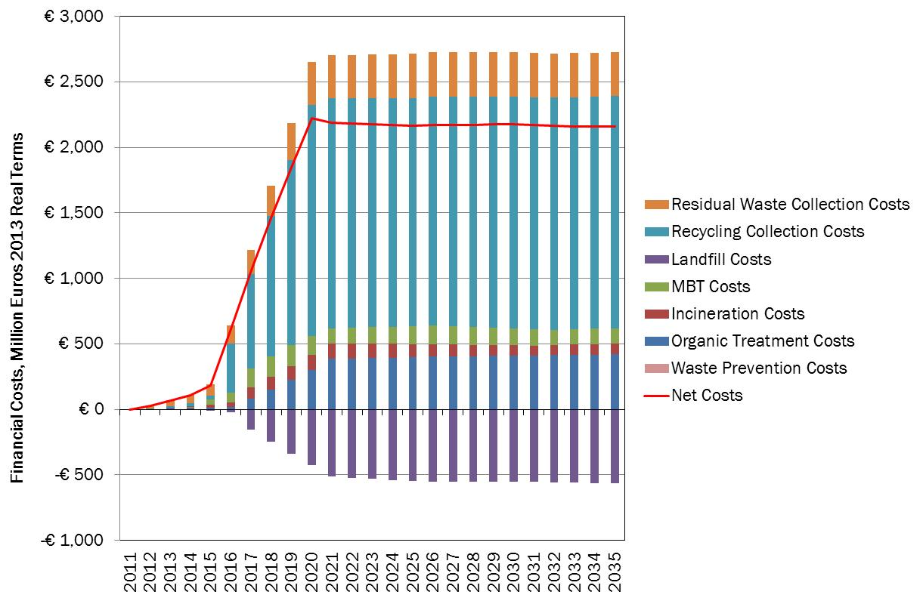
Figure 3: Full implementation vs BAU scenario - Financial Costs (million € - EU 28)
Figure 3 should be nevertheless interpreted with caution as it assumes that no efforts would have been accomplished by MS between 2011 and 2016 to meet the targets – which is an hypothesis taken in the model in absence of verified statistics for the years 2012-2016.
In addition, some of the savings identified under the following options 3 (see below) might also appear earlier in some MS even though experience shows that before capturing savings from diminishing residual waste collection there is a first phase where both collection systems (mixed residual waste and separate recyclable waste) are necessary – leading to increase costs during the first period of changes.
Environmental Costs
There are clear environmental benefits to be gained from full implementation. The majority of these benefits are realised prior to 2020 when the 50% recycling target and the final Landfill Directive target have to be met; however, the benefits continue to accrue steadily over time once full implementation is achieved. It is estimated that full implementation of the existing targets would lead to a reduction of 4,6% of new marine litter inflow by 2020. However, without further action, new marine inflow would increase by 2,9% by 2030. It is important to reiterate that not all the environmental benefits can be monetised, not least those associated with reduced marine litter. Research undertaken in specific circumstances does indicate, however, that the benefits from reducing litter in the terrestrial environment are potentially very significant indeed – see section 5.1.3.
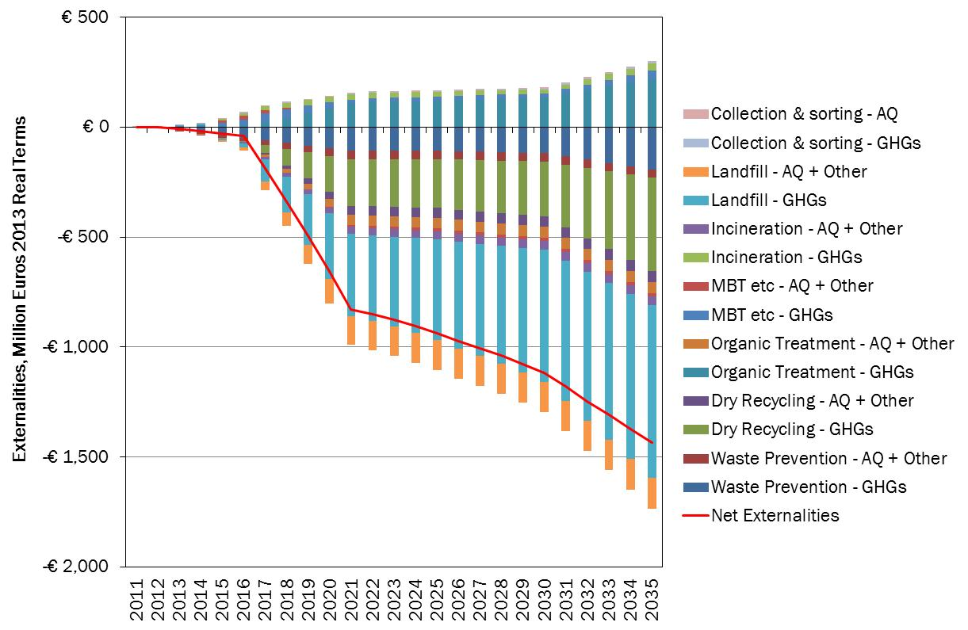
Figure 4: Full implementation vs BAU scenario - Externalities (million € - EU 28)
Net Social Costs
As shown in Figure 5 below, there is a net cost associated with full implementation relative to the Business as usual scenario as the cost of implementation outweighs the environmental benefits. The overall picture, however, shows that the net cost will progressively decrease over time (from €1.500 million to less than €600 million across the EU28). Again this Figure should be interpreted with care: as explained savings will progressively appear with the intensification of separate collection and higher recycling rates. More and more waste will be recycled and less and less residual waste will have to be collected and treated. In a first phase, these savings will be modest as both collection systems (separate and mixed) will have to be maintained. But in the longer term, and if efforts are made to further increase the capture of materials for recycling, the efficiency of logistics will improve, revenues from material sales will (other things being equal) increase, and spending on treatment / disposal will also increase. Net costs would then be expected to fall (see below).
In summary, it is assumed that this first phase of investment linked with the achievement of the existing targets requires a significant shift in the collection and treatment modes as well as in the way of managing waste for citizen. This implies additional costs with limited savings and benefits as the recycling rates remain relatively low, and logistics are not fully optimised so that the full benefits from a re-organisation of the system are not realised.
Figure 6 below shows the costs and benefits per MS. As explained above, some MS (notably ES, PL, CZ, GR, RO, SK) will have to upgrade their current waste management systems to ensure the full implementation of existing target without immediately capturing potential savings and benefits. It is important to note that the increase in cost reflects the standpoint of a cost-benefit analysis (CBA), and that the costs of landfilling, for example, do not include (as is conventional under CBAs) landfill taxes. As such, the ‘avoided costs’ from ‘not landfilling’ are relatively low, and reflect what are often still quite low costs of landfilling in the different MS.

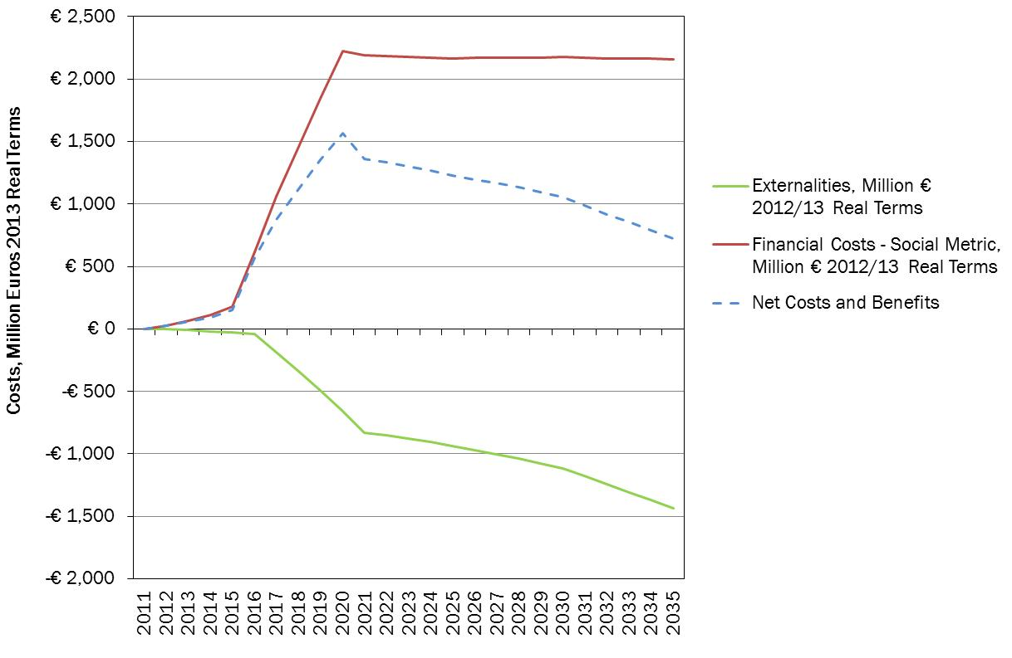
Figure 5: Full implementation vs BAU scenario – Net Social Costs (million € - EU 28)
Figure 6: Full Implementation vs BAU – Net Social Costs by MS in 2030

Employment
Compared to the BAU scenario, this scenario also leads to an increase in employment. The estimated increase in direct employment is 36,761 FTEs (Full-time equivalent) at EU 28 level. Most of the jobs will be created in the larger MS having to make additional efforts to meet the existing targets (SP, PL, PT, RO, SK and CZ).
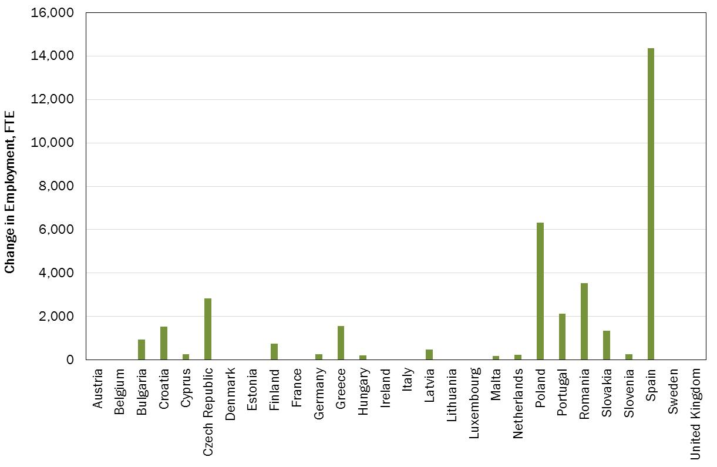
Figure 7: Full implementation vs BAU scenario - Changes in employment by 2030

Option 2: Measures to simplify the legislation, ensure proper monitoring and disseminate best practices
Managing the proposed 'early warning system' will require additional efforts both for the Commission and the concerned MS notably to identify the MS ‘at risk’ of non-attainment and to ensure that the appropriate measure are taken on time to meet the targets. The Commission with the EEA has developed a modelling tool which will be permanently maintained notably for that purpose. In addition, Roadmaps have already been produced by the Commission for the 10 least advanced MS which includes clear and tailored recommendations to improve the waste management. With the early warning procedure, the focus will be limited to those MS for which there is a clear added value of requiring additional information with the perspective of limiting possible infringement procedures later. Managing the early warning procedure will represent an additional workload for the EEA (identification of MS at risk) and for the Commission (launching a dialogue with the ‘at risk’ MS on the required measures to meet the targets). Nevertheless, in the light of the existing information and tools (roadmaps and modelling) and knowing that the Commission has already taken initiatives to promote compliance, it has been estimated that this workload could be covered with existing resources through a slight adaptation of the work priorities.
Measures aiming at improving statistics will require additional efforts by some MS who have not yet developed tools to assist with this. This is the case for the establishment of National waste Registries. The additional costs and potential savings are extremely difficult to assess for each MS: all MS have indeed already in place a system of data collection for waste management as they have to report these statistics to Eurostat and to the Commission. During the country visits carried out at the occasion of the compliance promotion exercise, it has been established that some MS have set in place parallel systems of data collection leading to significant differences in terms of waste generation, collection and treatment between for instance the National Environment Ministry and the statistical Agency. In the case of these countries, establishing a centralised registry could only lead to savings despite the initial investment which will be needed to set up the registry. In other MS these registries are already in place since several years. No additional costs are expected for these MS.
In fact, in the midterm all MS should capture savings from the establishment of a centralised waste management registry. The example of Austria shows that additional level of sophistication could lead to additional significant savings not only for the public authorities but also for waste operators. For instance, the Austrian system is designed to cover a number of environmental fields and is reported to cost around €4.5 million per year. Of this, €750,000 to €1,500,000 is reserved for the on-going development of waste related components. According to the Austrian Chamber of Commerce, this system helps to reduce the administrative burden of reporting and has helped to reduce costs by between €4 million to €10 million.
Imposing a third party verification will represent a cost for Member States. Nevertheless, these additional efforts should be compensated by the proposed dramatic simplification of the reporting flows. Re-investing these means into improving statistics, better monitoring of MS performances and ensuring the dissemination of best practices with a proper management of the early warning procedure seems to be largely justified.
A broad estimation has been made of the effects in terms of administrative burden of the proposed measures under Option 2 – see Table 1. It has been estimated that establishing tri annual reports by the MS requires around 45 working days for the WFD (30 days to establish the report and 15 days of additional follow up) and 30 working days for the other Directives.
Compiling the information from all MS and producing a report from the Commission to the European Council and the Parliament requires approximately 120 days (15 days to establish the report, 30 days to check the data reported by MS and ask additional questions, 60 days for translation of the incoming 20 pages reports from the MS and the report produced by the Commission and 15 days for the adoption procedure). This means an annual average of 40 days.
The time needed for the third party verification procedure has been estimated at 5 man days per year for the key statistics with the exception of packaging for which additional verifications are needed notably on data of packaging placed on the market. In principle, these verifications should decrease the work load at Eurostat level as part of these verifications is carried on by Eurostat. Nevertheless, more actions will be undertaken by Eurostat to ensure the reliability of the data collected therefore these savings are more hypothetical.
All in all as shown in Table 1 below, the global balance of the proposed measures under Option 2 seems positive leading to an annual average reduction of 10 working days for the MS and 60 working days for the Commission. These results are broad estimates and should be taken with precaution; the reality could vary from one MS to another in positive or negative terms depending on the actual situation in each MS. In this table, all data were reported on an annual basis, the time needed to establish the tri-annual reports was therefore divided by 3.

Proposed initiative | Man/days/year  Member States | Man/days/year  Commission
Tri annual reports  Waste Framework Directive  Landfill Directive  Packaging Directive  Report from the Commission | - 15 per MS, – 420 for EU 28  - 10 per MS, -382 for EU 28  -10 per MS, – 280 for EU 28 | - 40
Third party verification  Municipal waste statistics  Landfill statistics  Packaging statistics  Construction and demolition waste  Verification at EU level | +5 per MS, + 140 for EU 28  +5 per MS, + 140 for EU 28  +10 per MS, + 280 for EU 28  +5 per MS, + 140 for EU 28 | (-20)
Total | - 10 per MS, - 280 for EU 28 | - 60
Table 1: Estimation of the annual impacts on administrative burden of Option 2
As it is proposed to introduce at the same time a package of measures aiming at simplifying reporting obligations while improving the quality of the statistics (third party verification and National registries) and as the main impacts of these measures were assessed in this report (no significant impacts identified), it is not the intention of the Commission to undertake separate impact assessments when the technical requirements (third party verification and National registries) will be later defined through delegation.
Defining minimum condition for EPR schemes might contribute to reduce the costs of the EPR systems while ensuring higher recycling and reuse levels. As detailed in section 2.3.3 some MS have managed to increase the recycling rate for packaging waste to levels similar to the proposed targets for 2030 while ensuring a level of fee to be paid by the importer/producer and at the end by the consumer lower than in other less performing MS. It might therefore be expected that when a minimum level of harmonization is ensured, the cost effectiveness of most of the existing EPR will progressively improve. The elaboration of guidance on best practice at EU level can also contribute to the cost effectiveness of the systems.
For instance, it has been estimated that the full cost coverage of household packaging in Belgium through the EPR systems represents around €7.90 per year per capita for an average recycling rate of 85 % which is the highest in the EU. According to the available data, these costs vary from €5.50 € per year and per inhabitant to €19.70/year in the other MS – all of them meeting lower recycling rates. When comparing the fees paid by producers/importers per ton of packaging material put on the market, similar discrepancies appear: average fees charged to producers range from €14/ton to €212/ton (€21/ton in BE), with an average of €105/ton. In addition, in Belgium – like in some other MS – a specific budget is reserved to combat littering originating from packaging – around € 2M in 2012. In the NL, this amount raise to €20 M per year or €1,19 per year and per inhabitant.

Option 3: Upgrade EU targets
In order to compare the added value of upgrading the EU targets, the basis for the comparison of Options 3 is the full implementation scenario. Therefore, all the results provided in this section are relative to the full implementation scenario.
Option 3.1: Increased municipal waste recycling and preparation for reuse targets
As detailed in section 4, two levels of targets have been considered:
- First a low level of 60% by 2030 (Option 3.1 – low)
- A high level of 70% by 2030 (Option 3.1 - high)
The main results are detailed below:
Option 3.1 – Low: Increased MSW Targets at 60% in 2030
As shown in Figure 8 below, compared to the full implementation scenario, Option 4.1 (low) implies a progressive increasing of recycling of 14% while at the same time landfilling and incineration are progressively reduced by 5%. The mass loss line represents losses from MBT processes, the use of which is also significantly reduced. These effects occur because in some countries, investments in incineration and MBT are made in the full implementation scenario, so the higher target effectively forestalls some of the investment in incineration and MBT in some countries.
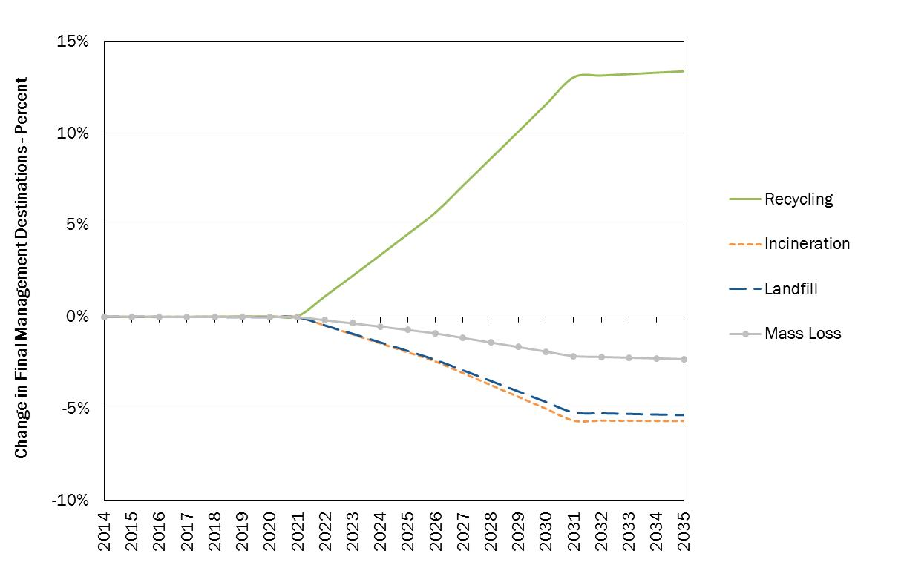
Figure 8: Option 4.1 low – Mass flow changes (% relative to full implementation, EU 28)
Financial Costs
Under this Option, the overall costs for the MS become negative as from 2020. This is a result from the avoided costs of waste being collected and treated as residual waste: more and more waste is diverted from mixed door to door collection systems into a combination of bring and door to door separate collection system which allow progressive savings.
The modelling assumes that in the full implementation scenario, many countries have already had to invest significantly in the upgrading of collection services relative to the situation they were in in 2011 (the latest year for which data is available).

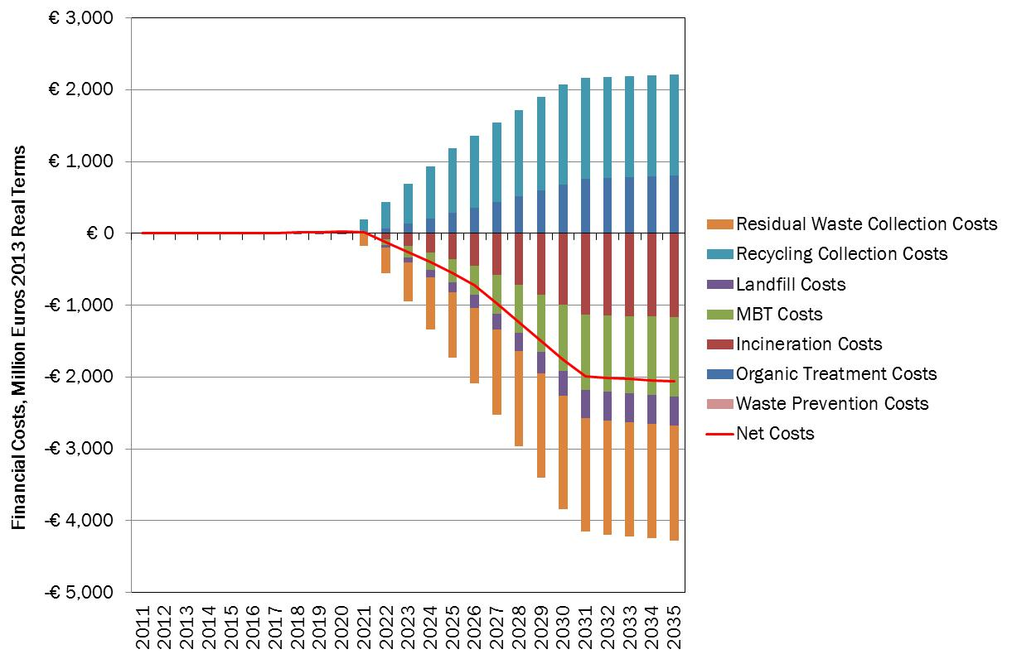
Figure 9: Option 3.1 (low) - Financial Costs (M€ - relative to full implementation, EU 28)
In moving to higher recycling rates, the capture of materials for recycling increases and the revenue generated from the sale of materials increases (so the costs, net of revenue generation, decline). At the same time, the quantity of residual waste requiring collection and treatment declines leading to reduced frequency of refuse collection and savings on the delivery of the collection service. In summary, the effect of measures which encourage/ incentivise the use of the services for recycling is to improve the efficiency of the logistics, and capture more revenue from each household. This explains the effect on collection costs in this and other high recycling scenarios in this impact assessment
Environmental Costs
There are significant benefits derived from the recycling of more material. The majority of these benefits are associated with the avoided GHG/Air emissions related to recycling but other significant benefits result from avoiding GHG and air pollutant emissions from residual waste treatment and disposal.
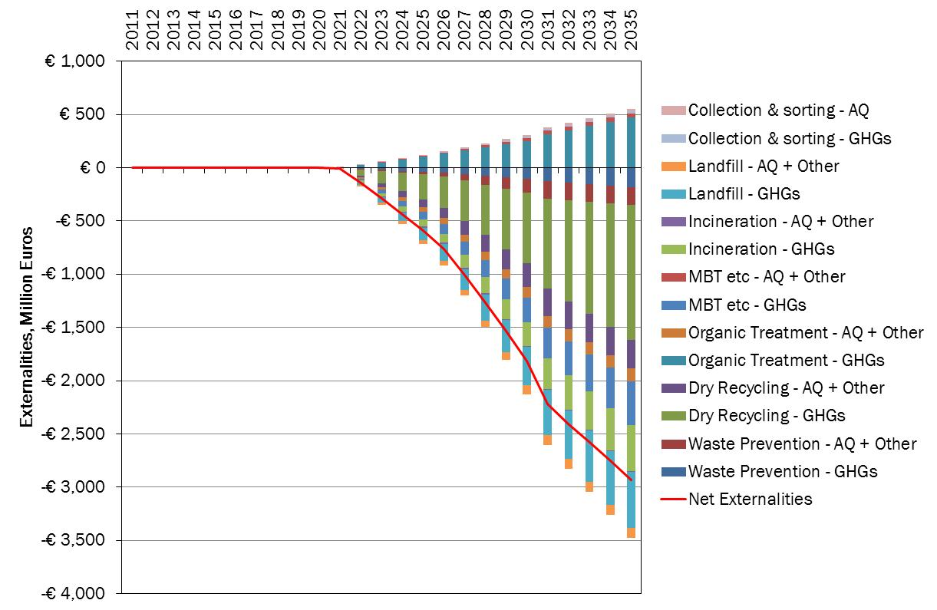
Figure 10: Option 3.1 (low) - Externalities (M€, relative to full implementation, EU 28)
Net Social Costs
With both the financial and environmental costs proving to be favourable relative to full implementation it is no surprise that the net position of Option 3.1 Low is very favourable – see Figure 11. The benefits exceed the costs in all years, though only marginally so in early years.
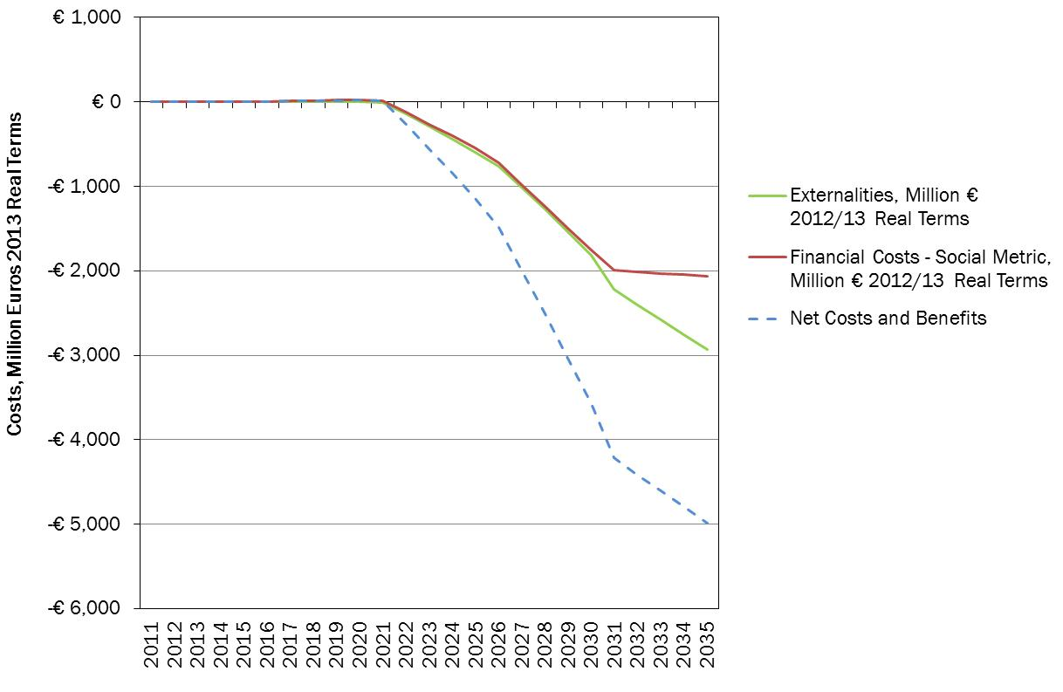
Figure 11: Option 3.1 (low) – Net Social Costs (M€ relative to full implementation, EU 28)
Employment
This Option also leads to an increase in employment. The estimated increase in direct employment is 78,519 (FTE – Full-time equivalent) across the EU. The effects in each MS are shown in the Figure below.

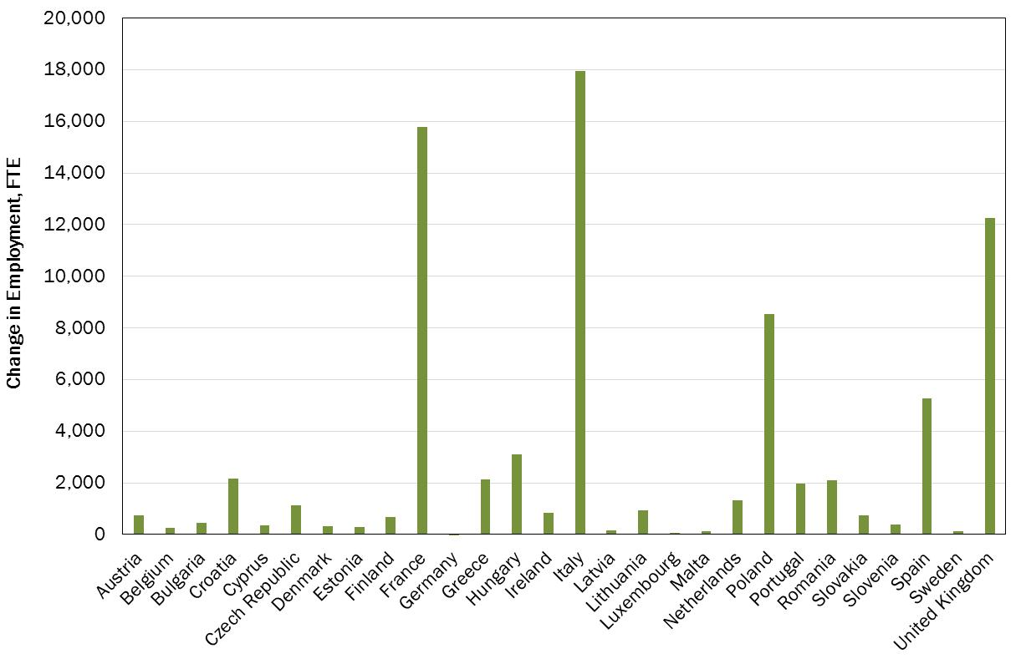
Figure 12: Option 3.1 (low) – Employment change relative to full implementation by 2030
Option 3.1- High: Increased MSW Targets at 70% by 2030
Compared to the full implementation scenario, Option 3.1 (high) implies a progressive increase of recycling up to 70%. In this case, a higher proportion of the switch, relative to full implementation, comes from reducing incineration (and MBT – indicated, in part, by the change in ‘mass loss’, which is associated with this management method).
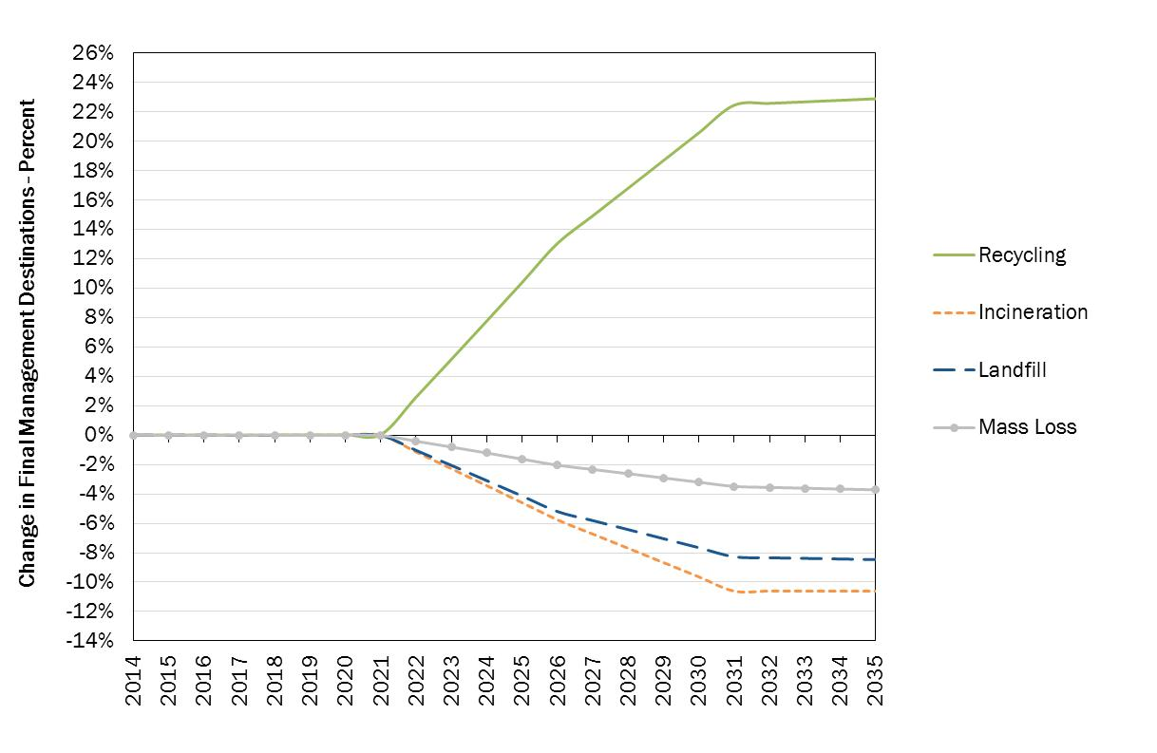
Figure 13: Option 3.1 low – Mass flows changes (% relative to full implementation, EU 28)
Financial Costs
Under this Option, as for the previous one, the overall costs for the MS are negative. This is as a result of significantly reduced residual waste collection and treatment costs. However, the effect is more pronounced than in Option 3.1- low for obvious reasons.
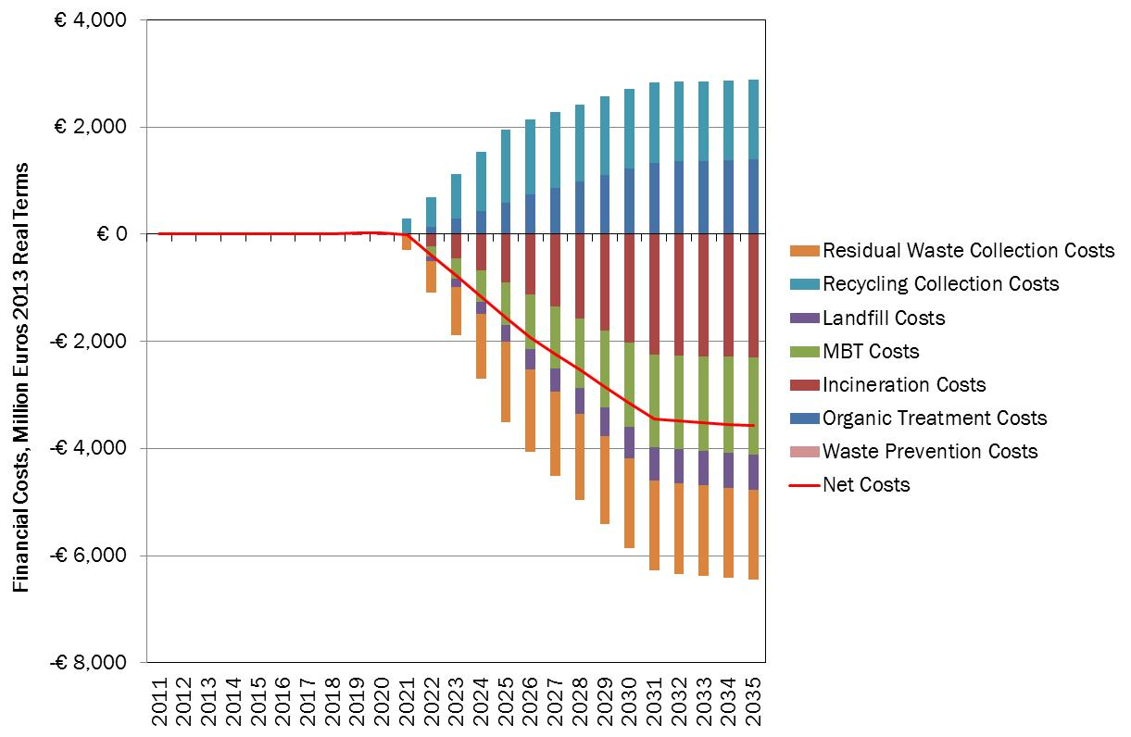
Figure 14: Option 3.1 (high) - Financial Costs (M€, relative to full implementation, EU 28)

Environmental Costs
The environmental benefits from this Scenario are higher than those achieved under the previous Option, and they are also delivered earlier in time. This option sees new marine litter inflows which are 10% lower than those projected under the full implementation scenario.
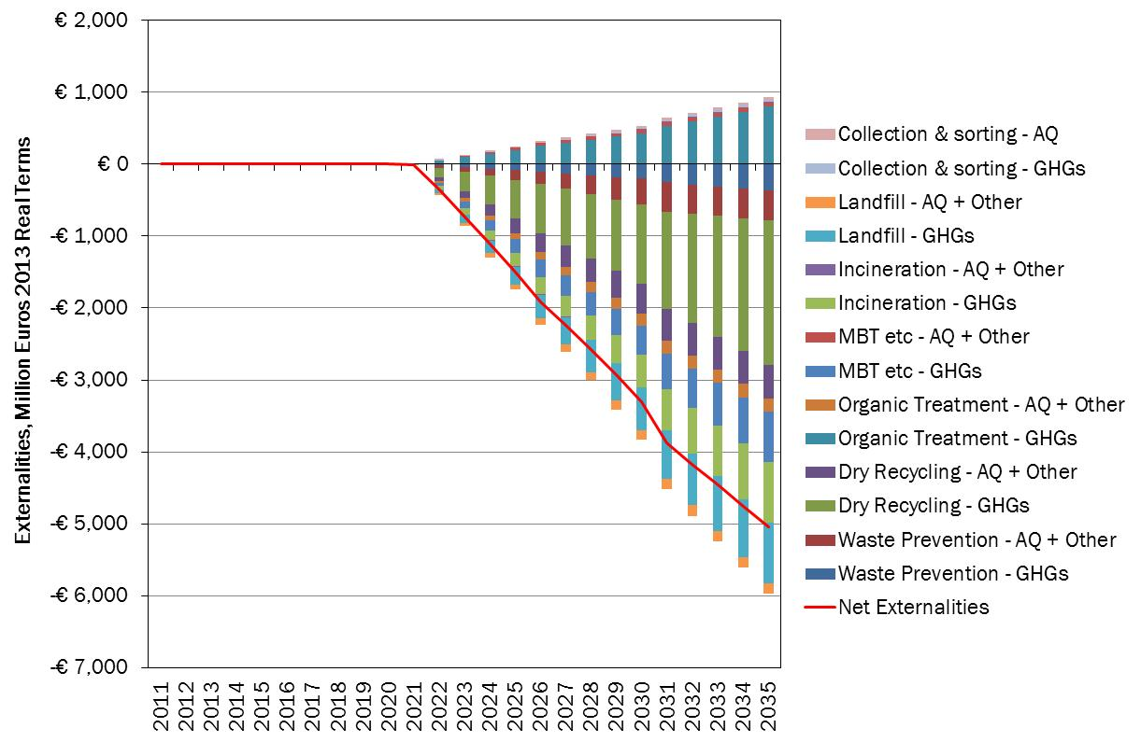
Figure 15: Option 3.1 (high) - Externalities (M€, relative to full implementation, EU 28)
Net Social Costs
At the level of the EU28 net position is even more favourable than under the 60% recycling Option as the benefits are higher, and the increase in benefits exceeds the additional costs - see Figure 16. However, one of the issues with this Option is that it might represent a challenge to some countries to achieve the targets even if as explained in Section 4.4 some EU Regions have already met higher recycling rates in 2010. A more detailed view of the Net Present Value (2014 – 2030) of the costs and benefits for each MS are shown in Figure 17. All countries expect RO and PL will experience a net social benefit (i.e. negative costs).
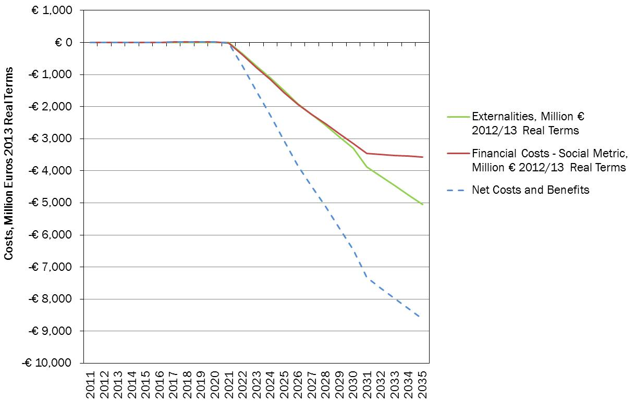
Figure 16: Option 3.1 (high) – Social Costs (M€, relative to full implementation, EU 28)
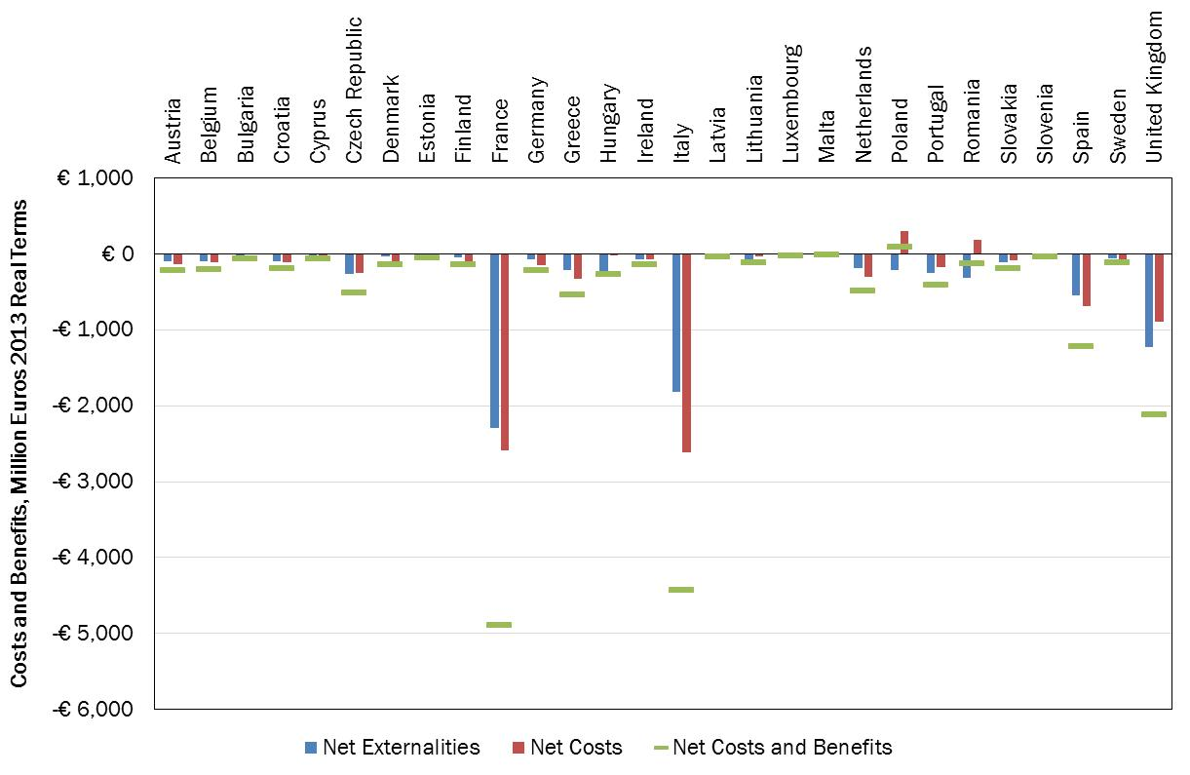
Figure 17: Option 3.1, high – NPV 2014-2030 costs/benefits (M€ to full impl EU 28)
Employment
This Option also leads to an increase in employment. The estimated increase in direct employment is 137,585 FTEs in 2030.
Option 3.2: Increased Packaging targets
Option 4.2 implies a progressive increasing of packaging recycling up to 80%. As part of packaging waste is of municipal origin, this will have an influence on the municipal waste recycling rate (increase by around 10% by 2030. As shown in Figure 18, landfilling is expected to progressively decrease as well as incineration in some MS. Most of the changes will start in 2016 when the possible new targets would be known by MS.
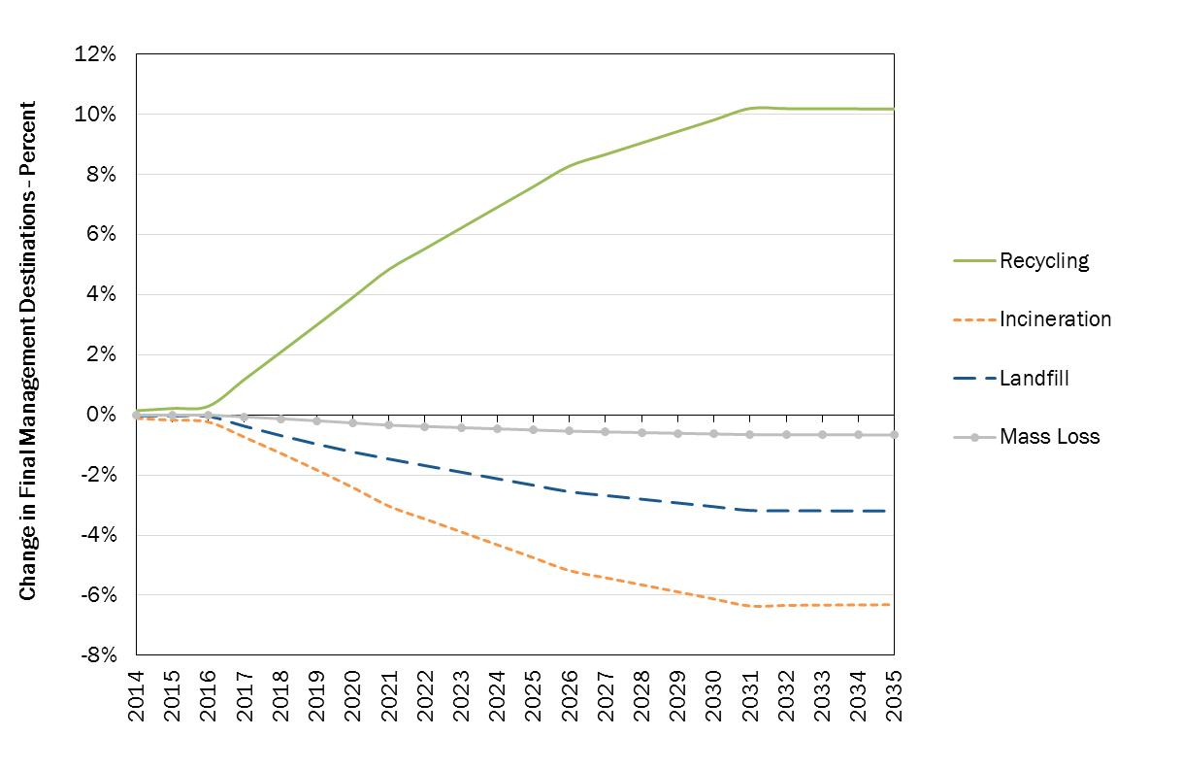
Figure 18: Option 3.2 – Changes in mass flows (% relative to full implementation, EU 28)

Financial Costs
Under this Option, the overall costs for the MS show net benefits very early on. As with previous Options, this is a result of the two competing effects, one from the increase in the cost of recycling, the other from the avoided costs of waste being collected and treated as residual waste. The effects are more pronounced because in Option 3.1 a significant proportion of the waste collected and treated for recycling is biowaste. This entails costs both in collection and treatment, whereas the collection of dry recyclables leads to the capture of material which can generally be sold at a better price.
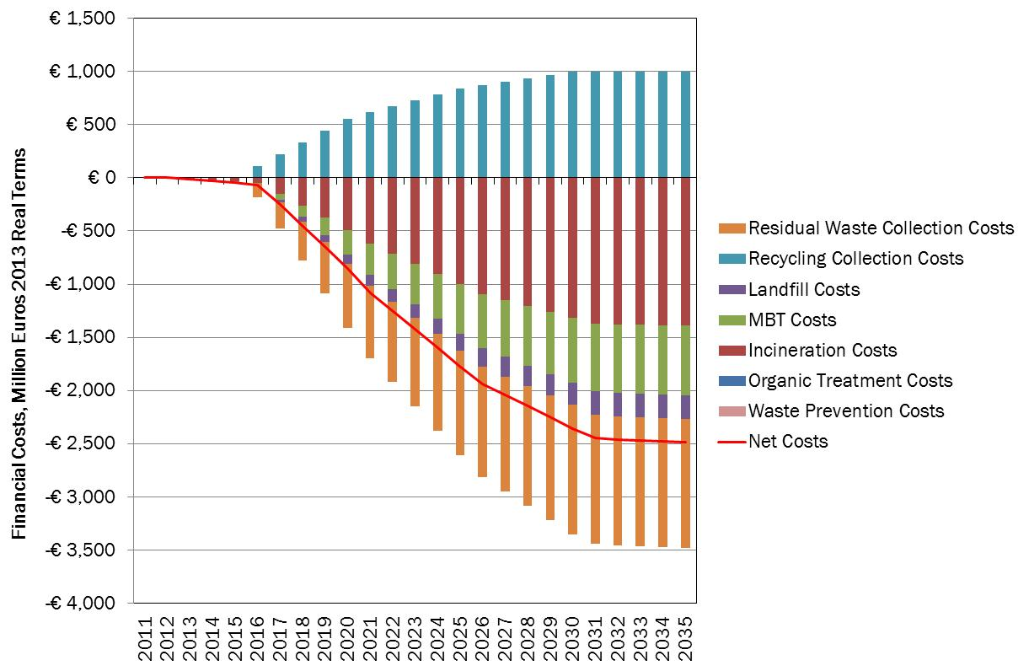
Figure 19: Option 3.2 - Financial Costs (M€ relative to full implementation, EU 28)
Environmental Costs - This Option is associated with significant environmental benefits, primarily due to the reduced reliance on incineration and landfill, both associated with fairly significant environmental impacts (these relate to GHGs and emissions to air, see Annex 6)
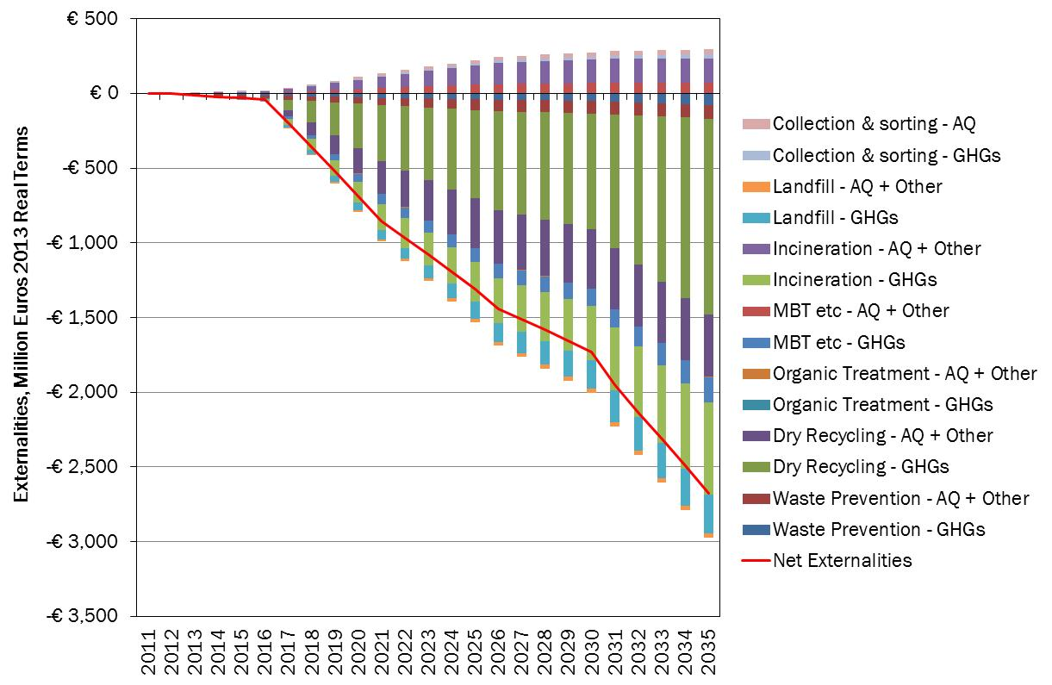
Figure 20: Option 3.2 - Externalities (M€ relative to full implementation, EU 28)

Net Social Costs
When considering the EU28 as a whole the net position of this Option is very favourable and is clearly linked to overall financial and environmental benefits – see Figure 21. On a MS level this Option also yields net social benefits for the vast majority of countries. Figure 21 shows the Net Present Value (2014 – 2030) of the costs and benefits for each MS. It is evident from this that the variance across MSs is quite significant, this is due, at least in part, to the size of the economies and the relative amount of packaging materials that are placed on the market in these countries (e.g. Germany, France, Italy, and the United Kingdom).
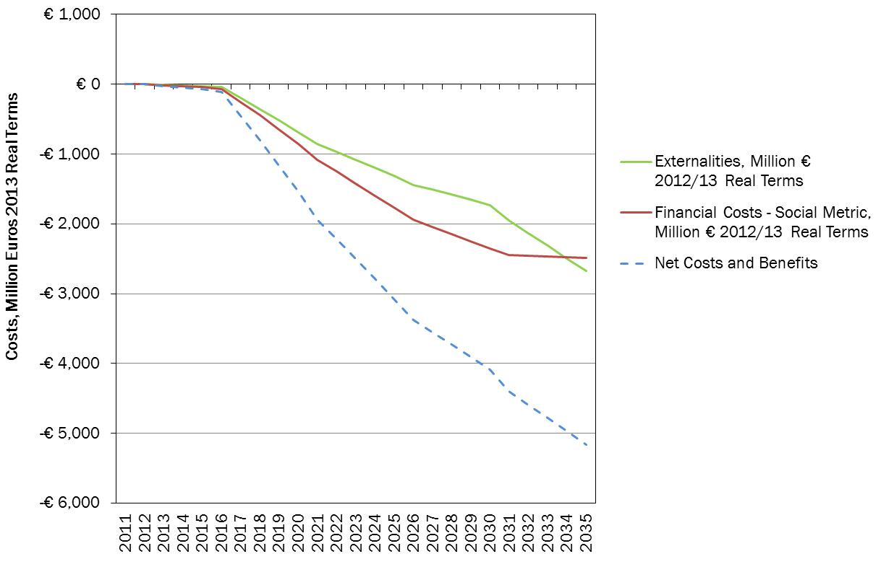
Figure 21: Option 3.2 – Net Social Costs (M€ relative to full implementation, EU 28)
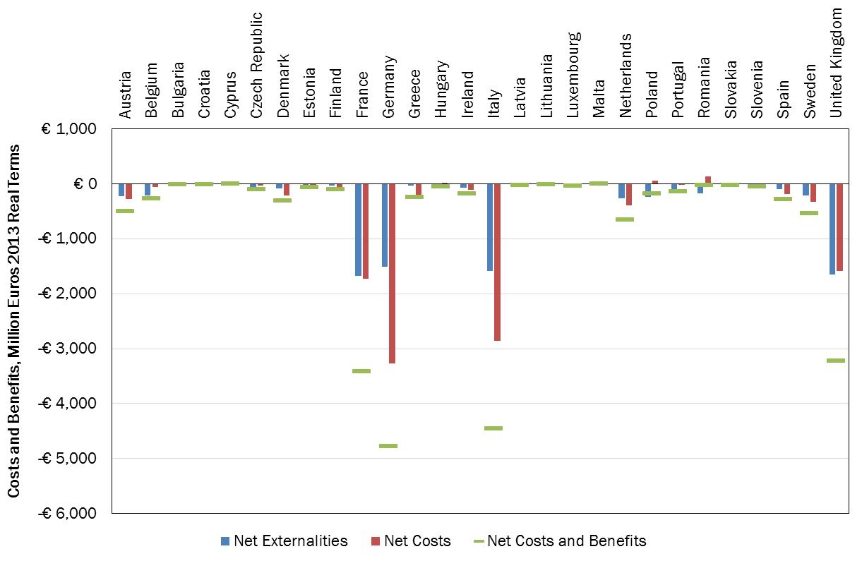
Figure 22: Option 3.2 – NPV 2014-2030 costs/benefits (M€ relative to full implementation)

Employment
Option 3.2 also leads to an increase in employment. The estimated increase in direct employment is 107,725 FTEs.
Option 3.2 – Metal spilt
The split between targets for ferrous and non-ferrous metals is expected to bring additional benefits as more Aluminium will be captured and recycled leading to additional avoided GHG emissions due to the ‘energetic content’ of Aluminium requiring a lot of energy for its production. The overall difference of NPV (2014-2030 at EU 28 level) between Option 3.2 without metal split and with metal split is estimated at 3,87 billions €.
Option 3.3 Measures to limit landfilling
As detailed in section 4, in this Option, landfilling will be progressively limited to 25% by 2025 for all MS and to 5% by 2030. This Option assumes that a landfill ban is implemented in isolation without additional efforts on recycling – which might not correspond to the reality in all MS. Nevertheless, in absence of clear indication on how MS would react to the introduction of a ban in isolation of additional measures, it was assumed that MS will respond by constructing treatment capacities – mainly incineration capacities see Figure 23 below - to deal with the residual waste remaining after full implementation has been achieved. As for option 3.2, it was assumed that most of the changes will start in 2016 when the possible new targets would be known by MS.
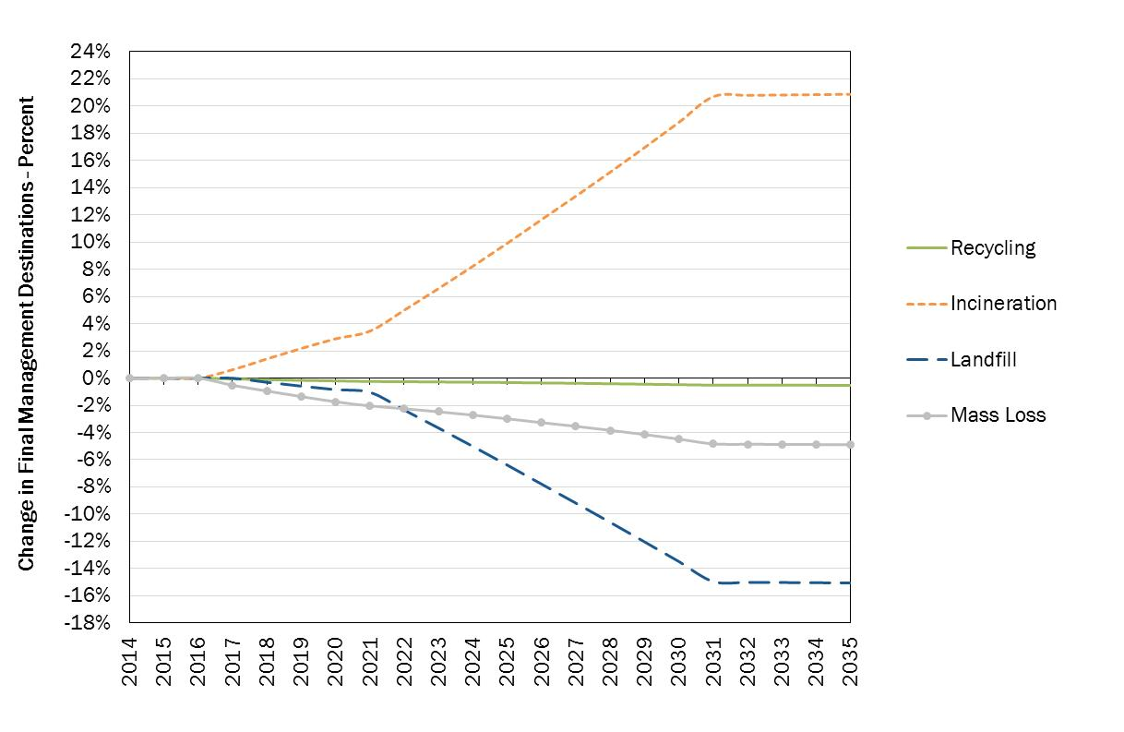
Figure 23: Option 3.3 - Changes in mass flows (%relative to full implementation, EU 28)
Financial Costs
The costs of this upfront investment are clear in the graph below. The increase in costs relates mainly to the fact that, because this is a cost benefit analysis and excludes taxes and transfers from the analysis, the costs of landfilling exclude the effect of instruments such as landfill and incineration taxes, and the support mechanisms in place in some countries for renewable energy. Under these assumptions, the costs of switching from landfill (without tax) to other residual waste management options are relatively high and not least in those countries where landfill clearly remains a very low cost option.
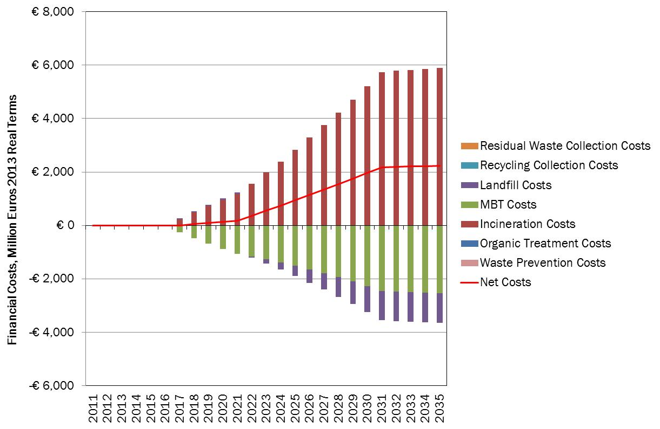
Figure 24: Option 3.3 - Financial Costs (M€ relative to full implementation, EU 28)
Environmental Costs
This scenario is associated with environmental benefits as materials are diverted from landfill and additional energy is produced by burning more waste.
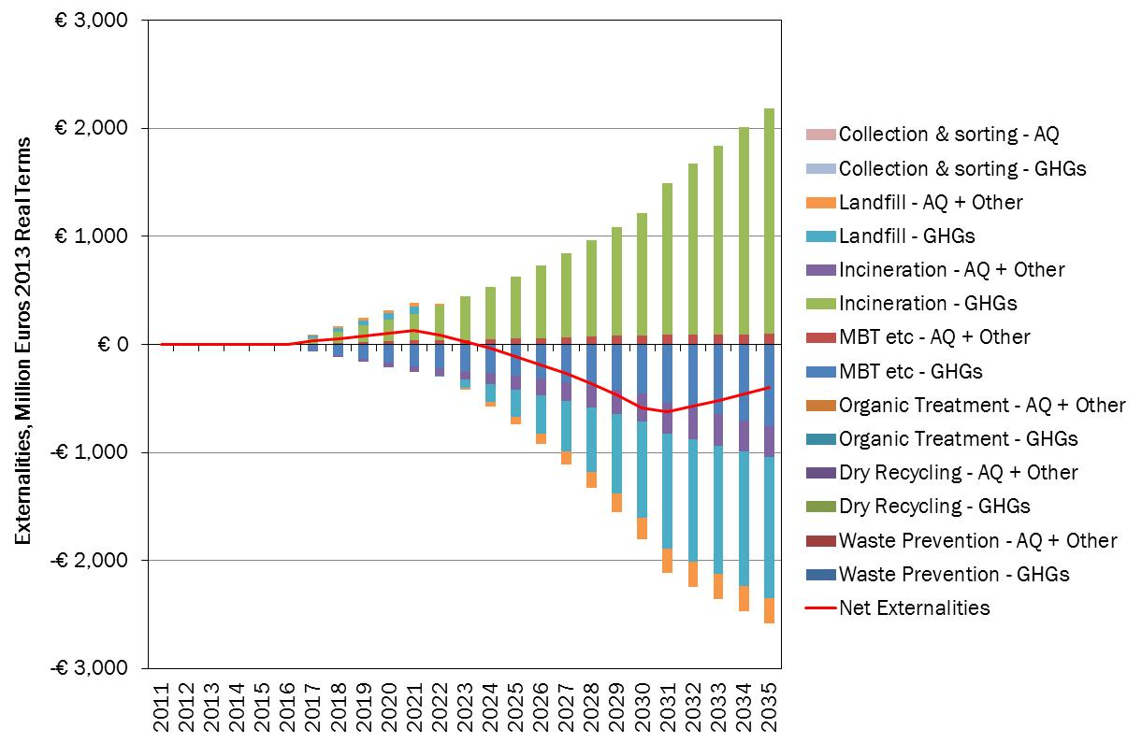
Figure 25: Option 3.3 - Externalities (M€ relative to full implementation, EU 28)
Net Social Costs
The overall position of this Option is that there is a net social cost as MS respond to the ban by constructing residual waste treatment capacity to deal with the residual waste that remains after MS have achieved full implementation of the existing legislation. The slight environmental benefits associated with this change in the early years are clearly outweighed by the costs. Essentially, this implies that the additional costs of switching from landfill to other residual waste treatments exceed the benefits that flow from such a switch.
This is broadly consistent with the majority of other studies on the costs and benefits of landfill and incineration.
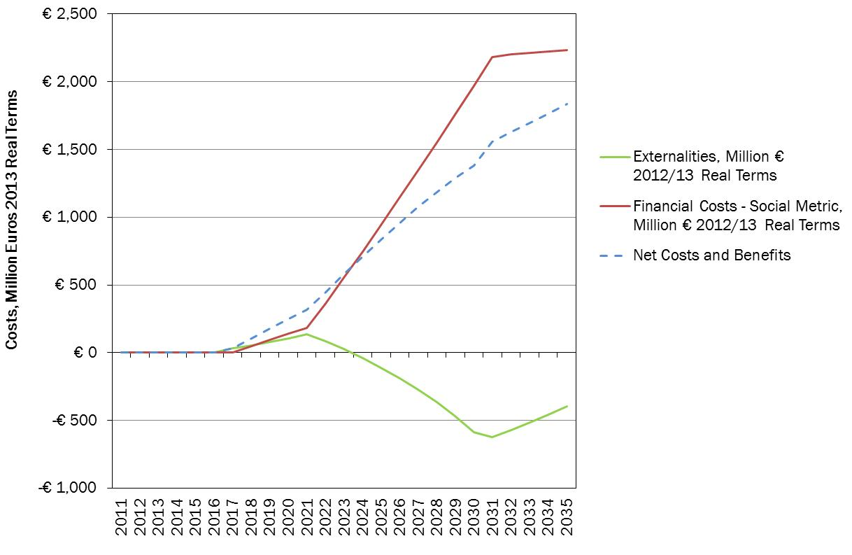
Figure 26: Option 3.3 – Net Social Costs (M€ relative to full implementation, EU 28)
Employment
This Option also leads to an increase in employment. The estimated increase in direct employment is 46,165 FTEs. This reflects the fact that the residual waste treatments are less ‘employment intense’ than other forms of treatment.
Option 3.4: Combined option
On the basis of the above analysis, the following option has been considered for assessment:
- The MSW targets stretched to 2030; with
- The increased packaging targets; and
- The restriction on MSW landfilled (to 5% of total) by 2030.
In the first instance, this combined option has been considered as being applied at the same level for all countries. The landfill restriction has been retained despite the net social costs indicated by the analysis of the impact of a landfill ban in isolation of an increase of recycling targets. The analysis from the modelling does not include all environmental externalities, notably those associated with emissions to water and land, which might be expected to be of some significance for landfilling, possibly in the longer term. The approach is also aligned with the vision set out in the Resource Efficiency Roadmap and 7th EAP.
As shown in Figure 27, this option implies an increase of recycling of 25% compared to the full implementation Scenario.
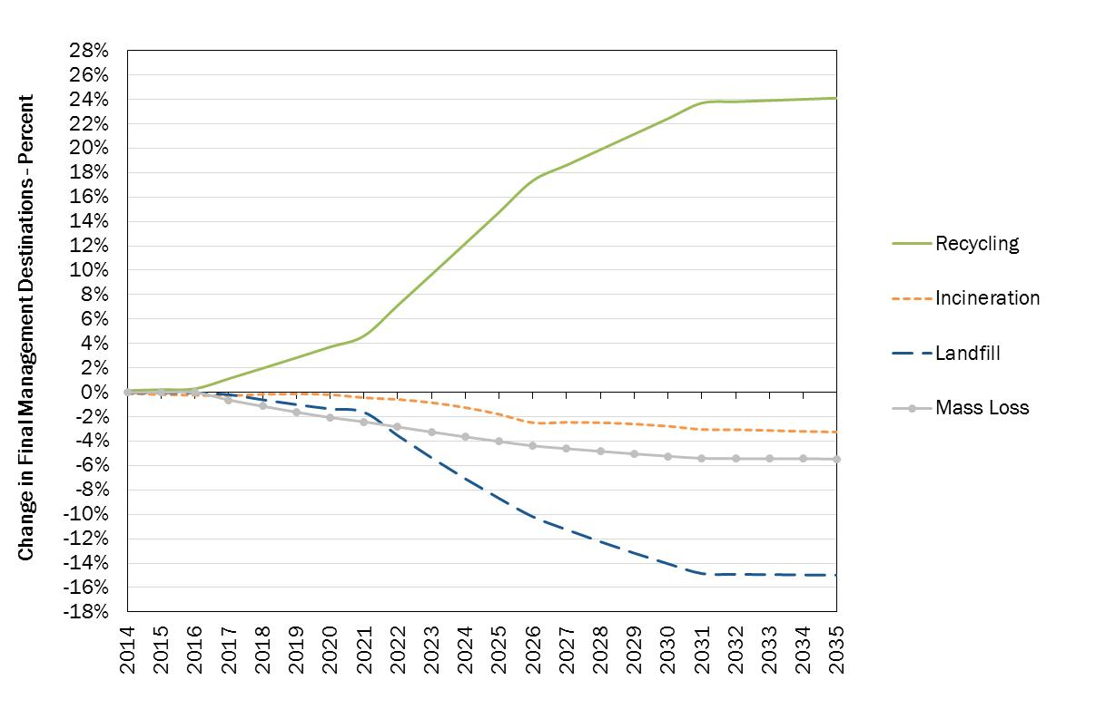
Figure 27: Option 3.4 - Changes in mass flows (% relative to full implementation, EU 28)
The graphics below indicate the financial costs (Figure 28), the environmental costs (Figure 29), and the net social costs of the proposed combination of options (Figure 30 and Figure 31). As stated above all figures are given relative to full implementation.
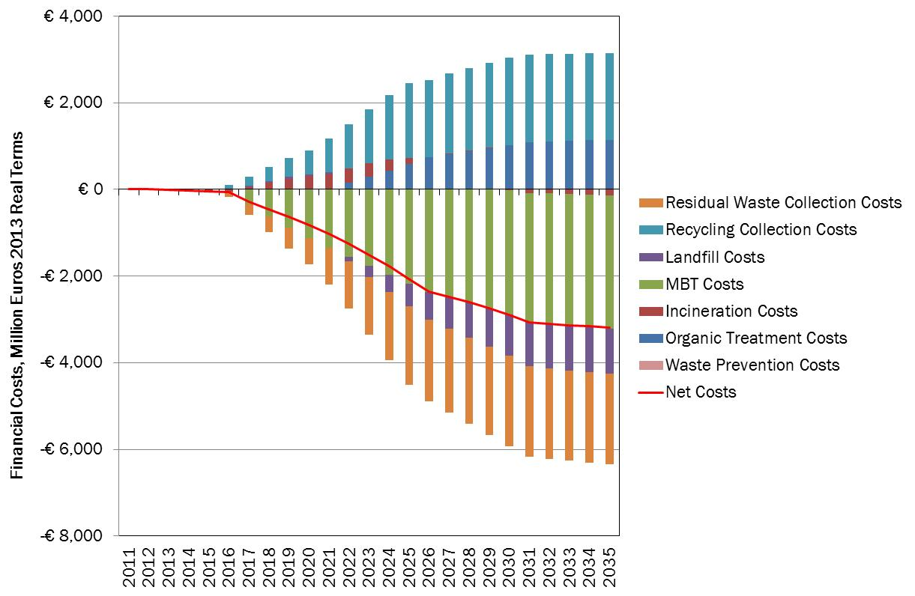
Figure 28: Option 3.4 – Financial Costs (M€ relative to full implementation, EU 28)

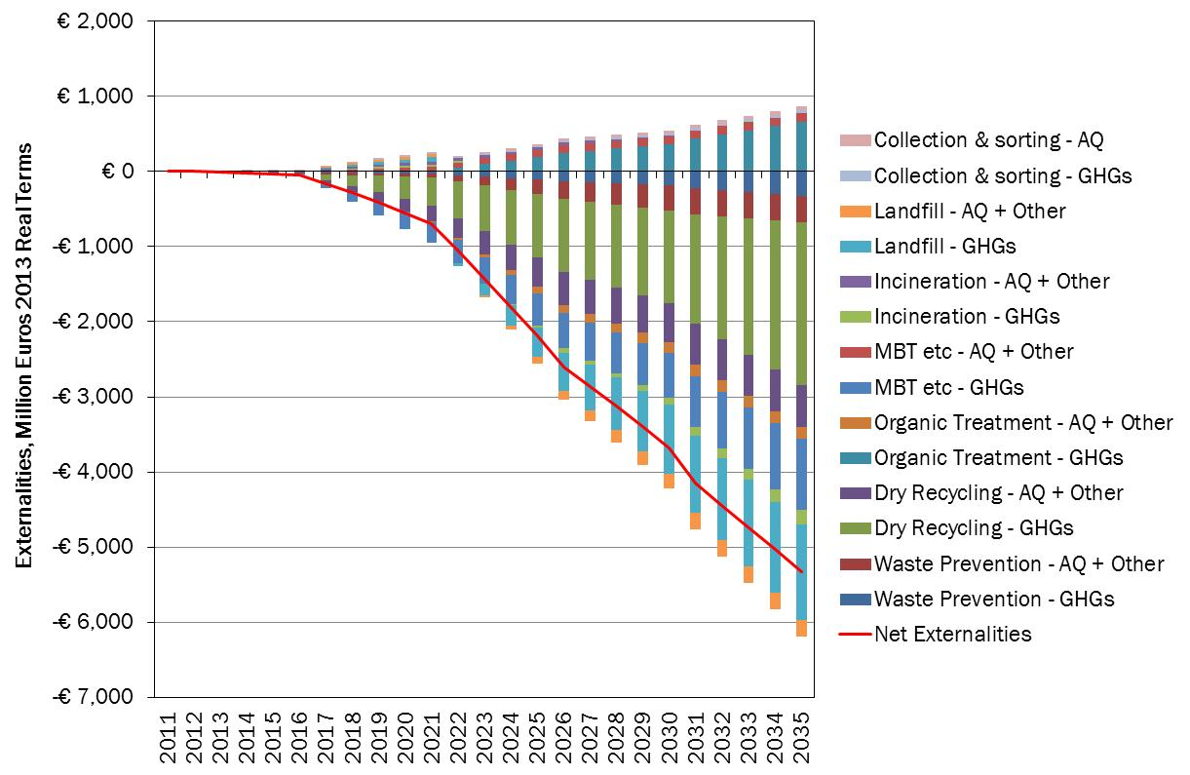
Figure 29: Option 3.4 - Externalities (M€ relative to full implementation, EU 28)
The marine litter modelling demonstrates that the combined effect of Option 3.4 is that projected new marine litter inflows are found to be 27,5% lower than those projected by the full implementation of existing legislation only by 2030. The decrease to 2020 is less pronounced (13%) since most of the measures only enter into force after 2020.
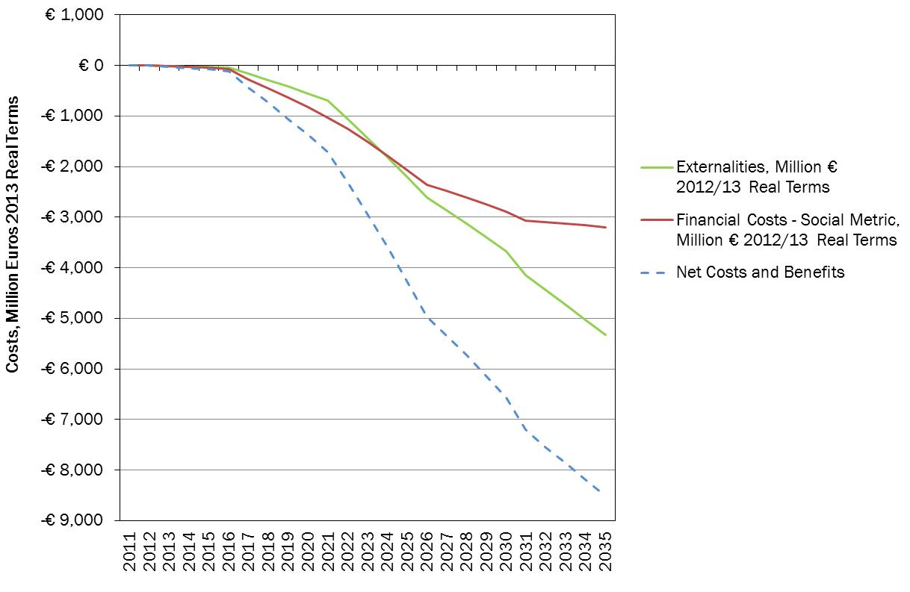
Figure 30: Option 3.4 – Net Social Costs (M€ relative to full implementation, EU 28)
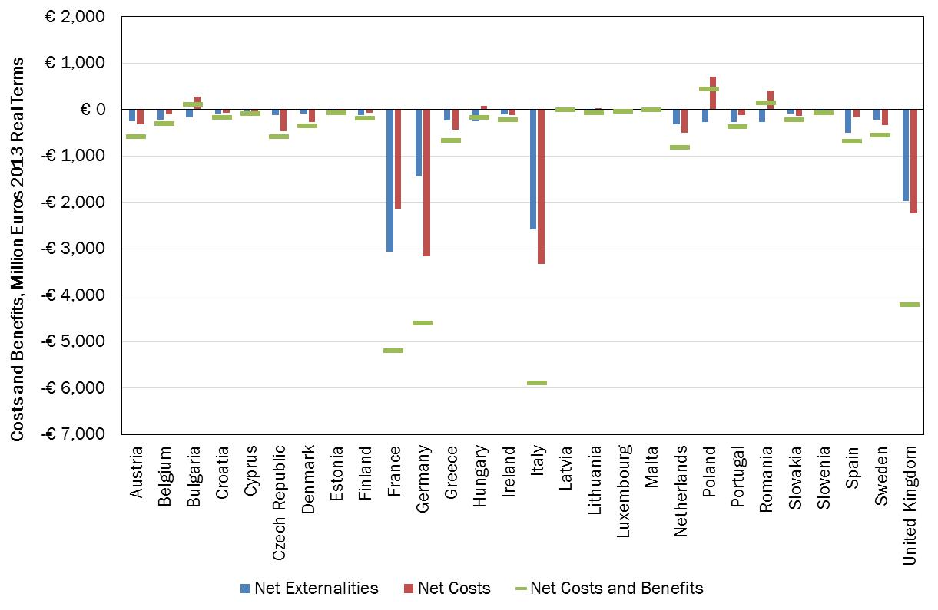
Figure 31: Option 3.4 – NPV 2014-2030 costs/benefits (M€ relative to full implementation)
As detailed in Figure 32, the approach would generate an estimated 177,637 FTEs in terms of employment across the EU.
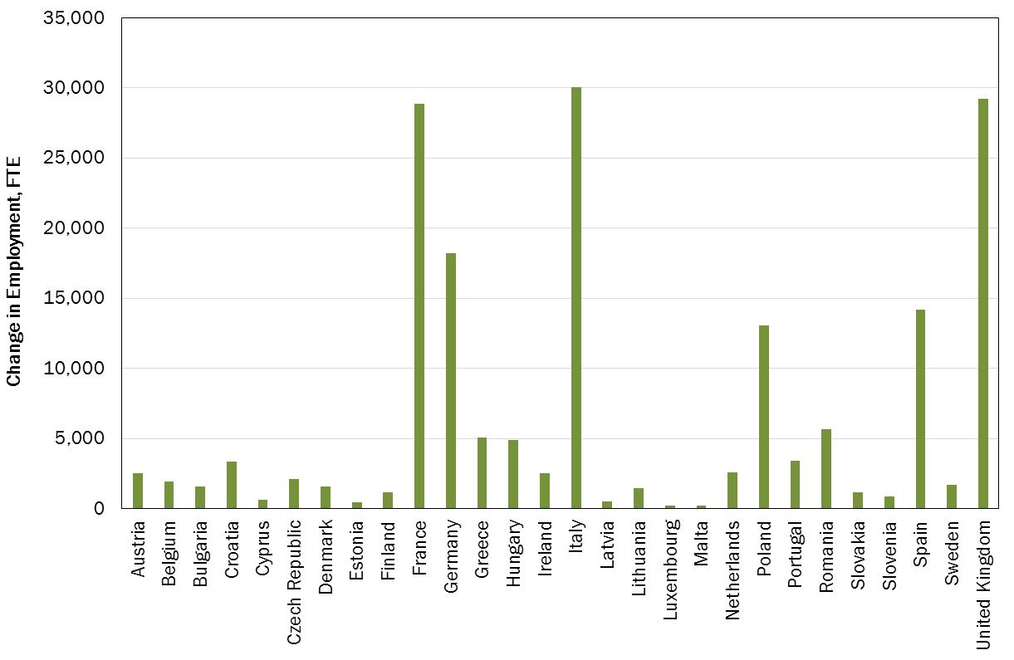
Figure 32: Option 3.4 - Changes in employment by 2030 relative to full implementation
Options 3.5 and 3.6
The impacts of options 3.5 and 3.6 as detailed in Section 4.4 are the same in terms of mass flow changes in the longer term than for option 3.4: imposing more stringent but still realistic deadlines could be achieved thorough differentiated deadlines per Group of MS or with time derogation for some MS according to their actual situation in terms of waste management. The difference between options 3.5 and 3.6 with option 3.4 is more significant for ‘Group 2’ and less important for ‘Group 1’ MS.
For Group 1 and 2 MS, the costs and benefits of increased recycling will be captured more rapidly than in option 3.4 which will have an influence on the net present value (NPV) at the EU 28 level: both options 3.5 and 3.6 will lead to an additional NPV of the net benefits of € 27,2 billion compared to the NPV of Option 3.4. Also the creation of jobs will be more rapid for Groups 1 and 2 if options 3.5 and 3.6 are implemented.
Option 3.7- Extension of landfill restrictions to other waste similar to municipal waste
Extending the proposed municipal waste landfill ban to all non-municipal waste landfilled in ‘Category 2’ landfills (designed to accept municipal waste and similar waste according to the Landfill Directive) would concern around 58 million additional tons of waste (55% increase compared to municipal waste).
In absence of any quality data on the composition of this additional waste and due to the lack of a clear counterfactual in terms of how such wastes might be managed in future, it has been assumed that:
- Such waste have a composition similar to municipal waste;
- Extending the ban to all similar waste would increase recycling in the same proportion than for MSW (70%), as well as a shift in the management of residual waste from landfill to various treatment options.
On this basis, it has been assumed that the present value (NPV 2014-2030, EU 28) of the social costs increased by 3.35 billion € compared to Option 3.4. It should be noted, however, that the different waste compositions will, in reality, affect environmental benefits, whilst the costs may be expected to be different, in reality, than for the municipal wastes.
In practice, extending the proposed ban to all waste entering ‘Category 2’ landfills will facilitate the enforcement of the proposed ban as it would apply independently from the origin of the waste as long as its composition is similar to municipal waste.
Main uncertainties associated with the model
The modelling which forms the basis for the IA is complex and incorporates a range of assumptions and variables which can be expected to influence the assessment. The main uncertainties are related to the design of collection systems in the MS, collection and treatments costs, waste composition and its evolution, material and energy values over time and GHG damage valuation. A summary of the main uncertainties is provided in Annex 8.
Nevertheless, it should be noted that:
- The model has been subject to peer review;
- Considerable efforts have been made to ensure assumptions are reasonable, and the modelling is based on the best information available (20 country visits were achieved to gather the most recent and relevant data);
- These efforts will be carried on by the EEA as the model will become a permanent tool maintained and improved by the EEA.
Finally, these uncertainties if they might influence the results in absolute terms, they will not change the relative position of the impacts of the different Options assessed in this IA.

1.3. Impacts on groups of stakeholder
Public authorities/ citizens: Meeting the proposed targets will imply in some zones additional direct costs particularly where separate collection have to be launched. These direct costs will be largely compensated by the expected benefits at society level. As shown in section 5.2, direct savings might be expected in the midterm as less residual waste will have to be collected and treated. These savings should be beneficial for public authorities and for citizens (less waste related taxes).
Nevertheless, experience confirmed by the results of the model (full implementation scenario), shows that direct costs are expected to increase in the first years as it is necessary to launch new ways of collecting waste (separate collection) and new waste treatment infrastructures (sorting centre, composing and digestion facilities, energy recovery infrastructures in the MS landfilling high level of waste). These costs have to be partly covered by public authorities in charge of waste management.
There are several ways of limiting he direct costs for the public authorities linked with improved waste management techniques:
- Focusing on the prevention of waste through fostering heightened awareness of the issue, and collaborating with private sector companies to design waste out of systems, or make the wastes more easily re-useable / recyclable; Citizens can be beneficiaries of waste prevention: for example, initiatives which have highlighted the level of waste of food have also brought to the attention of citizens the simple truth that wasting food wastes money;
- Improving governance - ensuring a better coordination between the authorities in charge of collecting and treating can lead to an integrated approach of waste management and a reduction of the costs;
- Focusing on efficiency of service delivery – the evidence suggests that there are further gains to be made in terms of improving the design of collection services and in ensuring citizens are able to participate easily in the system;
- Midterm targets – fixing at EU level a clear perspective at a mid-term horizon will avoid inappropriate investments which at the end are often paid by the local authorities;
- EPR schemes – have proven to having helped to cover the costs for launching separate collection – as detailed above, there is still large possibilities of optimizing these EPR schemes while expanding them to other waste streams;
- PAYT systems – the application of ‘clever’ PAYT systems are very effective to favour prevention and the participation in separate collection schemes, which in turn limit/reduce the overall costs of waste management.
As detailed in section 4.3, an optimal combination of economic instrument can contribute to improve waste management while limiting the overall cost of the system. In that sense, ensuring the dissemination of best practice is essential particularly in those MS where additional efforts will be needed to meet the proposed targets – which is one of the objectives of the proposed ‘early warning procedure’.
Manufacturing industries should be benefit from the re-injection in the EU economy of secondary raw materials (limiting the risk of raw material prices increase). In addition, it has been demonstrated that EPR schemes could be optimised notably through EU harmonisation which in turns could limit the fees to be paid by the producers/importers when they pace goods on the EU market. In the midterm, the manufacturing industry might also have to progressively modify the design of the products in order to ease the achievement of the European targets.
Waste operators whether large companies or SME involved in waste collection and treatment should benefit from better implementation of existing legislation and from new targets. As highlighted during the stakeholder consultation, new business opportunities will be created whether in collection, sorting or treatment sectors. The main potential loser might be landfill and low performing MBT operators but this should be limited as most of them are part of larger waste management group already having diversified their activities. Similarly in a limited number of countries few incinerator operators might meet difficulties to feed their oversized infrastructures. This might be attenuated by imports from MS lacking incineration infrastructures. The recycling industry: Reinforcing the target will create new opportunities and push for more innovation notably in sorting and recycling techniques. Social enterprises active in waste re-use could also benefit from additional stimulus to favour reuse for instance in the second hand sector.
Improved waste management might impact SMEs as additional efforts might be required to ensure proper at source waste separation. At the same time increasing prevention, reuse and recycling might also reduce the costs of waste management. SMEs flexibility, adaptability, and their willingness and ability to innovate also represent an asset for instance for the development of new techniques for improving waste sorting, reuse and recycling. The SME sector is a large part of the waste industry and some SMEs will be beneficiaries of a more forward thinking vision for waste management. As suggested during the seminar with SME’s held in preparation of this IA, some simplification measures should be envisaged for SME’s handling small quantities of waste.
The tourism and the fishery sectors would also benefit from reduced marine litter.

- Comparing the Options
In this section, the impacts of the options are compared between them. First the Options are compared on the basis of quantified data when they are availbale ( costs and benefits, impacts on employment and contribution to marine litter reduction). Then, a qualitative comparison of the options is achieved by assessing their relative contribution to each objective identified under section 3. From this combined analysis, a prefered option is then identifed and proposed.

2.1. Costs, benefits, employment and marine litter
The following Graphic shows the net social costs of each option compared to the full implementation scenario.
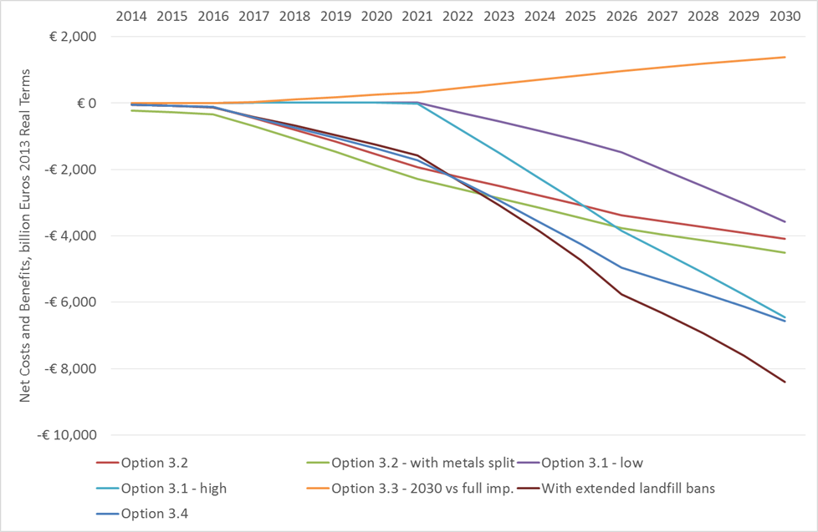
Figure 33: Comparing the options – Net social Costs (billions €, EU 28)
Option 3.4 with an extended landfill ban to all waste similar to municipal waste provides the highest ratio Cost/Benefits and represents the most interesting Option at society level.
The impacts from 2014 to 2030 of each option for key indicators is summarised in Table 2 below. The greatest net benefit on the period 2014-2030 is delivered by Option 3.7. In terms of job creation, Options 3.4, 3.5, 3.6 and 3.7 are the most promising. Options 3.4 and 3.7 delivers the best result in terms of GHG emission reduction (- 44 million Tons of annual GHG equivalent emission in 2030 and -62 million tons with an extension of the landfill ban to all similar waste).
With the implementation of the Options 3.4 to 3.7 and compared to the full implementation scenario, marine litter could be reduced by an additional 13% by 2020 and by an additional 27,5% by 2030. Additional savings coming from reduced marine litter inflows, by 2030 under these Options are estimated at 143 m€, mainly as a result of reduced beach cleaning and avoided damage to fishing vessels and gear (see Annex 9).
Option | Financial costs (NPV 2014-2030), € billion (1) | External costs (NPV 2014-2030) € billion (2) | Net social costs (1+2) | Jobs (FTEs in 2030) | GHG million tonnes CO2_{eq} (2030) | GHG million tonnes CO2_{eq} (2014-2030)
Option 3.1- low | -3.73 | -3.96 | -7.69 | 78,519 | -23 | -107
Option 3.1- high | -8.41 | -8.49 | -16.91 | 137,585 | -39 | -214
Option 3.2 | -11.2 | -8.45 | -19.66 | 107,725 | -20 | -183
Option 3.2 – metal split | -13.48 | -10.05 | -23.53 | 107,643 | -24 | -250
Option 3.3 | 5.64 | -0.65 | 4.99 | 46,165 | -13 | -49
Option 3.4 | -12.65 | -13 | -25.65 | 177,637 | -44 | -308
Option 3.5 and 3.6 | -13.62 | -13.58 | -27.2 | 177,628 | -44 | -320
Option 3.7 | -10.7 | -18.3 | -29 |  | -62 | -443
Note, negative costs represent a benefit
Table 2: Comparison of key indicators of the options retained

2.2. Contribution to the main objectives, efficiency and coherence
In Table 13 below, the relative contribution of each option to the main objectives as identified in section 3 is summarised.
With Option 1 – Full implementation, the legislation will remain complex and difficult to enforce properly, there will be no guarantee that best practices will be disseminated especially in the MS facing poor waste management performances, the level of the targets will remain too low to build a 'circular economy'.
All the other Options are compared to Option 1 as they come on top of full implementation of the existing legislation.
Option 2 scores best in terms of meeting some of the key objectives of this IA: several measures are proposed to simplify the legislation (dramatic reduction of reporting obligation, simplification of the measurement methods, removing obsolete requirements, reduction of administrative burden for SME’s, etc). Monitoring will be improved with the proposed measures to increase the reliability of statistics and with the new early warning procedure. Best practice will be disseminated with the implementation of the early warning procedure. Nevertheless, without new upgraded targets the contribution of Option 2 taken in isolation to resource efficiency will remain limited.
This option contributes to several objectives as defined in section 3 (see Table below) while some net savings could be expected (simplified reporting which should compensate efforts required on statistics – see section 5.2). In that sense, Option 2 can be seen as relatively efficient. Nevertheless, this Option is less coherent with some overarching objectives of the EU polices (resource efficiency, climate change, raw material access) than the other options including higher targets even tough it will contribute to a better implementation of the EU legislation which is also one of the overarching objectives of the EU.
Compared to the full implementation scenario (Option 1), Options 3.1 has limited advantages in terms of simplification and monitoring (one measurement method). The contribution to resource efficiency of Option 3.1 is positive (higher for Option 3.1 – high) and meeting the proposed targets implies that best practices are disseminated.
Compared to the full implementation scenario (Option 1), Options 3.2 has limited advantages in terms of simplification and monitoring (removing obsolete requirements and targets). The contribution to resource efficiency of Option 3.2 is positive and meeting the proposed targets implies that best practices are disseminated notably in terms of improved EPR schemes.
Options 3.3 has limited advantages in terms of simplification and monitoring (replacement of the landfill diversion target for biodegradable waste by overall landfill bans) compared to the full implementation scenario (Option 1), The contribution to resource efficiency of Option 3.3 is positive but limited as part of the waste diverted from landfilling will be incinerated including waste that could have been recycled. Meeting the proposed targets implies that best practices are disseminated notably in terms of use of key instruments (landfill taxes followed by landfill bans).
Option 3.4 has more advantages in terms of simplification as the proposed targets are consistent and synergetic between them. The proposed deadlines for each target are consistent between them as well as the level of the proposed targets. This simplification will facilitate the monitoring of the targets and meeting high levels of recycling while reducing landfilling will require the dissemination of best practices in all MS. The contribution to resource efficiency is considered as positive compered to –the full implementation scenario.
Compared to Option 3.4, options 3.5 and 3.6 are less performing in terms of simplification and monitoring as fixing differentiated targets depending on MS and/or allowing for time derogation will not contribute to simplify the legislation and the monitoring of the targets. The contribution to resource efficiency is nevertheless higher mainly because more raw materials and resources are captured earlier in several MS.
Option 3.7 performs better in terms of simplification and monitoring (landfill restrictions are applied to all ‘municipal’ type landfills independently from the municipal origin of the waste).
Options 3.4 to 3.7 have the most positive impact in terms of reductions of marine litter. However, a significant portion of the gains made are as a result of avoided increases in litter, rather than actual reductions of current litter inflows. Therefore further action is needed to achieve the significant reductions in marine litter called for in the 7th Environment Action Programme.
All Options between 3.1 and 3.7 will contribute to the objectives as defined in section 3, Option 3.3 being the less cost effective (and therefore the less efficient) though Option 3.7 has the best cost/benefit ratio while contributing highly to all objectives. The other Options are more of less efficient depending on their contribution to the objectives compared to their costs and benefits – see Table 3. As shown in Table 2, the coherence with some overarching objectives of the EU polices (resource efficiency, climate change, raw material access, job creation) is highest for Option 3.7 and lowest for Option 3.3 with intermediate situation for the other Options.

 | Objective 1 - Simplify | Objective 2 - Improving Monitoring | Objective 3 - Best practices | Objective 4 – Resource efficiency | Efficiency | Coherence
Option 1 | 0 | 0 | 0 | 0 | 0 | 0
Option 2 | + + + | + + + | + + | + | ++ | +
Option 3  Option 3.1 - low  Option 3.1 - high  Option 3.2  Option 3.3  Option 3.4  Option 3.5  Option 3.6  Option 3.7 | +  +  +  +  + + +  + +  + +  + + + | +  +  +  +  + +  + +  + +  + + + | + +  + + +  + +  + +  + + +  + + +  + + +  + + + | +  + +  + +  +  + +  + + +  + + +  + + + | +  + +  + +  -  + +  + +  + +  + + + | +  + +  + +  +  + + +  + + +  + + +  + + +
Table 3: Comparison of the effectiveness, coherence and efficiency of the options

2.3. Preferred Option
From the above analysis, it could be concluded that:
Option 2 would be useful to support the implementation of existing targets but seems indispensable if the proposed new targets arte applied. The measures proposed in Option 2 contribute to several objectives defined in section 3 and could be seen as ‘accompanying measures’ to ensure a proper implementation of the targets. Nevertheless, Option 2 taken in isolation will not deliver the expected results in terms of resource efficiency.
Options 3.1, 3.2 and 3.3 taken in isolation will not deliver the best results in terms of consistency between the proposed targets and cost and benefit ratio. As explained above, Options combining the different targets (Options 3.4 to Option 3.7) seems to be the most attractive. These options give a consistent perspective to waste management in the EU on the basis of past experience of the most advanced MS: landfill restrictions are progressively introduced and at the same time recycling targets are progressively increased which should avoid the creation of overcapacities of residual waste treatment facilities.
The proposed rate of progression of the recycling/reuse rates for municipal waste are fully consistent with the proposed packaging rates and with the progressive diminishing of landfilling: MS will progressively increase their packaging recycling/reuse rates which will contribute to increase the municipal recycling/reuse rates and at the same time reduce landfilling of municipal waste. By 2030, with the proposed approach a maximum of 30% of municipal waste will not be recycled or reused. This residual waste will be treated in residual waste facilities (incineration with energy recovery, MBT, others) so that only 5% corresponding to the not recoverable fraction will be at the end landfilled. This fully consistent approach for target setting was a repeated demand from the majority of the stakeholders.
Between Options 3.5 and 3.6 there is no clear preferences: fixing more stringent deadlines for some MS as proposed in these options allows capturing the potential benefits linked with improved waste management earlier (higher NPV). At the same time, fixing different deadlines complicates slightly the legislation even if it is already the case for some waste related Directives for which the deadline diverges according to the MS. Option 3.5 and 3.6 have pro and cons in terms of acceptability by the MS depending on the position of the MS. Fixing the same deadlines for all MS in a realistic way implies that the less performing MS are driving the ambition level of the EU legislation.
Nevertheless, these targets are minimum targets, nothing prevents MS from meeting more ambitious levels and/or more rapidly than the deadlines fixed in the legislation.
Option 3.7 expanding the landfill ban to all waste similar to municipal waste is the most attractive in terms of simplification, monitoring, best practice dissemination, resource efficiency, but also in terms of Cost/benefit ratio, job creation and GHG emission reduction.
This Option is similar to the main orientations provided by the Committee of the Regions in its outlook opinion on the target review – see Error: Reference source not found and is conform to the orientations of the 7th EAP which were recently endorsed by the Parliament and the Council.
A combination of Options 2 and 3.7 is therefore proposed.

2.4. Key implementation challenges
The main challenges related to the implementation of the proposed targets could be summarised as follows (more details per stakeholder group are given in section 5.3):
- For the less advanced MS, additional efforts will be required to develop separate collection at source, build the required infrastructure, adapt the waste management plans and strategies, and improve governance notably by ensuring a better coordination between the local, regional and National levels.
Measures proposed to disseminate best practices notably through the ‘early warning’ procedure, the dissemination of economic instruments, proposed improvements of EPR schemes (minimum requirements and guidance to MS) should ensure that these MS are taking advantage of the experience of the other MS to design the appropriate package of measures to meet the targets and at the end capturing rapidly the potential savings linked with the implementation of the upgraded targets.
Enough time was given to these MS to progressively meet the proposed targets (around 15 years calculated on the basis of the past experience of the other MS). In addition, as explained in section 4, all the proposed targets are already met today in some MS which demonstrates that they are perfectly feasible from the technical-economic point of view. In addition, new techniques have emerged at all levels of the recycling chain (separate collection, sorting, recycling) which should allow less advanced MS to make rapid progress in the coming years.
With the proposed targets, a clear and robust perspective is provided allowing the development of long term investment strategies. This will also provide clear lines for the future use of structural funds which should be orientated on the first steps of the waste hierarchy in line with the proposed targets. These funds could help to accelerate the necessary changes even though the recent experience of some MS (notably Estonia – see Box 2) has shown that an appropriate use of economic instruments can deliver the expected results without using these funds.
- For few more advanced MS, some difficulties might appear when overcapacities of incineration have been constructed. These temporary difficulties could be addressed by increasing imports of waste from surrounding countries lacking of infrastructure and not replacing the oldest or less performing facilities notably in terms of energy recovery. These changes have already started as explained in section 2.5.2.
The experience of the most advanced MS shows that meeting upgraded targets will not be possible without a better use of key instruments, an improved organisation and coordination of the competent authorities as well as the involvement of the whole civil society from citizen, NGO’s to industry and public authorities. In that sense, the proposed targets might be considered as a key driver to ensure that enough efforts will be achieved by all MS to address the causes of the problem identified in this impact assessment (such as issues related to governance, lack of use of economic instruments, lack of public awareness, inappropriate investments - see section 2.5).
The proposed “early warning” procedure will ensure that MS not making enough progress towards the upgraded targets will be identified sufficiently well in advance so that correcting measures (such as increased use of key instruments and improved governance – see section 4.2) could be taken on time.
Key compliance challenges of the proposed targets are mainly related to the delivery of timely and reliable waste generation and management statistics. This is a permanent concern of the Commission which was also highlighted unanimously by the stakeholder: without reliable data it is impossible to verify whether the targets are met or not. Obviously perfect statistics do not exist but with the proposed measures (development of additional guidance, establishment of national waste registries, third party verification of key statistics, reinforced role of Eurostat, clarification and simplification of the measurement methods) the necessary data should be collected with a satisfactory level of reliability. No new targets are proposed; simply the existing targets are upgraded and simplified/clarified and some obsolete targets are repealed.
In few member States illegal landfilling still exists and pauses clear problems of implementation. It is the responsibility of the Member States to combat illegal landfilling by all means. From that point of view, the proposed revised targets will not change the current situation – combatting illegal landfilling is a pre requisite to meet the existing targets while respecting the existing EU legislation (the Landfill Directive). From that point of view, no additional impacts are expected from the introduction of the proposed upgraded targets compared to the current situation.

2.5. Access to raw materials
As shown in Table 4 below, model calculations estimate that from 2030 onwards more than 50 million tonnes of the four key dry recyclables recovered from the municipal waste stream may be available for processing in the EU under Option 3.7 relative to what was recycled in 2011. This represents a more than doubling of what was recycled in 2011. Compared to the EU consumption of raw material, the expected recycled percentages in 2030 would vary from 3% (metals) to 43% for paper and cardboard, reflecting the relative consumption of the specific materials in consumer applications. This represents an increased value of around 7,2 billion € compared to what was recycled in 2011.

(Thousands of tons) | Recycling 2011 | Recycling 2030 – Option 3.7 | EU consumption 2011 | % recycled in 2030 / EU consumption
Paper/cardboard | 26,460 | 54,431 | 126,649 | 43%
Plastics | 8,595 | 20,093 | 146,256 | 14%
Metals | 6,562 | 10,799 | 315,174 | 3%
Glass | 12,601 | 18,449 | 95,516 | 20%
Table 4: Additional recycled material with the proposed option
As explained in section 5.1.1, recognising that raw material costs are one the largest share of input costs of the European manufacturing companies (between 30 and 40% of the cost structures), increasing the availability of high quality secondary raw materials for the EU market will have a positive impact on raw material prices. For several reasons, detailed in section 2.2 and 5.1.1, it is not possible to make solid projections on this potential impact.
The implementation of the proposed package of measures will also have a direct effect on other waste stream management: for instance, using economic instruments for C/D waste and municipal/packaging waste such as improved EPR systems or landfill/incineration taxes or PAYT systems will incentivize all initiatives aiming at reducing, reusing and recycling all type of waste. These positive effects can support the implementation of all waste related Directives including Directives targeting waste streams including critical raw materials (WEEE and end of life vehicle).
As shown in the following table, meeting all existing targets is more significant in terms of raw material access. It has been estimated that more than 400 million tons could be re-injected in the EU economy if all EU existing targets are implemented, representing between 10 to 43% of the EU demand depending on the material.
(Thousands of tons) | C/D waste | Recycling 2030 – Option 3.7 | WEEE/ELV’s | EU consumption 2011 | % recycled in 2030 / EU consumption
Paper/cardboard |  | 54,431 |  | 126,649 | 43%
Plastics | 7,842 | 20,093 | 1,279 | 146,256 | 20%
Metals | 15,684 | 10,799 | 5,865 | 315,174 | 10%
Glass |  | 18,449 | 169 | 95,516 | 20%
Aggregates | 329,376 |  |  | 1568,457 | 21%
Table 5: Amount of recycled materials – EU existing + proposed targets

2.6. Conclusions
Compared to the full implementation scenario, this combination of Options 2 and 3.7 will bring several benefits in terms of:
- Administrative burden reduction in particular for SMEs, simplification and better implementation including by keeping targets ‘fits for purpose’
- Job creation – more than 180.000 direct jobs could be created by 2030, most of them impossible to delocalize outside the EU
- GHG emission reduction – around 443 millions of tons of GHG could be avoided between 2014 and 2030
- Positive effects on the competitiveness of the EU waste management and recycling sectors as well as on the EU the manufacturing sector (better EPR, reduced risk on raw material access)
- Marine litter levels 13% lower by 2020 and by 27,5% lower by 2030
- Reinjection into the EU economy of secondary raw materials which in turn will reduce the dependency of the EU on raw materials imports
These midterm targets will give a very clear signal to the MS, the municipalities, the private waste management operators so that some mistakes made in the most advanced MS – creation of over capacities of incineration – would be avoided. It will also drive investments to the first steps of the waste hierarchy and prevent the development of infrastructures leading to high level of residues such as MBT facilities based on mixed waste.
A set of accompanying measures will allow facing most of the implementation challenges related to the proposed upgraded targets.
- Monitoring and Evaluation
The indicators for measuring progress accomplished by MS to meet the key objectives are driven by the legislation itself whether through the application of the waste hierarchy or by the quantitative targets themselves. Key indicators to monitor the achievement of the objectives are summarised in Table 6 below. Most statistics related to waste generation and treatment are already collected by the MS and sent to the Commission (Eurostat/DG ENV). As explained, no new targets are proposed; the existing targets for which monitoring tools are already in place are simply upgraded or clarified.
Indicator | Description, purpose | Who will collect/generate the indicator
Waste generation | Data on overall waste generation and per waste stream – comprising at least municipal, packaging, C/D waste are indispensable notably to follow progress of prevention | MS are already collecting these data and transmitting them to Eurostat
Prevention | As proposed in section 4, a specific new indicator might be calculated from existing data linking waste generation and GDP or consumption. This will give an indication on the effectiveness of prevention policies | Building upon EEA indicators under development, Eurostat databases and EEA reviews of waste prevention programmes
Waste treatment | Data on overall waste treatment and per waste stream – comprising at least municipal, packaging, C/D waste are indispensable notably to follow progress on targets | Eurostat - MS are already collecting these data based on existing legislation and gentlemen’s agreement
Distance to target | Distance between most recent statistics/projected data and quantitative legal targets should be regularly generated to monitor MS progress towards the targets and take correcting measures if needed. Concerned targets are: recycling/reuse rates for packaging/municipal waste, material recovery rate including backfilling for C/D waste, landfill diversion targets | MS are already reporting every 3 years on target attainment. As proposed in section 4, Eurostat should become the only recipient of all statistic even target related  The EEA should generate regular projections
New possible indicators | Tonnages of various type of materials lost for the EU economy, % of recycled materials re-injected into the EU economy, technical and economic viable potentials for recovering resources from waste in a circular economy | EEA
Table 6: Summary of the main indicators to be used for monitoring progress
A regular - every 3 years- follow-up of the distance to target as they appear in the latest available statistics and from projected data will be set in place notably in the context of the 'early warning' procedure. As explained in section 4, this task might be accomplished by the EEA notably by using the reference modelling tool. Other type of indicators might be generated in the future such as the potential tonnage of waste lost for the EU economy each year, the integration of secondary raw materials into products et on the market, etc. It is also the in the EEA intention to regularly update its ex post evaluation of MS performances on municipal waste, so that progress achieved can be followed for all MS.

Reference 1 in Annex 2 (part 3/3 of document)
Reference 1 in Annex 2 (part 3/3 of document)
Source: reference 1 in Annex 2 (part 3/3 of document)
Source : reference 21 in Error: Reference source not found
Source: reference 22 in Annex 2 (part 3/3 of document)
Directive 2010/75/EU on industrial emissions, OJ L 334, 17.12.2010, p. 17–119
Reference 23 in Annex 2 (part 3/3 of document)
Issue Paper to the "International Conference on Prevention and Management of Marine Litter in European Seas"http://www.marine-litter-conference-berlin.info/userfiles/file/28-03-13_Issue%20Paper_Version%20to%20be%20discussed%20at%20the%20conference.pdf
See Reference 6 in Annex 2 (part 3/3 of document)
Reference 6 in Annex 2 (part 3/3 of document)
Reference 1 in Annex 2 (part 3/3 of document)
Source: contacts in Member States
Based on Commission past experience
Source: reference 5 in Annex 2 (part 3/3 of document), 2011 data; due to higher material prices, this cost was even lower in 2012
Source: Annex 7 (part 3/3 of document)
This is compared to a 12,3% increase to 2030 under the BAU scenario, knowing that it does not take into account the reduction potential of up 80% in the consumption of single-use plastic bags identified in the IA accompanying the recent related Commission proposal
This Committee represents local and regional authorities which are in first line for what concerns municipal waste management
Source : reference 24 in Error: Reference source not found
See Reference 7 in Error: Reference source not found

