Table of Contents
Annex 1: List of Acronyms and abbreviations & Glossary 3
Annex 2: List of studies and sources used in the Impact Assessment 5
Annex 3: Summary of the main elements of the stakeholder consultation 8
Annex 4: Detailed results of the on line consultation on the target review 13
Annex 5: Attainment of the European waste Targets 15
Annex 6: Main reasons for rejecting some options 20
Annex 7 : Summary of MS reporting obligations 22
Annex 8: Overview of the European Reference Model 23
Annex 9: Overview of the Marine Litter module of the European Reference Model 24
Annex 10: Summary of the main Model uncertainties 33
Annex 11: Comparison of the main definitions used in the EU waste legislation 35

Annex 1: List of Acronyms and abbreviations & Glossary
7th EAP - 7th Environment Action Program
Backfilling means a recovery operation where suitable waste is used for reclamation purposes in excavated areas or for engineering purposes in landscaping and where the waste is a substitute for non-waste materials
BAU – Business as usual
C&D waste – Construction and demolition waste, which includes concrete, bricks, gypsum, wood, glass, metals, plastic, solvents, asbestos and excavated soil arising from activities such as the construction of buildings and civil infrastructure, total or partial demolition of buildings and civil infrastructure, road planning and maintenance
EEA - The European Environment Agency
ETC/SCP - European Topic Centre on Sustainable Consumption and Production
Energy recovery – The use of waste as fuel or other means to generate energy. Directive 2008/98/EC introduced specific new criteria to determine the efficiency level at which incineration in municipal waste incinerators can be deemed an energy recovery rather than disposal activity
EPR - Extended Producer Responsibility – these systems makes those placing goods on the market – producers, importers - responsible for the waste collection and treatment of the waste generated
EU-15 – EU Member States having joined the Union before 2004.
EU27 – All EU Member States except Croatia.
FTE – Full time equivalent
GDP - Gross Domestic Product
IA - Impact Assessment
IASG - Impact Assessment Steering Group
Industrial waste – Industrial waste is waste generated in industrial and manufacturing processes such as basic metals, food, beverage and tobacco products, wood and wood products and paper and paper products
LCA – Life cycle assessment (or analysis) – the investigation and evaluation of the environmental impacts of a given product or service caused or necessitated by its existence
MBT – Mechanical Biological Treatment facilities – facilities combining different mechanical and biological treatment usually aiming at treating residual waste (after separate collection)
MS – Member State
MSW - Municipal solid waste – Article 2 of Directive 1999/31/EC defines municipal waste as waste from households, as well as other waste which, because of its nature or composition, is similar to waste from households
MSFD – Marine Strategy Framework Directive (2008/56/EC)
NPP – National prevention programmes – Article 29 of the WFD requires MS to prepare waste prevention programmes by end 2013
Preparing for re-use – Article 3 of Directive 2008/98/EC defines preparing for re-use as ‘checking, cleaning or repairing recovery operations, by which products or components of products that have become waste are prepared so that they can be re-used without any other pre-processing’
PAYT - 'Pay as you thrown' systems. These systems also called variable rate pricing are systems in which residents are charged according to the waste they actually produced. There are different ways of metering the waste produced either sophisticated systems where waste is weighted or more simple systems where a tax is applied per waste bag according to its volume
PPWD - Packaging and Packaging waste Directive
PRO – Producer Responsibility Organisation – collective organisation aiming at ensuring that the obligations of financing/meeting waste management targets (reuse/recycling) laying on producers/importers when they place goods on the EU market are fulfilled
Recovery – Article 3 of Directive 2008/98/EC defines recovery as ‘any operation the principal result of which is waste serving a useful purpose by replacing other materials which would otherwise have been used to fulfil a particular function, or waste being prepared to fulfil that function, in the plant or in the wider economy’
Recycling – Article 3 of Directive 2008/98/EC defines recycling as ‘any recovery operation by which waste materials are reprocessed into products, materials or substances whether for the original or other purposes. It includes the reprocessing of organic material but does not include energy recovery and the reprocessing into materials that are to be used as fuels or for backfilling operations’. As detailed in Annex 11, there are some differences in the definition of the concepts of ‘recycling’, ‘recovery’, ‘reuse’ and municipal waste between the WFD, the Landfill and the PPWD
REFIT - Regulatory Fitness and Performance (REFIT) Communication, COM (2013) 685
Re-use – Article 3 of Directive 2008/98/EC defines re-use as ‘any operation by which products or components that are not waste are used again for the same purpose for which they were conceived’
Waste Hierarchy – Article 4 of Directive 2008/98/EC makes the waste hierarchy a ‘priority order’ in waste prevention and management legislation and policy, and defines it as, in order of preference: (a) prevention; (b) preparing for re-use; (c) recycling; (d) other recovery, e.g. energy recovery; and (e) disposal
Waste prevention – Article 4 of Directive 2008/98/EC defines prevention as ‘measures taken before a substance, material or product has become waste, that reduce: (a) the quantity of waste, including through the re-use of products or the extension of the life span of products; (b) the adverse impacts of the generated waste on the environment and human health; or (c) the content of harmful substances in materials and products’
Waste TS – Thematic Strategy on the Prevention and Recycling of Waste COM (2005) 666 adopted in December 2005
WEEE - waste from electric and electronic equipment
WFD – Waste Framework Directive originally adopted in 1975 and revised in 2008 as Directive 2008/98/EC

Annex 2: List of studies and sources used in the Impact Assessment
- Target review project, DG ENV support contract for the preparation of the impact assessment, Eunomia with Argus, Öko Institute and Copenhagen Resource Institute and Satsuma Media, final report in approbation process, http://www.wastetargetsreview.eu/
- Past and future climate benefits from better municipal waste management in Europe, EEA 2011, http://www.eea.europa.eu/publications/waste-opportunities-84-past-and
- Technological, Socio-Economic and Cost-Benefit Assessments Related to the Implementation and Further Development of EU Waste Legislation, Eunomia with Argus, Öko Institute and Copenhagen Resource Institute and Satsuma Media, final report in approbation process, http://www.wastemodel.eu/
- Use of economic instruments and waste management performances, Bio Intelligence Service with IEEP, Eunomia, Ecologic, Arcadis and Umweltbundesamt, April 2012, http://ec.europa.eu/environment/waste/pdf/final_report_10042012.pdf
- Application of the ‘producer responsibility’ principle in the context of waste management, Bio Intelligence Service with IEEP, Eunomia, Ecologic, Arcadis and Umweltbundesamt, December 2013, http://epr.eu-smr.eu/
- Support to Member States in improving waste management based on assessment of Member States' performances, Final report, May 2013, BiPro with Arcadis and Enviroplan, http://ec.europa.eu/environment/waste/framework/support_implementation.htm
- Managing municipal solid waste – a review of achievements in 32 European countries, EEA report N° 2/2013, EEA 2013, http://www.eea.europa.eu/publications/managing-municipal-solid-waste
- Treating waste as a Resource for the EU Industry. Analysis of Various Waste Streams and the Competitiveness of their Client Industries - Final report, ECSIP Consortium for the European Commission, DG ENTR, August 2013
- Study of the largest loopholes within the flow of packaging material, Bipro Final Report (ENV.D.2/ETU/2011/0043)
- Implementing EU Waste Legislation for Green Growth – Final report, Bio Intelligence Service for the European Commission DG ENV, November 2011 http://ec.europa.eu/environment/waste/studies/pdf/study%2012%20FINAL%20REPORT.pdf
- EEA report 8/2011, "Earnings, jobs and innovation – the role of recycling in a green economy", EEA 2011
- Resource saving and CO2 reduction potentials in waste management in Europe and the possible contribution to the 2020 CO2 reduction target in 2020, PROGNOS and IFEU, October 2008 http://www.prognos.com/CO2-study.609.0.html
- Is structural measures funding for municipal waste management infrastructure projects effective in helping Member States achieve EU waste policy objectives? European Court Auditor special report N° 20, 2012 http://www.eca.europa.eu/
- Municipal Solid Waste Management Capacities in Europe (Draft), EEA-ETC/SCP, January 2014
- Investment potential for the treatment of bio and recyclable municipal waste in the EU, final report, EIB with the support of Prognos and Lameyer KW consult, November 2013
- How to improve EU legislation to tackle marine litter, IEEP for Seas at Risk, July 2013
- Assessment of cumulative cost impact for the steel (2013) and aluminium industry (2013), http://ec.europa.eu/enterprise/sectors/metals-minerals/files/steel-cum-cost-imp_en.pdf and http://ec.europa.eu/enterprise/sectors/metals-minerals/files/final-report-aluminium_en.pdf
- EEA 2010 derived from SERI GLOBAL 2000, Friends of the Earth Europe (2009), see: www.seri.at/resource -report
- Mapping resource price – the past and the future, Ecorys 2012
- Diverting waste from landfill - Effectiveness of waste-management policies in the European Union. EEA Report No 7/2009, http://www.eea.europa.eu/publications/diverting-waste-from-landfill-effectiveness-of-waste-management-policies-in-the-european-union
- Danish Government (2013) Denmark Without Waste: Recycle More - Incinerate Less, November 2013, http://www.mst.dk/NR/rdonlyres/EBE9E5D4-B765-4D4E-9954-9B713846E4CF/162130/Ressourcestrategi_UK_web.pdf
- Jakus P. M., et al. (1996) Generation of Recyclables by Rural Households, Journal of Agricultural and Resource Economics, Vol 21 (1), pp 96-108; and Tiller K. H., et al. (1997) Household Willingness to Pay for Dropoff Recycling, Journal of Agricultural and Resource Economics, Vol 22 (2), pp 310-320). A. Bruvoll, B. Halvorsen and K. Nyborg (2002), Households' Recycling Efforts, Resources, Conservation and Recycling, 36: 337-354
- Bipro Final Report (ENV.D.2/ETU/2011/0043): Study of the largest loopholes within the flow of packaging material, p. 22
- Analysis of the key contribution to resource efficiency, BIO Intelligence Service for DG ENV, April 2012
- EIMPack (2011) Economic Impact of the Packaging and Packaging Waste Directive – literature review, http://eimpack.ist.utl.pt/docs/Literature%20Review_final.pdf.
- ECOLAS and PIRA (2005) Study on the implementation of the Directive 94/62/EC on Packaging and Packaging Waste and Options to Strengthen Prevention and Re-use of Packaging, http://ec.europa.eu/environment/waste/studies/packaging/050224_final_report.pdf

Annex 3: Summary of the main elements of the stakeholder consultation
Several categories of stakeholder were consulted in the context of this IA: proper waste management involves several actors including citizens, environmental NGO’s, public authorities - from municipal, regional to national levels, public or private waste management operators and industries placing goods on the market involved in extended producer responsibility (EPR) schemes.
A preliminary consultation of 30 main European stakeholders was organised during the first months of 2013. On this basis, the main themes for the review were identified and a questionnaire was placed online for 14 weeks - between 4th June and 10th September 2013. Additional in-depth consultations of key stakeholders and MS were organised including 20 country visits between April and July 2013 to discuss the assumptions used in the model and preliminary results from the model. Two specific websites - one on the target review and another on the model - were developed to inform stakeholders on progress and allowed for further suggestions and comments.
As local and regional authorities are key players in waste management, an ‘outlook’ opinion was solicited by the Commission from the Committee of the Regions. This opinion was adopted on 4th July 2013. A summary of the main recommendations is given below.
An additional online consultation was also organised on the establishment of a marine litter reduction target, while a conference dedicated to the prevention and management of marine litter in European seas was organised in April 2013 in Berlin.
Additional presentations and discussions were organised around the target review including in the relevant waste technical Committees created under the 3 Directives and also workshops and seminars organised by key stakeholders. For instance, a specific seminar on the application of the producer responsibility principle was organised in September 2013, and was followed up by a stakeholder consultation on the possible contents of guidance at EU level.
The results of the consultations on the Green paper on plastic waste including the report of the Parliament on the Green paper were also taken into account, as well as the results of a specific seminar focusing on SME’s and waste management held in December 2013 in follow-up of the findings of the Top 10 most burdensome legislative acts for SME’s.
On line consultation
Questions were asked on the relevance of the issues pre-identified for the target review and on this basis on the options proposed to solve these issues. Respondents were asked to 'score' the proposed pre identified options as well as to give their views on the possible evolution of the targets. They were invited to propose additional issues and options to be considered. The results of the consultation have been divided up to show the views of the different groups of stakeholders - Industry, NGOs, Academics, Public authorities and European Citizens.
A total of 670 responses were received during the consultation of which 216 from industry, 54 from NGO's, 49 from public authorities – whether National or Regional/local, 325 from citizens and 26 from other organisations including academic Institutions. Detailed results of the on line consultation are provided in Annex 4.
A consultation on the establishment of a reduction target for marine litter was also organised, asking respondents to identify relevant criteria for assessing possible litter reduction actions and to evaluate the effectiveness of such actions. 437 responses to the online questionnaire were received, predominantly from consumers/interested individuals (273 responses). NGOs (43 responses), academics/scientists (39 responses) and sectoral/industrial representatives (38 responses) were among those represented comparatively strongly. 8 local/regional authorities and 8 national authorities also responded.
Committee of the Regions- summary of the outlook opinion
On 4th July 2013, the Committee of the Regions issued an ‘outlook opinion’ on the waste target review. In summary, the Committee recommended the following measures:
- the introduction of more stringent standards with respect to waste prevention, based on the best results obtained to date. By 2020, the quantity of municipal waste generated per person should be reduced by 10% in comparison with the levels recorded in 2010;
- Member States to be given binding, quantitative, separate, minimum targets for each category of waste that is defined as reusable;
- raising the current mandatory target for the recycling of solid municipal waste to 70% by 2025, with intermediate targets and transitional periods to be negotiated;
- the adoption of recycling targets for industrial waste. These targets could be set for specific types of material rather than types of waste and should be just as ambitious as those set for household waste;
- adopting the most stringent common standards for waste sorting and cleaning. By 2020, 100% of waste should be subjected to selective sorting;
- the landfilling of all forms of organic or biodegradable waste that can be reused, wholly or partly recycled or that has value in terms of energy recovery, to be prohibited by 2020;
- the targets for recycling plastic packaging – for plastics of all kinds – to be raised to 70%, and the recycling targets for glass, metal, paper, cardboard and wood to 80%.
Summary of the consultation on EPR
56 stakeholders sent their feedback to the written consultation out of which: 22 industry and industry federations, 12 Producer Responsibility Organisations (PROs), 9 treatment operators, 1 solid waste management association, 5 regional and local authorities, 2 national authorities, 1 expert and 4 NGOs.
73% of the respondents agree that in general, an initiative by the European Commission, aiming at clarifying the scope, definition and objectives of EPR, and at defining common principles and minimal requirements for their implementation, is necessary through a combination of guidance/recommendations and legislation.
More than half of the respondents (53%) agree that the EPR definition, scope and objectives should be clarified, and some examples of key principles that should be included in the new definition were given. 67% of the stakeholders agreed that responsibilities should be shared and clearly defined along the whole supply chain. Treatment and waste management operators suggested including in the Packaging and Packaging Waste Directive a provision which requires Member States to assign roles and responsibilities to public authorities and economic operators within the concept of shared responsibility for packaging waste management.
51% of the stakeholders also agree on the fact that, a clear and stable framework is necessary, in order to ensure fair competition. However, 32% failed to agree with all the aspects proposed by the guidance. Some stakeholders go beyond and recommend additional restrictions in the way competition takes place within EPR, for example by imposing a single PRO for each product category. 84% of the respondents agreed that a clearing house is likely to be a valuable addition to the national systems, especially in certain circumstances, for example when several PROs are competing.
Depending on the nature of the stakeholder, there are divergent opinions with regards to the establishment of a full cost for end-of-life products, in line with the polluter pays principle. An isolated number of stakeholders believe that EPR is not an implementation of the polluter-pays-principle.
Almost half of the respondents agree that the fees paid by a producer to a collective scheme should reflect the true end-of-life management costs of his products. Some actors agree with the fact that there is a clear need of modulation of the fees in relationship with the waste hierarchy. 12.5% partially disagree with the guidance, as according to some, there is no point in independent third parties establishing true costs.
More than 55% of stakeholders seem to agree that transparency of performances and costs is necessary. However, according to some, full transparency has limits when for example, competition does exist between PROs and confidentiality of some information is mandatory.
The majority of stakeholders (83%) agreed that the harmonisation of key definitions and reporting modalities is needed at the European level. According to waste management stakeholders, the revision of the Packaging and Packaging Waste Directive should contain harmonised definitions.
Finally, 60% of stakeholders agree that both MS and obliged industry are responsible for the enforcement, and should ensure that the adequate means for monitoring and control are in place. Several methods of responsibility-sharing were proposed by different stakeholders.
Main signals coming from the consultations
In summary, some elements were consistently 'scored' high by most of the stakeholders as essential options for further consideration, including the need to:
- improve the credibility of statistics;
- improve reporting and monitoring methods, and improve and clarify existing definitions in the Directives
- simplify and make the targets more consistent
- take into account the divergent starting point between MS; and
- take additional measures at EU level other than setting targets such promoting the use of economic instruments and developing EU guidance on EPR schemes.
There was also broad support for extending some of the existing targets, most notably for recycling (85% of all respondents in favour), and to take additional measures to limit landfilling or incineration (57% of all respondents in favour of maximum ceilings). Fixing targets for waste prevention, (preparation for) re-use and/or other waste streams received mixed responses, with different stakeholder groups having fairly divided opinions on this.
The results from the consultation on the Green paper on plastic waste confirmed the necessity to take additional actions at EU level notably to prevent plastics waste from being landfilled and to dramatically increase the recycling rates of plastics in the EU. The European Parliament in its report¹³ called for an obligation to collect and sort 80% of plastic waste, discourage incineration and phase out landfilling of plastic waste.
The majority of the respondents to the consultation on EPR (73%) are in favour of an initiative by the European Commission, aiming at clarifying the scope, definition and objectives of EPR, and at defining common principles and minimal requirements for their implementation through a combination of guidance/recommendations and legislation.
During the seminar with SME’s different measures to simplify the legislation were suggested notably to exempt SME’s handling small quantities of waste from some registration and permitting procedures.
From the marine litter consultation, the effectiveness and feasibility of actions were found to be the most relevant criteria when evaluating possible actions to combat marine litter. From the possible sector-specific actions outlined, avoiding littering behaviour and shifting away from single-use plastic bags and bottles, (in the case of consumers), awareness-raising and improved enforcement of littering rules (in the case of local and regional authorities) and extending producer responsibility over the whole product lifecycle and the development of an EU-wide harmonised monitoring strategy (EU policymakers) were among the most widely-supported actions.

Annex 4: Detailed results of the on line consultation on the target review

(Separate document)

Annex 5: Attainment of the European waste Targets
- Municipal waste target
As detailed in Box 1, the 50% preparation for reuse/recycling target for municipal waste is applicable by 2020 and MS can choose from any of four measurement methods as to whether the target has been met or not. According to the 2010 Eurostat statistics, 7 MS are recycling more than 40%, 7 MS are recycling between 30 and 40% and the 14 remaining MS are below 30%.
As explained in section 2.2 below, Eurostat data on recycling are similar to the most demanding method – method 4 - for assessing whether the target is met or not, the other methods providing higher recycling rates, and so making it easier to meet the target.
According to the EEA report, under the most demanding method around 14 MS would be able to meet the target by 2020 at their existing rate of progress. 8 MS will have to accelerate their recycling at annual rates which were previously met only in the most advanced MS. For the 6 remaining MS (SK, HR, BU, RO, LV, LT), meeting the 50% target with the most demanding measurement method by 2020 would require an acceleration of recycling rates at a level faster than any found so far in other MS.
In other words, nearly half the MS will have to use another measurement method to demonstrate compliance with the target on time – which is perfectly permitted according to the WFD and the related Commission Decision – see Error: Reference source not found. The results from the model confirm this finding – see Table 1 below.
 | Target Met |  |  |  |  | Distance to Target, %
Method used | 1 | 2 | 3 | 4 |  | 1 | 2 | 3 | 4
Austria | Yes | Yes | Yes | Yes |  | 8% | 24% | 9% | 9%
Belgium | Yes | Yes | Yes | Yes |  | 4% | 27% | 5% | 5%
Bulgaria | Yes | Yes | No | No |  | 0% | 6% | -26% | -26%
Croatia | No | No | No | No |  | -20% | -19% | -31% | -31%
Cyprus | No | No | No | No |  | -15% | -12% | -29% | -29%
Czech Republic | Yes | Yes | No | No |  | 0% | 0% | -25% | -25%
Denmark | Yes | Yes | Yes | Yes |  | 12% | 19% | 5% | 5%
Estonia | No | Yes | No | No |  | -6% | 0% | -17% | -17%
Finland | No | Yes | No | No |  | -6% | 3% | -14% | -14%
France | No | Yes | No | No |  | -15% | 5% | -12% | -12%
Germany | Yes | Yes | Yes | Yes |  | 24% | 23% | 14% | 14%
Greece | No | No | No | No |  | -12% | -9% | -25% | -25%
Hungary | No | Yes | No | No |  | -5% | 2% | -19% | -19%
Ireland | Yes | Yes | Yes | Yes |  | 10% | 20% | 2% | 2%
Italy | No | Yes | No | No |  | -2% | 7% | -8% | -8%
Latvia | No | No | No | No |  | -12% | -11% | -33% | -33%
Lithuania | No | Yes | No | No |  | -3% | 2% | -21% | -21%
Luxembourg | Yes | Yes | No | No |  | 10% | 22% | 0% | 0%
Malta | No | No | No | No |  | -27% | -21% | -37% | -37%
Netherlands | Yes | Yes | Yes | Yes |  | 2% | 25% | 3% | 3%
Poland | No | No | No | No |  | -17% | -15% | -30% | -30%
Portugal | No | No | No | No |  | -21% | -21% | -38% | -38%
Romania | No | No | No | No |  | -24% | -20% | -37% | -37%
Slovakia | No | No | No | No |  | -16% | -10% | -31% | -31%
Slovenia | No | Yes | No | No |  | -1% | 5% | -7% | -7%
Sweden | Yes | Yes | Yes | Yes |  | 20% | 24% | 10% | 10%
United Kingdom | Yes | Yes | Yes | Yes |  | 10% | 20% | 2% | 2%
Table 1: Modelled 2020 MSW recycling rates – BAU Scenario

- Construction and demolition waste
According to the recent reports provided by 11 MS on the implementation of the WFD - reports due by September 2013, 4 MS have already met the 2020 material recovery target, 3 MS reported rates below 50% and 4 MS reported rates between 50 and 70% - see Error: Reference source not found.
Figure 1 below shows approximate values for material recovery rates for mineral C/D waste estimated on the basis of the Eurostat data. In summary, it seems that 2/3 of the MS will be able to meet the 70% target in the relatively short term. Additional efforts will be required for the other MS, knowing that the target has to be met by 2020 – 10 years after this estimation - which gives enough time to react for the remaining MS.
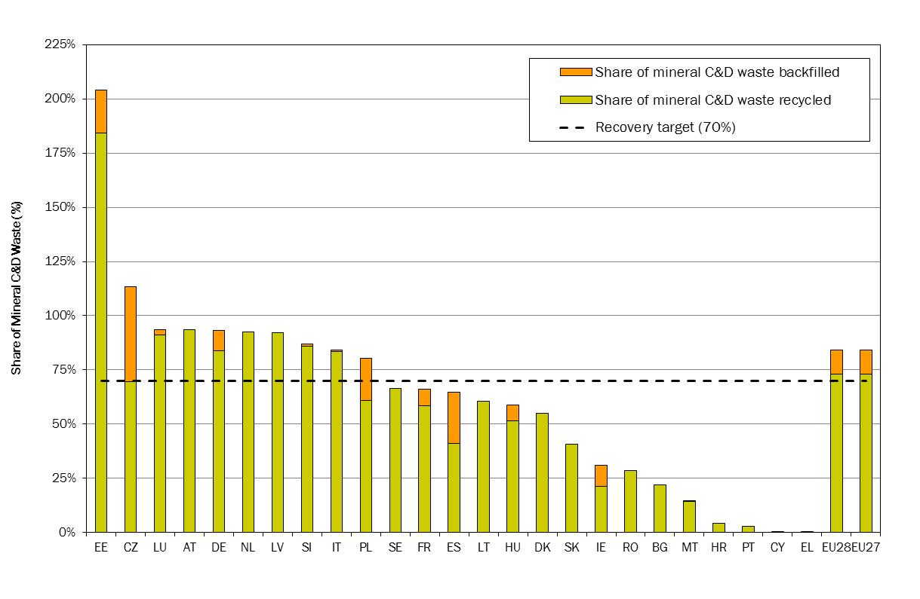
Figure 1: Approximate values for recovery rates for C&D Waste (2010)
- Packaging and packaging waste target
Figure 2 and Error: Reference source not found below summarise the current performances of the MS compared to the PPWD targets. In summary, 21 MS are exceeding the 55% overall recycling target, with most MS well on track to meet the deadlines taking into account the additional time offered to those with derogations. 26 MS have surpassed the targets for paper/cardboard and plastics, 25 MS for wood, 23 MS for metals and 19 MS for glass. In the fitness check it is highlighted that generally speaking higher recycling rates are achieved for commercial and industrial packaging waste with household packaging lagging behind. The performances achieved by the 3 most advanced MS – the ‘top 3’ MS – give an indication of the potential for future progress.

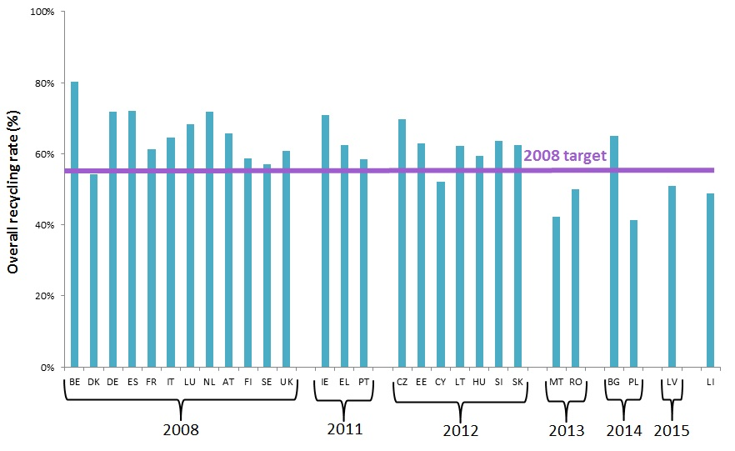
Figure 2: Packaging recycling rates 2011
- Landfill diversion target
Figure 3 and Figure 4 show the compliance status of MS with or without a time derogation period for meeting the landfill diversion target for biodegradable municipal waste. These data indicate that around 23 MS are on track to meet the target on time – i.e. either by 2016, or by 2020 with derogation. For the remaining MS, additional efforts will be necessary. At the other extreme, 6 MS are far beyond the target – landfilling below 5% of their 1995 levels.
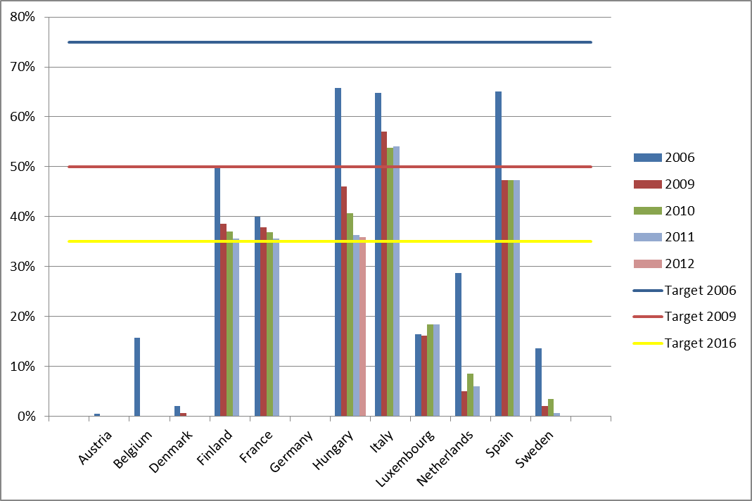
Figure 3: Percentage of biodegradable MSW landfilled compared to 1995
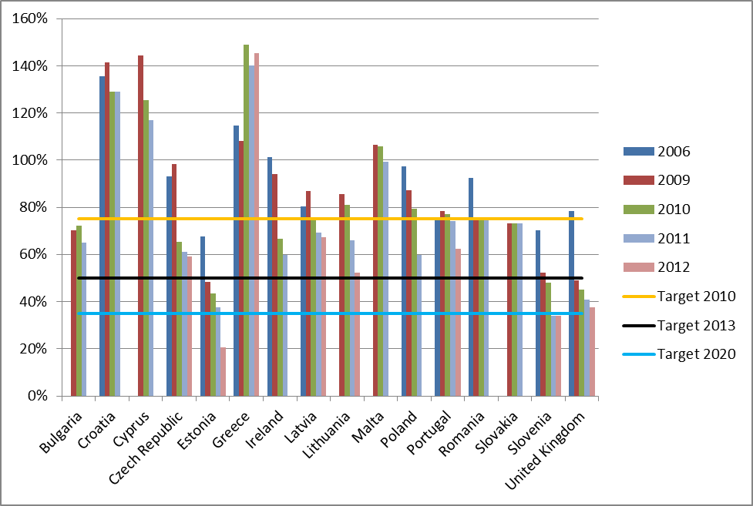
Figure 4: Percentage of biodegradable MSW landfilled vs 1995 - MS with derogations

Annex 6: Main reasons for rejecting some options
During the stakeholder consultation around 60 different pre-defined measures were considered in addition to open questions allowing stakeholders to suggest additional measures that had not already been identified. These measures were scrutinised in detail in light of the above objectives, their appropriateness for implementation in the EU, and the views expressed by stakeholders.
Scope of the target review
Targets for industrial and commercial packaging waste are already included in the EU waste legislation. Their reinforcement is discussed in the IA. These targets might be complemented by options that restrict the landfilling of recyclable waste which would also address industrial and commercial waste insofar as it is currently landfilled. Commercial waste is also partly covered by the targets on municipal waste at least for the smaller retailers covered by municipal collection systems.
Additional targets for industrial, mining and/or commercial waste were considered as ineffective at this stage: it is indeed questionable whether the establishment of general targets is appropriate for those waste streams. Industrial and mining waste is completely different from one sector to another: for instance waste generated by the steel industry, the food industry or the textile industry is of a very different nature and composition. A sector-specific approach appears to be a better option. In addition, the lack of reliable statistics remains a barrier to target-setting. Large scale industrial and mining activities are covered by BAT reference documents (BREF’s) drawn up under the Industrial Emission Directive and the Mining Waste Directive that include information on the prevention of resource use and waste generation, re-use, recycling and recovery. The on-going revision of the BREFs and the adoption of BAT conclusions will strengthen the impact of these BREFs on industrial practices leading to further resource efficiency gains and increased waste recycling and recovery.
Similarly, defining an overall target for hazardous waste seems inappropriate for the same reasons – diversity of nature, composition and origin of this waste. There is already a clear requirement in the WFD – all hazardous waste has to be managed without endangering human health or the environment. Hazardous waste from a range of industry activities is also addressed in BAT conclusions. Moreover, the establishment of recycling targets may not be appropriate as safety considerations should prevail over other policy objectives. In fact, it is difficult to apply the waste hierarchy to the management of hazardous waste since safe disposal can often be the best option available. Similarly on the basis of existing evidence, fixing EU targets for sewage sludge in terms of prevention or recycling/composting seems inappropriate.

Reuse
Reuse may appear as a very attractive option for specific waste streams such as textile, packaging, furniture and electric and electronic waste (however WEEE is not covered by this review exercise). Reuse of textiles and furniture could be encouraged through an increase of the overall municipal waste preparation for re-use and recycling target as it might be accounted for meeting the overall target as it includes preparation for re-use. Re-use should also be encouraged for packaging through an adaptation of the existing recycling target of the PPWD to include preparation for re-use as it is the case for municipal waste. As explained in the fitness check, the environmental benefits of reusable packaging are dependent on a number of factors including transportation distance. Therefore fixing specific legally binding targets for reusable packaging appears to be excessive as local conditions have to be taken into account. As with the waste prevention targets, MS should be encouraged to establish re-use targets in their NPPs and to support the work of third sector organizations in preparing items for reuse. In some MS such as in France, targets for reuse were introduced in the context of EPR schemes for furniture. Nevertheless, defining specific targets for re-use or preparation for re-use has been rejected at this stage mainly for data availability and enforcement reasons: it has been so far extremely difficult to isolate data on reuse or preparation for reuse in the waste statistics.
EPR schemes
Imposing completely harmonized conditions for all EU EPR schemes and/or obliging MS to put in place EPR schemes for specific waste streams is an option to be rejected for several reasons including subsidiarity considerations, but also due to the fact that some flexibility should be left to MS in the practical organization of their EPR systems as long as some minimum essential requirements are defined.
Material based target for municipal waste
Defining material based reuse/recycling targets for municipal waste seems to be unnecessary and should be rejected as meeting ambitious recycling targets for municipal waste will imply that the majority of potentially recyclable materials – whether from the dry - plastics, glass, metals, paper, textile, etc - or the wet - food and garden waste - fraction of municipal waste would have been separately collected and recycled. It could, though, contribute to higher recycling rates of Critical Raw Materials – particularly when electric and electronic waste equipment (WEEE) are concerned. However, the scope of the present target review does not include the WEEE Directive. Furthermore, imposing additional material-based targets and the related reporting obligation on the MS appears to be disproportionate while limiting the flexibility which should be left to the MS to ensure that local conditions and specific waste composition are taken into account when planning separate collection actions. This conclusion also applies to specific targets for instance for textile or biowaste even if these options were identified as attractive by some stakeholder during the consultation.
Maximum targets for incineration
Increasing the minimum recycling/reuse rate to around 70% in the medium term implies de facto that incineration will be limited to a maximum of 30% of waste generated which would broadly corresponds to the concept ‘not recyclable’ waste on the basis of the experience of the most advanced MS/regions. Therefore the option of defining a maximum target for incineration appears to have a very limited added value and should therefore be rejected, notably to keep the legislation as simple as possible.

Annex 7 : Summary of MS reporting obligations

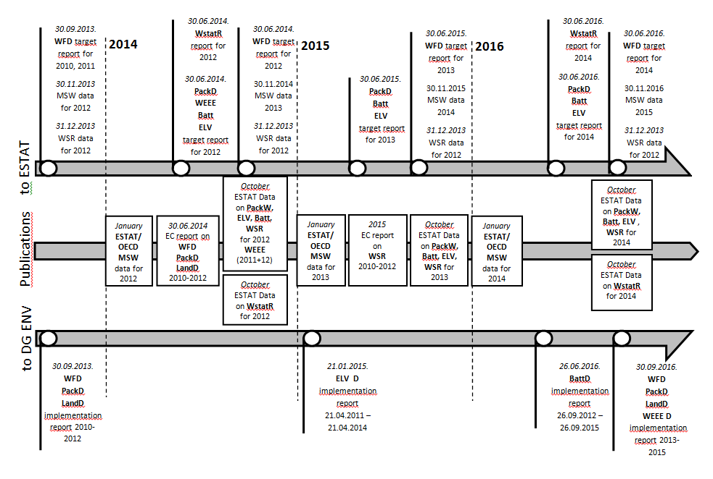
Figure 5: Summary of MS reporting obligations on a 3 year period

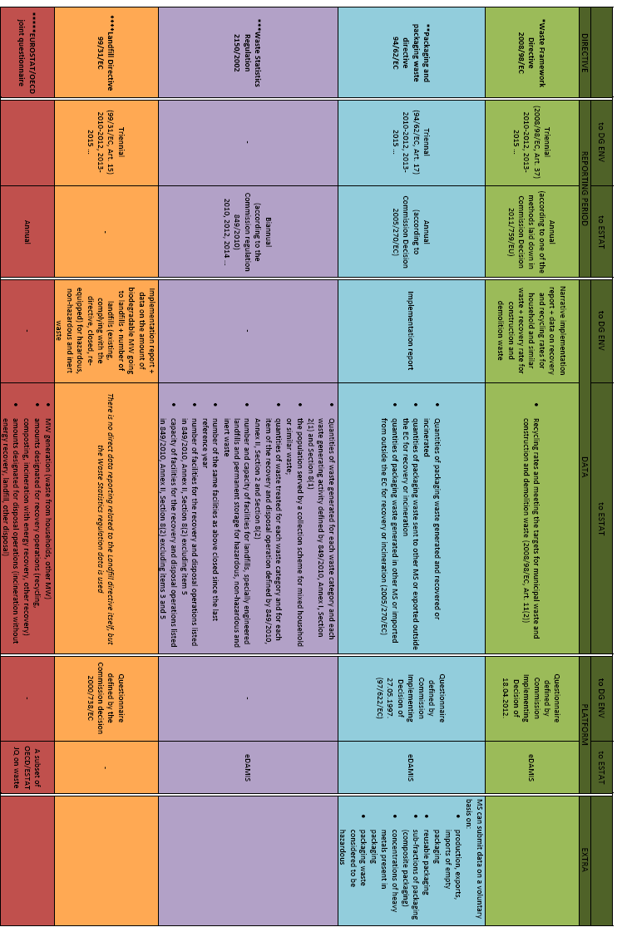

Annex 8: Overview of the European Reference Model

(Separate document)

Annex 9: Overview of the Marine Litter module of the European Reference Model
General Methodology
The marine environment works as a sink in which marine litter accumulates. It is very difficult to remediate accumulated old marine litter, especially when fragmented into e.g. micro-plastics. The most cost-effective way to tackle the problem is to prevent new litter from reaching the marine environment.
Recent technical guidance drawn up by the Technical Group on marine litter in the context of the Marine Strategy Framework Directive, and endorsed by Member States’ Marine Directors on 5 December 2013, identifies beach litter, sea floor litter, floating litter, litter in biota and micro-litter as relevant indicators. For the purposes of this modelling exercise, beach litter is used as a proxy for marine litter, as most data are available for this type of litter, and because beach litter represents a large proportion of new litter arriving in the marine environment.
For all scenarios a similar approach is used:
- First, future waste generation is assessed, using data on actual generation and on decoupling. Time horizons to 2020 and 2030 are considered.
- Secondly, the number and type of marine litter items found in 2020 and 2030 are projected, if 1000 are found in 2015, in option 1 (business as usual, no policy change).
- Thirdly, the reduction impact of a given policy scenario on each litter type is assessed. Recycled waste does not contribute to marine litter. Increased recycling reduces marine litter at source.
- For each option, the reduced number of items was calculated and compared to the number of items under the BAU (no policy change) and full implementation scenarios.
- The figure below illustrates the anticipated decrease from option 3.4, to the 2030 time horizon. The black figure represents the number of items in the BAU scenario. The red figure represents the diminished number of items in the selected option. In the case of overlapping targets (e.g. MSW and packaging waste), the target with the largest reduction impact is considered definitive.

No Policy Changes
In this case, recycling performance and levels of landfilling remain unaltered. We project levels of future waste generation and assume marine litter is correlated in a linear way to it. We assume that litter source is divided as follows between items of consumer origin and those of industrial origin. We know the balance between consumer and industrial for those items where the distinction could easily be observed. We recalculate the number of items where the origin is unclear or unknown using the same proportions:
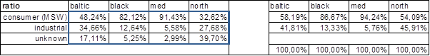
Coastlines are assessed as follows:
 | 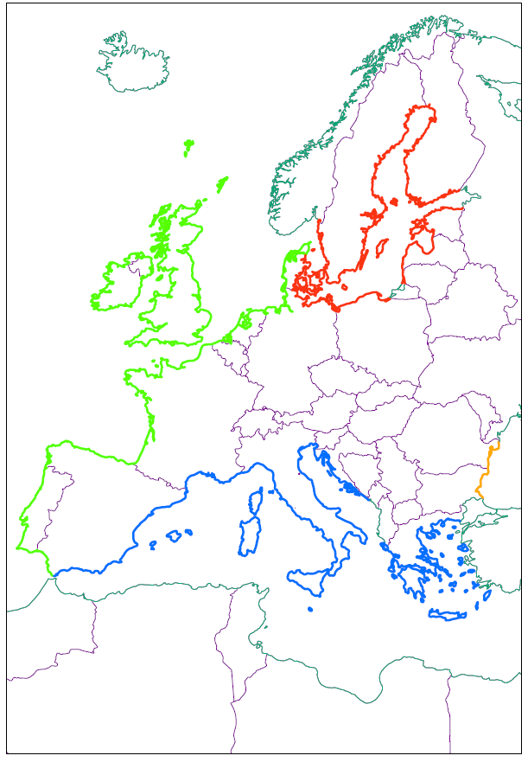
   | Km | Share of coastline
  Baltic Sea | 13.456 | 27%
  Mediterranean Sea | 16.628 | 33%
  North East Atlantic | 19.885 | 39%
  Black Sea | 631 | 1%
  Total coast line | 50.600 | 100%

Only coastlines of countries within the EU territory are included, since the reduction target only focuses on measures for reducing marine litter within the EU and since the detailed analysis of the surveys proves that the on-site generation/disposal of litter on beaches or its transportation over relatively short distances prevails. Beach litter originates from land-based activities for between 53% (North Sea) and 93% (Black Sea) of items while between 2% (Black sea) and 27% (North Sea) of beach litter items are likely to be transported over a long distances.
Taking into account the EU-beach length for each of the regional seas, we assess the distribution between industrial and consumer for the whole of the EU as: 68% consumer origin, 32% industrial origin.
For 1000 marine litter items found in 2015, we calculate that 104 items may be found in 2020 under a business as usual scenario, and thus that marine litter inflow will increase by 4,4%.

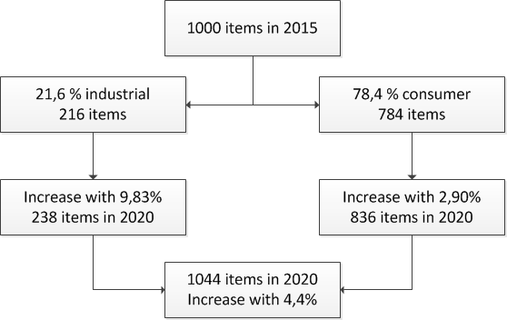

Conclusion: with no policy change new marine litter inflow tends to increase by 4.4% in 2020 compared to 2015. It would increase by 12.3% by 2030.

Option 1: Full implementation of existing legislation
In this option we assume that all Member States comply with existing targets.
For consumer waste (MSW), we assess the degree to which complying with the current legislation leads to a reduction in the potential source of marine litter (i.e. the non-recycled fraction). We apply the MSW recycling targets to the total number of items, and apply the packaging recycling targets to the MSW packaging items specifically. These targets are partially overlapping, and both must be met; we thus take into account the outcome effecting the highest reduction.
In general, we apply full compliance with packaging recycling targets (but nothing more). However in some cases, these performance levels have already been surpassed. In such cases, we assume that the higher recycling percentages will not decrease.
For litter from industrial sources (i.e. other than MSW), we assess the effect of the targets on the industrial packaging fraction.
We calculate the ‘business as usual’ number of marine litter items in 2020 and 2030, assuming that in 2015 there are 1000 items. We subtract from this figure the effects of targets leading to a reduction of the litter source, as calculated above, and we assess the possible marine litter reduction in the full implementation option.
Conclusion: under option 1 (full implementation of existing legislation), new marine litter inflow tends to decrease by 4.6% in 2020 compared to 2015. It would increase by 2.9% in 2030 without further policy action.

Option 3.1: 70% recycling by 2030
In this scenario we apply a 70% overall recycling rate for municipal waste, with reassessed recycling performances for the different MSW fractions.
Since no change to the target is proposed for 2020, at the time horizon to 2020, this scenario is exactly the same as option 1 (full implementation). However, the impact of a 70% recycling target by 2030 is significant, especially given the anticipated growth in waste generation (and thus marine litter) without additional measures and the effect of allowing only one measurement method for the WFD. This option sees new marine litter inflows which are 10% lower than those projected by the full implementation of existing legislation only.
Conclusion: under option 3.1 (70% recycling by 2030), new marine litter inflow tends to be 10% lower in 2030 than under the full implementation scenario.

Option 3.2: modernised packaging waste targets
Packaging waste targets are as in Error: Reference source not found in the main body of this Impact Assessment.
As no detailed data on metal marine litter is available from the OSPAR screenings, we assume the same ratio between steel packaging and aluminium packaging for marine litter as is the case for general waste statistics: an average of 15% aluminium and 85% steel packaging, based upon EUROSTAT data. The increased recycling targets for material streams which frequently end up as marine litter have a significant reduction impact at both the 2020 and 2030 timescales.
Conclusion: under option 3.2 (increased packaging waste targets), new marine litter inflow tends to decrease by 12% by 2020 and by 21% by 2030 when compared to the full implementation scenario.

Option 3.3 limiting landfilling to residual waste
Waste generation, the ratios of municipal/industrial, MSW and packaging waste recycling targets are the same as in the single measurement option.
Legal landfill is already a relatively minor source for marine litter:
 | Baltic sea | Black sea | Mediterranean | North sea
Landfills and dumpsites as a ML source | 0,94% | 3,88% | 0,14% | 1,09%
On average, taking into account the coastal length of each sea, the probability for marine litter inflow to originate from landfills and dumpsites (e.g. landfill escapes) is 0,68% of all litter inflow. The introduction of landfill bans is thus of modest impact. This does not take account of escapes from illegal landfills, which goes beyond the scope of this Impact Assessment.

Conclusion: option 3.3 (limiting landfilling) is of negligible impact on new marine litter inflow at both 2020 and 2030 time horizons.

Option 3.4: combining options 3.1, 3.2 and 3.3
The highest parameter values for the options 3.1, 32 and 3.3 are combined. The combined impact is significant in that projected new marine litter inflows are found to be 13% lower (by 2020) and 27,5% lower (by 2030) than those projected by the full implementation of existing legislation only.

Conclusion: under the option 3.4 new marine litter inflow tends to decrease by 13% by 2020 and 27,5% by 2030 when compared to the full implementation scenario.

Costs related to marine litter

This section provides an assessment of the costs associated with the current degradation of the marine environment, using a cost-based approach. Unit costs from literature have been extrapolated to the EU level on a sectoral basis.

Coastal and beach cleaning
Cleaning costs highlighted in existing literature are highlighted below:

Beach type | Cost per km (€) | year data | Location | Sea
Bathing | 34.450 | 2010 | Touristic beaches Netherlands & Belgium,10 municipalities | NS
 | 28.320 | 2010 | Touristic beaches; Netherlands, 6 municipalities | NS
 | 38.190 | 2010 | Spain: bathing beach | MED
 | 31.796 | 2010 | Portugal: bathing beach | ATL
Non-bathing | 214 | 2010 | Sweden, non-bathing beach | BAL
 | 372 | 2010 | Denmark, non-bathing beach | NS
Bathing & non-bathing | 7.150 | 2010 | UK, cleaning including beaches less intensively used by tourists | NS
 | 3.750 | 2012 | Latvia (Riga) bathing & non-bathing beach | BAL
 | 11.000 | 2007 | NL: average total coast length | NS
 | 8.278 | 2010 | Portugal: bathing & non bathing beach | ATL
Beach cleaning costs, per beach type (source Mouat, 2010; Arcadis, 2013 ; Reinhard et al, 2012)

The table highlights large differences in cleaning costs between bathing and non-bathing beaches. One of factors influences the frequency of cleaning is the intensity of beach use. Designated bathing beaches and the coast around the area must be cleaned regularly, in particular between Easter and September. Cleaning of non-bathing beaches is less frequent. In addition, soil type is a factor affecting cost. Sandy beaches can be mechanically cleaned, which is less costly, but this is not possible in coastal areas with rocky beaches.

No data is available on the breakdown throughout the EU of bathing and non-bathing coastal areas. However, based on the results outlined in Error: Reference source not found which covered to differing extents both bathing and non-bathing areas, a minimum, maximum and average cleaning cost have been calculated. All data have been converted to 2013 prices.

 | cost per km (€) | length of EU coastline (km) | cost in the EU (m€)
Average | 8.171 | 50.600 | 413,47
Minimum | 3.828 | 50.600 | 193,70
Maximum | 12.446 | 50.600 | 629,78

The estimates of cost to the tourism and recreation sector (in average €m per year) are extrapolated from individual figures of beach cleaning activities and therefore are subject to a high degree of uncertainty.

Fishing sector
The total costs of marine litter related incidents for EU fisheries are estimated using the average costs of marine litter per vessel in the Scottish fleet, analysed by Fanshawe (2002), Mouat et al (2010) and KIMO (2010). In the UK Cost Benefit Analysis for the MSFD (Cefas; 2012), average costs of litter to the fishery sector have been disaggregated into two categories. This is due to the different economic costs of marine litter impacts associated with different fishing methods.
- Incidents due to dumped catch, repairs to fishing gears and reduced fishing time by clearing nets are mainly applicable to those fisheries that have contact with the seabed.
- Incidents due to fouling are more likely to be due to litter in the water column and can therefore affect any type of fishing vessel.
These estimates should be interpreted with caution due the different probability of incidence with marine litter across the EU fleet. These estimates are based on best available evidence and some broad assumptions (simple extrapolation of Scottish North Sea data).

Costs related to marine litter on the sea bottom
Costs to the EU fishing fleet (trawlers) associated with litter incidents that involve dumping catch, repairing fishing gear and lost earnings as a result of reduced fishing time are estimated at 40,4 m€ per annum. The total cost has been estimated based on the average costs per vessel for this category damage, multiplied by the number of active EU vessels that use seafloor fishing gear.

Cost of reduced catch revenue
cost per vessel (€) | # trawlers in  the EU | cost for the EU (m€)
2.340 | 12.238 | 28,64

Cost of removing litter from fishing gear
cost per vessel (€) | # trawlers in  the EU | cost for the EU (m€)
959 | 12.238 | 11,74

Costs related to marine litter in the water column:
Costs to the total EU fishing fleet associated with litter incidents that involve fouling (e.g. of propellers) are estimated at between 16,8m€ per annum. The expenses of the EU fishing fleet on these kind of incidents are calculated by multiplying the average vessel costs with the number of active EU fishing vessels.
Cost of broken gear, fouled propellors
 |  | cost per vessel (€) | # fishing vessels in the EU | cost for the EU (m€)
 |  | 191 | 87 667 | 16,79

Cost to the fishing industry amounts to a total of 57,2 m€, using the cost-based approach outlined above. These estimated costs generated by marine litter are equivalent to a reduction of nearly 1% of the total revenues that are generated by the EU fleet in 2010 (landed value of 6600 m€).

Shipping sector
Marine litter also poses a navigational hazard to vessels in general. Incidents involving vessel damage caused by marine litter are widespread with over 70% of UK harbours and marinas reporting that their users had experienced incidents involving marine litter. Costs of rescue operations involving the coastguard to vessels with fouled propellers in UK waters reached between €830.000 and €2.189.000 in 2008 (Mouat et al; 2010). The most frequently reported cause of fouled propellers was derelict fishing gear. However, no unit costs per ship could be deducted from literature. Several sources only give anecdotal evidence of the dangers of blocked propellers and other gear. Thus, such costs are not accounted for in this model.

Total sectoral results
The total quantified cost of degradation, taking together the cost of beach cleaning and damage to fishing gear and vessels is estimated to be between 250,9 m€ and 687 m€. The ‘best estimate’ within this range is 469 m€. Assuming marine litter inflow growth of 2.9% to 2030 under the full implementation scenario, and a linear relationship between marine litter and costs, projected marine litter-related costs are 483 m€ in 2030 (2013 prices). This is compared with the projected 27,5% decrease of marine litter inflows (and associated costs) under scenario 3.4, whereby costs would fall to 340 m€ (2013 prices). This implies a total saving of 143 m€ in marine-litter related costs by 2030.

This is, however, a conservative estimate as it has not been possible to quantify impacts to all sectors and activities, including voluntary beach cleaning, cleaning of harbours and marinas, damage to non-fishing vessels, rescue call-out costs related to vessels damaged by marine litter or the cost of any health impacts from marine litter. In addition, the ecological value not directly related to money transfers, are not taken into account quantitatively.

Annex 10: Summary of the main Model uncertainties
Collection
The model has, necessarily, to simplify somewhat the complexity of the situation which actually exists in MS. In each country, there are, and are likely to be in future, a range of different collection systems in place. The model simplifies reality by modelling a narrow range of systems. However, although the range is narrowed, the general tendencies are expected to be a reasonable reflection of the relative costs of systems delivering varying recycling rates.
The model makes assumptions which determine the number of households which can be served by a given vehicle. These are likely to vary from place to place. The model seeks to deal with this through setting different parameters for urban, suburban and rural households.
The costs are modelled in real terms. They are essentially deemed to remain constant across time in real terms. The time horizon for the assessment is, however, considerable. Over such a period, the index of some input parameters to the collection model, such as labour costs, might not be the same as the general rate of price increases. As such, the costs might not remain constant in real terms over the time period considered. This is, however, believed to be the most reasonable assumption to make in the circumstances (projecting, for example, the rate of increase in real wages would appear to be rather speculative);
The value of materials being captured for recycling is deemed to remain constant in real terms. Following a period in history (roughly spanning the period 1950-2000) over which real prices for commodities have experienced a secular decline, the last decade has seen that secular decline completely reversed owing to increased global demand, notably from China. Many commentators believe prices may continue to rise in real terms, but there are, equally reasons why prices, not least in real terms, may decline. As such, the assumption regarding constant prices in real terms seems reasonable.
For each country, where municipal waste is concerned, the model uses data from MS regarding the composition of their municipal waste. The composition data is of variable quality. Because of the variation in composition from one country to another, the revenue generated from the capture of recyclables varies across countries (affecting net costs).
Quite apart from current waste composition, the modelling effectively has to consider waste composition over the period to 2030-2035. Relatively little is known about exactly how waste composition will change in future. What seems certain, however, is that it will change. It is to be hoped that those changes that do occur will increase the extent to which materials can be easily recycled. What cannot be known, however, is how such changes will affect the costs of collecting and processing materials, and the revenues generated from selling the materials collected. The assumption of constant composition is on the one hand unlikely to reflect reality, but on the other, it is felt that no reasonable alternative assumption exists.
Treatment
The costs of treatment are assumed to remain constant in real terms. For some treatments, as well as taking into account the sale of some materials (see above) the net costs take into account the sales of energy. The revenue derived from the sales of energy are assumed to be constant in real terms. This implies constant real terms prices for energy. Energy prices could, of course, follow a different path;
The costs are influenced by assumptions regarding capital costs, assumed to be constant across countries, and the costs of other inputs to the process. Labour costs have been adapted to MS labour costs. There is variation in unit capital costs of facilities, but the model assumes a single figure for a given treatment type. This seems reasonable given that the high level, strategic nature of the model means that assumptions regarding the size of specific facilities cannot meaningfully be made;
The way in which capital costs are financed will affect the costs for different facilities. In different MS, there are different patterns of financing and ownership of waste management facilities. Some facilities are funded from savings made by municipalities, others are financed using public/private partnerships. These situations lead to a variety in the costs of capital, and this affects the costs of operating facilities. The model effectively assumes a single figure for the real costs of capital.
Externalities
The overall figures for externalities reflect the inclusion and exclusion of various effects in the model. Main externalities of well operated facilities are captured by the model, but even so, some externalities are not captured by the model (see Annex 6).
The model assumes different damage costs for the air pollutants with these adapted for each Member State. These are based on the best evidence available, but clearly, uncertainties exist;
The model assumes a profile for the damages associated with GHG emissions. The debate concerning how best to value damages associated with GHGs continues apace. There are clearly alternative assumptions that could be made in this regard;
Some characteristics of key processes influence emissions, and hence, externalities. Key amongst these are:
- The modelling of the extent to which biodegradable material degrades in landfill;
- The capture of methane generated by landfills for energy generation and flaring (and crucially, the amount of methane escaping to the atmosphere);
- For technologies generating energy, such as incineration, the nature of the energy source which is assumed to be avoided, at the margin, when new facilities are introduced;
- The modelled GHG emissions from facilities relate back to waste composition. If composition is not well known, then the emissions will be similarly poorly understood (and as noted above, composition is likely to change in future).

Annex 11: Comparison of the main definitions used in the EU waste legislation
Definitions | Waste Framework Directive (WFD) | Packaging and Packaging waste Directive (PPWD) | Landfill Directive | Waste Statistic Regulation (Wstat R)
Prevention | Measures taken before a substance, material or product has become waste, that reduce: (a) the quantity of waste, including through the re-use of products or the extension of the life span of products; (b) the adverse impacts of the generated waste on the environment and human health; or (c) the content of harmful substances in materials and products | The reduction of the quantity and of the harmfulness for the environment of materials and substances contained in packaging and packaging waste, packaging and packaging waste at production process level and at the marketing, distribution, utilization and elimination stages, in particular by developing ‘clean’products and technology
Reuse | Any operation by which products or components that are not waste are used again for the same purpose for which they were conceived  Preparing for reuse: Checking, cleaning or repairing recovery operations, by which products or components of products that have become waste are prepared so that they can be re-used without any other pre-processing | Any operation by which packaging, which has been conceived and designed to accomplish within its life cycle a minimum number of trips or rotations, is refilled or used for the same purpose for which it was conceived, with or without the support of auxiliary products present on the market enabling the packaging to be refilled; such reused packaging will become packaging waste when no longer subject to reuse
Recycling | Any recovery operation by which waste materials are reprocessed into products, materials or substances whether for the original or other purposes. It includes the reprocessing of organic material but does not include energy recovery and the reprocessing into materials that are to be used as fuels or for backfilling operations | The reprocessing in a production process of the waste materials for the original purpose of for other purposes including organic recycling but excluding energy recovery  Organic recycling: Aerobic (composting) or anaerobic (biomethanization) treatment, under controlled conditions and using micro-organisms, of the biodegradable parts of packaging waste, which produces stabilised organic residues or methane |  | Same as PPWD  Reporting is done on aggregation of the R-codes listed in Annex II to the WFD. It is not always clear which of these R – codes refer to recycling, or recovery
Recovery | Any operation the principal result of which is waste serving a useful purpose by replacing other materials which would otherwise have been used to fulfil a particular function, or waste being prepared to fulfil that function, in the plant or in the wider economy. Annex II sets out a non-exhaustive list of recovery operations | Same as WFD  Energy recovery: Use of combustible packaging waste as a means to generate energy through direct incineration with or without other waste but with recovery of the heat |  | Same as WFD  The reporting is linked to the recovery codes listed in Annex II to the WFD, it is not always clear which of these R – codes refer to recycling, or recovery
Municipal waste | (not a definition as such in the Directive) Waste collected from private households, including where such collection also covers such waste from other producers |  | Waste from households as well as other waste which, because of its nature or composition is similar to waste from household
Disposal | Any operation which is not recovery even where the operation has as a secondary consequence the reclamation of substances or energy. Annex I sets out a non-exhaustive list of disposal operations; | Same as in the WFD | Landfill: a waste disposal site for the deposit of the waste onto or into land (i.e. underground) | Same as WFD and Landfill Directive (for Landfills)  Reporting is done on aggregations of the D-codes listed in Annex I to the WFD
Biowaste | Biodegradable garden and park waste, food and kitchen waste from households, restaurants, caterers and retail premises and comparable waste from food processing plants |  | Biodegradable waste: Any waste that is capable of undergoing anaerobic or aerobic decomposition, such as food and garden waste, and paper and paperboard
Treatment | Recovery or disposal operations, including preparation prior to recovery or disposal |  | Physical, thermal, chemical or biological processes, including sorting, that change the characteristics of the waste in order to reduce its volume or hazardous nature, facilitate its handling or enhance recovery | Reporting is done on aggregates of the R and D codes of the WFD

http://www.wastemodel.eu/ and http://www.wastetargetsreview.eu/
Full details of the conference, including the conclusions, are available at: http://www.marine-litter-conference-berlin.info/
http://www.europarl.europa.eu/plenary/en/texts-adopted.html
The questionnaire and the results from the consultation are available from the following link: http://www.wastetargetsreview.eu/section.php/4/1/consultation
Results from the consultation on the Green paper are available from the following link: http://ec.europa.eu/environment/consultations/plastic_waste_en.htm
Results from the consultation on marine litter will be made available from the following link: http://ec.europa.eu/environment/consultations/marine_litter_en.htm
Reference 7 in Annex 2
Reference 1 in Annex 2
Data above 100% for EE and CZ seems to be linked with differences between reporting times between C/D waste generated and treated (storage) and imports of mineral waste treated in EE and CZ
Source: Eurostat 2013
Extracted from the EEA report, reference 7 in Annex 2, updated in 2014. 2010 and/or 2011data are estimated for FR, IT, LU, NL, SE, HR and RO. 2009 data are estimated for BG, PL and PT. 2009 data were used for 2010 and 2011 for SP and SK
2015 is used as the baseline, as it will be the first full year for which Member State data on the presence of beach litter will be available under the monitoring programmes foreseen under Article 11 of the Marine Strategy Framework Directive (Directive 2008/56/EC).
NS: North Sea; MED: Mediterranean Sea; BAL: Baltic Sea; ATL: Atlantic Ocean;
Reinhard et al (2012) assumes that the Dutch bathing beaches are cleaned 120 times a year.
The data from the Latvian study converted to 2013 prices.
The data from the Dutch study converted to 2013 prices.
GBP cost data have been converted using the exchange rate Euro 1 = 0,839 GBD (dec 2013).
According to the Community Fishing Fleet Register (http://ec.europa.eu/fisheries/fleet/) 12.238 trawlers (category “towed Gears”) are currently in use (2013).
Losses are reported to amount €2.200/year/vessel, in 2010 prices (Mouat et al; 2010), corrected to €2340 in 2013 prices.
http://ec.europa.eu/fisheries/fleet
Vessels surveyed by KIMO (2010) spend an average of 41 hours a year removing marine litter from fishing gear. This is multiplied by an average EU27 labour cost of 23,4€ per hour. (see : http://epp.eurostat.ec.europa.eu/statistics_explained/index.php/Hourly_labour_costs).
87.667 fishing vessels according to the EC - Fleet Register on the Net (2013) http://ec.europa.eu/fisheries/fleet/index.cfm?method=Search.ListSearchSimple
In Mouat et al. (2010), the damage due to litter is budgeted at €180/year/vessel, based on data of Scottish fishing vessels (191 € actualized to 2013 prices).
According to Member States DCF data submissions, the total amount of income generated by the EU fishing fleet in 2010 (excluding Greece) was €7 billion. This amount consisted of €6,6 billion in fish sales, €34 million in fishing rights rental income, €193 million in non‐fishing income, and €126 million in direct income subsidies (JRC; 2012).
The economic study of Hall (2000) mentions “costly repairs, loss of time and danger to boaters and crews”, but without exact calculations as most incidents are not reported.

