Annex 4 – Detailed Results of the Consultation on the Review of European Waste Management Targets

Contents
1.0 Introduction 4
2.0 Analysis of Results 5
2.1 Stakeholder Groups 5
2.2 Analysis of Closed-ended Questions 6
2.3 Analysis of Open-ended Questions 6
3.0 Response Rates and Country Profiles 8
4.0 Waste Framework Directive 12
4.1 Key Issues 12
4.2 Suggestions for Revision 13
5.0 Landfill Directive 24
5.1 Key Issues 24
5.2 Suggestions for Revision 24
6.0 Packaging and Packaging Waste Directive Error! Bookmark not defined.
6.1 Key Issues Error! Bookmark not defined.
6.2 Suggestions for Revision Error! Bookmark not defined.
7.0 Roadmap to a Resource Efficient Europe Error! Bookmark not defined.
7.1 Waste Prevention Error! Bookmark not defined.
7.2 Preparation for Reuse Error! Bookmark not defined.
7.3 Recycling Rates Error! Bookmark not defined.
7.4 Limiting Incineration of Waste Which Might Otherwise be Recycled Error! Bookmark not defined.
7.5 Landfill Error! Bookmark not defined.
8.0 Targets as a Tool in Waste Legislation Error! Bookmark not defined.
9.0 Citizen Consultation Error! Bookmark not defined.

Introduction
The Targets Review Project has been commissioned by DG Environment at the European Commission. The project is aimed at identifying the issues and proposing possible solutions to the targets in the Waste Framework Directive, the Landfill Directive and the Packaging and Packaging Waste Directive. The basis for the review of the targets is twofold: on the one hand it is to respond to the review clauses set out in the Directives and, on the other, to bring these targets in line with the Commission’s ambitions of promoting resource efficiency and reducing greenhouse gas emissions.
This project is being delivered by Eunomia Research & Consulting (Eunomia) with support from Öko-Institut, the Copenhagen Resource Institute (CRI), ARGUS, and Satsuma Media. It is being delivered under Eunomia’s contract with the European Commission on “Technological, Socio-Economic and Cost-Benefit Assessments Related to the Implementation and Further Development of EU Waste Legislation”.
This document presents the results of the consultation on the Review of European Waste Management Targets which was held between the 4th June and 9th September 2013. Responses to each of the questions have been analysed and have been broken down according to the different stakeholder groups. The methodological approach to the data analysis is summarised in Section 2.0. This is followed by a summary of the response rates to each section of the consultation in Section 3.0. Finally, the results are presented in Section 4.0 to Section Error! Reference source not found., each of which deals with a different section of the consultation:
- Section 4.0 – Waste Framework Directive;
- Section 5.0 – Landfill Directive;
- Section Error! Reference source not found. – Packaging and Packaging Waste Directive;
- Section Error! Reference source not found. – Roadmap to a Resource Efficient Europe;
- Section Error! Reference source not found. – Targets as a Tool in Waste Legislation; and
- Section Error! Reference source not found. – Consultation questions for European Citizens.
It is important to note that this report does not provide an analysis of the options which will be carried forward for detailed analysis as part of the Commission’s impact assessment. This work is being carried out in parallel to this and will be published in the near future.

Analysis of Results
The consultation questions were subdivided into the following seven sections (the full consultation can be found in Appendix A1.0):
- General questions;
- Waste Framework Directive;
- Landfill Directive;
- Packaging and Packaging Waste Directive;
- Roadmap to a Resource Efficient Europe;
- Targets as a tool in waste legislation; and
- Consultation for European citizens.
The majority of the questions within each section were voluntary and therefore respondents could choose to respond or not, depending on whether they had an opinion on a particular subject. The consultation included a number of closed- and open-ended questions to which stakeholders could respond to. The closed-ended questions were straightforward to analyse as the statistics are clearly presented in numerical form. In contrast, the analysis of the open-ended questions required significantly more effort. These questions were analysed by reading each of the responses and coding the key themes that emerged from these answers. Each time a new theme emerged it was added to the list. If themes emerged a number of times, as they frequently did, these were coded accordingly. We describe below how the different aspects of the consultation were analysed.

Stakeholder Groups
The consultation questions were developed in close association with the Commission who provided the final sign off of the document before it was published in the Commission’s Interactive Policy Making (IPM) tool. The consultation sought to elicit views from the following stakeholder groups:
- Industry, not-for-profit, and academic organisations:
- Industry trade bodies/organisations;
- Industry representatives;
- Not-for-profit/non-governmental organisations;
- Academic institutions; and
- Other organisations.
- Public authorities (e.g. Member States, regional or local competent authorities); and
- European Citizens.
In most cases the results of the consultation have been divided up to show the views of the different groups of stakeholders. This is of particular importance when considering the proposed suggestions for revising the targets as different stakeholders typically have alternative, and often conflicting views, of what the best approach will be.

Analysis of Closed-ended Questions
In order to facilitate analysis the consultation contained a number of closed-ended questions. Closed-ended questions were used to allow respondents to rank various options as part of a ‘matrix’ or choose alternative answers from a finite list of options. Some of the most important questions in the consultation consisted of the ‘matrix’ style questions in which respondents were asked to rank various – on a scale of 1 to 5 – options which were put forward as suggestions for revising the existing Directive targets. There are many ways in which these data can be analysed in order to determine which the most preferred options are. As part of the analyses which have been presented in this report we have chosen two alternative methods for depicting these results:
- In order to enable the overall rank of each option to be compared we calculated the weighted average rank for all options presented in each ‘matrix’; and
- In order to ascertain the strength of the preference for or against certain options we also present the results of the difference between the number of respondents who ranked an option as 5 (i.e. very favourably) against the number who ranked it as 1 (i.e. an option not worth considering). The difference between the number of upper and lower rank responses provides a clearer means for illustrating strong differences in opinion, something which is not always clearly illustrated through a weighted average. In these figures the most favoured options are shown by a large number and options which were strongly disliked have low or even negative rankings.
It is believed that together these two sets of analyses provide a clear indication of which options may or may not be preferred (assuming there is a spread of opinion across options). Analysis of the remaining closed-ended questions was straight forward and, as shown in the results sections below, consisted of providing weighted averages and averages for different responses.

Analysis of Open-ended Questions
The majority of open ended questions in the consultation asked respondents to list additional issues and solutions which had not already been identified in the consultation. In a number of instances it was found that people had reiterated, albeit in different words, issues and/or solutions which had already been identified. In these instances responses were coded as ‘Issue/solution already listed’. When asked to identify additional issues a number of respondents offered solutions instead of presenting issues specifically related to the targets. To prevent these solutions from being lost, these responses were added to the questions which asked whether any additional solutions could be suggested. These responses were coded as ‘Response is a solution, not an issue’. Likewise, in cases where respondents were asked to propose additional solutions, but instead raised concerns about issues, the responses were coded as ‘Response is an issue, not a solution’. Finally, in a number of cases stakeholders identified issues and solutions which were not related to the scope of work being undertaken as part of the Review of Targets Project. These responses were coded as being ‘non-target issues/solutions’.
All other responses were coded with the intention of identifying common themes. For each open-ended question, lists of coded responses were created based on the answers that were received.

Response Rates and Country Profiles
A total of 670 responses were received from various stakeholders across Europe. The number of responses from different groups of stakeholder can be seen in Table 3-1. This table also provides details on how many stakeholders from each group responded to the different sections of the consultation. For example, 136 industry trade bodies responded to the consultation, with 122 of these respondents choosing to answer questions under the Waste Framework Directive section of the consultation.
Table 3-1: Response Rates Broken Down by Stakeholder and Consultation Section
Consultation Section |  | All Stakeholders | Stakeholder Group
 |  | All Stakeholders | Industry Trade Bodies | Industry Representatives | Not-for-Profit Organisations | Academic Institutions | Other Organisations | Public Authorities | European Citizens
Total Number of Responses | No. | 670 | 136 | 80 | 54 | 6 | 20 | 49 | 325
Total Number of Responses | % | 100% | 100% | 100% | 100% | 100% | 100% | 100% | 100%
Waste Framework Directive | No. | 371 | 122 | 73 | 50 | 5 | 18 | 47 | 56
Waste Framework Directive | % | 80% | 90% | 91% | 93% | 83% | 90% | 96% | 48%
Landfill Directive | No. | 313 | 102 | 57 | 42 | 3 | 16 | 47 | 46
Landfill Directive | % | 68% | 75% | 71% | 78% | 50% | 80% | 96% | 39%
Packaging Waste Directive | No. | 368 | 101 | 63 | 50 | 5 | 19 | 46 | 84
Packaging Waste Directive | % | 80% | 74% | 79% | 93% | 83% | 95% | 94% | 72%
Roadmap Section | No. | 462 | 136 | 80 | 54 | 6 | 20 | 49 | 117
Roadmap Section | % | 69% | 100% | 100% | 100% | 100% | 100% | 100% | 36%
Targets as a Tool in Waste Legislation | No. | 394 | 116 | 61 | 48 | 3 | 18 | 41 | 107
Targets as a Tool in Waste Legislation | % | 85% | 85% | 76% | 89% | 50% | 90% | 84% | 91%
Citizen Consultation | No. | 278 | - | - | - | - | - | - | 278
Citizen Consultation | % | 86% | - | - | - | - | - | - | 86%
Note: All percentages are given relative to the total number of responses received from each stakeholder group.
Each group of stakeholders was asked to identify which country they were based in and the results of this are summarised in Table 3-2.
Table 3-2: Distribution of Countries in which Stakeholders are Based1
Country | Stakeholder Group
Country | Industry Trade Bodies |  | Industry Representatives |  | Not-for-Profit Organisations |  | Academic Institutions |  | Other Organisations |  | Public Authorities |  | European Citizens
Country | No. | % | No. | % | No. | % | No. | % | No. | % | No. | % | No. | %
Austria | 3 | 2% | 2 | 3% | 3 | 6% | 0 | 0% | 2 | 10% | 1 | 2% | 3 | 1%
Belgium | 54 | 40% | 7 | 9% | 8 | 15% | 1 | 17% | 3 | 15% | 1 | 2% | 21 | 6%
Bulgaria | 0 | 0% | 1 | 1% | 1 | 2% | 0 | 0% | 0 | 0% | 0 | 0% | 2 | 1%
Cyprus | 0 | 0% | 0 | 0% | 0 | 0% | 0 | 0% | 0 | 0% | 0 | 0% | 1 | 0%
Czech Republic | 1 | 1% | 1 | 1% | 4 | 7% | 0 | 0% | 0 | 0% | 0 | 0% | 0 | 0%
Croatia | 0 | 0% | 0 | 0% | 2 | 4% | 0 | 0% | 0 | 0% | 1 | 2% | 4 | 1%
Denmark | 1 | 1% | 4 | 5% | 2 | 4% | 0 | 0% | 0 | 0% | 1 | 2% | 1 | 0%
Estonia | 0 | 0% | 0 | 0% | 0 | 0% | 0 | 0% | 0 | 0% | 2 | 4% | 0 | 0%
Finland | 3 | 2% | 3 | 4% | 1 | 2% | 0 | 0% | 0 | 0% | 0 | 0% | 1 | 0%
France | 10 | 7% | 11 | 14% | 6 | 11% | 1 | 17% | 2 | 10% | 2 | 4% | 85 | 26%
Germany | 10 | 7% | 9 | 11% | 10 | 19% | 1 | 17% | 3 | 15% | 5 | 10% | 73 | 22%
Greece | 0 | 0% | 2 | 3% | 0 | 0% | 0 | 0% | 0 | 0% | 0 | 0% | 1 | 0%
Hungary | 2 | 1% | 0 | 0% | 0 | 0% | 0 | 0% | 0 | 0% | 0 | 0% | 1 | 0%
Ireland | 3 | 2% | 0 | 0% | 0 | 0% | 0 | 0% | 2 | 10% | 1 | 2% | 1 | 0%
Italy | 6 | 4% | 5 | 6% | 0 | 0% | 0 | 0% | 2 | 10% | 1 | 2% | 56 | 17%
Latvia | 0 | 0% | 0 | 0% | 0 | 0% | 0 | 0% | 0 | 0% | 0 | 0% | 1 | 0%
Lithuania | 0 | 0% | 0 | 0% | 0 | 0% | 0 | 0% | 0 | 0% | 0 | 0% | 5 | 2%
Luxembourg | 0 | 0% | 0 | 0% | 0 | 0% | 0 | 0% | 0 | 0% | 1 | 2% | 0 | 0%
Malta | 0 | 0% | 0 | 0% | 0 | 0% | 0 | 0% | 0 | 0% | 0 | 0% | 0 | 0%
Netherlands | 6 | 4% | 7 | 9% | 2 | 4% | 1 | 17% | 0 | 0% | 3 | 6% | 5 | 2%
Poland | 0 | 0% | 1 | 1% | 1 | 2% | 0 | 0% | 0 | 0% | 1 | 2% | 9 | 3%
Portugal | 5 | 4% | 3 | 4% | 0 | 0% | 1 | 17% | 0 | 0% | 1 | 2% | 3 | 1%
Romania | 1 | 1% | 3 | 4% | 2 | 4% | 0 | 0% | 0 | 0% | 5 | 10% | 7 | 2%
Slovakia | 1 | 1% | 0 | 0% | 0 | 0% | 0 | 0% | 0 | 0% | 0 | 0% | 2 | 1%
Slovenia | 0 | 0% | 0 | 0% | 1 | 2% | 0 | 0% | 0 | 0% | 0 | 0% | 1 | 0%
Spain | 7 | 5% | 1 | 1% | 6 | 11% | 0 | 0% | 2 | 10% | 6 | 12% | 20 | 6%
Sweden | 4 | 3% | 2 | 3% | 1 | 2% | 0 | 0% | 0 | 0% | 3 | 6% | 0 | 0%
United Kingdom | 19 | 14% | 11 | 14% | 3 | 6% | 1 | 17% | 4 | 20% | 12 | 24% | 17 | 5%
Other | 0 | 0% | 7² | 9% | 1³ | 2% | 0 | 0% | 0 | 0% | 2⁴ | 4% | 5⁵ | 2%
Total | 136 | 100% | 80 | 100% | 54 | 100% | 6 | 100% | 20 | 100% | 49 | 100% | 325 | 100%
Notes:
- In the case of industry multinational organisations respondents were asked to identify the country in which their head office was based. All percentages are given relative to the total number of responses received from each stakeholder group.
- Six these stakeholders have their head offices in Switzerland and one in the USA.
- This stakeholder was from Norway.
- These two stakeholders were from Norway.
- These citizens were all from Switzerland.

Waste Framework Directive
As per the consultation this section is divided into two sections. The first presents a summary of the key issues that were identified by stakeholders that were not already identified within the consultation (see Appendix A1.0). The second looks at possible options for revising and/or improving the targets.

Key Issues
A number of issues were identified in the consultation and respondents were asked to succinctly list up to three additional issues that had not been listed in the consultation. As described in Section 2.0 these open ended responses were coded to identify common themes and allow the data to be subjected to more detailed analysis. The feedback on issues received by respondents was intended to provide additional context to the issues already identified in the consultation. In many instances stakeholders chose to provide solutions to problems instead of listing additional problems related to the existing targets that had not already been identified within the consultation. Some of the issues that were reported were also not directly related to the Waste Framework Directive targets or were repeats, albeit in different words, of the issues that had already been listed in the consultation. Some of the more commonly identified issues included the following:
- There are no separate targets for biowaste or other waste streams such as textiles;
- The obligation to have separate collections is not clearly defined and is not 'ambitious' enough;
- Targets focus too much on quantity of collected waste and not enough on the actual rates of reuse and/or recycling;
- The Waste Framework Directive does not distinguish well between different forms of recycling (e.g. closed- vs. open-loop recycling);
- The quality of the recyclate/final product is not taken into account in the existing targets;
- There is no harmonised definitions on treatment options (e.g. reuse, preparation for reuse, and recycling);
- There are no targets on waste prevention and/or reuse;
- There are no ‘communication targets’ to ensure effective sharing of information and to promote the required behaviour change;
- Statistical/data issues (e.g. poor quality data reporting/statistical analysis by some Member States);
- The weight based targets are inadequate as they do not account for differences in the environmental impacts of different materials;
- There are no recycling targets which cover commercial and industrial waste; and
- There are no strict penalties for failing to meeting the targets.

Suggestions for Revision
A number of suggested options for changes to the Waste Framework Directive were identified in the consultation. The following options were included in the consultation as part of a scoring matrix:
Targets on Municipal Waste, Article 11 (2) a
- Establish a single target and calculation method based only on the quantity of municipal waste collected. This would require that a consistent definition of municipal waste is used in all Member States.
- Extend the existing targets to include other specific waste streams beyond paper, metal, plastic and glass (for example, wood, food waste, textiles, and other materials in municipal waste).
- Establish a single target and calculation method based only on the quantity of household waste collected. This would require that a consistent definition of household waste is used in all Member States.
- Adjust the targets so that biowaste is also included.
- Set targets which reflect environmental weightings for materials (for example, through reference to greenhouse gas savings achieved through recycling).
- Improve monitoring and validation of the reports submitted by Member States so that the consistency and reliability of data can be validated.
- Introduce requirements on businesses to sort a range of waste materials for recycling and composting / anaerobic digestion.
Construction & Demolition Waste Targets, Article 11 (2) b
- The 70% recycling target should not include backfilling.
- Provide clear definitions of recycling and material recovery, and how these should be calculated for the C&D waste stream.
- Mandate sorting of wastes at C&D sites with a special attention to hazardous waste.
- Require facilities which sort ‘mixed’ C&D wastes to achieve a high level of recycling of the input materials.
Respondents were asked to rank each of the above options on a scale of 1 to 5, where:
- 1 = poor idea, not worth consideration;
- 3 = moderately good idea, may be worth further consideration; and
- 5 = very good idea, definitely deserves further consideration.
The results of the responses to this question are presented for all stakeholders in Figure 4-1 and for each stakeholder group in Figure 4-2 to Figure 4-5. In each of these figures the 11 options represent those listed above and the reader should refer back to this list in order to identify which options were most favoured by respondents. As described in Section 2.2 the results of this ranking exercise are presented in two ways:
- As a weighted average rank; and
- As the difference in the number of respondents who ranked an option as ‘5’ vs. those who ranked it as ‘1’.
In the pages below each figure contains two graphs which present the results of the above two analyses.

Figure 4-1: Scoring of Options by all Stakeholders
Targets on Municipal Waste Weighted Average Rank Construction & Demolition Waste Targets
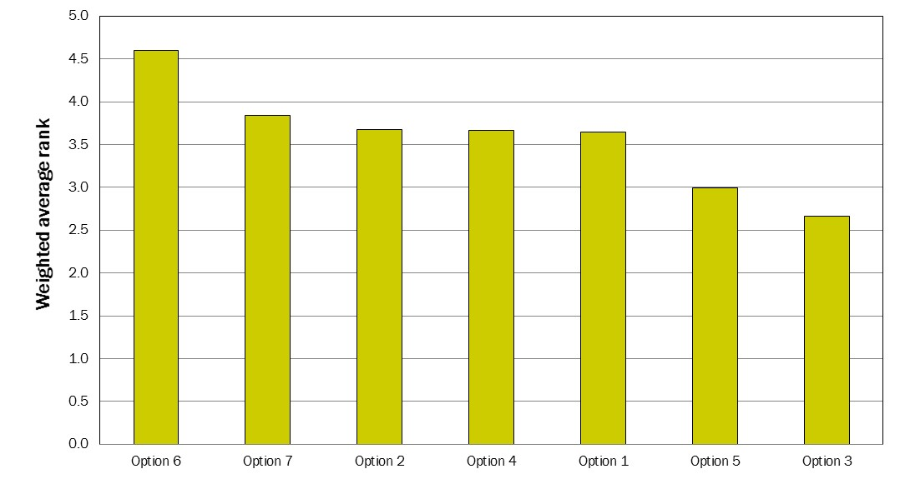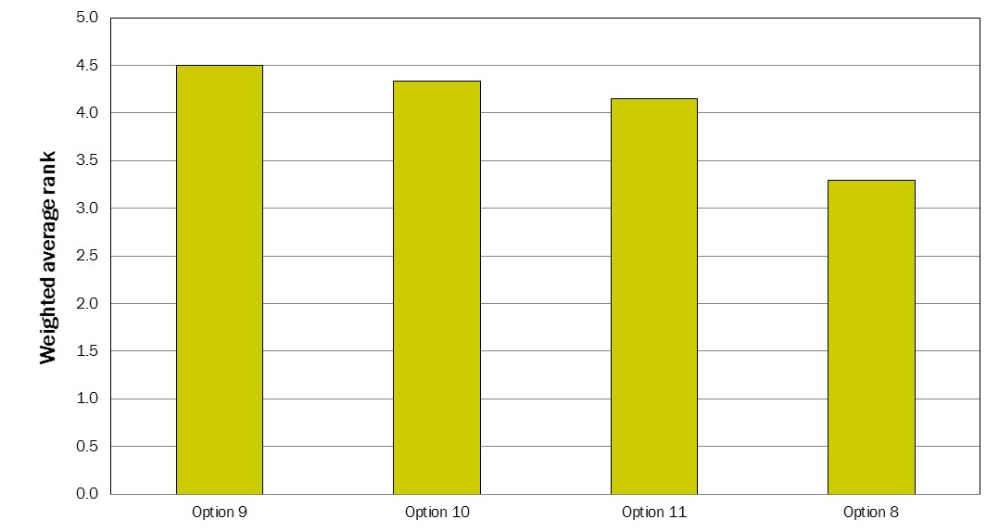
Difference in the Number of Rank 5 vs. Rank 1 Responses
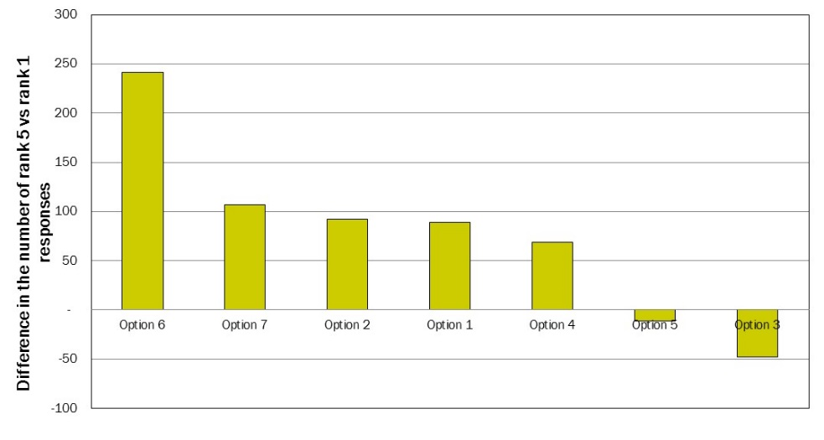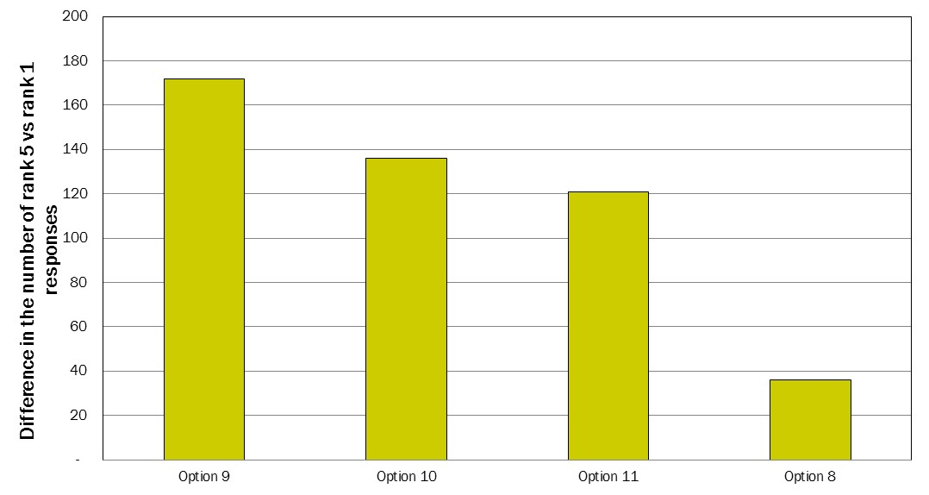
Figure 4-2: Scoring of Options by all Stakeholder Groups – Targets on Municipal Waste, Weighted Average Rank
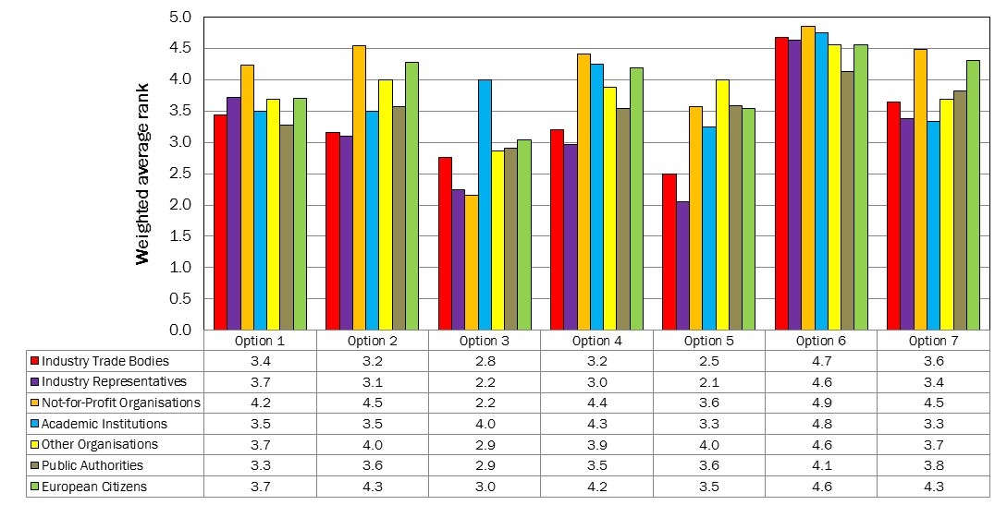

Figure 4-3: Scoring of Options by all Stakeholder Groups – Targets on Municipal Waste, Rank 5 vs. Rank 1

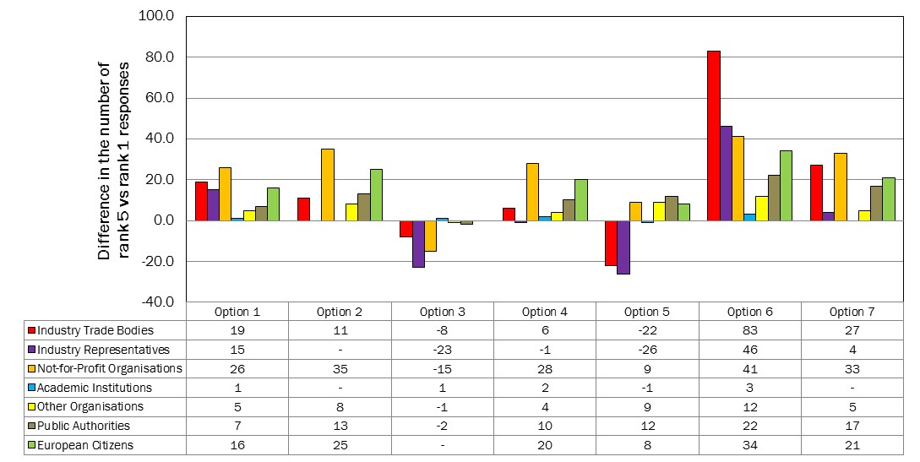

Figure 4-4: Scoring of Options by all Stakeholder Groups – Construction and Demolition Waste Targets, Weighted Average Rank
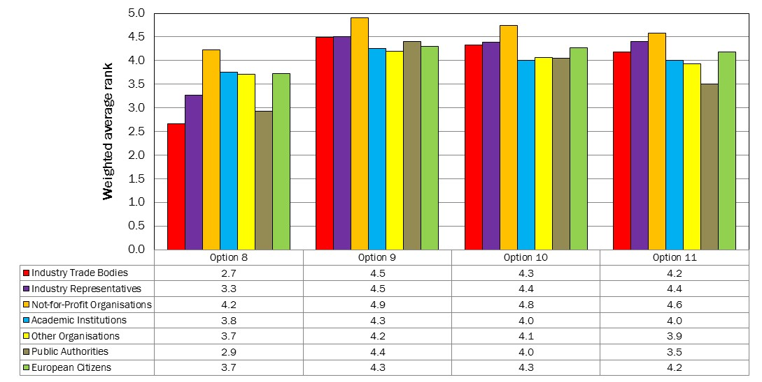

Figure 4-5: Scoring of Options by all Stakeholder Groups – Construction and Demolition Waste Targets, Rank 5 vs. Rank 1
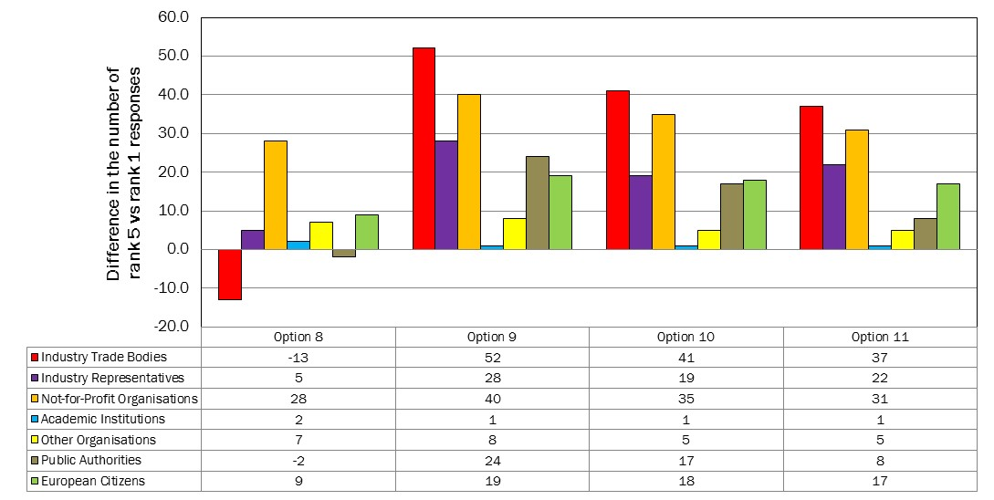

In addition to the listed options which were scored as part of the closed-ended scoring matrix respondents were also asked to list solutions that they felt had not already been identified and should potentially be considered. These open-ended responses were coded to identify the different themes that emerged from these responses. The range of additional solutions that were suggested by all stakeholder groups are summarised in Table 4-3.
Table 4-3: Additional Suggestions for Revision Provided by All Stakeholder Groups
Solution | Number of Times Solution Identified by Respondents
Introduce waste prevention and/or reuse targets | 27
Resource efficiency should be considered when setting targets | 26
There should be a clear distinction between different types of recycling (e.g. closed-loop vs. open-loop) | 25
C&D recycling targets should include backfilling under certain clearly defined conditions | 23
Targets should encourage/mandate separate collections (of dry recyclables and/or food waste) and the issues of separate collections should be clearly resolved by the EC | 21
Targets should be specified on a kg/capita basis and reduced over time | 14
All organisation collecting and recycling waste should report on quantities received/processed, there should be better reporting of end destinations | 13
Introduce recycling targets for commercial and/or industrial waste | 12
Establish a separate recycling target for biowaste | 9
Targets should incentivize local recycling rather than export to other EU countries or to outside the EU | 8
A better legislative definition of backfilling is required | 7
Targets for each material should be based on lifecycle assessment of environmental impacts | 7
Establish a specific target for hazardous waste | 6
Waste management at C&D sites should be more highly regulated (e.g. the requirement for Site Waste Management Plans in the UK) | 5
Ensure that existing targets are properly implemented | 5
Clarify all definitions in the legislation | 5
Extend producer responsibility legislation to other products/materials | 5
Introduce penalties for Member States who fail to meet the targets | 3
Targets should be equal or nearly equal across all Member States | 3
Better enforcement of the targets is required | 3
Targets should not mandate source segregation of recycling | 3
Targets should focus on the quality as well as quantity of recycled materials | 3
Introduce qualitative targets where technical specifications of raw materials are compared against secondary materials | 3
Target should be calculated on total waste arisings, not just municipal waste | 2
The targets should be more ambitious | 2
Put in place financial incentives to move waste to the top of the hierarchy | 2
Targets should be based on waste generated rather than waste collected as waste can be 'lost' from the system in the form of litter etc. | 2
Consider different targets for each member state which reflect the large variation in waste management across the EU | 2
Biowaste should not be included in the targets | 2
Source separation of hazardous wastes should be mandatory | 2
C&D recycling target should be more ambitious | 2
After 2020 set separate targets for household and municipal waste | 2
For C&D recycling target set individual/tailored improvement targets based on current performance of Member States | 2
Create targets to ensure recyclability of products and minimum resource use during manufacture | 1
Make the public advertisement of waste performance obligatory for local authorities | 1
Integrate the Packaging Waste Directive into the Waste Framework Directive | 1
Materials which can more easily/cost effectively be recycled should have higher targets | 1
Define the materials that can be included in backfilling | 1
Promote segregation of C&D waste | 1
High-efficiency energy recovery should be included in the targets | 1
Remove the exclusion of hazardous waste from the calculation method for the target of C&D waste. | 1
It is important to have a target for backfilling | 1
Waste streams should be based on European Waste Catalogue (EWC) codes | 1
The 70% material recovery target for C&D waste should only include recycling of other fractions than aggregate | 1
There is a need for harmonization of the provisions of the Waste Framework Directive when they are transposed in Member States | 1
Do not extend targets to include other specific waste streams beyond paper, metal, plastic and glass | 1
Implement a residual waste target to drive waste prevention | 1
New targets to include other specific waste materials should be made at a local, rather than at EU, level. | 1
New targets should be set even if not all states have reached existing targets | 1
Weight is a more reliable and effective measure than environmental impact | 1
Packaging of construction materials should be incorporated into C&D targets | 1
NGOs and industry associations should play a role in the monitoring and validation of the reports | 1
Waste targets should be calculated using parameters that are captured by Eurostat already | 1
C&D targets should not be set | 1
There may need to be some flexibility in the targets to allow for market forces | 1
An impact assessment should be carried out to look into the effects of including backfilling in the targets | 1
Dismantling, sorting and collection of different types of C&D waste should be mandatory | 1
The C&D target should be adjusted if it is to exclude backfilling | 1
Implementation of targets should be left to member states | 1
Define targets for each of the three steps of the recycling value chain: collection, preparation recovery and final recovery | 1
The C&D recycling target should, under certain circumstances, include incineration | 1
Develop a Biowaste Directive | 1
Set waste prevention target for C&I waste | 1
Set targets for 'critical materials' | 1
Use alternative instruments (e.g. taxes, charges, voluntary agreements) to achieve objectives | 1
SMEs below a certain size should not be obliged to segregate their waste | 1
Non-target solution | 192
Response was a comment on proposed solutions / Solution was already listed in the consultation | 76
Response is an issue, not a solution | 9

Landfill Directive
As per the consultation this section is divided into two sections. The first presents a summary of the key issues that were identified by stakeholders that were not already identified within the consultation (see Appendix A1.0). The second looks at possible options for revising and/or improving the targets.

Key Issues
A number of issues were identified in the consultation and respondents were asked to succinctly list up to three additional issues that had not been listed in the consultation. As described in Section 2.0 these open ended responses were coded to identify common themes and allow the data to be subjected to more detailed analysis. The feedback on issues received by respondents was intended to provide additional context to the issues already identified in the consultation. In many instances stakeholders chose to provide solutions to problems instead of listing additional problems related to the existing targets that had not already been identified within the consultation. Some of the issues that were reported were also not directly related to the Landfill Directive targets or were repeats, albeit in different words, of the issues that had already been listed in the consultation. Some of the more commonly identified issues included the following:
- The current targets are only for biodegradable municipal waste rather than other waste streams;
- There has been a cack of enforcement and implementation of the Landfill Directive in many Member States;
- Inconstant methodologies have been used to report on the targets and landfill statistics under the Landfill Directive;
- A lack of recycling infrastructure in some Member States means that they are unlikely to be able to meet the targets; and
- The Landfill Directive is not strongly linked to current European Commission thinking on resource efficiency and the implementation of the waste hierarchy.

Suggestions for Revision
A number of suggested options for changes to the Directive targets were identified in the consultation. The following options were included in the consultation as part of a scoring matrix:
- Revise the targets so that they are set in such a way that they do not penalise countries whose economies are growing faster after starting from a lower base.
- Establish a legal obligation for reporting on ‘municipal waste’ and enforcing the use of a single definition of the term by all Member States.
- Standardise the approach to performance measurement and progress reporting.
- In Member States where no data exists for 1995, a more recent baseline year should be set with targets adjusted accordingly.
- Clarify when treated waste should be considered ‘no longer biodegradable’ from the perspective of the Landfill Directive.
- Further tighten existing targets (e.g. move progressively towards zero biodegradable municipal waste sent to landfill).
- Progressively include all biodegradable wastes (not just biodegradable wastes of municipal origin) within targets similar to the existing ones.
- Introduce targets for the progressive reduction in the quantity of residual waste irrespective of how it is subsequently managed (whether it is sent to incineration, MBT or landfill, or any other residual waste management method).
- Define ‘pre-treatment’ in an unambiguous manner so that the ban on landfilling waste that is not pre-treated is applied equally across all countries.
Respondents were asked to rank each of the above options on a scale of 1 to 5, where:
- 1 = poor idea, not worth consideration;
- 3 = moderately good idea, may be worth further consideration; and
- 5 = very good idea, definitely deserves further consideration.
The results of the responses to this question are presented for all stakeholders in Figure 5-6 and for each stakeholder group in Figure 5-7 and Figure 5-8. In each of these figures the 9 options represent those listed above and the reader should refer back to this list in order to identify which options were most favoured by respondents. As described in Section 2.2 the results of this ranking exercise are presented in two ways in the figures below:
- As a weighted average rank; and
- As the difference in the number of respondents who ranked an option as ‘5’ vs. those who ranked it as ‘1’.
In the pages below each figure contains two graphs which present the results of the above two analyses.

Figure 5-6: Scoring of Options by all Stakeholders

Weighted Average Rank
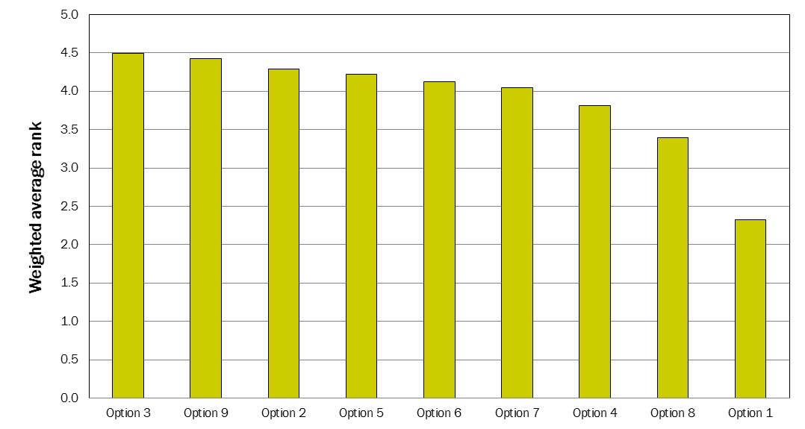

Difference in the Number of Rank 5 vs. Rank 1 Responses
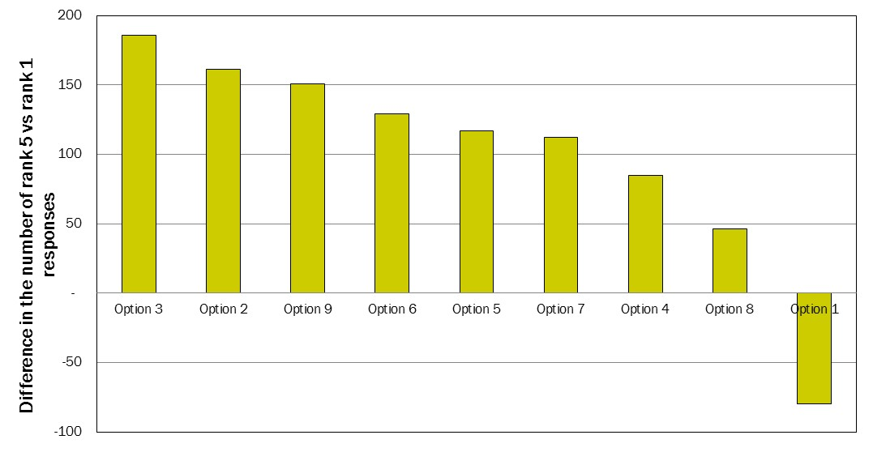
Figure 5-7: Scoring of Options by all Stakeholder Groups, Weighted Average Rank
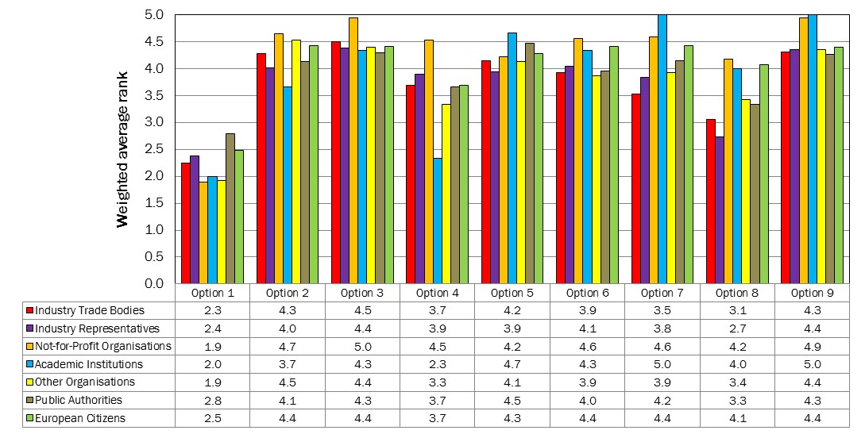

Figure 5-8: Scoring of Options by all Stakeholder Groups, Rank 5 vs. Rank 1
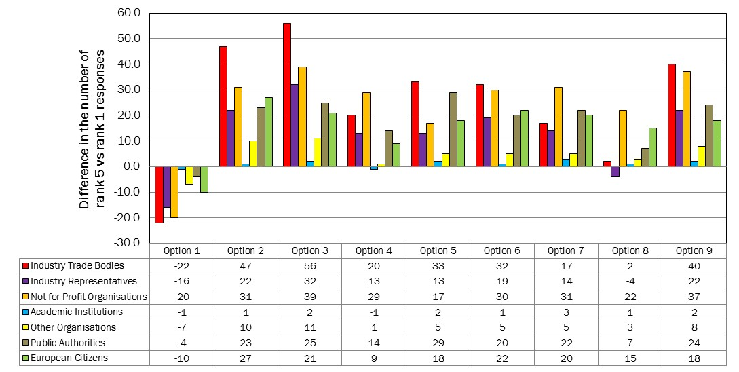
In addition to the listed options which were scored as part of the closed-ended scoring matrix respondents were also asked to list any additional solutions that they felt had not already been identified and should potentially be considered. These open-ended responses were coded to identify the different themes that emerged from these responses. The additional solutions that were suggested by all stakeholder groups are presented in Table 5-4 below.
Table 5-4: Additional Suggestions for Revision Provided by Stakeholders
Solution | Number of Times Solution Identified by Respondents
Introduce landfill bans for recyclable and/or combustible materials | 36
Residual waste reduction targets should be specified (e.g. reduction in kg per capita per year) with suitable (i.e. environmentally sound and cost effective) alternatives treatment/recycling options are in place | 28
Member states should be financially rewarded for legislation which moves waste up the hierarchy | 22
Include more material streams in landfill diversion targets | 18
Residual waste reduction targets should be set in the WFD not in the Landfill Directive | 17
Progressive introduction of landfill bans on untreated waste | 16
Adopt the legal framework as devised by the German Landfill Ordinance which excludes the disposal of plastic waste in bulk in landfills | 13
No landfill bans unless feasible alternatives can be identified i.e. landfilling is not simply replaced by incineration | 12
Introduce a mandatory landfill tax | 10
Introduce landfill bans for biowaste | 6
Provide support to member states regarding infrastructure investments | 4
Stricter enforcement of the targets/Directive is required | 4
Levels of targets should be informed by environmental impact assessments | 4
Ensure all EU funding supports the waste hierarchy | 4
Countries starting from a low base should have the same targets but a longer time to achieve them | 2
There should not be an outright ban on landfill - some level of landfilling will always be required | 2
Specific diversion rules should be developed for different materials | 2
Penalise Member States who exaggerated their statistics for 1995 | 1
Implement landfill bans for specific materials and/or waste streams | 1
Gradual introduction of landfill and incineration bans with suitable (i.e. environmentally sound and cost effective) alternatives treatment/recycling options are in place | 1
Targets should be variable depending on waste produced per person and balanced against economic performance | 1
There should be a stronger link to EC resource efficiency policy | 1
More guidance required from EU on recommended treatment methods | 1
There should be two different targets for biodegradable wastes, one for household waste and one for commercial waste. | 1
Baseline years and deadlines to reach the targets should be the same for all Member States | 1
Member States whose data is estimated or highly inconsistent should have a more recent baseline year with targets adjusted accordingly | 1
If member states are far from achieving targets, setting more ambitious targets may not be effective | 1
There should be an updated baseline year for all Member States to ensure a level playing field | 1
The first priority should be to avoid illegal and uncontrolled landfill sites | 1
Targets should be set for household and industrial waste instead of municipal waste. | 1
The choice of measurement methodology is to be kept at national level bearing in mind the need to achieve comparability at the EU-level | 1
Member State which landfill more than X% of its waste should be required to agree an Action Plan of national measures to reduce the amount of waste sent to landfill | 1
Alternatives to targets should be considered, such as economic instruments etc. | 1
Replace percentage targets with a single target setting maximum amount of landfilled biodegradable waste of any origin in kg per capita | 1
Move towards a maximum level of landfilling for all waste of X% per year | 1
Post-consumer wood materials should be diverted from landfill | 1
Non-target related solution proposed by stakeholder | 70
Response was a comment on proposed solutions / Solution was already listed in the consultation | 50
Response is an issue, not a solution | 2

