 | 
COUNCIL OF  THE EUROPEAN UNION |  |  | Brussels, 21 November 2012
 | Interinstitutional File:  2012/0221 (APP) |  | 16587/12
INF 186
INST 669
PARLNAT 371

COVER NOTE
from: | The Senate of the Italian Republic
date of receipt: | 5 November 2012
Subject: | Proposal for a Council Regulation amending Regulation (EEC/Euratom) No 354/83, as regards the deposit of the historical archives of the institutions at the European University Institute in Florence  [doc. 13183/12 INF 127 - COM(2012) 456 final]  - Opinion on the application of the Principles of Subsidiarity and Proportionality

Delegations will find attached the above-mentioned opinion.

________________________

ANNEX
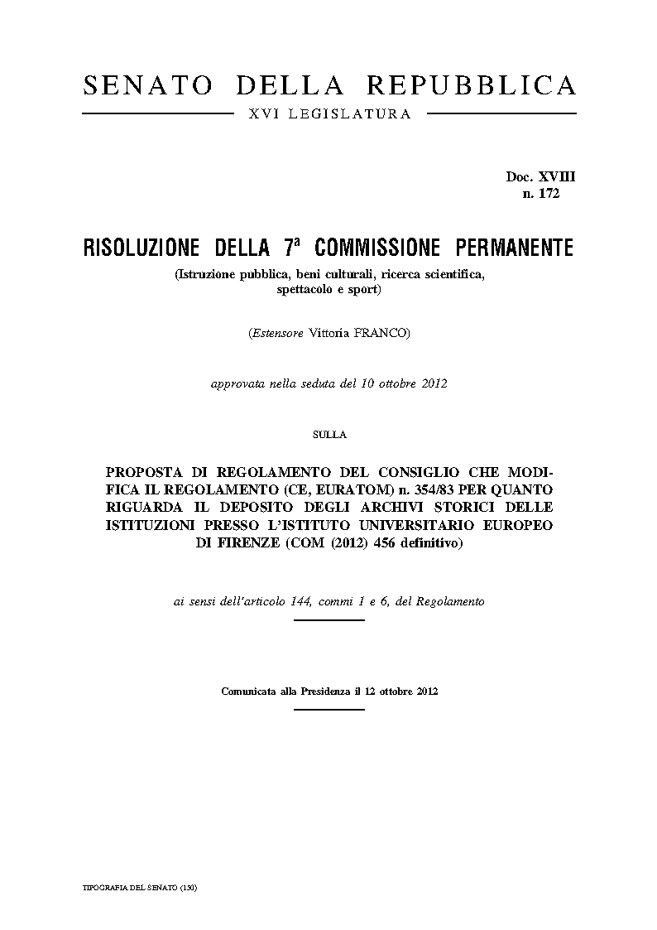
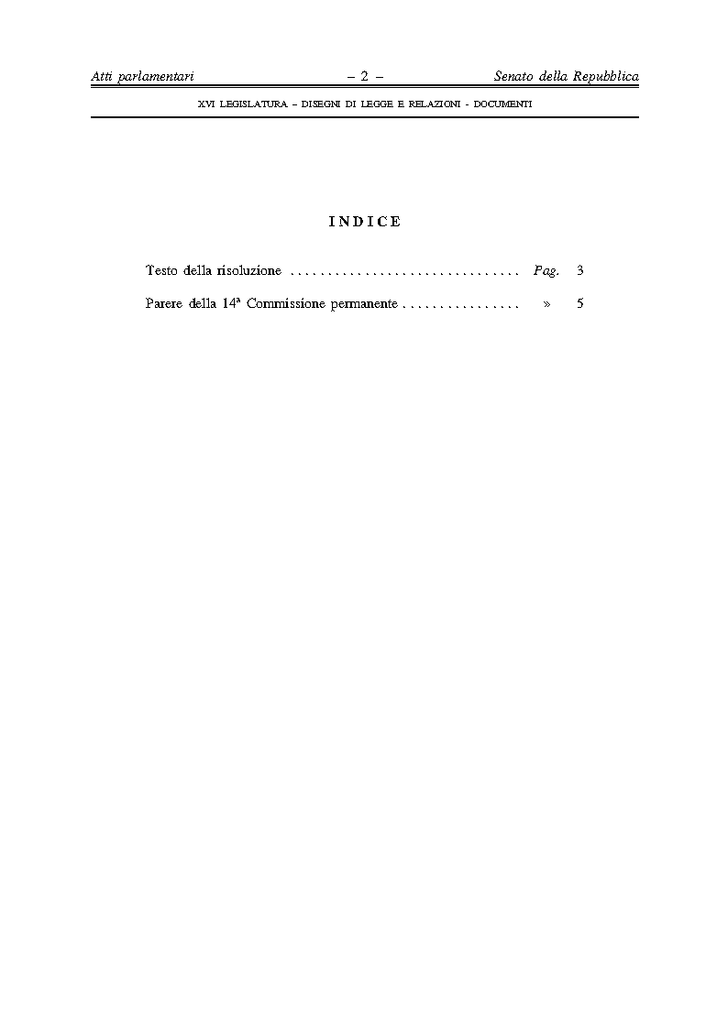
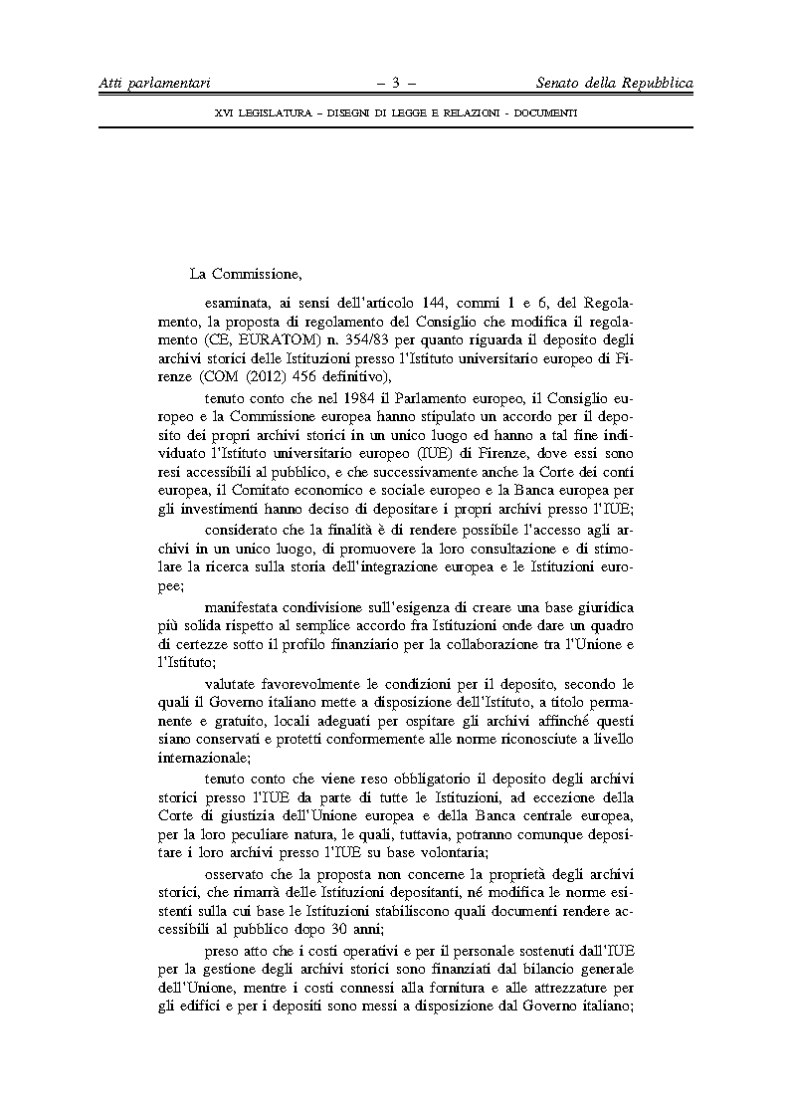
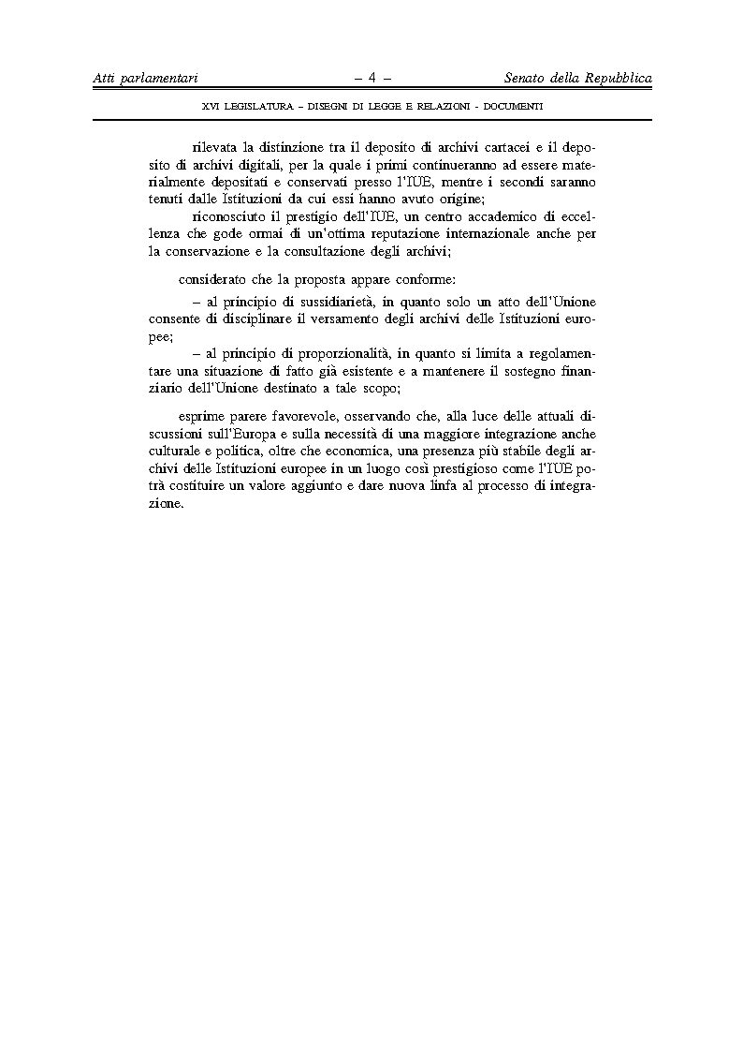
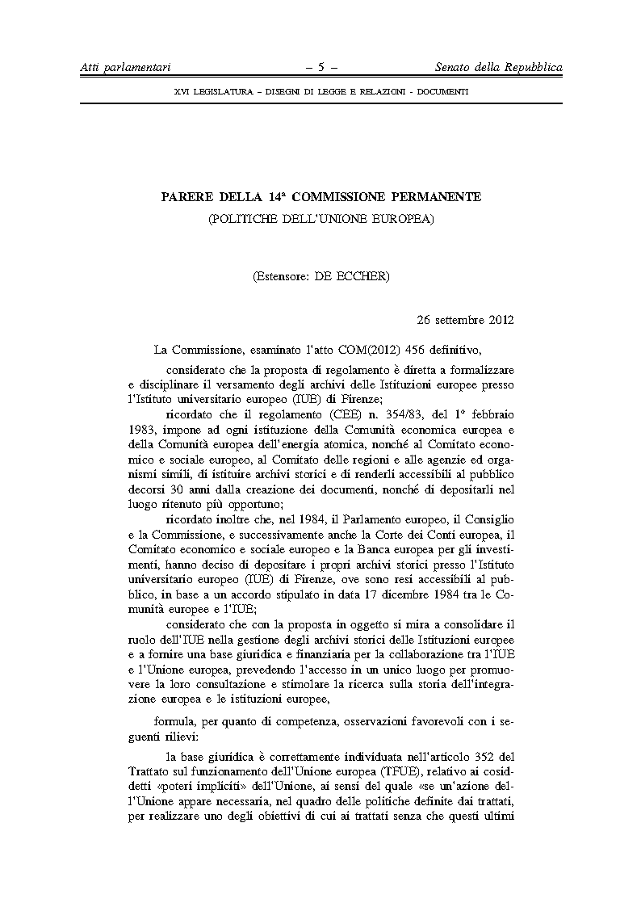
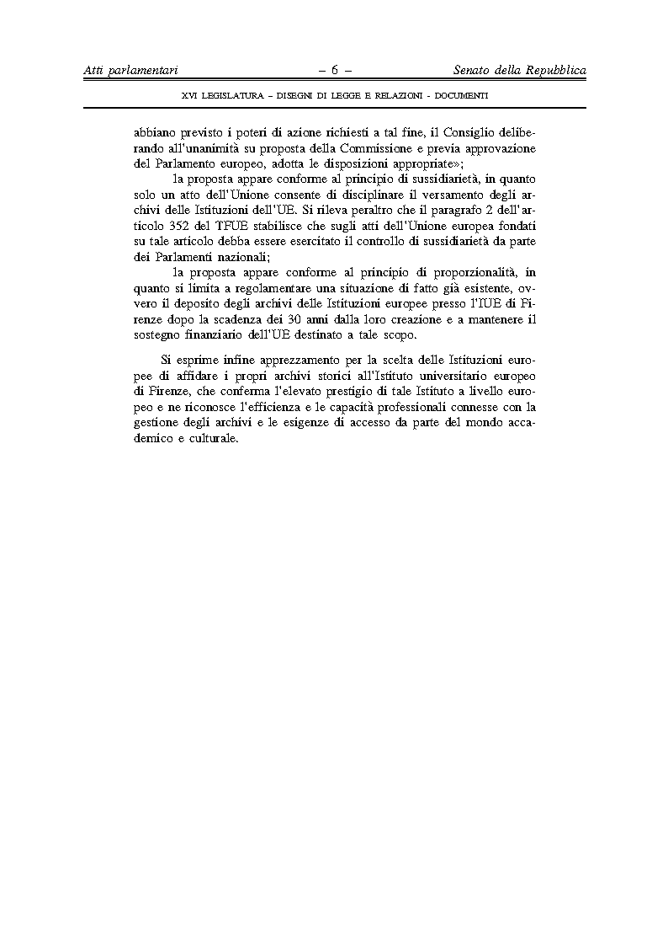

Translation(s) of the opinion may be available on the Interparliamentary EU Information Exchange site IPEX at the following address: http://www.ipex.eu/IPEXL-WEB/search.do

