 | 
COUNCIL OF  THE EUROPEAN UNION |  |  | Brussels, 19 November 2012
 | Interinstitutional File:  2012/0245 (COD) |  | 16464/12
COHAFA 147
DEVGEN 313
ACP 233
PROCIV 185
RELEX 1061
FIN 880
CODEC 2731
INST 662
PARLNAT 367

COVER NOTE
from: | Portuguese Assembleia da República
date of receipt: | 16 November 2012
to: | Mr Dimitris CHRISTOFIAS, President of the Council of the European Union
Subject: | Proposal for a Regulation of the European Parliament and of the Council Establishing the European Voluntary Humanitarian Aid Corps  – EU Aid Volunteers  [doc. 14150/12 COHAFA 116 DEVGEN 251 ACP 180 PROCIV 146 RELEX 861 FIN 691 CODEC 2230 - COM(2012) 514 final]  - Opinion on the application of the Principles of Subsidiarity and Proportionality

Delegations will find attached a copy of the above opinion.

________________________
ANNEX

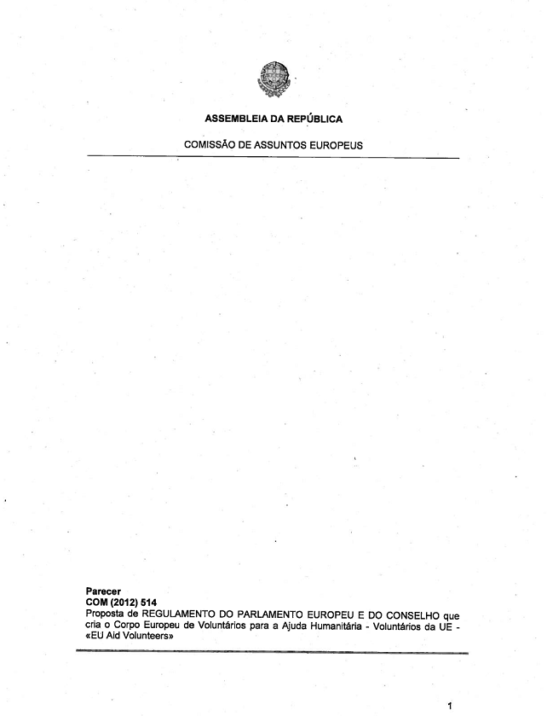

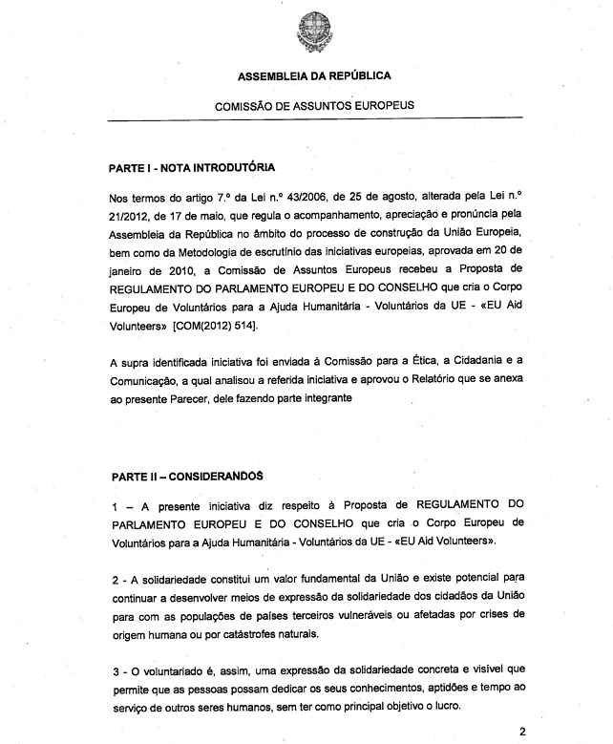

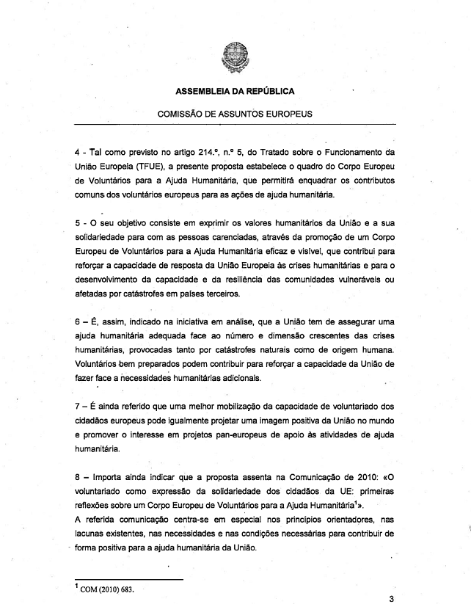

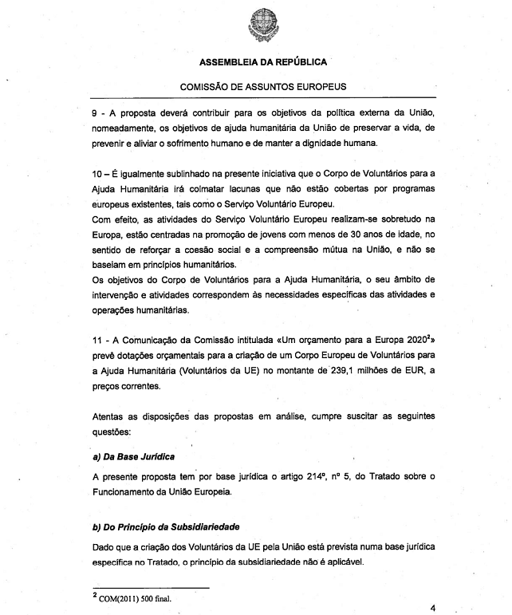

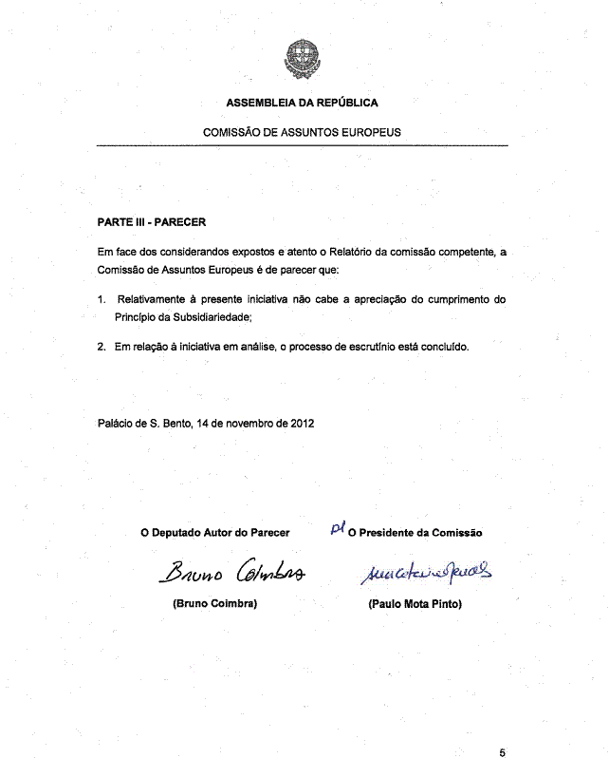

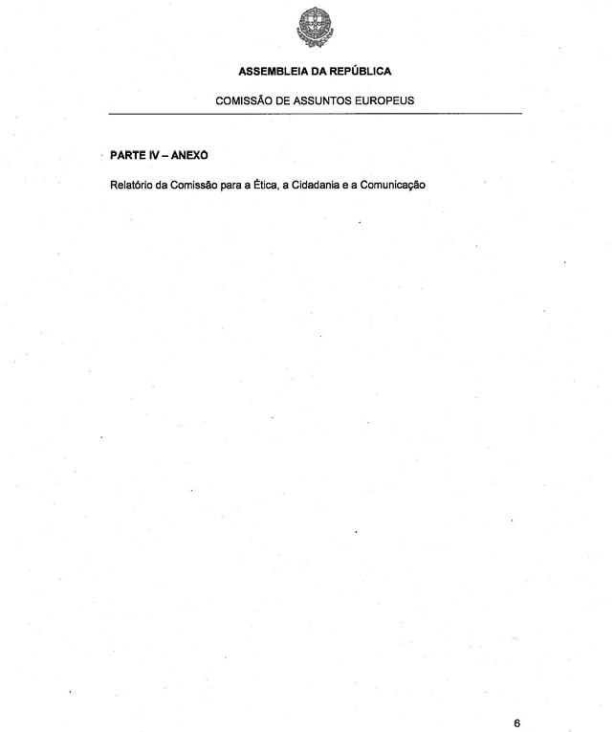

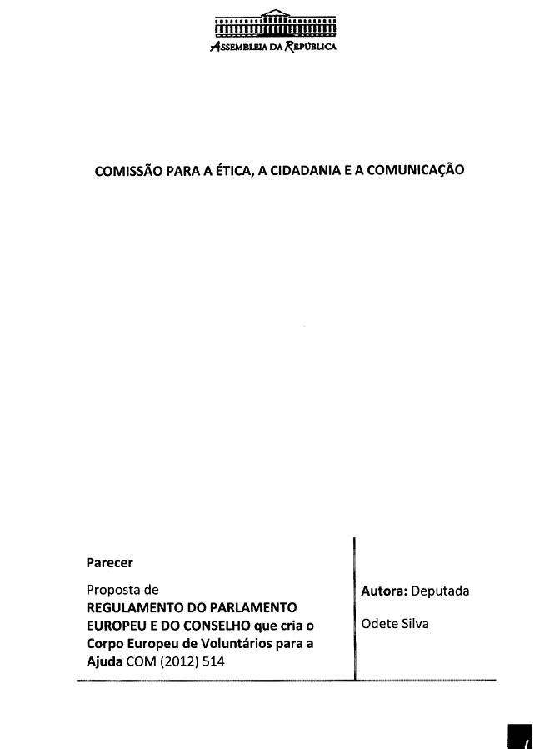

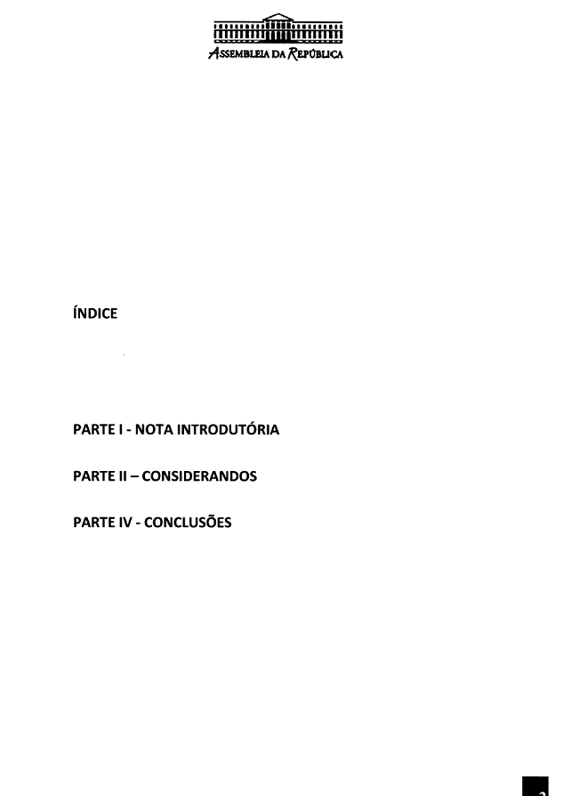

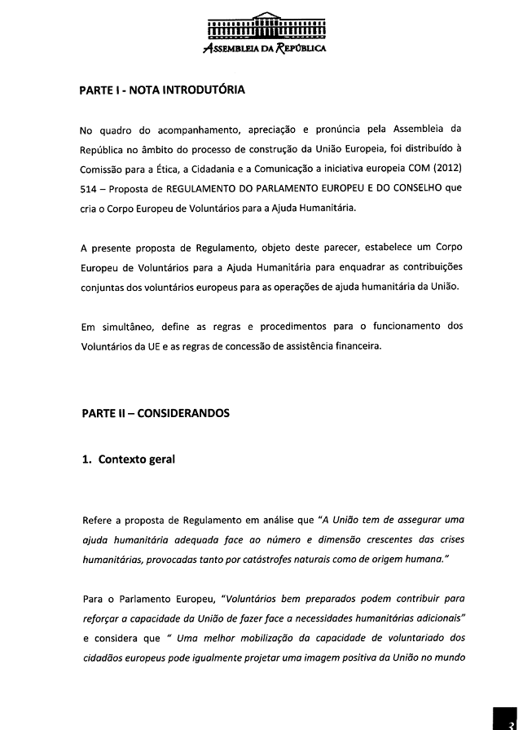

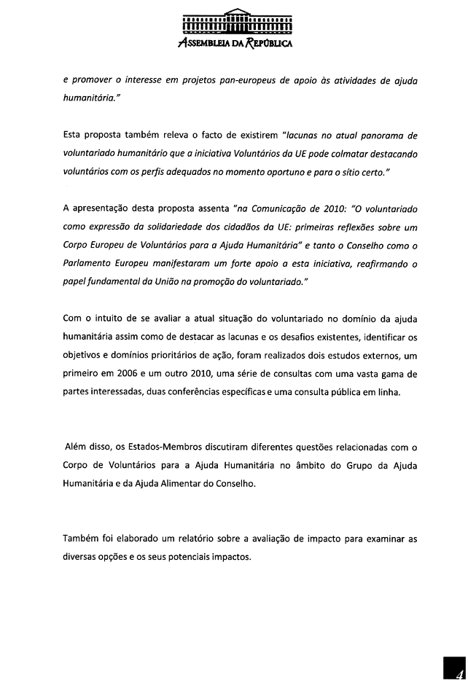

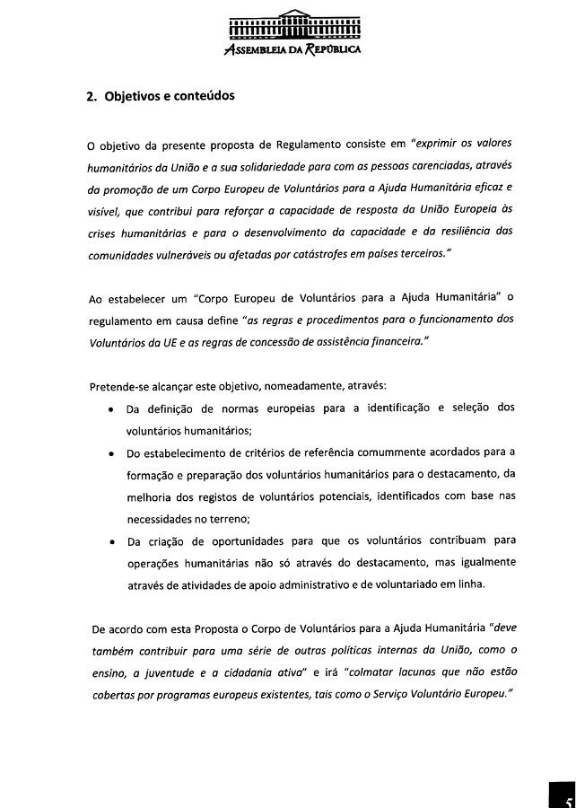

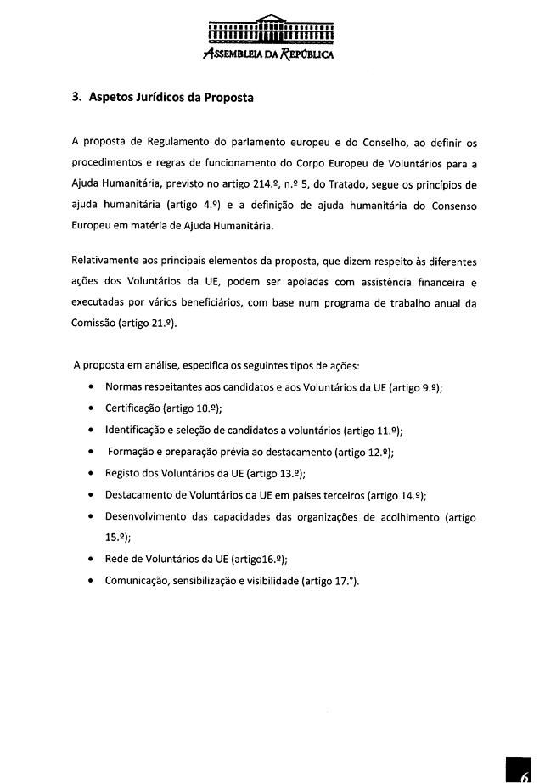

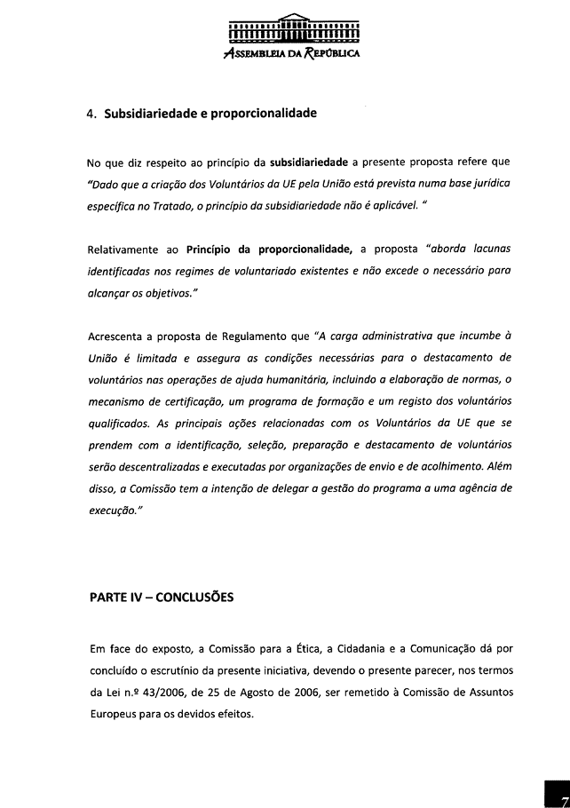

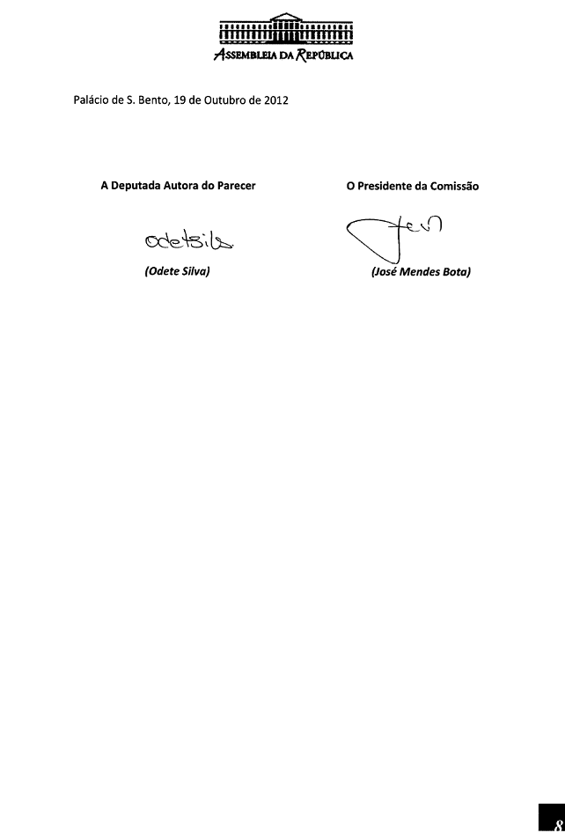

Translations can be found at the Interparliamentary EU information exchange sit IPEX at the following address: http://www.ipex.eu/IPEXL-WEB/search.do

