 | 
COUNCIL OF  THE EUROPEAN UNION |  |  | Brussels, 19 November 2012
 | Interinstitutional File:  2012/0242 (CNS)  2012/0244 (COD) |  | 16484/12
EF 268
ECOFIN 963
CODEC 2735
INST 666
PARLNAT 369

COVER NOTE
from: | Italian Chamber of Deputies
date of receipt: | 15 November 2012
to: | President of the European Union
Subject: | Proposal for a COUNCIL REGULATION conferring specific tasks on the European Central Bank concerning policies relating to the prudential supervision of credit institutions AND  Proposal for a REGULATION OF THE EUROPEAN PARLIAMENT AND OF THE COUNCIL amending Regulation (EC) No 1093/2010 establishing a European Supervisory Authority (European Banking Authority) as regards its interaction with Council Regulation (EU) No…/… conferring specific tasks on the European Central Bank concerning policies relating to the prudential supervision of credit institutions  [doc. ST 13683/12 EF 199 ECOFIN 770 - COM(2012) 511 final and  ST 13682/12 EF 198 ECOFIN 769 CODEC 2115 - COM(2012) 512 final]  - Opinion on the application of the Principles of Subsidiarity and Proportionality

Delegations will find attached the above mentioned Opinion.

________________________

Encl.:
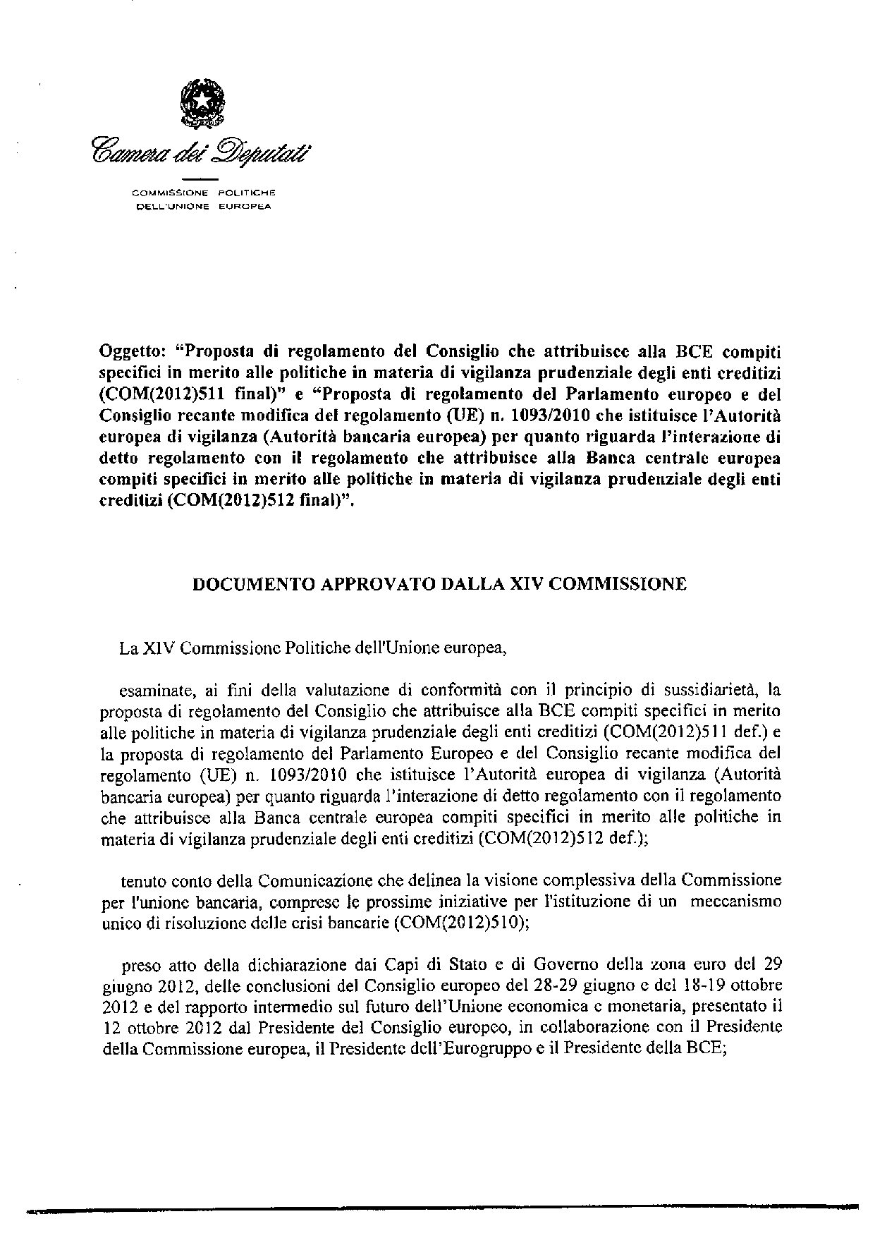
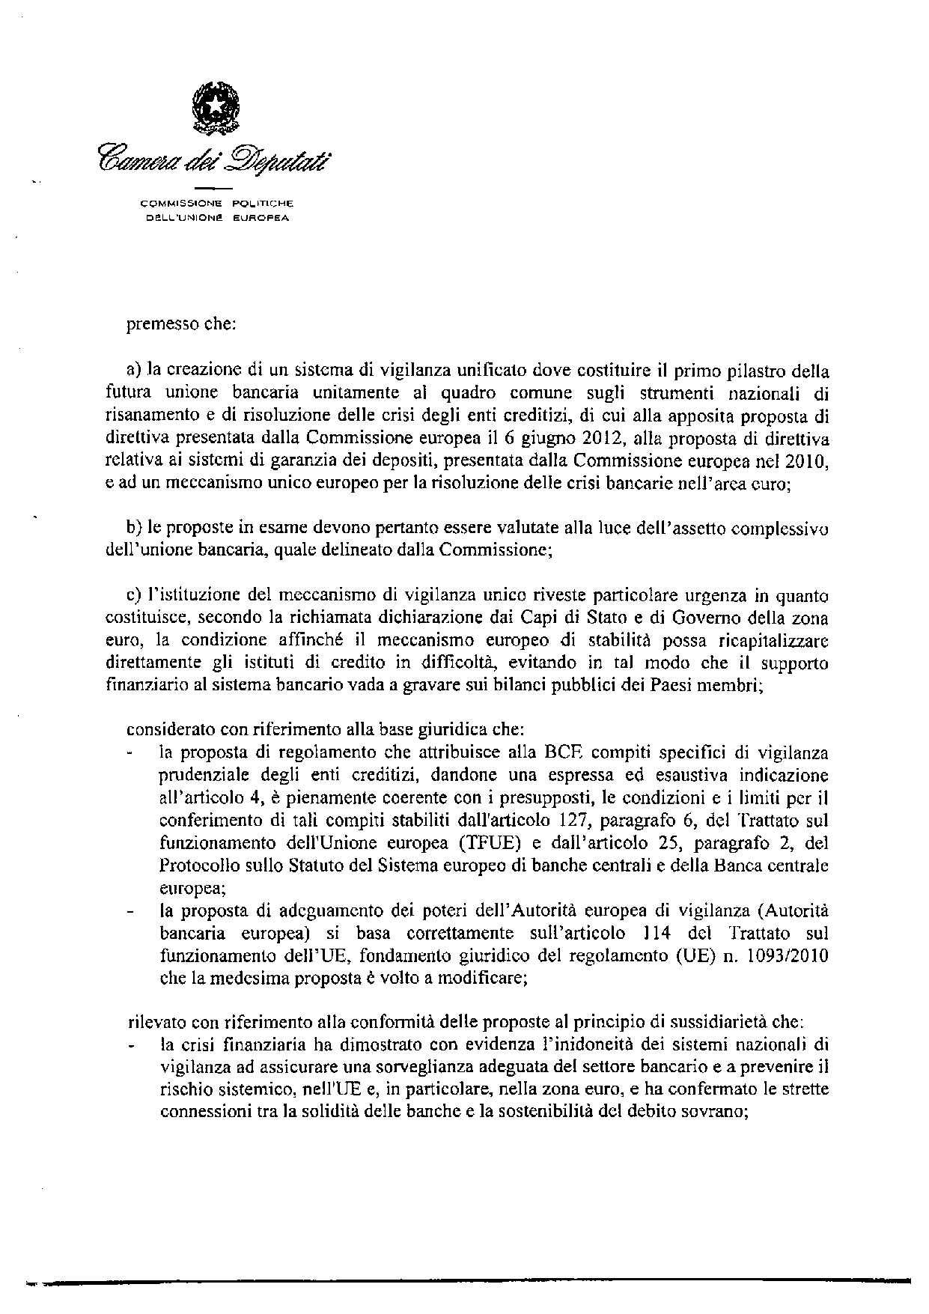
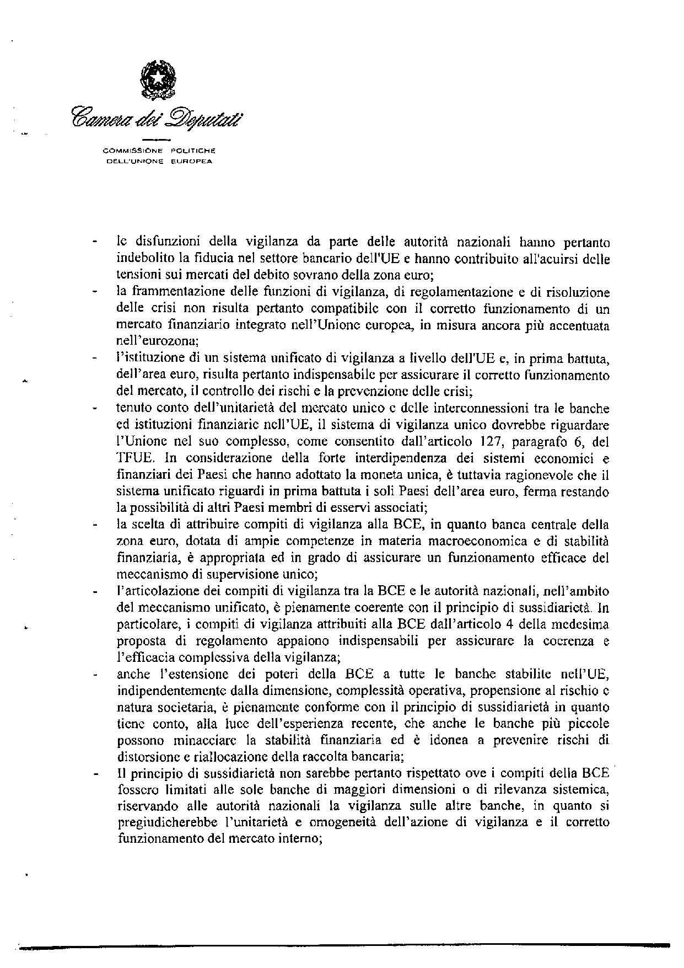
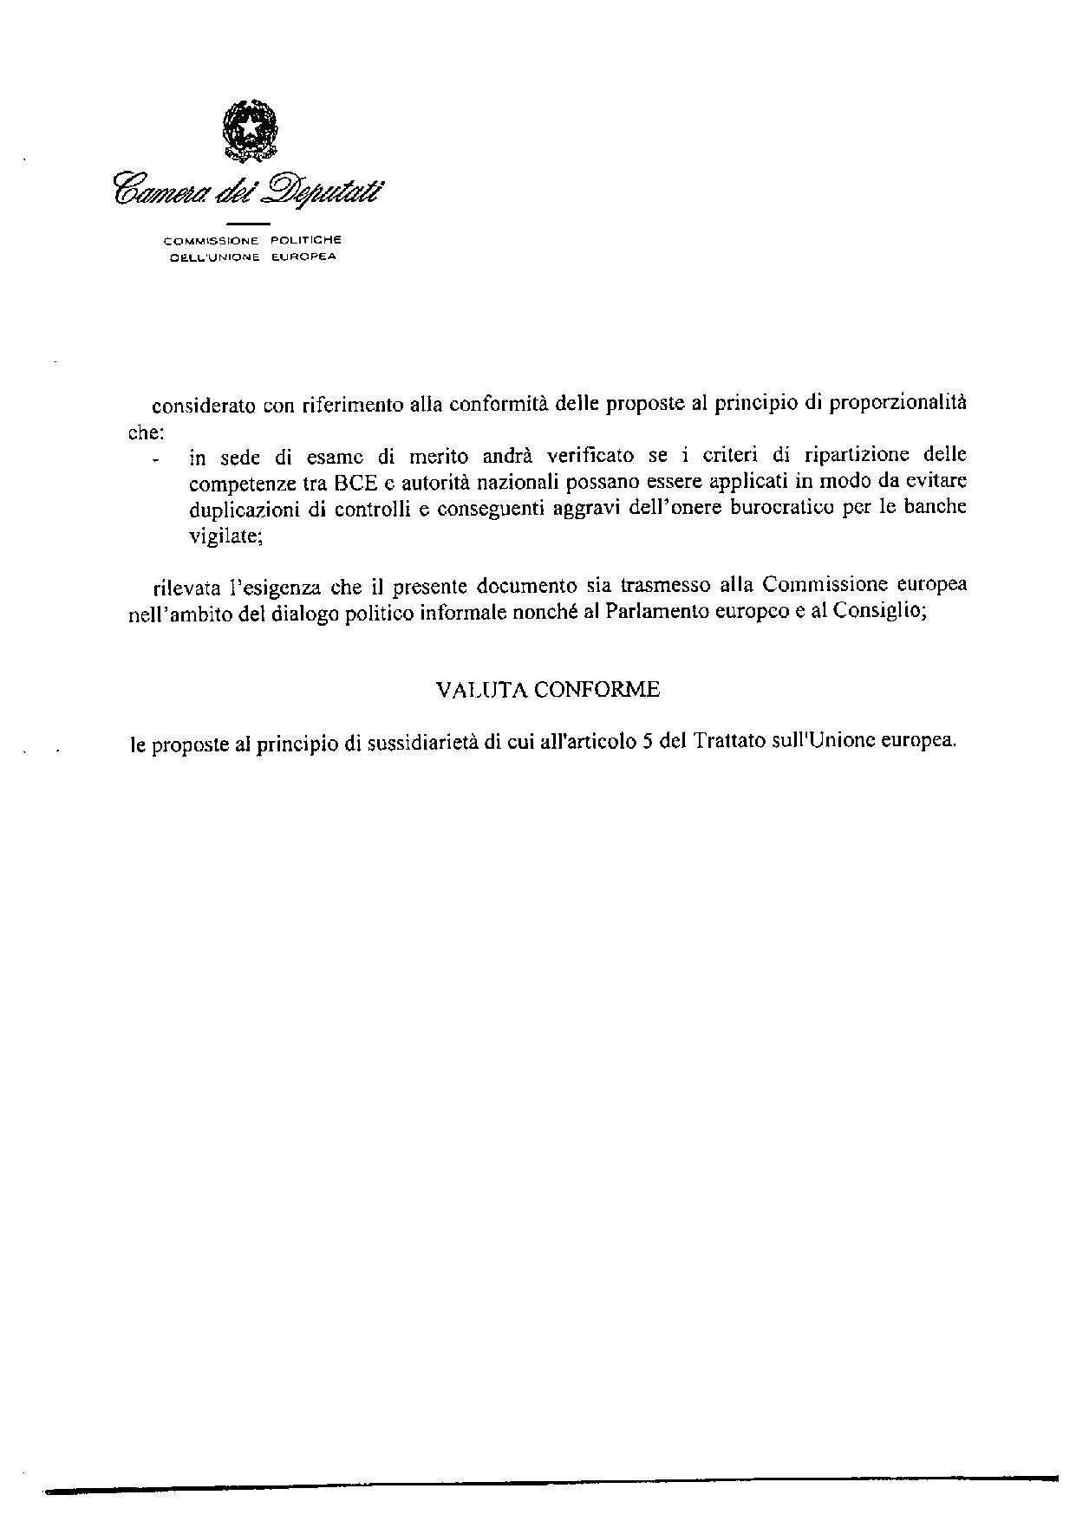

Translation(s) may be available in the Interparliamentary EU information exchange site IPEX at the following address: http://www.ipex.eu/IPEXL- WEB/search.do

