EXPLANATORY MEMORANDUM
CONTEXT OF THE PROPOSAL
1. The rules applicable to financial contributions from the European Globalisation Adjustment Fund (EGF) are laid down in Regulation (EU) No 1309/2013 of the European Parliament and of the Council of 17 December 2013 on the European Globalisation Adjustment Fund (2014-2020) and repealing Regulation (EC) No 1927/2006 (the 'EGF Regulation').
2. The Spanish authorities submitted application EGF/2014/003 ES/Aragón food and beverage for a financial contribution from the EGF, following redundancies and cessation of activities within the meaning of Article 3 of the EGF Regulation (hereafter referred to as 'redundancies') in 661 enterprises operating in the NACE Rev. 2 Division 56 (Food and beverage service activities) in the NUTS level 2 region of Aragón (ES24).
3. After an examination of this application, the Commission has concluded, in accordance with the applicable provisions of the EGF Regulation, that the conditions for awarding a financial contribution from the EGF are met.
SUMMARY OF THE APPLICATION
EGF application: | EGF/2014/003 ES/Aragón food and beverage
Member State: | Spain
Region(s) concerned (NUTS level 2): | Aragón (ES24)
Date of submission of the application: | 21.2.2014
Date of acknowledgement of receipt of the application and date of request for additional information. | 7.3.2014
Deadline of provision of the additional information: | 18.4.2014
Deadline for the completion of the assessment: | 11.7.2014
Intervention criterion: | Article 4(1)(b) of the EGF Regulation
Sector(s) of economic activity  (NACE Rev. 2 division): | 'Food and beverage service activities' Division 56
Reference period (nine months): | 1.3.2013 – 1.12.2013
Number of redundancies or cessations of activity during the reference period: | 904
Number of eligible beneficiaries expected to participate in the measures: | 280
Budget for personalised services (EUR) | 1 575 998
Budget for implementing EGF (EUR) | 24 002
Total budget (EUR) | 1 600 000
Fianancial contribution requested from the EGF contribution (EUR) | 960 000 | (60 % of total budget)
ASSESSMENT OF THE APPLICATION
Procedure
4. The Spanish authorities submitted application EGF/2014/003 ES/Aragón food and beverage within 12 weeks of the date on which the intervention criteria set out in paragraphs 5 to 7 below were met, on 21 February 2014. The Commission acknowledged receipt of the application within two weeks of the date of submission of the application, on 7 March 2014. On the same date, the Commission requested additional information from the Spanish authorities. Such additional information was provided within six weeks of the date of the request. The deadline of 12 weeks of the receipt of the complete application within which the Commission should finalise its assessment of the application's compliance with the conditions for providing a financial contribution expires on 11 July 2014.
Eligibility of the application
Intervention criteria
5. The Spanish authorities submitted the application under the intervention criterion of Article 4(1)(b) of the EGF Regulation, which requires at least 500 redundancies over a reference period of nine months in enterprises operating in the same economic sector defined at NACE Rev. 2 division level and located in one region or two contiguous regions defined at NUTS 2 level.
6. The application relates to 904 workers made redundant in 661 enterprises operating in the NACE Rev. 2 Division 56 (Food and beverage service activities) in the NUTS 2 level region of Aragón (ES24).
7. The reference period of nine months runs from 1 March 2013 to 1 December 2013.
Calculation of redundancies and of cessation of activity
8. All the redundancies have been calculated from the date of the de facto termination of the contract of employment or its expiry within the reference period.
Eligible beneficiaries
9. The total number of eligible beneficiaries is 904.
Link between the redundancies and the global financial and economic crisis addressed in Regulation (EC) No 546/2009
10. In order to establish the link between the redundancies and the global financial and economic crisis addressed in Regulation (EC) No 546/2009, the Spanish autorities argue that in 2009, as a consequence of the global financial and economic crisis, there was a significant downturn in the economy at EU-27 level, as well as in the Spanish economy. In 2009 the GDP growth rate (percentage change on previous year) was – 4,5 % at EU-27 level and – 3,8 % in Spain. In 2010 and 2011 the EU-27 economy recovered and the GDP growth rates were 2,0 % and 1,7 % respectively while in 2012 the EU-27 GDP growth was again negative (– 0,4 %). The Spanish GDP growth rate was negative in 2010 (– 0,2 %) and 2012 (– 1,6 %) and slightly positive (0,1 %) in 2011.
GDP growth rate
(percentage change on previous year)
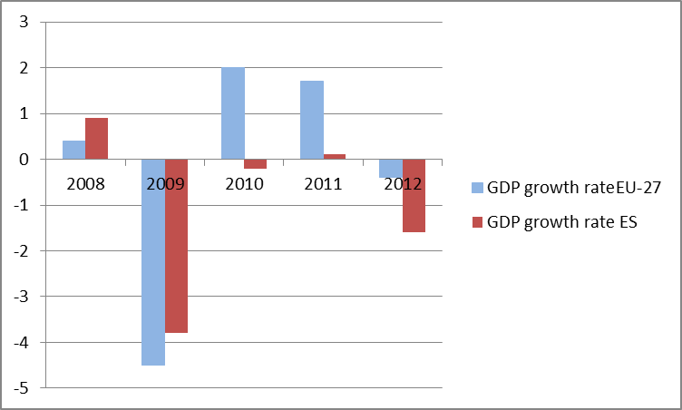
Source: Eurostat
11. The global financial and economic crisis severely affected the Spanish economy and led the Spanish government to take measures such as increasing tax revenues — in particular VAT whose standard rate increased from 16 % to 18 % in 2010 and further to 21 % in 2012 —, streamlining public expenditure and decreasing public sector employees' salaries. There was also a decrease in the average income in the private sector in an attempt to increase the competitiveness of the Spanish economy. An immediate effect of the reductions in income was a decrease in consumption. During the period 2009-2012 household consumption in Spain fell for three out of the four years compared with the same period of the respective previous year. Household consumption at EU-27 level also declined but to a lesser extent.
Household consumption
(percentage change on previous year)
 | 2009 | 2010 | 2011 | 2012
EU-27 | – 1,67 | 1,04 | 0,26 | – 0,74
Spain | – 3,82 | 0,11 | – 1,16 | – 2,84
Source: Eurostat
12. The decline in household consumption in Spain resulted in shrinking demand for food and beverage services, given the strong linkage of the household expenditure level with food and beverage consumption away from home. The Spanish authorities, citing data from the Spanish Ministry of Agriculture Food and Environment, have explained that in 2012 the total household expenditure on food in Spain decreased by 1,3 % compared to 2011. It is noteworthy that expenditure on food for home consumption increased by 0,2 % while that on food-away-from-home decreased by 4,1 %. Expenditure on food services has been declining since the beginning of the financial and economic crisis; during the period from 2009 to 2012 it decreased by 12,1 %.
Away from home food expenditure
(million EUR)
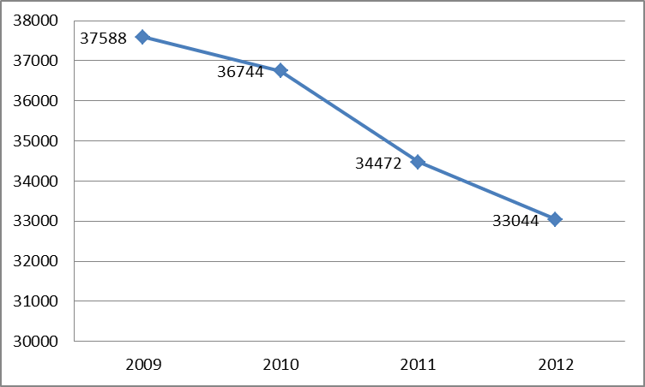
Source: Spanish Ministry of Agriculture and Food and Environment.
Events giving rise to the redundancies and cessation of activity
13. According to the annual report of Federación Española de Hostelería y Restauración (FEHR) on the accommodation, food and beverage service activities for 2012, the sectoral index of business activity declined by 8.26 % during the period 2010-2012. Moreover, the Spanish authorities argue that as a consequence of the decrease in expenditure on away-from-home food, the number of businesses operating in the food and beverage service activities sector had fallen by 3,5 % at national level in 2011 compared with 2009, while in Aragón the decrease was of 11 %.
14. The decline in business activity in the food and beverage service activities sector and the closure of many businesses operating in this sector resulted in a large number of redundancies.
Expected impact of the redundancies as regards the local, regional or national economy and employment
15. Employment in Aragón has been severely affected by the crisis. The unemployment rate in the region has increased rapidly, rising from 4,2 % in December 2007 to 18,4 % in December 2013. The employment situation in Aragón seems particularly fragile, given the impact of the crisis also on other sectors such as construction and retail, which are very important for the region's economy. Following the redundancies in the construction and retail sectors in Aragón, Spain submitted applications in May 2010 and December 2011 for financial contributions from the EGF.
Unemployment rate in Aragón
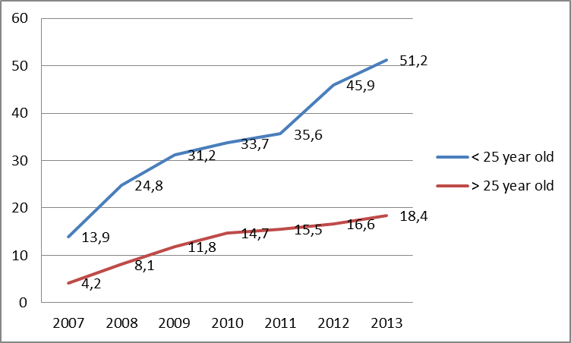
Source: EPA
16. The food and beverage service activities sector has traditionally been considered as a safety net at times of scarce employment, since finding a job in the food and beverage sector used to be easy, mainly due to the fact that these jobs have demanding work schedules which are difficult to reconcile with family life. The fact that now even the food and beverage service activities sector is suffering the consequences of the financial and economic crisis, with resulting redundancies, has an adverse impact on the regional economy more serious than the figures alone seem to show.
Targeted beneficiaries and proposed actions
Targeted beneficiaries
17. The estimated number of eligible beneficiaries expected to participate in the measures is 280.
18. The breakdown of expected participants by sex, nationality and age group is as follows:
Category |  | Number of  targeted beneficiaries
Sex: | Men: | 97 | (34,64 %)
 | Women: | 183 | (65,36 %)
Nationality: | EU nationals: | 174 | (62,14 %)
 | non-EU nationals: | 106 | (37,86 %)
Age group: | 15-24 years: | 26 | (9,29 %)
 | 25-54 years: | 232 | (82,86 %)
 | 55-64 years: | 22 | (7,85 %)
 | over 64 years: | 0 | (0,00 %)
Proposed actions
19. The personalised services which are to be provided to the workers made redundant consist of the following actions, which combine to form a co-ordinated package of personalised services aimed at re-integrating the redundant workers into employment. They are organised in four areas:
1. Guidance, counselling and job search
- Welcome session, occupational guidance and profiling: The first measure provided to all participants includes the profiling of the workers as well as the provision of information on available jobs, on skills and training requirements, on available training programmes and on incentives.
- Training in job-search techniques, self-employment and social skills: The workers will participate in workshops focused on self-employment and the promotion of entrepreneurship or they will be trained in job-search skills. This measure will also aim to improve the self-knowledge of the participants and to reinforce their self-esteem and social skills.
2. Training and re-training
- General training and re-training: This measure offers several different training pathways. The targeted beneficiaries will be given the opportunity to follow one or more courses in the following fields: (1) General training on information and communication technologies (ICT), basic or intermediate levels. (2) Training in vocational skills: Nowadays the food and beverage sector requires not only qualified but also versatile professionals. To acquire specific skills on demand in the sector a variety of vocational training courses will be provided, such as bartender and cocktails, dining service in restaurants, banquet waiter, food handling, assistant cook, vacuum cooking, grill and cooking of 'platos combinados', etc. The participants will be also offered vocational training for jobs in other sectors which require licensing (e.g. private security guard, passenger transport CPC, etc). (3) Training with commitment of hiring: The training courses on topics addressing the identified needs of local enterprises, which will in turn undertake to recrute some of the course participants. (4) Training on personal skills development: The participants will be trained in transversal skills, including decision-making process, conflict resolution, adaptation to change, interpersonal relations skills, etc.
- Recognition of prior experience: This covers the evaluation of prior knowledge and experience of each individual worker as well as the identification of areas where further training is required. The participants, after concluding the recognition of prior experience procedure, will receive an official attestation of skills and knowledge issued by the Agencia de Cualificaciones Profesionales de Aragón (Aragón agency for vocational qualifications).
3. Reintegration into employment
- Intensive job-search assistance: This will involve an intensive search for new employment (including active research of the local and regional employment opportunities, exploring employment opportunities in developing sectors (e.g. renewable energies, organic trade, etc) and job-matching.
- Tutoring after reintegration into work: This will prevent possible problems arising in the new jobs; the workers reintegrated into employment will be guided during the first months in their new jobs.
4. Incentives
- Job-search allowance: Beneficiaries who take part in the measures and follow the agreed pathway to reintegration will receive a single allowance of EUR 300, paid in two instalments of EUR 150.
- Contribution for carers of dependent persons: Beneficiaries who take part in the measures and who have care responsibilities for dependant persons (children, elderly or disabled persons) will receive a one-off allowance of EUR 150 to encourage them to participate in the measures by compensating part of the additional costs incurred for providing care to the dependant persons while participating in the measures.
- Employment incentive: Beneficiaries who return to employment will receive a wage subsidy of EUR 200 per month for a maximum of three months to encourage them — in particular older beneficiaries — to return to employment, especially when the conditions offered are less attactive than at their previous job.
- Employment incentives for self-employed workers: Beneficiaries who set up as self-employed workers will receive an allowance of EUR 400 per month for a maximum of three months to support them during the start-up period of their activity.
20. The proposed actions, described above, constitute active labour market measures within the eligible actions set out in Article 7 of the EGF Regulation. These actions do not substitute for passive social protection measures.
21. The Spanish authorities have confirmed that none of these actions are the responsibility of enterprises by virtue of national law or collective agreements.
Estimated budget
22. The estimated total costs are EUR 1 600 000, comprising expenditure for personalised services of EUR 1 575 998 and expenditure for preparatory, management, information and publicity, control and reporting activities of EUR 24 002.
23. The total financial contribution requested from the EGF is EUR 960 000 (60 % of total costs).
Actions | Estimated number of participants | Estimated cost per participant  (EUR) | Estimated total costs  (EUR);  (% of total)
Personalised services (Actions under Article 7(1)(a) and (c) of the EGF Regulation):
Welcome session, occupational guidance and profiling  (Acogida, elaboración de los itinerarios personalizados de inserción y asesoramiento laboral) | 280 | 1 077 | 301 560
Training in job search techniques, self-employment and social skills  (Formación en técnicas para la búsqueda de empleo, autoempleo y habilidades sociales ) | 280 | 400 | 112 000
General training, re-training and vocational training; and recognition of prior experience  (Formación para el empleo y acreditación de competencias) | 220 | 1 425 | 313 500
Intensive job-search assistance  (Asistencia a la recolocación) | 280 | 2 150 | 601 938
Tutoring after reintegration into work  (Seguimiento en el empleo) | 145 | 400 | 58 000
Sub-total (a): |  |  | 1 386 998
Sub-total (a): |  |  | (88,0 %)
Allowances and incentives (Actions under Article 7(1)(b) of the EGF Regulation):
Job-search allowance  (Incentivo para la búsqueda activa de empleo) | 280 | 300 | 84 000
Contribution for carers of dependent persons  (Medidas de acompañamiento) | 140 | 150 | 21 000
Employment incentive  (Incentivo para la recolocación laboral) | 100 | 600 | 60 000
Employment incentives for self-employed worker  (Incentivo para la actividad por cuenta propia) | 20 | 1 200 | 24 000
Sub-total (b): |  |  | 189 000
Sub-total (b): |  |  | (12,0 %)
Actions under Article 7(4) of the EGF Regulation
1. Preparatory activities |  |  | 5 900
2. Management |  |  | 0
3. Information and publicity |  |  | 4 100
4. Control and reporting |  |  | 14 002
Sub-total (c): |  |  | 24 002
Sub-total (c): |  |  | (1,5 %)
Total costs (a + b + c): |  |  | 1 600 000
EGF contribution (60 % of total costs) |  |  | 960 000
24. The costs of the actions identified in the table above as actions under Article 7(1)(b) of the EGF Regulation do not exceed 35 % of the total costs for the coordinated package of personalised services. The Spanish authorities confirmed that these actions are conditional on the active participation of the beneficiaries in job-search or training activities.
Period of eligibility of expenditure
25. The Spanish authorities started providing the personalised services to the targeted beneficiaries on 21 February 2014. The expenditure on the actions referred to in point 19 will therefore be eligible for a financial contribution from the EGF from 21 February 2014 to 21 February 2016.
26. The Spanish authorities started incurring administrative expenditure to implement the EGF on 7 November 2013. The expenditure for preparatory, management, information and publicity, control and reporting activities will therefore be eligible for a financial contribution from the EGF from 7 November 2013 to 21 August 2016.
Complementarity with actions funded by national or Union funds
27. The Spanish authorities have indicated that the financial contribution from the EGF will not replace actions that are mandatory for the enterprises concerned by virtue of national law or pursuant to collective agreements.
28. The Spanish authorities have indicated that the measures described above receiving a financial contribution from the EGF will not also receive financial contribution from other Union financial instruments.
29. The three ESF operational programmes (2007-13) co-financing actions in Aragón are: ESF Pluri-regional Operational Programme Adaptability and Employment, ESF Operational Programme Anti-discrimination and ESF Operational Programme for Aragón. Although some of the EGF measures could be similar to ESF measures there is a difference: EGF measures have a uniqueness and special character (they address a sector and a particular population) and they are tailor-made and have an intensive format. Continuous follow-up of ESF and EGF actions pursuing similar purposes and the workers concerned will prevent any overlap between ESF and EGF measures.
30. The sources of national pre-financing or co-funding are committed annually in the Budget Act of the Gobierno de Aragón.
Procedures for consulting the targeted beneficiaries or their representatives or the social partners as well as local and regional authorities
31. The Spanish authorities have indicated that the co-ordinated package of personalised services has been drawn up in consultation with the trade unions Confederación Sindical de Comisiones Obreras-CC.OO Aragón and Unión General de Trabajadores-UGT Aragón; and the employers' organisations Confederación de Empresarios de Aragón-CREA and Confederación de la Pequeña y Mediana Empresa Aragonesa-CEPYME Aragón. The social partners were consulted twice: in 20 June 2013 and 16 October 2013. In the first meeting the social partners agreed on the submission of an EGF application for the food and beverage service activities sector. In the second meeting the draft application was discussed and agreed, in particular the content and the schedule of the actions.
Management and control systems
32. The application contains a detailed description of the management and control system which specifies the responsibilities of the bodies involved. Spain has notified the Commission that the financial contribution will be managed and controlled by the same bodies that manage and control the ESF. The Instituto Aragonés de Empleo (INAEM) will be the intermediate body for the managing authority.
Commitments provided by the Member State concerned
33. The Spanish authorities have provided all necessary assurances regarding the following:
- the principles of equality of treatment and non-discrimination will be respected in the access to the proposed actions and their implementation;
- the requirements laid down in national and EU legislation concerning collective redundancies have been complied with;
- the proposed actions will provide support for individual workers and will not be used for restructuring companies or sectors;
- the proposed actions will not receive financial support from other Union funds or financial instruments and any double financing will be prevented;
- the proposed actions will be complementary with actions funded by the Structural Funds;
- the financial contribution from the EGF will comply with the procedural and material Union rules on State aid.
BUDGETARY IMPLICATION
Budgetary proposal
34. The EGF must not exceed a maximum annual amount of EUR 150 million (2011 prices), as laid down in Article 12 of Council Regulation (EU, Euratom) No 1311/2013 of 2 December 2013 laying down the multiannual financial framework for the years 2014-2020.
35. Having examined the application in respect of the conditions set out in Article 13(1) of the EGF Regulation, and having taken into account the number of targeted beneficiaries, the proposed actions and the estimated costs, the Commission proposes to mobilise the EGF for the amount of EUR 960 000, representing 60 % of the total costs of the proposed actions, in order to provide a financial contribution in response to the application.
36. The proposed decision to mobilise the EGF will be taken jointly by the European Parliament and the Council, as laid down in point 13 of the Interinstitutional Agreement of 2 December 2013 between the European Parliament, the Council and the Commission on budgetary discipline, on cooperation in budgetary matters and on sound financial management.
Related acts
37. At the same time as it presents this proposal for a decision to mobilise the EGF, the Commission will present to the European Parliament and to the Council a proposal for a transfer to the relevant budgetary line for the amount of EUR 960 000.
38. At the same time as it adopts this proposal for a decision to mobilise the EGF, the Commission will adopt a decision on a financial contribution, by means of an implementing act, which will enter into force on the date at which the European Parliament and the Council adopt the proposed decision to mobilise the EGF.
Proposal for a
DECISION OF THE EUROPEAN PARLIAMENT AND OF THE COUNCIL
on the mobilisation of the European Globalisation Adjustment Fund, in accordance with Point 13 of the Interinstitutional Agreement of 2 December 2013 between the European Parliament, the Council and the Commission on budgetary discipline, on cooperation in budgetary matters and on sound financial management
(application EGF/2014/003 ES/Aragón food and beverage)
THE EUROPEAN PARLIAMENT AND THE COUNCIL OF THE EUROPEAN UNION,
Having regard to the Treaty on the Functioning of the European Union,
Having regard to Regulation (EU) No 1309/2013 of the European Parliament and of the Council of 17 December 2013 on the European Globalisation Adjustment Fund (2014-2020) and repealing Regulation (EC) No 1927/2006, and in particular Article 15(4) thereof,
Having regard to the proposal from the European Commission,
Acting in accordance with the procedure laid down in point 13 of the Interinstitutional Agreement of 2 December 2013 between the European Parliament, the Council and the Commission on budgetary discipline, on cooperation in budgetary matters and on sound financial management,
Whereas:
(1) The European Globalisation Adjustment Fund (EGF) was established to provide support for workers made redundant and self-employed persons whose activity has ceased as a result of major structural changes in world trade patterns due to globalisation, as a result of a continuation of the global financial and economic crisis addressed in Regulation (EC) No 546/2009, or as a result of a new global financial and economic crisis and to assist them with their reintegration into the labour market.
(2) The EGF shall not exceed a maximum annual amount of EUR 150 million (2011 prices), as laid down in Article 12 of Council Regulation (EU, Euratom) No 1311/2013 laying down the multiannual financial framework for the years 2014-2020.
(3) Spain submitted an application to mobilise the EGF, in respect of redundancies in 661 enterprises operating in the NACE Rev. 2 Division 56 (Food and beverage service activities) in the NUTS 2 level region of Aragón (ES24), on 21 February 2014 and supplemented it by additional information as provided by Article 8.3 of Regulation (EU) No 1309/2013. This application complies with the requirements for determining a financial contribution from the EGF as laid down in Article 13 of Regulation (EU) No 1309/2013.
(4) The EGF should, therefore, be mobilised in order to provide a financial contribution of an amount of EUR 960 000 for the application submitted by Spain,
HAVE ADOPTED THIS DECISION:
Article 1
For the general budget of the European Union for the financial year 2014, the EGF shall be mobilised to provide the sum of EUR 960 000 in commitment and payment appropriations.
Article 2
This decision shall be published in the Official Journal of the European Union.
Done at Brussels,
For the European Parliament For the Council
The President The President

OJ L 347, 20.12.2013, p. 855.
Regulation (EC) No 1893/2006 of the European Parliament and of the Council of 20 December 2006 establishing the statistical classification of economic activities NACE Rev. 2 and amending Council Regulation (EEC) No 3037/90 as well as certain EC regulations on specific statistical domains (OJ L 393, 30.12.2006, p. 1).
In accordance with the fourth paragraph of Article 7 of Regulation (EU) No 1309/2013.
Within the meaning of Article 3(a) of the EGF Regulation.
For the list of enterprises concerned and the number of workers made redundant in each enterprise see Annex.
Source: www.fehr.es
EGF/2010/016 ES Aragón Retail. COM(2010) 615
EGF/2011/017 ES Aragón construction of buildings. COM(2012) 290
http://www.datosmacro.com/paro-epa/espana-comunidades-autonomas/aragon?sector=EPA&sc=T&anio=2013
'Plato combinado' is a low priced dinner consisting of a main course with all the trimmings served on the same plate.
Certificate of Professional Competence (CPC) is the certificate attesting that certain professional drivers passed the courses and tests required by Directive 2003/59/EC.
OJ L 347, 20.12.2013, p. 884.
OJ C 373, 20.12.2013, p. 1.
OJ L 347, 20.12.2013, p. 855.
OJ C 373, 20.12.2013, p. 1.
OJ L 167, 29.6.2009, p.26.
OJ L 347, 20.12.2013, p. 884.
Within the meaning of Article 3(a) of the EGF Regulation.
Regulation (EC) No 1893/2006 of the European Parliament and of the Council of 20 December 2006 establishing the statistical classification of economic activities NACE Rev. 2 and amending Council Regulation (EEC) No 3037/90 as well as certain EC regulations on specific statistical domains (OJ L 393, 30.12.2006, p. 1).

