Delegations will find attached for information a copy of the above opinion.

ANNEX
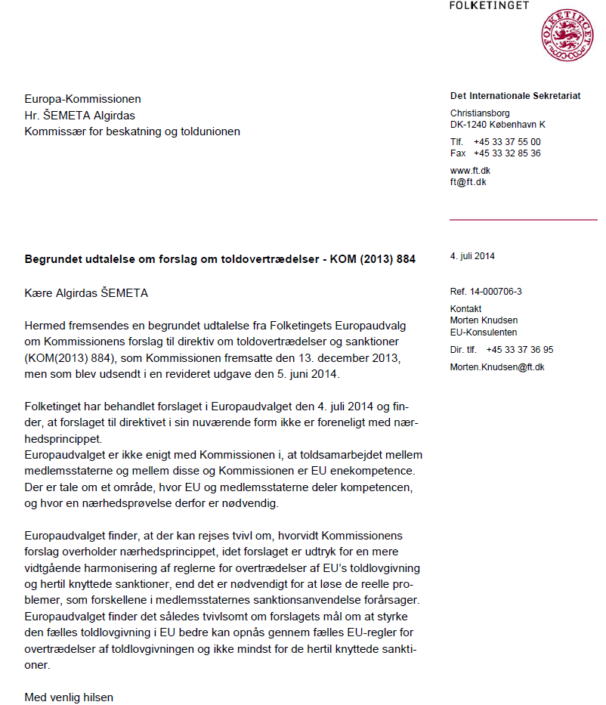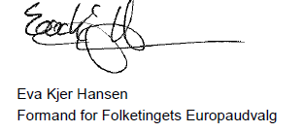

The translation can be found at the Interparliamentary EU information exchange site IPEX at the following address: http://www.ipex.eu/IPEXL-WEB/dossier/document/COM20130884.do

