COMMUNICATION FROM THE COMMISSION TO THE EUROPEAN PARLIAMENT AND THE COUNCIL
Ten Years of Antitrust Enforcement under Regulation 1/2003:
Achievements and Future Perspectives

Introduction
- Regulation 1/2003 was a landmark reform which comprehensively overhauled the procedures for the application of Articles 101 and 102 TFEU ("EU competition rules"). It introduced an enforcement system that is based on the direct application of the EU competition rules in their entirety. It empowered Member States’ competition authorities ("NCAs") and national courts to apply all aspects of the EU competition rules, in addition to the European Commission. It also introduced new, close forms of cooperation between the Commission and NCAs, notably in the framework of the European Competition Network ("ECN").
- To mark ten years of enforcement of Regulation 1/2003, this Communication: (1) provides a facts based review of public enforcement during this period by the Commission and the NCAs; and (2) examines some key aspects of enforcement by the NCAs, in particular institutional and procedural issues, with a view to its further enhancement. It is to be read in conjunction with the accompanying Commission Staff Working Documents which contain a more detailed review.
- The Communication builds on the Report on five years of functioning of Regulation 1/2003. It found that the new system has positively contributed to the stronger enforcement of the EU competition rules, but that some aspects merited further evaluation, such as divergences in procedures and fining powers.

Ten Years of Antitrust Enforcement under Regulation 1/2003
- Regulation 1/2003 has given the Commission greater scope to set its priorities, enabling it to devote more resources to investigating cases and conducting inquiries in key sectors of the economy suffering from market distortions, as well as less conventional forms of anticompetitive behaviour in new sectors, which can be of particular importance to consumers.
- Regulation 1/2003 also equipped the Commission with a renewed set of enforcement powers, including enhanced investigation powers and commitment decisions, which have been regularly employed.
- The new enforcement system largely relies on market players assessing the compatibility of their conduct with the EU competition rules and on targeted ex post enforcement action by competition authorities. In support of this, the Commission has given extensive general guidance to assist undertakings and national enforcers. The Commission had already adopted a set of notices on a range of substantive and procedural matters at the time of the entry into application of Regulation 1/2003. It subsequently adopted revised block exemption regulations and accompanying guidelines concerning the application of Article 101 TFEU to horizontal, vertical and technology transfer agreements. This system of self-assessment framed by the extensive guidance provided by the Commission has worked well and stakeholders have adapted to the new system without major difficulties. Moreover, the Commission issued a guidance paper on its priorities in the application of Article 102 TFEU to exclusionary abuses. It also adopted new guidelines on setting fines, a new leniency notice, a notice on settlements in cartel cases, an information note on inability to pay and a notice on best practices in antitrust cases.
- Regulation 1/2003 has considerably enhanced the enforcement of the EU competition rules by NCAs and national courts. NCAs and national courts not only have the power to apply the EU competition rules in full: they are obliged to do so when agreements or conduct are capable of affecting trade between Member States. These changes have considerably boosted enforcement of the EU competition rules by NCAs. The Regulation also introduced cooperation tools and obligations to ensure efficient work sharing and effective cooperation in the handling of cases and to foster coherent application. Building on these mechanisms, the ECN has developed into a multi-faceted forum for exchanges of experience on the application of substantive competition law as well as on convergence of procedures and sanctions. National courts play an essential role in the private enforcement of the EU competition rules. The Commission has sought to improve the effectiveness of private damages claims brought before national courts and a Directive on antitrust damages actions will be adopted soon.
- There are now multiple enforcers of the EU competition rules, which has led to their much wider application. In the period covered from 1 May 2004 to 31 December 2013, the application of the EU competition rules has grown at a remarkable rate, with approximately 780 cases being investigated by the Commission (122) and the NCAs (665). Enforcement by the NCAs has developed in a broadly coherent manner.
Enforcement decisions - May 2004 to December 2013
COM: 122 NCA: 665
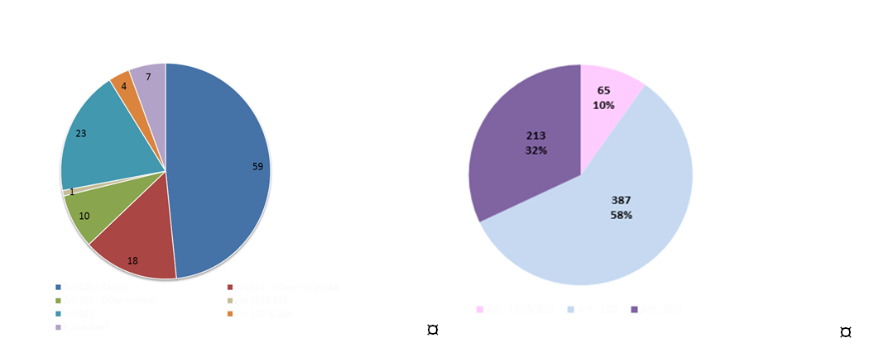
Art 101 – Cartels Art 101 – Other horizontal
Art 101 – Other vertical Art 101&102
Art 102 Art 102&106
Procedural
Art. 101&102 Art 101 Art. 102
- The Commission and the NCAs have prioritised the most serious and harmful anticompetitive practices, in particular, cartels, which account for a substantial proportion of their enforcement record. A sizeable portion of their activities was also dedicated to tackling abuses of dominant position in liberalised markets such as energy, telecom and transport, in particular, practices tending to exclude competitors from the market.
- The considerable joint enforcement record of the Commission and the NCAs is analysed from a number of perspectives: (1) the types of infringements tackled; (2) the sectors on which enforcement has focused; and (3) the type of procedures used.
Enforcement activity by infringement
- The Commission has prioritised the fight against cartels, the most pernicious anti-competitive infringement. For the Commission, this represents almost 48% of its enforcement activity. The Commission and the NCAs have developed and adapted their leniency programmes which are an important tool to detect cartels and have reinforced their capabilities to investigate cartels, in particular through new technologies and means to effectively gather digital data.
- Other horizontal agreements account for 15% of the Commission's enforcement record. The Commission has dealt with practices with significant repercussions for consumers, such as non-compete clauses in the telecoms sector and horizontal price-setting in the payments sector. Vertical agreements represent 9% of the Commission's activities and include anti-competitive restraints between car manufacturers and their after-sales partners aimed at foreclosing independent repairers from the aftersales market.
- Similar to the Commission, the NCAs also concentrated their enforcement efforts on cartels (27%). In addition, the NCAs tackled a significant number of other horizontal practices (19%), including stand-alone exchanges of information where the information exchange did not form part of a broader cartel agreement. The NCAs were also very active in addressing vertical practices (27%), in particular, resale price maintenance, anti-competitive forms of exclusive distribution and exclusive purchasing and restrictions of parallel trade.
- With respect to the application of Article 102 TFEU, this accounts for 20% of the Commission's enforcement record. The main focus has been on exclusionary practices (84%), which foreclose competitors or limit effective competition. The Commission has tackled exclusionary practices such as refusal to deal, rebates, tying/bundling practices, margin squeeze and exclusivity clauses, as well as less conventional forms, such as making payments for the postponement or cancellation of the launch of a competitor's products. Cases involving exploitative abuses (16%), such as excessive prices, were less frequently pursued. Similarly, the majority of NCAs’ envisaged decisions concerned exclusionary abuses (65%). They also tackled a high proportion of cases involving both exclusionary and exploitative abuses (22%) and cases involving exploitative abuses only (15%). Exclusionary practices examined by the NCAs include the full range of classical abuses, as well as less typical forms such as the denigration of competitors’ products. Cases brought by the NCAs against exploitative abuses include excessive pricing by dominant energy producers and excessive tariffs imposed by collecting societies.

Enforcement activity by sector
- A breakdown of the Commission’s and NCAs’ enforcement activities by sector shows that while a broad range of products and services is covered, a number of key sectors have featured prominently.
COM NCAs
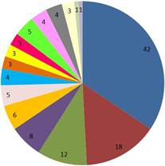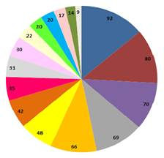

Basic and Manufacturing Industries Payment Systems Pharma / Health Services

Energy Consumer Goods Transport

IT / Internet Consumer electronics Telecoms (Infrastructure) Post

Food / Retail / Agricultural products Other Services Environment

Media (content) Financial Services Liberal Professions
Motor vehicles

- The sector most investigated by the Commission and the NCAs is basic and manufacturing industries (42 and 92 decisions, respectively). This largely reflects the prioritisation of the fight against cartels which have mostly been detected in this sector.
- Both the Commission and the NCAs have concentrated on recently liberalised sectors or sectors in the process of liberalisation, such as telecoms, media, energy and transport, which are often characterised by high market concentration and/or the presence of dominant operators. For example, energy is the second sector with the most decisions (18 and 80 for the Commission and the NCAs respectively).
- The NCAs have been particularly active in the transport (69) and food (70) sectors. Other key areas of enforcement have been media (66), telecoms (48), consumer goods (42), other services (35) and the liberal professions (31). The Commission was very active in the IT sector (12), which is important for the growth of the EU economy and where many of the players have a global reach. The remaining 50 decisions of the Commission are spread across 13 different sectors, with food and retail accounting for the highest number (8).
Enforcement activity by procedure
- For both the Commission and the NCAs, prohibition decisions are the most important means of enforcing the EU competition rules. The use of prohibition decisions by the Commission was facilitated by the introduction of the cartels settlement procedure. Such expedited procedures also exist in a number of Member States.
- Regulation 1/2003 equipped the Commission with an enhanced set of enforcement tools, notably, the ability to take decisions making commitments offered by parties binding and enforceable under Article 9. This power has since been rolled out for virtually all NCAs, meaning that prohibition and commitment decisions are the principal tools used in the ECN.
- The primary purpose of commitment decisions is to preserve effective competition by addressing the potentially anti-competitive practices and to ensure a quick outcome on the market. Commitment decisions allow for the quicker resolution of competition concerns on a more cooperative basis. Such decisions have often been adopted in fast-moving markets and/or in markets that are in the process of liberalisation. Whether an authority follows a particular enforcement route is based on a number of factors. A prohibition decision may be adopted if the case calls for the imposition of fines to sanction past behaviour, if the only remedy available is the cessation of the anti-competitive behaviour or if there is a need for a clear legal precedent. Equally, the use of commitment decisions depends on whether the parties offer effective, clear and precise commitments.
Commitment and Prohibition Decisions
COM NCAs
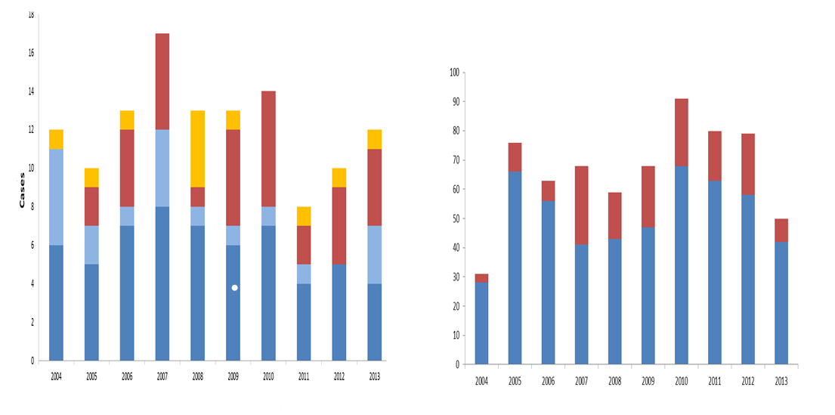

Cartel AT – article 7 AT – article 9 Other
prohibition commitments

Cooperation with national courts
- Under Regulation 1/2003 national courts have become an important arm of application of the EU competition rules. The Regulation foresees a number of mechanisms to promote coherent application by national courts. Under Article 15 national courts can request the Commission's opinion on questions concerning the application of the EU competition rules. From 2004 to 2013 the Commission has provided 26 opinions. The Commission can also participate as amicus curiae in national court proceedings. The Commission has made use of this tool on 13 occasions in eight Member States. The Regulation contains a mechanism by which the Commission is informed of national court judgments but it has not worked optimally.

enhancing competition enforcement by the NCAs: institutional and procedural issues
- Regulation 1/2003 has brought about a landmark change in the way in which EU competition law is enforced. The EU competition rules have to a large extent become the “law of the land” through-out the EU. NCAs have become a key pillar of the application of the EU competition rules. This has meant that the work carried out in the ECN has become increasingly important to ensure coherent enforcement and to allow stakeholders to benefit from a more level playing field.
- After ten years of working together, a substantial level of convergence in the application of the rules has been achieved but divergences subsist. They are largely due to differences in the institutional position of NCAs and in national procedures and sanctions. These issues were largely left open by Regulation 1/2003, subject to the EU law principles of effectiveness and equivalence.
- To enhance EU competition enforcement for the future, the institutional position of NCAs needs to be reinforced while at the same time ensuring further convergence of national procedures and sanctions applying to infringements of EU antitrust rules. Both aspects are key to achieving a truly common competition enforcement area in the EU. This Communication identifies a number of areas in which further progress should be made in the future.
Institutional Position of the NCAs
- EU law leaves Member States a large degree of flexibility for the design of their competition regimes. Despite the lack of specific EU law requirements, the position of the NCAs has evolved in the direction of more autonomy and effectiveness. Many national laws contain specific safeguards to ensure the independence and impartiality of NCAs. For instance, recent reforms in Cyprus, Ireland, Greece and Portugal have strengthened the position of the NCAs. Reforms have been recommended in other Member States to strengthen the institutional position and resources of NCAs in the framework of the European Semester. The Commission has closely followed instances where NCAs were merged with other regulators. Such amalgamation of competences should not lead to a weakening of competition enforcement or a reduction in the means assigned to competition supervision.
- To ensure the effective enforcement of the EU competition rules, NCAs should be independent when exercising their functions and should have adequate resources. Challenges in this regard still persist, in particular concerning the autonomy of NCAs vis-à-vis their respective governments, and appointments and dismissals of NCA management or decision-makers. Issues have also arisen with regard to ensuring sufficient human and financial resources. This is reflected in the ECN Resolution of Heads of Authorities on the continued need for effective institutions which was adopted against the backdrop of cuts in the resources of several authorities. The Resolution underlined, inter alia, the need for appropriate infrastructure and expert resources.
- Furthermore, the achievements made to date remain fragile and can be rolled back at any time. This can be contrasted with related policy areas, such as the telecoms, energy and railway sectors, where EU law already provides for a number of requirements regarding independence, financial and human resources of the national supervisory authorities.
- It is necessary to ensure that NCAs can execute their tasks in an impartial and independent manner. For this purpose, minimum guarantees are needed to ensure the independence of NCAs and their management or board members and to have NCAs endowed with sufficient human and financial resources. Important aspects in this respect are the grant of a separate budget with budgetary autonomy for NCAs, clear and transparent appointment procedures for the NCA's management or board members on the basis of merit, guarantees ensuring that dismissals can only take place on objective grounds unrelated to the decision-making of the NCA and rules on conflicts of interest and incompatibilities for the NCA's management or board.
Convergence of procedures
- The procedures for the application of the EU competition rules by NCAs are largely governed by national law, subject to general principles of EU law, in particular the principles of effectiveness and equivalence. This means that NCAs apply the EU competition rules on the basis of different procedures.
- Many Member States have voluntarily aligned their procedures to a greater or lesser extent with the procedural rules set out for the Commission in Regulation 1/2003. Multilateral work within the ECN has been a catalyst in promoting greater convergence. By way of follow-up to the 2009 Report, seven ECN Recommendations on key enforcement powers were endorsed in 2013. These Recommendations are intended to serve as advocacy tool which NCAs can use vis-à-vis policymakers to help ensure that they are equipped with an effective competition toolkit.
- Currently, differences still subsist throughout the EU. While most NCAs now have the same main working tools as the Commission, some still lack fundamental powers, such as to inspect non-business premises. Not all NCAs have express powers to set their enforcement priorities, i.e. to choose which cases to investigate. There are also differences in the scope of investigative powers, e.g. NCAs may have the power to inspect but they cannot seal premises or effectively gather digital evidence. Similarly, all NCAs have the power to adopt prohibition decisions but some cannot impose structural remedies. Some NCAs cannot effectively sanction non-compliance with a commitment decision or enforce their powers to inspect.
- The ECN Recommendations are very useful in practice but where procedural differences are rooted in national legal regimes and traditions, convergence cannot always be achieved by such soft tools. Moreover, achievements made in terms of securing convergence can always be rolled back. Differences in procedural rules lead to legal costs and uncertainty for undertakings operating cross-border.
- It is necessary to ensure that all NCAs have a complete set of powers at their disposal, which are comprehensive in scope and are effective. Important elements are the core investigative powers, the right of NCAs to set enforcement priorities, key decision-making powers and the necessary enforcement and fining powers to compel compliance with investigative and decision-making powers.
Enhancing the effectiveness of sanctions
a. Fines
- EU law does not regulate or harmonise sanctions for breach of the EU antitrust rules. It is for the Member States to ensure that they provide for sanctions which are effective, proportionate and dissuasive. Whatever sanctions a jurisdiction applies, it is generally recognised that antitrust enforcement cannot be effective if it is not possible to impose deterrent civil/administrative fines on undertakings.
- Sustained attention to having effective fines has helped to achieve a high level of voluntary convergence, with many NCAs operating a similar basic methodology for setting fines. Divergences still exist with regard to the underlying principles of the fines calculation, such as the base used for calculating the basic amount of the fine and the method for taking into account gravity and duration.
- More upstream, fundamental issues concerning the potential addressees of a fine and liability issues pose problems. Firstly, in one Member State it is currently not possible to impose deterrent civil/administrative fines on undertakings. Secondly, the basic concept of "undertaking" used for the calculation of the fine is not always convergent with the EU law concept of undertaking as interpreted by the EU Courts, which may have consequences for establishing parental liability and economic succession. Furthermore, some NCAs still lack the power to impose fines on associations of undertakings. Finally, the legal maximum of the undertaking's turnover is construed and applied differently in some Member States. Differences of the types cited can lead to very divergent outcomes in terms of fines, some of which may not achieve the desired deterrent effect.
- To make enforcement of the EU antitrust rules more convergent and effective throughout the EU, it is necessary to ensure that all NCAs have effective powers to impose deterrent fines on undertakings and on associations of undertakings. Important aspects in this regard are ensuring that NCAs can impose effective civil/administrative fines on undertakings and associations of undertakings for breaches of the EU competition rules; ensuring that basic fining rules are in place taking into account gravity and duration of the infringement and foreseeing a uniform legal maximum; and ensuring that fines can be imposed on undertakings, in line with the constant case law of the EU courts, in particular, on issues such as parental liability and succession. Any measures taken to this end would need to find the right balance between increased convergence of the basic rules for fines and an appropriate degree of flexibility for NCAs when imposing fines in individual cases.
b. Leniency
- The ECN Model Leniency Programme (MLP) is a good illustration of how the ECN is able to develop effective policy tools. The MLP sets out how to design a state-of-the-art leniency programme. This has been a major catalyst in encouraging virtually all Member States and/or NCAs to introduce and develop their own leniency policies. There has been a significant degree of alignment with the MLP and work is on-going to implement the refinements made in the 2012 revision of the MLP.
- A well-designed leniency programme is an essential tool for enhancing effective enforcement against the most serious infringements, in particular secret price-fixing and market-sharing cartels. However, there is no requirement at EU level to have a leniency programme in place and the exemplary level of convergence can always be put into question. It is necessary to ensure that the achievements made in leniency programmes are secured.
c. Interface of corporate leniency programmes with sanctions on individuals
- The majority of Member States provide for sanctions to be imposed on individuals for breaches of competition law, over and above fines on undertakings. If such systems do not provide for leniency for the employees of undertakings which are considering applying for corporate leniency, this may lead to disincentives to cooperate with authorities EU-wide. The threat of investigations and sanctions targeted at employees may deter potential corporate applicants from applying.
- Currently, sufficient arrangements to protect employees of undertakings from individual sanctions if they cooperate under the corporate leniency programme of a NCA or the European Commission exist only in a few jurisdictions. It is appropriate to consider possibilities to address the issue of interplay between corporate leniency programmes and sanctions on individuals that exist at Member State level.

Conclusion
- Regulation 1/2003 has transformed the competition enforcement landscape. The enforcement of the EU competition rules has considerably increased as a result of the achievements of the Commission, the ECN and the NCAs. The Commission has a strong enforcement record, investigating an important number of cases and carrying out inquiries in key sectors of the economy. It has also provided guidance for stakeholders, NCAs and national courts. There has been a dynamic development of close cooperation within the ECN, which has underpinned the coherent application of the EU competition rules throughout the EU. NCAs have become a key pillar of the application of the EU competition rules and have considerably boosted enforcement.
- All of these elements have contributed to the effective enforcement of the EU competition rules throughout the last decade. Competition has helped to create a wider choice for consumers of better-quality products and services at more competitive prices. It plays a key role in creating the conditions to boost the productivity and efficiency of European firms, a crucial factor to enable the EU economy to be more competitive and move towards sustainable growth.
- However, it is important to build on these achievements to create a truly common competition enforcement area in the EU.
- To this end, it is necessary, in particular, to:
- further guarantee the independence of NCAs in the exercise of their tasks and that they have sufficient resources;
- ensure that NCAs have a complete set of effective investigative and decision-making powers at their disposal; and
- ensure that powers to impose effective and proportionate fines and well-designed leniency programmes are in place in all Member States and consider measures to avoid disincentives for corporate leniency applicants.
The Commission will further assess appropriate initiatives to best achieve these goals.

Council Regulation (EC) No 1/2003 of 16 December 2002 on the implementation of the rules on competition laid down in Articles 81 and 82 of the Treaty (OJ 2003 L1, 4.1.2003, p.1).
Communication from the Commission to the European Parliament and the Council, Report on the functioning of Regulation 1/2003 COM(2009) 206 final and the accompanying Staff Working Paper SEC(2009) 574 final ("2009 Report").
See the Internet (http://ec.europa.eu/competition/antitrust/legislation/legislation.html).
See the Internet (http://ec.europa.eu/competition/antitrust/actionsdamages/documents.html).
The Commission has received very few national court judgments deciding on the application of the EU competition rules.
Such changes were underpinned by the Economic Adjustment Programmes.
Communication from the Commission to the European Parliament, the Council, the European Economic and Social Committee and the Committee of the Regions, 2014 European Semester: Country-specific recommendations, COM(2014) 400 final.
See the Internet (http://ec.europa.eu/competition/ecn/ncas.pdf).
See the Internet (http://ec.europa.eu/competition/ecn/documents.html).
See the Internet (http://ec.europa.eu/competition/ecn/documents.html).

