Table of Contents
1. Introduction 4
2. Fund Management report 4
2.1. Development of the Fund in 2013 4
2.2. Situation of the Fund 5
2.2.1. Contributions as at 31 December 2013 5
2.2.2. The Fund’s holdings net of accrued interest at 31 December 2013 5
2.3. General and segmental analyses of the Fund 6
2.3.1. Liquidity analysis 6
2.3.2. General analysis of the results of the Fund 7
2.3.3. Analysis by segment 7
2.4. Benchmarking, performance and interest rate risk analysis 13
2.4.1. Benchmarking 13
2.4.2. Performance 15
2.4.3. Interest rate risk 15
3. Fund Financial Statements as at 31 December 2013 16
3.1. Economic Outturn Account For the year ended 31 December 2013 16
3.2. Balance sheet as at 31 December 2013 17
3.3. Statement of changes in contributors' resources for the year ended 31 December 2013 (in EUR) 18
3.4. Cash Flow statement for the year ended 31 December 2013 19
3.5. Notes to the financial statements 20
3.5.1. General disclosures 20
3.5.2. Significant accounting policies 20
3.5.3. Financial Risk Management 24
3.5.4. Available for Sale portfolio 32
3.5.5. Other short term receivables 32
3.5.6. Cash and Cash Equivalents 33
3.5.7. Contributions 33
3.5.8. Current Liabilities 34
3.5.9. Financial operations revenues 34
3.5.10. Financial operations expenses 34
3.5.11. Subsequent events 34

1. Introduction
According to the Article 7 of the Guarantee Fund Regulation, the assets of the Guarantee Fund (the "Fund") are managed by the EIB (the "Bank"). The agreement signed between the European Commission (the "Commission") and the Bank defines the principles governing the management of assets.
Under Article 8(2) of the Agreement, at the beginning of March of each year the Bank has to send the Commission an annual status report on the Fund and the management thereof and the financial statements of the Fund for the preceding year.
The management report on the Fund is presented in the section 2 of this Commission Staff Working Document (SWD). The financial statements audited by an external auditor are included in section 3.

2. Fund Management report

2.1. Development of the Fund in 2013
As at 31 December 2013 total assets (excluding accrued interest) of the Fund amounted to EUR 1,987.4 million against EUR 2,002.9 million as at 31 December 2012, a decrease of EUR 15.5 million.
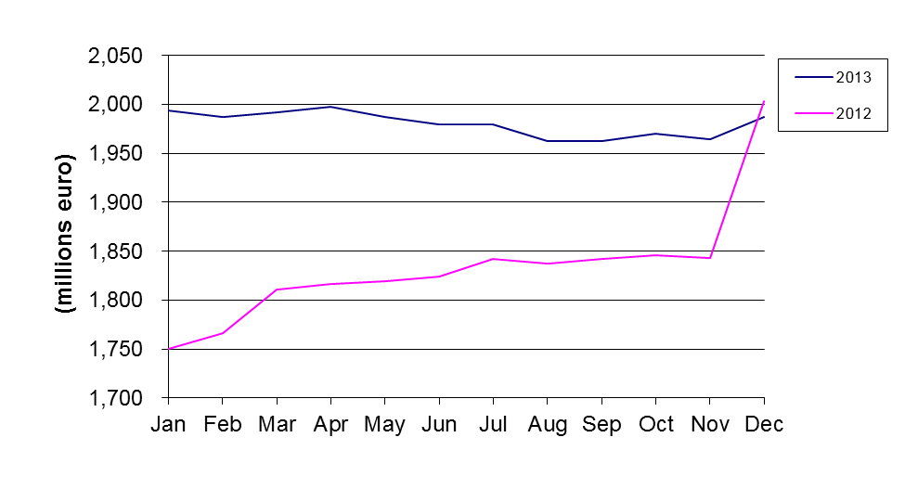
Fig.1: Development of total assets in 2013 and 2012

The net operating result amounted to EUR 31.94 million at 31 December 2013 compared with EUR 43.99 million at 31 December 2012 representing a decrease of 27.4%.

2.2. Situation of the Fund

2.2.1. Contributions as at 31 December 2013

2.2.1.1. Contributions paid in as at 31 December 2013
The net contributions paid into the Fund by the European Union budget increased by EUR 64.7 million or 6.7% from EUR 965.4 million at 31 December 2012 to EUR 1,030.1 million at 31 December 2013.
This is explained by the movements shown in the following table:
Contributions paid in (in EUR) | Situation at 31/12/2012 | Movements in 2013 | Situation at 31/12/2013
Provisioning | 3,389,825,163 | 155,660,000 | 3,545,485,163
Repayment of surplus | -1,775,870,000 | 0 | -1,775,870,000
Activation of guarantee calls | -501,883,829 | -60,628,847 | -562,512,676
Recovery of historic called amounts | 578,854,354 | 0 | 578,854,354
Repayment of funds | -725,521,527 | -30,335,186 | -755,856,713
Balance | 965,404,161 | 64,695,967 | 1,030,100,128

2.2.1.2. Contributions payable and receivable as at 31 December 2013
As at 31 December 2013 the Fund has recorded EUR 22.2 million (2012: EUR 18.0 million) as contribution payable representing the provisioning for three guarantee calls made by the Bank in 2013 with regard to Syrian loan defaults (2012: two guarantee calls). In addition, as at 31 December 2013 the Fund has recorded EUR 58.4 million (2012: EUR 155.7 million) as contributions to be paid in by the European Union.

2.2.2. The Fund’s holdings net of accrued interest at 31 December 2013
The Fund’s holdings at 31 December 2013 excluding accrued interest and contributions receivable totalled EUR 1,929.0 million as detailed below:
- EUR 150.9 million in the monetary portfolio (nominal value of interbank term deposits);
- EUR 1.2 million in the current accounts;
- EUR 1,776.9 million in the Available For Sale (AFS) (portfolio market value of fixed rate bonds, floating rate bonds, inflation linked bonds and zero-coupon bonds, excluding accrued interest).
The Fund operates in one currency only, the Euro.

2.3. General and segmental analyses of the Fund

2.3.1. Liquidity analysis
The liquidity position of the Fund at 31 December 2013 is outlined in the table below. The liabilities shown in the column "maturity undefined" represent the Contributor's (i.e. European Union's) resources.
Liquidity position as at 31 December 2013 (in EUR million):

Maturity | less than 3 months | 3 months to 1 year | 1 to 10 years | maturity undefined | Total
Total Assets | 385 | 187 | 1,432 | 0 | 2,004
Total contributors’ resources | 0 | 0 | 0 | 1,981 | 1,981
Total Liabilities | 23 | 0 | 0 | 0 | 23
Total contributors’ resources and liabilities | 23 | 0 | 0 | 1,981 | 2,004

2.3.2. General analysis of the results of the Fund
Overall, during the reporting period 1 January 2013 to 31 December 2013 the Fund achieved EUR 31.94 million in net revenue. The following table outlines the net revenue earned in 2013 and compares it with 2012:
In EUR million | From 1 January to  31 December 2013 |  | From 1 January to  31 December 2012
Interest income on cash & cash equivalents | 0.21 | 0.7% | 2.15 | 4.9%
Interest income on AFS assets | 31.30 | 98.0% | 36.87 | 83.9%
Realised gain on sale of AFS assets | 1.36 | 4.2% | 8.60 | 19.5%
Income from securities lending activity | 0.08 | 0.3% | 0.10 | 0.2%
Realised loss on sale of AFS assets | 0.00 | 0.0% | -2.78 | -6.3%
Commission and other charges | -1.01 | -3.2% | -0.95 | -2.2%
Total | 31.94 | 100.0% | 43.99 | 100.0%

2.3.3. Analysis by segment

2.3.3.1. Analysis of money market operations
Money-market investments (excluding accrued interest) amount to EUR 152.1 million at 31 December 2013, as compared to EUR 250.1 million the year before.
- Evolution of money-market rates in 2013

Market sentiment in 2013 was, as in 2012, still affected by recurring fears of recession everywhere in the developed markets, linked with a slowdown from emerging markets. Growth prospects at the beginning of the year were described as “weak” and the road to recovery as “long and arduous”.
In May the European Central Bank (ECB) cut interest rates for the first time in 10 months and held out the possibility of further policy action to support the recession-hit euro zone economy. Responding to a drop in euro zone inflation well below its target level and rising unemployment, the ECB lowered its main rate by a quarter percentage point to a record low 0.50 percent.
The following months progressed with market’s speculations about further cuts from the ECB given the not so positive macro data releases. On the other hand, the ECB itself was confirming to stand ready to act, if deemed necessary, and to analyse other non-conventional measures.
In November, the ECB lowered benchmark interest rate to a new record low 0.25 percent, maybe a little earlier than market thought and likely in reaction to softening data, and strengthening Euro. In justifying the move, the ECB commented that it continued to expect a gradual recovery but risks to the economic outlook remained to the downside. It also expected underlying price pressure to remain subdued. In the European Central Bank's (ECB)view, risks to inflation remained broadly balanced over the medium term.
The whole year 2013 was in general characterized by excess liquidity in the system to alleviate market pressures on sluggish growth, a situation which kept rates at extremely low levels.
Figure 2 shows the evolution of the one-and three-month Euribor during 2013.
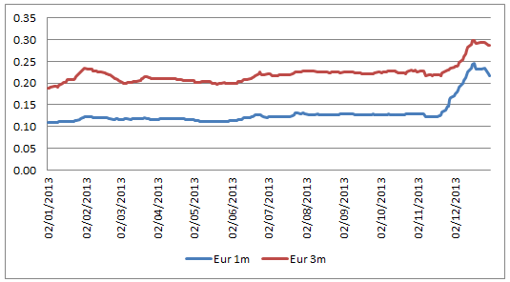
Fig. 2: Evolution of Money Market rates during 2013 (source Reuters)

- Profile of counterparties
In accordance with the agreement between the European Union and the Bank on the management of the Fund, all banks with which deposits are placed should have a minimum short-term credit rating of P-1 (Moody's or equivalent). The breakdown, including accrued interest, is as follows:

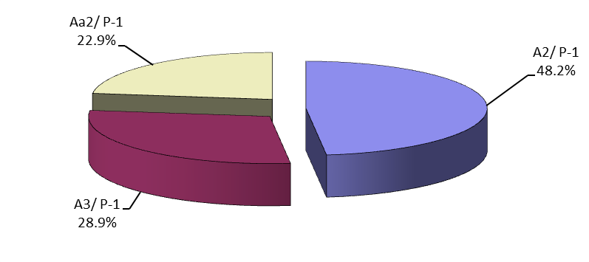

Fig. 3: Short term interbank investments by profile of counterparty at 31 December 2013

- Geographical breakdown
As regards the diversification of counterparty location, despite the credit limit cut for Italian and Spanish banks, the Bank is pursuing its objective of geographical distribution throughout the countries of the European Union and complying with the internal credit limits that make these counterparties available. This allows searching for better market on a risk-return basis.

2.3.3.2. Analysis of bond portfolio results
The bond portfolio, seen as a long-term investment portfolio, is made up of euro-denominated securities initially acquired with the intention of holding them until maturity. In the Fund’s Financial Statements these securities are classified as Available for Sale (AFS) in line with the Commission accounting rule 11. At 31 December 2013, the market value (excluding accrued interest) of fixed rate securities with a residual period to maturity of less than three months amounted to EUR 80.8 million, between 3 months and one year EUR 128.9 million and between one and 10 years EUR 819.9 million.
The starting value of the securities in this portfolio is the acquisition cost. The difference between the entry price and the redemption value is the premium/discount spread, which is amortised over the remaining life of each of the securities using the effective interest rate method as specified in the Commission accounting rules.
At 31 December 2013, the nominal value of the investment bond portfolio was EUR 1,739.8 million, against a clean market value of EUR 1,776.9 million.
The global (modified) duration of the bond portfolio decreased over 2013 to reach 1.53 years at the end of the year. As of 31 December 2013, the clean market value of the investment bond portfolio came to EUR 1,776.9 million (2012: EUR 1,596.6 million) compared with a book value (including premiums/discounts) of EUR 1,740.2 million (2012: EUR 1,542.9 million), which gives an unrealised fair value result of EUR +36.7 million (2012: EUR +53.7 million).

With the combined effects of the improvement of the eurozone’s economic environment and the Federal Reserve’s tapering, German long rates started a gradual rise in Q4 2013 across the curve as shown in figure 4.
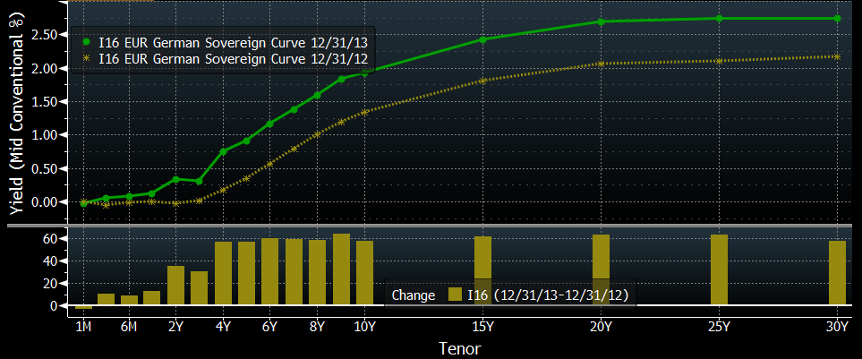

Fig. 4: Euro sovereign yield declined during 2013 (Source Bloomberg)

In line with the 2013 approved investment strategy and in compliance with the guidelines, a total nominal amount of EUR 481.8 million (including the inflows) was invested in fixed and floating rate sovereign, supranational and agency debt (SSA) (56%), covered bonds (36%) and corporate bonds (8%) within allowed maturities either on an outright or switch basis, both in the primary and secondary markets. All of the transactions were done to meet the overall objectives of the portfolio. The charts below outline the total 2013 investments as well as the country diversification of the portfolio investments added during 2013.

Fig. 5: Investments during 2013
Fig. 6: Country exposure

As of 1 January 2013, a total nominal amount of EUR 263 million of redemptions on the long-term portfolio was scheduled for the year with EUR 174 million of fixed rate bonds and EUR 89 million of Floating Rate Notes. At the end of 2013, the remaining exposure (based on nominal values and by
issuer country name) to Greece, Ireland and Portugal accounted for EUR 17 million (GR), EUR 30 million (IE) and EUR 16 million (PT) respectively, whereas the less exposed countries like Italy and Spain amounted to EUR 57.5 million (IT) and EUR 27.5 million (ES) respectively.
The 2013 asset allocation did not deviate significantly from the 2012 strategy as the quest for yield was decisive in the relative performance of asset classes, along with country of origin.
In terms of asset classes, the 2013 strategy foresaw an increase of the share of FRN bonds, covered bonds, SSA’s, small allocations to corporates and inflation-linked bonds as detailed below.
In order to stabilize the performance of the portfolio within an environment of increasing yields of high quality assets, leading to an underperformance of fixed rate bonds, investments in the FRN format were continued. The 2013 purchases of FRNs amounted to EUR 281 million in total or 58% versus EUR 200.8 million or 42% in fixed rate bonds. They were spread among different asset classes as depicted in figure 5 above. As regards the country diversification, Germany was favoured with EUR 63 million or 22%, France 21%, The Netherlands 12%, Belgium and Australia 9%, Norway, the Czech Republic, Slovenia, Slovakia and Luxembourg 4%, Denmark 3%, whereas Sweden and Finland accounted for 2% each as depicted in figure 6 above.
The covered bond purchases amounted to a total sum of EUR 171.8 million, spread with a view of good diversification among a variety of jurisdictions offering the best risk/reward such as France, Germany, Netherlands, the Nordic Countries, Australia, New Zealand and United Kingdom. Particular emphasis has been put on pursuing investment opportunities out of Eurozone (National Bank of Canada, The Royal Bank of Scotland or New Zealand BNZ International Funding) and – in case of Eurozone issuers – on staying within the safest Pfandbrief and in general northern universe, avoiding more volatile issuers in current market environment. The few purchases of French and Belgium covered bonds have been made on opportunistic basis due to an attractive yield offered by respective papers (La Banque Postale (FR) and Belfius Banque (BE)).
Due to their liquidity and generally high credit quality, SSA assets formed with EUR 270 million the bulk of the 2013 investments. The strongest jurisdictions have been favoured. It is worth mentioning however that for diversification purposes, also new jurisdictions have been considered, such as Slovakia, Slovenia and the Czech Republic.
In line with last year’s strategy, a small portion of corporates/financials (Rabobank) have been purchased. They can be seen as the best source of diversification, however there are relatively few of them being in line with the credit requirements of the asset management guidelines.
No additional investments in inflation-linked bonds were pursued due to the unexpected rapid decline of inflation and the emergence of deflation talk in the euro area rising towards the end of 2013.
In 2013, agencies and supranational institutions suffered a wave of downgrades. French and Dutch agencies, along with the EFSF, saw their ratings lowered by one notch by S&P and Fitch in the wake of their respective sovereign downgrades. The rating agencies actions however had no impact on the portfolio’s holdings and did not trigger mandatory sales.
In order to improve the average yield carry of the portfolio, a few German, French and Danish government papers and covered bonds of relatively short maturities, whose yield approached the 0% yield level, have been sold.

- Breakdown of the investment portfolio between fixed rate and variable rate securities (nominal value)
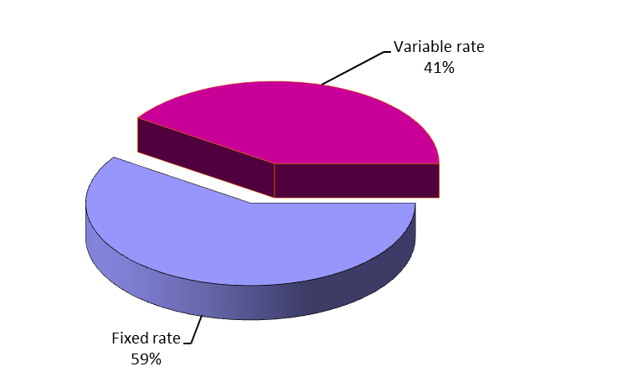
Fig. 7: Investment portfolio breakdown between fixed3 and variable rate securities at 31 December 2013

- Redemption profile of investment portfolio (nominal value)
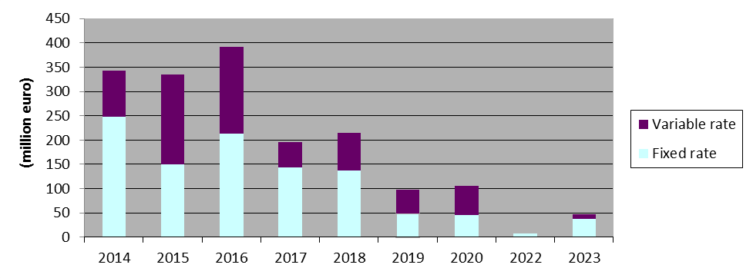
Fig.8: Investment portfolio: Redemption profile at 31 December 2013
The latest final maturity date for fixed rate securities is 5 September 2023.
- Profile of issuers
All the securities held in the portfolio are in line with the management guidelines and meet the following criteria for:
- Securities issued or guaranteed by Member States4: minimum rating Baa3;
- Securities issued by a Supranational, other States or Public Company: minimum rating Aa2;
- Covered Bonds or other legal bodies (including structured products): minimum rating Aaa;
- Securities issued by Banks and Corporates: minimum rating Aa2.
The profile of issuers by issuer type and long term rating5 of the investment portfolio (nominal amount) at 31 December 2013 is as follows:
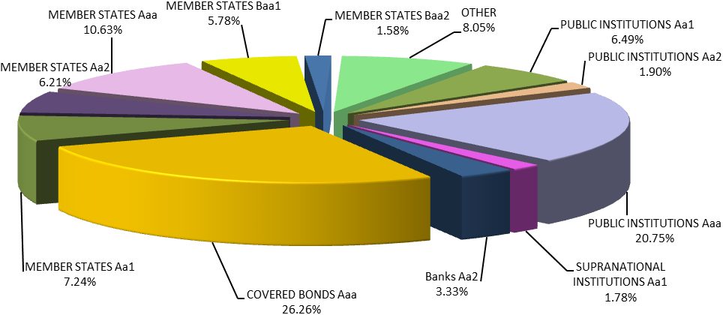
Fig.9: Investment portfolio: Profile of issuers at 31 December 20136

2.4. Benchmarking, performance and interest rate risk analysis

2.4.1. Benchmarking
The performance of the Fund is monitored on a marked-to-market (MTM) basis against a composite index. This index is the result of the combination of the following sub-indices:
- Euribid 1M for money-market operations
- Euribid 3M for floating rate notes and fixed rate bond with less than one year to maturity
- IBOXX EUR Sovereign indices for fixed rate bonds issued by sovereign (or similar) issuers, split by maturity buckets
- IBOXX EUR Collateralized Covered indices for fixed rate bonds issued by corporate (or similar) issuers, split by maturity buckets
Index weightings are based on portfolio composition and are reviewed:
- at each end-month day: the dates which define the time buckets (up to 1y, from 1y to 3y, from 3y o 5y, from 5y to 7y and from 7y to 10y) are updated. As a consequence, the shifts between buckets due to the aging of existing positions are accounted only once per month at end-month, following the same procedure underlying the managing of the IBOXX’s indexes;
- during the month, whenever a change higher then ±5% in one of the asset-classes (respect to the last benchmark’s adjustment) is observed. This change can be the result of:
- the impact of a contribution from the Commission to the portfolio (external cash flows from the Commission);
- the impact of a withdrawal from the portfolio to the Commission (external cash flows to the Commission);
- the impact of a transaction settled (sales and purchases);
- the impact of a redemption;
- the sum of the impacts of previous events accumulated from the last benchmark’s adjustment, taking also into consideration the changes in the clean values of the positions.

Bucket (years) | Performance Benchmark Sector |  | Instrument |  | Average Clean Market Value Composition of 2013
0-1 |  | 1 m |  | Money Market |  | 14.5%
 |  | 3 m |  | FRN and Fixed Rate Bonds |  | 42.7%
1-3 |  | sovereign |  |  |  | 5.4%
 |  | covered bonds |  |  |  | 5.0%
3-5 |  | sovereign |  | Fixed |  | 2.0%
 |  | covered bonds |  | Rate |  | 0.7%
5-7 |  | sovereign |  | Bonds |  | 12.8%
 |  | covered bonds |  |  |  | 11.9%
7-10 |  | sovereign |  |  |  | 4.2%
 |  | covered bonds |  |  |  | 0.8%
Total |  |  |  |  |  | 100%

2.4.2. Performance
The performance of the Fund portfolio was monitored on a marked-to-market basis. During 2013, the portfolio delivered a 0.7914% MTM yearly return, underperforming its benchmark by -33.71 bps. The evolution of the portfolio return and excess return vis-à-vis its benchmark is presented in the following table:
 | Portfolio |  |  |  | Out-performance
 | Market Value (including accrued interest) | Monthly return (absolute return in %) | YTD return (absolute return in %) |  | Monthly  Excess Return compared to benchmark (in%) | YTD  Excess Return (in%)
31/01/2013 | 1,857,208,927 | -0.3326 | -0.3326 |  | -0.2434 | -0.2434
28/02/2013 | 2,004,674,040 | 0.3717 | 0.0379 |  | 0.1097 | -0.1347
31/03/2013 | 2,007,384,259 | 0.1053 | 0.1432 |  | -0.0323 | -0.1672
30/04/2013 | 2,012,765,616 | 0.4270 | 0.5708 |  | -0.0984 | -0.2666
31/05/2013 | 2,002,292,900 | -0.1077 | 0.4624 |  | 0.0382 | -0.2278
30/06/2013 | 1,994,416,344 | -0.3516 | 0.1092 |  | 0.0179 | -0.2090
31/07/2013 | 1,993,773,267 | 0.2179 | 0.3274 |  | 0.0020 | -0.2074
31/08/2013 | 1,977,497,672 | -0.0680 | 0.2592 |  | -0.0366 | -0.2440
30/09/2013 | 1,978,345,758 | 0.2092 | 0.4689 |  | -0.0166 | -0.2612
31/10/2013 | 1,984,987,075 | 0.3357 | 0.8062 |  | -0.0340 | -0.2963
30/11/2013 | 1,979,916,318 | 0.1456 | 0.9529 |  | -0.0146 | -0.3115
31/12/2013 | 1,946,455,697 | -0.1600 | 0.7914 |  | -0.0258 | -0.3371

2.4.3. Interest rate risk
The interest rate risk sensitivity of the MTM value of the portfolio mainly stems from its fixed rate exposure. A 1bp increase of interest rates reduces the value of the portfolio by EUR 298,123 of which EUR 285,264 is related to the fixed rate bond exposure. The global modified duration of the fund decreased during 2013 and stood at 1.53 years as of 31 December 2013, compared to 1.64 years as of 31 December 2012.

GF Sub- Portfolios | Market Value (excluding accrued interest) | Modified Duration (Years) | Interest Rate Exposure (+/-1bp)
Floating Rate Notes | 707,245,666 | 0.16 | -/+ 11,660
Fixed Rate Bonds | 1,029,643,817 | 2.73 | -/+ 285,264
Money Market Instruments | 190,866,970 | 0.06 | -/+ 1,199
Cash account | 1,266,7977
Total GF | 1,929,023,250 | 1.53 | -/+ 298,123

3. Fund Financial Statements as at 31 December 2013

3.1. Economic Outturn Account For the year ended 31 December 2013

 | Notes | From | From
 | Notes | 01.01.2013 | 01.01.2012
 | Notes | to 31.12.2013 | to 31.12.2012
 | Notes | EUR | EUR
Financial operations revenues | 9
Interest income |  | 31,507,572.30 | 39,022,011.60
Interest income on cash and cash equivalents |  | 208,412.77 | 2,152,817.58
Net interest income on Available for Sale portfolio |  | 31,299,159.53 | 36,869,194.02
Realised gain on sale of Available for Sale portfolio |  | 1,364,029.81 | 8,596,018.53
Income from securities lending activity |  | 83,827.76 | 104,765.51
Financial operations expenses | 10
Realised loss on sale of Available for Sale portfolio |  | 0.00 | -2,781,347.56
Other financial charges |  | -1,014,843.31 | -951,832.57
Thereof: Management fees |  | -841,299.43 | -805,306.70
ECONOMIC RESULT OF THE YEAR |  | 31,940,586.56 | 43,989,615.51
Items directly recognised in contributors’ resources
Net change in fair value of Available for Sale portfolio |  | -15,411,253.21 | 91,322,572.14
Net amount transferred to profit or loss |  | -1,604,945.84 | -3,443,811.19
 |  | -17,016,199.05 | 87,878,760.95
NET RESULT RECOGNISED IN  CONTRIBUTORS’ RESOURCES |  | -17,016,199.05 | 87,878,760.95

3.2. Balance sheet as at 31 December 2013
ASSETS | Notes | 31.12.2013 | 31.12.2012
 |  | EUR | EUR
NON-CURRENT ASSETS
Available for Sale portfolio | 4
Available for Sale portfolio – cost |  | 1,394,349,787.68 | 1,277,457,029.68
Available for Sale portfolio – actuarial difference |  | 2,830,052.94 | 1,937,127.51
Available for Sale portfolio – adjustment to fair value |  | 35,027,112.52 | 52,128,946.59
Total Available for Sale portfolio |  | 1,432,206,953.14 | 1,331,523,103.78
CURRENT ASSETS
Available for Sale portfolio | 4
Available for Sale portfolio – cost |  | 345,762,688.23 | 265,916,314.50
Available for Sale portfolio – actuarial difference |  | -2,717,150.48 | -2,383,541.31
Available for Sale portfolio – adjustment to fair value |  | 1,635,647.34 | 1,540,460.39
Available for Sale portfolio – accrued interest |  | 16,933,098.26 | 18,974,631.18
Total Available for Sale portfolio |  | 361,614,283.35 | 284,047,864.76
Short-term receivables
Contributions receivable |  | 58,432,294.00 | 155,660,000.00
Other short term receivables | 5 | 0.00 | 601,389.32
Total Short-term receivables |  | 58,432,294.00 | 156,261,389.32
Cash and cash equivalents | 6
Current accounts |  | 1,222,298.07 | 8,074,235.40
Short-term deposits – nominal |  | 150,872,000.00 | 242,000,000.00
Accrued interest on short-term deposits |  | 8,814.35 | 19,608.74
Total cash and cash equivalents |  | 152,103,112.42 | 250,093,844.14
Total current assets |  | 572,149,689.77 | 690,403,098.22
TOTAL ASSETS |  | 2,004,356,642.91 | 2,021,926,202.00
CONTRIBUTORS’ RESOURCES AND LIABILITIES | Notes | 31.12.2013 | 31.12.2012
 |  | EUR | EUR
CONTRIBUTORS’ RESOURCES
Contributions | 7
Net contributions paid in |  | 1,030,100,127.55 | 965,404,160.88
Contributions payable as guarantee call |  | -22,191,713.04 | -17,982,385.53
Contributions allocated but not yet paid in |  | 58,432,294.00 | 155,660,000.00
Reserves
Available for Sale reserve - First Time Application |  | 2,313.96 | 11,865.89
Available for Sale reserve |  | 36,662,759.86 | 53,669,406.98
Accumulated surplus
Results brought forward |  | 846,343,661.55 | 802,354,046.04
Economic result of the year |  | 31,940,586.56 | 43,989,615.51
Total Contributors’ resources |  | 1,981,290,030.44 | 2,003,106,709.77
CURRENT LIABILITIES | 8
Accounts Payable
Guarantee call payable | 7 | 22,191,713.04 | 17,982,385.53
Others |  | 874,899.43 | 837,106.70
Total Current Liabilities |  | 23,066,612.47 | 18,819,492.23
TOTAL CONTRIBUTORS’ RESOURCES AND LIABILITIES |  | 2,004,356,642.91 | 2,021,926,202.00

3.3. Statement of changes in contributors' resources for the year ended 31 December 2013 (in EUR)
 | Notes | Contributions | Reserves |  | Accumulated Surplus | Economic Result of the year | Total  contributors’ resources
 |  | Contributions | First Time Application Available for Sale reserve | Available for Sale  reserve | Accumulated Surplus | Economic Result of the year | Total  contributors’ resources
Balance as at 01.01.2012 |  | 987,277,788.12 | -7,630.95 | -34,189,857.13 | 760,201,245.08 | 42,152,800.96 | 1,755,434,346.08
Contributions from the Commission allocated but not yet paid | 7 | 155,660,000.00 | 0.00 | 0.00 | 0.00 | 0.00 | 155,660,000.00
Contributions paid to the Bank as guarantee call net of recovered amounts | 7 | -21,873,627.24 | 0.00 | 0.00 | 0.00 | 0.00 | -21,873,627.24
Change of contributions payable as guarantee call | 7 | -17,982,385.53 | 0.00 | 0.00 | 0.00 | 0.00 | -17,982,385.53
Change of First Time Application - Available for Sale reserve |  | 0.00 | 19,496.84 | 0.00 | 0.00 | 0.00 | 19,496.84
Change of Available for Sale reserve | 4 | 0.00 | 0.00 | 87,859,264.11 | 0.00 | 0.00 | 87,859,264.11
Allocation of the Economic result of the year 2011 |  | 0.00 | 0.00 | 0.00 | 42,152,800.96 | -42,152,800.96 | 0.00
Economic result of the year 2012 |  | 0.00 | 0.00 | 0.00 | 0.00 | 43,989,615.51 | 43,989,615.51
Balance as at 31.12.2012 |  | 1,103,081,775.35 | 11,865.89 | 53,669,406.98 | 802,354,046.04 | 43,989,615.51 | 2,003,106,709.77
Contributions from the Commission allocated but not yet paid | 7 | 58,432,294.00 | 0.00 | 0.00 | 0.00 | 0.00 | 58,432,294.00
Contributions repaid to the Commission |  | -30,335,185.93 | 0.00 | 0.00 | 0.00 | 0.00 | -30,335,185.93
Contributions paid to the Bank as guarantee call | 7 | -60,628,847.40 | 0.00 | 0.00 | 0.00 | 0.00 | -60,628,847.40
Change of contributions payable as guarantee call | 7 | -4,209,327.51 | 0.00 | 0.00 | 0.00 | 0.00 | -4,209,327.51
Change of First Time Application - Available for Sale reserve |  | 0.00 | -9,551.93 | 0.00 | 0.00 | 0.00 | -9,551.93
Change of Available for Sale reserve | 4 | 0.00 | 0.00 | -17,006,647.12 | 0.00 | 0.00 | -17,006,647.12
Allocation of the Economic result of the year 2012 |  | 0.00 | 0.00 | 0.00 | 43,989,615.51 | -43,989,615.51 | 0.00
Economic result of the year 2013 |  | 0.00 | 0.00 | 0.00 | 0.00 | 31,940,586.56 | 31,940,586.56
Balance as at 31.12.2013 |  | 1,066,340,708.51 | 2,313.96 | 36,662,759.86 | 846,343,661.55 | 31,940,586.56 | 1,981,290,030.44

3.4. Cash Flow statement for the year ended 31 December 2013

 |  | From 01.01.2013 to 31.12.2013 | From 01.01.2012 to 31.12.2012
 |  | EUR | EUR
Operating activities
Bank charges / audit fees paid during the year |  | -171,742.27 | -145,725.87
Contributions paid as guarantee call |  | -60,628,847.40 | -24,022,972.83
Recovered amounts on guarantee call |  | 0.00 | 2,149,345.59
Net Cash Flows from operating activities |  | -60,800,589.67 | -22,019,353.11
Investing activities
 | Interest received on cash and cash equivalents | 219,205.55 | 2,675,264.53
 | Treasury management fee paid during the year | -805,306.70 | -739,809.98
 | Purchase of investments - Available for Sale portfolio | -523,078,195.53 | -736,980,629.68
 | Proceeds of investments - Available for Sale portfolio | 324,477,096.51 | 407,099,445.00
 | Interest received - Available for Sale portfolio | 36,599,210.68 | 38,824,106.90
 | Income from securities lending activity | 83,827.76 | 104,765.51
Net Cash Flows from investing activities |  | -162,504,161.73 | -289,016,857.72
Financing activities
 | Contributions received from the Commission | 155,660,000.00 | 260,170,000.00
Contributions repaid to the Commission |  | -30,335,185.93 | 0.00
Net Cash Flows from financing activities |  | 125,324,814.07 | 260,170,000.00
Net decrease in cash and cash equivalents |  | -97,979,937.33 | -50,866,210.83
Cash and cash equivalents at beginning of the financial year |  | 250,074,235.40 | 300,940,446.23
Cash and cash equivalents at the end of the financial year |  | 152,094,298.07 | 250,074,235.40
Cash and cash equivalents are composed of
(excluding accrued interest):
Current accounts |  | 1,222,298.07 | 8,074,235.40
Short-term deposits |  | 150,872,000.00 | 242,000,000.00
Total cash and cash equivalents |  | 152,094,298.07 | 250,074,235.40

3.5. Notes to the financial statements

3.5.1. General disclosures
The rules and principles for the management of the Fund are laid out in the Convention between the Commission and the Bank dated 25 November 1994 and the subsequent amendments dated 17/23 September 1996, 8 May 2002, 25 February 2008, 20 October 2010, and 9 November 2010 (the “Convention”).
The main principles of the Fund, as extracted directly from the Convention, are as follows:
- The Fund will operate in one single currency being Euro (EUR). It will exclusively invest in this currency in order to avoid any exchange rate risk.
- The management of the Fund will be based upon the traditional rules of prudence relating to financial activities. It needs to pay particular attention to reduce the risks and to ensure that the managed assets have a sufficient degree of liquidity and transferability while considering the Fund’s commitments.
The present financial statements cover the period from 1 January 2013 to 31 December 2013.
The financial statements have been prepared on a going concern basis, which assumes that the Fund will be able to meet the mandatory payments of the guarantees. In addition, according to article 6 of the Convention if, as a result of the activation of guarantees following one or major default, resources in the Fund fall below certain threshold, a request to replenish the Fund may be submitted.

Bank’s management has authorized the financial statements for issue on 28 March 2014.

3.5.2. Significant accounting policies

3.5.2.1. Basis of preparation
The Fund’s financial statements have been prepared in accordance with the accounting rules adopted by the Accounting Officer of the Commission, in particular “Accounting rule 11 – Financial assets and liabilities” dated December 2004 and updated in October 2006, December 2009 and December 2011. The updated rule is effective for periods beginning on or after 1 January 2012 with the exception of the rules on disclosures in Chapter 9, which shall become effective for periods beginning on or after 1 January 2014.

The amounts in the financial statements are not rounded except in the section financial risk management where the amounts are rounded to the nearest thousand EUR.

3.5.2.2. Significant accounting and judgments and estimates
The preparation of financial statements in conformity with the accounting rules adopted by the Accounting Officer of the Commission requires the use of certain critical accounting estimates. It also requires the Bank's Management to exercise its judgment in the process of applying the Fund’s accounting policies. The areas involving a higher degree of judgment or complexity, or areas where assumptions and estimates are significant to the financial statements are disclosed hereafter.
The most significant use of judgments and estimates are as follows:
Fair value of financial instruments
Where the fair values of financial assets and financial liabilities recorded on the balance sheet cannot be derived from active markets, they are determined using a variety of valuation techniques that include the use of mathematical models. The input to these models is taken from observable markets where possible, but where this is not feasible, a degree of judgement is required in establishing fair values. The judgments include considerations of liquidity and model inputs such as correlation and volatility for longer dated derivatives.
Impairment losses on financial instruments
The Fund reviews its financial instruments at each reporting date to assess whether an allowance for impairment should be recorded in the economic outturn account. In particular, judgment by the Bank Management is required in the estimation of the amount and timing of future cash flows when determining the level of allowance required.

3.5.2.3. Changes in the presentation
The Fund has changed the presentation of its Available for Sale portfolio in the balance sheet.
Following a decision of the Accounting Officer of the Commission concerning the “Presentation of the Guarantee Fund for external actions and other available for sale portfolios” on 31 January 2013, the Available for Sale financial instruments of the Fund’s portfolio are categorised as current or non-current asset distinction of the EU Accounting rule 2 according to their remaining contractual maturity at the balance sheet date. Available for Sale investments with a remaining maturity of less than a year and accrued interest with payment date less than a year are presented in the balance sheet as current assets, while Available for Sale investments with a remaining maturity of more than a year are presented in the balance sheet as non-current assets. The presentation of the comparative figures has been changed accordingly. This decision has no effect on the economic outturn account.

3.5.2.4. Changes in accounting policies
There are no changes regarding the accounting policies compared with the previous financial year.

3.5.2.5. Summary of significant accounting policies
3.5.2.5.1 Foreign currency translation
The Fund uses the Euro (EUR) for presenting its financial statements, which is also the functional currency.
Foreign currency transactions are translated at the exchange rate prevailing on the date of the transaction.
Monetary assets and liabilities denominated in currencies other than Euro are translated into Euro at the exchange rate prevailing at the balance sheet date. The gain or loss arising from such translation is recorded in the economic outturn account.
Non-monetary items that are measured in terms of historical cost in a foreign currency are translated using the exchange rates at the dates of the initial transactions. Non-monetary items measured at fair value in a foreign currency are translated using the exchange rates at the date when the fair value was determined.
Exchange differences on non-monetary assets are a component of the change in their fair value. Depending on the classification of a non-monetary financial asset, exchange differences are either recognised in the economic outturn account or within the reserves.
Exchange differences arising on the settlement of transactions at rates different from those at the date of the transaction, and unrealised foreign exchange differences on unsettled foreign currency monetary assets and liabilities, are recognised in the economic outturn account.
The elements of the economic outturn account are translated into Euro on the basis of the exchange rates prevailing at the end of each month.
3.5.2.5.2 Cash and cash equivalents
The Fund defines cash and cash equivalents as current accounts, short-term deposits or treasury bills with original maturities of three months or less.
3.5.2.5.3 Available for Sale portfolio
The bond portfolio, seen as Available for Sale portfolio, is composed of Euro-denominated securities.
These securities are classified as Available for Sale (AFS) according to the accounting rules adopted by the Accounting Officer of the Commission and consequently, are carried out at their fair value through contributors’ resources.
In accordance with the decision of the Accounting Officer of the Commission concerning the “Presentation of the Guarantee Fund for external actions and other available for sale portfolios” on 31 January 2013, the Available for Sale financial instruments of the Fund’s Portfolio are categorised as current or non-current asset according to their remaining contractual maturity at the balance sheet date. Available for Sale investments with a remaining maturity of less than a year and accrued interest with due date less than a year are presented in the balance sheet as current assets, while Available for Sale investments with a remaining maturity of more than a year are presented in the balance sheet as non-current assets.
Unrealised gains or losses are reported in reserves until such security is sold, collected or otherwise disposed of, or until such security is determined to be impaired. Impairment losses identified are recognised in the economic outturn account for the year.
On disposal of an Available for Sale security, the accumulated unrealised gain or loss included in contributors’ resources is transferred to the economic outturn account for the year. Interest income on Available for Sale securities is included in “interest income”. The determination of fair values of Available for Sale investments is generally based on quoted market rates in active markets.
These securities are initially measured at their acquisition cost, being their fair value at this moment. The difference between the entry price and the redemption value, i.e. the premium/discount spread, is amortised over the remaining life of each of the securities using the effective interest rate method as specified under Accounting Rule 11.
Securities are considered impaired if there is objective evidence of impairment as a result of one or more events that occurred after the initial recognition of the security (a “loss event”) and that loss event has an impact on the estimated future cash flows of the security that can be reliably estimated.
Evidence of impairment is mainly about significant financial difficulties of the issuer, e.g. a breach of contract, a restructuring of the debt of the issuer or a high probability of bankruptcy. It is important to stress that the disappearance of an active market because the entity’s financial instruments are no longer publicly traded is not evidence of impairment. A downgrade of an entity’s credit rating is not, in itself, evidence of impairment, although it may be evidence of impairment when considered with other available information. A decline in the fair value of a financial asset below its cost or amortised cost is not necessarily evidence of impairment.

If in a subsequent period, the fair value of a debt instrument classified as Available for Sale increases and the increase can be objectively related to an event occurring after the impairment loss was recognised in the economic outturn account, the impairment loss shall be reversed, with the amount of the reversal recognised in the economic outturn account.

The sales and purchases of the securities are accounted for at settlement date.

3.5.2.5.4 Contributions
Contributions are increased by:
- Payment allocations made to the Fund by the general budget of the European Union;
- Guarantee recoveries received from the Bank.
Contributions are decreased by:
- Payment allocations to be made from the Fund to the general budget of the European Union;
- Guarantee calls made by the Bank.
Contributions to be received from the general budget of the European Union, or to be paid back to the general budget of the European Union are recognized in the balance sheet on the date when they become due or owed according to articles 3, 4, 5 and 6 of the Council Regulation (Commission, Euratom) No 480/2009 of 25 May 2009 establishing a Guarantee Fund for external actions (codified version). When it relates to articles 5 and 6 the contributions to be paid or received, based on the year end n-1 difference between the target amount and the value of the Fund’s net assets, are calculated and recorded at the beginning of the year n. When article 4 applies, the contribution to be paid back is calculated and recorded at the date of accession of the new Member State to the European Union.
Contributions to be paid to the Bank in the context of guarantee calls in line with the Guarantee Agreement between the European Union and the Bank in respect of loans and loan guarantees granted by the Bank for projects outside the European Union signed on 22 November 2011 (“Guarantee Agreement”) are derecognised from the balance sheet on the date when the guarantee call becomes due.
Guarantee recoveries paid from the Bank to the Fund in line with the Guarantee Agreement are recognised in the balance sheet as contributions on the date when the guarantee recovery becomes due.

3.5.2.5.5 Interest income
Interest income covers interest earned on cash equivalents and Available for Sale portfolio and is recorded in the economic outturn account on an accrual basis.

3.5.2.5.6 Treasury management fees
According to the Convention, the Bank shall receive a treasury management fee which is calculated on the basis of, in the case of securities, the average market value at the end of each month, and in the case of cash and money market deposits, the average nominal value at the end of each month.
Treasury management fees are recorded in the economic outturn account on an accrual basis.

3.5.2.5.7 Securities Lending Activity
In April 2008 the Fund entered into an automatic securities lending program with Euroclear Bank SA/NV to lend assets from its Available for Sale bond portfolio. Within this securities lending program all bonds from the Available for Sale portfolio are eligible to be lent out.

Securities lent within the automatic securities lending program are not derecognized from the Fund’s balance sheet as the control of the contractual rights that comprises these securities is still held by the Fund itself.

Income from securities lending activity is recorded in the economic outturn account on an accrual basis.

3.5.2.6. Taxation
The Protocol on the Privileges and Immunities of the European Communities, appended to the treaty on the European Union and the treaty of the functioning of the European Union, stipulates that the assets, revenues and other property of the Institutions of the Union are exempt from all direct taxes.

3.5.3. Financial Risk Management
The Risk Management function of the Bank ensures that the portfolio is managed in line with the agreed asset management guidelines, especially in respect of the eligible investments in the Fund’s portfolio, the maximum maturity, the interest rate risk and the credit risk exposure of the Fund’s portfolio. In this respect quarterly reporting is also delivered to the Commission concerning the risk and the performance of the Fund’s portfolio. The reporting makes reference to breaches, if any, of the limits set out in the Guarantee Fund Agreement and includes a comparison of the valuations of the portfolio to a performance index taken as benchmark.

3.5.3.1. Credit Risk
Current accounts - Profile of counterparty

The current accounts of the Fund are rated A1 as at December 2013 and 31 December 2012. The Fund has two current accounts opened with BNP Paribas Fortis and one current account opened with Euroclear Bank as follows:

Current accounts | 31.12.2013  EUR | 31.12.2012  EUR
BNP Paribas Fortis transitory account | 33,976.91 | 31,653.21
BNP Paribas Fortis current account | 1,144,843.27 | 8,019,682.63
Euroclear Bank current account | 43,477.89 | 22,899.56
Total | 1,222,298.07 | 8,074,235.40

Fixed Short-Term Deposits - Profile of counterparties
In accordance with the agreement between the Commission and the Bank on the management of the Fund, all interbank investments should have a minimum issuer short term rating from Moody's or equivalent of P-1. The following table shows the ratings of the interbank investments as at 31 December 2013 and as at 31 December 2012 (including accrued interest).

Long term rating | Short term rating | 31.12.2013 |  | 31.12.2012
Long term rating | Short term rating | EUR |  | EUR
Aa2 | P-1 | 34,600,192.22 | 22.93% | 45,701,510.64 | 18.88%
Aa3 | P-1 | 0.00 | 0.00% | 17,001,728.34 | 7.02%
A1 | P-1 | 0.00 | 0.00% | 102,706,224.45 | 42.44%
A2 | P-1 | 72,706,329.42 | 48.19% | 76,610,145.31 | 31.66%
A3 | P-1 | 43,574,292.71 | 28.88% | 0.00 | 0.00%
Total |  | 150,880,814.35 | 100.00% | 242,019,608.74 | 100.00%

Available for Sale portfolio - Profile of issuers

All the securities held in the portfolio are in line with the management guidelines and meet the following criteria for:
- Securities issued or guaranteed by Member States: minimum rating Baa3;
- Securities issued by a Supranational, other States or Public Company: minimum rating Aa2;
- Covered Bonds or other legal bodies (including structured products): minimum rating Aaa;
- Securities issued by Banks and Corporates: minimum rating Aa2.

As at 31 December 2013 and 31 December 2012 the profile of the Available for Sale portfolio by issuer type and long term rating is as follows - amounts are indicated at market value excluding accrued interest:

Issuer | 31.12.2013 |  | 31.12.2012
 | EUR |  | EUR
Banks Aaa | 5,000,000.00 | 0.28% | 0.00 | 0.00%
Banks Aa2 | 58,283,384.80 | 3.28% | 40,723,849.10 | 2.55%
European Union Aaa | 21,507,242.10 | 1.21% | 22,032,900.75 | 1.38%
Member State Aaa | 190,199,502.20 | 10.70% | 275,538,052.25 | 17.26%
Member State Aa1 | 132,579,067.48 | 7.46% | 0.00 | 0.00%
Member State Aa2 | 109,897,057.00 | 6.18% | 60,795,547.30 | 3.81%
Member State Aa3 | 21,084,170.00 | 1.19% | 10,614,981.00 | 0.66%
Member State A1 | 17,197,780.00 | 0.97% | 17,833,500.00 | 1.12%
Member State A2 | 24,742,260.00 | 1.39% | 15,119,290.00 | 0.95%
Member State A3 | 9,835,700.00 | 0.55% | 74,463,489.20 | 4.66%
Member State Baa1 | 104,738,951.00 | 5.89% | 82,413,049.50 | 5.16%
Member State Baa2 | 27,856,375.00 | 1.57% | 37,556,767.25 | 2.35%
Member State Ba2 | 16,108,691.20 | 0.91% | 15,711,641.60 | 0.98%
Member State B3 | 16,984,122.69 | 0.96% | 16,486,020.63 | 1.03%
Covered Bond Aaa | 465,365,704.56 | 26.20% | 401,665,202.43 | 25.16%
Covered Bond Aa1 | 0.00 | 0.00% | 4,989,000.00 | 0.31%
Corporate Aaa | 10,019,700.00 | 0.56% | 0.00 | 0.00%
Public Institution Aaa | 363,705,421.20 | 20.48% | 452,279,794.95 | 28.33%
Public Institution Aa2 | 34,372,228.00 | 1.93% | 34,777,887.00 | 2.18%
Public Institution Aa1 | 115,731,761.40 | 6.51% | 10,588,000.00 | 0.67%
Supranational Aaa | 0.00 | 0.00% | 23,007,364.40 | 1.44%
Supranational Aa1 | 31,679,019.60 | 1.78% | 0.00 | 0.00%
Total | 1,776,888,138.23 | 100.00% | 1,596,596,337.36 | 100.00%

The above presented table is prepared according to the agreed asset management guidelines. In particular, the issuer ratings of the AFS portfolio refer to the best rating given by Moody’s, Standard & Poor’s or Fitch.
The following table shows the portfolio structure by exposure towards EU sovereign (either directly or indirectly) and exposure towards other entities as at 31 December 2013 (in EUR):

At 31.12.2013 | Purchase price | Value at maturity | Book Value*)
EU sovereigns
Austria | 14,215,300.00 | 14,000,000.00 | 14,082,530.00
Belgium | 88,493,581.53 | 88,000,000.00 | 89,864,657.00
Czech Republic | 21,462,900.00 | 21,000,000.00 | 21,084,170.00
France | 144,945,983.68 | 146,000,000.00 | 152,611,467.48
Germany | 138,218,880.00 | 139,500,000.00 | 144,589,142.70
Greece | 17,661,350.00 | 17,000,000.00 | 16,984,122.69
Ireland | 29,619,200.00 | 30,000,000.00 | 30,571,261.00
Italy | 56,022,535.00 | 57,500,000.00 | 60,525,522.50
Lithuania | 12,460,600.00 | 13,000,000.00 | 13,642,167.50
Luxembourg | 14,946,600.00 | 15,000,000.00 | 14,937,799.50
Netherlands | 16,456,350.00 | 16,500,000.00 | 16,590,030.00
Poland | 3,716,000.00 | 4,000,000.00 | 4,248,860.00
Portugal | 16,032,480.00 | 16,000,000.00 | 16,108,691.20
Slovakia | 36,422,750.00 | 36,500,000.00 | 37,691,180.00
Slovenia | 10,000,000.00 | 10,000,000.00 | 9,835,700.00
Spain | 27,432,225.00 | 27,500,000.00 | 27,856,375.00
European Union | 20,429,270.00 | 20,500,000.00 | 21,507,242.10
EU Supranational | 31,723,650.00 | 31,000,000.00 | 31,679,019.60
Total EU sovereigns | 700,259,655.21 | 703,000,000.00 | 724,409,938.27
Other sovereign or  corporate bonds | 1,039,852,820.70 | 1,036,838,624.14 | 1,052,478,199.96
TOTAL | 1,740,112,475.91 | 1,739,838,624.14 | 1,776,888,138.23

*) The book value represents the clean market value of the assets excluding accrued interest.
In the tables above “EU sovereigns” comprise of bonds issued or guaranteed by EU Member States and EU Supranationals, while “others” comprise of bonds issued by banks, covered bonds and bonds issued or guaranteed by non EU Supranationals or EU and non EU Public Institutions.
The following table shows the portfolio structure by exposure towards EU sovereign (either directly or indirectly) and exposure towards other entities as at 31 December 2012 (in EUR):
At 31.12.2012 | Purchase price | Value at maturity | Book Value*)
EU sovereigns
Austria | 19,346,300.00 | 19,000,000.00 | 19,573,496.90
Belgium | 23,357,250.00 | 23,000,000.00 | 25,661,697.30
Czech Republic | 10,420,000.00 | 10,000,000.00 | 10,614,981.00
Denmark | 6,497,790.00 | 6,500,000.00 | 6,520,150.00
France | 119,945,563.68 | 121,000,000.00 | 130,669,960.40
Germany | 126,988,710.00 | 128,500,000.00 | 136,782,077.35
Greece | 17,661,350.00 | 17,000,000.00 | 16,486,020.63
Ireland | 62,552,280.00 | 63,000,000.00 | 63,537,017.00
Italy | 71,146,535.00 | 72,500,000.00 | 74,463,489.20
Lithuania | 17,622,600.00 | 18,000,000.00 | 18,876,032.50
Netherlands | 16,456,350.00 | 16,500,000.00 | 17,126,217.60
Poland | 3,716,000.00 | 4,000,000.00 | 4,339,440.00
Portugal | 16,032,480.00 | 16,000,000.00 | 15,711,641.60
Slovakia | 26,617,750.00 | 26,500,000.00 | 28,613,350.00
Spain | 37,413,125.00 | 37,500,000.00 | 37,556,767.25
European Union | 20,429,270.00 | 20,500,000.00 | 22,032,900.75
EU Supranational | 22,681,540.00 | 22,000,000.00 | 23,007,364.40
Total EU sovereigns | 618,884,893.68 | 621,500,000.00 | 651,572,603.88
Other sovereign or corporate bonds | 924,488,450.50 | 919,700,000.00 | 945,023,733.48
TOTAL | 1,543,373,344.18 | 1,541,200,000.00 | 1,596,596,337.36

*) The book value represents the clean market value of the assets excluding accrued interest.
The presentation for “others” and “EU sovereigns” as at 31 December 2012 has been changed as the bonds issued or guaranteed by EU Public Institutions were considered as EU sovereigns in previous year financial statements.

3.5.3.2. Market Risk
Interest rate risk position (in EUR’000)

The following table shows the sensitivity of the three Guarantee Fund (GF) sub-portfolios to interest rate variations. The GF sub-portfolios are as follows:
- GF – Short term (Short term deposits, zero coupon bonds),
- GF – FRN (AFS Bond portfolio variable interest), and
- GF – Long Term (AFS Bond portfolio fixed interest).

31 December 2013
GF subportfolios | Nominal value  in  EUR'000 | Clean market value  in  EUR'000 | Modified Duration (Years) | IR Exposure (+/-1bp)  in  EUR'000 | IR Exposure (100bp)  in  EUR'000 | IR Exposure  (-100bp)  in  EUR'000
GF - Short term | 190,872 | 190,867 | 0.06 | -/+ 1.199 | - 119 | + 121
GF - FRN | 706,439 | 707,246 | 0.16 | -/+ 11.660 | - 1,161 | + 1,171
GF - Long term | 993,400 | 1,029,644 | 2.73 | -/+ 285.264 | - 27,789 | + 29,301
TOTAL GF | 1,890,711 | 1,927,756 | 1.53 | -/+ 298.123 | 29,069 | + 30,592

31 December 2012
GF subportfolios | Nominal value  in  EUR'000 | Clean market value  in  EUR'000 | Modified Duration (Years) | IR Exposure (+/-1bp)  in  EUR'000 | IR Exposure (100bp)  in  EUR'000 | IR Exposure  (-100bp)  in  EUR'000
GF - Short term | 242,000 | 241,996 | 0.11 | -/+ 2.860 | - 284 | + 288
GF - FRN | 519,500 | 520,334 | 0.16 | -/+ 8.560 | - 853 | + 860
GF - Long term | 1,021,700 | 1,076,262 | 2.69 | -/+ 294.311 | - 28,728 | + 30,165
TOTAL GF | 1,783,200 | 1,838,592 | 1.64 | -/+ 305.731 | - 29,865 | + 31,313

The clean market value of the GF-Short term sub-portfolio as reported above represents the sum of clean market values calculated for short term deposits and zero coupon bonds. Those clean market values are determined as follows:
- Short term deposits: the sum of the nominal value and total interest at maturity for each position is discounted from the maturity date to the spot date, whereas the spot date equals the valuation date plus two business days. Finally, accrued interest at spot date is subtracted from the calculated market value of the position.
- Zero coupon bonds : the nominal value of each position is multiplied with the observed spot quote/price.
The clean market values of the GF-FRN and GF-Long term sub-portfolios as reported above represents the sum of clean market values calculated for inflation linked, fixed and floating rate bonds. Those clean market values are determined as follows:
- Fixed rate bonds: the nominal value of each position is multiplied by its market quote as observed at valuation date.
- Floating rate bonds (FRNs): the nominal value of each position is multiplied by its market quote as observed at valuation date.
- Inflation linked bonds: the nominal value of each position is multiplied by its market quote as observed at valuation date multiplied by the Inflation Index Ratio.
- Greek bonds: a model based valuation methodology is applied at valuation date (ad-hoc market driven discounting methodology), as described in note 3.2.

3.5.3.3. Liquidity Risk
Liquidity position
The table below provides an analysis of assets, liabilities and contributors’ resources into relevant maturity groupings based on the remaining period from the balance sheet date to the contractual maturity date, while the accrued interest is presented based on the due date of those cash flows. The below table is presented under the most prudent consideration of maturity dates. Therefore, in the case of liabilities the earliest possible repayment date is shown, while for assets it is the latest possible repayment date.
As at 31 December 2013 the accrued interest is classified on the basis of the due date of the respective coupon date while in the previous financial statements they were presented in line with the final maturity of the related bond positions. In the below table the comparative figures have been changed in accordance with the change in presentation. Those assets and liabilities that do not have a contractual maturity date are grouped together in the “Undefined maturity” category.
The liquidity position as at 31 December 2013 is as follows (in EUR):
Maturity  (at 31 December 2013) | Less than  3 months | 3 months to 1 year | 1 year to  10 years | Undefined maturity | TOTAL
Assets
Available for Sale portfolio | 174,636,028.41 | 186,978,254.94 | 1,432,206,953.14 | 0.00 | 1,793,821,236.49
of which accrued interest | 8,858,962.41 | 8,074,135.85 | 0.00 | 0.00 | 16,933,098.26
Short term receivables | 58,432,294.00 | 0.00 | 0.00 | 0.00 | 58,432,294.00
Current accounts | 1,222,298.07 | 0.00 | 0.00 | 0.00 | 1,222,298.07
Short term deposits | 150,880,814.35 | 0.00 | 0.00 | 0.00 | 150,880,814.35
of which accrued interest | 8,814.35 | 0.00 | 0.00 | 0.00 | 8,814.35
Total assets | 385,171,434.83 | 186,978,254.94 | 1,432,206,953.14 | 0.00 | 2,004,356,642.91
Contributors' resources
Contributors' resources | 0.00 | 0.00 | 0.00 | 1,981,290,030.44 | 1,981,290,030.44
Current liabilities
Amounts payable to the Bank | 23,066,612.47 | 0.00 | 0.00 | 0.00 | 23,066,612.47
Total contributors' resources and liabilities | 23,066,612.47 | 0.00 | 0.00 | 1,981,290,030.44 | 2,004,356,642.91

The liquidity position as at 31 December 2012 is as follows (in EUR):
Maturity  (at 31 December 2012) | Less than  3 months | 3 months to 1 year | 1 year to  10 years | Undefined maturity | TOTAL
Assets
Available for Sale portfolio | 119,868,431.15 | 164,179,433.61 | 1,331,523,103.78 | 0.00 | 1,615,570,968.54
of which accrued interest | 10,629,256.15 | 8,345,375.03 | 0.00 | 0.00 | 18,974,631.18
Short term receivables | 156,261,389.32 | 0.00 | 0.00 | 0.00 | 156,261,389.32
Current accounts | 8,074,235.40 | 0.00 | 0.00 | 0.00 | 8,074,235.40
Short term deposits | 242,019,608.74 | 0.00 | 0.00 | 0.00 | 242,019,608.74
of which accrued interest | 19.608,74 | 0.00 | 0.00 | 0.00 | 19,608.74
Total assets | 526,223,664.60 | 164,179,433.61 | 1,331,523,103.78 | 0.00 | 2,021,926,202.00
Contributors' resources
Contributors' resources | 0.00 | 0.00 | 0.00 | 2,003,106,709.77 | 2,003,106,709.77
Current Liabilities
Amounts payable to the Bank | 18,819,492.23 | 0.00 | 0.00 | 0.00 | 18,819,492.23
Total Contributors' resources and Liabilities | 18,819,492.23 | 0.00 | 0.00 | 2,003,106,709.77 | 2,021,926,202.00

3.5.3.4. Foreign exchange risk exposure
As all assets and liabilities of the Fund are denominated in Euro, the Fund is not exposed to foreign exchange risk.

3.5.4. Available for Sale portfolio
The following tables show the movements of the Available for Sale portfolio:

 | EUR
Balance as at 1 January 2012 | 1,194,552,654.14
Acquisitions | 736,980,629.68
Disposals and withdrawals (original acquisition cost) | -400,493,045.00
Change in carrying amount - actuarial difference | -1,359,480.78
Change in accrued interest | -1,969,053.61
Change in fair value | 87,859,264.11
Balance as amount at 31 December 2012 | 1,615,570,968.54

 | EUR
Balance as at 1 January 2013 | 1,615,570,968.54
Acquisitions | 523,078,195.53
Disposals and withdrawals (original acquisition cost) | -326,339,063.80
Change in carrying amount - actuarial difference | 559,316.26
Change in accrued interest | -2,041,532.92
Change in fair value | -17,006,647.12
Balance as at 31 December 2013 | 1,793,821,236.49

At 31 December 2013, the nominal value of the investment portfolio was EUR 1,739.8 million (2012: EUR 1,541.2 million), against a market value of EUR 1,776.9 million (2012: EUR 1,596.6 million), excluding accrued interest.

Accrued interest at 31 December 2013 amounting to EUR 16,933,098.26 (2012: EUR 18,974,631.18) is split between:
- Fixed rate notes EUR 16,405,005.93 (2012 EUR: 18,653,314.71)
- Floating rate notes EUR 528,092.33 (2012: EUR: 321,316.47)

As at 31 December 2013 the market value of securities lent within the automatic security lending agreement with Euroclear (excluding accrued interest) amounts to EUR 37,605,514.54 (2012: EUR 39,086,160.80).

3.5.5. Other short term receivables
Other short term receivables amount to EUR nil at 31 December 2013 and amounted to EUR 601,389.32 at 31 December 2012 representing coupons due but unpaid at balance sheet date.

3.5.6. Cash and Cash Equivalents
The following table shows the split of cash and cash equivalents (including accrued interest):
Description | 31.12.2013  EUR | 31.12.2012  EUR
Current accounts | 1,222,298.07 | 8,074,235.40
Short term deposits | 150,880,814.35 | 242,019,608.74
of which accrued interest | 8,814.35 | 19,608.74
Total | 152,103,112.42 | 250,093,844.14

3.5.7. Contributions
Contributions are increased by contributions from the general budget of the European Union and by the recovery of previous interventions made by the Fund with regard to defaulted guaranteed loans. Contributions are either decreased by repayments to the general budget of the European Union or by interventions the Fund is paying with regard to defaulted guaranteed loans. Contributions to/from the budget of the European Union are recognised in the balance sheet on the date when they become due or owed according to articles 3, 4, 5 and 6 of the Council Regulation (Commission, Euratom) No 480/2009 of 25 May 2009 establishing a Guarantee Fund for external actions.
The contribution allocated but not yet paid in as at 31 December 2012 amounting to EUR 155,660,000.00 was paid in cash during the reporting period. In 2013, the Fund has been allocated an additional contribution amount of EUR 58,432,294.00 which has not been paid as at 31 December 2013.
In December 2013 the Fund made a capital repayment of EUR 30,335,185.93 to the Commission following the recent EU enlargement with a new member: the Republic of Croatia.
The following table shows the movements of the contributions during the reporting period:
 | EUR
Balance as at 1 January 2012 | 987,277,788.12
Contributions from the Commission allocated but not paid in | 155,660,000.00
Contributions payable as guarantee call | -17,982,385.53
Contributions paid to the Bank as guarantee call | -24,022,972.83
Recovery of historic called amount | 2,149,345.59
Balance as at 31 December 2012 | 1,103,081,775.35

 | EUR
Balance as at 1 January 2013 | 1,103,081,775.35
Contributions from the Commission allocated but not paid in | 58,432,294.00
Change of contributions payable as guarantee call | -4,209,327.51
Contributions paid to the Bank as guarantee call | -60,628,847.40
Contributions repaid to the Commission | -30,335,185.93
Balance as at 31 December 2013 | 1,066,340,708.51

3.5.8. Current Liabilities

Description | 31.12.2013  EUR | 31.12.2012  EUR
Accounts Payable
Guarantee call payable | 22,191,713.04 | 17,982,385.53
Treasury management fees | 841,299.43 | 805,306.70
Audit fees | 33,600.00 | 31,800.00
Total | 23,066,612.47 | 18,819,492.23
Treasury management fees are payable to the Bank on an annual basis.

3.5.9. Financial operations revenues

Description | From 01.01.2013  to 31.12.2013 | From 01.01.2012  to 31.12.2012
Description | EUR | EUR
Total amount, thereof: | 32,955,429.87 | 47,722,795.64
Interest income, thereof: | 31,507,572.30 | 39,022,011.60
Interest income on cash and cash equivalents | 208,412.77 | 2,152,817.58
Interest income on Available for Sale portfolio | 31,299,159.53 | 36,869,194.02
Other financial income, thereof: | 1,447,857.57 | 8,700,784.04
Realised gain on sale of Available for Sale portfolio | 1,364,029.81 | 8,596,018.53
Income from securities lending activity | 83,827.76 | 104,765.51

3.5.10. Financial operations expenses
Description | From 01.01.2013  to 31.12.2013 | From 01.01.2012  to 31.12.2012
Description | EUR | EUR
Total amount, thereof: | -1,014,843.31 | -3,733,180.13
Realised loss on sale of Available for Sale portfolio | 0.00 | -2,781,347.56
Treasury management fees | -841,299.43 | -805,306.70
Bank fees | -139,943.88 | -114,725.87
Audit fees | -33,600.00 | -31,800.00

3.5.11. Subsequent events
There have been no material post-balance sheet events, which would require disclosure or adjustment to the 31 December 2013 financial statements.

The balance of total assets includes a contribution receivable of EUR 58.4 million which is due to be paid in 2014 (2012: EUR 155.7 million). In the chart presented in figure 1 contributions receivable are recognized as assets in December of the corresponding years.
In December 2013 the Fund made a capital repayment of EUR 30.3 million to the EU following the recent EU enlargement with a new Member State: Croatia.
3 The fixed rate portfolio includes the zero-coupon bonds.
4 Member States securities (including securities guaranteed by Member States) may be kept in an event of downgrade below the minimum requirements. This applies also to cases where the rating downgrade would trigger a lower limit.
5 Reported ratings are ratings of the respective issues. In the absence of all bond/issue ratings, the respective issuer ratings (in case of guaranteed positions the guarantor ratings) have been reported.
6 The “Other” category presented in figure includes: Member States A2 (1.38%), Member States Aa3 (1.21%), European Communities Aaa (1.18%), Member States B3 (0.98%), Member State A1 (0.95%), Member States Ba2 (0.92%), Member States A3 (0.57%), Corporates Aaa (0.57%), Banks Aaa (0.29%)
7 The EUR 1.267 million “cash account” balance reported in this table does not include any payments relating to commissions, fees and other payments not strictly depending on the positions in the portfolio. This explains why it does not match the EUR 1.222 million total balance of the “current account” balance reported in section 1.2. The “cash account” balance is however reset at the beginning of each year to match the total balance of the current accounts.

