 | 
COUNCIL OF  THE EUROPEAN UNION |  |  | Brussels, 5 November 2012
 | Interinstitutional File:  2012/0180 (COD) |  | 15774/12
PI 137
AUDIO 107
CULT 139
CODEC 2575
PARLNAT 353

COVER NOTE
from: | French Senate
date of receipt: | 26 October 2012
To: | President of the Council of the European Union
Subject: | Proposal for a Directive of the European Parliament and of the Council on collective management of copyright and related rights and multi-territorial licensing of rights in musical works for online uses in the internal market  [doc. 12669/12 PI 99 AUDIO 75 CULT 105 CODEC 1920 - COM(2012) 372 final]  - Opinion of the application of the principles of Subsidiarity and Proportionality

Delegations will find attached the above mentioned opinion.

.

________________________

Encl.:
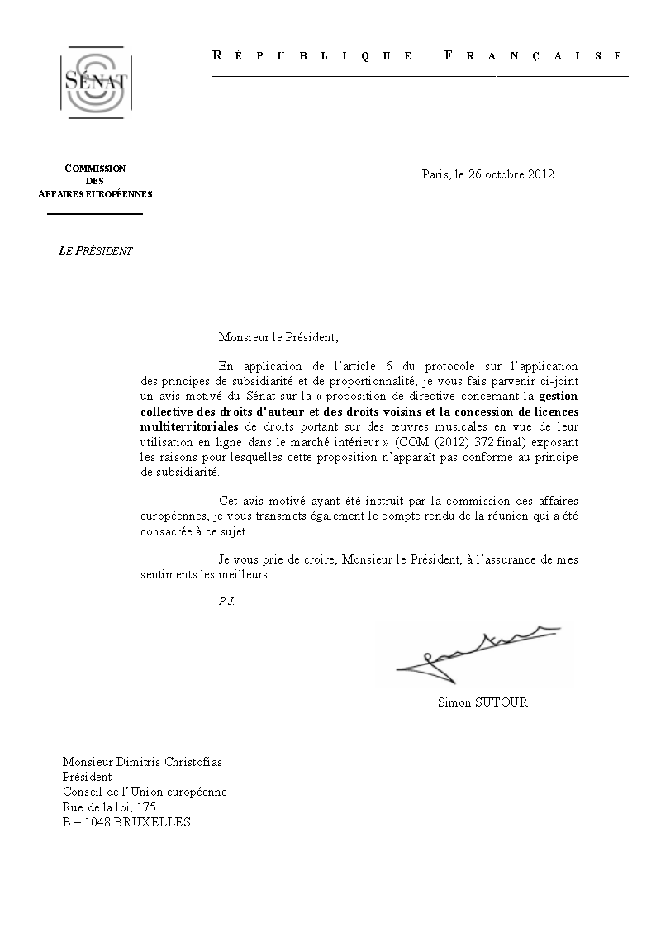
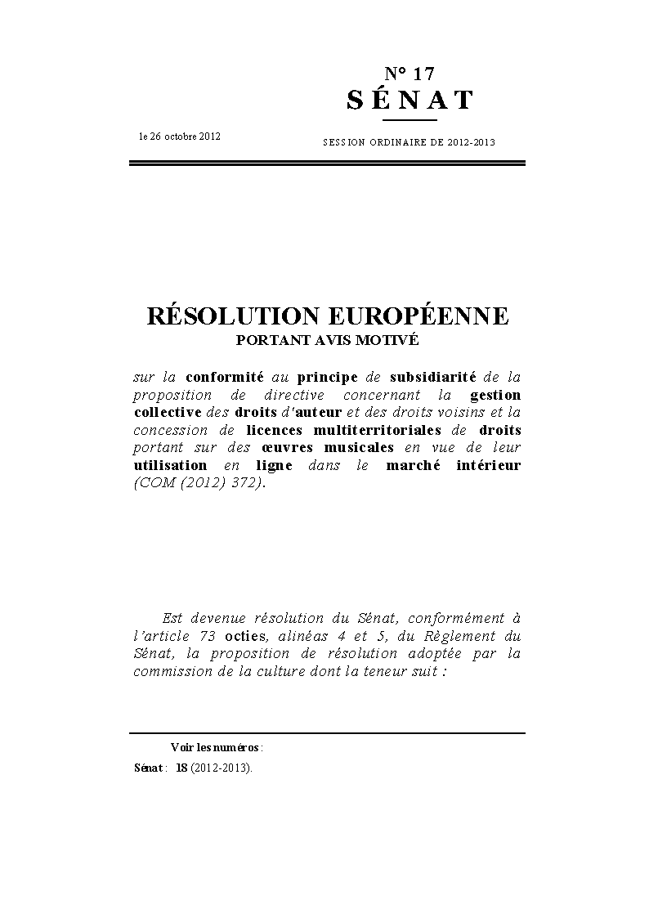
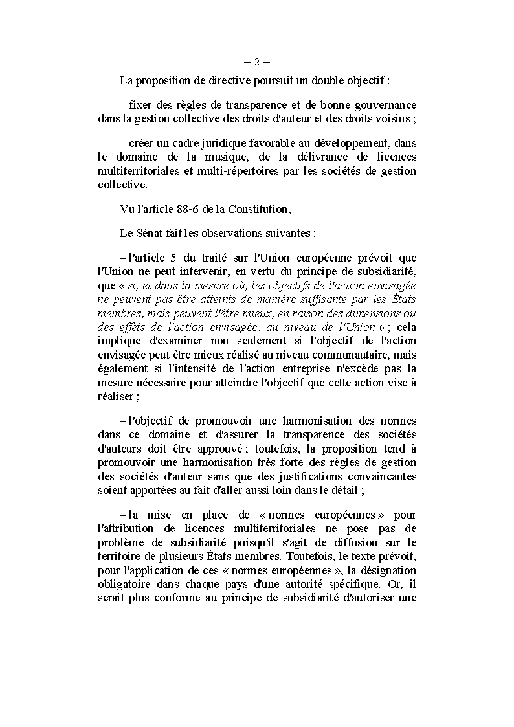
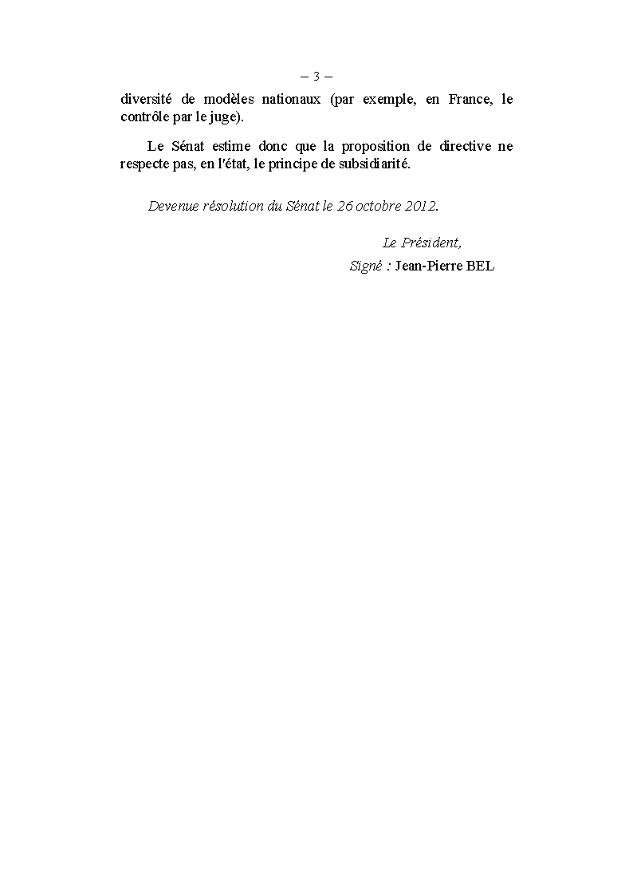

This opinion is available in English on the parliamentary EU information exchange site (IPEX) at the following address: http://www.ipex.eu/ipex/cms/home/Documents/pid/10

