 | 
COUNCIL OF  THE EUROPEAN UNION |  |  | Brussels, 29 October 2012
 | Interinstitutional File:  2012/0205 (CNS) |  | 15635/12
FISC 154
INST 629
PARLNAT 351

COVER NOTE
from: | The Portuguese Parliament
date of receipt: | 24 October 2012
to: | The President of the Council of the European Union
Subject: | Proposal for a Council Directive amending Directive 2006/112/EC on the common system of value added tax as regards a quick reaction mechanism against VAT fraud  [doc. 13027/12 FISC 113 - COM(2012) 428 final]  - Opinion on the application of the Principles of Subsidiarity and Proportionality

Delegations will find attached the abovementioned opinion.

________________________

Encl.

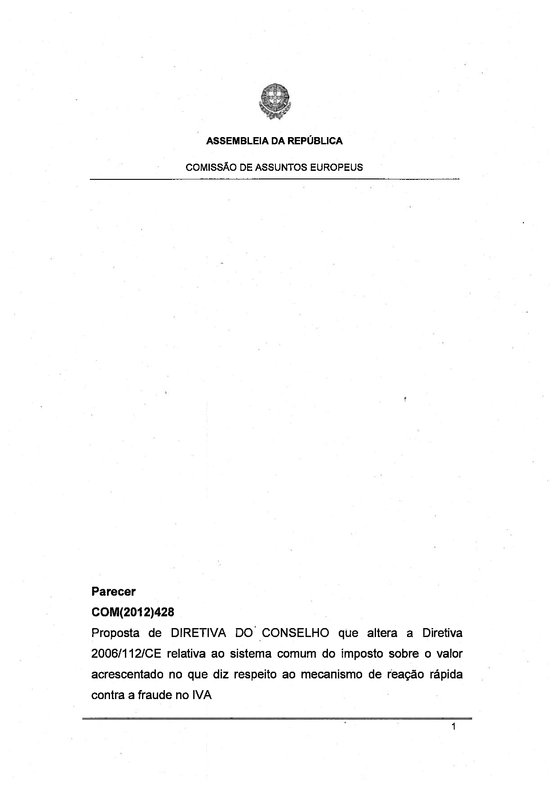
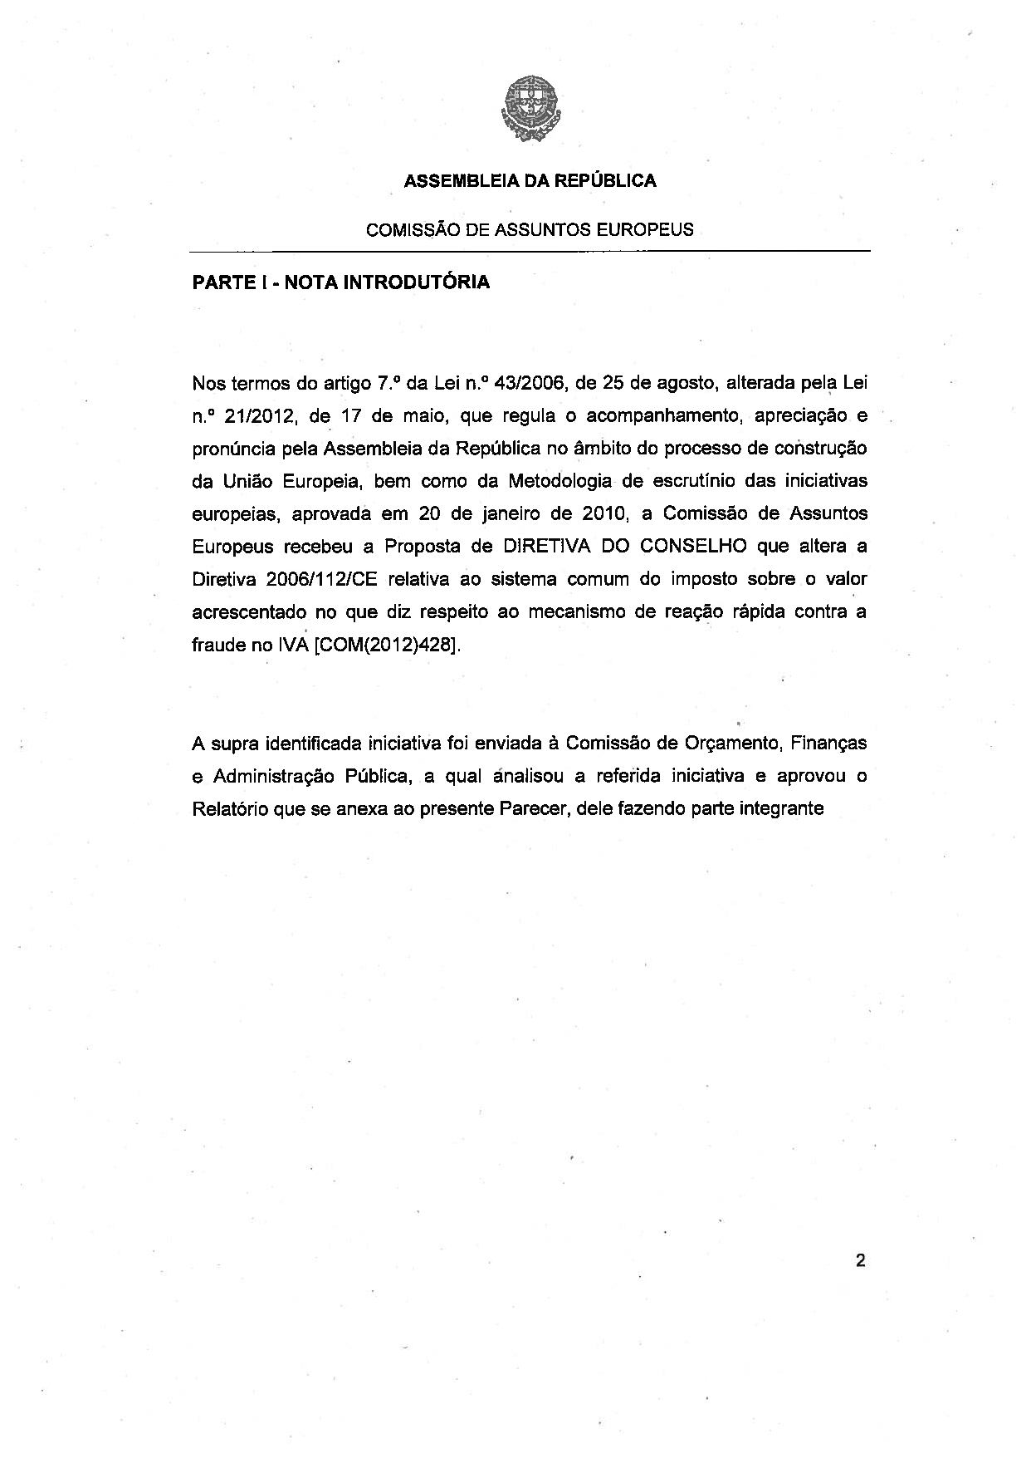
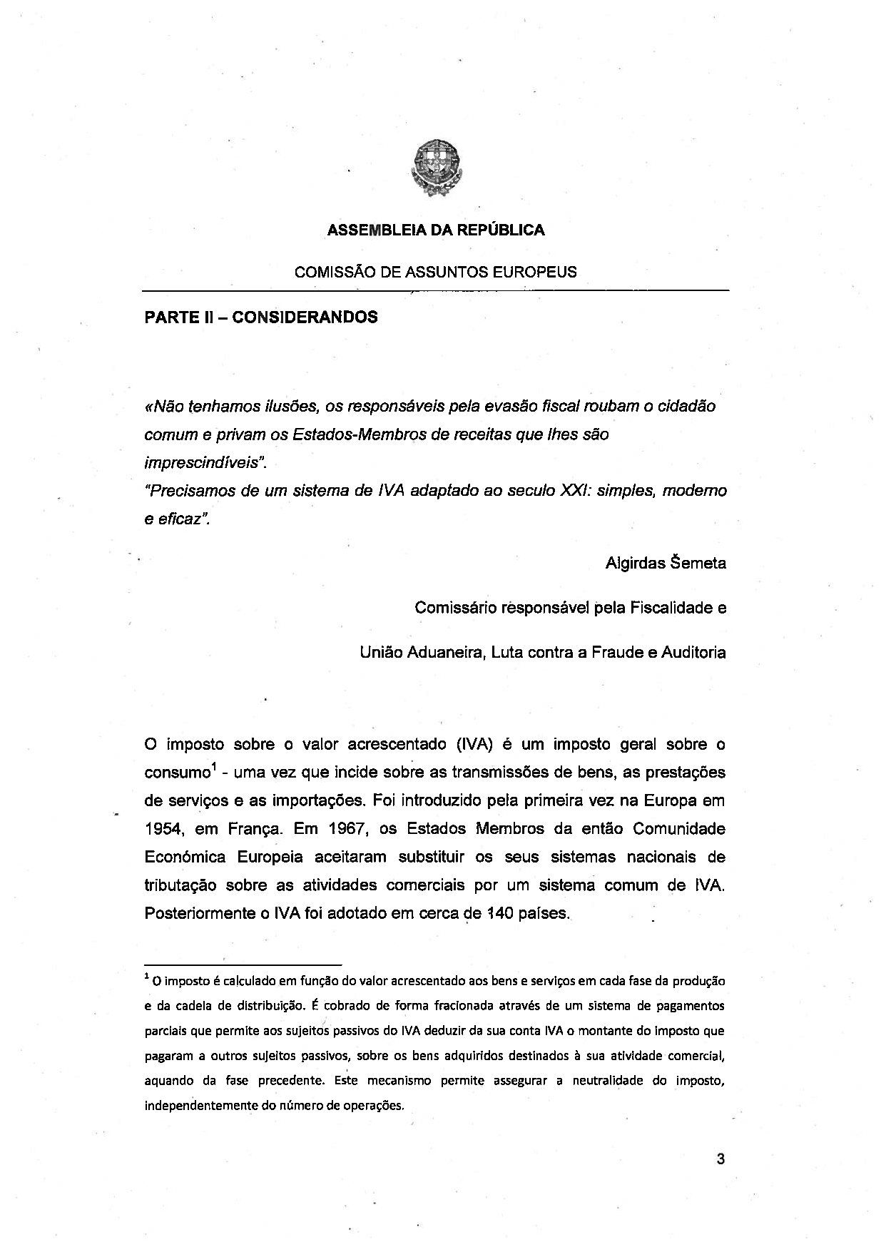
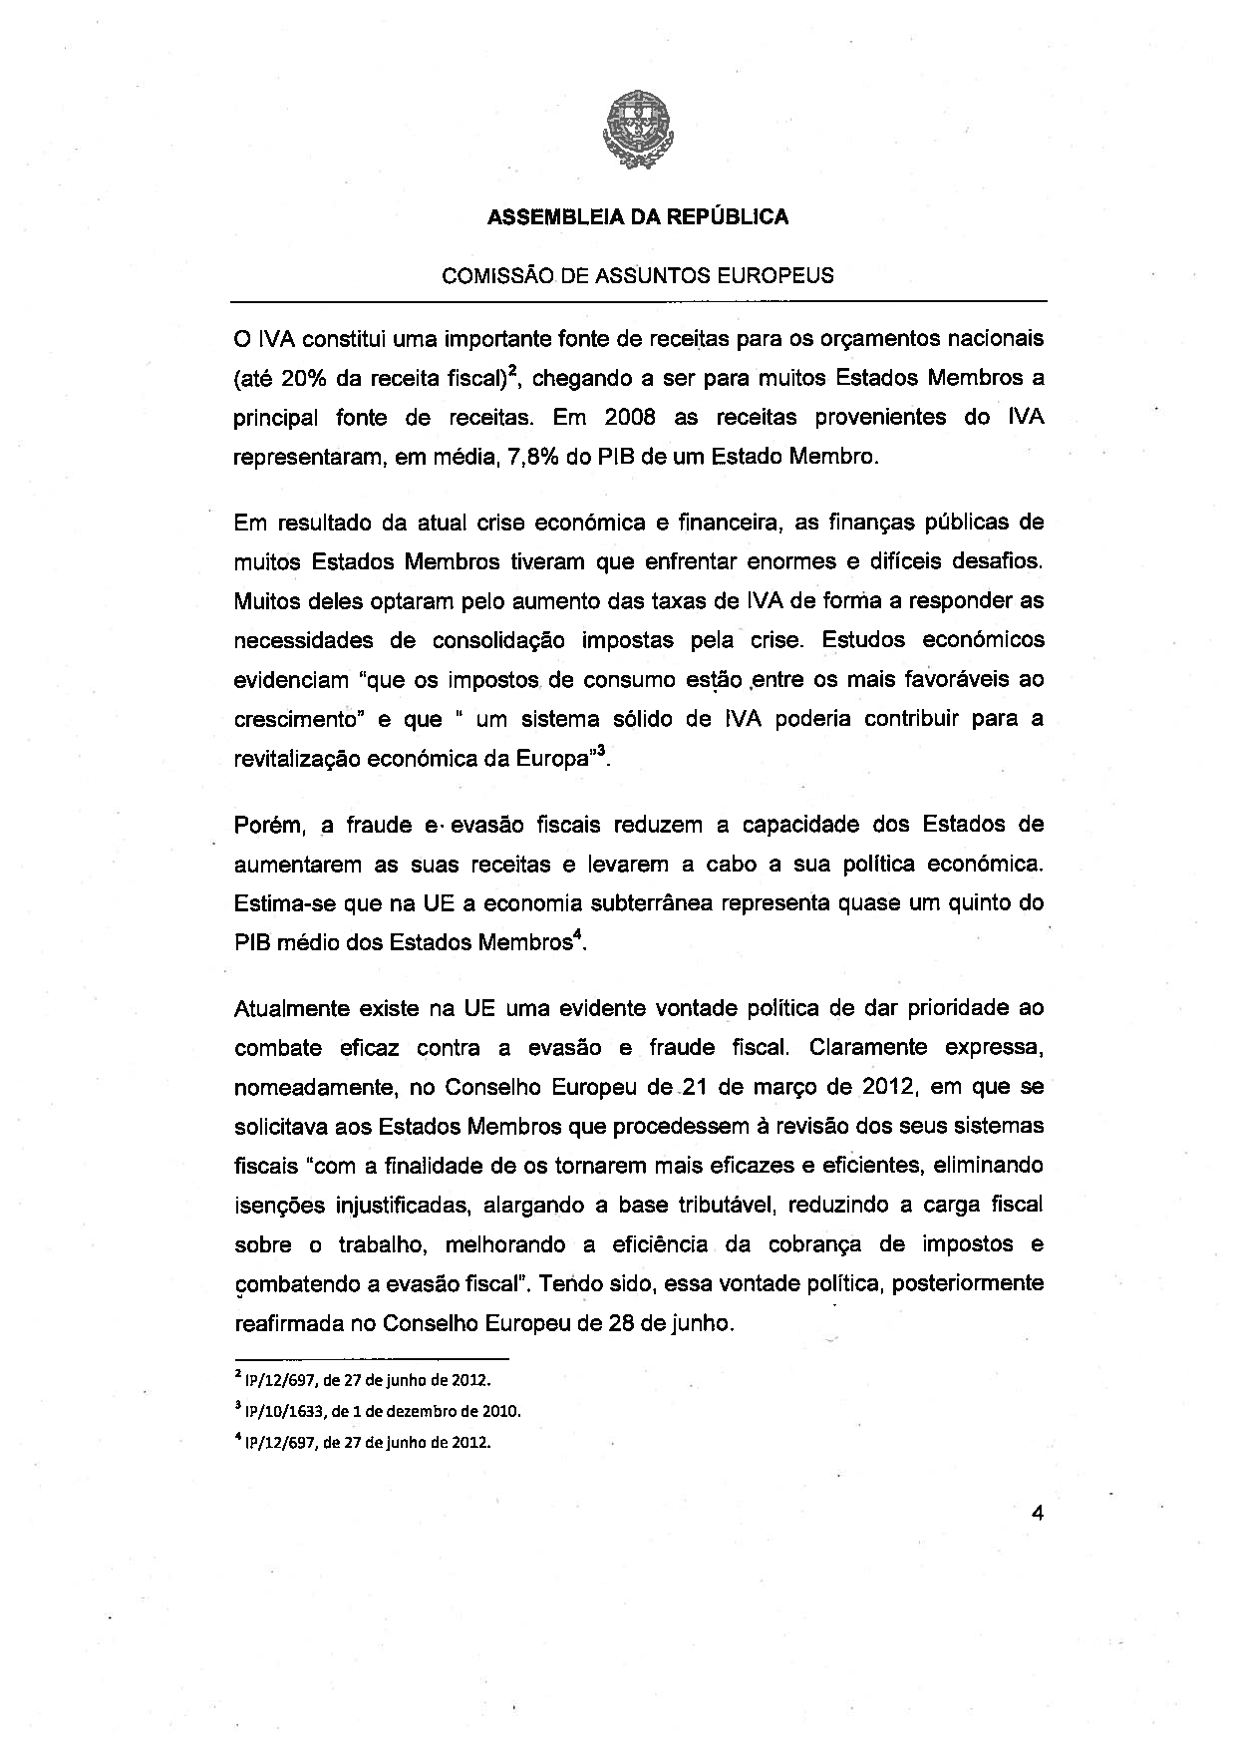
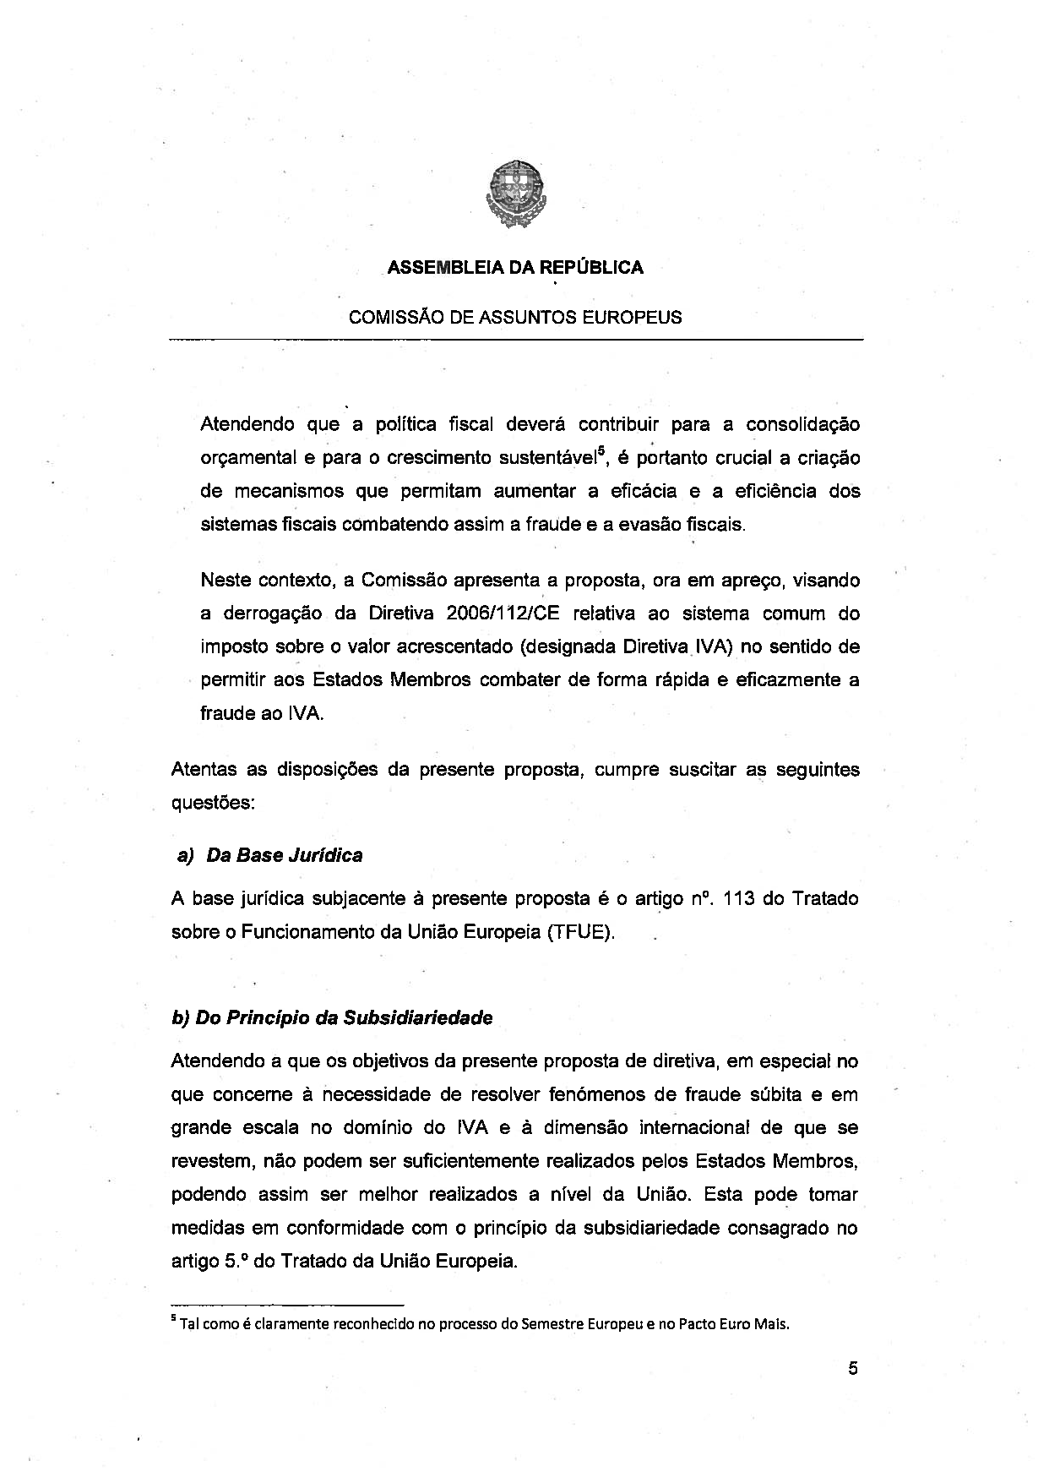
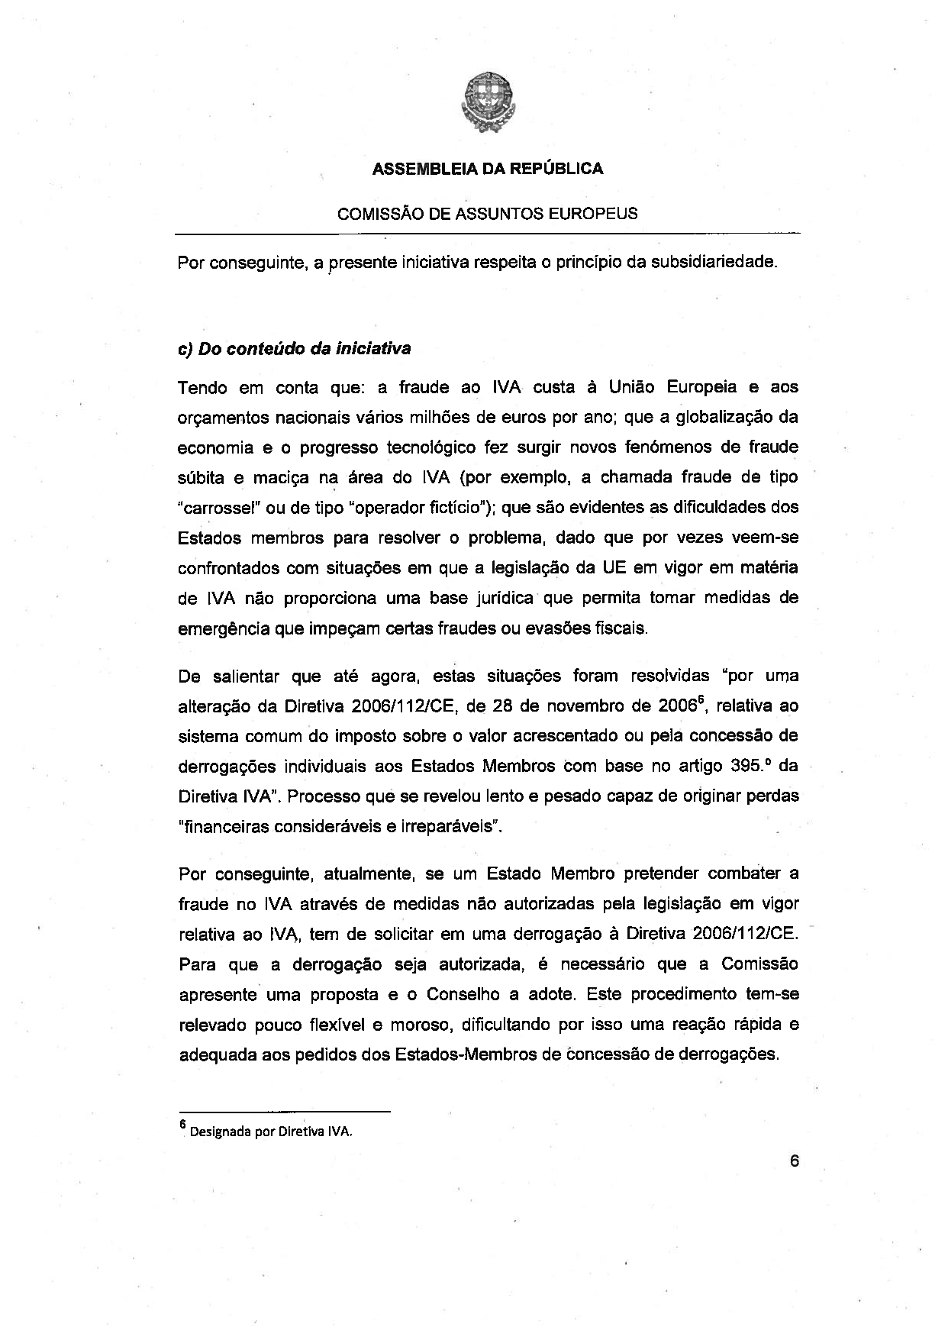
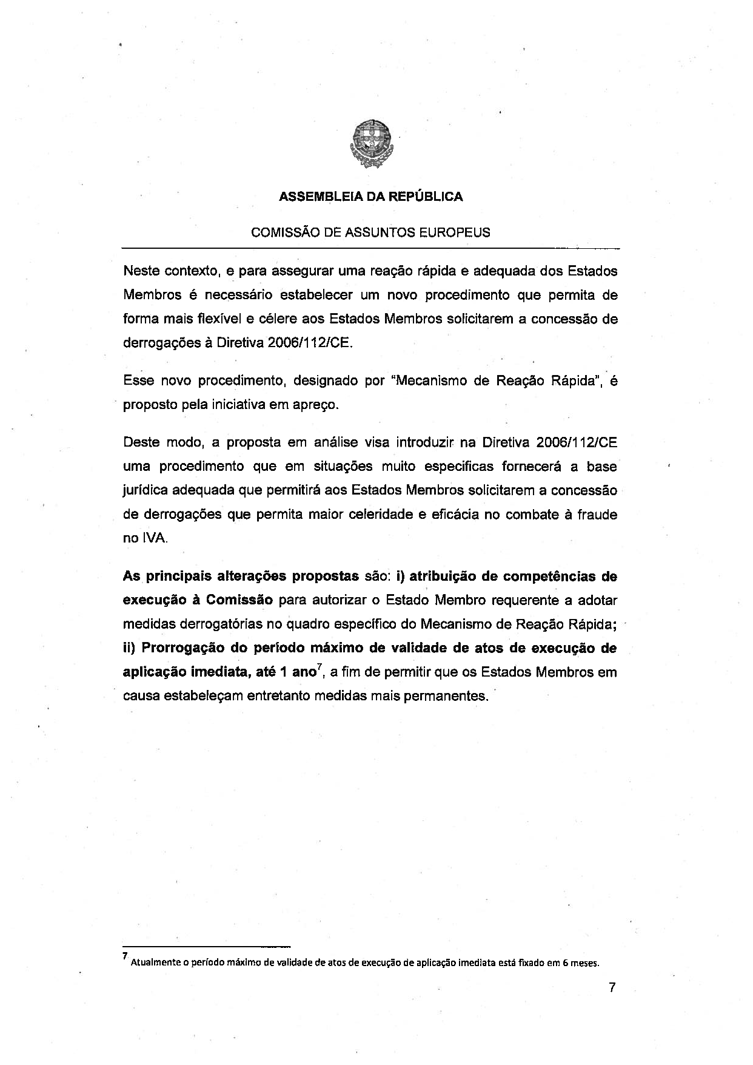
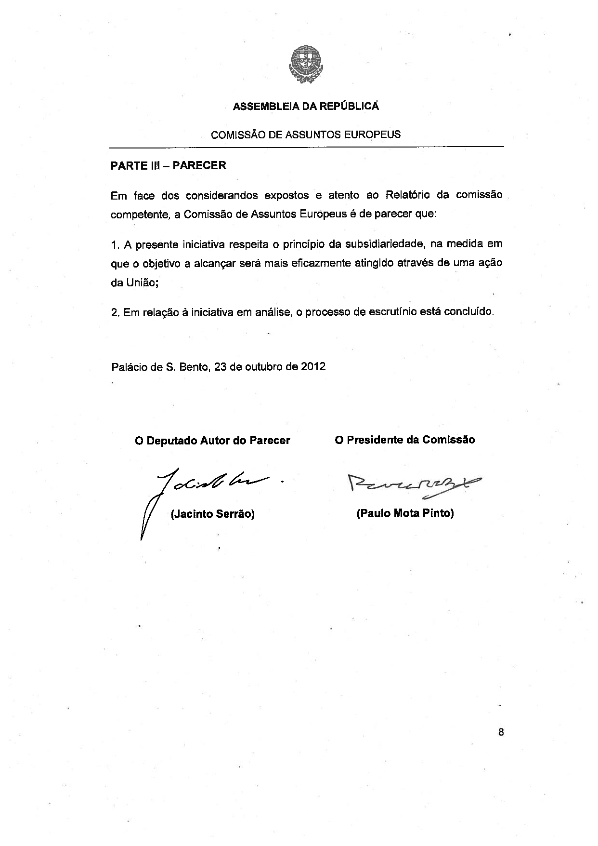
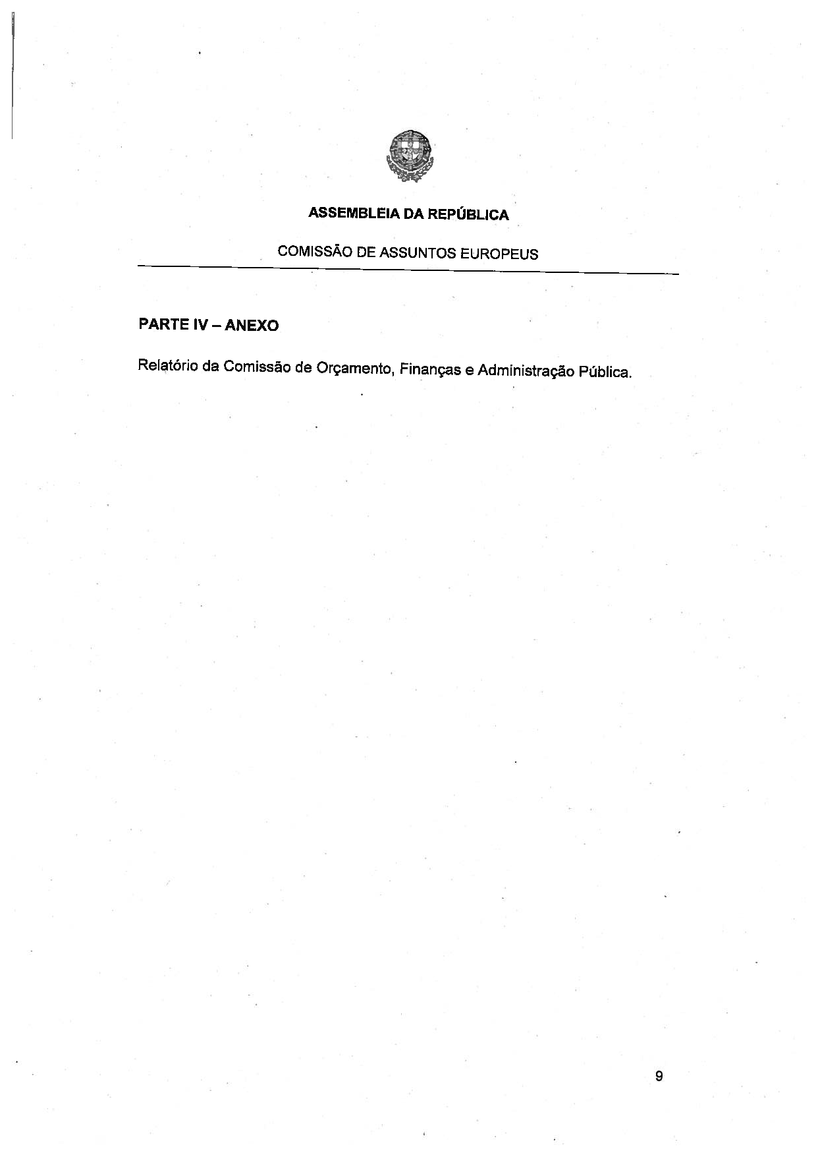
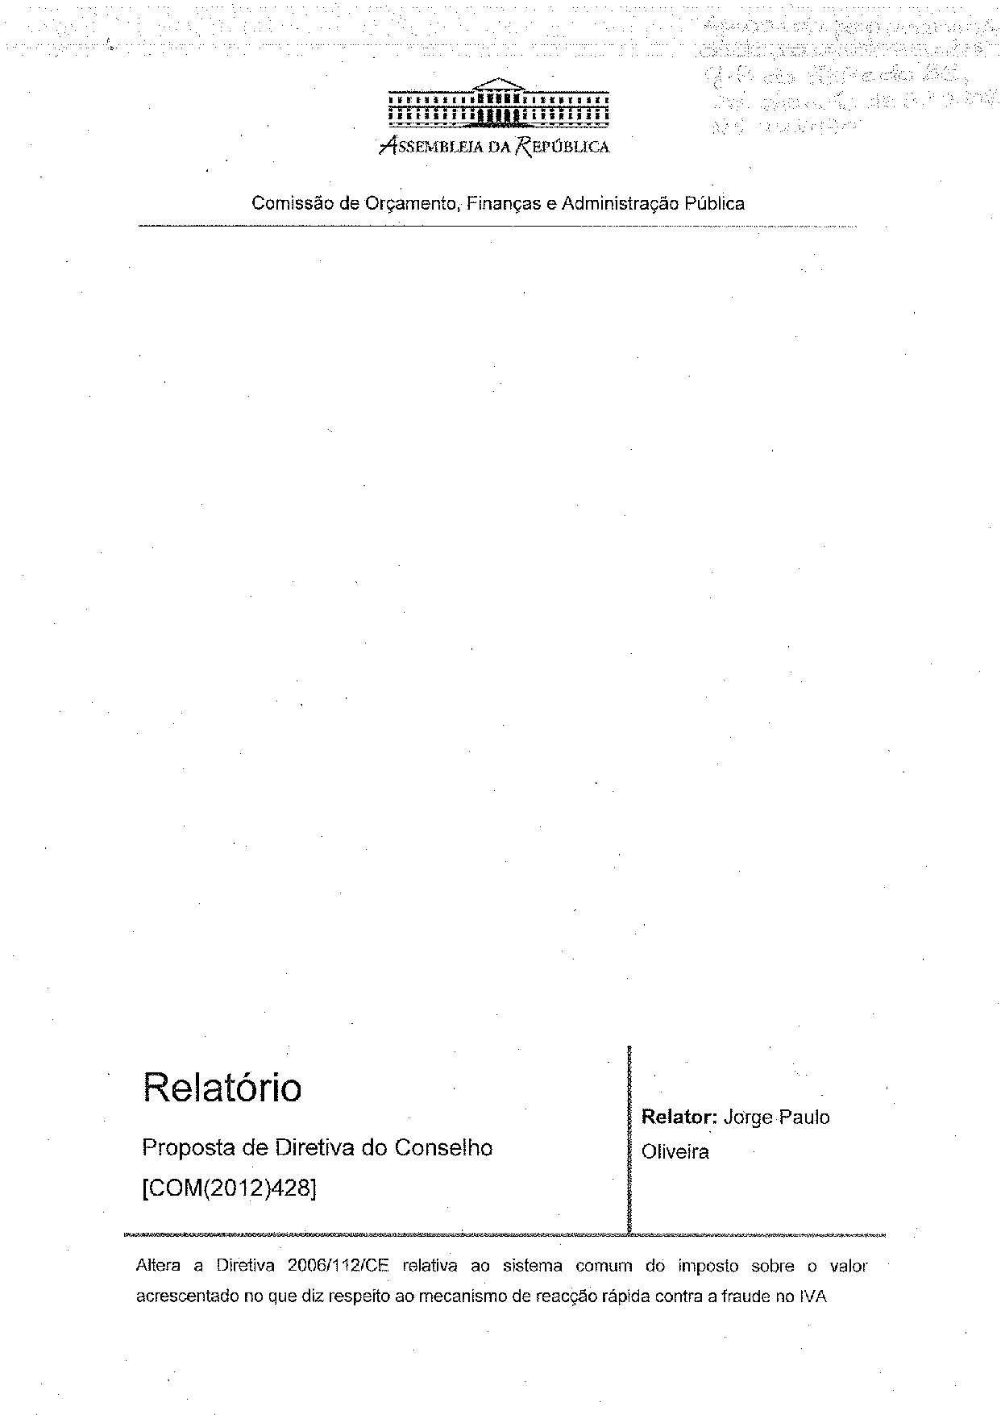
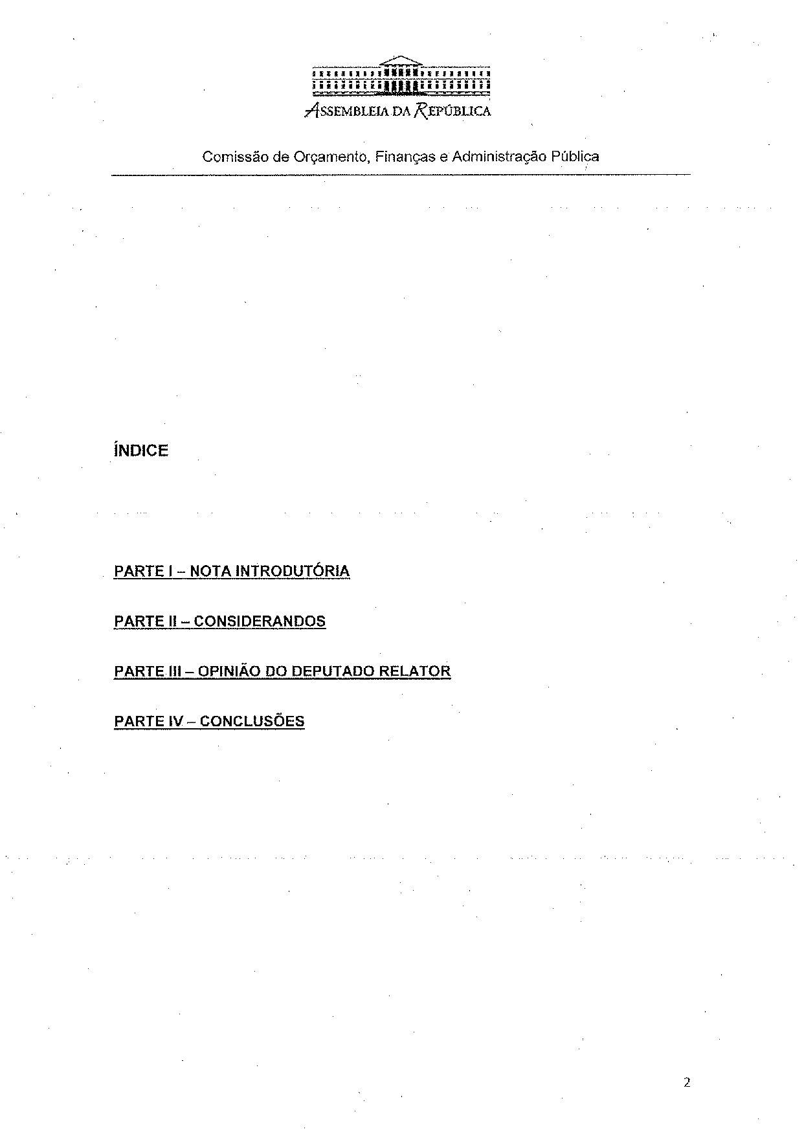
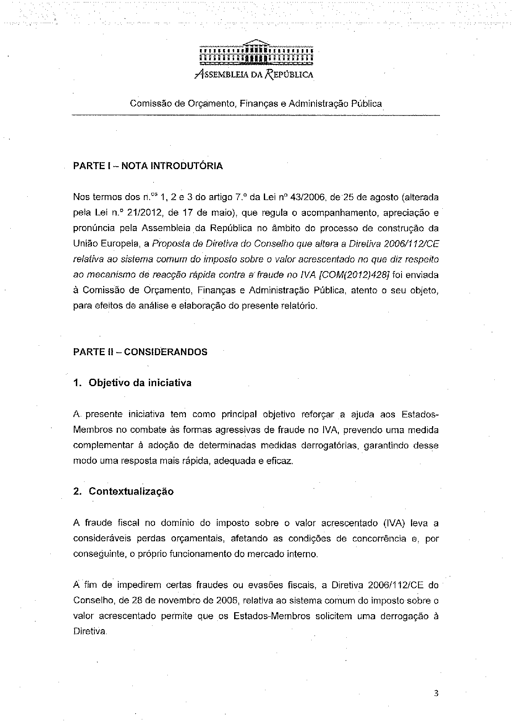
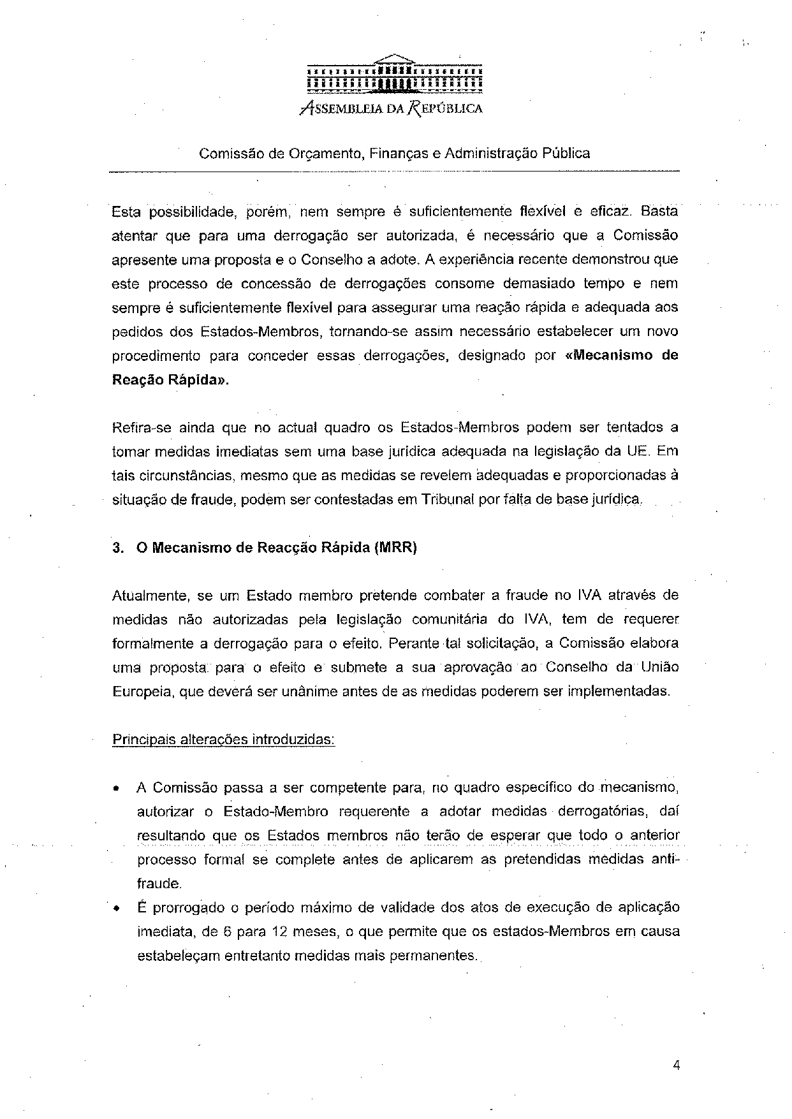
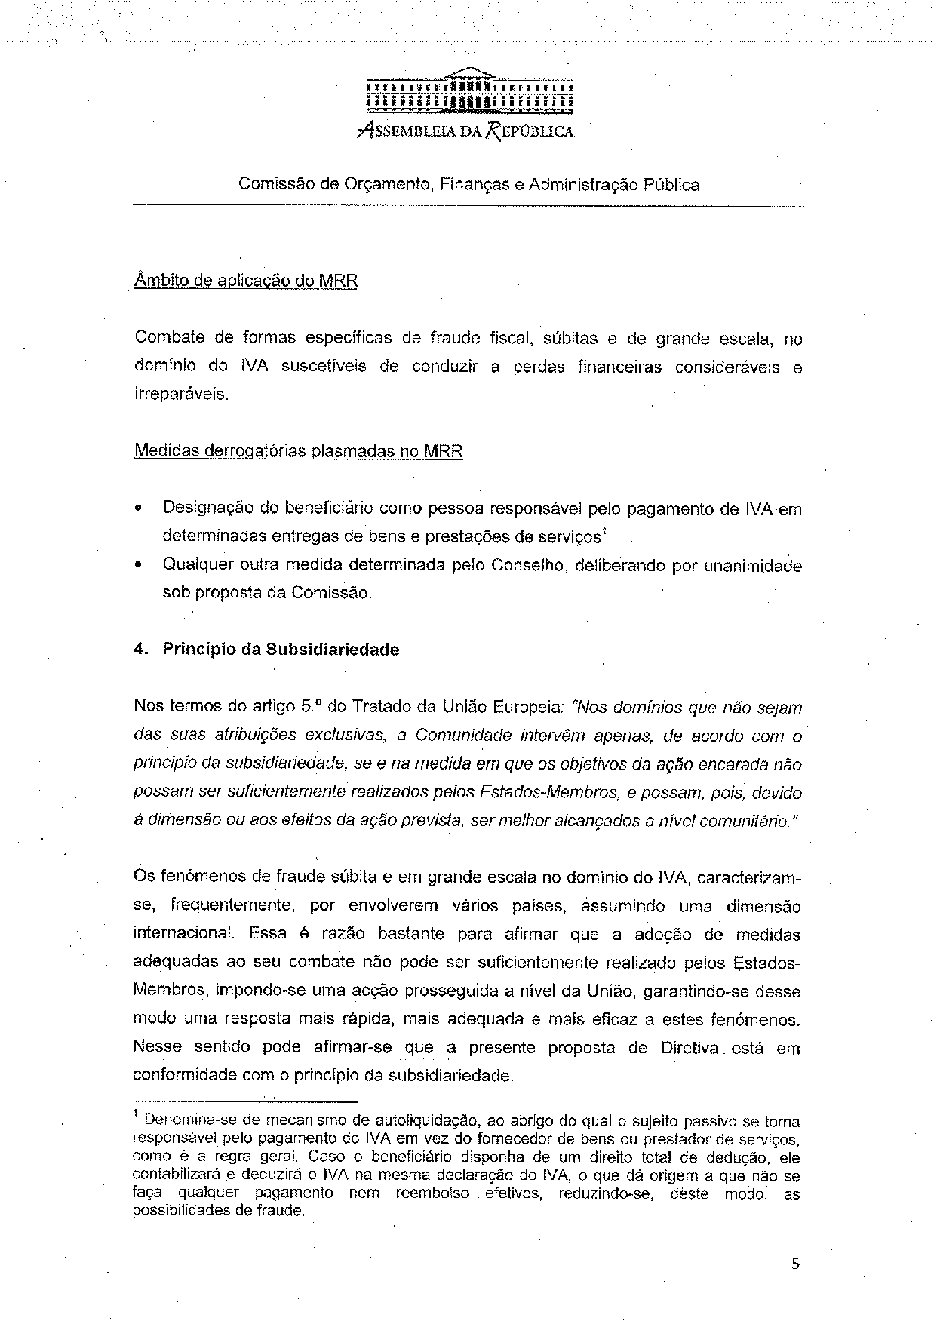
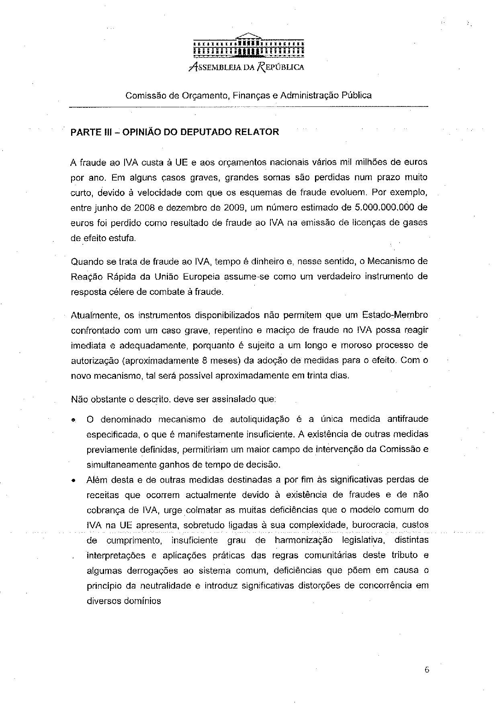
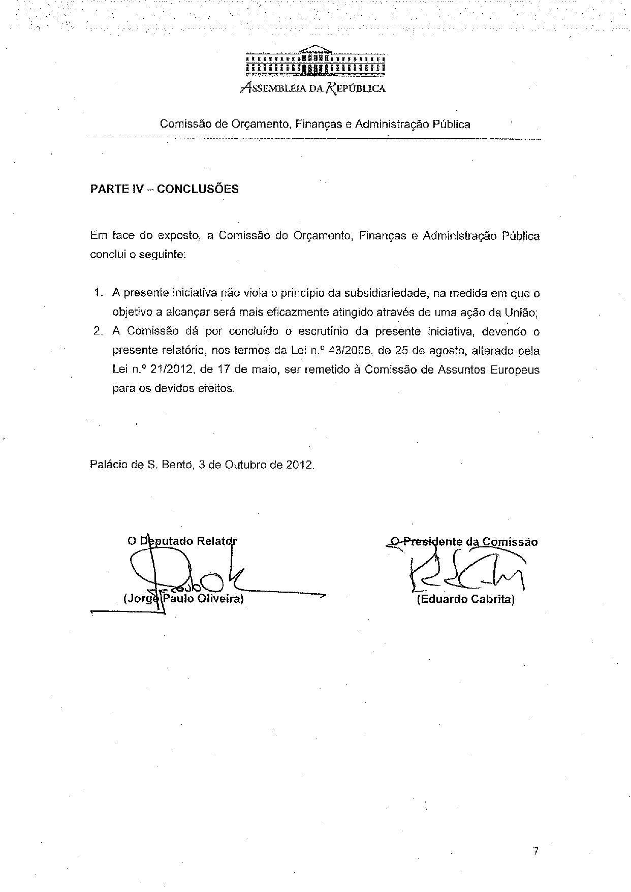

Translation(s) of the opinion may be available on the Interparliamentary EU Information Exchange site IPEX at the following address: http://www.ipex.eu/IPEXL-WEB/search.do

