Contents

1. Facts and figures 3
1.1. Existing instruments and enforcement 3
1.1.1. National level 3
1.1.2. European level 3
1.1.3. Monitoring and enforcement 4
1.2. Cross-cutting issues 5
1.2.1. SMEs 5
1.2.2. Eurobarometer surveys 5
1.2.3. Standards 16
1.3. Level and instruments 16
1.3.1. Alternative instruments 16
2. Specific actions on Tourism Accommodation Safety by the Commission 17
2.1. Earlier actions (2003-2012) 17
2.2. Most recent actions (2012-2013) 19

Facts and figures
This section presents the facts and figures which are available in relation to the issues that the Green Paper addresses. Not all aspects covered in section 4 ‘Questions’ in the paper are mirrored in this annex as supporting material does not necessarily exist for each of them.

Existing instruments and enforcement

National level
In broad terms, when it comes to tourism accommodation services the type of policies varies significantly. In 2013 a questionnaire has invited Member States to describe national rules regarding the safety of tourism accommodation services (among other services). Of the 24 Member States which submitted information, 21 reported the existence of general legislation covering services as a category (either general legislation on service safety, or on product safety, or on consumer protection or on safety at work), while 17 Member States reporting having detailed sectorial legislation in relation to accommodation services, complemented by self-regulation in 6 cases. 2 Member States did not report either horizontal or sectorial policies.
A screening of the content of the reported sectorial legislation allowed for more detailed comparison across Member States. Relevant authorities were given a list of safety-related provisions (see table below) and were asked to indicate which of them were present in their national legislation. Of the 17 Member States where sectorial legislation is in place (AT, BE, CY, CZ, DE, EL, ES, ET, FR, HR, IT, LT, LU, MT, PL, PT, SK), a large majority (13 Member States) include obligations related to the condition of the premises; a general obligation to provide only safe services is present in 8 cases and obligations related to the qualifications of the service provider are required in 10 cases. On the other hand, only half of those Member States (DE, EL, CZ, HR, LU, MT, PL, PT, SK) require by law the establishment of authorities to monitor and take action. Furthermore, just 5 (LU, MT, CZ, PL, EL) include provisions for the identification and assessment of risks and only in 2 (CZ, PL) there is an obligation to notify authorities on risks and accidents related to the provision of the service – an essential tool for comparative purposes across the EU.
The graph below illustrates the content of the existing sectorial legislation of the 17 reporting Member States.
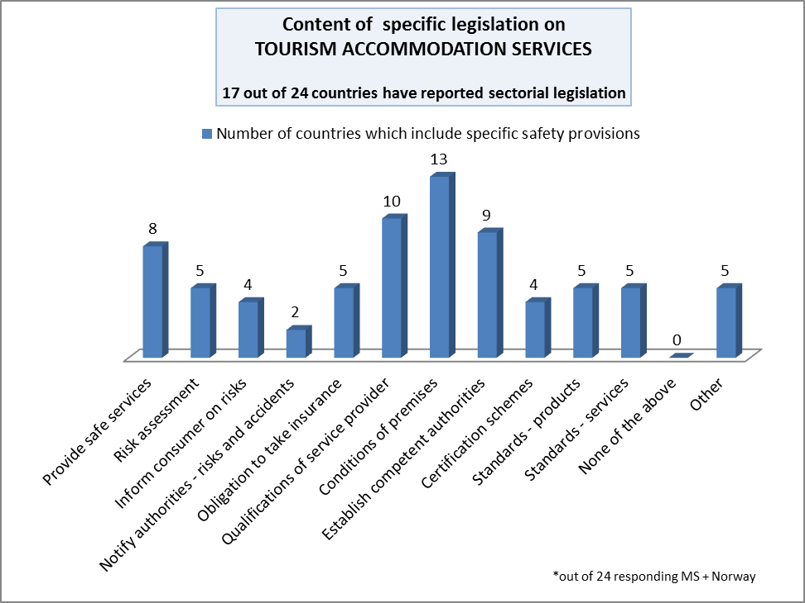

European level
The freedom to provide services is regulated by Articles 56-62 TFEU. More specifically Directive 2006/123/EC on Services in the Internal Market aims at facilitating the exercise of the freedom of establishment for service providers and the free movement of services, making it easier for EU service providers to operate in any other EU Member State. Safety of services is not specifically the subject matter of the Directive. However, Article 18 of the Directive allows for derogations to the freedom to provide services (art 16) under specific conditions and in particular cases relating to the safety of services. A receiving Member State may under those conditions exceptionally apply its requirements to a particular incoming service provider with regard to the provision of a specific service. Under the conditions of article 23 of the directive the Members Sates may ensure that services providers whose services present direct and particular risks to the health and safety subscribe to appropriate liability insurance. Mutual assistance obligation for the member state of establishment covers in particular information on risk of serious damage to the health or safety (Art. 29.3). Finally, Article 26 provides for a framework of voluntary quality enhancing measures in relation to certification or assessment of service provider activities, development of quality charters or labels and charters as well as the development of voluntary European standards for services.
With respect to the safety of tourism related services, there is no comprehensive legislation at EU level. The only instrument regarding safety in tourist accommodation is the Council Recommendation 86/666 on fire safety in existing hotels, which defines minimum safety standards for all hotels in the EU (of a capacity of at least 20 guests) and recommends that Member States take all appropriate measures to guarantee these safety standards when existing laws are not sufficient.
In addition, a number of EU instruments and initiatives in various policy areas (e.g. REACH, construction products, safety at workplace, professional qualifications, environment and package travel) may contribute directly or indirectly to the safety of tourism accommodation services.
As an example, in the framework of the implementation of the Construction Products Regulation (EU) 305/2011, the Commission has asked CEN/CENELEC to develop as soon as possible a harmonised standard on carbon monoxide detectors. The standard will foresee 3rd party certification for these products and will ensure appropriate sensitivity and end of life indication.

Monitoring and enforcement
The only existing European instrument regulating fire safety in tourism accommodation is non-binding by nature and therefore of no compulsory enforcement. In June 2001, the Commission presented a report on the application of the recommendation in Member States. The report concluded that although the recommendation contributed to increase the level of safety in hotels across the EU, the minimum safety standards prescribed in the recommendation were not fully achieved.
At their own initiative, FTO-ABTA (the Federation of Tour Operators merged into the British Travel Association) carried out in 2009 a study on compliance with existing rules on fire safety including Recommendation 86/666 by tourist accommodation providers applying the UK industry’s own inspection and reporting methods. 2.123 properties covering 10 EU Member States were inspected either by the tour operators’ own staff (i.e. specially trained resort staff or specialist health and safety staff) or by external consultants.
The study presented a summary of the property ratings by country which suggests large national differences in the standards of fire safety in resort hotels: In support of the reliability of the resulting data, the study stressed that there could be no possible motive for the tour operator’s own records (whether self-generated or consultant’s products) to depict a less satisfactory picture of a property than the one found.
Member State | Hotel is not fit for use or has major deficiencies | Hotel has serious deficiencies which should be rectified urgently | Hotel has deficiencies which should be rectified as soon as possible | Hotel fire safety is of an acceptable standard – any deficiencies are of a minor nature and easily rectifiable | Total hotels audited
Austria | 43% | 32% | 11% | 15% | 324
Bulgaria | 22% | 32% | 14% | 32% | 76
Cyprus | 10% | 19% | 16% | 55% | 186
France | 31% | 15% | 27% | 28% | 199
Greece | 12% | 19% | 12% | 57% | 292
Italy | 20% | 22% | 11% | 46% | 171
Malta | 16% | 19% | 14% | 52% | 64
Portugal | 11% | 13% | 12% | 64% | 171
Spain | 6% | 19% | 17% | 58% | 640
TOTAL |  |  |  |  | 2123

Further, the study concluded that 38% of the properties audited by the tour operators and their consultants are likely to be non-compliant with the 86/666 Recommendation on Fire Safety in Existing Hotels.

Cross-cutting issues

SMEs
Small or micro sized tourism enterprises accounted in the past five years for over 97% of all tourism accommodation providers.
Sector I55: Accommodation services
 | 2.008 | 2.009 | 2.010 | 2.011 | 2.012 | 2.013 | 2.014
Micro 0 - 9 | 196.491 | 218.843 | 204.934 | 205.676 | 210.742 | 213.047 | 219.777
Small 10 - 49 | 35.563 | 38.155 | 37.276 | 39.920 | 40.436 | 40.835 | 42.081
Medium 50 - 249 | 5.677 | 6.346 | 5.883 | 6.063 | 6.113 | 6.163 | 6.354
Large 250+ | 614 | 592 | 583 | 624 | 640 | 634 | 656
All SMEs | 237.731 | 263.344 | 248.094 | 251.017 | 256.752 | 259.346 | 267.422
Total | 238.345 | 263.936 | 248.677 | 251.628 | 257.378 | 259.965 | 268.063

Eurobarometer surveys
A Flash Eurobarometer on service safety released in 2012 related to the safety aspects of certain paid-for service categories including tourism accommodation.
25.524 European citizens aged 15 and above were interviewed between 7 and 10 May 2012 in all 27 European Union Member States. The purpose of the survey was to investigate Europeans perceptions and experiences with the safety of specific services including tourism accommodation. More specifically, the aspects investigated were:
- Perceptions about the safety of these services.
- The proportion using each service and the incidence of accidents causing injury.
- The experience of safety aspects while using each service (the building itself, the room and the equipment, hygiene conditions, fire signs and equipment, recreational facilities, pool facilities, heating system and security against carbon monoxide leaks).
- The perceived causes and the consequences of accidents leading to injury.
- Whether consumers complain about accidents, and the reasons they do not complain.
The main results of the survey were:
- In general terms, reports of accidents causing injury while using services were low
- Most respondents (54%) said that injury causing accidents in paid-for services were caused by themselves/ the user.
- As far as accommodations are concerned, 98% of the respondents did not report any accidents while staying in a paid-for accommodation in the last two years.
Question: In the last two years, have you or anyone else from your household used any of the following paid-for services in (OUR COUNTRY)
Answers: Accommodation (hotels, camping sites, etc.) please do not think of food and restaurants

Q3. For each type of paid-for services you or someone else from your household used in the last two years in (OUR COUNTRY), did any of the following happen?
- Accommodation (hotels, camping sites, etc.)
- Beauty and wellness centres (hairdressers, tanning salons, spas, etc.)
- Amusement parks and fairgrounds
- Swimming pools
- Organised outdoor leisure activities (skiing, canoeing, mountain biking, etc.)

Answers:
- None of this happened
- An accident, resulting in physical harm or injury, occurred
- When using the service, you felt it was not safe and you stopped using it
- Don’t know

Basis: Those who used accommodation in the last 2 years = 12858 Those who used beauty and wellness centres in the last 2 years = 11749 Those who went to amusement parks and fairgrounds in the last 2 years = 9677 Those who went to swimming pools in the last 2 years = 12200 Those who participated to organized leisure outdoor activities in the last 2 years = 6147
At least nine out of ten users of paid-for accommodation rated the building and equipment and hygiene at their accommodation as safe, but they were less certain about the pool (64% safe) and heating systems (61% safe).
Q4. Thinking about the last time you used paid-for accommodation in (OUR COUNTRY), please tell me how safe you considered the following aspects of the accommodation
- The building itself, the room and the equipment (common areas, balconies, bathrooms, toilets, furniture, electrical appliances, etc.)
- Hygiene conditions (quality of water, cleanliness, etc.)
- Equipment and signs in case of fire
- The recreational facilities (garden, playground, etc.)
- The pool and its surroundings
- The heating system and security against carbon monoxide

Total ‘safe’
Total ‘Not safe’
Not applicable
Don’t know

Basis: Those who used accommodation in the last 2 years and did not have any accident = 11792

Respondents are most likely to say that the fire signs and equipment in their accommodation were unsafe (8%), followed by hygiene conditions (7%). It is worth noting in the case of hygiene that 91% of respondents rated this aspect of their accommodation as safe - compared to 78% for fire signs and equipment.
Just over one in twenty (6%) said that the recreational facilities of their accommodation were unsafe.
Pool facilities were also rated as unsafe by 6% of respondents. Of all the aspects asked about, respondents were most likely to say that their accommodation did not have a pool (25%) or recreational facilities (17%).
One in twenty (5%) said that the heating system and security against carbon monoxide leaks in their accommodation were unsafe. However more than one in five (22%) were unable to give an opinion on the heating system of their accommodation.
Of the 12.585 users of accommodation services across the EU27, 164 reported having experienced an accident resulting in physical harm or injury. The breakdown by country from the Eurobarometer report is shown below.
Question: Q3.1 for each type of paid-for services you or someone else from your household used in the last two years in (OUR COUNTRY), did any of the following happen?
Option: Accommodation (hotels, camping sites, etc.)
Answer: An accident, resulting in physical harm or injury, occurred

When asked about what the accident was related to, the answers of those 164 citizens indicated the following:
Q10. Was the accident in the accommodation related to any of the following?
- General safety (common areas, bedrooms, balconies, bathroom, public toilets, furniture, electrical appliances, etc.)
- Hygiene (water, chemicals, etc.)
- Pool safety (no lifeguard, poorly maintained, etc.)
- Carbon monoxide leak
- Fire
- Recreational facilities (garden, playground, etc.)
- Other + none (spontaneous)
- Don’t know

Almost all (92%) said the premises and equipment were in good enough condition, while 82% said safety information was displayed, and 62% said the staff seemed to be properly qualified in terms of safety precautions. Respondents were most unsure about the safety qualifications of staff, with 20% saying they could not remember or were not sure
Q5. Thinking about safety, the last time you used paid-for accommodation in (OUR COUNTRY), please tell me if…
- The premises and/or equipment were in good enough condition
- Information regarding safety was displayed (warning signs about risks, instructions on use, emergency exits, etc.)
- The staff seemed to be properly qualified in terms of safety precautions

Answers
- Yes
- No
- I don’t remember/I’m not sure
- Don’t know

Basis: Those who used accommodation in the last 2 years and did not have any accident = 11792

In general, consumers' views on why accidents happen, the consequences of those accidents and the involvement of children in these accidents were also collected.
Most of the respondents (54%) said it was their own fault, or the fault of the user. One in five (20%) said the bad state of the premises or equipment was to blame, while 16% said that the staff were responsible due to insufficient competence. Around one in ten blamed insufficient supervision (13%), insufficient warnings about risks (12%) or insufficient instructions on use (8%). One in twenty (5%) said a lack of or poor emergency procedures was responsible for the accident. One in ten (10%) mentioned 'other' as a reason.
Q12. In your opinion, was the accident caused by…?
- My own fault/the own fault of the user
- Bad state of the premises/the equipment
- Insufficient competence of service provider/staff responsible
- Insufficient supervision
- Insufficient warning about risks
- Insufficient instructions on use
- Lack of/poor emergency procedures
- Other (SPONTANEOUS)
- Don’t know

Overall the results of this survey contributed evidence about different aspects of the accidents experienced and confirmed that the general evaluation of safety aspects was not negative but nearly 10% of users identified common safety issues which should be addressed (mainly training and qualification of staff and lack of information about safety procedures and risks).
Furthermore, tourists’ concerns about safety have been regularly monitored via the “Eurobarometer survey on the attitudes of Europeans towards tourism” since 2008. Four subsequent waves of surveys between 2008 and 2012 confirmed that safety did not have any effect in discouraging European travellers from going on holidays.
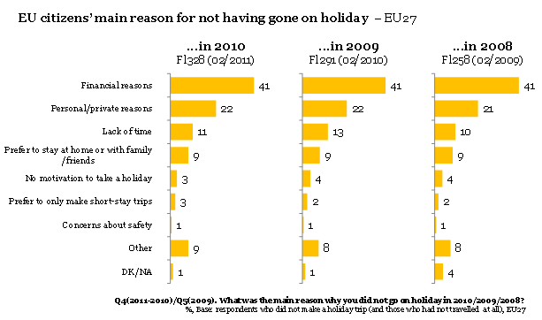
EU citizens’ main reason for not going on holiday – EU27
Q4(2011-2010)/Q5(2009) – What was the main reason why you did not go on holiday in 2010/2009/2008
%, Base: respondents who did not make a holiday trip (and those who had not travelled at all), EU27
- Financial reasons
- Personal/private reasons
- Lack of time
- Prefer to stay at home or with family/friends
- No motivation to take a holiday
- Prefer to only make short-stay trips
- Concerns about safety
- Other
- Don’t Know/Not applicable

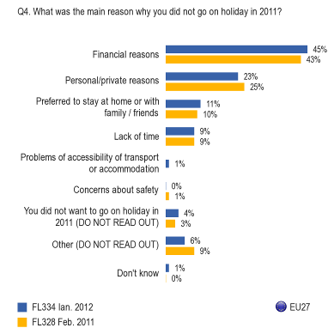

Q4. What was the main reason why you did not go on holiday in 2011?
- Financial reasons
- Personal/private reasons
- Preferred to stay at home or with family/friends
- Lack of time
- Problems of accessibility of transport or accommodation
- Concerns about safety
- You did not want to go on holiday in 2011 (DO NOT READ OUT)
- Other (DO NOT READ OUT)
- Don’t Know

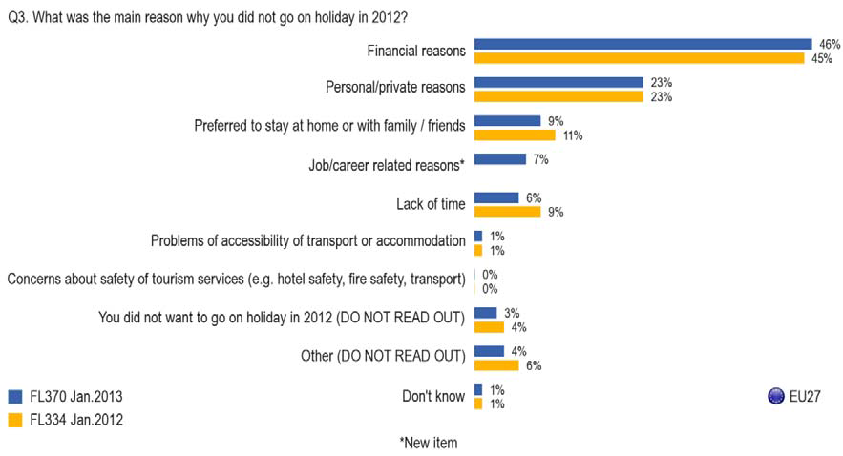
Q4. What was the main reason why you did not go on holiday in 2012?
- Financial reasons
- Personal/private reasons
- Preferred to stay at home or with family/friends
- Job/career related reasons * (new item)
- Lack of time
- Problems of accessibility of transport or accommodation
- Concerns about safety of tourism services (e.g. hotel safety, fire safety, transport)
- You did not want to go on holiday in 2012 (DO NOT READ OUT)
- Other (DO NOT READ OUT)
- Don’t Know

The latest Eurobarometer survey (launched in January 2014) aimed at understanding whether there were specific concerns towards safety of tourism accommodations. The results were as follows:

- Only a minority of respondents experienced safety problems with paid accommodation during their 2013 holiday. Overall, only 4% of respondents who travelled at least once in 2013 registered a complaint during their trip.
- A high proportion of respondents (95%) were satisfied with the safety of their accommodation. A similar proportion (95%) were satisfied with the quality of their accommodation.

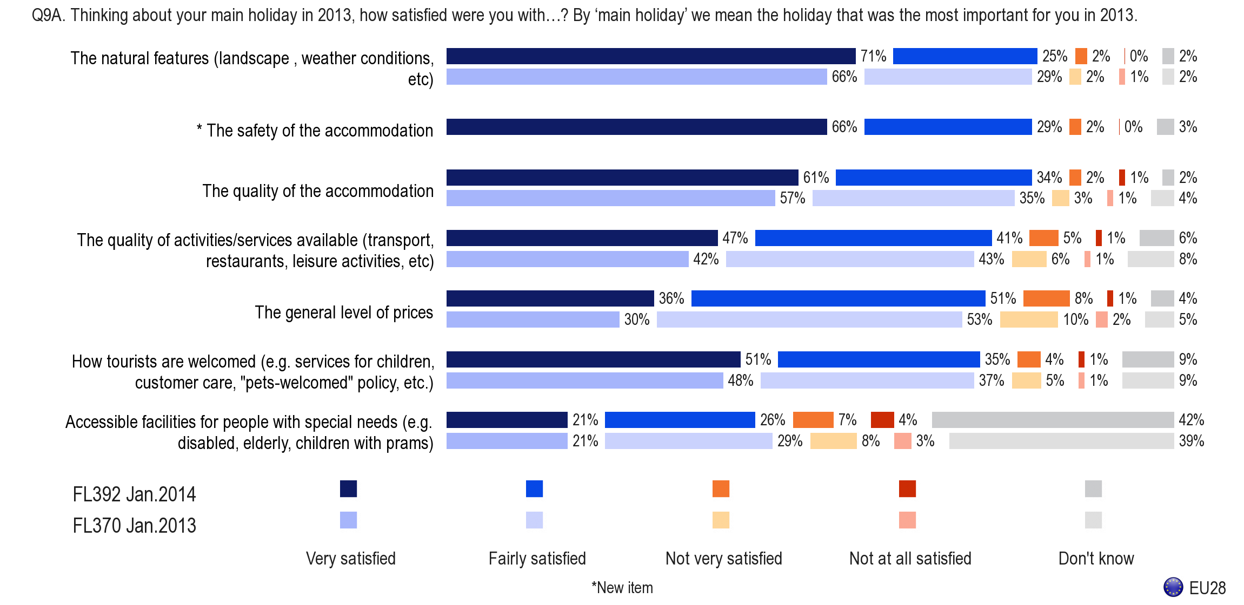
Q9A. Thinking about your main holiday in 2013, how satisfies were you with…? By ‘main holiday’ we mean the holiday that was the most important for you in 2013.
- The natural features (landscape, weather conditions, etc.)
- The safety of the accommodation * (new item)
- The quality of the accommodation
- The quality of activities/services available (transport, restaurants, leisure activities, etc.)
- The general level of prices
- How tourists are welcomed (e.g. services for children, customer care, “pets-welcome” policy, etc.)
- Accessible facilities for people with special needs (e.g. disabled, elderly, children with prams)

- The vast majority of respondents (92%) did not experience any safety issues when using paid accommodation during their main holiday in 2013. Of the 6% that did, the most common experience was food poisoning or sickness (2%), followed by a slip, trip or fall (1%) and swimming pool incidents (1%).

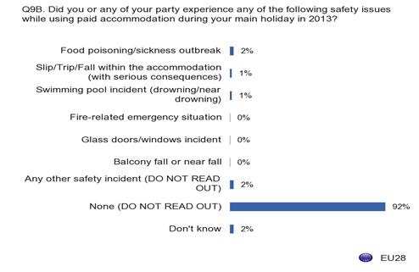
Q9B – Did you or any of your party experience any of the following safety issues while using paid-accommodation during your main holiday in 2013?
- Food poisoning/sickness outbreak
- Slip/trip/Fall within the accommodation (with serious consequences)
- Swimming pool incident (drowning/near drowning)
- Fire-related emergency situation
- Glass doors/windows incident
- Balcony fall or near fall
- Any other safety incident (DO NOT READ OUT)
- None (DO NOT READ OUT)
- Don’t Know

Standards
Regulation (EU) No 1025/2012 on European Standardisation that became applicable on 1 January 2013 establishes conditions for European standardisation with a clear reference to the development of standards in the field of services and opens the door to European standardisation which can support the application of Union legislation and policies in the domain of service safety. Art 2(4)(c) establishes that the standards technical specification (requirements) for services refer to their levels of quality, performance, interoperability, environmental protection, health or safety. This potentially creates room for discussion on standardisation of the safety of tourism accommodation services.

Level and instruments

Alternative instruments
In 2008, the Association of Hotels, Restaurants and Cafés in Europe (HOTREC), maintaining its preference towards industry performance-based rather than prescriptive, normative approaches, developed a self-regulation initiative, known as the MBS (Management, Building, Systems) Methodology, aimed at further enhancing fire safety in all hotels in Europe. The Commission services took part in a stakeholders’ Consultative Committee which was involved throughout the development of the Methodology. The MBS contains a set of performance-oriented recommendations aimed at guiding the Management of the hotels to make sure that the hotel's Building features and its Systems can efficiently fulfil the same objectives laid down in Council Recommendation 86/666.
The principle of an industry-led self-regulatory measure has received wide support. The 2010 Commission Communication on Tourism foresees that the Commission will continue to cooperate closely with the member States, the tourism industry and stakeholders’ organisations in the sector to improve safety in accommodation structures, particularly with regard to fire risks.

Specific actions on Tourism Accommodation Safety by the Commission
Some actions, outlined below, have been developed by the Commission in recent years in relation to tourism accommodation services.

Earlier actions (2003-2012)
The oldest still existing EU level text relevant to tourism accommodation safety is the above-mentioned Council Recommendation 86/666/EEC on Fire Safety in Existing Hotels.
When the EU legislator modernised the rules relating to the safety of consumer products, it did not include the safety of services in the same initiative. Article 20 of Directive 2001/95/EC on General Product Safety (GPSD) however required the Commission to "identify the needs, possibilities and priorities for Community action on the safety of services and submit to the European Parliament and the Council, before 1 January 2003, a report, accompanied by proposals on the subject as appropriate".
The Commission therefore launched a consultation and issued a report in 2003 on the Safety of Services for Consumers, which mentioned specifically that “it would be appropriate to focus on the sectors most relevant for consumers in a cross-border perspective, for example mass-accommodation services like hotels, camping or other tourist facilities”. The Council endorsed the results of the Commission report and adopted in 2003 a resolution on safety of services for consumers which called upon the Commission to examine "the need for concrete Community initiatives and activities in this field, which might include inter alia the development of a legislative framework with particular attention to the identified priority areas". It further prompted the Commission to study, in cooperation with Member States, the scope, priorities and the most appropriate and effective approaches, methodologies, and procedures for improving the knowledge on service safety and data collection, as well as to examine the possible contribution from European standards to reach a common high level of safety in services.
In 2005 the Commission launched a study to identify and describe existing methodologies for monitoring accidents and data collection in relation to consumer services, with a particular focus on tourism services and related activities, to do a comparative analysis of these methodologies and to propose options for a future scheme at EU level. The study remarked that “tourism and leisure-related accidents are very unevenly distributed between regions (end even between individual towns of tourist resorts) within each member state. In contrast most product-related accidents tend to be evenly distributed across resident populations. The data capture methods best suited to safety needs are therefore significantly different to those best suited to product safety needs and this limits the potential for any one database to serve both needs optimally”. The study concluded that a single central database containing information on all relevant tourism and leisure services accidents would not be a feasible project in the medium term. The main recommendation was that in the long term there should be a common EU mandatory duty on consumer service suppliers to report all serious incidents involving consumers, pointing to Member states’ responsibility towards generating national accident estimates for each tourism and leisure-related sector in a standard format to be easily collated on a European web site to create comparison tables.
In 2005, the Commission asked the Member States' views on a possible revision of the Recommendation 86/666. At that moment, for some Member States the existing requirements at EU and national levels were sufficient, while others would welcome an update of the fire safety requirements in hotels at EU level, in particular to improve issues such as fire safety management, safety instructions, staff training and emergency planning. No consensus emerged at the time.
Recommendations from the study on data collection systems were further discussed and elaborated during an international workshop on “Accident and injury data collection for non-food products and service risk assessment”, held in Brussels in 2006. In line with the results of the study, the workshop concluded also that better access to existing databases and accident information should be provided via the Internet and that the extension of existing best practices would be the best approach for the short and medium term.
In parallel, during 2006, the Commission launched a study into possible improvements of the European Injury Data Base (IDB) for the purpose of colleting service-related data. The study concluded that, while it would be difficult in practice to improve the database to include service-related injuries, specific follow-up research could be undertaken based on already available data in the IDB to obtain better insight into service-related accidents.
As indicated in the 2007 Commission Communication – Agenda for a sustainable and competitive European Tourism, ensuring that tourists as well as the local communities where tourism services are offered are safe and secure is a further challenge and also a basic condition for a successful development of tourism. Ensuring the safety of tourists is a key aspect for the tourism sector, in line with the current momentum where inspiring confidence is vital.
In 2010 the Commission launched an ambitious study to describe the hotel sector by Member State, with the objective to identify its major safety risks (excluding food safety-related risks), and to carry out an inventory of injuries and accidents occurred in hotels in recent years. However, the study failed to fulfil its objectives due among other reasons to the variety of the hotel sector and the lack of availability of accident records relating specifically to the provision of the service, linked to also reputational issues. The recommendations of the study were not of the quality expected to serve as a base for policy decisions and the study was therefore not accepted by the Commission services.
The 2010 Commission Communication on Tourism mentioned earlier outlines a policy that aims at supporting this sector of the European economy and proposes initiatives to promote its competitiveness as well as its sustainable and quality-based development. It specifically mentions that "the Commission will continue to cooperate closely with the Member States, the tourism industry and stakeholders' organisations in the sector to improve safety in accommodation structures, particularly with regard to fire risks." The Communication stresses the potential for boosting tourism by improving safety in the tourism industry.
Finally, the European Parliament own-initiative report in response to that Communication "stresses the importance of paying due attention to the question of safety in various types of accommodation, particularly in regard to fire safety regulations and carbon monoxide safety measures”.

Most recent actions (2012-2013)
One of the possibilities discussed recently by the Commission services was undertaking a revision of the Recommendation 86/666 on Fire Safety in Existing Hotels using as a basis the MBS Methodology. A consultative stakeholder workshop was organised for this purpose in June 2012 to discuss this option. There was consensus on the general principles of this initiative, especially on the need to adapt and improve the content of the Recommendation regarding among other issues its requirements, scope and application at national level. Also, a majority of stakeholders went one step further and questioned the non-binding nature of the Recommendation as the most suitable tool to tackle the issue of fire safety in hotels across Europe, on the grounds of lack of consistent implementation and enforcement across Member States. However, there was no consensus among the stakeholders on the further course of action, in particular regarding the content of the MBS Methodology. A number of suggestions were put forward regarding aspects that would need to be further considered and which are included in the scope of the Green Paper.

OJ L 376, 27.12.2006, p.36-68
COM (2001) 348 final, http://ec.europa.eu/consumers/cons_safe/serv_safe/fire_safe/ps06_en.pdf
An analysis of the implementation of existing regulations on fire safety in tourist accommodation, an FTO European tourist accommodation study by Stewart Kidd, 2009
Flash Eurobarometer 350, Safety of Services, http://ec.europa.eu/public_opinion/flash/fl_350_en.pdf
Flash EB 258/2009, 291/2010. 328/2011, 334/2012. 370/2013
http://ec.europa.eu/public_opinion/flash/fl_392_en.pdf
OJ L316 ,14.11.2012, p12
From a safety perspective, it underlines in recital (3) that standards "may maintain and enhance service quality, provide information and ensure interoperability and compatibility thereby increasing the safety and value for consumers".
Communication from the Commission to the European parliament, the Council, the European Economic and Social Committee and the Committee of the Region – Europe, the world's No 1 tourist destination – a new political framework for tourism in Europe, COM(2010) 352 final
The European Parliament own-initiative report (2010/2206(INI)) in response to the Communication refers to self-regulatory tools as it “considers that incentives should be given for adherence to the MBS (Management, Building and System) method, without prejudice to national regulations in force in line with the 1986 Council recommendations, or alternative regulatory actions should be taken wherever self-regulation fails".
Report from the Commission to the European Parliament and the Council on the Safety of Services to Consumers, COM(2003) 313 final
Council Resolution of 1 December 2003 on Safety of Services for Consumers (2003/C 299/01)
“Methodology for systematic collection of statistics in relation to safety of services”, by Consumer Risk Ltd, http://ec.europa.eu/consumers/cons_safe/serv_safe/datacollect/rep_idb2005_en.pdf
“Improving the product and service dimension of the IDB – a feasibility study”, by the Consumer Safety Institute
COM/2007/0621 final
(2010/2206(INI)) - Europe, the world's No 1 tourist destination - a new political framework for tourism in Europe, Committee on Transport and Tourism.

