TABLE OF CONTENTS
REPORT FROM THE COMMISSION TO THE EUROPEAN PARLIAMENT AND THE COUNCIL Protection of the European Union’s financial interests — Fight against fraud 2013 Annual Report
Executive summary 5
1. Introduction 8
2. Fraud and other irregularities 8
2.1. Reported irregularities and overall trends and tendencies, 2009-13 8
2.2. Irregularities reported as fraudulent affecting the EU budget 10
2.2.1. Revenue 12
2.2.2. Expenditure 13
2.2.2.1. Natural resources (agriculture, rural development and fisheries) 15
2.2.2.2. Cohesion policy (in the 2007-13 and 2000-06 programming periods) 16
2.2.2.3. Pre-accession policy (Pre-accession assistance (PAA) and the Instrument for Pre-Accession (IPA)) 16
2.2.2.4. Expenditure directly managed by the Commission 17
2.2.3. Results of the European Anti-Fraud Office (OLAF) 17
2.3. Irregularities not reported as fraudulent 17
2.3.1. Revenue 18
2.3.2. Expenditure 19
3. Recovery and other preventive and corrective measures 19
3.1. Expenditure: preventive mechanisms 20
3.1.1. Interruptions in 2013 20
3.1.2. Suspensions 21
3.2. Expenditure: financial corrections and recoveries in 2013 21
3.3. Recovery relating to own resources revenue 22
4. Anti-fraud policies at EU level 23
4.1. Anti-fraud policy initiatives taken by the Commission in 2013 23
4.1.1. Regulation No 883/2013 on investigations conducted by OLAF 23
4.1.2. Proposal for a directive on the fight against fraud to that affects the Union’s financial interests by means of criminal law 23
4.1.3. Proposal for the establishment of a European Public Prosecutor's Office (EPPO) 23
4.1.4. Fighting corruption in the EU 23
4.1.5. Anti-fraud policy in customs 24
4.1.5.1. Mutual Administrative Assistance (MAA) - proposal for an amendment to Regulation 515/97) 24
4.1.5.2. Joint Customs Operations (JCOs) 24
4.1.5.3. Undervaluation Initiative 25
4.1.5.4. The Anti-Fraud Information System (AFIS) 25
4.1.6. Fight against VAT fraud 26
4.1.7. Anti-fraud provisions in international agreements 26
4.1.8. Fight against illicit trade in tobacco products 27
4.1.8.1. Communication on stepping up the fight against cigarette smuggling and other forms of illicit trade in tobacco products 27
4.1.8.2. World Health Organisation Framework Convention on Tobacco Control (FCTC) – Protocol to Eliminate Illicit Trade 27
4.1.8.3. Cooperation Agreements between the European Union, the Member States and four cigarette manufacturers 28
4.1.9. Public procurement rules 28
4.1.10. Proposal for a Directive on the protection of the euro and other currencies against counterfeiting by means of criminal law 28
4.1.11. Commission Anti-fraud Strategy (CAFS) 29
4.1.12. The Hercule and Pericles programmes 29
4.1.12.1. Implementation of the Hercule II and Pericles programmes 29
4.1.12.2. Multiannual Financial Framework (MFF) 2014-20 30
4.2. Advisory Committee for Coordination of Fraud Prevention (COCOLAF) 30
4.3. European Parliament resolution of 3 July 2013 on protecting the EU’s financial interests – the fight against fraud – Annual Report 2011 31
5. Measures taken by Member States to counter fraud and other illegal activities affecting the EU’s financial interests 32
5.1. Measures to combat fraud and other irregularities affecting the EU’s financial interests 32
5.2. Implementation of Article 3.4 of the new OLAF Regulation on designating the anti-fraud coordination service (AFCOS) 33
5.3. Implementation of the 2012 recommendations 34
6. Conclusions and recommendations 35
6.1. An unprecedented set of anti-fraud measures 35
6.1.1. The beginning of the road: CAFS 35
6.1.2. The reform of the European Anti-Fraud Office 36
6.1.3. Measures to fight fraud and corruption in public procurement 36
6.1.4. Sectoral measures: revenue 36
6.1.5. Sectoral mesures: expenditure 37
6.1.6. What lies ahead 37
6.2. Operational results: a different pace 38
6.2.1. Revenue: Quality of information and control strategies 38
6.2.2. Expenditure: a developing landscape 39
ANNEX 1 — Irregularities reported as fraudulent 40
ANNEX 2 — Irregularities not reported as fraudulent 41
ANNEX 3 — 2013 financial corrections implemented under shared management (EUR million) 42

Executive summary
This 2013 Annual Report on Protection of the European Union’s financial interests is presented by the Commission in cooperation with the Member States under Article 325 of the Treaty on the Functioning of the European Union (TFEU). It covers Commission and Member State measures in the fight against fraud, and their results. This is the last report under the current Commission and therefore discusses the achievements made over the last five years. The conclusions and recommendations included in the report are based on an analysis of the information available for the past five years and the problems and risks identified during this time.
Measures to protect the EU’s financial interests, 2009-13
In 2009-13, the Commission has taken unprecedented legal and administrative measures to improve the protection of the EU’s financial interests.
This series of measures started in 2011, when the Commission adopted its multi-annual Anti-Fraud Strategy (CAFS). Initially addressed to the Commission services, the Strategy was pivotal in raising awareness of fraud among the national authorities responsible. Moreover, based on the Strategy, specific anti-fraud provisions were introduced into the new spending programmes for 2014-20.
A second milestone in stepping up the fight against fraud was marked by the adoption of the new OLAF Regulation in 2013. This Regulation has streamlined OLAF's procedures and increased its effectiveness. It also reinforced the procedural guarantees for the persons concerned by an OLAF investigation.
In 2012 and 2013, the Commission addressed the criminal law aspect of the protection of the EU's financial interests by adopting proposals for:
- a directive on the fight against fraud by means of criminal law in July 2012 which should remove loopholes in Member States' anti-fraud legislation that impede the effective prosecution of fraudsters;
- a regulation on the establishment of a European Public Prosecutor’s Office (EPPO) in July 2013. The EPPO proposal is one of the most significant legislative proposals over concerning the protection of the EU financial interests.
The Commission has also taken a number of significant measures specifically to protect the revenue side of the EU budget. These include:
- the proposal for an amendment of Regulation 515/97 on Mutual Administrative Assistance in the customs area;
- the Directives on a quick reaction mechanism against VAT fraud and a reverse charge mechanism;
- the signing of the FCTC Protocol against illicit tobacco trade; and
- the Communication on the fight against tobacco smuggling in 2013.
With these measures, the Commission has shaped a new landscape for anti-fraud policy at EU level.
Detection and reporting of (fraudulent and non-fraudulent) irregularities that affect the EU budget
In 2013, 1 609 irregularities were reported as fraudulent (this includes both suspected and established fraud), involving EUR 309 million in EU funds. There are still significant differences in the number of fraudulent irregularities reported by each Member State, possibly due to different approaches to detecting fraud and, in some cases, to non-homogeneous interpretations when applying the legal framework. Reported fraudulent irregularities have been decreasing on the revenue side. On the expenditure side, their number dropped sharply between 2009 and 2011, but is increasing again.
Some trends have grown stronger in the past two years: the involvement of administrative bodies in detecting fraudulent irregularities has continued to increase and the use of falsified documentation has become the most common way of committing fraudulent acts.
Irregularities not reported as fraudulent have increased, particularly in terms of amounts. This mainly reflects the increased resources made available to various spending programmes, more programmes being implemented, and the fact that European institutions and national audit services are paying more attention to the management of funds.
Preventive and corrective measures
In 2013, the Commission made several decisions to ensure that EU resources are spent according to the principle of sound financial management and that EU financial interests are protected. It made 217 decisions to interrupt payment (involving over EUR 5 billion) in the cohesion policy area. Of these, 131 were still open at the end of 2013 (involving about EUR 2 billion of interrupted payments). The Commission also made four new suspension decisions (three of these were still ongoing at the end of the year).
The Commission made financial corrections of over EUR 2.5 billion and issued recovery orders for EUR 955 million.
The measures taken in 2013 show that the Commission takes protecting the EU’s financial interests seriously and that the mechanisms in place are effective in accomplishing this goal. However, now it is national budgets that bear the risk of not recovering amounts that have already been paid out to beneficiaries but are subject to financial corrections.
Anti-Fraud Coordination Services (AFCOS)
This year's report focuses on the requirement for each Member States to set up an Anti-Fraud Coordination Service (AFCOS) in accordance with Article 3.4 of Regulation (EU) No 883/2013. Setting up AFCOS aims to facilitate effective cooperation and exchange of information with the European Anti-Fraud Office (OLAF).
Four Member States have not formally established their AFCOS yet but plan to do so by the end of 2014.
The responsibilities of national AFCOS vary depending on the country. All Member States gave their AFCOS a coordinating role, albeit to varying extents. Only a few Member States empowered their AFCOS to act in an investigative capacity.

1. Introduction
Each year, under Article 325(5) of the Treaty on the Functioning of the European Union (TFEU), the Commission, in cooperation with the Member States, submits to the European Parliament and the Council a report on measures taken to counter fraud and any other illegal activities affecting the EU’s financial interests.
The Treaty states that the EU and the Member States share responsibility for protecting the EU’s financial interests and fighting fraud. National authorities manage around 80 % of EU expenditure and collect Traditional Own Resources (TOR). The Commission oversees both of these areas, sets standards and verifies compliance. It is essential that the Commission and Member States work closely together to ensure that work protecting the EU’s financial interests is effective. One of the main aims of this report is to assess how effective this cooperation was in 2013, and how it could be improved.
This report describes the measures taken at EU level in 2013 and provides a summary and evaluation of the actions taken by Member States to counter fraud. An analysis of the main achievements of national and European bodies in detecting and reporting fraud and irregularities relating to EU expenditure and revenue is included. The report in particular highlights the establishment of an Anti-Fraud Coordination Service (AFCOS) in each Member State, as this will facilitate the exchange of key information relating to the EU’s financial interests between Member States and OLAF.
The report is accompanied by six Commission Staff Working Documents. The documents entitled ‘Implementation of Article 325 by Member States in 2013’ and the‘Statistical Analysis of Irregularities’ contain tables summarising the main results of each Member State’s anti-fraud actions.

2. Fraud and other irregularities

2.1. Reported irregularities and overall trends and tendencies, 2009-13
In 2013, 15 779 (fraudulent and non-fraudulent) irregularities were reported to the Commission, involving an overall amount of about EUR 2.14 billion, of which about EUR 1.76 billion concern the expenditure sectors of the EU budget. The detected irregularities represent 1.34 % of payments on the expenditure side and 1.86 % of gross TOR collected.
Compared to 2012, the number of irregularities increased by 17%. However, the financial amount related to the detected irregularities decreased by 36%.
In the last five years, there have been significant changes in the way Member States and the Commission report irregularities. Two platforms were specifically developed and have facilitated an increase in the timeliness and overall quality and quantity of information on irregularities affecting the EU budget.
The availability of this information has led to a significant change in the information made available through this report, shifting the focus from irregularities treated in general terms to those reported as fraudulent.
Between 2009 and 2013, the number of reported irregularities increased by 22%; while the related amounts increased by 48%.
This increase is partly linked to the resources available to the EU budget, which in 2013 were over 10% higher than in 2009. However, the most likely factor causing the increase is the fact that the EU institutions (the European Commission and Court of Auditors) and national services have paid more attention to and exercised greater control over the management of EU funds.
Consequently, although the irregularities reported as fraudulent (the detection of which falls largely under the responsibility of Member States and is more difficult) have decreased to a certain extent in the last five years (see Section 2.2 and Chart 2, below), the number of irregularities not reported as fraudulent has progressively increased.
Chart 1: Reported irregularities (fraudulent and non-fraudulent) and the related amounts, 2009-13
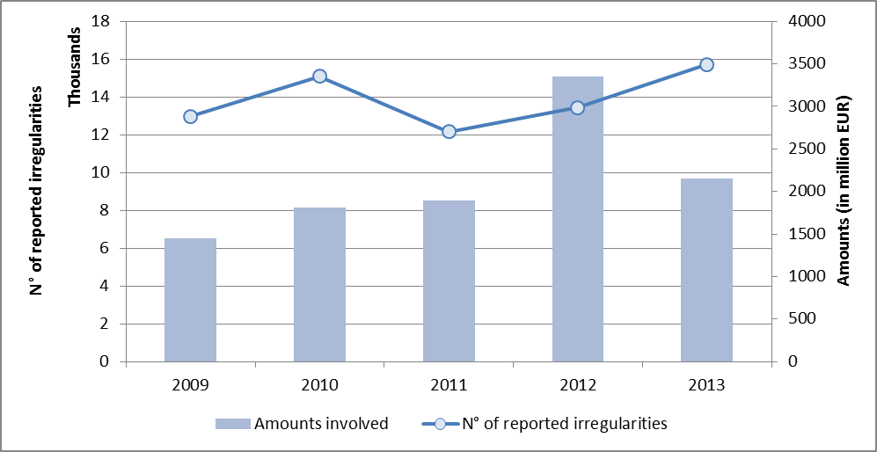

2.2. Irregularities reported as fraudulent affecting the EU budget
The number of fraudulent irregularities reported and the related amounts are not a direct measure of the level of fraud affecting the EU budget. They indicate the results achieved by Member States and EU institutions in detecting cases of potential fraud. The final decision on whether a case really constitutes fraud pertains to the responsible (judicial) authorities of the Member State involved.
In 2013, Member States reported as fraudulent 1 609 irregularities involving an overall amount of EUR 309 million in EU funds. Out of these, 25 fraudulent irregularities concerned funds managed under direct expenditure, involving EUR 1.2 million, and eight fraudulent irregularities were reported by candidate countries and involved about EUR 1 million.
The number of fraudulent irregularities reported in 2013 increased by 30% in comparison with the previous year, while their financial impact decreased by 21%. It should be noted that annual fluctuations in amounts are less important than variations in the number of reported cases (amounts can be particularly affected by individual cases involving high values). Significant differences are recorded between sectors, as shown in Table 1. Chart 2 shows the overall trends over the last five years, highlighting a certain decrease in the number of reported cases and amounts during this period.
There are also differences between the revenue trend (decreasing) and the expenditure trend (where fluctuations appear to be linked to the evolution of the multi-annual programming cycles and where there has been an increase since 2012).
Table 1: Irregularities reported as fraudulent in 2013
A breakdown of all fraudulent irregularities reported in 2013, by Member State and budget sector, is set out in Annex 1.
Chart 2: Irregularities reported as fraudulent and the related amounts, 2009-13
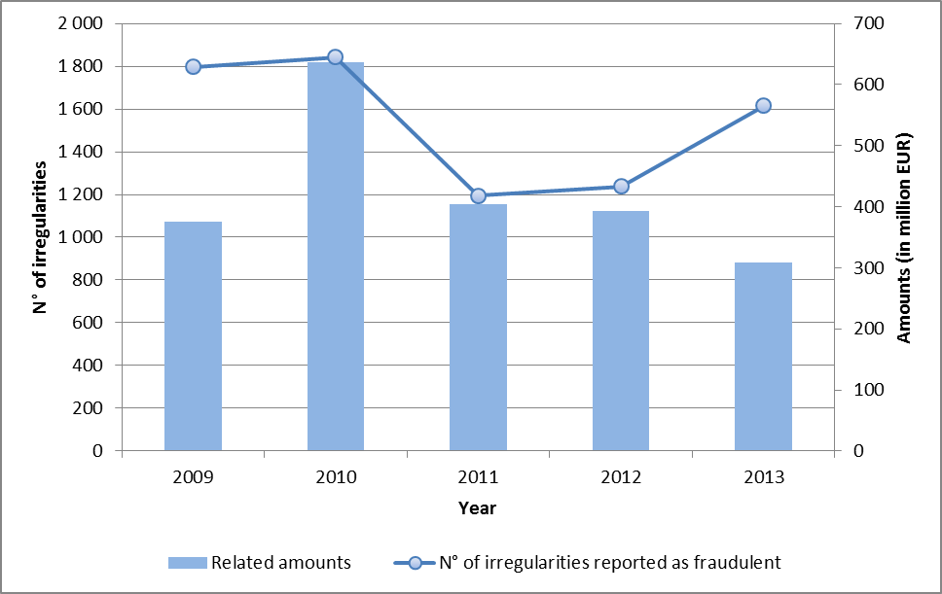

2.2.1. Revenue
The number of fraud cases reported for 2013 (633) is 17% lower than the average number reported for 2009-13 (763). The total established amount of TOR reported for 2013 (EUR 54 million – 61 million including estimated amounts) is 44% lower than the average established amount for 2009-13 (EUR 96 million).
In 2013, almost half of fraud cases (47%) were revealed during inspections by anti-fraud services and 29 % during customs controls carried out at the time of clearance of goods. About 56% of all TOR amounts involved in fraud cases were established during an inspection carried out by anti-fraud services.
Analysis shows that the number of fraud cases decreased over the 2009-13 period, as shown in Chart 3.
CHART 3: TOR — Cases of fraud and the established amounts affected, 2009-13
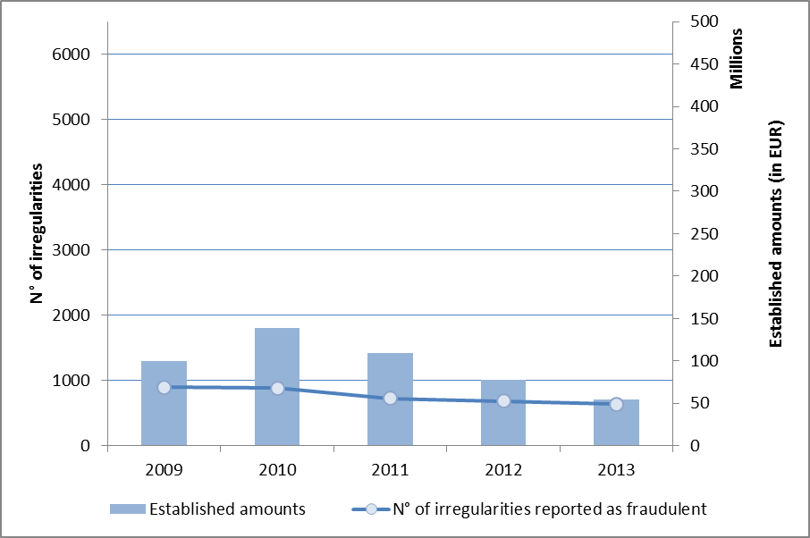

2.2.2. Expenditure
For EU expenditure, the increase in the number of irregularities reported as fraudulent was significant, at 76%. It reflects mainly the natural resources sector (where the increase was at 175%, see paragraph 2.2.2.1). Increases were also seen in the cohesion (15%) and pre-accession (27%) policies. Decreases were seen in direct expenditure (14%). The fluctuations in the amounts involved is less explicative as already specified as they decreased in all sectors, with the exception of agriculture (+10%).
Notified irregularities often relate to transactions that took place in a financial year other than that in which they were detected or reported. There is an average time lapse of about four years between when a (potential) act of fraud is committed and when it is reported to the Commission.
Charts 4 and 5 show the reported fraudulent irregularities and their related amounts, by expenditure sector.
Unlike in previous years, most irregularities reported as fraudulent (60%) were detected in the agricultural sector. As in previous years, however, the largest share of amounts that involve irregularities (63 %) comes from cohesion policy.
Charts 4 & 5: Irregularities reported as fraudulent by budget sector (expenditure) — by number and amount
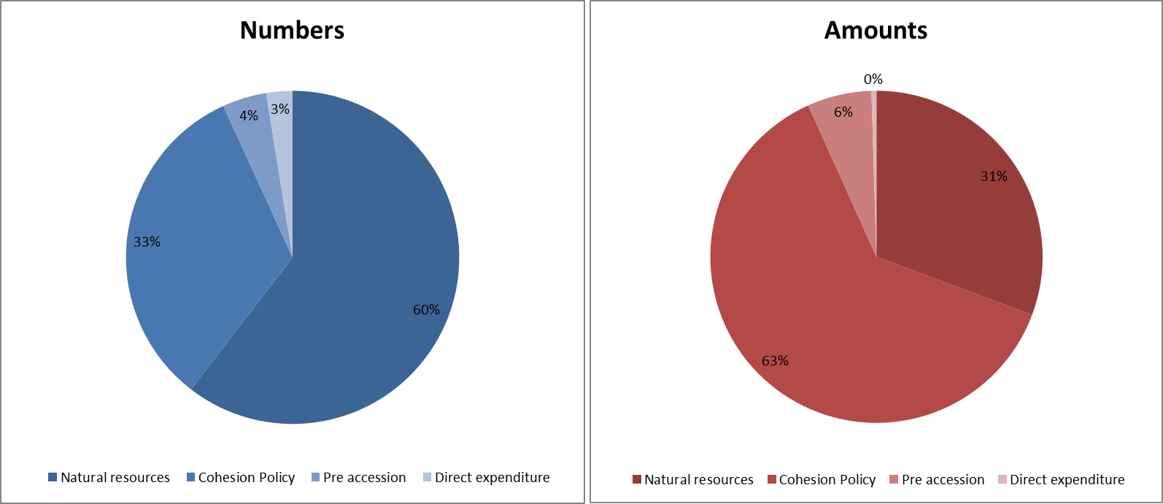
Detected modi operandi did not vary significantly compared to previous years. The use of false or falsified documentation or declarations remained the most frequently used method.
Only three of the irregularities reported as fraudulent relate to corruption.
About 48% of the irregularities reported as fraudulent in 2013 were detected by anti-fraud bodies or during criminal investigations or other external controls. 52% were detected by the administrative control systems provided for under sectoral regulations. This underlines the importance of external controls in the fight against fraud and the need for strong coordination with managing and audit authorities. It also shows that the latter have improved significantly. Anti-fraud or criminal investigations detected cases of potential fraud involving high financial amounts, which reflects their ability to target their work, and reflect their strong investigative capabilities.
In 2013, only one Member State, Ireland, did not classify any of its irregularities as fraudulent. Detection continues to vary between Member States. The Member States who detected and reported the highest number of fraudulent irregularities are: Italy, Romania, Bulgaria, Poland, Denmark and Greece (between 302 and 55). In terms of the amounts involved, the highest figures were reported by Italy, Poland, Romania, Greece and Germany (between EUR 68 and 24 million). Very few fraudulent irregularities (fewer than three for all expenditure sectors) were reported by Belgium, Lithuania, Luxembourg, Hungary, the Netherlands, Finland, and Sweden. These differences are caused by several factors and reflect very different approaches, not only among Member States but also among various administrations in the same Member State. Some Member States allocate significant resources to countering fraud; others prefer to apply financial corrections without further investigation of the potential criminal offence.
Of the irregularities reported as fraudulent in the last five years, 8 % were classified as fraud (ratio of established fraud). This ratio has doubled in comparison with that in 2012.

2.2.2.1. Natural resources (agriculture, rural development and fisheries)
The sharp increase in fisheries sector (+475%) was expected considering the delayed implementation of the programmes and the low numbers reported until last year.
For agriculture, the picture is more complex, as the irregularities notified by four Member States (Bulgaria, Denmark, Italy and Romania) represent about 75% of the total number of irregularities reported as fraudulent, but the number of irregularities reported as fraudulent also increased for five other countries (Czech Republic, Greece, Spain, France and Poland).
For Denmark, the reported cases are a continuation of the investigation started in 2012. The cases of suspected fraud are related to non-compliance with national restrictions on the use of fertiliser and cross-compliance requirements. Administrative proceedings on cross-compliance are ongoing and in many cases it is the court who will deliver the final judgement.
For Romania and Bulgaria, a number of weaknesses were identified in the system and this has led to more controls and consequently to more irregularities being detected.
Italy had the highest number of irregularities reported as fraudulent (213). About one-third are a consequence of a wide-spread ongoing investigation. However, a significant number may have been caused by an over-zealous application of the fraudulent classification; this will be further monitored in the coming years.
The increase in irregularities reported as fraudulent concerns both the European Agriculture Guarantee Fund and the Rural Development Fund. 18% of reported cases concern both funds.
Almost 30% of fraudulent irregularities involved the use of false or falsified documents or declarations.
In 2013, the proportion of potential fraudulent irregularities detected by anti-fraud services increased in comparison with previous years, to 44%, while the proportion of criminal investigations remained stable (8%). This is in particular due to the results notified by Italy and Denmark.
The ratio of established fraud in agriculture increased compared to 2012: it stood at 7 % of all cases reported in 2009-13 (6% in 2012).

2.2.2.2. Cohesion policy (in the 2007-13 and 2000-06 programming periods)
Although reporting of fraudulent irregularities increased by 15% in comparison to 2012, for the first time cohesion policy was not the area of budgetary expenditure with the highest number of irregularities reported as fraudulent. The related amounts, although decreasing, still represent the largest share of the total, however.
Consistently with the trends highlighted in 2012, the European Regional Development Fund (ERDF) accounted for the largest proportion of reported fraudulent irregularities in 2013. However, in the past five years the number of irregularities reported as fraudulent was almost the same for the European Social Fund (ESF) and the ERDF. In terms of amounts involved, the ERDF always represented the biggest proportion (because it provides higher amounts of financing for supported projects).
Most fraudulent irregularities (55 %) were detected by the control system provided for in EU legislation, not criminal investigations or anti-fraud bodies. This continued the trend already highlighted in 2012, but represents a striking change from the previous programming period (2000-06), when fraudulent irregularities were almost exclusively detected during anti-fraud and criminal investigations.
The Commission’s work in recent years on raising awareness of fraud in cohesion policy seems to have paid off, but the trend described above needs further consolidation. In terms of financial amounts, the most significant fraudulent irregularities were still detected during criminal and anti-fraud investigations (76 %).
The time taken to report fraudulent cases after they are detected remains the same, eight months on average. Irregular practices were detected, on average, two years and six months after they began.
The ratio of established fraud for cohesion policy has increased in comparison with 2012; 11% of the irregularities reported as fraudulent in 2009-13 were declared as established due to final decisions in Greece, Germany, Poland and Slovenia (this figure stood at 3% in 2012).

2.2.2.3. Pre-accession policy (Pre-accession assistance (PAA) and the Instrument for Pre-Accession (IPA))
The number of irregularities reported as fraudulent in PAA remained at the same level as in the previous year, although it has been decreasing since 2009. Romania and Bulgaria are the countries that reported fraudulent irregularities in PAA, mostly in rural development.
The number of fraudulent irregularities and the related irregular amounts related to the IPA increased in comparison with 2012. This increase can be considered within the norm because reporting of irregularities in IPA only started in recent years. Most of the fraudulent irregularities were reported by Turkey. The highest fraudulent amounts were recorded in relation to transition assistance, institution building and rural development.

2.2.2.4. Expenditure directly managed by the Commission
Expenditure directly managed by the Commission is analysed based on data on the recovery orders issued by Commission services.
In 2013, according to the accrual-based accounting system (ABAC), Commission services classified 25 recoveries as suspected fraud and reported them to OLAF. They accounted for EUR 1.2 million – less than in the previous year.

2.2.3. Results of the European Anti-Fraud Office (OLAF)
In 2013, OLAF launched 253 investigations and 34 coordination cases, and concluded 293 (of which 164 contained recommendations).
It sent 85 recommendations for judicial action to national authorities and recommended that approximately EUR 402.8 million be recovered, of which EUR 84.9 million related to revenues and EUR 317.9 million to expenditure (see Table 2).
Table 2: Amounts recommended for recovery in 2013 following OLAF investigations

2.3. Irregularities not reported as fraudulent
In 2013, the Commission was notified of 14 170 irregularities not reported as fraudulent (about 16 % more than in 2012). The figures increased for all sectors with the exception of pre-accession. The related financial impact decreased to about EUR 1.84 billion (38% less than in 2012), with significant increases in agriculture (see paragraph 2.3.2), as shown in Table 3.
Table 3: Irregularities not reported as fraudulent in 2013
Annex 2 shows a breakdown of all non-fraudulent irregularities reported in 2013, by Member State and budgetary sector.

2.3.1. Revenue
The number of irregularities reported for 2013 (4 144) was 5% higher than the average number of irregularities reported for 2009-13 (3 936). The total established amount of TOR involved (EUR 326 million – 327 million including estimated amounts) was 16 % higher than the average established amount for 2009-13 (EUR 280 million).
CHART 6: TOR – Cases of irregularities not reported as fraudulent and the amounts affected, 2009-13
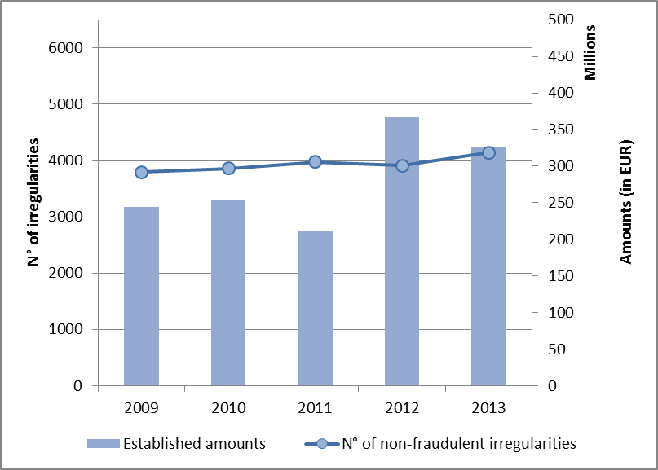
In 2013, most cases of irregularities (56%) and the established TOR amounts (56%) were detected using post-clearance controls.

2.3.2. Expenditure
The increase in the number of irregularities not reported as fraudulent concerns all expenditure sectors of the EU budget, with the exception of pre-accession.
However, this increase in reported irregularities is mirrored by a significant decrease in the amounts concerned, in particular in cohesion policy. A significant increase was observed in the natural resources policy area (mainly linked to rural development and to progress in implementing its programmes and the increased checks required by the findings of the European Court of Auditors and the Commission in the past years), and in direct expenditure.

3. Recovery and other preventive and corrective measures
An important aspect of protecting the EU’s financial interests involves the use of mechanisms to prevent and correct fraud and other irregularities so as to ensure that the budget is implemented in accordance with the principles of sound financial management.
Under shared management, the Commission may adopt the following measures:
- preventive measures: interruption of payments (moving the payment deadline back by up to six months); suspension of all or part of the interim payments to a Member State;
- corrective measures: if a Member States does not take the required measures, the Commission may decide to impose a financial correction. Expenditure that is not in accordance with applicable rules is either the subject of a recovery order or a deduction from the subsequent request for payment.
Data on Member States’ direct recoveries from beneficiaries are only partially available and are included in the Commission staff working document ‘Statistical evaluation of irregularities’.
Data on management types other than shared management (particularly direct expenditure) mainly concern recovery orders issued by Commission services or deductions from cost claims.

3.1. Expenditure: preventive mechanisms

3.1.1. Interruptions in 2013
In 2013, the Commission took 217 decisions to interrupt payments in the cohesion policy area (involving almost EUR 5 billion, similarly to the previous year). Of these, 131 were still open at the end of 2013 (involving almost EUR 2 billion).
Table 4 shows the interruption cases handled in 2013 and the significant prevention activity carried out, particularly in relation to the ERDF/Cohesion Fund, which represent more than 72 % of cases and about 87 % of the total amounts concerned.
Table 4: Interruption cases handled by the Commission services in 2013

3.1.2. Suspensions
One of the two suspension decisions concerning the ERDF and still in force at the end 2012 was lifted by the end of 2013, while the other remained in force. Four new suspension decisions were adopted in 2013. Another two new suspension decisions were adopted in January 2014.
One of the two suspension decisions concerning the ESF adopted in 2012 and still effective at the end of 2012 was lifted in 2013, while the other remained in force. 11 suspension decisions were adopted in 2013 and all but one were still ongoing at the end of 2013. One suspension decision adopted in 2011 was still ongoing at the end of 2013.

3.2. Expenditure: financial corrections and recoveries in 2013
In 2013, corrective measures decided by the Commission vis-à-vis Member States and beneficiaries increased in comparison with the previous year (by 20 %), while those implemented decreased (by 24%) , mainly in the cohesion policy area and in particular in relation to the ERDF (where they decreased by 40%, see Table 5).
Table 5: Financial corrections and recoveries per budgetary sector, 2013–12
Annex 3 shows a breakdown by Member State of financial corrections implemented in 2013 under shared management.

3.3. Recovery relating to own resources revenue
About 98% of all established amounts of TOR are collected without any particular problems. The remaining 2% relate to cases of fraud and irregularities. Member States are obliged to recover the unpaid amounts of TOR and to register them in the OWNRES database. For 2013, the amount to be recovered after fraud and irregularities involving a TOR amount of over EUR 10 000 was EUR 380 million. Of this, EUR 234 million has already been recovered by Member States for cases detected in 2013, making the recovery rate for 2013 62%, the best recovery result reported in the last decade. In addition, Member States continued their recovery activities for cases from previous years. In 2013, they recovered a combined total of approximately EUR 130 million for cases of fraud and irregularities detected between 1989 and 2012.
The overall historical recovery rate (1989-2010) is 75% when the calculation only takes into account closed cases for which Member States have completed their recovery work.
The classification of a case as fraudulent can be used as an indicator for forecasting recovery results. Recovery in cases of fraud is generally much less successful than in cases of irregularity (recovery rate of 24% compared to 68%).
Member States’ activities to recover TOR are monitored by means of TOR inspections and by a procedure that requires all amounts exceeding EUR 50 000 that are finally declared irrecoverable by Member States to be reported to the Commission. Member States are held financially liable for the non-recovery of TOR if weaknesses are observed in their recovery work.

4. Anti-fraud policies at EU level

4.1. Anti-fraud policy initiatives taken by the Commission in 2013

4.1.1. Regulation No 883/2013 on investigations conducted by OLAF
The OLAF regulation governing its work came into force on 1 October 2013. It strengthens the rights of the persons concerned by an OLAF investigation and clarifies the rights of witnesses. It clarifies the way in which investigation procedures should be conducted. It also strengthens the obligations on exchanging information between OLAF and EU Member States. Member States are now required to designate an Anti-Fraud Coordination Service (AFCOS) to facilitate effective cooperation and exchange of information with OLAF, including information of an operational nature. OLAF is assisting and advising Member States in their implementation of this new obligation. The regulation also contains provisions on cooperation with EU law enforcement bodies and with third countries.

4.1.2. Proposal for a directive on the fight against fraud to that affects the Union’s financial interests by means of criminal law
The Commission submitted a proposal for a directive on the protection of the EU’s financial interests by means of criminal law in 2012. It aims to strengthen the existing legal framework in this area by creating common minimum rules on defining criminal offences, sanctions and time-limitations for these offences. The Council adopted a general approach on 6 June 2013 and the European Parliament adopted its report in first reading on 16 April 2014.

4.1.3. Proposal for the establishment of a European Public Prosecutor's Office (EPPO)
On 17 July 2013 the Commission adopted a proposal for a regulation on the establishment of a European Public Prosecutor's Office (EPPO). The initiative is based on Article 86 of the TFEU. The EPPO would have the mandate to investigate, prosecute and bring to judgement crimes affecting the EU’s financial interests, as defined in the future Anti-fraud directive, and to ensure that this is done in a harmonised, independent and efficient way. According to the proposal, the EPPO would consist of a central level with a limited number of European prosecutors, and of a decentralised level with European delegated prosecutors in the Member States. Investigations would be carried out mainly at decentralised level by the delegated prosecutors, but certain key decisions would be taken at central level. The EPPO’s powers would be balanced by strong defence rights as guaranteed by Member States’ national laws, EU law and the Charter of Fundamental Rights. At the end of 2013, negotiations in the Council were still ongoing.

4.1.4. Fighting corruption in the EU
In 2011, the Commission presented an overall EU anti-corruption policy and called for a sharper focus on corruption in a range of policy fields. It highlighted closer cooperation, updated rules on confiscating criminal assets, revised public procurement legislation, better crime statistics and more rigorous use of conditionalities in cooperation and development policies.
The Commission committed to publishing an EU anti-corruption report every two years. The first report was adopted in February 2014. It seeks to intensify anti-corruption measures in the EU and to strengthen mutual trust between Member States. It also identifies EU-wide trends, facilitates the exchange of best practice and prepares the ground for future EU policy measures. Corruption in public procurement is the cross-cutting theme of the first report and complements the study on the ‘Costs of corruption in public procurement’ presented by OLAF in 2013.

4.1.5. Anti-fraud policy in customs

4.1.5.1. Mutual Administrative Assistance (MAA) - proposal for an amendment to Regulation 515/97)
On 25 November 2013, the Commission adopted a proposal for an amendment to Regulation (EC) No 515/97. The objective is to improve detection of and the fight against customs fraud by improving the availability of data, addressing inefficiencies of dual data protection supervision, ensuring admissibility of evidence in Member States’ court proceedings, and increasing data confidentiality.
The European Parliament adopted a Resolution on this in April 2014. Negotiations are still ongoing in the Council.

4.1.5.2. Joint Customs Operations (JCOs)
JCOs are coordinated and targeted operational measures implemented by the customs authorities of Member States and third countries, over a limited time period, to combat illicit cross-border trafficking in goods.
In the context of mutual assistance between EU customs administrations and the Commission, OLAF provides an IT platform, IT applications and an operations room for Member States to use to carry out JCOs. In 2013, OLAF supported or co-organised the following JCOs:
JCO HELIOS: Its aim was the fight against illegal maritime activities on high-taxed goods and illegal drugs and/or other prohibited/sensitive goods.
JCO HALYARD: The main aim was to identify, locate, intercept and reinforce the control of yachts and other vessels suspected of carrying illegal drugs and/or other prohibited/sensitive goods (including cigarettes). 124 Kg of cocaine were seized by the Customs authorities in the United Kingdom
JCO WAREHOUSE: It targeted excise goods in transit and excise goods imported under procedure 42 and subsequently put into the Excise Movement Control System (EMCS) under suspension of excise duties and VAT. This was the first time that tax authorities on a European-level were involved in the entire course of a JCO. As a result, almost 45 million smuggled cigarettes, nearly 140.000 litres of diesel fuel and about 14.000 litres of vodka were seized, in an estimated amount of € 9 million in the form of evaded customs duties.
JCO ROMOLUK: It targeted cigarette and alcohol smuggling. It also started the process of strengthening multi-agency cooperation. Cooperation with border guards and Frontex led to more seizures at the green border and inland through mobile control groups. Around 23 million pieces of smuggled cigarettes were seized, averting potential losses of customs duties and taxes in the EU of approximately 4.6 million €.
In addition to the JCOs, OLAF supported the PCA DISMANTLE project that ran throughout 2013.

4.1.5.3. Undervaluation Initiative
Undervaluation fraud in the customs area means the misdescription of the value of goods to evade full payment of customs duties on importation into the EU. This fraud has a direct impact on both the EU budget and national tax revenue and contributes to trade distortion, which penalises those Member States that carry out stricter controls with regard to declared customs values.
OLAF, together with a number of Member States, launched an initiative addressing this persistent and complex phenomenon to foster coordination/cooperation and equivalent protect the EU’s financial interests. It is based on an analysis of trade flows and aims to detect suspicious patterns and identify specific targets for risk-based checks, co-ordinate control strategies and ultimately lead to investigation and prosecution.
It will enter its operational phase in 2014.

4.1.5.4. The Anti-Fraud Information System (AFIS)
The main objective of AFIS is to improve cooperation with partners to help them correctly apply EU customs law. Member States use AFIS to report cases of fraud and irregularities. By the end of 2013, AFIS had 8 642 registered end-users on behalf of 1 670 services in Member States, third countries, international organisations, the Commission and other EU institutions.
In 2013, AFIS users exchanged 10 978 MAB mail messages. A total of 8 598 cases were published in the AFIS mutual assistance databases and modules. The transit information database (ATIS) received information on seven million new transit consignments, representing a total of 35 million movements of goods. The irregularity management system (IMS) received 23 282 new communications (9 998 related to new cases and 12 740 updates to existing cases) on irregularities from Member States and candidate countries, and at the end of 2013 it held a historical total of 174 000 communications. A total of four JCOs, three regional and one EU-wide, were conducted in 2013 using the AFIS system’s Virtual Operations Coordination Unit (VOCU) as its communication tool.

4.1.6. Fight against VAT fraud
In 2013 Directive 2013/42 was adopted to implement the Quick Reaction Mechanism to handle massive and sudden fraud that cannot be stopped using traditional means. The scope of the Reverse Charge Mechanism was also extended. Two Recommendations to the Council have been launched and are currently being discussed; they would make it possible to open negotiations with Russia and Norway for an EU agreement on administrative cooperation in the field of VAT. The Eurofisc network is fully operational and new ways are being explored to strengthen its activities, including a new cross-border risk analysis project. The VAT gap bi-annual study published in 2013 gives a better understanding of recent trends in VAT fraud.

4.1.7. Anti-fraud provisions in international agreements
To safeguard the EU’s financial interests and ensure proper application of customs legislation, EU international agreements contain provisions on customs mutual administrative assistance (MAA) and measures on the enforcement of preferential treatment.
In 2013, 46 agreements including MAA provisions for 69 third countries were in force and bilateral or regional negotiations were under way with another 51 countries.. In 2013, agreements containing free trade provisions became operational between the EU and Peru, Colombia and the Central American region. Such agreements were also initiated with Singapore, Moldova and Georgia. It should also be noted that in 2013 the EU Council adopted a revised Overseas Association Decision covering 25 of the EU’s Overseas Countries and Territories and, for the first time, the Decision includes measures on the enforcement of preferential treatment.

4.1.8. Fight against illicit trade in tobacco products

4.1.8.1. Communication on stepping up the fight against cigarette smuggling and other forms of illicit trade in tobacco products
A comprehensive EU Strategy and an Action Plan were adopted in June 2013.The Communication builds on the anti-smuggling policy in place at the EU’s Eastern borders and proposes measures to reinforce cooperation with the main sources and transhipment countries for smuggled tobacco products, and measures to secure the supply chain of tobacco products such as tracking and tracing. Measures are proposed to organise targeted customs operations, to increase enforcement capacity with more coordinated financing, technical assistance and training, and sharing of best practices. Attention is given to addressing corruption, decreasing the incentives created by gaps and loopholes in the excise legislation, strengthening sanctions and raising awareness among the public about the risks associated with illicit cigarettes. The majority of actions planned for 2013 were achieved and the implementation of the Action Plan will continue in 2014.

4.1.8.2. World Health Organisation Framework Convention on Tobacco Control (FCTC) – Protocol to Eliminate Illicit Trade
In 2013, the FCTC Protocol was signed by 54 parties, including the EU, and will enter into force once it is ratified by the 40 countries that need to do so. The EU and its Member States are now in the process of preparing the conclusion of the Protocol and adopting a decision on this matter.
The Protocol aims to combat illicit trade in tobacco products by putting in place a variety of measures. These include inter alia an obligation for all tobacco manufacturers to record information that allows the tracking and tracing of their product, access of officials to that information, and the reporting of that information upon request to a global information sharing point. Moreover, the Protocol foresees rules on the licensing of manufacturers and persons involved in the import and export of tobacco products and due diligence obligations for the manufacturers with regard to their customers’ compliance with the applicable laws and regulations. These supply chain control provisions are complemented by provisions on offences, law enforcement co-operation, mutual administrative and legal assistance, and extradition and international cooperation.
The Commission is fully committed to the FCTC Protocol and its ratification at global level.

4.1.8.3. Cooperation Agreements between the European Union, the Member States and four cigarette manufacturers
Binding agreements have been concluded between the EU, Member States and four tobacco manufacturers. The Agreement with PMI was concluded in 2004, the one with JTI in 2007, and the agreements with BAT and ITL in 2010. All EU Member States acceded to the cooperation agreements, with the exception of Sweden, who has not yet concluded agreements with BAT and ITL. Croatia also acceded to the cooperation agreements. OLAF monitors the implementation of the agreements which includes compliance with rules on global tracking and tracing of products to avoid them ending up on the illicit market.

4.1.9. Public procurement rules
Public procurement is a “hot spot” for fraud and corruption. It was chosen as the special chapter in the first EU Anti-Corruption report of early 2014. EU public procurement rules contribute to preventing, detecting and redressing corruption. The new public procurement and concessions directives enhance transparency, e.g. by making e-procurement mandatory, regulating concessions and looking closer at the vulnerable post-award phase. They strengthen the anti-corruption purpose, e.g. by defining conflicts of interest, extending the exclusion grounds to collusion between bidders and unduly influencing the contracting authority, and introducing monitoring and reporting obligations to curb procurement fraud and other serious irregularities.

4.1.10. Proposal for a Directive on the protection of the euro and other currencies against counterfeiting by means of criminal law
In 2013, the Commission submitted a proposal for a Directive to better protect the euro and other currencies from counterfeiting by using criminal law measures. Directive 2014/62/EU was adopted in the first half of 2014.
The Directive builds on and replaces Council Framework Decision 2000/383/JHA on increasing protection against counterfeiting by using criminal penalties and other sanctions, which was adopted in connection with the introduction of the euro. It maintains the provisions of the Framework Decision and introduces the following new provisions:
- effective investigative tools, such as those used in organised crime or other serious cases, made available in cases of counterfeiting of currency;
- common maximum penalties, including imprisonment of at least eight years for production and five years for distribution, for the most serious counterfeiting offences;
- transmission of seized counterfeit euro notes and coins to National Analysis Centres and National Coin Analysis Centres during ongoing judicial proceedings for analysis and identification, to enable the detection of further counterfeit euros in circulation; and
- the obligation to report every two years to the Commission the number of counterfeiting offences committed and the number of persons convicted.

4.1.11. Commission Anti-fraud Strategy (CAFS)
Adopted in June 2011, the Commission Anti-fraud Strategy (CAFS) is mainly addressed to Commission services. It has now been implemented and the Commission is required to report on its implementation this year.
In summary, the three priority actions that had to be completed by 2013 have been implemented:
- Anti-fraud provisions have been added to the new legal framework for spending programmes under the Multi-annual Financial Framework 2014-20;
- All Commission services but one have developed an anti-fraud strategy in which they propose anti-fraud activities specific to their sector. One Commission service is still in the process of developing its strategy and will finalise it shortly;
- The procurement directives have been revised to add measures that prevent, detect and correct fraud.

4.1.12. The Hercule and Pericles programmes

4.1.12.1. Implementation of the Hercule II and Pericles programmes
In 2013, the Hercule II Programme (2007-13) continued to support actions aimed at strengthening the operational and investigative capacity of customs and law enforcement agencies to combat fraud against the EU. The programme provided grants for assistance (EUR 7 million), training activities, including two digital forensic training sessions (EUR 3 million), legal training and studies (EUR 0.7 million), as well as IT support for the purchase of data and information made available to Member State authorities (EUR 3.3 million). Beneficiaries reported that significant results were achieved with the equipment purchased under the programme, in particular in their fight against cigarette smuggling and corruption perpetrated against the EU’s financial interests.
In 2013, under the Pericles Programme for the protection of euro banknotes and coins against fraud and counterfeiting, the Commission (OLAF) committed to 13 activities, including conferences, seminars and staff exchanges, organised by it and/or by Member States. These events focused specifically on increasing networking and regional cooperation in sensitive areas, as well as strengthening cooperation between different professional categories with a role in protecting the euro against counterfeiting. 95.42% of the Pericles Programme’s EUR 1 million budget was committed by the end of 2013.

4.1.12.2. Multiannual Financial Framework (MFF) 2014-20
Negotiations on the proposal for the Hercule III programme were successfully concluded with a political agreement in November 2013 and the adoption of Regulation (EU) No 250/2014. For the Pericles 2020 programme, Regulation (EU) No 331/2014 establishing an exchange, assistance and training programme to protect the euro against counterfeiting was adopted on 11 March 2014, and the Proposal for a Council Regulation extending to the non-participating Member States the application of Regulation (EU) No 331/2014 is expected to be adopted by the end of 2014.

4.2. Advisory Committee for Coordination of Fraud Prevention (COCOLAF)
Under Article 325 of the TFEU, Member States continued the close and regular cooperation between their authorities responsible for fraud prevention. They were supported by the Commission, including in the Advisory Committee for Coordination of Fraud Prevention (COCOLAF), which is a major forum for coordinating activities in Member States and whose meetings are organised by OLAF.
In 2013, COCOLAF met twice and was consulted by OLAF on the main developments in legislative and policy initiatives in the fight against fraud, such as the initiatives on criminal law for protecting the EU’s financial interests and the setting up of the European Public Prosecutor's Office.
COCOLAF shared its views on the implementation of the new OLAF regulation, in particular with regard to the designation of an anti-fraud co-ordination service (AFCOS) in all Member States, to facilitate effective cooperation and exchange of information. OLAF has advised Member State administrations on designating their AFCOS.
COCOLAF’s expert groups were restructured to further improve its overall functioning.

4.3. European Parliament resolution of 3 July 2013 on protecting the EU’s financial interests – the fight against fraud – Annual Report 2011
The resolution welcomed OLAF’s work on implementing the action plan on cigarette smuggling and the Protocol on eliminating illicit trade in tobacco products.
The Commission proposals to establish the European Public Prosecutor’s Office (EPPO) and on the fight against fraud that affects the EU’s financial interests by means of criminal law were outlined. These initiatives aim to contribute to investigations, the prosecution of offences and putting in place common definitions of criminal offences, sanctions and the time-limitation for offences.
Work aiming to harmonise the legal framework has been carried out to address the issues of comparability in anti-fraud systems. The development of standard evaluation criteria is difficult as the concept of ‘irregularity’ is defined according to national provisions. This also presents a challenge in comparing data on the implementation of obligations on fraud reporting.
The Commission supports the European Parliament’s recommendation for Member States to make it easier for tax officials to access customs data.
It adopted new provisions on irregular payments, as requested by Parliament in discussions on the recovery system in the agricultural sector.
OLAF and its Supervisory Committee agreed temporary working arrangements in September 2012. Permanent working arrangements were subsequently agreed in January 2014. The role of the Committee was clarified in the new OLAF Regulation, which entered into force on 1 October 2013.
The Commission appreciates the Parliament’s support for the Anti-Fraud Strategy for administrative arrangements with third countries and international organisations..
The Commission is in complete agreement with Parliament on the need for political non-interference in current legal proceedings and on respecting confidentiality. It notes that no breaches of fundamental rights or procedural guarantees were identified by the OLAF Supervisory Committee.
OLAF notes that no thresholds were introduced in the selection of cases for investigation, which was based on OLAF’s investigative policy priorities (IPPs).
The Commission agrees that customs fraud warrants special attention but does not share the view of Parliament that most customs cases are attributable to corruption as less than 1% of OLAF customs investigations involve suspected or established corruption.
The Commission does not agree with the Parliament that steps on national declarations have not been taken since 2011. Mandatory reporting in shared management was adopted as part of the 2012 Financial Regulation.
Simplification of the rules on public procurement has not been as extensive as the Parliament hoped. The Commission will continue to encourage and support Member States in their simplification work.

5. Measures taken by Member States to counter fraud and other illegal activities affecting the EU’s financial interests

5.1. Measures to combat fraud and other irregularities affecting the EU’s financial interests
Each year, the Member States report to the Commission on the main measures taken under Article 325 TFEU to combat fraud and other illegal activities affecting the EU’s financial interests. In 2013, Member States implemented various general and specific provisions to improve the prevention and combatting of such fraud.
The vast majority of legislative measures adopted by the Member States individually or as part of packages concerned public procurement, and were mainly adopted in combination with other measures related to financial crime, conflicts of interest, corruption, fraud and organised crime with horizontal or sectoral effects. Ten Member States introduced specific measures or sets of measures concerning public procurement in order to mitigate corruption and strengthen transparency, the effectiveness of management, and the effectiveness of control and audit. These measures also included operational measures with a sectoral effect.
Some Member States also reported on implementing separate general measures related to corruption, financial crime (including money laundering) and organised crime. The Czech Republic and Greece introduced anti-corruption measures within their national anti-corruption strategies.
Most Member States reported that they put in place administrative measures, in general related to increased monitoring and desk checks carried out by managing authorities, agencies or bodies involved in financial audit and investigation. This included the adoption of new guidelines, instructions and manuals.
Organisational measures adopted by Member States related mostly to the reorganisation of existing bodies and the adjustment of their competences, as well as inter-agency cooperation, general trainings and training on fraud awareness .
Many Member States put in place operational measures that mainly involved new or upgraded IT tools, web reporting and hotlines, as well as strengthened risk indicators and more checks. Four Member States reported enhanced cooperation with law enforcement and judicial authorities.

5.2. Implementation of Article 3.4 of the new OLAF Regulation on designating the anti-fraud coordination service (AFCOS)
The specific theme of the 2013 questionnaire is the implementation of Article 3.4 of the new OLAF regulation, which requires Member States to designate an Anti-Fraud Coordination Service (AFCOS) to facilitate effective cooperation and exchange of information, including information of an operational nature, with OLAF.
The AFCOS may be responsible for coordinating all national legislative, administrative and investigative obligations and activities related to protecting the EU’s financial interests and must ensure cooperation with OLAF and other Member States. If an AFCOS is vested with investigative powers (administrative or criminal), it can usefully complement and support OLAF’s investigations (on-the-spot checks) in the Member States.
So far, 23 Member States have appointed an AFCOS. These include all post-2004 Member States, plus Belgium, Denmark, Greece, France, Italy, the Netherlands, Austria, Portugal, Finland and the United Kingdom.
The four remaining Member States who have not formally designated their AFCOS yet reported that the procedures were ongoing, and are expected to be finalised before the end of 2014, or within two years. Germany reported that the Federal Ministry of Finance continues to coordinate matters relating to OLAF at national level.
All designated AFCOS are entrusted with coordination responsibilities, which are particularly broad in Bulgaria, Czech Republic, Estonia, Croatia, Cyprus, Italy, Lithuania, Hungary, Malta, Romania, Slovenia, Slovakia and Portugal.
In eight Member States, the AFCOS are also entrusted with certain investigative powers. Cyprus, Romania, Portugal and Malta reported broad competences here. Cyprus, Lithuania and Romania specified that their AFCOS had investigative competences in the area of criminal investigations.
Cooperation agreements between AFCOS and judicial authorities have been set up in Bulgaria, the Czech Republic, Estonia, Croatia, Latvia, Malta, Romania and Slovenia. Cooperation happens on a case-by-case basis in Belgium, France, Italy, Cyprus, Lithuania, Hungary, the Netherlands, Poland, Portugal and Finland.
AFCOS act as a contact point in the framework of OLAF’s investigations in Belgium, Bulgaria, Cyprus, Lithuania, Malta, Portugal, Romania and Slovakia. Germany reconfirmed its cooperation arrangement with OLAF.
The Commission will carefully monitor whether each designated AFCOS complies with the requirements set out in Article 3.4 of the OLAF Regulation and whether it ensures efficient and effective cooperation with OLAF.

5.3. Implementation of the 2012 recommendations
In the 2012 report on the protection of the Union’s financial interests, the Commission made a number of recommendations to Member States, in particular on: designating the national Anti-fraud Coordination Service (AFCOS); the need for appropriate criminal law sanctions for fraud; the speedy adoption and transposition of the public procurement directives; improving the low levels of reporting of fraudulent irregularities; the need for effective systems of risk assessment for checks of high-risk imports; and the adoption and implementation of the Multi-annual Financial Framework (MFF) provisions on fraud prevention in spending programmes. Implementation of these recommendations, presented during the 2013 reporting exercise, was generally adequate, although some concerns were not fully addressed.
Most Member States designated an AFCOS but some are still in the course of setting one up, discussing where in their public administration to locate it, or have not yet taken steps to set one up at all.
Although most Member States have adopted and implemented criminal law legislation covering fraud, their follow up reports show that there is still a lack of consistency in sanctions for fraud and the limitation period for prosecutions across the EU.
A number of Member States outlined their commitment to implementing the package of reforms included in the Public Procurement Directives as soon as it is adopted, and indicated that transposition of the Directives is advancing.
Three Member States were specifically mentioned in the 2012 report on low reporting of fraudulent irregularities in cohesion policy. Greece outlined updates made to its internal procedures and significant progress has been seen since these were implemented. Spain is examining a more integrated approach to underpinning risk analysis mechanisms for the 2014-20 programming period. France highlighted that checks carried out by the Commission and the Court of Auditors led to no findings of suspected fraud.
Most Member States said they take account of the analysis included in the report and the accompanying Staff Working Documents when planning checks and controls related to cohesion policy. Several Member States outlined changes already made or changes planned as a result of the report’s findings.
Member States were asked to step up their work to address the risks highlighted in rural development investment projects. Sweden reported significant improvements to systems and payments in 2013, after ‘serious or very serious shortcomings’ were identified following a 2012 review of procedures. Spain outlined the improvements it made, including in inspection procedures and trainings for inspectors, following recommendations by the Commission and the Court of Auditors. In its 2013 report on infringements, Slovenia highlighted significant weaknesses, particularly in the area of public procurement. It also reported that it had held seminars that aimed to improve procedures.
As concerns revenue and customs controls for high-risk imports, almost all Member States reported that adequate risk-analysis systems were now in place and no changes had occurred since 2012.
A structured cooperative relationship between managing authorities and relevant anti-fraud bodies is in place in most cases. As concerns specific IT tools for analysing the risk of fraud, Belgium reported its intention to use ARACHNE in the next programming period. Denmark stated that it is considering using ARACHNE for structural funds and will try to use IT tools in agriculture.
Most Member States reported that preparations for implementing the Multiannual Financial Framework 2014-20 were advancing, and that they remain committed to complying with the MFF provisions.

6. Conclusions and recommendations
As the mandate of the current Commission is coming to an end, it is worth taking a retrospective look at the most significant initiatives undertaken and the results achieved over the last five years in the area of protecting the EU’s financial interests and the fight against fraud.

6.1. An unprecedented set of anti-fraud measures
Unprecedented legal and administrative measures and proposals have been taken, which profoundly impact on how the Commission and the Member States deal with protecting the EU’s financial interests.

6.1.1. The beginning of the road: CAFS
In 2011, the Commission adopted its multiannual Anti-Fraud Strategy (CAFS). Initially addressed to the Commission services, the Strategy was pivotal in raising fraud awareness and bringing the issues of fraud detection and prevention into the spotlight.
The Strategy led to Commission services and EU agencies adopting sectoral anti-fraud strategies. The addition of anti-fraud provisions to the new legal framework for spending programmes in 2014-20 was also a significant achievement.
The actions implemented in the framework of the Strategy have increased the Commission’s and national authorities’ awareness and capabilities.

6.1.2. The reform of the European Anti-Fraud Office
In 2012, the European Anti-Fraud Office carried out an extensive reorganisation to step up efficiency in its investigative process and streamline governance and policy actions.
The adoption of Regulation (EU) No 883/2013 provided an improved legal framework which strengthens the rights of the persons concerned by an OLAF investigation, and also enhances the necessary cooperation with Member States through the appointment of the AFCOS.
Recommendation 1:
The four Member States who have not yet designated AFCOS are invited to do so by the end of 2014.

6.1.3. Measures to fight fraud and corruption in public procurement
Public procurement is a “hot spot” for fraud and corruption. In 2012, the Commission started to modernise the existing rules to strengthen transparency and their anti-corruption purpose. In February 2014, three directives were adopted.
In 2013, OLAF presented a study on the ‘Costs of corruption in public procurement’, and in February 2014 the first EU anti-corruption report was adopted. Both reports contain recommendations and highlight best practices.
In addition, Member States reported a significant number of legislative and administrative measures aimed at strengthening work in this area.
Recommendation 2:
Member States are invited to take into account the recommendations included in the anti-corruption reports and the best practices highlighted there.

6.1.4. Sectoral measures: revenue
In order to step up the fight against VAT fraud, a directive was adopted in 2013 to implement the Quick Reaction Mechanism to deal with massive and sudden VAT fraud. Established in 2010, the Eurofisc network started operational work in 2011 with the progressive establishment of four working fields and specific risk-analysis projects.
The fight against illicit tobacco products gained momentum. In 2010, the two latest cooperation agreements with tobacco manufacturers were concluded. In 2011, the Commission prepared an action plan to fight cigarette and alcohol smuggling along the EU’s eastern border. In June 2013, a comprehensive EU strategy and an action plan to fight smuggling and other forms of illicit trade in tobacco products were adopted. At the end of 2013, the Protocol to eliminate the illicit trade in tobacco products appended to the World Health Organisation’s (WHO’s) Framework Convention on Tobacco Control (FCTC) was finalised and signed by the EU.

6.1.5. Sectoral mesures: expenditure
In 2013, the main regulatory provisions for the 2014-20 spending programmes were adopted. For the first time, they contain a specific requirement for national authorities to set up effective and proportionate anti-fraud measures taking into account the risks identified.
National audit authorities and the Commission will monitor the correct implementation of such requirements. In addition, guidelines on fraud risk assessments and effective and proportionate ant-fraud measures were prepared together with the national authorities.
Member States will need to respect these to ensure that the EU’s financial interests are protected against fraud.
Recommendation 3:
The Commission recommends that Member States implement the legal requirements according to the adopted guidelines.

6.1.6. What lies ahead
Three main legislative proposals have been submitted to the co-legislators in previous years and are awaiting approval:
    - a directive on the fight against fraud by means of criminal law;
    - a regulation to set up the European Public Prosecutor’s Office;
    - the amendment of Regulation (EC) No 515/97 on mutual administrative assistance in the customs area.
The adoption of these proposals would complement and strengthen the legal framework shaped in 2009-13. It would strengthen the fight against fraud and would ensure stronger coordination with and between Member States.
Recommendation 4:
The Commission invites the co-legislators to swiftly complete the legislative work started and to adopt the pending proposals.

6.2. Operational results: a different pace
Although the legislative landscape has changed considerably in the last few years, the analysis described in section 2.2 of this report shows that the impact of these measures is not as evident as one could have expected.
On the one hand, the overall trend in detecting and reporting potential fraudulent irregularities in the last five years shows a slow decrease, although this seems to have reversed since 2012. On the other hand, the number of irregularities not reported as fraudulent has progressively increased. The decreasing trend is more evident on the revenue side than it is on the expenditure side.

6.2.1. Revenue: Quality of information and control strategies
On the revenue side, it is not clear whether the trend is due to a shift towards detecting irregular cases or to the way in which Member States classify cases. Other possible reasons could include: the new fraud prevention measures implemented in Member States to identify vulnerabilities; the possibility of Member States pursuing financial interests without further investigation of the potential criminal offence; the possibility that Member States’ controls strategies may need to include more dynamic factors to better adapt to the changing environment.
Recommendation 5:
In view of the decreasing number of fraud cases reported, the Commission recommends that Member States review their control strategies to ensure that well-targeted, risk-based customs controls are in place to make it possible to effectively detect fraudulent import operations.
Some quality issues have nonetheless been identified when the reported information was analysed. When comparing the number of fraud and irregularity cases for 2009-13 with the figures from previous reports, it appears that there is a time gap between when the cases are detected and when they are reported via the OWNRES application. Although Member States’ work to regularly update the information on cases of fraud and irregularities can only be welcomed, the timely reporting of fraud and irregularity cases should nevertheless be respected.

Recommendation 6:
Member States should step up work to ensure timely reporting on and updating of fraud and irregularity cases. To ensure effective monitoring and follow-up, reliable information on fraud and irregularity cases should be entered in OWNRES.

6.2.2. Expenditure: a developing landscape
On the expenditure side, the changes in the number of fraudulent irregularities reported in the last five years are more difficult to interpret (decreasing in 2009-11, and then increasing in the following two years). However, it seems to be more linked to the fact that most of spending programmes are multi-annual (structural and rural development funds and Pre-accession assistance).
An unexpected change was observed in 2013 in the agricultural sector (with significantly more cases of potential fraud detected and reported); this could be the result of ad hoc investigations and might not be confirmed in future years.
However, the role of the managing authorities in detecting fraud has been growing, in particular since 2012. Their role should grow further in the coming years, thanks to the recently developed anti-fraud strategies that will be fully implemented in 2014-20.
Recommendation 7:
The Commission recommends that Member States correctly implement the EU’s anti-fraud rules, based on carefully prepared and up-to-date fraud risk assessments, and supported by adequate IT tools that will help to better target checks.
Structured coordination (exchange of data and information) between anti-fraud bodies and managing authorities has proved to be a best practice and should be implemented in all Member States.
Fraud detection practices remain very different between Member States and the Commission remains concerned with the low number of potentially fraudulent irregularities reported by some countries. The Commission will continue its work to raise fraud awareness and to provide guidelines to improve the convergence of national systems to protect the EU’s financial interests against fraud more efficiently.
Recommendation 8
As some Member States report very low numbers of fraudulent irregularities, the Commission recommends strengthening their work on detecting and/or reporting fraud:
- in the area of cohesion policy: France, Spain, Ireland, Hungary, Denmark and the Netherlands;
- in the area of agriculture: Lithuania, the Netherlands, Portugal and Finland.

ANNEX 1 — Irregularities reported as fraudulent
(The number of irregularities reported as fraudulent measures the results of Member States’ work to counter fraud and other illegal activities affecting EU financial interests; it should not be interpreted as the level of fraud on the Member States’ territories)
ANNEX 2 — Irregularities not reported as fraudulent
ANNEX 3 — 2013 financial corrections implemented under shared management (EUR million)

OJ L 248,18.9.2013, p.1.
(i) Implementation of Article 325 by the Member States in 2013; (ii) Statistical evaluation of irregularities reported for 2013 own resources, natural resources, cohesion policy and pre-accession assistance; (iii) Recommendations to follow up the Commission report on protection of the EU’s financial interests — fight against fraud, 2012; (iv) Methodology regarding the statistical evaluation of reported irregularities for 2013; (v) Annual overview with Information on the Results of the Hercule II Programme in 2013; VI) Implementation of the Commission Anti-Fraud Strategy (CAFS).
The Irregularity Management System (IMS) for reporting irregularities in the areas of shared management and the ‘recovery context’ in the Commission’s accounting system (ABAC) for expenditure managed by the Commission.
This implies that the cases initially reported by Member States as potentially fraudulent may be dismissed by judicial authorities.
For definitions, see Annex IV (Methodology).
The high percentage of amounts for which irregularities were reported as fraudulent relative to the total payments for Pre-accession assistance (last column of Table 1) is entirely due to the fact that payments for this sector were very limited in 2013 (EUR 28 million) as the assistance programmes were almost completed. Fraudulent irregularities detected and reported in 2013 relate to actions financed under previous financial years.
For comparability reasons, figures for 2009-12 are based on the data used to prepare the reports for those years.
On average, two years and nine months pass between the time when a fraudulent act is committed and the moment it is detected. Another average of fifteen months then pass before the irregularity is reported to the Commission. However, these figures are significantly influenced by the irregularities reported in the agricultural sector (20 months after detection); in cohesion policy the time gap is much shorter (eight months).
Two in cohesion policy and the other in agriculture. Three Member States reported that they had detected such cases: Czech Republic, Latvia (cohesion policy) and the Netherlands (agriculture). The latter is related to the financial year 1999 and is linked to other similar cases reported in previous years by France and Belgium. Due to its complexity and the secrecy of investigations it was only reported in 2013.
See Annex 1.
The ratio of established fraud is the percentage of the number of cases of established fraud over the total number of irregularities reported as fraudulent (cases of suspected or established fraud) during the five-year period.
EAGF.
EAFRD.
The Commission services responsible for cohesion policy, together with OLAF, have implemented a Joint Anti-Fraud Strategy since 2008.
SAPARD.
For a full description see ‘The OLAF report 2013’. http://ec.europa.eu/anti_fraud/documents/reports-olaf/2013/olaf_report_2013_en.pdf
Ibidem, Figure 16, page 21.
See footnote 4.
For comparability reasons, figures for 2009-2012 are based on the data used for the reports of those years.
Data presented in this section reflect those published in the Commission’s annual accounts, i.e. in Explanatory Note No 6 of the Accounts of the Union, pending the audit by the European Court of Auditors.
Cases of a significant deficiency of Member State management and control systems in 2007-13, or of certified expenditure being linked to serious irregularities.
Applied in three cases: (a) evidence of serious deficiency in the management and control system with no corrective measure taken; (b) certified expenditure linked to serious irregularity; or (c) a Member State’s serious breach of its management and control obligations.
Financial corrections follow three main steps: (a) in progress: subject to change not formally accepted by the Member State; (b) confirmed/decided: agreed by the Member State or decided via a Commission decision; (c) implemented: the financial correction is carried out and undue expenditure corrected.
Subsequent amendments to the legal framework have significantly changed the reporting rules for the current programming period.
Germany
Italy
Three related to Spain were still in force at the end of 2013; one (Estonia) was lifted before year-end.
Spain
Czech Republic
Slovakia
Germany
Belgium, Czech Republic, Spain, France, Italy, Slovakia and the United Kingdom
France
For further details, see: http://ec.europa.eu/anti_fraud/about-us/legal-framework/memo_en.htm
See also SWD ‘Implementation of Article 325 by the Member States in 2013’.
COM(2012) 363 final.
COM(2013) 532.
See point 4.1.2.
Communication from the Commission to the European Parliament, the Council and the European Economic and Social Committee of 6 June 2011 on Fighting Corruption in the EU — COM(2011) 308 final.
COM(2014) 38 final of 3.2.2014.
http://ec.europa.eu/anti_fraud/documents/anti-fraud-policy/research-and-studies/pwc_olaf_study_en.pdf
COM(2013) 796.
A7-2041/2014.
Regional Maritime Joint Customs Operation involving Italian, Spanish and French customs services.
In the zone of the Western Mediterranean Sea between Gibraltar and Sicily
Regional Joint Customs Operation of maritime surveillance, involving: Belgium, France, Ireland, the Netherlands, Portugal, Spain, Germany and the United Kingdom (including Gibraltar, Guernsey, Jersey and the Isle of Man).
Sailing from South America, the Caribbean, and West and North Africa, to the European area.
OLAF and Lithuania co-organised this JCO involving all 28 Member States.
OLAF and Romania co-organised this regional JCO that was carried out at the Romanian/Moldovan and Romanian/Ukrainian borders.
FRONTEX, EUROPOL and EUBAM were involved.
PCA (Priority Control Area)-DISMANTLE was set up by DG TAXUD in close coordination and with the support of OLAF. It addressed the risk of smuggling and diversion of cigarettes and alcohol from specific identified third countries at the eastern border. It also covered specific transit and excise risks as identified by Member States experts. PCA was carried out from 1 February 2013 until 31 December 2013. It was endorsed by the Customs Code Committee (CRM section) and was based on the Customs Code.
AFIS secure mail service
1 779 of those cases were forwarded to the WCO (non-nominal data only), at the request of Member States
OJ L 201, of 26.7.2013, p. 1
Directive 2013/43
19 September 2013
(2013/755/EU), OJ L 344, 19.12.2013, p 1.
COM(2013) 324 final, 6.6.2013.
Monitoring the movement
To detect at which point the product fell off the legal supply chain
20 December 2013.
The FCTC-Protocol is an international treaty annexed to the WHO Framework Convention on Tobacco Control.
Philip Morris International (PMI), Japan Tobacco (JTI), British American Tobacco (BAT) and Imperial Tobacco Limited (ITL)
The text of the agreements is available at: http://ec.europa.eu/anti_fraud/investigations/eu-revenue/cigarette_smuggling_en.htm
See also the OLAF report 2013.
See also point 4.1.4.
Directive 2014/23/EU of the European Parliament and of the Council of 26 February 2014 on the award of concession contracts, Directive 2014/24/EU of the European Parliament and of the Council of 26 February 2014 on public procurement and repealing Directive 2004/18/EC and Directive 2014/25/EU of the European Parliament and of the Council of 26 February 2014 on procurement by entities operating in the water, energy, transport and postal services sectors and repealing Directive 2004/17/EC
COM(2013) 42 final.
OJ L 151, 21.5.2014, p. 1.
The Council adopted a general approach in October 2013 and the European Parliament its opinion in December 2013.
COM(2011) 376 final.
See the staff working document on implementing the CAFS.
See paragraph 4.1.9
COM(2011) 914 final
OJ L 84, 20.3. 2014, p. 6.
COM(2011) 913 final.
OJ L 103, 5.4.2014, 1.
Established under Commission Decision 94/140/EC of 23 February 1994, as amended on 25 February 2005.
See point 4.1.1.
http://www.europarl.europa.eu/sides/getDoc.do?pubRef=-//EP//TEXT+TA+P7-TA-2013-0318+0+DOC+XML+V0//EN&language=EN
The successful outcome of ‘Operation Barrel’ involved the cooperation of 24 Member States and a number of external actors, resulting in the seizure of 1,2 million cigarettes.
Legislative, administrative, organisational or operational measures.
Single legislative measures concerning public procurement were adopted by Bulgaria, the Czech Republic, Lithuania, Malta, Spain, Romania and Sweden, while packages of measures (legislative, administrative, organisational or operational measures) were adopted by Estonia and Greece.
Germany, Greece, Italy, Cyprus, Latvia, Hungary, Malta, Romania, Slovenia and the United Kingdom.
Germany, Cyprus, Latvia, Hungary, Slovenia and the United Kingdom.
Belgium, Bulgaria, Denmark, Cyprus, Latvia, Malta, Poland Romania and Finland.
Belgium, Denmark, Germany, Estonia, Ireland, Greece, France, Croatia, Italy, Latvia, Luxembourg, the Netherlands, Romania, Slovenia, Slovakia Finland, and the United Kingdom.
Greece, Spain, France, Luxembourg, Hungary, Poland, Portugal and Romania.
Greece, Spain, Italy, Latvia and the United Kingdom.
Bulgaria, Estonia, Ireland, Greece, Luxembourg, Hungary, Romania and Slovenia.
Bulgaria, Ireland, Greece, Poland and Slovenia.
France, Lithuania, Malta and Romania.
Regulation (EU, EURATOM) No 883/2013, Art. 3.4.
Denmark, Greece, Austria, Portugal and the United Kingdom appointed its AFCOS service in 2014.
By June 2014.
Finland reported an interim solution. .
Ireland, Spain, Luxembourg and Sweden.
Spain.
Department EA6.
Belgium, Bulgaria, Cyprus, Lithuania, Malta, Portugal, Romania and Slovakia,
Concluded in April 2008 and naming the contact point for OLAF.
See section 5.2.
Cyprus reported that it has no formal procedures for taking these documents into account but outlined its intention to changes this. Slovakia believes this recommendation does not reflect risk areas that require targeting by its audit authority.
See section 4.1.11.
See section 6.1.5.
See section 4.1.9.
See section 4.1.4.
Regulation (EU) No 904/2010.
In 2013 and 2014.
For the amounts related to agriculture in the Netherlands, see footnote 9 and paragraph 3.4.1 of the Commission staff working document on ‘Statistical evaluation of irregularities’.
Row and column totals may not correspond to the sum of values displayed due to rounding.

