TABLE OF CONTENTS
COMMISSION STAFF WORKING DOCUMENT Statistical evaluation of irregularities reported for 2013 Own Resources, Natural Resources, Cohesion Policy, Pre-accession and Direct expenditure
LIST OF ABBREVIATIONS 8
1. Introduction 10
1.1. Scope of the document 10
1.2. Structure of the document 10
Part I - REVENUES 11
2. Traditional Own Resources 11
2.1. Introduction 11
2.2. General analysis – Trend analysis 11
2.2.1. Reporting Years 2008-2013: Cases of fraud and irregularities 11
2.2.1.1. Irregularities reported as fraudulent 12
2.2.1.2. Irregularities not reported as fraudulent 13
2.2.2. Established and estimated amounts 14
2.2.3. Recovery 15
2.2.3.1. Recovery rates 16
2.3. Specific analysis 16
2.3.1. Irregularities reported as fraudulent 16
2.3.1.1. Modus operandi 16
2.3.1.2. Method of detection of fraud cases 17
2.3.1.3. Smuggled cigarettes 18
2.3.1.4. Fraud cases by amount category 19
2.3.2. Irregularities not reported as fraudulent 19
2.3.2.1. Modus operandi 19
2.3.2.2. Method of detection of irregularity cases 19
2.3.2.3. Non-fraudulent irregularities by amount category 21
2.4. Member States’ activities 21
2.4.1. Member States’ classification of cases of fraud and other irregularities and related rates 21
2.4.2. Recovery rates 22
2.4.2.1. Fraud 22
2.4.2.2. Other Irregularities 22
2.4.2.3. Historical recovery rate 23
2.4.3. Commission’s monitoring 23
2.4.3.1. Examination of the write off reports 23
2.4.3.2. Commission’s inspections 23
2.4.3.3. Particular cases of Member State failure to recover TOR 24
Part II - EXPENDITURE 25
Section I - Shared Management 25
Natural Resources 25
3. Common Agricultural Policy (CAP) 25
3.1. Introduction 25
3.2. General analysis – Trend analysis 26
3.2.1. Irregularities reported as fraudulent 26
3.2.2. Irregularities not reported as fraudulent 28
3.3. Specific analysis 30
3.3.1. Irregularities reported as fraudulent 30
3.3.1.1. Modus operandi 30
3.3.1.2. Type of control / Method of detection 32
3.3.1.3. Complexity of the irregularities reported as fraudulent 35
3.4. Anti-fraud activities of Member States 36
3.4.1. Detection – Reporting Efficiency 36
3.4.2. Detection of irregularities reported as fraudulent in 2012 by Member State 38
3.4.3. Fraud detection rate 39
3.4.4. Ratio of established fraud 2009-2013 40
3.5. Recovery cases 42
3.5.1. Legal Framework 42
3.5.2. Amounts recovered in 2013 42
3.5.3. Application of the 50/50 Rule 43
3.5.4. Commission’s Audits 45
4. Common Fisheries Policy (CFP) 46
4.1. General analysis 46
4.2. Specific analysis 47
4.2.1. Types of irregularity detected 47
4.2.2. Method of detection 47
4.3. Control activity by Member States 47
Sustainable Growth 49
5. Cohesion Policy 49
5.1. Trend analysis 50
5.1.1. Irregularities reported as fraudulent 50
5.1.1.1. Trend by programming period 50
5.1.1.2. Trend by Fund 52
5.1.1.3. Trend by objective 54
5.1.2. Irregularities not reported as fraudulent 56
5.2. Specific Analysis – Irregularities reported as fraudulent in relation to the Programming Period 2007-13 58
5.2.1. Priorities concerned by the irregularities reported as fraudulent in 2013 58
5.2.2. Types of irregularities / modus operandi detected - Irregularities reported as fraudulent in 2013 59
5.2.3. Type of control / method of detection – Irregularities reported as fraudulent 60
5.2.3.1. Complexity of the irregularities reported as fraudulent 62
5.2.4. Type of irregularities not reported as fraudulent – 2008-2013 63
5.3. Anti-fraud activities by Member States 63
5.3.1. Detection – Reporting Efficiency 64
5.3.2. Detection of irregularities reported as fraudulent in 2013 by Member State 65
5.3.3. Fraud detection rate 66
5.3.4. Fraud Prevention Rate 67
5.3.5. Ratio of established fraud 2008-2012 68
Section II - Decentralised Management 70
The EU as a global player / Pre-Accession Policy 70
6. Pre-Accession Policy (Pre-Accession Assistance and Instrument for Pre-Accession) 70
6.1. The Pre-accession Assistance (PAA), 2000-06 and Instrument for Pre-Accession (IPA), 2007-13 70
6.2. General analysis – Trend analysis 73
6.2.1. Trend analysis 73
6.2.2. Trend analysis IPA 74
6.2.3. Reporting efforts 74
6.3. Specific analysis – Financial year 2013 75
6.3.1. Pre-Accession Assistance (PAA) 75
6.3.2. Instrument for Pre-Accession (IPA) 76
6.3.3. Method of detection 76
6.3.4. Recovery for the Pre-Accession Assistance (PAA) 77
Section III – Centralised Management 78
7. Direct Management 78
7.1. Introduction 78
7.2. General analysis 79
7.2.1. Five year analysis 2009-2013 79
7.3. Specific analysis 80
7.3.1. Recoveries according policy areas 80
7.3.2. Recoveries according to legal entity residence 82
7.3.3. Method of detection 82
7.3.4. Types of error 83
7.3.5. Time delay 83
7.3.6. Recovery 83
COUNTRY FACTSHEETS 85
Belgium 86
Bulgaria 87
Czech Republic 88
Denmark 89
Germany 90
Estonia 91
Ireland Error: Reference source not found
Greece 93
Spain 94
France 95
Croatia 96
Italy 97
Cyprus 98
Latvia 99
Lithuania 100
Luxembourg 101
Hungary 102
Malta 103
Netherlands 104
Austria 105
Poland 106
Portugal 107
Romania 108
Slovenia 109
Slovakia 110
Finland 111
Sweden 112
United Kingdom 113
ANNEXES 114
ANNEX 1 115
ANNEX 2 116
ANNEX 3 117
ANNEX 4 118
ANNEX 5 119
ANNEX 6 120
ANNEX 7 121
ANNEX 8 122
ANNEX 9 123
ANNEX 10 124
ANNEXES 11-15 125
ANNEX 11 126
ANNEX 12 127
ANNEX 13 128
ANNEX 15 130

LIST OF ABBREVIATIONS
CAP | Common Agricultural Policy
CF | Cohesion Fund
CFP | Common Fishery Policy
CN | Combined Nomenclature (Customs)
CP | Cohesion Policy
DetE | Detection Efficiency
DG | Directorate General
EAFRD | European Agricultural Fund for Rural Development
EAGF | European Agricultural Guarantee Fund
EC | European Commission
EFF | European Fishery Fund
ER | Error Rate
ERDF | European Regional Development Fund
ESF | European Social Fund
EU | European Union
EU-10 | The ten Member States having acceded the EU in 2004
EU-12 | The twelve Member States having acceded the EU between 2004 and 2007
EU-15 | The fifteen Member States of the EU before the 2004 accession
EU-2 | Bulgaria and Romania
EU-27 | The 27 Member States before Croatian accession
EUR | Euro
FDR | Fraud Detection Rate
FFL | Fraud Frequency Level
GNI | Gross National Income
HRR | Historical Recovery Rate
NR | Natural Resources
OLAF | European Anti-Fraud Office (Office pour la Lutte Anti-Fraude)
OWNRES | Web application for communication of irregularities in the field of Traditional Own Resources
RepE | Reporting Efficiency
RR | Recovery Rate
SME | Small and Medium Sized Enterprise
TFEU | Treaty on the Functioning of the European Union
TOR | Traditional Own Resources

1. Introduction

1.1. Scope of the document
The present document is based on the analysis of the notifications provided by national authorities of cases of irregularities and suspected or established fraud. The reporting is performed in fulfilment of a legal obligation enshrined in sectoral European legislation.
The document accompanies the Annual Report adopted on the basis of article 325 of the Treaty on the Functioning of the European Union (TFEU), according to which “The Commission, in cooperation with Member States, shall each year submit to the European Parliament and to the Council a report on the measures taken for the implementation of this article”.
For this reason, this document should be regarded more as an analysis of the achievements of Member States.
The methodology (including the definition of terms and indicators), the data sources and the data capture systems are explained in detail in the Commission Staff Working Document – Methodology for the Statistical Evaluation of Irregularities.

1.2. Structure of the document
The present document is divided in two parts.
The first part is dedicated to the analysis of irregularities reported in the area of the Traditional Own Resources (Revenues).
The second part, concerning the expenditure part of the budget, is composed of three sections, dedicated, respectively, to shared, decentralised and centralised management modes.
The section dedicated to shared management, covers the natural resources (agriculture, rural development and fisheries) and the cohesion policy. Decentralised management refers to the pre-accession policy, while the centralised management section mainly deals with internal and external policies for which the Commission directly manages the implementation.
The document is completed by 27 country factsheets, which summarise, for each Member State, the main indicators and information that have been recorded through the analyses.
15 Annexes complement the information and data of this document, providing a global overview of the irregularities reported according to the relevant sector regulations. Annexes from 1 to 10 concern Traditional Own Resources, Annexes 11 and 12 Natural Resources and Annexes from 13 to 15 the Cohesion Policy.
Part I - REVENUES

2. Traditional Own Resources

2.1. Introduction
For more information about how information concerning irregularities and fraud related to Traditional Own Resources are collected and analysed, see paragraph 1.3 of the Commission Staff Working Document ‘Methodology’.
Charts TOR1 –TOR4 provide an overview of the number of cases of fraud and irregularities per reporting year, established amounts and recovery rates as published in the previous years’ reports and to compare them with the reporting trends observed for the 2008-2012 period.
The following analysis is based on the data available on the cut-off date (7 April 2014) and aims to provide an overview of the reported cases of fraud and irregularities reported for 2013 together with their financial impact.

2.2. General analysis – Trend analysis

2.2.1. Reporting Years 2008-2013: Cases of fraud and irregularities
The number of cases reported via OWNRES for 2013 (4 777) is currently almost as high as the average number of cases of fraud and irregularities reported for the 2008-2012 period (4 812).
The total established amount of TOR involved (EUR 380 million) is about 2 % higher than the average established amount for years 2008-2012 (EUR 371 million).
In 2013, two big cases totalling to the amount of EUR 29 million were reported comparing to 2012, when six big cases with a total established amount of about EUR 104 million affected the total established amount.
Chart TOR1: Total cases of fraud and irregularities and amounts affected (2008-2013)
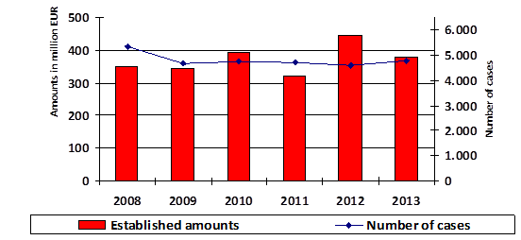
When the number of cases of fraud and irregularity are compared with those published in the previous report, it appears that there is a time gap between the detection of the cases and their reporting via the OWNRES application. For 2012, there has been an increase in the number of fraud and irregularity cases (totalling to 668) since the last report. Although the efforts by Member States in constantly updating the information on cases of fraud and irregularities is to be welcomed, the timely input of new reports and updates should nevertheless be respected.
Annex 1 shows the situation on the cut-off date (7 April 2014) for years 2008-2013.

2.2.1.1. Irregularities reported as fraudulent
The number of fraud cases registered in OWNRES for 2013 (633) is currently 26 % lower than the average number of fraud cases reported for the 2008-2012 period (851).
The total established amount of TOR involved (EUR 54 million) represents almost half of the average established amount for the years 2008-2012 (EUR 100 million).
For 2013, Estonia, Luxemburg, Slovakia and Sweden did not communicate any case of fraud exceeding an amount of EUR 10 000.
CHART TOR2: Cases of fraud and established amounts (2008-2013)
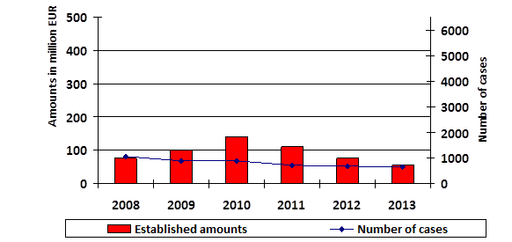
On the cut-off date, only 13 % of all cases detected in 2013 were classified as fraud, whereas the figure for 2008 was 22 %. Since 2008 this percentage has decreased (for cases detected after 2008). It is not clear whether this is due to a shift toward the detection of irregular cases or the way in which Member States classify cases. Other possible reasons could be new fraud prevention measures implemented in Member States to identify vulnerabilities, or Member States might pursue financial interest without further investigation of the potential criminal offence or Member States’ control strategies would need to include more dynamic factors to better adjust to the changing environment. Member States need to ensure that well targeted, risk based customs controls are in place allowing effective detection of fraudulent import operations.
Annex 2 shows the situation on the cut-off date for years 2008-2013.

2.2.1.2. Irregularities not reported as fraudulent
At the same time, the number of irregularities communicated via OWNRES for 2013 (4 144) was 5 % higher than the average number reported for 2008-2012 (3 962).
The total established amount of TOR (EUR 326 million) was 20 % higher than the average established amounts for the years 2008-2012 (EUR 271 million).
Greece, Luxemburg and Malta did not report any cases of irregularity exceeding an amount of EUR 10 000 for 2013.
CHART TOR3: Cases of non-fraudulent irregularities and established amounts (2008-2013)
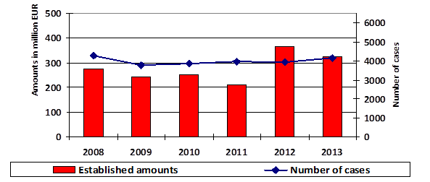
Annex 3 shows the situation on the cut-off date for years 2008-2013.

2.2.2. Established and estimated amounts
In 2013, the total established amount of TOR (gross) was EUR 20.9 billion and the greater part of it (98 %) was recovered without any particular problem and made available to the Commission via the A-account. In comparison with the total amount established, according to the OWNRES data, around EUR 388 million has been established and estimated by the Member States in connection with detected cases of fraud and irregularities where the amount at stake exceeds EUR 10 000.
The total established and estimated amounts reported in OWNRES represent 1.86 % of the total established amount of TOR (gross) for 2013. This proportion has decreased compared with 2012 when it was 2.05 %. A percentage of 1.86 % indicates that of every EUR 100 of TOR (gross) established, an amount of EUR 1.86 is registered as irregular or fraudulent in OWNRES. There are differences among the Member States. In 10 Member States, the percentage is above the average of 1.86 %. The highest percentage for 2013 can be seen in Cyprus with 5.18 %. The proportion of established and estimated OWNRES amounts to established TOR in 2013 compared to 2012 increased from 0 % to 3.75 % for Malta, from 0.61 % to 5.18 % for Cyprus and from 0.4 % to 1.21 % for Estonia. For Romania, the proportion of established and estimated OWNRES amounts to established TOR decreased in 2013 from 14.3 % to 3.16 % compared to the previous year.
For the seven Member States which established and made available most of the TOR amounts, the percentage of the established and estimated OWNRES amounts to established TOR for 2013 was equal to 1.91 %. In comparison with the previous year, this represents a decrease of 0.14 percentage points.
TOR MAP1: Showing the percentage of established and estimated amounts in OWNRES of established TOR in 2013
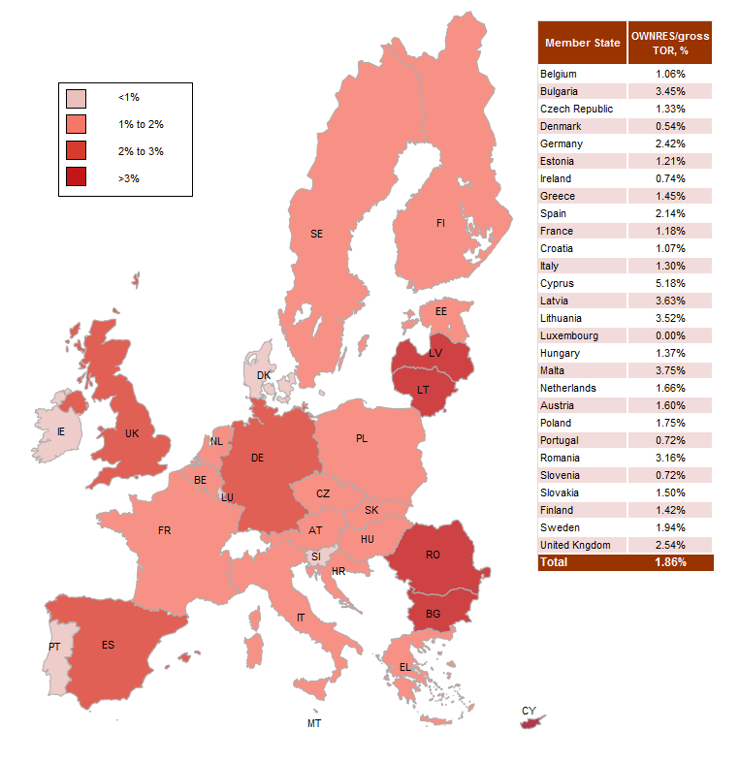

2.2.3. Recovery
The fraud and irregularity cases detected in 2013 show an established amount of EUR 380 million. EUR 221 million of this was recovered in cases where an irregularity was at issue and EUR 13 million in fraud cases. In total EUR 234 million was recovered by all Member States for all cases which were detected in 2013. In absolute numbers, Germany recovered the highest amount in 2013 (EUR 85 million) followed by the United Kingdom (EUR 64 million). In addition, Member States continued their recovery actions related to the detected cases of previous years. The EU-28 recovered EUR 130 million in 2013 which related to cases detected between 1989 and 2012.

2.2.3.1. Recovery rates
Over the past, five years the annual RR has varied between 38 % and 52 % (see Chart TOR4). The recovery rate for 2013 is currently 62 % which is the best recovery result reported in the past decade. In other words, of every amount over EUR 10 000 of duties established and reported for 2013 in OWNRES, approximately EUR 6 200 has already been paid.
Since the overall recovery rate for 2012 recorded in the last year’s report has climbed from 47 % to 59 %, it can be expected that the overall recovery rate for 2013 will also increase in the future. On the cut-off date, the overall RR for all years 1989-2013 was 55 %.
CHART TOR4: Annual recovery rates 2008-2013
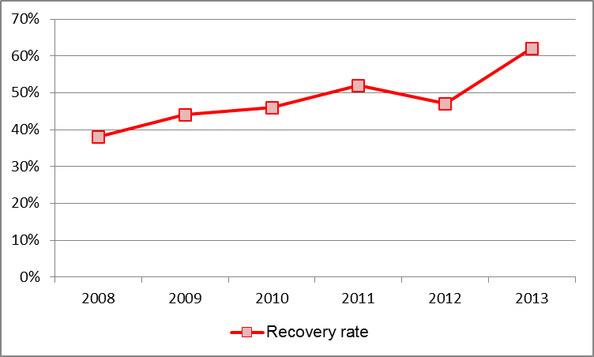
Recovery rates vary among the Member States. The highest recovery rates for 2013 are in Estonia and Slovakia (100 %), Hungary (87 %), Portugal (85 %), Sweden (84 %), Germany (80 %), Bulgaria, Slovenia and Finland (78 %). Differences in recovery results may arise from factors such as the type of fraud or irregularity, or the type of debtor involved. Because recovery is ongoing, it can be expected that the recovery rate for 2013 will also go up in the future.

2.3. Specific analysis

2.3.1. Irregularities reported as fraudulent

2.3.1.1. Modus operandi
In 2013, most of the fraud cases (83 %) and the majority of established amounts (93 %) for fraud cases in the EU-28 are related to the customs procedure ‘release for free circulation’. A total of 6 % of all cases and 2 % of all established amounts in OWNRES fraud cases registered for 2013 involve the transit procedure. The percentage of established amounts for fraud cases involves customs warehousing and inward processing — 4 % and 1 % respectively.
A breakdown of frauds by mechanism type reveals that most cases of fraud relate to false declarations. Incorrect use of preferential arrangements, incorrect origin or country of dispatching, or classification are most frequently mentioned. Smuggling as a fraud mechanism ranked second place in 2013.

2.3.1.2. Method of detection of fraud cases
In 2013, most fraud cases were revealed during inspections by anti-fraud services (47 %) and customs controls at the time of clearance of goods (29 %). Other methods that featured frequently were post-clearance controls (11 %) and tax audits (9 %).
CHART TOR5: Fraud cases - % of the method of detection by cases in 2013
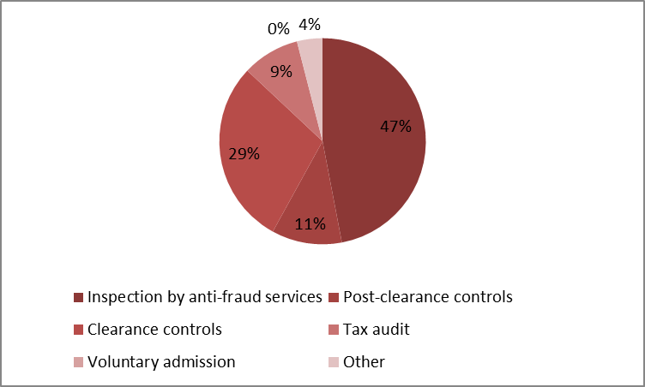
In monetary terms, of the EUR 54 million established in fraud cases registered for 2013, around 56 % were discovered by anti-fraud services, 14 % by tax audits, 13 % during a clearance control and 11 % during post-clearance controls. Only in Spain, were tax audits the most important detection method for fraud cases in monetary terms. In Belgium, the Czech Republic, Greece, Germany, France, Italy and Romania more than 50 % of all established amounts in fraud cases were detected by anti-fraud services. As regards amounts, clearance controls were the most important method for detecting fraud in Croatia, Latvia, Finland and the United Kingdom.
CHART TOR6: Fraud cases - % of the method of detection by amounts established in 2013
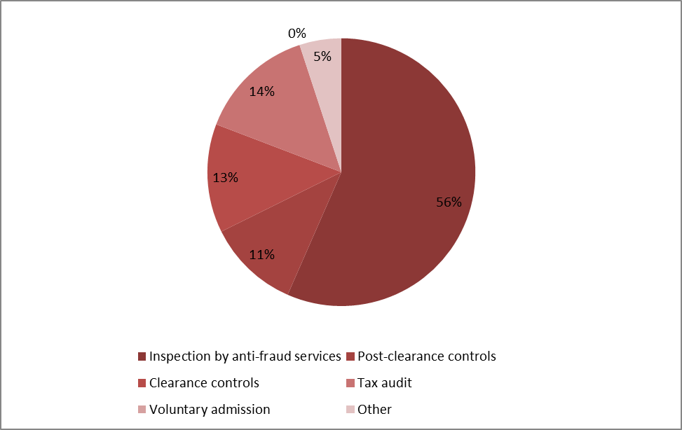

2.3.1.3. Smuggled cigarettes
In 2013, there were 133 cases of smuggled cigarettes registered (CN code 24 02 20 90) involving estimated TOR of around EUR 7 million. In 2012 the number of cases of smuggled cigarettes was 224, totalling around EUR 25 million.
Table TOR1: Cases of smuggled cigarettes in 2013
The highest number of cases was reported by the UK (22). The highest amount was reported by Greece (EUR 1.3 million).
No cases were reported by Denmark, Estonia, Spain, France, Cyprus, Luxembourg, Portugal, Slovenia, Slovakia and Sweden.

2.3.1.4. Fraud cases by amount category
In 2013, the established amount was below EUR 50 000 in 460 cases of fraud (73 % of all fraud cases), whereas it was above EUR 50 000 in 173 cases (27 %).
Table TOR2: Fraud by amount category in 2013
The total established amount in fraud cases where the amount at stake was above EUR 50 000 amounted to EUR 46 million (86 % of all the established amounts in fraud cases).

2.3.2. Irregularities not reported as fraudulent

2.3.2.1. Modus operandi
In 2013 most of the established amounts in OWNRES in the EU-28 (87 %) for irregularity cases related to the customs procedure ‘release for free circulation’. In all, 7 % of all established amounts in OWNRES cases in 2013 involved inward processing, 4 % related to customs warehousing and only 1 % to transit procedure. A high amount was established and reported in connection with inward processing by the United Kingdom (EUR 17 million).
A breakdown of irregularities by mechanism type confirms that most cases of irregularity relate to incorrect declarations (incorrect classification, value, country of origin or use of preferential arrangements) and formal shortcomings (failure to fulfil obligations or commitments).

2.3.2.2. Method of detection of irregularity cases
In 2013, most irregularity cases (56 %) were revealed during post-clearance customs controls. Other methods of detection for irregularities that featured frequently were clearance controls (12 %), tax audits (10 %) followed by anti-fraud services (9 %).
CHART TOR7: Non-fraudulent irregularity cases - method of detection of irregularity by number of cases in 2013
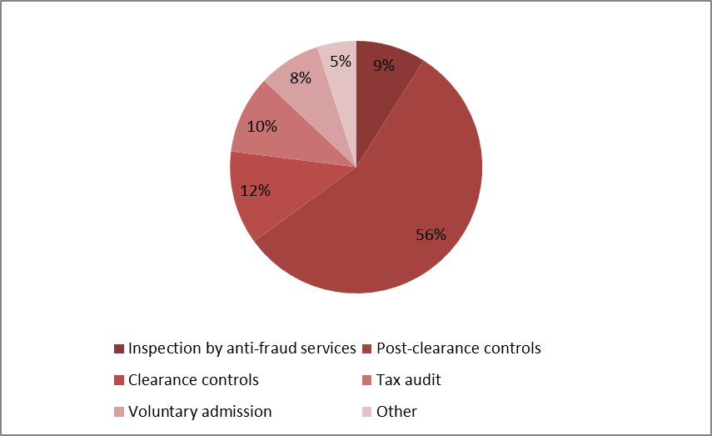
Considering the established amounts, around 56 % of all irregularity cases registered for 2013 were discovered by post-clearance controls, whereas 16 % were related to voluntary admission, 9 % to tax audits, 8 % to inspections by anti-fraud services and 8 % to controls at the time of clearance of goods. In 10 Member States, more than 50 % of all irregularity cases — in amounts — were detected by post-clearance controls. In France, Portugal and Romania more than 50 % of the amounts relating to irregularity cases were detected by anti-fraud services. Significant amounts were reported as irregularities following voluntary admission by Germany (EUR 37 million), the UK (EUR 10 million) and the Netherlands (EUR 2 million).
CHART TOR8: Non-fraudulent irregularity cases - method of detection of irregularity by amounts in 2013
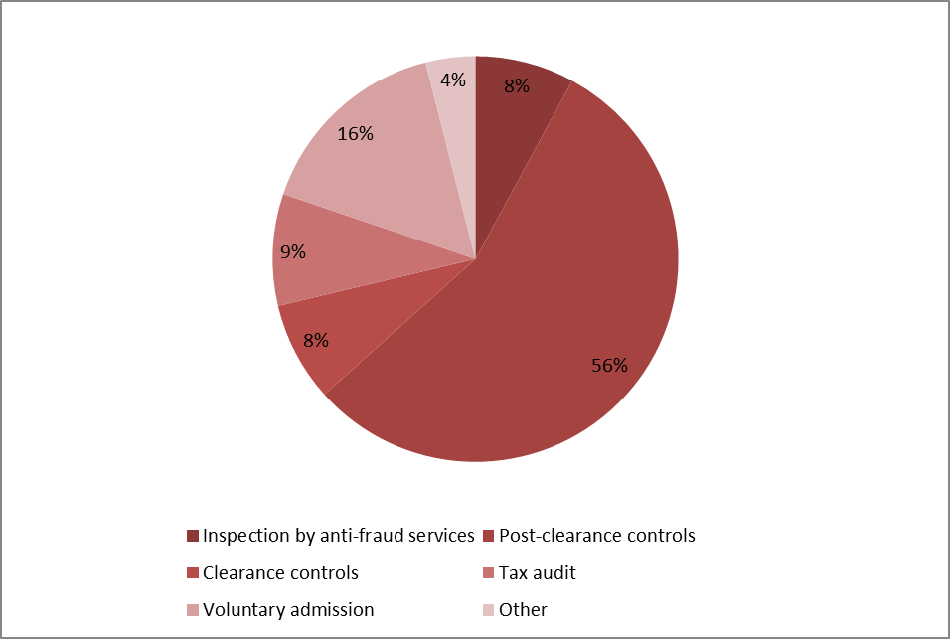

2.3.2.3. Non-fraudulent irregularities by amount category
In 2013, the established amount was below EUR 50 000 in 3100 cases of irregularity (75 % of all irregularity cases), whereas it was above EUR 50 000 in 1 044 cases (25 %).
The total established amount in irregularity cases where the amount at stake was above EUR 50 000 amounted to EUR 267 million (82 % of all the established amounts in irregularity cases).
Table TOR3: Non-fraudulent irregularities by amount category in 2013

2.4. Member States’ activities

2.4.1. Member States’ classification of cases of fraud and other irregularities and related rates
For 2013, Member States classified 633 cases as fraud out a total of 4777 cases reported via OWNRES, which indicates a Fraud Frequency Level (FFL) of 13 %. The differences between Member States are relatively large. In 2013 most Member States categorised between 10-50 % of all cases as fraud. However, four Member States did not categorise any cases as fraud. Six Member States categorised less than 10 % of cases as fraud. Seven Member States registered more than 50 % of cases as fraud.
In 2013, the total established and estimated amount affected by fraud in the EU was EUR 61 million and the overall fraud detection rate was 0.29 %. For 2013, the highest percentages can be seen in Malta with 3.75 % and Lithuania 2.52 %.
The total established and estimated amount affected by irregularities was more than EUR 328 million which indicates an irregularity detection rate of 1.57 %. The highest percentages can be seen in Cyprus (4.81 %) and Bulgaria (3.06 %).
There are large differences between Member States’ classifications, which may partly depend on their classification practices. This can influence the comparison of the amounts involved in fraud and irregularities by Member States. Moreover, individual bigger fraud cases detected in a specific year may affect annual rates significantly. Factors such as the type of traffic, type of trade, the level of compliance of the economic operators, the location of a Member State can influence the rates significantly. Bearing in mind these variable factors, the detection rates can also be affected by the way a Member State’s customs control strategy is set up to target risky imports and to detect TOR-related fraud and irregularities.

2.4.2. Recovery rates

2.4.2.1. Fraud
Over the 1989-2013 period, OWNRES shows that, on average, 18 % (1989-2013) of the initially established amount was corrected (cancelled). The recovery rate (RR) for all years (1989-2013) is 28.25 %. The RR for fraud cases detected in 2013 was 23.74 % which is below the average rate of 33.5 % for fraud cases for the 2008-2012 period. The RR in fraud cases is clearly much lower than that for irregularities.

2.4.2.2. Other Irregularities
OWNRES shows that on the cut-off date, an average 36 % (1989-2013) of the initially established amount in relation to irregularities has been corrected (cancelled) since 1989. The RR for irregularity cases reported for 2013 is 67.9 %. On the cut-off date, the annual RR for the last five years has varied between 60 % and 82 %. The overall RR for all years (1989-2013) for all irregularity cases is 67.34 %.

2.4.2.3. Historical recovery rate
Also in the long term, the HRR reveals an equally strong relation as annual recovery rates, showing that recovery in fraud cases is generally much less successful than in cases of irregularity (see table TOR4). Classification of a case as fraud is thus a strong indicator for forecasting short- and long-term recovery results.
Table TOR4: Historical recovery rate (HRR)

2.4.3. Commission’s monitoring

2.4.3.1. Examination of the write off reports
In 2013, 19 Member States submitted 144 new write-off reports to the Commission. In 2013, the Commission processed 203 cases in all totalling EUR 83 million, including cases that had been reported previously for which Member States had sent additional information. In 47 of these cases amounting to EUR 22 million, Member States were asked to pay the outstanding amounts as they were not considered diligent in recovering the debts.
Examination of Member States’ diligence in write-off cases constitutes a very effective mechanism for gauging their activity in the field of recovery. It encourages national administrations to step up the regularity, efficiency and effectiveness of their recovery activity, since any lack of diligence leading to failure to recover results in individual Member States having to foot the bill.

2.4.3.2. Commission’s inspections
In its TOR inspections, the Commission has put a special emphasis on Member States’ customs control strategies and closely monitors their actions in relation to the observations made during the inspections. Member States show their willingness to adapt their control strategies and to progressively implement systems that provide for efficient and effective risk analysis to protect the EU’s financial interests. Thematic reports consolidating the results of the inspections and evaluating and comparing Member States’ performance are frequently prepared and discussed with the Member States with a view to remedying the individual shortcomings found. One general conclusion drawn by the Commission from its inspections in Member States in recent years is that their control strategies are increasingly shifting from customs controls at the time of clearance of goods to post-clearance customs controls. For transit procedure, a decreasing number of irregularities have been observed which is also due to fully automated processing of transit shipments following the introduction of Phase 4 of NCTS.

2.4.3.3. Particular cases of Member State failure to recover TOR
If TOR are not established because of an administrative error by a Member State, the Commission applies the principle of financial liability. Member States have been held financially liable in 2013 for over EUR 14.7 million, and new cases are being given appropriate follow-up.
Part II - EXPENDITURE
Section I - Shared Management
Natural Resources
Success in previous decades in guaranteeing sufficient food production, has led to a shift in emphasis to, producing higher quality food for consumers, increasing farms' profitability, diversifying the rural economy and protecting the natural environment. There is a direct management component but the majority of expenditure is disbursed by Member States under the following shared management funds.
- The European Agricultural Guarantee Fund (EAGF) which finances direct payments to farmers and measures to respond to market disturbances, such as private or public storage and export refunds.
- The European Agricultural Fund for Rural Development (EAFRD) which finances the rural development programmes of the Member States.
- The European Fishery Fund (EFF) which provides funding and technical support for initiatives that can make the fishery industry more sustainable.
Table NR1 shows the financial resources available for this policy area.
Table NR1: Financial instruments and 2013 appropriations for the Natural Resources Policies

3. Common Agricultural Policy (CAP)

3.1. Introduction
For the last 50 years the Common Agricultural Policy (CAP) has been the European Union's (EU) most important common policy. This explains why traditionally it has taken a large part of the EU's budget, although the percentage has steadily declined over recent years.
The CAP is financed by two funds, EAGF and EAFRD, which form part of the EU's general budget.
Under the basic rules for the financial management of the CAP, the Commission is responsible for the management of the EAGF and the EAFRD. However, the Commission itself does not make payments to beneficiaries. According to the principle of shared management, this task is delegated to the Member States, who themselves work through national or regional paying agencies. Before these paying agencies can claim any expenditure from the EU-budget, they must be accredited on the basis of a set of criteria laid down by the Commission.
The paying agencies are, however, not only responsible for making payments to the beneficiaries. Prior to doing so, they must, either themselves or through delegated bodies, satisfy themselves of the eligibility of the aid applications. The exact checks to be carried out are laid down in the different sectoral regulations of the CAP and vary from one sector to another.
The expenditure made by the paying agencies is then reimbursed by the Commission to the Member States, in the case of the EAGF on a monthly basis and in the case of EAFRD on a quarterly basis. Those reimbursements are, however, subject to possible financial corrections which the Commission may make under the clearance of accounts procedures.
Table NR2 shows the financial resources available for the CAP.
Table NR2: Financial instruments and 2013 appropriations for the CAP

3.2. General analysis – Trend analysis

3.2.1. Irregularities reported as fraudulent
Table NR3 presents the trend of the irregularities reported as fraudulent by Member States for the period 2009-2013 in relation to the fund concerned. This shows a significant increase in relation to 2012 for the both funds: irregularities reported as fraudulent doubled for the EAGF and quadrupled for the EAFRD. The most significant increase, however, concerned those irregularities related to beneficiaries of both funds, which have committed violations in relations to both schemes.
As a result, about half of the irregularities reported as fraudulent in the period 2009-2013 affect the EAGF and about one third the EAFRD. The remaining part consists of irregularities committed by beneficiaries of both funds.
Table NR3: Irregularities reported as fraudulent by Fund –2009-2013 for the CAP
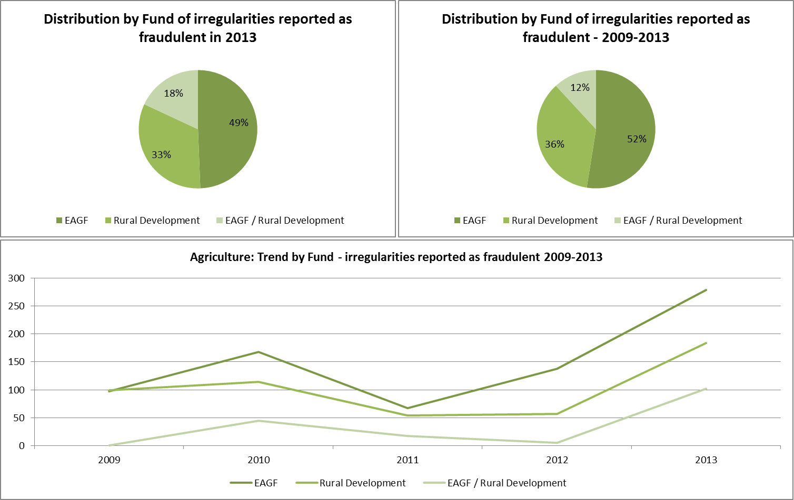
The three entries of Table NR3 have significantly increased in 2013 in comparison with previous years. This increase is mainly due to the results communicated by four Member States (Bulgaria, Denmark, Italy and Romania) which represent about 75% of the total number of irregularities reported as fraudulent in 2013. Apart from these four Member States, other five contribute significantly to the total number of reported cases (Czech Republic, Greece, Spain, France and Poland). The nine countries together have reported about 94% of the total fraudulent irregularities.
Table NR4 provides in the same form of Table NR3 information about the trends linked to the amounts involved in cases reported as fraudulent and confirms the generalised increase in comparison with the previous year.
The shares related to the two funds do not diverge significantly with the distribution of available resources among them (see Table NR2).
Table NR4: Financial amounts involved in irregularities reported as fraudulent by Fund –2009-2013 for the CAP
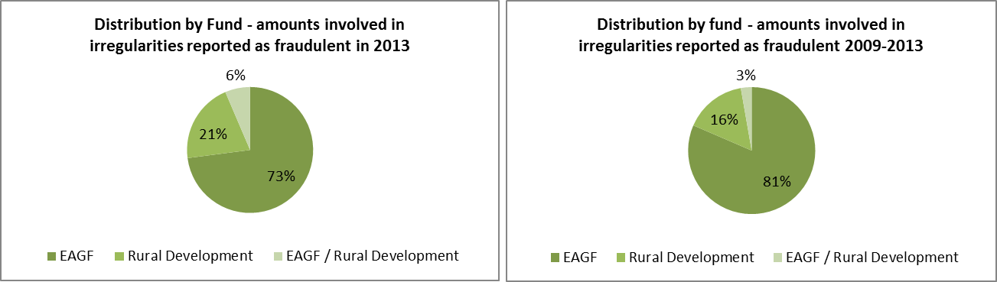
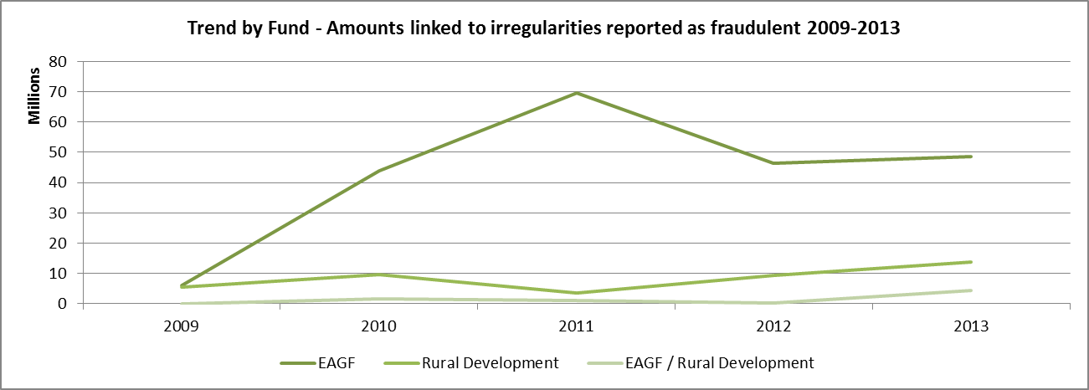
The trend analysis about the financial amounts can be misleading as it can be greatly influenced by single observations of significant. For instance, the “distance” observed in 2011 between the two funds, finds entire explanation in very few cases involving high amounts linked to the EAGF, which determine the divergence from the trend highlighted in Table NR3.

3.2.2. Irregularities not reported as fraudulent
Regarding irregularities not reported as fraudulent, the number of those reported relating to EAFRD has been constantly increasing (see Table NR5), while those related to EAGF has remained relatively stable. Consistently with this trend, also the irregular amounts linked to the rural development instrument have been increasing (as highlighted in Table NR6), but with a trend that is more evident in the last three years.
Contrary to the irregularities reported as fraudulent, only 1% of those not reported as fraudulent involves violations in both funds.
Table NR5: Irregularities not reported as fraudulent by Fund – 2009-2013 for the CAP
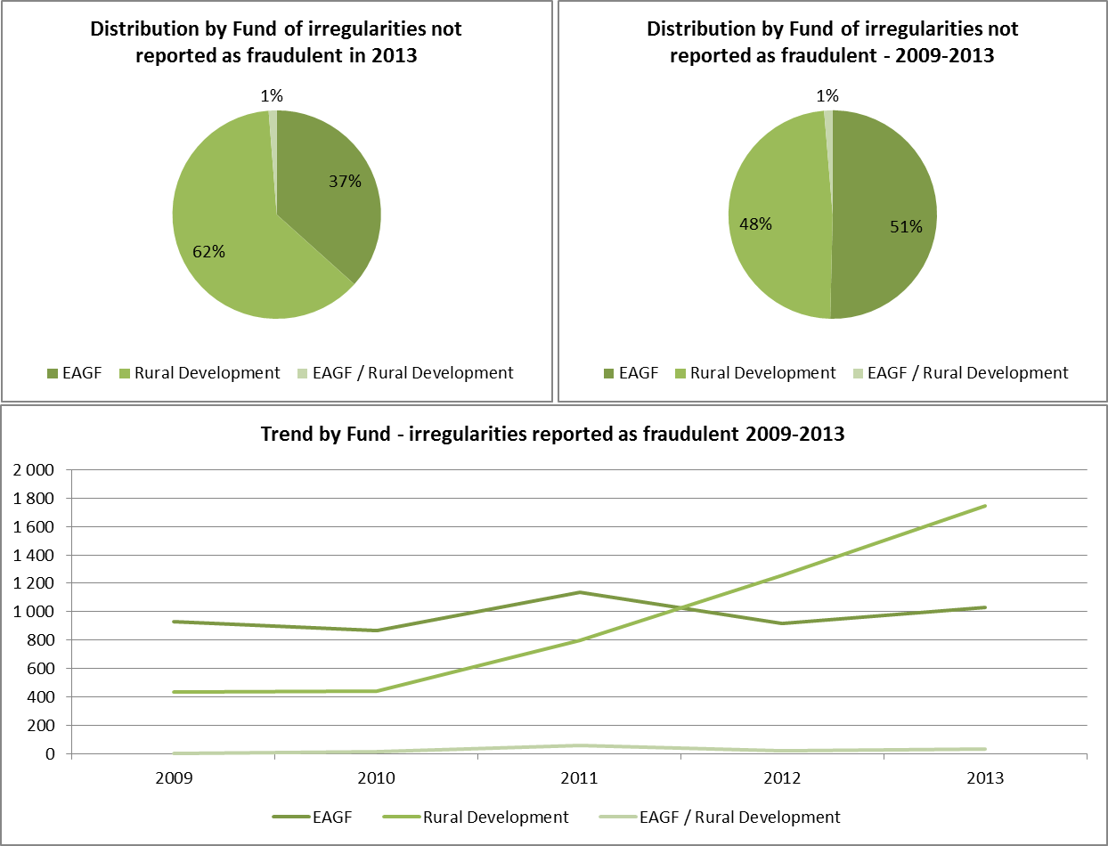
Unlike fraudulent irregularities the largest share, in terms of numbers, in 2013 is for the EAFRD, while for the period 2009-2013, the share of the two funds is almost evenly balanced.
The increase in the irregular amounts related to the EAFRD is also determining the situation that 2012 represents the highest peak in relation to irregular amounts linked to non-fraudulent irregularities of the last five years.
Table NR5 shows the information concerning the years 2009-2013.
Table NR5: Financial amounts linked to irregularities not reported as fraudulent by Fund – 2009-2013 for the CAP
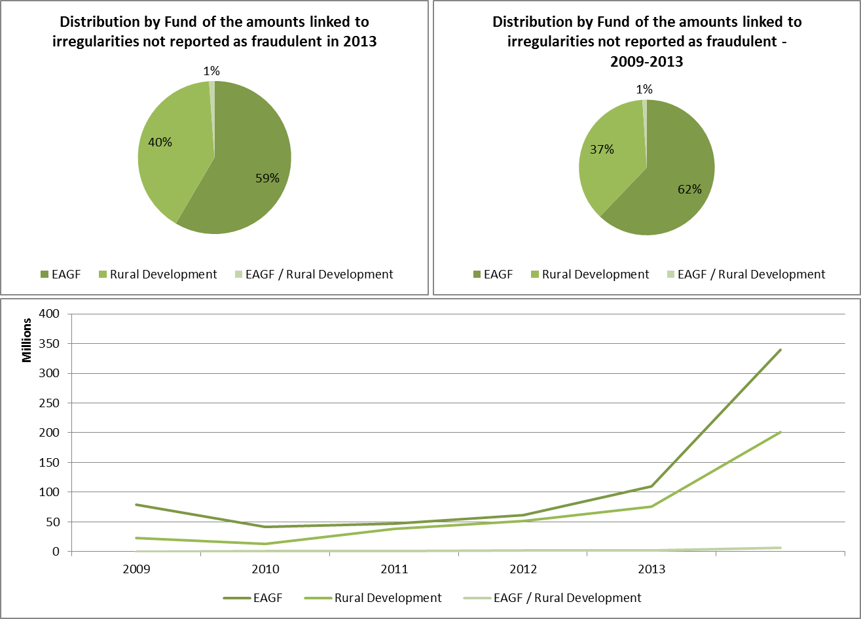

3.3. Specific analysis

3.3.1. Irregularities reported as fraudulent

3.3.1.1. Modus operandi
Table NR7 compares the types of irregulary / modi operandi linked to fraudulent cases detected in 2013 with those detected from 2009 to 2013 (included).
The most recurrent modus operandi is related to the infringement related to documentary proofs, and in particular, to the use of 'false or falsified declarations', 'false or falsified documents' and 'false or falsified request for aid', ‘declaration of fictitious product, species and/or land’ in line with what reported in general for the whole period 2009-2013. ‘Quantities outside permitted limits, quotas or thresholds (related, respectively to products, species or land)’ remained a significant reported type of breach, resulting again from the reporting by the Danish authorities as in 2012 and, probably linked to the follow-up to the same investigation.
Another significant infringement reported in 2013 refer to the ‘beneficiary not having the required quality’ (51 occurrences), which represents a new development in relation to the previous years.
Table NR7: Types of irregularities in relation to the CAP
A single case of corruption has been reported (it is included within the category 'OTHER') and involves an amount of over EUR 6.3 million (on the 15.7 million of that group). This case, reported by the Netherlands, is related to the financial year 1999 and due to its complexity and the secrecy of investigations has been reported only in 2013.

3.3.1.2. Type of control / Method of detection
Table NR8 shows the types of controls having identified the irregularities reported as fraudulent in 2013.
Table NR8: Control methods having identified the irregularities reported as fraudulent in 2013
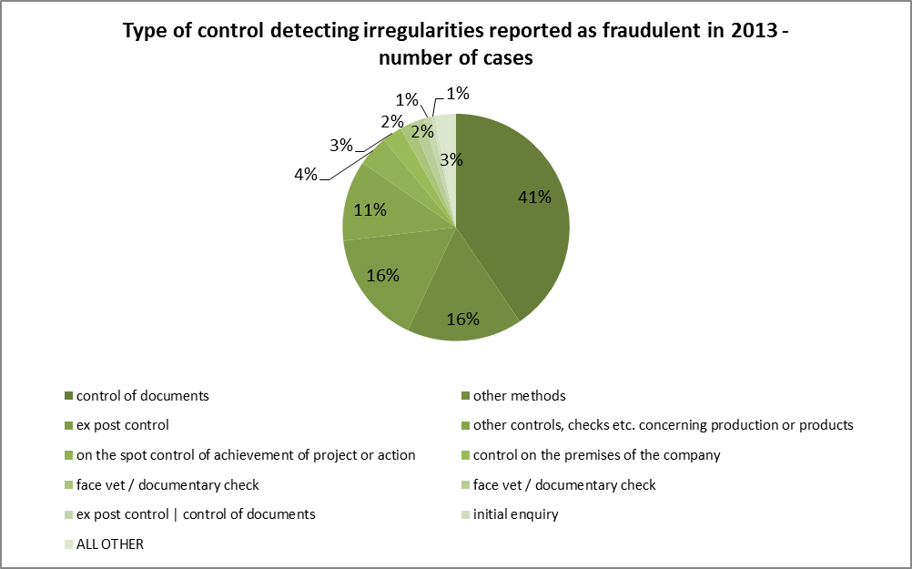
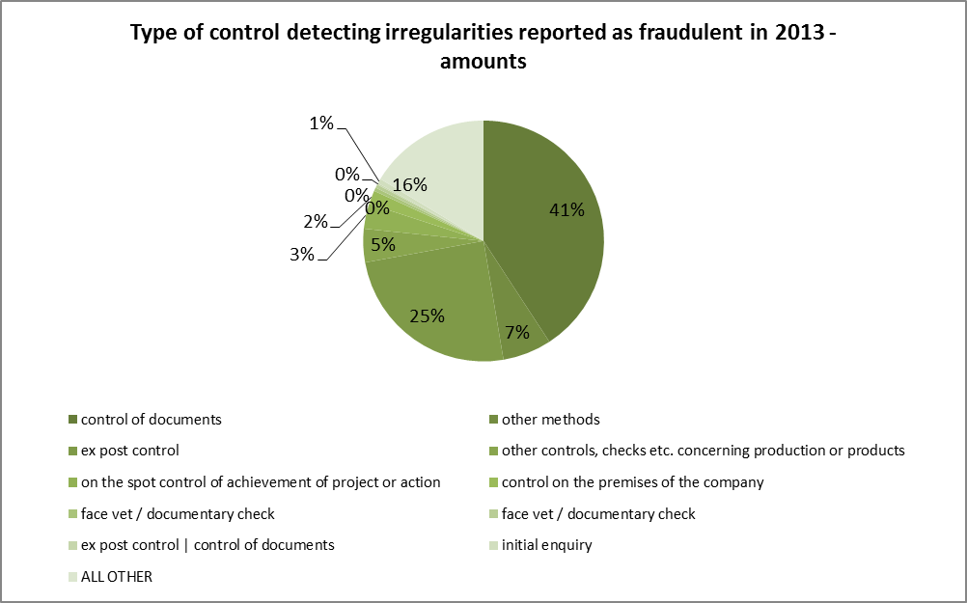
Minor differences are noticeable in comparison with the whole reference period 2009-2013, as showed in Table NR9.
Table NR9: Control methods having identified the irregularities reported as fraudulent 2009-2013
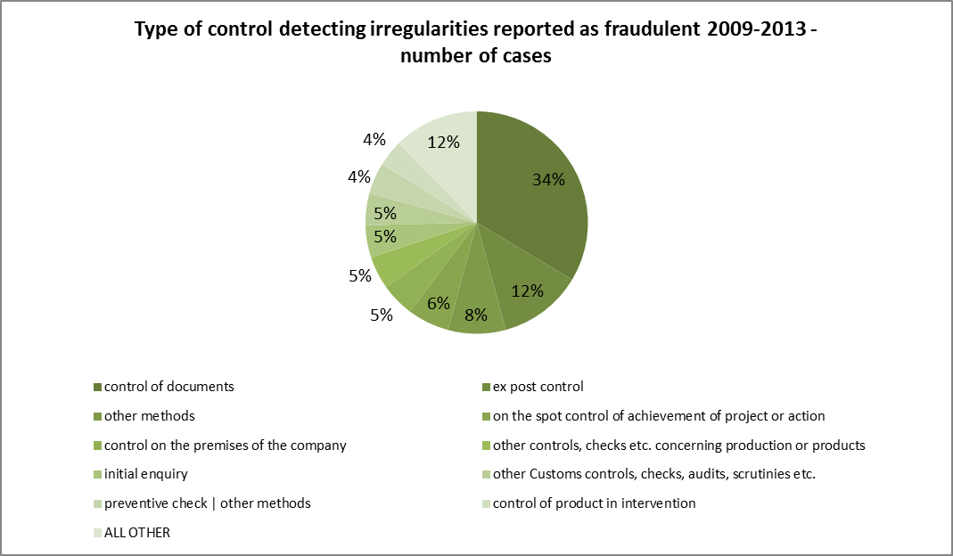
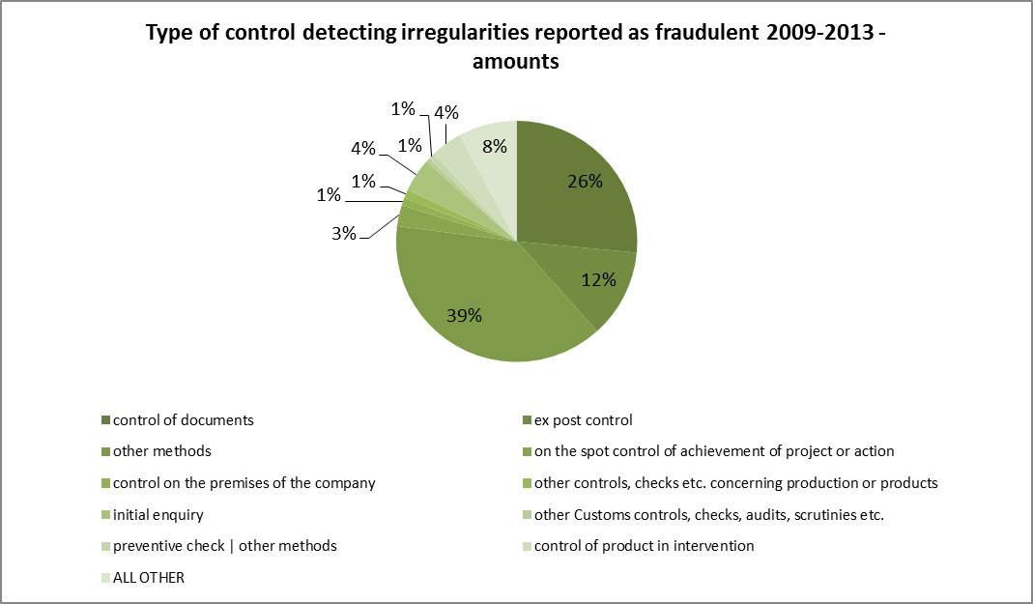
The bodies having identified the majority of the irregularities reported as fraudulent are mainly the administrative bodies, while the anti-fraud bodies deal with the cases with the highest financial impact as showed in Table NR10.
Table NR10: Types of controls having detected the irregularities reported as fraudulent in 2013 in relation to the CAP
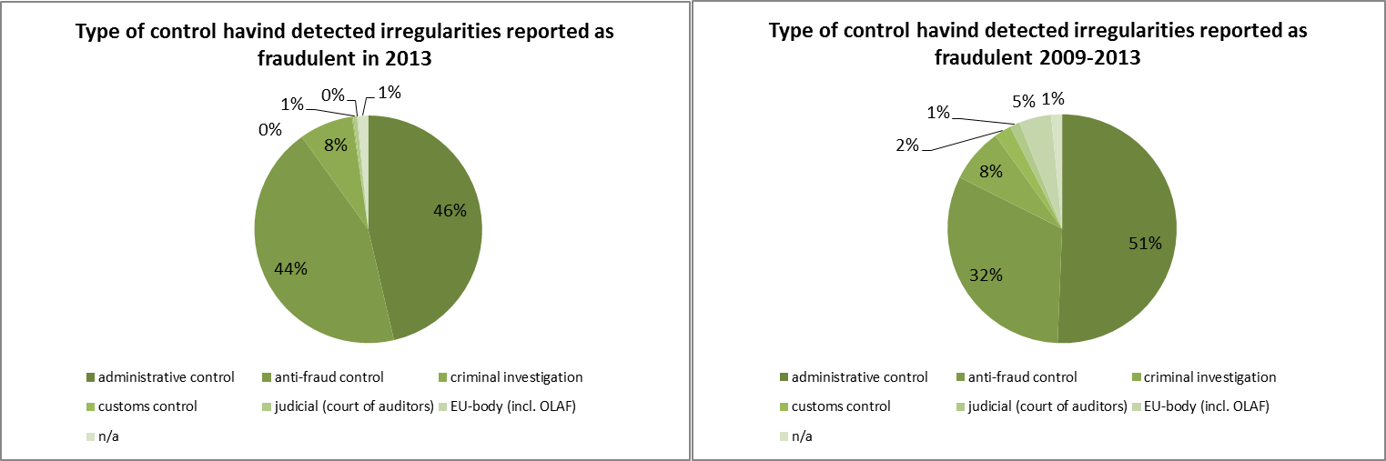
Statistics concerning the cases detected by EU bodies (including OLAF) do not appear entirely accurate.
Among the 247 cases related to Anti-fraud controls, the great majority originates from Italy and Denmark.

3.3.1.3. Complexity of the irregularities reported as fraudulent
In 2012, for the first time, an estimation of the level of complexity of the irregularities reported as fraudulent was provided.
In relation to the information published in 2012 on this subject, the methodology to identify the complexity of reported fraudulent irregularities has been reviewed and refined, therefore no comparison should be made between the two documents as the present one is founded on different ‘rules’.
Table NR11 provides an estimation of the level of complexity of the irregularities reported as fraudulent based on this revised methodology. It also compares the situation of those reported in 2013 with those communicated in the reference period 2009-2013 (included).
The share of the 'complex' cases slightly increases in 2013 in comparison to the reference period, while share of the 'simple' fraudulent irregularities decreases and the 'moderate' complexity category remains fairly stable.
The 'complex' cases are referred to the EAFRD for the majority (about 60%), while those related to the EAGF drop to 20% in 2013 in comparison to the 30% of the period 2009-2013.
On the contrary, EAGF has the greatest share of ‘Simple’ cases (70% in 2013 and 65% in the period 2009-2013).
Table NR11: Complexity of fraudulent irregularities detected in relation to the CAP
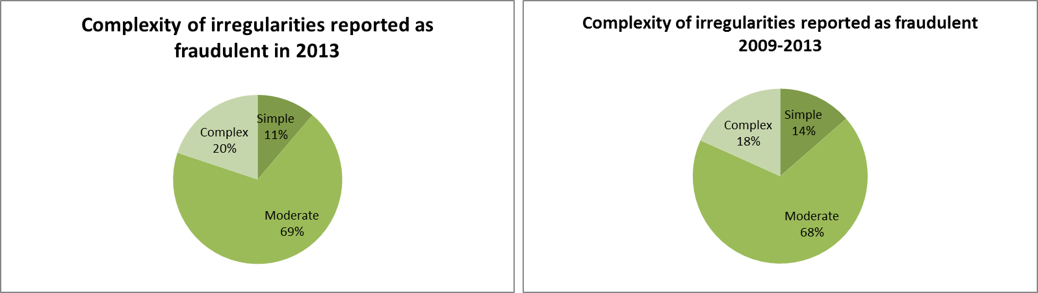
This is the second attempt of estimating the proportion of 'complex' cases on the total fraudulent irregularities identified. Therefore the method is liable of being improved in the next years.

3.4. Anti-fraud activities of Member States
Previous paragraphs have examined the trend and main features and characteristics of the irregularities reported as fraudulent.
The present paragraph aims at examining some aspects linked to the anti-fraud activities and results of Member States. Five elements are taken into account:
    - the time that runs between the beginning of the fraudulent practice and its detection/establishment by the competent authority and reporting to the Commission (Detection / Reporting Efficiency);
    - the number of irregularities reported as fraudulent by each Member State;
    - the fraud detection rate (the ratio between the amounts involved in cases reported as fraudulent and the payments occurred in the financial year 2012);
    - the fraud prevention rate (the ratio between the amounts involved in cases reported as fraudulent which have been detected before payments were executed);
    - the ratio of cases of established fraud on the total number of irregularities reported as fraudulent.

3.4.1. Detection – Reporting Efficiency
Table NR12 shows the average number of months between the moment in which the fraudulent practice is put in place and when the fraudulent irregularity it is detected/established (Detection Efficiency – DetE) and then the average number of months between its establishment and the reporting (Reporting Efficiency – RepE) to the Commission.
The EU average is about 6 years and three months (75 months) between the first and the last of those events (DetE + RepE). In 2012 this lapse consisted of about 4 years, while the overall average for the reference period is about 5 years and a half (67 months).
The duration of the DetE should not be seen as a sign of inefficiency per se. More relevant, in this respect, is the RepE, which is, in average, about 20 months, worsening in comparison to 2012 (7 months).
Eleven (11) of the twenty-one (21) Member States having reported fraudulent irregularities in 2013, have a DetE lower than 40 months.
Table NR12: Detection and Reporting Efficiency by Member State
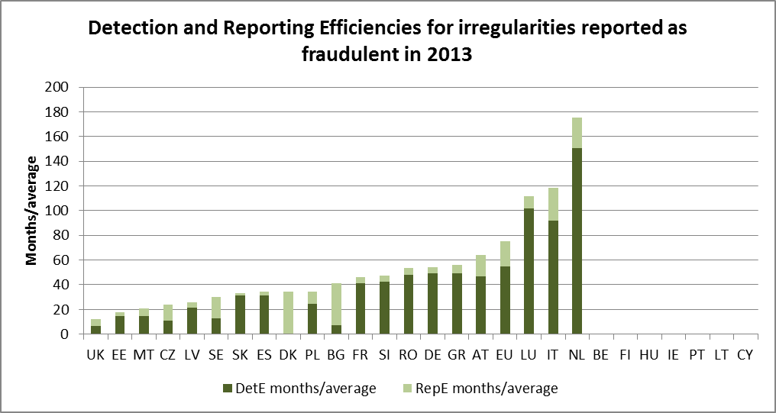
The results in 2013 are also negatively influencing the overall results for the period 2009-2013, in particular as irregularities reported as fraudulent in 2013 represent about one third of all irregularities reported in the reference period.
In the case of the Netherlands, the result depends exclusively on a single case related to an irregularity linked to the financial year 1999, having involved a criminal investigation.

3.4.2. Detection of irregularities reported as fraudulent in 2012 by Member State
Map NR1 divides Member States in four groups, depending on the number of irregularities reported as fraudulent in 2013:
    - Group 1: no irregularities reported as fraudulent irregularities in 2012;
    - Group 2: between 1 and 9 such cases reported in 2012;
    - Group 3: 10 to 30 irregularities reported as fraudulent;
    - Group 4: more than 30 cases reported.
The composition of these groups is similar to the previous years, with the significant exception of Denmark, which is in Group 4, while in previous years it was in Group 1 or 2.
Map NR1: Number of irregularities reported as fraudulent in 2013 by Member State - CAP
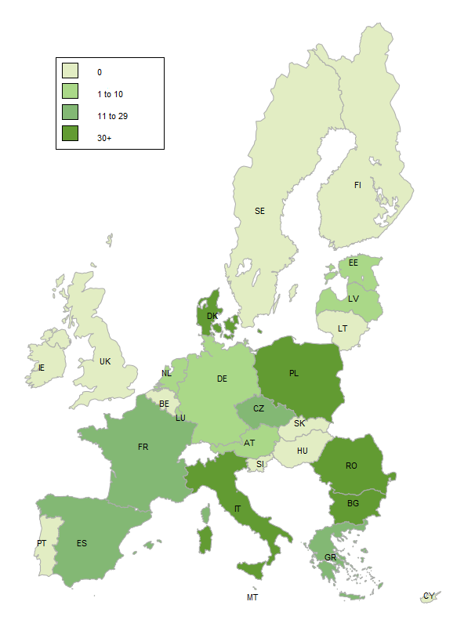
The detailed figures of Map NR1 are showed in Table NR12.

3.4.3. Fraud detection rate
The fraud detection rate compares the results obtained by Member States in their fight against fraud with the payments received by them in a given financial year. This implies that a single case reported as fraudulent and involving a significant financial amount can produce a better result that that achieved by the sum of the financial impact of several irregularities affecting lower amounts. For this reason, this indicator should be read in conjunction with the number of irregularities reported as fraudulent and for this reason they are presented together in Table NR13.
In 2013, the highest fraud detection rates are referred to Malta, Italy, the Netherlands, Estonia, Italy, Bulgaria, Romania and Denmark.
Table NR13: number of irregularities reported as fraudulent in 2013, amounts involved and fraud detection rate by Member State
In relation to the Netherlands, the result, as already mentioned, is due to a case related to the financial year 1998, established in 2012 (after a complex criminal investigation in the Netherlands and Belgium) and reported in 2013. In this case, the picture provided by the indicator is clearly distorted and this should be taken into account.

3.4.4. Ratio of established fraud 2009-2013
Table NR14 shows the ratio between the cases of established fraud and the total number of irregularities reported as fraudulent (including suspected and established fraud) in the period 2009-2013. Taking into account only cases reported in 2013 would be meaningless, as the criminal proceedings leading to a conviction for fraud may take several years.
In this respect, the average ratio of established fraud at EU level is 7% (increasing from 6% in 2012), with Latvia, Bulgaria, Belgium, Germany, Austria and the United Kingdom showing a rate above this level, and Poland presenting a rate in line with the EU average.
Table NR14: number of cases of suspected and established fraud and ratio of established fraud – cases reported between 2009-2013 in the CAP
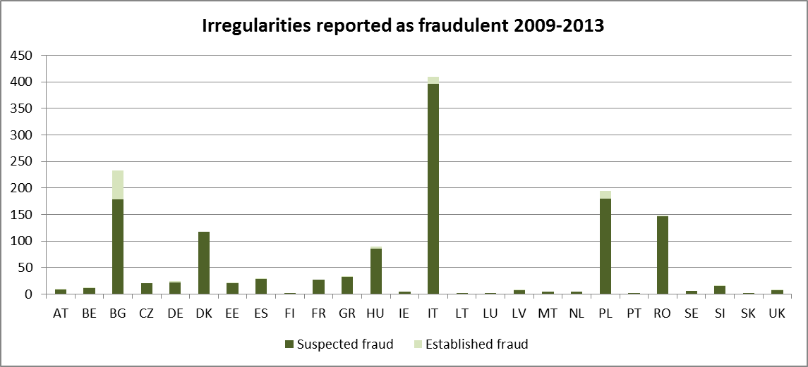
A significant impact on the rate is determined by the number of irregularities reported as fraudulent by Member States. In this respect, the countries which influence the EU average results are Italy, Poland, Bulgaria, Romania and Denmark.
Data take into account also developments related to older cases.

3.5. Recovery cases

3.5.1. Legal Framework
Regulation (EC) No 1290/2005 on the financing of the CAP requires the Member States to recover sums lost as a result of detected irregular payments. However, the recovery procedures, in accordance with the principle of subsidiarity, are wholly the responsibility of the Member States concerned and, thus, subject to their individual judicial procedures. Therefore, while some procedures delivery rapid results, other take a longer period of time.
In order to address delays by some Member States in recovering undue payments, the legislator introduced an automatic clearing mechanism under which 50 % of any undue payments which the Member States have not recovered from the beneficiaries within 4 years or, in the case of legal proceedings, 8 years, would be charged to their national budgets (50/50 rule).
Even after the application of this mechanism, Member States are, however, obliged to pursue their recovery procedures and, if they fail to do so with the necessary diligence, the Commission may decide to charge the entire outstanding amounts to the Member States concerned. Moreover, Member States are required to off-set any outstanding debts against future payments to the debtor (compulsory compensation).
Undue payments that are the result of administrative errors committed by the national authorities also have to be deducted from the annual accounts of the paying agencies concerned and, thus, excluded from EU financing.

3.5.2. Amounts recovered in 2013
Table NR15 sets out the amounts recovered in 2013 by the Member States for the EAGF (split between ABB02 and ABB03 is not provided in the data received) and the EAFRD. This shows that 197 million EUR was recovered in respect of the two funds.
Table NR15: Recoveries by the Member States from the Final Beneficiaries of unduly paid amounts

3.5.3. Application of the 50/50 Rule
The financial consequences of non-recovery for cases dating from 2009 (4 year deadline for recovery) or 2005 (8 year deadline if legal proceedings) will be determined for 2013 in accordance with the 50/50 rule mentioned above by charging approximately €17.1 million to the Member States concerned. Moreover, around € 18.7 million will be borne by the EU budget for cases reported irrecoverable during financial year 2013. The final figures will be established in April 2014 when the financial clearance decision for financial year 2013 will be adopted. Due to the application of the 50/50 rule, important non-recovered sums have already been charged to the Member States for EAGF expenditure.
The overall outstanding amount still to be recovered from the beneficiaries at the end of that financial year was 1 318.3 million EUR. Of this amount, 1 097.1 million EUR is outstanding to the EU budget (the difference having already been charged to the Member States via the 50/50 mechanism).
As regards the recovery of undue payments financed by the EAFRD, it has to be noted that the 50/50 rule is applied only after the closure of the rural development programmes.
The clearance mechanism (50/50 rule) referred to above provides a strong incentive for Member States to recover undue payments from the beneficiaries as quickly as possible. As a result, by the end of financial year 2013, 49 % of the new EAGF debts from 2007 and thereafter had already been recovered, which is a significant improvement compared to the past. The detailed breakdown of this recovery rate has developed as indicated in Table NR16.
Table NR16: Rate of recovery from beneficiaries of irregularities detected since 2007 (EAGF)
It is worth noting that some of these new debt amounts were already written off by Member States in the period 2007-2013 (€ 74.6 million) and therefore they will most likely not be recovered. For more details on the recovery rates at Member State level, see the Table NR17.
Table NR17: Recoveries from beneficiaries for cases detected since 2007 in EUR (EAGF)

3.5.4. Commission’s Audits
During the period 2008-2013, the Commission has audited the correct application of the new clearance mechanism through 29 audit missions in 19 Member States (including all EU-15 Member States with a low recovery rate for the cases detected since 2007). In general the Member States' authorities have adequate procedures in place to protect the financial interest of the European Union. Deficiencies found during these audits are being followed in the context of conformity clearance procedures. The ECA's systems audits for the last two years have not found any serious deficiencies in the Member States' debt management systems.
The diligence of the Member States' authorities in the recovery of the most significant individual irregularity cases is assessed in the context of a further 30 on-going conformity clearance procedures (desk audits).
Common Fisheries Policy (CFP)
As the activities of each fishing fleet affect the opportunities of other fleets, the EU countries have decided to manage their fisheries in collaboration, through the common fisheries policy (CFP). This policy brings together a range of measures designed to achieve a thriving and sustainable European fishing industry.
Among the most important areas of action of the CFP is the provision of funding and technical support for initiatives that can make the industry more sustainable. These actions are supported by the European Fisheries Fund (EFF).

3.6. General analysis
Implementation of programmes financed by the EFF has been implemented more slowly than that of other policies under shared management in the first years of the programming period 2007-2013. For this reason, the number of irregularities reported by Member States in relation to this fund is limited and has started in 2010.
Table NR18 shows the overall number of irregularities (fraudulent and non-fraudulent reported by year and the related financial amounts.
The increase from one year to the other simply reflects the increased level of implementation of the programmes.
The share of irregularities reported as fraudulent on the total is more important in 2013 (15% and 39% of the related amounts) than in the reference period 2010-2013 (10% and 32% of the related amounts).
Table NR18: EFF - Irregularities (fraudulent and non-fraudulent reported by year – 2010-2013
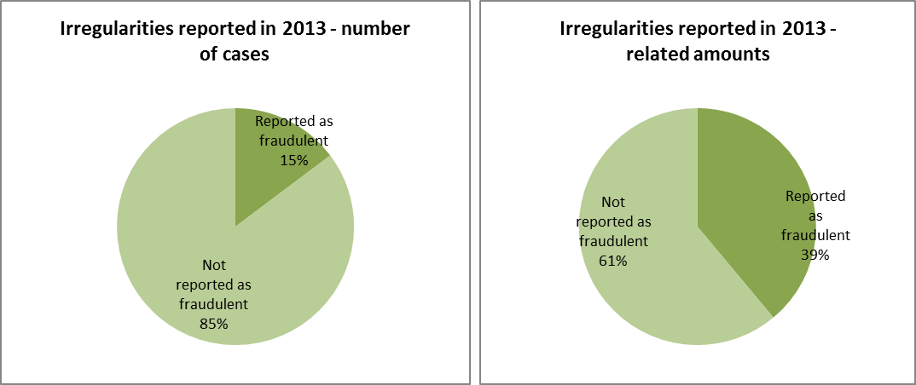
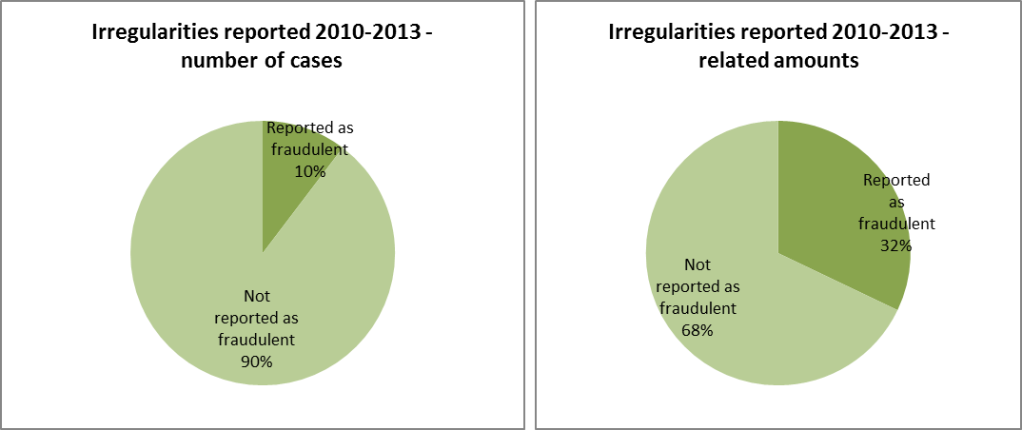

3.7. Specific analysis
Given the limited number of irregularities reported so far, the analysis covers the whole period 2010-13.

3.7.1. Types of irregularity detected
The number of irregularities reported in relation to the EFF is limited and to some extent incomplete in relation to the typologies of irregularities detected by national authorities.
This is reflected by the circumstance that of the 271 detected irregularities (fraudulent and non-fraudulent), 62 do not indicate the modus operandi (almost 23% of the total).
The most detected typology is 'Not eligible expenditure', followed 'Absence of declaration' and 'Infringements of public procurement rules' and ‘Failure to respect other regulations/contract conditions’ and ‘Other irregularities concerning the right to aid’. These types plus those for which no modus operandi has been reported cover almost 77% of the reported irregularities.
In relation to the 28 irregularities reported as fraudulent, there is no real pattern emerging from the reported information, also taking into account that in 12 cases no information has been provided. The use of ‘false or falsified documents’ occurs five (5) times and four times (4) problems linked to bookkeeping.

3.7.2. Method of detection
In relation to the methods of detection, the most frequently reported are 'Control of documents', 'Administrative or financial controls' and 'On-the-spot checks'.
In relation to the irregularities reported as fraudulent, ten (10) occurrences are linked to ‘controls by national anti-fraud services’ and six (6) to the ‘control of documents’.

3.8. Control activity by Member States
Table NR19 shows the results of the control activities in the Member States.
Irregularities have been detected and reported by 21 Member States; fraudulent irregularities by 6 Member States. In terms of numbers of irregularities, the majority has been detected by Spain and Poland, while in terms of amounts the highest results have been obtained by Romania and Spain.
Italy is the Member State having detected and reported the highest number of fraudulent irregularities. The 19 Italian cases represent 68% of the total number of irregularities reported as fraudulent and 77% of the related amounts.
Table NR19: EFF – Irregularities (fraudulent and non-fraudulent) reported by Member State – 2010-13
Sustainable Growth
Cohesion for growth and employment’ covers the Structural Funds, i.e. the European Regional Development Fund (ERDF) and the European Social Fund (ESF), as well as the Cohesion Fund (CF).
It relates essentially to the following policy areas:
- regional policy, for the ERDF and the CF, and
- employment and social affairs, for the ESF.
The principal objective of cohesion policy is to strengthen economic, social and territorial cohesion between regions and Member States of the EU by providing additional resources for those regions and countries whose economic development is lagging behind. The Structural Funds also aim at strengthening regions’ competitiveness and attractiveness, as well as employment, and at strengthening cross-border, transnational and interregional cooperation. The resources available are concentrated on promoting economic convergence, in particular on sustainable growth, competitiveness and employment in line with the Europe 2020 strategy. These resources are also essential tools to fight financial, economic and social crises.
Cohesion policy is promoted using three shared management instruments, with individual EU countries actually distributing funds and managing expenditure.
Sustainable growth is also promoted through centralised direct management by the Commission and centralised indirect management where the Commission distributes funds to EU and other agencies (see chapter 6).

4. Cohesion Policy
The resources for the Cohesion policy support three main objectives:
- Convergence: aims to modernise and diversify regional economic structures, to support sustainable integrated economic development and create sustainable jobs.
- Regional competitiveness and employment: covers environment and risk prevention, access to transport and telecommunications services; Innovation and the knowledge economy.
- The European Territorial Cooperation objective: focuses on development of economic and social cross-border activities; transnational cooperation, and networking and exchange of experiences between regional and local authorities.
Three financial instruments are the vehicles to achieve the goals of this policy:
- The European Regional Development Fund (ERDF) is the largest fund and aims to support the development and structural adjustment of less developed regions in all Member States through investments in research, infrastructure, business support or direct financial support to SMEs.
- The European Social Fund (ESF) prevents and fights unemployment, by making Europe's workforce and companies better equipped to face new challenges and preventing people losing touch with the labour market. Training programs are the primary method; however advice, coordination and sometimes microfinance are also provided to entrepreneurs and SMEs.
- The Cohesion Fund promotes sustainable development in Member states with a per person GNI below 90% of the EU average. The fund has two components: Transport and Environment.
Table CP1 shows the financial resources available for the Cohesion Policy under the different financial instruments. The table also shows that, even if there are virtually no more commitments related to the programming period 2000-06, payments linked to it, although limited, are still part of the picture.
Table CP1: Financial instruments and 2013 appropriations for the Cohesion Policy by programming period and financial instruments

4.1. Trend analysis
In comparison with the other budget sectors, the analysis of the Cohesion policy poses a higher level of complexity, given by the fact that the information received is related to different programming periods, which are regulated by different rules.

4.1.1. Irregularities reported as fraudulent

4.1.1.1. Trend by programming period
Table CP2 analyses the trend linked to the communication of the irregularities reported as fraudulent in the last five years (2009-2013), making a distinction by Fund involved and the relevant programming period.
In the last five years, while the fraudulent irregularities linked to the PP2000-06 have been decreasing (although this decrease is less evident between 2012 and 2013), those linked to the PP2007-13 have been constantly increasing. These trends are linked to the current implementation of the latter period and the closure of the previous. They also reflect the increasing attention and resources deployed to combat fraud in relation to the programming period 2007-13.
Table CP2: trend of the number of irregularities reported as fraudulent between 2009 and 2013 by programming period – Cohesion Policy
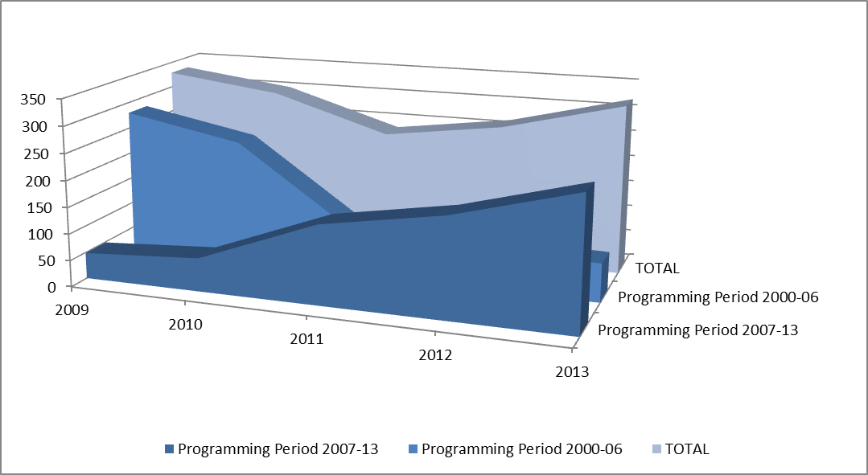
Table CP2 and its associated chart do not include irregularities reported as fraudulent related to previous programming periods, which have been communicated until 2011.
Table CP3 provides in the same form of Table CP2 information about the trends linked to the amounts involved in cases reported as fraudulent, confirming the continuous increase related to the PP2007-13, although, concerning involved amounts, fluctuations can be much more significant as individual cases involving high amounts can easily distort the overall picture. This is clearly the case concerning the years 2011 to 2013, with the intermediate showing the highest amounts.
Table CP3: trend of financial amounts linked to the irregularities reported as fraudulent between 2009 and 2013 by programming period – Cohesion Policy
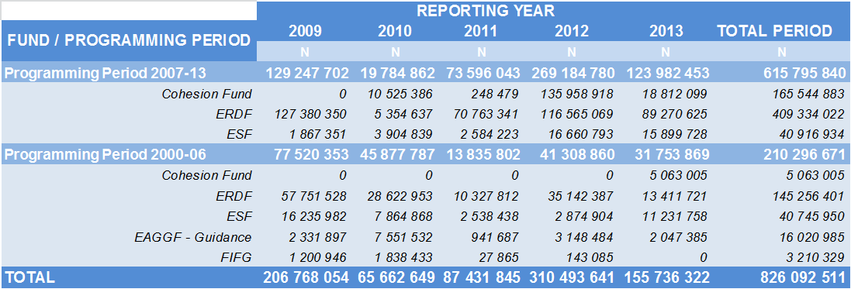
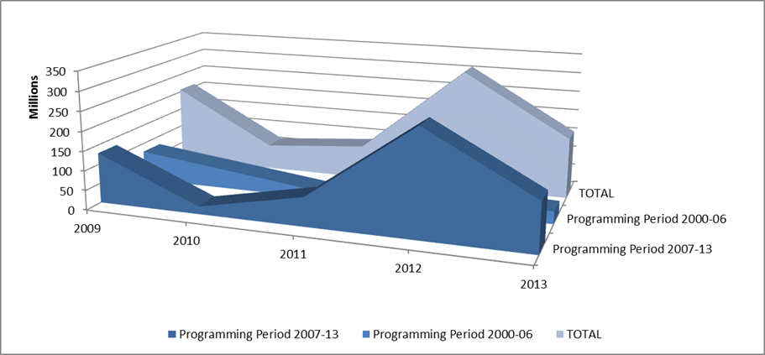

4.1.1.2. Trend by Fund
The analysis of the same data presented in Table CP2 but focussed on the distribution of the irregularities reported as fraudulent by Fund (Table CP4), highlights the following situations:
    - The increase since 2010 of cases concerning the ERDF;
    - Potential frauds affecting the Cohesion fund are reported regularly since 2010, while they were completely absent in the previous programming period,
    - A significant decrease, between the years 2009-2011, of the cases related to the ESF, which since then have remained quite stable.
Table CP4: trend of the number of irregularities reported as fraudulent between 2008 and 2012 by Fund – Cohesion Policy
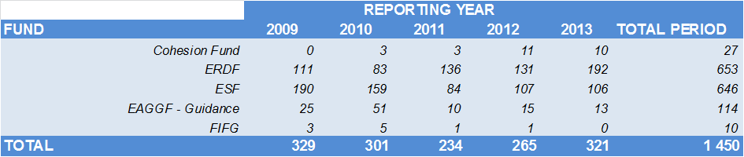
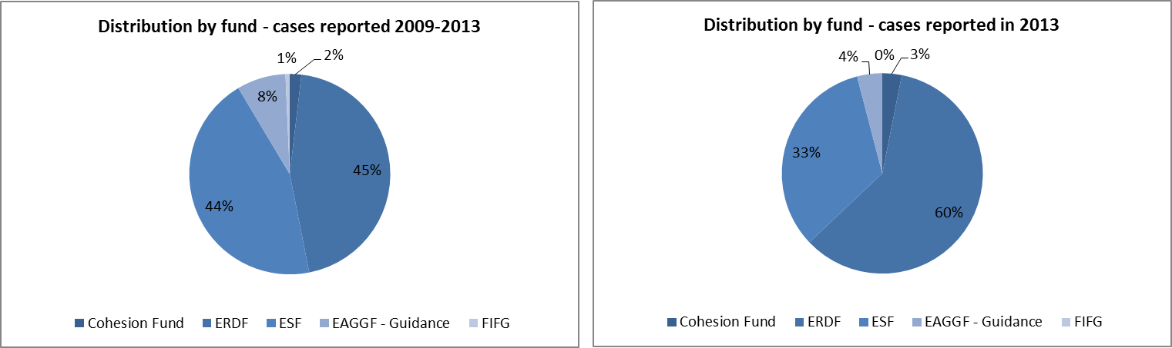
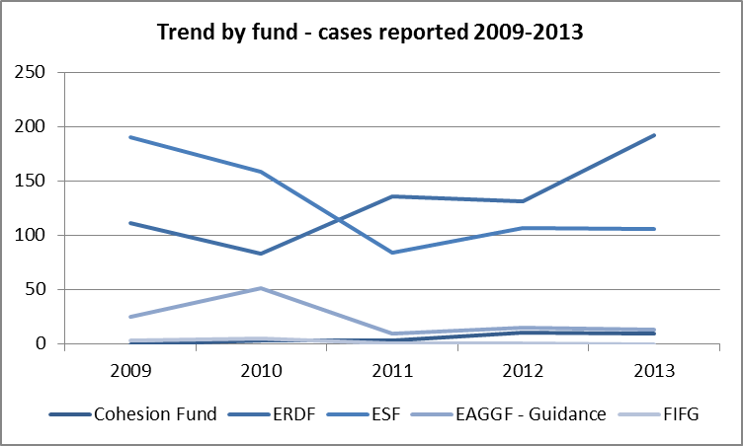
Table CP5 analyses these trends examining the financial amounts linked to the irregularities reported as fraudulent in the reference period.
In this respect, the weight of the ERDF on the total is accentuated by the higher amounts with which this fund contributes to the co-financing of development projects.
Since 2010 the increasing weight of the Cohesion Fund and of the ERDF is confirmed also in relation to the amounts involved.
Table CP5: trend of financial amounts linked to the irregularities reported as fraudulent between 2008 and 2012 by fund – Cohesion Policy
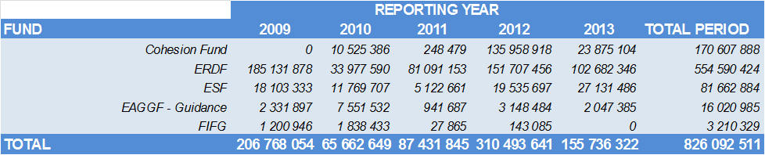
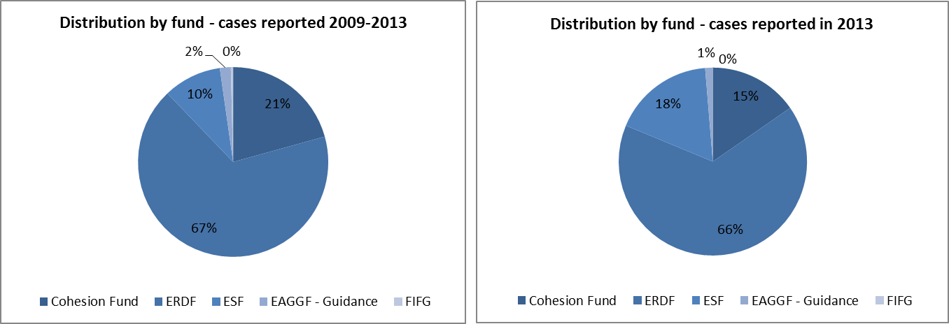
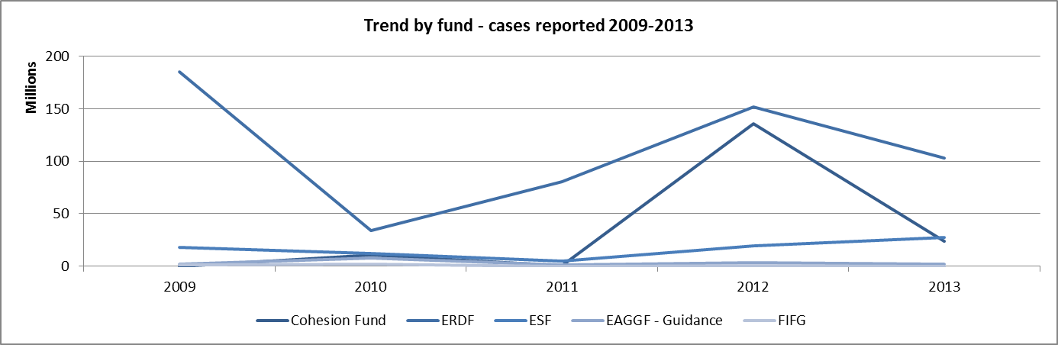

4.1.1.3. Trend by objective
Specific to the Cohesion Policy is that programmes and financial resources available to implement them are closely linked to the geographical dimension, that is to say that the objectives that they pursue depend on the region (and its level of economic development) in which they are implemented. For this reason, the analysis by objective is important.
From this point of view, the analysis of irregularities reported as fraudulent in the last five years do not change the trend already highlighted in past reports.
As showed in Table CP6, the fraudulent irregularities detected and reported by Member States mainly concern programmes implemented under the Convergence objective (previously Objective 1), linked to the less economically developed regions in Europe.
Their notifications have progressed in a linear way since 2010.
Nonetheless, the distribution among the various objectives is remarkably similar to the distribution of the resources among the objectives, at least in relation to the overall situation 2009-2013.
This parallelism is however lost in relation to the distribution of the involved amounts as showed in Table CP7.
Table CP6: trend of irregularities reported as fraudulent between 2009-13 by Objective
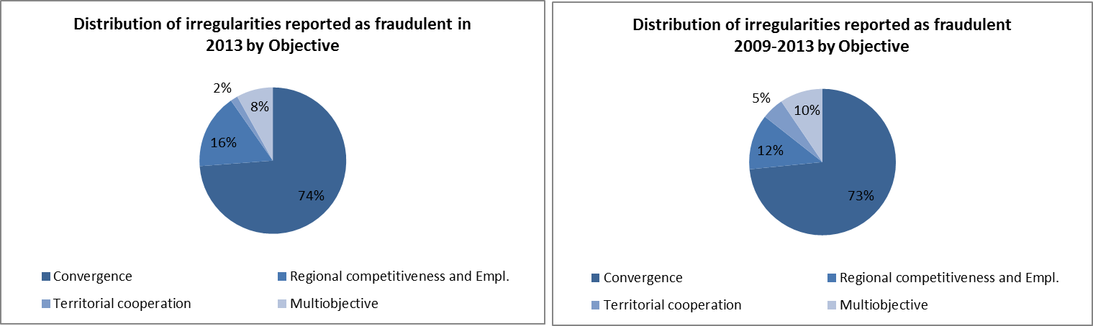
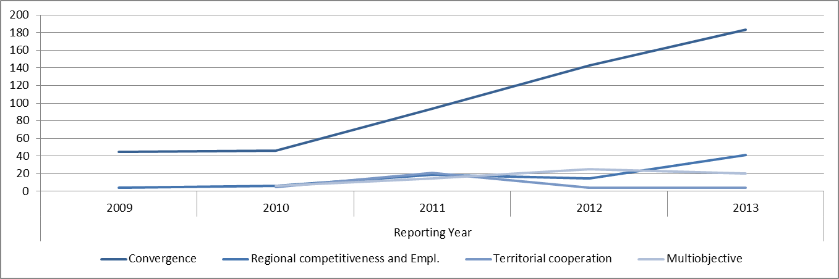
The analysis by objective presented above is exclusively referred to the programming period 2007-13.
Table CP7 analyses the trend in relation to the reported amounts linked to the irregularities showed in Table CP6.
The Convergence objective shows an absolute predominance in this respect, as it represents about 95% of the total amounts linked to fraudulent irregularities in the reference period.
This is only partially rebalanced in relation to the fraudulent irregularities notified in 2013.
Table CP7: trend of amounts related to irregularities reported as fraudulent between 2009-13 by Objective
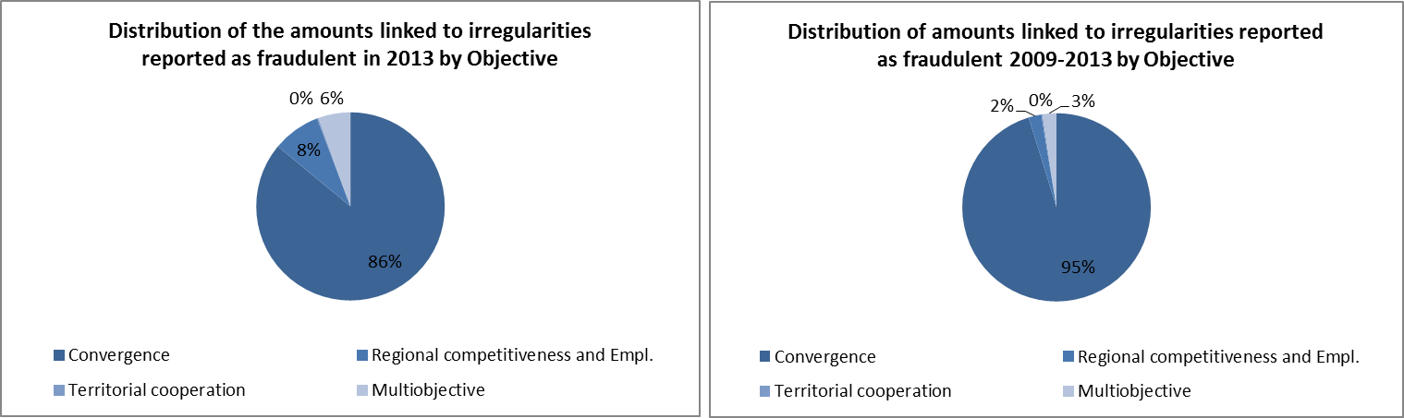
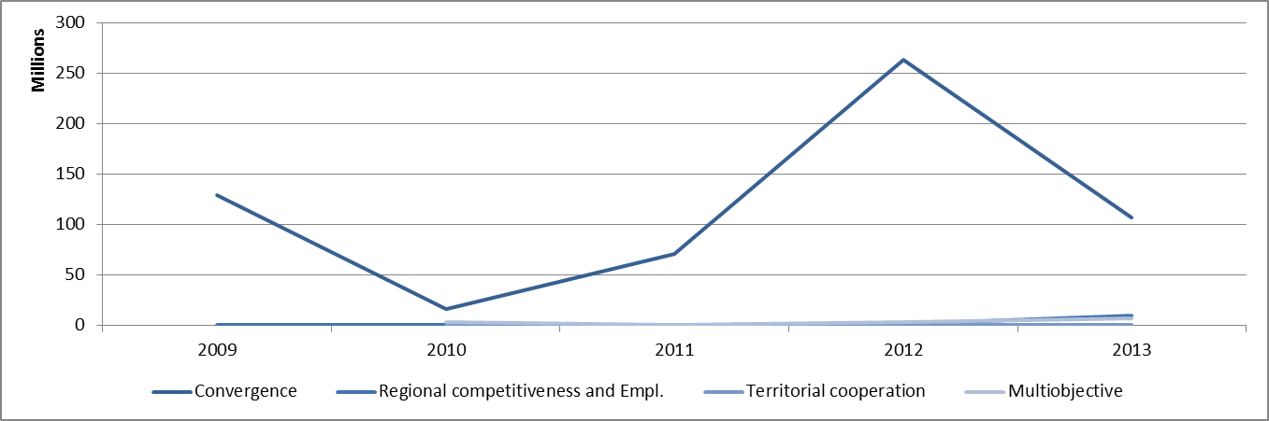
The analysis by objective presented above is exclusively referred to the programming period 2007-13.

4.1.2. Irregularities not reported as fraudulent
Table CP8 analyses the trend linked to the communication of the irregularities not reported as fraudulent in the last five years (2009-2013), making a distinction by Fund involved and the relevant programming period.
Data confirm the increasing results of checks performed on the project financed in the framework of the programming period 2007-13 due to its mounting level of implementation and the progressive phasing-out from the actions linked to the previous programming phase.
The level of reporting related to the programming period 2007-13 has already almost reached the levels of reporting that in the previous programming cycle were recorded at closure.
Table CP8: trend of the number of irregularities not reported as fraudulent between 2009 and 2013 by programming period – Cohesion Policy
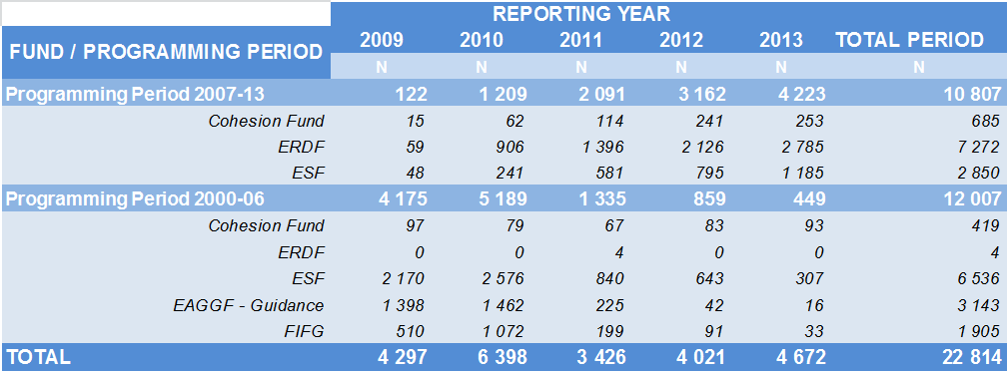
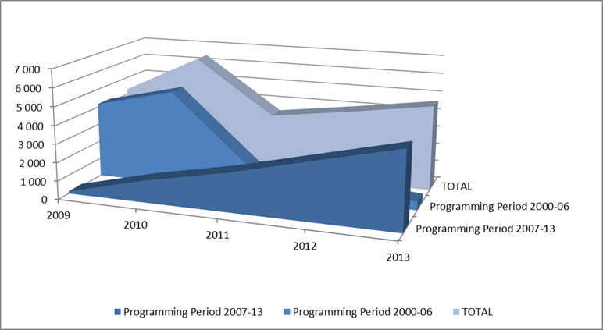
Table CP9 shows the trend related to the amounts linked to the reported non-fraudulent irregularities. Once more, as already mentioned several times in relation to the trends of the financial amounts, fluctuations can happen more often, as they are linked to individual irregularities or group of irregularities of significant value, which produce distortive effects from one year to the other.
Table CP9: trend of financial amounts linked to the irregularities not reported as fraudulent between 2009 and 2013 by programming period – Cohesion Policy
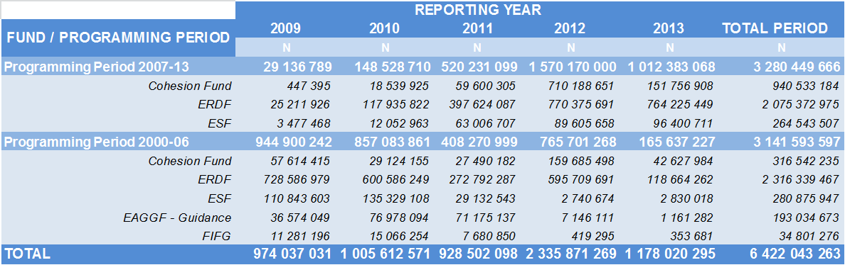
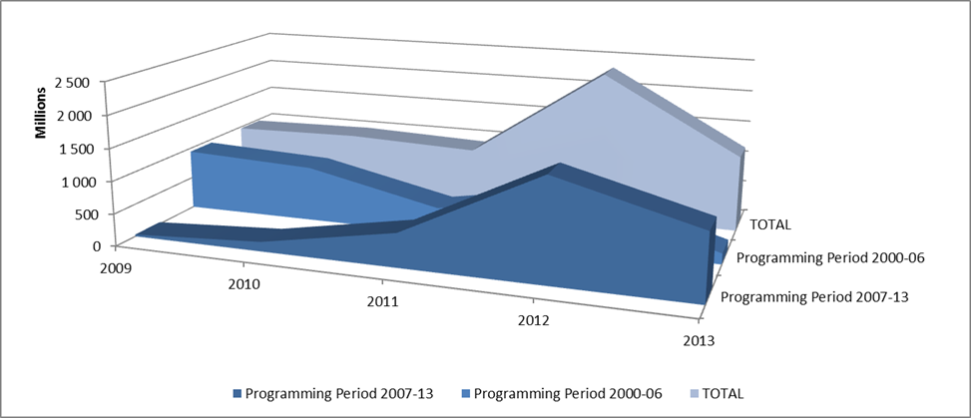

4.2. Specific Analysis – Irregularities reported as fraudulent in relation to the Programming Period 2007-13

4.2.1. Priorities concerned by the irregularities reported as fraudulent in 2013
The operational programmes financed by the Cohesion Policy are implemented in relation to the already mentioned objectives, but also along identified Priorities and Themes.
The information provided by Member States allows for an analysis of the priority areas in relation to which Member States have identified projects affected by potentially fraudulent practices.
Table CP10 shows the number of reported fraudulent irregularities and their related financial amounts.
In terms of numbers, the 'Priorities' most concerned were 'Research and Technological Development (RTD)', 'Improving access to employment and sustainability' and 'Investment in social infrastructure'.
From the amounts point of view, the most significant results concern 'Transport', ‘RTD’ and 'Investment in social infrastructure'.
The highest average values per fraudulent irregularities concern the priorities ‘Transport’, ‘Energy’ and ‘Environmental protection and risk prevention’.
Table CP10: PP2007-13 - Irregularities reported as fraudulent by Priority
About 45% of the irregularities used for this analysis did not provide information in relation to the priority area concerned.
The table focuses on the last two years in consideration of the fact that Member States started reporting information concerning the ‘priority’ areas in a more consistent way as of 2012.

4.2.2. Types of irregularities / modus operandi detected - Irregularities reported as fraudulent in 2013
The analysis of the detected practices used in connection with the irregularities reported as fraudulent in 2013 (Table CP11) reveals a relative decrease of those generically described as 'not-eligible expenditure' and a significant increase of those linked to the use of 'false or falsified or incorrect documents, certificates or declarations', which intuitively represent the type of behaviour directly linked to fraud as aimed at deceiving the administration/body paying out the funding.
Apart from the residual category ‘Other’, the groups which showed the most significant variation in comparison with previous years, are linked ‘Multiple financing’ and to irregularities concerning the accounts/bookkeeping.
Although marginal on the total, two case potentially involving corruption have been detected and reported, bringing the total number to 14 in the period 2009-2013. These 14 cases affect the highest average amounts reported in the reference period (about EUR 7 million).
Table CP11: Programming Period 2007-13 - Types of irregularity/Modus operandi detected in relation to irregularities reported as fraudulent
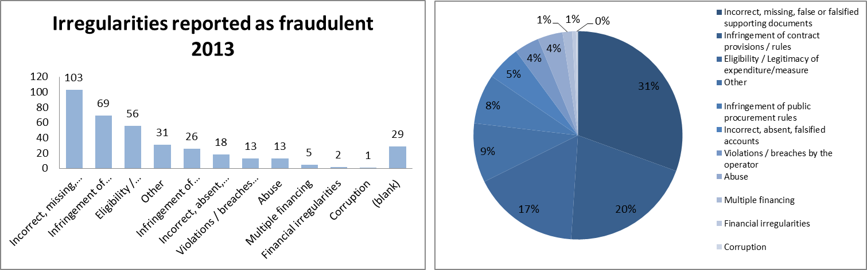
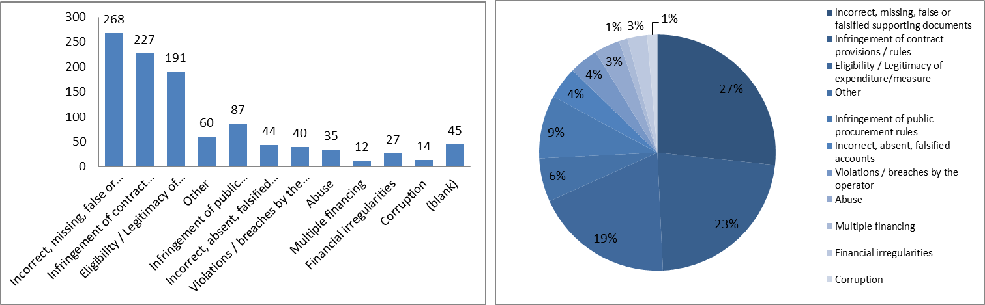
The number of irregularities for which no description has been provided has been increasing significantly in 2013 in relation to previous years.

4.2.3. Type of control / method of detection – Irregularities reported as fraudulent
The analysis of the information concerning the Programming Period 2007-13 shows an important shift in relation to the previous programming period. The number of fraudulent irregularities detected by administrative controls is proportionally significantly higher than what was the case in the previous period, where the administrative verifications, on the spot checks and audit of operations would detect less than 20% of the cases, while in the current period they detect about 63%. This is only slightly decreasing in 2013, where irregularities reported as fraudulent detected by the management and control systems of the funds represent 55% of the total.
Both the analysis on 2013 and the reference period 2009-2013 confirm that anti-fraud checks and criminal investigations focus on cases with higher financial amounts involved.
Table CP12: Programming Period 2007-13 - Type of checks having detected the irregularities reported as fraudulent
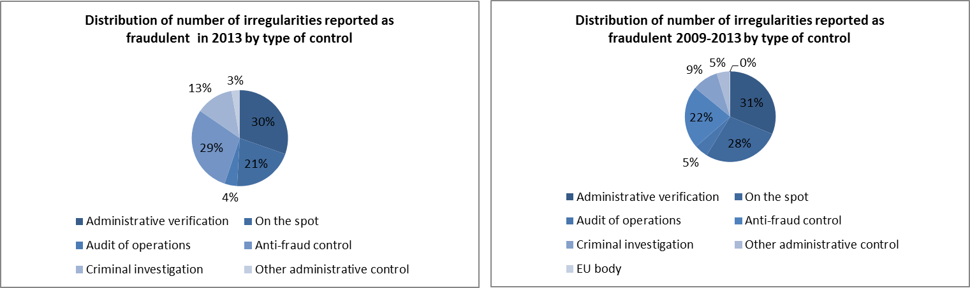
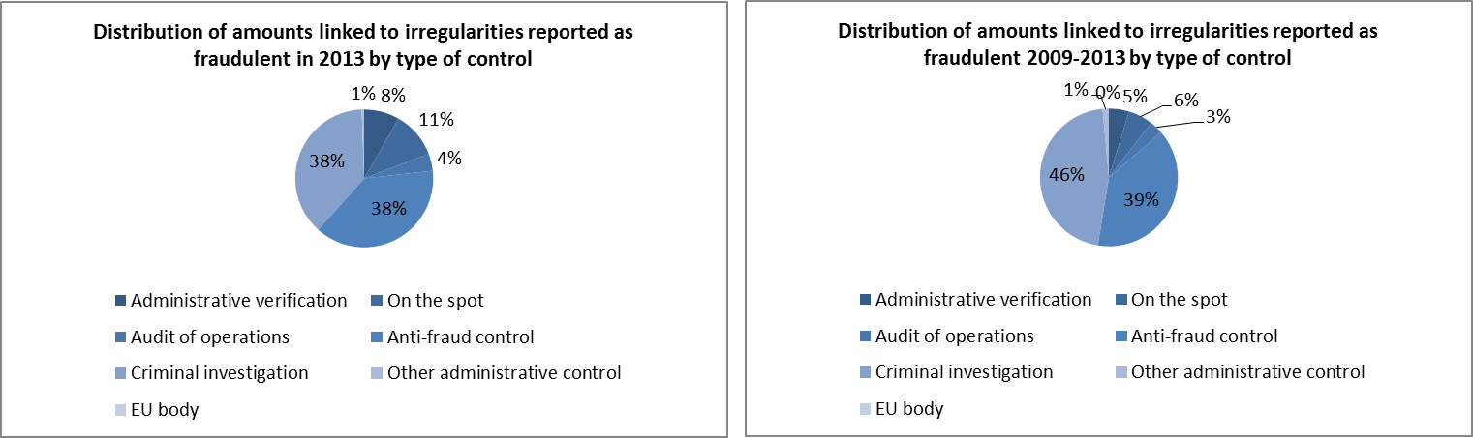
The results of this analysis may be influenced by the accuracy of the information reported by Member States, which may have highlighted the subsequent activity of bodies in charge of the management and control of the funds and neglected the detection activity of the anti-fraud bodies.
Another element to be kept into account is that for 197 cases reported in the years 2009-2013, it was not possible to determine the type of check.
The number of cases linked to investigations by EU bodies (including OLAF) is not accurate.

4.2.3.1. Complexity of the irregularities reported as fraudulent
In 2012, for the first time, an estimation of the level of complexity of the irregularities reported as fraudulent was provided.
In relation to the information published in 2012 on this subject, the methodology to identify the complexity of reported fraudulent irregularities has been reviewed and refined, therefore no comparison should be made between the two documents as the present one is founded on different ‘rules’.
Table CP13 provides an estimation of the level of complexity of the irregularities reported as fraudulent based on this revised methodology. It also compares the situation of those reported in 2013 with those communicated in the reference period 2009-2013 (included).
The share of the 'complex' cases decreased in 2013 in relation to the reference period, while share of the 'simple' fraudulent irregularities remained stable, with a consequent increase of the 'moderate' complexity category.
The 'complex' cases are mainly referred to the ESF.
Table CP13: Complexity of fraudulent irregularities detected in relation to the Cohesion policy
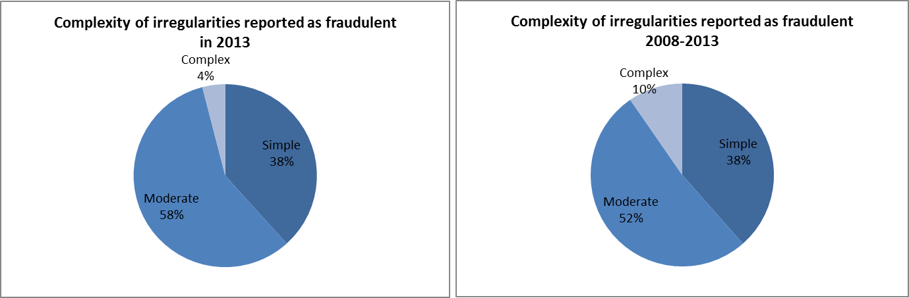
This is the second attempt of estimating the proportion of 'complex' cases on the total fraudulent irregularities identified. Therefore the method is liable of being improved in the next years.

4.2.4. Type of irregularities not reported as fraudulent – 2008-2013
Table CP14 provides an overview of the types of irregularities detected in relation to non-fraudulent irregularities.
It confirms some of the main trends highlighted in previous years, as the infringements most frequently detected and those involving the highest amounts are those concerned with public procurement.
Table CP14: Programming period 2007-13 - types of non-fraudulent irregularities

4.3. Anti-fraud activities by Member States
Previous paragraphs have examined the trend and main features and characteristics of the irregularities reported as fraudulent.
The present paragraph aims at examining some aspects linked to the anti-fraud activities and results of Member States. Five elements are taken into account:
    - the time that runs between the beginning of the fraudulent practice and its detection/establishment by the competent authority and reporting to the Commission (Detection / Reporting Efficiency);
    - the number of irregularities reported as fraudulent by each Member State;
    - the fraud detection rate (the ratio between the amounts involved in cases reported as fraudulent and the payments occurred in the financial year 2012);
    - the fraud prevention rate (the ratio between the amounts involved in cases reported as fraudulent which have been detected before payments were executed);
    - the ratio of cases of established fraud on the total number of irregularities reported as fraudulent.

4.3.1. Detection – Reporting Efficiency
Table CP15 shows the average number of months between the moment in which the fraudulent practice begins and when it is detected/established (Detection Efficiency – DetE) and then the average number of months between its establishment and the reporting to the Commission (Reporting Efficiency – RepE).
The EU average is more than three years (38 months) between the first and the last of those events (DetE + RepE).
The duration of the DetE should not be seen as a sign of inefficiency per se. More relevant, in this respect, the RepE, which is, in average, about 8 months that is an acceptable time frame.
For nine (9) Member States having reported fraudulent irregularities in 2013, the DetE is lower than 30 months (EU average), while eleven (11) are above this average.
The overall time gap between the initial moment and reporting (DetE + RepE) is increasing in 2013 in comparison with previously reported information. This is normal as the programming period implementation goes forward and potential fraud is increasingly detected after payment.
Table CP15: Cohesion Policy – Detection and Reporting Efficiency
Three Member States (Austria, Finland and Ireland) have not reported fraudulent irregularities in 2013 in relation to the programming period 2007-13. For Ireland, information provided in relation to cases reported in previous years did not allow calculating any average time gap. For Malta and Finland, the calculation was possible only in relation to DetE.
The Netherlands, Denmark and Luxembourg have reported no fraudulent irregularities in relation to the programming period 2007-2013.

4.3.2. Detection of irregularities reported as fraudulent in 2013 by Member State
Map CP1 divides Member States in four groups, depending on the number of irregularities reported as fraudulent in 2013:
    - Group 1: no irregularities reported as fraudulent irregularities in 2013. 7 Member States belong to this group.
    - Group 2: between 1 and 9 such cases reported in 2012. 11 Member States belong to this group;
    - Group 3: 10 to 30 irregularities reported as fraudulent. 8 countries are included in this group;
    - Group 4: more than 30 cases reported. It counts 1 Member State.
Map CP1: Number of irregularities reported as fraudulent in 2013 by Member State – Cohesion Policy
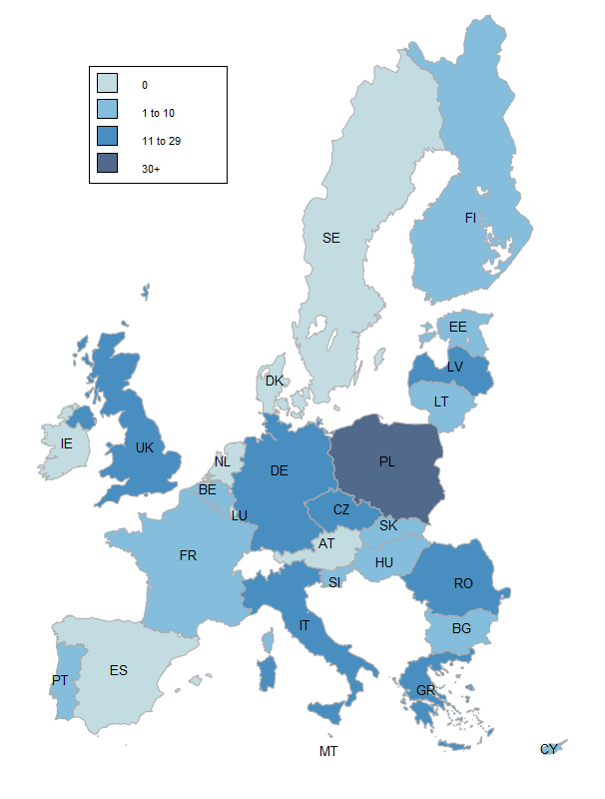

4.3.3. Fraud detection rate
The fraud detection rate compares the results obtained by Member States in their fight against fraud with the payments received by them in a given financial year. This implies that a single case reported as fraudulent and involving a significant financial amount can produce a better result than that achieved by the sum of the financial impact of several irregularities affecting lower amounts. For this reason, this indicator should be read in conjunction with the number of irregularities reported as fraudulent and for this reason they are presented together in Table CP16.
In 2013, the highest fraud detection rates are referred to the Latvia, the United Kingdom, Slovenia, Romania and the Czech Republic (all above 0.3%).
A second important element is the stock of reported irregularities and involved amounts and their relation to the payments occurred in the reference period.
The highest number of detected fraudulent irregularities for the period 2007-13 originates from Germany, Poland, the Czech Republic, Italy, Romania and Latvia.
The accumulated fraud detection rate (2008-2013) is the highest (>0.3%) for the Czech Republic, Latvia, Italy, Poland, Romania and Slovenia.
Table CP16: number of irregularities reported as fraudulent in 2013, amounts involved and fraud detection rate by Member State

4.3.4. Fraud Prevention Rate
The fraud prevention rate (FPR) compares the percentage of the amounts detected before payment with the total amounts related to irregularities reported as fraudulent.
The calculation is performed on the whole stock of irregularities reported as fraudulent in the years from 2008 to 2013 and not exclusively on those reported in 2013.
The FPR can easily result higher in the case of Member States having reported a low number of fraudulent irregularities and therefore should be ‘read’ and interpreted together with the overall number of irregularities reported as fraudulent and the fraud detection rate, as showed in Table CP17.
The overall FPR is above 48%, indicating that almost half of the amounts involved in fraudulent irregularities is detected before payment.
In this respect, the most performing Member States, which satisfy the two conditions of having FPR and FDR above the average are the Czech Republic and Latvia.
Table CP17: number of irregularities reported as fraudulent between 2008 and 2013, amounts involved, irregular amounts paid out and fraud prevention rate by Member State

4.3.5. Ratio of established fraud 2008-2012
Table CP18 shows the ratio between the cases of established fraud and the total number of irregularities reported as fraudulent (including suspected and established fraud) in the period 2008-2013. It would be meaningless to take into account only cases reported in 2013, as the criminal proceedings leading to a conviction for fraud may take several years. In some Member States, proceedings to establish fraud may be, in certain cases, of an administrative nature.
In this respect, the average ratio of established fraud at EU level is 11% (up from 3%), with a significant increase in comparison to the calculation of this indicator on the previous Report.
Two Member States decisively contribute to this result in consideration of the number of established fraud cases reported: Greece and Germany. High ratios (significantly above average) are showed by Greece, Slovenia, Germany and Cyprus show a rate above this level; Estonia, Poland, the Czech Republic and Slovakia show a rate that is higher than last year’s average (3%).
Table CP18: number of cases of suspected and established fraud and ratio of established fraud – cases reported between 2008-2013 in the Cohesion policy
A significant impact on the rate is determined by the number of irregularities reported as fraudulent by Member States. In this respect, the countries which greatly influence the EU average results are Poland, Germany, the Czech Republic, Italy Romania, and Latvia.
Greece has reported 22 cases, of which 20 of established fraud, following an administrative proceeding, which ascertained the fraudulent practices and imposed the related sanctions. The concerned persons are entitled to appeal in justice against these decisions.
Section II - Decentralised Management
The EU as a global player / Pre-Accession Policy
The goal of the EU as a global player is also promoted through direct management. Pre-Accession Assistance (PAA) is provided through decentralised management where third countries distribute funds but account to the EU for how it is spent. In the last stages new member states manage pre-accession funds under shared management to help them complete the transition.

5. Pre-Accession Policy (Pre-Accession Assistance and Instrument for Pre-Accession)
The assistance in pre-accession is provided on the basis of the European Partnerships of the potential candidates and the Accession Partnerships of the candidate countries. The current candidate countries are Croatia, Iceland, the Former Yugoslav Republic of Macedonia, Montenegro, Serbia and Turkey. Accession negotiations were opened with Croatia and Turkey in October 2005 and with Iceland in July 2010.

5.1. The Pre-accession Assistance (PAA), 2000-06 and Instrument for Pre-Accession (IPA), 2007-13
The old Pre-accession Assistance (PAA), regarding the period 2000-06, was financed by series of European Union programmes and financial instruments for candidate countries or potential candidate countries, namely the programmes for candidate countries, PHARE, SAPARD and ISPA, Phare Cross-Border Cooperation (CBC) and Coordination, Pre-accession financial assistance for Turkey, Assistance for reconstruction, development and stabilisation for potential candidate countries (CARDS) and Transition facility.This assistance has nearly been closed except for a few payments in CARDS.
The current Instrument for Pre-Accession Assistance (IPA), which covers the period 2007-2013, is delivered through five components. The policy and programming of IPA consists of Multi-Annual Indicative Financial Framework (MIFF) on a three year basis, established by country, component and a theme, and Multi-Annual Indicative Planning Documents (MIPDs) per country or per groups of countries (regional and horizontal programmes). The Candidate Countries submit also Strategic Coherence Frameworks (SCF) and Multi-annual Operational Programmes, both regarding IPA Components III and IV. Their principal aim is to prepare beneficiary countries for the future use of the Cohesion policy instruments by imitating closely its strategic documents, National Strategic Reference Framework (NSRF) and Operational Programmes (OP), and management modes.
The financing of IPA is provided by the five following different components and DG Enlargement leads in the coordination of the instrument:
    - Component I, Transition Assistance and Institution Building (TAIB), is managed by the European Commission's Directorate General for Enlargement;
    - Component II, Cross-Border Cooperation, is managed by the European Commission's Directorate General for Enlargement and part is managed, under shared management with Member States, by European Commission's Directorate General for Regional Policy;
    - Component III, Regional Development, is managed by the European Commission's Directorate General for Regional Policy;
    - Component IV, Human Resources Development, is managed by the European Commission's Directorate General for Employment and Social Affairs; and
    - Component V - Rural Development is managed by the European Commission's Directorate General for Agriculture.
The pre- and post-accession assistance is implemented through a variety of management modes which take into account different levels of preparedness of the beneficiary countries. The assistance under IPA is designed also to prepare the beneficiary countries to assume full responsibility for the management of financial assistance granted by the EU.
The eligibility for IPA components differs depending on the state of preparedness. In the use of funds the IPA beneficiary countries are divided into two categories. The EU candidate countries Croatia, the Former Yugoslav Republic of Macedonia, Serbia and Turkey are eligible for all five components of IPA. While the new candidate countries, Iceland and Montenegro (candidate status awarded in 2010), currently remain outside the scope of intervention of IPA Component III, the regional development. The Potential candidate countries in the Western Balkans (Albania, Bosnia and Herzegovina, Montenegro and Kosovo under UN Security Council Resolution 1244/99) are eligible only for the first two components.
Implementation of Components I and II falls under the responsibility of DG Enlargement, which initiates the components under a centralised management mode, with a view to transferring implementation management powers to the beneficiary countries as soon as their administrative capacities are considered sufficiently developed to ensure sound financial management. The EU Delegations play a major role in the delivery of IPA, in particular under the de-concentrated and decentralised management modes.
The implementation can be handled:
- directly by central management: funds are managed by DG Enlargement at headquarters;
- directly de-concentrated: funds are managed by EU Delegations under the supervision;
- directly centralised: cross-delegated when funds are managed by another service of the Commission through cross sub-delegation;
- indirectly in a centralised indirect management: funds are managed by executive agencies, specialised Community bodies (such as the European Investment Bank or the European Investment Fund) and national or international public-sector bodies or bodies governed by private law with a public-service mission;
- indirectly decentralised with ex ante control: funds are managed by accredited national authorities of the beneficiary country, but procurement is subject to ex ante control by the EC Delegation;
- decentralised without ex ante control: funds are managed by accredited national authorities of the beneficiary country and are not subject to ex ante controls by an EC Delegation;
- joint: funds are jointly managed with International Organisations (EBRD, EIB, Sigma, UN agencies, etc.)
In Croatia, the implementation of Pre-accession assistance is decentralised to national authorities. Montenegro is preparing for conferral of management powers for IPA Component I and II. Decentralised management is still under development in the Former Yugoslav Republic of Macedonia. Payments in decentralised programmes remained less than half of the initial forecasts in FYROM. In Serbia, the national authorities submitted an application for the conferral of management in June 2012 and it could be granted by the end of 2013. Absorption capacity under decentralised management in Turkey is not optimal, with delays in tendering, contracting, as well as execution of payments.
In the old pre-accession assistance PAA, there was only EUR 3.8 million paid for CARDS in 2013. With regard to the current pre-accession instrument IPA, a total EUR 804.5 million euros paid in 2013. Table PA1 presents payments made for IPA and PAA in financial year 2013 compared to 2012.
Table PA1 – Payments made for IPA and PAA, comparison 2012 and 2013

5.2. General analysis – Trend analysis

5.2.1. Trend analysis
Regarding the Pre-Accession Assistance (PAA), the number of irregularities reported as fraudulent slightly increased in 2013 compared to the previous year. Yet, there is a downward trend since 2009 regarding the related irregular amounts as Table PA2 and Chart PA1 show.
Table PA2 – Reported irregularities (PAA), 2009-2013
Chart PA1 –Irregularities reported as fraudulent (PAA), 2009-2013
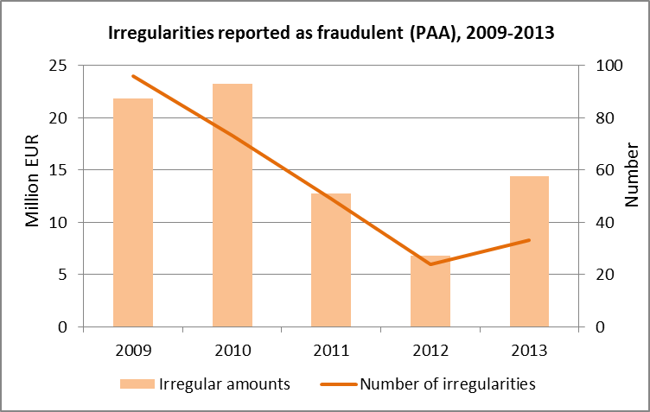
For the total number of irregularities (reported as fraudulent and not reported as fraudulent) for the PAA, there were 181 irregularities reported in 2013 and the amount affected EUR 59.8 million similarly to 2012. (In the previous year, there were 214 irregularities and the amount affected was EUR 50.2 million.) However, a slight increase can be observed compared to 2012, which is due to the reclassification of some cases (qualification of the irregularity) of reporting year 2012.
In the past five years, most of the irregularities (reported and not reported as fraudulent) and the highest aggregate amount concern first Romania and secondly Bulgaria. In relation to the distribution of irregularities according to funds it can be said that most of the fraudulent irregularities concern SAPARD, however in terms of non-fraudulent irregularities the latter is preceded by ISPA.

5.2.2. Trend analysis IPA
Generally it can be said that the trend of IPA reporting (2007-13) has begun to develop in a stable upward curve which means a continuous increase in the number of irregularities reported and involved amounts since 2010. The increasing trend can be considered within the norm as the reporting of irregularities of IPA has only begun in recent years.
Chart PA2 below demonstrates the evolution of reporting of all the irregularities (reported and not reported as fraudulent) since 2010.
Chart PA2 – Reported irregularities (IPA), 2010-2013
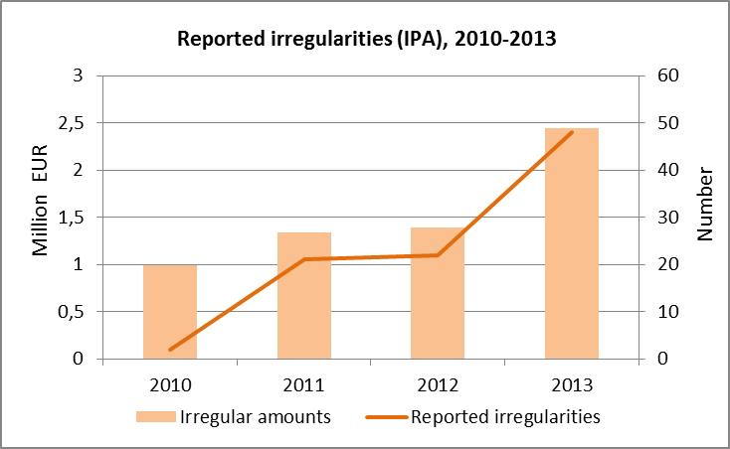
During the past few years, the highest number of irregularities reported as fraudulent was communicated by Turkey followed by Macedonia. The highest fraudulent amounts were recorded in relation to Cross-Border Cooperation and secondly to Transition Assistance and Institution Building. However, Transition Assistance scores the highest with regard to irregularities not reported as fraudulent.

5.2.3. Reporting efforts
In general the communications received regarding IPA via IMS are complete and in terms of timeliness the reporting behaviour is satisfactory. The level of completeness of the reported information has been improving depending on experience with reporting.
Serbia and Macedonia have reported irregular cases in the IMS system during 2013. The information provided by these countries is complete and detailed, moreover the classification of the irregularities is accurate.
Turkey and Croatia have continued the consistent reporting. Croatia increased significantly the number of reported irregularities since its connection to IMS in October 2012.

5.3. Specific analysis – Financial year 2013

5.3.1. Pre-Accession Assistance (PAA)
In 2013 a total number of 33 irregularities were reported as fraudulent with the amount affected of EUR 14.4 million as Table PA3 demonstrates.
Table PA3 – Reported irregularities per country (PAA), 2013
These fraudulent irregularities were reported by Bulgaria and Romania. Regarding irregularities not reported as fraudulent, it was Romania communicating by far the highest number of cases with EUR 43.7 million amounts affected.
Like in the previous years, the majority of cases concern again SAPARD in 2013, the Special Accession Programme for Agriculture and Rural Development.
Table PA4 – Reported irregularities per fund (PAA), 2013
With 25 irregular fraudulent cases reported and EUR 13 million involved, the SAPARD fund remains the most fraudulent one among all the PAA funds, accompanied by PHARE with 8 cases and EUR 1.3 million affected.
The practices repeatedly employed in committing fraudulent irregularities are mainly ‘falsified supporting documents’ (45.5% of the cases and 42.5% of the irregular amounts involved), followed by ‘other irregular documents’ (37.9% of the cases and 21.1% of the irregular amounts).
With regard to irregularities not reported as fraudulent, the highest irregular amounts have been reported in relation to ISPA fund (EUR 33.6 million), followed by SAPARD (EUR 11.2 million). The most frequent modus operandi are: ‘failure to respect other regulations/contract conditions’ (55.4% of the cases and 21.5% of the irregular amounts) and ‘Non-eligible expenditure’ (28.4% of the cases and 71.8% of the irregular amounts).

5.3.2. Instrument for Pre-Accession (IPA)
In IPA (2007-13), there were 9 irregularities reported as fraudulent involving EUR 1.2 million irregular amounts. Tables PA5 and PA6 show the breakdown per country and per fund respectively.
Table PA5 – Reported irregularities per country (IPA), 2013
In 2013 Turkey reported most of the irregularities considered as fraudulent (6 cases out of total 9, involving over one million euros). Turkey was also the country reporting the highest aggregate amounts involved in irregularities not reported as fraudulent, though the highest number of such irregularities was recorded by Croatia (19 cases out of total 39).
Table PA6 – Reported irregularities per fund (IPA), 2013
Regarding the modus operandi of irregular cases irregularities reported as fraudulent, the following can be said: most of the irregular amounts (72.7 %) related to one single case, where ‘Conflict of interest’ has been identified.
When it comes to other irregularities not reported as fraudulent, the most frequent practice employed are: ‘Infringement of rules concerning public procurement’ (concerns 35.9 % of the cases and only 4.8 % of the irregular amounts), ‘Failure to respect other regulations/contract conditions’ (concerns 10.3 %cases but concerns 35.2 % of the irregular amounts) and finally ‘Non-eligible expenditure’ (concerns 28.2 % of the cases and only 10.5 % of the irregular amounts).

5.3.3. Method of detection
In 2013, Regarding PAA, most of the irregularities reported as fraudulent was detected by community controls and associated controls (in more than half of the cases and over 77% of irregular amounts). Additionally, interservice cooperation proved to be the second most frequent method of detection of such irregularities (in around 20% of cases and 36% of irregular amounts). This finding is underlining the importance of audits performed by responsible Commissions services and investigations conducted by OLAF.
In case of IPA, over 80% of the total number of irregular cases reported in 2013 was detected by national administration.

5.3.4. Recovery for the Pre-Accession Assistance (PAA)
The table PA7 demonstrates the recovery situation per country in the PAA. It provides an overview for years between 2003 and 2013 of the recoveries: amounts still to be recovered and the cumulative recovery rate.
Table PA7: Recovery by beneficiary country (PAA), cumulative results, 2003-2013
As it appears from the above table, the recovery of irregular amounts is not yet completed. The overall cumulative recovery rate for irregularities reported as fraudulent is 29.22%, which is lower than in the case of irregularities not reported as fraudulent (37.36%). The figures do not take into account the recoveries and financial corrections made by the Commission.
Section III – Centralised Management

6. Direct Management

6.1. Introduction
This chapter contains a descriptive analysis of the data on recovery orders issued by Commission services in relation to expenditures managed under ‘direct management’ mode, which is one of the three implementation modes the Commission can use to implement the budget.
According to the Financial Regulation, ‘direct management’ means that the Commission implements the budget by its departments, including its staff in the Union Delegations under the authority of their respective Head of Delegation, or through executive agencies.
For financial year 2013, a total of EUR 14.6 billion has been effectively disbursed under the ‘direct management’ mode. Table DM1 presents the actual payments made in financial year 2013 for the nineteen policy areas corresponding to 98% of the overall payments made under ‘direct management’.
Table DM1 – Payments made in financial year 2013 per policy area

6.2. General analysis
In 2013, for the nineteen policy areas, the Commission services registered 2245 recovery orders in ABAC that were qualified as irregularities for a total financial value EUR 81.9 million. Among these recovery orders, 25 have been reported as fraudulent, involving EUR 1.2 million irregular amounts.

6.2.1. Five year analysis 2009-2013
As a trend analysis, the comparison between five years, from 2009 to 2013 will be hereunder provided. This is the first five years that can be compared as the ABAC recovery context was only set up in 2008. Nonetheless, it has to be noted that such a comparison will only serve as a snapshot of data gathered in those five years, rather than to point out to any evolution or prediction of future trends.
Generally it can be said that in the past five years, the number and related financial value of irregularities reported as fraudulent have steadily decreased, meanwhile the number and related amounts regarding recovery orders qualified as irregularities not reported as fraudulent firmly increased. At the same time, the expenditure under the direct management mode remained stable: around 14 billion euros are effectively disbursed each year. As a consequence, the ratio between irregular amounts recovered and payments made has also increased. Table DM2 and DM3 summarise these figures for irregularities during the five-year term.
Table DM2 – Irregularities not reported as fraudulent and related amounts, financial years 2009-2013
Table DM3 – Irregularities reported as fraudulent and related amounts, financial years 2009-2013
The ABAC system shows that there were over ten thousand registered irregularities (not reported as fraudulent) with a total financial value of exactly EUR 315 million. This total irregular amount, when compared to the reference figure of the total payments of the same five years (over EUR 72 billion) , gives the overall irregularity detection rate of less than half percent (0.44%). As far as the irregulartites of fraudulent nature (irregularities reported as fraudulent) are concerned, this fraud detection rate is close to zero (0.02%), which is calculated on the basis of a total of 257 recoveries with related amount of EUR 17 million. The registered irregulariy figures demonstrate the efficient irregularity detection and reporting systems in place.

6.3. Specific analysis

6.3.1. Recoveries according policy areas
Table DM4 provides a more detailed classification of the policy areas and related irregularities with financial values for year 2013.
Table DM4 – Irregularities reported by policy areas and related amounts, 2013
In financial year 2013, the highest number of 'irregularities reported as fraudulent' was recorded in the ‘External relations’ area, however in terms of irregular amounts, the policy field ‘Development and relations with ACP States’ scored with half a million euros. This policy area alone counts for almost the half of fraudulent amounts recovered.
Regarding 'irregularities not reported as fraudulent', most of the irregularities were registered in the area of ‘Information society and media’ to which the second highest aggregate irregular amounts is linked. This year, the 'Mobility and transport' policy area appears to have recorded the biggest aggregate non-fraudulent irregular amounts. This policy field, together with ‘Information society and media’ and ‘Research’ counts for more than half of the total irregular amounts for 2013.
When looking at the five year perspective as presented by table DM5, one can perceive that ‘External relations’ policy field has the highest fraud detection rate (0.09%). The same policy field counts for more than half of the fraudulent amounts recovered. The second largest aggregate fraudulent amounts were recovered in the fields of ‘Development and relations with ACP States’ and ‘Information society and media’.
Regarding 'irregularities not reported as fraudulent', policy area ‘Home Affairs’ stands out with the highest irregularity detection rate (1.72%). This means that the ratio of the total irregular amounts and the effective payments was the highest in this policy field. It is followed ‘Information society and media’ and ‘Education and culture’. Nonetheless, the highest aggregate non-fraudulent irregular amounts were recorded in the field ‘Information society and media’, secondly in ‘External relations’ and thirdly in ‘Research’. These three policy areas account for half of the total irregular amounts recovered during the five years.
Table DM5 – Irregularities reported by policy areas and related amounts, financial years 2009-2013
It can also be said that some policy areas registered increasing irregular amounts over the five years. These are notably the following: ‘Information society and media’, ‘Research’, ‘External relations’ and ‘Education and culture’. Additionally, policy fields ‘Development and relations with ACP States’, ‘Mobility and transport’ and ‘Home affairs’ have been fluctuating around the average. The remaining 12 policy areas remained always below the average irregular amounts recorded for the year concerned.
Yet, it has to be reiterated that the explanation for the relatively high number of irregularities resides in the fact that Commission services duly detect and keep record of these cases in ABAC.

6.3.2. Recoveries according to legal entity residence
In 90% of the irregular cases (reported as fraudulent and not reported as fraudulent together) corresponding to a total 83% of irregular amounts, the legal entity was resident in one of the 28 Member States of the European Union. It should be noted however, that the residence of the legal entity is not necessarily the same as that of the main beneficiary.
Table DM6 summarizes the recoveries made according to the legal entity country to which the payment was unduly disbursed between 2009 and 2013. EU Member States are listed, other countries are grouped under the ‘non-EU’ category.
Table DM6 – Recoveries per country of residence of the legal entity, 2009-2013

6.3.3. Method of detection
For each recovery order, the Commission service that issues the order has to indicate how the irregularity has been detected. Six different categories have been pre-defined, two of which fall under the direct responsibility of the European Commission: On-the-spot checks and the verification of documents by desk officers and financial officers responsible for the implementation of the commitment. Table DM7 gives a breakdown of the recoveries by source of detection and by qualification. As there are no significant fluctuations form one year to the other, the below table presents the five year totals.
Table DM7 – Irregularities reported by source of detection and by qualification, 2009-2013
OLAF detected the vast majority of the cases qualified ‘irregularities reported as fraudulent’: 42.4% of recoveries account for 44.7% of the total irregular amounts. This figure, however, depends on the closure of investigations. It may increase over time, as some irregularities categorised as ‘not reported as fraudulent’ can be turned to ‘reported as fraudulent’ after the outcome of on-going investigations.
In the past five years, most of the cases ‘irregularities not reported as fraudulent’ were detected through ‘Community controls’ (on-the-spot checks and desk checks of documents). All together 65.6% of recoveries representing 78.0% of total irregular amounts were detected by ‘Community controls’.

6.3.4. Types of error
The Commission services also have to indicate the type of error that was detected when the recovery order was issued. Several types of error can be attributed to one irregular case. Largely it can be observed that error ‘Action not in accordance with the rules’ and error ‘Expenditure not covered by the legal base’ appear most frequently every year, (reported as fraudulent or not) during the past five years. Besides, ‘Missing documents’ and ‘Action not implemented’ are the third most frequent error types.

6.3.5. Time delay
For the recovery orders qualified as irregularities (both reported as fraudulent and not reported as fraudulent) issued between 2009 and 2013, the average delay between the occurrence of the irregularity and its detection is 3.4 years. However, the time delay varies significantly, so the average does not represent the series. More than half of the cases (54%) were detected within 4 years following the year when the irregularity was committed; meanwhile in the other half (46%) of the cases the delay varied between 4 and 13 years.

6.3.6. Recovery
This paragraph describes the payments made to the Commission further to the issuing of the recovery orders. Once a recovery order is issued, the beneficiary is requested to pay back the amount unduly received or the amount is offset from remaining payments for the beneficiary.
For the recovery orders issued in 2013, 78.1% of the total irregular amounts have been recovered. This means that is EUR 64.0 million (out of EUR 81.9 million) has already been cashed. Yet there are differences between the recovery rates for irregularities reported as fraudulent and those not reported as fraudulent. The recovery rate for irregularities reported as fraudulent is only 23.1% and it is always lower than that of the irregularities not reported as fraudulent when looking at the five year period.
In a five year perspective, the recovery rates are the following: for irregularities reported as fraudulent it is 54.4% and for non-fraudulent irregularities it is 63.9%, meanwhile the overall recovery rate for all the irregularities is 63.4%.

COUNTRY FACTSHEETS
Belgium
Bulgaria
Czech Republic
Denmark
Germany
Estonia
Irland
Greece
Spain
France
Croatia
Italy
Cyprus
Latvia
Lithuania
Luxembourg
Hungary
Malta
Netherlands
Austria
Poland
Portugal
Romania
Slovenia
Slovakia
Finland
Sweden
United Kingdom

ANNEXES
ANNEX 1
ANNEX 2
(The number of irregularities reported as fraudulent measures the results of efforts by Member States to counter fraud and other illegal activities affecting EU financial interests; it should not be interpreted as the level of fraud in their territories)
ANNEX 3
ANNEX 4
ANNEX 5
ANNEX 6
ANNEX 7
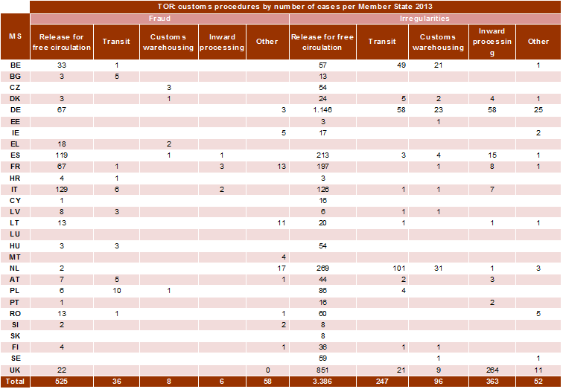
ANNEX 8
ANNEX 9
ANNEX 10
ANNEXES 11-15
Legenda
IRQ0: cancelled communication
IRQ2: Irregularities not reported as fraudulent
IRQ3: suspected fraud
IRQ5: established fraud
ANNEX 11
Irregularities reported in 2013 under Regulation 1848/2006 by Member State
(The number of irregularities reported as fraudulent measures the results of efforts by Member States to counter fraud and other illegal activities affecting EU financial interests; it should not be interpreted as the level of fraud in their territories)
ANNEX 12
Irregularities reported in 2013 under Regulation 498/2007 by Member State
(The number of irregularities reported as fraudulent measures the results of efforts by Member States to counter fraud and other illegal activities affecting EU financial interests; it should not be interpreted as the level of fraud in their territories)
ANNEX 13
Irregularities reported in 2013 under Regulation 1681/1994 by Member State
(The number of irregularities reported as fraudulent measures the results of efforts by Member States to counter fraud and other illegal activities affecting EU financial interests; it should not be interpreted as the level of fraud in their territories)
ANNEX 14
Irregularities reported in 2013 under Regulation 1831/1994 by Member State
ANNEX 15
Irregularities reported in 2013 under Regulation 1828/2006 by Member State
(The number of irregularities reported as fraudulent measures the results of efforts by Member States to counter fraud and other illegal activities affecting EU financial interests; it should not be interpreted as the level of fraud in their territories)

This document does not represent an official position of the Commission.
For comparability reasons, the figures for the 2008-2012 period are based on the data used for the reports of those years.
Cases with an established amount of TOR exceeding EUR 10 million.
For comparability reasons, the figures for 2008-2012 are based on the data used for the reports of those years.
20 % based on the data used in the 2008 report.
For comparability reasons, the figures for 2008-2012 are based on the data used for the reports of those years.
See Annex 4.
For comparability reasons the figures of 2008-2012 are based on the data used for the reports of those years.
See Annex 5.
This calculation is based on 79 711 cases, an established amount of EUR 5.7 billion and a recovered amount of EUR 3.2 billion.
See Annexes 6 and 7.
See Annexes 8 and 9.
Combined nomenclature or CN –nomenclature of the Common Customs Tariff.
See Annexes 6 and 7.
See Annexes 8 and 9.
The Czech Republic, Estonia, Cyprus, Hungary, the Netherlands, Austria, Poland, Slovakia, Sweden and the United Kingdom.
Estonia, Luxembourg, Slovakia and Sweden.
The Czech Republic (5 %), Germany (5 %), Cyprus (6 %), the Netherlands (4 %), Portugal (5 %) and the UK (2 %).
Greece (100 %), Croatia (63 %), Italy (50%), Cyprus (50%), Latvia (58 %), Lithuania (51 %) and Malta (100 %).
See Annex 4.
See Annex 4.
This calculation is based on 15 517 cases, an established amount of EUR 1.74 billion (after already processed corrections) and a recovered amount of EUR 0.5 billion.
See Annex 10.
On the cut-off date, for years 2008-2012, the annual RR for fraud cases varied between 21 % and 58 %.
See Annex 10.
This calculation is based on 64 194 cases, an established amount of EUR 4.0 billion (after already processed corrections) and a recovered amount of EUR 2.66 billion.
Case C-392/02 of 15/11/2005. These cases are identified on the basis of Articles 220(2)(b) (administrative errors which could not reasonably have been detected by the person liable for payment) and 221(3) (time-barring resulting from Customs’ inactivity) of the Customs Code, Articles 869 and 889 of the Provisions for application of the Code, or on the basis of non-observance by the customs administration of Articles of the Customs Code giving rise to legitimate expectations on the part of an operator.
For a description of the methodology used for assessing the complexity of irregularities reported as fraudulent, consult the Commission Staff Working Document on the ‘Methodology regarding the statistical evaluation of reported irregularities for 2013’.
Judicial authorities performed searches on the premises of involved persons in 2003, first in Belgium, and later on in other Member States including the Netherlands, which reported it in 2013 due to the secrecy of the penal procedure, which was levied at that date. The case represents an anomaly not caused by flaws in the Dutch system of control and financial management.
For the analysis of irregularities reported in relation to the Financial Instrument for Fishery Guidance (FIFG) related to the programming period 2000-06, see chapter 5 on the Cohesion Policy.
For a description of the methodology used for assessing the complexity of irregularities reported as fraudulent, consult the Commission Staff Working Document on the ‘Methodology regarding the statistical evaluation of reported irregularities for 2013’.
The report reflects situation as of 2012. In June 2013 Iceland's Foreign Minister Gunnar Bragi Sveinsson informed the European Commission that the newly elected government intended to "put negotiations on hold".
Turkey has been receiving pre-accession assistance since 2002.
Albania, Croatia, FYROM, Serbia, Kosovo under United Nations Security Council Resolution 1244, and Bosnia Herzegovina, Council Regulation (EC) No 2666/2000 of 5 December 2000.
The EU-10 that joined European Union in 2004 received a Transition facility during 2004-2006. However the EU-2 received a Transition facility in 2007 which is regarded as a post-accession assistance.
Potential candidate countries were defined at the Santa Maria da Feira European Council of 20 June 2000.
Following the entry into force of the Treaty of Lisbon, Delegations have become a part of the European External Action Service, with effect from 1 December 2010.
2012 Annual Activity report, DG ENLARGEMENT
Based on own calculation, ABAC data taking into account operational expenditure for budget title 22.
There were 2 cases in Bulgaria and one case in Romania that were reclassified (from suspicion of fraud into no irregularity) regarding the reporting year 2012. The requalification of these three irregularities affected the irregular amounts involved (reported as fraudulent) and subsequently caused a decrease of EUR 37.7 million in the total figure for financial year 2012, compared to what was published in the previous PIF 2012 Report.
The cumulative recovery rate is the percentage of the total irregular amounts that has successfully been recovered.
The Financial Regulation provides for three types of management, one of them is the centralised management. In accordance with Article 58 (Methods of implementation of the budget) of the Council Regulation (EU, Euratom) No 966/2012 and Commission Delegated Regulation (EU) No 1268/2012.
Own calculation based on ABAC data for the nineteen policy areas representing 98% of payments under the direct management mode, excluding administrative expenditure.
Recovery orders that have been qualified by the Commission services as suspected fraud and subsequently reported to OLAF, or recoveries made following to OLAF investigation.
Only the nineteen policy areas - listed in table DM1 - are taken into account.
Croatia is taken into account as the 28th Member State of the EU throughout the past five years although it became member of the Union only on 01/07/2013.

