TABLE OF CONTENTS
COMMISSION STAFF WORKING DOCUMENT Implementation of the Commission Anti-Fraud Strategy (CAFS)
LIST OF ABBREVIATIONS 3
1. Introduction 5
2. Priorities 5
2.1. Adequate anti-fraud provisions 6
2.2. Anti-fraud strategies for Commission Services 6
2.3. Revision of the Procurement Directives 7
2.4. Reporting the anti-fraud strategies in the Annual Activity Reports 9
3. Prevention and detection of fraud 9
3.1. Systematic controls and risk analyses 9
3.2. Awareness raising and training 10
4. Investigations 10
4.1. OLAF investigations 10
4.2. Whistleblowing 11
5. Sanctions 11
6. Recovery 12
7. Other cross-cutting prevention instruments 12
8. Conclusion 13

LIST OF ABBREVIATIONS
TFEU | Treaty on the Functioning of the European Union
EUR | Euro
DG | Directorate General
EAGF | European Agricultural Guarantee Fund
EAFRD | European Agricultural Fund for Rural Development
EFF | European Fishery Fund
CAP | Common Agricultural Policy
CAFS | Commission Anti-Fraud Strategy
AAR | Annual Activity Report
MoU | Memorandum of Understanding
CED | Central Exclusion Database
REGIO | Directorate-General for for Regional and Urban Policy
HOME | Directorate-General for Home affairs
CNECT | Directorate-General for Communication Networks, Content and Technology
ENV | Directorate-General Environment
COMP | Directorate-General Competition
NR | Natural Resources
EC | European Commission
CFP | Common Fishery Policy
ERDF | European Regional Development Fund
ESF | European Social Fund
CF | Cohesion Fund
SME | Small and Medium Sized Enterprise
CP | Cohesion Policy
OLAF | European Anti-Fraud Office (Office pour la Lutte Anti-Fraude)

1. Introduction
On 24 June 2011 the Commission adopted the Commission Anti-Fraud Strategy (CAFS) with the following objective:
To improve prevention, detection and the conditions for investigations of fraud and to achieve adequate reparation and deterrence, with proportionate and dissuasive sanctions, and respecting the due process, especially by introducing anti-fraud strategies at Commission Service level respecting and clarifying the different responsibilities of the various stakeholders.
The Commission stated in its communication that it will report on the implementation of this Anti-Fraud Strategy beginning with the 2013 Commission report on the protection of the EU financial interests. This report is the result of this obligation. It provides an overview of the state of play with regard to the implementation of the CAFS up to 2013. Firstly the implementation of the three priority actions will be described, followed by a description of the implementation of the other activities proposed in the CAFS.
By adopting the CAFS, the Commission envisaged reaching the objective without creating additional layers of control and administrative burden. That is also why this report is integrated as an annex to the Article 325 report of the Commission on the Protection of the Financial Interests of the EU.

2. Priorities
The CAFS provides for anti-fraud measures in the areas of prevention and detection, investigations, sanctions, recovery and other horizontal fraud prevention policies. In these areas, the Commission established three priority actions that had to be addressed as a matter of priority by the end of 2013 and that were related to the prevention of fraud:
    - Adequate anti-fraud provisions in Commission Proposals on spending programmes under the new multi-annual financial framework, in the light of impact analyses.
    - The development of anti-fraud strategies at Commission Service Level with the assistance of OLAF and of the central services, and their implementation.
    - The revision of the public procurement directives with a view to addressing the need for simplification while limiting the risks of procurement fraud in the Member States.
These priority actions were completed by the end of 2013 as was proposed in the CAFS.

2.1. Adequate anti-fraud provisions
The first action has been completed in time. By the end of 2011 most Commission proposals had been adopted by the College, including provisions related to anti-fraud measures. These anti-fraud provisions covered, as in the past, possibilities for OLAF to perform investigations into suspicions of fraud related to EU-expenditure and also fraud prevention measures, as is the case in the legislative proposals for the European Structural and Investment Funds and for the funds related to the Common Agricultural policy. By the end of 2013, the legislator had adopted most legislative acts, respecting including the anti-fraud clauses.
Several Directorates-General have developed guidance on the implementation of the anti-fraud provisions. A good example is DG Regional and Urban Policy, in collaboration with DG Employment and Social Inclusion and DG Maritime Affairs and Fisheries, which provided a guidance note to implement the obligation for the Member States’ Managing Authorities to put in place proportionate and effective anti-fraud measures, taking into account the risks identified (Article 125.4(c) of Regulation (EU) No 1303/2013). This guidance note provides the Managing Authorities with a methodology to perform a fraud risk assessment. The outcome of this assessment can be used to mitigate the identified risks with anti-fraud measures.

2.2. Anti-fraud strategies for Commission Services
All Commission Services (Directorates-General and Executive Agencies), except one, have developed an anti-fraud strategy in which they propose anti-fraud activities specific for their policy area. The last Commission Service is close to completing their strategy.
The anti-fraud strategies are based on a methodology that was prepared by OLAF in 2012. This methodology proposed to follow a risk-based approach and the development of action plans focussing on the fraud risks identified. Around 88% of the Commission Services have used this methodology for the elaboration of their anti-fraud strategy. Not all Services used the methodology because their strategy had already been adopted before the methodology was presented.
The anti-fraud strategies are accompanied by action plans that contain anti-fraud actions tailored to the needs of the Commission Service. These actions are focused on several attention areas such as fraud awareness, improved guidance to staff, and additional internal controls.
Chart 1
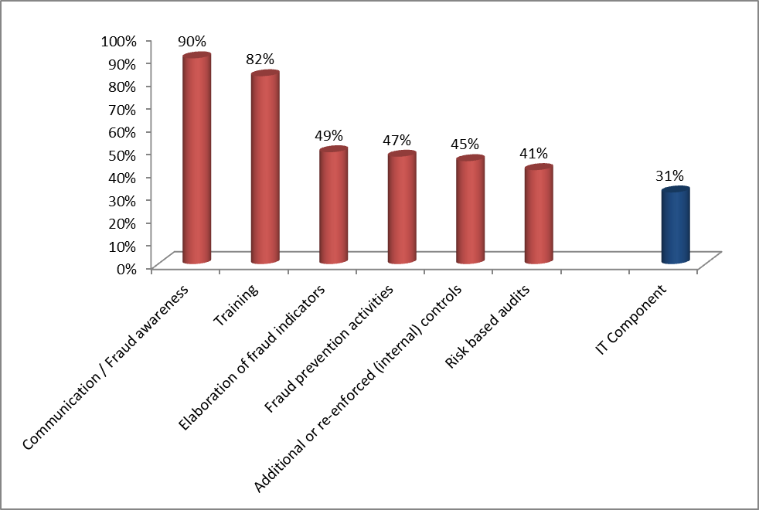
Most strategies propose either actions aimed at communication and fraud awareness or training. These take the form of dedicated anti-fraud training on procedures to report fraud and red flags or ethics seminars with the staff of Commission services.
Training and communication / fraud awareness activities are the most frequently proposed actions in the anti-fraud strategies. Commission Services also proposed to elaborate fraud indicators specific to their field, based on either the casebooks provided by OLAF or their own analysis of fraud cases or frequently observed irregularities.
Almost one third of the anti-fraud strategies contain an IT-component in which IT tools are proposed that will be used as anti-fraud measures. The most commonly mentioned IT-tool is the improved security and monitoring of access to IT-systems. Other, more specific examples of these IT-tools are the use of an instrument to detect plagiarism, a tool to record meetings with stakeholders to increase transparency and e-training on anti-fraud measures available for staff working in remote areas.

2.3. Revision of the Procurement Directives
The public procurement directives and the new directive on the awarding of concessions were agreed by the co-legislators in 2013, and adopted by the European Parliament and the Council respectively in January and February 2014. This reform delivers a radical simplification of procurement processes to the benefit of EU public authorities and companies including SMEs, and also provides for the spending of public money in a better way, including in supporting innovation, social inclusion and green growth.
The new rules have three main objectives: simplification, flexibility and legal certainty. The simplification of procedures, greater flexibility and their adaptation to better serve other public sector policies or the possibility of the best quality-price ratio (‘value for money’) will make public procurement more efficient and more strategic, respecting the principles of transparency and competition to the benefit of both public purchasers and economic operators. The rules on concessions will create a common framework for a major tool of public management in Europe, thus contributing to the conditions set for stimulating investment in major public services of the future.
The Directives clarify notably the notion of “conflict of interests”. This shall at least cover “any situation where staff members of the contracting authority who are involved in the conduct of the procedure or may influence its outcome have, directly or indirectly, a financial, economic, political or other personal interest which might be perceived to compromise their impartiality and independence in the context of the procurement procedure”.
Member States have to take measures to effectively prevent, identify and remedy conflicts of interest arising in the conduct of public procurement procedures. Exclusion grounds are strengthened and extended e.g. to cases of undue influence on the decision process or serious misrepresentation in providing information on the absence of grounds of exclusion. The Directives will now provide for the compulsory exclusion in case of abnormally low tenders when it is due to non-compliance of EU law in the field of (international) social and labour law and (international) environmental law.
The directive strikes a balance between simplification and fraud prevention and detection efforts. For instance, the new rules propose simpler procedures for bidding (e.g. standard self-declarations; the division of contracts into lots is encouraged to facilitate bidding by smaller firms) while introducing tougher rules and provisions on subcontracting and 'abnormally low bids'; more emphasis on quality, environmental considerations and social aspects and not only on the cheapest price.
The legislation includes provisions on fraud prevention and detection, such as monitoring and reporting on the award of contracts and the follow-up of breaches of procurement rules and specific violations such as fraud, corruption, conflicts of interests and other irregularities.

2.4. Reporting the anti-fraud strategies in the Annual Activity Reports
In line with the revised Standing Instructions for the Annual Activity Report (AAR) for the year 2013 following Article 66 (9) and Article 32(2) point d of the financial regulation that relates to the prevention, detection, correction and follow-up of fraud and irregularities as one of the internal control objectives, the authorising officers by delegation had to report on their anti-fraud strategies.
All Commission Services but one have [up to now or currently] developed an anti-fraud strategy in which they propose anti-fraud activities specific for their policy area; the state of play in terms of implementation and identified outstanding measures are made public, in so far as it does not endanger their effectiveness. Quantified indicators reported were essentially the number of fraud suspicions transferred to or being investigated by the European Anti-Fraud Office (OLAF).

3. Prevention and detection of fraud
The CAFS dedicated much attention to the prevention and detection of fraud. It underlined the importance of an integrated approach by emphasising that the objectives of the CAFS should be achieved through the internal control process of the Commission, applicable at all management levels. The priority actions described in the previous paragraph are an example of this approach. In addition, the Commission has performed several other actions aimed at the improvement of prevention and detection of fraud.

3.1. Systematic controls and risk analyses
One of the best practices mentioned in the CAFS, was the so called ‘Pluto-approach’ which was a successful project of the Commission that identified fraud risks by combining information from different IT-databases.
Based on this successful experience the Commission has set up guidelines for IT project owners in the EU institutions. These guidelines enable them to enhance their IT-systems during the design phase in order to facilitate anti-fraud actions when the IT-systems are put to use.
This approach has been taken further by the Commission with the introduction of several other IT-tools. In the research area, CHARON and DAISY are used as tools to identify (fraud) risks in EU-funded projects. Based on the information provided by these tools, risk-based audits can be performed in addition to the regular sample-based audits.
In the field of shared management, the ARACHNE tool is made available for Member States’ use by DG EMPL and DG REGIO. This tool uses publicly available information to identify areas of higher risk that deserve additional attention by Member States’ authorities. The tool has been piloted successfully; it will be gradually rolled out in 2014 to MS that voluntarily decide to implement it in order to further improve their fraud risk management controls.

3.2. Awareness raising and training
The Commission revises its training on anti-fraud issues and the material used during these trainings to take into account the latest developments with regard to fraud prevention and detection. In addition to these dedicated trainings, fraud prevention and detection actions have also been integrated into trainings that are linked to areas in which fraud could occur, such as trainings on procurement and financial expenditure.
Apart from the above mentioned standardised trainings, several commission services have organised tailor made trainings for their particular policy area. These trainings have been developed by DG HOME, CNECT, COMP, ENV, JUST and the external relations DGs with support from OLAF. In addition, trainings have been given to several Member States, candidate countries and potential candidate countries on specific subjects related to the detection of fraud in several Funds (in particular the Instruments for Pre-accession Assistance) or new anti-fraud measures.

4. Investigations

4.1. OLAF investigations
At the time of adoption of the CAFS, the Commission presented an amended proposal for reforming OLAF. On 1 October 2013, Regulation No 883/20131 governing the work of OLAF entered into force. The new Regulation provides a clear statutory basis that codifies past practice and reinforces the effectiveness of OLAF's investigative activities. The Regulation also sets the basis for a better exchange of information between OLAF and its partners.
To better prioritise the opening of investigations, the new OLAF regulation introduces criteria that the Director-General should take into account when deciding to open an investigation and strategic priorities (Art. 5.1). An inter-institutional exchange between the European Commission, the Council, the European Parliament and OLAF on these strategic priorities took place in April 2014 in a constructive dialogue.
The Commission and OLAF are currently in the process of revising their Administrative Arrangement (former MoU) in order to streamline the flow of information concerning internal and external investigations in the light of Regulation 883/2013. The Regulation, in its articles 3.6, 4.8 and in particular 7.6, reinforces OLAF’s obligation to inform the Institutions and bodies concerned and foresees the possibility to adopt appropriate precautionary measures to protect the financial interests of the Union without delay, even during an investigation in progress. The Administrative Arrangements are expected to be adopted by mid-2014.

4.2. Whistleblowing
The guidelines on whistleblowing, issued in December 2012, provide ample guidance on how and when to report serious irregularities. They highlight the protection afforded to whistleblowers acting in good faith. This protection includes confidentiality of the identity of the whistleblower. The guidelines also include provisions on the consequences of malicious denunciations.
OLAF is keeping statistical information on cases with whistleblowers as source, as table 1 shows.
Table 1
Current Stage | 2011 | 2012 | 2013 | Total
Selection |  |  | 4 | 4
Dismissed | 8 | 11 | 8 | 27
On-going investigation/coordination case | 1 | 2 | 1 | 4
Closed without recommendations | 2 | 1 |  | 3
Closed with recommendations |  | 1 |  | 1
Total | 11 | 15 | 13 | 39
In the last three years, 39 cases were reported to OLAF by whistleblowers. At the end of 2013, four reported cases were still in the selection phase, which means that OLAF has not yet decided to open an investigation or dismiss the case. In the past three years, there are 8 cases in which an investigation was opened based on information provided by a whistleblower. Four of these cases have been closed, resulting in one case in OLAF issuing recommendations.

5. Sanctions
The impact analysis for the PIF Directive showed that sanctions on fraud committed against the EU budget vary widely throughout the EU. With the proposal for a Directive of the European Parliament and of the Council on the fight against fraud to the Union’s financial interests by means of criminal law (COM(2012)363 final), adopted on 11 July 2012, the Commission aims at defending taxpayers’ money in the most efficient way. It addresses the diverging rules and often diverging levels of protection within the national systems of the Member States that have caused measures against fraud not to have reached the necessary level of deterrence.
The Commission has raised awareness among Member States by providing a vademecum on the Central Exclusion Database (CED) and by encouraging them to assign liaison officers for the CED. So far, 20 Member States have assigned liaison officers for the CED. The number of entities registered in the CED (440 entities as of June 2014) is a matter of attention and the Commission is working on a legislative proposal to address this issue.
In the customs area, a proposal for a Directive of the European Parliament and of the Council on the Union legal framework for customs infringements and sanctions (COM(2013) 884 final) was adopted on 13 December 2013.

6. Recovery
The CAFS underlined the responsibility of Member States’ authorities and Commission Services in the recovery of sums unduly paid.
The competent authorities of the Member States and of European institutions have to provide information on the actions they have taken following recommendations made by OLAF (Recital 32 of Regulation No 883/2013). Following this obligation, the Commission has set up a reporting system to monitor the recovery of sums unduly paid that covers both shared management and direct management. Based on the information provided by the competent authorities, OLAF reports the amounts recovered following investigations in its annual report.

7. Other cross-cutting prevention instruments
The Commission has set up an EU anti-corruption reporting mechanism to periodically assess the Member States’ efforts to tackle corruption (The EU anti-corruption report). A tangible result of this was the first EU anti-corruption report published on 13 February 2014. The report showed that no EU Member States is free of corruption.
With regard to professional ethics and integrity, the Commission pursued and will pursue the highest standards. Under the CAFS, training on ethics and integrity has been given to all new comers in the Commission Services.
In addition, awareness has been raised of the possible existence of conflicts of interests for staff and newly recruited personnel. A specific module in the Commission’s electronic personnel system regarding professional ethics obligations has been developed. This module covers requests for authorisation of outside activities, requests to accept gifts and declarations of spouse employment. The specific module concerning declarations of conflicts of interest is under development.
At the time of adoption of the CAFS, the European Transparency Initiative was just initiated and the Transparency Register launched. Today the system is fully operational and contains more the 6 500 registrants. A review process conducted by the Commission resulted in a series of recommendations for improvement which will be implemented through a new Inter-institutional agreement on the Transparency Register. This Inter-institutional agreement is expected to be adopted by the European Parliament and will enter into force as from 1 January 2015.

8. Conclusion
The priority actions of the CAFS were related to the prevention of fraud. By completing the priority actions in time, the Commission has improved the protection of the financial interests of the EU. The adoption of anti-fraud clauses in the legal framework for the programming period 2014-2020 has affirmed OLAF’s powers to investigate fraud in this period. In addition, the responsibilities to prevent, detect, report and correct fraud and irregularities has been properly addressed in the respective legal instruments, at the level of implementation where this is most appropriate.
The development of anti-fraud strategies at Commission Service level has a long lasting positive effect on the anti-fraud cycle in the Commission by the anti-fraud actions proposed in the action plans of the services.
The revision of the Procurement directives in particular can have a big impact on an improved system that goes even beyond the Commission, and touches activities in the Member States funded by the EU budget as well.
In 2014 implementation of the CAFS will continue, in particular with regard to ongoing actions such as awareness-raising and training. Future anti-fraud actions and priorities in the anti-fraud policy will be proposed for the agenda of the new Commission.

COM(2011) 376 final
The Authorising Officer by delegation shall report to his or her institution on the performance of his or her duties in the form of an annual activity report …declaring that,… he or she has reasonable assurance that: (a) the information contained in the report presents a true and fair view; (b) the resources assigned to the activities described in the report have been used for their intended purpose and in accordance with the principle of sound financial management;(c) the control procedures put in place give the necessary guarantees concerning the legality and regularity of the underlying transactions…
“For the purposes of the implementation of the budget, internal control is defined as a process applicable at all levels of management and designed to provide reasonable assurance of achieving the following objectives: […] (d) prevention, detection, correction and follow-up of fraud and irregularities”.
CHARON and DAISY are IT-tools developed on the basis of the experiences with PLUTO in the research sector. They make use of data made available by beneficiaries of EU-funding to better target risk-based audits.
A whistleblower is a member of staff, acting in good faith, who reports facts discovered in the course of or in connection with his or her duties which point to the existence of serious irregularities. The reporting should be done in writing and without delay.
The proposal for a Directive of the European Parliament and of the Council on the fight against fraud to the Union’s financial interests by means of criminal law (COM(2012)363 final)

