COMMISSION STAFF WORKING DOCUMENT Annual Overview with Information on the Results of the Hercule II Programme in 2012 - (Article 7 of Decision 878/2007 of 23 July 2007)
TABLE OF CONTENTS
1. Introduction 3
1.1. Hercule II Programme Description 3
1.2 Purpose and scope of this overview 5
2. Budget implementation in 2013 6
3. Activities under the Hercule-II Financing Decision in 2013 8
3.1. Technical assistance for the fight against fraud 9
3.2. Anti-fraud training 12
3.2.1. Grants 12
3.2.2. Procurement- Conferences 15
3.2.3. Procurement- Computer Forensics Training (sector of activity: 8.1.3) 17
3.3. Training, Seminars and Conferences – Legal part 18
3.4. IT support 20
4. Multi-annual impact 21
4.1. To enhance transnational and multidisciplinary cooperation 22
4.2. To build networks throughout the MS, acceding countries and candidate countries 24
4.3. To provide technical and operational support for MS' law enforcement agencies 26
4.4. To strike a geographical balance by including all MS, acceding countries a candidate countries 30
4.5. To multiply and intensify the measures in areas identified as the most sensitive, particularly in the field of cigarette smuggling and counterfeiting 31
5. Communication activities 32
5.1.1 Informing potential beneficiaries 32
5.1.2. Dissemination of results 33
5.2. Publicity 33
6. Feed-back from participants in the programme 33
7. Conclusions and way forward 36

1. Introduction

1.1. Hercule II Programme Description
The Hercule Programme was established by Decision 804/2004/EC for the period 2004-06. By Decision 878/2007/EC, the programme was extended to cover the years 2007-2013 as Hercule II, with a financial envelope of EUR 98.5 million and an average annual budget of around EUR 14 million.
The programme is the only instrument specifically dedicated to protecting the financial interests of the EU by supporting the fight against irregularities, fraud and corruption affecting the EU Budget. The Hercule Programme is administered by the European Anti-Fraud Office (OLAF), which is a Directorate-General of the European Commission.
The main objectives of the Hercule II Programme are:
- Enhancing transnational and multidisciplinary cooperation between Member States’ authorities, the Commission and OLAF;
- Building networks throughout the Member States, acceding countries and candidate countries –in accordance with a memorandum of understanding- facilitating the exchange of information, experience and best practices, while also respecting the distinct traditions of each Member State;
- Providing technical and operational support for the law enforcement authorities of the Member States in their fight against illegal cross border activities, emphasising support for customs authorities;
- Without undermining operational effectiveness, striking a geographical balance by including, if possible, all Member States, acceding countries and candidate countries –in accordance with a memorandum of understanding- in the activities financed under the programme;
- Multiplying and intensifying the measures in the areas identified as the most sensitive, particularly in the field of cigarette smuggling and counterfeiting.

General activities supported by the Programme in 2013 (as stipulated by Commission Decision C(2013) 612 final adopting a Financing Decision for 2013 for Hercule II):
- Technical assistance (''Technical Assistance'') aimed at providing specific knowledge, equipment and information technology tools to national authorities;
- Anti-fraud and legal training (''Training'') supporting training activities and legal studies focused on the protection of the EU financial interests;
- IT support for national authorities (''IT Support'') providing specific databases and IT tools facilitating data access and analysis.
The Hercule II programme identifies the following bodies that are eligible for receiving grants:
- all national or regional administrations of a Member State or a country outside the EU, which promote the strengthening of EU action to protect the EU's financial interests;
- all research and educational institutes that have had legal personality for at least one year, are established and operating in a Member State or in a country outside the EU, and promote the strengthening of EU action to protect the EU's financial interests;
- all non-profit-making bodies that have had legal personality for at least one year, are established and operating in a Member State or in a country outside the EU and promote the strengthening of EU action to protect the EU's financial interests.
In addition to beneficiaries and bodies located in the Member States, participation in Hercule II was also open for beneficiaries and bodies listed in Article 3 of the Hercule II Programme located in:
- acceding states;
- the EFTA/ EEA countries, in accordance with the conditions laid down in the EEA Agreement;
- candidate countries associated with the European Union, on the basis of the conditions stipulated in the association agreements of their additional protocols on participation in Union programmes concluded or to be concluded with those countries.
The Hercule II Programme is administered by the European Anti-Fraud Office (OLAF). Since February 2012, the overall coordination and implementation of the programme is carried out by Unit OLAF.D.5: Hercule, Pericles & Euro protection.
The annual work programme for 2013 was adopted on 7 February 2013 and financed under item 24.0201 of the European Union budget for 2013.

1.2 Purpose and scope of this overview
The annual overview is intended to fulfil the requirement under Article 7 of Decision 878/2007/EC to "provide annual information on the results of the programme to the European Parliament and to the Council". To that end, it covers information on actions for which commitments are made under the Financing Decision 2013.
As Hercule II actions are multi-annual, most of the final reports on the actions funded under the 2013 budget have not yet been received. Section 4 of this overview (Multi-annual impact) thus assesses the impact of previous years' actions that were finalised in 2013 and for which the technical and financial reports were received in 2013.

2. Budget implementation in 2013
Table 1 gives an overview of the available budget and the commitments made on the 2013 budget as provided for in the Hercule II Financing Decision 2013. The overview is broken down by sector of activity and type of support. The amounts in the "budget" column correspond to the Financing Decision 2013, whereas the amounts in the "commit" column correspond to the aggregated amounts indicated in the contracts and grant agreements concluded by the Commission. The commitment level has increased from 87% in 2012 to 91% in 2013. The payments under the grant agreements committed on the 2013 budget cannot be reported as most of the activities are on-going. It is only after the activity has ended that this information can be provided. It must be noted that the final payments are mostly lower than the committed amounts as the incurred, eligible costs are almost always lower than foreseen in the initial budget of the action.
Table 1: Available budget and commitments made in 2013
SECTORS OF ACTIITY OF THE FIN. DEC. 2013 |  | BUDGET | COMMIT | %
7. TECHNICAL ASSISTANCE
Purchase special equipment (7) | Grants | 7 000 000 | 6 110 923 | 87,3
8. TRAINING
Training (8.1.1) | Grants | 1 000 000 | 1 012 094 | 101,2
Conferences (8.1.2) | Procurement | 1 200 000 | 802 081 | 66,8
Forensic (8.1.3) | Procurement | 800 000 | 1 691 636 | 211,5
9. TRAINING – LEGAL PART
Legal (9) | Grants | 700 000 | 524 867 | 75,0
10. IT SUPPORT
IT Databases (10.1.1) | Procurement | 2 500 000 | 2 056 595 | 82,3
IT Data analysis (JRC) (10.1.2) | Procurement | 500 000 | 275 300 | 55,1
Tobacco analysis (10.1.3) | Procurement | 300 000 | 250 000 | 83,3
Total Grants & Procurement |  | 14 000 000 | 12 723 496 | 90,9
The Hercule II budget for 2013 was implemented by making use of procurement and grants. The overall amount available for grants was EUR 8 700 000, in particular for technical assistance (sectors 7.1, maximum 50% co-financing), training (sector 8.1.1, maximum 80% co-financing) and the legal part of training (sector 9, maximum 90% co-financing). Procurement was used for the purchase of training and conferences (including computer forensics, sectors 8.12 and 8.1.3) and IT-support, for an overall amount of EUR 5 300 000, as shown in the graph below.
Graph 1: Hercule II commitments 2013 by financial instrument.
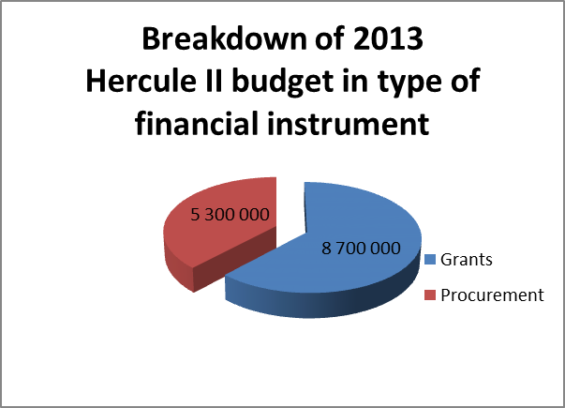
Graph 2: Distribution of the 2013 budget per sector
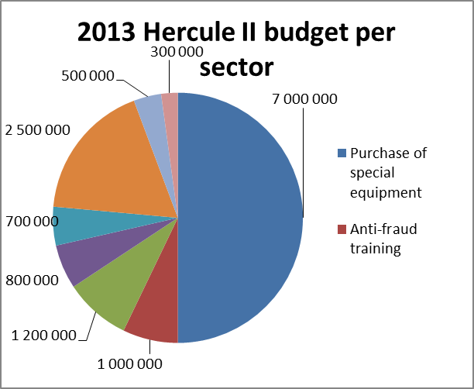
Activities to support the fight against smuggling and counterfeiting of cigarettes are funded under Technical Assistance "The purchase of special equipment and tools'', as well as under the Training Sector (Conferences and seminars for customs) and IT-support (Maintenance and update of a database with information on the chemical composition and origin of seized smuggled and counterfeited cigarettes).
Grants are awarded after the examination of applications submitted within the framework of Calls for Proposals. The examination of the applications is made on the basis of four sets of criteria listed in the Calls to ensure that the Hercule II budget is spent in full compliance with the new Financial Regulation and its Rules of Application and to ensure that the "best value for money" is obtained for the actions to be funded under the grants. In the year 2013, the Hercule II budget was implemented for the first time on the basis of the new Financial Regulation. The main changes for the applicants compared to previous year relate to the requirement to inform applicants within six months on the outcome of the evaluation procedure of the applications submitted within the framework of a Call for Proposals. Other changes relate to shortened payment delays and more detailed requirements on the publication of awarded grants.
Applications for grants submitted under the Technical Assistance Calls for Proposals are examined on the basis of their feasibility, transnational and multi-disciplinary scope, complementarity with other EU actions and geographical coverage of the activities. The applicants need to demonstrate how the action will contribute to strengthening the protection of the financial interests of the EU. Beneficiaries of grants have to report on the results of the action and how these results contributed to the protection of the EU's financial interests.
For Conferences and Training activities, applications for grants are examined on the basis of award criteria that allow the selection of the actions that have a wide geographical scope, support implementation of the Commission's Anti-Fraud Strategy (CAFS) and that target relevant and important groups of professionals, such as lawyers or judges.
One of the programme’s objectives is the requirement to strike a geographical balance of the funded activities. The graph below gives an overview of the Hercule II grant commitments for all sectors in 2013 by Member State.
Graph 3: Commitments for grants in 2013 by Member State 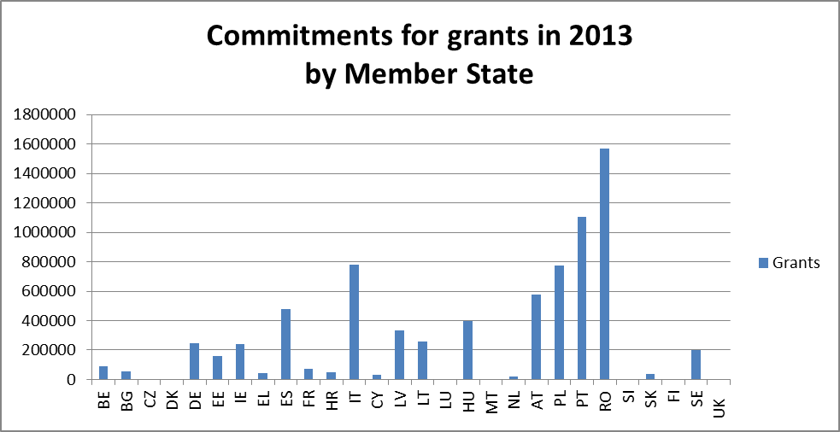

3. Activities under the Hercule-II Financing Decision in 2013
The Annual Work Programme is adopted by a Commission Decision ("Financing Decision") to implement the Hercule II Programme. In 2013, the Financing Decision was adopted on 7 February 2013. The budget (commitment appropriations) made available by the budget authority for 2013 was EUR 14 million. This amount was slightly lower than in 2012. Moreover, the payment appropriations were reduced from EUR 10.5 million in 2012 to EUR 9.9 million in 2013, which has led to difficulties in meeting the financial commitments made in 2013 and previous years.

3.1. Technical assistance for the fight against fraud (sector of activity: 7)
In 2013, the overall budget available for Technical Assistance actions amounted to EUR 7 million. This budget is available for grants to support national and regional authorities with the purchase of special equipment and tools needed in the fight against fraud affecting the EU’s financial interests. The equipment includes tools and devices for the fight against cigarette smuggling and counterfeiting. Examples of actions for which funding could be requested were:
- special investigative tools and methods in the fight against fraud and corruption such as monitoring or "tracking & tracing" devices;
- technical and financial support to strengthen inspections of containers and trucks at the EU's external borders, such as X-Ray scanners or sniffer dogs to detect for example illegal consignments of cigarettes and tobacco;
- actions aimed at setting up or improving automated container-code recognition systems and automated number-plate recognition systems or upgrading of existing systems.
The Commission launched two “Technical Assistance” Calls for Proposals in 2013. One Call was aimed at supporting actions to strengthen the operational and investigative capacity of national and regional authorities in their fight against EU-fraud (“Investigation Support”), whereas the other Call was aimed at supporting actions to fight the smuggling and counterfeiting of cigarettes and tobacco (“Cigarettes”). Information on the Calls was published in the Official Journal and on the Commission’s website. Information on the Calls was also transmitted to the members of the Cocolaf. The deadline for the submission of applications for both Calls was set at 12 July 2013.
The indicative amount available for each Call was EUR 3.5 million. The Commission received 26 applications for the “Investigation Support” Call from 15 different Member States for an amount of EUR 6.5 million, whereas 10 applications from 7 different Member States were submitted for the “Cigarettes” for an amount of EUR 2.2 million. The requested amount (EUR 8.7 million) exceeded the available budget of EUR 7 million.
The examination of the submitted applications eventually led to the award of 32 grants for an overall amount of EUR 6.1 million. Only three applications had to be rejected whereas two applications from the same applicant were merged into a (smaller) one. The awarded amount was considerably lower than the requested amount of EUR 8.7 million due to the rejection of three applications (for a requested amount of EUR 1.4 million) and the fact that VAT is no longer an eligible cost item, where many applicants included this in their request. The average co-financing percentage for the awarded grants amounted to 44% of the eligible costs.
The annual work programme 2013 provided for a third Call for Proposals if sufficient budget was available after the examination of the applications under the first two Calls. The remaining budget however was modest (EUR 0.9 million) and did not justify the launching of a third Call that should have been processed in 2014. It was also expected that applicants would wait submitting applications for funding until the entry into force of the new Hercule III Regulation, which allows for an increased maximum co-funding percentage for technical assistance grants of 80% of the eligible costs (up to 90% in exceptional and duly justified cases) instead of the maximum of 50% under the Hercule II Decision. The Financing Decision for the 2013 work programme provides for sufficient flexibility to transfer commitment appropriations to the “Training” sector of activities to launch a second Call for Proposals for training activities in the area of technical assistance, such as the interpretation of images generated by x-rays scanners.
Tables 2 and 3 below give an overview of the successful applications that were submitted within the framework of both Technical Assistance Calls for Proposals (“Investigation Support” and “Cigarettes”), for which the deadline was set at 12 July 2013.
Table 2: Grants awarded under the “Investigation Support” Call for Proposals
 | MS | BENEFICIARY | ELIGIBLE COSTS IN EUR | TOTAL COMMITTED IN EUR | CO-FIN % | SUBJECT
1 | SE | National Bureau of Investigation | 404 892 | 202 446 | 50 | Monitoring equipment for radio communications
2 | RO | General Inspectorate of the Romanian Police | 1 849 581 | 924 791 | 50 | PC’s; forensics software; tracking and tracing equipment
3 | ES | Guardia Civil | 330 102 | 165 051 | 50 | Monitoring equipment for radio communications
4 | PL | Customs Chamber Wroclaw | 369 717 | 184 859 | 50 | PC’s and forensics software for intelligence purposes
5 | RO | Prosecutor’s office attached to the High Court of Cassation | 194 114 | 97 057 | 50 | PC’s, digital forensics software and devices; audio-visual monitoring devices
6 | IT | Guardia di Finanza | 1 274 217 | 500 000 | 39 | Digital forensics tools, software and training
7 | RO | General Inspectorate of the Romanian Border Police | 22 530 | 11 265 | 50 | PC’s and equipment for storing and transmitting audio and video recordings
8 | HU | Special Service for National Security | 405 475 | 202 738 | 50 | Camera’s, encrypting devices and voice recognitions systems
9 | RO | Braşov County Police Inspectorate | 116 665 | 58 332 | 50 | PC’s, digital forensics devices and software and equipment to detect falsified documents
10 | LT | Financial Crime Investigation Service | 33 226 | 16 600 | 50 | Digital forensics tools and software
11 | EE | Estonian Tax and Customs Board | 274 444 | 137 142 | 50 | Update of obsolete PC’s and encryption devices
12 | LT | Customs Criminal Service | 281 721 | 140 861 | 50 | Monitoring equipment for radio communications
13 | RO | Neamt County Police Inspectorate | 157 460 | 75 930 | 48 | ANPRS equipment and monitoring equipment for vehicles
14 | CY | Cyprus Police | 58 843 | 29 422 | 50 | PC’s, tools and software for digital forensics
15 | LV | Corruption Prevention and Combatting Bureau | 544 014 | 272 007 | 50 | Equipment for monitoring and processing digital information
16 | IE | Revenue Commissioners | 373 968 | 186 984 | 50 | X-rays scanners and sniffer dogs
17 | LT | Special Investigation Service | 203 488 | 100 000 | 49 | PC’s, monitoring devices, tools and software for digital forensics
18 | BE | Service Public Fédéral | 33 242 | 14 087 | 42 | Camera’s, tools and software for digital forensics
19 | PL | Regional Police Headquarters Lublin | 275 968 | 120 126 | 44 | PC’s, camera’s, tools and software for digital forensics (including training) for mobile teams
20 | RO | Dambovita County Police Inspectorate | 102 110 | 51 055 | 50 | PC’s and tools for the examination of cigarettes
21 | PL | Polish Ministry of Finance | 426 956 | 213 478 | 50 | Specialised equipment for mobile intervention units
22 | PL | Regional Police Headquarters Gdańsk | 365 168 | 125 000 | 34 | Devices for monitoring radio communications and movements of vehicles; software for spatial analyses
23 | PT | Polícia Judiciária Lisbon | 2 118 206 | 1 059 103 | 50 | Development of anti-fraud interception systems
24 | FR | French Customs | 86 960 | 42 480 | 49 | PC’s and digital forensics software for analysis of large amounts of data
 | Tot |  | 10 301 829 | 4 930 811 | 48
Table 3: Grants awarded under the “Cigarettes” Call for Proposals
 | MS | BENEFICIARY | TOTAL COSTS IN EUR | TOTAL COMMITTED IN EUR | CO-FIN % | SUBJECT
1 | LV | State Revenue Service | 118 731 | 59 365 | 50 | Camera’s, metal detectors and special equipment for vehicle inspections
2 | RO | General Inspectorate of the Romanian Police | 389 320 | 194 660 | 50 | Purchase and adaptation of vehicles for transport of sniffer dogs
3 | ES | Guardia Civil | 322 901 | 161 451 | 50 | Mobile x-rays scanners and training, housing and transport means for sniffer dogs
4 | PL | Regional Police Headquarters Olsztyn | 358 576 | 179 288 | 50 | Investigation equipment and vans for fighting smuggling
5 | RO | Braşov County Police Inspectorate | 22 275 | 11 137 | 50 | Training, housing and transport means for sniffer dogs
6 | AT | Federal Ministry of Finance | 2 172 333 | 500 000 | 23 | Mobile x-rays scanner
7 | EL | Customs | 84 930 | 42 465 | 50 | Training and housing of sniffer dogs
8 | RO | Giurgiu County Police Inspectorate | 63 764 | 31 745 | 50 | Training and housing of sniffer dogs
 | Tot |  | 3 582 830 | 1 180 112 | 33

3.2. Anti-Fraud Training

3.2.1. Grants (sector of activity: 8.1.1)
The training actions supported under the Hercule II Programme will help prevent fraud against the Union’s financial interests, including the fight against cigarette smuggling and counterfeiting by encouraging exchanges of experience between the authorities of the Member States and the dissemination of general and operational knowledge in the fields concerned.
These actions are also intended to create networks between Member States, accession countries, candidate countries and third countries in order to facilitate exchange of information, experience and best practices, while respecting the traditions of each Member State.
The following activities are eligible under this sector of activity:
- Training in the form of conferences, seminars, colloquia, courses, e-learning and symposia, workshops, hands-on training etc.;
- Exchanges of best practices (including on fraud risk assessment).
The results expected in this area are:
- Enhanced skills and knowledge of investigators and other national and regional staff charged with the fight against fraud, irregularities and any other illegal activity affecting the EU budget;
- Reinforced and new networks in the Member States and acceding states and candidate countries to facilitate exchange of information, experience and best practices, while respecting the traditions of each Member State;
- Increased awareness among targeted audiences on the work and role of OLAF and its working methods;
- Strengthened cooperation between OLAF and national anti-fraud organisations.
Two Calls for proposals were published in 2013. The first Call was published in March 2013 with as deadline 29 May 2013 to submit applications.
The second Call for proposals, published in December 2013 and currently under evaluation, had as specfic training priority the organisation of technical training. The budget needed for this Call was transferred from unused commitments from the Technical Assistance and Legal Training sector of activities.
Results first Call for proposals:
Following the first Call for proposal, the Commission received 38 applications from 14 Member States.
The aggregated costs of the 38 applications amounted to EUR 3 439 703, and the Commission was asked to contribute EUR 2 727 355 (80%), where EUR 1 million was available. The Commission awarded grants to 17 applications, whereas 21 projects were rejected.
The total amount committed under the first Training Call for 2013 is EUR 1 012 094.
The applications in the table below eventually were awarded a grant.
Table 4: Grants awarded for Anti-fraud training
 | MS | BENEFICIARY | TOTAL COSTS/ IN EUR | TOTAL COMMITTED IN EUR | CO-FIN % | PROJECT TITLE
1 | DE | Chief Public Prosecutor in Munich | 117 580.16 | 94 064 | 80 | European Public Prosecutor's Office – Protection of the EU's financial interests
2 | BE | IGO-IFJ | 98 539.80 | 75 050 | 76 | Case management and the use of EU legislation/tools: Key components in the fight against financial crime
3 | RO | Arad County Police Inspectorate | 70 529.05 | 56 119 | 79 | PRO-NET- Development of a professional law enforcement network in Romania, Hungary, Serbia and Bulgaria, involved in the fight against cigarette smuggling and counterfeiting
4 | RO | Neamt County Police Inspectorate | 21 444.50 | 16 941 | 79 | Seminar on countering tobacco smuggling and counterfeit goods
5 | HU | Office of the Prime Minister | 182 930.41 | 146 344 | 80 | Comprehensive as well as practical training sessions for Balkan countries and Turkey in the field of public procurement control in order to further strengthen the capacities of ex-ante and in-built controls for detecting and eliminating possible irregularities and fraud cases
6 | PL | Province Police Headquarters in Olsztyn | 55 655.58 | 37 502 | 67 | Protecting the European Union’s financial interests through acquisition of practical skills in identifying illegal production and distribution of tobacco, spirits and pharmaceuticals, and collaboration between services.
7 | HU | Transparency International Hungary | 57 643 | 46 114 | 80 | Safeguarding EU funds against fraud & corruption through the civil control mechanism of Integrity Pacts
8 | RO | Center for Independent Journalism | 51 065 | 40 265 | 78 | Monitoring the spending of publicity budgets of the EU-funded projects – the Romanian experience
9 | PL | Provincial Police Headquarters in Gdańsk | 64 390 | 51 512 | 80 | Pomeranian Police Protecting the European Union’s Financial Interests
10 | EE | Estonian Tax and Customs Board under the Ministry of Finance | 29 003 | 23 203 | 80 | Training on interpretation of the images generated on the scanning devices
11 | BG | C.R.E.A.M. Bulgaria – PPP Alliance | 52 479 | 41 983 | 80 | Balkan forum for the promotion of public-private partnerships as an anti-corruption instrument
12 | BG | National Customs Agency | 18 741 | 14 993 | 80 | Strengthening of the capability of Bulgarian Customs Authorities to fight customs fraud through starting a project on combating customs-related illegal activities through the Internet
13 | SK | Financial Directorate of the Slovak Republic | 47 552 | 37 665 | 79 | Fight against smuggling of cigarettes and illegal tobacco production seminar
14 | IT | Agenzia delle Dogane e dei Monopoli | 223 932 | 179 145 | 80 | Cooperation and strategy to fight against illicit trafficking of counterfeit cigarettes and medicines in the Western Balkans, Mediterranean Region, Eastern neighbouring countries, Turkey and Italy
15 | PT | The Institute of Social Science of the University of Lisbon | 57 440 | 45 952 | 80 | Protecting Whistle-Blowers and Strengthening Judicial Cooperation across Europe and Neighbourhood Countries as a Major Challenge for the Fight against Corruption and Fraud against EU Financial Interests
16 | HR | Partnership for Social Development | 60 326 | 48 260 | 80 | CLISFP – Cross-Country Legal and Institutional Framework for Suppression of Fraud in Public Procurement
17 | IT | Corte dei conti - Seminario di formazione permanente | 88 710 | 56 978 | 64 | Seminar and training activities aimed at exchanging professional experiences amongst the Courts of Audit of France, Greece, Italy, Portugal and Spain and the EU institutions in the prevention and fight against fraud and other irregularities affecting the financial interests of the EU
 | Tot |  | 1 209 249 | 1 012 094 | 84

3.2.2. Procurement - Conferences (sector of activity: 8.1.2)
The training and other measures financed under this heading cover high level conferences and ad-hoc training actions focused on the protection of the Union’s financial interests. In 2013, the Commission used the services of a firm specialised in organising events – MCI Benelux S.A. – under a framework service contract for the organisation of its conferences. In some cases, other framework contracts were used (e.g AMEX) under this sector of activity. The overall budget for conferences under procurement is EUR 1 200 000.
The total amount committed under Hercule II budget in 2013 was EUR 802 081.31. This relates to seven events which took place in 2013 as well as in early 2014 (numbered 2 to 8 in the table below). The table also includes a conference which took place in 2013 (number 1), but committed under the 2012 Hercule II budget .
The amounts in the table below are not the committed amounts, but they refer to the incurred costs, i.e.: the amounts eventually paid by the Commission, and are lower than the amounts committed for these events.
Table 5: Conferences organised by OLAF under the Hercule II budget:
N° | DATES | TITLE CONFERENCE |  | LOCATION - COUNTRY | PARTICIPANTS |  | AMOUNT PAID in EUR
1 | 22-24 April 2013 | 12th OAFCN training seminar “Combatting Fraud by Educating  With New Communication Tools” |  | Rome, Italy | 90 |  | (114 195)
Objectives: The main purpose of the OAFCN is to prevent fraud through a 'free-flow' of information ('prevention is better than cure'). The seminar, entitled "Combatting fraud by educating with new communication tools", focused on the use of new communication tools and strategies, including social media, to target anti-fraud messages at different audiences (with an emphasis on young people, i.e. future taxpayers).
2 | 26-28  June 2013 | 2013 AFCOS Conference |  | Turkey, Ankara | 92 |  | 108 437
Objectives: To bring together AFCOS representatives from the Member States, Candidate Countries and potential Candidate Countries, to present the work of OLAF and AFCOS and their cooperation; to discuss challenges relevant to mutual cooperation; to share experience and best practices.
3 | 16-20 September 2013 | 14th Conference of International Investigators 2013 |  | Tunis, Tunisia | 110 |  | 35 491
Objectives: To bring together representatives from the various anti-fraud and anti-corruption investigative services around the world to discuss challenges relevant to mutual cooperation and to share experience and best practices.
4 | 14-15 October 2013 | How to prevent and fight rural development fraud? |  | Zagreb, Croatia | 100 |  | 105 360
Objectives: Improve prevention detection and prosecution of fraud detrimental to rural development funds and programmes. Raise awareness in Member States and (potential) candidate countries on the role and obligations of the national authorities and the investigative and coordination role of OLAF.
5 | 11-14 November 2013 | 18th Task Group Cigarettes Conference |  | Bucharest, Romania | 72 |  | 136 056
Objectives: to discuss operational matters related to investigations into illegal production and smuggling of cigarettes.
6 | 27-29 November 2013 | European Anti-fraud Prosecutors Network |  | Brussels, Belgium | 50 |  | 85 871
Objectives: To discuss about perspectives of a European Public Prosecutor's Office.
7 | 14-15 January 2014 | Debriefing JCO WAREHOUSE |  | Vilnius, Lithuania | 80 | Final payment Pending  53 516 committed
Objectives:. Discussion and approval final report for joint customs operation.
8 | 26-27 February 2014 |  | The Fight against Fraud in the Area of EU Cohesion Policy Funds – The Challenges Ahead | Athens,Greece | 190 | Final payment Pending  94 885 committed
Objectives:
1. Stressing the importance and obligation to create AFCOS by the end of 2014;
2. Supporting the Greek authorities in the creation of the National Anti-Fraud Strategy in the field of structural measures;
3. Providing to national Greek authorities specific training tools and techniques on fraud detection.

3.2.3. Procurement - Computer Forensics Training (sector of activity: 8.1.3)
In 2013, the Commission signed two specific contracts for the organisation of two training sessions in Digital Forensics training. The training was organised by a Croatian service provider (Insig2 Ltd), which was awarded a framework service contract following an open Call for tender. The target audience of the training consisted of staff employed by national or regional administrations of the Member States, EFTA/EEA countries and candidate countries which promote the strengthening of EU action to protect the EU's financial interests. A large number of the participants worked for customs, forensics departments or police forces.
Table 6: Overview of the two digital forensic training sessions
DATES | LOCATION | COURSE | PARTICIPANTS | TRAINERS | COMMITTED  EUR
December 2013 | Opatija, Croatia | 9 | 214 | 31 | 890 259
May-June 2014 | Zagreb,  Croatia | 14 | 155 | 32 | 801 377
The training consisted of courses given to both beginners and advanced students for improving their skills and competences in operating tools and software used during forensics examinations of computers, tablets, mobile phones or any other digital device. The courses also included training for tools used to collect evidence from devices running under different operating systems. The courses, the trainers and the overall quality of the training complied with the quality standards set by an international organisation of computer forensic experts. At the end of the training sessions, the participants had to pass an exam to assess the newly acquired skills and competences. All participants succeeded in passing these tests.
The training sessions also gave the opportunity to the participants to network and to exchange information and best practices in relation to computer forensic examinations.
The overall commitment for the two sessions amounted to EUR 1 691 636 which included the costs of training, the accommodation, travel costs for the participants and networking facilities.

3.3. Training, Seminars and Conferences – Legal part (sector of activity: 9)
The legal part of the training, conferences and seminars sector aims to further support, enhance and develop the specific legal and judicial aspects of the protection of EU's financial interests against fraud, corruption and other illegal activities by co-financing training activities, seminars, comparative studies and conferences.
The following activities are eligible under this sector of activity:
- organisation of seminars and conferences;
- studies in comparative law;
- dissemination, including publication of scientific knowledge concerning the protection of the EU's financial interests;
- publication and distribution of a scientific periodical on the protection of the EU's financial interests;
- organisation of the annual meeting of the Presidents of the Associations for European Criminal Law and for the Protection of the EU Financial Interests.
The results expected in this area are:
- organisation of seminars and conferences on the priority topics identified in the 2013 Financing Decision;
- production of studies that help the Commission (OLAF) identify measures to protect the EU's financial interests;
- production of scientific studies and/or articles that can serve to stimulate debate on one of the priority topics;
- translation of texts and documents that are relevant or of interest for the protection of the EU's financial interests;
- promotion of the dissemination of scientific knowledge relating to the protection of the EU's financial interests and the results of the measures referred to above;
- publication of a periodical on the protection of the EU's financial interests;
- organisation of an annual meeting of the chairpersons of the Associations for European Criminal Law and for the Protection of EU's Financial Interest.
Following the publishing of the 2013 Call for Proposals, 34 applications were received from 12 Member States. The aggregated costs of the 34 applications amounted to EUR 2 795 352 and the Commission was asked to contribute EUR 2 435 555 (87%), where EUR 700 000 was available. In 2013 the total amount committed was EUR 524 867. The Commission decided to award a grant to 10 applications, where 24 applications were rejected. The applicants could receive a grant covering up to 90% of the eligible costs of the action.
Table 7: Grants awarded under the 2013 Call (Deadline: 30 April 2013)
 | MS | BENEFICIARY | TOTAL COSTS IN EUR | TOTAL COMMITTED IN EUR | CO-FIN % | PROJECT TITLE
1 | AT | Austrian Association for European Criminal Law | 86 529 | 76 971 | 89 | Conference: ”New challenges for Anti-corruption Measures and for the Protection of EU Financial Interests" (connected with Annual Meeting of Presidents of the Associations)
2 | NL | The Hague University of Applied Sciences, Centre for Research and Development, Group on International Peace, Justice and Security | 20 854 | 18 769 | 90 | Seminar : “Negotiated Settlements for Corruption Offences: a European Perspective”
3 | DE | Max Planck Institute for Foreign and International Criminal Law | 72 507 | 60 000 | 83 | Periodical publication: “EUcrim: the European Criminal Law Associations' Forum - publication of a periodical on the protection of the EU's financial interests”
4 | FR | Association de Recherches Penales Europeenes | 34 698 | 31 198 | 90 | Conference: "Le contrôle judiciaire du Parquet européen: Nécessité, Modèles, Perspectives"
5 | DE | Academy of European Law (ERA) | 72 850 | 65 150 | 89 | Conference: “Annual Forum on Combating Corruption in the EU: new approaches to compliance and enforcement”
6 | ES | Galician School of Public Administration (EGAP) | 36 174 | 32 557 | 90 | Seminar: “Administrative transparency and protection of the financial interests of the European Union in the Galicia-North Portugal Euroregion”
7 | IE | Irish Center for European Law | 59 961 | 53 965 | 90 | Conference: “Prospects for Criminal Law at EU level”
8 | DE | Rheinische Friedrich-Wilhelms-Universität Bonn | 30 477 | 25 949 | 85 | Conference: “The European Public Prosecutor's Office and the prosecutor general in federal states - what lessons can the EU learn from the Swiss and the German models?”
9 | ES | Fundacio ESADE | 130 121 | 117 108 | 90 | Comparative law study: “Avoiding Fraud in Cohesion Policy 2014-2020: a comparative Study on the correct observance and implementation of the public procurement EU regulations by managing and contracting authorities”
10 | IT | Centro di Studi di Diritto Penale - Como | 48 000 | 43 200 | 90 | Conference: “The acquisition of evidence and defence guarantees in crimes against the financial interests of the European Union”
 | Tot |  | 592 171 | 524 867 | 89

3.4. IT support (sector of activity: 10)
The Hercule II programme provides funds to procure databases or subscription to databases for customs and fraud investigation organisations in the Member States in order to support their investigations. Access to databases is procured and managed by the Commission and allows for substantial economies of scale (sector of activity: 10.1.1).
Access to these databases is provided to the Member States through the secure AFIS network, which is managed by OLAF. OLAF staff also use these databases for their investigations.
Table 8: Databases that were contracted under the Hercule II budget in 2013
 | NAME | CONTENT | TOTAL PRICE IN
1 | SEASEARCHER | Information on vessels and vessel movements | 249 480
2 | NTELX | Information on ship manifests | 1 771 500
3 | CTI | China Trade Information: Detailed shipments of Chinese imports and exports | 34 185  59 996*
4 | TIPS | TIPS Indian trade statistics: detailed shipment records of Indian imports and exports | 1 430
5 | GRS | Global Reference Solution: contains basic company information from all over the world and gives information on links between companies | 425 000*
6 | D&B reporting system | Dun & Bradstreet: Financial details of companies all over the world | 150 000*
7 | GTA | Global Trade Atlas: International trade statistics | 200 000*
 | COMMITTED UNDER 2013 BUDGET |  | 2 056 595
 | COMMITTED UNDER 2012 BUDGET |  | 834 996
 | GRAND TOTAL |  | 2 891 591
* GRS, D&B reporting system, GTA and CTI subscriptions for 2013-2014 were committed under the 2012 Hercule II budget

Develop specific IT tools for data analysis (sector of activity: 10.1.2)
In 2013, Hercule II support was given to two projects carried out by the Joint Research Centre (JRC): Automated Monitoring Tool (AMT) and Container Traffic (CONTRAFFIC). These two projects provide the appropriate tools in order to support investigations that need data and analyses on container movements (current and past), providing more realistic and effective scenarios for joint customs operations (sector of activity: 10.1.2).
AMT has the following operational objectives:
- To increase OLAF's operational antifraud efforts by providing automated analysis of trade flow data at EU level. The tool is now ready for routine use as part of the analytical process;
- To further develop a tool to be used to detect signals in customs declaration data provided by Member States, with prioritisation of the signals detected in customs declarations. There has been an increase in the number of Member States using this functionality;
- To continue developing the ground-breaking software so that its deployment can be widened. We continue to develop the use of alternative search methodologies. The AMT is now being implemented in a secure AFIS environment, as part of a larger project.
The CONTRAFFIC Single Administrative Document (CONTRAFFIC-SAD) analysis system is a pilot project run by the Commission (OLAF and JRC) in collaboration with Customs authorities in Member States. The aim of the project is to evaluate the feasibility and to demonstrate the effectiveness of using Container Status Messages data to identify imports of containerized goods where the origin country is wrongly declared. The project is based on the CONTRAFFIC technology developed at the JRC in collaboration with OLAF over the last 10 years. In 2011, an administrative arrangement was concluded for a period of two years between the Commission and the JRC for the AMT project and it was extended until April 2014. The overall costs for the project, which has been successfully concluded, amount to EUR 400 000.
The administrative arrangement for the CONTRAFFIC project was renewed in 2013 for an amount of EUR 250 000 and is expected to be renewed in 2014.

Tobacco analysis (sector of analysis: 10.1.3)
In 2013, the Commission concluded a new specific agreement under an existing framework contract with the Scottish Oceans Institute (SOI Ltd) for the establishment and maintenance of a database containing information on the specific characteristics of tobacco products and the analysis of samples of tobacco.
For this purpose, SOI makes analyses of samples of seized cigarettes which allow the determination of the brand and the manufacturing plant. Under this contract, SOI carried out almost 50 analyses of samples taken from cigarettes and tobacco seizures carried. This information provides an important input to investigations into cigarettes smuggling and counterfeiting.
SOI maintained the database by entering the results of the analyses and provides the Commission with quarterly reports on the results (sector of activity: 10.1.3).
The total amount committed in 2013 was EUR 250 000.

4. Multi-annual impact
As Hercule II actions are multi-annual, most of the final reports on actions funded under the 2013 budget have not yet been received. For this section of the overview the Commission assessed the impact of previous years' actions finalised during 2013 (final technical and financial reports received in 2013). The Decision establishing the Hercule II Programme has five specific objectives as set out in section 1.1. For each of these objectives, the overview below provides a summary of the main results achieved in 2013.

4.1. To enhance transnational and multidisciplinary cooperation
The specialised antifraud trainings granted under Chapter 8.1.1 (Training) ensured a far-reaching anti-fraud and anti-corruption campaign across the EU and allowed a wide dissemination of anti-fraud measures affecting the EU's financial interests.
The themes of these training seminars covered a wide range of disciplines – from fraud prevention and detection, the fight against irregularities and the strengthening of regional cooperation for preventing corruption at the EU external border, to combating the counterfeiting of cigarettes and tobacco and focus on laws and practices to prevent fraud with EU funds.
The main results of these actions are:
- Better understanding of modi operandi and knowledge obtained in the field of preventing and combating fraud detrimental to the EU's financial interests;
- specific skills in prevention, detection and investigation in the fight against fraud;
- input for further development and improvement of the activities of national organisations, including legislative work;
- dissemination of information about the latest developments, methods, techniques in the field of the fight against fraud and corruption; and
- information obtained through networks established between organisations.
Examples of actions financed under Hercule II – Training Part which took place in 2013:
The project of the Anticorruption General Directorate, Romania with as title 'Strengthening regional cooperation for preventing and countering corruption at the EU's external borders' included four staff exchange meetings and a round table meeting with partner organisations from Serbia (IAS - Internal Affairs Sector) and Moldova (CCEC - Centre for Countering Economic Crimes and Corruption). A handbook on best practice experiences was produced.

The action's objectives were to:
- create networks between Moldova, Romania and Serbia in order to facilitate the exchange of information, experience and best practices in fighting fraud and corruption;
- identify shortcomings in the systems for preventing and combating fraud and corruption, with a view to rectifying them;
- develop common methods of preventing fraud and corruption and promote better knowledge of them at regional level.

The Financial Directorate of the Slovak Republic organised an eight-day training course for customs officers from the Czech Republic and the Slovak Republic with as title 'Training focused on the detection of smuggled and counterfeited tobacco products in rail and shipping transport'.

The objectives of the training were to:
- improve knowledge of procedures in the fight against smuggling of tobacco products in rail transport and shipping and apply in practice the knowledge acquired;
- improve international cooperation and exchange knowledge and experience;
- have an effective and professional customs presence at border crossing points to increase the detection of smuggled and counterfeited tobacco products;

- be able to carry out customs surveillance and cooperate in the area of cigarette smuggling with officers and agencies from other Member States.

The National Customs Agency, Bulgaria dealt with the action with as title 'Increasing the capacity of Bulgarian customs to combat trafficking of illicit tobacco products' focused on increasing analytical capacity in threat assessment analysis and operational risk analysis.

The action involved exchange visits to France, Romania and the United Kingdom by a core team of Bulgarian customs officers to:

- familiarise themselves with the types of analyses being done and to identify the most appropriate practices to be included in the analytical manual for Bulgarian customs officers;

- increase the analytical capacity of Bulgarian customs to assess the risks of illicit trade in tobacco products.

Transparency International Czech Republic organised a project with as title 'EU funds watch' in which four countries participated (the Czech Republic, Estonia, Hungary and Lithunia), involved a research component and the organisation of an international conference and three dissemination seminars. The action's objectives were to:

- improve the expertise of those handling EU funds in the prevention and detection of fraud and to improve the knowledge of OLAF and its working methods;

- identify shortcomings in systems for preventing and combating fraud with a view to rectifying them.

The Digital Forensics Training organised by Insig2 Ltd in Croatia enabled officials working for law enforcement agencies to develop, improve and update their competences in the area of digital forensics. It also gave trainees access to certification procedures recognised at international level and supported the creation and maintenance of a network of digital forensics experts across the EU to promote and share information on best practices in computer forensics and can be called upon in case of need.

OLAF organised in June 2013 the “2013 AFCOS Conference” with participants working for national authorities in the field of financial control, administrative investigations, judiciary, management of EU funds, irregularity reporting. The aim of the conference was to gather AFCOS representatives from the Member States (MS), Candidate Countries (CC), and potential Candidate Countries, to present the work of OLAF and AFCOS, to discuss about challenges relevant to the mutual cooperation and to share experience. The impact expected over OLAF anti-fraud activities is of utmost importance:
1) better understanding of recently adopted legislation (e.g.: Regulation 883/2013) and other on-going legislative initiatives (EPPO, PIF Directive) in the area of protection of the EU's financial interests;
2) improved coordination between OLAF and MS/CC/potential CC authorities in carrying out investigative work;
3) MS and CC taking steps in preparation of their national anti-fraud strategies; adaptation of MS and CC to changes in irregularity reporting envisaged for the new Programming Period 2014-2020.

In April 2013, OLAF organised the 12th OAFCN Training Seminar “Combatting Fraud by Educating with New Communication Tools”. The main purpose of this seminar was to foster communication and to prevent fraud through a 'free-flow' of information ('prevention is better than cure'). This seminar was mainly focused on the use of new communication tools and strategies, including social media, to target anti-fraud messages at different audiences.

4.2. To build networks throughout the MS, acceding countries and candidate countries
Under the legal training sector of Hercule II, financial support has been granted to academic projects, such as comparative law studies, legal conferences and seminars and publications dealing with particular issues related to the protection of the EU's financial interests. The ten actions co-financed 2013 had a wide international dimension. The audiences were mainly judges, prosecutors, lawyers, investigators, police officers, academics, researchers, national civil servants, as well as members and officials of the EU institutions. These events promoted the dissemination of legal information on the latest developments in the area of fraud prevention and the fight against fraud, and constituted a good forum for discussion of future legislative solutions in the field of the protection of the EU financial interests.
Examples of actions financed under Hercule II – Legal Part which took place in 2013 (granted under the 2012 budget):
“eucrim” – The European Criminal Law Associations’ Forum: publication of 4 issues in 2013 by the Max Planck Institute, Germany.
- Issue: 1/2013 Focus: Information and Data Protection
- Issue: 2/2013 Focus: Confiscation, Freezing and Recovery of Assets
- Issue: 3/2013 Focus: Protection of Financial Interests of the European Union
- Issue: 4/2013 Focus: Financial Crime
The issues addressed current developments in the protection of the EU's financial interests and the activities of OLAF, the latest developments in relation to the procedural and substantive criminal law, data protection as well as the tracing and recovery of assets.
These issues are published in English. Each news item was supplemented by internet links containing the source(s) of information (legislation, judgments, etc.) in English, French, and German (where available).
eucrim is disseminated in three ways:
- e-mail (1635 subscribers in 2013),
- website (all issues are stored on the eucrim website and can be downloaded free of charge), and
- publication (2000 of each edition were printed and distributed to individuals, universities, law libraries, EU institutions, national law enforcement agencies, courts etc.

Conference on “The Challenges of Trans-national Investigation”, March 2013, Birmingham, UK.
The conference organised by the Law School of the University of Birmingham examined the experiences and identified the problems faced by the national authorities during transnational investigations. Professors, researchers, lawyers, prosecutors and national law enforcement officials from 16 Member States were represented in this conference.
The conference addressed the development of mechanisms to assist prosecutors in conducting transnational investigations, the challenges of financial investigations, the prosecutorial and investigatory experiences of different Member States and the potential contribution of setting up a European Public Prosecutor Office (EPPO). The issues of the defence rights in transnational investigations, the right to silence and the non-criminal proceedings and transfer of evidence were also presented and discussed.

The Academy of European Law organised a conference on the topic of “Making the fight against corruption in the EU more effective: towards the development of new evaluation mechanisms” (May 2013, St. Julians, Malta)
Participants from all over the EU took part to 5 sessions organised on the following topics:
• recent initiatives and major challenges in the fight against corruption;
• assisting Member States' authorities with the implementation of the new EU anti- corruption policies;
• criminalising active and passive corruption carried out in the course of business activities;
• what makes the fight against corruption so difficult in practice?
• towards the development of a comprehensive methodology to measure the real costs of corruption.
The experts from EU countries (UK, Germany, Malta, Romania, France, etc.) and third countries (Switzerland), together with the representatives of OLAF and the European Commission debated the major initiatives in the field of EU anti-corruption policy.
The conference constituted a great opportunity for the transfer of knowledge (new anti-corruption policy carried out by the EU Commission), for improving EU cooperation, exchange of best practices and the establishment of networks between investigators and prosecutors.
The conference was preceded by the annual meeting of the Presidents of the Associations for European Criminal Law and for the Protection of EU's Financial Interests. The meeting, hosted by the Maltese association, offered a valuable opportunity to enhance and expand the existing network, to initiate exchanges of views between the professionals and to develop ideas for future legal projects.

The “Fondazione Lelio e Lisli Basso” from Rome, Italy organised a conference on "Protecting fundamental and procedural rights - from the investigation of OLAF to the future EPPO" in June 2013 in Rome, Italy.
The action achieved the following objectives:
• To improve the knowledge of practitioners and experts by clarifying the different legal and political aspects related to the establishment of the EPPO;
• To provide updated information on the existing legislation and perspective;
• To ensure a comparative perspective in the analysis of the implications for the establishment of the EPPO.
By investigating and clarifying the different aspects, opportunities and constraints related to the establishment of the EPPO, the conference ensured the acquisition of skills in terms of fundamental rights' protection and the strengthening of networking between the different actors involved and interested in the establishment of the EPPO: institutional representatives, academics, practitioners, judges and lawyers and the national associations for European Criminal Law and for the Protection of the EU Financial Interests.
The scientific findings of the conference were published in English and Italian and distributed to the main national and transnational networks and associations that work in the field of the protection of the EU’s financial interests.

The “Centro Di Diritto Penale Europeo Catania” organised a conference on “The challenges of setting up a European Public Prosecutor's Office: definition of common rules and their impact on internal legal systems” in June 2013, in Catania, Italy.
The Conference addressed the setting up of the EPPO from the point of view of the substantive and procedural criminal law and was attended by academics, practitioners (judges, public prosecutors, lawyers) and students.
During the conference the institutional and practical aspects of setting up the EPPO were analysed, together with the legal status, the internal organisation and the relations of this office with the other relevant bodies and agencies involved in the cooperation in criminal matters in the EU. Six sessions on different topics related to the establishment of the EPPO (the need for common rules in the framework of a coherent EU criminal policy, the democratic control and judicial review, the investigative rules of the EPPO, the rules on procedural guarantees and defence rights, etc.) and a conclusive Round Table on the “Guidelines for the European agenda and for the national legislator” were provided during the event. The scientific outcome of the Conference was published in a book disseminated to the public institutions concerned and Italian libraries.

4.3. To provide technical and operational support for MS’ law enforcement agencies.
In 2013, the supported activities led to substantial qualitative improvements in existing technical systems used for investigative and operational activities by national and regional administrations. The purchase of new operational and investigative equipment was made possible through grants provided under the programme. The grants also covered specific technical training for staff to ensure optimal use, maintenance and management of the equipment.
Since 2013, grant beneficiaries are requested to provide information in a final technical report on the main results that were achieved with the equipment purchased with financial support from the Hercule II Programme. This information is needed to demonstrate how and to what extent the Programme contributed to protecting the Union’s financial interests. The purchase and installation of the equipment however requires time and at the moment the final report is due, there are often few results to be reported. For this reason, grant beneficiaries are now invited to submit a final implementation report one year after the closing date of the action. The final implementation report allows the beneficiary to report extensively on the results, such as seizures made of smuggled cigarettes, the detection of networks of organised crime (OC) groups or the number of arrests made. The beneficiaries are also invited to come up with an estimate of the prevented losses to the national and EU budgets as a direct result of the use of the equipment. This information contributes to improving the transparency of the Programme’s implementation, for as far as this transparency does not endanger on-going operations and investigations and helps identifying the strengths and weaknesses of the Programme’s implementation.
The programme's co-financing of the purchase of technical equipment for law enforcement agencies engaged in combating fraud is aimed mainly at:
• ensuring better technical equipment across the EU and increasing compatibility to facilitate cross-border cooperation and achieve procurement savings;
• efficient use of the equipment acquired;
• facilitating joint operations and international support for operations;
• better disclosure of offences and higher quality evidence for the courts.
The Commission received reports on the implementation of grants that were funded under the Hercule II budgets of 2010, 2011 and 2012. Even though it is difficult and sometime impossible to establish a direct causal relationship between the grant on the one hand and the results achieved with the equipment purchased with financial support from the grant on the other hand, it can be easily assumed that without the financial support a substantially lower number of arrests, seizures and convictions would have been made and that the efficiency and effectiveness of staff using the equipment would not be as high as is the case nowadays. This view has been explicitly expressed by some beneficiaries of the grants in their final reports on the implementation and achievements of the grant.
Examples of highly sophisticated and transnational compatible technical equipment deployed in 2013.
The grant was awarded to the German Ministry of Finance – Customs – for the purchase of mobile x-rays inspection systems. This advanced equipment is used for the uncovering of illegal shipments of tobacco products, and contributes therefore to customs control in quantitative as well as in qualitative terms. During the period 1 October 2012 - 31 December 2013, the mobile x-rays inspection systems scanned 17 318 units in certain border crossing regions inland. The deployment of the inspection systems has resulted in the successful detection of a range of illicit articles: 20 kg raw opium, 15 840 counterfeit polo shirts, 22 kg hashish and 150 000 cigarettes were seized during this period. According to the beneficiary, the deterrent effect of their use must also be considered, even though this is difficult to quantify.

The Spanish Guardia Civil used the Hercule II-grant to purchase equipment in order to target cigarette smuggling and counterfeiting. The equipment consisted of investigation support tools, such as false document detectors, monitoring software and tracking devices. These tools are strategically deployed over the EU external boarders in Spain to combat these offences. They enable an early detection of cigarette smuggling and counterfeiting and an early deployment of operational technical support for tracking persons and vehicles suspected of smuggling and counterfeiting cigarettes. Although many operations making use of the aforementioned equipment purchased by this grant are still on-going, several achievements can already be mentioned:
- the Guardia Civil – together with the Spanish Customs – arrested 10 people who were involved in a criminal organization dedicated to the smuggling of cigarettes from China through the Valencia harbour. 465 440 packets of cigarettes were seized with a financial impact estimated at EUR 2.2 million;
- The use of false document detectors and tracking devices in another operation resulted in the arrest of 7 people and the seizure of 25 000 packets of cigarettes, 1 000 000 counterfeited garments and a small amount of cash. This operation was carried out successfully in cooperation with the Guardia Nacional Republicana of Portugal, as the cigarettes and textiles were imported from Portugal and were illegally distributed in Spain;
- The deployment of tracking devices by the Guardia Civil allowed for the arrest of 24 persons suspected of involvement in a criminal organisation, and the seizure of 15 470 packets of cigarettes smuggled from Gibraltar into Spain (total financial impact of EUR 62 500). The criminal organization used vessels to transport the cigarettes, and warehouses to hide them in this coastal area.
- Undercover video surveillance cameras were used to survey a criminal organization active in the smuggling of Isoglucose, exceeding the quota put in place by the Common Agricultural Policy. Alcohol beverages, alcohol derived beverages and intermediates were targeted during this operation. The total fraud is estimated at EUR 8.9 million. 72 people were arrested allegedly involved in a criminal organization dedicated to the fraud of special taxes and VAT in the sector of alcohol, wine and vinegar by means of declaring false productions.

The Romanian National Anticorruption Directorate (DNA) was able to purchase technical and IT forensic equipment, such as audio recorders, video recorders, a special computer and a processor based workstation. This highly sophisticated equipment is used in operation aimed at detecting suspicions of e.g. abuse of office, forgery, money laundering and tax evasion. Following the delivery of the equipment, this equipment has already been deployed in 17 investigations of the National Anticorruption Directorate, whereby 14 of them took place in 2013. Whilst some of the investigations are still on-going, several criminal offenses have been reported so far, such as the use of bribes, the unauthorized use of classified information and the abuse of office. This has resulted in the arrest of 25 people, and the seizure of 51 000 packets of cigarettes. The financial impact from these operations is estimated at approximately EUR 75 million.
Examples of procured access to external databases.
Access procured by the Commission to external databases provides essential operational information to investigators in both Member States and OLAF. The data are necessary for protecting the revenue side of the budget and relate to trade flows as well as shipping and container movements. Information on companies, such as company ownership data and information on the legal status is also essential for investigations and analysis relating to the expenditure side of the budget.

Chinese and Indian commercial databases have been very helpful in supporting the on-going investigations OLAF carried out in support of operational customs investigations of the Member States. They provided a high-quality contribution, in terms of intelligence, to prove the wrong description of goods or circumvention of goods aimed at avoiding anti-dumping duties. In several cases, information from the databases supported the allegations which led to opening investigations and brought further evidence to the case. Such evidence may eventually lead to the recovery of evaded anti-dumping duties by the Member States.

The trade databases continue to be vital investigative tools for investigations in customs and trade irregularities and fraud. They are also important tools in the assessment of incoming information to determine whether or not to open an investigation.
A commercial database of worldwide trade statistics with aggregated figures is used by both the Member States and OLAF to analyse trade flows, identify potentially suspicious trade and cross-check allegations of customs fraud involving Member States. Cross-checks can support decisions on whether to open a case or not, thus saving resources for all concerned.
Examples:
- A sudden increase in the export of a product from non-EU country X to non-EU country Y. A corresponding increase in the imports into several Member States of the same product from country Y. If the product originates in country X then anti-dumping and countervailing duties are due. If originating in country Y, no extra duties are due. Suspicion: The product originates in country X, is transhipped via country Y to avoid extra duty payment and the origin is wrongly declared as country Y.
- Confirmation of an allegation of large importations of a product into the EU from a non-EU country. Suspicion: The goods have been deliberately misclassified to claim a lower rate of duty under the incorrect tariff heading.
- Product allegedly transhipped via a third country: A clear change in the pattern of trade was established and incorrect classification in the third country.
- Trade flows failed to confirm an allegation of a product with origin country X being transhipped via country Y and wrongly declared as being origin country Y to avoid extra duties payable from country X. No significant revenue was found to be at risk, the case was closed.

Databases containing information related to movements of vessels and containers have been used to support several cases against international cigarettes smuggling led by Member States Customs in close cooperation with OLAF. The smuggling of cigarettes by sea occurs through complex contraband operations run by criminal organisations, often involving several transhipments, false or misleading bills of lading.
In the context of one OLAF investigation into international cigarette smuggling, the support provided through data collected in the database on movements of vessels led Customs authorities in two Member States and a third country to seize large quantities of contraband cigarettes from the vessels and thus prevent losses in unpaid duties and taxes. The information from the database helped OLAF to handle a large amount of incoming information related to the movements of vessels loaded with cigarettes.
Information on suspect containers is also a vital tool for OLAF and the Member States to fight international cigarette smuggling. In one OLAF investigation related to the movement of cigarette containers involving several Member States, large quantities of contraband cigarettes were seized with the support of information on container movements provided by the databases. The operation prevented the loss of unpaid duties and taxes.

Examples of operational results obtained from the use of the CONTRAFFIC-SAD tool (developed with the Joint Research Centre).

By April 2014, the Single Administrative Document (SAD) data analysis facility was used by 11 Member States’ Customs sending their data to the JRC systematically and receiving signals in return (out of 12 Member States (MS) that joined the project so far).
The initial results achieved on the Belgian imports of 2009 showed a very good overall hit-rate: 56% of the identified signals were correct and led to the recovery of duties. For 2010 imports, OLAF still has a limited number of known results (final feedback from MS Customs for only 13 signals showing a 38% hit-rate), while for 2011 to 2013 OLAF still does not dispose of enough feedback on the results of the identified signals. The overall average hit-rate for all the feedbacks received until April 2014 is about 22%.
For 2011, the 158 signals identified for the 6 countries that provided data relate to wrongdoings with a potential financial impact of EUR 3.6 million. The 2012 signals, for the 10 participating countries, were 194 with a potential total value of EUR 3.5 million, while for 2013 the 293 signals detected have a potential total value of EUR 4.6 million.
Lessons learnt from using the system included: CONTRAFFIC has 38% coverage for incoming containers into the EU; a large number of SAD declarations do feature a missing or incorrect container ID.
One drawback of the current pilot project is the process of checking the validity of the identified signals by national customs as this takes a very long time or cannot be completed in due time. An additional limitation is the lack of container ID information in most of the SAD declarations. Declarations without a proper container ID may in fact be more risky as importers may deliberately choose not to report the container ID if they wish to hide the real origin of goods. Finally, to render origin cross-checking more operational the Commission needs to have carriers reporting their Container Status Messages data directly, as proposed by the amendment of the Regulation No 515/1997.
Overall, the project has achieved during 2013 a major result regarding the evasion of anti-dumping duties on imports from Indonesia of steel fasteners. Several signals were generated and reported to the project participants regarding this product. Investigations carried out by MS have confirmed that the reported signals were connected to fraudulent importations linked to an OLAF case. The total amount of potential recovery reported by OLAF to this case amounts to EUR 26 million. This case has demonstrated the capacity of the project to generate fraud signals that are associated to cases with an important financial impact, acting at the same time as a potential deterrent instrument.

4.4. To strike a geographical balance by including all MS, acceding countries and candidate countries
One objective of the Hercule II Decision is to ensure a geographical balance in the participation of Member States, acceding states and candidate countries in the programme. In 2013, organisations located in 21 Member States received a grant.
Map 1: Geographical distribution of Hercule II grants awarded per MS in 2013
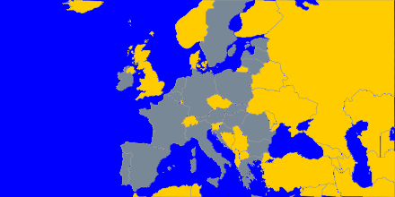
Under the Technical Assistance sector (sectors 7.1.1 and 7.1.2) 16 Member States were awarded a grant for purchasing specialised technical equipment, strengthening their capacities in the fight against irregularities, fraud and corruption. The external databases procured with Hercule II budget were intensively used by national and regional administrations responsible for protecting the EU's financial interests in all 28 Member States.
As far as the training, seminars and conference activities are concerned, the co-financed events (grants awarded) finalised in 2013 reported a total of around 2 600 participants. They represented 36 different countries (27 Member States, 4 candidate countries, 2 Balkan countries, and 3 other third countries).

4.5. To multiply and intensify the measures in areas identified as the most sensitive, particularly in the field of cigarette smuggling and counterfeiting
The widespread availability of illicit tobacco within the EU has led to the loss of considerable tax and duty revenues (losses to the EU and Member States' budgets as a result of cigarette smuggling are estimated to be at least EUR 10 billion per year). One feature of the illicit market for cigarettes in the EU is the significant quantity of counterfeit products available at lower cost than the genuine products.
An award was granted to the Hellenic Financial Police (HFP) in Greece for the purchase of technical equipment, such as forensic software and devices. This equipment is used for operations against fuel smuggling as well as cigarette smuggling. Concerning the former, smuggling products such as oil, liquid petroleum gas and lubricants were targeted. As a result of the use of this equipment, 55 tons of oil, 1 158 LPG cylinders and 1 102 lubricants barrels were seized (impact estimated at more than EUR 1 000 000). Furthermore, 8 persons were arrested, many illegal oil tanks were found and sixteen tank trucks were seized. Concerning the fight against cigarette smuggling, approximately 1 620 630 cigarette packets and 540 tobacco packs (25 gram each) were seized. Moreover, 6 persons were arrested and weapons and vehicles were seized.

The Latvian State Revenue Service (SRS) used the grant to purchase a fuel unloading system. This is a relatively cheap system that is used at border crossing points and that allows determining the volume of fuel in cars and trucks. Discrepancies between the actual volume of fuel and the tank’s fuel capacity on the basis of the specifications represent a strong indication to the presence of other goods, such as smuggled cigarettes. With the help of this equipment, 26 infringements were detected. The result of using this equipment was the seizure of 6 700 individual cigarettes and 9 079 litres of illegal fuel. An unforeseen side-effect of the use of this equipment was the detection of fuel for which excises were not paid.

The Customs Agency, Italy implemented a project with as title 'Illicit trafficking of cigarettes in the Western Balkans Region, Turkey and Italy'. Senior customs officers from eight countries (Italy, Albania, Bosnia and Herzegovina, Kosovo (under UNSCR 1244), the Former Yugoslav Republic of Macedonian (FYROM), Montenegro, Serbia and Turkey) participated in the event.
The aim of the action (workshop, training actions and conference) was to:
- create a network of contact points in the customs administrations of the participating countries and enhance their further cooperation;
- develop an assessment of the threat posed on a regional scale by cigarette and tobacco smuggling;
- identify the best practices for fighting against the smuggling of tobacco products and the related indicators and risk profiles.
5. Communication
The successful implementation of the programme required the development of a structured way to:
- inform (potential) beneficiaries of the programme on funding opportunities, and to provide answers to questions from (potential) beneficiaries by means of four different functional email boxes;
- disseminate information on the achievements and the results of the actions that received funding.

5.1.1 Informing potential beneficiaries
Notices concerning the organisation of Calls for Proposals were published in the Official Journal and the full texts of the documents was made available on the Commission's website (http://ec.europa.eu/anti_fraud/about-us/funding/index_en.htm).
Table 9: Time schedule of the Calls for Proposals in 2013:
Sector | Sector of Activity | Budget available (EUR) | Deadline for the submission
7. | Technical Assistance for the fight against EU fraud:  - Investigation Support  - Cigarettes | 3 500 000  3 500 000 | 12 July 2013  12 July 2013
8.1.1 | Training, seminars and conferences:  - First Call  - Second Call | 1 000 000  1 000 000 | 31 May 2013  6 March 2014
9. | Training, seminars and conferences – Legal part | 700 000 | 30 April 2013
The professional networks (mainly the European Lawyers' Association and the training organisations) were approached by OLAF's staff members concerning information on funding opportunities. Potential applicants were also informed via e-mails sent to the members of the Advisory Committee for the Coordination of Fraud Prevention (COCOLAF), the OLAF Anti-Fraud Communicators Network (OAFCN) and European Judicial Training Network (EJTN). The training Call was also published in the news section of the e-Justice Portal.

5.1.2. Dissemination of results
The dissemination of the results of actions under Hercule II, in particular technical assistance, is rather sensitive as most of the achievements relate to investigations for which information cannot be disclosed. The dissemination on training activities was realised through the distribution of electronic and/or paper reports summarising the event. Some beneficiaries posted the training materials on their websites or created a dedicated website for their projects.

5.2. Publicity
Under the training (8.1.1 and 8.1.2) and the legal training (9) sectors, all beneficiaries of grants were requested to mention the support from the Hercule II programme:
- In every publication (title page) or related material developed (e.g. studies, booklets, newsletters, leaflets);
- In electronic information (e.g. websites, audio-visual material, videos, software) and;
- At information events (conferences, seminars).
They were also requested to insert a link from their website to the Hercule II programme's site.

6. Feedback from participants of the programme
In 2013, OLAF received all final reports with the results achieved by projects co-financed in 2012 under the Sector “Anti-Fraud Training”. In order to assess the events, beneficiaries submitted the standardized “OLAF evaluation form” to all participants attending the training. The events were attended by 1836 participants and OLAF received 1589 evaluation forms from the beneficiaries, which represents a response rate of almost 87% that is well above the expected rate of 75% expected by OLAF.
As it can be noticed in the table below, some questions were specifically addressed to evaluate the logistics and level of organisation of the event (1-8) and some others (9-14) more specifically targeted to assess the expected impact of the event.
Table 10: Questions from the evaluation form
1 | Accommodation
2 | Travel arrangements
3 | General organisation
4 | Interpretation offered
5 | Relevance of the subject matter to your work
6 | How well were the stated objectives achieved?
7 | Did you have enough time for questions and discussions?
8 | Where your questions and concerns addressed to your satisfaction?
To what extent did the event:
9 | Improve your understanding of EU and national mechanisms in combating fraud affecting the financial interests of the EU?
10 | Allow an exchange of experiences between the various authorities from the participant countries?
11 | Help to coordinate activities between the participant countries?
12 | Help to disseminate knowledge, particularly of an operational nature?
13 | Improve cooperation between practitioners and academics?
14 | Raise your awareness of the need to protect the financial interests of the EU?
As shown in the graph below, the results were very positive and they show the best value for money of all project co-financed with an average per each question exceeding the score of 4 (good).
Graph 4: Average score for the 14 questions
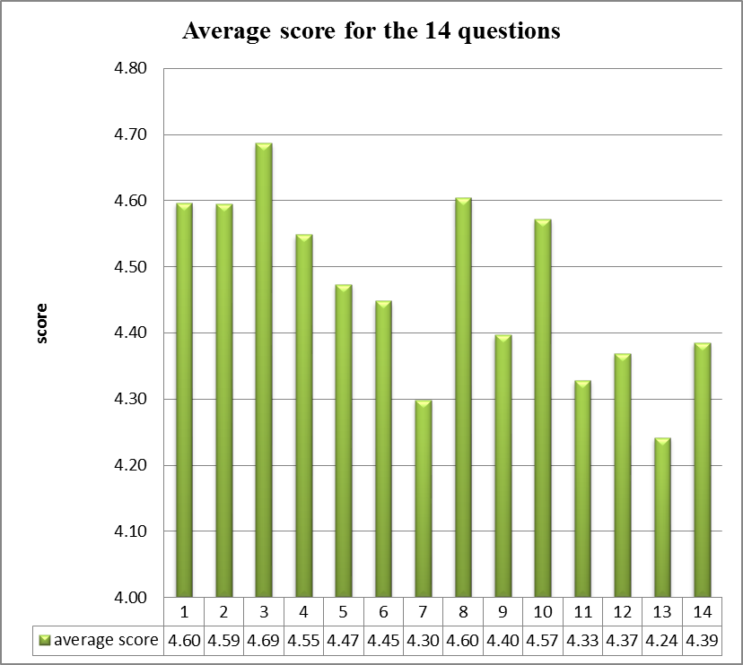
Questions results (1= Poor; 2 = Below average; 3 = Average; 4= Good; 5 = Excellent, N=1589)
The positive results were also confirmed by the overall satisfaction of participants with all the events which were scored as excellent (66%) or good (31%) and by high percentage of participants recommending the co-funded event.
Graph 5: Overall satisfaction with all 2013 events
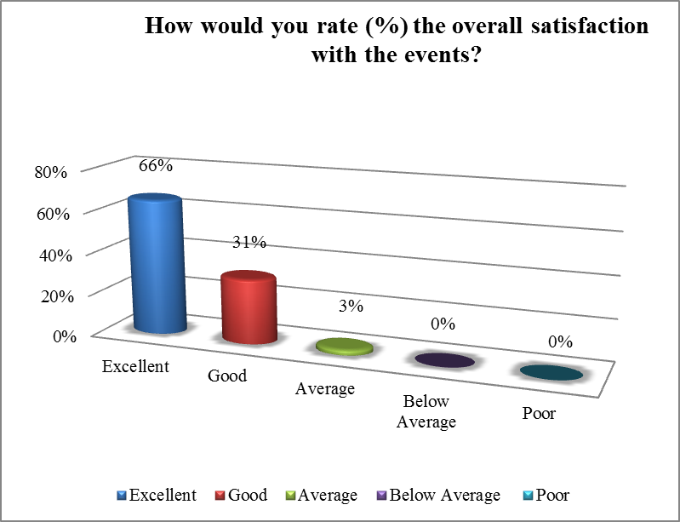
Data source: 2013 Final Reports (N=1589)

Graph 6: Satisfaction per event co-financed
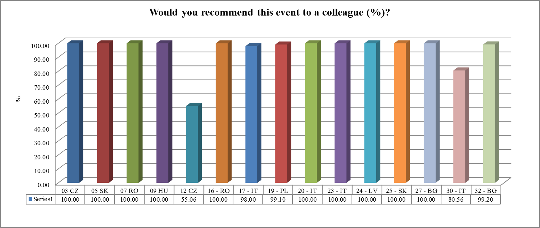
Data source: Final reports 2013 (N=1589)

The evaluation reported in 2013 confirmed the importance of the Hercule II Programme, Sector Training as the unique funding opportunity accessible for national authorities for exchanging information, best practices and enhancing skills and knowledge of investigators and other national and regional staff charged with the fight against fraud, irregularities and any other illegal activity affecting the EU budget.
It also increased awareness among targeted audiences on the work and role of OLAF and its working methods, as well as strengthened cooperation between OLAF and national anti-fraud organisations.

7. Conclusions and way forward
The results above clearly show that the activities covered by the annual overview 2013, and funded under the Hercule II Programme, were overall successful. By 31 December 2014, the Commission (OLAF) shall present to the European Parliament and to the Council a report on the achievement of the objectives of the programme.
The available budget for the Hercule II Programme was committed 91%. It should be noted that half of the budget was spent on grant agreements, in particular technical assistance, which require a national co-funding of at least 50% of the eligible costs. Budget restrictions in the Member States eventually led to fewer applications for smaller amounts as well as the withdrawal of some successful applications.
The Commission adopted a proposal for a new programme, Hercule III, under the Multi-Annual Financial Framework MFF (2014-2020). This proposal has been discussed within the Anti-Fraud Working Group of the Council (GAF) as well as within the Budget Control Committee and a compromise between the two branches of the legislative authority has been reached by the end of 2013. The new Hercule III Regulation has been formally adopted on 26 February 2014 and published in the Official Journal on 20 March 2014. The Regulation entered into force on 21 March 2014 and applies from 1 January 2014 in order to ensure the continuity of the Programme.

As amended by Decision 878/2007 of 23 July 2007.
C(2013) 612 final of 7 February 2013. This Decision was published on OLAF's internet webpages.
Article 2a of the Hercule II Programme.
C (2013) 612 final of 7 February 2013.
OJ L 66 of 8 March 2013.
The budget reference for the commitment and payment appropriation is 24.0201.
7 The figures are rounded.
Commitments cover the total costs in 2013 of legal obligations (contracts, grant agreements/decisions) entered into for operations extending over more than one year (Art. 7, FR). The total amount for the commitments cannot exceed the allocated budget.
A further (provisional) commitment of 1.000.000 EUR has been made for the second training Call.
A commitment of EUR 890 259 was made in October 2013 for the first digital forensics session held in December 2013. A second commitment of EUR 801 377 was made for a second session held in May-June 2014 by using the remainder of the budget available at the end of the year under the Hercule II Financing Decision 2013.
See footnote 10.
The total amount does not include the further (provisional) commitment mentioned in footnote 9.
Eligibility, exclusion, selection and award criteria.
Regulation (EU, Euratom) No. 966/2012 of the European Parliament and of the Council of 25 October 2012 on the financial rules applicable to the general budget of the Union, OJ L 298 of 26 October 2012.
Commission Delegated Regulation (EU) No. 1268/2012 of 29 October 2012 on the rules of application of Regulation 966/2012, OJ L 362 of 31 December 2012.
C(2011)376 final of 24 June 2011
C(2013) 612 final of 7 February 2013.
OJ C 176 of 21 June 2013.
Article 3 of the Financing Decision allows changes in the allocation of the budget up to 20% of the budget for the programme in 2013.
The average time elapsed between the deadline for submission of applications and the notification to the applicants on the outcome of the evaluation was less than three months. The average time needed for signing the grant agreements was longer due to the fact that additional information had to be requested from applicants and also depends on the time needed by the applicants to sign the agreement.
OAFCN: OLAF Anti-Fraud Communicator's Network
This conference took place in 2013 but was committed under the Hercule II budget of 2012.
AFCOS: Anti-Fraud Coordination Service: with the entry into force of Regulation 883/2013 of 11 September 2013, all Member States shall “designate a service to facilitate effective cooperation and exchange of information, including information of an operational nature, with the Office” (Article 3 (4).
Joint Customs Operation
AFIS: Anti-Fraud Information System
COM(2013)324 final of 6 June 2013: Stepping up the fight against cigarette smuggling and other forms of illicit trade in tobacco products – A comprehensive EU strategy.
The four functional emailboxes consist of a general e-mailbox for the Hercule II programme and more specific emailboxes for Technical Assistance, Training and Legal Training.
15 projects were co-financed by the Hercule II Programme, Sector Training in the first and second Call 2012.
Art 7 of the Decision 878/2007/EC of 23 July 2007.
COM (2011)914 final of 19 December 2011.
Regulation 250/2014 of the European Parliament and of the Council of 26 February 2014, establishing a programme to promote activities in the field of the protection of the financial interests of the European Union (“Hercule III”), OJ L84 of 20 March 2014.
Article 16 of Regulation 250/2014.

