 | 
COUNCIL OF  THE EUROPEAN UNION |  |  | Brussels, 23 October 2012
 | Interinstitutional File:  2012/0193 (COD) |  | 15142/12
DROIPEN 142
JAI 712
GAF 23
FIN 775
CADREFIN 428
CODEC 2421
INST 600
PARLNAT 335

OPINION
from: | The Portuguese Parliament
dated: | 3 October 2012
No Cion doc.: | COM(2012) 363 final
Subject: | Proposal for a Directive of the European Parliament and of the Council on the fight against fraud to the Union's financial interests by means of criminal law  Opinion on the application of the Principles of Subsidiarity and Proportionality

Delegations will find attached the above mentioned opinion.

________________________

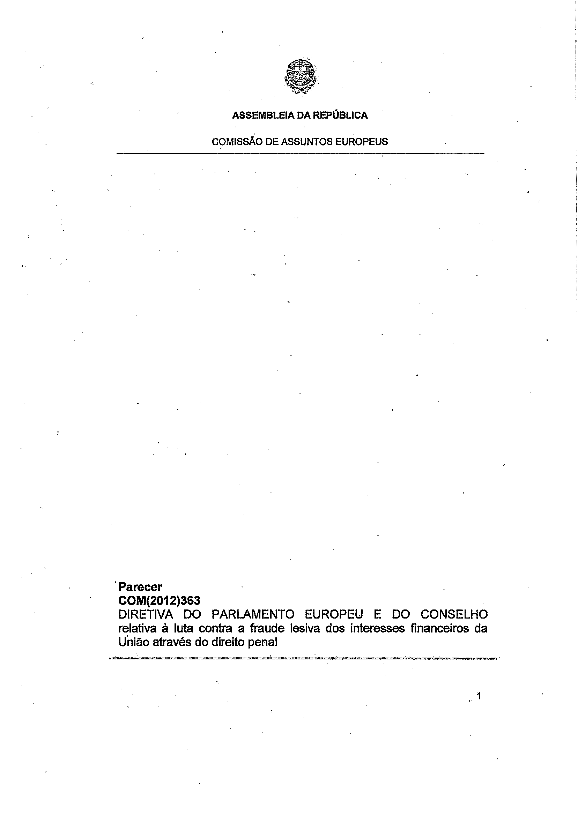

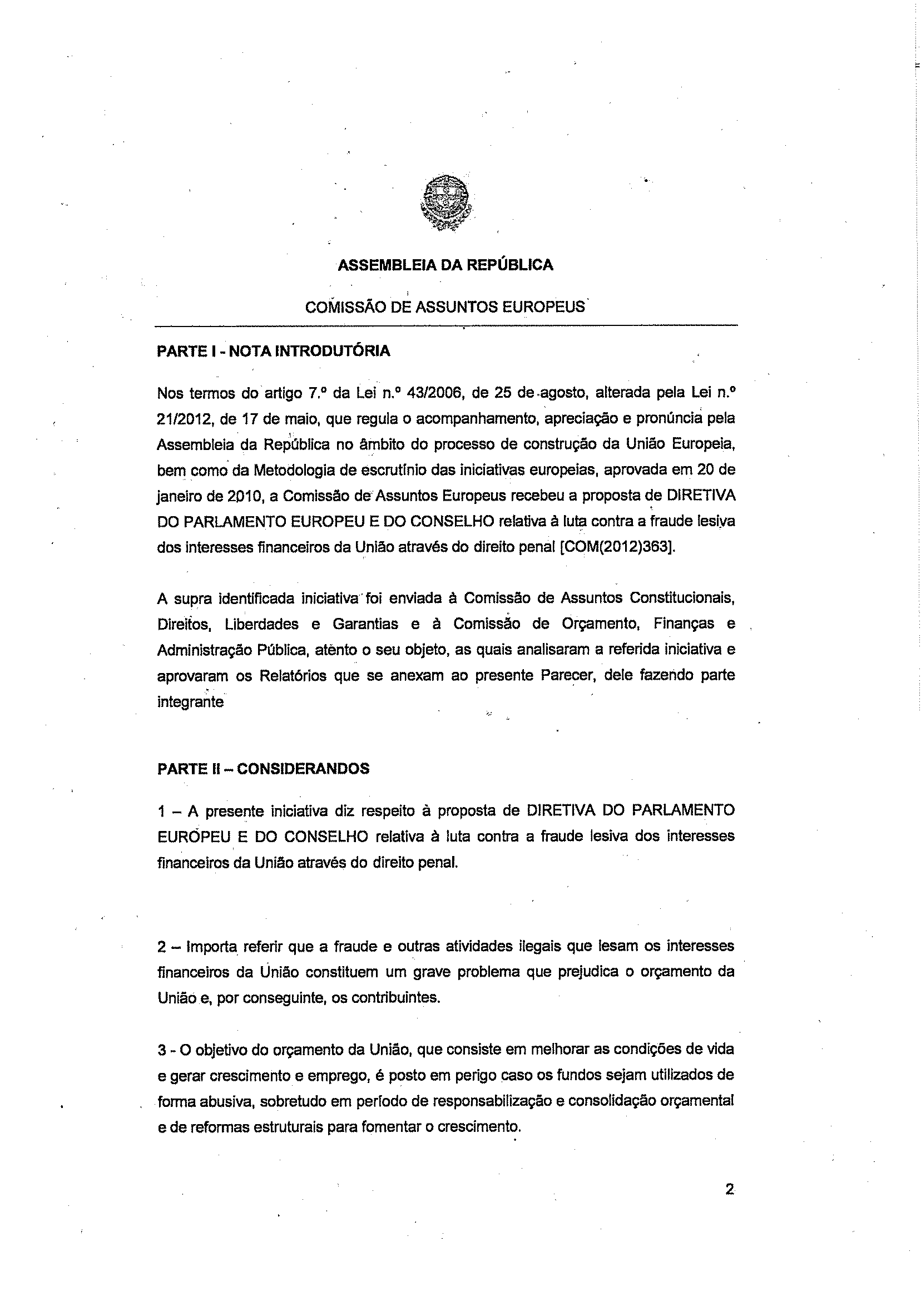

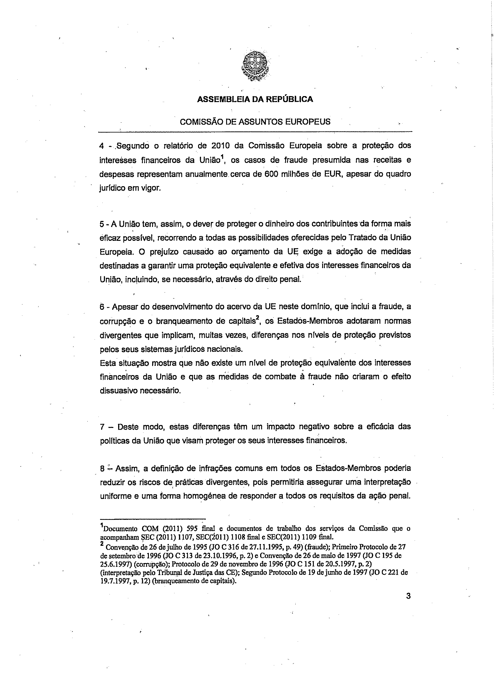

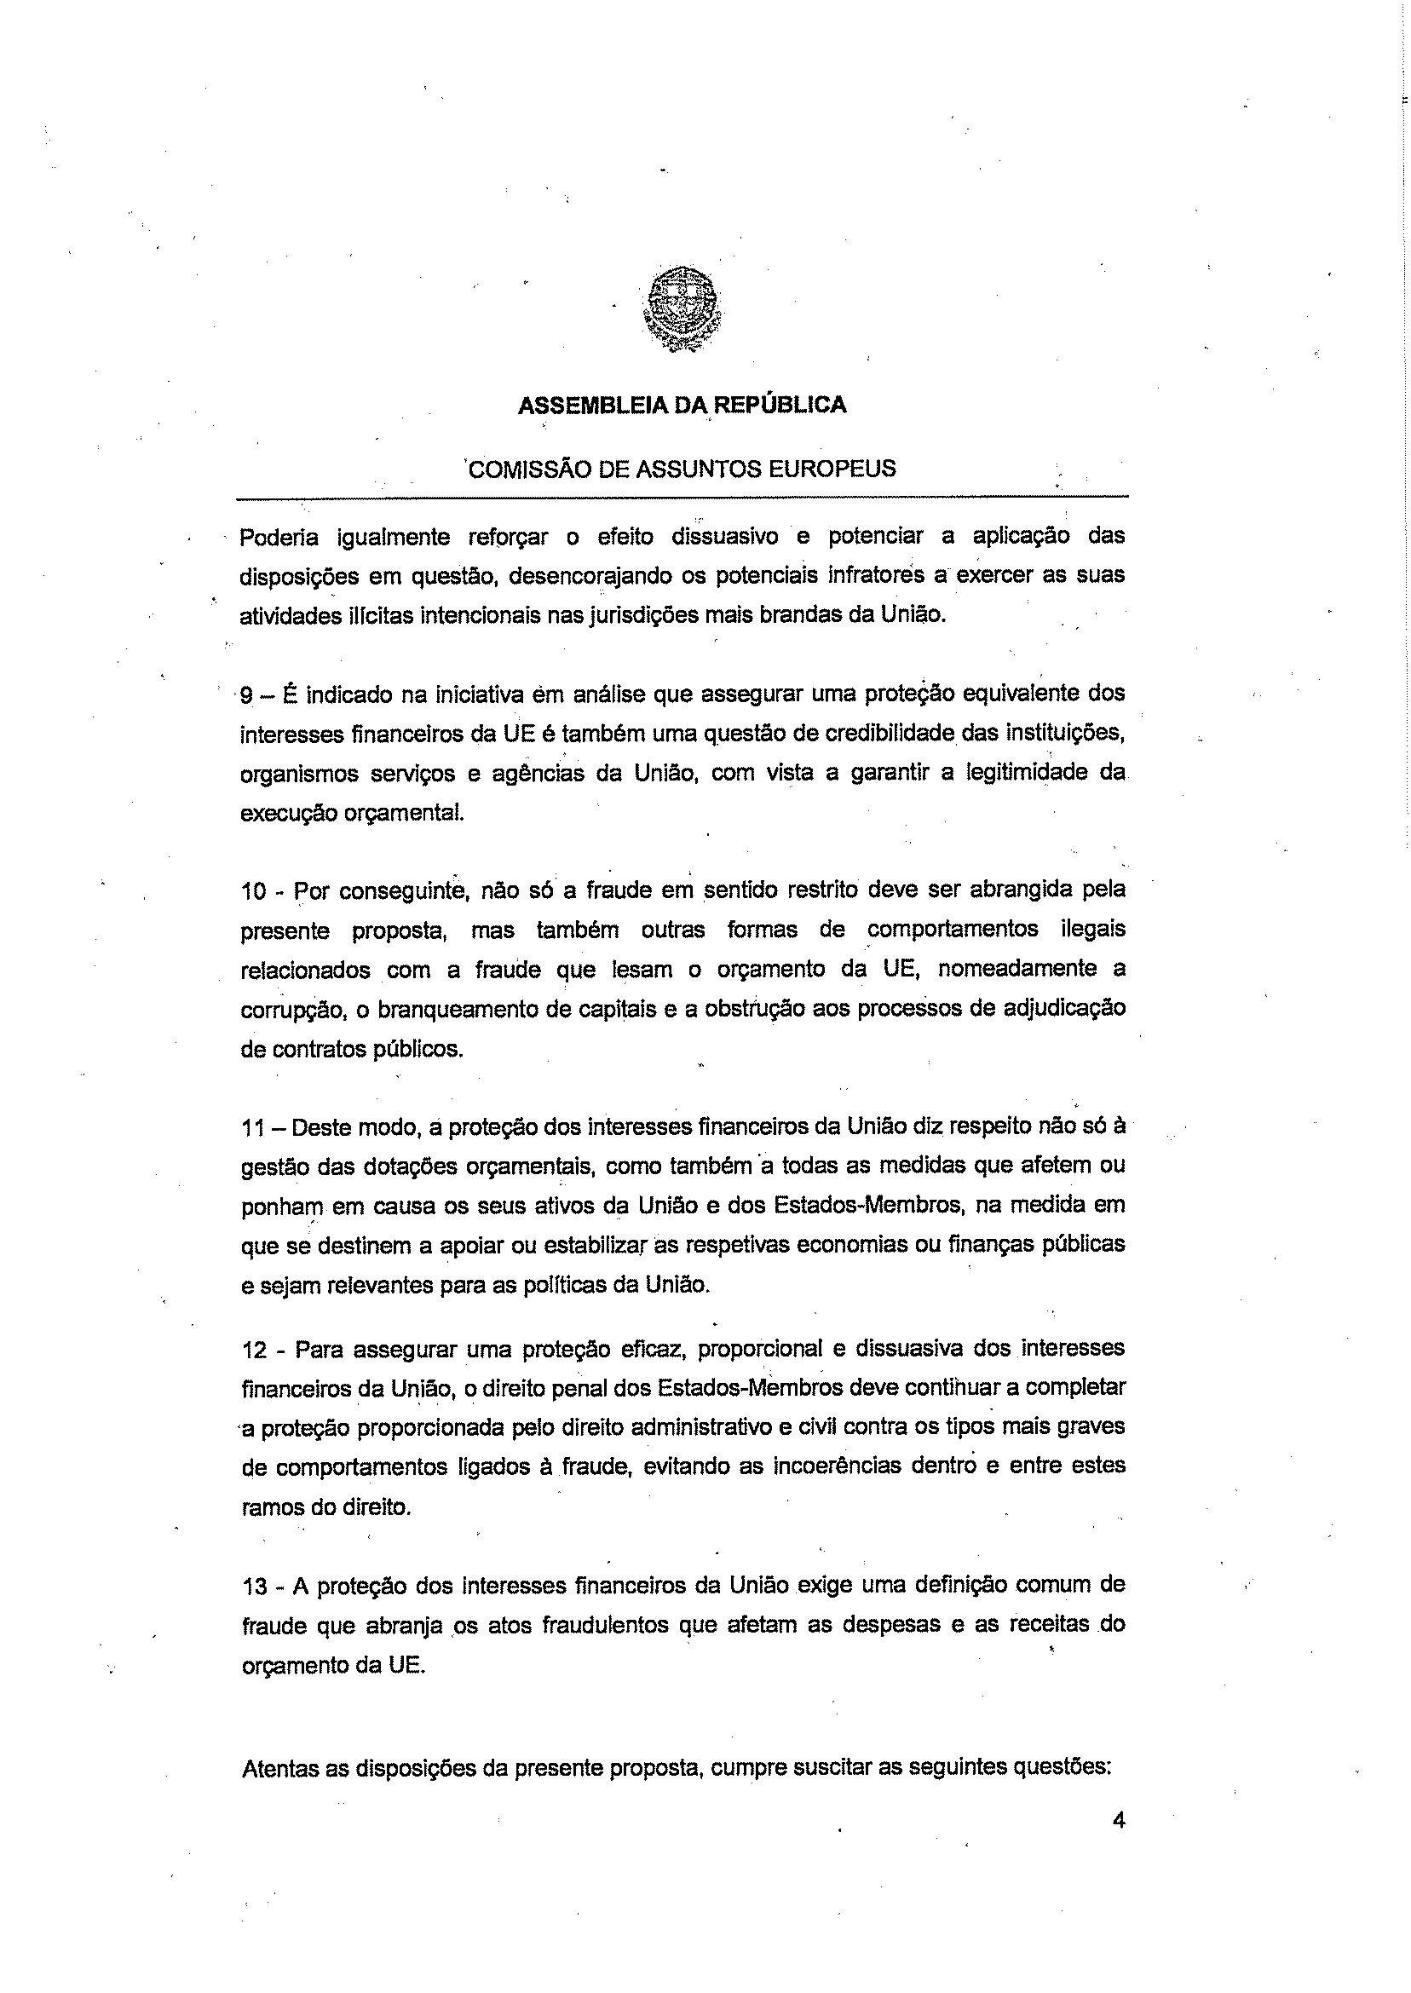

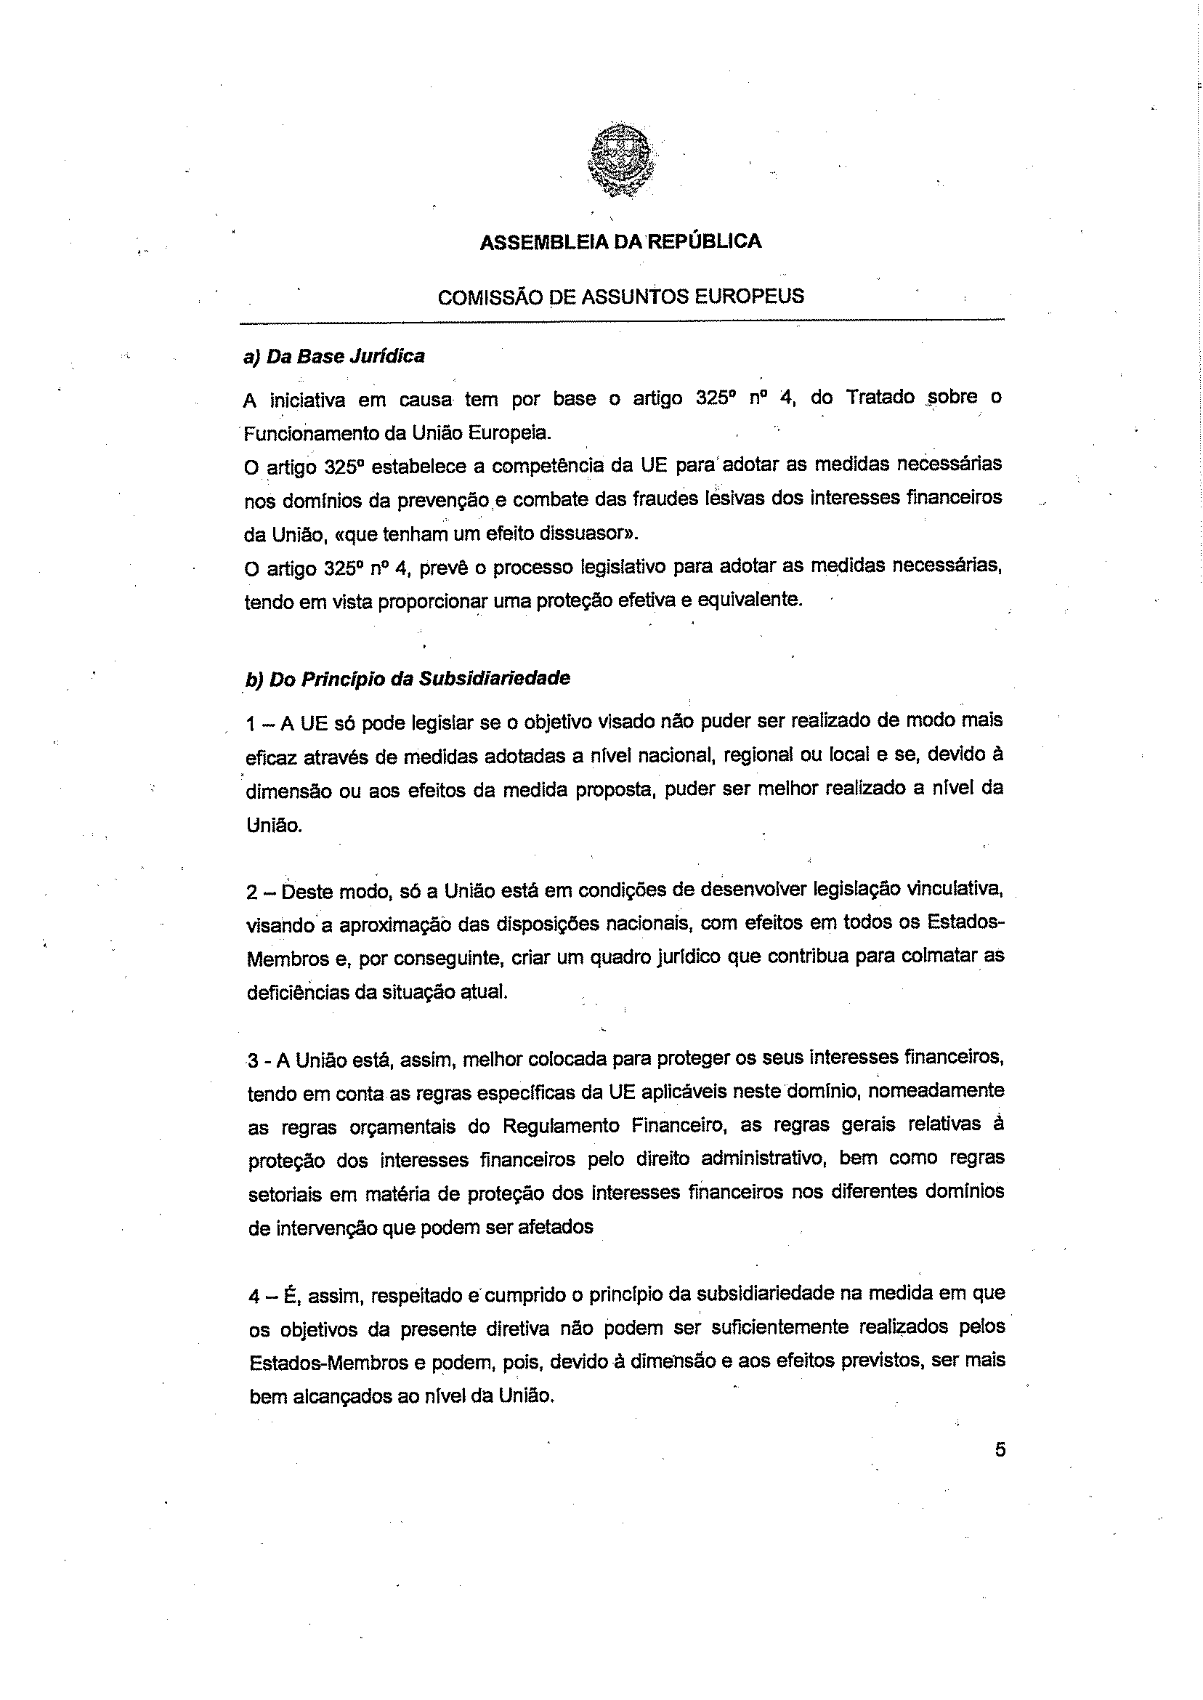

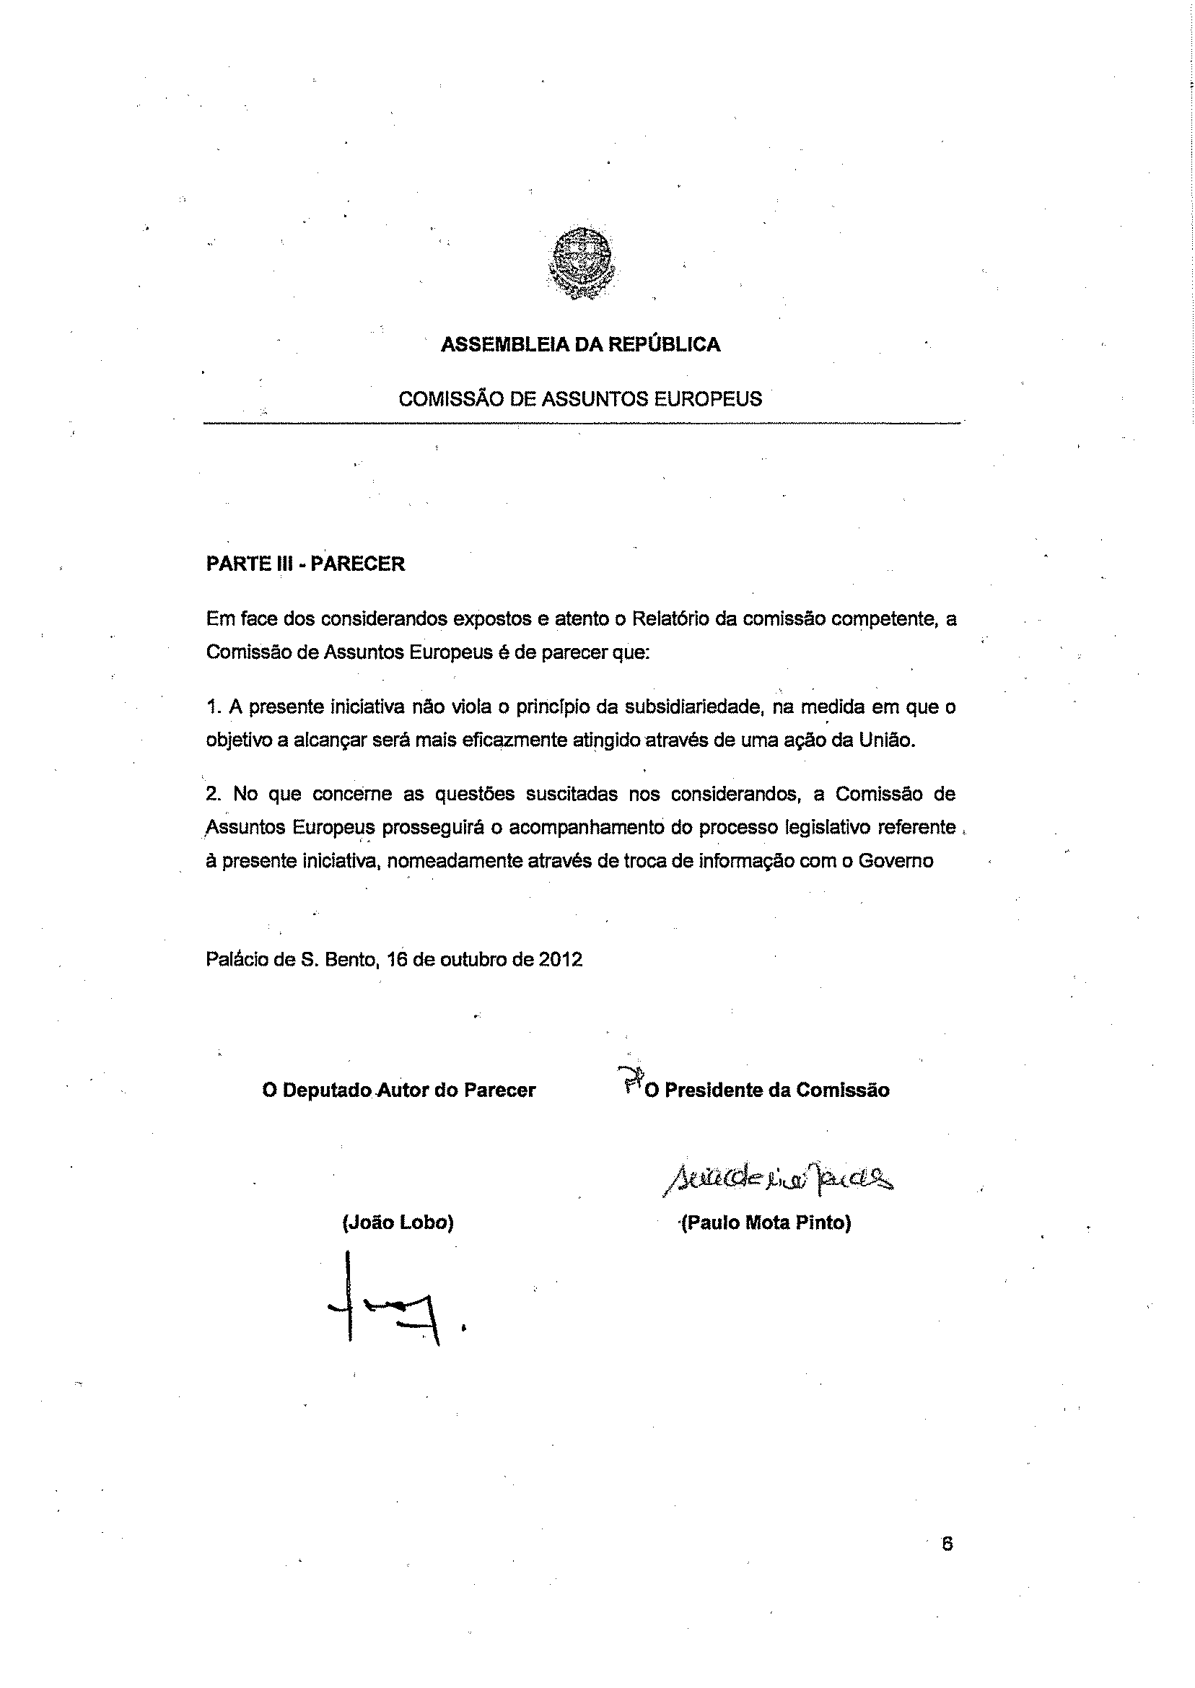



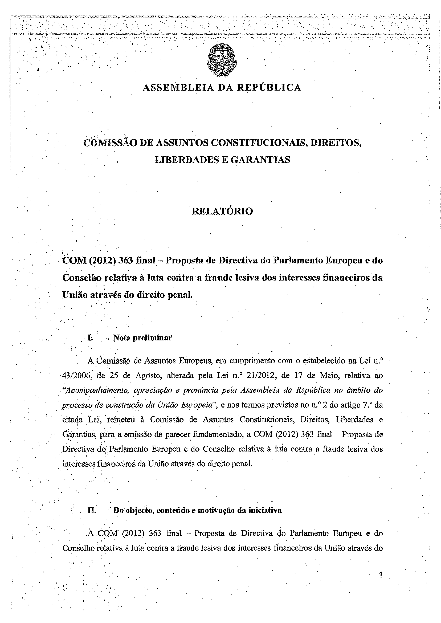

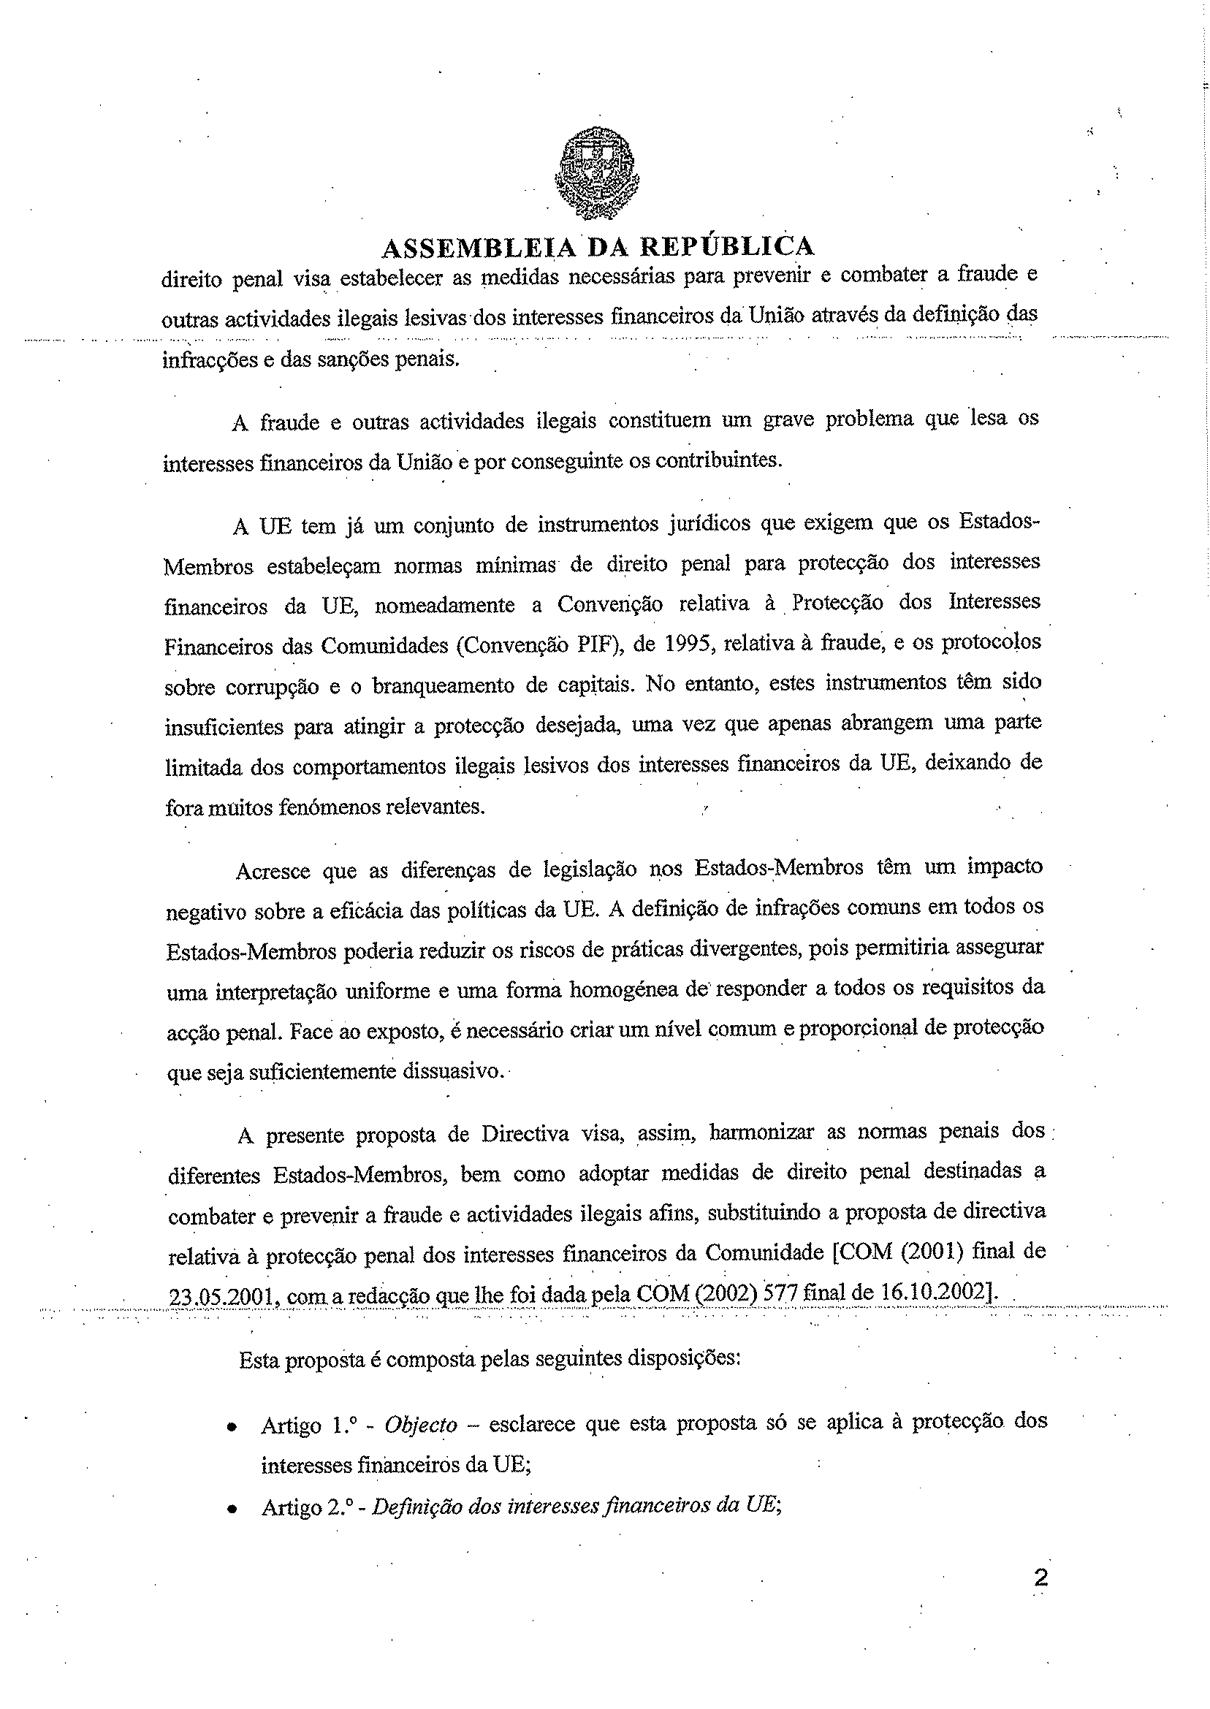

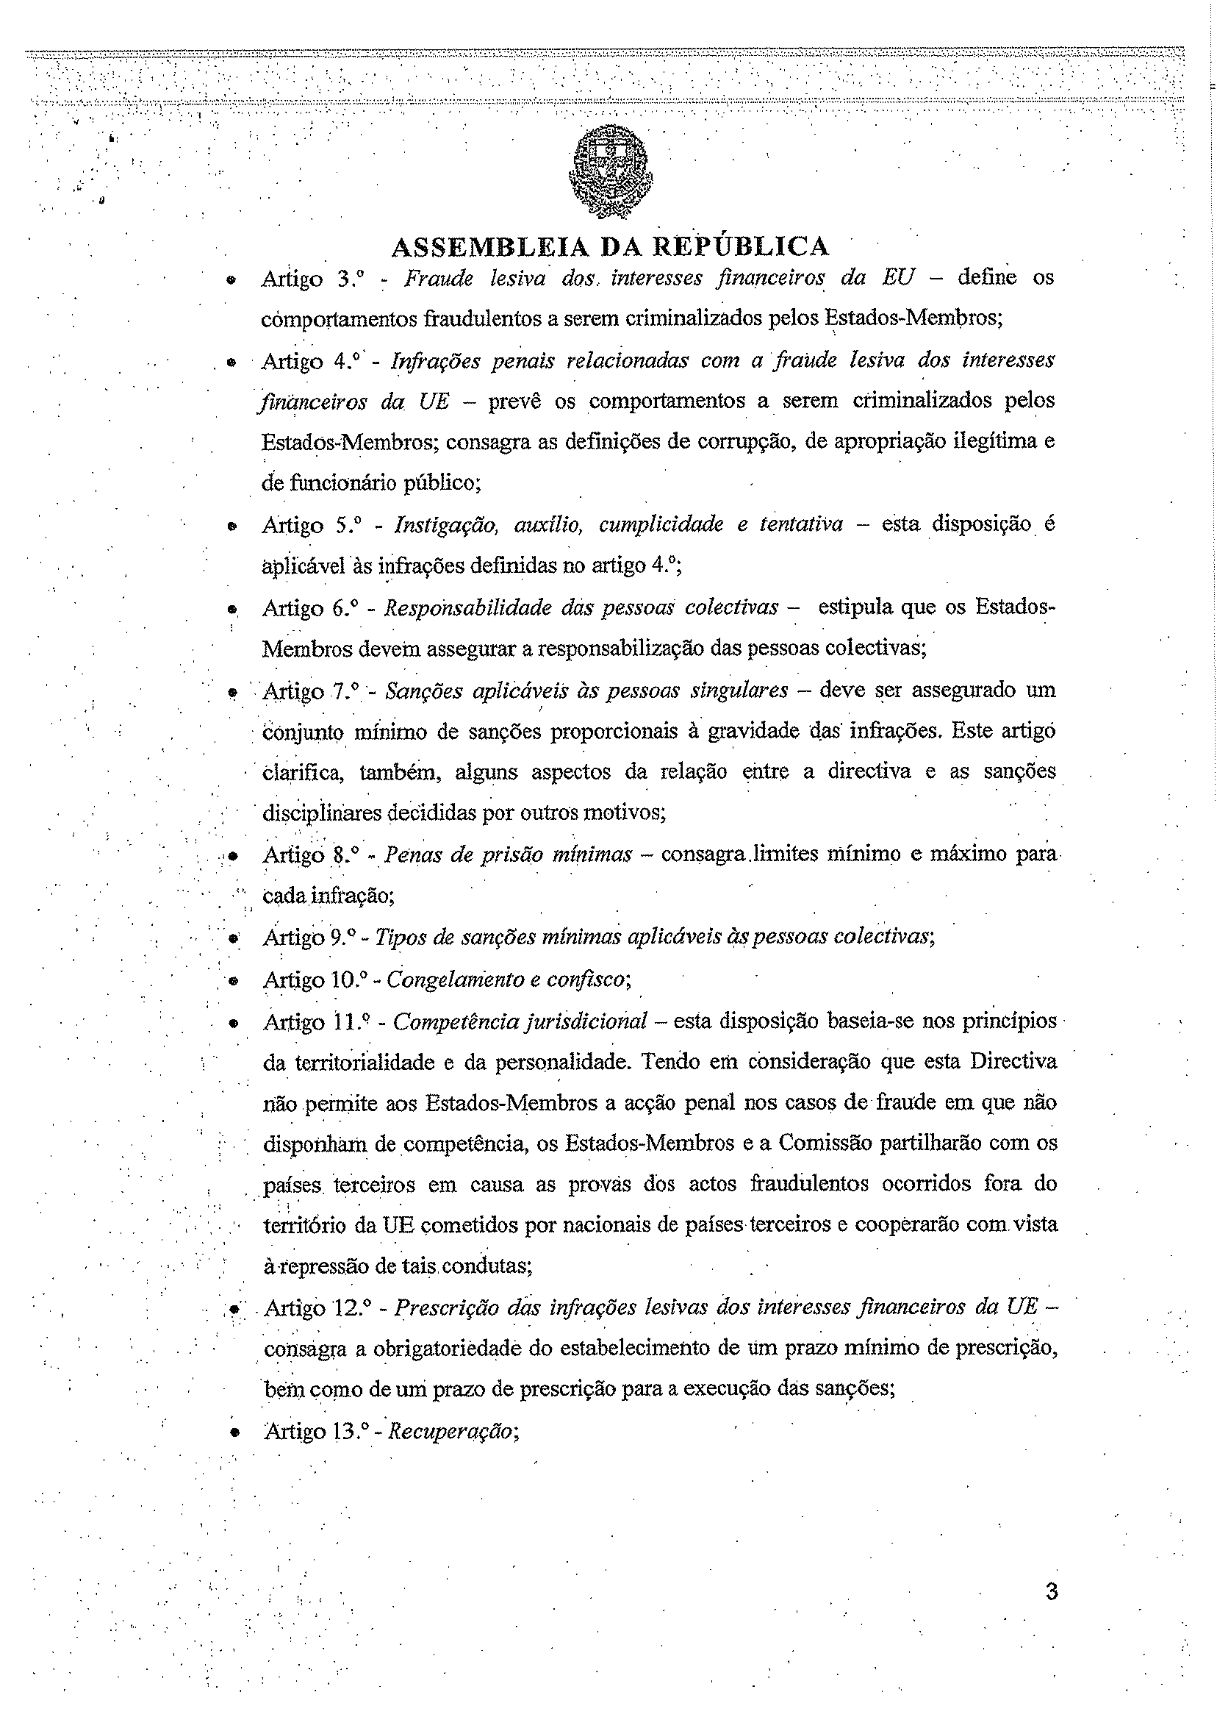

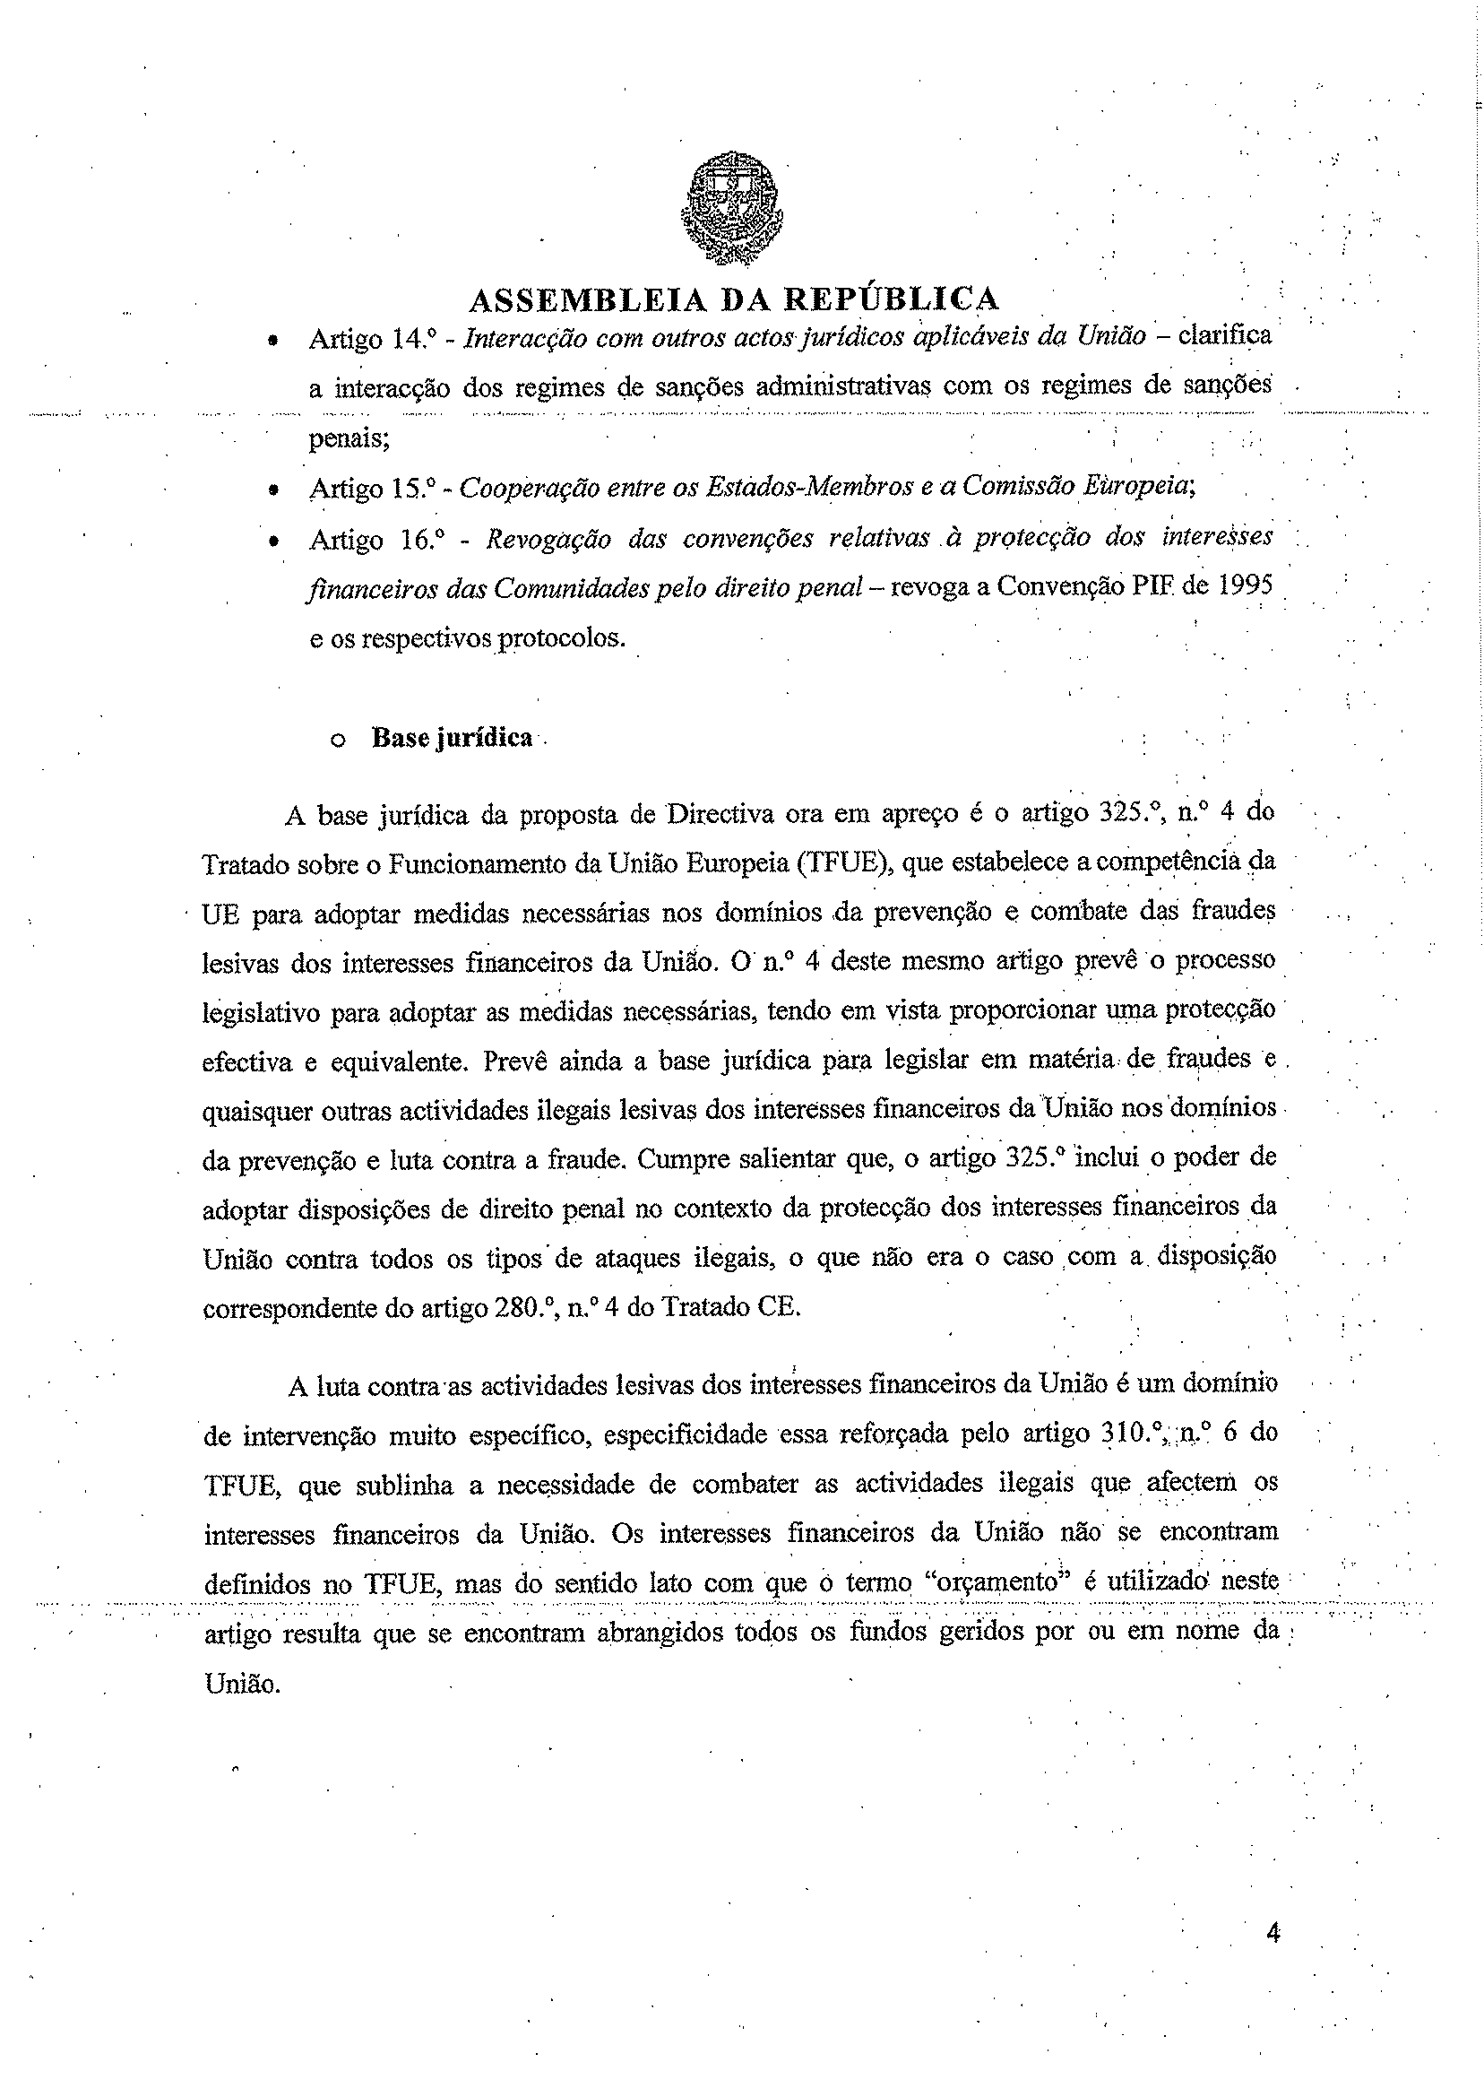

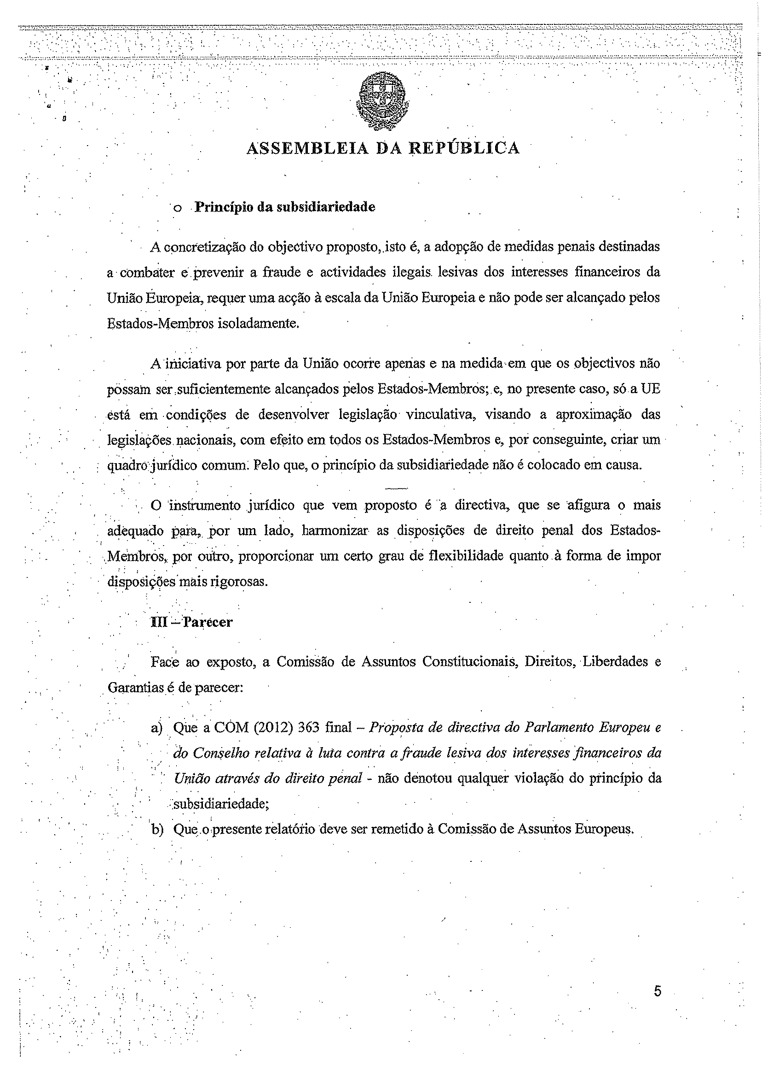

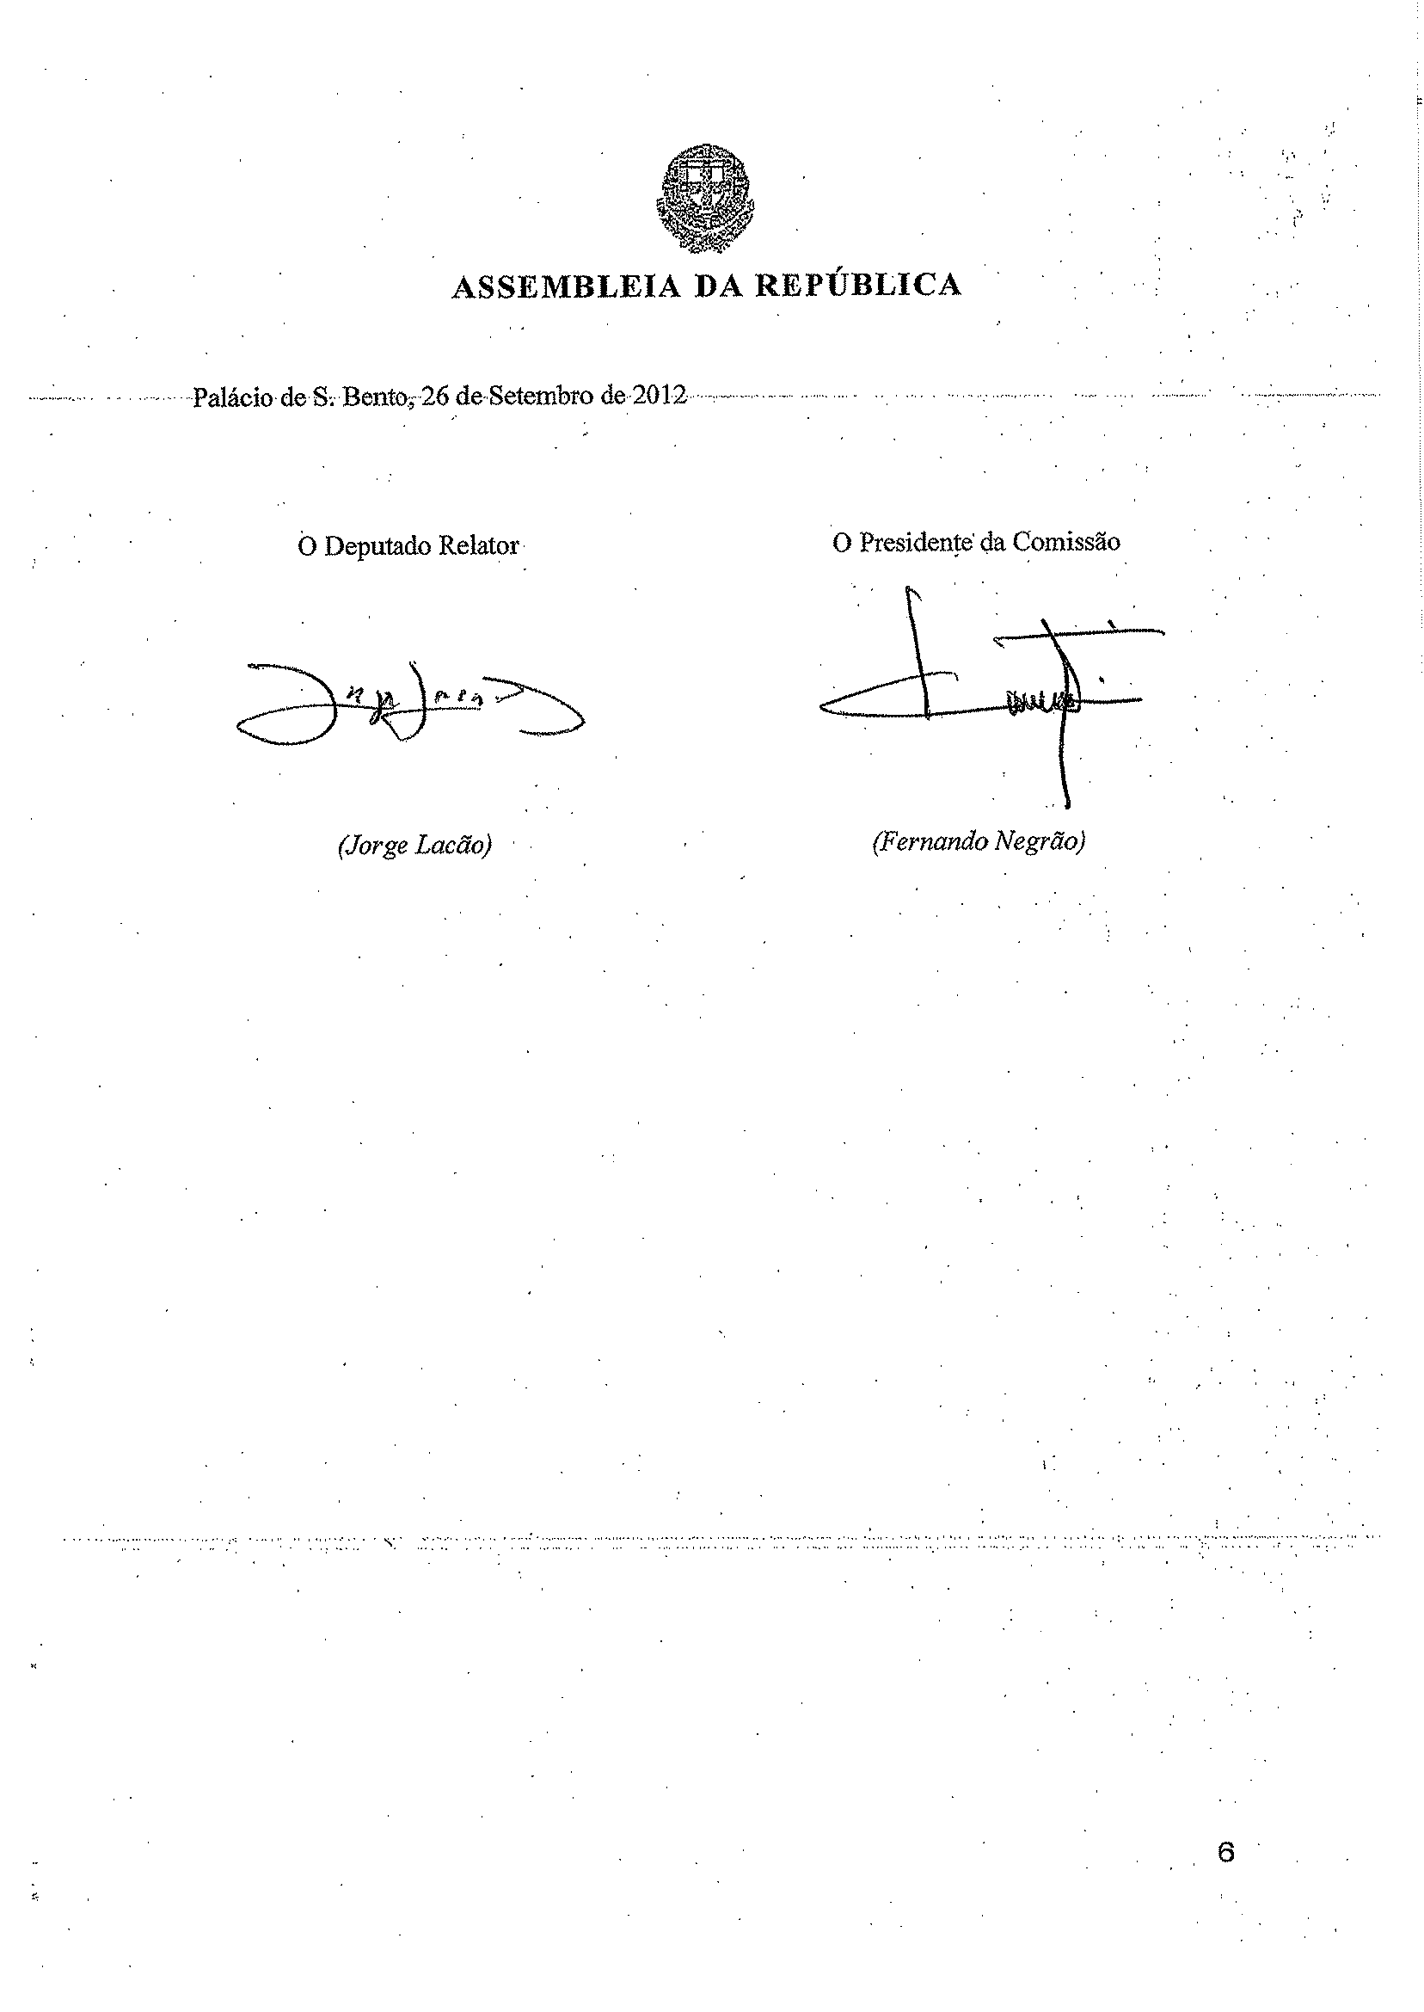

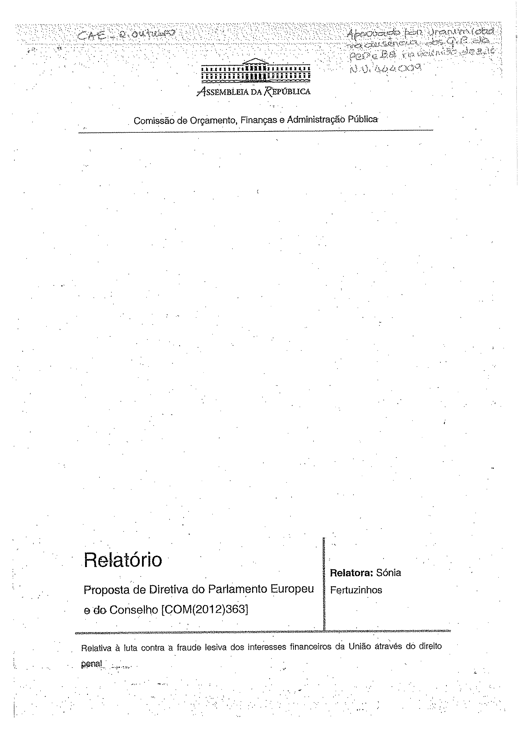

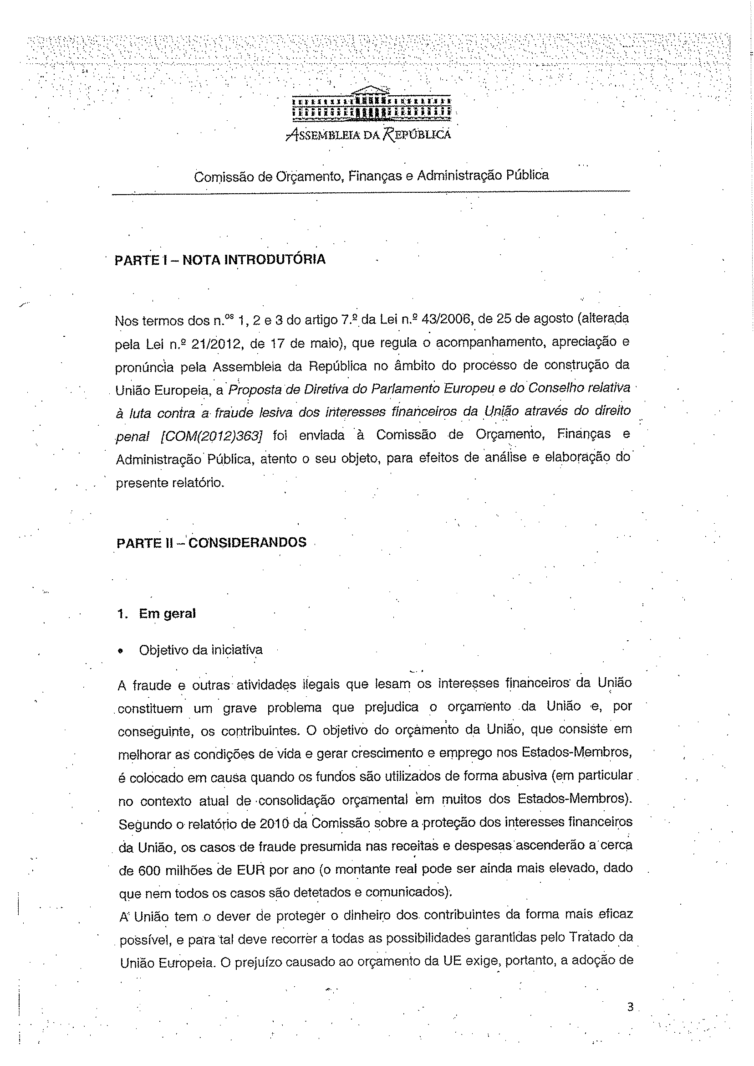

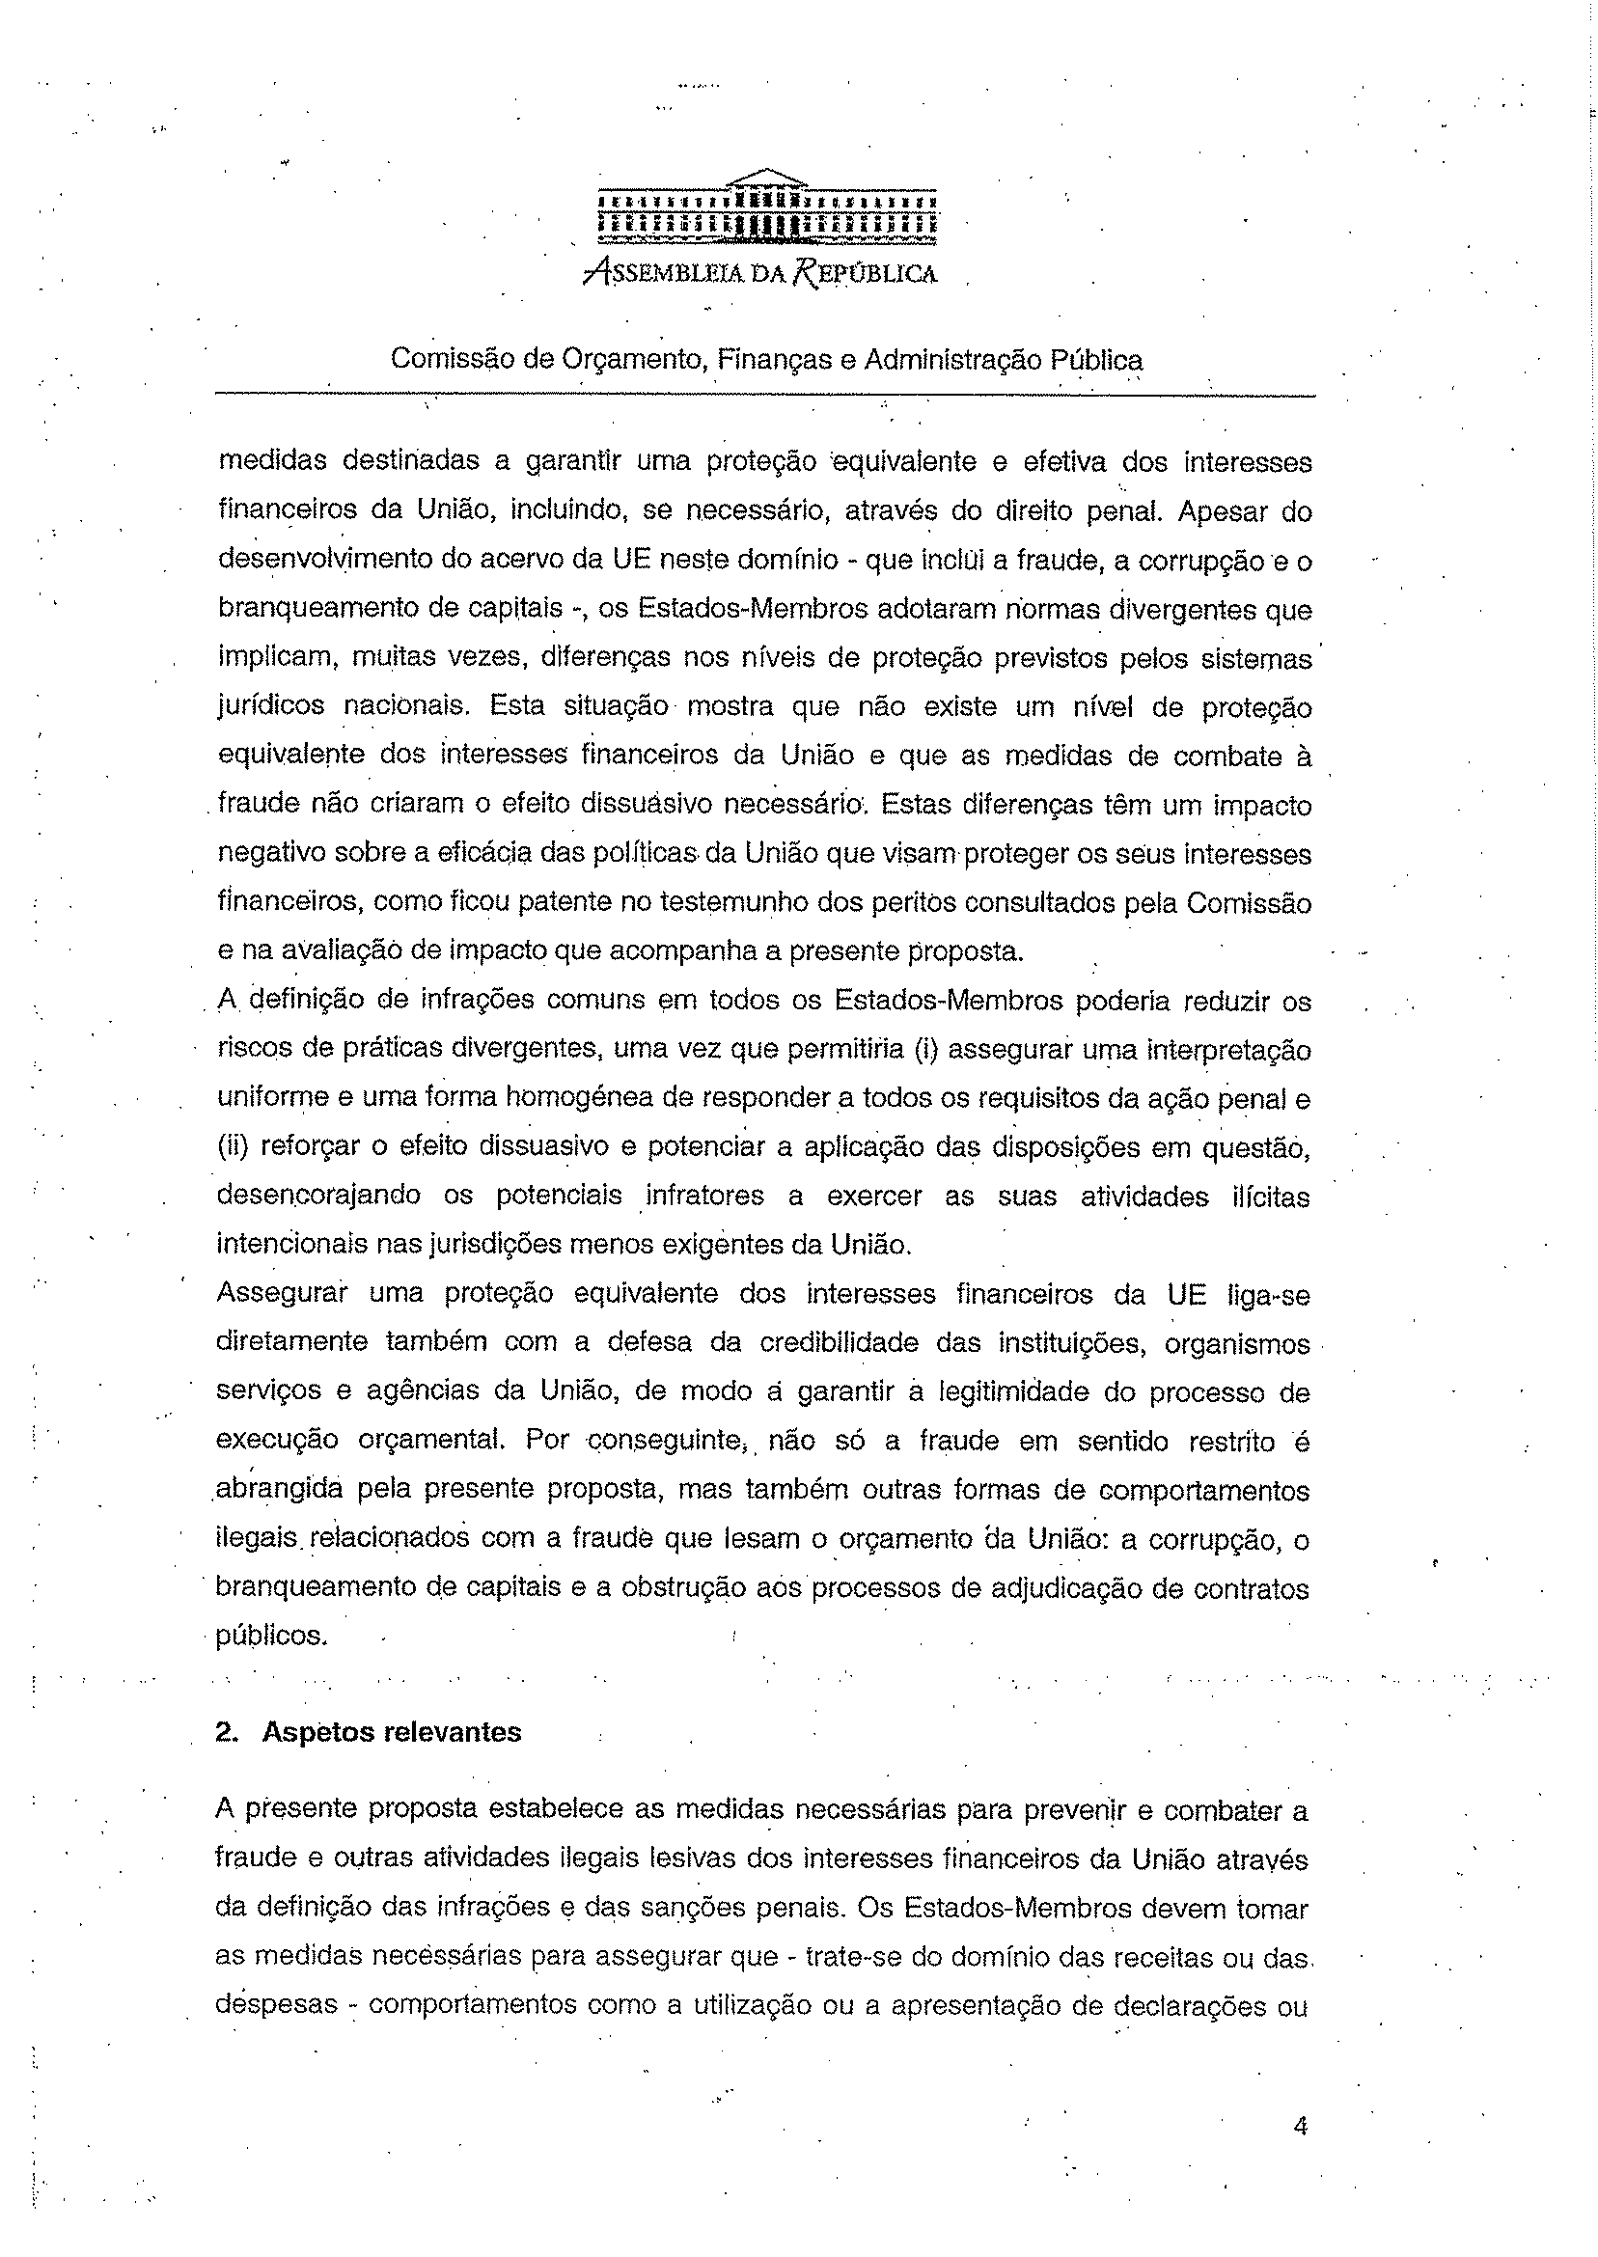

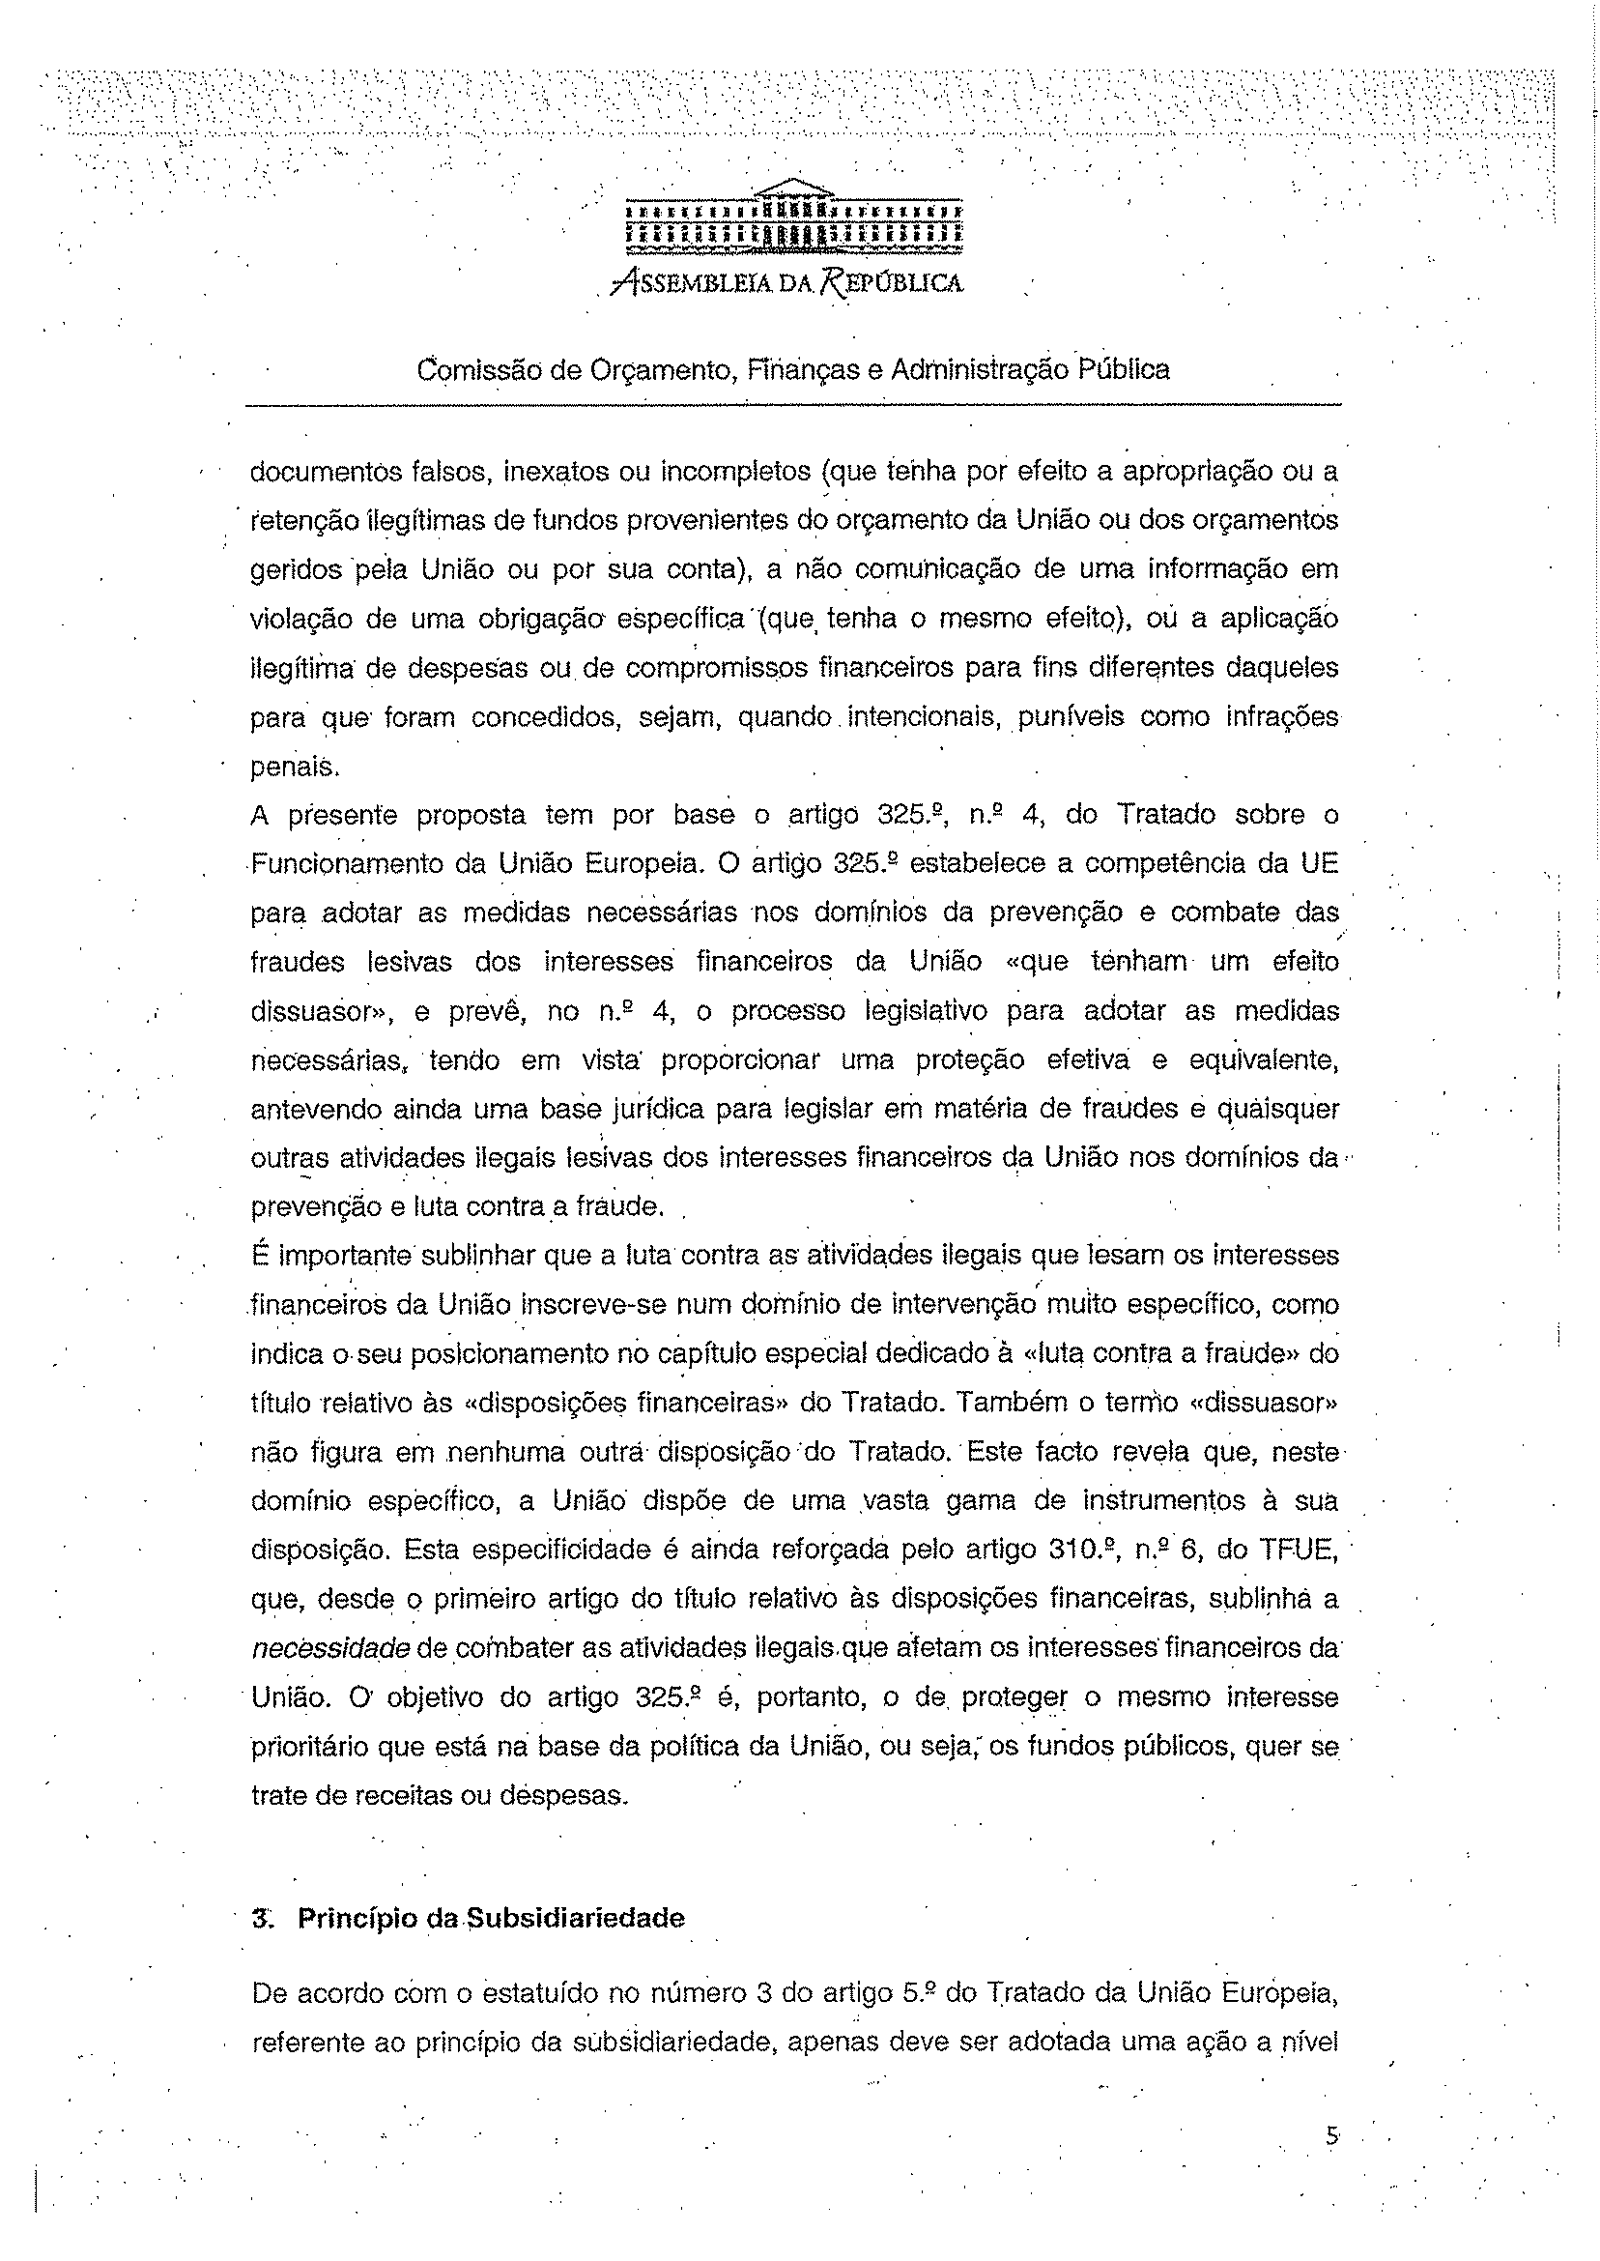

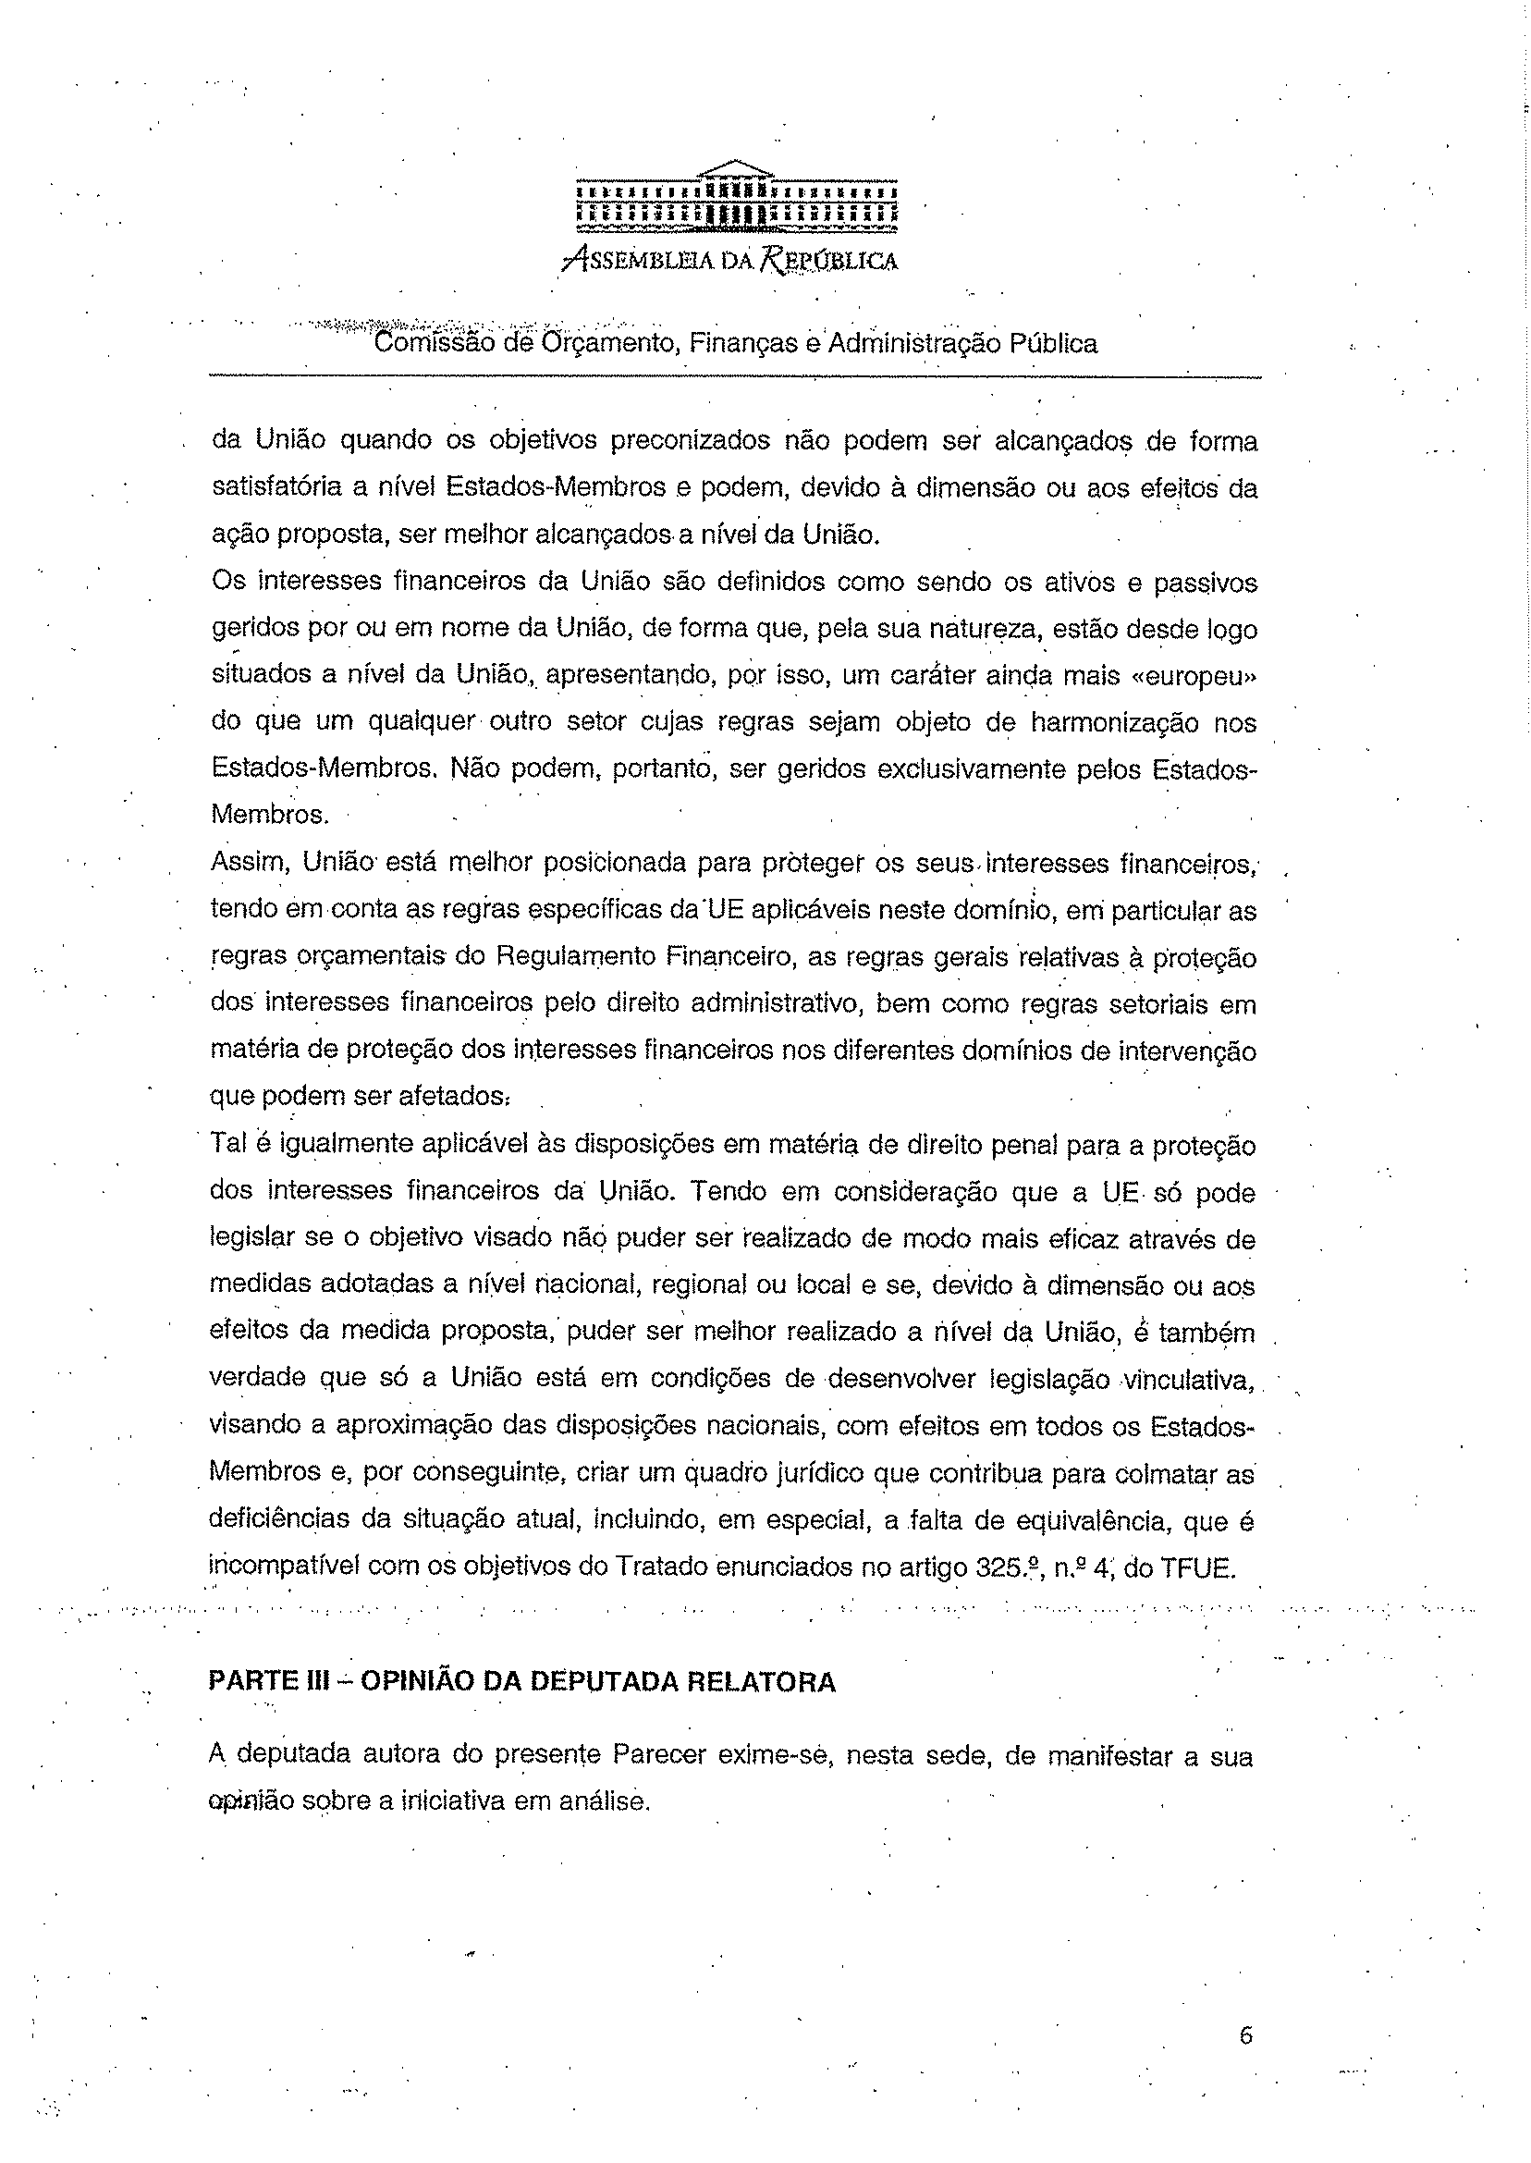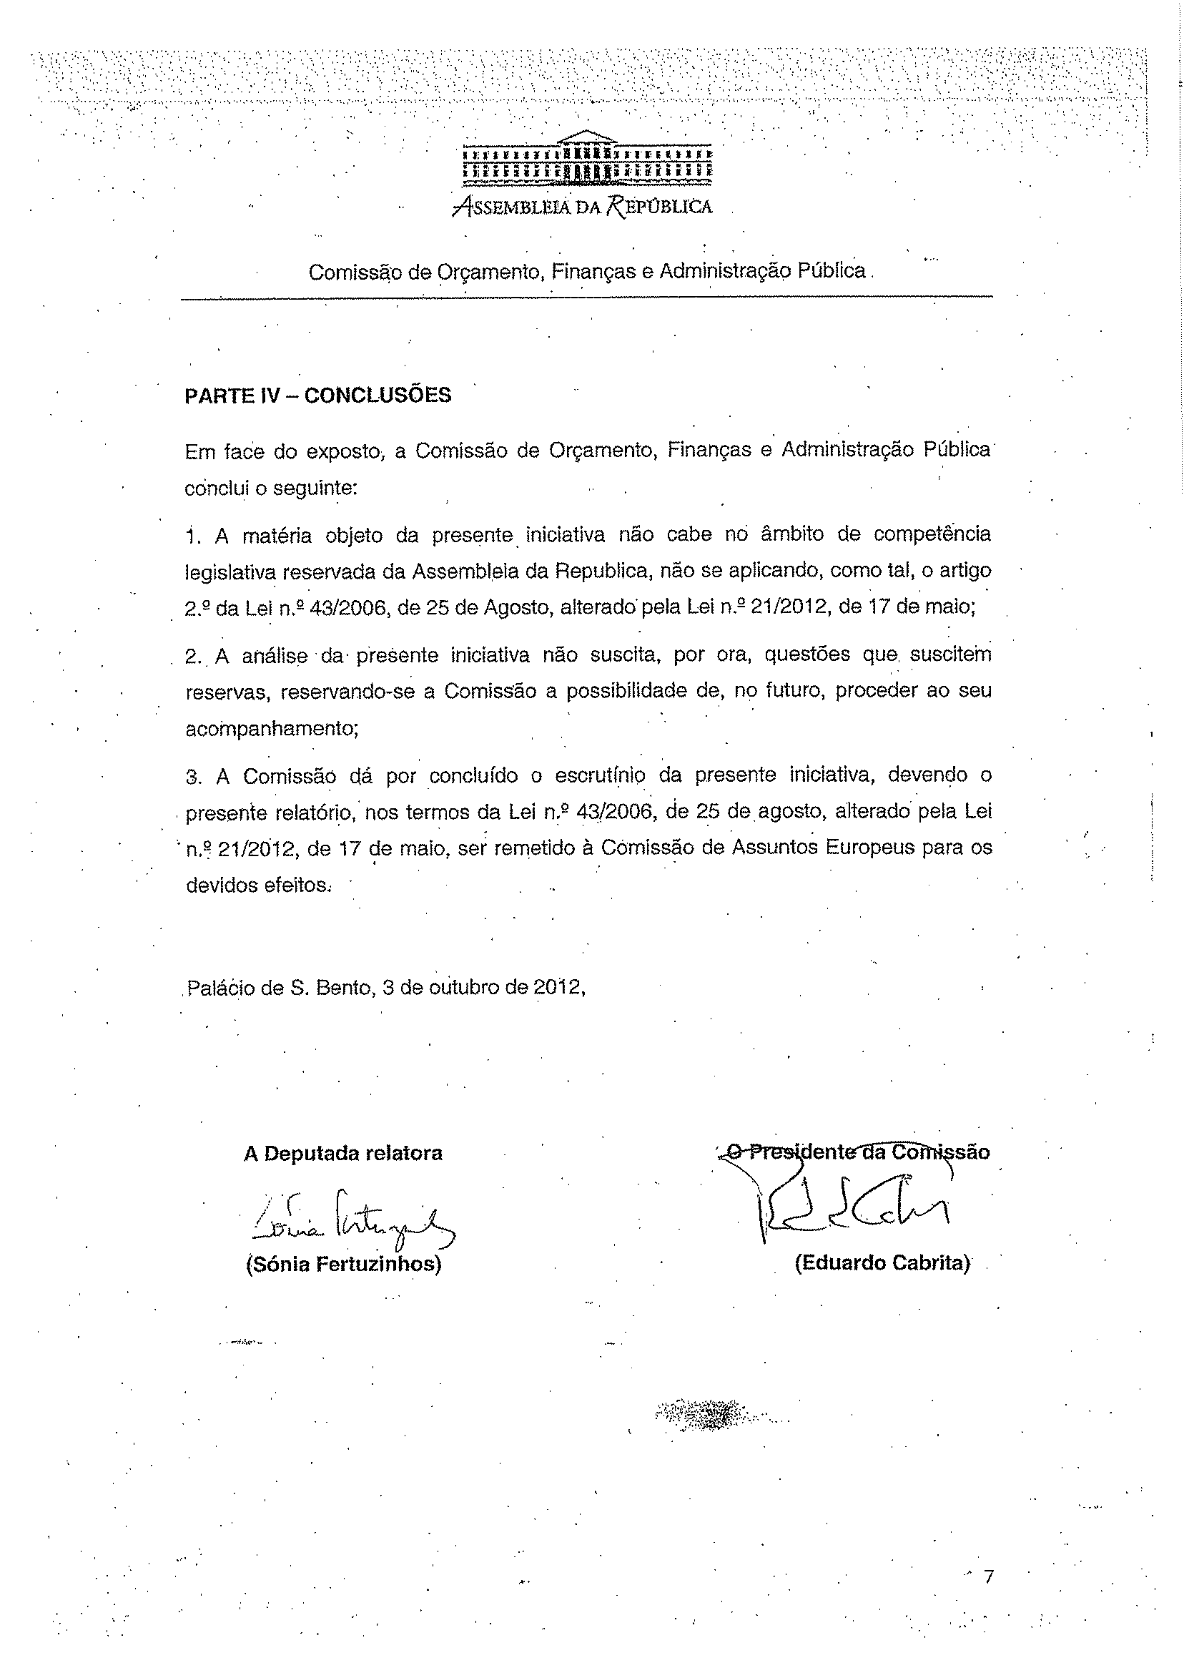

Translation(s) of the opinion may be available at the Interparliamentary EU information exchange site IPEX at the following address: http://www.ipex.eu/IPEXL-WEB/search.do

