 | 
COUNCIL OF  THE EUROPEAN UNION |  |  | Brussels, 23 October 2012
 | Interinstitutional File:  2012/0193 (COD) |  | 15194/12
DROIPEN 144
JAI 717
GAF 24
FIN 784
CADREFIN 431
CODEC 2435
INST 605
PARLNAT 340

OPINION
from: | The Swedish Parliament
dated: | 17 October 2012
No Cion doc.: | COM(2012) 363 final
Subject: | Proposal for a Directive of the European Parliament and of the Council on the fight against fraud to the Union's financial interests by means of criminal law  Opinion on the application of the Principles of Subsidiarity and Proportionality

Delegations will find attached the above mentioned opinion.

________________________

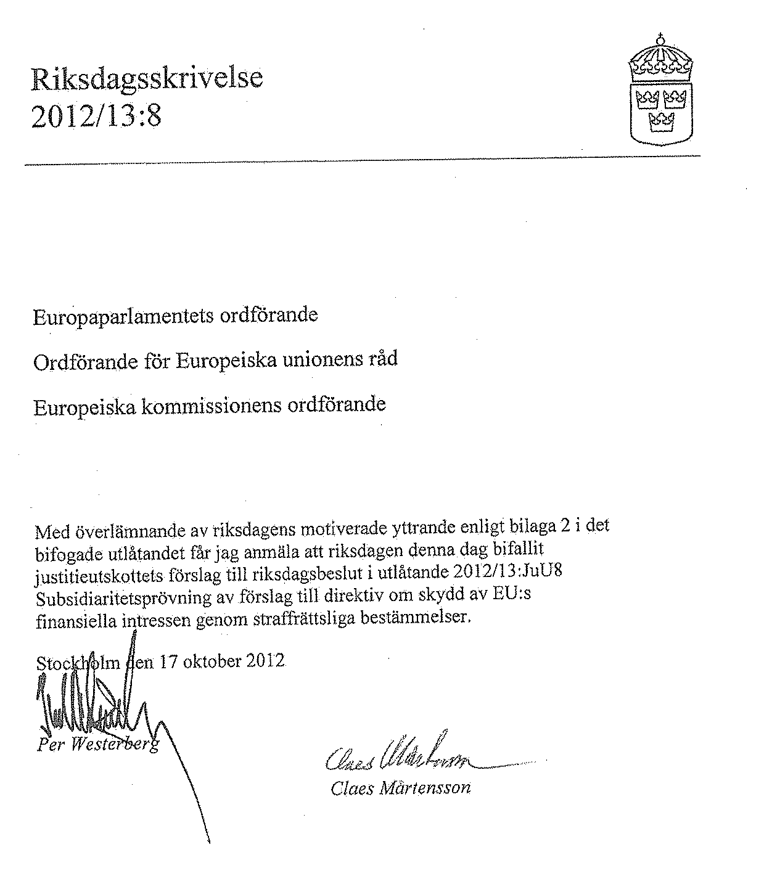________________

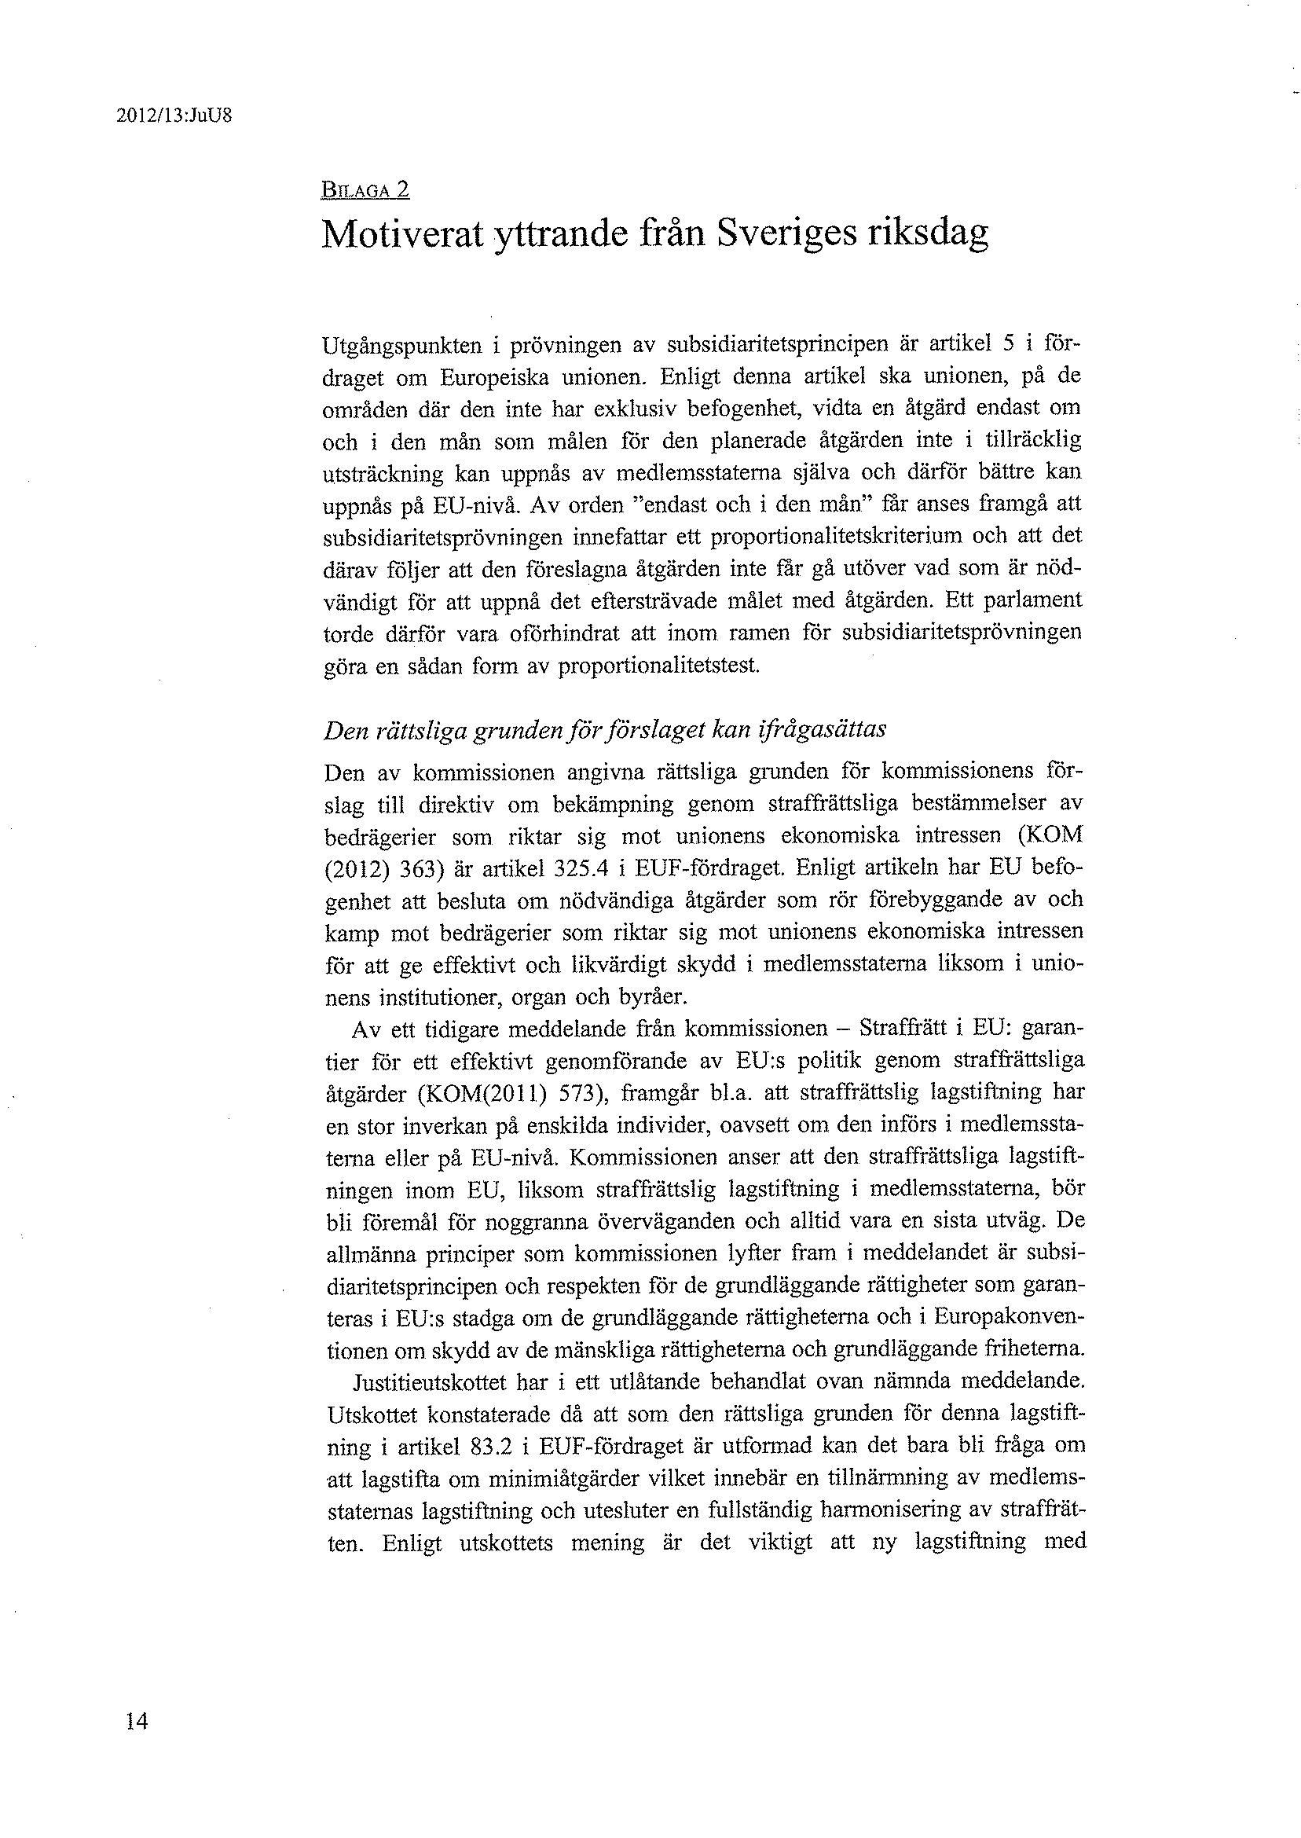

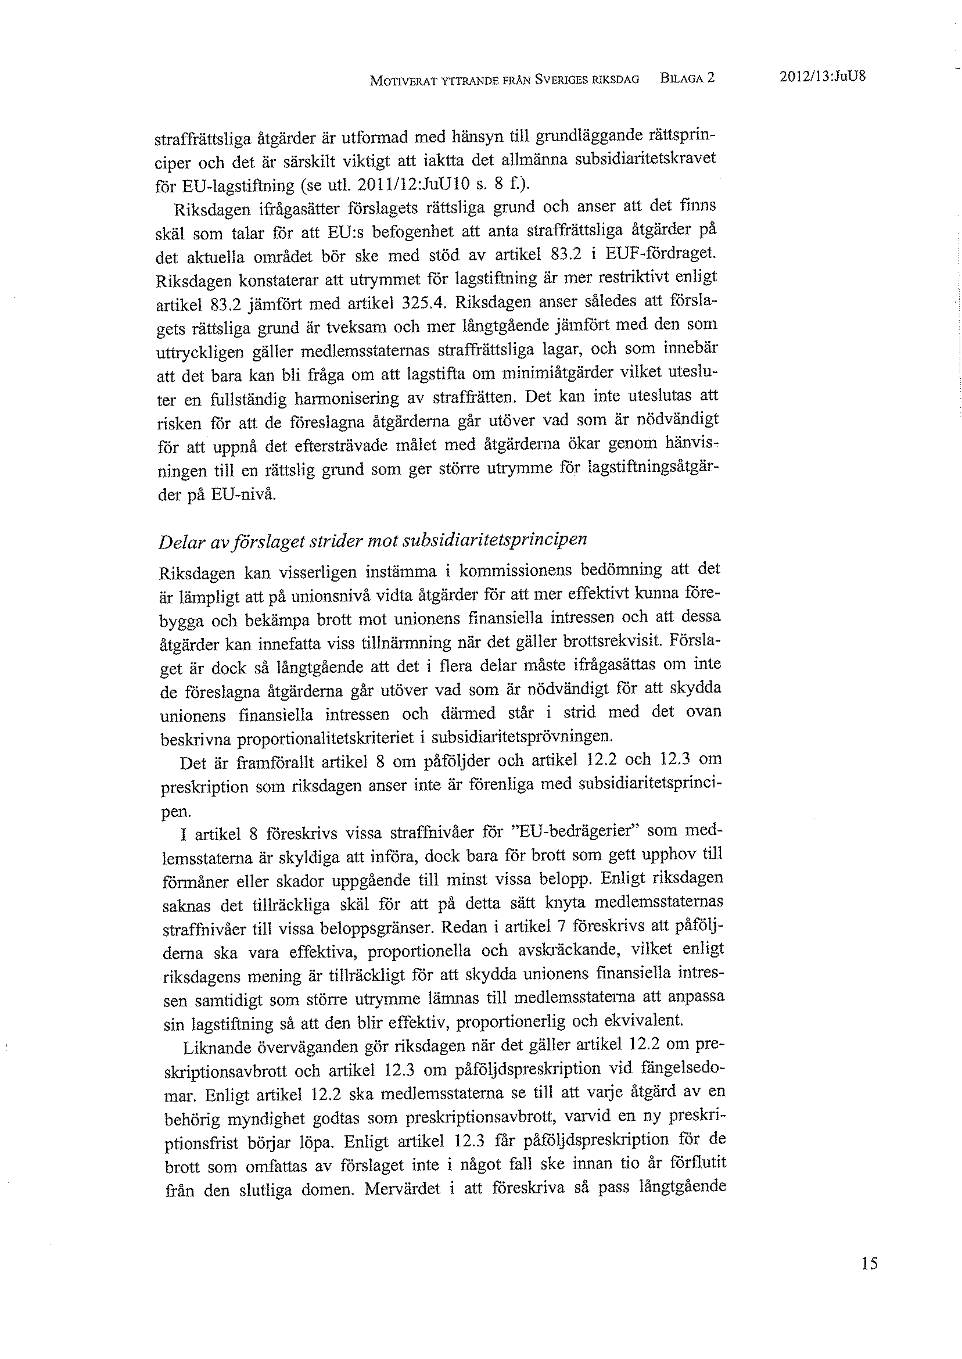

_____________

Translation(s) of the opinion may be available at the Interparliamentary EU information exchange site IPEX at the following address: http://www.ipex.eu/IPEXL-WEB/search.do

