 | 
COUNCIL OF  THE EUROPEAN UNION |  |  | Brussels, 22 October 2012
 | Interinstitutional File:  2012/0163 (COD) |  | 14484/12
WTO 331
FDI 26
CODEC 2442
INST 609
PARLNAT 341

COVER NOTE
from: | the Senate of the Netherlands
date of receipt: | 18 October 2012
to: | Mr Dimitris CHRISTOFIAS, President of the Council of the European Union
Subject: | Proposal for a Regulation of the European Parliament and of the Council establishing a framework for managing financial responsibility linked to investor-state dispute settlement tribunals established by international agreements to which the European Union is party  [doc. 11868/12 WTO 242 FDI 18 CODEC 1768 - COM(2012) 335 final]  - Opinion on the application of the Principles of Subsidiarity and Proportionality

Delegations will find attached the above-mentioned opinion.

________________________

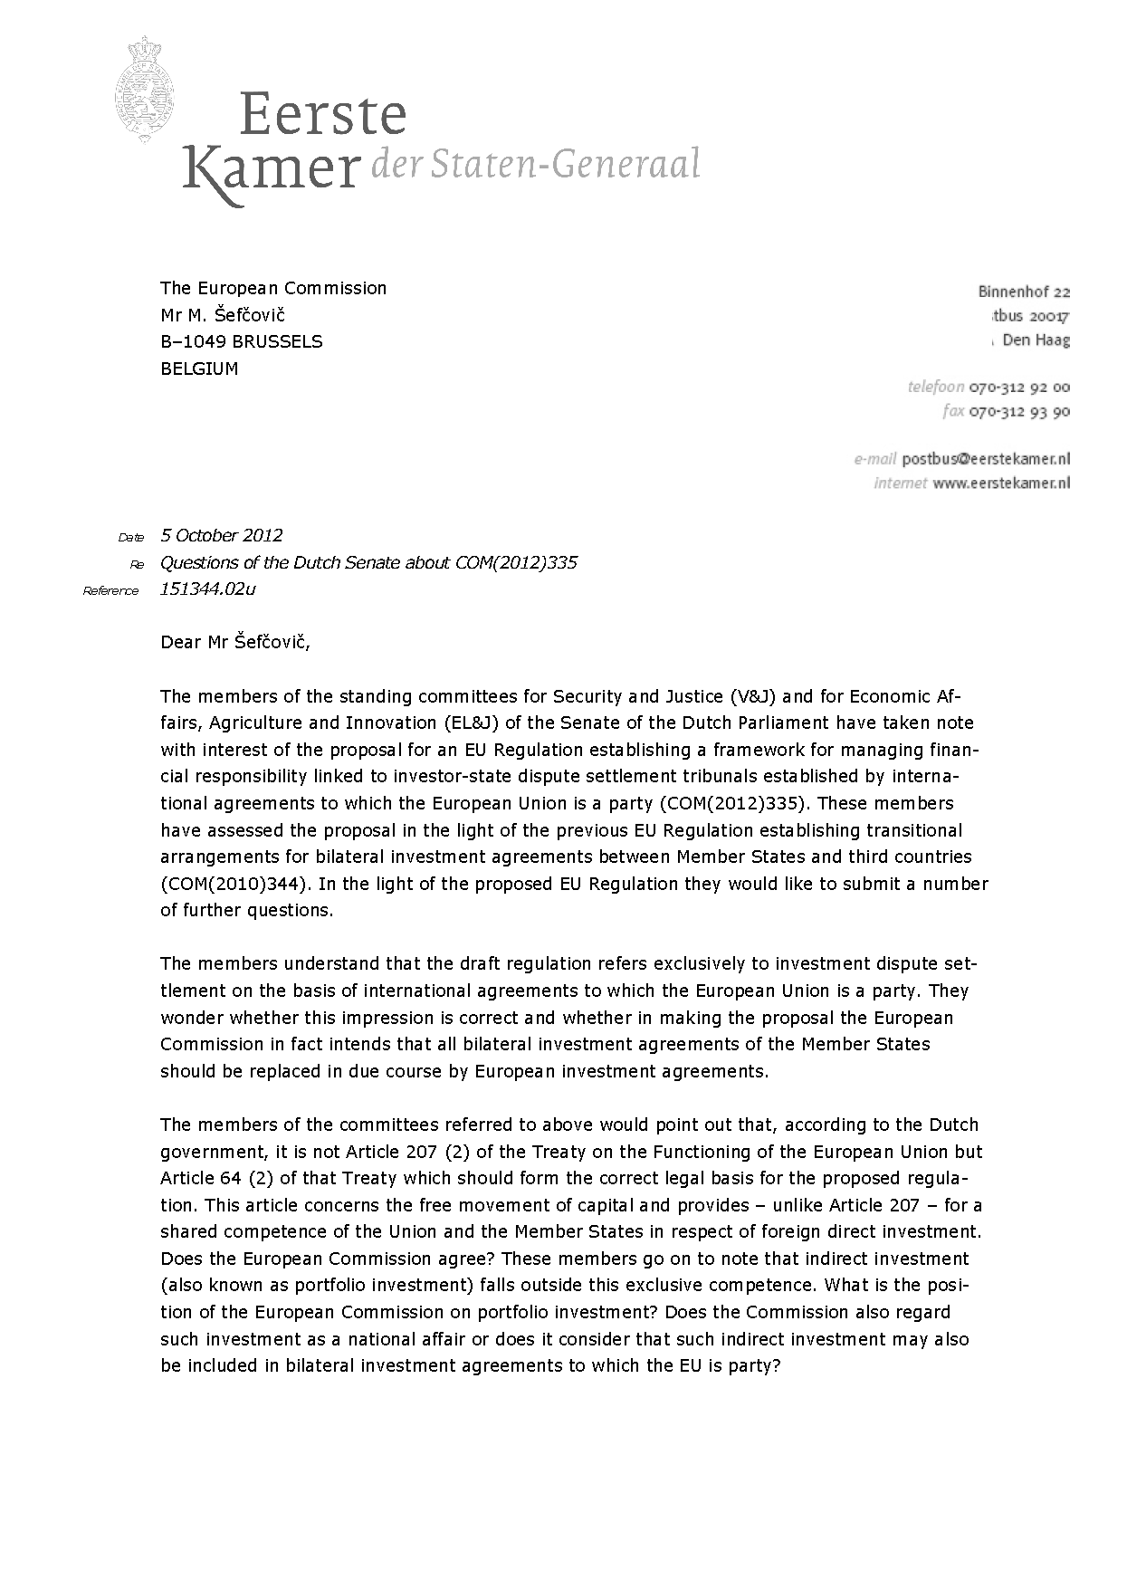
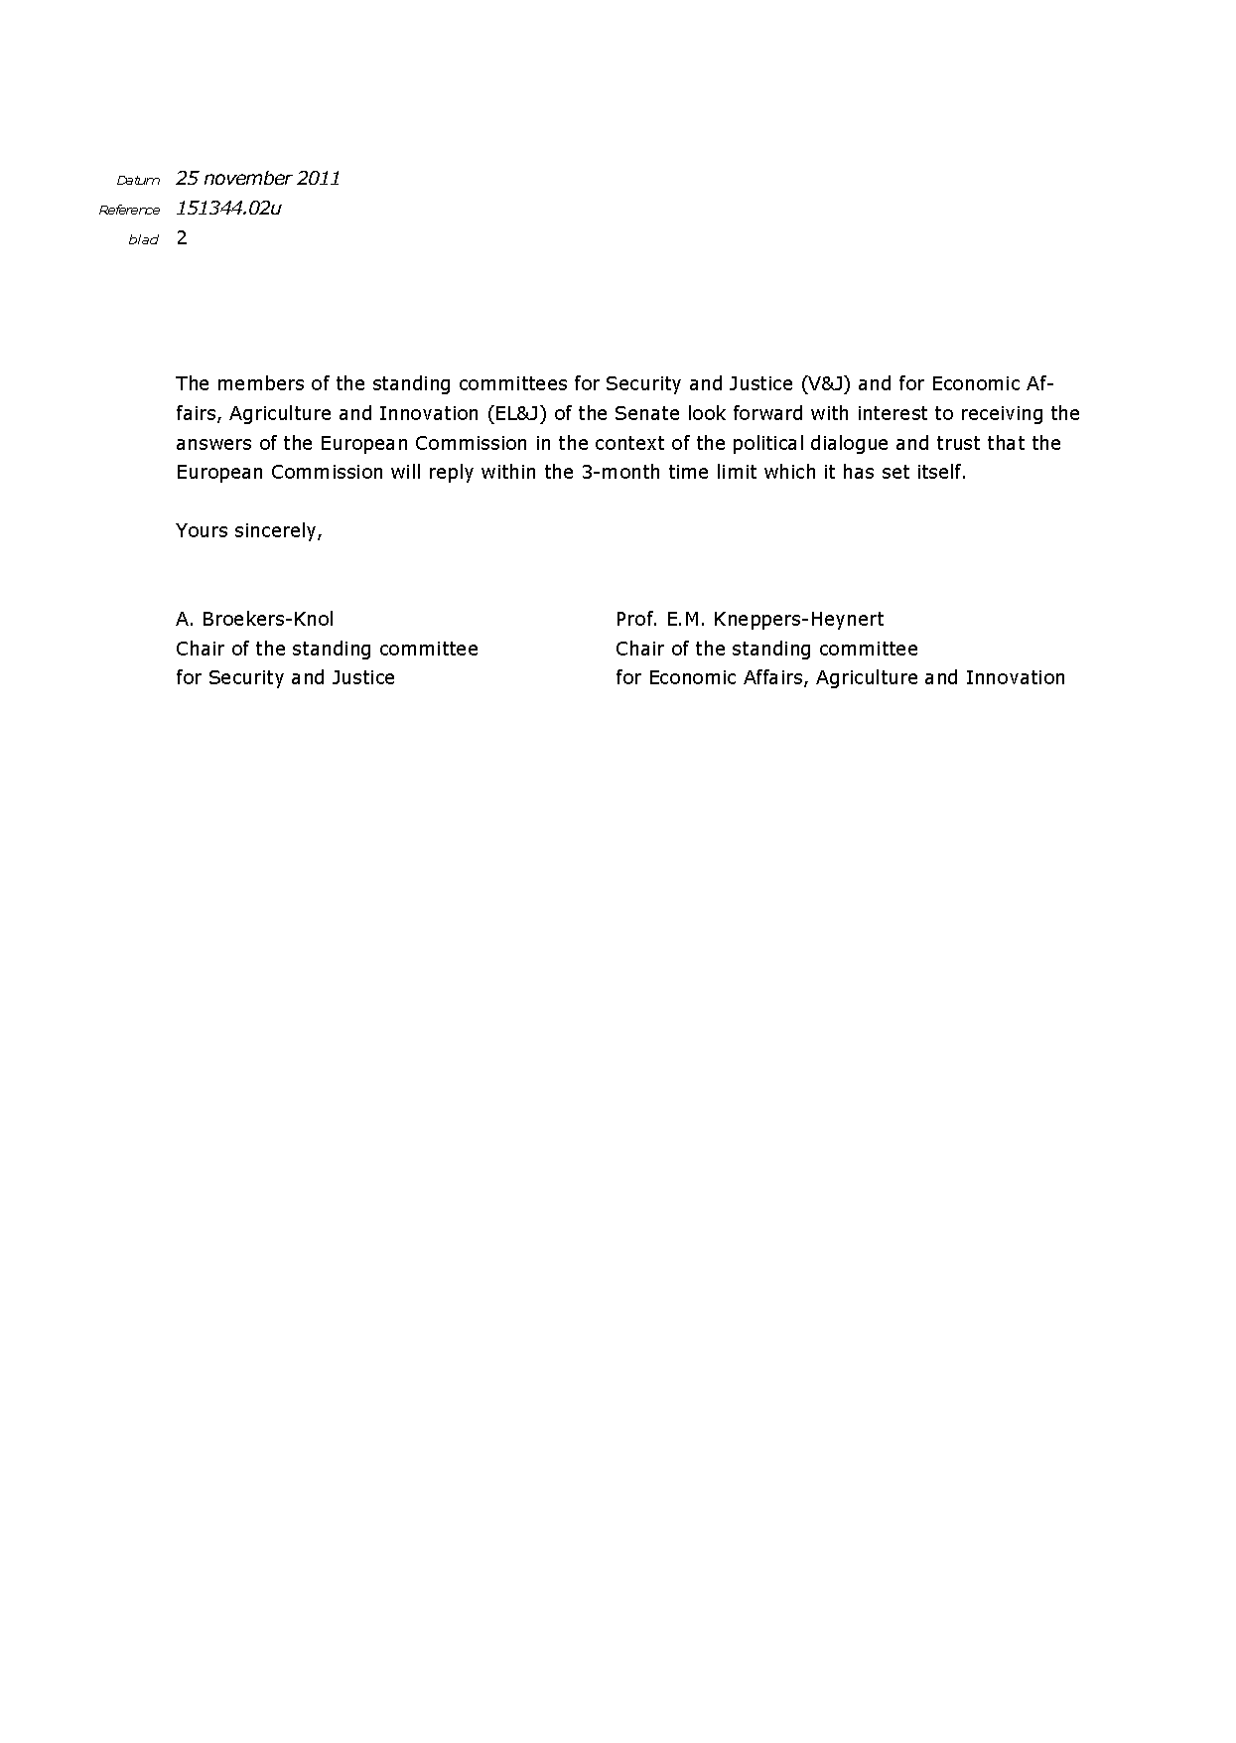

Translation(s) of the opinion may be available on the Interparliamentary EU Information Exchange site IPEX, at the following address: http://www.ipex.eu/IPEXL-WEB/search.do <https://portal.consilium.europa.eu/dana-cached/help/empty.html>

