 | 
COUNCIL OF  THE EUROPEAN UNION |  |  | Brussels, 19 October 2012
 | Interinstitutional File:  2012/0164 (APP) |  | 15166/12
ECOFIN 858
UEM 296
INST 601
PARLNAT 336

NOTE
from: | The President of the Assembleia da República
date of receipt: | 18 October 2012
to: | The President of the Council of the European Union
Subject: | Proposal for a COUNCIL REGULATION  establishing a facility for providing financial assistance for Member States whose currency is not the euro  [doc . 12201/12 ECOFIN 673 UEM 253 - COM(2012) 336 final]  - Opinion on the Application of the principles of Subsidiarity and Proportionality

Delegations will find attached the above mentioned opinion.
________________________

Encl.:

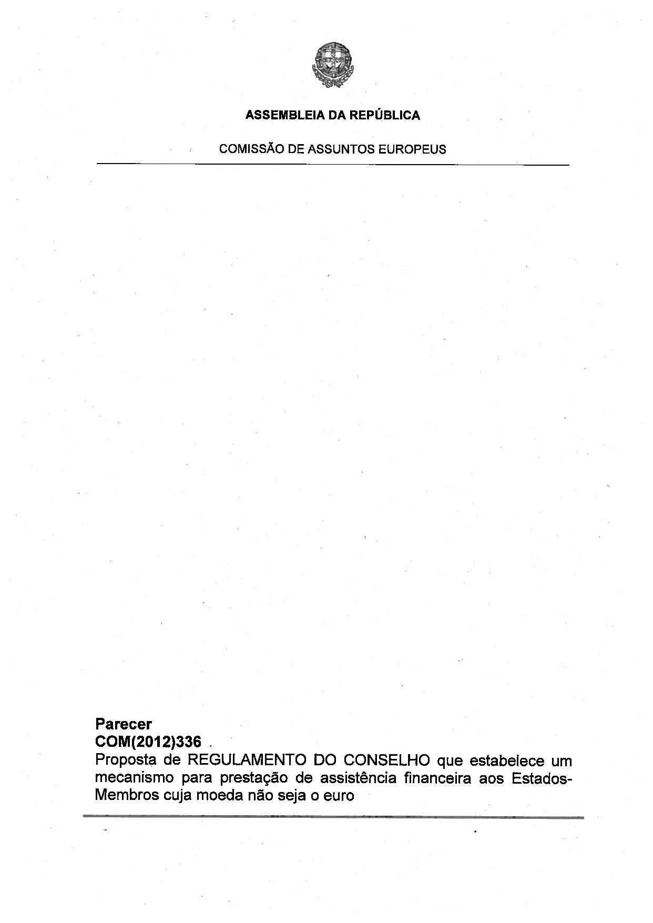
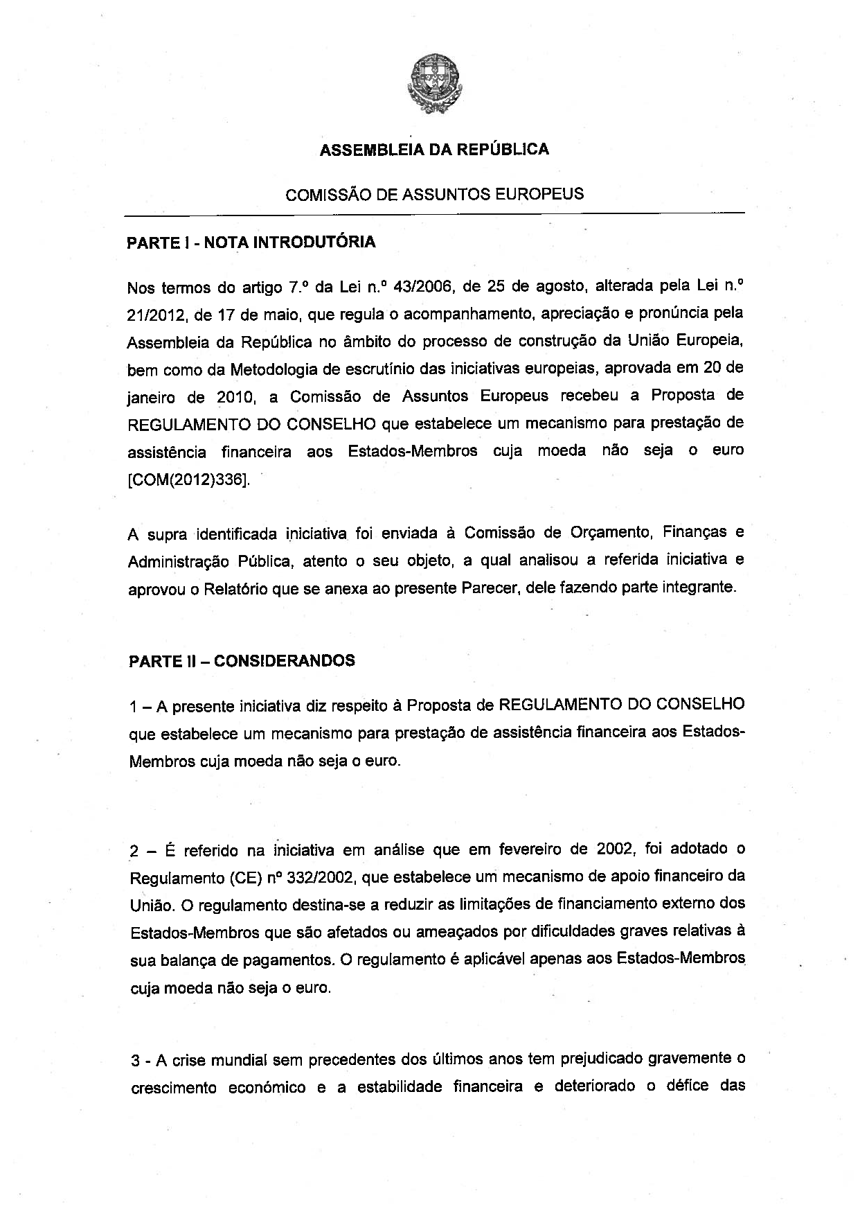
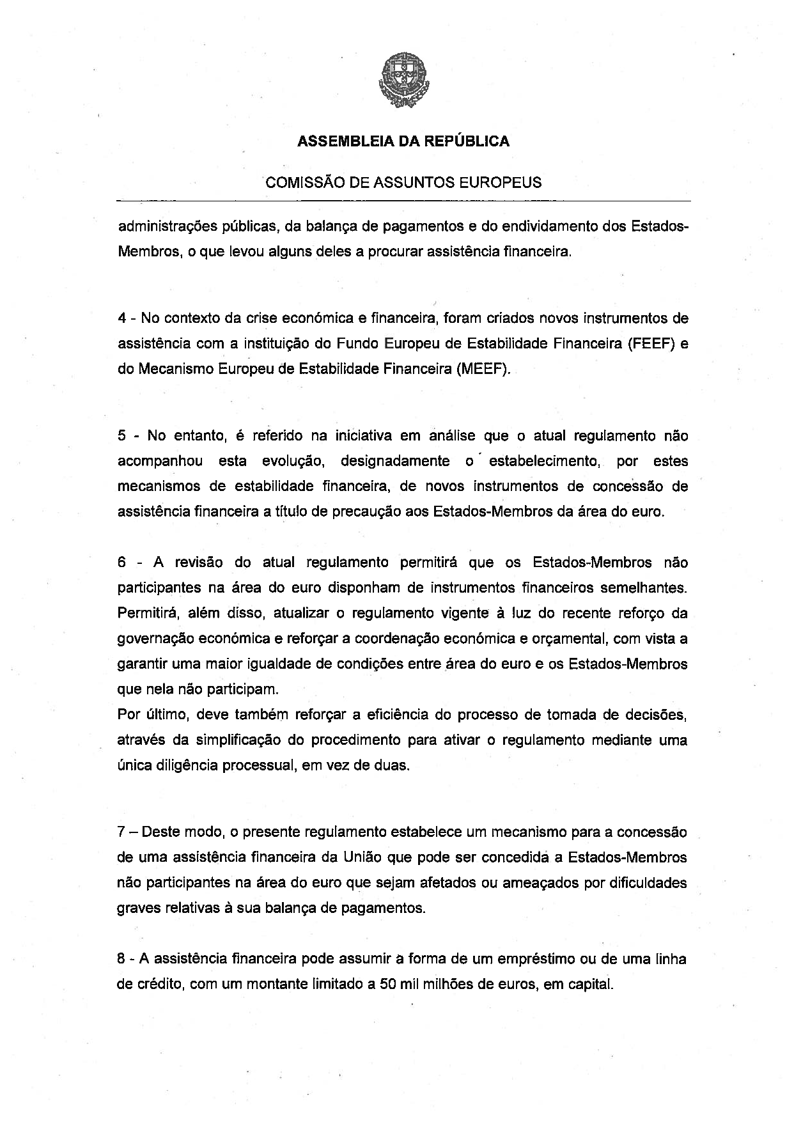
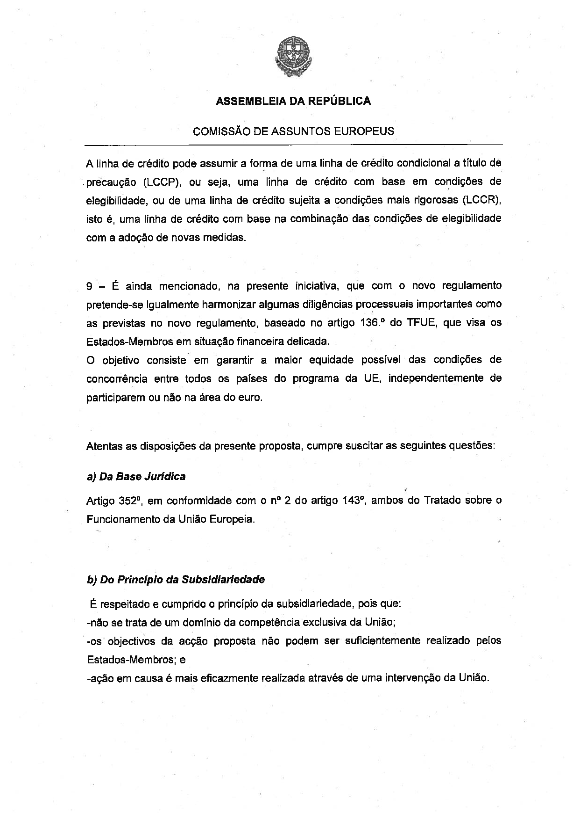
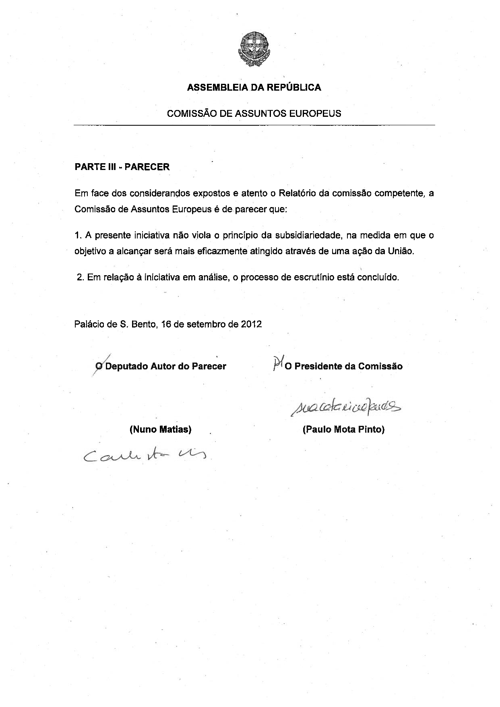

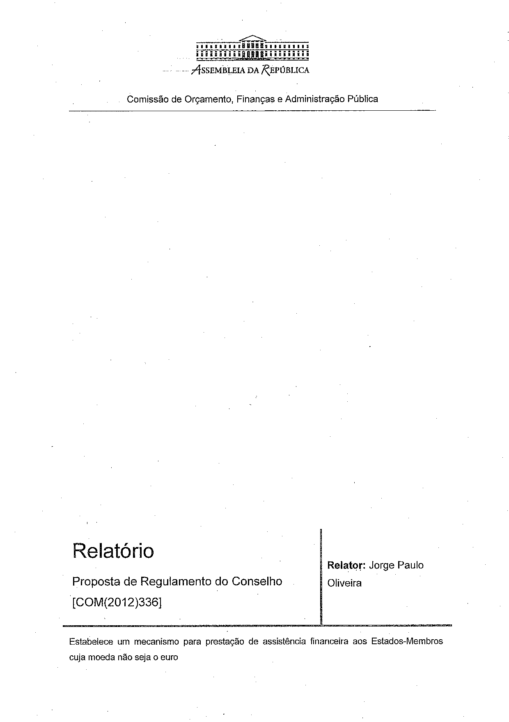
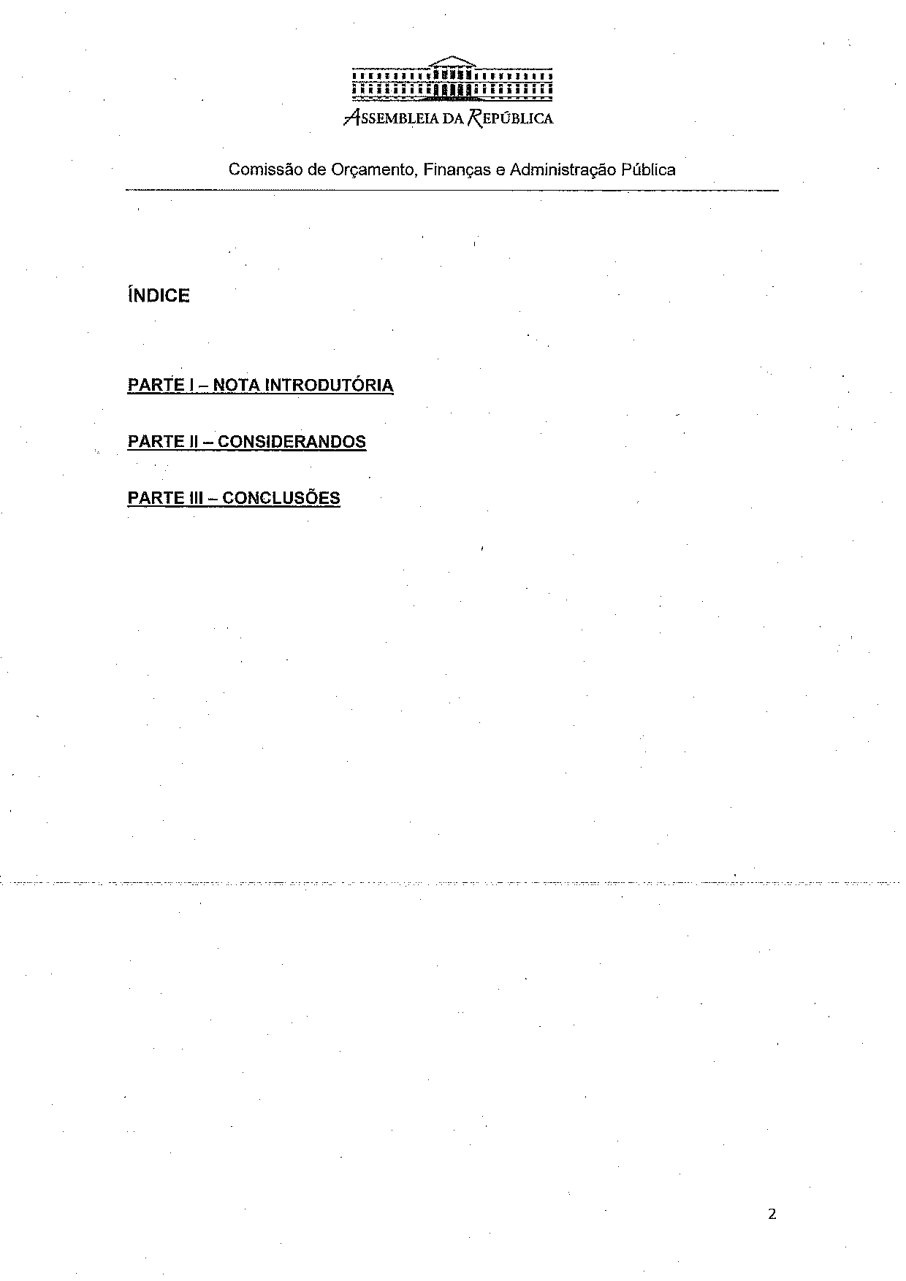
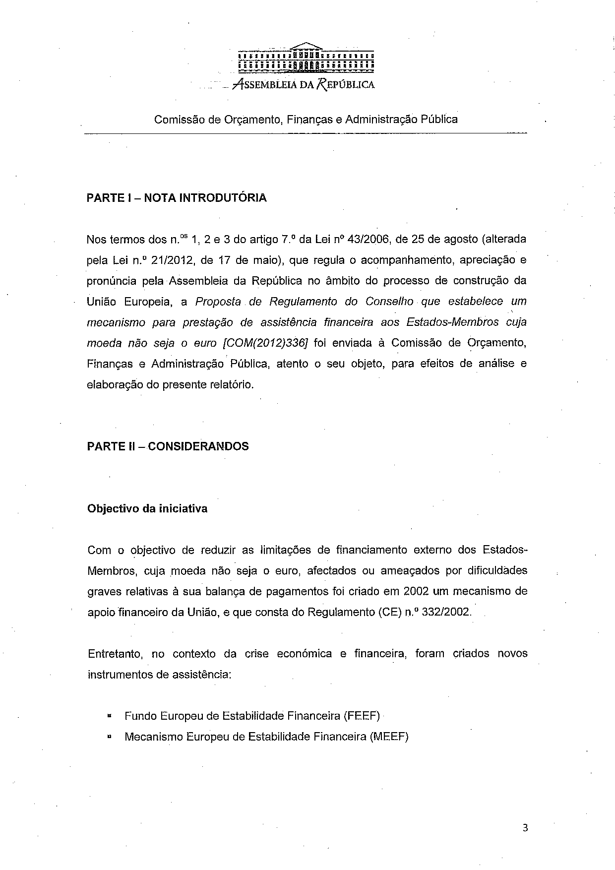
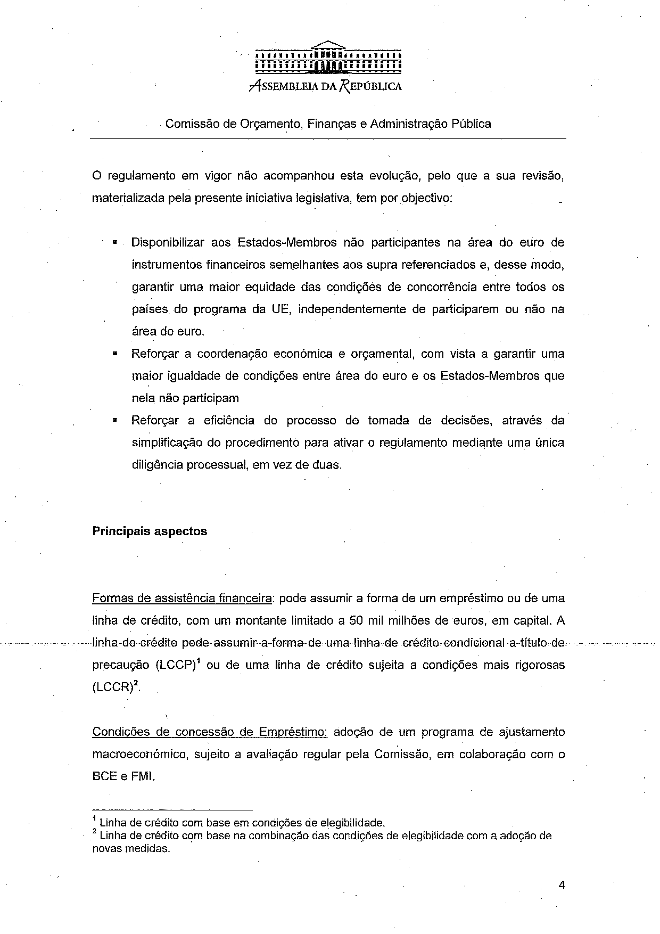
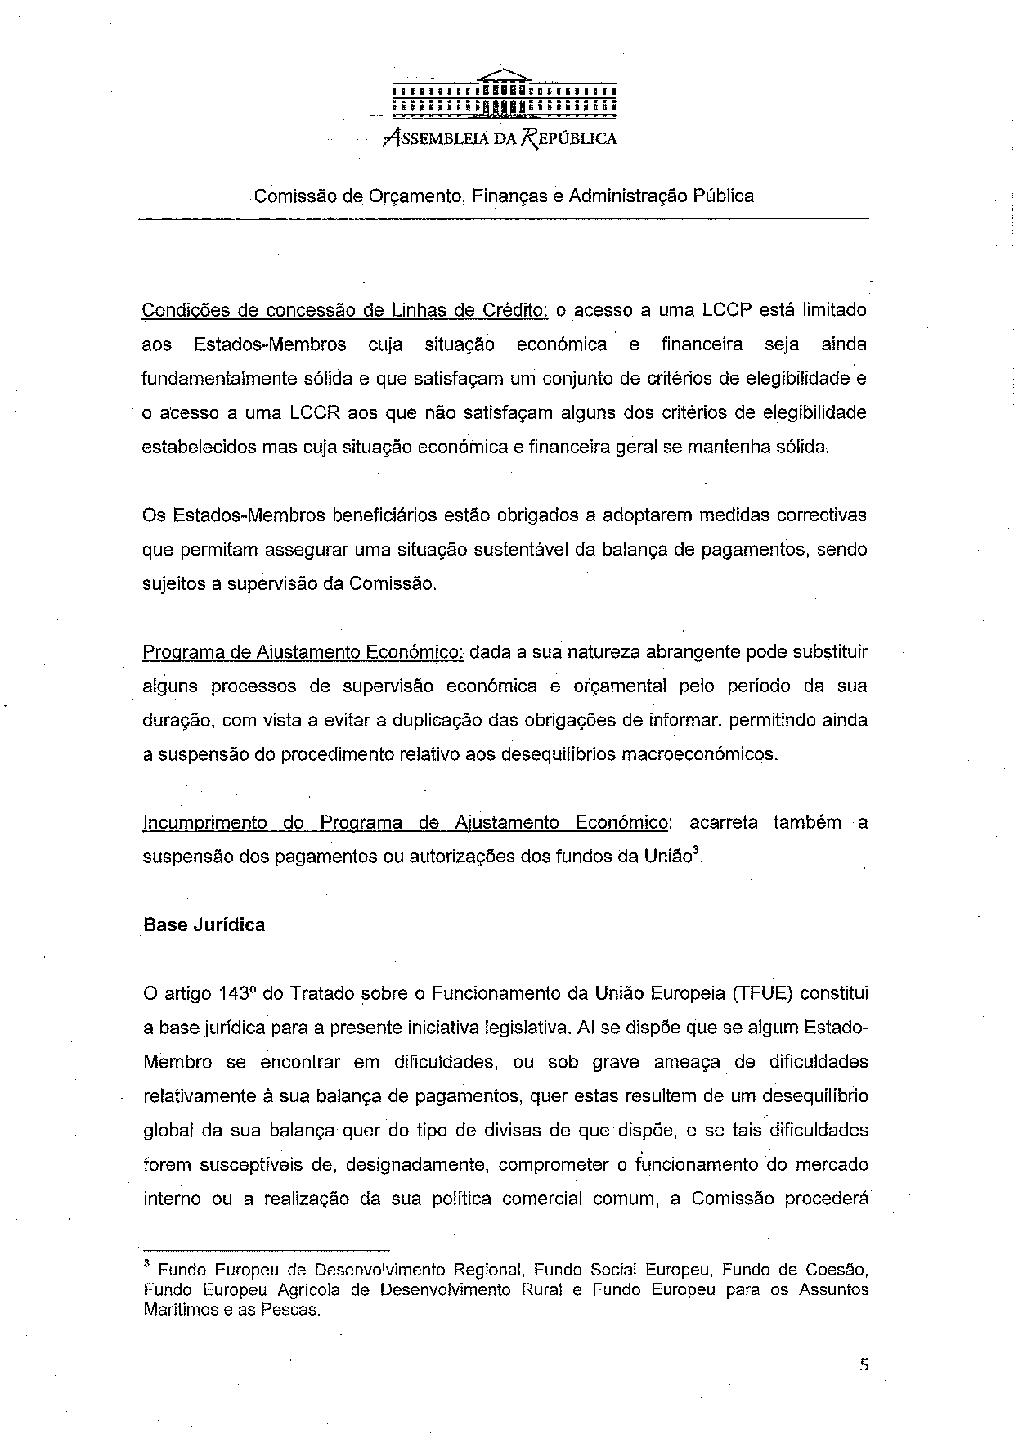
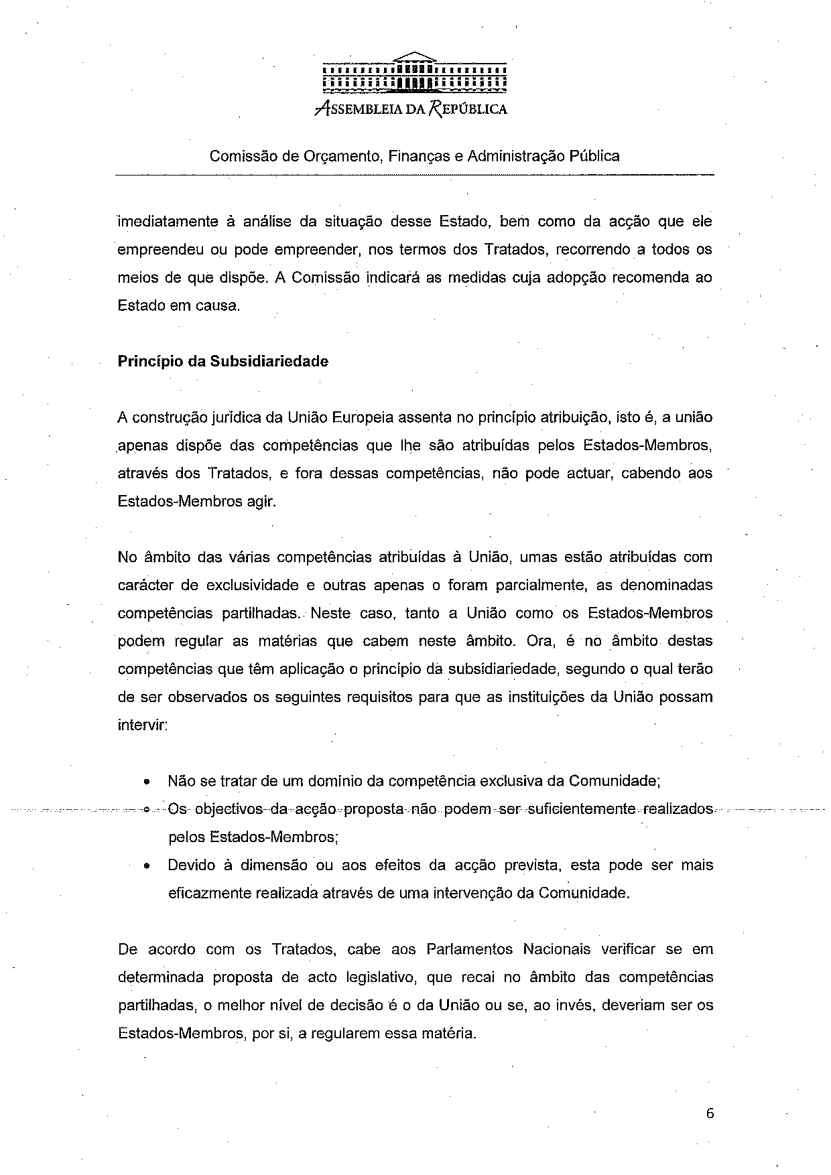
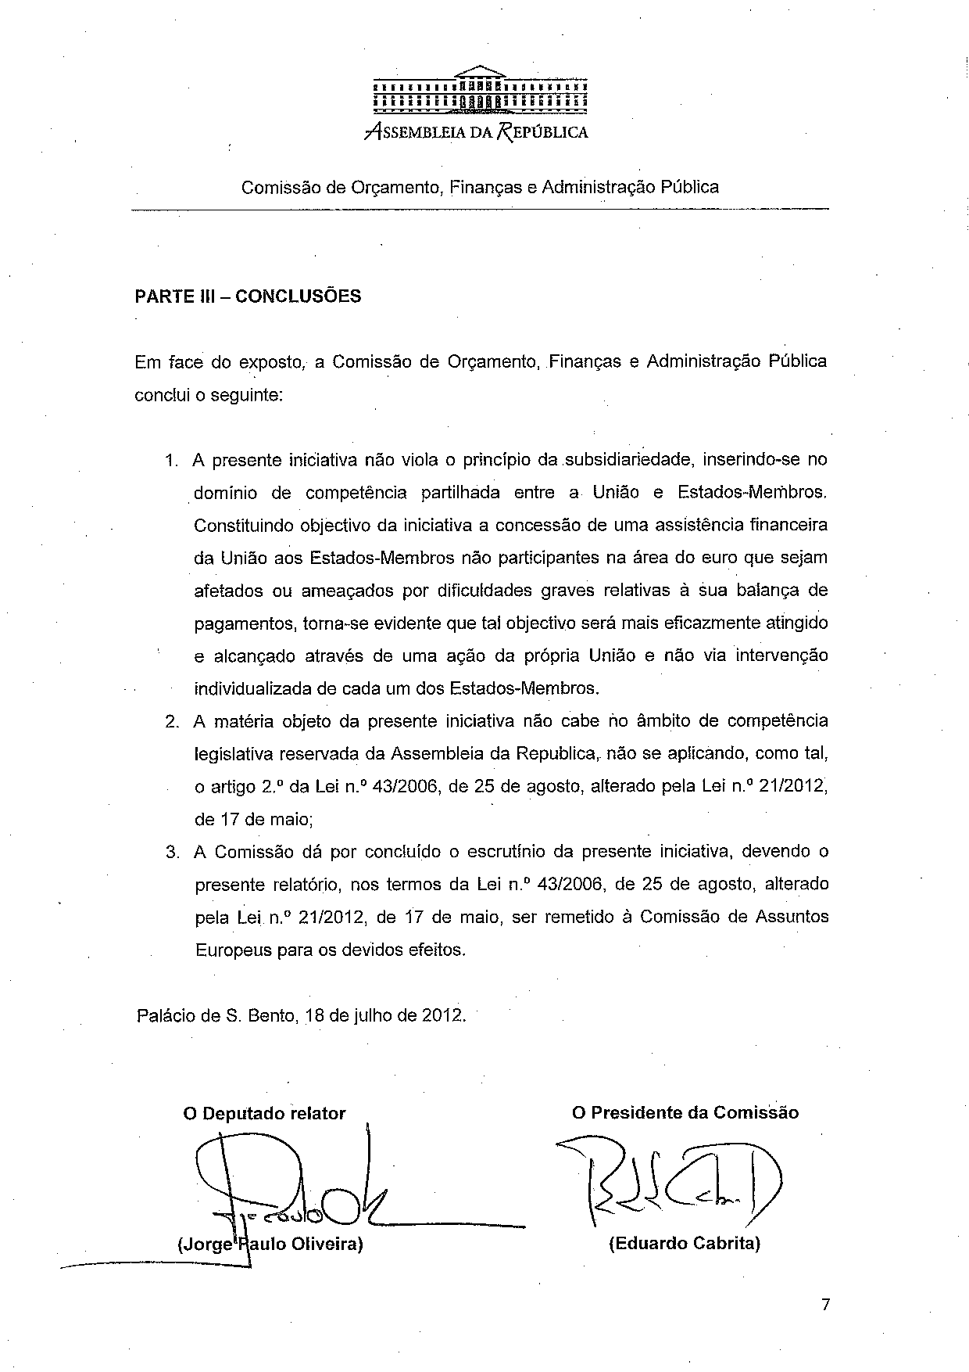

This opinion is available in English on the parliamentary EU http://www.ipex.eu/IPEXL-WEB/search.do

