 | 
COUNCIL OF  THE EUROPEAN UNION |  |  | Brussels, 19 October 2012
 | Interinstitutional File:  2012/0192 (COD) |  | 14982/12
PHARM 74
SAN 234
MI 637
COMPET 625
CODEC 2391
INST 588
PARLNAT 330

COVER NOTE
from: | Portuguese Parliament
date of receipt: | 10 October 2012
to: | The President of the Council of the European Union
No Cion doc.: | 12751/12 PHARM 60 SAN 176 MI 508 COMPET 513 CODEC 1946 -  COM (2012) 369 final
Subject: | Proposal for a Regulation of the European Parliament and of the Council on Clinical trials on medicinal products for human use, and repealing Directive 2001/20/EC  - Opinion on the application of the Principles of Subsidiarity and Proportionality

Delegations will find attached for information a copy of the above opinion.

________________________

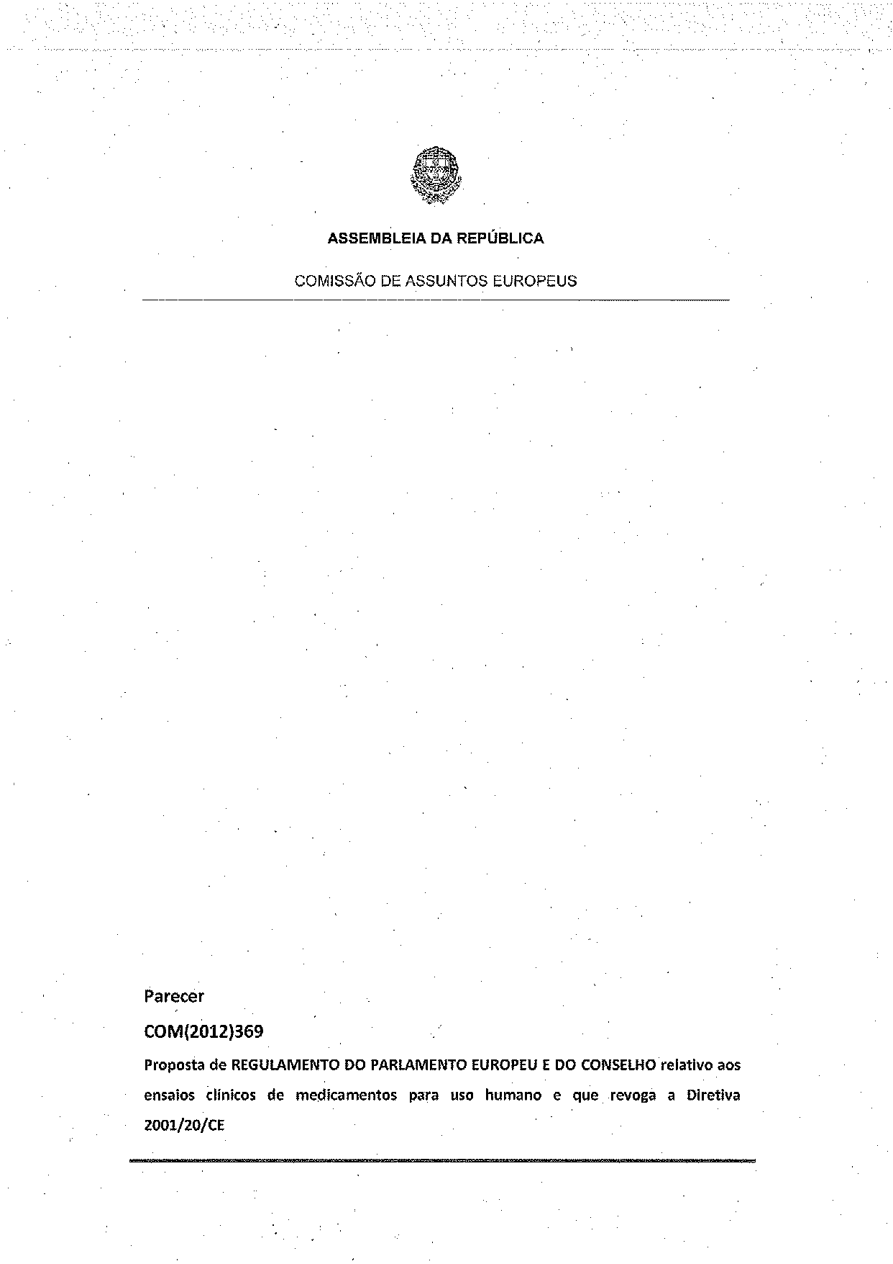
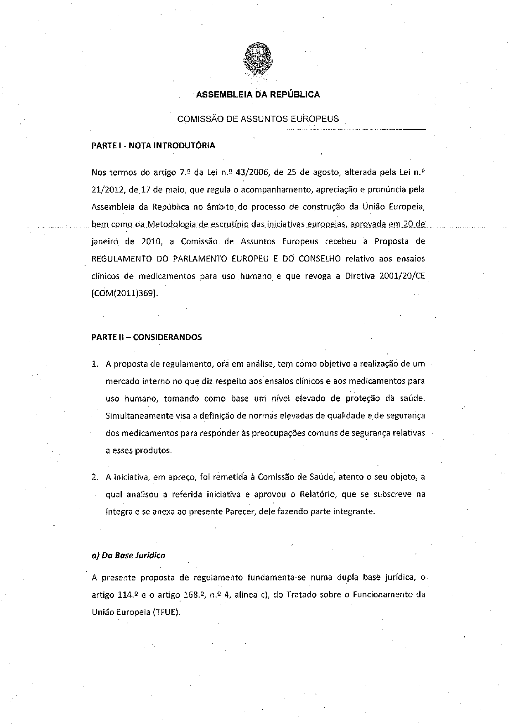
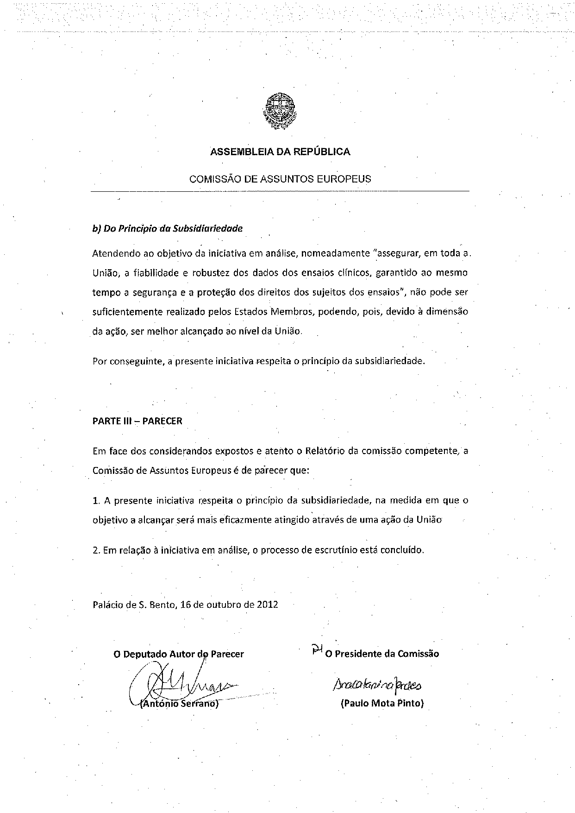
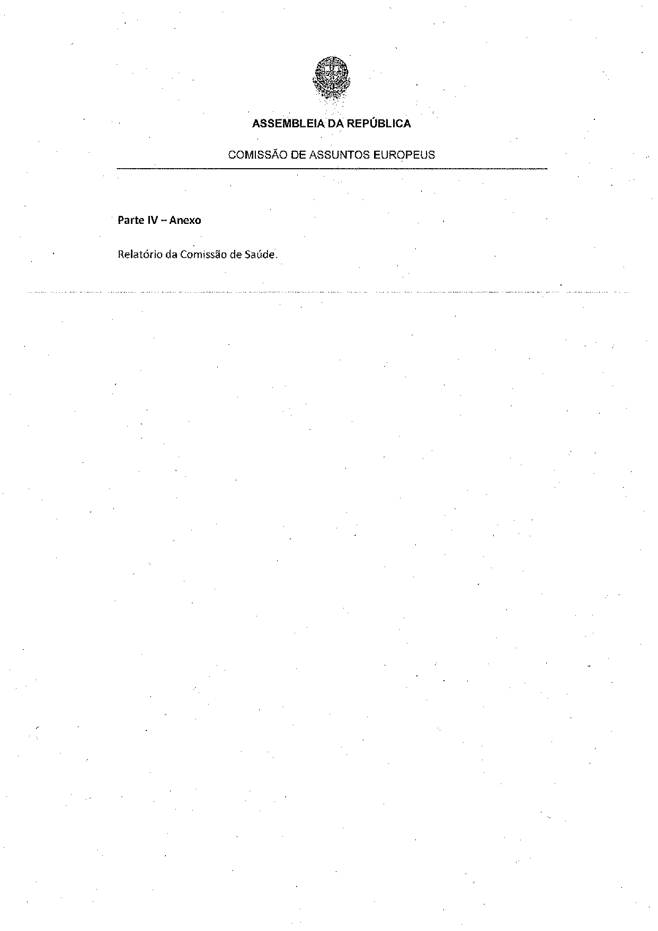
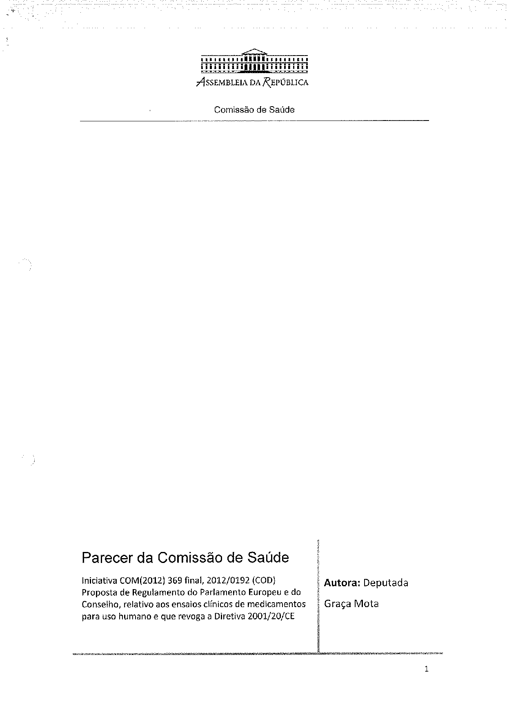
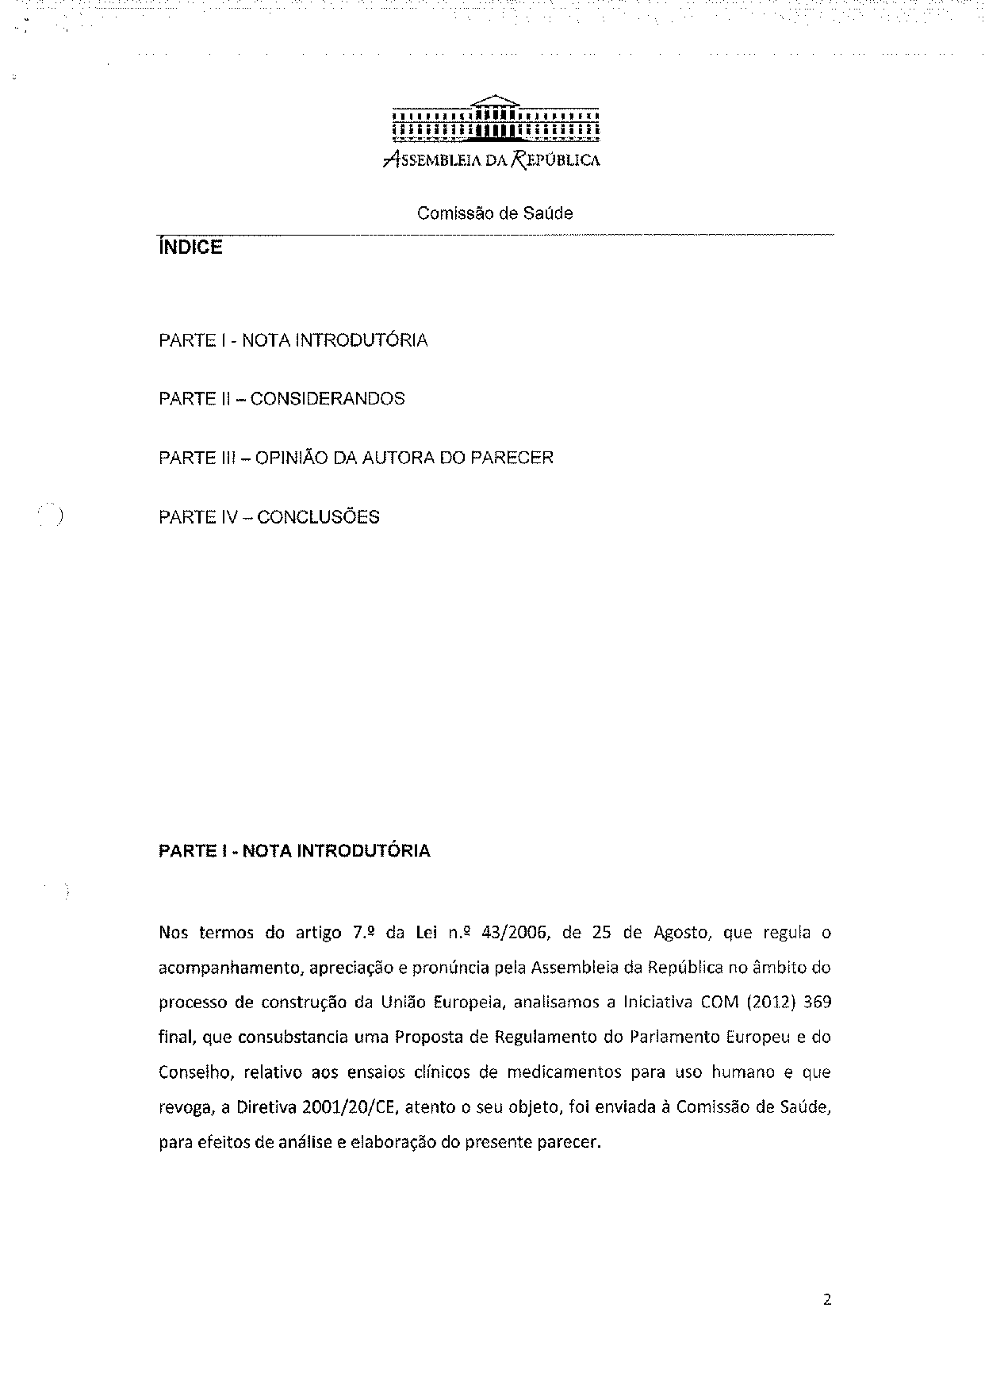
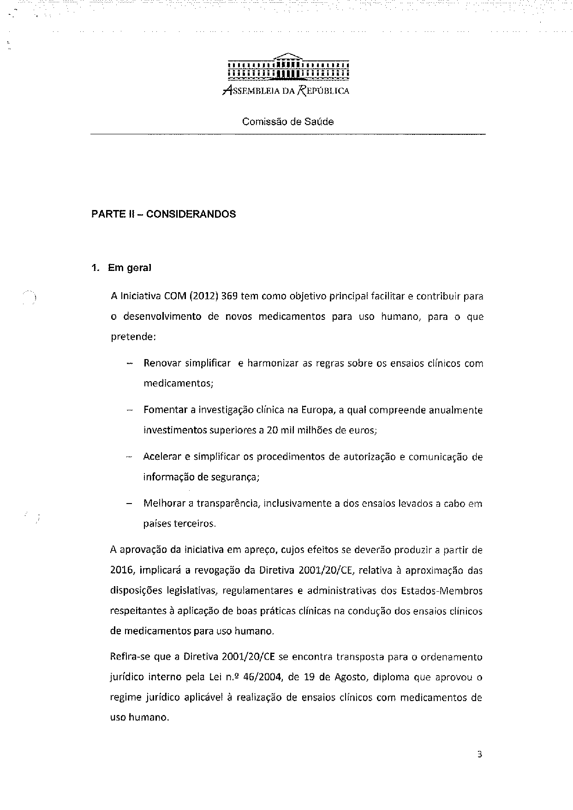
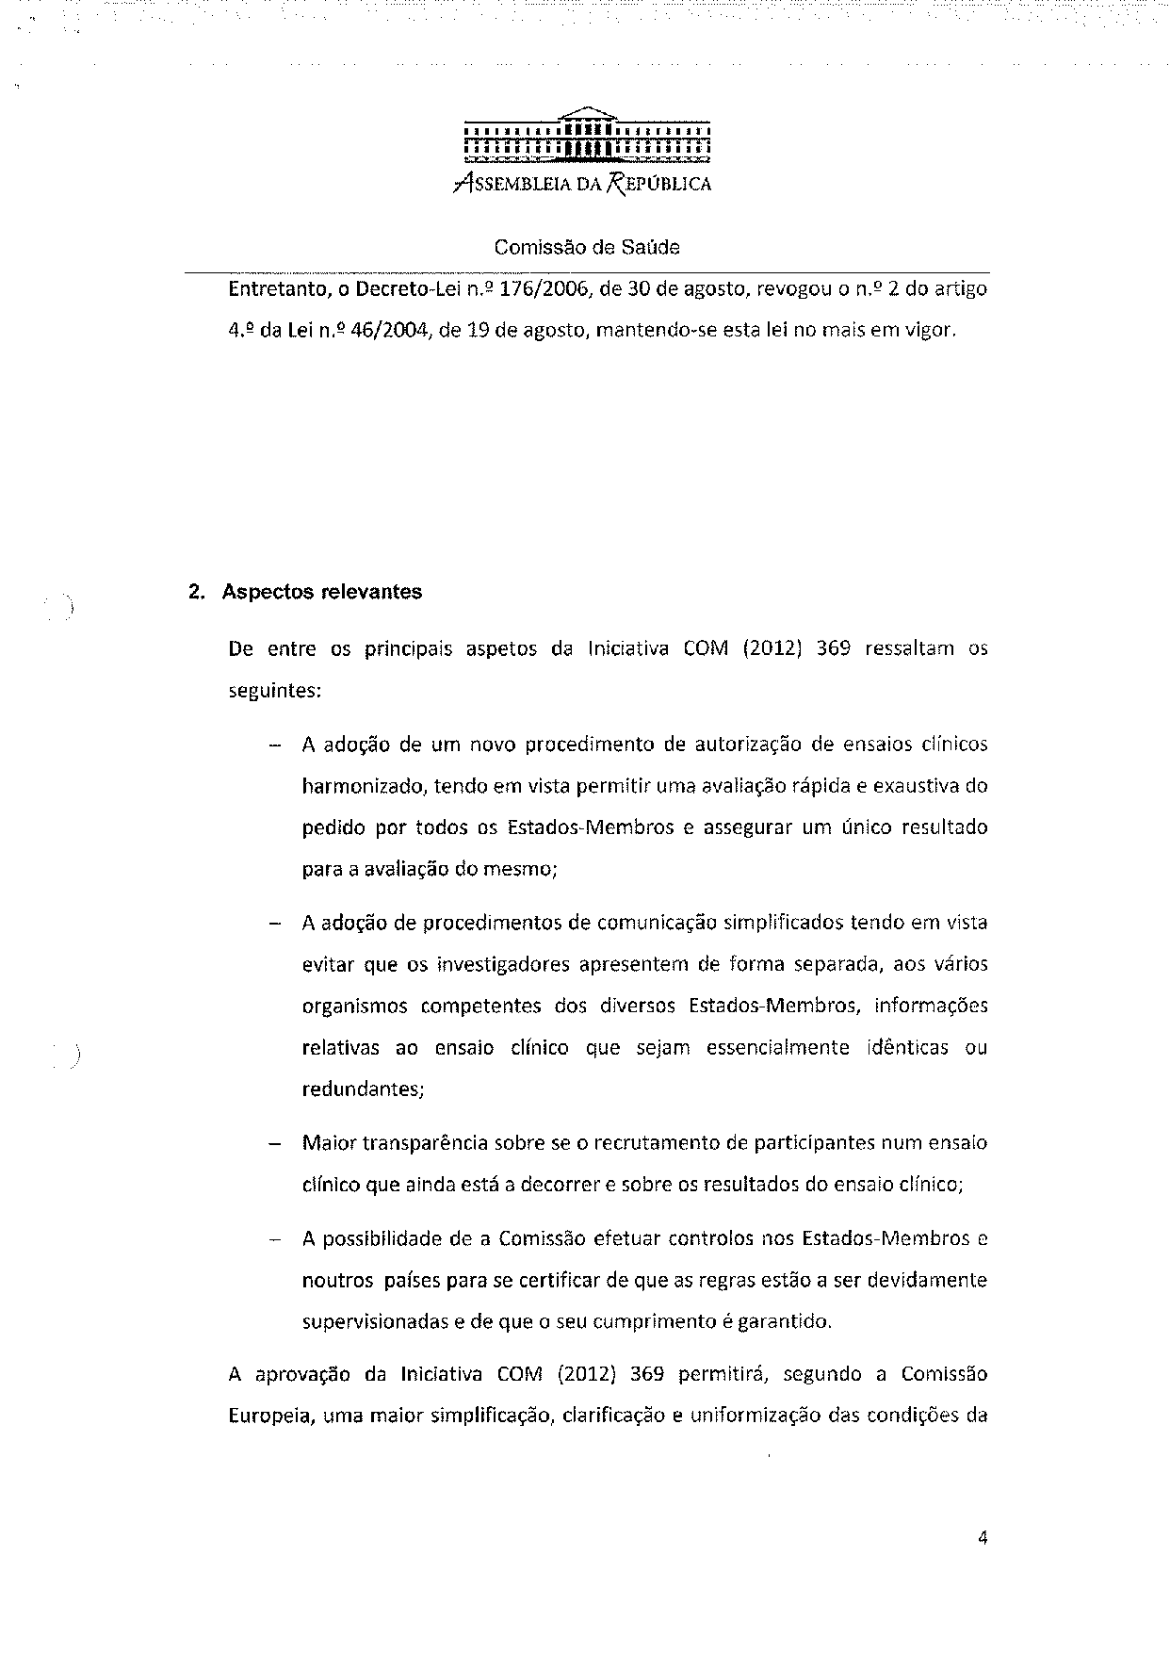
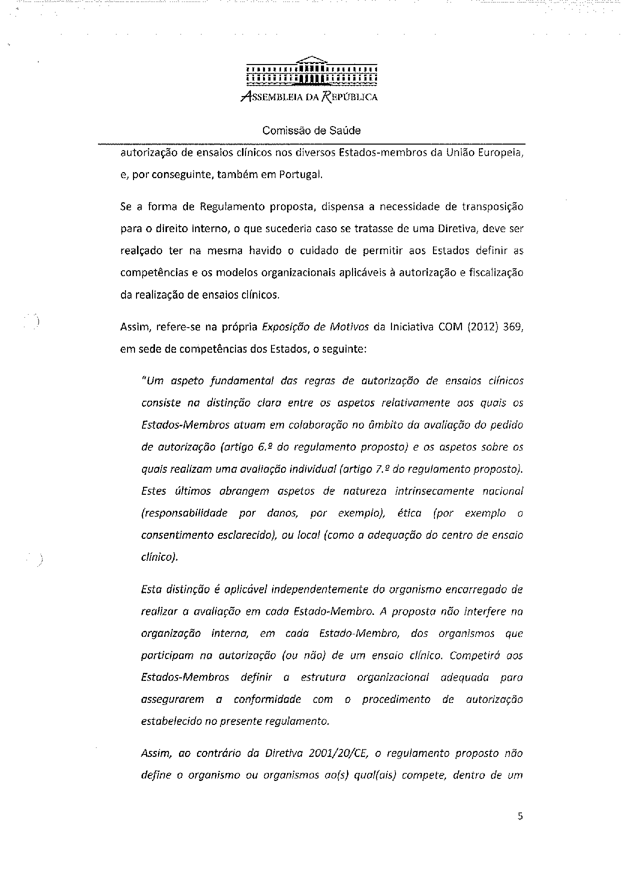
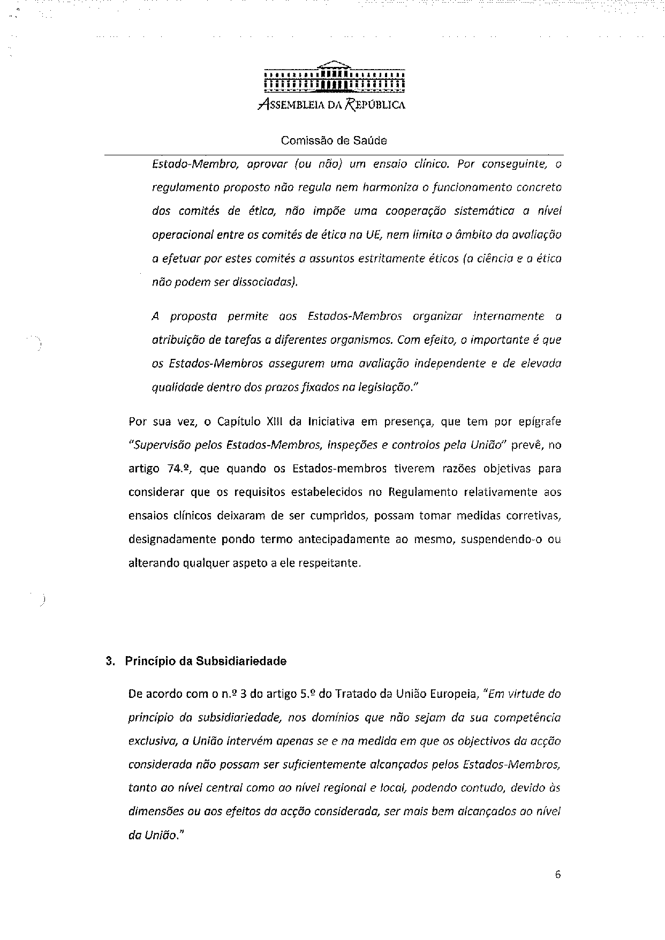
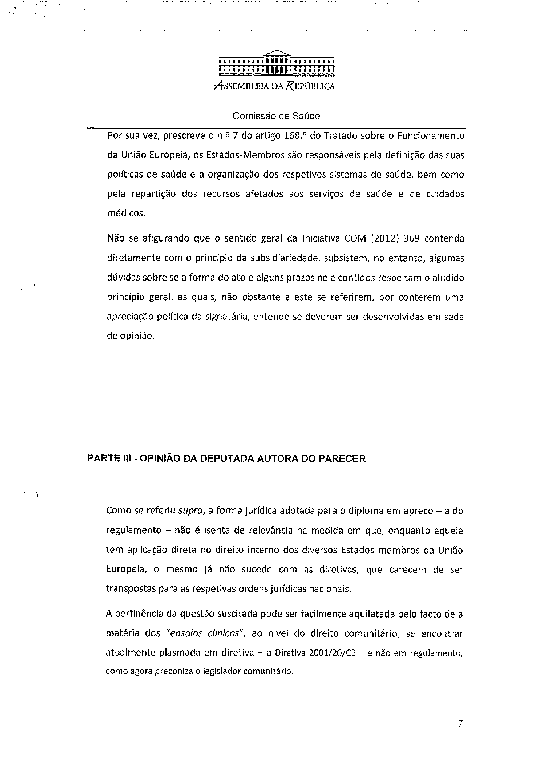
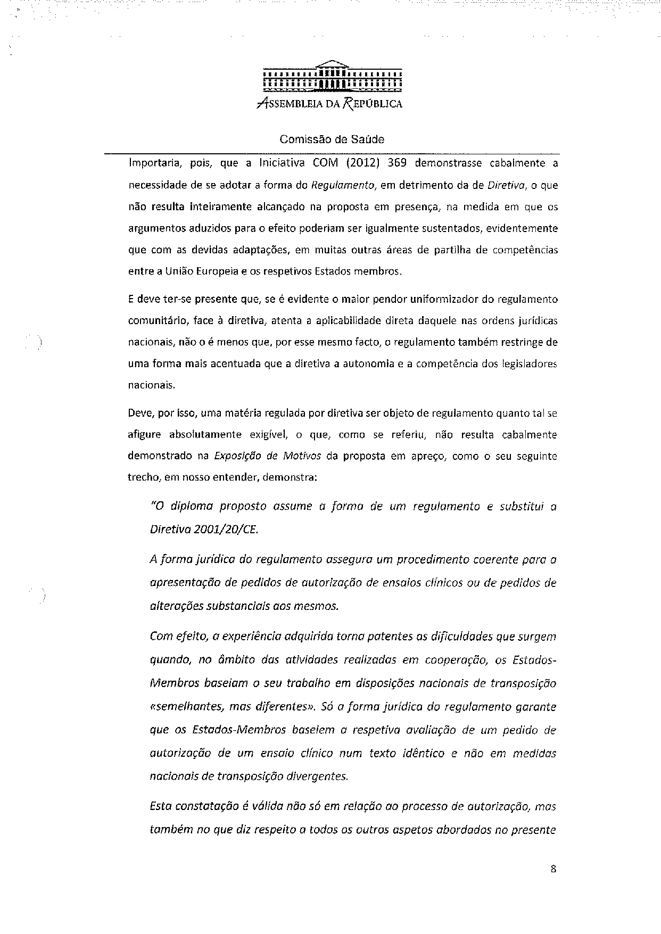
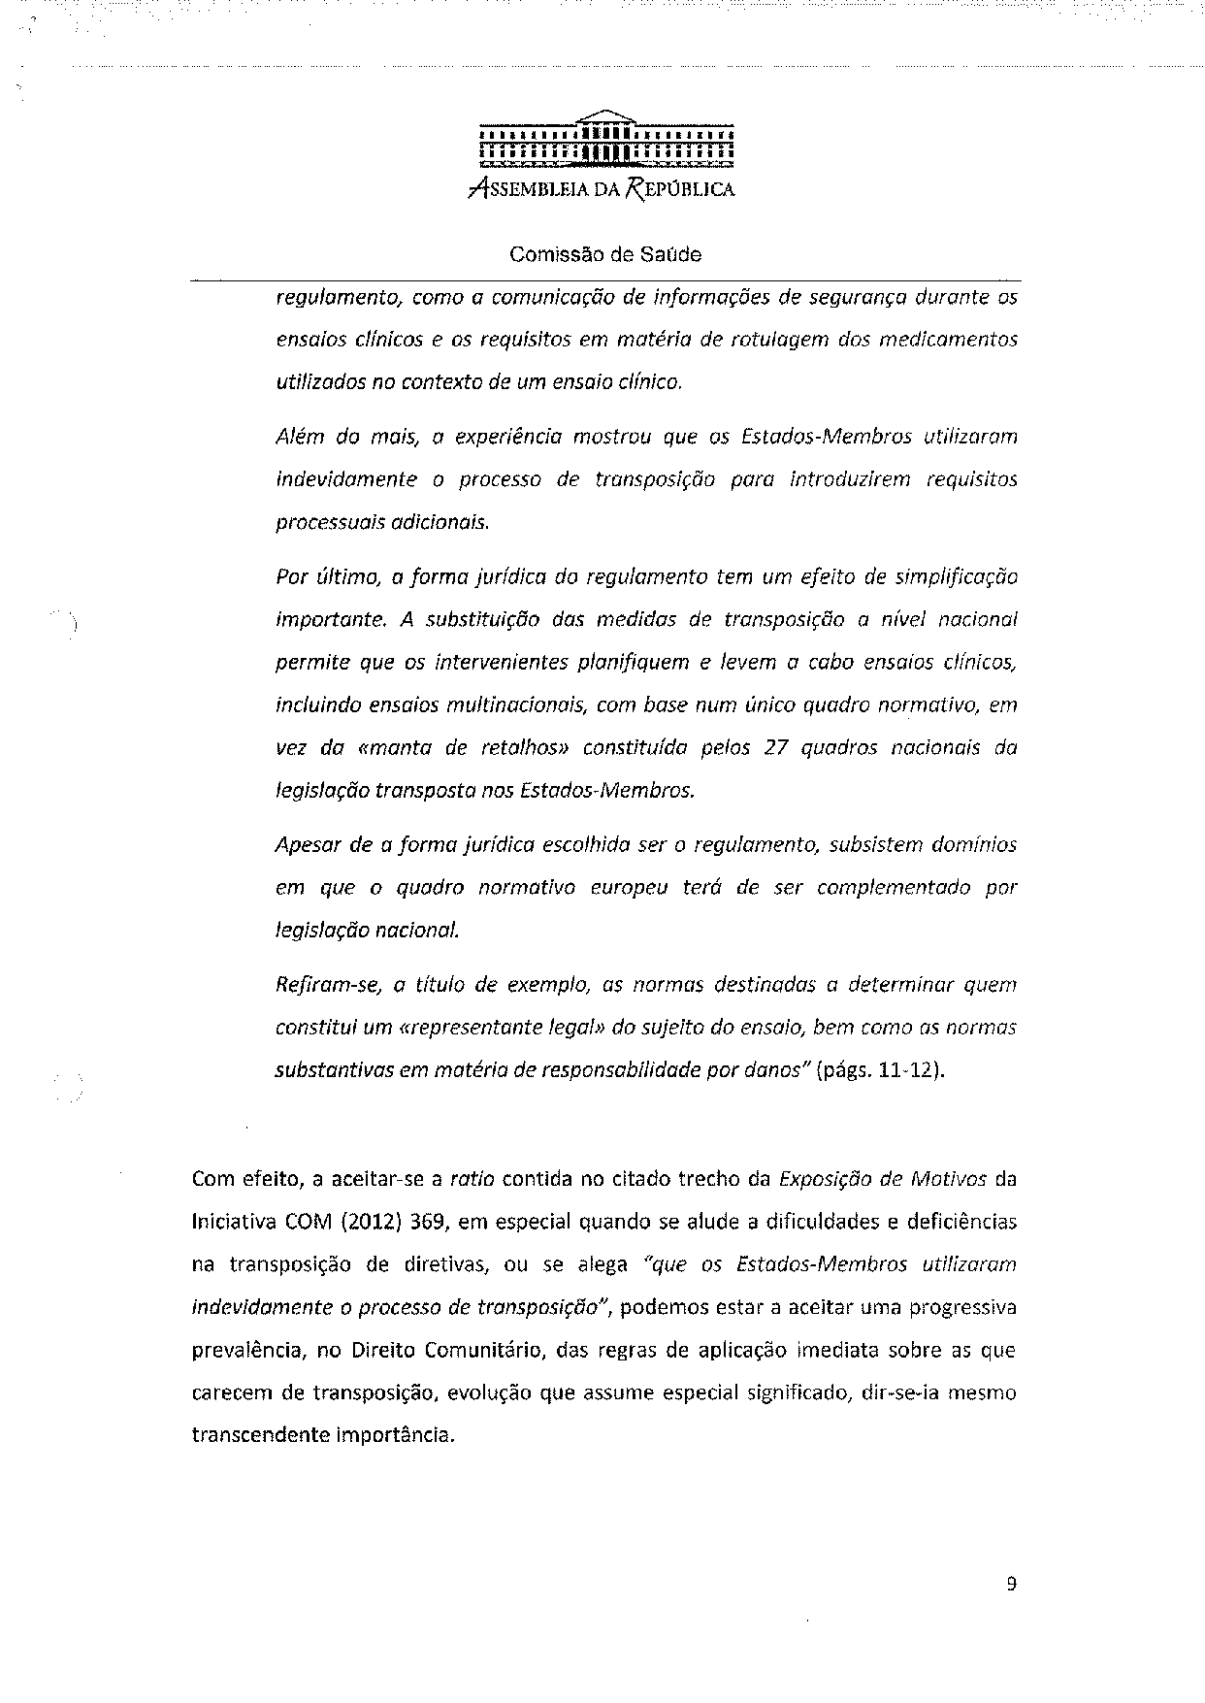
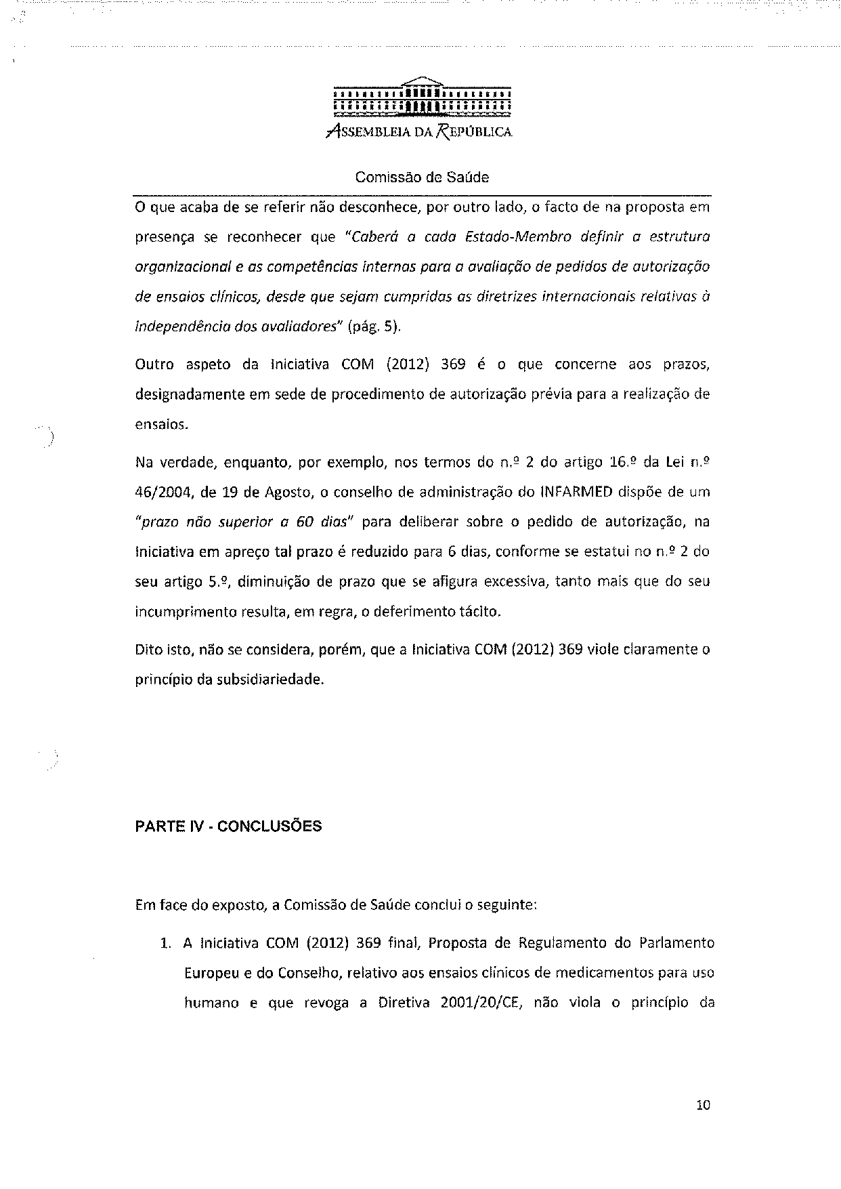
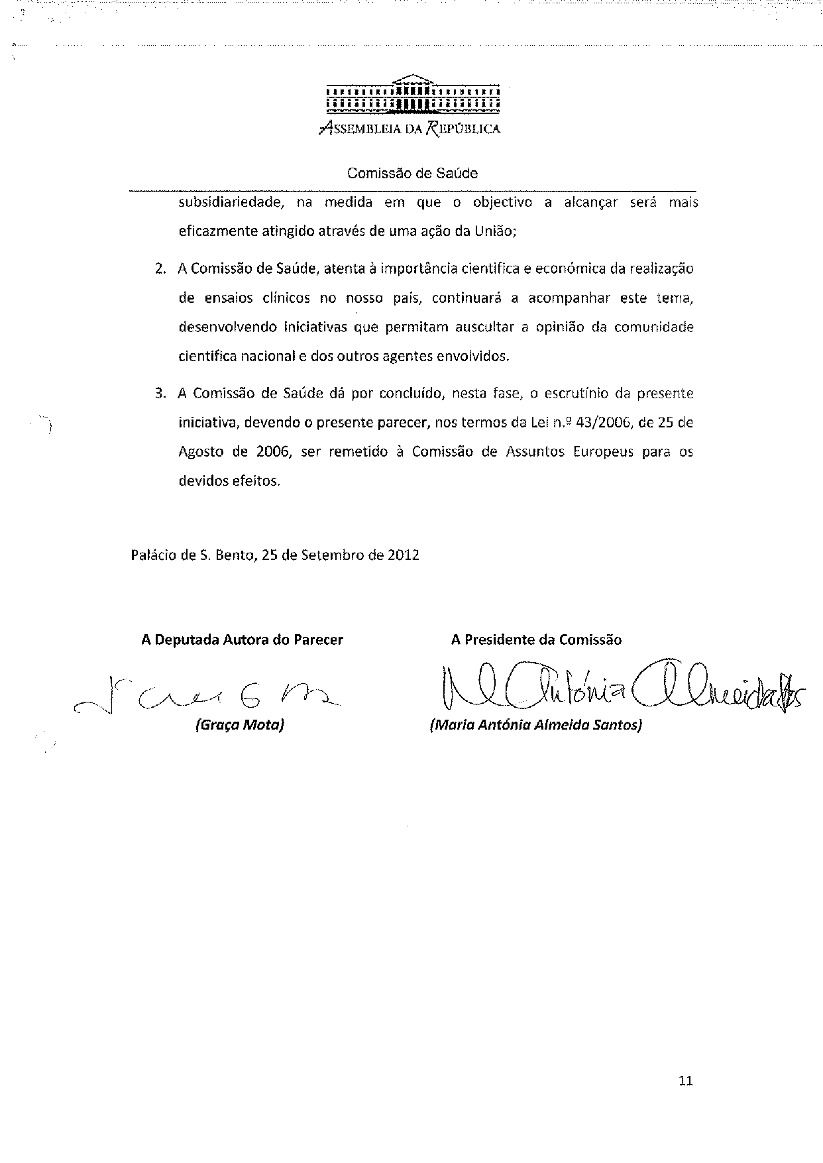

The translation can be found at the Interparliamentary EU information exchange site IPEX at the following address: http://www.ipex.eu/IPEXL-WEB/dossier/document/COM20120369.do#dossier-COD20120192

