 | 
COUNCIL OF  THE EUROPEAN UNION |  |  | Brussels, 17 October 2012
 | Interinstitutional File:  2012/0175 (COD) |  | 15101/12
EF 226
ECOFIN 851
SURE 13
CODEC 2413
INST 597
PARLNAT 332

COVER NOTE
from: | The Portuguese Parliament
date of receipt: | 10 October 2012
to: | President of the European Union
Subject: | Proposal for a DIRECTIVE OF THE EUROPEAN PARLIAMENT AND OF THE COUNCIL on insurance mediation  (recast)  [doc. ST 12407/12 EF 168 ECOFIN 691 SURE 10 CODEC 1880 - COM(2012) 360 final]  - Opinion on the application of the Principles of Subsidiarity and Proportionality

Delegations will find attached the abovementioned opinion.
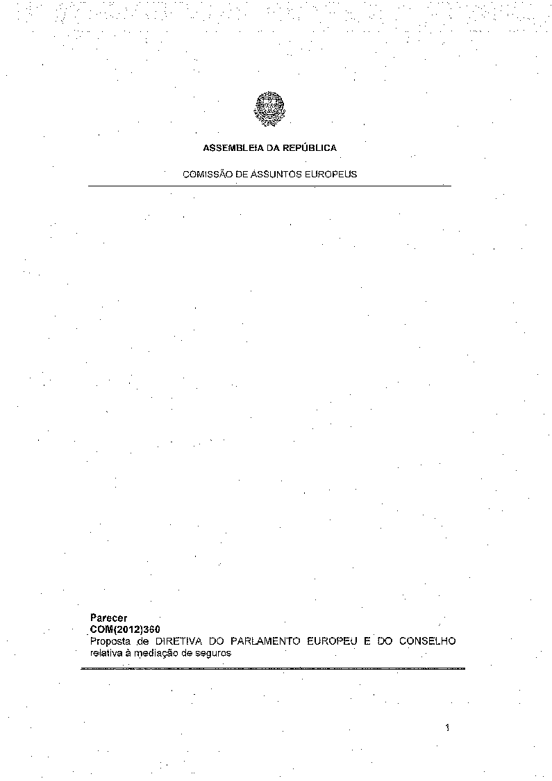
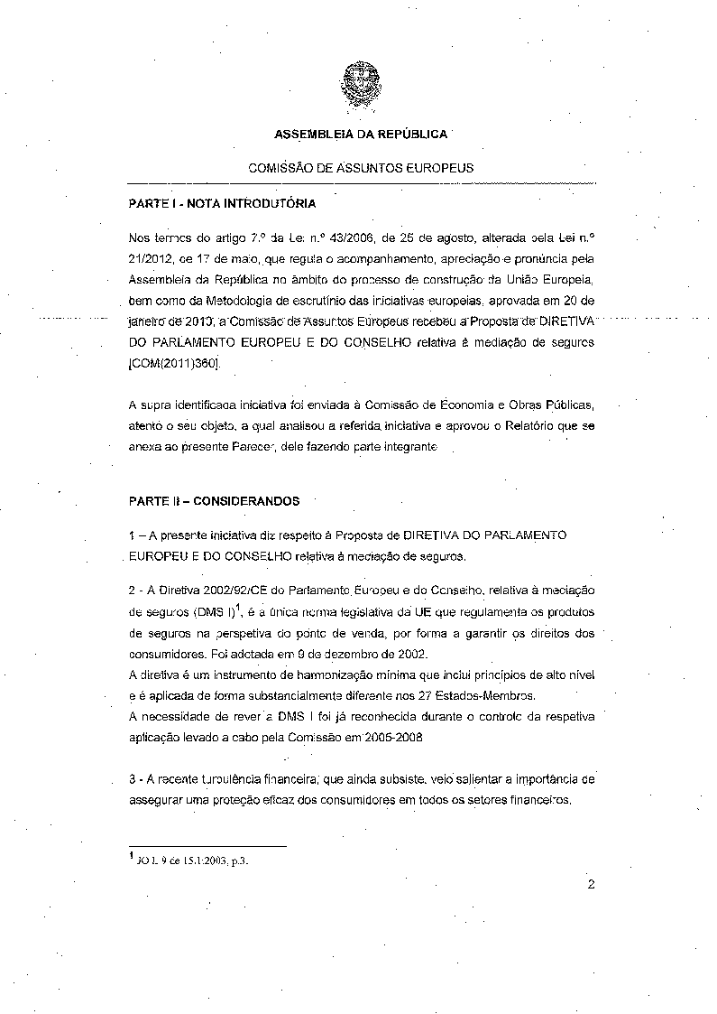
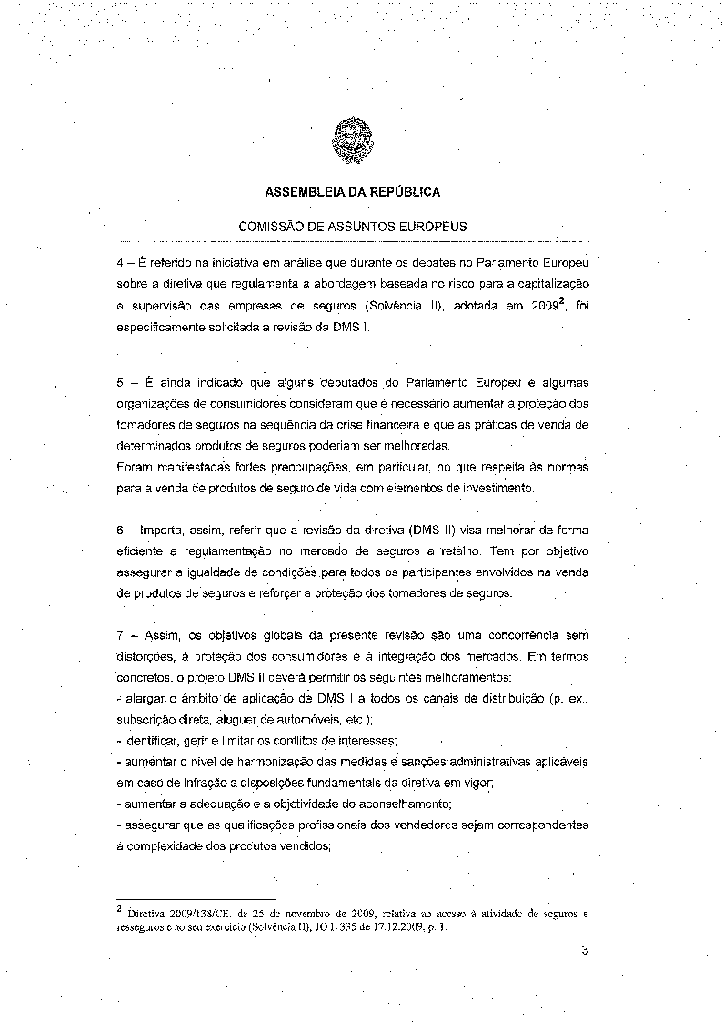
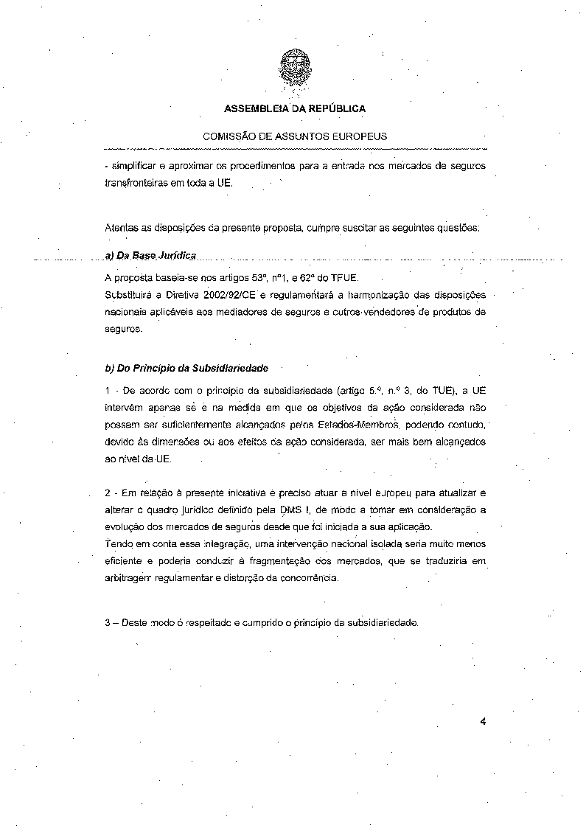
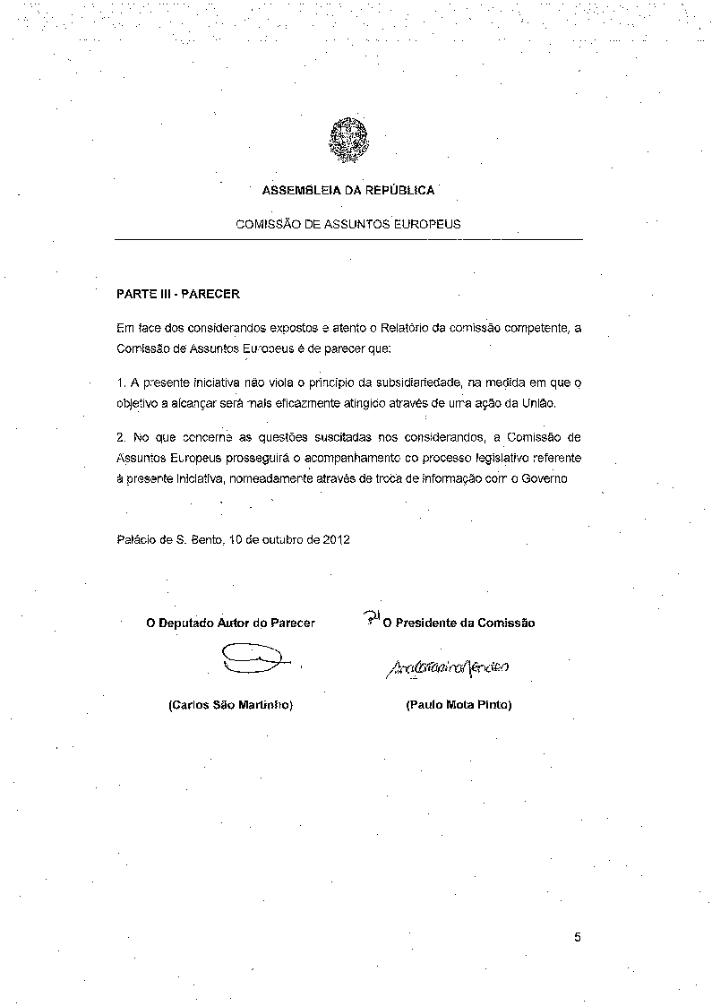

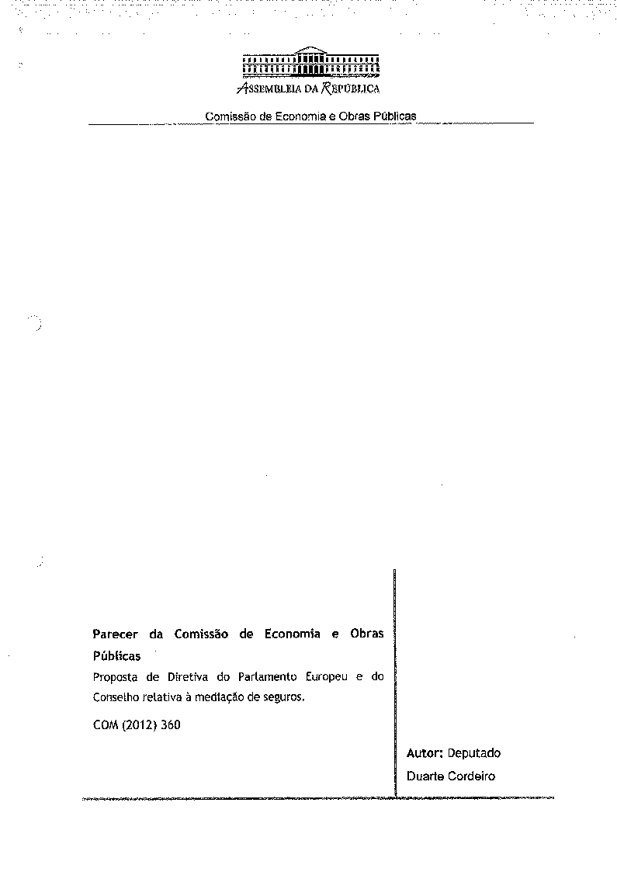
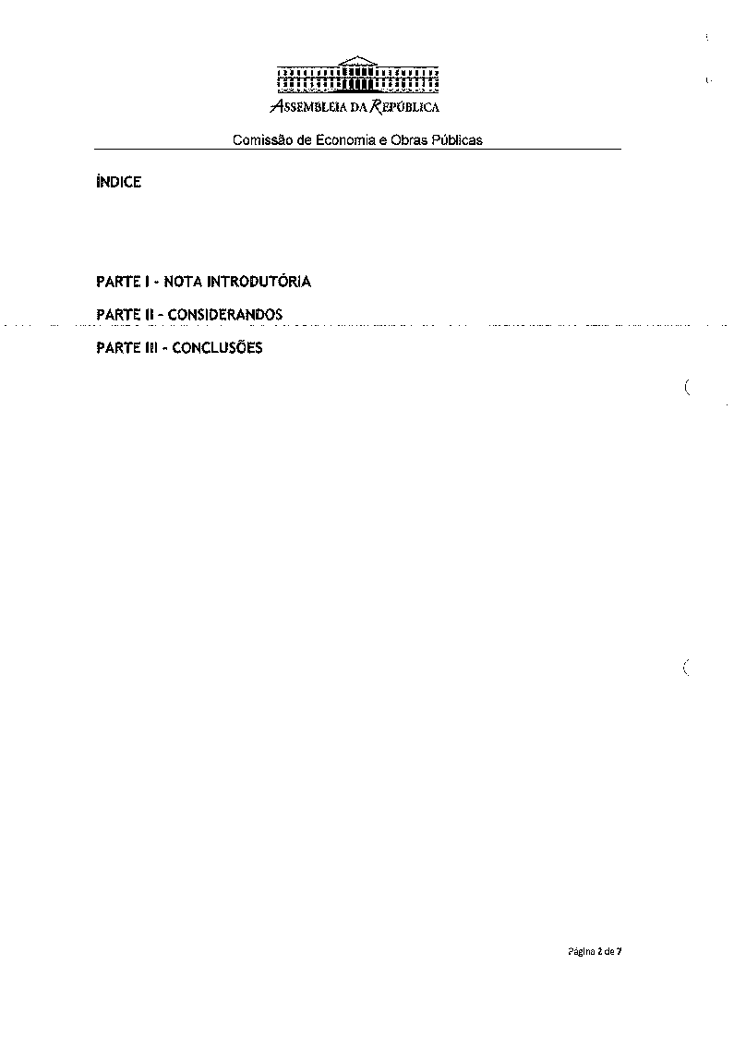
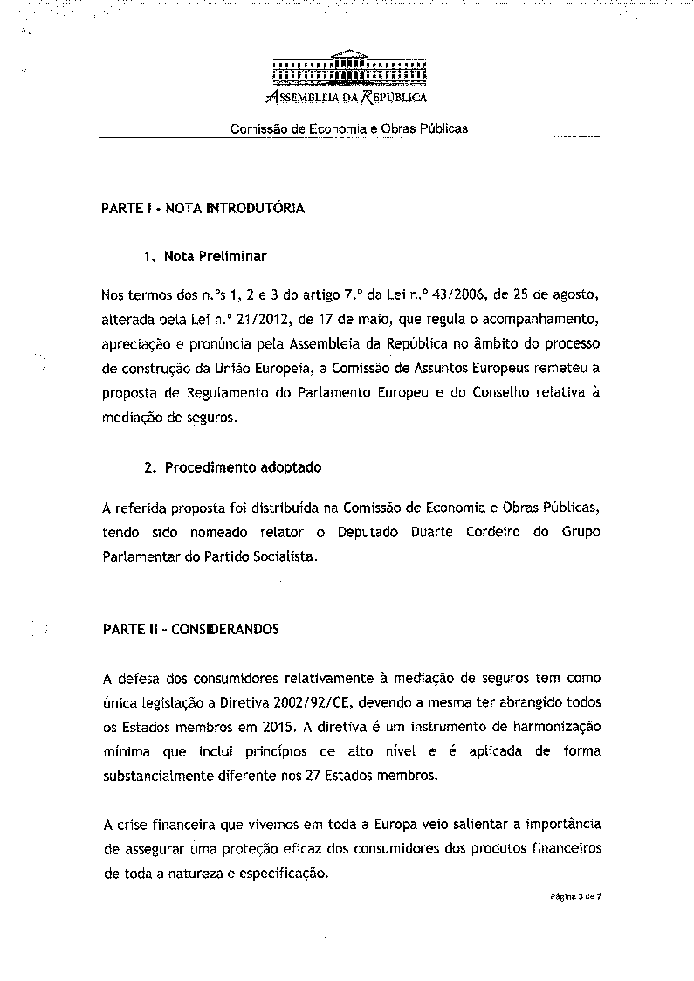
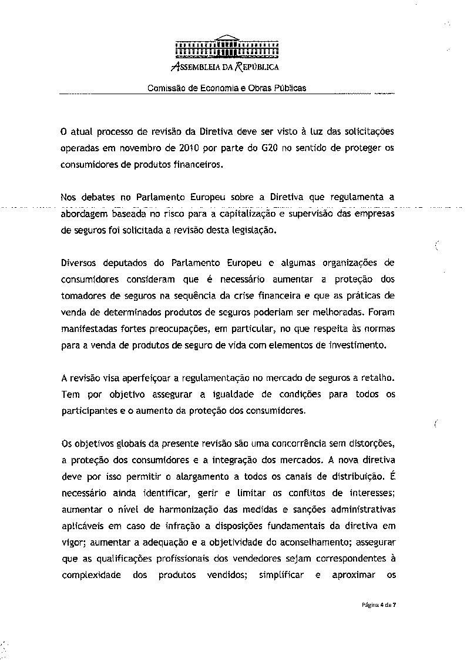
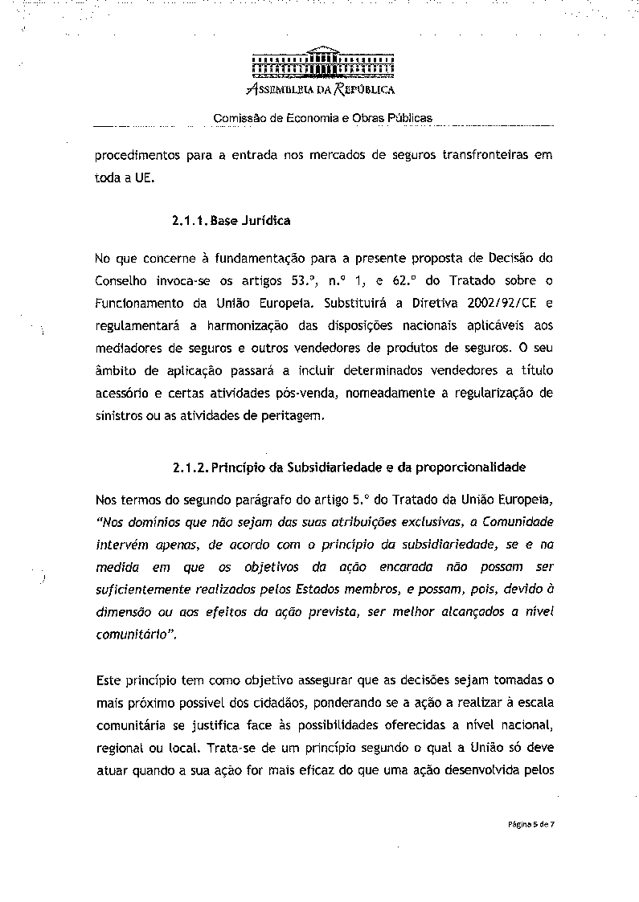
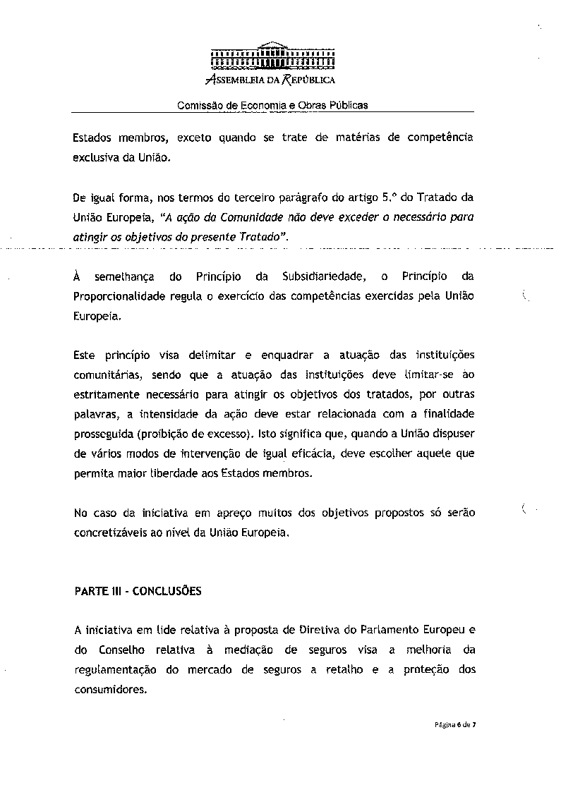
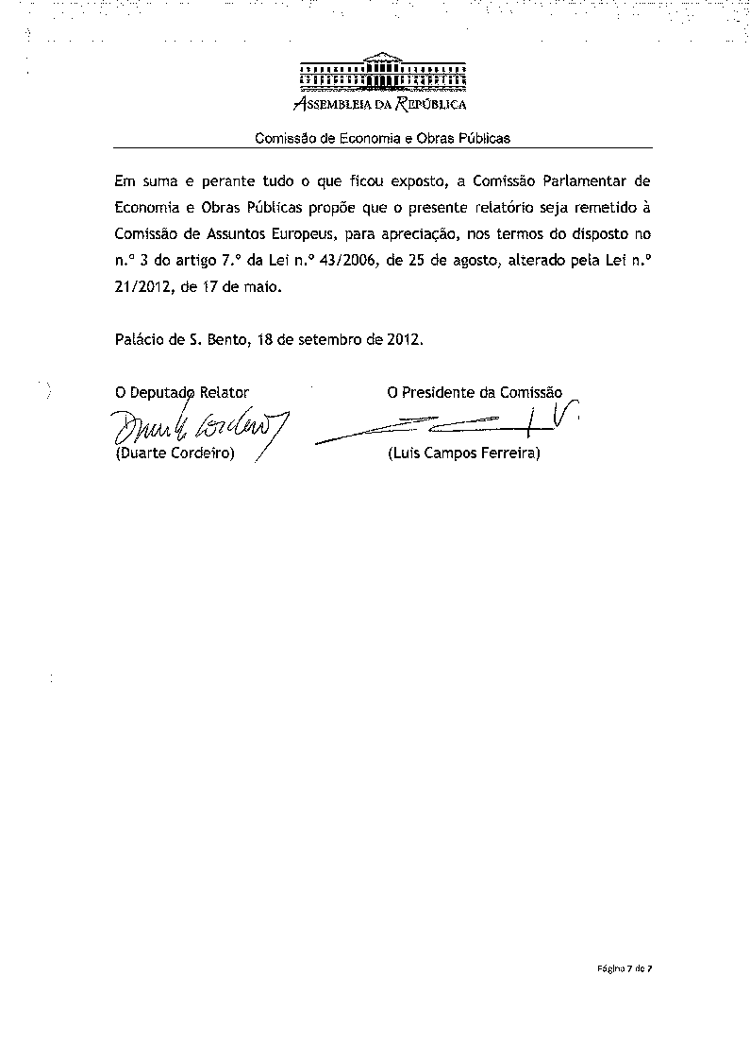

Translations of the opinion may be available in the Interparliamentary EU information exchange site IPEX at the following address: http://www.ipex.eu/IPEXL- WEB/search.do

