 | 
COUNCIL OF  THE EUROPEAN UNION |  |  | Brussels, 17 October 2012
 | Interinstitutional File:  2012/0168 (COD) |  | 15104/12
EF 228
ECOFIN 853
CODEC 2415
INST 599
PARLNAT 334

COVER NOTE
from: | The Portuguese Parliament
date of receipt | 10 October 2012
to | President of the European Union
Subject: | Proposal for a DIRECTIVE OF THE EUROPEAN PARLIAMENT AND OF THE COUNCIL amending Directive 2009/65/EC on the coordination of laws, regulations and administrative provisions relating to undertakings for collective investment in transferable securities (UCITS) as regards depositary functions, remuneration policies and sanctions [doc. ST 12397/12 EF 166 ECOFIN 689 CODEC 1878 - COM(2012) 350 final]  - Opinion on the application of the Principles of Subsidiarity and Proportionality

Delegations will find attached the above mentioned opinion.
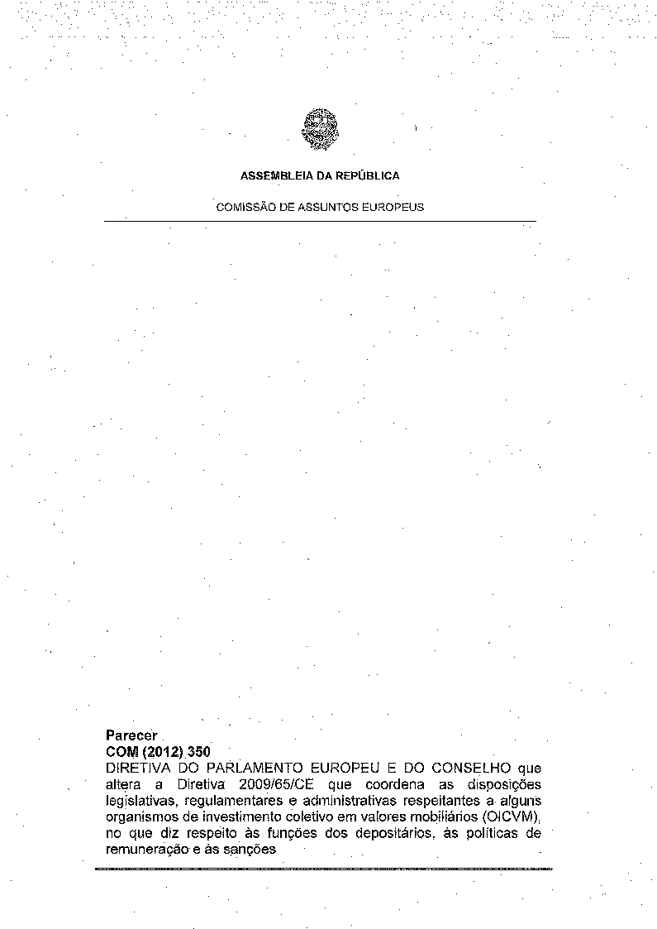
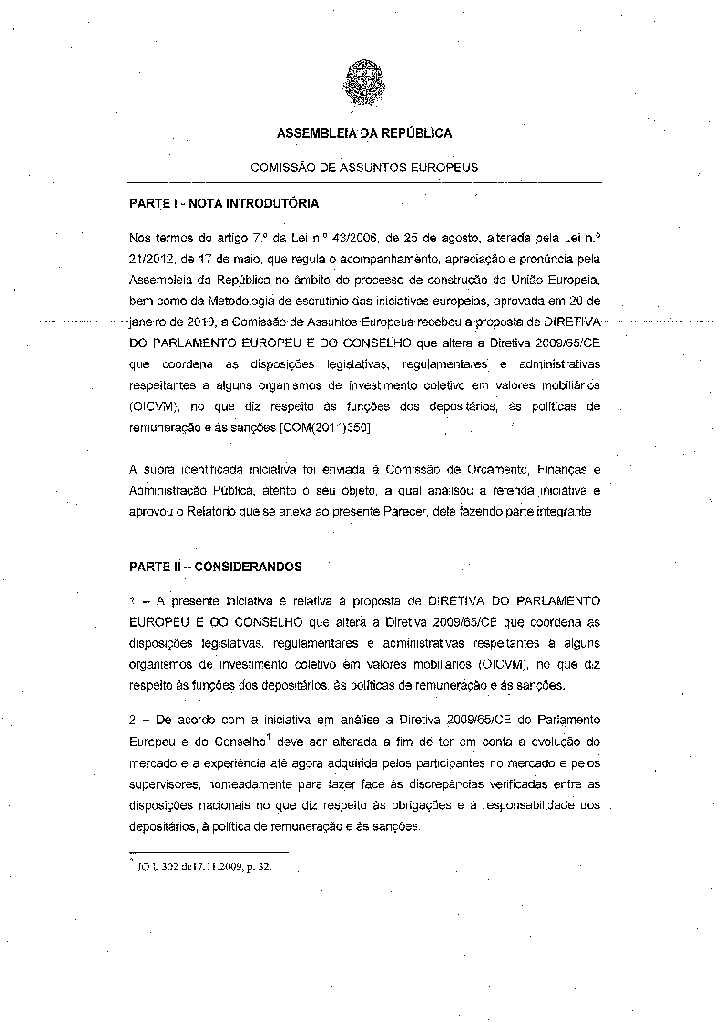
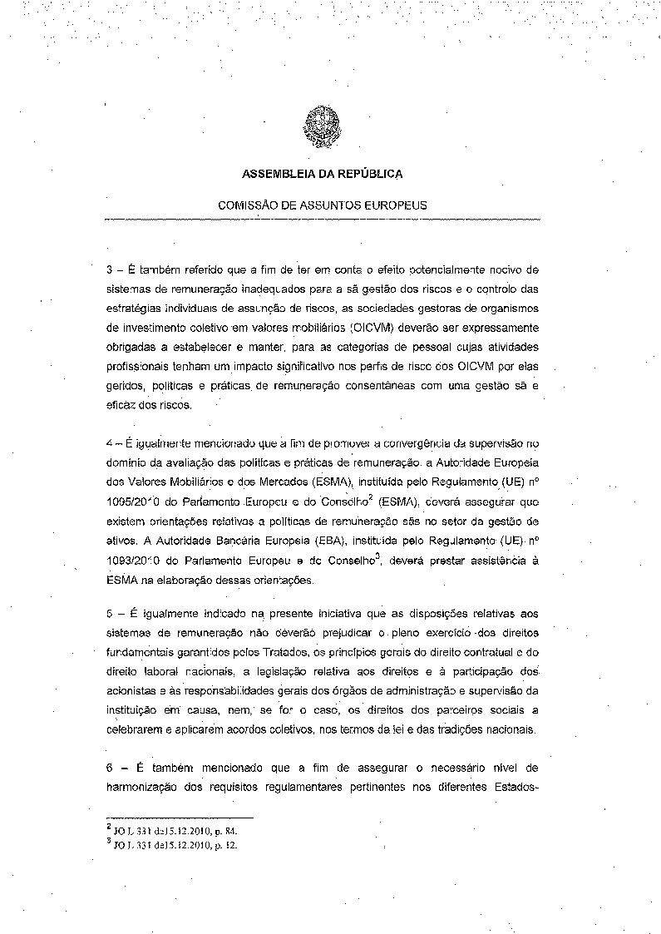
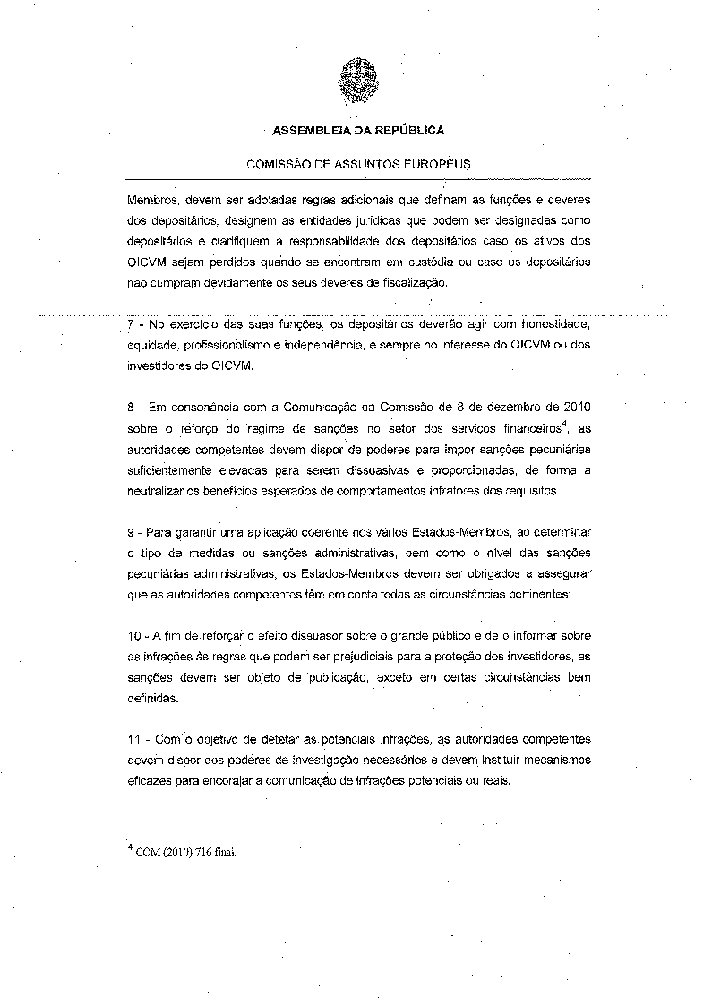
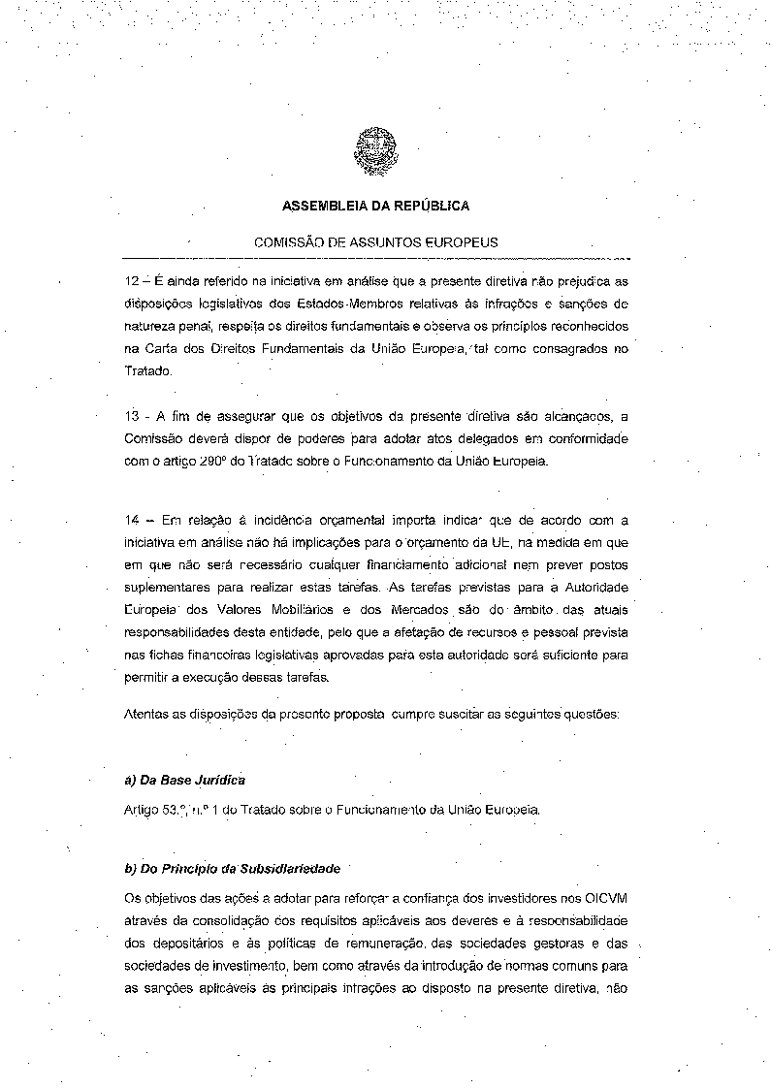
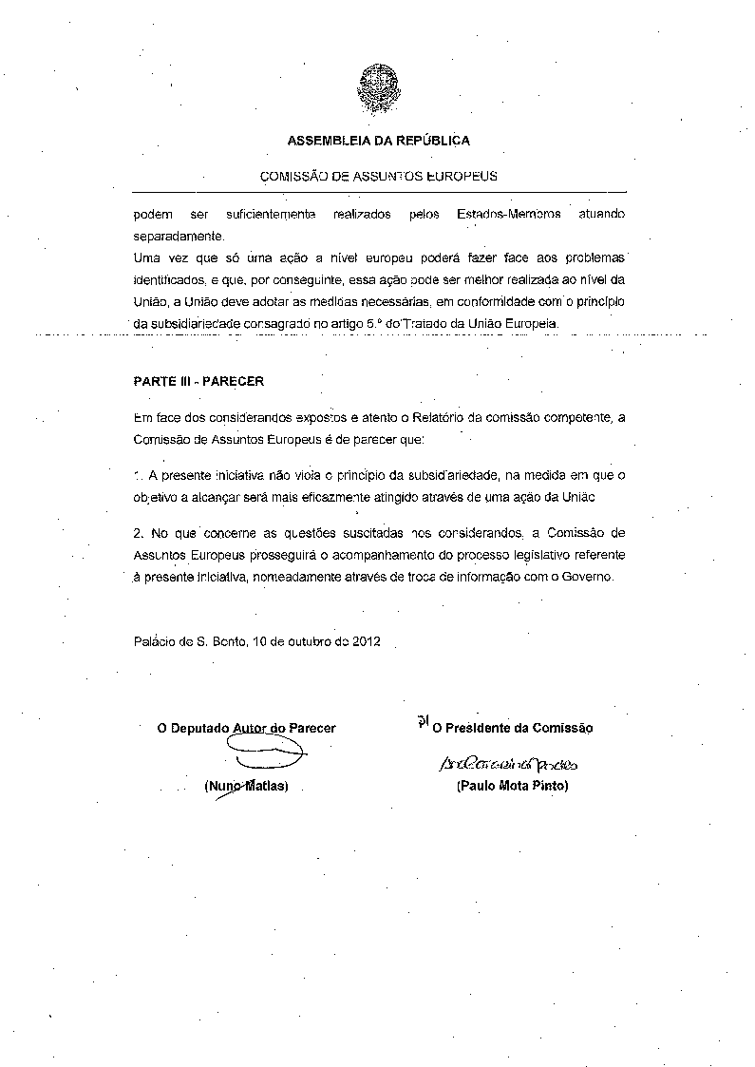


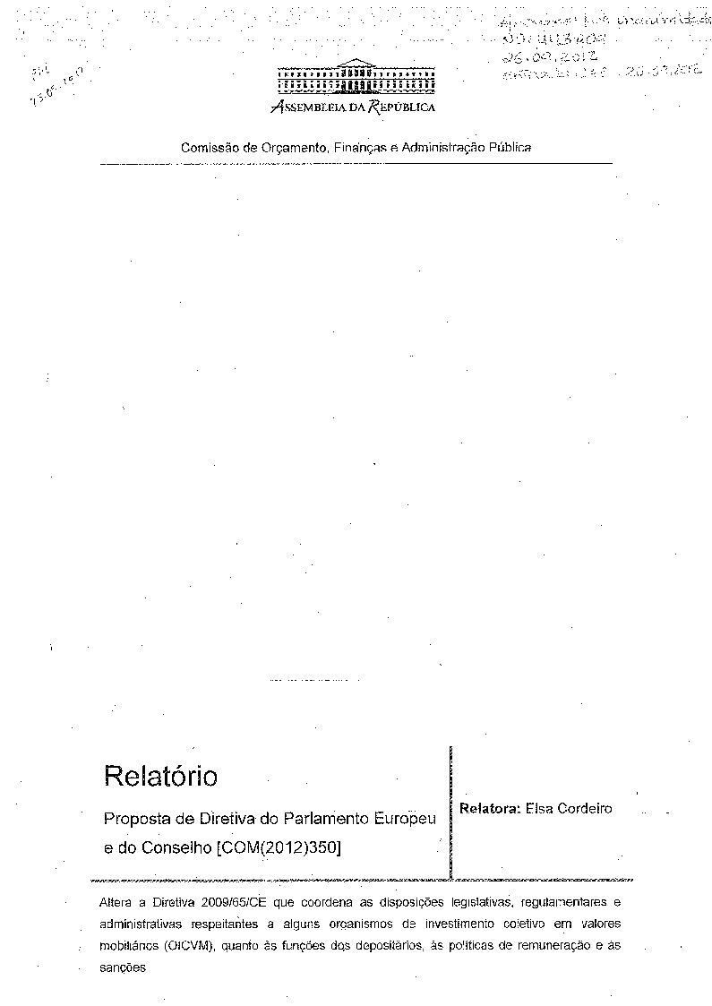
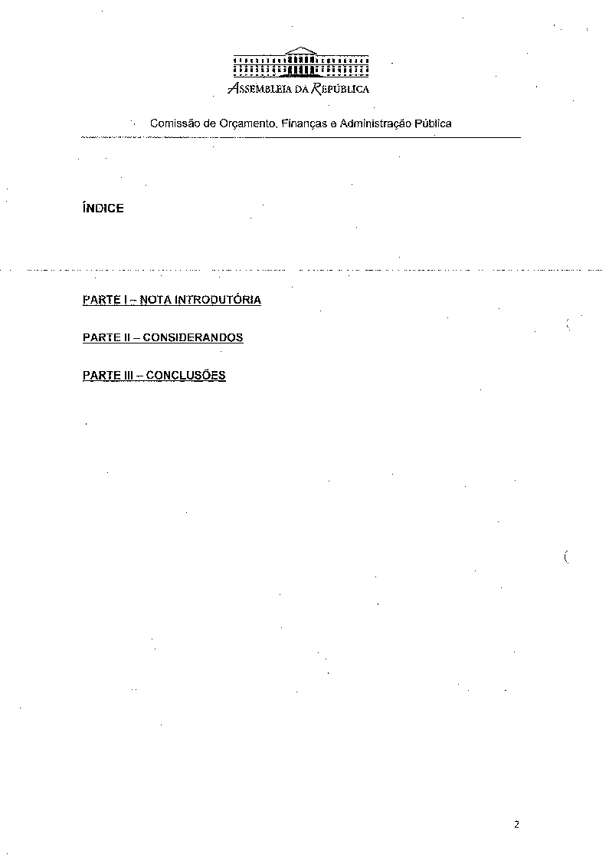
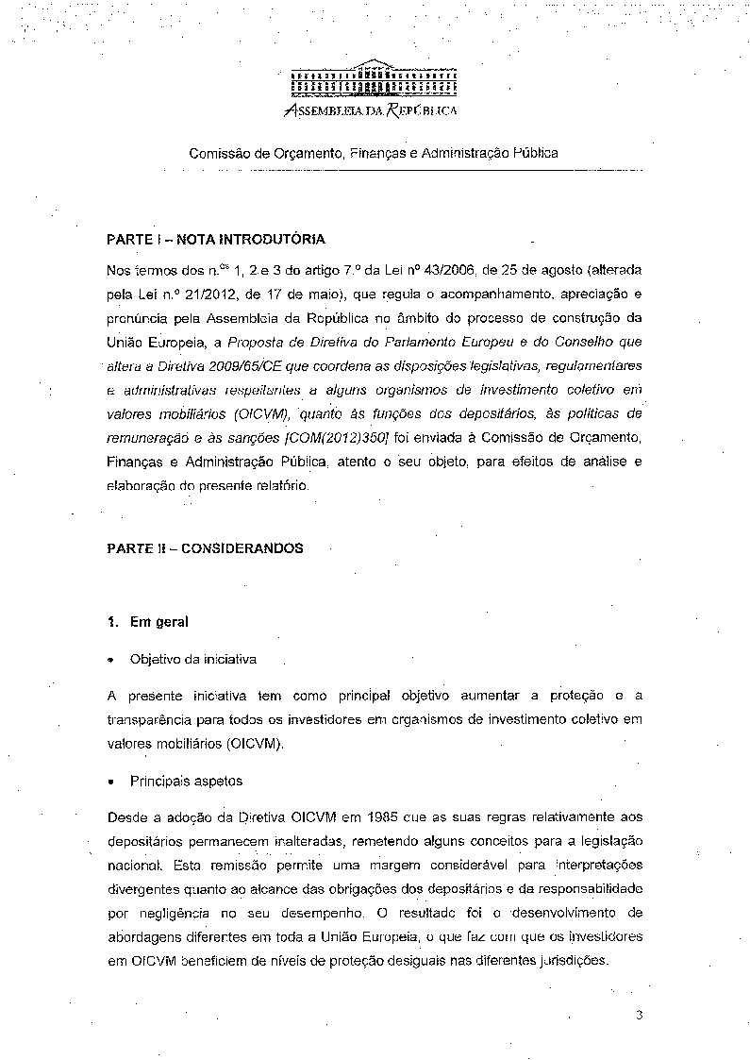
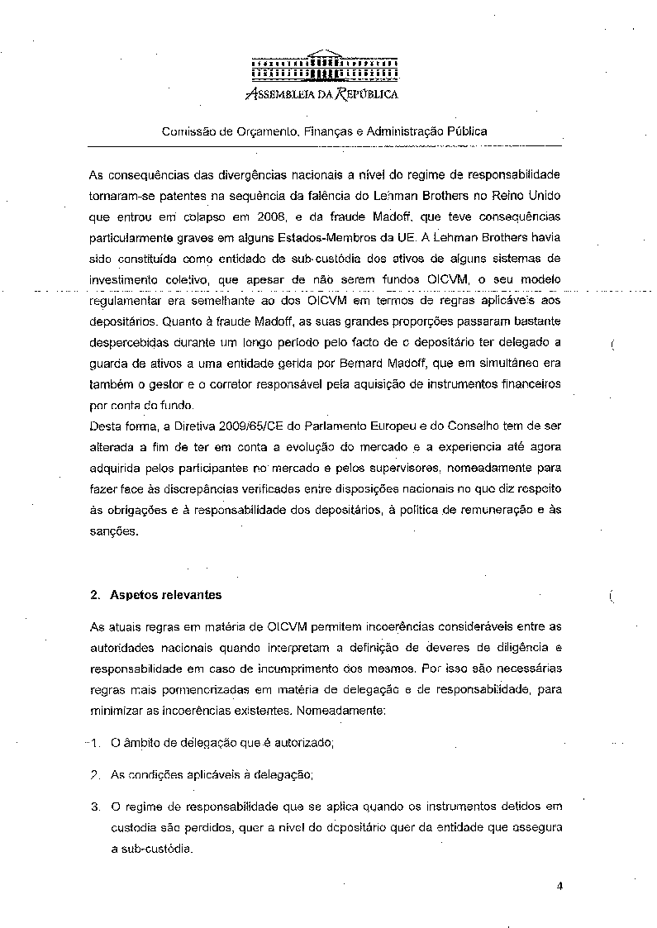
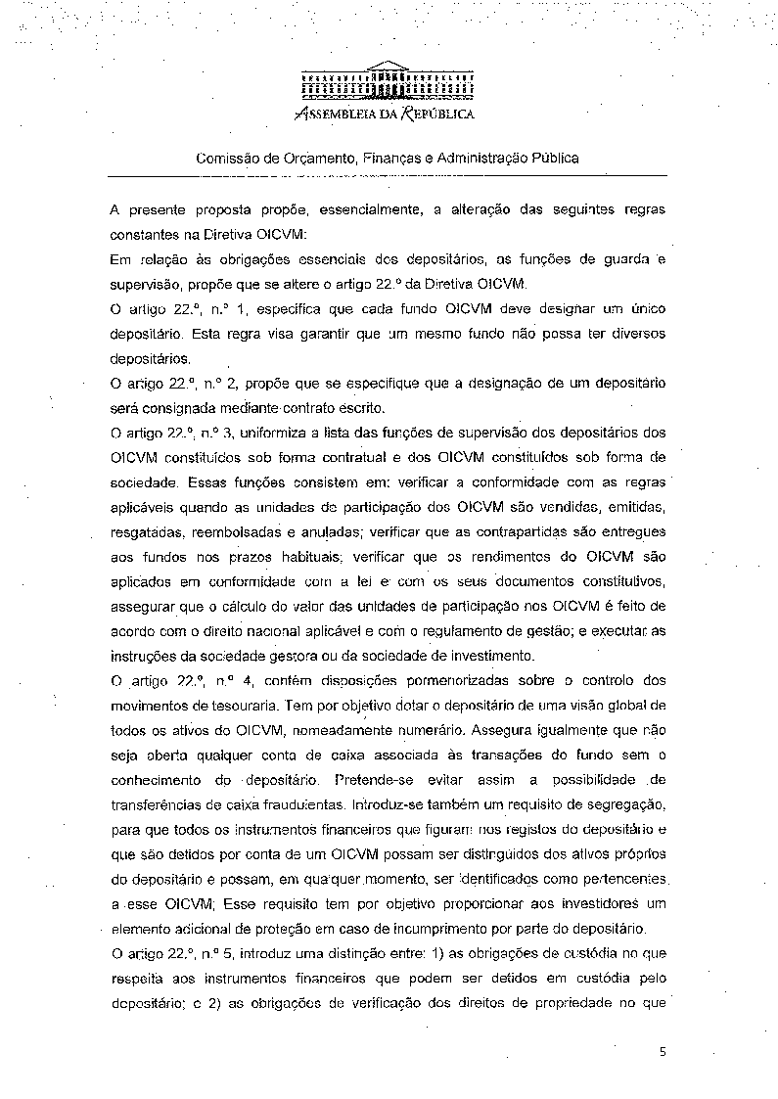
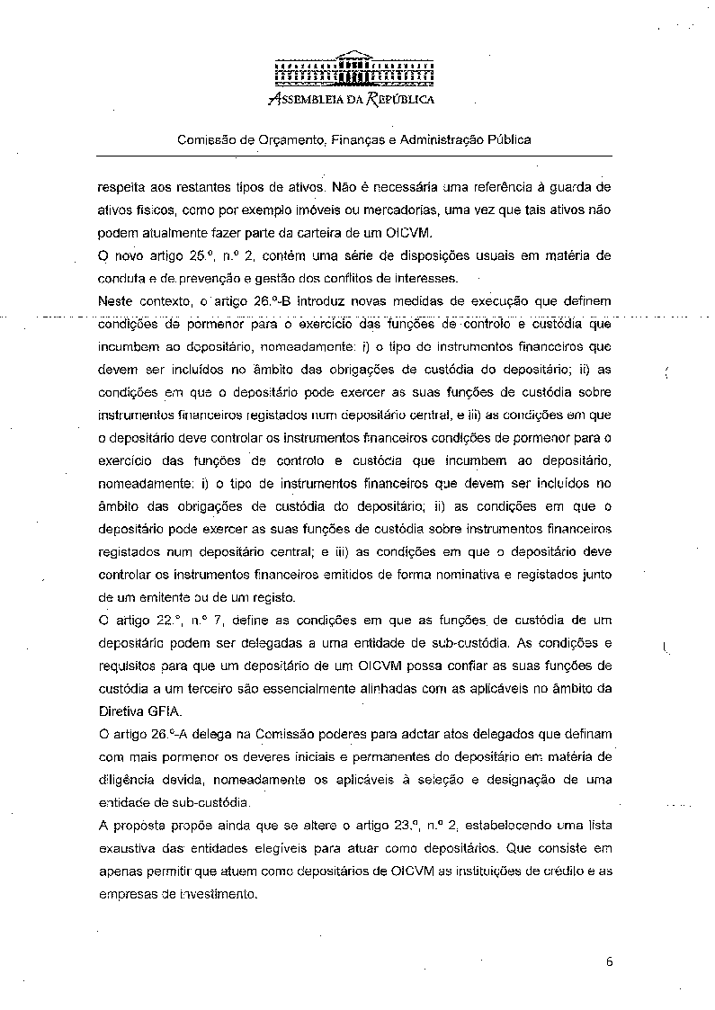
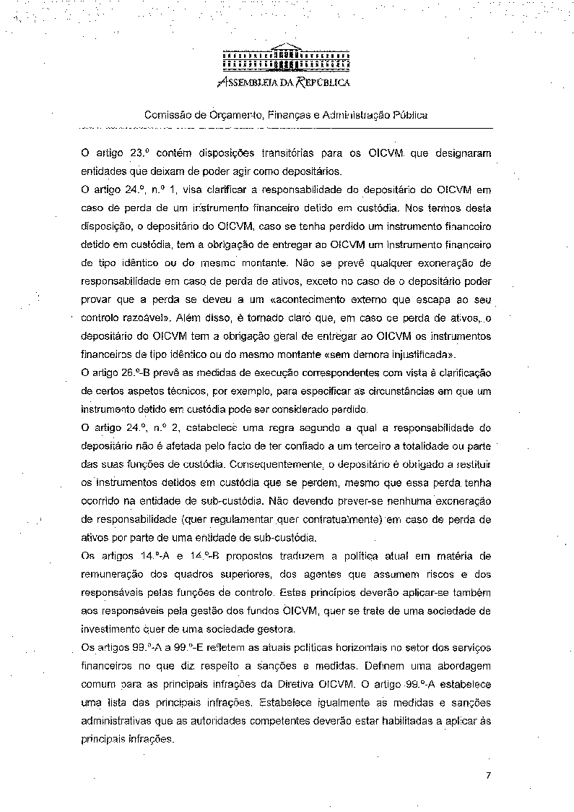
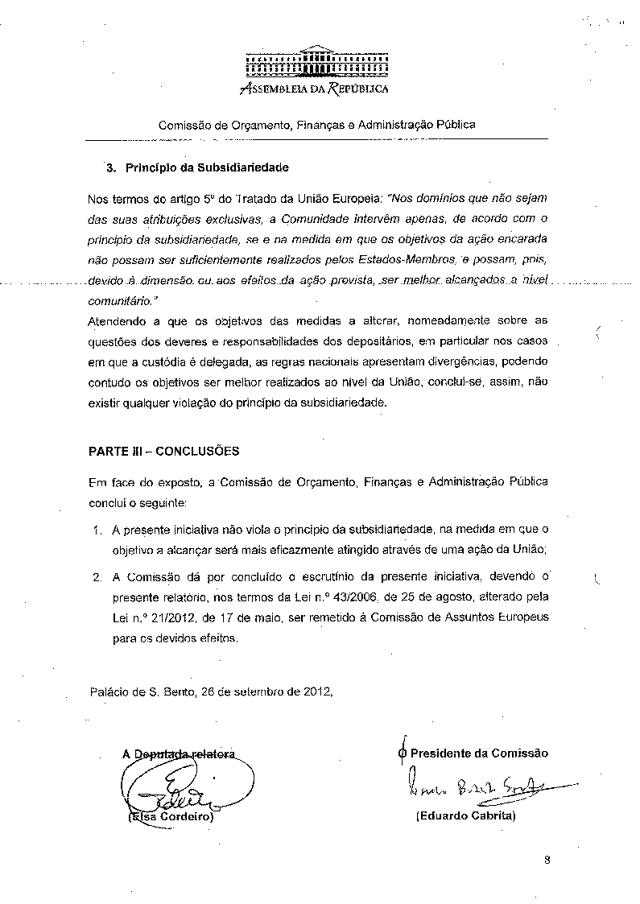
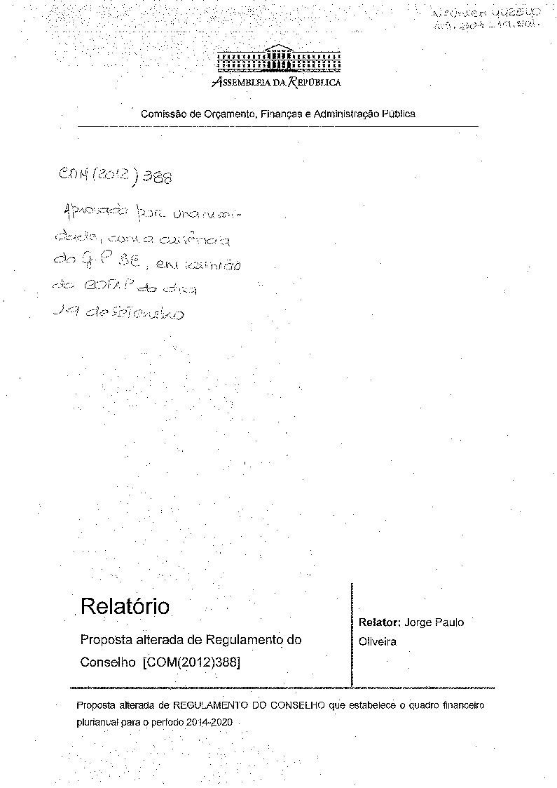
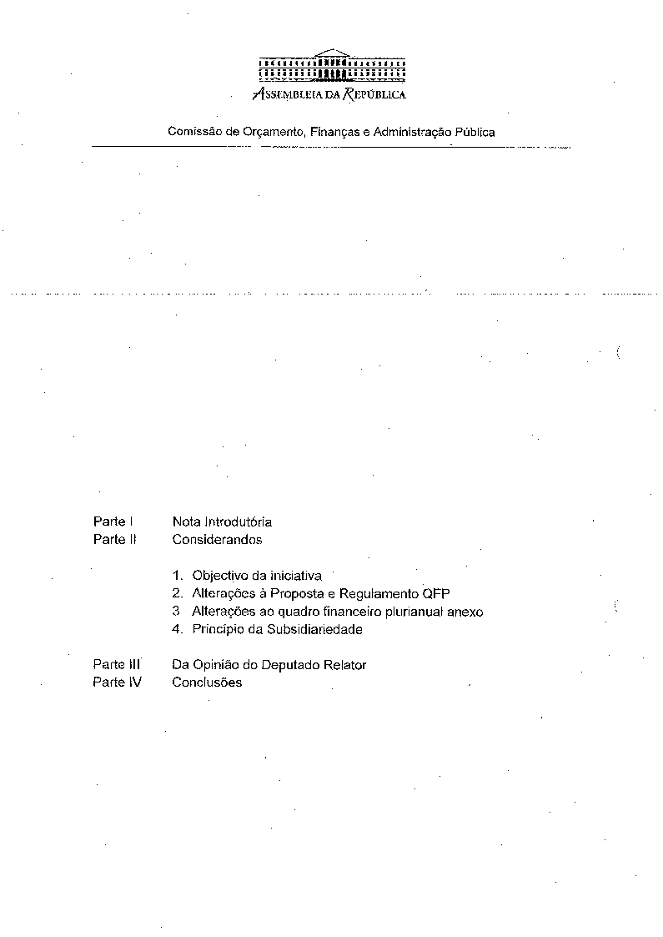
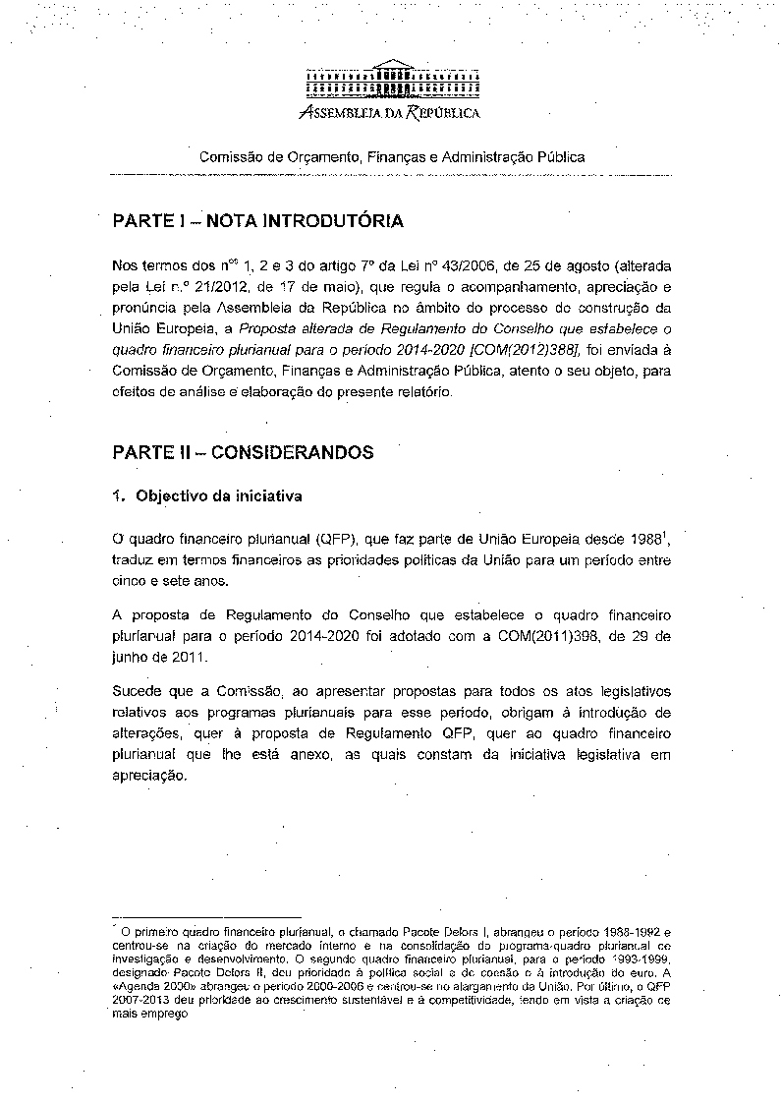
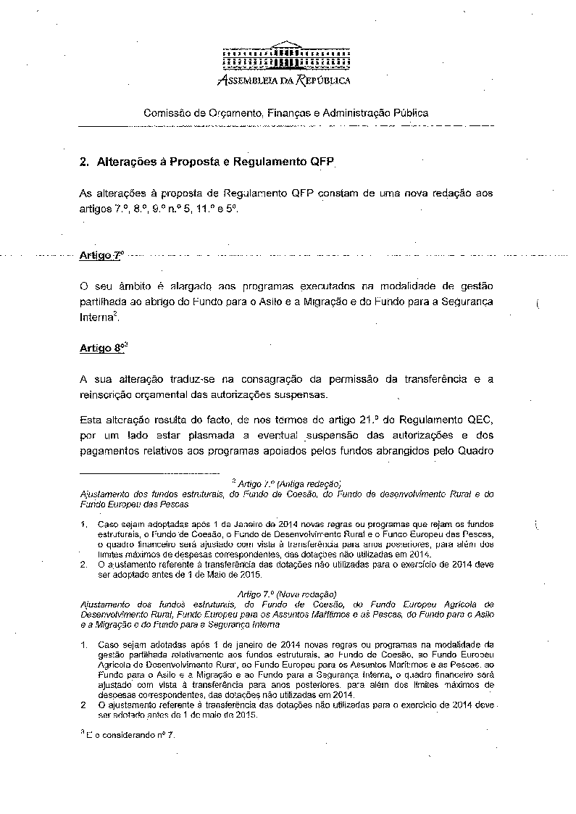
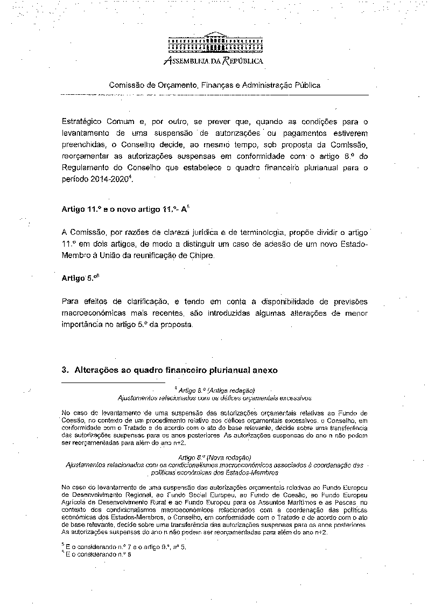
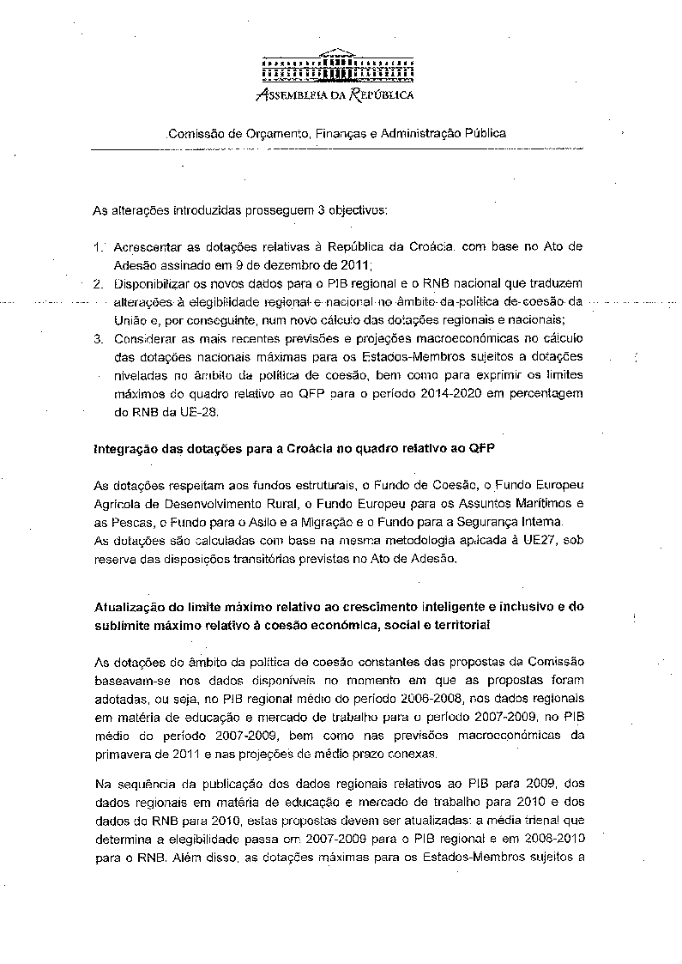
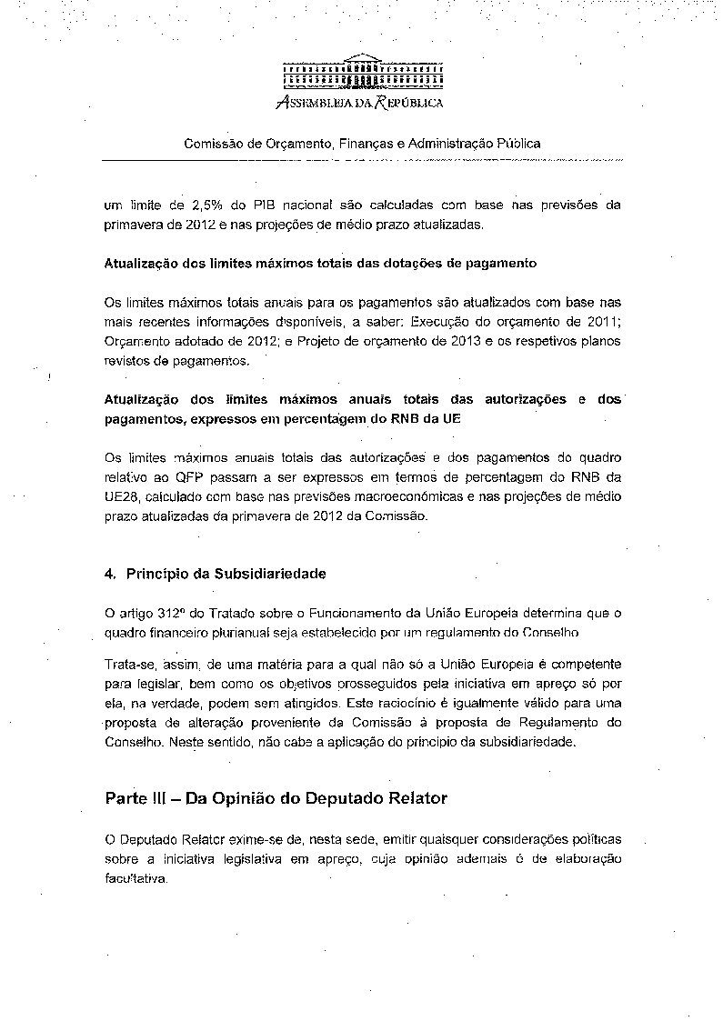
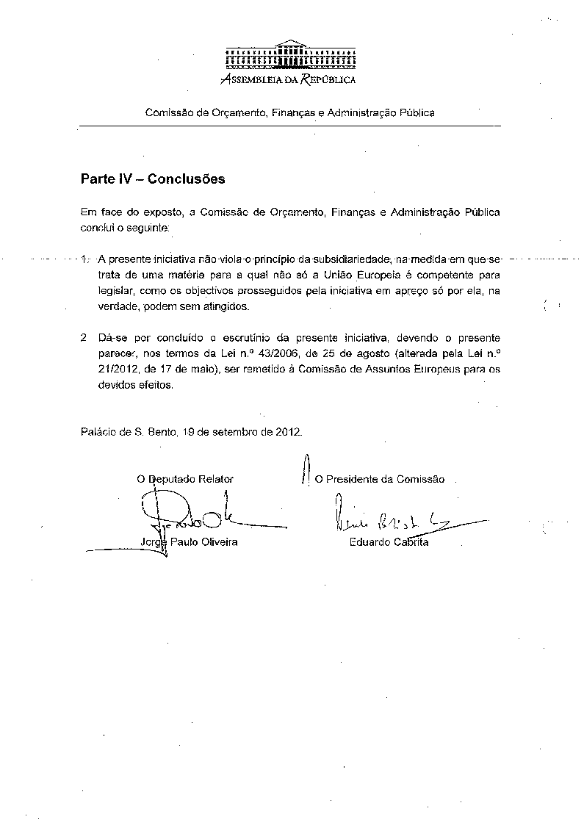

Translations of the opinion may be available in the Interparliamentary EU information exchange site IPEX at the following address: http://www.ipex.eu/IPEXL- WEB/search.do

