 | 
COUNCIL OF  THE EUROPEAN UNION |  |  | Brussels, 12 October 2012
 | Interinstitutional File:  2012/0196 (COD) |  | 14891/12
ENV 772
PECHE 401
WTO 326
CODEC 2374
INST 582
PARLNAT 325

COVER NOTE
from: | The President of the Assembly of the Republic of Portugal
date of receipt: | 10 October 2012
to: | General Secretariat of the Council of the European Union
Subject: | Proposal for a Regulation of the European Parliament and of the Council on the protection of species of wild fauna and flora by regulating trade therein (Recast)  [12875/12 ENV 641 PECHE 294 WTO 277 + COR 1]  - Opinion on the application of the Principles of Subsidiarity and Proportionality

Delegations will find annexed a copy of the above letter.

________________________
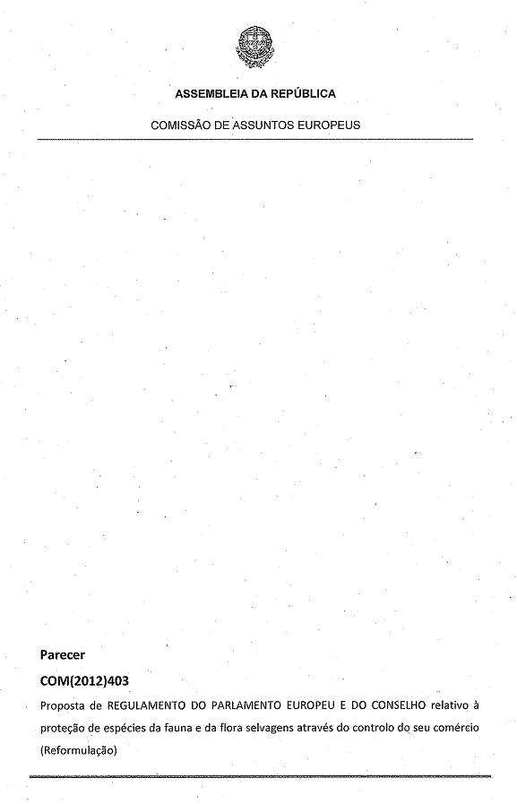
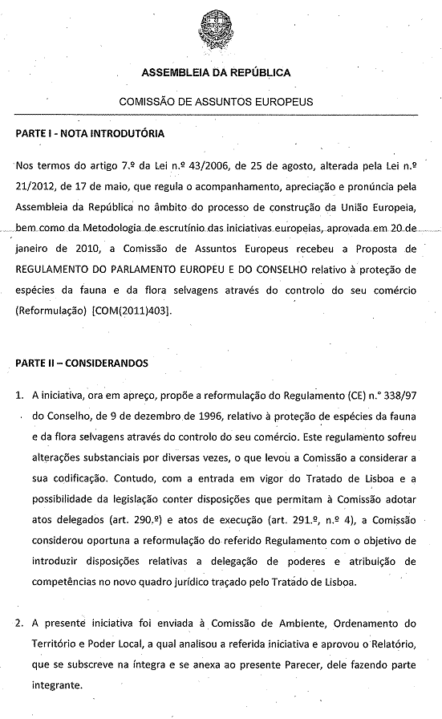
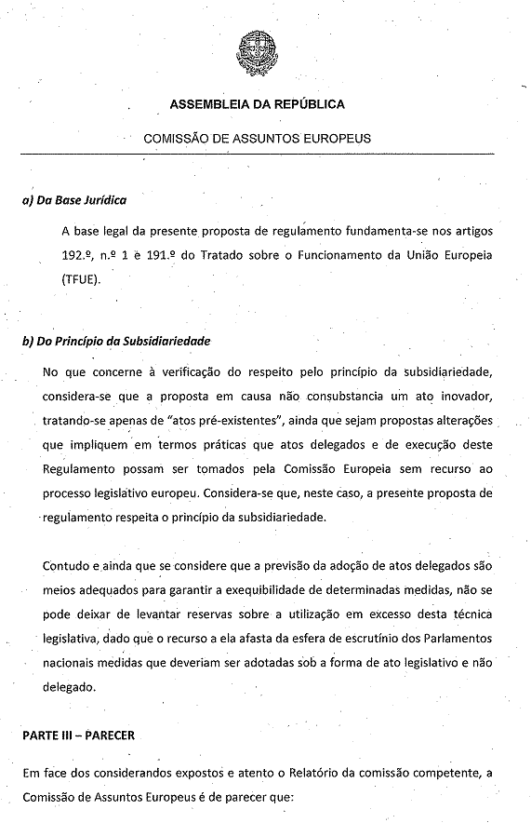
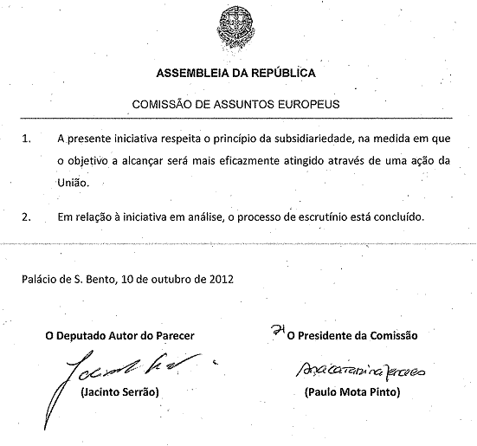
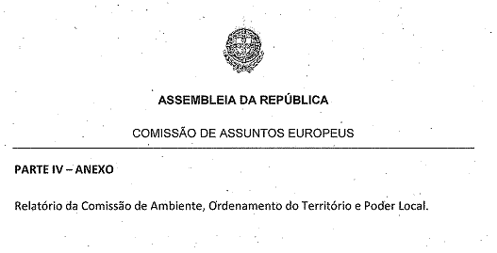
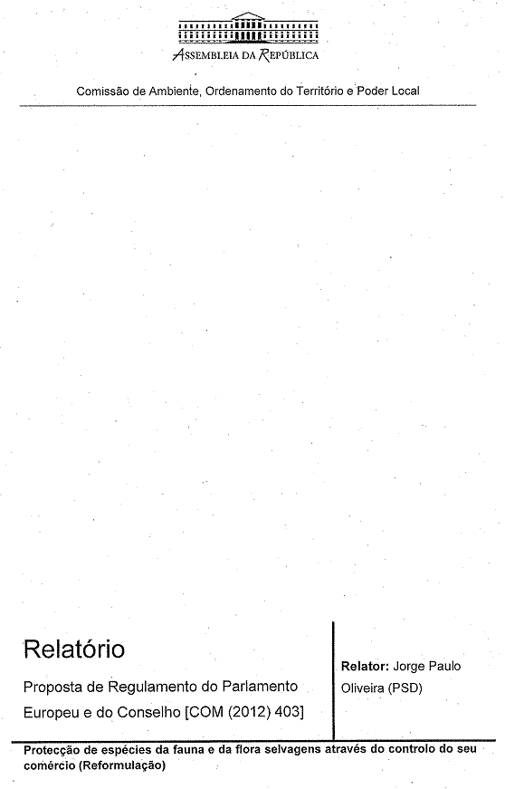
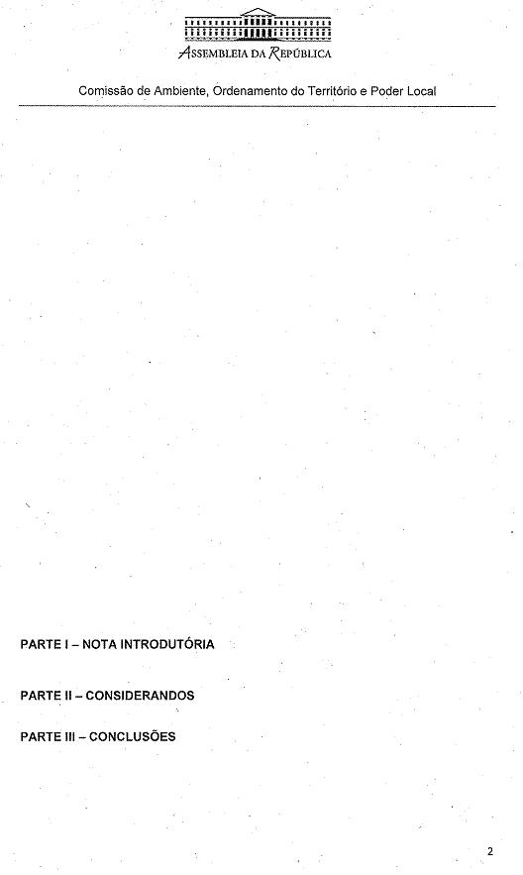
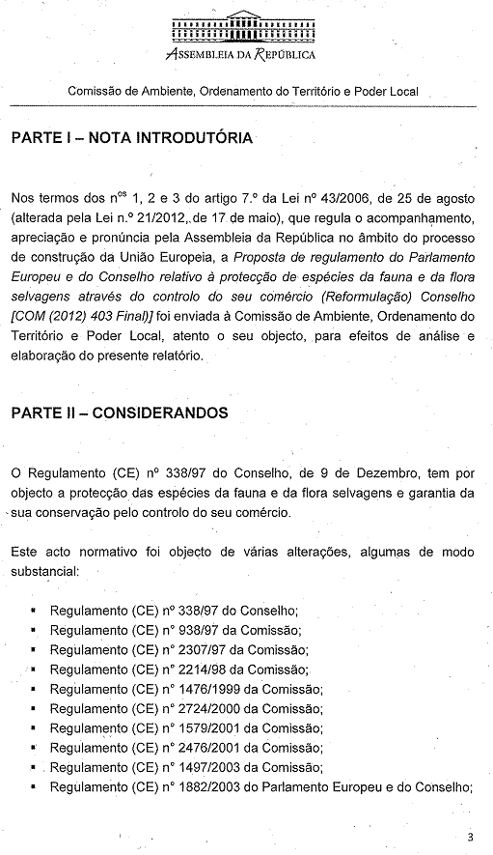
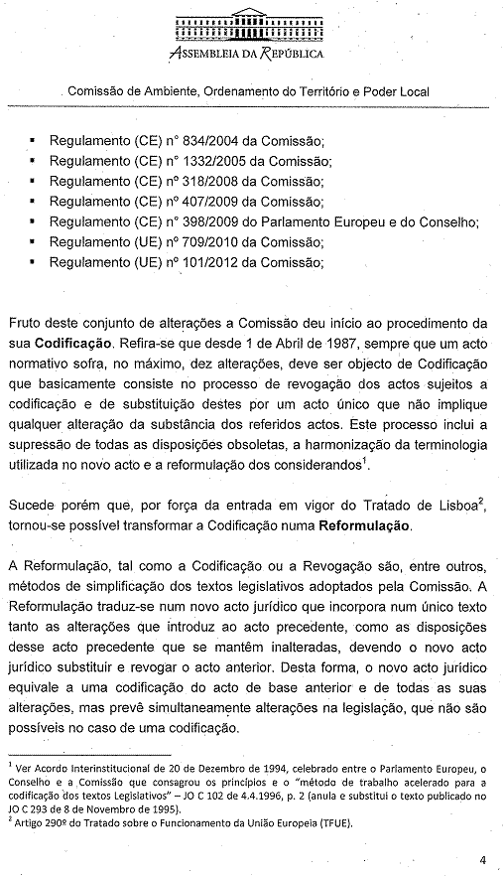
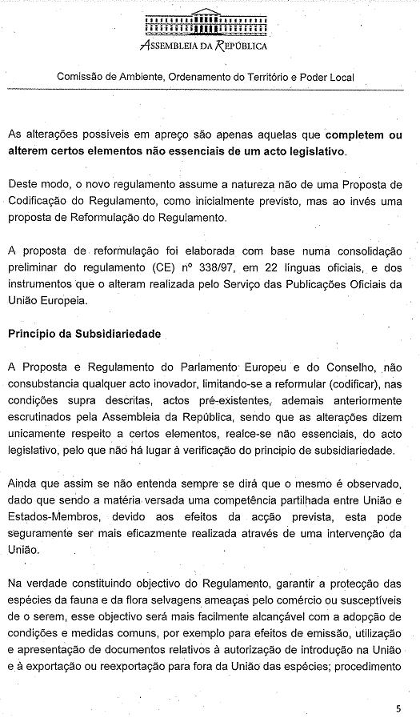
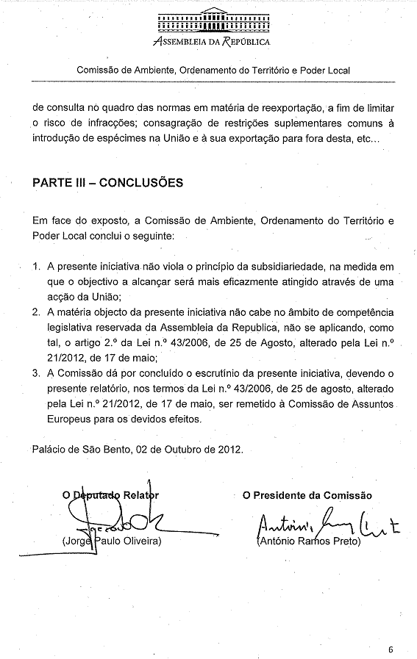

The translation of this document will be available at the Interparliamentary EU information exchange site IPEX at the following address: http://www.ipex.eu/IPEXL-WEB/search.do

