 | 
COUNCIL OF  THE EUROPEAN UNION |  |  | Brussels, 3 October 2012
 | Interinstitutional File:  2012/0102 (CNS) |  | 14406/12
FISC 132
INST 566
PARLNAT 322

COVER NOTE
from: | The Portuguese Parliament
date of receipt: | 26 September 2012
to: | The President of the Council of the European Union
Subject: | Proposal for a Council Directive amending Directive 2006/112/EC on the common system of value added tax, as regards the treatment of vouchers  [doc. 9926/12 FISC 67 - COM(2012) 206 final]  - Opinion on the application of the Principles of Subsidiarity and Proportionality

Delegations will find attached the abovementioned opinion.

________________________

Encl.

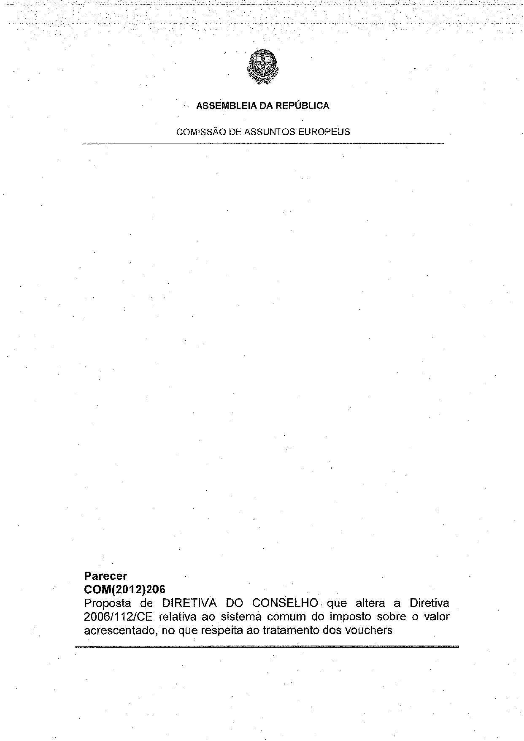
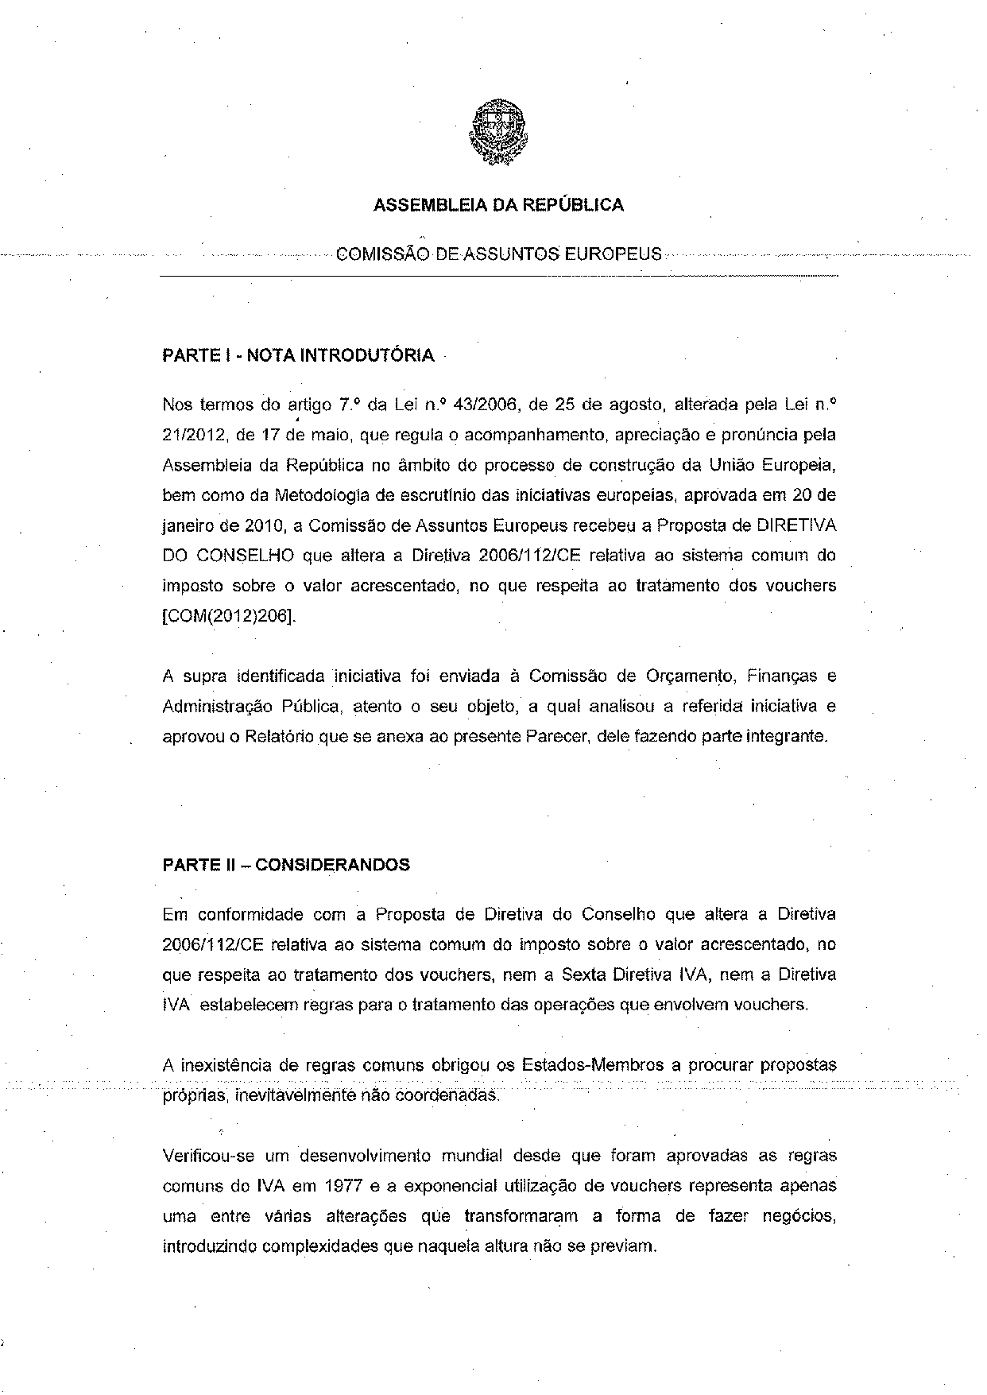
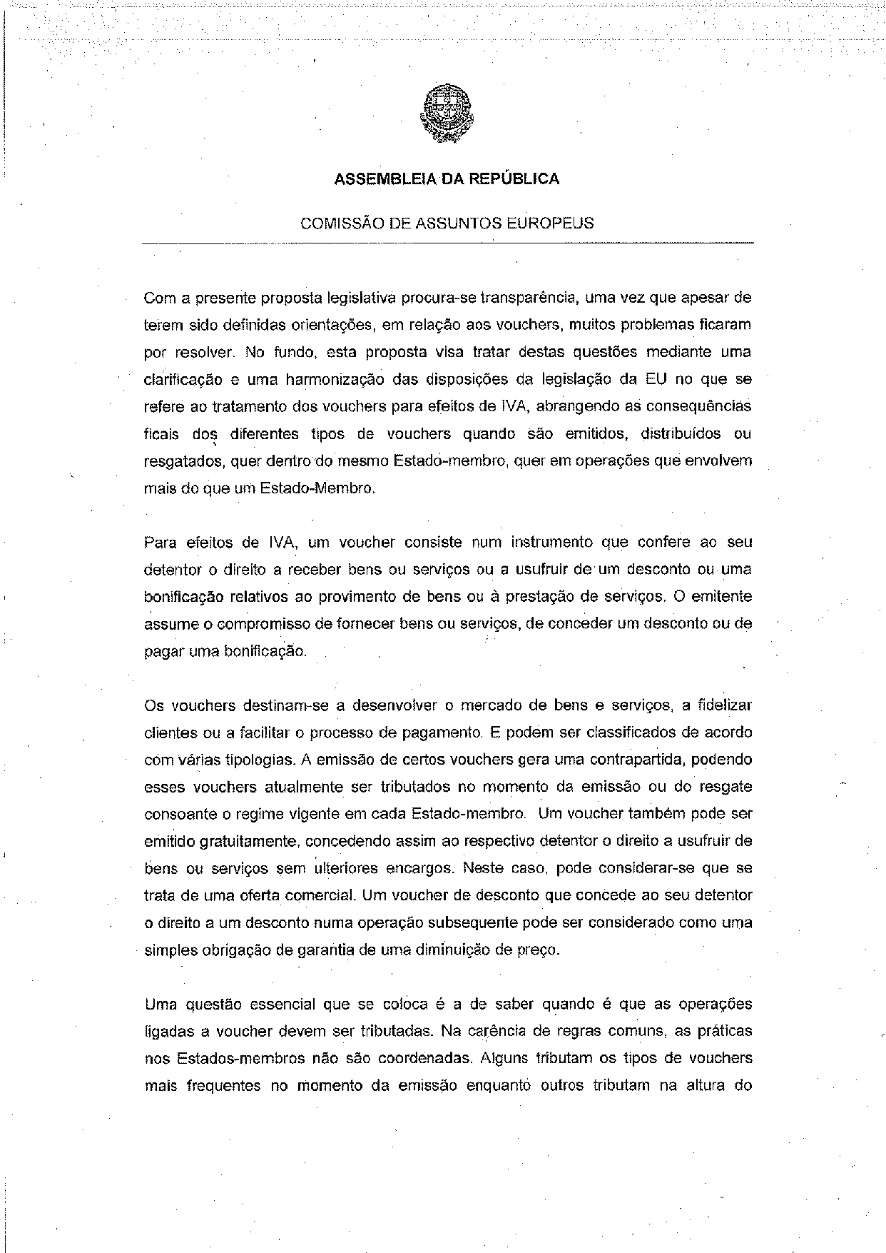
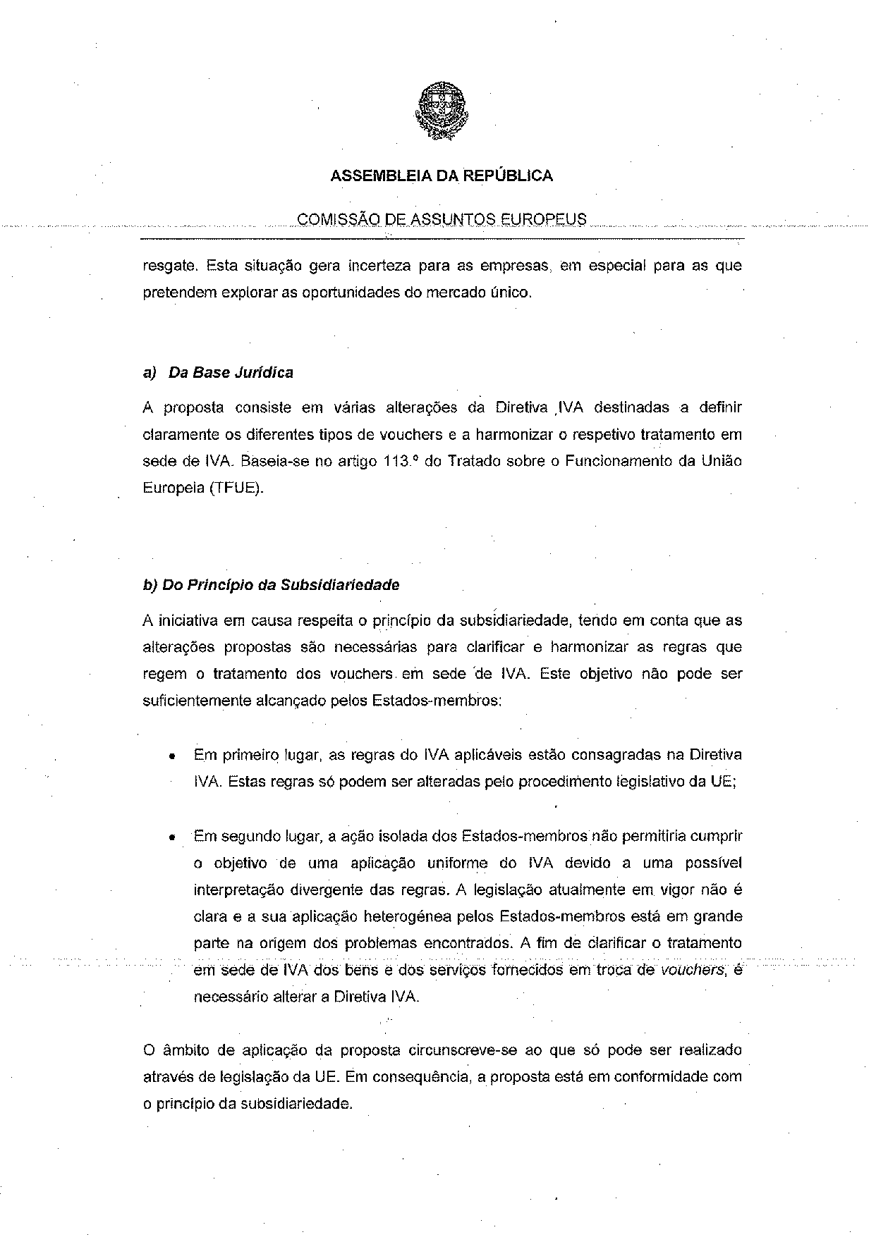
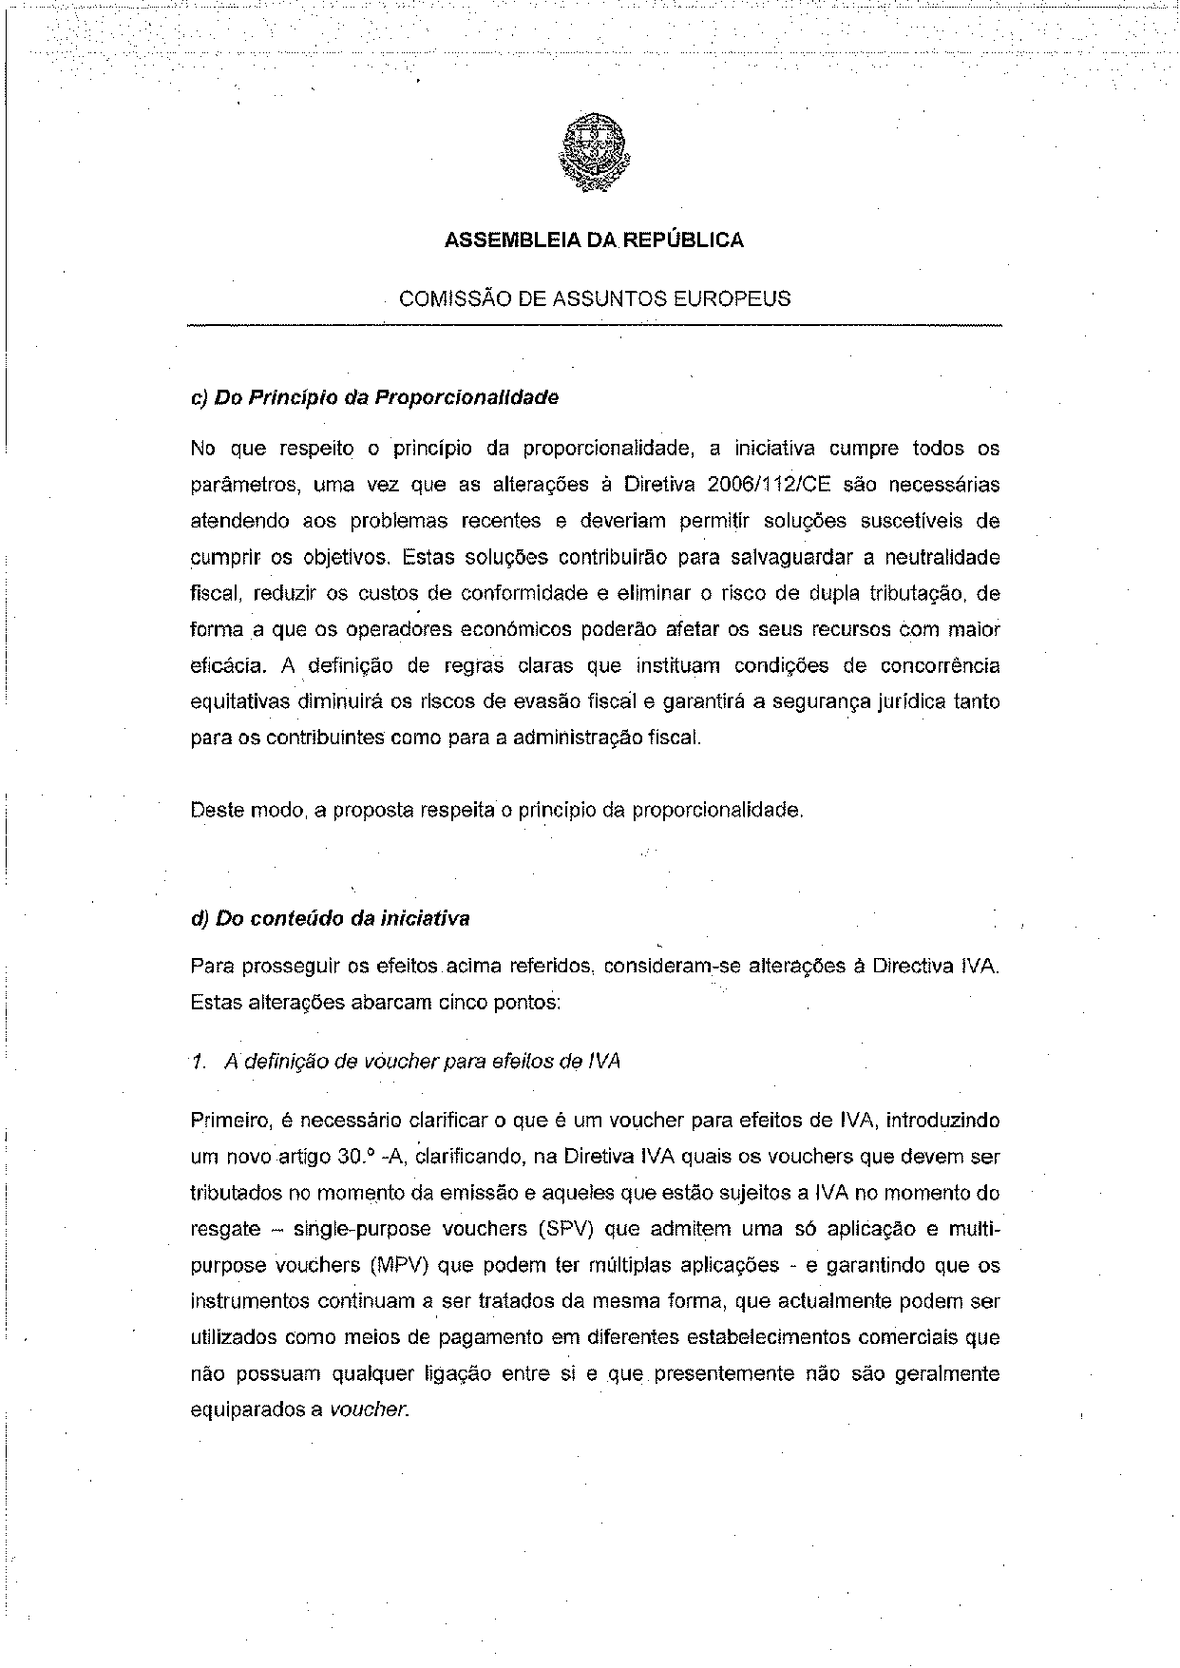
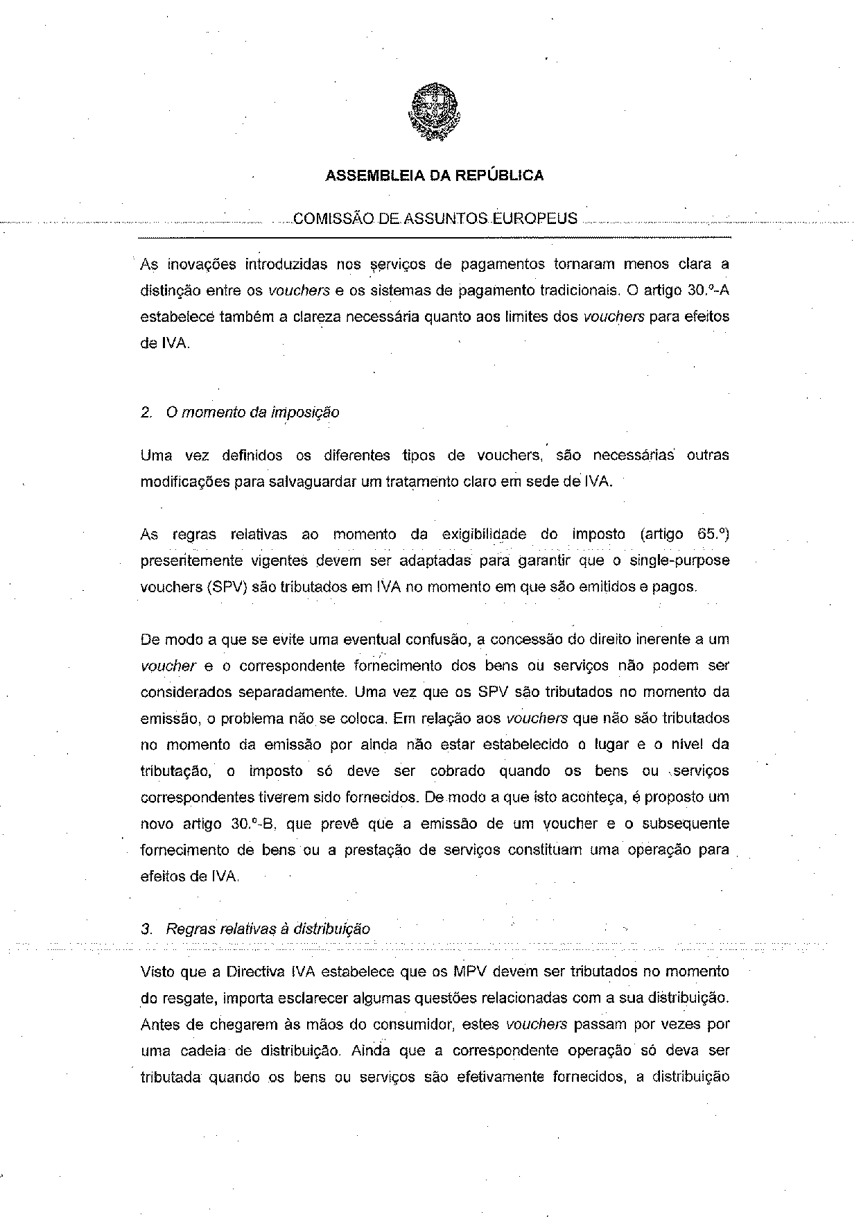
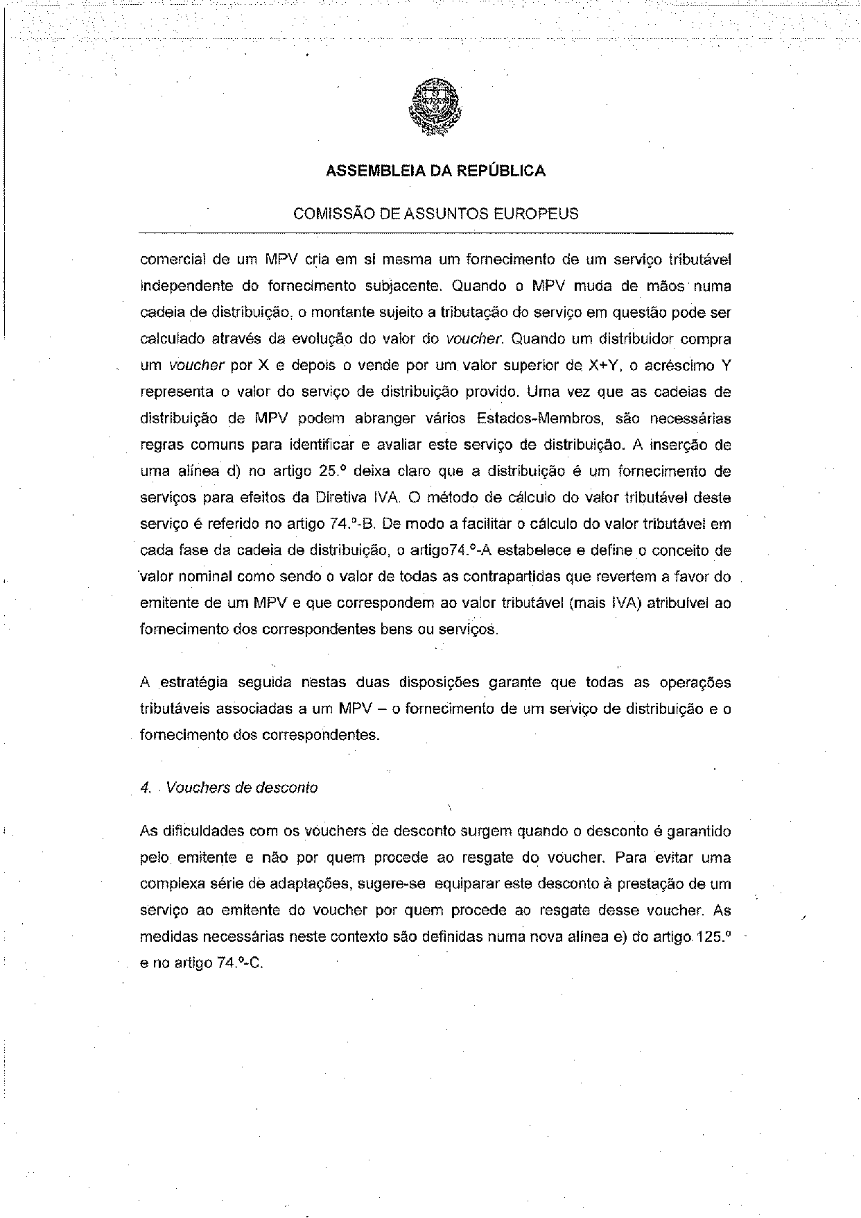
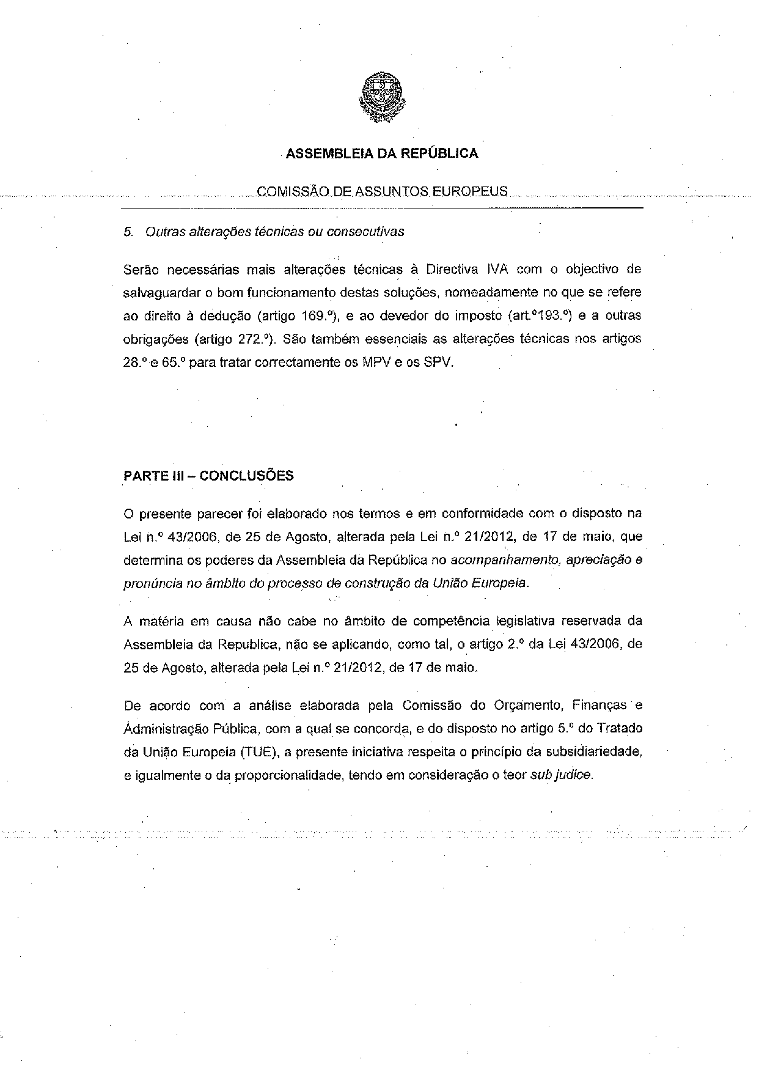
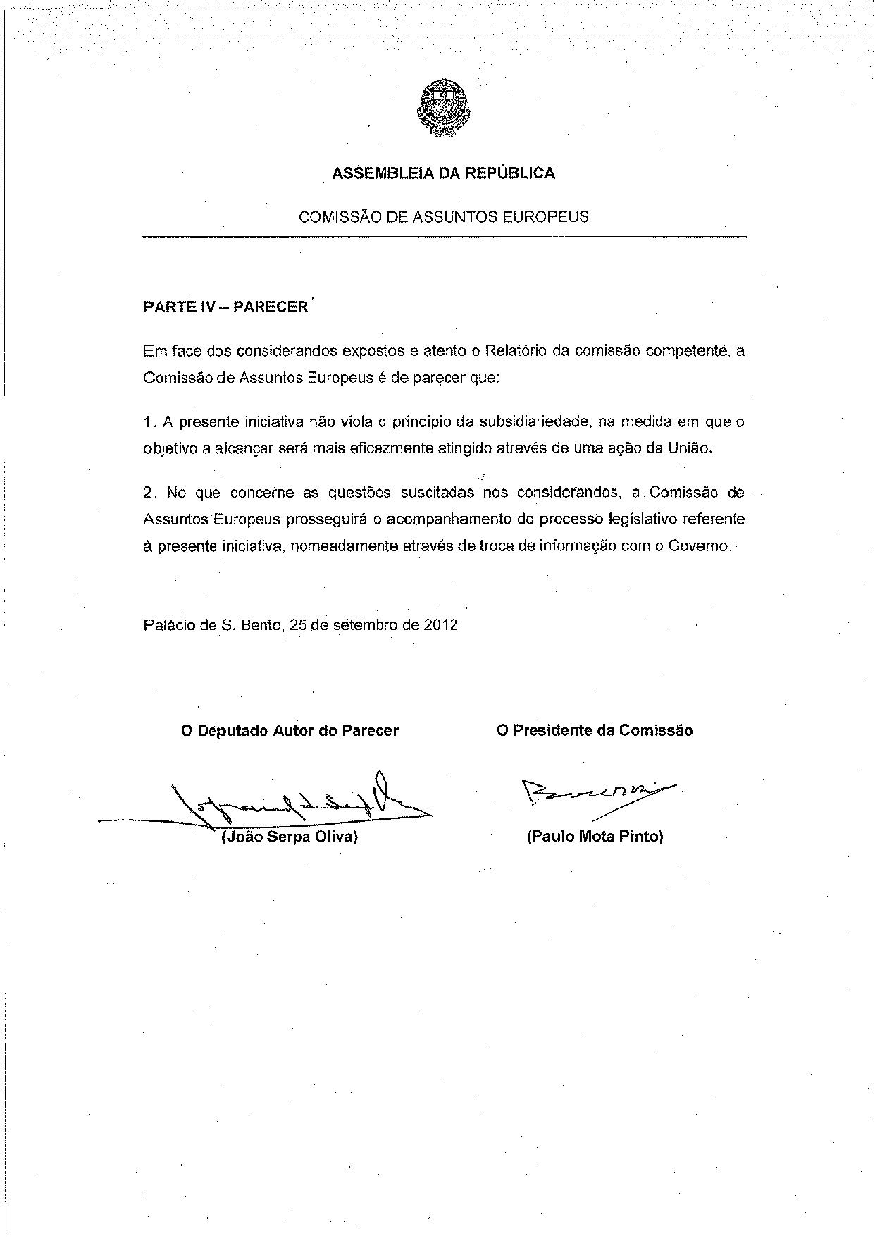
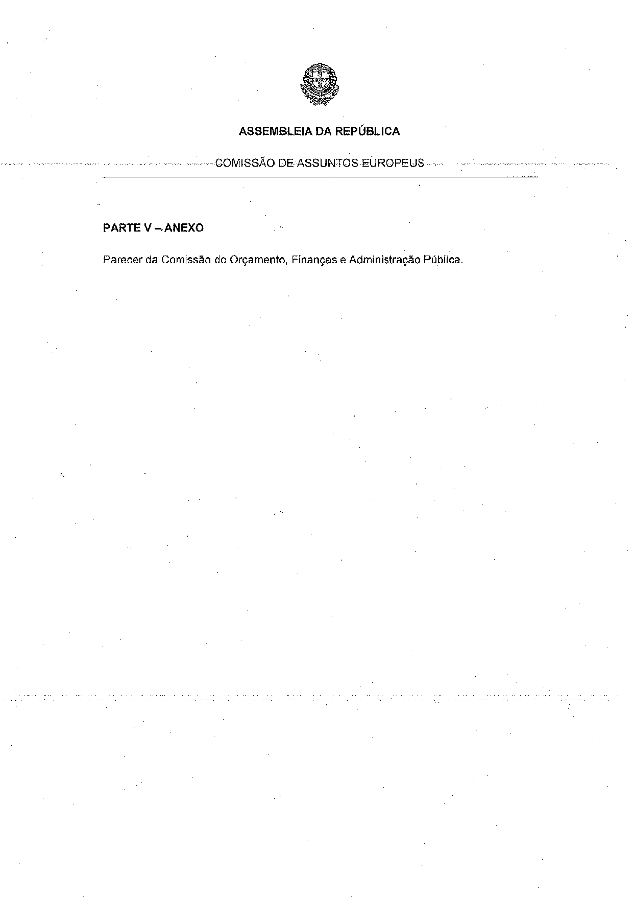
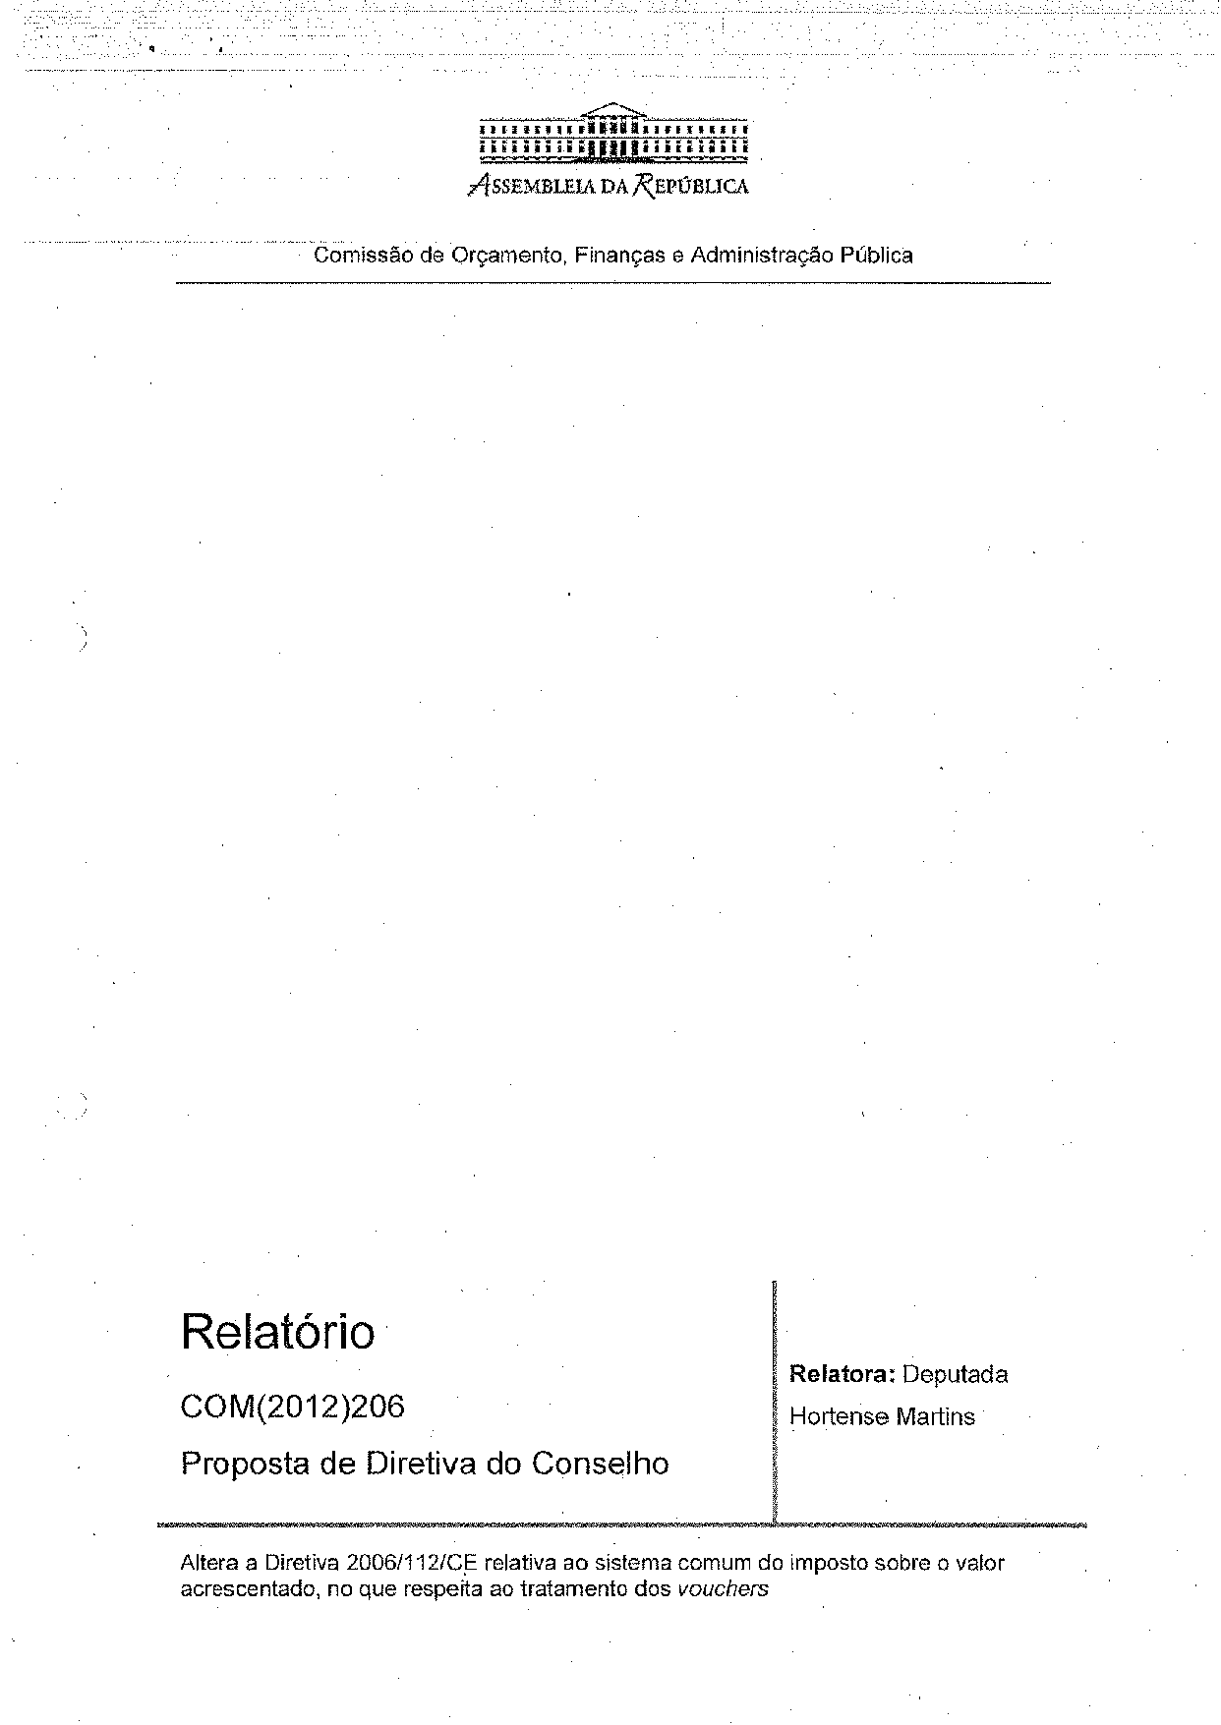
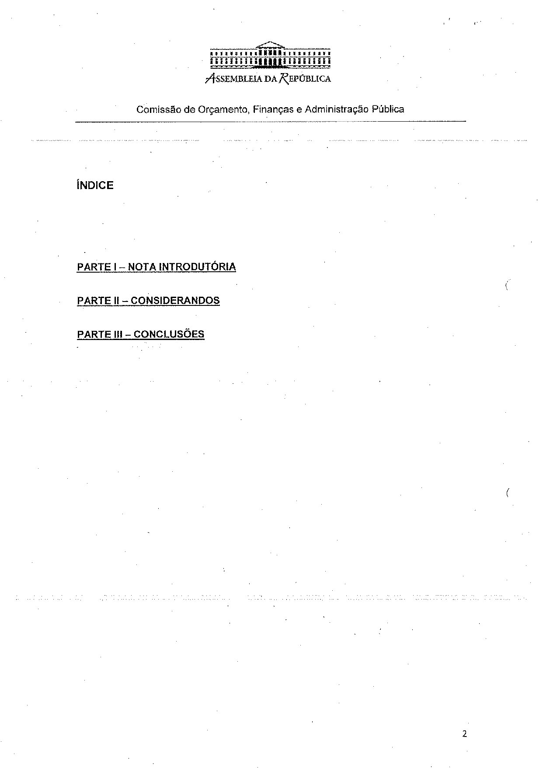
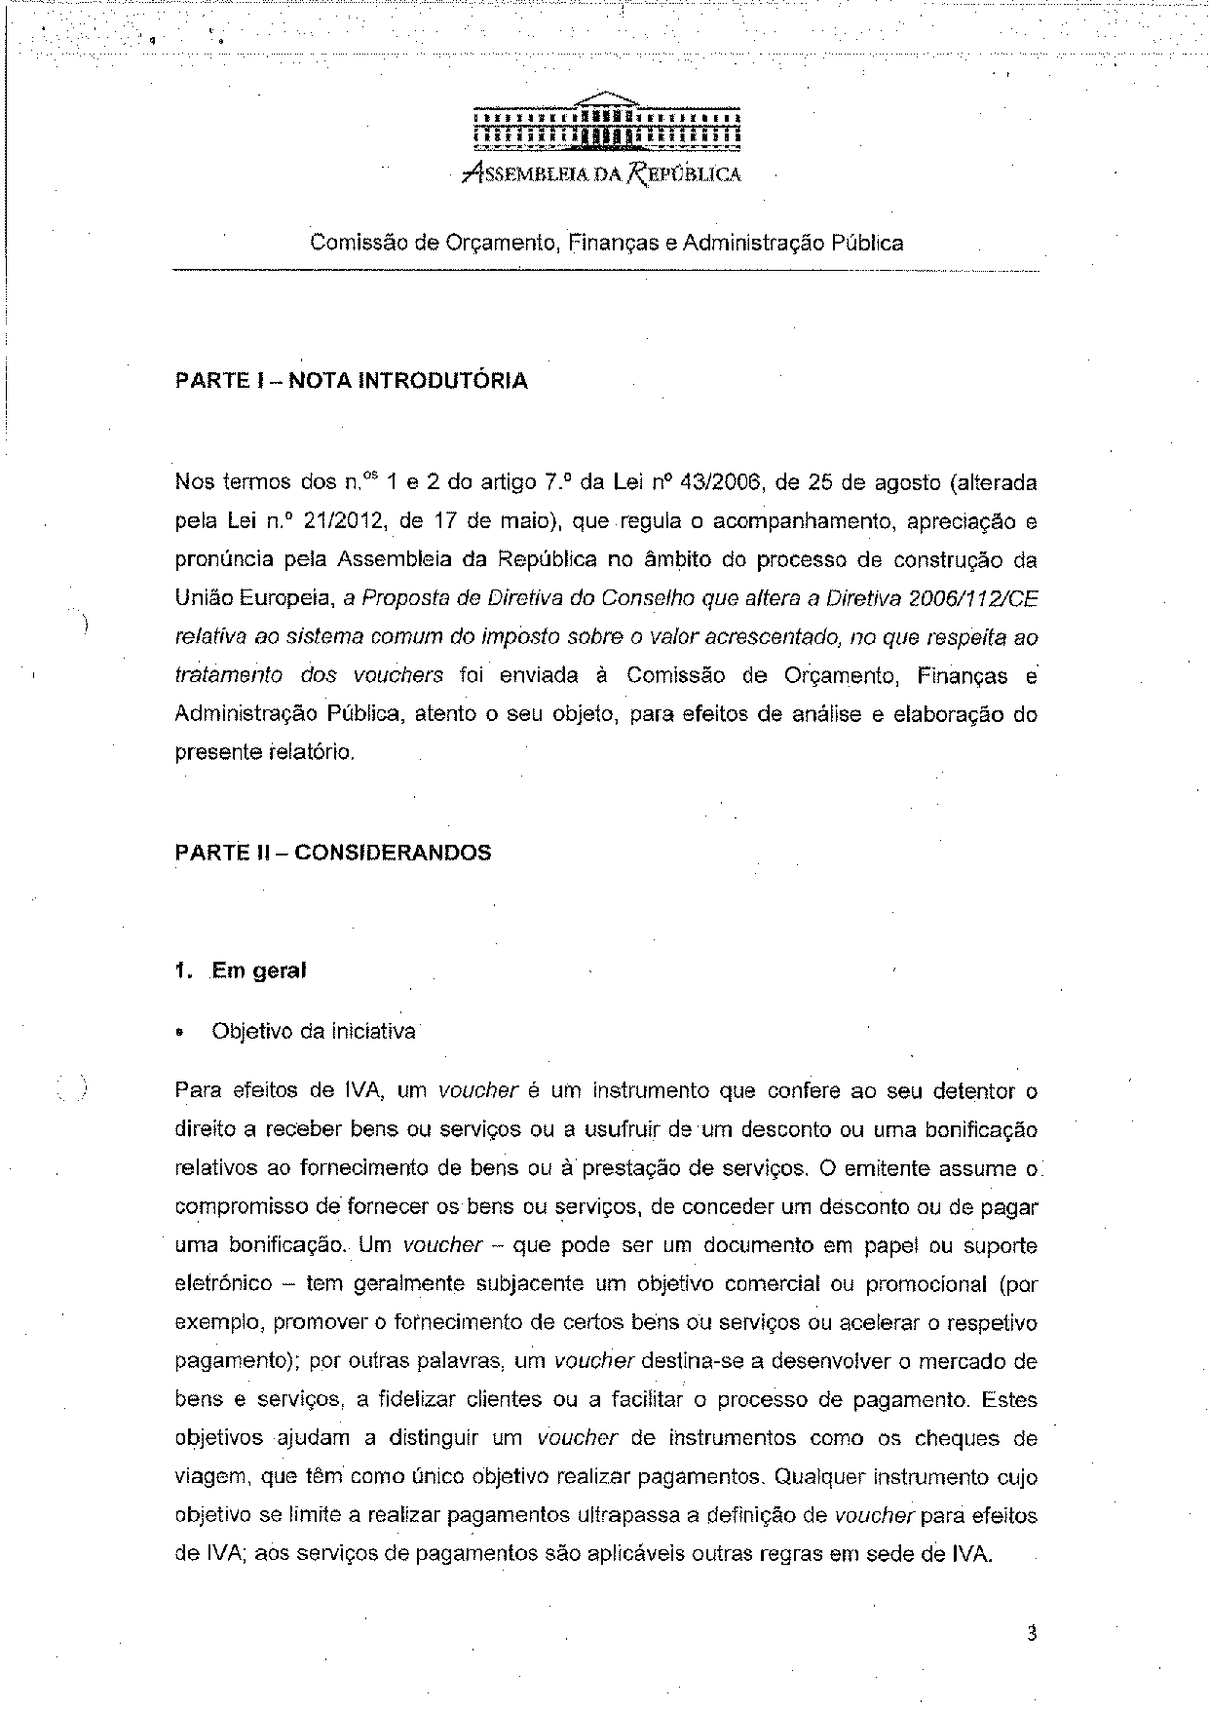
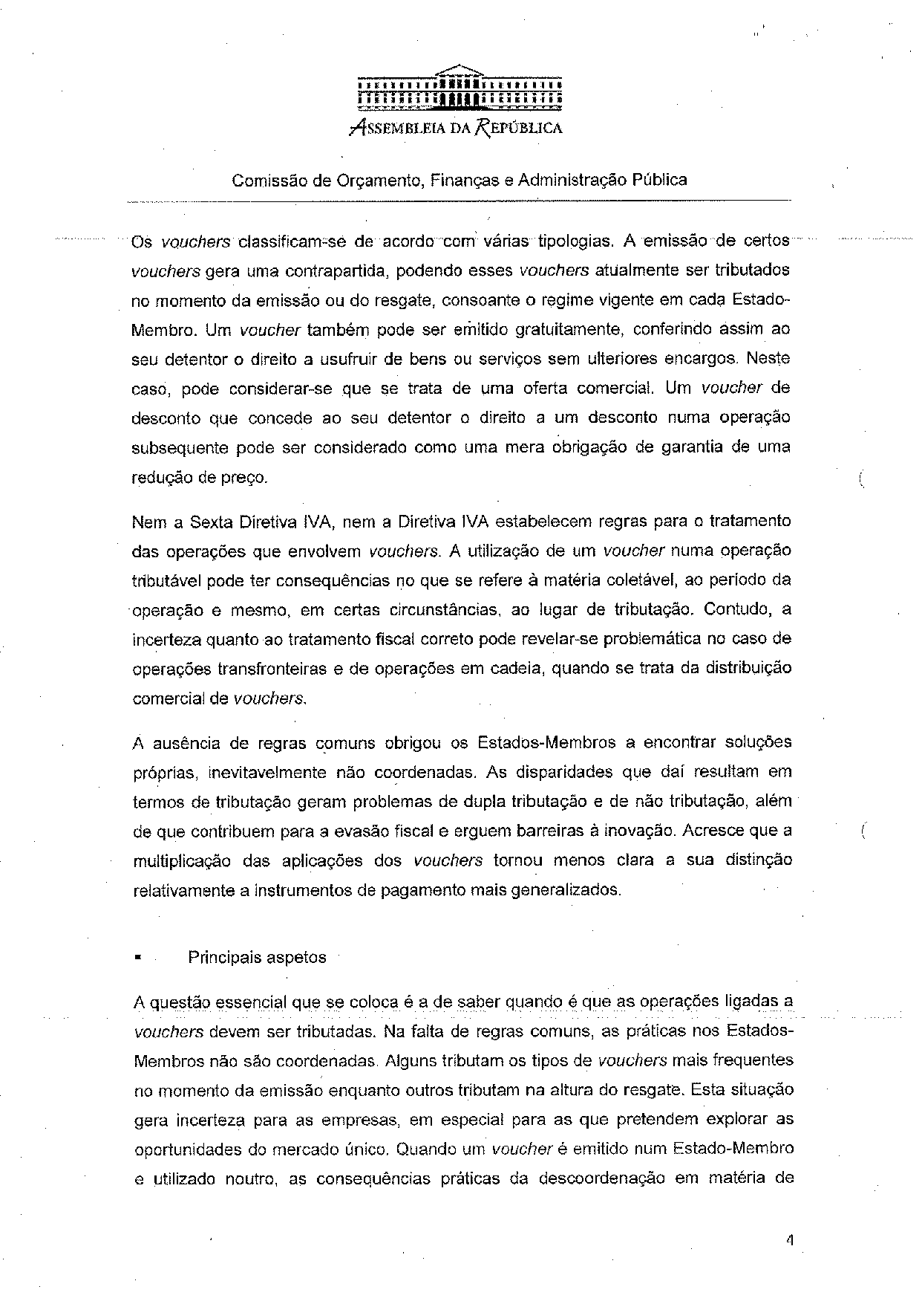
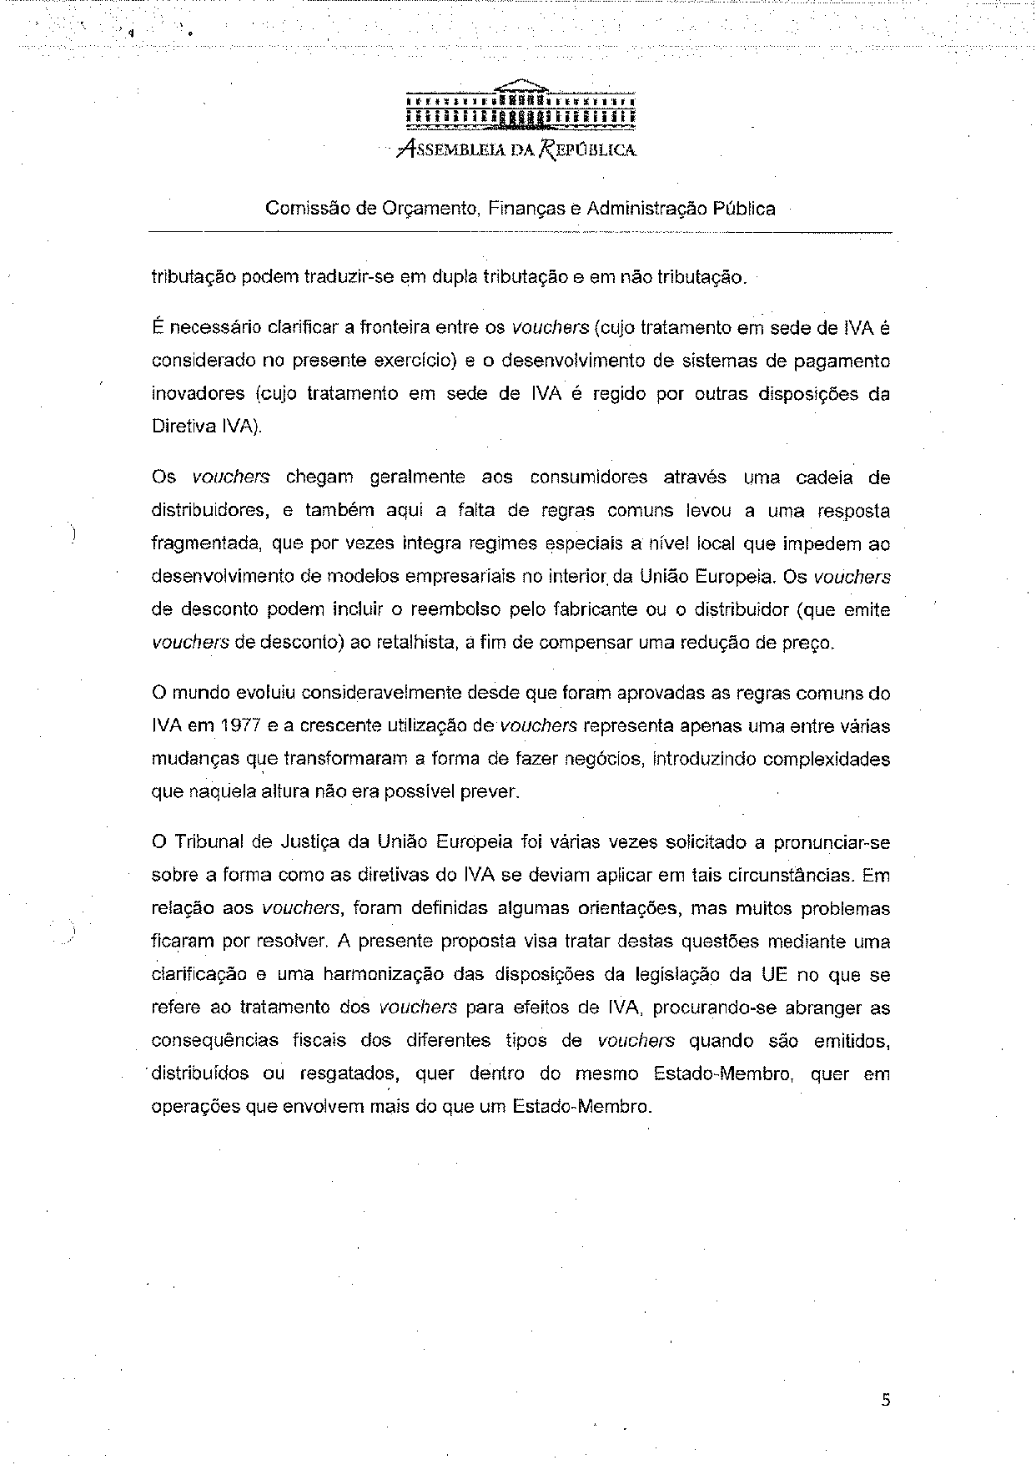
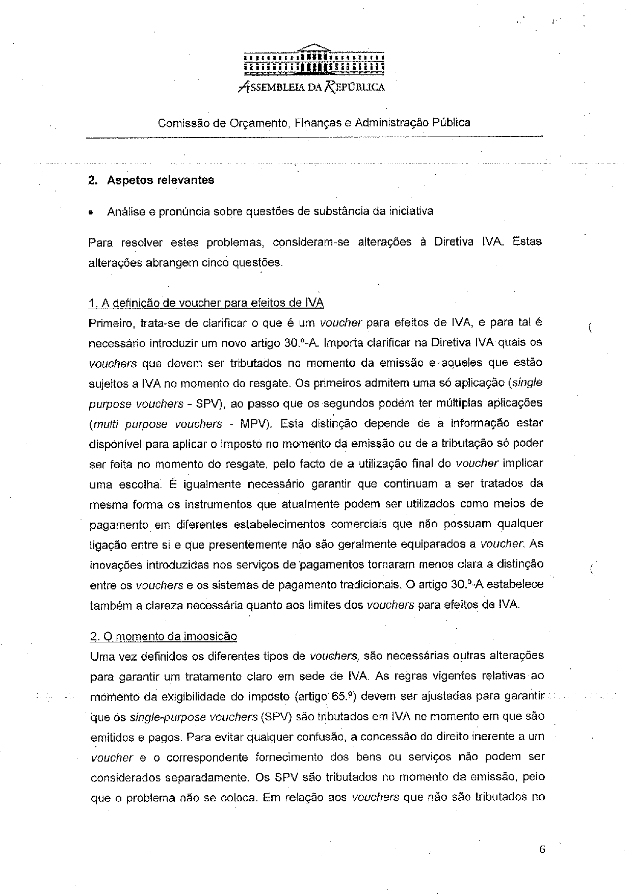
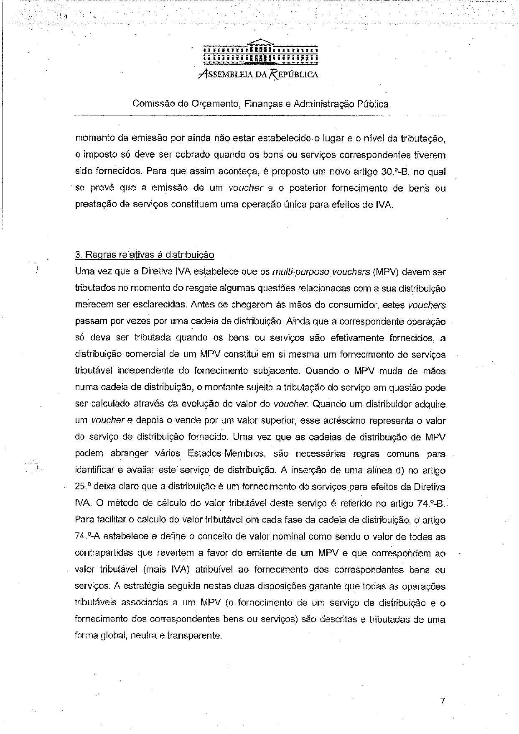
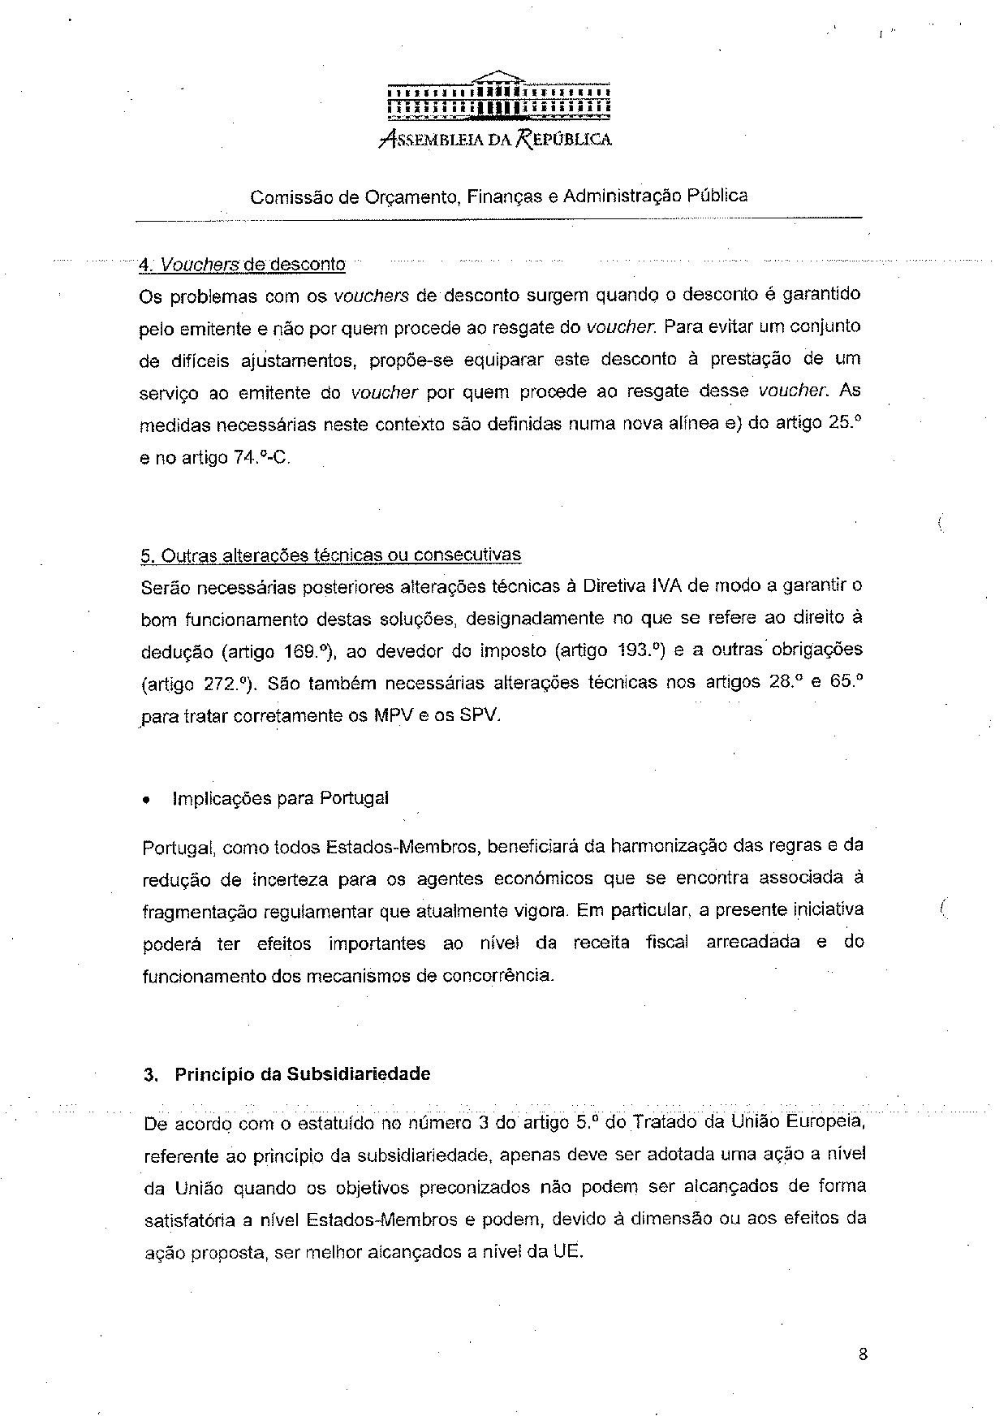
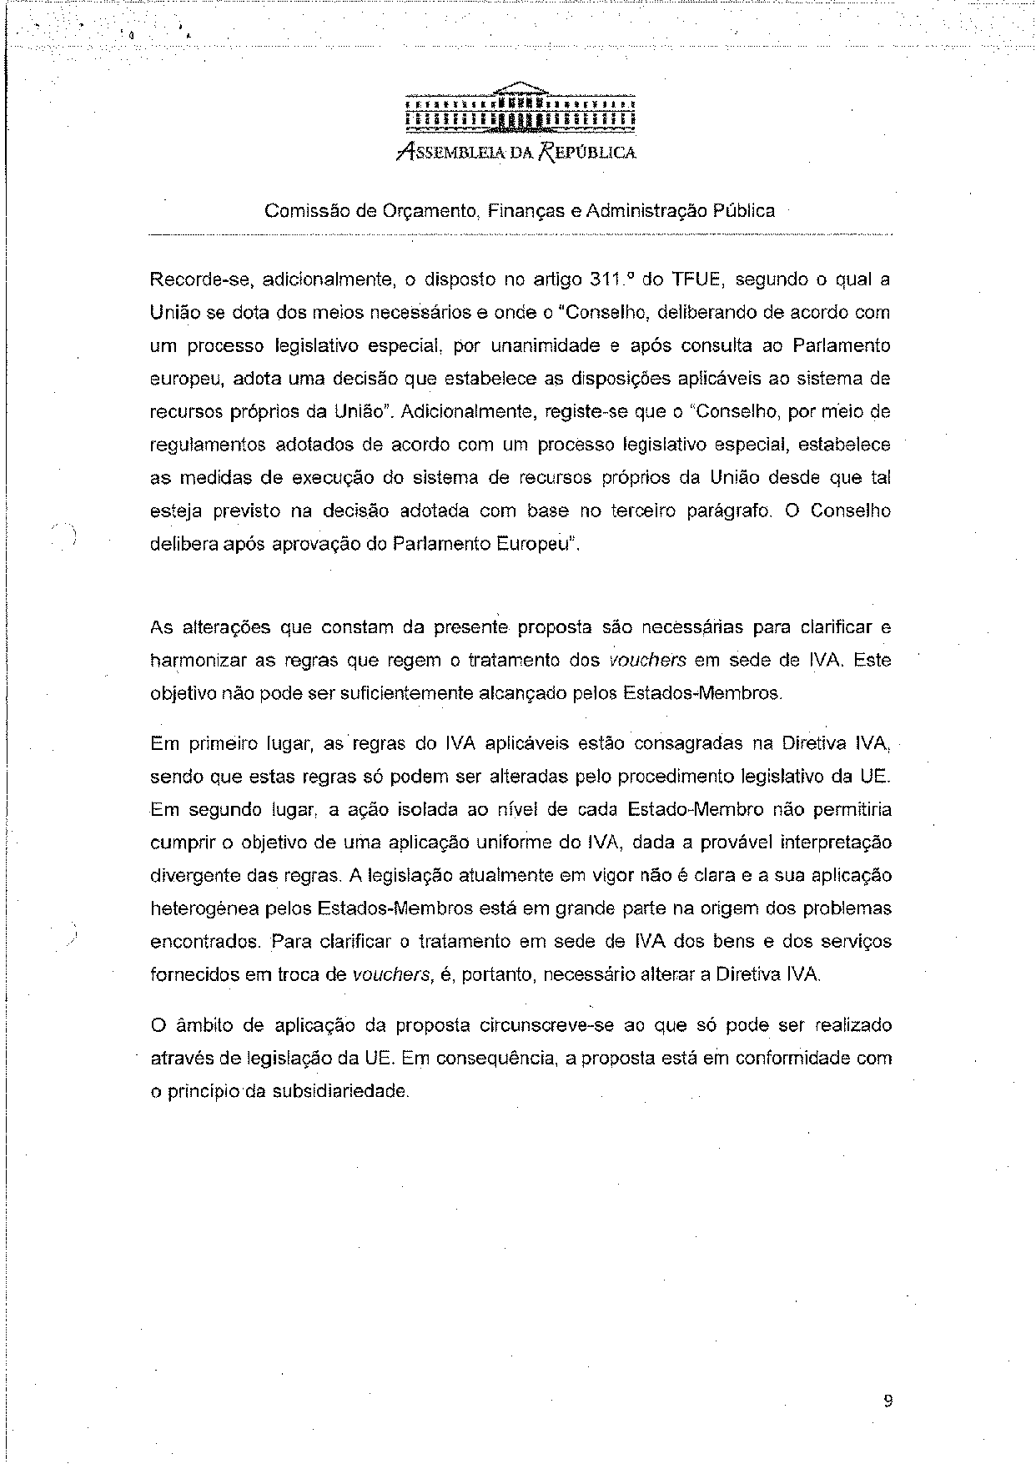
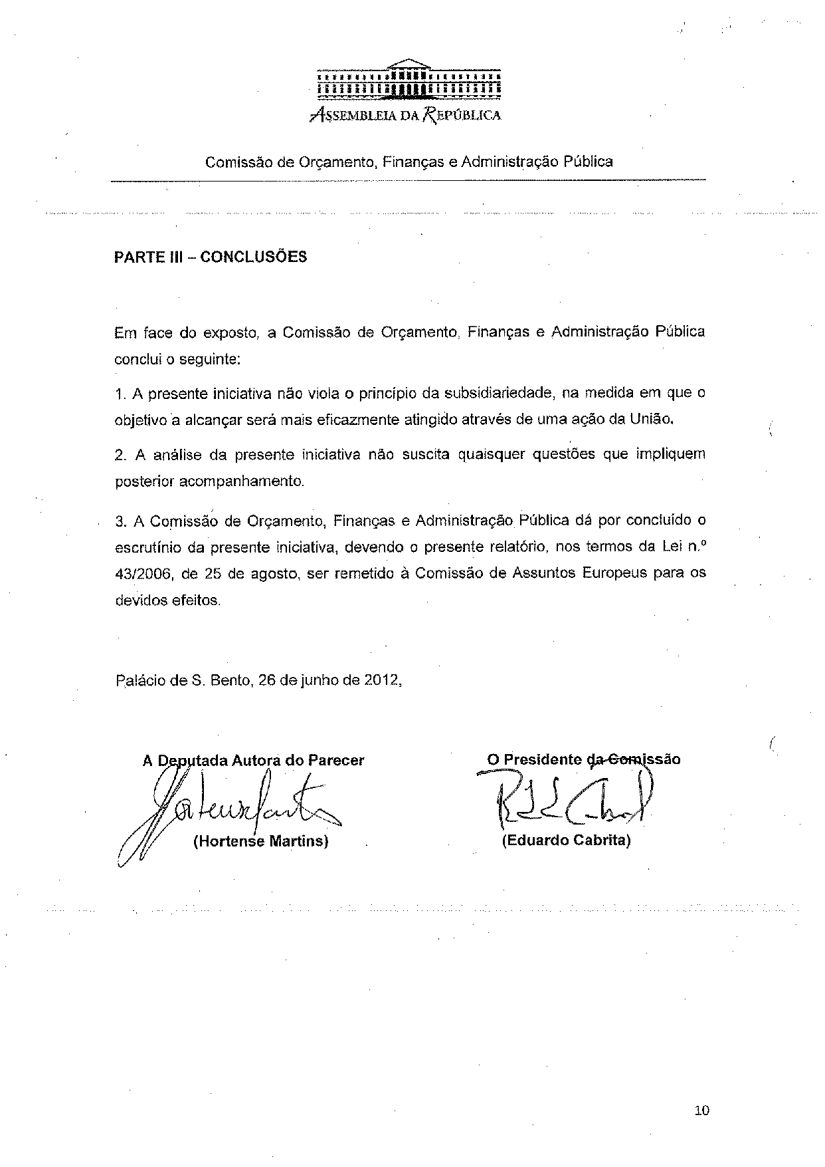

Translation(s) of the opinion may be available on the Interparliamentary EU Information Exchange site IPEX at the following address: http://www.ipex.eu/IPEXL-WEB/search.do

