 | 
COUNCIL OF  THE EUROPEAN UNION |  |  | Brussels, 26 September 2012
 | Interinstitutional File:  2012/0042(COD) |  | 13795/12
ENV 706
ONU 113
FORETS 59
AGRI 583
CODEC 2139
INST 531
PARLNAT 312

COVER NOTE
from: | The Senate of the Republic of Italy
date of receipt: | 13 September 2012
to: | General Secretariat of the Council of the European Union
Subject: | Proposal for a Decision of the European Parliament and of the Council on accounting rules and action plans on greenhouse gas emissions and removals resulting from activities related to land use, land use change and forestry [doc. 7639/12 ENV 204 ONU 34 FORETS 23 AGRI 144 CODEC 655 - COM(2012) 93 final]  - Opinionon the application of the Principles of Subsidiarity and Proportionality

Delegations will find attached the above mentioned opinion.

____________

Encl.

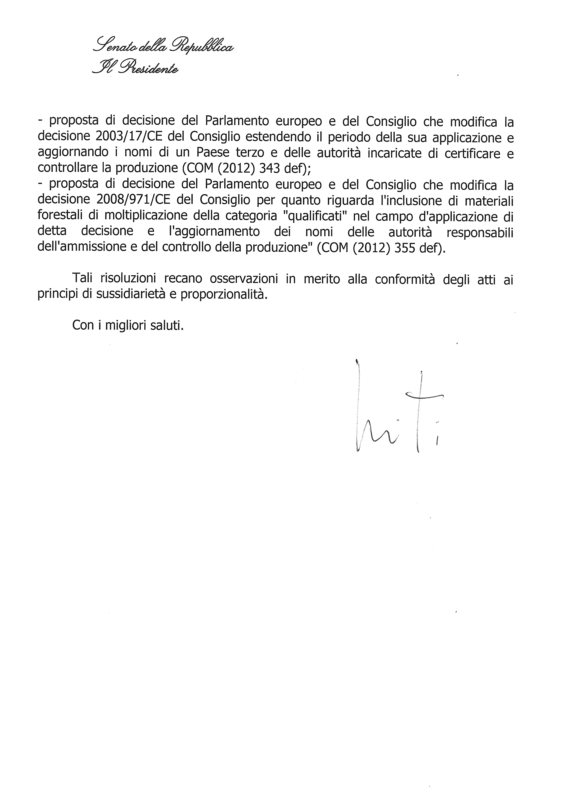
_______________

The translation of the following opinion may be available at the Interparliamentary EU information exchange site IPEX at the following address: http://www.ipex.eu/IPEXL-WEB/search.do

