 | 
COUNCIL OF  THE EUROPEAN UNION |  |  | Brussels, 25 September 2012
 | Interinstitutional File:  2012/0150(COD) |  | 14197/12
EF 209
ECOFIN 797
DRS 110
CODEC 2224
INST 554
PARLNAT 320

COVER NOTE
from: | Portuguese Parliament
date of receipt: | 21 September 2012
to: | President of the Council of the European Union
Subject: | Proposal for a DIRECTIVE OF THE EUROPEAN PARLIAMENT AND OF THE COUNCIL establishing a framework for the recovery and resolution of credit institutions and investment firms and amending Council Directives 77/91/EEC and 82/891/EC, Directives 2001/24/EC, 2002/47/EC, 2004/25/EC, 2005/56/EC, 2007/36/EC and 2011/35/EC and Regulation (EU) No 1093/2010  [doc. ST 11066/12 EF 136 ECOFIN 552 DRS 91 CODEC 1600 - COM(2012) 280 final]  - Opinion on the application of the Principles of Subsidiarity and Proportionality

Delegations will find attached the above mentioned Opinion.

________________________

Encl.:
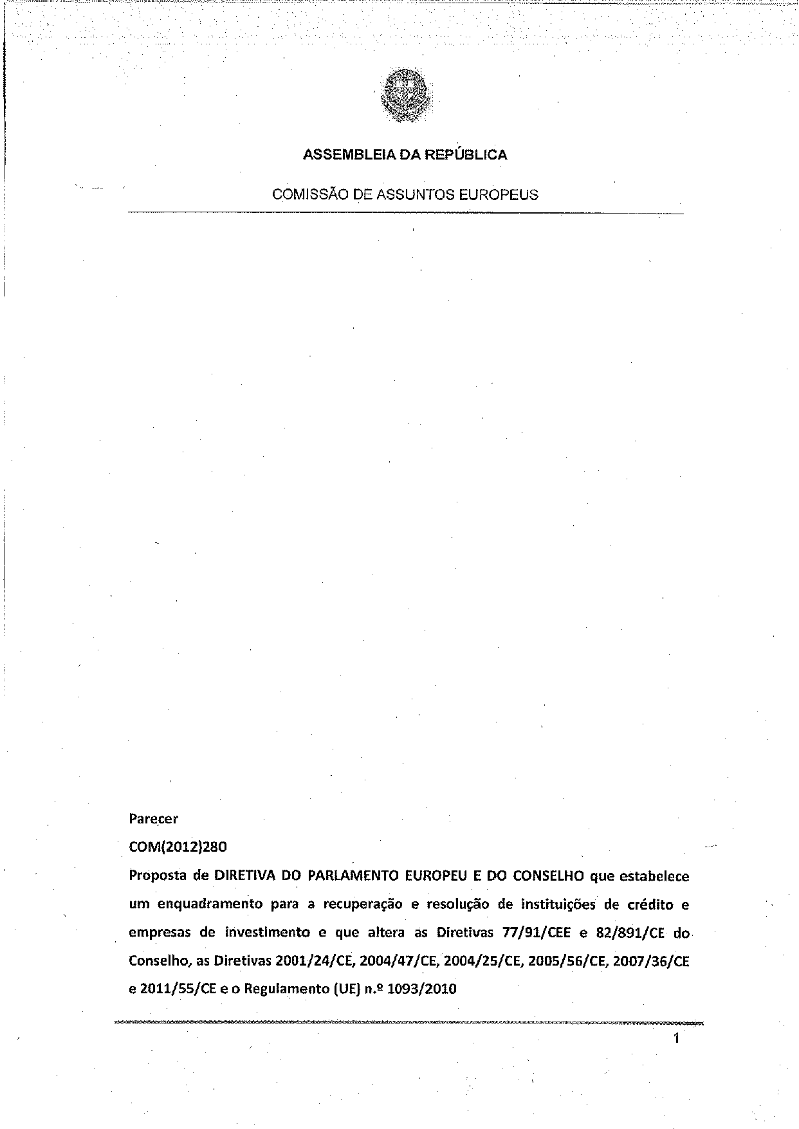
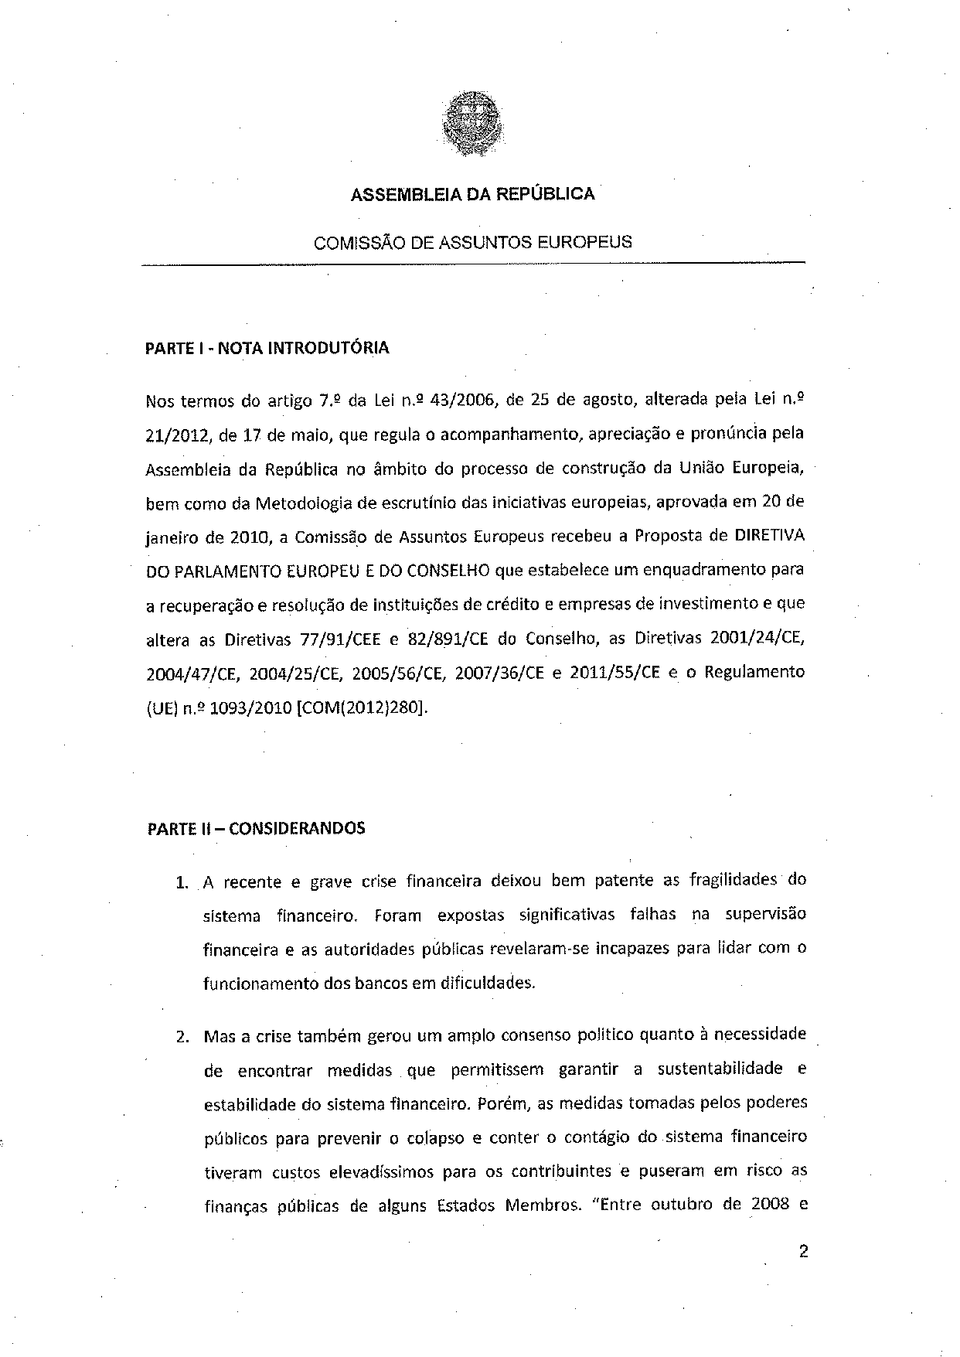
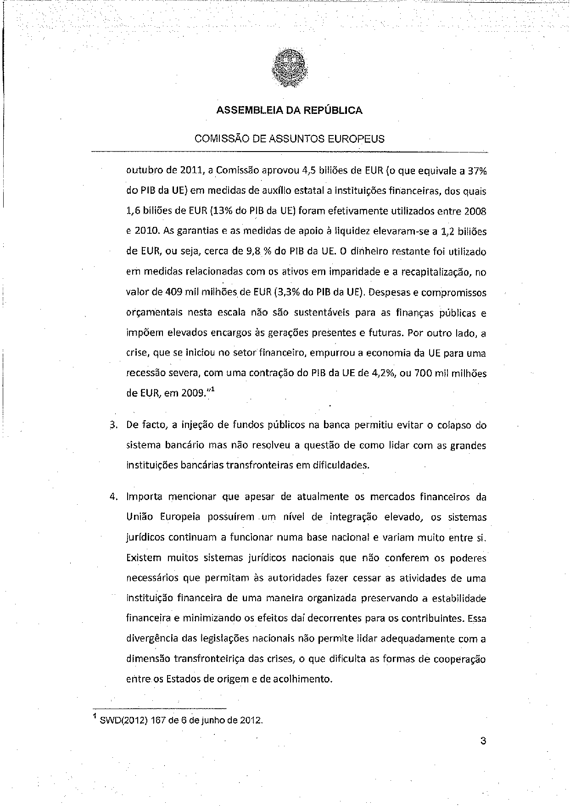
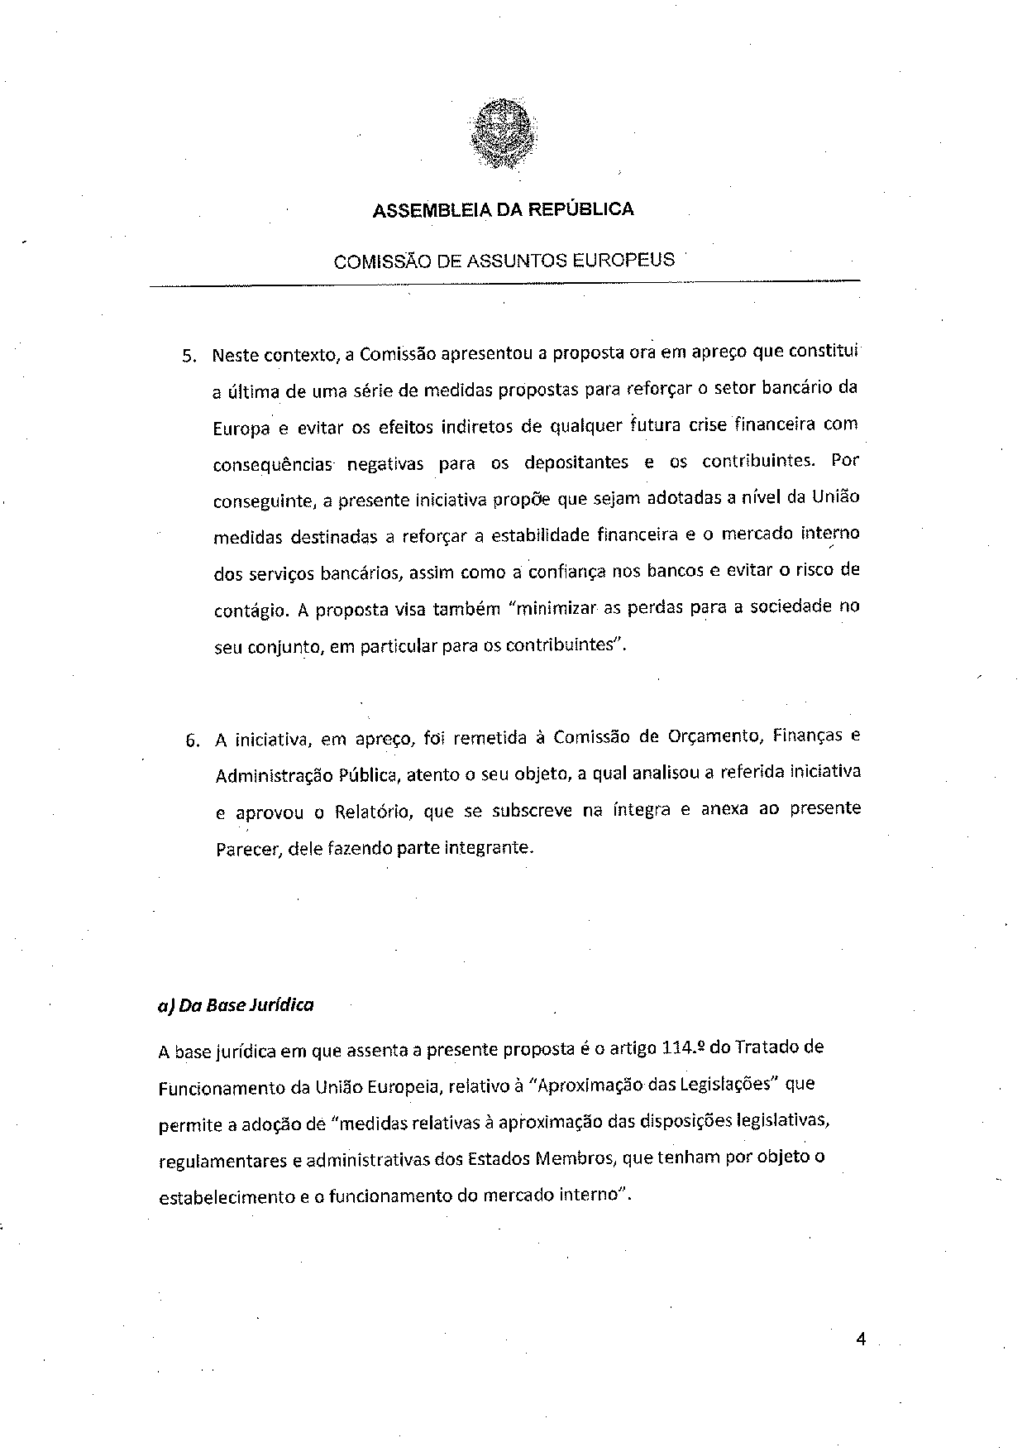
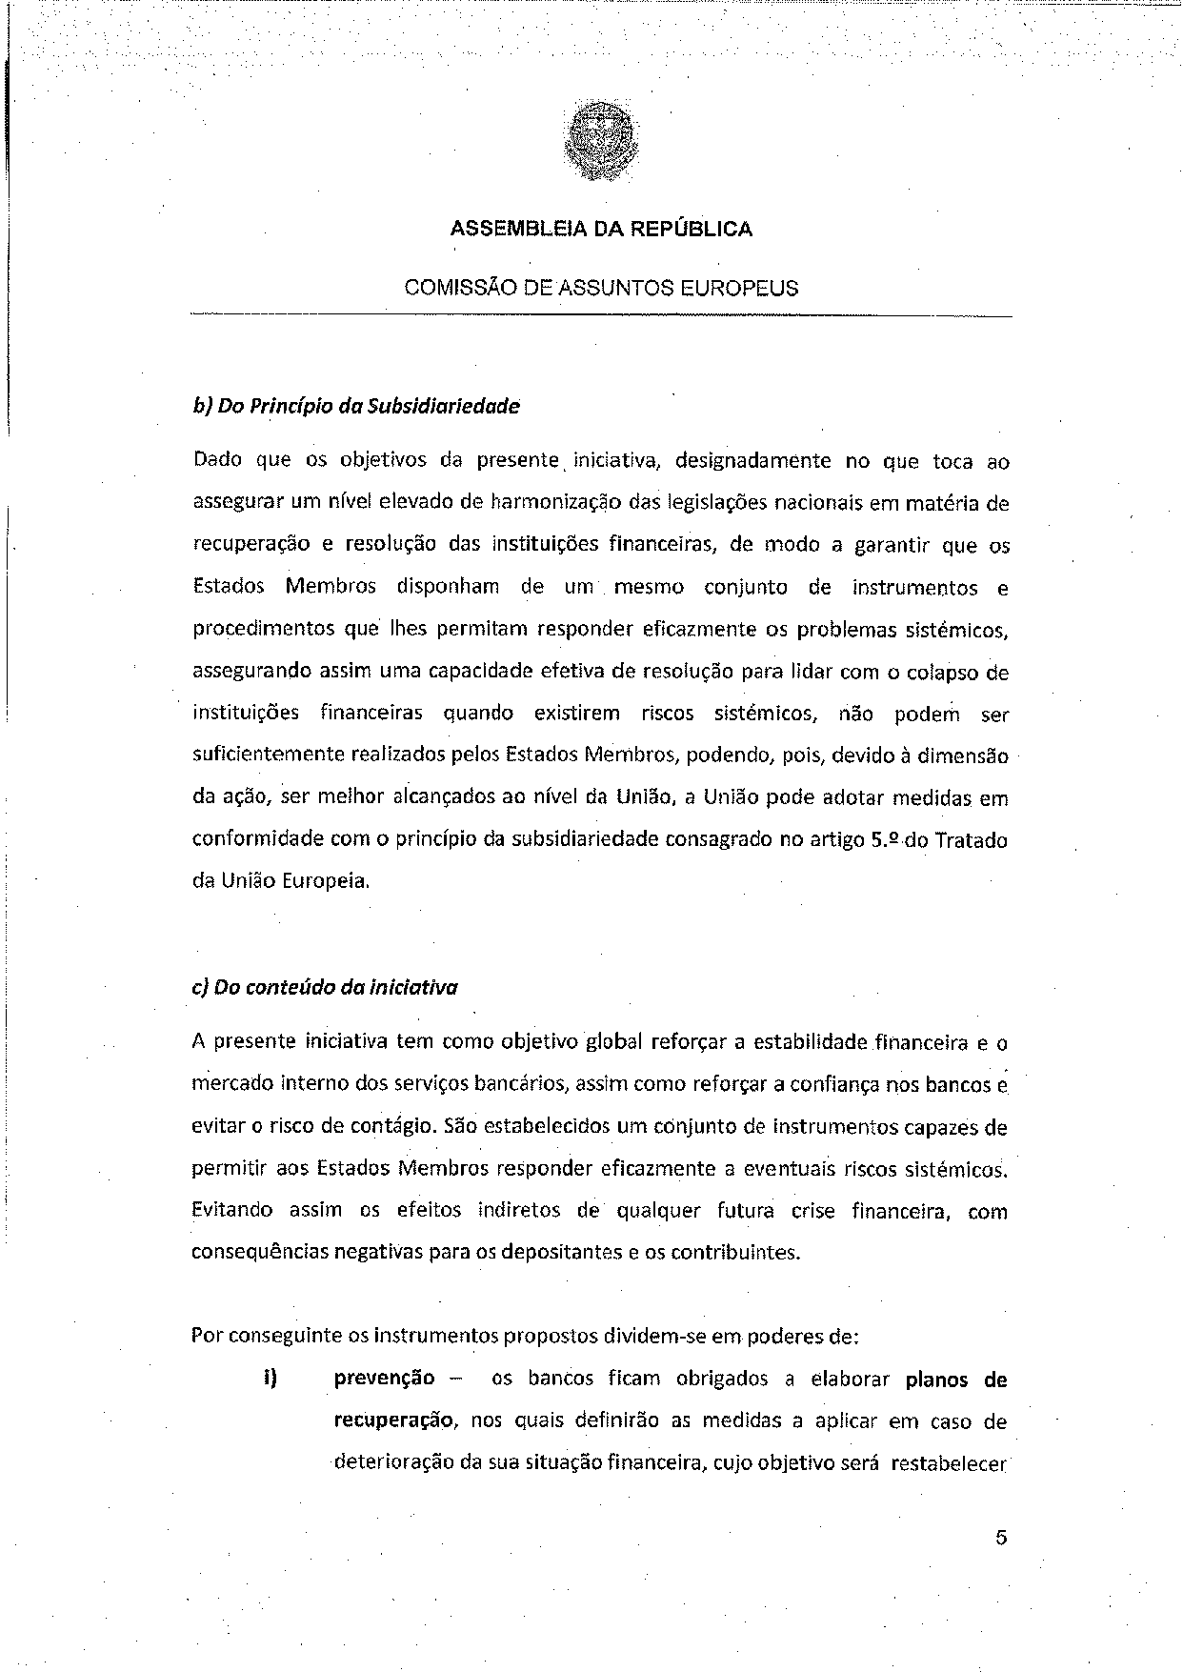
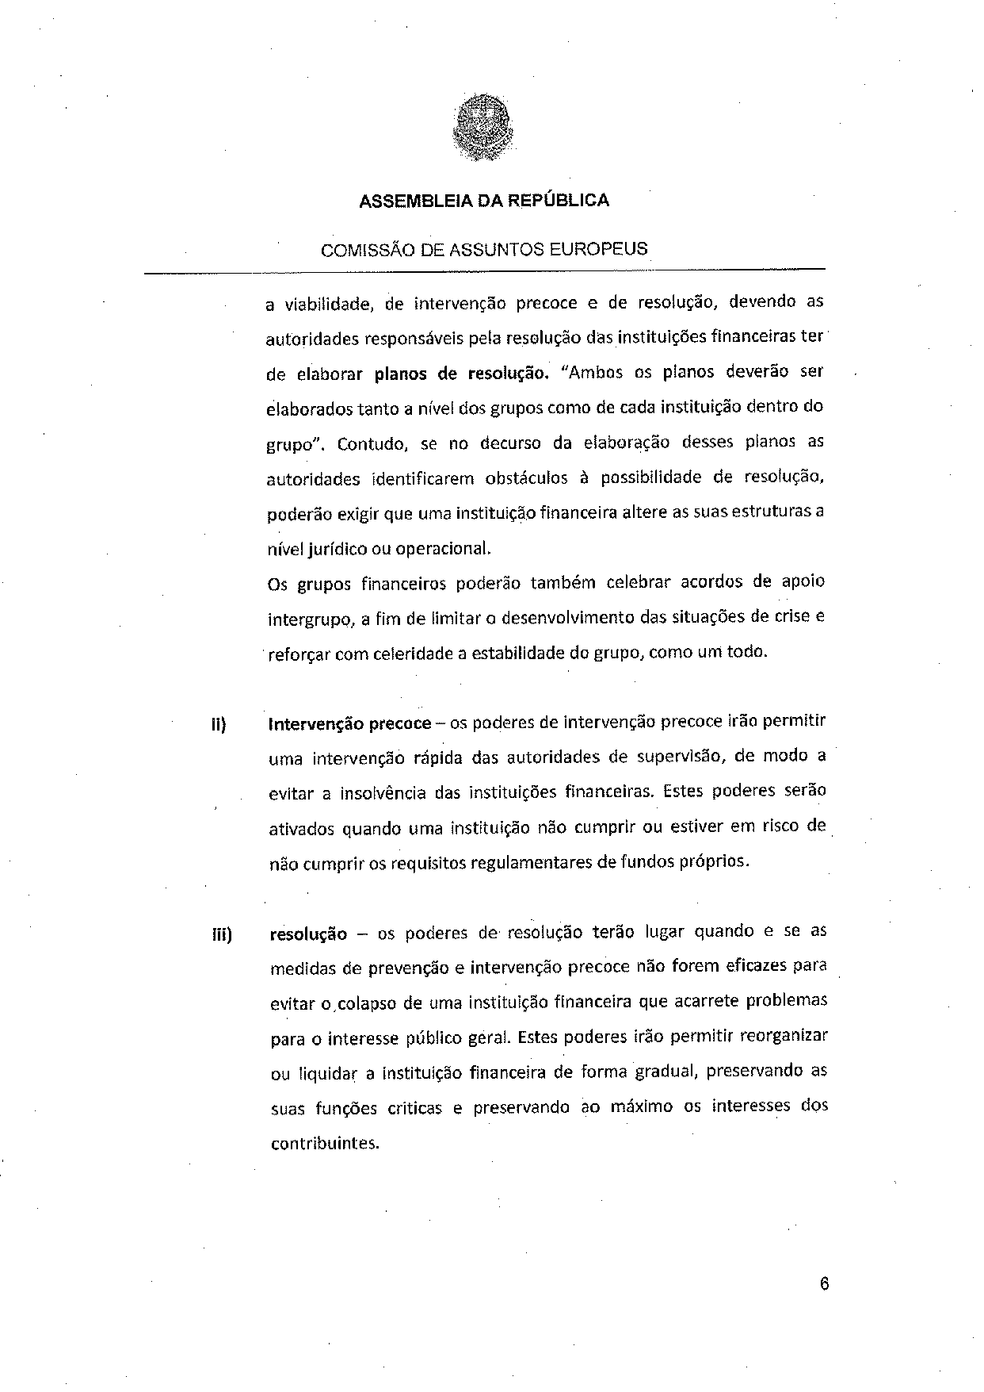
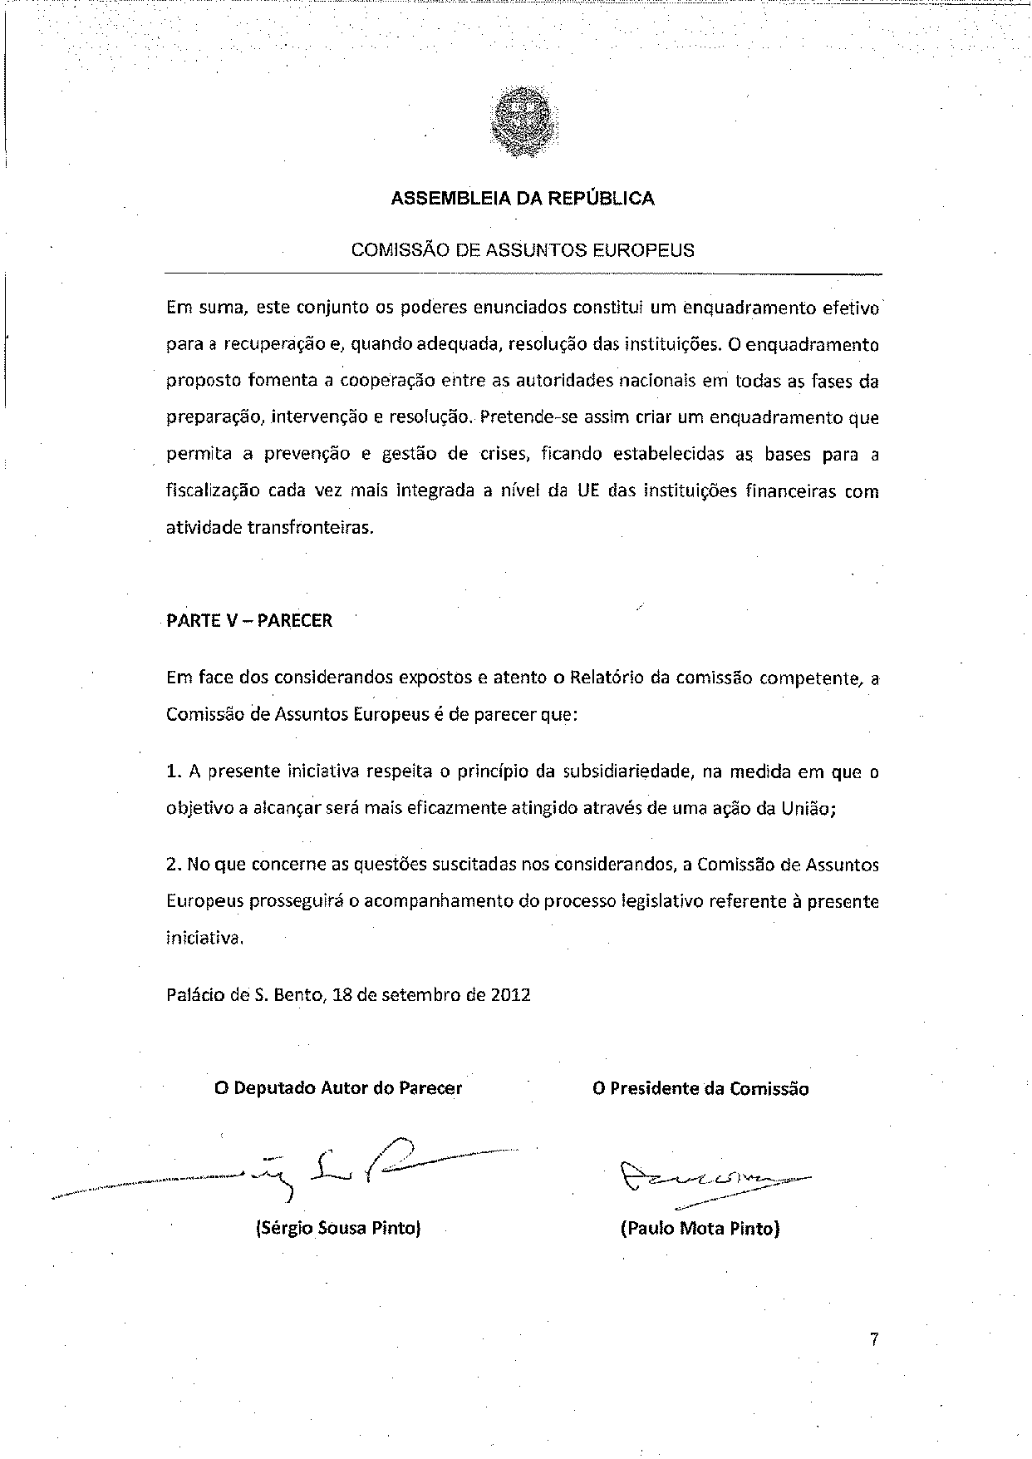

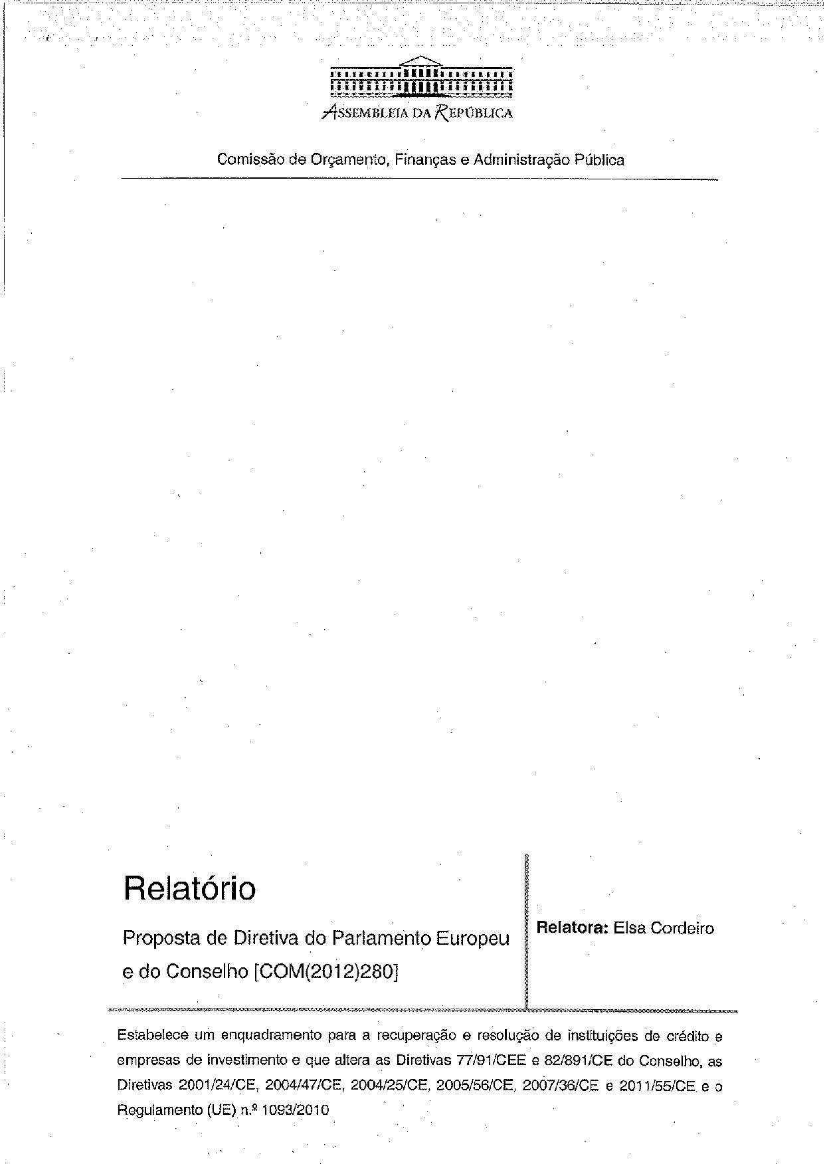
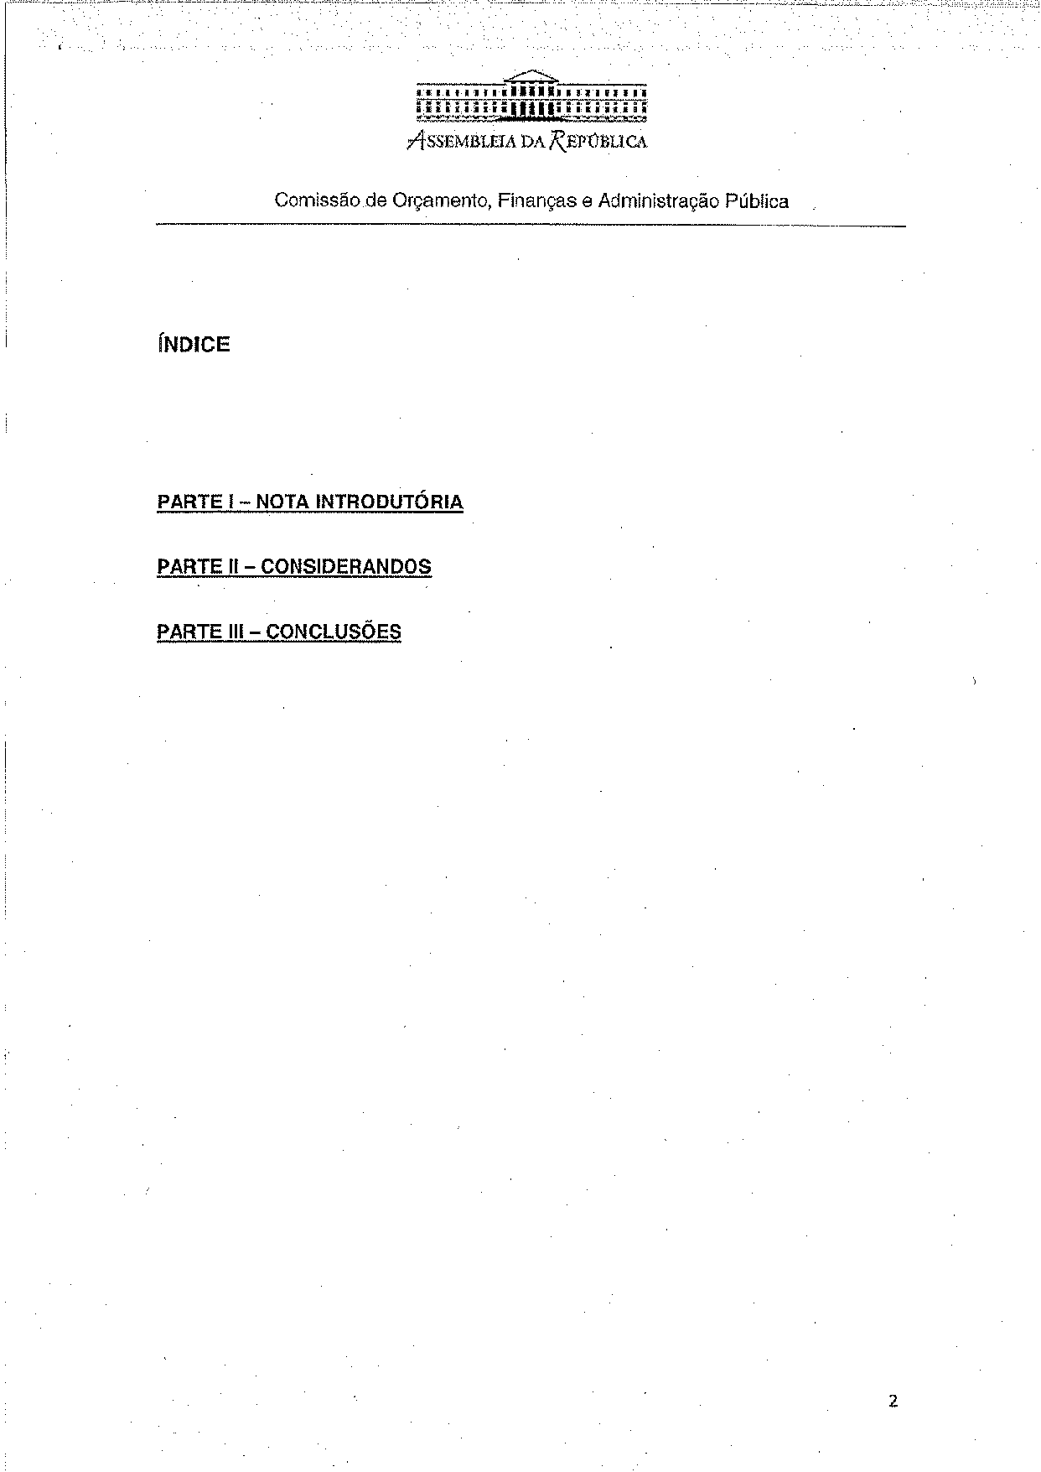
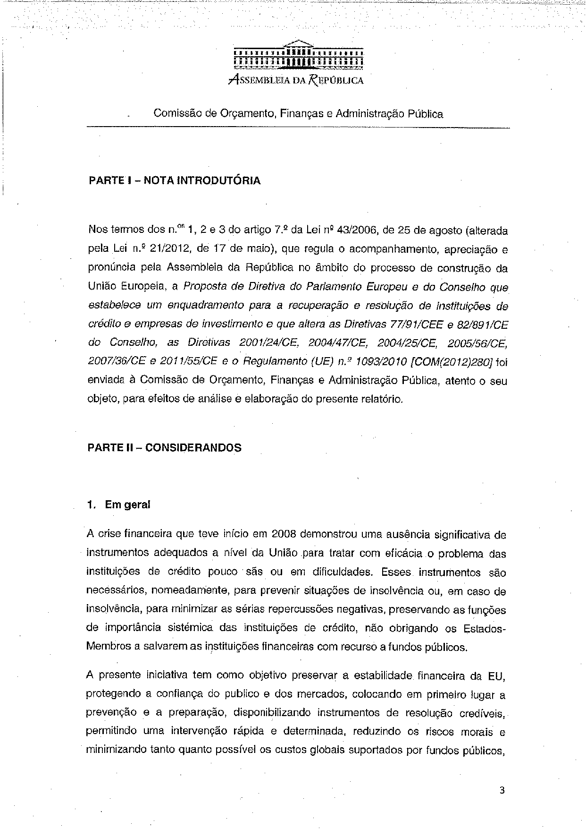
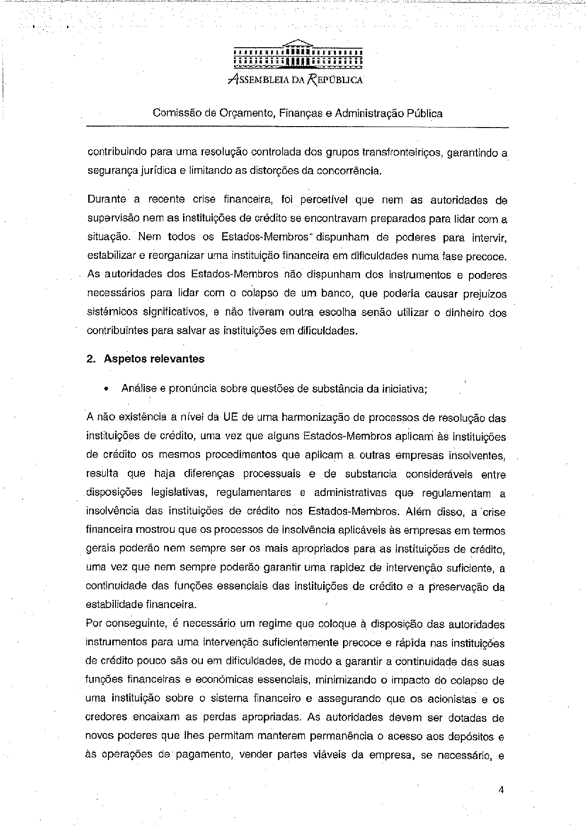
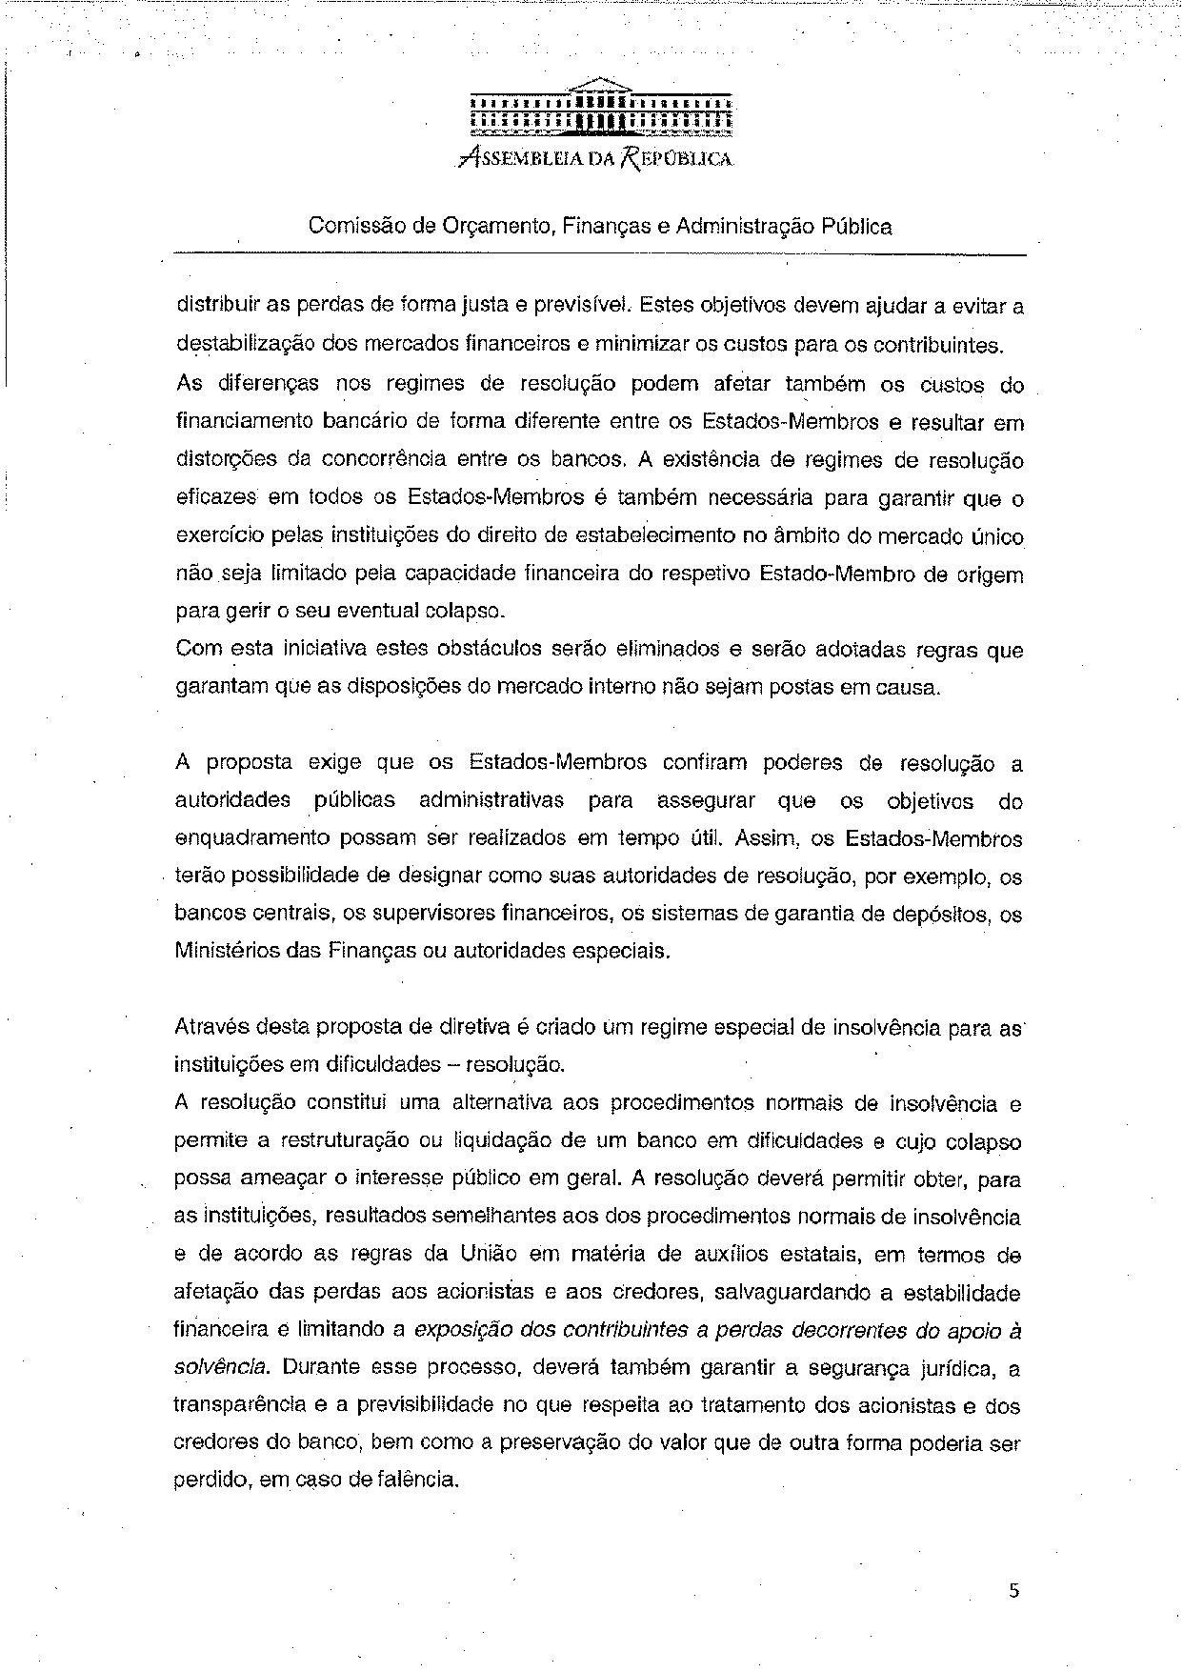
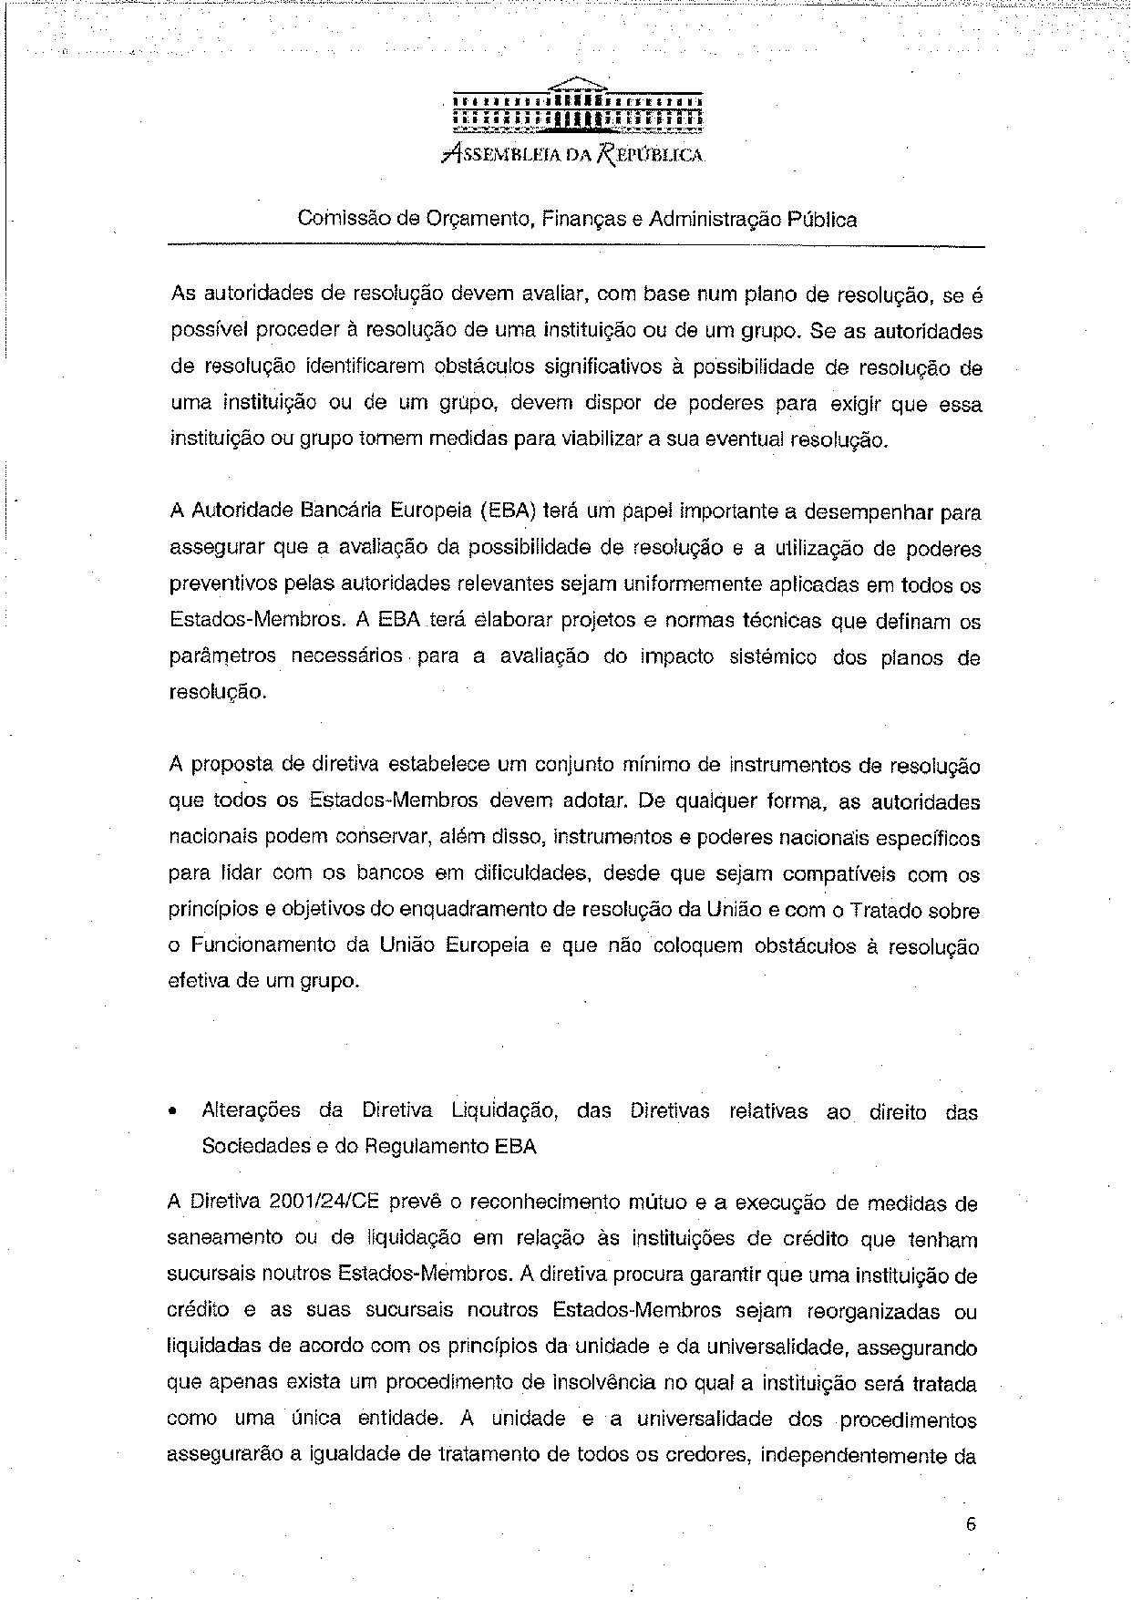
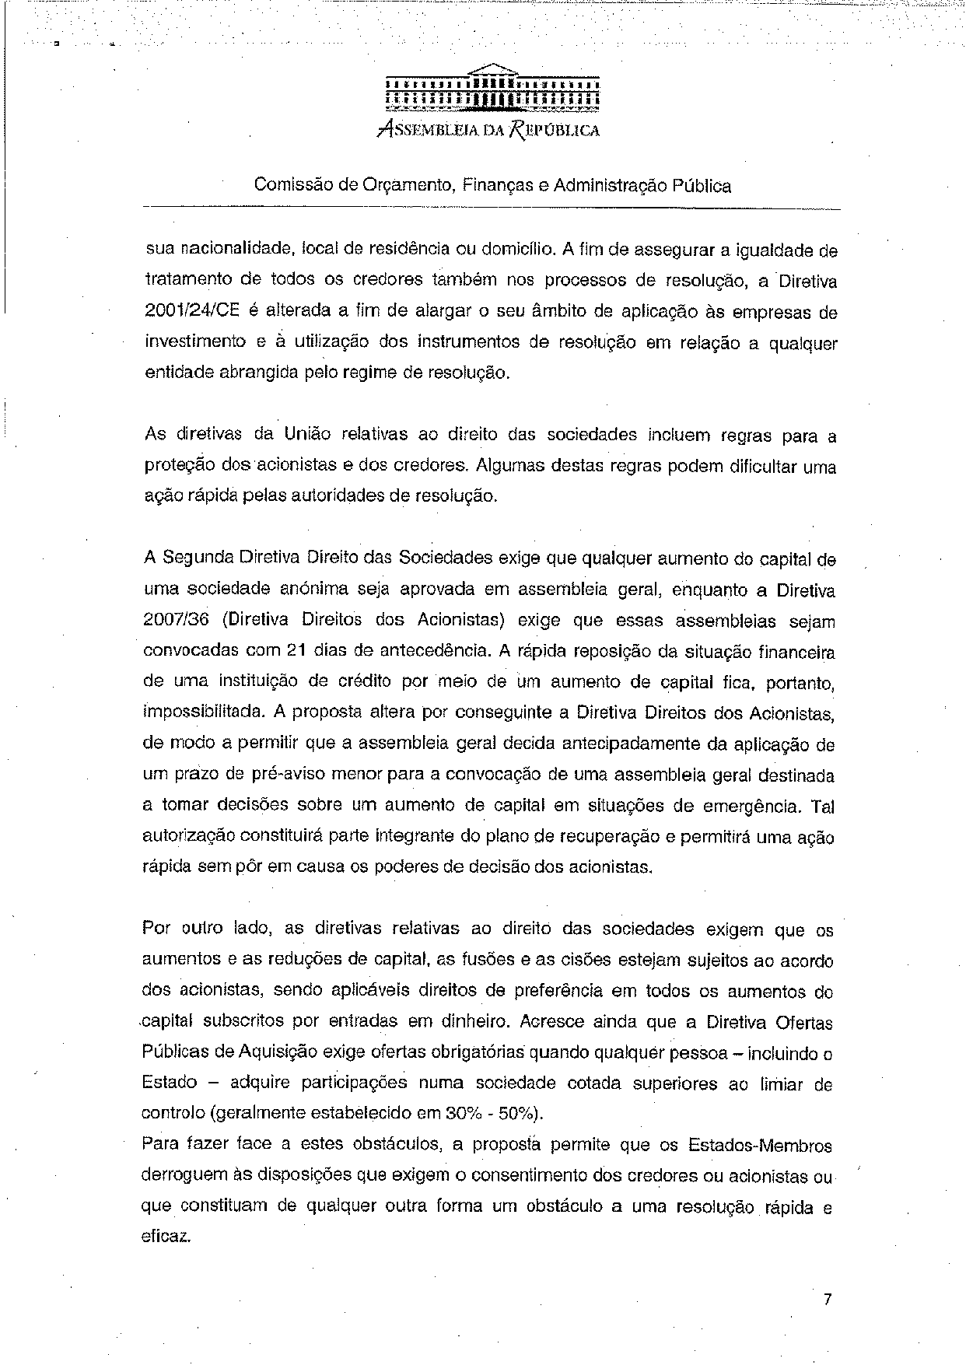
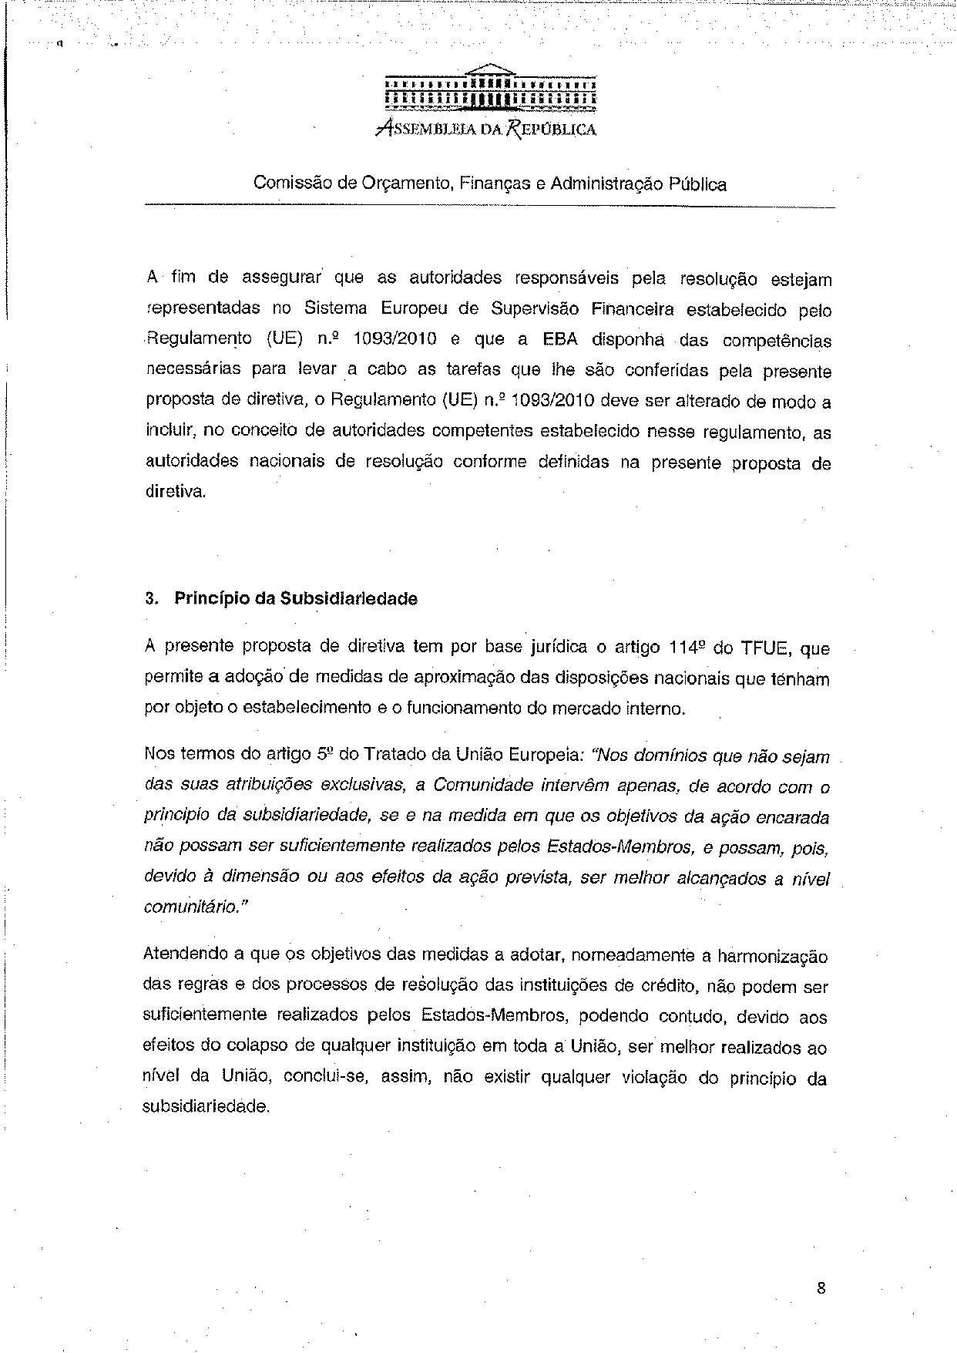
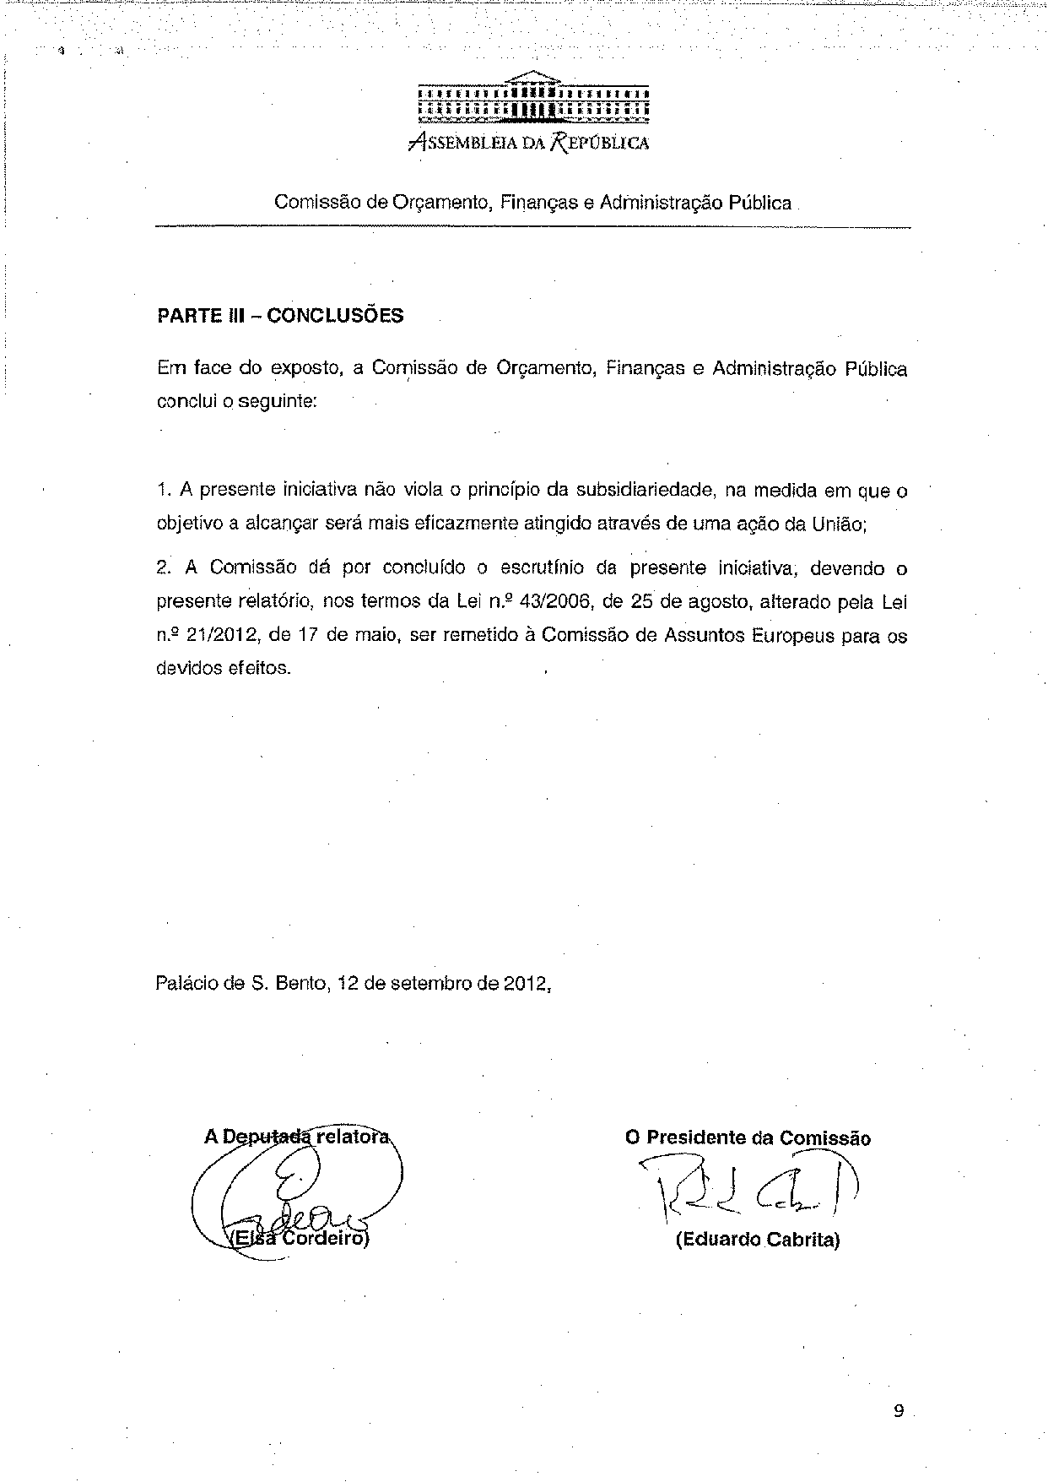

Translation(s) may be available in the Interparliamentary EU information exchange site IPEX at the following address: http://www.ipex.eu/IPEXL- WEB/search.do

