 | 
COUNCIL OF  THE EUROPEAN UNION |  |  | Brussels, 20 September 2012
 | Interinstitutional File:  2012/0073 (NLE) |  | 14052/12
UD 232
CDN 16
INST 542
PARLNAT 317

COVER NOTE
from: | Portuguese Parliament
date of receipt: | 12 July 2012
No. Cion doc.: | 8376/12 UD 98 CDN 3
Subject: | Proposal for a Council Decision on the conclusion of the Agreement between the European Union and Canada on customs cooperation with respect to matters related to supply chain security

Delegations will find attached the Opinion of the Portuguese Parliament on the above proposal.

________________________

Encl.:

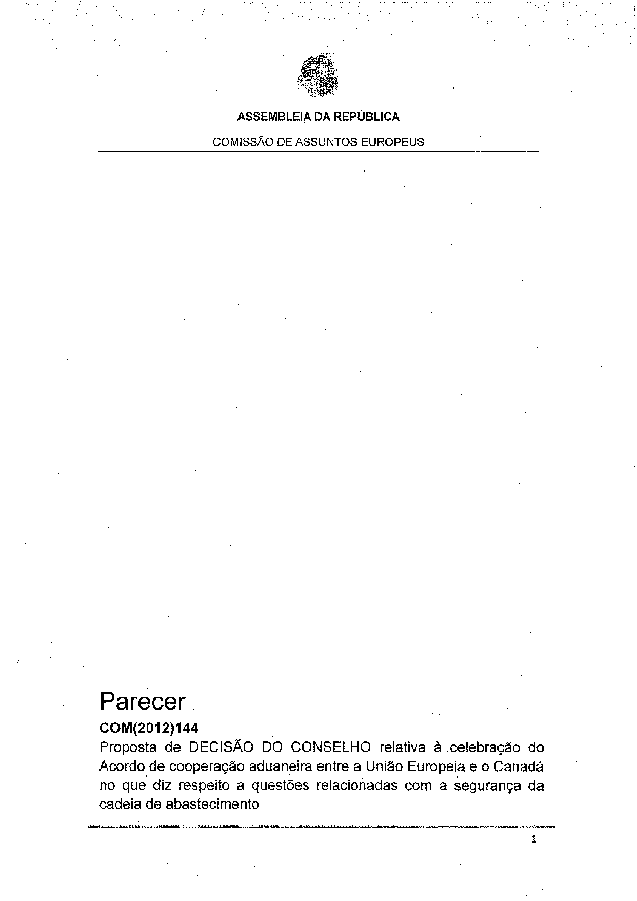
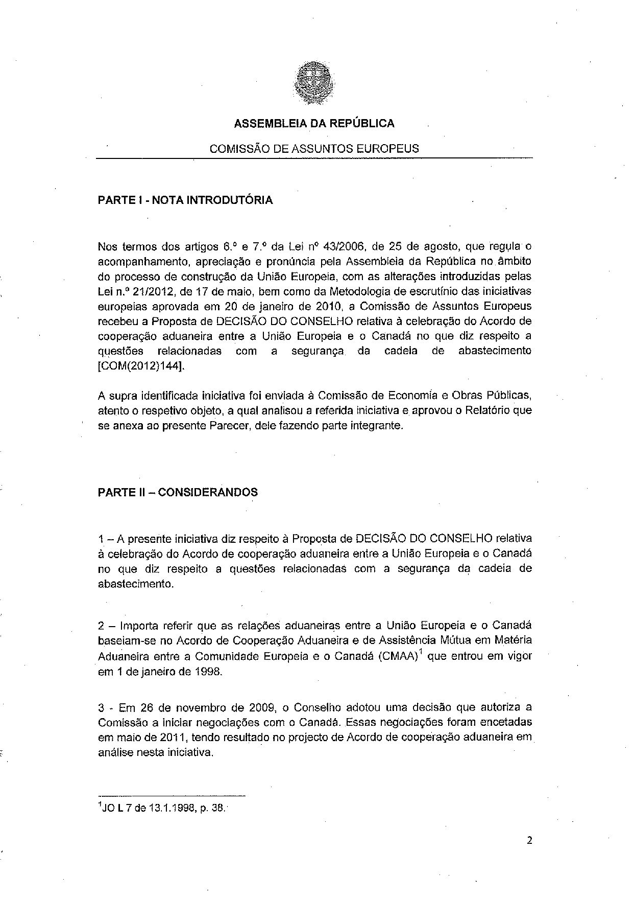
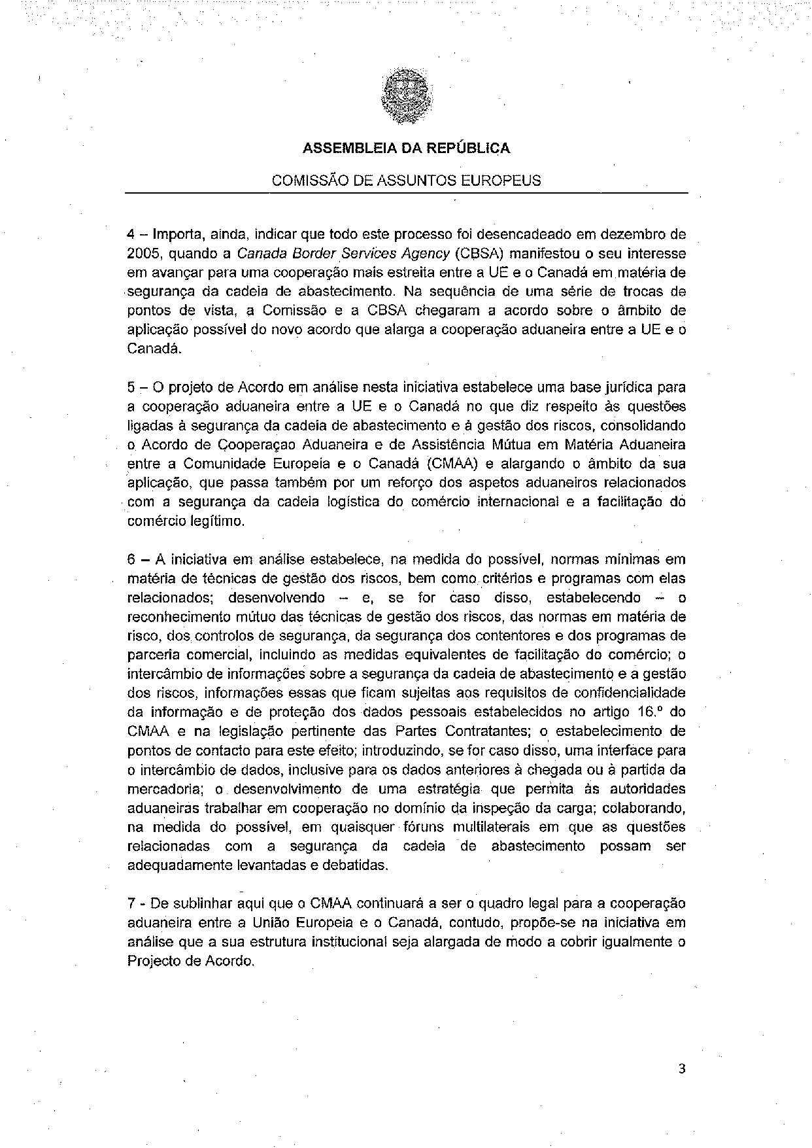
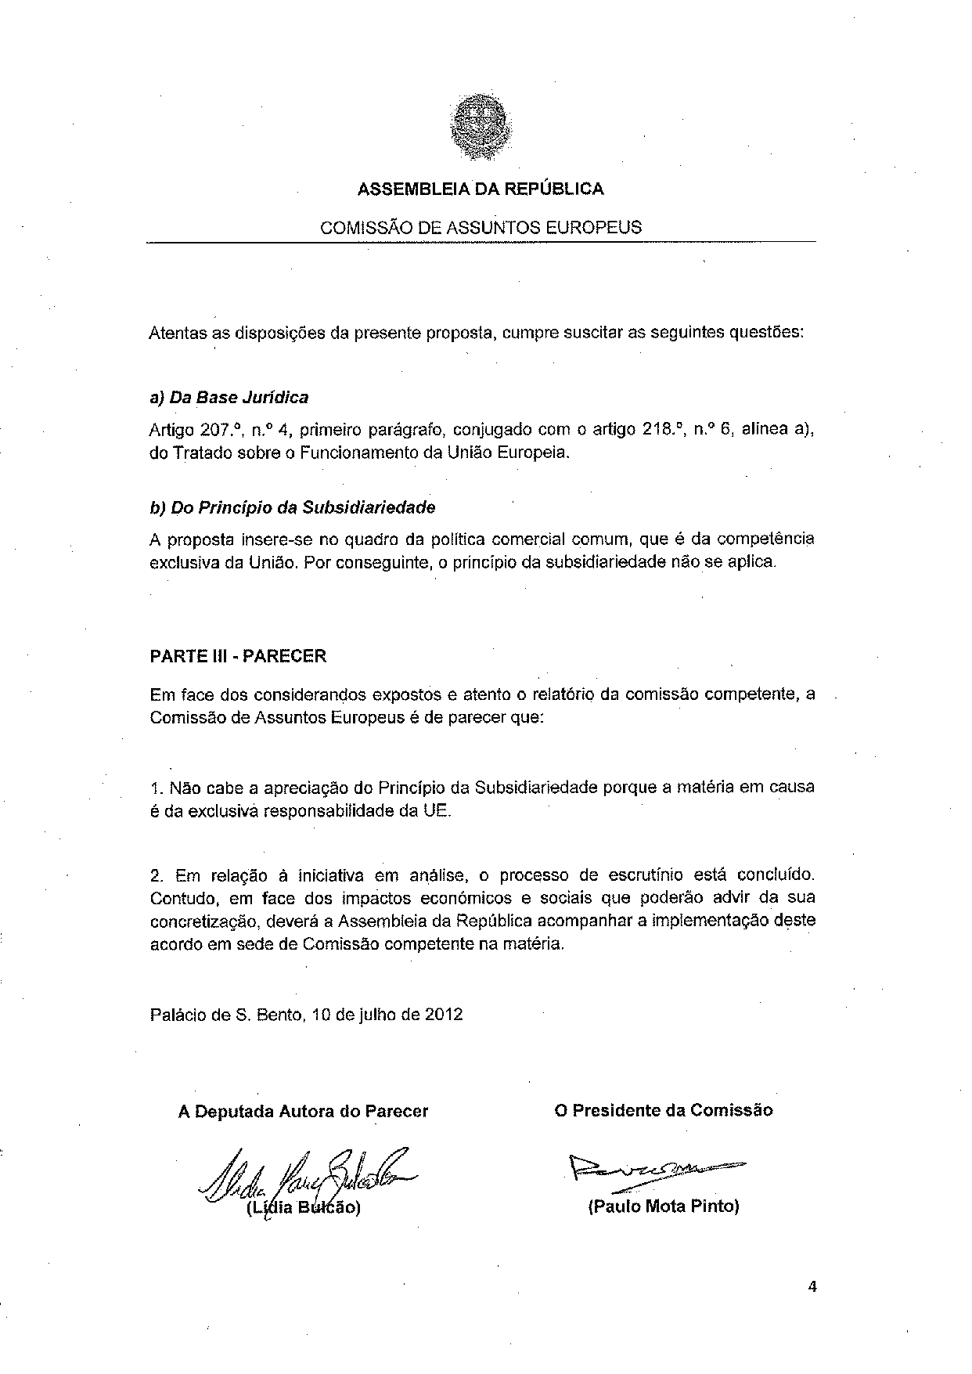

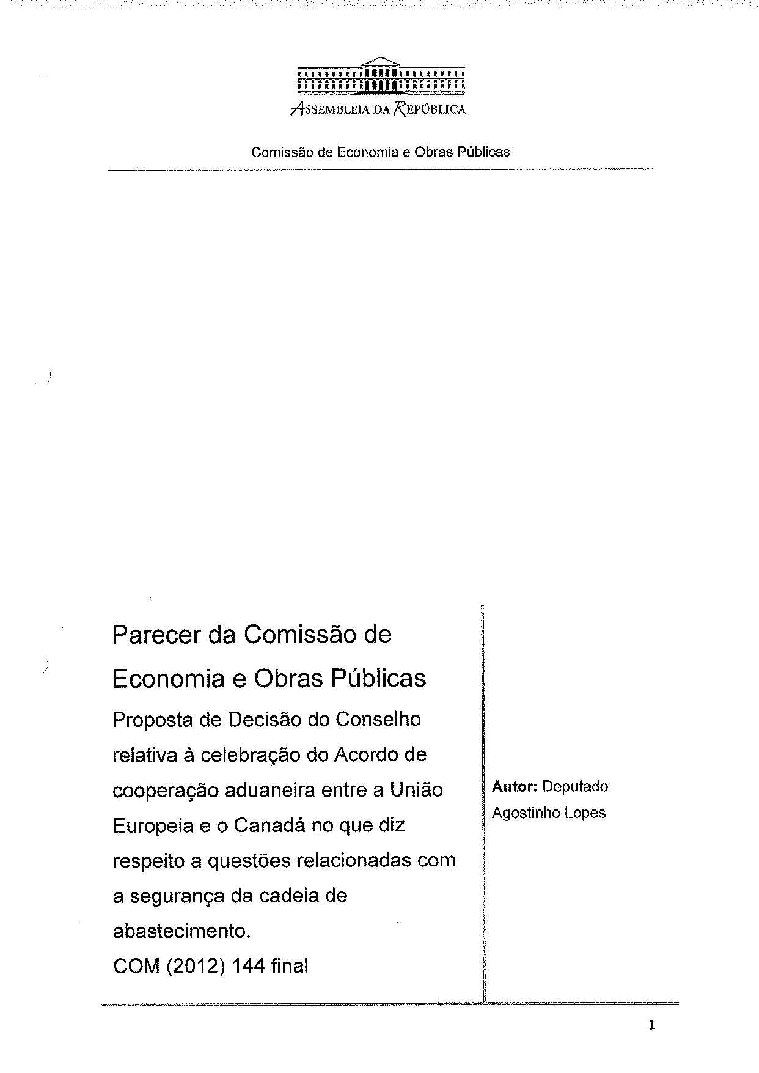
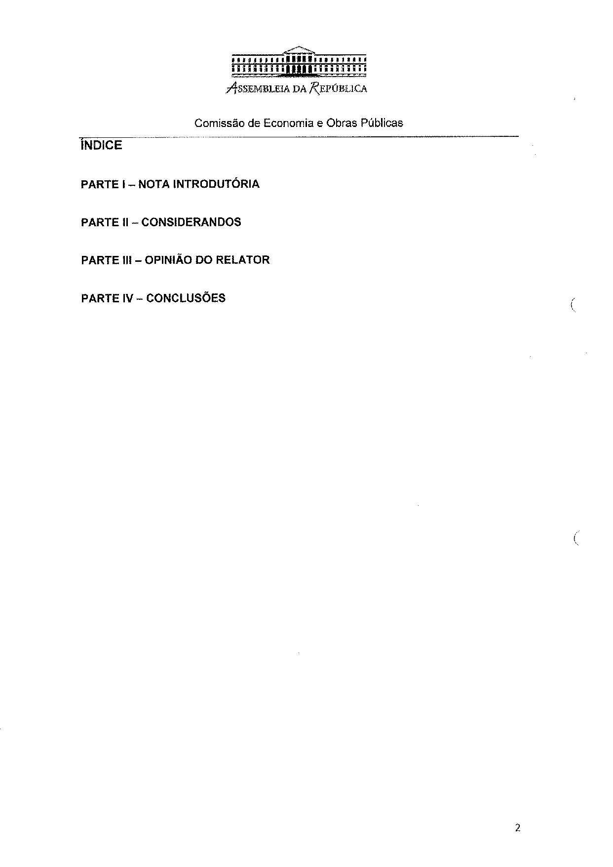
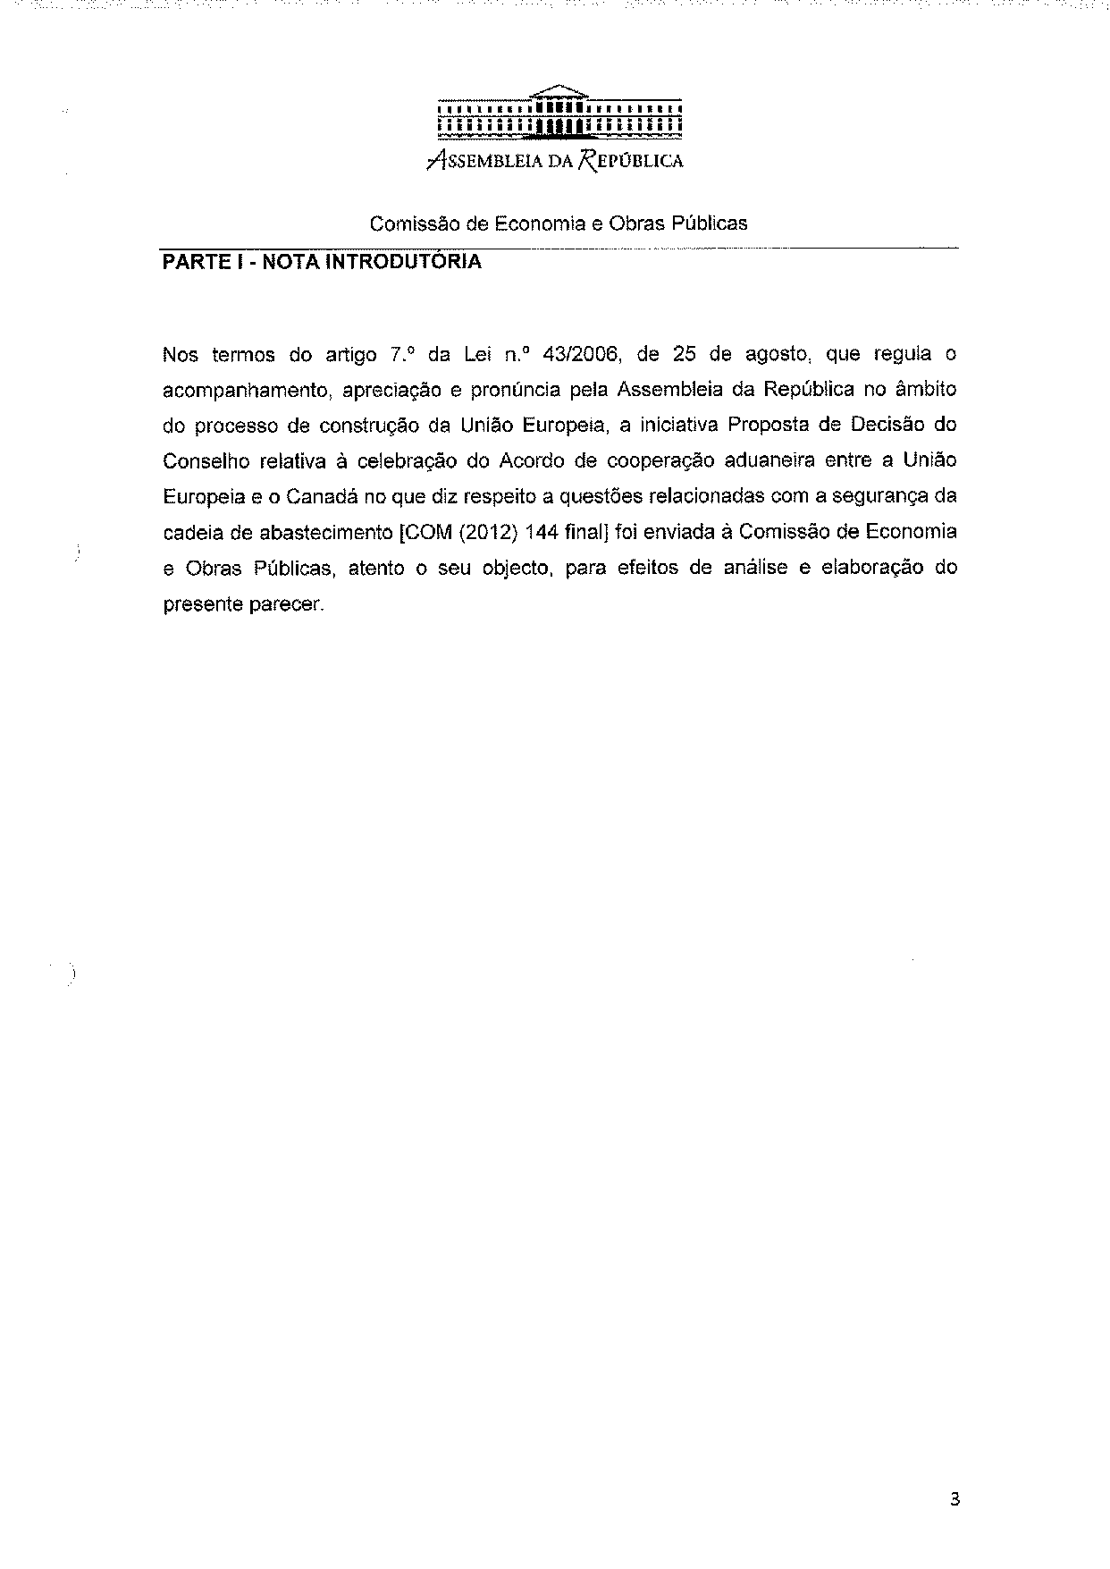
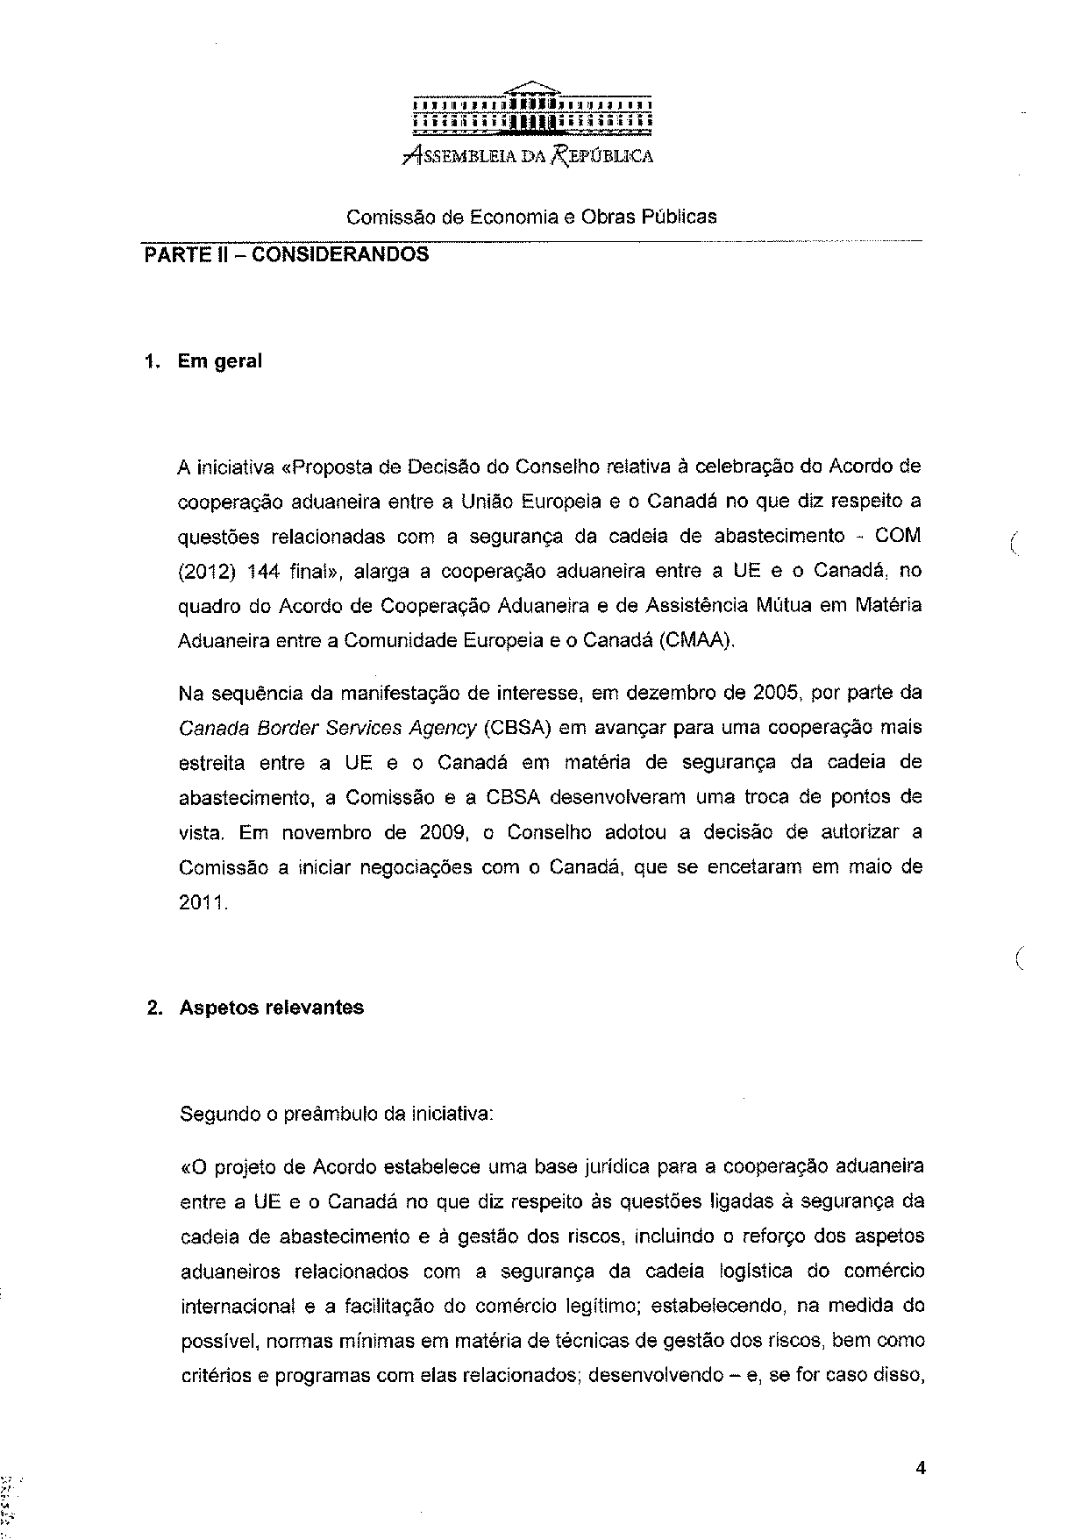
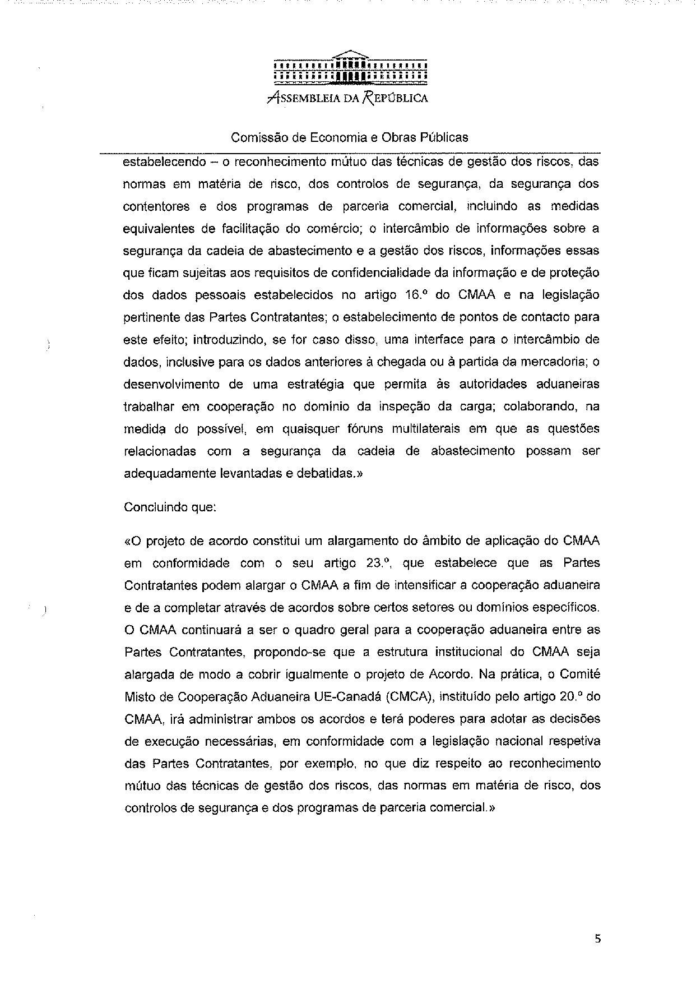
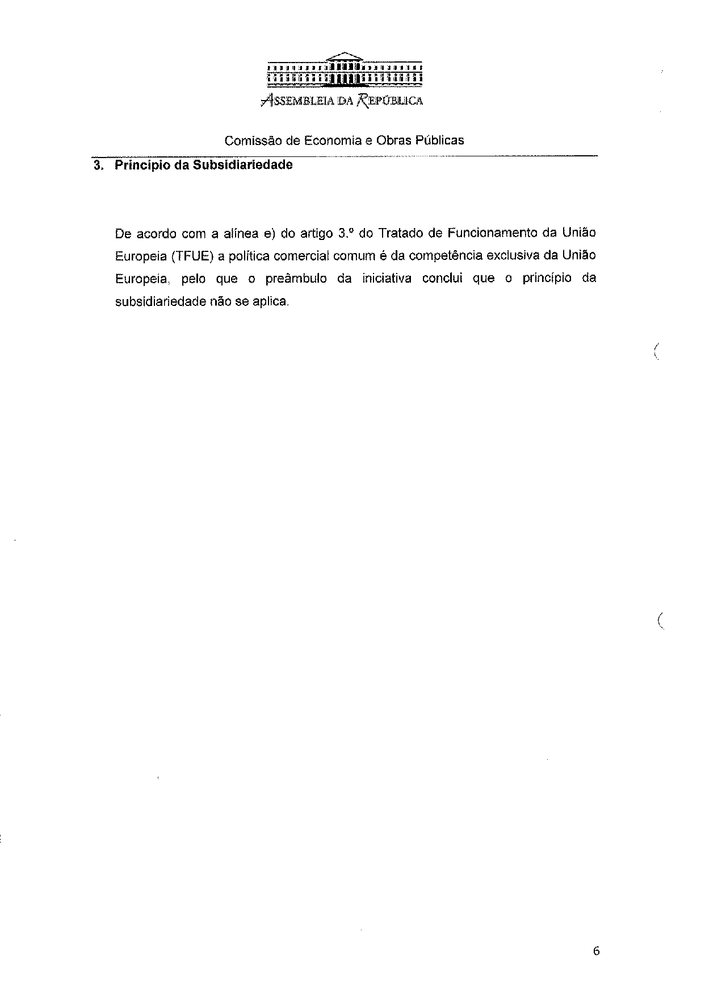
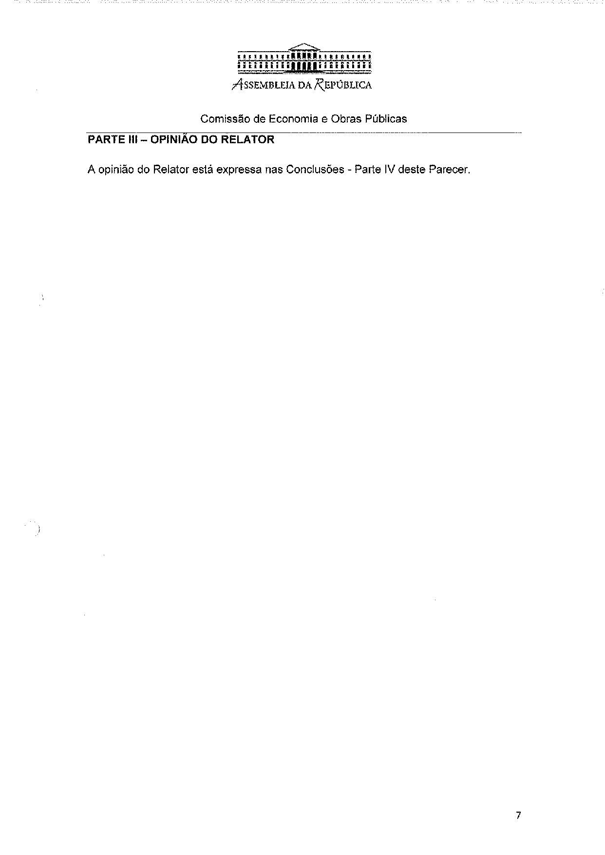
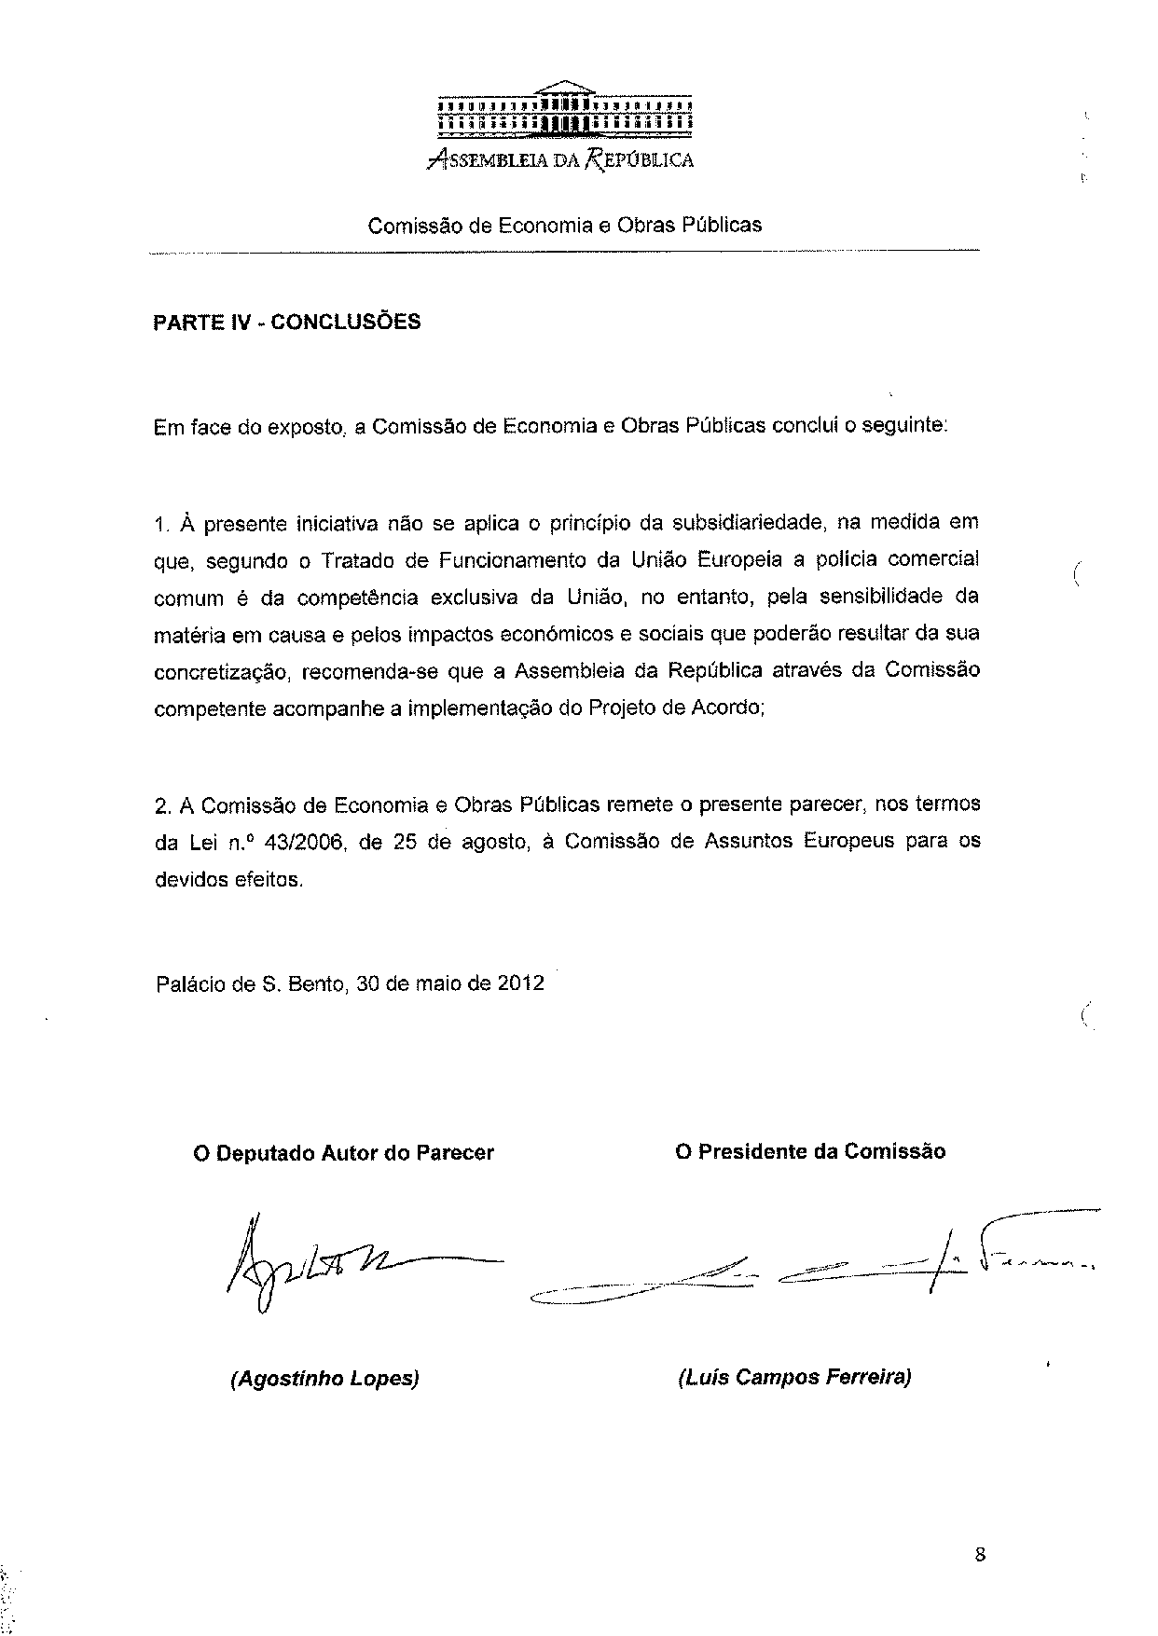

Translation may be available at the Interparliamentary EU information exchange site IPEX at the following address: http://www.ipex.eu/IPEXL-WEB/search.do.

