 | 
COUNCIL OF  THE EUROPEAN UNION |  |  | Brussels, 26 July 2012
 | Interinstitutional File:  2011/0295 (COD)  2011/0297 (COD) |  | 12935/12
EF 182
ECOFIN 727
DROIPEN 112
CODEC 1980
INST 486
PARLNAT 302

COVER NOTE
from: | The Italian Senate
date of receipt: | 23 July 2012
to: | President of the Council of the European Union
Subject: | Proposal for a REGULATION OF THE EUROPEAN PARLIAMENT AND OF THE COUNCIL on insider dealing and market manipulation (market abuse)  [doc. ST 16010/11 EF 146 ECOFIN 719 DROIPEN 126 CODEC 1804 - COM(2011) 651 final]  AND  Proposal for a DIRECTIVE OF THE EUROPEAN PARLIAMENT AND OF THE COUNCIL on criminal sanctions for insider dealing and market manipulation  [doc. ST 16000/11 DROIPEN 125 EF 145 ECOFIN 717 - COM(2011) 654 final]  - Opinion on the application of the Principles of Subsidiarity and Proportionality

Delegations will find attached the above mentioned opinion.

________________________

Encl.

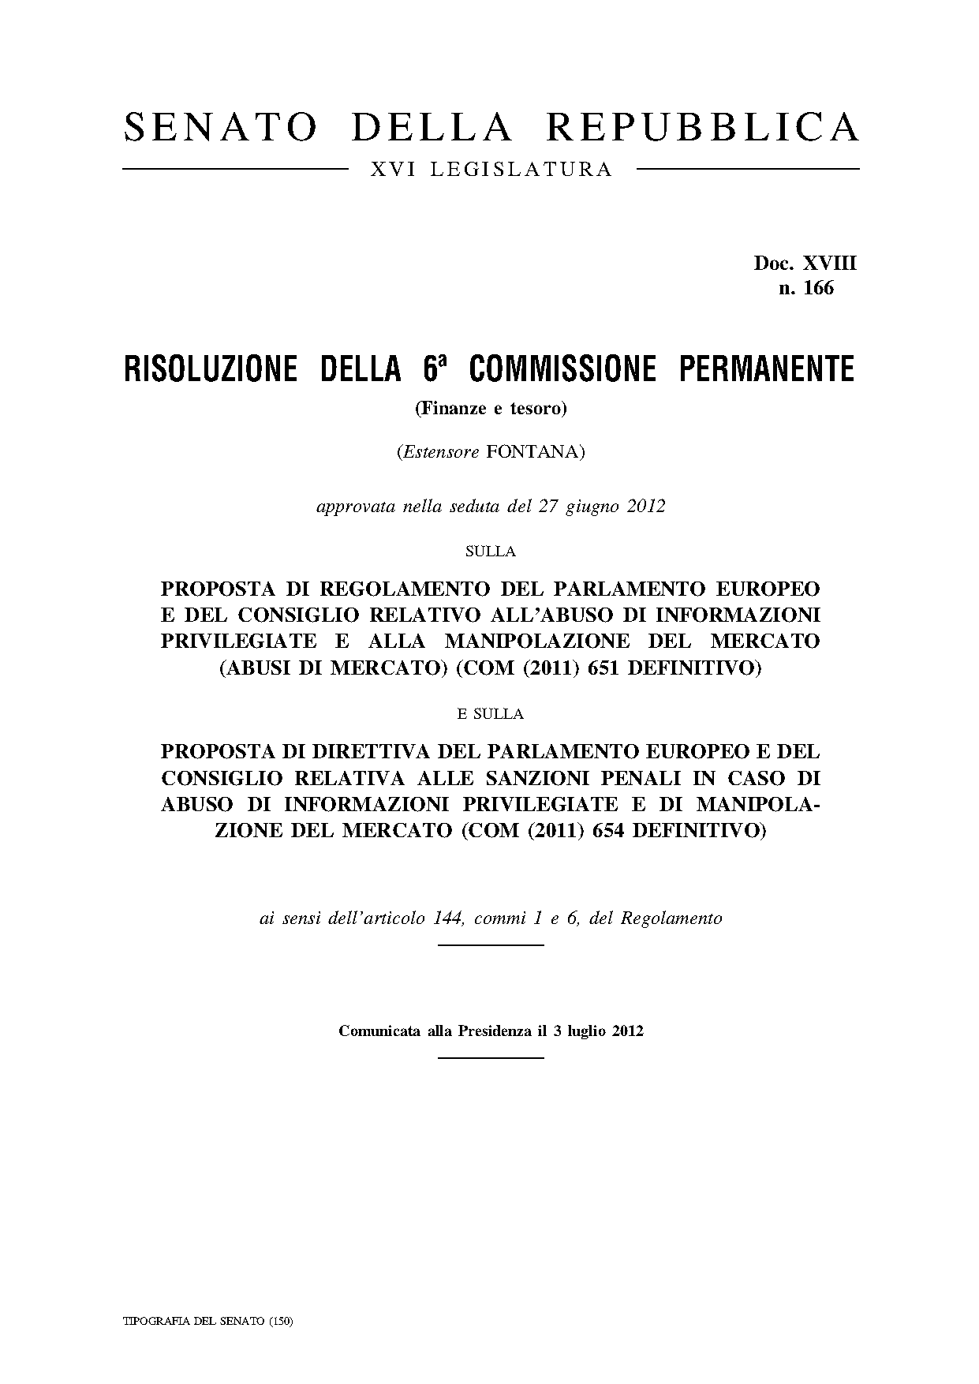
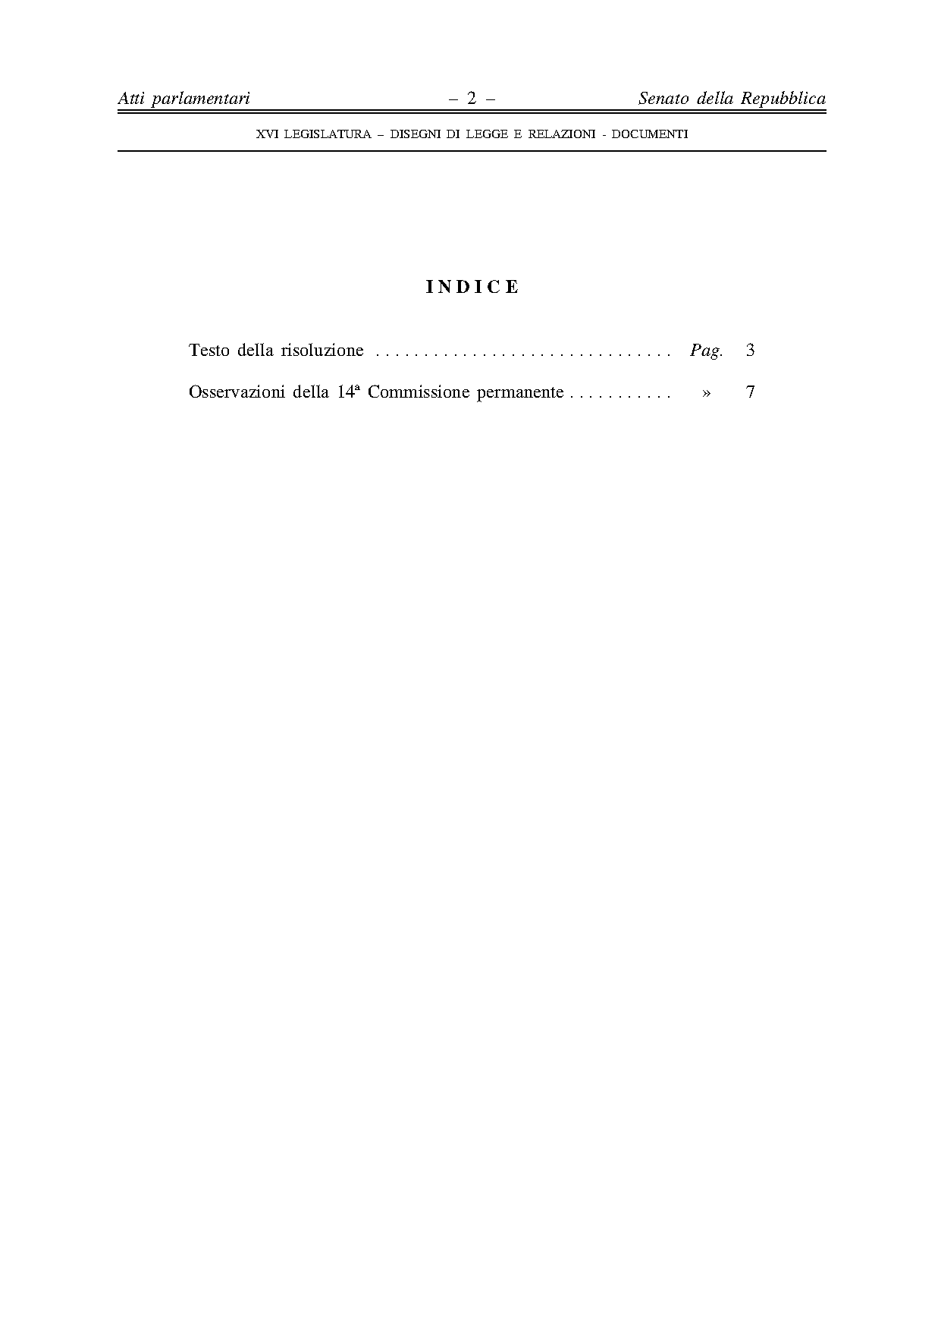
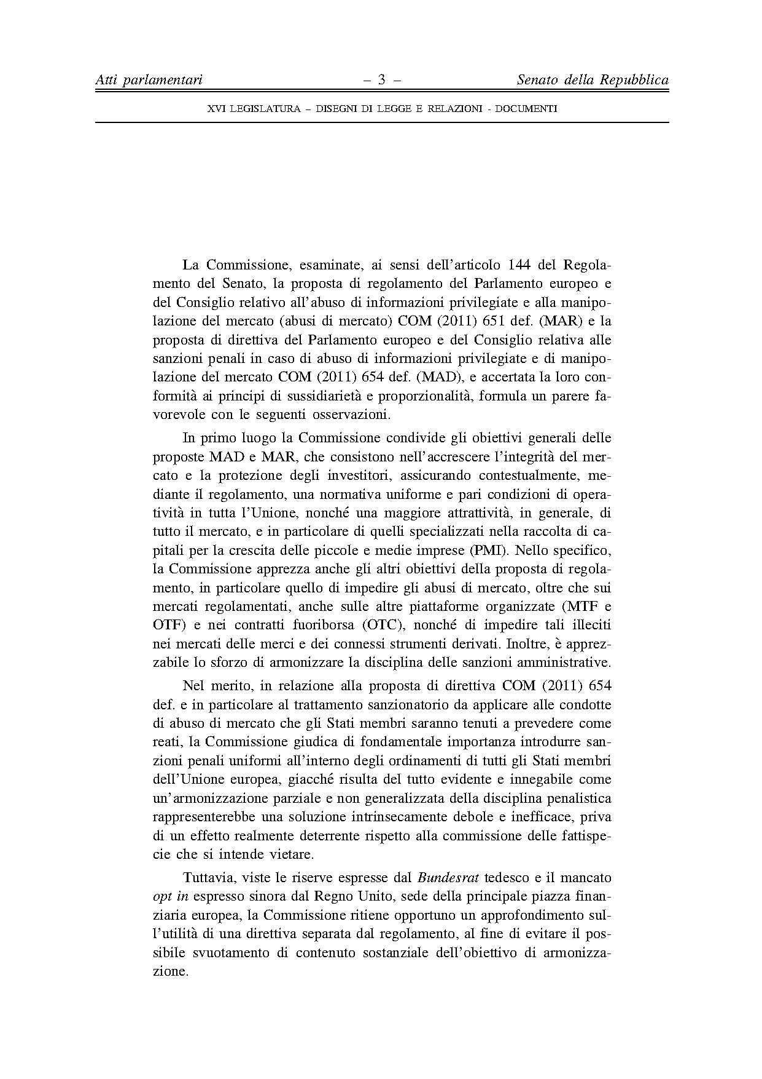
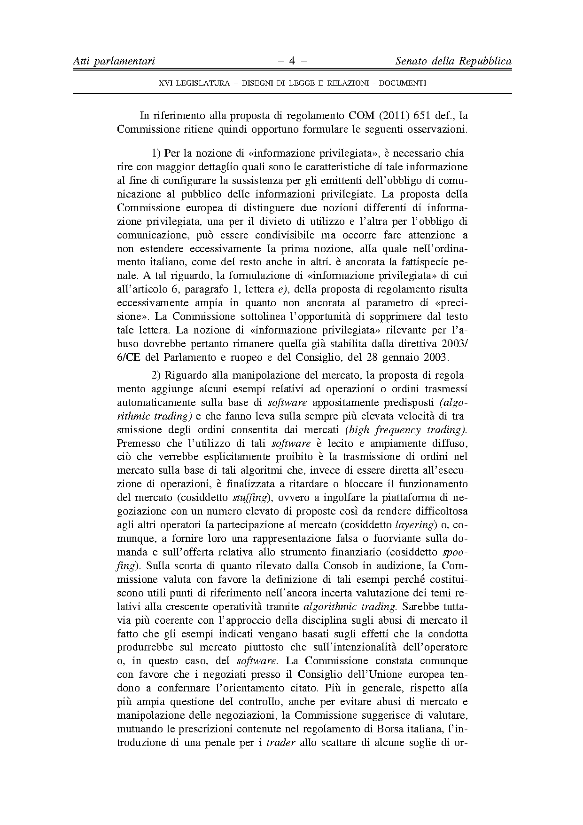
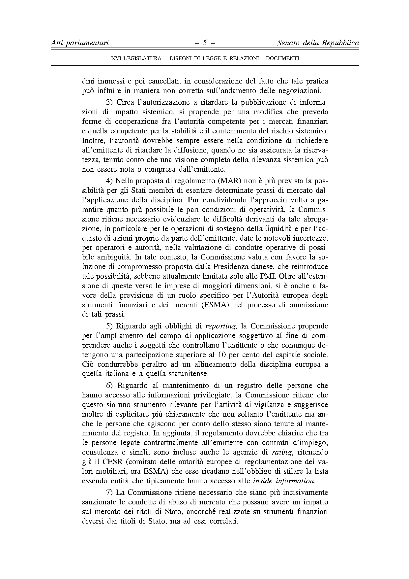
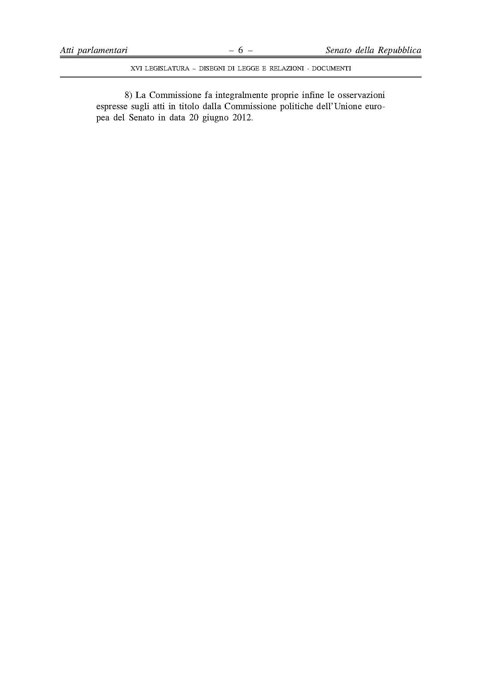
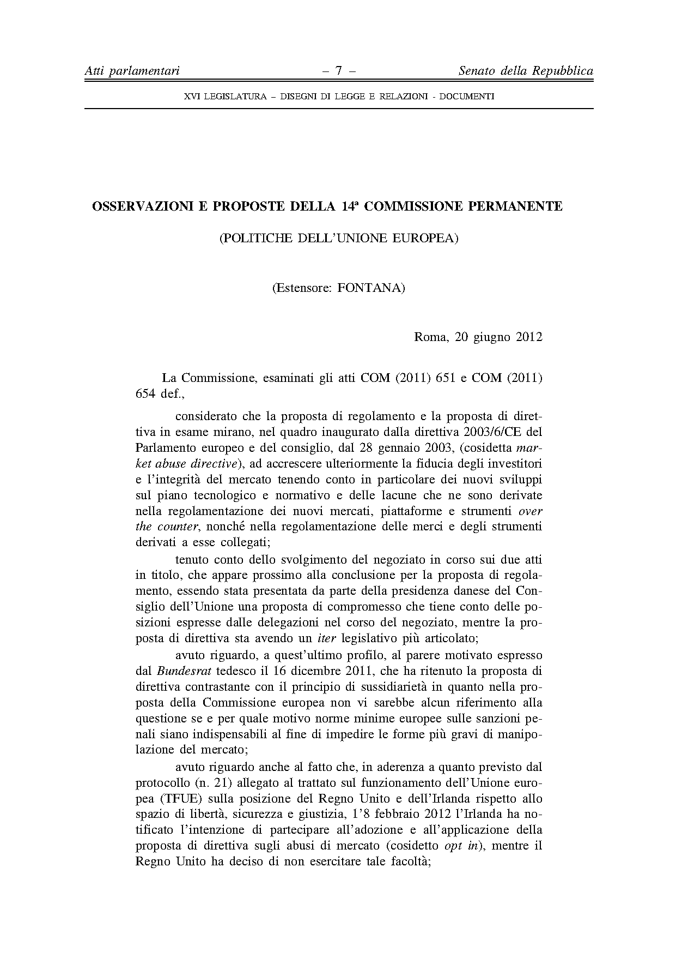
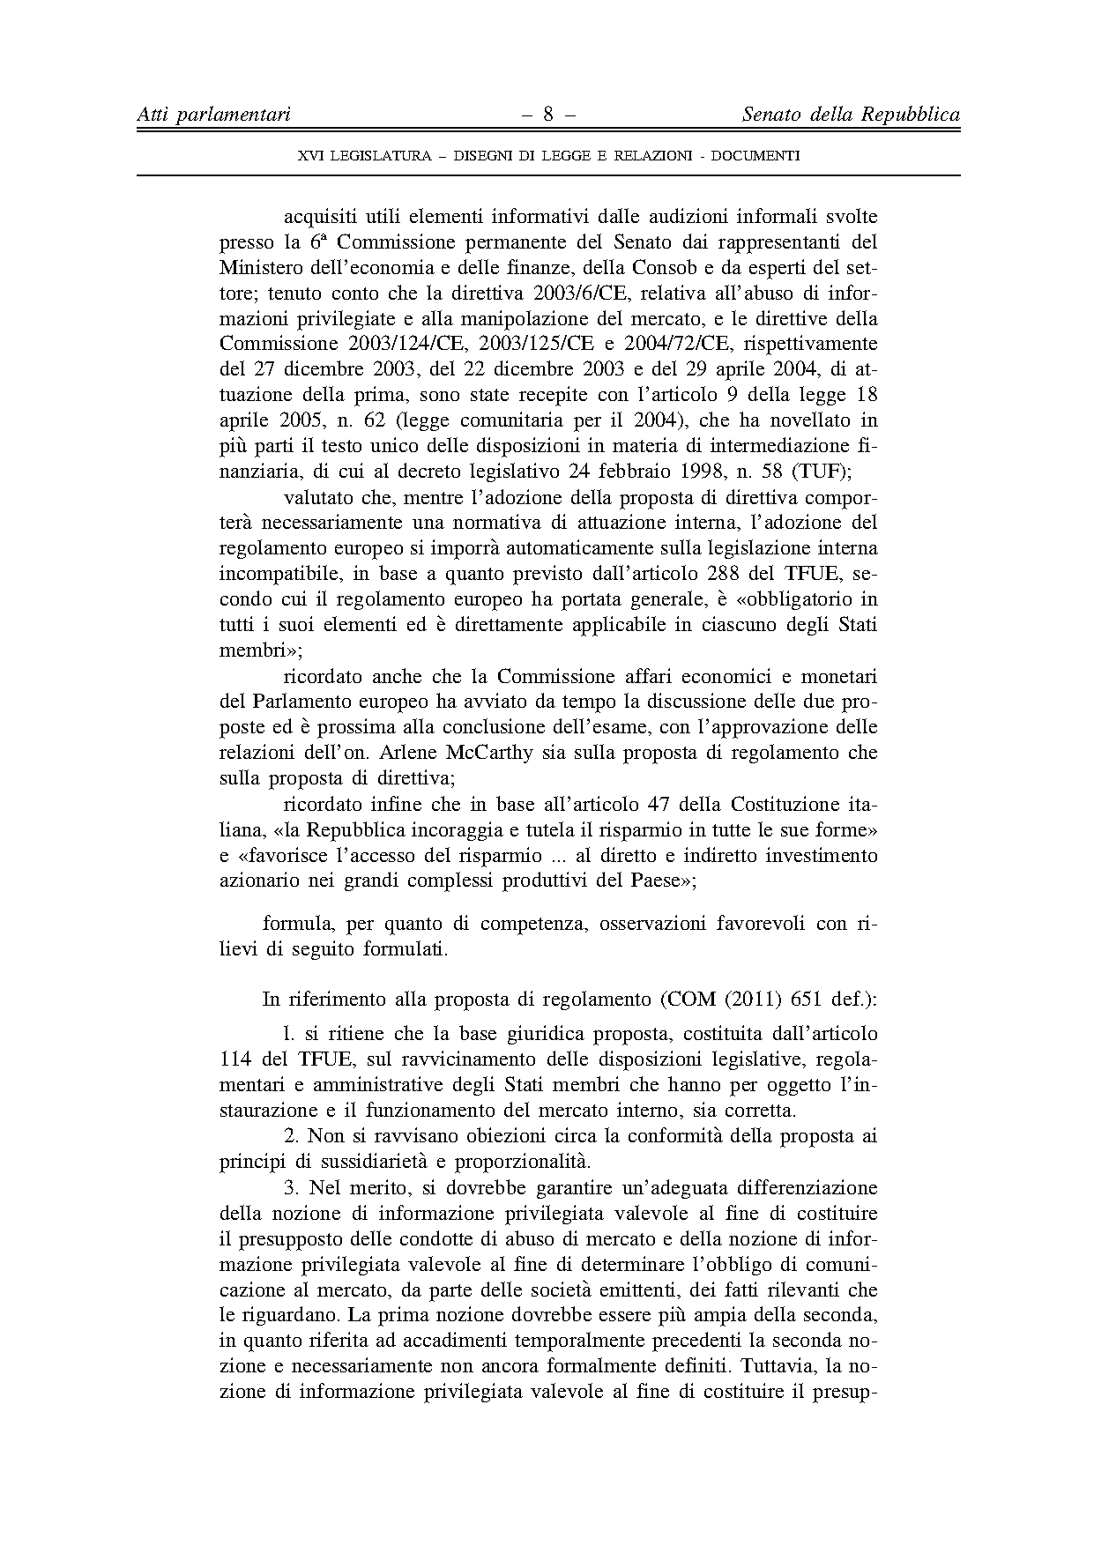
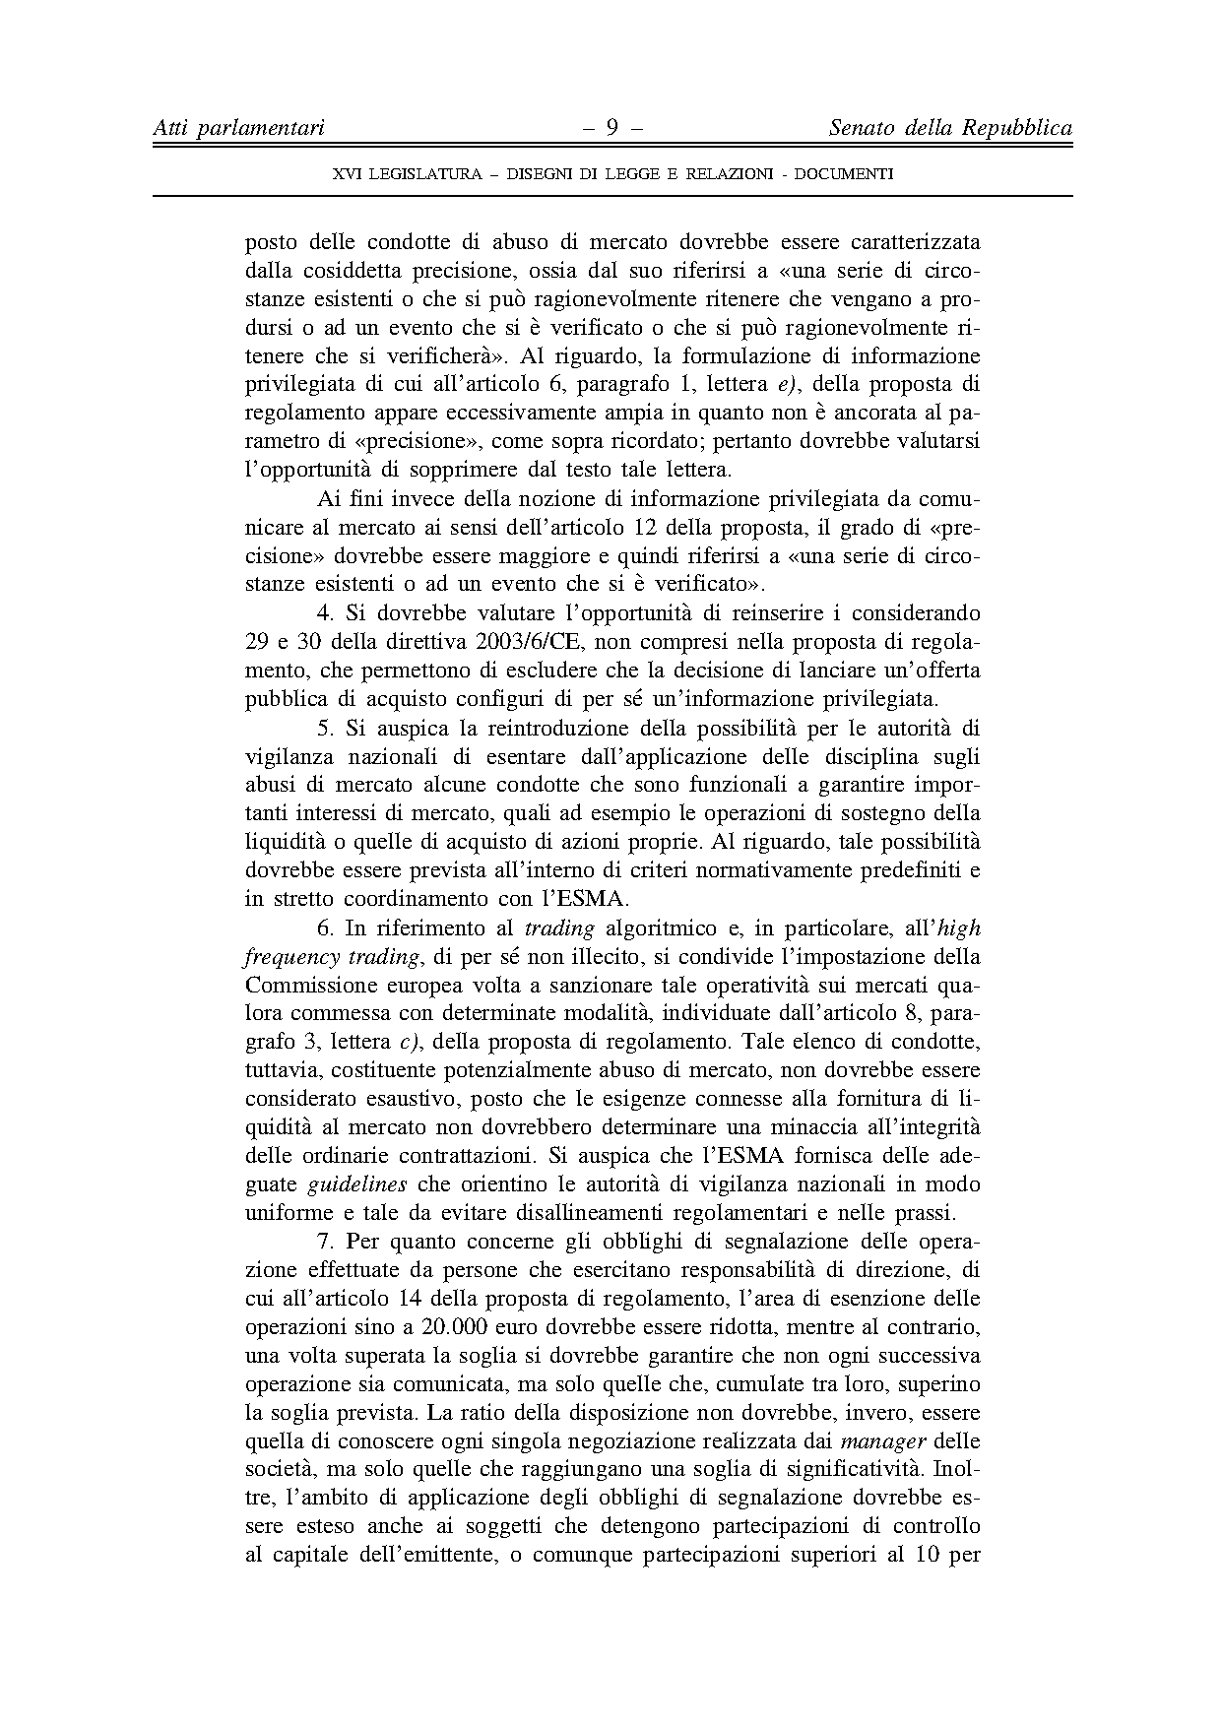
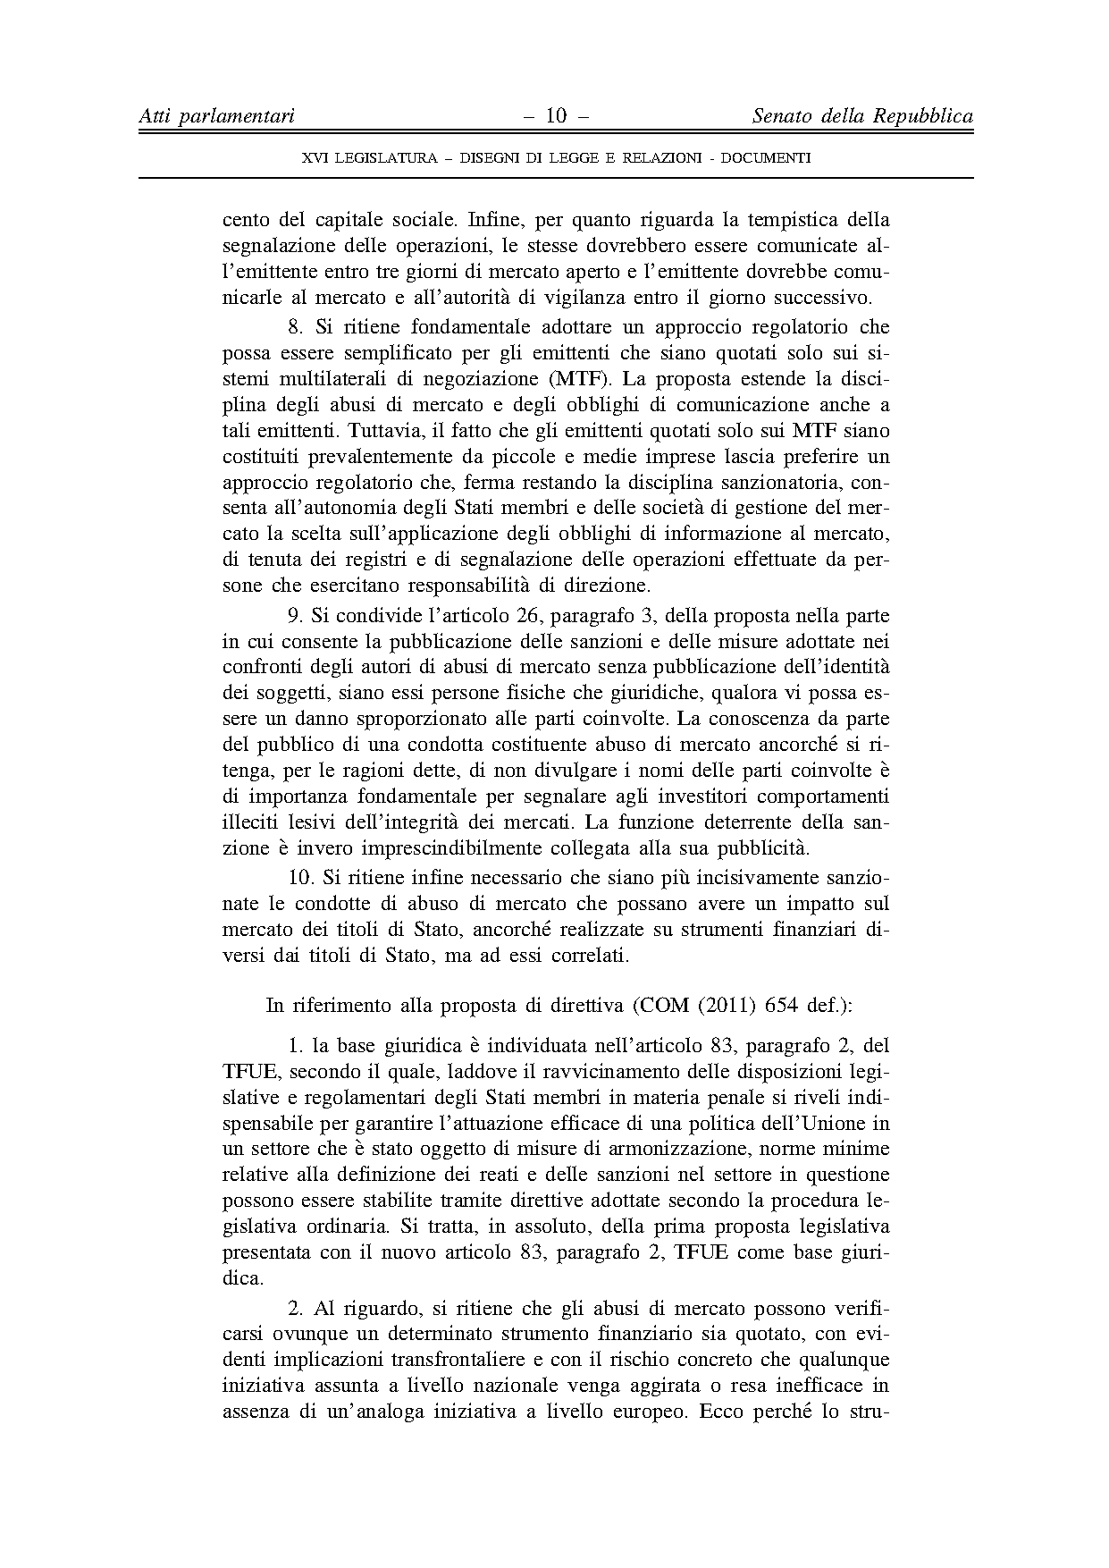
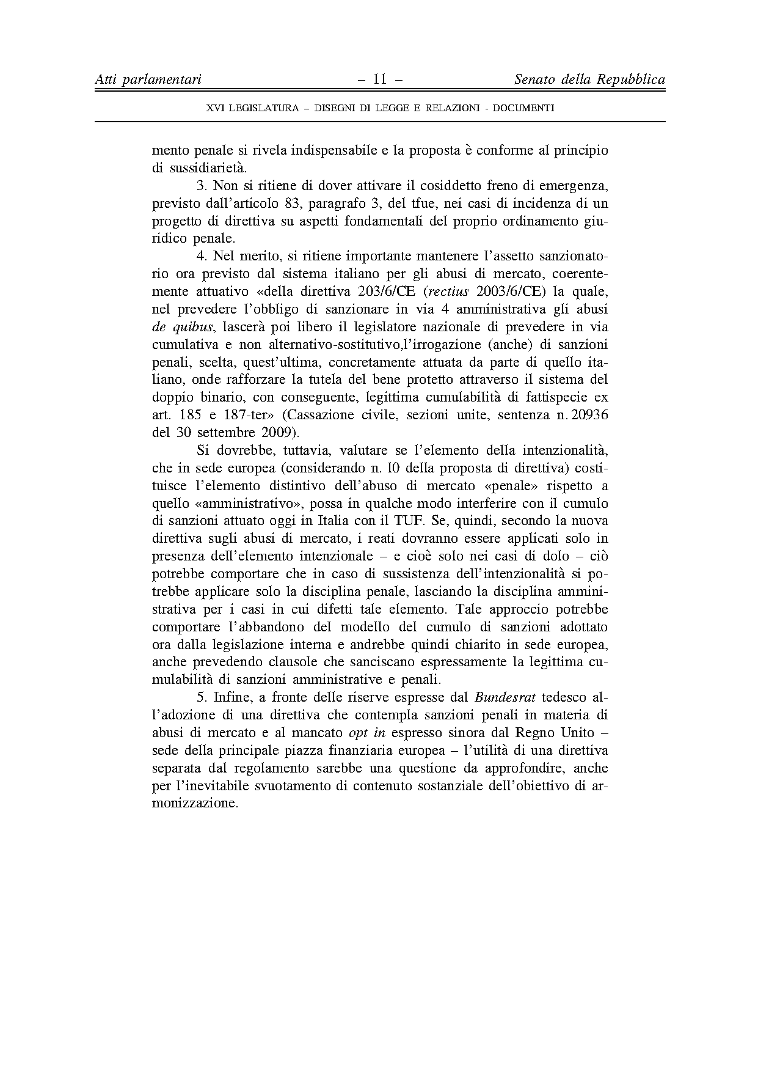


Translation(s) may be available in the Interparliamentary EU information exchange site IPEX at the following address: http://www.ipex.eu/IPEXL- WEB/search.do

