 | 
COUNCIL OF  THE EUROPEAN UNION |  |  | Brussels, 26 July 2012
 | Interinstitutional File:  2011/0297 (COD) |  | 12893/12
DROIPEN 111
EF 180
ECOFIN 723
CODEC 1974
INST 482
PARLNAT 300

OPINION
from: | The Italian Senate
dated: | 24 July 2012
No Cion doc.: | 16000/11 DROIPEN 125 EF 145 ECOFIN 717 CODEC 1811  COM(2011) 645 final
Subject: | Proposal for a DIRECTIVE OF THE EUROPEAN PARLIAMENT AND OF THE COUNCIL on criminal sanctions for insider dealing and market manipulation  Opinion on the application of the Principles of Subsidiarity and Proportionality

Delegations will find attached the above mentioned opinion.

________________________
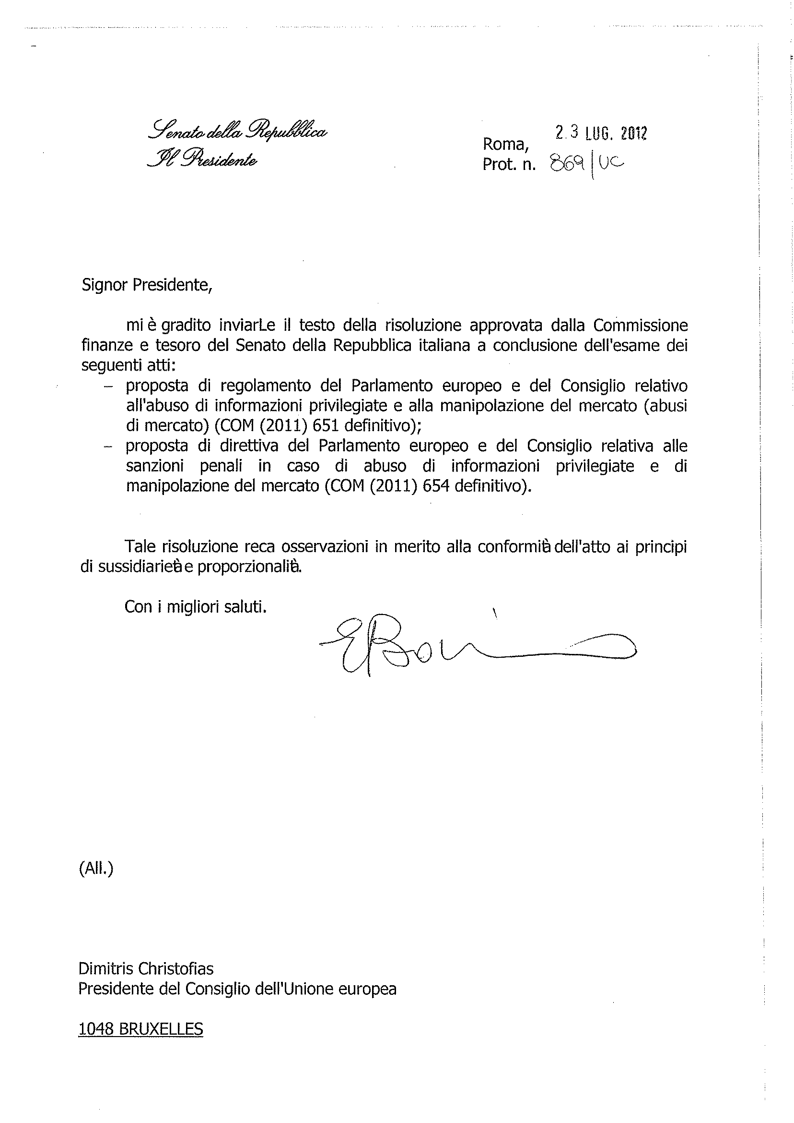
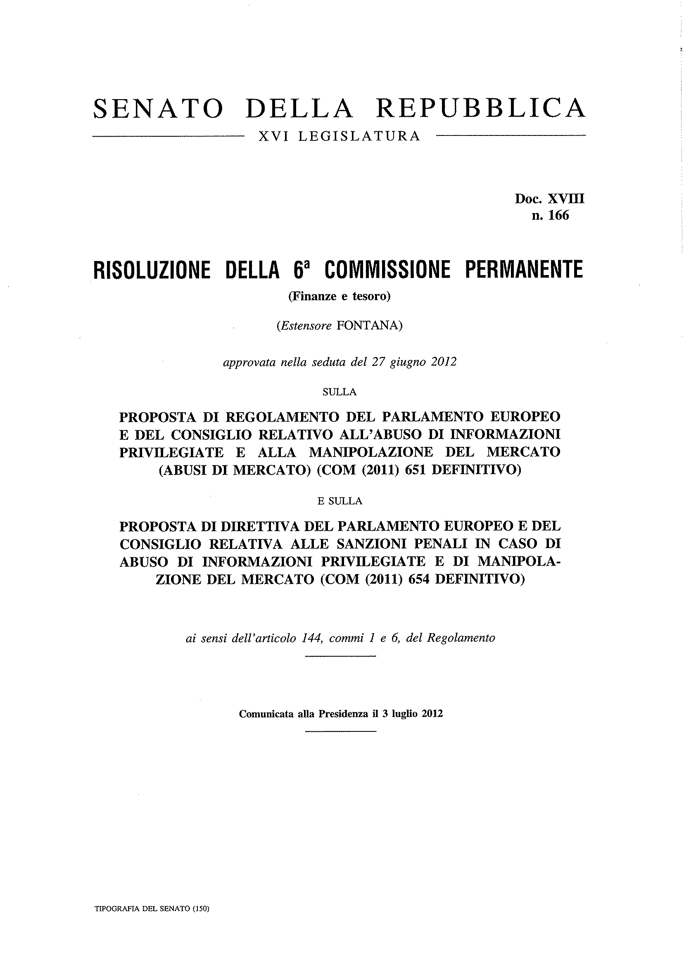
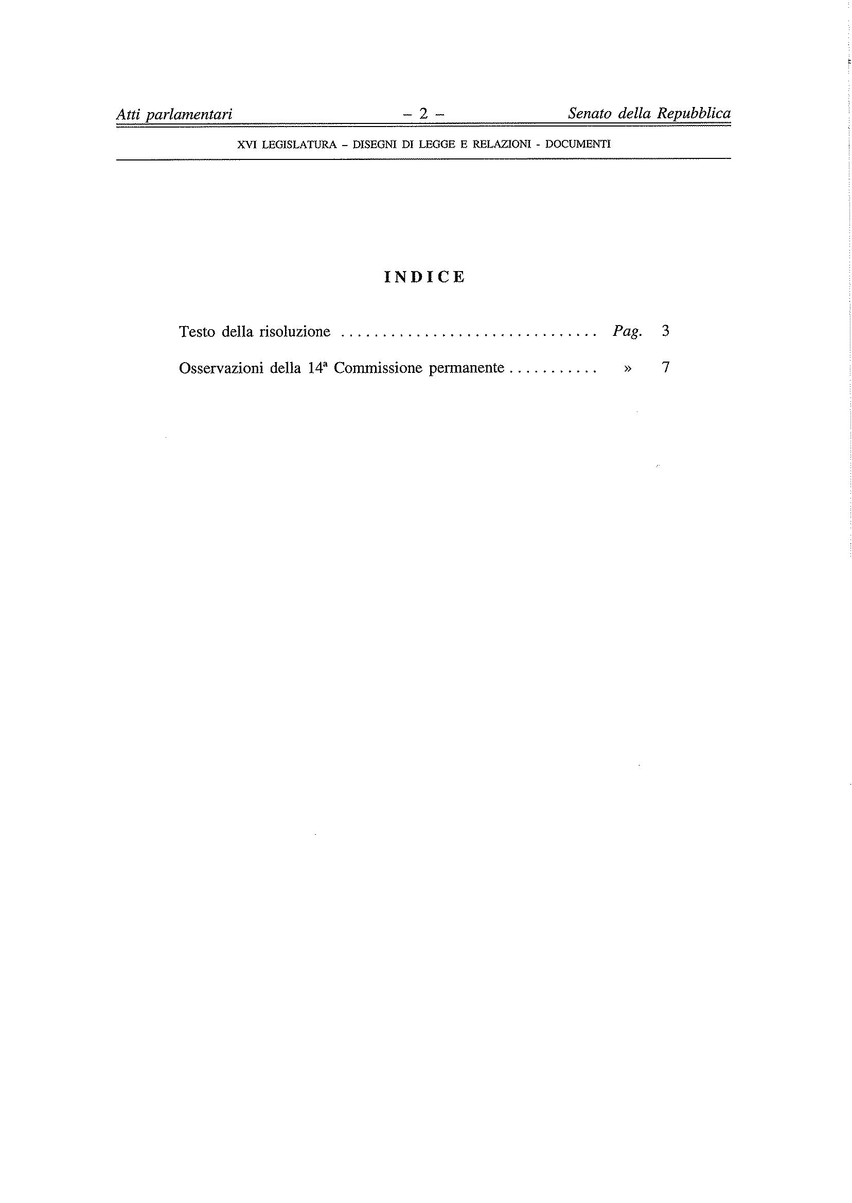
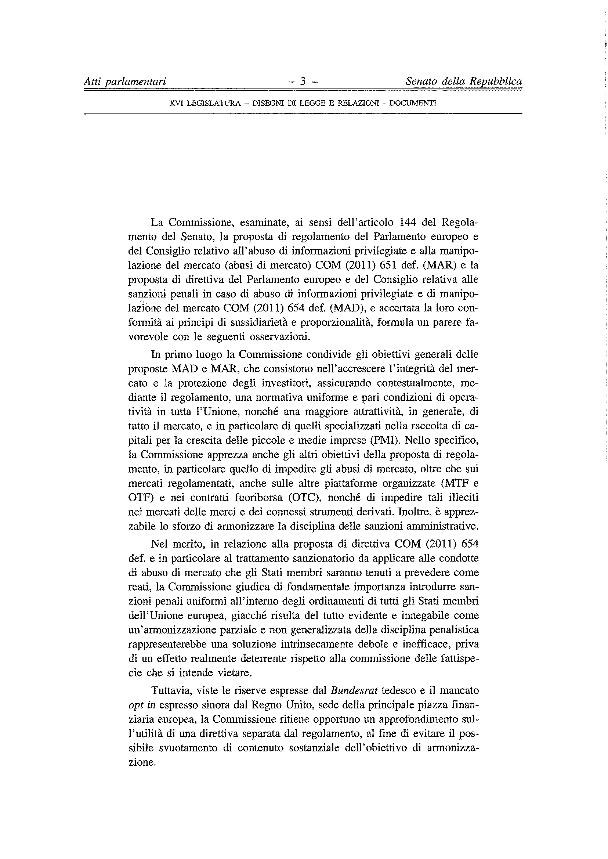
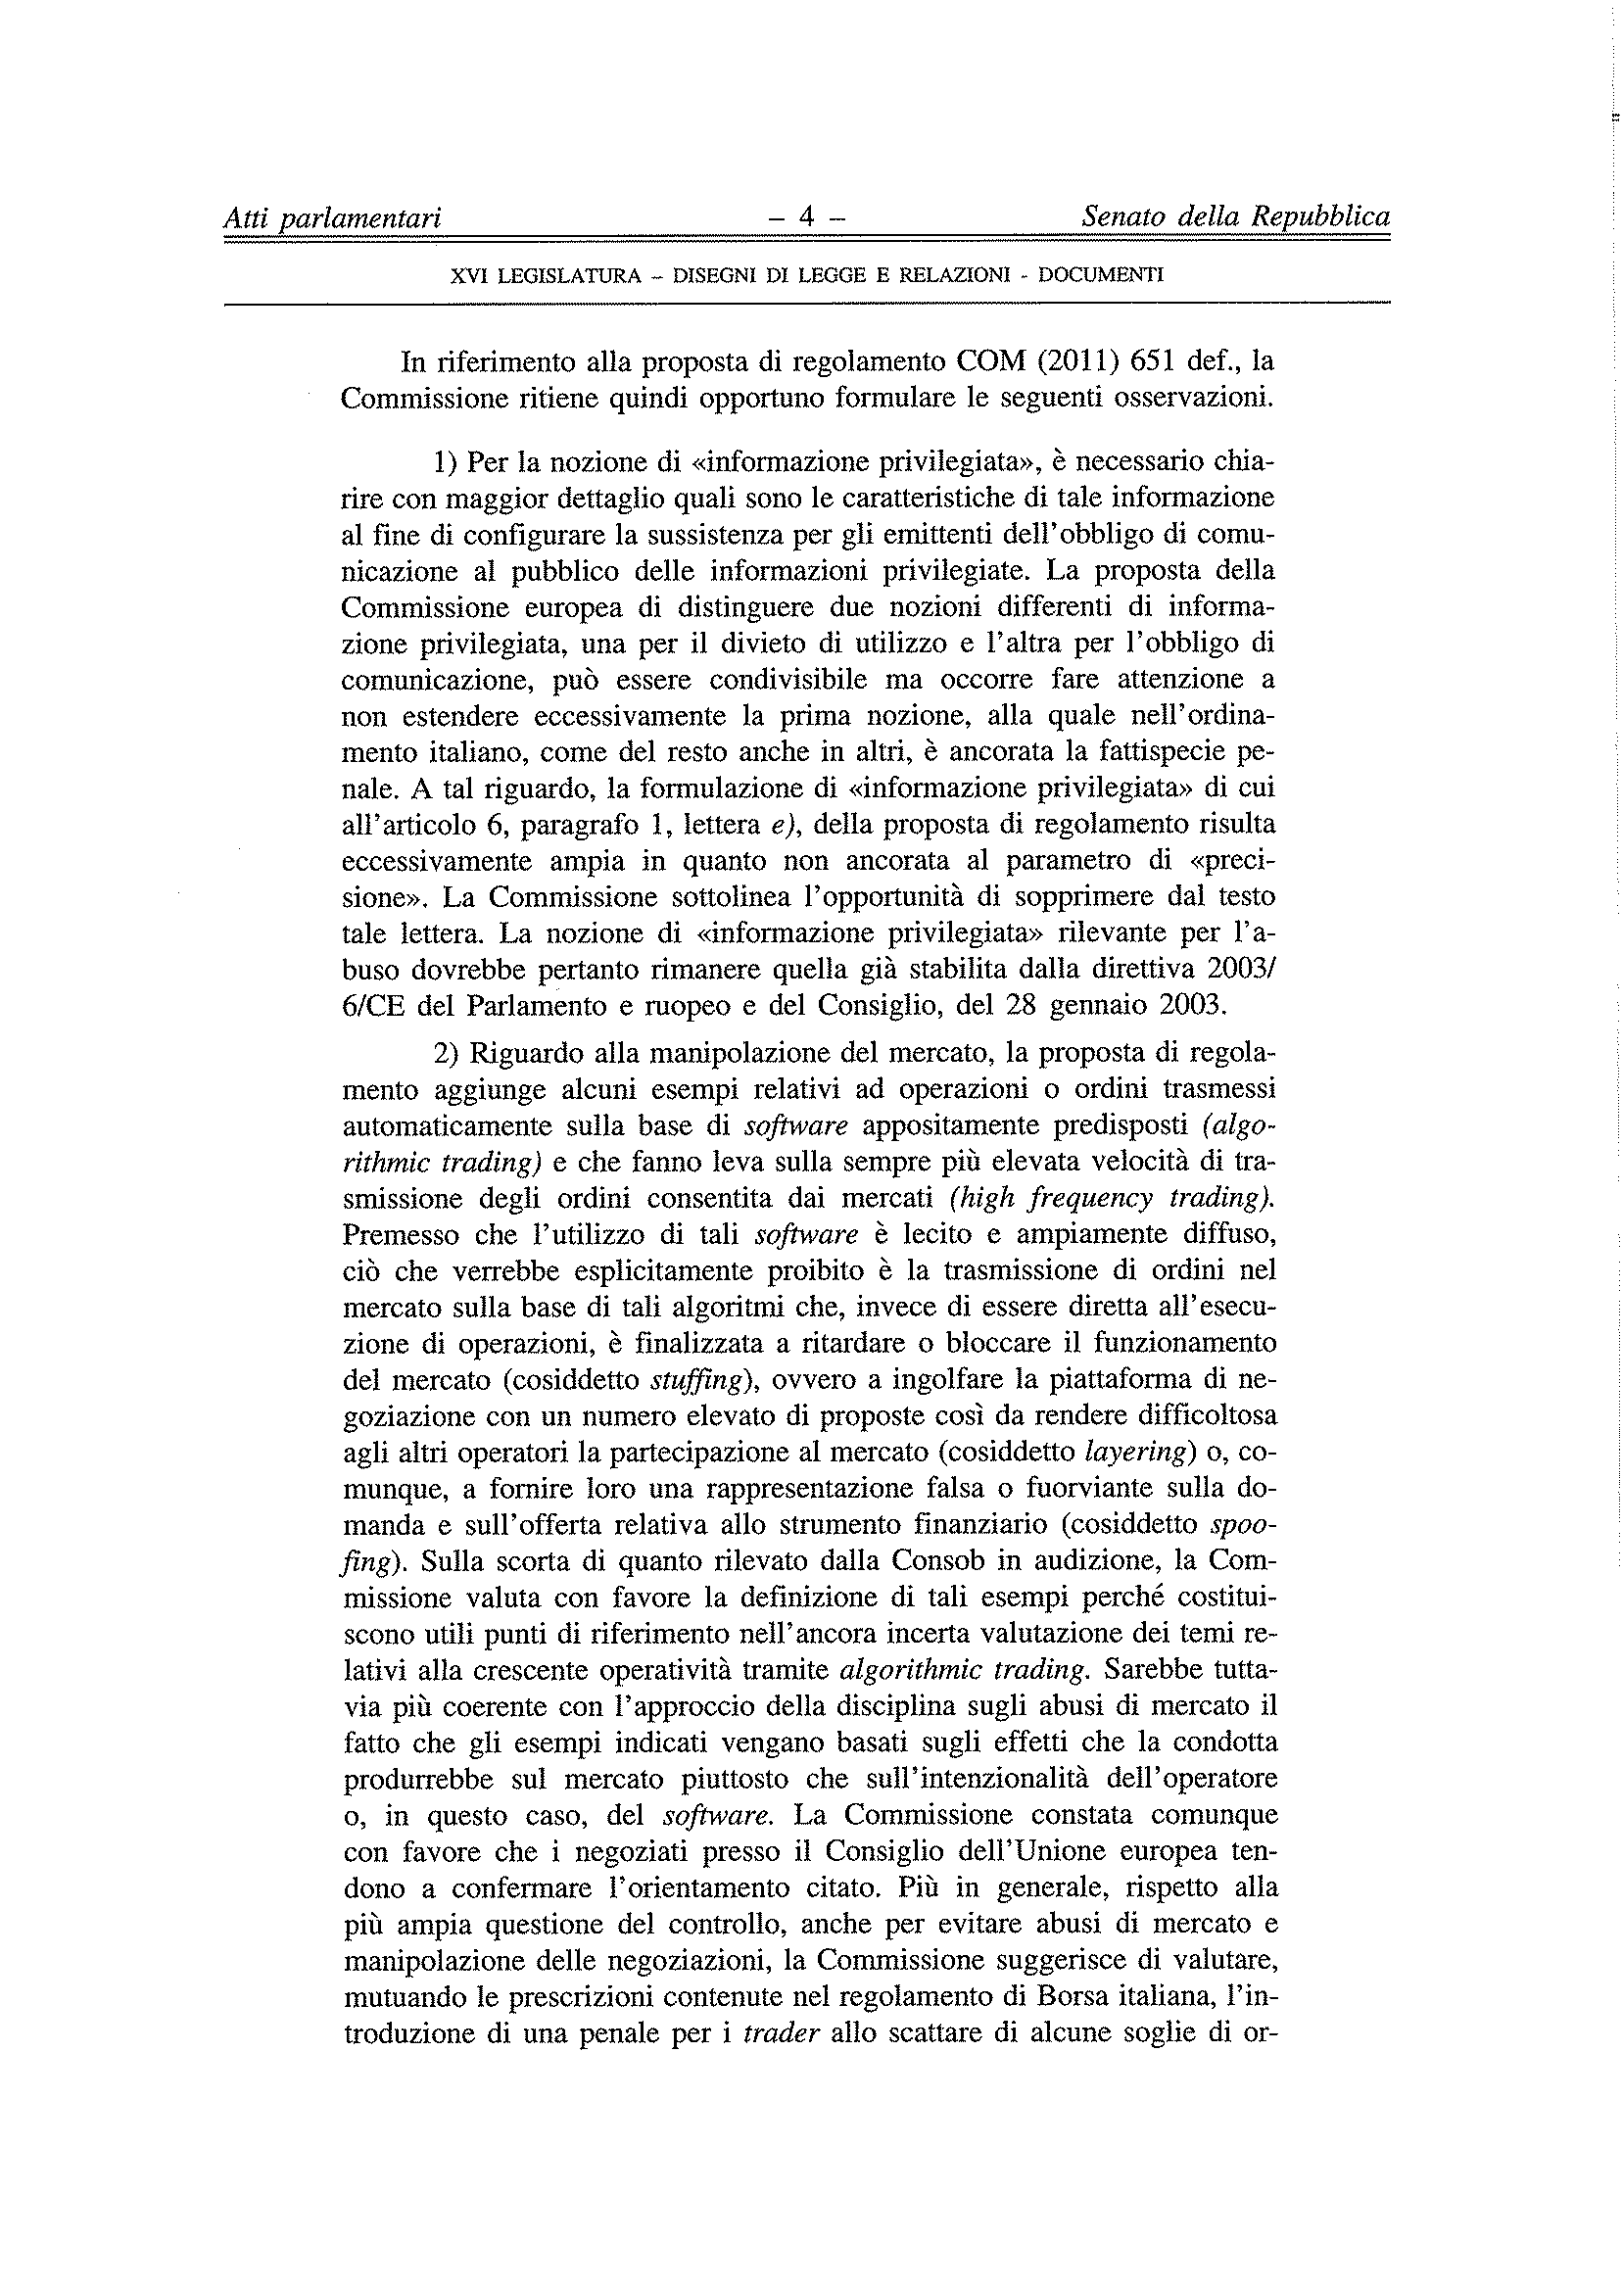
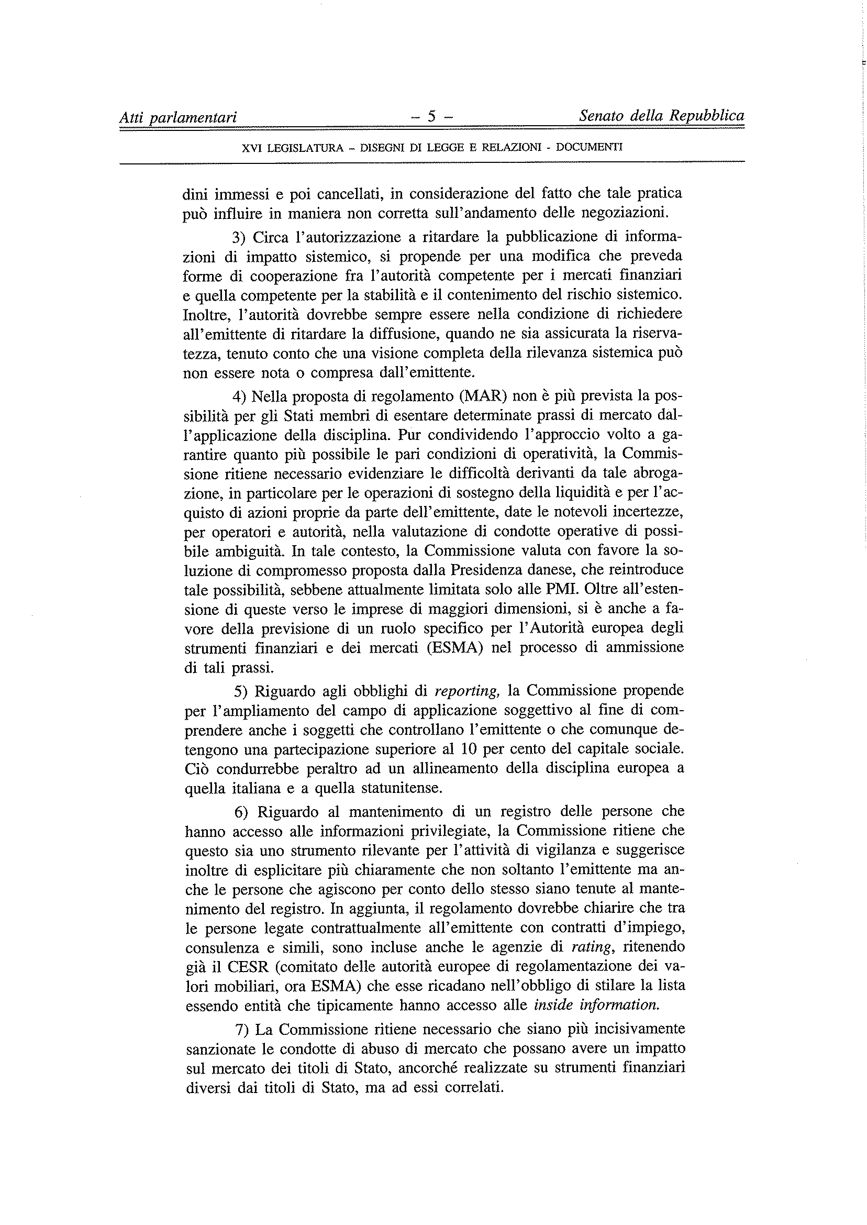

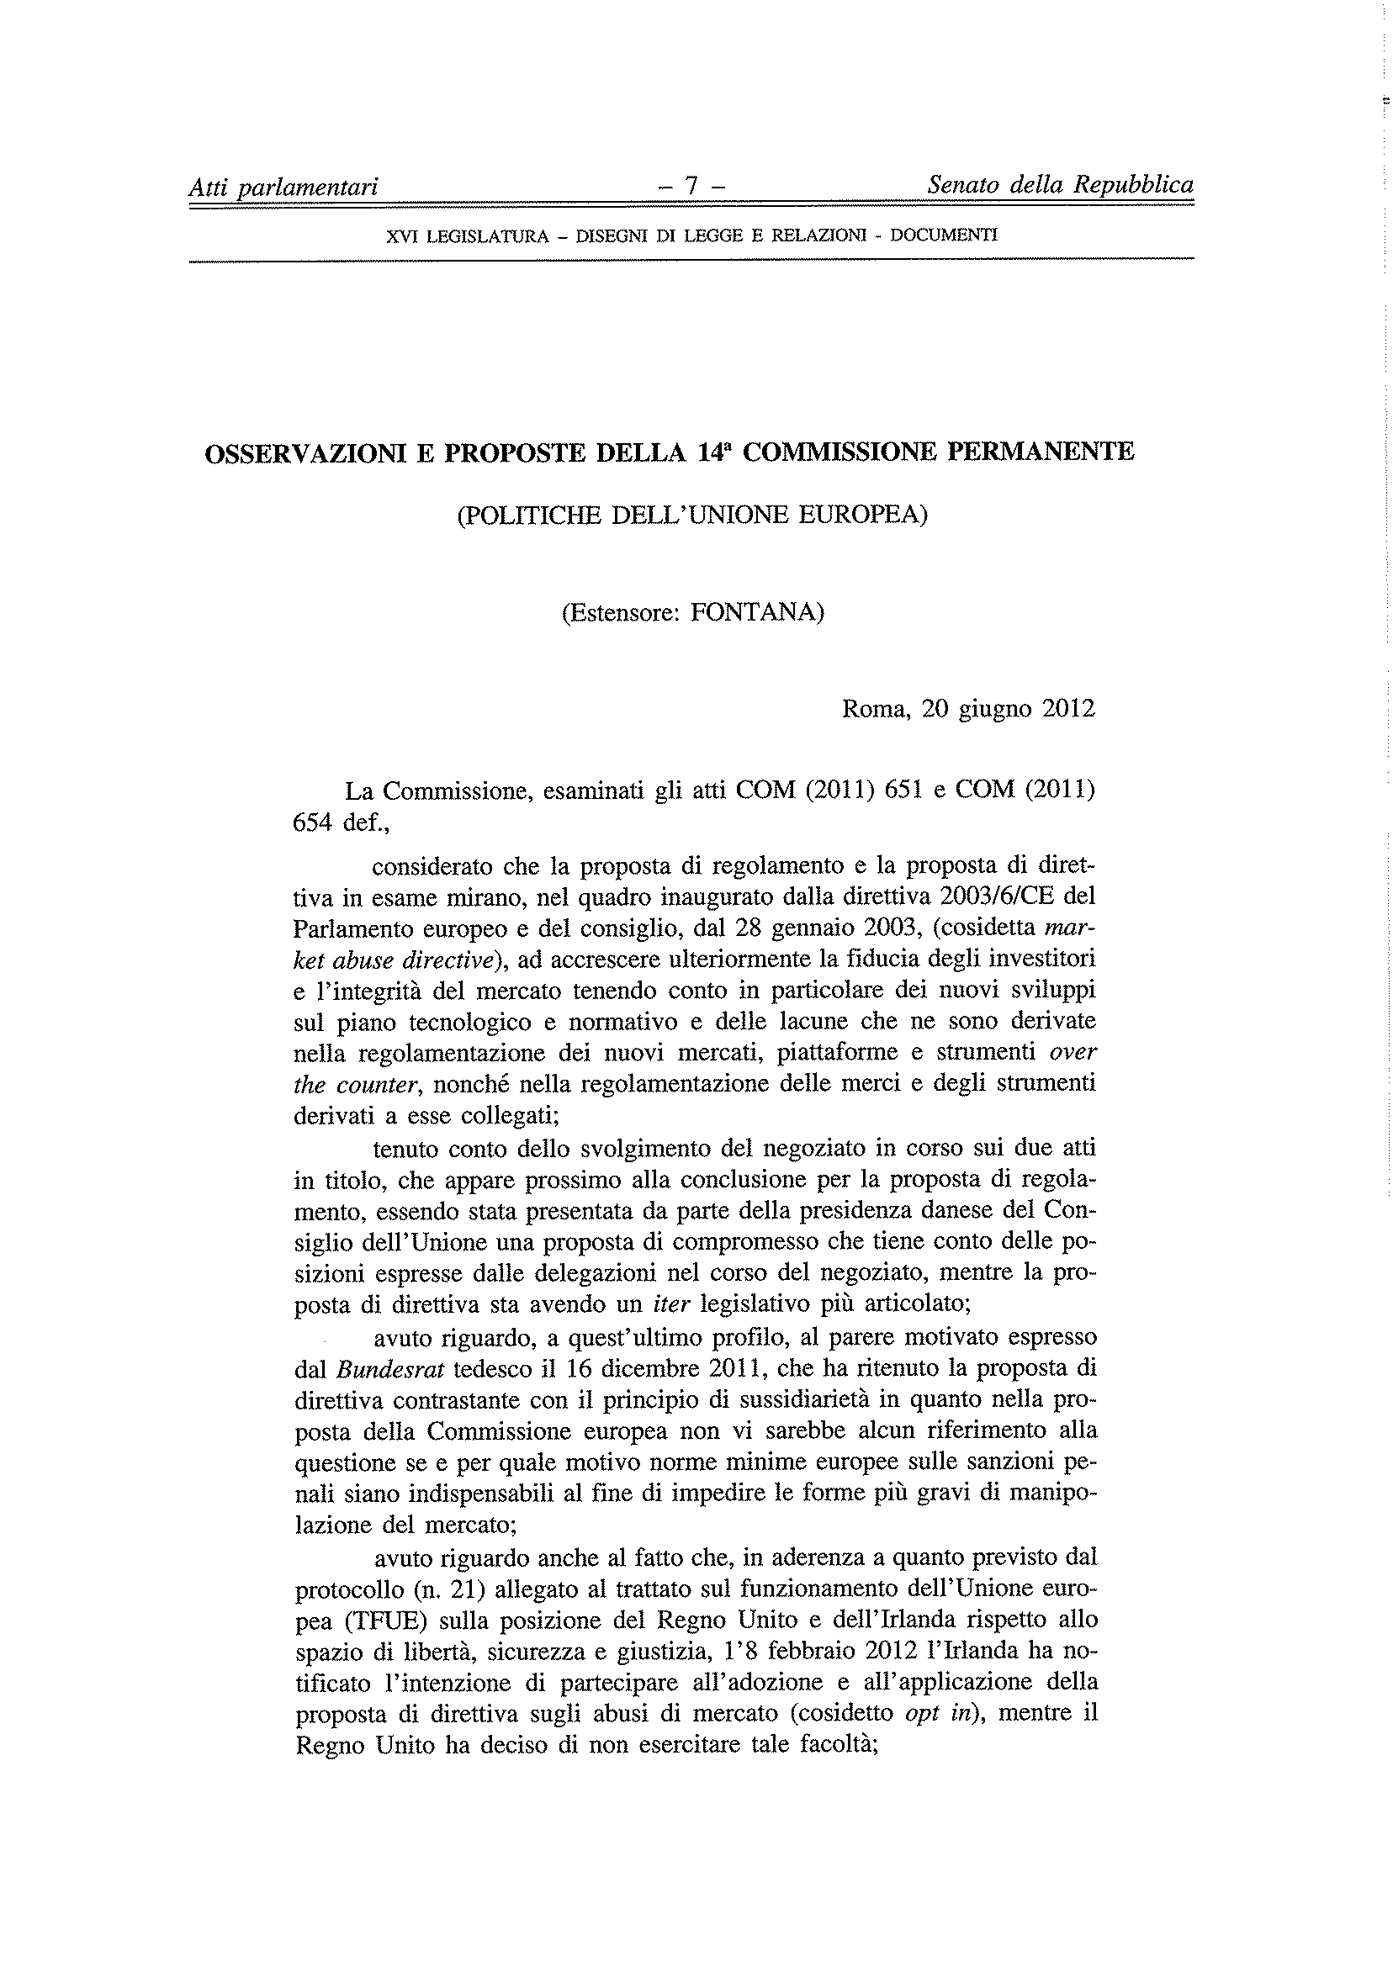
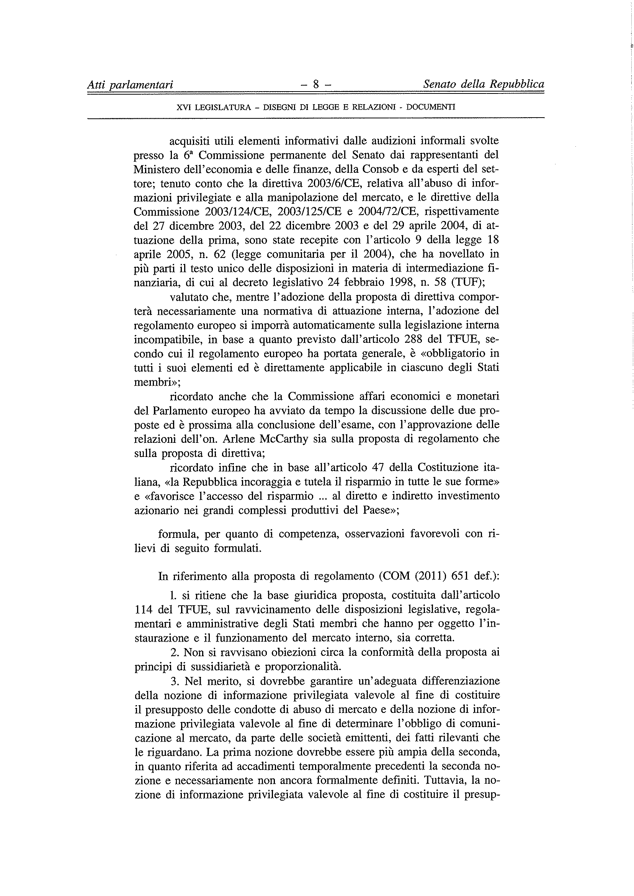
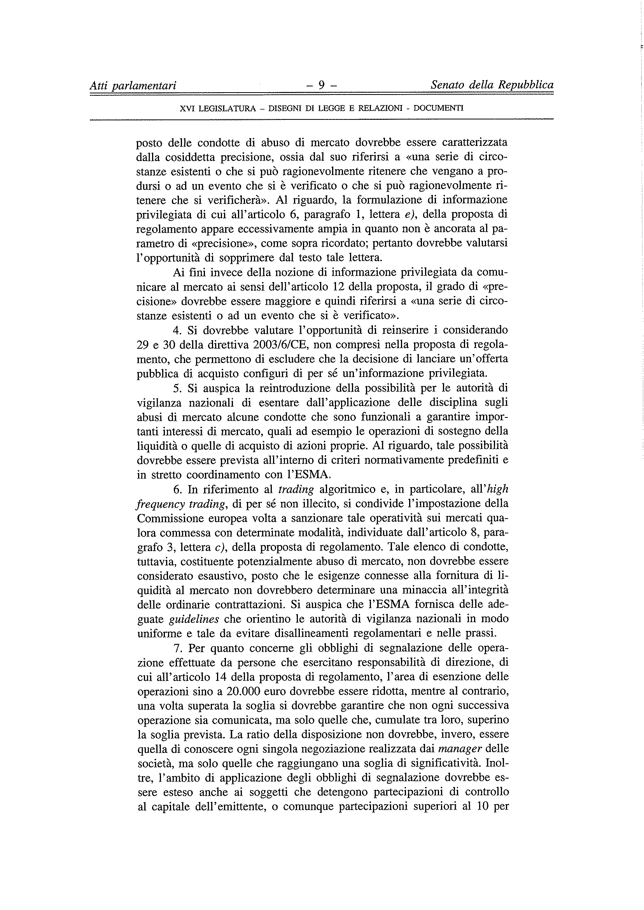
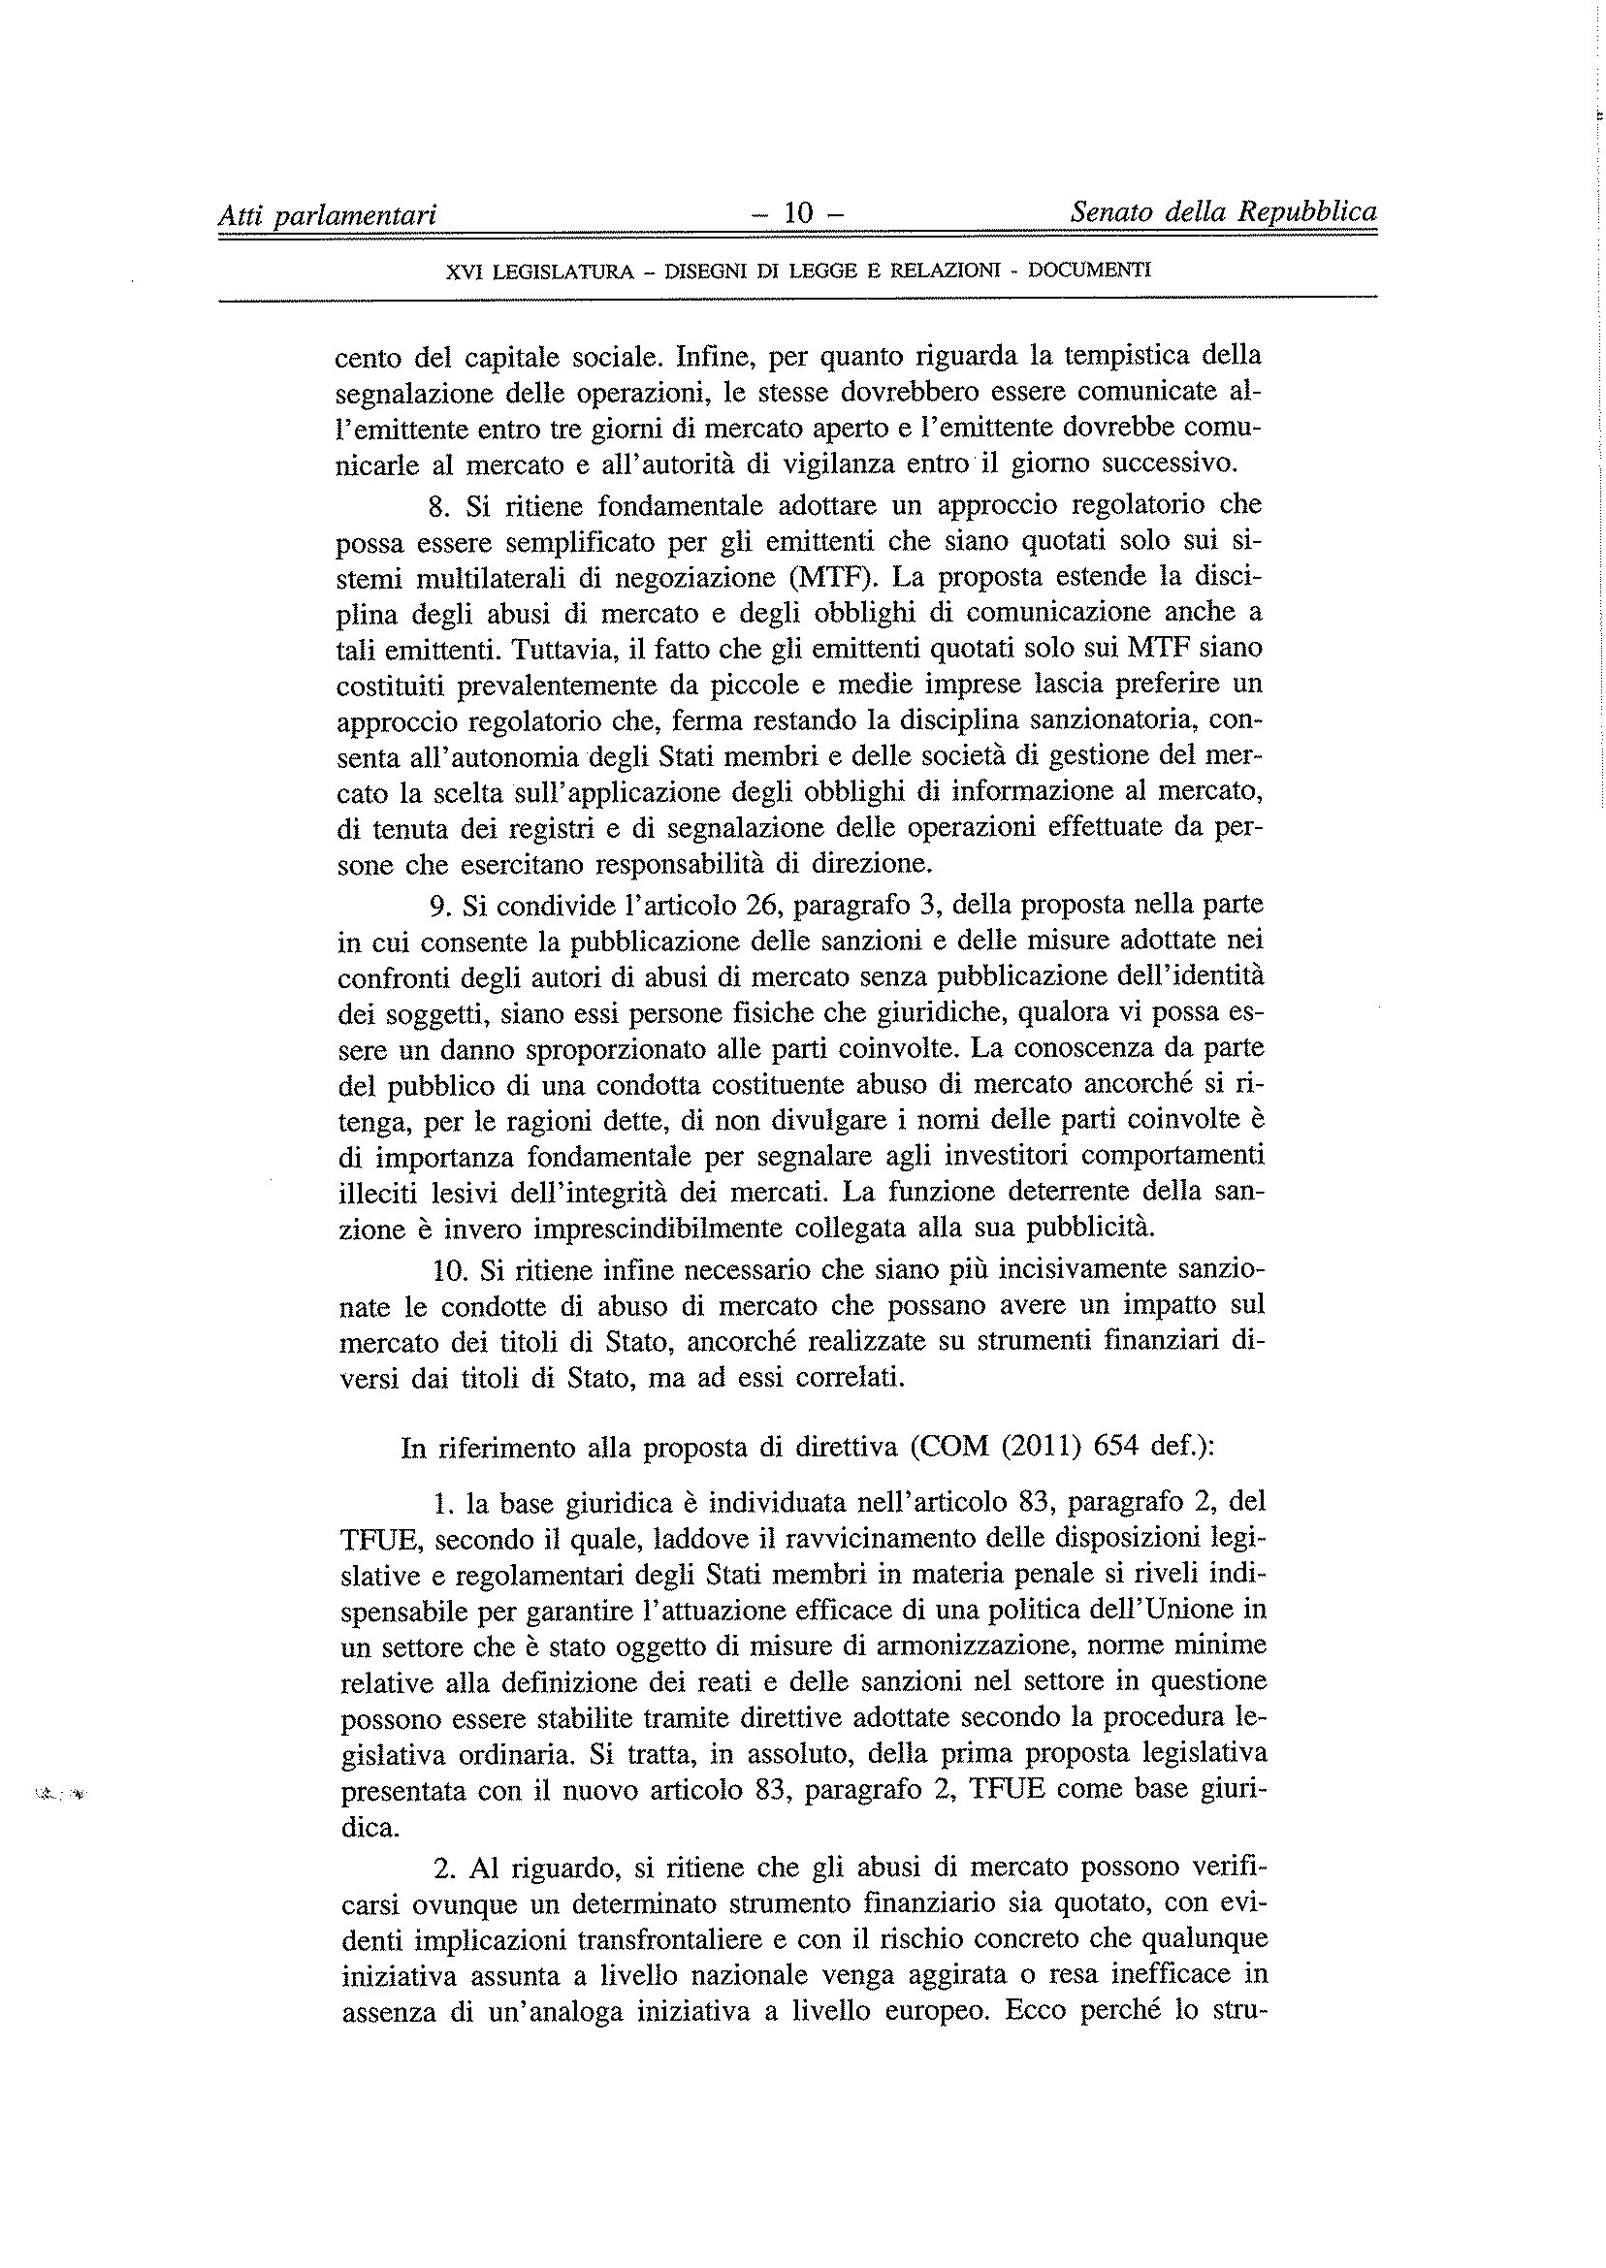
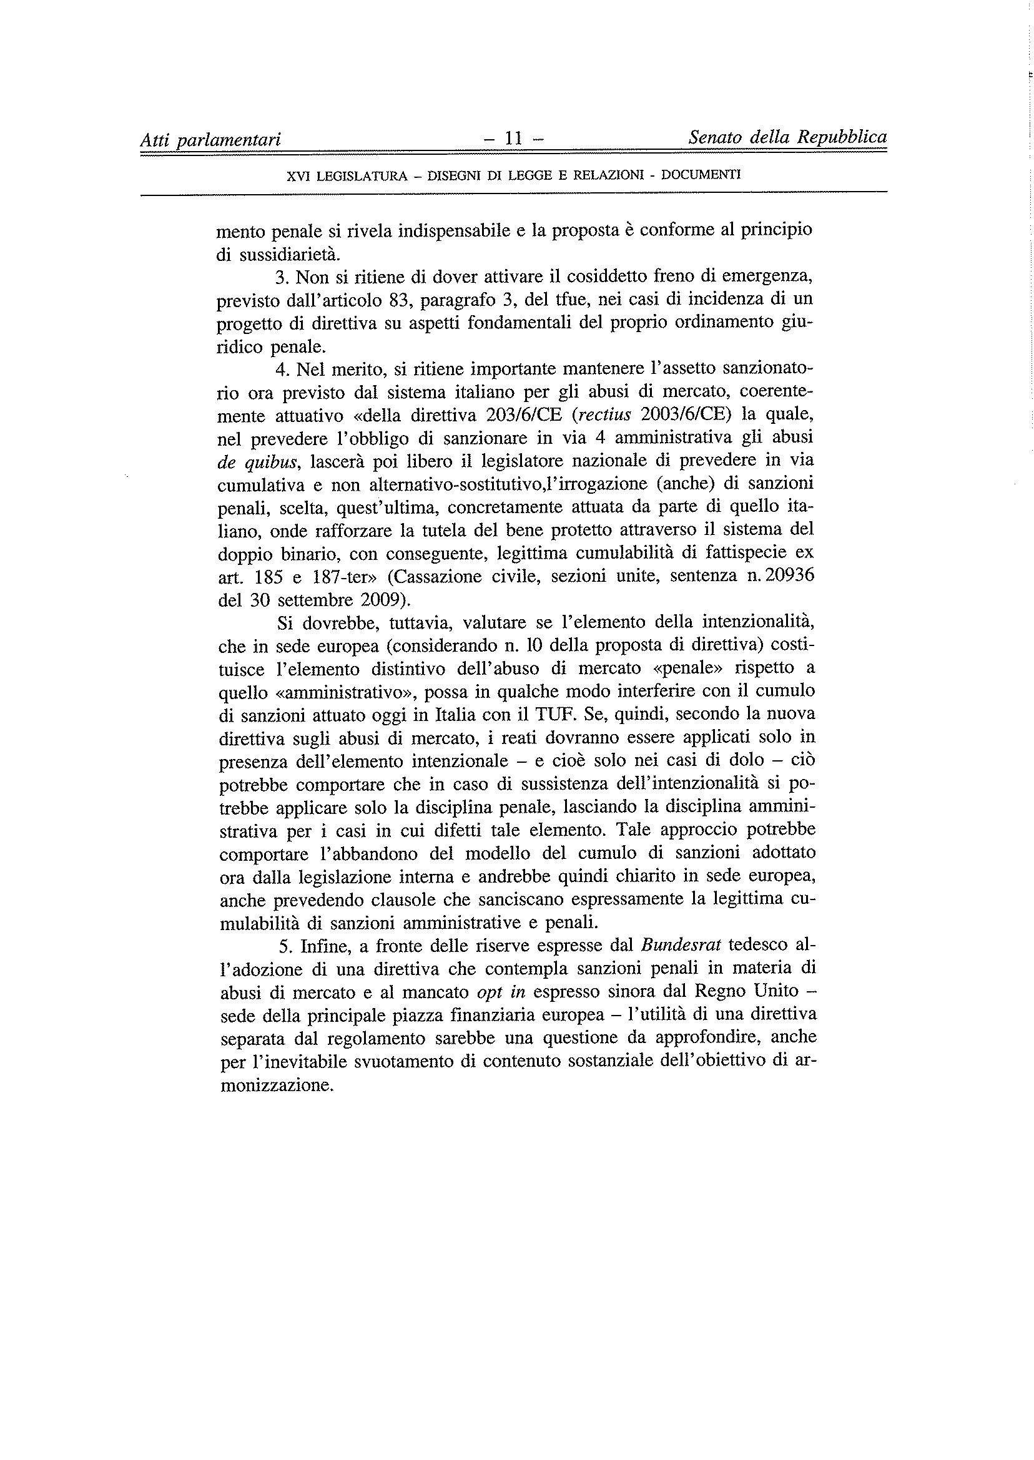
_______________

Translation(s) of the opinion may be available at the Interparliamentary EU information exchange site IPEX at the following address: http://www.ipex.eu/IPEXL-WEB/search.do

