EXPLANATORY MEMORANDUM
Article 12 of Council Regulation (EU, Euratom) No 1311/2013 laying down the multiannual financial framework for the years 2014-2020 allows for the mobilisation of the European Globalisation Adjustment Fund (EGF) within the annual ceiling of EUR 150 million (2011 prices) over and above the relevant headings of the financial framework.
The rules applicable to the contributions from the EGF for applications submitted until 31 December 2013 are laid down in Regulation (EC) No 1927/2006 of the European Parliament and of the Council of 20 December 2006 on establishing the European Globalisation Adjustment Fund,.
On 20 December 2013, France submitted application EGF/2013/014 FR/Air France for a financial contribution from the EGF, following redundancies in Air France in France.
After a thorough examination of this application, the Commission has concluded in accordance with Article 10 of Regulation (EC) No 1927/2006 that the conditions for a financial contribution under this Regulation are met.
SUMMARY OF THE APPLICATION AND ANALYSIS
Key data:
EGF Reference no. | EGF/2013/014
Member State | France
Article 2 | (a)
Primary enterprise | Air France
Suppliers and downstream producers | 0
Reference period | 1.7.2013 – 31.10.2013
Starting date for the personalised services | 6.11.2012
Application date | 20.12.2013
Redundancies during the reference period | 1 019
Redundancies before and after the reference period | 4 194
Total eligible redundancies | 5 213
Redundant workers expected to participate in the measures | 3 886
Expenditure for personalised services (EUR) | 51 845 626
Expenditure for implementing EGF (EUR) | 30 000
Expenditure for implementing EGF (%) | 0,06
Total budget (EUR) | 51 875 626
EGF contribution (50 %) (EUR) | 25 937 813
1. The application was presented to the Commission on 20 December 2013 and supplemented by additional information up to 24 July 2014.
2. The application meets the conditions for deploying the EGF as set out in Article 2(a) of Regulation (EC) No 1927/2006, and was submitted within the deadline of 10 weeks referred to in Article 5 of that Regulation.
Link between the redundancies and major structural changes in world trade patterns due to globalisation
3. In order to establish the link between the redundancies and major structural changes in world trade patterns due to globalisation, France argues that although globally, the international air transport market is still dominated by European airlines, this sector has undergone serious economic disruption, in particular a decline of the EU’s market share. Over the period 2008-2012, the global traffic increased by 4,6 % per year, as part of a trend of long-term growth observed since 1970. However the air traffic between Europe and the rest of the world is growing at a slower pace (2,4 %) which has led to a decrease of the EU-27’s market share in air transport measured in revenue passenger-kilometres (RPK).
4. Despite the growth of world traffic over the period 2008-2012, the growth of world air traffic between Europe and the rest of the world was limited mainly due to weak growth in flows between Europe and the Middle East. Whilst the decline in the air traffic between the EU and four of the regions considered (North America, South America, Africa and Asia) ranged 0,3 % to 2,8 %, the air traffic between the EU and the Middle East declined by 11,4 %.
5. Available data for 2013 indicate that the trend shown for the period 2008-2012 continues. Europe grew by 3,8 % in 2013 compared to 2012, below the world average (5,2 %), and accounts for 38 % of the world traffic (measured in RPK), one percentage point less than in 2012. The Middle East region remains the fastest growing in the world, expanding at 10,9 % in 2013 and accounting for 9 % of the world traffic.
6. As shown in the chart below, the evolution of market shares origin-destination between Europe on the one hand, and sub-Saharan Africa, the Middle East and Asia, on the other hand, shows a decline of EU airlines by nearly 10 percentage points in favour of the Gulf carriers and Turkish Airlines between 2008 and 2013.
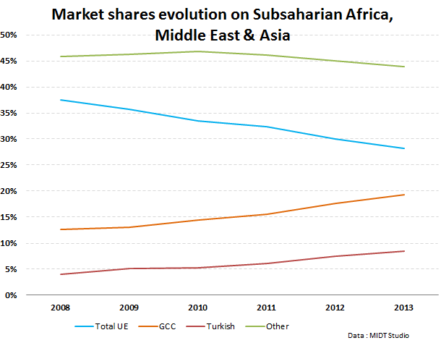
7. The effects of these changes in trade patterns have been worsened by other factors such as a decrease in demand as a consequence of the economic crisis and the increase of oil prices (fuel represents sometimes almost one third of seat/kilometer costs).
8. The period 2008-2012 was difficult for the three largest airlines in Europe Lufthansa, Air France-KLM and IAG, all of them show losses at least in two years out of the five years considered.
Net results of Air France-KLM, Lufthansa and IAG (2008-2012)
(million euros)
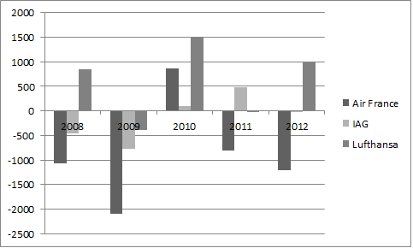
9. The Air France-KLM group situation is particularly difficult because of its financial situation. The group's debt ratio and net debt is higher than IAG's or Lufthansa's.
Comparison of net debt and debt ratios in 2011
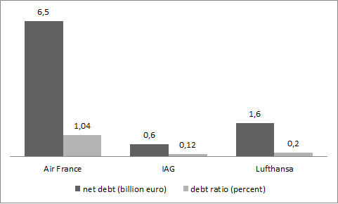
Source: Air France
10. Faced with a high debt and an insufficient stock market capitalization (less than the value of its fleet) Air France could not efficiently react to the loss of market share in international air transport, which ended in a plan of several thousands of voluntary departures agreed with the workers and employees representatives.
Demonstration of the number of redundancies and compliance with the criteria of Article 2(a)
11. France submitted this application under the intervention criteria of Article 2(a) of Regulation (EC) No 1927/2006, which requires at least 500 redundancies over a four-month period in an enterprise in a Member State, including workers made redundant in its suppliers and downstream producers.
12. The application cites 1 019 redundancies in Air France during the four-month reference period from 1 July 2013 to 31 October 2013 and a further 4 194 redundancies outside the reference period, but related to the same collective redundancies procedure. All of these redundancies were calculated in accordance with the third indent of the second paragraph of Article 2 of Regulation (EC) No 1927/2006.
Explanation of the unforeseen nature of those redundancies
13. The French authorities argue that the growth of long-haul fleet of three major companies in the region of the Persian Gulf was unexpected and spectacular. The number of long-haul aircraft has increased from 100 in 2005, and nearly 200 in 2008 to over 300 in 2012, including a growing number of very large aircraft A380. A large majority of the airline industry was doubtful about the reality of the intent and economic model to make these investments profitable when these orders and purchase intentions were announced by Gulf airlines.
14. The capacity of these companies continues growing very rapidly with huge orders, such as those recorded in the Dubai air show in November 2013. Emirates created the surprise by announcing the purchase of 150 units of Boeing 777x (capacity 342 to 440 seats) as well as 50 Super Jumbo A380 (capacity 500 seats per aircraft). Emirates alone covers Airbus' sales targets for this aircraft for 2014 (25 units). Etihad Airways announced an order for 56 long-haul Boeing and 87 Airbus aircraft, including 50 Airbus A350. Meanwhile, Qatar Airways has announced an order for five Airbus A330-freighter and confirmed the purchase of 50 Boeing 777x aircraft which were first ordered in November at the Dubai air show, and added purchase rights for 50 more units of this long-haul aircraft.
15. According to the press the expansion plans at Emirates, Qatar and Etihad highlight how the centre of gravity for global-air travel has shifted to the Middle East from Europe and North America.
16. Moreover, this phenomenon is part of a legal framework marked by a strong trend towards liberalization of air services. Out of 28 EU Member states, 24 have signed agreements with the Gulf countries offering their carriers broad access to the European market. These rapidly changing 'rules of the game' deprive European carriers of the predictability which was indispensable for planning their investments in fleet, which value is considerable.
17. The price of oil has remained at levels historically high. In 2011 fuel costs accounted for 24 % of air enterprises' revenue against 17 % in 2007.
18. The combination of these circumstances and the situation in the air transport sector in the years following the economic and financial crisis made difficult to predict the future development of air transport and take the necessary adjustment measures less suddenly.
Identification of the dismissing enterprises and workers targeted for assistance
19. The application relates to 5 213 redundancies.
20. The break-down of the 3 886 targeted workers is as follows:
Category | Number | Percent
Men | 2 322 | 59,75
Women | 1 564 | 40,25
EU citizens | 3 879 | 99,82
Non EU citizens | 7 | 0,18
15-24 years old | 1 | 0,03
25-54 years old | 1 206 | 31,03
55-64 years old | 2 679 | 68,94
> 64 years old | 0 | 0,00
21. There are 212 workers with longstanding health problems or disability.
22. In terms of occupational categories, the break-down is as follows:
Category | Number | Percent
Senior executives ("Cadres supérieurs") | 69 | 1,78
Middle-ranking executives ("Cadres") | 607 | 15,62
Technicians and supervisors ("Techniciens et agents de maîtrise") | 2 803 | 72,13
Employees and workers ("Employés, ouvriers") | 407 | 10,47
23. In accordance with Article 7 of Regulation (EC) No 1927/2006, France has confirmed that a policy of equality between women and men as well as non-discrimination has been applied, and will continue to apply, during the various stages of the implementation of and, in particular, in access to the EGF.
Description of the territory concerned and its authorities and stakeholders
24. The redundancies covered in this application occurred mainly in the region of the Ile-de-France (77 %); the remaining 23 % are spread across the country including Corse and DOM, but predominantly (70 %) in the southern regions of Midi-Pyrénées and Provence-Alpes-Cote d'Azur (PACA).
25. The competent authority is the Ministry of Labour, Employment, Vocational Training and Social Dialogue, the regional Direcctes and the Délégation générale à l’emploi et à la formation professionnelle (DGEFP). Air France itself will be a major stakeholder, and will be co-ordinating the scheme.
26. The French authorities confirmed that the requirements laid down in national and EU legislation concerning collective redundancies have been complied with.
Expected impact of the redundancies as regards local, regional or national employment
27. The largest number of redundancies occurred in the Ile-de-France (mainly in Roissy). As this concerns the region of Paris, unemployment levels tends to be lower than that of metropolitan France while in PACA unemployment is 1,5 percentage points higher and the unemployment level in Midi-Pyrénées is aligned to the metropolitan France's level.
Unemployment levels
in the regions mainly concerned by the redundancies
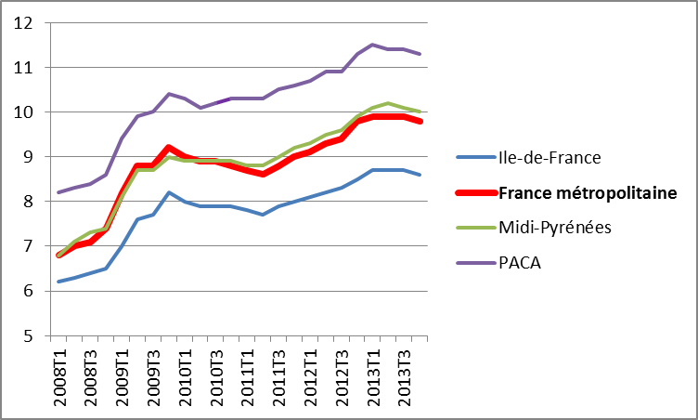
Source: INSEE
28. The French authorities argue that the redundancies in Air France will aggravate the unemployment situation, which has already deteriorated as a result of the economic and financial crisis. In the period 2008-2013 unemployment rose by 38,7 % in Ile-de-France, 37,8 % in PACA, 47,0 % in Midi-Pyrénées and by 44,1 % in metropolitan France. Furthermore, Ile-de-France faces another mass redundancy as the Peugeot Citroën Automobile (PSA) production plant in Aulnay is being closed entirely in 2014.
29. In the territory concerned by the redundancies about 40 % of the unemployed persons have been unemployed for more than one year and there are seven job-seekers for every job.
30. As Air France employs more than one thousand workers, it is obliged to contribute to the revitalisation of these regions under Article L1233-84 of the Code du Travail. This means that Air France will contribute to the creation of new activities and jobs so as to alleviate the impact of the dismissals in these regions.
Co-ordinated package of personalised services to be funded and a breakdown of its estimated costs, including its complementarity with actions funded by the Structural Funds
31. The "Projet Transform 2015", which is the object of this EGF application from France, aims to support the 5 213 workers who volunteered to leave the company and specifically the 3 886 targeted workers.
32. The measure within the "Projet Transform 2015" for which the French authorities seek EGF co-funding is the redeployment leave ("congé de reclassement"). This measure is intended for workers who, at the time of their voluntary departure, do not yet have any precise plans for redeployment and wish to benefit, over a period which can extend to nine months and under certain circumstances up to 15 months, from retraining measures, advice, guidance or assistance to set up or take over a business.
- Advisory services and vocational guidance for workers. The workers will be accompanied and oriented towards their projects for redeployment as workers or self-employed persons. The participants will avail of job-to-job counselling and guidance, job search support, coaching, information on available training, promotion of entrepreneurship and advice on business start-up (this can include search for funding, help with a business plan, and other accompanying services towards entrepreneurship), etc.
- Training. The workers will be proposed various types of trainings which are tailored to their needs, as identified by the counsellors providing the advisory services. Particular attention will be paid to the 'parcours encadrés' which are vocational trainings of long duration on jobs in demand. Some examples of possible vocational trainings are: training on vines and wine (winemaker), food and beverage services CAP fresh pastry goods and cakes, training towards DAEFLE (degree of proficiency in teaching French as a foreign language), metal works occupations, training towards CTRIV (passengers driver), etc.
- Contribution for business creation. This measure comprises a grant up to EUR 24 000 which can be complemented with up to EUR 5 000 hiring benefits. The contribution for business creation will be paid in various instalments once certain milestones have been reached. A first instalment of EUR 3 000 will be paid upon presentation of proof of setting up or taking over a business, such as the receipt of registration. A second and third instalment of EUR 6 000 each upon presentation of the first and second VAT return on sales showing a minimum turnover of at least EUR 500 and EUR 1 000 respectively. The self-employed persons and sole proprietors who are exempted from property assessment will receive the second and a third instalment of EUR 6 000 upon presentation of the first and second statement of activity to the RSI, indicating a turnover of at least EUR 200 and EUR 500 respectively with proof of payment of dues. An additional instalment of EUR 9 000 is foreseen for enterprises, self-employed persons and sole proprietors not exempted from property assessment upon presentation of the first year tax return certified approved.
For hiring in a full-time permanent position a former Air France worker targeted for EGF assistance, the contribution for business creation will additionally be topped-up with EUR 3 000 (EUR 5 000 if the recruited worker is over 55).
- Regular information and communication activities aimed at the participants workers.
- Redeployment allowance (allocation de congé de reclassement). This monthly allowance, paid until the end of the congé de reclassement, amounts to 70 % of the worker's last gross salary. This amount is calculated based on the assumption of the workers' full-time participation in active labour market measures; if participation is to a lesser extent, the EGF will pay workers an allowance which is proportionate to their actual participation.
- Mobility allowance. The targeted worker who accepts a job, involving a change of residence of more than 100 km from the current place of residence, will receive a lump sum of EUR 2 880 to cover the necessary expenditure..
33. The expenditure for implementing the EGF, which is included in the application in accordance with Article 3 of Regulation (EC) No 1927/2006, covers organisation, monitoring and traceability of the data. The French authorities explained that the low level of expenditure for implementing the EGF and the zero rating of control measures and information and publicity were due to the fact that they did not price activities which they were in any case obliged to carry out as part of the national management.
34. The personalised services presented by the French authorities are active labour market measures within the eligible actions defined by Article 3 of Regulation (EC) No 1927/2006. The French authorities estimate the total costs at EUR 51 875 626, of which the expenditure for personalised services at EUR 51 845 626 and the expenditure for implementing the EGF at EUR 30 000 (0,06 % of the total amount). The total contribution requested from the EGF is EUR 25 937 813 (50 % of the total costs).
Actions | Estimated number of workers targeted |  | Estimated cost per worker targeted  (EUR)  (*) | Total costs (EGF and national cofinancing) (EUR)  (**)
Personalised services (first paragraph of Article 3 of Regulation (EC) No 1927/2006)
Advisory services and vocational guidance for workers  (Orientation professionelle) | 3 886 |  | 1 385 | 5 382 694
Training  (Formation) | 1 268 |  | 2 567 | 3 255 292
Contribution for business creation  (Primes à la crèation d'entreprise) | 955 |  | 22 000 | 21 010 000
Regular information and communication activities  (Actions de communication destinés aux travailleurs concernés) | 3 886 |  | 70 | 272 020
Redeployment allowance  (allocation de congé de reclassement) | 3 379 |  | 6 387 | 21 580 020
Mobility allowance  (Mobilité géographique) | 120 |  | 2 880 | 345 600
Sub total personalised services |  |  |  | 51 845 626
Expenditure for implementing EGF (third paragraph of Article 3 of Regulation (EC) No 1927/2006)
Preparatory activities |  |  |  | 0
Organisation, monitoring and traceability of the data |  |  |  | 30 000
Information and publicity |  |  |  | 0
Control activities |  |  |  | 0
Sub total expenditure for implementing EGF |  |  |  | 30 000
Total estimated costs |  |  |  | 51 875 626
EGF contribution (50 % of total costs) |  |  |  | 25 937 813
(*) To avoid decimals, the estimated costs per worker have been rounded. However the rounding has no impact on the total cost of each measure which remains as in the application submitted by France.
(**) Totals do not tally due to roundings.
35. The French authorities did not indicate how the measures described above are complementary with actions funded by the Structural Funds. However, they explained that there is no public intervention foreseen in support of former Air France workers. Since Air France is a company in bonis (i.e. not in liquidation) employing 1000 employees or more, it is the employer's responsibility to pay the full costs of accompanying measures to ensure the redeployment of employees laid off (see footnote on redeployment leave, in paragraph 31).
36. The French authorities have additionally stated that they have concluded a written agreement with the dismissing enterprise to the effect that in implementing the measures described above it will not also receive financial contributions from other Union financial instruments for the same measures.
Date(s) on which the personalised services to the affected workers were started or are planned to start
37. France started the personalised services to the affected workers included in the co-ordinated package proposed for co-financing to the EGF on 6 November 2012. This date therefore represents the beginning of the period of eligibility for any assistance that might be awarded from the EGF.
Procedures for consulting the social partners
38. The French authorities have indicated that the co-ordinated package of personalised services has been drawn up in consultation with the representatives of the targeted beneficiaries and the social partners. Numerous meetings between the Air France management and trade union representatives took place between Q1 2012 and July 2013 concerning the agreements on the Transform 2015 plan.
39. The French authorities confirmed that the requirements laid down in national and EU legislation concerning collective redundancies have been complied with.
Information on actions that are mandatory by virtue of national law or pursuant to collective agreements
40. As regards the criteria contained in Article 6 of Regulation (EC) No 1927/2006, the French authorities in their application:
- confirmed that the financial contribution from the EGF does not replace measures which are the responsibility of companies by virtue of national law or collective agreements;
- demonstrated that the actions provide support for individual workers and are not to be used for restructuring companies or sectors;
- confirmed that the eligible actions referred to above do not receive assistance from other EU financial instruments.
Management and control systems
41. The application contains a description of the management and control system which specifies the responsibilities of the bodies involved. France has notified the Commission that the financial contribution will be managed by the Délégation générale à l’emploi et à la formation professionnelle (DGEFP, General Delegation for Employment and Vocational Training) of the Ministry of Labour, Employment and Health. The payments will be managed within the same ministry by the Département Financiement, Dialogue et Contrôle de Gestion - Mission du financement, du budget et du dialogue de gestion (DGEFP-MFBDG, Mission funding, budget and management). Certification will be provided by the Pôle de Certification (Certification Centre) of the Directorate-General for Finances in Nantes.
Financing
42. On the basis of the application from France, the proposed contribution from the EGF to the coordinated package of personalised services (including expenditure to implement EGF) is EUR 25 937 813, representing 50 % of the total cost. The Commission's proposed allocation under the Fund is based on the information made available by France.
43. Considering the maximum possible amount of a financial contribution from the EGF under Article 12 of Council Regulation (EU, Euratom) No 1311/2013, as well as the scope for reallocating appropriations, the Commission proposes to mobilise the EGF for the total amount referred to above.
44. The proposed decision to mobilise the EGF will be taken jointly by the European Parliament and the Council, as laid down in point 13 of the Interinstitutional Agreement of 2 December 2013 between the European Parliament, the Council and the Commission on budgetary discipline, on cooperation in budgetary matters and on sound financial management.
45. The Commission presents separately a transfer request in order to enter in the 2014 budget specific commitment appropriations, as required in Point 13 of the Interinstitutional Agreement of 2 December 2013.
Source of payment appropriations
46. Appropriations allocated to the EGF budget line in the 2014 budget will be used to cover the amounto of EUR 25 937 813.
Proposal for a
DECISION OF THE EUROPEAN PARLIAMENT AND OF THE COUNCIL
on the mobilisation of the European Globalisation Adjustment Fund in accordance with point 13 of the Interinstitutional Agreement of 2 December 2013 between the European Parliament, the Council and the Commission on budgetary discipline and sound financial management (application EGF/2013/014 FR/Air France from France)
THE EUROPEAN PARLIAMENT AND THE COUNCIL OF THE EUROPEAN UNION,
Having regard to the Treaty on the Functioning of the European Union,
Having regard to Regulation (EC) No 1927/2006 of the European Parliament and of the Council of 20 December 2006 establishing the European Globalisation Adjustment Fund, and in particular Article 12(3) thereof,
Having regard to Regulation (EU) N° 1309/2013 of the European Parliament and of the Council of 17 December 2013 on the European Globalisation Fund (2014-2020) and repealing Regulation (EC) N° 1927/2006,
Having regard to the Interinstitutional Agreement between the European Parliament, the Council and the Commission of 2 December 2013 on budgetary discipline, on cooperation in budgetary matters and on sound financial management, and in particular point 13 thereof,
Having regard to the proposal from the European Commission,
Whereas:
(1) The European Globalisation Adjustment Fund (EGF) was established to provide additional support for workers made redundant as a result of major structural changes in world trade patterns due to globalisation and to assist them with their reintegration into the labour market.
(2) The EGF shall not exceed a maximum annual amount of EUR 150 million (2011 prices), as laid down in Article 12 of Council Regulation (EU, Euratom) No 1311/2013 laying down the multiannual financial framework for the years 2014-2020.
(3) France submitted an application to mobilise the EGF, in respect of redundancies in the enterprise Air France, on 20 December 2013 and supplemented it by additional information up to 24 July 2014. This application complies with the requirements for determining the financial contributions as laid down in Article 10 of Regulation (EC) No 1927/2006. The Commission, therefore, proposes to mobilise an amount of EUR 25 937 813.
(4) The EGF should, therefore, be mobilised in order to provide a financial contribution for the application submitted by France,
HAVE ADOPTED THIS DECISION:
Article 1
For the general budget of the European Union for the financial year 2014, the European Globalisation Adjustment Fund (EGF) shall be mobilised to provide the sum of EUR 25 937 813 in commitment and payment appropriations.
Article 2
This Decision shall be published in the Official Journal of the European Union.
Done at Brussels,
For the European Parliament For the Council
The President The President

OJ L 347, 20.12.2013, p. 884.
OJ L 406, 30.12.2006, p. 1. See also Article 23 of Regulation (EU) 1309/2013, OJ L 347, 20.12.2013, p. 855.
In accordance with the third paragraph of Article 3 of Regulation (EC) No 1927/2006.
EU-27 – North America declined by 0,5 %, EU-27 – South America by 1,8 %, EU-27 – Africa by 2,8 %, EU-27 – Asia by 1,2 %
http://www.icao.int/Newsroom/News%20Doc%202013/COM.43.13.ECON-RESULTS.Final-2.en.pdf
IAG includes British Airways and Iberia.
Source: Les compagnies aériennes européennes sont-elles mortelles? Perspectives à vingt ans
Debt ratio is defined as the ratio of total debt to total assets.
http://online.wsj.com/articles/qatar-airways-confirms-purchase-of-50-boeing-777x-aircraft-1405504408
http://dohanews.co/qatar-airways-to-buy-50-long-haul-b777x-planes-from-boeing/
Direccte (Directions régionales des entreprises, de la concurrence, de la consommation, du travail et de l'emploi) http://www.direccte.gouv.fr/. Established in 2010, Direccte brings together various administrative services related to trade, tourism, commerce and industry, business intelligence, industry, labour and employment, competition and consumers
Institut national de la statistique et des études économiques (INSEE). http://www.insee.fr
As regards the redeployment leave (‘congé de reclassement’), Article L1233-71 of the Labour Code provides that a company which employs more than one thousand people is required to propose the measures set out therein for a minimum duration of four months. According to the above-mentioned legislation, the period as from the fifth month is therefore optional and may be subject to a contribution from the EGF in accordance with Article 6(1) of Regulation (EC) No 1927/2006. Air France has decided to propose this measure for a maximum period of twelve months. The application does not provide for any contributions for the first four months of the redeployment leave, which correspond to the minimum duration stipulated by law.
Exceptionally, the workers following a ‘parcours encadré’ (i.e. vocational training of long duration on jobs in demand) can see their redeployment leave ‘congé de reclassement’ extended up to 15 months to cover the completion of the parcours encadré and additional three months of accompanied job-search.
CPA stands for Certificate for professional aptitude.
Conducteur(trice) du transport routier interurbain de voyageurs (CTRIV)
"micro-social", ultra simplified social system, etc
Régime Social des Indépendants (social scheme for self-employed persons).
OJ C 373, 20.12.2013, p. 1.
OJ L 406, 30.12.2006, p. 1.
OJ L 347, 20.12.2013, p. 855.
OJ C 373, 20.12.2013, p. 1.
OJ C […], […], p. […].
OJ L 347, 20.12.2013, p. 884.

